Manuscript Title: Modulation of Synovial Fibroblasts Mechanical Response by Osteoarthritis-Associated Inflammatory Stressors

Authors:
Juliana Jamal^{1,2}, Margaret M. Roebuck², Siam-Yee Lee¹, Simon P. Frostick², Azlina Amir Abbas⁴, Azhar Mahmood Merican⁴, Teo Seow Hui⁴, Amanda Wood ², Sik-Loo Tan⁴, George Bou-Gharios³, and Pooi-Fong Wong^{1,*}

Affiliations:
¹Department of Pharmacology, Faculty of Medicine, University of Malaya, 50603 Kuala Lumpur, Malaysia
²Department of Molecular and Clinical Cancer Medicine, Institute of Translational Medicine, University of Liverpool, Liverpool, L69 3BX, United Kingdom
³ Musculoskeletal Biology I Group, Department of Musculoskeletal Biology, Institute of Ageing and Chronic Disease, University of Liverpool, Liverpool, L7 8TX, United Kingdom
⁴Tissue Engineering Group, Department of Orthopedic Surgery (NOCERAL), Faculty of Medicine, University of Malaya, 50603 Kuala Lumpur, Malaysia

*Correspondence to: PF. Wong, Department of Pharmacology, Faculty of Medicine, University of Malaya, 50603 Kuala Lumpur, Malaysia.
E-mail address: wongpf@um.edu.my

Highlights
- SFb from OA patients differ by size and SA-β-gal expression from scope SFb
- Mechanical stress modifies inflammatory and ECM gene expression of SFb
- Soluble factors in OA-pre-obese condition media drive SFb inflammatory response
- Lubricin gene expression is susceptible to both loading and inflammation stressors

Abstract
Objectives: To compare mechanobiological response of synovial fibroblasts (SFb) from OA patient’s cohorts
under mechanical load and inflammatory stressors for better understanding of SFb homeostatic functions.

Methods: Primary SFb isolated from knee synovium of OA obese (OA-ob:SFb), OA-pre-obese (OA-Pob:SFb), non-OA arthroscopic (scope:SFb), and non-OA arthroscopic with cartilage damage (scope-CD:SFb) were exposed to OA-conditioned media (OA-CM), derived from OA obese (OA-ob:CM), OA-pre-obese (OA-Pob:CM), and mechanical stretch at either 0%, 6% or 10% for 24h. Differences in the mRNA levels of genes involved in extracellular matrix production, inflammation and secretory activity were measured.

Results:
Despite the significant BMI differences between the OA-ob and OA-Pob groups, OA-Pob has more patients with underlying dyslipidaemia, and low-grade synovitis with higher levels of soluble chemokines and inflammatory cytokines [biomarkers / secretory analytes / secretory factors], COL4A1, CCL4, SPARC and FGF2 in OA-Pob:CM. All primary SFb exhibited anti-proliferative activity with both OA-CM. Mechanical stretch stimulated lubricin production in scope:SFb, higher TGFβ1 and COL1A1 expressions in scope-CD:SFb. OA-Pob:CM stimulated greater detrimental effects than the OA-ob:CM, with higher pro-inflammatory cytokines, IL1β, IL6, COX2 and proteases such as aggrecanases, ADAMTS4 and ADAMTS5, and lower ECM matrix, COL1A1 expressions in all SFb. OA-ob:SFb were unresponsive but expressed higher pro-inflammatory cytokines under OA-Pob:CM treatment.

Conclusion: Both mechanical and inflammatory stressors regulate SFb molecular functions with heterogeneity in responses that are dependent on their pathological tissue of origins. For example, mechanical stretch promotes a favorable effect with enhanced lubricin production in scope:SFb and TGFβ1 and COL1A1 in scope-CD:SFb, the presence of excessively high OA-associated inflammatory mediators in OA-Pob:CM drive all SFb regardless of pathology, towards greater pro-inflammatory activities.

Keywords: Osteoarthritis, synovial fibroblasts, mechanical stress, inflammatory response, obesity, mediators of inflammation

Abbreviations:
BMI, body mass index
IF, immunofluorescence
IHC, immunohistochemistry
OA, osteoarthritis
OA:CM, OA-conditioned media
OA-ob:CM, OA obese synovial tissue conditioned media

OA-Pob:CM, OA-pre-obese synovial tissue conditioned media
SFb, synovial fibroblasts
OA-ob:SFb, OA obese synovial fibroblasts
OA-Pob:SFb, OA-pre-obese synovial fibroblasts
Scope:SFb, non-OA arthroscopic synovial fibroblasts
Scope-CD:SFb, non-OA arthroscopic with cartilage damage grade I-III synovial fibroblasts

Introduction
OA is the most common form of arthritis. Older age, female above 60 years, being overweight or obese, joint trauma, overuse and mechanical overload or abnormal stresses on the joint, can increase the risk of developing OA (Heidari, 2011; Loeser, 2010). The complex pathophysiology of OA involves degeneration and remodelling of the whole joint tissues driven by a combination of cellular changes, inflammatory mediators, matrix degrading enzymes and biomechanical stresses (Loeser et al., 2012; Man and Mologhianu, 2014). The characteristics of endstage-OA include depletion of articular cartilage, thickening of subchondral bone, formation of osteophytes, development of bone marrow lesions, degeneration of ligaments, hypertrophy of joint capsule and synovial inflammation (Loeser et al., 2012).
Chronic inflammation, which is increased by ageing and obesity, underlies OA development through increased oxidative stress, ‘wear-and-tear’ of the joints and abnormal biomechanical loads to the joints (Heidari, 2011). The synovium faces multiple insults, local and systemic inflammatory insults throughout the joint movement stresses themselves often exacerbated by obesity (Smith, 2011). However, research into the synovium or synovial fibroblasts (SFb) within the synovial inflammation apparent during OA progression (Scanzello and Goldring, 2012) is relatively limited.
The knee is a uniaxial hinge synovial joint supporting extension and flexion during the gait cycle. An ideal in vitro replicate of longitudinal direction subjected on muscle tissue or tendon during exercise was reported using the uniaxial cyclic stretch system on muscle cells or tenocytes (Passey et al., 2011). The uniaxial cyclic stretch system, however, partially recapitulates the mechanical stresses experienced by the synovium which has a wider range of movement as it is loosely attached to the inner surface of the articular capsule (Schett et al., 2001; Simkin, 1991). Nevertheless, relative to other muscle tissues, the synovium is continually exposed to a dynamic mechanical stress due to the load of body weight and shear forces of the synovial fluid motion during exercise under both normal and pathological conditions (Schett et al., 2001), which the present study aims to recapitulate using both mechanical loading and inflammatory stressors.
SFb, resident cells in the synovium, play an important role in nourishing chondrocytes, lubricating and maintaining cartilage by contributing to synovial fluid composition as synovial fluid flows during joint movement (Ospelt, 2017). Multiple cellular physiological processes within SFb functions are regulated by mechanical loading including changes in cell orientation, proliferation, cell division synthesis and breakdown of extracellular matrix proteins (Guilak, 2011; Yanagida-Suekawa et al., 2013). Studies in rabbits demonstrated enhanced secretion of hyaluronan by SFb following cyclic stretch (Ingram et al., 2008). Obesity is associated with OA progression via increased joint loading by excess weight and through inflammatory adipocytokines secretion (Richter et al., 2015). Mechanical stress also attenuates the production of inflammatory mediators of prostaglandin E₂ (PGE₂) by SFb (Sambajon et al., 2003). However, how mechanical stress, obesity and inflammatory mediators are integrated or how these factors affect SFb function remains unclear.
This study was undertaken to evaluate the responses of OA-SFb to mechanical loading, inflammatory stressors and combinations of both. Changes in cell morphology and molecular functions such as production of extracellular matrix and inflammatory mediators have been analysed. Distinct molecular responses [Functional and molecular responses] of SFb derived from endstage-OA were identified compared with SFb responses from non-inflammatory knee pathologies without osteoarthritis. Our findings suggest that metabolic and inflammatory insults impact the morphology and molecular functions of synovial fibroblasts, including effects induced by mechanical stretch. In particular, the OA-Pob:CM associated inflammatory mediators promote cartilage destructive pathways.

Material and methods
Patients demography
Patients with knee pathologies were recruited from the Orthopaedic Surgery Clinic at the University of Malaya Medical Centre (UMMC) following exclusion and inclusion criteria and Medical Research Ethics Committee (MREC) of UMMC approval. Patient’s clinical data including any history of arthritis, injuries, medications, physical examinations, laboratory and radiological clinical records were collated. Intra-operative tissue samples were obtained from 26 patients, 17 endstage-OA patients attending for primary knee replacement surgery for primary OA and 9 patients with sports-related injuries attending for arthroscopic debridement or repair. Of the endstage-OA patient’s tissues 12 were used to prepare conditioned media. Ten endstage-OA and 9 arthroscopy knee synovium tissues were used for primary fibroblast culture and testing (Supplementary Figure 1A). Endstage-OA patients were further grouped into pre-obese (OA-Pob) or obese groups (OA-ob), according to the BMI category cut-off at 27.5kg/m² (Table 1) by the Malaysia Clinical Practice Guidelines (CPG) (Zainudin et al., 2014). Arthroscopy patients were included only if they presented with no clinical or radiographic features indicating OA and did not have any history of previous knee pain or injuries. Arthroscopy patients were further grouped into those with or without cartilage damage (grade I, II or III), documented in operative notes.

Primary synovial fibroblast explant culture
Synovial tissue, biopsied at the medial gutter was collected into DMEM and placed on ice before being processed the same day. Primary synovial fibroblasts (SFb) cultures were established using mechanical disaggregation and a single passage.

Histology
Formalin fixed synovial tissue biopsies were stained with haematoxylin and eosin, for vimentin and CD68 (Santa Cruz, USA; Cat No. sc6260, sc20060; monoclonal mouse anti-human) at 1:500 using manufacturer’s Protocol F Leica BOND RX^{m} Automated Stainer (Leica Biosystems, USA). Negative controls utilised mouse IgG1 isotype serum at 1:500 (Agilent DAKO, USA; Cat No. X0931). Tonsil was used as the positive staining control. Images of synovial tissue sections were acquired and digitised at 10x using Aperio ImageScope v12.3.2.8013 or 20x using Aperio CS2 Digital Pathology Scanner (Leica Biosystems, USA).

Immunofluorescence staining
Adherent primary SFb at passage 1 were cultured on µ-Slide 8 well with glass bottom (Ibidi), and stained for vimentin (Santa Cruz, USA; Cat No. sc6260 at 1:50), followed by anti-Mouse IgG (H+L), F(ab')₂ Fragment (Alexa Fluor® 488 Conjugate) at 1:2000 dilution (Cell Signalling). Nuclei were counterstained with Hoechst 33342 at 1:600 (Molecular Probes, Life Technologies, UK). Images were captured using TCS SP5 II confocal microscope (Leica). SA-β-gal activity was measured using the fluorogenic β-galactosidase substrate method (Debacq-Chainiaux et al., 2009) of 5-dodecanoylaminofuorescein di-β-D-galactopyranoside (C₁₂FDG, Sigma). Unstained control and oxidative stress induced premature senescent HUVECs were negative and positive controls, respectively. Sample acquisition and analysis was performed using FACS Canto II (BD Pharmingen). Data were acquired using FITC detection channel and data were analysed by FlowJo software (version 10.6.1).

OA-conditioned media preparation
Two forms of OA synovial tissue conditioned media (OA-CM) were prepared. Tissue explants from 6 OA-Pob and 6 OA-ob patients (Figure 1), were cultured in serum-free and antibiotic-free DMEM at 1.0 g tissue/5mL medium, for 48h in CO₂ incubator. The resulting conditioned medium was centrifuged at 1,200 rpm for 10 min, the supernatant being aliquoted and stored at -80ºC before being pooled into separate OA-Pob:CM or OA-ob:CM for use. A panel of 12; CXCL8, SPARC, COL4A1, CCL4, FN1, BMP2, FGF2, LEP, ADIPOQ, EGF, SERPINF1 and BMP4, analytes secreted into the conditioned media, were quantified simultaneously by Luminex 200 using Magnetic Luminex Assay (R&D Systems).

OA-CM treatment and cell proliferation assay
A labelled free, real-time cell proliferation analyser (RTCA SP, ACEA Biosciences Inc.) was utilized to evaluate the proliferation profiles of SFb cultured in OA-ob:CM or OA-Pob:CM (Jamal et al., 2014). Cells were seeded at 70% confluent on E-plate 96 (ACEA Biosciences Inc.), and synchronised by 6h serum starvation. Individual treatment wells comprised complete media or with added OA-ob:CM or OA-Pob:CM, at a dilution ratio of 1:2, 1:4 or 1:8. Cell proliferation was monitored for 72h detailing the normalized cell index; an increase or decrease in cell index reflects an increase or decrease in cell proliferation respectively (Roshan Moniri et al., 2015). A plateaued cell index indicates 100% cell confluency or cell growth arrest.

In-vitro uniaxial strain mechanical loading assay
A biomechanical tensile loading regimen was used to determine the influence of mechanical strain on molecular changes in SFb. SFb were seeded onto a collagen type I coated-silicone chambers (10cm² chamber, Strexcell, USA) at 45,000 cells/chamber and incubated for 24h, before synchronisation as above. Synchronised cells were subjected to a 1Hz, 24h, 6% or 10% uniaxial stretching regimen with or without addition of either OA-ob:CM OA or OA-Pob:CM using an Automated Cell Stretching System (STB-1400-10; Strexcell, USA). Cells in an untreated and non-stretched chamber were the controls. Once the protocols finished, total RNA was extracted immediately.

Total RNA extraction and qPCR gene expression
Total RNA was extracted using RNA isolation kit (RNeasy Mini Kit, Qiagen, USA), and reverse transcribed using the High Capacity RNA-to-cDNA conversion kit (Applied Biosystems, USA). Differences in mRNA levels of COL1A1, SOX9, TGFB1, IL1B, TIMP1, IL6, ADAMTS4, ADAMTS5, PRG4, SIRT1, SIRT6 and COX2 genes were measured by a qPCR system (CFX96 Real-Time System, Bio-Rad). Supplementary Table 1 details all forward and reverse primer sequences utilised. Relative gene expression data were calculated using the 2−ΔΔCT method by normalising to β2M (internal reference gene control). mRNA expressions were reported as fold change (log₂) relative to each respective pathology group’s non-stretched control.

Network analysis and visualisation
Protein association network and visualisation for cluster of SFb’s regulatory genes and soluble analytes measured in OA-CM was performed using StringApp as previously described (Doncheva et al., 2019) on Cytoscape platform (v3.7.2). Functional enrichment analysis of genes-analytes clusters was carried out using a Cytoscape plugin, String Enrichment App with an FDR threshold of 5% and by filtering out the redundant GO terms using the default redundancy cutoff of 0.5. Significant GO Biological Process associated with the genes-analytes cluster was visualised as a split donut charts around the nodes (Doncheva et al., 2019). Visualization of differential gene expression networks to portray functional genes-analytes interactions and experimental response was performed using Cytoscape StringApp as described by (Cline et al., 2007; Doncheva et al., 2019). The size and colour intensities of nodes corresponded to the p-value score and log₂ fold change values (of being either upregulated or downregulated), under each experimental condition.

Statistical analysis
Data were tested using the Kolmogorov-Smirnov Z test and Shapiro-Wilk normality test (Ghasemi and Zahediasl, 2012). All statistical analyses were performed using GraphPad Prism 8. The unpaired two-tailed t-test was performed for comparison between two groups, *p<0.05, **p<0.01, ***p<0.001 and ****p<0.0001. For SA-β-gal, cell proliferation and gene expression assays, statistical analyses were performed using multiple comparison one-way ANOVA corrected via Holm-Sidak test, *p<0.05, **p<0.01, ***p<0.001 and ****p<0.0001 and for comparison to the non-stretch, untreated control, #p<0.05, ##p<0.01, ###p<0.001 and ####p<0.0001.

Results
Patients demography
OA patients were significantly older than patients with sports-related injuries and presented with multiple co-morbidities such as hypertension, diabetes and dyslipidaemia with statin medication (Table 1a). The BMI of OA-ob patients was significantly higher than all other groups, with no significantly difference between scope, scope-CD and OA-Pob groups (Table 1b). OA patients presented more metabolic derangements than all Scope patients. Dyslipidaemia was identified in 6/8 OA-Pob:CM patients compared with 3/9 OA-ob:CM groups, while 5/9 OA-ob:CM patients were type-2 diabetics. There was a significantly higher plasma glucose (p=0.009), serum CRP (p=0.005), HbA1c(NGSP) (p=0.032) and HbA1c(IFCC) (p=0.030) in the OA-ob:CM than OA-Pob:CM patient groups (Table 1b).

Table 1a. Patient demographic and clinical characteristics of different pathology groups.
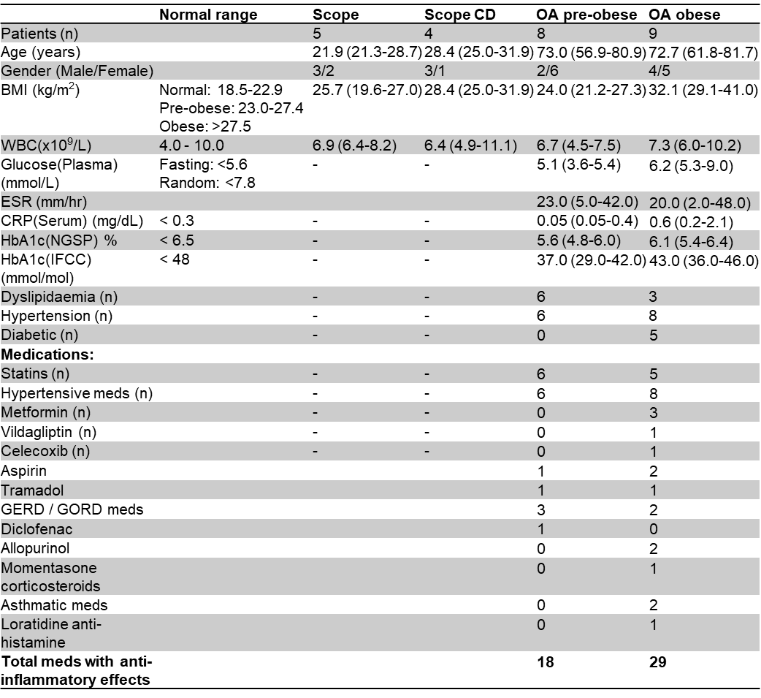
Age, BMI, WBC, Glucose(plasma), ESR, CRP(serum), HBA1c(NGSP) and HBA1c(IFCC) are reported as median (min – max). Gender, dyslipidaemia, hypertension, diabetic and medications are reported as number of patients. BMI, body mass index; WBC, white blood cell count; ESR, erythrocyte sedimentary rate; CRP, C-reactive protein; HbA1c, glycohemoglobin. Hypertensive medications include: Amlodipine, telmisartan, atenolol, Perindopril, bisoprolol, valsartan, hydrochlorthiazide, Telmisartan, nebivolol. Diabetic Mellitus Type 2 medications include: metformin, glicazide, linagliptin and vildagliptin.
Table 1b. Significance analysis of selected clinical characteristics between different pathology groups.
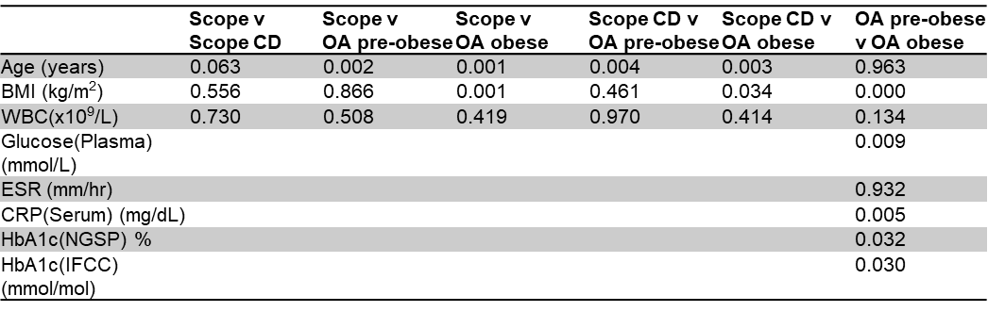
Statistical analysis was performed on patient’s clinical data using non-parametric Mann-Whitney U, exact significant between OA-Pob:CM and OA-ob:CM, p<0.05 was deemed significantly different.

Histology
Low-grade synovitis was evident in H&E stained synovial membrane sections from OA patients. Focal inflammatory cell aggregates and increased cells density at the synovial intimal and subintimal layer (Krenn et al., 2006) are observed in OA-Pob synovial tissues (Figure 1A and 1C). Synovial tissues from the OA-ob group contained adipocytes with an abundant vascular supply in the synovial subintimal layer Figure 1B. Presence of CD68-macrophage positive cells was abundant at the synovial intimal layer (arrows) and scattered diffusedly at the synovial subintima layer in the OA pre-obese synovium (Figure 1E), than in the OA obese synovial tissue section (Figure 1F). Positive vimentin staining of cells on the same sections indicating an extensive intermediate filament network characteristic of activated or poised fibroblasts (Robinson-Bennett and Han, 2006), (Figure 1C and 1D).

Characterisation of SFb
Isolated primary SFb from synovial tissues exhibited an homogenous spindle-shape morphology and strong expression of vimentin (Figure 1I). SFb from OA-ob were significantly larger than scope-CD:SFb at passage 3 (p<0.001, Figure 1J). OA-ob:SFb showed the highest SA-β-gal activity at 7.83% ± 1.77 (mean±S.D.), followed by OA-Pob:SFb 5.12% ± 1.19, scope-CD:SFb 0.72% ± 0.31 and lowest in scope:SFb 0.61% ± 0.48. There were significant differences between combined OA:SFb and combined scope:SFb and scope-CD:SFb (Figure 1K). There was no significant difference in the SA-β-gal activity between the OA-ob:SFb and OA-Pob:SFb.

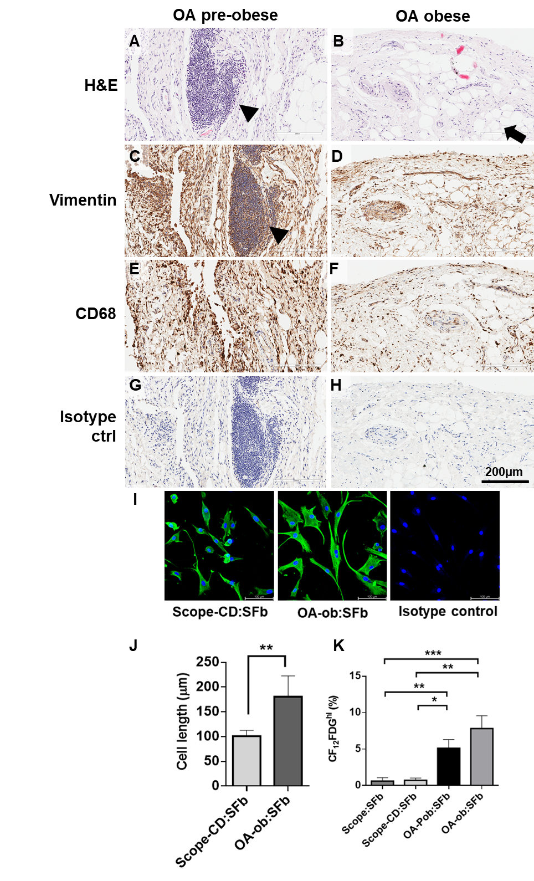
Figure 1. Characterization of synovial membrane from different pathology groups.
A-H, Representative images of synovial membrane histology. Black arrowheads in A and C show the focal aggregates of inflammatory immune cells infiltration (arrows on CD 68 cells) . Black arrow in B show the presence of adipocytes. I, Immunuofluorescence detection of vimentin on isolated primary synovial fibroblasts. J, Mean cell length in µm with SD of scope-CD:SFb and OA-ob:SFb. K, SA-β-gal activity in SFbs derived from scope, scope-CD, OA pre-obese and OA-obese pathology groups. Data are reported in percentage of C₁₂FDG^{bright} cells from the parent population with SD. Statistical significance is expressed as *p<0.05, **p<0.01, ***p<0.001
OA conditioned media composition
The concentrations of collagen type-IV alpha-1 chain (COL4A1), C-C motif chemokine ligand 4 (CCL4), secreted protein acidic and cysteine rich (SPARC) and fibroblast growth factor 2 (FGF2) were significantly higher in OA-Pob:CM than OA-ob:CM (Figure 2A). OA-ob:CM showed significantly greater concentration of fibronetin (FN1), leptin (LEP) and Serpin Family F Member 1 (Serpin F1) when compared to OA-Pob:CM (Figure 2A). The concentration of C-X-C motif chemokine ligand 8 (IL8/CXCL8) was detected at concentrations higher than 110,000pg/ml in OA-Pob:CM than OA-ob:CM. Adiponectin (ADIPOQ) was detected in both forms of OA-CM (Figure 2A). The levels of bone morphogenetic protein 2 (BMP2), bone morphogenetic protein 4 (BMP4) and endothelial growth factor (EGF) were undetectable in both forms of OA-CM (data not shown). Q
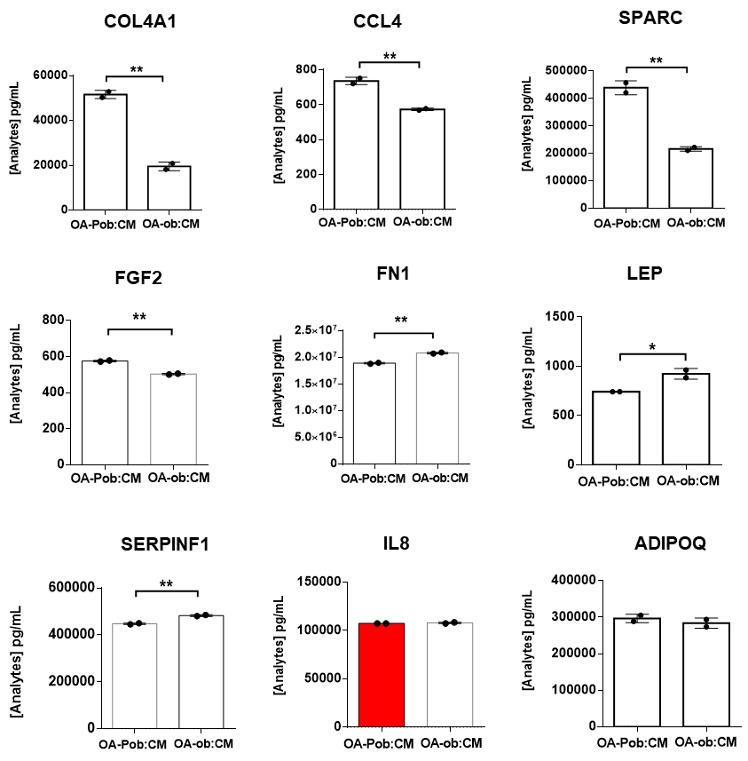
Figure 2. Detection of analytes in both forms of OA-CM. Quantitation of soluble analytes in OA-Pob:CM and OA-ob:CM was performed using multiplex magnetic-beads based assay. The dots on each bar graph each represent the mean with SD of the three technical replicates for each of two independent multiplex analyses. Statistical significance is expressed as **p<0.01 (Unpaired two-tailed t-test).

Effects of OA-conditioned media on SFb proliferation
OA-Pob:CM treatment significantly reduced the proliferation of scope:SFb (Figure 3A) at 24h. Both forms of OA-CM significantly reduced scope-CD:SFb proliferation profile more than any other SFb group at 24h treatment period (Figure 3B). The cell proliferation reduction impact by either form of OA-CM, was low on OA-Pob:SFb and OA-ob:SFb at 24h treatment period (Figure 3C-D), with OA-ob:SFb being the least affected by either CM at all treatment dilutions. As the 1:4 dilution of both OA-Pob:CM and OA-ob:CM produced consistent effects on SFb from all pathological origins, it was used in all subsequent studies.

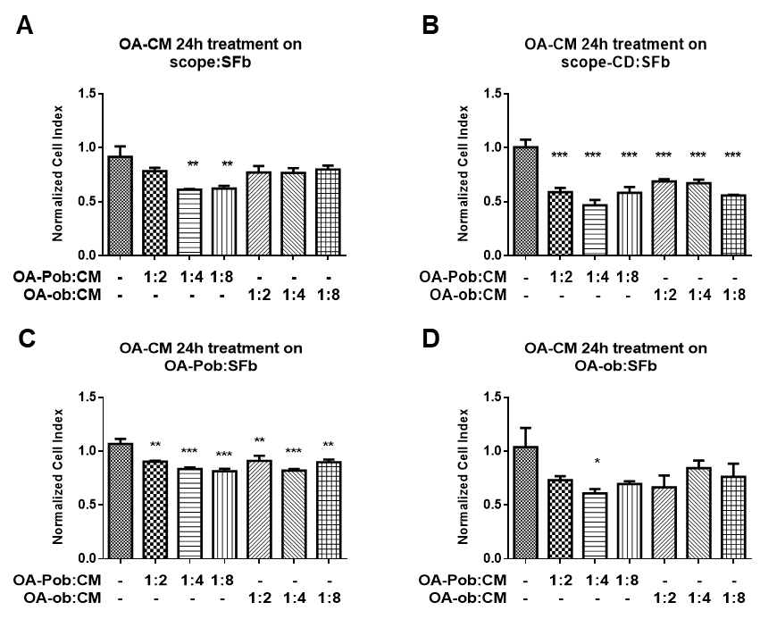
Figure 3. Growth kinetics of SFb treated with different concentrations of OA-Pob:CM or OA-ob:CM. Bar charts show the mean normalized cell index value with SD, which indicates the proliferation profile of A, Scope:SFb; B, Scope-CD:SFb; C, OA-Pob:SFb and D, OA-ob:SFb captured at 24h following treatment with OA:CM. Statistical significance is expressed as *p<0.05, **p<0.01, ***p<0.001 (multiple comparison one-way ANOVA)

Effects of tensile loading on SFb
subjecting the cells to 6% or 10% uniaxial stretch resulted in cells realigned perpendicular to the direction of stretch, in contrast to the non-stretch control SFb and regardless of the presence of OA-CM (Figure 4A). OA-ob:SFb showed reduced ADAMTS5 and SIRT6 mRNA expressions under 6% strain (Figure 4B and 4D, respectively. The mRNA expression of TGFβ1 was highly upregulated in scope-CD:SFb and OA-Pob:SFb, but not in the scope:SFb or OA-ob:SFb under 6% or 10% load (Figure 4C). Scope:SFb produced the highest fold-change mRNA expression of PRG4 when the cells were subjected to 10% strain for 24h compared to other SFb pathologies (Figure 4E). The COL1A1 mRNA expression was significantly increased in scope-CD:SFb when subjected to 10% strain compared with 6% strain and other SFb pathologies (Supplementary Figure 2A). OA-ob:SFb showed reduced SOX9 mRNA expression than the scope:SFb under similar strain condition (Supplementary Figure 2A). Mechanical stretch did not affect the mRNA expressions of SIRT1, COX2, TIMP1, IL6, ADAMTS4 and IL1β (Supplementary Figure 2A).

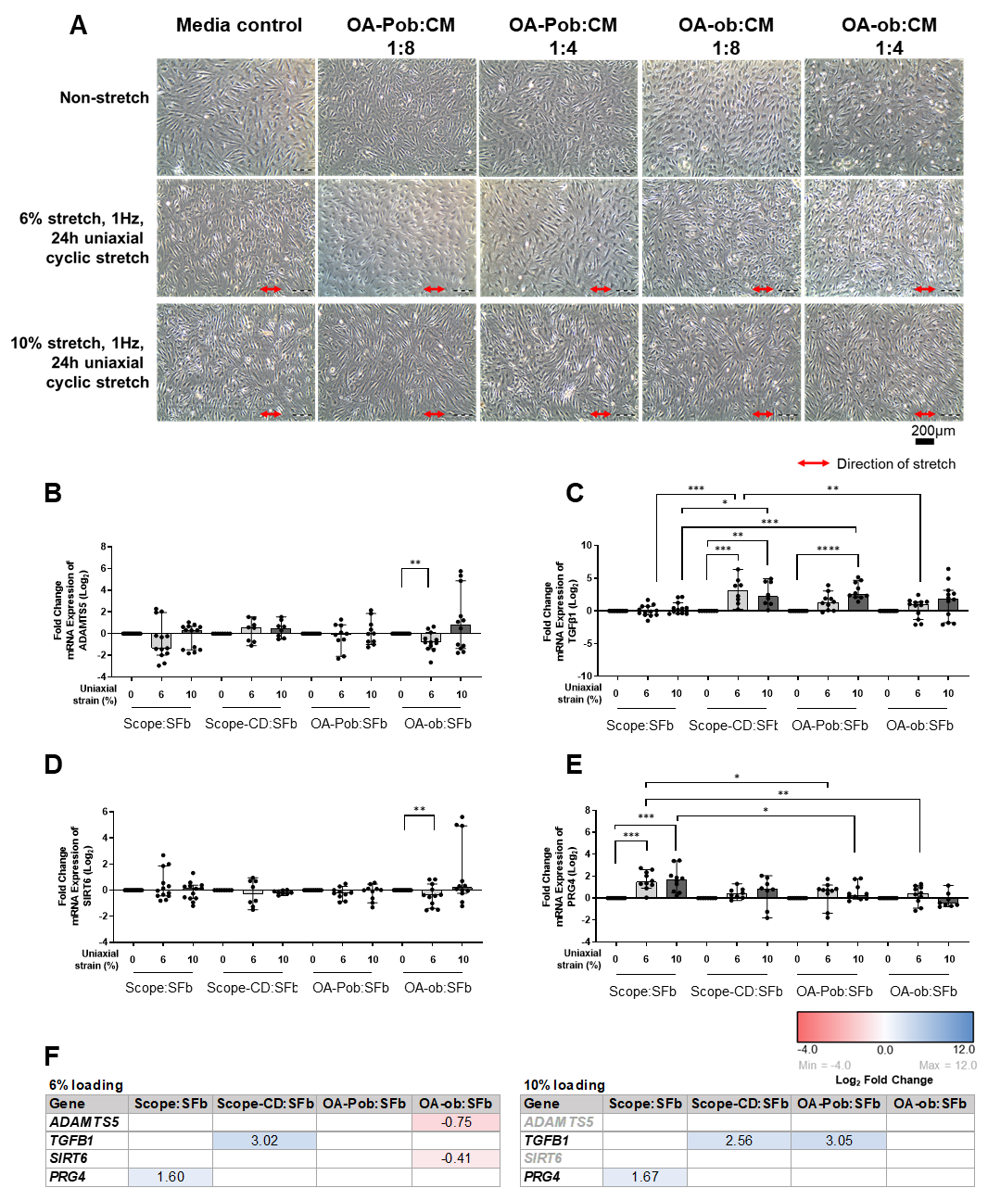
Figure 4. Effects of tensile loading on SFb. A, Cells re-oriented perpendicularly to the direction of stretch following mechanical stretch at 6% or 10%, regardless of treatment to OA:CM. B-E, Mean fold change mRNA expression with SD of ADAMTS5; TGFβ1; SIRT6 and PRG4 respectively, following mechanical stretch at 6% or 10% uniaxial tensile load. Significant differences within and between pathology groups are indicated. F, Heatmap summaries of the significant mean fold change of gene expression within each pathology group, in comparison to the non-stretch and untreated control group. Blue indicates upregulation (Log₂ fold change > 0) and red indicates downregulation (Log₂ fold change < 0) in the mRNA expression. Statistical significance is expressed as *p<0.05, **p<0.01, ***p<0.001 and ****p<0.0001.

Effects of OA-CM on SFb gene expression
expression of COL1A1 was reduced in scope:SFb, scope-CD:SFb and OA-ob:SFb by treatment with OA-Pob:CM, in contrast to OA-Pob:SFb (Figure 5A). Scope:SFb exhibited a highly significant downregulation in expression of COL1A1 mRNA when exposed to either form of OA-CM (Figure 5A). A significant increase in ADAMTS4 mRNA expression was observed in scope:SFb, scope-CD:SFb and OA-Pob:SFb when the cells were exposed to the OA-Pob:CM (Figure 5B). Only OA-ob:SFb treated with OA-ob:CM showed a significant increase in ADAMTS4 mRNA (Figure 5B). The mRNA expression of ADAMTS5 was increased in all SFb pathologies and significantly highest in OA-Pob:SFb when exposed to OA-Pob:CM (Figure 5C). Treatment with OA-ob:CM increased ADAMTS5 mRNA expression in OA-ob:SFb (Figure 5C). Both OA-CM types increased the expression of TIMP1 in OA-ob:SFb (Figure 5D). Prominent upregulations in IL1β, IL6 and COX2 mRNA expressions were observed in all SFb pathologies treated with OA-Pob:CM, compared to OA-ob:CM (Figure 5E-G). Only scope:SFb responded to OA-ob:CM treatment with increased IL6 mRNA expression (Figure 5F). In contrast to scope:SFb and OA-ob:SFb, TGFβ1 mRNA expression was significantly increased in scope-CD:SFb and OA-Pob:SFb when treated with OA-ob:CM (Figure 5H). The TGFβ1 mRNA expression was upregulated in OA-Pob:SFb by OA-Pob:CM (Figure 5H). OA-Pob:CM reduced the expression of SIRT6 in scope:SFb (Figure 5I). OA-ob:CM induced the expression of PRG4 in scope:SFb and OA-Pob:SFb (Figure 5J). Neither form of OA-CM altered expression of SIRT1 and SOX9 in any SFb pathology (Supplementary Figure 2B).

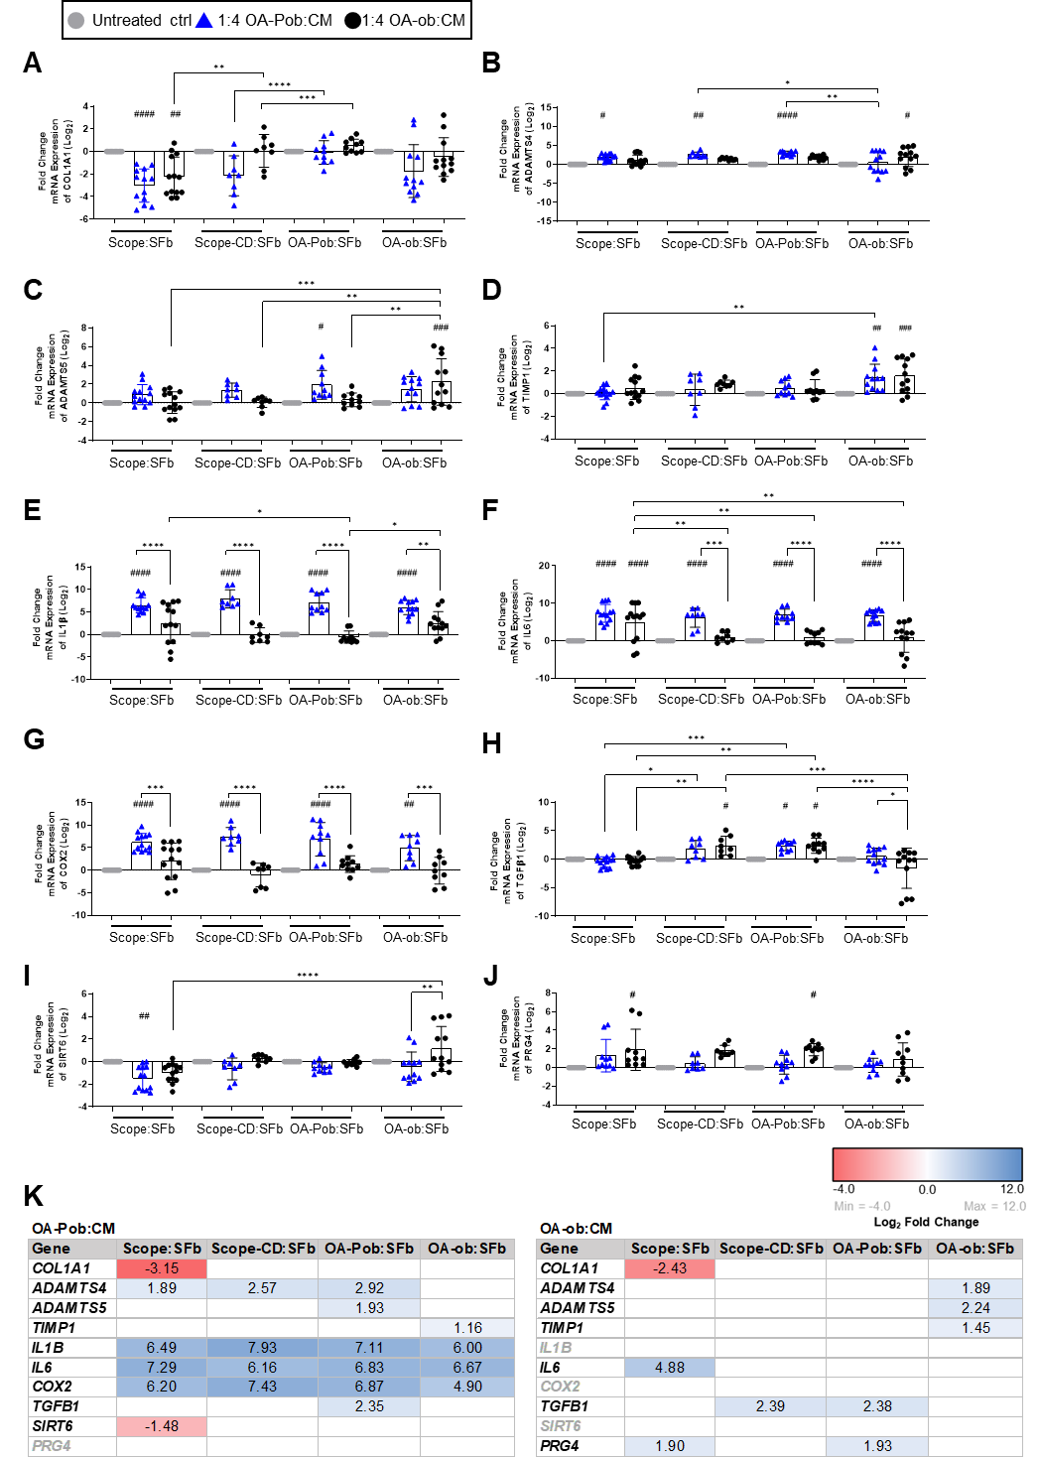
Figure 5. Effects of conditioned media stressors on genes regulating ECM processing and inflammatory response in SFb. A-J, Comparison of mean fold change mRNA expression with SD of COL1A1, ADAMTS4, ADAMTS5, TIMP1, IL1β, IL6, COX2, TGFβ1, SIRT6 and PRG4 in scope:SFb, scope-CD:SFb, OA-Pob:SFb and OA-ob:SFb. Significant differences within and between pathology groups are indicated. K, Heatmap summaries of the significant mean fold change of gene expression within each pathology group, in comparison to the non-stretch and untreated control group. Blue indicates upregulation (Log₂ fold change > 0) and red indicates downregulation (Log₂ fold change < 0) in the mRNA expression. Statistical significance is expressed as *p<0.05, **p<0.01, ***p<0.001 and ****p<0.0001. For comparison to each pathology group non-stretch, untreated control, #p<0.05, ##p<0.01, ###p<0.001 and ####p<0.0001.

Effects on SFb of combined uniaxial stretch and OA-CM
The mRNA expression of COL1A1 was reduced in all SFb pathologies with significant reductions in scope:SFb and OA-ob:SFb under the combination treatment, regardless of which mechanical strain level or form of OA-CM (Figure 6A). In contrast to OA-ob:SFb, all other SFb pathologies showed increased ADAMTS4 mRNA expressions when exposed to combined stressors (Figure 6B). Highest expression of ADAMTS4 was detected in scope:SFb treated with OA-Pob:CM, regardless of the mechanical strain level (Figure 6B). Combining OA-Pob:CM treatment with mechanical stress at either 6% or 10% significantly increased the expression of IL1β mRNA in all pathological groups of SFb when compared with controls (Figure 6C). This result was consistent with IL6 and COX2 mRNA expressions in Figure 6D and 6E, respectively. Combined effects of OA-ob:CM with 6% or 10% mechanical strain significantly induced the expression of IL1β, IL6 and COX2 but only in scope:SFb, without affecting other SFb pathologies (Figure 6C-E). Unlike scope:SFb and OA-ob:SFb which showed no significant changes in the TGFβ1 mRNA expression toward the combination treatment, scope-CD:SFb and OA-Pob:SFb showed increased TGFβ1 expression when treated with OA-Pob:CM with different strain levels (Figure 6F). Highest TGFβ1 mRNA expression was stimulated by scope-CD:SFb upon OA-ob:CM and 6% strain (Figure 6F). Prominent downregulation of SIRT1 mRNA expression was observed only in scope:SFb following the combined stressors effects, with no significant changes in other SFb pathologies (Figure 6G). The combined effect of 10% mechanical stretch and exposure to either form of OA-CM induced SIRT6 mRNA expression in scope:SFb (Figure 6H). The mRNA expression of PRG4 was stimulated in scope:SFb, scope-CD:SFb and OA-Pob:SFb when the cells were subjected to either 6% or 10% strain in combination with OA-ob:CM, but not with OA-Pob:CM treatment (Figure 6I). OA-ob:SFb did not express any significant difference in PRG4 mRNA expression regardless of the combination of stressors (Figure 6I). The combination of inflammatory and mechanical stressors in SFb did not affect the mRNA expressions of ADAMTS5, TIMP1 and SOX9 (Supplementary Figure 2C).

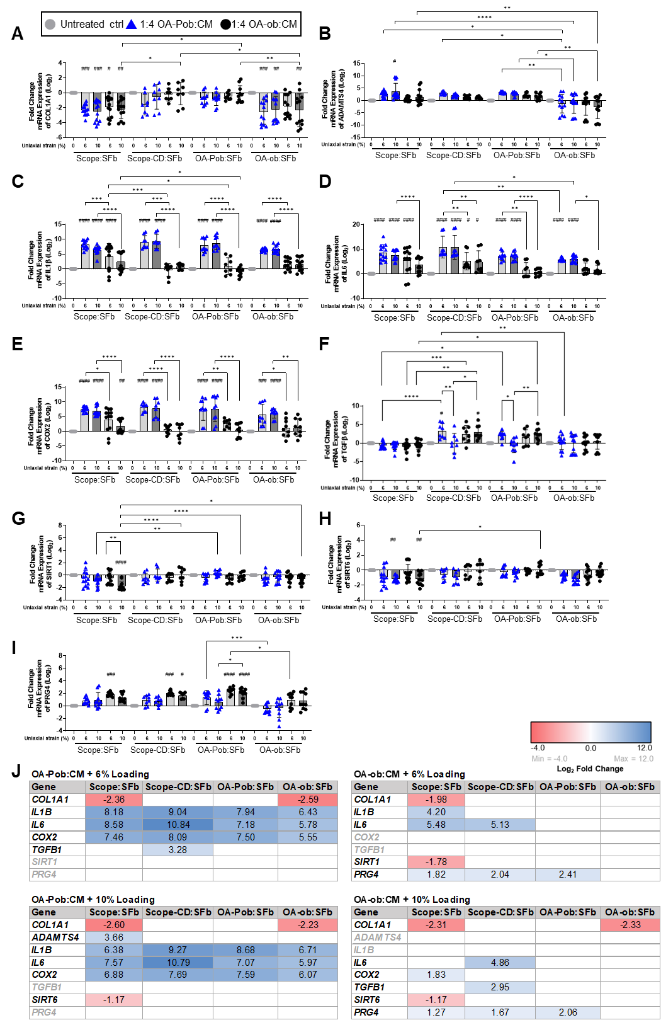
Figure 6. Effects of conditioned media stressors in combination with tensile loading on genes regulating ECM processing and inflammatory response in SFb. A-I, Comparison of fold change mRNA expression with SD of COL1A1, IL1β, IL6, COX2, TGFβ1, SIRT1 and PRG4 in scope:SFb, scope-CD:SFb, OA-Pob:SFb and OA-ob:SFb. Significant differences within and between pathology groups are indicated. J, Heatmap summaries of the significant mean fold change of gene expression within each pathology group, in comparison to the non-stretch and untreated control group. Blue indicates upregulation (Log₂ fold change > 0) and red indicates downregulation (Log₂ fold change < 0) in the mRNA expression. Statistical significance is expressed as *p<0.05, **p<0.01, ***p<0.001 and ****p<0.0001. For comparison to each pathology group non-stretch, untreated control, #p<0.05, ##p<0.01, ###p<0.001 and ####p<0.0001.

Integration of Functional Enrichment Changes in SFb
In this study, genes not previously listed in the GO process cellular response to mechanical stimulus (GO.0071260), ADAMTS5 and PRG4 were identified as mechanosensitive. Genes responsive to mechanical loading overlap with those with roles in inflammatory responses (TGFβ1, IL1β and COX2) (Figure 7A and B). In SFb, the mechanosensitivity of several genes was modulated by concurrent exposure to OA-condition media. This network relationship further impacted negatively in the extracellular matrix organisation and hyaluronan metabolic processes with increased in ADAMTS4, IL1β and reduced COL1A1 when the cells were subjected to the OA-Pob:CM, regardless of tensile load. Under OA-Pob:CM treatment regardless of tensile load, SFb consistently expressing high level of IL6, IL1β and COX2 (Figure 7C-E). These genes have a common role in regulating the inflammatory response (GO.0006954), and the cellular response to cytokine stimulus (GO.0071345). Several soluble analytes predominate in OA-Pob:CM, including SPARC, CXCL8 and FGF2 further mediating these cytokine and inflammatory responses in SFb (Figure 7C). In addition, connecting and underpinning this is the influence of lipid metabolic processes with Adiponectin influential in both OA-CM. SFb continuously express PRG4 under the tensile load or OA-ob:CM treatment, but not in the presence of OA-Pob:CM (Figure G and H). This indicates the ability of SFb to produce lubricin continuously in the presence of low but not under higher inflammatory mediator conditions. Under OA-ob:CM treatment with or without tensile load, only IL6, which is involved in the inflammatory response and cellular response to cytokine stimulus is found to be moderately upregulated by SFb. This cellular response is predominantly mediated by FN1 and LEP which are major soluble analytes in OA-ob:CM (Figure F-H).

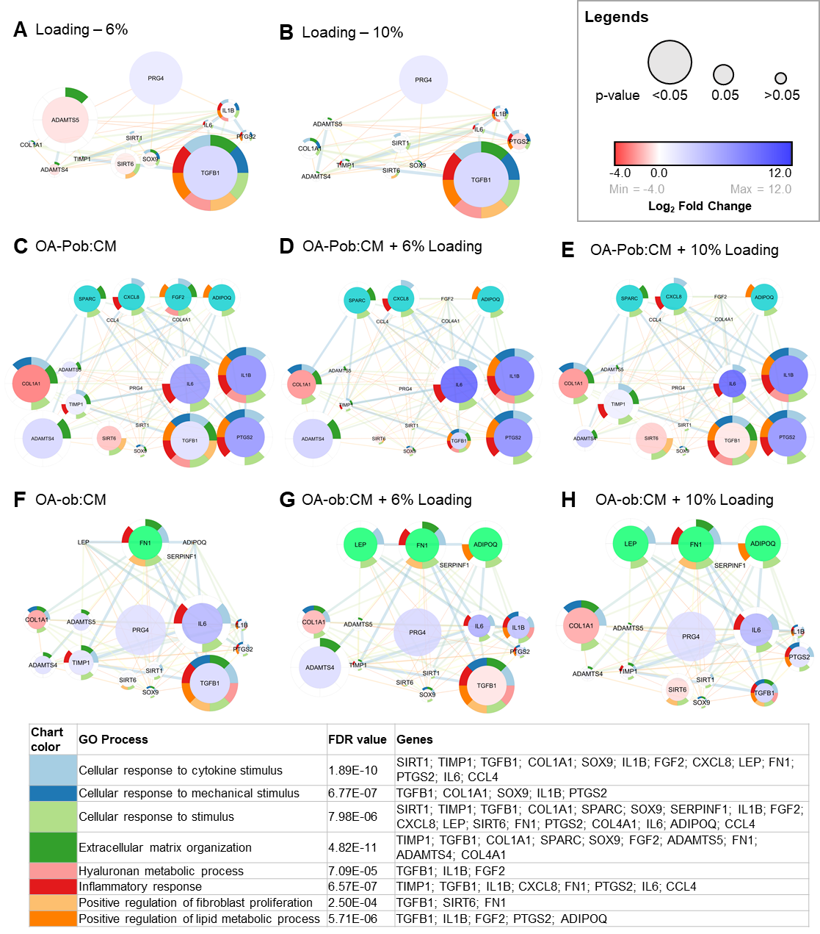

Figure 7. Illustration of predicted interactions and functional enrichment analysis with FDR value linking the 12 target genes (COL1A1, IL1β, IL6, ADAMTS-4,-5, SOX9, SIRT-1,-6, TIMP1, TGFβ1, PRG4 and COX2) and 9 analytes present in OA-CM (Adiponectin, CCL4, COL4A1, FN1, FGF-2, IL-8, LEP, SERPINF1 and SPARC). COX2 is identified by PTGS2 and IL8 identified by CXCL8 in Cytoscape StringApp. Each enriched GO biological process, colour coded into a split donut charts around the node (official symbol), include both an analyte and target gene. Gene expression profiles are coloured using log₂ fold change to indicate direction of regulation and p-value by size. A, 6% and B, 10% tensile loading alone. C-E, OA-Pob:CM alone and with 6% and 10% mechanical stretch. F-H, OA-ob:CM alone and with 6% and 10% mechanical stretch.

Discussion
This study investigated how synovial fibroblasts isolated from different knee pathologies (scope, OA obese and OA non obese) show different pathophysiological challenges might interact to modify gene expression. While chondrocytes within the avascular cartilage are nourished by synovial fluid during the compressive phase, the synovial membrane is subject to complex tensile loading which modifies synovial fluid component synthesis by synovial fibroblasts. Uniaxial cyclic stretch of 6% is mid-range, 10% is at the higher end of the physiological limits for fibroblasts; 1.0 Hz corresponds to a typical human step frequency (Bohannon, 1997; Momberger et al., 2005; Yan et al., 2012). Furthermore, the microenvironment within which synovial fibroblasts function is subject to both systemic and joint specific patient influences. The synovium of the OA patients was exposed to multiple stresses, dyslipidaemia, diabetes, hypertension and associated medications, unlike the Scope/Scope-CD patients. The subintimal layer of OA-Pob synovial tissues contained inflammatory cells aggregates, indicative of an ongoing inflammatory reaction (Krenn et al., 2006). Isolated OA fibroblasts presented an increased size and SA-β-gal activity, characteristic of a senescent morphology, relative to fibroblasts from significantly younger Scope and Scope-CD patients (Campisi et al., 2011). However, regardless of their pathological grouping, all fibroblasts re-oriented perpendicularly to the direction of the applied uniaxial mechanical stretch (Humphrey et al., 2014).

Elevated concentrations of chemokines and inflammatory cytokines such as IL6, IL8, CCL3, CCL4 levels have been measured in plasma and elevated ADIPOQ, SPARC, COL4A1, FN1 and SERPINF1 in synovial fluid of endstage-OA patients (Balakrishnan et al., 2014; Zhao et al., 2015). This study utilised OA tissue conditioned media as representative of relevant systemic stressors in OA patients. COL4A1, CCL4, SPARC, LEP, FGF2, IL8, SERPINF1, FN1 and ADIPOQ were detected in both forms of OA-CM. Moreover, OA-Pob:CM contained higher COL4A1, CCL4, SPARC, FGF2 and IL8 than OA-ob:CM. This might reflect the anti-inflammatory effects of diabetic and NSAIDs medications taken by many diabetic OA-ob patients. Collectively, all these secretory factors enhanced the pro-inflammatory effects of OA-Pob:CM. Both forms of OA-CM reduced fibroblasts proliferation, OA-Pob:CM being significantly more potent.

Lubricin, the product of the PRG4 gene, is a joint lubricant secreted into synovial fluid. It is highly expressed by fibroblasts, superficial zone chondrocytes and upregulated by mechanical loading of human articular chondrocytes (Das et al., 2008; Veale and Firestein, 2017). At 6% stretch, scope:SFb significantly upregulated lubricin expression which increased further at 10% stretch. There was no significant change in lubricin mRNA expression by scope-CD:SFb, OA-Pob:SFb or OA-ob:SFb, which explains the decreased lubricin level reported in synovial fluid of OA and ACL-injury patients (Elsaid et al., 2008; Szychlinska et al., 2016). Lubricin also regulates inflammatory responses through Toll-like receptor, as shown in in vitro and in vivo rodent model of OA (Iqbal et al., 2016). OA-ob:CM upregulated PRG4 expression by Scope:SFb, Scope-CD:SFb and OA-Pob:SFb, the upregulation being maintained or even enhanced during simultaneous mechanical loading. Dysregulation of lubricin production were observed under OA-Pob:CM treatment, regardless of simultaneous mechanical loading conditions, indicating the inhibition of lubricin production under the influence of exceptionally high cytokines concentrations (Jones and Flannery, 2007). This study has confirmed the susceptibility of PRG4 gene expression to physiological challenges such as loading and inflammation and demonstrated the potential for functional capacity changes in PRG4 expression specific to different knee pathologies.

Elevated levels of IL1β, TNFα, IL6 and IL8 in synovial fluid, synovial membrane, cartilage and subchondral bone layer mediated OA pathogenesis by inducing other inflammatory mediator such as COX2, and inhibiting ECM synthesis and repair mechanisms in OA chondrocytes (Wojdasiewicz et al., 2014). Similarly, the responses of synovial fibroblasts, from each pathology, to OA-Pob:CM included increased inflammatory response of IL1β, IL6, COX2, and extracellular matrix breakdown by ADAMTS4 and/or ADAMTS5 expression with concurrent downregulated COL1A1 in Scope:SFb, Scope-CD:SFb and OA-ob:SFb. This upregulation of the fibroblasts inflammatory profile was maintained during simultaneous biomechanical loading. Exposure to OA-ob:CM induced different responses compared to OA-Pob:CM, a reflection of lower COL4A1, CCL4, SPARC, and FGF2 concentrations. Inflammatory genes upregulation was markedly reduced and changes in matrix turnover genes differed both from OA-Pob:CM and between pathological groups. The addition of mechanical loading to OA-ob:CM upregulated IL6 in all fibroblasts while IL1β changed little. The highly reactive inflammatory response of both OA-Pob:SFb and OA-ob:SFb reflects the in vivo OA synovium with inflammatory cytokines and chemokines released by the fibroblasts which promote the involvement and accumulation of immune cells within the synovial membrane (Scanzello and Goldring, 2012; Schroder et al., 2019).

Up-regulation of TGFβ1 by mechanical stretch has been detected in smooth muscle cells, cardiac fibroblasts, mesangial cells and anterior cruciate ligament cells (Kim et al., 2002). In cartilage, TGFβ1 has been shown to induce new matrix synthesis through translocation of SMAD complexes from cytoplasm to nucleus, stimulating collagen transcription (Ghosh et al., 2001; Kresse and Schonherr, 2001). Mechanical load at 10% promoted concurrent increase in TGFβ1 and COL1A1 expression in scope-CD fibroblasts, but not scope fibroblasts. This perhaps reflects the intrinsic differences in TGF-β dependency between the two scope groups, as the activation of TGF-β stimulate extracellular matrix synthesis, necessary for cartilage-damage repair (van der Kraan, 2018). Although TGFβ1 expression remain upregulated in scope-CD fibroblasts under inflammatory stressor obese-OA CM and simultaneous mechanical load at 10%, however the expression of COL1A1 was suppressed and overridden by the abundance of pro-inflammatory cytokines in the OA-CM which inhibited COL1A1 synthesis. In OA-Pob:SFb, mechanical load at 10% upregulated TGFβ1 and this upregulation sustained under OA-CM treatment and simultaneous mechanical load condition, but not OA-ob:SFb. This suggests that TGF-β plays different roles under different microenvironment in different cell populations. In a murine OA model, the activation of TGF-β induces synovial lining cells proliferation, disrupts the apoptotic process and deposits collagen type I and III extracellular matrix, leading to synovial tissue hyperplasia and fibrosis (Bakker et al., 2001). Moreover, TGF-β can induces synovial lining fibroblasts to produce inflammatory factors, such as IL-1 and TNF-α which can further stimulate articular chondrocytes terminal hypertrophy (Shen et al., 2014).

A balance expression between aggrecanases (ADAMTS) and tissue inhibitor of metalloproteinases (TIMP) regulate matrix collagen turnover (Gardner and Ghorpade, 2003). Both ADAMTS4 and ADAMTS5 play significant roles in OA development by degrading cartilage aggrecan (Hughes et al., 2004). While ADAMTS5 is constitutively expressed in both healthy and osteoarthritic human cartilage, the overexpression of ADAMTS4 correlates with cartilage destruction severity and is inducible by pro-inflammatory cytokine IL1 (Yatabe et al., 2009). In the present study, cyclic stretch of 6% had little impact on the expression of matrix turnover genes such as COL1A1, ADAMTS4 or ADAMTS5 and TIMP1. However, the addition of OA-Pob:CM which contains significantly higher pro-inflammatory cytokines induced the expression of ADAMTS4 and ADAMTS5 in scope fibroblasts with simultaneous mechanical load at 10%.

Silent information regulator 2 type 1, sirtuin 1 (SIRT1) is linked to various ageing-associated diseases including cardiovascular disease, inflammation arthritis, osteoporosis and OA (Morris, 2013). The expression of SIRT1 protein is decreased in chondrocytes and synovial fibroblasts from OA patients. In OA chondrocytes, all catabolic, mechanical load, and nutritional stresses inhibited SIRT1 protein expression (Takayama et al., 2009). The role of sirtuin 6 (SIRT6) has been implicated in aging, inflammatory and metabolic pathways (Wu et al., 2015). The level of SIRT6 level was significantly decreased in articular chondrocytes of OA patients compared to healthy donors (Lee et al., 2013). In RA mice model, overexpression of SIRT6 suppressed the inflammatory responses of synovial fibroblasts induced by TNF-α (Lee et al., 2013). Overexpression of SRY-related protein 9 (SOX9) has a protective role by suppressing the expression of ADAMTS-4,-5,-7,-12 and promoting cartilage matrix protein of COL2A1 and aggrecan (Zhang et al., 2015). In human OA cartilage, SOX9 expression was suppressed in cartilage with severe damage (Zhang et al., 2015). Mechanical stretch at both 6% and 10% exerted no significant impact on fibroblasts regulatory genes SIRT1, SIRT6 and SOX9, with one exception whereby SIRT6 was downregulated in OA-ob:SFb exposed to 6% mechanical load. Furthermore, these gene expressions were further reduced by simultaneous exposure to OA-CM. SIRT1, SIRT6, SOX9 and TIMP1 were downregulated in scope:SFb but remained almost unchanged in fibroblasts from joints with cartilage damage.

Conclusions
OA results from complex pathological processes which lead to progressive damage to all joint tissues. In this study, we demonstrated that SFb regulate and are regulated by the complex interplay of inflammatory and mechanical stresses, and their molecular responses are dependent on their pathology of origin. By segregating OA patients into pre-obese or obese group, and arthroscopy patients into their scope or scope-CD group, the heterogeneity between the pathological groups can be differentiated. This study has identified a list of inflammatory cytokines and chemokines associated with OA which were released into the conditioned media aggravating a significant inflammatory response and reducing cell proliferation in SFb. SFb are mechanosensitive and their morphology and orientation changes in response to uniaxial stretch. Mechanical stretch promotes responses impacting functionality with enhanced lubricin production in scope SFb and scope-CD SFb. However, exposure to OA-CM reverses this mechanical stretch-induced effect with significant increases in expression of inflammatory cytokines and mediator genes. Our findings suggest that both mechanical stress and inflammatory stressors play important regulatory roles in SFb. Physiological levels of mechanical stress are needed to maintain joint specific SFb cellular functions, however, inflammation in combination with excessive mechanical stress may cause the aberrant physiological effects and lead to OA.

Electronic supplementary material
Supplementary Table 1
Supplementary Figure 1
Supplementary Figure 2

Declaration of interests
The authors declare that they have no known competing financial interests or personal relationships that could have appeared to influence the work reported in this paper.

Acknowledgement
We would like to thank our collaborators in National Orthopaedic Centre of Excellence for Research and Learning (NOCERAL), Malaysia for providing patients tissue samples and biopsies utilised in this study as well as granting the access to utilise the cell stretch instrument at the Orthopaedic Molecular and Biological Laboratory (OMBL), UM.

Funding: This work was supported by the Fundamental Research Grant Scheme from The Ministry of Education Malaysia, FRGS 2018-1 (Project No. FP011-2018A).

References
Bakker, A.C., van de Loo, F.A., van Beuningen, H.M., Sime, P., van Lent, P.L., van der Kraan, P.M., Richards, C.D., van den Berg, W.B., 2001. Overexpression of active TGF-beta-1 in the murine knee joint: evidence for synovial-layer-dependent chondro-osteophyte formation. Osteoarthritis Cartilage 9(2), 128-136.
Balakrishnan, L., Nirujogi, R.S., Ahmad, S., Bhattacharjee, M., Manda, S.S., Renuse, S., Kelkar, D.S., Subbannayya, Y., Raju, R., Goel, R., Thomas, J.K., Kaur, N., Dhillon, M., Tankala, S.G., Jois, R., Vasdev, V., Ramachandra, Y., Sahasrabuddhe, N.A., Prasad Ts, K., Mohan, S., Gowda, H., Shankar, S., Pandey, A., 2014. Proteomic analysis of human osteoarthritis synovial fluid. Clin Proteomics 11(1), 6.
Bohannon, R.W., 1997. Comfortable and maximum walking speed of adults aged 20-79 years: reference values and determinants. Age Ageing 26(1), 15-19.
Campisi, J., Andersen, J.K., Kapahi, P., Melov, S., 2011. Cellular senescence: a link between cancer and age-related degenerative disease? Seminars in cancer biology 21(6), 354-359.
Cline, M.S., Smoot, M., Cerami, E., Kuchinsky, A., Landys, N., Workman, C., Christmas, R., Avila-Campilo, I., Creech, M., Gross, B., Hanspers, K., Isserlin, R., Kelley, R., Killcoyne, S., Lotia, S., Maere, S., Morris, J., Ono, K., Pavlovic, V., Pico, A.R., Vailaya, A., Wang, P.-L., Adler, A., Conklin, B.R., Hood, L., Kuiper, M., Sander, C., Schmulevich, I., Schwikowski, B., Warner, G.J., Ideker, T., Bader, G.D., 2007. Integration of biological networks and gene expression data using Cytoscape. Nat Protoc 2(10), 2366-2382.
Das, R.H.J., Jahr, H., Verhaar, J.A.N., van der Linden, J.C., van Osch, G.J.V.M., Weinans, H., 2008. In vitro expansion affects the response of chondrocytes to mechanical stimulation. Osteoarthritis and Cartilage 16(3), 385-391.
Debacq-Chainiaux, F., Erusalimsky, J.D., Campisi, J., Toussaint, O., 2009. Protocols to detect senescence-associated beta-galactosidase (SA-betagal) activity, a biomarker of senescent cells in culture and in vivo. Nat Protoc 4(12), 1798-1806.
Doncheva, N.T., Morris, J.H., Gorodkin, J., Jensen, L.J., 2019. Cytoscape StringApp: Network Analysis and Visualization of Proteomics Data. J Proteome Res 18(2), 623-632.
Elsaid, K.A., Fleming, B.C., Oksendahl, H.L., Machan, J.T., Fadale, P.D., Hulstyn, M.J., Shalvoy, R., Jay, G.D., 2008. Decreased lubricin concentrations and markers of joint inflammation in the synovial fluid of patients with anterior cruciate ligament injury. Arthritis Rheum 58(6), 1707-1715.
Gardner, J., Ghorpade, A., 2003. Tissue inhibitor of metalloproteinase (TIMP)-1: the TIMPed balance of matrix metalloproteinases in the central nervous system. J Neurosci Res 74(6), 801-806.
Ghasemi, A., Zahediasl, S., 2012. Normality tests for statistical analysis: a guide for non-statisticians. Int J Endocrinol Metab 10(2), 486-489.
Ghosh, A.K., Yuan, W., Mori, Y., Chen, S.-j., Varga, J., 2001. Antagonistic Regulation of Type I Collagen Gene Expression by Interferon-γ and Transforming Growth Factor-β: INTEGRATION AT THE LEVEL OF p300/CBP TRANSCRIPTIONAL COACTIVATORS. Journal of Biological Chemistry 276(14), 11041-11048.
Guilak, F., 2011. Biomechanical factors in osteoarthritis. Best practice & research. Clinical rheumatology 25(6), 815-823.
Heidari, B., 2011. Knee osteoarthritis prevalence, risk factors, pathogenesis and features: Part I. Caspian journal of internal medicine 2(2), 205-212.
Hughes, C.E., Caterson, B., Little, C.B., Wainwright, S.W., 2004. 217 - Aggrecanases 1 and 2, in: Barrett, A.J., Rawlings, N.D., Woessner, J.F. (Eds.), Handbook of Proteolytic Enzymes (Second Edition). Academic Press, London, pp. 740-746.
Humphrey, J.D., Dufresne, E.R., Schwartz, M.A., 2014. Mechanotransduction and extracellular matrix homeostasis. Nature reviews. Molecular cell biology 15(12), 802-812.
Ingram, K.R., Wann, A.K.T., Angel, C.K., Coleman, P.J., Levick, J.R., 2008. Cyclic movement stimulates hyaluronan secretion into the synovial cavity of rabbit joints. The Journal of physiology 586(6), 1715-1729.
Iqbal, S.M., Leonard, C., Regmi, S.C., De Rantere, D., Tailor, P., Ren, G., Ishida, H., Hsu, C., Abubacker, S., Pang, D.S., Salo, P.T., Vogel, H.J., Hart, D.A., Waterhouse, C.C., Jay, G.D., Schmidt, T.A., Krawetz, R.J., 2016. Lubricin/Proteoglycan 4 binds to and regulates the activity of Toll-Like Receptors In Vitro. Sci Rep 6, 18910-18910.
Jamal, J., Mustafa, M.R., Wong, P.F., 2014. Paeonol protects against premature senescence in endothelial cells by modulating Sirtuin 1 pathway. Journal of ethnopharmacology 154(2), 428-436.
Jones, A.R.C., Flannery, C.R., 2007. Bioregulation of lubricin expression by growth factors and cytokines. Eur Cell Mater 13, 40-45.
Kim, S.G., Akaike, T., Sasagaw, T., Atomi, Y., Kurosawa, H., 2002. Gene expression of type I and type III collagen by mechanical stretch in anterior cruciate ligament cells. Cell Struct Funct 27(3), 139-144.
Krenn, V., Morawietz, L., Burmester, G.R., Kinne, R.W., Mueller-Ladner, U., Muller, B., Haupl, T., 2006. Synovitis score: discrimination between chronic low-grade and high-grade synovitis. Histopathology 49(4), 358-364.
Kresse, H., Schonherr, E., 2001. Proteoglycans of the extracellular matrix and growth control. J Cell Physiol 189(3), 266-274.
Lee, H.-S., Ka, S.-O., Lee, S.-M., Lee, S.-I., Park, J.-W., Park, B.-H., 2013. Overexpression of sirtuin 6 suppresses inflammatory responses and bone destruction in mice with collagen-induced arthritis. Arthritis Rheum 65(7), 1776-1785.
Loeser, R.F., 2010. Age-related changes in the musculoskeletal system and the development of osteoarthritis. Clinics in geriatric medicine 26(3), 371-386.
Loeser, R.F., Goldring, S.R., Scanzello, C.R., Goldring, M.B., 2012. Osteoarthritis: a disease of the joint as an organ. Arthritis and rheumatism 64(6), 1697-1707.
Man, G.S., Mologhianu, G., 2014. Osteoarthritis pathogenesis - a complex process that involves the entire joint. Journal of medicine and life 7(1), 37-41.
Momberger, T.S., Levick, J.R., Mason, R.M., 2005. Hyaluronan secretion by synoviocytes is mechanosensitive. Matrix biology : journal of the International Society for Matrix Biology 24(8), 510-519.
Morris, B.J., 2013. Seven sirtuins for seven deadly diseases ofaging. Free Radical Biology and Medicine 56, 133-171.
Ospelt, C., 2017. Synovial fibroblasts in 2017. RMD open 3(2), e000471-e000471.
Passey, S., Martin, N., Player, D., Lewis, M.P., 2011. Stretching skeletal muscle in vitro: does it replicate in vivo physiology? Biotechnology Letters 33(8), 1513-1521.
Richter, M., Trzeciak, T., Owecki, M., Pucher, A., Kaczmarczyk, J., 2015. The role of adipocytokines in the pathogenesis of knee joint osteoarthritis. Int Orthop 39(6), 1211-1217.
Robinson-Bennett, B., Han, A., 2006. 30 - Role of Immunohistochemistry in Elucidating Lung Cancer Metastatic to the Ovary from Primary Ovarian Carcinoma, in: Hayat, M.A. (Ed.) Handbook of Immunohistochemistry and in Situ Hybridization of Human Carcinomas. Academic Press, pp. 537-545.
Roshan Moniri, M., Young, A., Reinheimer, K., Rayat, J., Dai, L.-J., Warnock, G.L., 2015. Dynamic assessment of cell viability, proliferation and migration using real time cell analyzer system (RTCA). Cytotechnology 67(2), 379-386.
Sambajon, V.V., Cillo, J.E., Jr., Gassner, R.J., Buckley, M.J., 2003. The effects of mechanical strain on synovial fibroblasts. J Oral Maxillofac Surg 61(6), 707-712.
Scanzello, C.R., Goldring, S.R., 2012. The role of synovitis in osteoarthritis pathogenesis. Bone 51(2), 249-257.
Schett, G., Tohidast-Akrad, M., Steiner, G., Smolen, J., 2001. The stressed synovium. Arthritis Res 3(2), 80-86.
Schroder, A., Nazet, U., Muschter, D., Grassel, S., Proff, P., Kirschneck, C., 2019. Impact of Mechanical Load on the Expression Profile of Synovial Fibroblasts from Patients with and without Osteoarthritis. Int J Mol Sci 20(3).
Shen, J., Li, S., Chen, D., 2014. TGF-β signaling and the development of osteoarthritis. Bone Research 2, 14002.
Simkin, P.A., 1991. Physiology of normal and abnormal synovium. Seminars in Arthritis and Rheumatism 21(3), 179-183.
Smith, M.D., 2011. The normal synovium. The open rheumatology journal 5, 100-106.
Szychlinska, M.A., Leonardi, R., Al-Qahtani, M., Mobasheri, A., Musumeci, G., 2016. Altered joint tribology in osteoarthritis: Reduced lubricin synthesis due to the inflammatory process. New horizons for therapeutic approaches. Annals of Physical and Rehabilitation Medicine 59(3), 149-156.
Takayama, K., Ishida, K., Matsushita, T., Fujita, N., Hayashi, S., Sasaki, K., Tei, K., Kubo, S., Matsumoto, T., Fujioka, H., Kurosaka, M., Kuroda, R., 2009. SIRT1 regulation of apoptosis of human chondrocytes. Arthritis & Rheumatism 60(9), 2731-2740.
van der Kraan, P.M., 2018. Differential Role of Transforming Growth Factor-beta in an Osteoarthritic or a Healthy Joint. J Bone Metab 25(2), 65-72.
Veale, D.J., Firestein, G.S., 2017. Chapter 2 - Synovium, in: Firestein, G.S., Budd, R.C., Gabriel, S.E., McInnes, I.B., O'Dell, J.R. (Eds.), Kelley and Firestein's Textbook of Rheumatology (Tenth Edition). Elsevier, pp. 20-33.
Wojdasiewicz, P., Poniatowski , Ł.A., Szukiewicz, D., 2014. The Role of Inflammatory and Anti-Inflammatory Cytokines in the Pathogenesis of Osteoarthritis. Mediators of Inflammation 2014, 19.
Wu, Y., Chen, L., Wang, Y., Li, W., Lin, Y., Yu, D., Zhang, L., Li, F., Pan, Z., 2015. Overexpression of Sirtuin 6 suppresses cellular senescence and NF-κB mediated inflammatory responses in osteoarthritis development. Sci Rep 5, 17602-17602.
Yan, Y., Singh, G.K., Zhang, F., Wang, P., Liu, W., Zhong, L., Yang, L., 2012. Comparative study of normal and rheumatoid arthritis fibroblast-like synoviocytes proliferation under cyclic mechanical stretch: role of prostaglandin E2. Connect Tissue Res 53(3), 246-254.
Yanagida-Suekawa, T., Tanimoto, K., Tanne, Y., Mitsuyoshi, T., Hirose, N., Su, S., Tanne, K., Tanaka, E., 2013. Synthesis of hyaluronan and superficial zone protein in synovial membrane cells modulated by fluid flow. Eur J Oral Sci 121(6), 566-572.
Yatabe, T., Mochizuki, S., Takizawa, M., Chijiiwa, M., Okada, A., Kimura, T., Fujita, Y., Matsumoto, H., Toyama, Y., Okada, Y., 2009. Hyaluronan inhibits expression of ADAMTS4 (aggrecanase-1) in human osteoarthritic chondrocytes. Annals of the Rheumatic Diseases 68(6), 1051.
Zainudin, S., Daud, Z., Mohamad, M., Tong Boon, A.T., Wan Mohamed, W.M.I., 2014. A Summary of the Malaysian Clinical Practice Guidelines on Management of Obesity 2004. 2014 26(2).
Zhang, Q., Ji, Q., Wang, X., Kang, L., Fu, Y., Yin, Y., Li, Z., Liu, Y., Xu, X., Wang, Y., 2015. SOX9 is a regulator of ADAMTSs-induced cartilage degeneration at the early stage of human osteoarthritis. Osteoarthritis Cartilage 23(12), 2259-2268.
Zhao, X.Y., Yang, Z.B., Zhang, Z.J., Zhang, Z.Q., Kang, Y., Huang, G.X., Wang, S.W., Huang, H., Liao, W.M., 2015. CCL3 serves as a potential plasma biomarker in knee degeneration (osteoarthritis). Osteoarthritis Cartilage 23(8), 1405-1411.

