Accepted version of article for Anthropology in Action: Journal for Applied Anthropology in Policy and Practice (Special issue: COVID-19 and the Transformation of Intimacy)

Title
Beyond the Edges of the Screen: Longing for the Physical ‘Spaces Between’

Authors
Alyssa Grossman and Selena Kimball

Abstract
This article, co-written by a visual anthropologist (Grossman), and a visual artist (Kimball), takes the form of a collaborative and self-reflexive conversation. In it we explore how particular types of screen-mediated interactions during the COVID-19 lockdown are reconfiguring our own experiences of environmental and spatial intimacy, both within our academic research and studio practice, and in broader processes of emotional, intellectual, and creative exchange. Looking through the cross-disciplinary lenses of our own longstanding friendship and collaborative working relationship, we discuss how these changed bodily perceptions of shared environments and the human interactions within them are giving rise to personal longings for the ‘spaces between’ ourselves and our surroundings, extending beyond the edges of the screen.

Keywords
Art-anthropology collaborations, COVID-19, genius loci, haptic visuality, ontophany, phenomenological aesthetics, screens, spatial anthropology

Introduction: Letter to a Long-time Friend and Creative Collaborator
27 May 2020
Dear A.,
I miss doing stuff with people.
So much talk, so many screens.
Last week I was invited to a Zoom meeting with other members of my department [the Department of Fine Arts at Parsons School of Design] to think through the changes we had undergone as a result of the COVID-19 pandemic. We were asked to speak about three of the most profound things we had learned or experienced over the past few months.
I did not want to tell this to a grid of tiny flattened faces on my screen. I have been physically alone for so long, trying to process what has been happening in the world, in my own city, through this very screen. Nearly all of what I know about this pandemic has come through my screen. Yes, it’s come from different and varied sources. But it has reduced my own bodily awareness to the rectangular space just above my neckline. My exchanges with others have started relying more on actual words, and less on connotation, innuendo, subtlety and jokes. The visual structure of Zoom literally depicts us as we have been living under lockdown—separate, boxed-in individuals, cut off from each other on all sides.
I miss the kind of knowing that you can absorb through your skin. I miss the kind of spatial perception that comes from seeing things from multiple angles, from using my peripheral vision. I miss the awareness that comes from the physical agency of crossing my arms or tilting my head. We act as very different kinds of receivers when we communicate through the screen. What happens in the absence of a shared physical environment to tug and temper the personal exchange?
I decided to do an experiment during my Zoom meeting. We were having this intense discussion among faculty members about the effects of the lockdown, and our responses to it, and the injustices that we had been seeing play out all around us. But with all of these emotional things going on, I was just sitting there looking at this flat grid of faces. When it was my turn to talk, I responded by asking my colleagues to each point their computer cameras for thirty seconds in the direction of their windows, toward the sky.
We all directed our cameras outwards, and suddenly the grid changed. It got disrupted. It was a moment where everybody was looking out of their own window, paying attention to their environment. We were turning away from each other, but in this group activity of turning away, it opened up a shared experience. We were all physically acting together, no longer staring at each other’s (and our own) portraited faces. And I felt like doing this made me lose a tiny bit of my sense of self. It made me happy. It was a radical act of turning-away, where our attention was redirected outside of the group; but it allowed me to experience other people’s presence in a more intimate way.
Here's a screenshot.
x S.

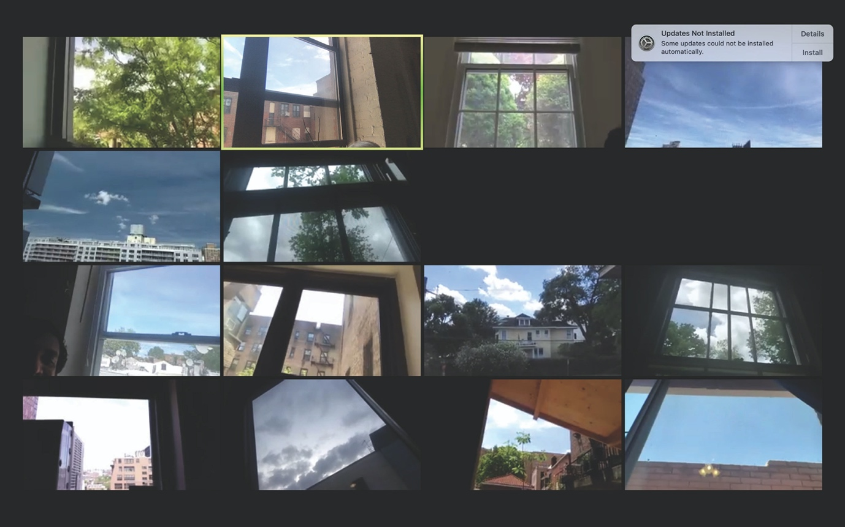
Figure 1: Digital screenshot of Zoom faculty meeting (Parsons School of Design), 2020. Photo by Selena Kimball.

Intimacies and Interfaces
To observe the sky in the age of the steam engine is not to experience the sky ontophanically the way one does in the age of digital interfaces… (Vial 2019: 52).

As we write this article, much of the world is still living under the structures of lockdown implemented in response to the COVID-19 crisis. In our respective countries of residence (England and the US), restrictions have only moderately begun to ease. There is not yet enough temporal or emotional distance to calculate all of the medical and epidemiological implications of this pandemic, let alone to begin to fathom its social, cultural, racial, economic, environmental, psychological, and political reverberations. The effects are still occurring, and as long as they are so close, they can look somewhat blurred.
But this closeness, this blurredness, is what we wish to examine more carefully here. We present this text as a shared, self-reflexive conversation, from the perspective of a visual anthropologist (Alyssa) and a visual artist (Selena) who have been friends and collaborators for over twenty years. Our history of communicating with each other has run the gamut of in-person conversations and phone calls, to handwritten and typewritten letters, to emails, text messages and video calls. Fundamental to these exchanges is that they have always intertwined references to our emotions, personal experiences and memories with our intellectual musings, creative ideas and thoughts about our work. Over the years, these multi-layered, affective engagements have manifested in a range of forms, involving joint fieldwork and travel expeditions, academic workshops and publications, collaborative films and exhibitions. We have built our individual practices around this shared history, reaching out to the spaces between our disciplines, but also to the spaces between us as co-creators and friends.
This article is part of a larger (but still personal) endeavour of emotional, intellectual and artistic exchange. Our contribution to this journal issue has grown out of years of conversations with each other that over the past few months have been held over the phone and the videoconferencing app Zoom. These initially informal, unstructured discussions led to more focused reflections on how the experience of lockdown has been impacting not only our physical contact with others, as people in the world, but also our encounters with the physical and social landscapes that surround us. We began to examine how particular types of screen-mediated interactions during this pandemic were reconfiguring our own experiences of environmental and spatial intimacy.
Our interest in this subject is rooted in the broader disciplines with which we are involved. Looking at the ‘phenomenological intensity of the spatially immersive world’ and its impact on ‘selfhood, intersubjectivity, and affectivity’ lie at the heart of the growing field of spatial anthropology (Roberts 2018: xii). Certain research within philosophy and cultural/human geography points to the ways in which the affective qualities of our surroundings, broadly labelled ‘atmospheres’, are influenced by social dynamics and material conditions (Trygg 2020: 1). The shared perception of an atmosphere—as well as the personal interactions occurring within it—can be felt by the entire body. As Dylan Trygg writes, such a corporeal response is due to the way atmosphere is ‘both diffused through the air and grasped under the skin’ (ibid.: 4). Art also enters each of us through the body. Related research on aesthetic perception has shown that encounters with visual art involve bodily, somatosensory processes that bring viewers into intimate relationships with the art objects they behold, physically impacting what is ‘constitutive of our sense of self’ (Esrock 2001: 234). Using our situated (yet fluid) anthropological and artistic frameworks to analyse how these configurations are playing out during the ongoing lockdown, we contemplate our own changing bodily perceptions of shared environments and spatial intimacy. Drawing upon the rich history of our friendship and collaborations, we discuss our personal longings for the ‘spaces between’ that extend beyond the edges of the screen.

Alyssa: It’s so frustrating, I never end up properly remembering the conversations I have with people over Zoom.
Selena: If we were having this conversation in the same room together, how would it be imprinted differently in our memories? Would the details of our physical surroundings become part of our recollections of this encounter?
Alyssa: When we’re together in a room, we’re literally sharing the same air. It’s a physical intimacy that is related to other forms of emotional intimacy. And because of that shared environment, you have these weird, intuitive leaps, you see things out of the corner of your eye. Different things pop up in your mind because of everything else going on around you. But talking to you now on the screen, I feel like my sense of proprioception is just gone.
Selena: I think about the idea of ‘palaces of memory’, and how they were conceptualised with the understanding that the spatial awareness of our body is what builds our mental capacity for memory. Certain associations are generated when the presence of specific architectural settings can prompt a set of words or ideas to be imprinted onto our bodies and minds. Could that happen now, with this kind of video call? If so, how? Where?

Technological Ontophanies
…[T]echnology is never merely used, never simply instrumental. It is always also incorporated and lived by human beings who create and engage it within a structure of meanings and metaphors in which subject-object relations are not only cooperative and co-constitutive but are also dynamic and reversible (Sobchack 2016: 91).

Living with the presence of COVID-19 has altered humans’ corporeal and perceptual experiences of being in the world, as we abruptly and for an extended period of time have been required to curtail and monitor our movements through public space. Several months in, we continue to grapple with how this dynamic is affecting our relationships and interactions with others. For those with access and means (and we count ourselves within this group), most communication outside of individual households has shifted to revolve primarily around two-dimensional, electronic screens. With fewer opportunities to share our experiences face-to-face, we depend more on media outlets to find out how others in the world are being affected. Routine, everyday encounters with other people and places are available largely only through the interface of the computer.
These screens! What are we actually doing with them? What are they doing to us? More than fifty years after Marshall McLuhan’s initial writings on the capacity of media as extensions of the human body to ‘configure the awareness and experience of each one of us’ (1994 [1964]: 21), his findings are still germane. As he observed, ‘the “message” of any medium or technology is the change of scale or pace or pattern that it introduces into human affairs’ (McLuhan 1994 [1964]: 8). Others have confirmed that technologies in all their various forms not only describe and mediate phenomena, but also bring them into being; they ‘radically in-form our social, personal, and bodily existence’ as well as our ‘temporal and spatial consciousness’ (Sobchack 2016: 89-90). Stéphane Vial notes that different technological systems (whether they are pens, cameras, typewriters or touch pads) create distinct ‘ontophanies’, or experiences of how things and beings appear, which mould our ‘perceptual surroundings’ (Vial 2019: 53). As we understand phenomena through the mechanisms that enable us to perceive them, these different technologies give rise to a range of values, relationships and perceptual cultures.
Developing this concept in relation to perception in the digital era, Vial asserts that face-to-face ontophany is distinct from mechanical ontophany, which in turn is different from digital ontophany. A face-to-face experience of the world has a strong ‘phenomenological aura’ (in the Benjaminian sense of the term), because the communication is affected not only by the physical body, but also by the social and visual atmosphere of the meeting place, the furniture and architecture of the surroundings (Vial 2019: 127). Telephonic ontophany has a weaker phenomenological aura than physical presence. But because this mechanical technology (at least in the case of analogue devices) physically carries sounds through space, it can be interpreted as having a stronger aura than what is experienced through a digital interface.
Yet Vial does not place a value judgement on these distinct forms of ontophany. While ‘network messages’ may have weak phenomenological auras, he argues, they have strong ‘reality effects’, manifesting as robust online friendships, or online social activist communities that are just as operational in the world as physical ones (Vial 2019: 128). This position directly challenges the notion of digital dualism, a perspective that regards the ‘real’ as unequivocally distinct from the ‘virtual’, and that sees involvement with the latter as necessarily inhibiting experience of the former. Online interactions can thus be recognised as enmeshed with all other facets of our lives, contributing to our experiences of an ‘augmented’ life, a ‘new composite reality’ that engenders equally legitimate forms of sociality and intimacy (ibid.: 76).
This perspective resonates with findings of a recent study on the quality of online interactions in relation to health and well-being (Lomanowska and Guitton 2016). The study confirmed that online relationships do often involve levels of intimacy and significance comparable with those in offline relationships, but that online interactions usually exist as part of a much broader range of modalities of communication that involve multiple forms of digital and face-to-face interaction (ibid.: 140). To bring these observations back to our present-day situation: we are not suggesting in this article that lockdown-related, screen-based communications are less ‘real’ than in-person ones. But they carry a different phenomenological aura—or degree of perceptual intensity—from what we had been accustomed to prior to COVID-19, a dynamic that may be magnified by the severe imbalance in the overall ratio of our face-to-face versus online interactions during this pandemic.
How do we, as beings in the world, perceive an atmosphere? Tonino Griffero ascribes atmospheric perceptions to the realm of the ‘cognitive unconscious’ (Griffero 2014: 44), not unlike how Walter Benjamin described photographic technology’s ability to access ‘unconscious optics’, capturing and conveying with mechanical precision the auras that escape the subjective filters of human perception (Benjamin 1969: 237). However, only early photographs had such power, Benjamin noted, before the rise of mass production led them to lose their sense of history, their unique ‘presence in time and space’ (ibid.: 220). Reduced to commodities, later films and photographs produced by capitalist technologies of industrialisation and commercialisation conveyed a violent immediacy, as opposed to auras experienced through more distant, contemplative processes of perceiving singular works (ibid.: 223).
In contemporary debates, newer technologies also have been linked to capitalism’s commodification of the unconscious. As Michelle Henning argues, during the rise of the photographic industry over the last century, the shift towards instant photography and faster rates of exposure contributed to the collapse of time and space that Benjamin wrote about, changing the textures of human interactions generated by earlier photographic encounters that required a slower pace and more deliberate staging (Henning 2018). Vivian Sobchack describes electronic and digital photographic technologies as conjuring up a jolting presence through mechanisms that ‘[atomize] and abstractly [schematize] the analogic quality of the photographic and cinematic into discrete pixels and bits of information that are then transmitted serially, each bit discontinuous, discontiguous, and absolute…’ (Sobchack 2016: 109). According to Sean Cubitt, the ‘fields of spots and dots’ that comprise the ‘commodity form of the image’ are deeply entrenched in the production and consumption of all electronically transmitted images (Cubitt 2014: 11).
As digital operating systems process images through algorithms and binary logic, the relationship between image, computer and screen has become highly ‘fraught’ and ‘complex’ (Schäffner 2011: 45). On the one hand, the dispersed and abstract qualities of digital experience can be seen to ‘diffuse and/or disembody the lived body’s material and moral gravity’, with perceptions of these media linked to the feeling of being outside of an inhabited sense of time (Sobchack 2016: 115, italics in the original). On the other hand, certain aesthetic experiments with digital technologies (including manipulations of speed, rhythm and image content), can be understood as catalysing new forms of embodied and sensory visual perception, resulting in a heightened sense of affectivity and an expanded ‘threshold of the “now” of phenomenological experience’ (Hansen and Lenoir 2004: 15).

Disrupting Media Transparencies
Screens themselves can be regarded as objects of phenomenological analysis, possessing ‘ontological significance beyond the mere content of their surfaces’ (Introna and Ilharco 2006: 70). We not only look at them, but we also touch them; they can be interactive, three-dimensional, enveloping of the entire body (Connor 2004: 19). Actual, in-the-world screens serve to gather our attention and locate us in particular involvements with our surroundings (Introna and Ilharco 2006: 63). Related research has examined how the haptic qualities of visual images have a powerful ability to affect people on bodily, tangible levels, producing ‘subjective effects like those that arise through physical contact’ (Marks, et al. 2016: 259; see also Marks 2000, 2002). A haptic image, according to Laura U. Marks, is one where it is difficult to distinguish figure from ground (Marks, et al. 2016: 261). This interference with our habitual form of image-reading invites a feeling that the objects of vision are inseparable from the self, provoking a more embodied way of looking. Haptic viewing can occur in different circumstances and with multiple forms of media: it can result from a cognizance of the materiality of a medium, for example when you notice scratches on the surface of a projected film. But it can also occur in response to high-resolution digital images with extreme contrast, or crowded images that overwhelm the eye, or partially obscured images that compel you to engage more closely.
Despite this research showing how haptic qualities of visual images have the ability to draw people in and affect them on visceral levels, our own screen-based communication during this period of social distancing points to different forces at work. During our lockdown Zoom conversations, we found ourselves talking about how visual encounters that might ordinarily stir us or cause us to react in affective ways have been conspicuously absent from our current video calls. As the physical spaces between ourselves and our environment have become less palpable, the diversity and immediacy of the sensory elements that ordinarily surround us feels reduced. The visual grid that now scaffolds so many of our work meetings and social interactions stipulates a kind of docility in our bodily alignment with the computer. An overall sense of numbing, flattening and distancing permeates our phenomenological perceptions of (and within) the surroundings perceived through the frame of the screen.
Whether this impression of flattening is attributable to the weaker phenomenological aura of the digital, or merely to ‘Zoom fatigue’, the default use of screen images during this period seems to have fallen back on functionality: as transparent media of communication. In our eagerness to connect to other people under the current conditions of social isolation, it is easy to forget that we are facing material technological structures of perception that engage us in distinct forms of phenomenological experience (see Benjamin 1969: 222; Emerling 2012: 49). How then might we shift our habitual use of these digital forms of communication to counter such assumptions of transparency, and harness their haptic qualities? In his day, Walter Benjamin evoked Cubism and Futurism as schools that did not ‘use the apparatus as such for the artistic presentation of reality, but aimed at some sort of alloy in the joint presentation of reality and apparatus’ (Benjamin 1969: 250). What sorts of contemporary intrusions into the increasingly pervasive grids of Zoom and Facetime could be mobilised now, in order to highlight the materiality of these visual tools of representation, to subvert delineations of figure and ground, and access a more visceral experience of ‘being between’ each other and other spaces?

Selena: If the Zoom conversation we’re having right now were in a film, it would be so different. There would be a camera over to my right; it would be at an angle that would capture a different view of my body. You’d have a reverse shot. You’d be able to see that I was in my studio, with this couch over on one side. But here, there’s a collapse of space. There’s nothing in between, which is exactly what is needed to make something spatial. We get locked into the representation that appears on the other person’s screen. This happens in work-related video calls, but it can even happen when you’re having Zoom cocktails with friends.
Alyssa: So, what if our cameras were somewhere else, like on the ceiling? How might that change things?

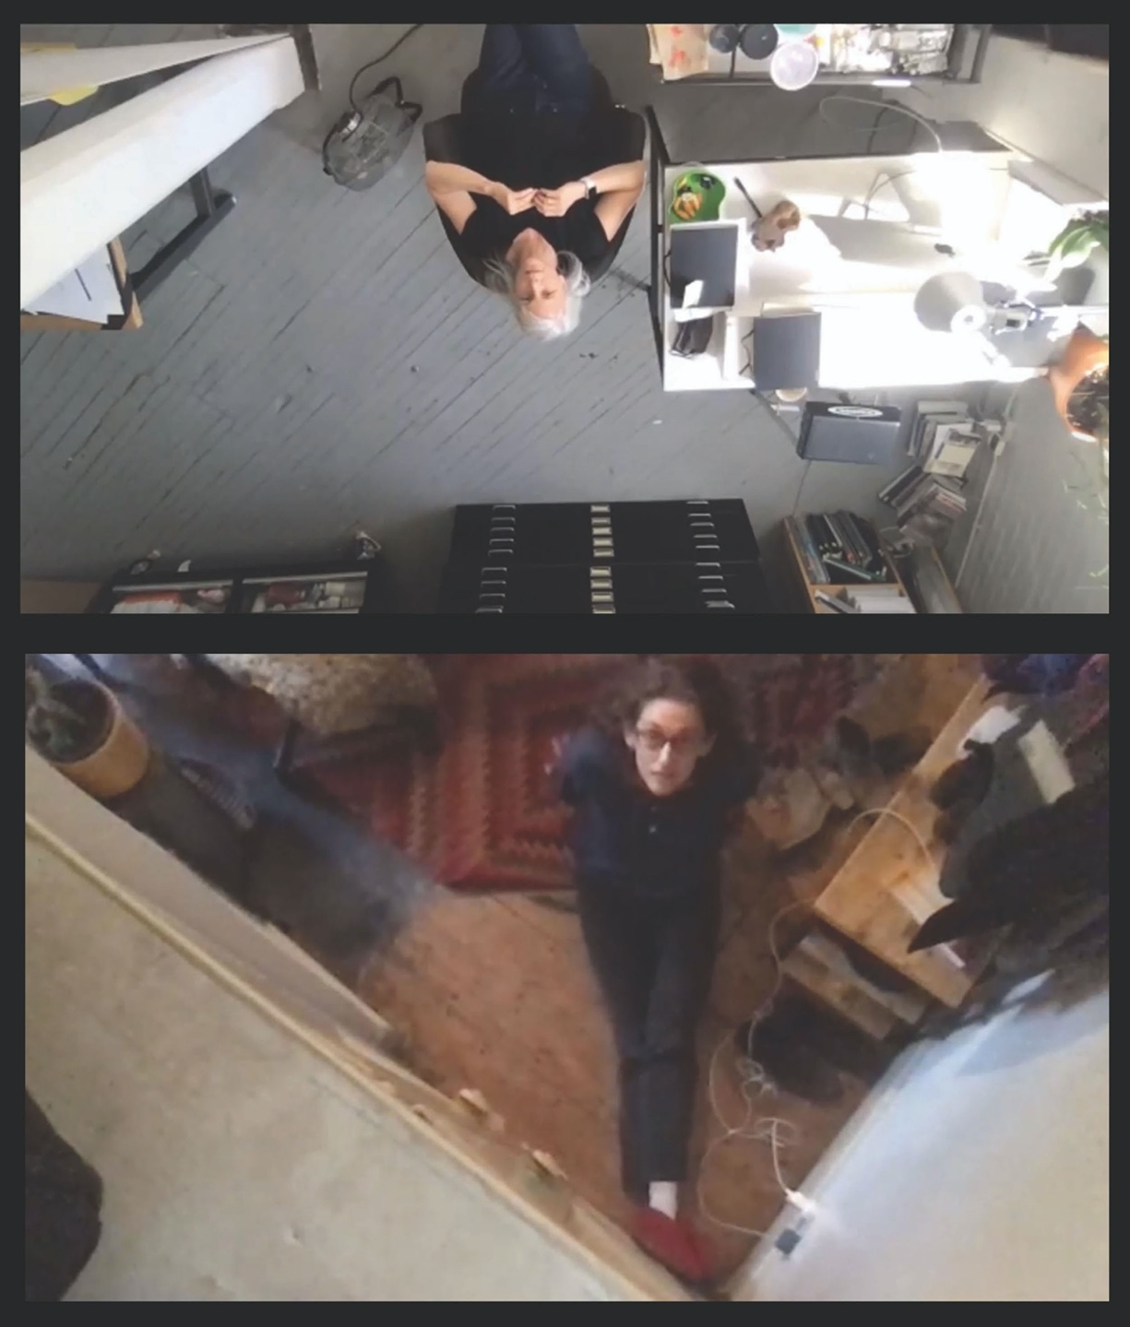

Figure 2: Digital screenshot of Zoom conversation between the authors, 2020. Photo by Alyssa Grossman and Selena Kimball.

Technology’s Genius Loci
We can assume that genius loci is a signifier of a process that is happening and cannot intentionally be created. It is significant in terms of being both the mediator and medium of social interactions (Vecco 2020: 225).

Perceiving the ‘atmosphere’ or genius loci of a place involves strong affective impulses, as heightened perceptions of shared social spaces can tap into commonly held cultural values. This process of communal emotion involves feelings of ‘integrative togetherness’ and ‘mutual self-other awareness’ (Trygg 2020: 2). Yet while shared responses to a given atmosphere can provide a basis for feelings of closeness, not everyone experiences a shared atmosphere in the same way. In fact, it is not the sharedness but the diversity, the ‘convergences between different subjective experiences’, which are responsible for generating feelings of intimacy within a space (ibid.: 4). There are no ‘cohesive’ or ‘solid’ group perceptions, but rather ‘chaotic-multiple’ situations (Griffero 2014: 32), which then allow people to connect and communicate with one another through their own experiential filters.
Engaging in a video call, each participant faces the same images on their individual screen. There is very little visual variation in the communicative interface. But if members of the conversation turn their cameras towards their window, or perch their computers up on a high shelf, the homogeneity of the frame is shattered. Instead of experiencing a uniformity of perceptual horizons, we become more attuned to our own (and one another’s) individual surroundings, and we have an opportunity to participate in a more intimate collective experience that is grounded in our perspectival specificity. We become more attentive to our bodily presence and how it relates to the physical world we are occupying; and this attention becomes part of our broader social and communicative relations.
In the Zoom conversation referenced above (one of several that we scheduled explicitly to work on this article), the perspectival shift caused by moving our computers from our desks to a higher physical elevation initially made us laugh. Calling attention to the edges of the screen, this displacement prompted us to engage in new bodily configurations not ordinarily part of video conferencing protocol. We both sat down on the floor, physically looking up at our computers, whose camera lenses were angled down at ourselves. Extracting the frame of our surroundings from the frame of our computer screens, we were able to look up at and down upon each other simultaneously. Our laughter gave way to stretches of silence as we took in the new angles of what we were seeing and how we were seeing.
The conversation then shifted from a session focusing on thoughts and ideas, to an exchange around how our feelings were feeding into these thoughts and ideas. How ridiculous might this exercise appear to others, engaging our bodies in a situation that to many people may not even look like research? But we are testing out how it feels to be using technology in ways it was not intended to be used. What exactly led to this situation of us having a conversation on the floor? Our collaborations have often gravitated toward the anthropology of the self, enacting experiments, minor disruptions in the familiar textures of our everyday lives. How might we incorporate into this article our long history of knowing each other, working through ideas together, building up layers of intimacy and trust?
Places can inhabit us as much as we inhabit them, as humans perceive physical surroundings not only through vision, but through multiple senses, including sound, smell and touch. Anthropologist Ivo Strecker invokes the concept of genius loci, or ‘spirit of place’, coined by Christian Norberg-Schulz (who in turn drew upon Martin Heidegger’s notion of ‘dwelling’) to theorise certain aspects of his fieldwork with the Hamar in Southern Ethiopia. Being attuned to the atmosphere, sense or genius loci of a place, he writes, helps us orientate to our surroundings, and forge more meaningful relationships with the environments we inhabit (Strecker 2000: 87). He notes that learning about others’ perceptions of genius loci can lead to more fine-grained anthropological understandings of how people situate themselves in the world. It can offer more intimate access to cultural perceptions and values through attention to the ‘specifics of physical localities, technologies, lifestyles, rather than seeking to appeal to absolutes and essences’ (Gell 1995: 252, cited in Strecker 2000: 96).
Because the elusive and fragmentary nature of people’s everyday cultural experiences are elements that, according to anthropologist Stephen Tyler, ‘cannot be known discursively or performed perfectly’ (Tyler 1986: 123), techniques such as evocation and defamiliarisation could be advocated as more suitable approaches than realism for conveying the specific impacts of genius loci. As Griffero writes, ‘atmospheres are not accessible to a representative-ocular-distal perception but to an ambulatory and synaesthetic one’ (Griffero 2014: 30). Which brings us back to the subversive appeal of using representational images in unexpectedly non-literal and performative ways (see also Marks 2015: 73). By disrupting the normalised operations of these platforms, we call attention to their role as producers of experience, not just as conveyors of messages. Through such tactics, we might begin to reclaim the screen as an evocative tool of the optical unconscious, extending our conceptualisations and uses of screen-based communication during this period of social distancing to explore new affective relationships and perceptual realms.

Post Script
…[W]e are reformulating the decentered subject as a point of view that moves away from the internal perspective of a singular subject in order to resituate it on the boundary between the inner realm of thought and feeling and the experiential and exterior world of political, social, and ethical forces and acts (Fielding 2017: viii).

21 June 2020
Dear A.,
Where exactly do the edges of the screen lie? Are our bodies inside or outside its rectangular border? Or are they both? Neither? What agency do we have in our physical relationship to these screens? These questions seem more pressing now, during lockdown, than ever before.
Every screen, every frame, is a socio-political construction that makes a specific claim on the body of a viewer. We often unconsciously and automatically assume the position it asks us to take (right now my face is parallel to and a few feet away from my computer screen). We have been trained by these quadrilateral technologies—but also by earlier technologies, including painting. Even with a painting you might think you have a choice about how to look at it or where to stand in order to ‘see’ it, but each canvas actually requires you to physically locate yourself in a particular way to take in its scale, detail and facture. Therein lies its power.
Take an iconic Modernist painting, for example—have you ever stood in front of one of Ad Reinhardt’s black paintings and let it fill your vision? There is a particular moment when you become aware of the emergence of subtle contrasting squares of bluish black, then patches of warm black. It’s like watching a film of your own perceptual system turning on and responding. Even though the surface of the painting has not changed, your body has; as you stand there and look, the gradual dilation of your pupils allows you to perceive something that you could not previously see, but that was already there.
Yet this opening-up of awareness, as fresh as it may feel, is also an absorption into a particular system—in this case, a Modernist Greenburgian legacy reifying the formal qualities of paint, specifically derived from a white, Eurocentric take on the universality of human perception. While we may be active viewers, Reinhardt’s paintings still situate us within that canon, in the same way that the screen compels us toward its own perceptual and bodily orientations.
But all screens are not the same. Viewed on a computer, Reinhardt’s paintings would just come across as black rectangles. He painted those ‘screens’ so that you would have to physically approach their huge, flat surfaces, and let your body take the lead in responding to them. The thing to remember, I suppose, is that all bodies are not the same; bodies are mutable, and screens as technologies do not possess the ultimate power to account for, disrupt or interrogate the plurality of positions a body can take. Look up, look out.
x S.

Acknowledgements
Many thanks to the journal editors and the anonymous peer reviewers for their comments and suggestions. We are grateful to Michelle Henning and Kay Richardson, both in the Department of Communication and Media at the University of Liverpool, for their insightful responses to an earlier draft of this article. Thank you to the Fine Arts faculty members at Parsons School of Design who generously contributed images of their own corner of the sky to this project.

Bios
Alyssa Grossman is a Lecturer in the Department of Communication and Media at the University of Liverpool. Her research explores everyday sites and practices of memorialisation, as well as the intersections and divergences between the fields of anthropology and contemporary art.
Selena Kimball is a visual artist whose work—large-scale photomontage, installation, and book projects—examines visual perceptions of history by reimagining the photographic collections (archives, printed books, newspapers) that document these events. She is Assistant Professor of Contemporary Art Practice at Parsons School of Design.

References

Ahmed, S. (2010), ‘Happy Objects’, in The Affect Theory Reader, (eds) M. Gregg and G.J. Seigworth (Durham, NC: Duke University Press), 29-51.

Barthes, R. (1989), The Rustle of Language, translated by R. Howard (Berkeley and Los Angeles: University of California Press).

Benjamin, W. (1969), ‘The Work of Art in the Age of Mechanical Reproduction’, in Illuminations (ed) H. Arendt, translated by H. Zohn (New York: Schocken Books), 217-251.

Berlant, L. (2011), Cruel Optimism (Durham, NC: Duke University Press).

Connor, S. (2004), ‘Fascination, Skin and the Screen’, Critical Quarterly 40, no. 1: 9-24, https://doi.org/10.1111/1467-8705.00142.

Cubitt, S. (2014), The Practice of Light: A Genealogy of Visual Technologies from Prints to Pixels (Cambridge, MA: The MIT Press).

Derrida, J. (1997), Of Grammatology (corrected edition), translated by G.C. Spivak (London: The Johns Hopkins University Press).

Emerling, J. (2012), Photography: History and Theory (London and New York: Routledge).

Esrock, E. (2001), ‘Touching Art: Intimacy, Embodiment, and the Somatosensory System’, Consciousness and Emotion 2, no. 2: 233-254, https://doi.org/10.1075/ce.2.2.04esr.

Fielding, H.A. (2017), ‘A Feminist Phenomenology Manifesto’, in Feminist Phenomenology Futures, (eds) H.A. Fielding and D.E. Olkowski (Bloomington: Indiana University Press), vii-xxii.

Foucault, M. (1995), Discipline and Punish: The Birth of the Prison, translated by A. Sheridan (New York: Vintage Books).

Gell, A. (1995), ‘The Language of the Forest: Landscape and Phonological Iconism in Umeda’, in The Anthropology of Landscape: Perspectives on Place and Space, (eds) E. Hirsch and M. O’Hanlon (Oxford: Clarendon Press), 232-254.

Griffero, T. (2014), ‘Atmospheres and Lived Space’, Studia Phaenomenologica 14: 29-51, DOI: 10.5840/studphaen2014144.

Hansen, M.B.N. and T. Lenoir (2004), New Philosophy for New Media (Cambridge, MA: The MIT Press).

Henning, M. (2018), ‘Photography Sets the Image Free: Inaugural Professorial Lecture’, Public Lecture Series, University of West London, 7 March (unpublished lecture), https://repository.uwl.ac.uk/id/eprint/4730/1/Henning-Inaugural-Lecture-transcript.pdf (accessed 15 July 2020).

Highmore, B. (2017), Cultural Feelings: Mood, Mediation and Cultural Politics (London: Routledge).

Introna, L.D. and F.M. Ilharco (2006), ‘On the Meaning of Screens—Towards a Phenomenological Account of Screenness’, Human Studies 29, no. 1: 57-76, https://doi.org/10.1007/s10746-005-9009-y.

Jurgenson, N. (2011), ‘Digital Dualism versus Augmented Reality’, Cyborgology, 24 February, https://thesocietypages.org/cyborgology/2011/02/24/digital-dualism-versus-augmented-reality/ (accessed 15 July 2020).

Jurgenson, N. (2016), ‘Fear of Screens’, The New Inquiry, 25 January, https://thenewinquiry.com/fear-of-screens/ (accessed 23 June 2020).

Lomanowska, A. and M. Guitton (2016), ‘Online Intimacy and Well-Being in the Digital Age’, Internet Interventions 4: 138-144, https://doi.org/10.1016/j.invent.2016.06.005.

Marks, L.U. (2000), The Skin of the Film: Intercultural Cinema, Embodiment, and the Senses (Durham, Duke University Press).

Marks, L.U. (2002), Touch: Sensuous Theory and Multisensory Media (Minneapolis: University of Minnesota Press).

Marks, L.U. (2015), Hanan al-Cinema: Affections for the Moving Image (Cambridge, MA: The MIT Press).

Marks, L.U., D. Chateau and J. Moure (2016), ‘The Skin and the Screen—A Dialogue’, in Screens: From Materiality to Spectatorship—A Historical and Theoretical Reassessment, (eds) D. Chateau and J. Moure (Amsterdam: Amsterdam University Press), 258-263.

McLuhan, M. (1994 [1964]), Understanding Media: The Extensions of Man (Cambridge, MA: The MIT Press).

Roberts, L. (2018), Spatial Anthropology: Excursions in Liminal Space (London: Rowman and Littlefield, International, Ltd.).

Schäffner, W. (2011), ‘The Telephonic Revolution of the Digital Image’, in Gray Room 43 (Audio/Visual), 145-155, https://doi.org/10.1162/GREY_a_00036.

Sobchack, V. (2016), ‘The Scene of the Screen: Envisioning Photographic, Cinematic, and Electronic “Presence”’, in Post-Cinema: Theorizing 21st Century Film, (eds) S. Denson and J. Leyda (Falmer: Reframe Books), 88-128.

Strecker, I. (2000), ‘The Genius Loci of Hamar’, Northeast African Studies 7, no. 3, New Series (Special Issue: Cultural Variation and Social Change in Southern Ethiopia: Comparative Approaches): 85-118, DOI: 10.1353/nas.2005.0009.

Trygg, D. (2020), ‘The Role of Atmosphere in Shared Emotion’, Emotion, Space and Society 35: 1-7, https://doi.org/10.1016/j.emospa.2020.100658.

Tyler, S. (1986), ‘Post-Modern Ethnography: From Document of the Occult to Occult Document’, in Writing Culture: The Poetics and Politics of Ethnography, (eds) J. Clifford and G.E. Marcus (Berkeley: University of California Press), 122-140.

Vecco, M. (2020), ‘Genius Loci as a Meta-Concept’, Journal of Cultural Heritage 41: 225-231, https://doi.org/10.1016/j.culher.2019.07.001.

Vial, S. (2018), ‘Ontophany Theory: Historical Phenomenology of Technology and the Digital Age’, in French Philosophy of Technology. Philosophy of Engineering and Technology, Vol 29, (eds) B. Bensaude-Vincent, X. Guchet and X. Loeve (Cham: Springer International Publishing), 385-400.

Vial, S. (2019), Being and the Screen: How the Digital Changes Perception (Cambridge, MA: The MIT Press).

Yates, F. (1966), The Art of Memory (New York: Routledge).

See Yates 1966 for a detailed account of how ancient Roman orators used the mnemonic device of visualising rooms in large buildings or palaces to train themselves to remember speeches. Through associating particular words with images of distinct spaces, they were able to commit substantial amounts of linguistic material to memory.
Building on Bachelard’s notion of ‘phenomenotechnique’, which maintains that scientific technologies construct phenomena, rather than merely describe them, Vial notes that the term ‘ontophany’ first appeared in a 1965 publication by Mircea Eliade, referring to the ‘manifestation of being’ (Vial 2018: 390).
As Jacques Derrida suggests, it is the ‘absolute proximity of voice and being, of voice and the meaning of being’ which makes spoken language the most direct and powerful conduit to sensed, thought and lived experience (Derrida 1997: 12).
Vial does not explicitly refer to Roland Barthes’ use of this term, which critiques the ‘referential illusion’ resulting from 19th century realist authors’ use of concrete details to denote a sense of unmediated reality (see Barthes 1986: 148). Vial is making a different claim here, that the virtual must still be seen as operating within the order of reality—it can exist without being physically manifest, and must be acknowledged as ‘part of our imaginary world that can be realized in the real world’ (Vial 2019: 70).
Nathan Jurgenson is an example of a social media theorist who writes extensively about digital dualism, critiquing ‘disconnectionists’ such as Sherry Turkle who view the ‘virtual’ as devoid of sociality and as fundamentally separate from the ‘real’ (see Jurgenson 2011, 2016).
For related texts on affective atmospheres and ‘mood work’, see Ahmed 2010, Berlant 2011 and Highmore 2017.
This term is a nod to Foucault’s notion of the ‘docile body,’ subjected to the mechanics of power through subtle, calculated and coercive ‘manipulation[s] of its elements, its gestures, its behaviour (Foucault 1995: 138).
Marshall McLuhan independently echoed this observation, describing Cubism’s rejection of the ‘illusion of perspective in favour of instant sensory awareness of the whole’ as an unequivocal confirmation that ‘the media is the message’ (McLuhan 1994 [1964]: 13, italics in the original).
As Kay Richardson has pointed out, humans typically use the gaze in social communication to try and strategically command attention; the locked mutual gaze tends to be reserved for lovers or combatants (personal communication, 26 June 2020).

