Binder-free 3D Printing of Covalent Organic Framework (COF) Monoliths for CO₂ adsorption

Ximeng Liu^{a,1}, Gwendolyn J. H. Lim^{a,1}, Yuxiang Wang^{b,1}, Lei Zhangª, Dinesh Mullangiª, Yue Wu^{c}, Dan Zhao^{b}, Jun Dingª, Anthony K. Cheetham^{a,d}, John Wang^{a,}*
ª Department of Materials Science and Engineering, National University of Singapore, 117574 Singapore, Singapore
^{b} Department of Chemical & Biomolecular Engineering, National University of Singapore, 117585 Singapore, Singapore
^{c} Department of Chemistry and Materials Innovation Factory, University of Liverpool, Liverpool, L7 3NY, UK
^{d} Materials Research Laboratory, University of California, Santa Barbara, CA 93106, USA
* Corresponding author: Prof John Wang (msewangj@nus.edu.sg)
¹ These authors contributed equally to this work

Abstract:
Covalent organic frameworks (COFs) present a large group of crystalline porous polymeric materials, which are formed with organic building blocks by strong covalent bonds. They have great potential in energy, environment, biotechnology areas due to their high surface areas, tunable pore size distribution, and versatile functionality. However, they are largely synthesized in powder form only. The recent 3D printing technology requires the addition of binders. For the targeted applications in gas separation and adsorption, the existence of any binders not only increases the cost, but also reduces the surface area of the active materials and adds on dummy weight, which is especially harmful to functional porous materials where the retention of surface functionality and surface area is paramount. Herein, we report a binder-free, 3D printing process for COF materials (SNW-1 and ATFG-COF), capable of producing free-standing, crack-free 3D COF monoliths by the control of the solvent choices and their diffusion and evaporation among the different parts of the monoliths. Compared to SNW-1 with F127 binder added, the binder-free 3D monolith shows a larger surface area of 794 m²/g, which is similar to SNW-1 powder. The higher CO₂ adsorption and CO₂/N₂ sorption selectivity compared to monoliths made with F127 binder further demonstrate the advantage of binder-free, 3D printing technology applied to COFs.

Keywords
3D covalent organic framework monolith, binder-free 3D printing, CO₂ adsorption

- Introduction
Covalent organic frameworks (COFs)[1] have attracted increasing scientific attention due to their promising properties for applications in gas storage and separation,[2-5] heterogeneous catalysis,[6-10] energy storage,[11-13] biotechnology,[14-16] and pollution mitigation.[17, 18] They are formed by the connection of organic building units through strong covalent bonds. The large variety of available organic building blocks presents diverse possibilities in the architecture and functionality of COFs. Due to the strong covalent bonds and incorporation of stable aromatic chains, some COFs have higher thermal and chemical stability compared to metal-organic frameworks (MOFs).[19] In addition, since COFs only consist of light elements, they often have larger specific surface areas as compared to MOFs.[19, 20] COFs are largely synthesized in powder or 2D film forms, which often limits their usage; therefore, building complex, free-standing 3D monoliths for COFs could offer additional benefits.[21-24] Shaping these powdered materials into complex bulk forms is difficult, as the traditional processing methods restrict the geometries that can be produced. Also, the framework structure may collapse during compression at high pressure.[25] Recently, 3D printing has become a rapidly advancing technology to fabricate free-standing 3D monoliths with desired macroscale structures.[26] For applications in gas storage and separation, consolidating a porous solid material into a 3D porous network structure, such as a monolithic mesh, is of particular interest as gases can move across the materials more easily due to the presence of flow channels.[27-31] This is in contrast to the traditional adsorbents, which are generally pressed into beads or pellets for large-scale applications.[32] Therefore, the common issues of high pressure drop and low mass and heat transfer can be addressed by 3D printing technology.
Direct ink writing (DIW) is one of the simplest and most versatile 3D printing methods. A key consideration in DIW is the formulation of the active materials into a paste/ink with ideal rheological properties. The ink should undergo shear thinning so that it can be extruded continuously out of the fine nozzle onto a substrate layer-by-layer without clogging, but solidifying rapidly afterwards to retain its desired shape. Conventionally, in the preparation of the ink, polymer additives such as polycaprolactone (PCL), acrylonitrile butadiene styrene (ABS), and Pluronic F127 are often mixed with the active materials to provide the right rheology and guarantee strong interactions between the particles; this ensures that the paste can be extruded as a continuous filament and that the 3D structure will not crack. Otherwise, there will be cracks formed or even hairline fractures within the filaments due to the stresses caused by the irregular shrinkage during drying processes.
Although the use of binders in 3D printing may not pose significant problems for most of the conventional materials, it is indeed largely detrimental to the family of porous and organic framework materials such as COFs. In this case, any use of binders will compromise the benefits of COF materials by blocking their functional surface and reducing the active surface area. In addition, a follow-up post-processing/de-binding step not only complicates the process, but often involve harsh conditions, such as oxidation at high temperatures in air, which can ruin the structure of COFs. Even through mild solvent de-binding methods, the 3D architecture of the COF monolith may crack after binder dissolution.[21] There are attempts in modifying the binders used. For example, a combination of 2-hydroxyethyl cellulose (HEC) and poly(vinyl alcohol) (PVA) [33] has been demonstrated to produce less negative impact on the surface area of porous framework materials than F127, but the effectiveness of this method varies across different materials examined. In order to solve this problem, extensive efforts have been made to establish binder-free, 3D printing methods. In the case of titania, Elkoro et al. used a very acidic (pH < 1) TiO₂ paste, and applied thermal treatment at above 150 °C on the printed monolith to create oxygen bridges by dehydrating adjacent hydroxyl groups and maximize the interactions between particles.[34] Another strategy of using halloysite nanotubes as the additive before converting it to the zeolite product by thermal treatment was reported by Yu et al.[35] However, these two methods can only work for materials with certain chemical compositions. Recently, Ke et al. reported a universal method for the DIW 3D printing of COFs by extruding a combination of F127 and COF precursors, then removing it after heating the monolith to form the COF in situ. This method has been successfully applied to several COFs.[21] Nevertheless, it involves the usage of F127 and post-fabrication treatment. Therefore, a more general and facile, additive-free 3D printing method would be significant for both reducing the fabrication steps and, more importantly, preserving the desired properties of the COFs in 3D monolithic forms.
We recently developed the first methodology for 3D printing additive-free MOF monoliths using DIW by exploiting the shear-thinning rheology of colloidal gels of MOF nanoparticles in common alcohol solvents.[36] The large interparticle forces resulting from the small particle size of the MOF nanoparticulate gel improve the rheological properties and structural integrity. However, for the common COF materials fabricated by hydrothermal methods, the attractive forces between particles are not large enough to maintain structural integrity due to their larger particle sizes. Generally, a very high solid content (active material to solvent ratio) in the paste is typically required to ensure a crack-free structure during the subsequent drying process.[37] COF materials, with their extremely high pore volumes, will appear excessively thick at even medium solid content, and an extrudable gel-like texture can only be achieved with a relatively low solid content. With higher solid contents, they will lose the required pseudoplastic behaviour, causing clogging at the fine nozzle tip and hindering the 3D printing process. Thus, there is a need to investigate and modify the drying behaviour and conditions to achieve a crack-free 3D COF monolith, given the special scenario of a binderless green body with high solvent content.
In this work, we demonstrate a facile, additive-free 3D printing process to develop 3D-printed Schiff-based network-1 (SNW-1) monoliths. SNW-1 is a well-researched COF formed by the reaction between melamine and terephthalaldehyde and has been commonly used for CO₂ storage and separations.[38-40] The dense CO₂-philic amine sites, which can bind CO₂ and form carbamate[41], in the SNW-1 structure increase its affinity for CO₂, and its high micropore volume and surface area allow for high CO₂ storage.[42] During our investigation, we found that the drying process plays a crucial role in crack-free monolith formation. This can be controlled by varying the substrate, which changes the solvent evaporation rate. As a prototype, an SNW-1 monolithic mesh was successfully fabricated by using the porous filter paper as the substrate, and it shows good performance for CO₂/N₂ separation. Since SNW-1 has poor crystallinity and sometimes even be described as “covalent organic polymer”.[40] Therefore, monoliths of a 3D-connected azine-linked COF based on 1,3,5-triformylphloroglucinol (ATFG-COF), which has higher crystallinity, have also been made by using this binder-free 3D printing technology, showing the general applicability of our method. We have elucidated the key effects of the substrate on successful, binder-free 3D printing method, and demonstrated binder-free 3D printed COFs for the first time. The specific binder-free 3DP method devised and the post-printing procedure established in this work will be a timely extension of the 3D printing process, which will also be widely applicable to other porous framework materials.

- Experimental
2.1 Synthesis of SNW-1 paste and SNW-1 powder:
156.5 mg Melamine was dissolved in 7.6 mL dimethyl sulfoxide by sonication, followed by adding 250 mg terephthalaldehyde. The solution was then sonicated for 2 h and transferred into a 45 mL hydrothermal autoclaves. The autoclave was heated at 180 °C for 10 h to afford a white color jelly-like product. The product was then washed with 3 × 30 mL acetone and 3 × 30 mL water, and collected by centrifugation (10000 rpm for 10 min). Next, the paste was centrifuged again without adding extra solvent at 8000 rpm for 5 min to obtain the final paste with a solid content of 5.10 wt%, denoted as SNW-1-5.10wt%. The last centrifugation step was repeated for 1 time and 2 times respectively to obtain pastes with progressively increased solid contents, namely SNW-1-6.60wt% and SNW-1-7.72wt%. To obtain pastes with even higher solid contents, the solvent in SNW-1-7.72wt% paste was partially evaporated at ambient conditions for 1 day (to obtain SNW-1-9.45wt%) and for 5 days (to obtain SNW-1-15.48wt%) respectively. The synthesis procedure for SNW-1 powder is similar to that for SNW-1 paste. The only difference is that the SNW-1 powder sample was obtained by washing three times with 30 mL acetone/ tetrahydrofuran/ dichloromethane separately, same as the washing procedure in other literatures[40, 43], and dried at 80 °C in vacuum for 1 day.
2.2 Synthesis of SNW-1-F127 paste:
The synthesized SNW-1 gel (~0.7g SNW-1) was added into 5 mL DI water forming a 20 vol% SNW-1 suspension. 1.67 g F127 was then added into the suspension under stirring. The suspension was then immediately cooled to below 4ºC to form the SNW-1-F127 paste. The paste was removed from the refrigerator and gently stirred only immediately before use.
2.3 Synthesis of ATFG-COF paste:
180 mg of 1,3,5-triformylphloroglucinol, 6 mL of dioxane, and 0.5 mL of mesitylene were added into a 20 mL reaction vial and stirred at room temperature for 30 min. 64 µL of hydrazine hydrate was then added in one shot under vigorous stirring, followed by the addition of 2 mL of aqueous 6 M acetic acid. The vial was sealed and heated at 120 °C for 12 h. The paste was obtained after washing three times with 30 mL acetone/THF/dioxane/1-butanol separately, and collected by centrifugation (10000 rpm for 10 min).
2.4 Preparation of 3D-printed monolith:
The paste was loaded into a 10 ml syringe with a Luer-lock stainless-steel blunt-end tip (340 μm) for printing. The material was printed using Allevi 2 Bioprinter (Allevi). A compressed air system was used to pressurize the syringe barrel (∼20 PSI) and control the gel flow rate. A circular pellet with a diameter of 12 mm and a thickness of 2 mm was printed with a print speed of 20 mm/s in rectilinear, honeycomb, and Archimedean spiral patterns. The height per printed layer was set to be 0.4 mm and the infill density of the solid pellet printed was set at 30%. Different substrates (cellulose acetate film, PTFE film, cellulose ester filter paper, PTFE filter paper, and glass fiber filter paper) were used for comparison. After 3D printing, the monoliths were placed in a refrigerator (∼4°C) for three days before drying them at 80 °C under vacuum.
2.5 Gas adsorption test:
CO₂ and N₂ sorption isotherms at 298 K and 273 K were measured using a Micromeritics ASAP 2020. Before the measurements, the sample was degassed under reduced pressure (< 10⁻² Pa) at 150 °C for 10 h. UHP grade gases were used for gas sorption measurements.
2.6 Characterization:
The structure, morphology, and texture of the prepared samples were characterized by Scanning electron microscope (SEM) (Zeiss, 5 kV) and Transmission electron microscope (TEM) (JEOL-2010F). XRD studies were conducted using a Bruker D8 diffractometer operating at 40 kV and 40 mA with Cu K radiation (0.15406 nm). N₂ adsorption/desorption isotherms were measured on Micromeritics 3FLEX at 77 K. The specific surface area was calculated using the BET method. The FTIR spectra were collected on Agilent FTIR 660, where the samples were mixed with KBr and pressed into pellets for testing. TGA studies were conducted using TGA Q500 (TA Instruments). The samples were heated from 30 °C to 100 °C at the heating rate of 10 °C/min, and stayed at 100 °C for 10 min. Then the samples were further heated to 200 °C at the heating rate of 10 °C/min. The TGA measurement for each paste has been conducted for three times. The variation of the results is smaller than 5%.
- Results and discussion
The synthesis method for SNW-1 is shown in Figure 1a. A stoichiometric mixture of terephthaladehyde and melamine was reacted in dimethyl sulfoxide (DMSO) at 180°C for 10 h. One aldehyde group in terephthaladehyde will react with two amine groups from melamine to form two carbon-nitrogen single bonds with the elimination of water.[43] The product was washed with acetone and water repeatedly through centrifugation, with water as the final solvent. Using a layer-by-layer approach, pastes were used to print cylindrical monoliths, 1.2 cm in diameter, with mesh-like macropore channels. For comparison, SNW-1 powder was also obtained through a similar procedure but with grinding. The synthesized SNW-1 paste consists of fine particles with an average size of 10 nm as examined by TEM (Figure 1b). The X-ray powder diffraction (XRD) patterns (Figure 1c) for both the monolith and powder samples show a broad peak at around 23°, which corresponds to the literature values for SNW-1.[38] In the Fourier transform infrared spectroscopy (FTIR) spectra (Figure 1d), triazine ring peaks occur at 1539 and 1471 cm⁻¹, while the NH₂ stretching peaks at 3470 and 3420 cm⁻¹, NH₂ deformation peak at 1650 cm⁻¹, C-H stretching peak at 2870 cm⁻¹, and C=O stretching peak at 1690 cm⁻¹ are all absent, proving the complete conversion of melamine and terephthalaldehyde to SNW-1 by the connection of NH₂ and C=O groups.[43] The Brunauer–Emmett–Teller (BET) surface area of the monolith is around 794 m²/g, and the pore size is around 0.5 nm (Figure 1e,f). The results agree with the literature values[44] and are also similar to those of the powder sample. The characterization results prove the synthesized SNW-1 paste has negligible change on the chemical composition and structure compared to the powder counterparts and reported SNW-1 powder.
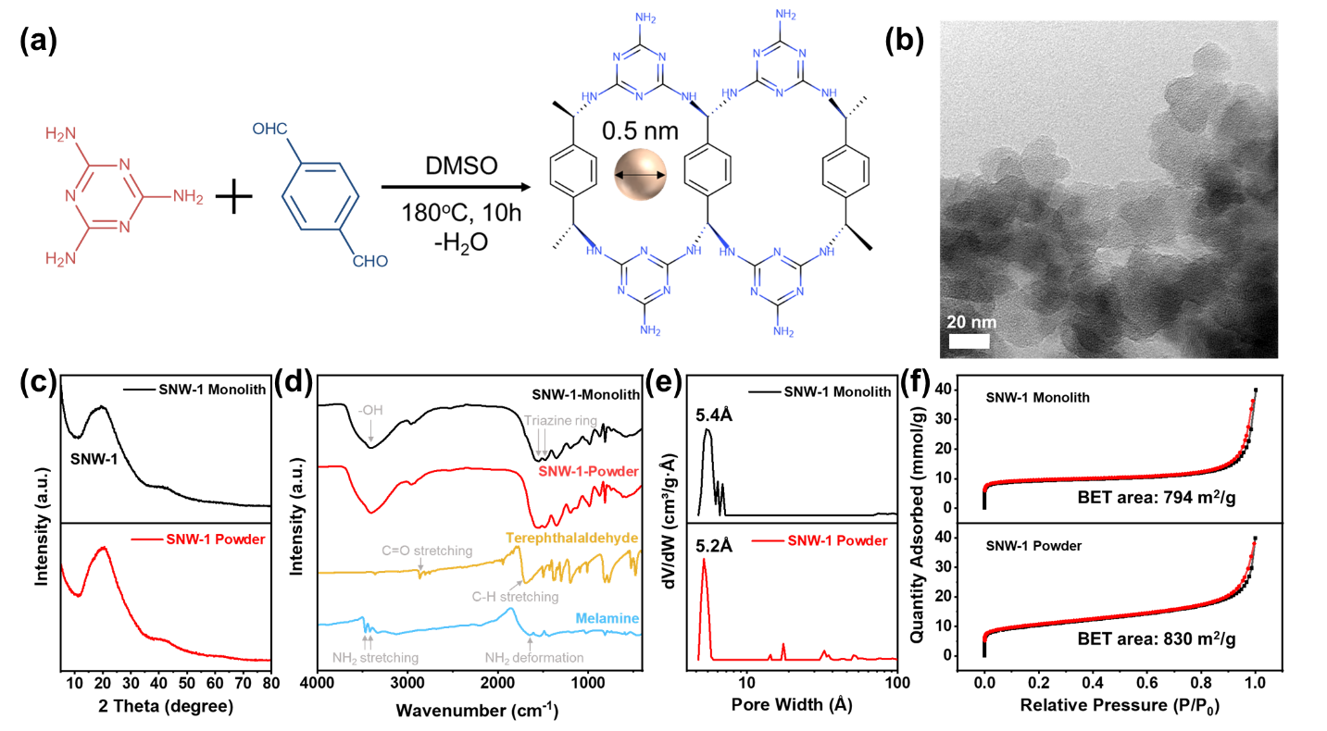
Figure 1. (a) Synthesis procedure of SNW-1; (b) TEM image of SNW-1 paste; (c) XRD, (d) FTIR, (e) NLDFT pore size distribution, and (f) 77K N₂ adsorption-desorption isotherm of the SNW-1 monolith and powder

In our printing experiments, pastes with low solid contents of 9.45 wt%, 7.72 wt%, 6.60 wt%, and 5.10 wt% were obtained and confirmed by thermogravimetric analysis (TGA) measurements (Figure S1). All pastes could be extruded smoothly. On further increasing the solid content to 15.48 wt%, the SNW-1 paste became excessively thick and could not form a continuous printable ink. The rheological properties of the SNW-1-9.45wt% were further investigated, as shown in Figure 2a-c. Generally, an ideal printable ink should exhibit shear-thinning flow behaviour at high shear rates to allow the ink to exit the fine nozzle continuously as a rod-like filament. It also requires a gel core-fluid shell structure at rest, which can retain its configuration and also fuse the filaments at their contact points.[37] As shown in Figure 2a, our SNW-1 ink exhibits a higher storage modulus (G’) than loss modulus(G”), and both moduli remain stable against oscillatory angular frequency. This indicates that deformation does not cause microstructural disruption and thus will be recoverable. The yield stress (σ_{y}) can be estimated from the oscillatory stress sweep curve (Figure 2b) to be around 1000 Pa. Above the yield stress, the storage modulus drops dramatically to lower than 10 Pa and becomes smaller than the loss modulus at the yield stress. These findings indicate that the ink can flow easily as a viscous fluid through the fine nozzle under high pressure and behave as a rigid body at rest. The linear relationship between the shear rate and viscosity on a logarithmic scale (Figure 2c) also demonstrates that the ink behaves like a gel at low shear stress and fluid at high shear stress, allowing a smooth extrusion. These desirable rheological properties indicate that the formulated SNW-1 paste is ideal for 3D printing.
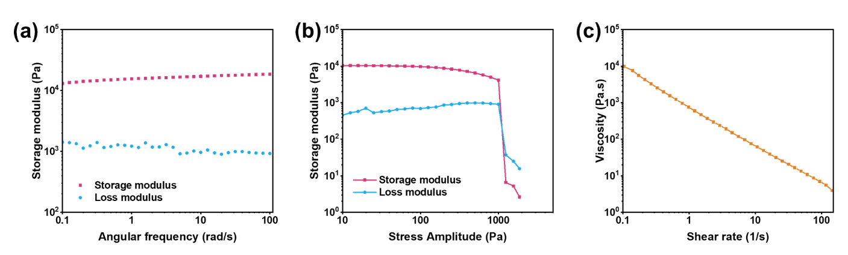
Figure 2. Rheological properties of the SNW-1-9.45wt% (a) The storage modulus and the loss modulus versus the angular frequency; (b) The storage modulus and the loss modulus against the shear stress-amplitude at a constant frequency of 6.283 rad/s; (c) Viscosity against shear rate

In spite of the excellent properties of the ink, the 3D-printed meshes with different solid contents all cracked during the drying process due to the low solid loading of the formulated inks. We then realized that by changing the substrate from cellulose acetate (CA) film to mixed cellulose ester (CE) filter paper (containing cellulose acetate and cellulose nitrate) with 0.2 µm pores, crack formation was significantly reduced, as shown in Figure 3a,b. The SNW-1-5.10wt% on filter paper still suffered from cracking, but considerably less than that of the sample dried on cellulose acetate film. When the solid content was increased to 6.60 wt%, the printed mesh retained its overall structure with only a single crack. Further increasing the solid content to 7.72 wt% and 9.45 wt%, both printed meshes were crack-free. Compared to their freshly printed counterparts with a diameter of 1.2 cm, the SNW-1-7.72wt% and SNW-1-9.45wt% meshes shrunk to 0.8 cm and 1.0 cm, respectively, after drying. The SEM images and photos of the SNW-1-9.45wt% monolith in different viewing directions (Figure S2a,b) show a clear layer-by-layer morphology without cracks, indicating a well-retained shape for each filament. The filament has a diameter of around 354 µm and is composed of small SNW-1 particles (Figure 4a,b). With the binder-free 3D printing method, the SNW-1 particles in SNW-1-monolith remain unmodified as compared to the as-synthesized SNW-1 powder (Figure 4c), except for some degree of agglomeration due to inter-particle forces. Other printed crack-free architectures can also be achieved by using CE filter paper (Figure S3). Therefore, for the paste of porous materials like SNW-1, which can only accommodate a low solid content, changing the substrate from CA film to CE filter paper effectively relieves the cracking problem, outweighing the positive impact brought about by increasing the solid content. It is therefore clear that a change in the substrate plays a crucial role in successful, binder-free 3D printing, as seen from the marked differences in dried monoliths. In order to understand the mechanism underlying the differences in crack propensity in samples printed on different substrates, we propose a few possible reasons: 1) the porous filter paper provides a pathway for the water to evaporate from the bottom, as opposed to non-porous film substrates, thus allowing for more uniform shrinkage of the monoliths; 2) the hydrophilic nature of the CE filter paper enables water to be absorbed and escape from the bottom; 3) the lower surface energy on the CE filter paper allows smaller adhesion and a smoother movement of the SNW-1 monolith during the shrinkage process.[45]
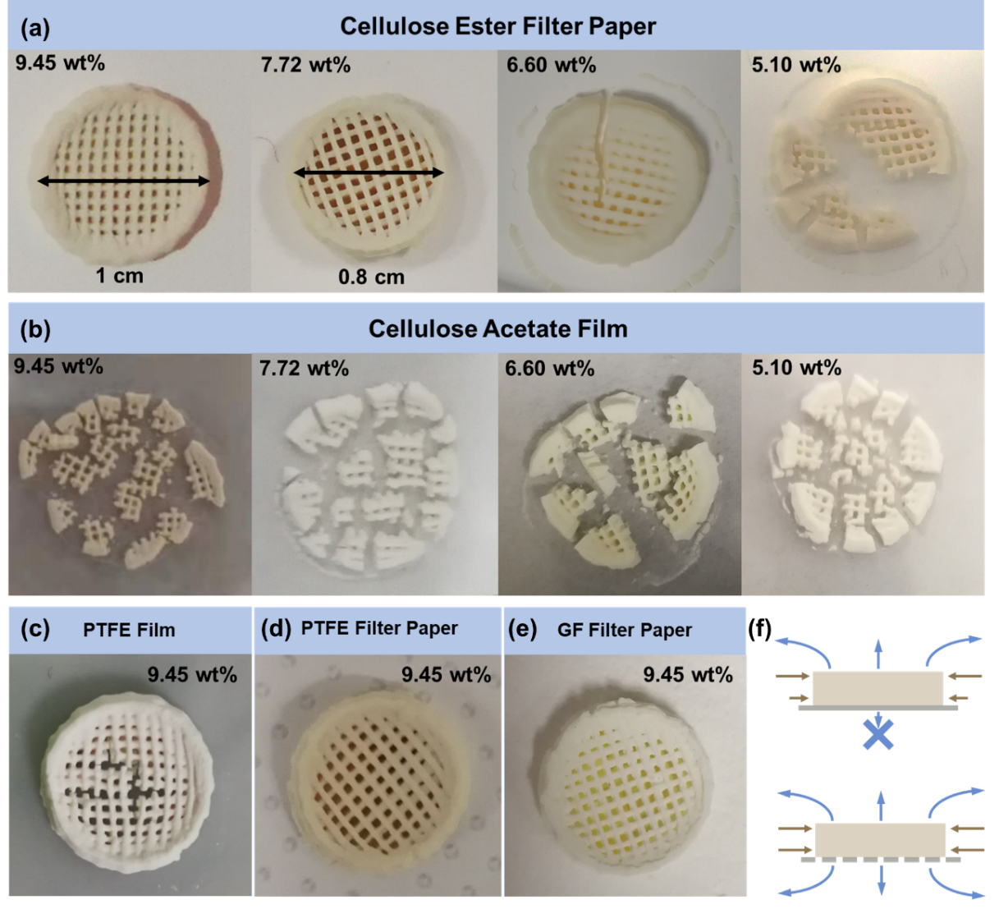
Figure 3. The appearance of the 3D-printed SNW-1 monoliths with different solid contents on (a) cellulose ester filter paper and (b) cellulose acetate film; Appearance of the 3D-printed SNW-1 monolith with 9.45 wt% solid content on (c) PTFE film, (d) PTFE filter paper, and (e) glass fiber filter paper;(f) schematic of the drying mechanism of 3D-printed monoliths on porous and non-porous substrates.

To test these hypotheses, PTFE filter paper, and PTFE film were tested as substrates (Figure 3c,d). Since PTFE exhibits a high degree of hydrophobicity, the PTFE filter paper should not absorb water from below the structure but should still allow water to evaporate through the pores. Compared to CE filter paper, both the PTFE filter paper and film exhibit smaller surface energies, thus resulting in smooth movements of the material on top.[46] It was noted that the structure printed on PTFE film gave slightly better results than that using cellulose acetate film, but still had cracks on the filaments; this showed that a lower substrate surface energy could help to reduce the cracks, but was not the main reason for the formation of a crack-free monolith. On changing the substrate to the PTFE filter paper, the dried monolith has no cracks, suggesting that the presence of pores to allow breathability of the structure is the key factor for obtaining a crack-free structure. A similar crack-free monolith can also be obtained by using a glass fiber (GF) filter paper (Figure 3e), providing further evidence for this conclusion. These results show that the pores in the substrate have a strong effect on the drying process, which can greatly reduce the formation of cracks in the printed monolith. During the conventional drying process (using the CA film or any non-porous substrate), water tends to evaporate faster from the top layers where it is directly exposed in the air, while the bottom layers adhere more tightly to the substrate. This leads to different shrinking rates at the top and bottom, as illustrated in Figure 3f. The inconsistent shrinkage builds up large stress in the monolith structure as the bottom layers drag along the substrate; it is therefore relatively easy to form cracks when the active material has no polymeric binder. When using the filter paper as the substrate, the existence of 0.2 µm pores allows sufficient water evaporation from the bottom layers to match the speed of drying at the top layers, leading to crack-free monoliths.

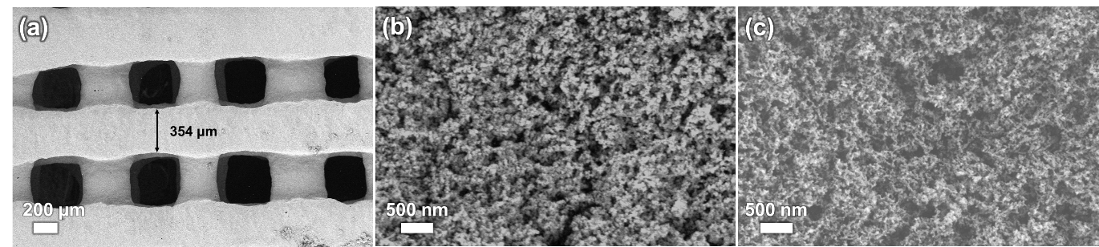
Figure 4. (a,b) Top-view SEM images of SNW-1-9.45wt%; (c) SEM images of SNW-1-powder

In order to demonstrate the general applicability of our strategy, ATFG-COF, a more crystalline COF material which has a nanowire morphology with a width of around 35 nm, was 3D-printed using the same method. By mixing ATFG-COF with 1-butanol, which is more viscous, a paste that could be extruded consistently was formed. During the drying process, the same situation occurred; ATFG-COF monoliths on the CA film cracked, but the monoliths stayed crack-free on CE filter paper (Figure S4). The as-printed ATFG-COF also showed a similar XRD pattern, surface area, and pore distribution as the literature results.[47] This provides further evidence that a porous substrate can balance the drying behavior to reduce cracking in porous COF monoliths.
For comparison with our binder-free strategy, SNW-1 with F127 added as the polymeric binder was also used for 3D printing. In the presence of F127 binder, crack-free 3D monoliths could be printed on cellulose acetate film, as the polymer is able to form a bridge to hold the active material together. After drying, the diameter of the monolith gradually becomes smaller from bottom to top (Figure S5a,b). The conical frustum architecture demonstrates the occurrence of different shrinkage rates between the top and bottom layers, regardless of the addition of polymeric binders. The diameter of the filament is around 375 µm (Figure S5c), showing that the presence of binder results in a thicker filament as compared to a binder-free printed monolith. Although adding F127 can easily solve the cracking problem, the surface area obtained by the BET method for the SNW-1/F127 monolith is only 22 m²/g, and the microporosity disappears (Figure S5d). The low surface area results from adding the F127, which has a small surface area and comprises polymeric chains that block the pores in SNW-1. This clearly shows the negative effects of adding an additional polymeric binder on the structure and functionality of the active material.
The printed SNW-1-9.45wt% monolith, the SNW-1/F127 monolith, and the SNW-1 powder were tested for CO₂ and N₂ adsorption and selectivity. Figure 5a,b show the adsorption isotherms of CO₂ and N₂ at 298 K and 273 K, respectively. The CO₂ uptake of the SNW-1 monolith at 1 bar is 58.42 cm³/g at 273 K and 41.41 cm³/g at 298 K, which is almost the same as that of the SNW-1 powder (60.54 cm³/g at 273 K and 44.9 cm³/g at 298 K), with a difference of less than 8%. This value is much smaller than the difference in CO₂ uptake between other common 3D-printed adsorbents and their powder counterparts,[32] showing the advantage of not using the binder. In contrast to the high adsorption of CO₂, the uptake of N₂ at 1 bar for the SNW-1 monolith is only 6.59 cm³/g at 273 K and 2.81 cm³/g at 298 K. The adsorption affinity for CO₂ over N₂, calculated from the single-component adsorption isotherms using the ideal adsorption solution theory (IAST) at an equilibrium partial pressure of 0.85 bar (N₂) and 0.15 bar (CO₂), shows high values of 62.04 and 66.54 for the SNW-1 monolith at 273 K and 298 K, respectively (Figure 5c). This demonstrates that the SNW-1 monolith shows the same high CO₂ adsorption and CO₂/N₂ selectivity that is found in the SNW-1 powder, SNW-1 literature value[40], and for certain other materials, such as COF-1[3], COP-19[48], porous aromatic frameworks[49], melamine-based polyamines[50], metal-cyclam-based zirconium MOFs[51], porous carbon framework[52]. The well-preserved CO₂ affinity of SNW-1 shows that our binder-free 3D printing technology preserves the high surface area, porosity, and/or surface functionality of the parent material. In contrast, the CO₂ uptake of SNW-1 with F127 at 1 bar is only 5.80 and 1.46 cm³/g at 273 and 298 K, respectively, indicating a major drawback of using binders.
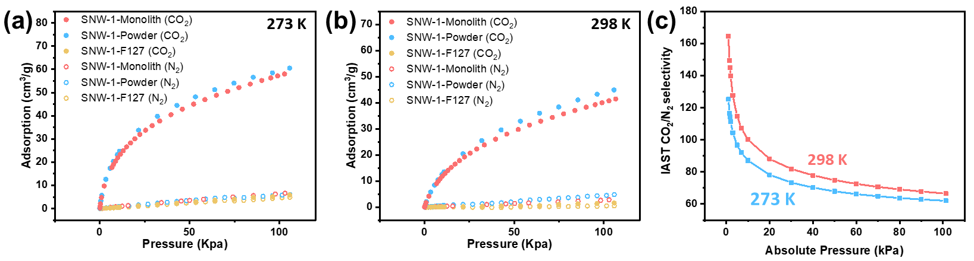
Figure 5. (a) CO₂ and N₂ adsorption curve of SNW-1 monolith, SNW-1 powder, and SNW-1/F127 monolith at (a) 273K and (b) 298K; (c) sorption selectivity of CO₂ over N₂ SNW-1 monolith by IAST calculation.

- Conclusion
In summary, we have demonstrated the successful 3D printing of COF materials without the need for any binders. In order to develop 3D monoliths of COFs with high CO₂ adsorption capacity, a binder-free 3D printable formulation is the first key step. In order to avoid cracks during the subsequent drying process, it is critically important to control the solvent evaporation; this was achieved by using appropriate porous substrates to obtain a uniform shrinkage rate across the top and bottom layers. The binder-free 3D SNW-1 monolith shows undiminished BET surface area and porosity, and unobstructed surface functionalities as compared to its powder-form counterpart, which together contribute to its high CO₂ adsorption and CO₂/N₂ sorption selectivity. By adopting a similar procedure, 3D-printed crack-free ATFG-COF monoliths were also be obtained without the addition of binder. The binder-free printing parameters explored in this work provide important insights into the 3D printing of COFs in general, enabling the preservation of access to the micro- and mesopores in the 3D-printed structures. With our binder-free 3D printing technique, the benefits of the macro-/micro-scale structure can be integrated well with the nanoscale features of the COF without sacrificing porosity, surface area, and surface functionality. In addition, the two-step facile and non-toxic process, in combination with the elimination of binder usage and the potential to further simplify the paste preparation and post-processing steps, for example by using an industrial mixer to scale up paste manufacturing and/or drying at a higher rate, will lead to reductions in the production time and cost.

Acknowledgements
This work was supported by the Ministry of Education - Singapore (MOE AcRF Tier 2 MOE2019-T2-1-093), research conducted at the National University of Singapore. Prof John Wang and Prof Anthony Cheetham acknowledge the support of Singapore MOE (Tier 1, R284-000-193-114) for research conducted in NUS.

References
[1] A.P. Côté, A.I. Benin, N.W. Ockwig, M. O'Keeffe, A.J. Matzger, O.M. Yaghi, Porous, Crystalline, Covalent Organic Frameworks, Science 310 (2005) 1166-1170.
[2] Q. Gao, X. Li, G.-H. Ning, H.-S. Xu, C. Liu, B. Tian, W. Tang, K.P. Loh, Covalent Organic Framework with Frustrated Bonding Network for Enhanced Carbon Dioxide Storage, Chem. Mater. 30 (2018) 1762-1768.
[3] H. Furukawa, O.M. Yaghi, Storage of Hydrogen, Methane, and Carbon Dioxide in Highly Porous Covalent Organic Frameworks for Clean Energy Applications, J. Am. Chem. Soc. 131 (2009) 8875-8883.
[4] S.S. Han, H. Furukawa, O.M. Yaghi, W.A. Goddard, Covalent Organic Frameworks as Exceptional Hydrogen Storage Materials, J. Am. Chem. Soc. 130 (2008) 11580-11581.
[5] Z. Kang, Y. Peng, Y. Qian, D. Yuan, M.A. Addicoat, T. Heine, Z. Hu, L. Tee, Z. Guo, D. Zhao, Mixed Matrix Membranes (MMMs) Comprising Exfoliated 2D Covalent Organic Frameworks (COFs) for Efficient CO2 Separation, Chem. Mater. 28 (2016) 1277-1285.
[6] X. Zhao, P. Pachfule, S. Li, T. Langenhahn, M. Ye, C. Schlesiger, S. Praetz, J. Schmidt, A. Thomas, Macro/Microporous Covalent Organic Frameworks for Efficient Electrocatalysis, J. Am. Chem. Soc. 141 (2019) 6623-6630.
[7] S. Lin, C.S. Diercks, Y.-B. Zhang, N. Kornienko, E.M. Nichols, Y. Zhao, A.R. Paris, D. Kim, P. Yang, O.M. Yaghi, C.J. Chang, Covalent organic frameworks comprising cobalt porphyrins for catalytic CO<sub>2</sub> reduction in water, Science 349 (2015) 1208-1213.
[8] H. Xu, J. Gao, D. Jiang, Stable, crystalline, porous, covalent organic frameworks as a platform for chiral organocatalysts, Nature Chemistry 7 (2015) 905-912.
[9] S.M.J. Rogge, A. Bavykina, J. Hajek, H. Garcia, A.I. Olivos-Suarez, A. Sepúlveda-Escribano, A. Vimont, G. Clet, P. Bazin, F. Kapteijn, M. Daturi, E.V. Ramos-Fernandez, F.X. Llabrés i Xamena, V. Van Speybroeck, J. Gascon, Metal–organic and covalent organic frameworks as single-site catalysts, Chem. Soc. Rev. 46 (2017) 3134-3184.
[10] X. Wang, X. Han, J. Zhang, X. Wu, Y. Liu, Y. Cui, Homochiral 2D Porous Covalent Organic Frameworks for Heterogeneous Asymmetric Catalysis, J. Am. Chem. Soc. 138 (2016) 12332-12335.
[11] C.R. DeBlase, K.E. Silberstein, T.-T. Truong, H.D. Abruña, W.R. Dichtel, β-Ketoenamine-Linked Covalent Organic Frameworks Capable of Pseudocapacitive Energy Storage, J. Am. Chem. Soc. 135 (2013) 16821-16824.
[12] S. Wang, Q. Wang, P. Shao, Y. Han, X. Gao, L. Ma, S. Yuan, X. Ma, J. Zhou, X. Feng, B. Wang, Exfoliation of Covalent Organic Frameworks into Few-Layer Redox-Active Nanosheets as Cathode Materials for Lithium-Ion Batteries, J. Am. Chem. Soc. 139 (2017) 4258-4261.
[13] F. Xu, H. Xu, X. Chen, D. Wu, Y. Wu, H. Liu, C. Gu, R. Fu, D. Jiang, Radical Covalent Organic Frameworks: A General Strategy to Immobilize Open-Accessible Polyradicals for High-Performance Capacitive Energy Storage, Angew. Chem. Int. Ed. 54 (2015) 6814-6818.
[14] Q. Fang, J. Wang, S. Gu, R.B. Kaspar, Z. Zhuang, J. Zheng, H. Guo, S. Qiu, Y. Yan, 3D Porous Crystalline Polyimide Covalent Organic Frameworks for Drug Delivery, J. Am. Chem. Soc. 137 (2015) 8352-8355.
[15] S. Mitra, H.S. Sasmal, T. Kundu, S. Kandambeth, K. Illath, D. Díaz Díaz, R. Banerjee, Targeted Drug Delivery in Covalent Organic Nanosheets (CONs) via Sequential Postsynthetic Modification, J. Am. Chem. Soc. 139 (2017) 4513-4520.
[16] L. Bai, S.Z.F. Phua, W.Q. Lim, A. Jana, Z. Luo, H.P. Tham, L. Zhao, Q. Gao, Y. Zhao, Nanoscale covalent organic frameworks as smart carriers for drug delivery, Chem. Commun. 52 (2016) 4128-4131.
[17] N. Huang, L. Zhai, H. Xu, D. Jiang, Stable Covalent Organic Frameworks for Exceptional Mercury Removal from Aqueous Solutions, J. Am. Chem. Soc. 139 (2017) 2428-2434.
[18] H. Fan, J. Gu, H. Meng, A. Knebel, J. Caro, High-Flux Membranes Based on the Covalent Organic Framework COF-LZU1 for Selective Dye Separation by Nanofiltration, Angew. Chem. Int. Ed. 57 (2018) 4083-4087.
[19] Y. Song, Q. Sun, B. Aguila, S. Ma, Opportunities of Covalent Organic Frameworks for Advanced Applications, Adv. Sci. 6 (2019) 1801410.
[20] S. Yao, X. Yang, M. Yu, Y. Zhang, J.-X. Jiang, High surface area hypercrosslinked microporous organic polymer networks based on tetraphenylethylene for CO2 capture, J. Mater. Chem. A 2 (2014) 8054-8059.
[21] M. Zhang, L. Li, Q. Lin, M. Tang, Y. Wu, C. Ke, Hierarchical-Coassembly-Enabled 3D-Printing of Homogeneous and Heterogeneous Covalent Organic Frameworks, J. Am. Chem. Soc. 141 (2019) 5154-5158.
[22] X. Zhou, C.-j. Liu, Three-dimensional Printing for Catalytic Applications: Current Status and Perspectives, Adv. Funct. Mater. 27 (2017) 1701134.
[23] B. Yao, S. Chandrasekaran, H. Zhang, A. Ma, J. Kang, L. Zhang, X. Lu, F. Qian, C. Zhu, E.B. Duoss, C.M. Spadaccini, M.A. Worsley, Y. Li, 3D-Printed Structure Boosts the Kinetics and Intrinsic Capacitance of Pseudocapacitive Graphene Aerogels, Adv. Mater. 32 (2020) 1906652.
[24] A. Lee, A.R. Hudson, D.J. Shiwarski, J.W. Tashman, T.J. Hinton, S. Yerneni, J.M. Bliley, P.G. Campbell, A.W. Feinberg, 3D bioprinting of collagen to rebuild components of the human heart, Science 365 (2019) 482-487.
[25] Z. Su, Y.-R. Miao, G. Zhang, J.T. Miller, K.S. Suslick, Bond breakage under pressure in a metal organic framework, Chemical Science 8 (2017) 8004-8011.
[26] H. Thakkar, S. Lawson, A.A. Rownaghi, F. Rezaei, Development of 3D-printed polymer-zeolite composite monoliths for gas separation, Chem. Eng. J. 348 (2018) 109-116.
[27] K. Fu, Y. Yao, J. Dai, L. Hu, Progress in 3D Printing of Carbon Materials for Energy-Related Applications, Adv. Mater. 29 (2017) 1603486.
[28] C.-Y. Lee, A.C. Taylor, A. Nattestad, S. Beirne, G.G. Wallace, 3D Printing for Electrocatalytic Applications, Joule 3 (2019) 1835-1849.
[29] H. Thakkar, S. Eastman, Q. Al-Naddaf, A.A. Rownaghi, F. Rezaei, 3D-Printed Metal–Organic Framework Monoliths for Gas Adsorption Processes, ACS Appl. Mater. Interfaces 9 (2017) 35908-35916.
[30] V. Middelkoop, K. Coenen, J. Schalck, M. Van Sint Annaland, F. Gallucci, 3D printed versus spherical adsorbents for gas sweetening, Chem. Eng. J. 357 (2019) 309-319.
[31] S. Couck, J. Lefevere, S. Mullens, L. Protasova, V. Meynen, G. Desmet, G.V. Baron, J.F.M. Denayer, CO2, CH4 and N2 separation with a 3DFD-printed ZSM-5 monolith, Chem. Eng. J. 308 (2017) 719-726.
[32] H. Thakkar, S. Eastman, A. Hajari, A.A. Rownaghi, J.C. Knox, F. Rezaei, 3D-Printed Zeolite Monoliths for CO2 Removal from Enclosed Environments, ACS Appl. Mater. Interfaces 8 (2016) 27753-27761.
[33] J. Dhainaut, M. Bonneau, R. Ueoka, K. Kanamori, S. Furukawa, Formulation of Metal–Organic Framework Inks for the 3D Printing of Robust Microporous Solids toward High-Pressure Gas Storage and Separation, ACS Appl. Mater. Interfaces 12 (2020) 10983-10992.
[34] A. Elkoro, I. Casanova, 3D Printing of Structured Nanotitania Catalysts: A Novel Binder-Free and Low-Temperature Chemical Sintering Method, 3D Print. Addit. Manuf. 5 (2018) 220-226.
[35] S. Wang, P. Bai, M. Sun, W. Liu, D. Li, W. Wu, W. Yan, J. Shang, J. Yu, Fabricating Mechanically Robust Binder-Free Structured Zeolites by 3D Printing Coupled with Zeolite Soldering: A Superior Configuration for CO2 Capture, Adv. Sci. 6 (2019) 1901317.
[36] G.J.H. Lim, Y. Wu, B.B. Shah, J.J. Koh, C.K. Liu, D. Zhao, A.K. Cheetham, J. Wang, J. Ding, 3D-Printing of Pure Metal–Organic Framework Monoliths, ACS Materials Letters 1 (2019) 147-153.
[37] J.A. Lewis, J.E. Smay, J. Stuecker, J. Cesarano, Direct Ink Writing of Three-Dimensional Ceramic Structures, J. Am. Ceram. Soc. 89 (2006) 3599-3609.
[38] X. Wu, Z. Tian, S. Wang, D. Peng, L. Yang, Y. Wu, Q. Xin, H. Wu, Z. Jiang, Mixed matrix membranes comprising polymers of intrinsic microporosity and covalent organic framework for gas separation, J. Membr. Sci. 528 (2017) 273-283.
[39] S. Yuan, X. Li, J. Zhu, G. Zhang, P. Van Puyvelde, B. Van der Bruggen, Covalent organic frameworks for membrane separation, Chem. Soc. Rev. 48 (2019) 2665-2681.
[40] X. Gao, X. Zou, H. Ma, S. Meng, G. Zhu, Highly Selective and Permeable Porous Organic Framework Membrane for CO2 Capture, Adv. Mater. 26 (2014) 3644-3648.
[41] D.M. D'Alessandro, B. Smit, J.R. Long, Carbon Dioxide Capture: Prospects for New Materials, Angew. Chem. Int. Ed. 49 (2010) 6058-6082.
[42] L. Zou, Y. Sun, S. Che, X. Yang, X. Wang, M. Bosch, Q. Wang, H. Li, M. Smith, S. Yuan, Z. Perry, H.-C. Zhou, Porous Organic Polymers for Post-Combustion Carbon Capture, Adv. Mater. 29 (2017) 1700229.
[43] M.G. Schwab, B. Fassbender, H.W. Spiess, A. Thomas, X. Feng, K. Müllen, Catalyst-free Preparation of Melamine-Based Microporous Polymer Networks through Schiff Base Chemistry, J. Am. Chem. Soc. 131 (2009) 7216-7217.
[44] Y. Yin, Z. Li, X. Yang, L. Cao, C. Wang, B. Zhang, H. Wu, Z. Jiang, Enhanced proton conductivity of Nafion composite membrane by incorporating phosphoric acid-loaded covalent organic framework, J. Power Sources 332 (2016) 265-273.
[45] Q. Shen, Surface Properties of Cellulose and Cellulose Derivatives: A Review, Model Cellulosic Surfaces, American Chemical Society2009, pp. 259-289.
[46] J.S. Park, S.M. Lee, B.S. Joo, H. Jang, The effect of material properties on the stick–slip behavior of polymers: A case study with PMMA, PC, PTFE, and PVC, Wear 378-379 (2017) 11-16.
[47] L. Stegbauer, M.W. Hahn, A. Jentys, G. Savasci, C. Ochsenfeld, J.A. Lercher, B.V. Lotsch, Tunable Water and CO2 Sorption Properties in Isostructural Azine-Based Covalent Organic Frameworks through Polarity Engineering, Chem. Mater. 27 (2015) 7874-7881.
[48] H.A. Patel, C.T. Yavuz, Highly optimized CO2 capture by inexpensive nanoporous covalent organic polymers and their amine composites, Faraday Discuss. 183 (2015) 401-412.
[49] T. Ben, C. Pei, D. Zhang, J. Xu, F. Deng, X. Jing, S. Qiu, Gas storage in porous aromatic frameworks (PAFs), Energy & Environmental Science 4 (2011) 3991-3999.
[50] L. Shao, M. Liu, Y. Sang, J. Huang, One-pot synthesis of melamine-based porous polyamides for CO2 capture, Microporous Mesoporous Mater. 285 (2019) 105-111.
[51] J. Zhu, P.M. Usov, W. Xu, P.J. Celis-Salazar, S. Lin, M.C. Kessinger, C. Landaverde-Alvarado, M. Cai, A.M. May, C. Slebodnick, D. Zhu, S.D. Senanayake, A.J. Morris, A New Class of Metal-Cyclam-Based Zirconium Metal–Organic Frameworks for CO2 Adsorption and Chemical Fixation, J. Am. Chem. Soc. 140 (2018) 993-1003.
[52] T. Wu, J. Dong, K. De France, P. Zhang, X. Zhao, Q. Zhang, Porous carbon frameworks with high CO2 capture capacity derived from hierarchical polyimide/zeolitic imidazolate frameworks composite aerogels, Chem. Eng. J. 395 (2020) 124927.

