ABSTRACT for ACR:

Perspectives of Radiologist Physicians in the Imaging of Chronic Nonbacterial Osteomyelitis

Farzana Nuruzzaman, Mingqian Huang, Christian Hedrich, Hermann Girschick, Julie Cherian, Karen Onel, T. Shawn Sato, Polly Ferguson and Yongdong Zhao, Stony Brook Children's
Hospital, Stony Brook, Mount Sinai Hospital, New York, New York, University of Liverpool, Liverpool, United Kingdom, Wuerzburg, Germany, Hospital for Special Surgery, New York, University of Iowa, Iowa City, University of Iowa Carver College of Medicine, Iowa City, University of Washington, Seattle

Background/Purpose: Radiological imaging is integral to the diagnosis of chronic nonbacterial
osteomyelitis (CNO) and has been included as a central component in suggested diagnostic criteria
[1,2]. Objectives of this study were: 1) to determine imaging modalities and features deemed
important by radiologists in the diagnostic workup of suspected CNO cases; 2) to generate input
from radiologists regarding monitoring of patients with CNO.

Methods: Population targeted were active attending radiologist physician members of the Society of
Skeletal Radiology email list serve. The survey was administered online through RedCap. Descriptive
statistics were conducted with continuous variables reported as medians/means and categorical
variables as frequencies/percentages.

Results: A total of 66 respondents (5%) consented and completed the survey. The majority were
paediatric radiologists, subspecializing in musculoskeletal radiology, with >10 years of experience
(Table 1). Radiologists consider CNO in the radiological imaging interpretation differential diagnosis
an average of 10 cases per year. 79% and 45% of respondents reported high confidence in identifying imaging features of CNO on whole body MRI (WBMRI) and localized MRI, respectively. The level of confidence drops to 24% and 13% when interpreting X-rays (XRs) and bone scintigraphy, respectively (Figure 1). Among all imaging modalities interpreted “always” in the initial diagnostic workup of potential cases of CNO, XRs (52%) were most commonly interpreted, followed by localized MRI (46%) and WBMRI (35%), which suggested the sequence of utilization of these three imaging modalities in new cases. In established cases of CNO, wherein WBMRI was the most frequently interpreted (48%), followed by localized MRI (26%) and XRs (25%) (Figure 2). Most common imaging features that led respondents to suggest a bone biopsy included disorganized bone formation (64%/56%), moth-eaten appearance (61%/56%), and lytic lesions (50%/44%) on XRs/CTs, respectively as well as the presence of soft tissue mass/swelling (68%/44%) and MRI signal hyperintensity of bone marrow at unifocal site (24%) on MRI. A majority of respondents preferred a combination of short tau inverse recovery (STIR), T1 and di􀃠usion weighted imaging (DWI) sequences in the MRI images of potential CNO cases. 46% of respondents reported using an established WBMRI protocol at their institutions.

Conclusion: WBMRI is considered the most useful imaging modality for initial diagnosis and
monitoring of CNO by radiologists. Certain morphological features including disorganized bone
structure, moth-eaten appearance, lytic lesions, soft tissue mass/swelling and unifocal signal
hyperintensity of bone marrow may result in increased chance of bone biopsy to exclude differential
diagnoses. Findings from this survey will promote discussion within a focused group to develop
imaging guidelines for the diagnostic workup and disease monitoring in CNO and contribute to
earlier diagnosis and individualized care.

[1] Jansson, A et al. “Classification of nonbacterial osteitis.” Rheumatology (Oxford) 46, 1 (2007)
[2] Roderick, MR, et al. “Chronic recurrent multifocal osteomyelitis (CRMO).” Paediatric Rheumatology 14, 47 (2016)
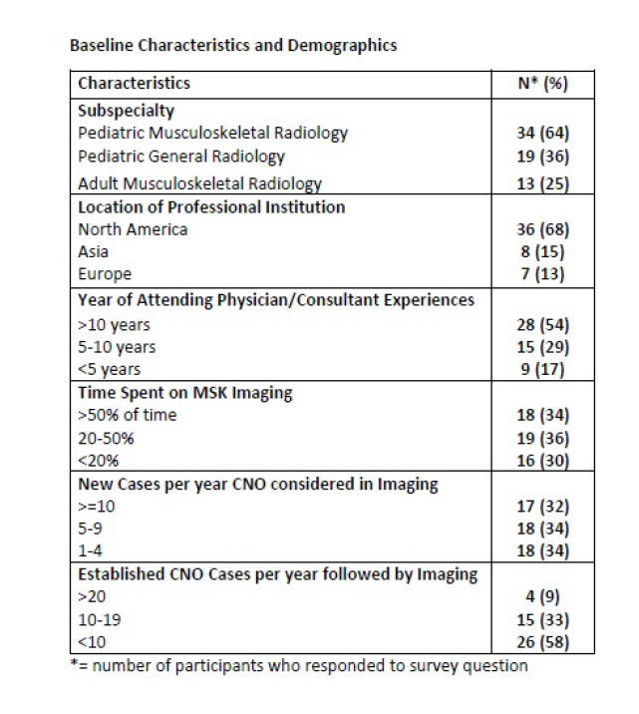
Table 1: Baseline demographics and characteristics of survey respondents

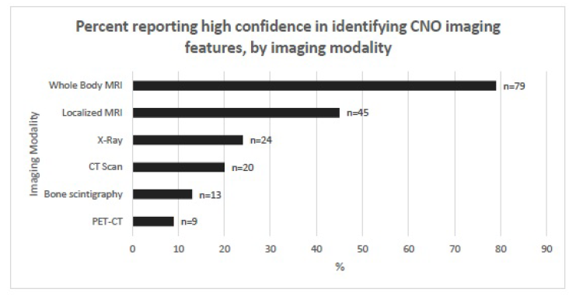
Figure 1: Level of confidence of radiologist physicians in identifying features of CNO by imaging
Modality

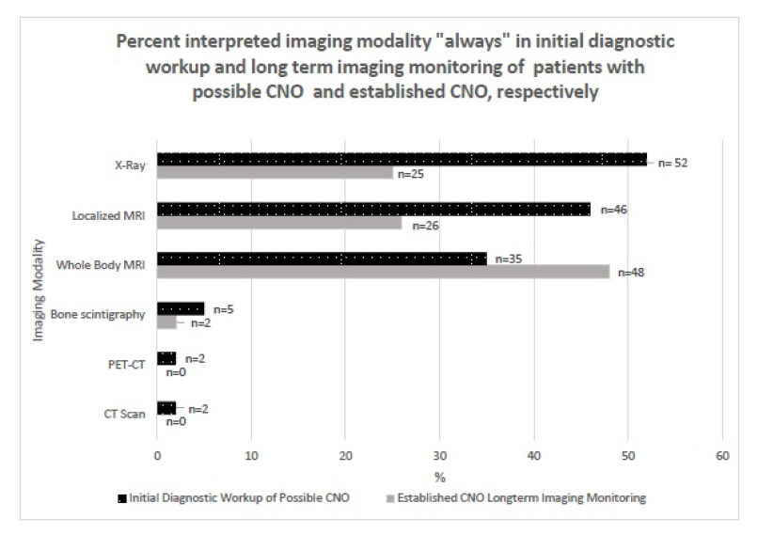

Figure 2: Imaging modalities interpreted by radiologist physicians in potential and established cases
of CNO

