Receptance-based Frequency assignment for assembled structures

Shike Zhang, Huajiang Ouyang[1]

School of Engineering, university of Liverpool, Liverpool L69 3GH, UK

**Abstract**: For engineering structures, there is a strong need to assign natural frequencies to achieve desired dynamic performance. This paper proposes a receptance-based frequency assignment method for assembled structures. Very often, the substructures involved are not allowed or are difficult to change. This method uses the links between the substructures as targets of structural modifications and determines the structural properties of the links that assign the desired frequencies cast as an optimization problem. These links could be either simple discrete structural components such as masses and springs or complex continuous structures. Only a few receptances of the substructures are required in this method, which can be measured accurately and easily in practice. Two numerical examples are presented to show the validity of this method and its strength in dealing with complex assembled structures.

**Keywords**: Inverse dynamic analysis; Frequency assignment; Receptance; Assembled structures; Structural modification

# Introduction

In engineering, structures often experience undesirable vibration and even fail due to fatigue. Frequency assignment is a very effective way to tackle these problems by shifting the affected natural frequencies to desired values (locations). This assignment is usually achieved by making modifications to the mass, stiffness, and occasionally damping of the structures.

There are typically two categories of frequency assignment methods: forward and inverse (Li and He, 1999). The forward methods are to determine the eigenvalues and eigenvectors of a system with known modifications. This procedure is repeated until the requirement, such as desired frequencies or modes, is met (Olsson and Lidström, 2007). They are widely used in vibration optimization and in finite element updating. Baldwin and Hutton (1985) reviewed several structural modification methods that had been proposed prior to the 1980s, including Rayleigh’s quotient, sensitivity approaches, and perturbation approaches. Hang et al. (2010) recently investigated means of efficiently predicting the effects of distributed structural modifications on dynamic response of a complex structure. The inverse methods, in contrast, are to determine the structure parameters such that the modified systems could have desired frequencies and/or modes, which are more intuitive in practical problems (Çakar, 2011; Joseph, 1992; Mottershead, JE, 2001; Nylen and Uhlig, 1997). Some inverse methods rely on system modal data (Braun and Ram, 2001; Bucher and Braun, 1993; Liangsheng, 2003). Braun and Ram (2001) considered the inverse problem of determining the structural modifications which could assign a desired spectrum and developed physically realisable solutions. They showed that it was possible to solve the inverse structural modification problem without truncation error if both left and right eigenvectors of the system are available. However, those methods are difficult to apply to complex structures because accurate modal data are hard to obtain and their solutions are sensitive to errors. To overcome these problems, receptances, which could be directly measured, have been adopted in many inverse dynamic problems. Tsuei and Yee (1989) presented sensitivity graphs of the modification parameters with respect to the desired frequency using the receptance of the unmodified system. In a subsequent paper, the same authors (1991) improved the method to get the necessary mass and stiffness modifications that assign natural frequencies to a viscously damped system. Kyprianou et al. (2004) assigned natural frequencies to a multi-degrees of freedom (DoFs) undamped system by an added mass and one or more springs. There are new additional DoFs involved in the modifications. The authors (Kyprianou et al., 2005) later assigned natural frequencies or anti-resonances to a portal frame by determining the dimensions of the cross-section of a column as a beam. Zhu et al. (2009)assigned receptances using classical vibration absorbers. The parameters of absorbers were determined using selected receptances from original system. Çakar (2011) developed a new method which is based on Sherman-Morrison formula. This method can maintain certain pre-specified natural frequencies unchanged when the mass and stiffness properties of the structure are modified. Tsai et al. (2018) presented an experimental validation to an inverse frequency assignment method. A gear rotor-bearing system was tested and several natural frequencies and nodes were assigned by adding masses.

There was usually one structure involved, which was to be modified by changing the existing structural properties of or adding a simple structure to an original structure, in those aforementioned investigations. However, for assembled structures, there would be more than one substructure involved. The above methods could not be directly applied to assign frequencies for assembled structures, especially when the substructures are not allowed or difficult to be modified and only the links between substructures could be changed. For example, when an engine is to be installed on a ship, resonance should be avoided. However, the engine and the ship usually come from different suppliers and thus cannot be modified directly. Then it would be important to carry out structural modifications on the links that connect the engine and ship structure and optimize the links. Therefore, this research aims to establish a receptance-based frequency assignment method, which assigns frequencies to an assembled structure and finds the optimal links between the substructures.

There are already a number of papers on predicting dynamic behaviours of assembled structures. Substructure-coupling methods have been widely used to couple substructures and predict their dynamic responses (Craig Jr and Chang, 1977; Liu and Ewins, 2000; Mehrpouya et al., 2015; Schmitz and Donalson, 2000). Those methods, although their initial purpose is not frequency assignment, could also be used to solve forward frequency assignment problems (Imregun, 1987; Mottershead, John E. et al., 2005). There are mainly two types of substructure-coupling methods: Modal synthesis methods (Craig and Bampton, 1968), and frequency domain methods (Ren and Beards, 1995). Modal synthesis methods usually would produce modal truncation errors, while frequency domain methods, using the measured frequency response functions directly, could avoid this problem (de Klerk et al., 2006). De Klerk et al. (2008) presented a general framework which allowed for classification of substructuring methods and highlighted the interrelations between those methods. A reformulation and generalization of the classical frequency-based substructuring method was introduced by De Klerk et al (2006). D’Ambrigio et al. (2004) analysed the feasibility of assembling different substructures’ models, such as FRF (frequency response function) models, modal models and FE (finite element) models, for predicting the dynamic behaviour of assembled structures. Liu et al. (2000) reviewed some FRF-coupling methods and then proposed a general joint description method for FRF-coupling analysis. The FRFs of a plate connected with a beam via a steel bolt were predicted. An inverse substructure method was developed for the analysis of the dynamical characteristics of a three-substructure coupled system based on the inverse substructure method of a two-substructure coupled system by wang et al. (2011). Matthias et al. (2016) predicted the frequency response functions at the tool tip of a holder-tool assembly based on receptance-coupling substructure analysis.

Although the substructure coupling method, in theory, could be used to assign frequencies by repeating the coupling process with different links until the requirements are met, an inverse method (that would avoid a trial-and-error process) would be more appealing in practice. However, there are few publications about the inverse assignment problems of assembled structures. Birchfield et al. (2013) predicted the dynamic response of a coupled-rotor-system using the receptance functions of individual subsystems. The subsystems were coupled using springs and dampers and the critical speed of coupled-rotor-system was changed to a desired value. No additional degree of freedom was introduced when modifying the link.

In substructure-coupling methods, those links would be treated as substructures so that the coupling method could be applied. However, this is not efficient when there are multiple links. In this paper, the links are treated as modifications of uncoupled substructures and they could be discrete components (masses, springs and dampers) or continuous structures (beams, plates or even more complicated structures). Those links are optimized based on the receptances of the substructures and finite element models of the links. Two numerical examples, respectively with a discrete structure or a continuous structure, are demonstrated to validate this proposed method. The numerical results indicate that this method could be implemented for frequency assignment to complex structures in practice.

# Theory

This section shows a frequency assignment method for an assembled structure by modifying the properties of its links. The following derivation is based on two substructures and two links. However, it is apparently applicable to an assembled structure with any number of substructures and links.

As shown in Fig. 1, substructure A and substructure B are connected through two links C and D. The DoFs of substructure A, ‘**p**’, are coupled with the DoFs of substructure B, ‘**q**’, by link C. Similarly, the DoFs of substructure A, ‘**i**’, are coupled with DoFs of substructure B, ‘**j**’, through link D. All the other DoFs of substructures A and B are denoted by ‘**a**’ and ‘**b**’, respectively. The internal DoFs of links C and D are denoted by ‘**c**’ and ‘**d**’. It should be noted that there is no restriction on the complexity of these substructures and links, though links are more likely to be less complex than substructures in practice. Those added links C and D, are modifications of this “assembled structure” in order that the modified structure could have certain desired natural frequencies.

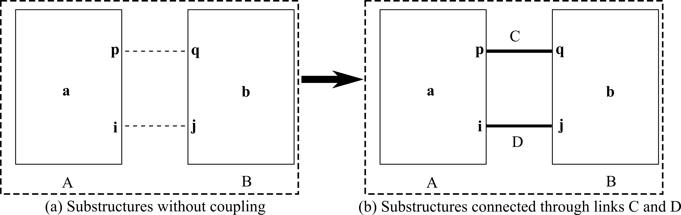

Fig. 1 Substructure A and B connected by links C and D

When substructure A and B are connected through links C and D, there will be internal forces, denoted by force vectors **f**, at the interface DoFs **p**, **q**, **i**, and **j**, are shown in Fig. 2.

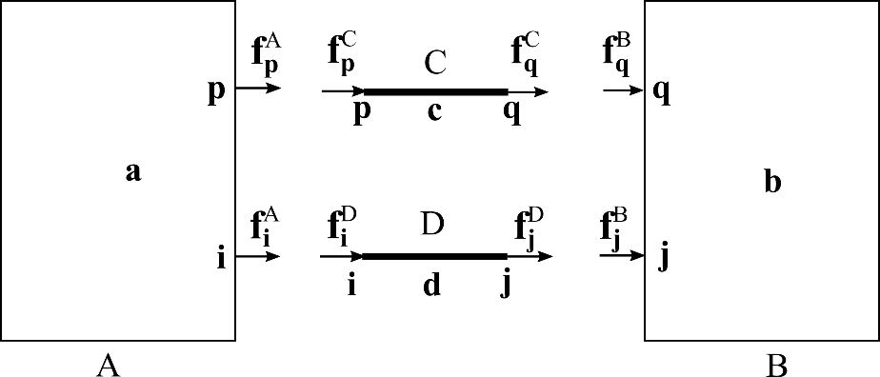

Fig. 2 internal forces in the interfaces DoFs

The equations of motion for substructures A and B in frequency domain can be expressed as

|  |  |  |
| --- | --- | --- |
|  | $$\left[\begin{matrix}Z_{aa}^{A} & Z_{ap}^{A} & Z_{ai}^{A} & 0 & 0 & 0 \\ Z_{pa}^{A} & Z_{pp}^{A} & Z_{pi}^{A} & 0 & 0 & 0 \\ Z_{ia}^{A} & Z_{ip}^{A} & Z_{ii}^{A} & 0 & 0 & 0 \\ 0 & 0 & 0 & Z_{qq}^{B} & Z_{qj}^{B} & Z_{qb}^{B} \\ 0 & 0 & 0 & Z_{jq}^{B} & Z_{jj}^{B} & Z_{jb}^{B} \\ 0 & 0 & 0 & Z_{bq}^{B} & Z_{bj}^{B} & Z_{bb}^{B}\end{matrix}\right]\left[\begin{matrix}x_{a}^{A} \\ x_{p}^{A} \\ x_{i}^{A} \\ x_{q}^{B} \\ x_{j}^{B} \\ x_{b}^{B}\end{matrix}\right]=\left[\begin{matrix}0 \\ f_{p}^{A} \\ f_{i}^{A} \\ f_{q}^{B} \\ f_{j}^{B} \\ 0\end{matrix}\right]$$ | (1) |

The nine matrix blocks at the top left corner and the nine matrix blocks at the bottom right corner in the matrix of equation (1) can be grouped respectively as

$Z^{A}=\left[\begin{matrix}Z_{aa}^{A} & Z_{ap}^{A} & Z_{ai}^{A} \\ Z_{pa}^{A} & Z_{pp}^{A} & Z_{pi}^{A} \\ Z_{ia}^{A} & Z_{ip}^{A} & Z_{ii}^{A}\end{matrix}\right]$, $Z^{B}=\left[\begin{matrix}Z_{qq}^{B} & Z_{qj}^{B} & Z_{qb}^{B} \\ Z_{jq}^{B} & Z_{jj}^{B} & Z_{jb}^{B} \\ Z_{bq}^{B} & Z_{bj}^{B} & Z_{bb}^{B}\end{matrix}\right]$

Here $Z^{A}$ and $Z^{B}$ are the dynamic stiffness matrices of substructure A and substructure B respectively, when they are considered as separate structures. For convenience, the dependence on frequency is omitted in the above and following equations.

Similarly, the equations of motion for links C and D can be written as

|  |  |  |
| --- | --- | --- |
|  | $$\left[\begin{matrix}Z_{pp}^{C} & Z_{pc}^{C} & Z_{pq}^{C} & 0 & 0 & 0 \\ Z_{cp}^{C} & Z_{cc}^{C} & Z_{cq}^{C} & 0 & 0 & 0 \\ Z_{qp}^{C} & Z_{qc}^{C} & Z_{qq}^{C} & 0 & 0 & 0 \\ 0 & 0 & 0 & Z_{ii}^{D} & Z_{id}^{D} & Z_{ij}^{D} \\ 0 & 0 & 0 & Z_{di}^{D} & Z_{dd}^{D} & Z_{dj}^{D} \\ 0 & 0 & 0 & Z_{ji}^{D} & Z_{jd}^{D} & Z_{jj}^{D}\end{matrix}\right]\left[\begin{matrix}x_{p}^{C} \\ x_{c}^{C} \\ x_{q}^{C} \\ x_{q}^{D} \\ x_{d}^{D} \\ x_{j}^{D}\end{matrix}\right]=\left[\begin{matrix}f_{p}^{C} \\ 0 \\ f_{q}^{C} \\ f_{i}^{D} \\ 0 \\ f_{j}^{D}\end{matrix}\right]$$ | (2) |

Besides, the conditions of displacement compatibility should be satisfied:

$x_{p}^{A}=x_{p}^{C}$, $x_{q}^{B}=x_{q}^{C}$, $x_{i}^{A}=x_{i}^{D}$, $x_{j}^{B}=x_{j}^{D}$

and the conditions of force equilibrium must stand as

$f_{p}^{A}+f_{p}^{C}=0$, $f_{q}^{B}+f_{q}^{C}=0$, $f_{i}^{A}+f_{i}^{D}=0$, $f_{j}^{B}+f_{j}^{D}=0$

Therefore, based on the above equations, equation (1) and equation (2) could be assembled into one equation below, which is the equation of motion of the assembled structure when without an external excitation,

|  |  |  |
| --- | --- | --- |
|  | $$\left(\tilde{Z}+Δ\tilde{Z}\right)x=0$$ | (3) |

where

$\tilde{Z}=\left[\begin{matrix}Z_{aa}^{A} & Z_{ap}^{A} & Z_{ai}^{A} & 0 & 0 & 0 & 0 & 0 \\ Z_{pa}^{A} & Z_{pp}^{A} & Z_{pi}^{A} & 0 & 0 & 0 & 0 & 0 \\ Z_{ia}^{A} & Z_{ip}^{A} & Z_{ii}^{A} & 0 & 0 & 0 & 0 & 0 \\ 0 & 0 & 0 & 0 & 0 & 0 & 0 & 0 \\ 0 & 0 & 0 & 0 & 0 & 0 & 0 & 0 \\ 0 & 0 & 0 & 0 & 0 & Z_{qq}^{B} & Z_{qj}^{B} & Z_{qb}^{B} \\ 0 & 0 & 0 & 0 & 0 & Z_{jq}^{B} & Z_{jj}^{B} & Z_{jb}^{B} \\ 0 & 0 & 0 & 0 & 0 & Z_{bq}^{B} & Z_{bj}^{B} & Z_{bb}^{B}\end{matrix}\right]$,

$Δ\tilde{Z}=\left[\begin{matrix}0 & 0 & 0 & 0 & 0 & 0 & 0 & 0 \\ 0 & Z_{pp}^{C} & 0 & Z_{pc}^{C} & 0 & Z_{pq}^{C} & 0 & 0 \\ 0 & 0 & Z_{ii}^{D} & 0 & Z_{id}^{D} & 0 & Z_{ij}^{D} & 0 \\ 0 & Z_{cp}^{C} & 0 & Z_{cc}^{C} & 0 & Z_{cq}^{C} & 0 & 0 \\ 0 & 0 & Z_{di}^{D} & 0 & Z_{dd}^{D} & 0 & Z_{dj}^{D} & 0 \\ 0 & Z_{qp}^{C} & 0 & Z_{qc}^{C} & 0 & Z_{qq}^{C} & 0 & 0 \\ 0 & 0 & Z_{ji}^{D} & 0 & Z_{jd}^{D} & 0 & Z_{jj}^{D} & 0 \\ 0 & 0 & 0 & 0 & 0 & 0 & 0 & 0\end{matrix}\right]$,

$x={\left[\begin{matrix}x_{a}^{A} & x_{p}^{A} & x_{i}^{A} & x_{c}^{C} & x_{d}^{D} & x_{q}^{B} & x_{j}^{B} & x_{b}^{B}\end{matrix}\right]}^{T}$

In equation (3), $\tilde{Z}$ only consists of the dynamic stiffness matrices of the substructures and $Δ\tilde{Z}$ only concerns the dynamic stiffness matrices of the links. However, it is usually hard to obtain accurate dynamic stiffness matrices of substructures, which would require detailed faithful models corrected by experimental results through, for example, model updating techniques. In contrast, receptance matrix, which is the inverse of dynamic stiffness matrix, can be easily and accurately measured from experiment. Therefore, using receptance matrices of substructures would be much appealing.

Define a receptance-related matrix $\tilde{H}$ as

|  |  |  |
| --- | --- | --- |
|  | $$\tilde{H}=\left[\begin{matrix}H^{A} & 0 & 0 & 0 \\ 0 & αI_{c} & 0 & 0 \\ 0 & 0 & αI_{d} & 0 \\ 0 & 0 & 0 & H^{B}\end{matrix}\right]$$ | (4) |

where $I_{c}$ and $I_{d}$ are identity matrices of suitable dimensions, $α$ is a scaling number which is used to keep the elements in matrix $\tilde{H}$ in similar orders of magnitude to those of $H^{A}$ and $H^{B}$ to avoid ill-conditioning, and

$H^{A}={\left(Z^{A}\right)}^{-1}=\left[\begin{matrix}H_{aa}^{A} & H_{ap}^{A} & H_{ai}^{A} \\ H_{pa}^{A} & H_{pp}^{A} & H_{pi}^{A} \\ H_{ia}^{A} & H_{ip}^{A} & H_{ii}^{A}\end{matrix}\right]$, $H^{B}={\left(Z^{B}\right)}^{-1}=\left[\begin{matrix}H_{qq}^{B} & H_{qj}^{B} & H_{qb}^{B} \\ H_{jq}^{B} & H_{jj}^{B} & H_{jb}^{B} \\ H_{bq}^{B} & H_{bj}^{B} & H_{bb}^{B}\end{matrix}\right]$

which are the receptance matrices of the uncoupled substructures A and B, respectively.

Then, equation (3) is pre-multiplied by this matrix $\tilde{H}$ to yield

|  |  |  |
| --- | --- | --- |
|  | $$\left(\tilde{I}+\tilde{H}Δ\tilde{Z}\right)x=0$$ | (5) |

where

$$\tilde{I}=\left[\begin{matrix}I^{A} & 0 & 0 & 0 \\ 0 & 0 & 0 & 0 \\ 0 & 0 & 0 & 0 \\ 0 & 0 & 0 & I^{B}\end{matrix}\right]=\left[\begin{matrix}I_{a} & 0 & 0 & 0 & 0 & 0 & 0 & 0 \\ 0 & I_{p} & 0 & 0 & 0 & 0 & 0 & 0 \\ 0 & 0 & I_{i} & 0 & 0 & 0 & 0 & 0 \\ 0 & 0 & 0 & 0 & 0 & 0 & 0 & 0 \\ 0 & 0 & 0 & 0 & 0 & 0 & 0 & 0 \\ 0 & 0 & 0 & 0 & 0 & I_{q} & 0 & 0 \\ 0 & 0 & 0 & 0 & 0 & 0 & I_{j} & 0 \\ 0 & 0 & 0 & 0 & 0 & 0 & 0 & I_{b}\end{matrix}\right]$$

Equation (5) would have solutions only if

|  |  |  |
| --- | --- | --- |
|  | $det⁡\left(\tilde{I}+\tilde{H}Δ\tilde{Z}\right)$ =0 | (6) |

The above equation could be simplified as

|  |  |  |
| --- | --- | --- |
|  | $$det\left({\tilde{I}}_{s}+{\tilde{H}}_{s}(ω)Δ{\tilde{Z}}_{s}(ω)\right)=det\left(\left[\begin{matrix}{\tilde{I}}^{C} & 0 \\ 0 & {\tilde{I}}^{D}\end{matrix}\right]+\left[\begin{matrix}{\tilde{H}}_{CC} & {\tilde{H}}_{CD} \\ {\tilde{H}}_{DC} & {\tilde{H}}_{DD}\end{matrix}\right]\left[\begin{matrix}Z^{C} & 0 \\ 0 & Z^{D}\end{matrix}\right]\right)=0$$ | (7) |

where

${\tilde{I}}^{C}=\left[\begin{matrix}I_{p}^{A} & 0 & 0 \\ 0 & 0 & 0 \\ 0 & 0 & I_{q}^{A}\end{matrix}\right]$, ${\tilde{H}}_{CC}=\left[\begin{matrix}H_{pp}^{A} & 0 & 0 \\ 0 & αI_{c} & 0 \\ 0 & 0 & H_{qq}^{B}\end{matrix}\right]$, ${\tilde{H}}_{CD}=\left[\begin{matrix}H_{pi}^{A} & 0 & 0 \\ 0 & 0 & 0 \\ 0 & 0 & H_{qj}^{B}\end{matrix}\right]$,

${\tilde{I}}^{D}=\left[\begin{matrix}I_{i}^{A} & 0 & 0 \\ 0 & 0 & 0 \\ 0 & 0 & I_{j}^{A}\end{matrix}\right]$, ${\tilde{H}}_{DC}=\left[\begin{matrix}H_{ip}^{A} & 0 & 0 \\ 0 & 0 & 0 \\ 0 & 0 & H_{jq}^{B}\end{matrix}\right]$, ${\tilde{H}}_{DD}=\left[\begin{matrix}H_{ii}^{A} & 0 & 0 \\ 0 & αI_{d} & 0 \\ 0 & 0 & H_{jj}^{B}\end{matrix}\right]$

Detailed derivations from equation (6) to equation (7) could be found in the Appendix. It should be noticed that the number of rows or columns in the matrices in equation (6) is the total number of DoFs of the assembled structure, which is usually very large in practice, while the number of rows or columns in the matrices in equation (7) is the number of DoFs of the connection DoFs between substructures A and B together and links C and D together, which is much smaller.

In equation (7), $ω$ is the desired natural frequency. The desired natural frequency could be assigned by solving equation (7) for $Δ{\tilde{Z}}_{s}$. However, in reality, it is usually difficult to solve equation (7) directly, especially when the number of modifications is large or there are multiple desired frequencies. On the other hand, there may be more than one solution to this equation. Instead, converting this problem into an optimization problem would be more convenient to find a solution. Therefore, equation (7) is converted into

|  |  |  |
| --- | --- | --- |
|  | $$\min_{Δ{\tilde{Z}}_{s}}\left\{\sum_{i=1}^{m}{\det\left({\tilde{I}}_{s}+{\tilde{H}}_{s}(ω_{i})Δ{\tilde{Z}}_{s}(ω_{i})\right)}\right\}$$ | (8) |

Here $m$ is the number of desired natural frequencies. There are many optimization methods. Since the optimization algorithm is not the focus of this paper, the detailed optimization process is not presented here.

Suppose that there is only one link C in Fig. 1, equation (7) would be recast as

|  |  |  |
| --- | --- | --- |
|  | $$det\left({\tilde{I}}^{C}+{\tilde{H}}_{CC}Z^{C}\right)=0$$ | (9) |

Similarly, if there are *n* independent links (that is, they do not have shared DoFs), denoted by $L_{1}, L_{2},…, L_{n},$ equation (7) would be written as

|  |  |  |
| --- | --- | --- |
|  | $$det\left(\left[\begin{matrix}{\tilde{I}}^{L_{1}} & 0 & ⋯ & 0 \\ 0 & {\tilde{I}}^{L_{2}} & ⋯ & 0 \\ ⋮ & ⋮ & ⋱ & ⋮ \\ 0 & 0 & ⋯ & {\tilde{I}}^{L_{n}}\end{matrix}\right]+\left[\begin{matrix}{\tilde{H}}_{L_{1}L_{1}} & {\tilde{H}}_{L_{1}L_{2}} & ⋯ & {\tilde{H}}_{L_{1}L_{n}} \\ {\tilde{H}}_{L_{2}L_{1}} & {\tilde{H}}_{L_{2}L_{2}} & ⋯ & {\tilde{H}}_{L_{2}L_{n}} \\ ⋮ & ⋮ & ⋱ & ⋮ \\ {\tilde{H}}_{L_{n}L_{1}} & {\tilde{H}}_{L_{n}L_{2}} & ⋯ & {\tilde{H}}_{L_{n}L_{n}}\end{matrix}\right]\left[\begin{matrix}Z^{L_{1}} & 0 & ⋯ & 0 \\ 0 & Z^{L_{2}} & ⋯ & 0 \\ ⋮ & ⋮ & ⋱ & ⋮ \\ 0 & 0 & ⋯ & Z^{L_{n}}\end{matrix}\right]\right)=0$$ | (10) |

Therefore, this method could be applied to frequency assignment of assembled structure with any number of links. This receptance-based method does not require the system models of substructures. Only receptance matrices of substructures at the connection DoFs are needed and they are easier to be measured, compared with mass matrices and more importantly, stiffness matrices.

# Numerical simulation

In this section, two simulated examples are analysed using the proposed method in section 2. The first example has two discrete substructures, which are to be connected using a spring-mass-spring link. The second one is about two frame structures connected through 4 beams. Damping is not considered in either example. In the following simulations, the required receptances are obtained from theoretical models. However, they will be directly measured in practice.

## Discrete structure with one discrete link

Two discrete substructures A and B are connected using a spring-mass-spring link, as shown in Fig. 3. The parameters of these substructures are given in Table 1. Table 2 shows the natural frequencies of substructures A and B. It is required to assign a frequency $f=15 Hz$ to the assembled structure by designing the link.

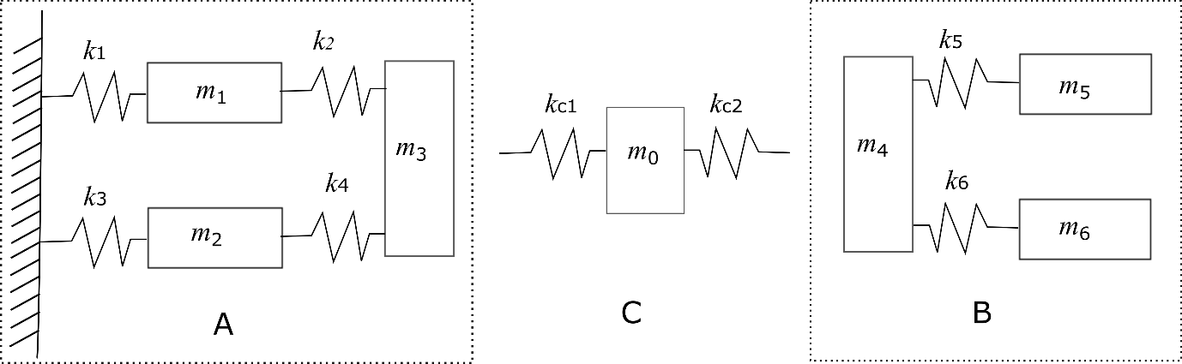

Fig. 3 substructure A and B coupled through link C

Table 1 Substructures parameters

|  |  |
| --- | --- |
| Mass elements (kg) | $m_{1}=5$*, $m_{2}=4$, $m_{3}=7$, $m_{4}=4$*  *, $m_{5}=2$, $m_{6}=1$* |
| Stiffness elements (N/m) | $1×{10}^{5}$ for all |

In this example, link C takes the form of spring-mass-spring, as shown in Fig. 3. Suppose the parameters of this link are denoted by $\left(k_{c1}, k_{c2}, m_{0}\right)$, the dynamic stiffness matrix of this link is

$$Z^{C}(f)=\left[\begin{matrix}k_{c1} & -k_{c1} & 0 \\ -k_{c1} & k_{c1}+k_{c2}-{m_{0}(2πf)}^{2} & -k_{c2} \\ 0 & -k_{c2} & k_{c2}\end{matrix}\right]$$

Table 2 Natural frequencies of substructures A and B

|  |  |  |  |
| --- | --- | --- | --- |
| Mode | 1 | 2 | 3 |
| Substructure A (Hz) | 15.98 | 33.34 | 40.46 |
| Substructure B (Hz) | 0 | 40.47 | 58.55 |

The receptance matrix at the desired frequency value is

$${\tilde{H}}_{CC}(f)={\left[\begin{matrix}h_{33}^{A} & 0 & 0 \\ 0 & α1 & 0 \\ 0 & 0 & h_{44}^{B}\end{matrix}\right]=10}^{-5}\left[\begin{matrix}7.84 & 0 & 0 \\ 0 & 1 & 0 \\ 0 & 0 & -1.50\end{matrix}\right]$$

According to equation (9), the optimization problem in this example would be

$$min\left\{det\left({\tilde{I}}^{C}+{\tilde{H}}_{CC}(f)Z^{C}(f)\right)\right\}$$

This optimization problem can be solved using MATLAB built-in function *fmincon*. If $k_{c1}=1×{10}^{5}$ N/m, the obtained result is $k_{c2}=0.28×{10}^{5}$ N/m, $m_{0}=6.75$ kg.

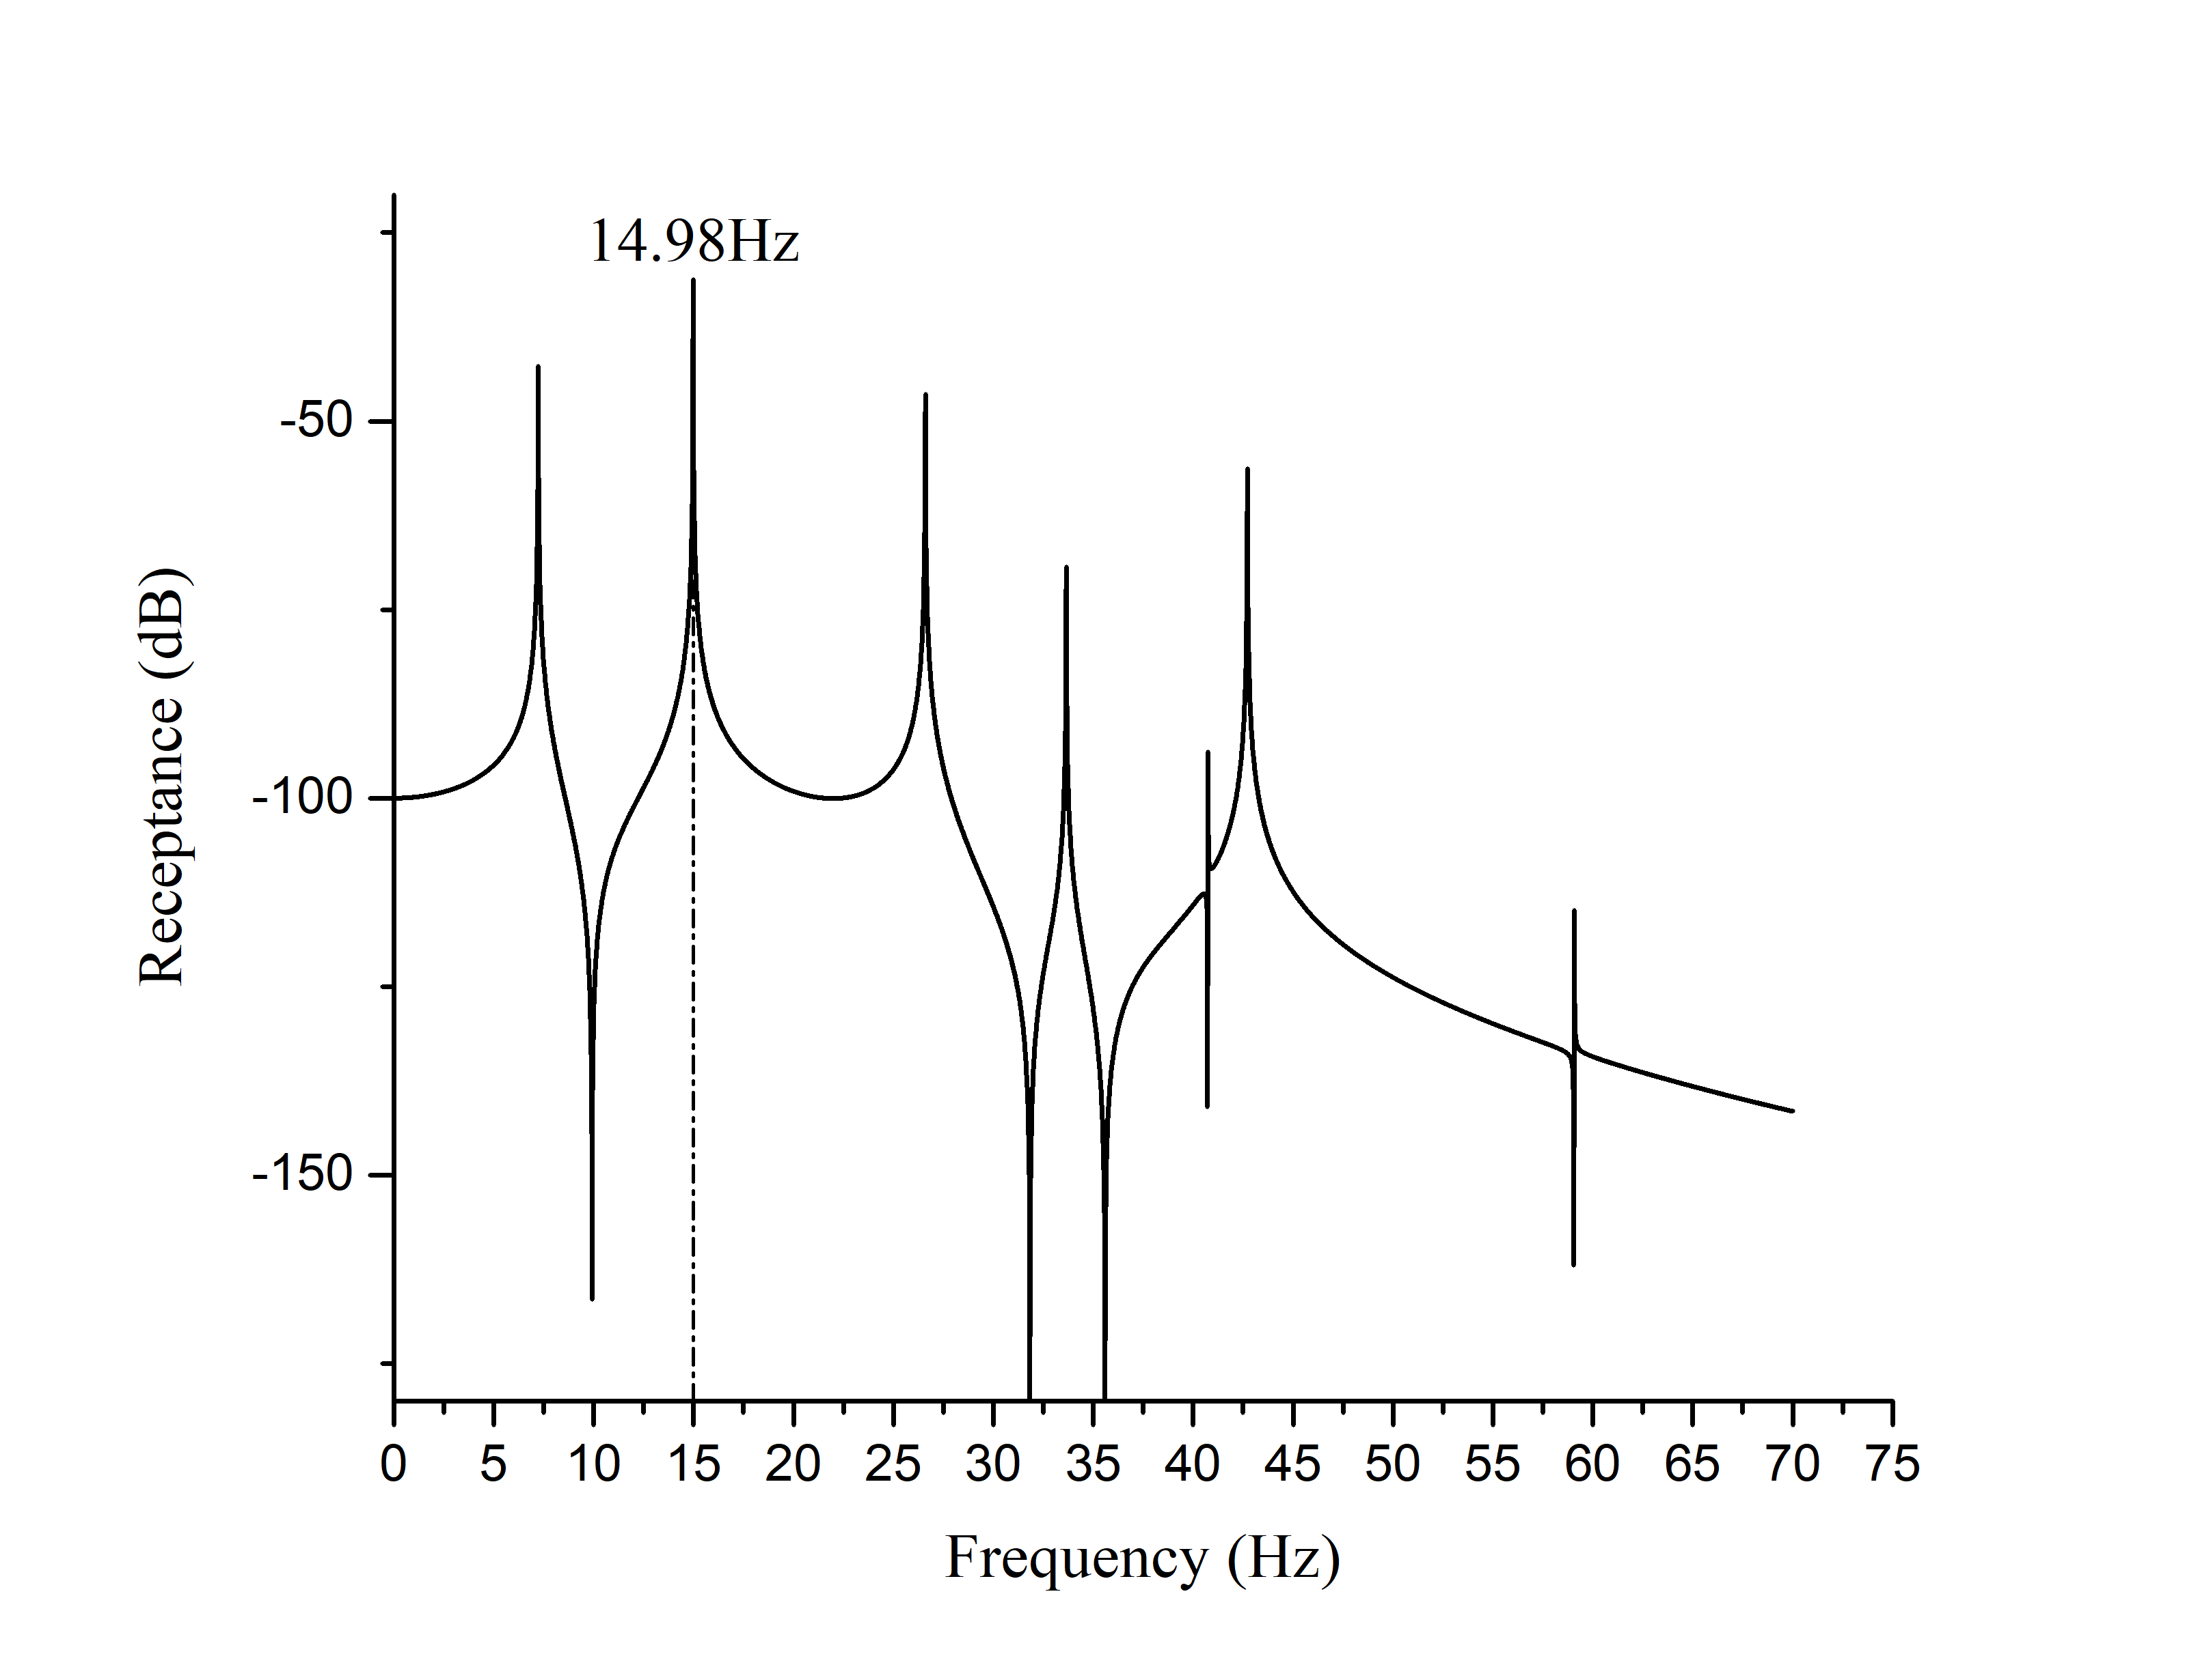

Fig. 4 Frequency response function $h_{34}$ of the assembled structure

Fig. 4 shows the frequency response function $h_{34}$ of the assemble structure. Apparently the obtained natural frequency 14.98 Hz is very close to desired frequency 15 Hz. In fact, there are multiple solutions in this optimization problem. One could choose a desired solution based on other criteria, such as a restriction on the value of the mass or stiffness.

## Continuous structure with multiple continuous links

Consider two frame structures A (in dark colour) and B (in light colour), which are composed of mild steel beams, are connected by four links at the mid-points of their four sides. Frame B is placed at the centre of frame A. The corresponding finite element models are shown in Fig. 5. The finite element model of frame A has 14 nodes and 6 beams with two of them grounded. The finite element model of frame B has 12 nodes and 4 beams. Each node has 3 degrees of freedom (a horizontal translation and a vertical translation, and a rotation). The material properties of frames A and B, and links C are the same. The Young’s modulus is 210GPa and the density is 7850 kg/m3. The cross-sectional areas of frames A and B are described in Table 3. The four links consist of two horizontal beams and two vertical beams. The cross-sectional areas of those link beams are optimized to assign (1) one natural frequency $f=35$ Hz, and (2) two natural frequencies simultaneously, $f_{1}=35$ Hz and $f_{2}=100$ Hz.

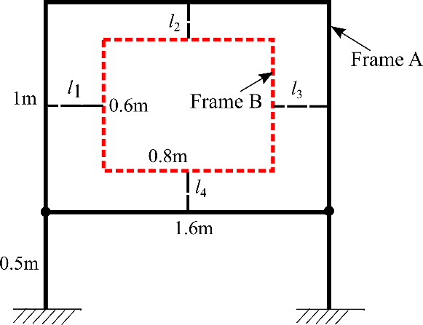 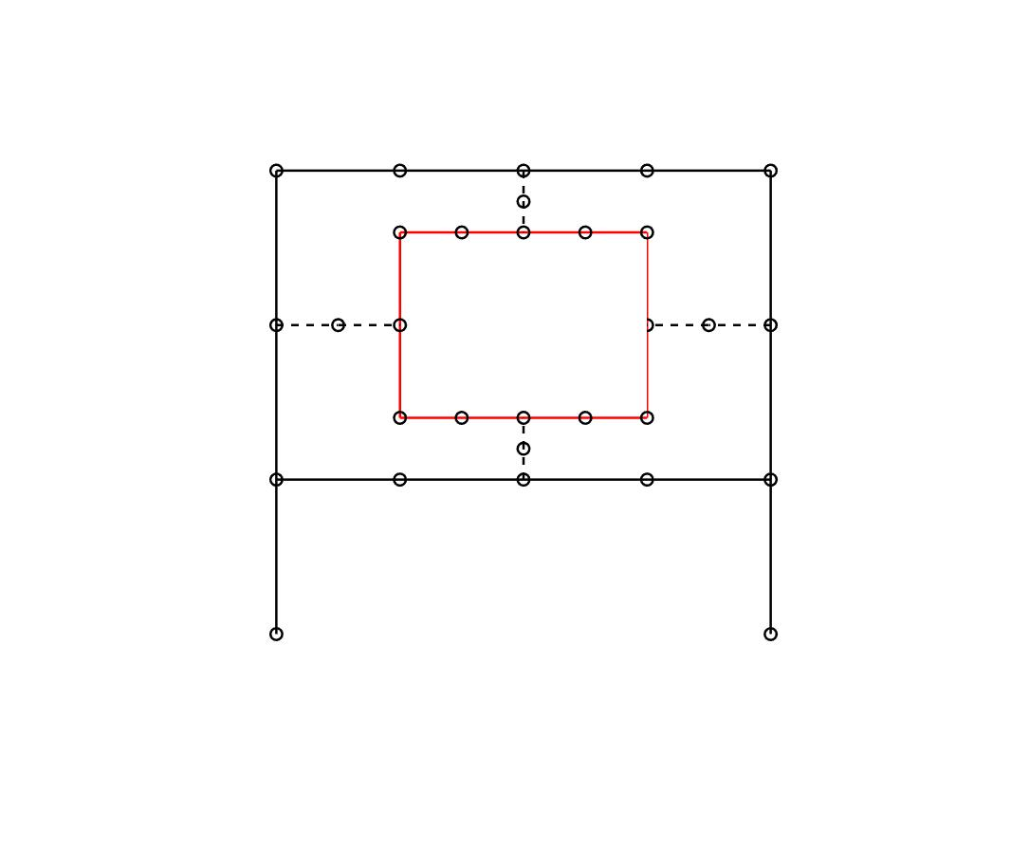

Fig. 5 Finite element model of frames A and B and links

Table 3 Cross-sectional areas of frames A and B

|  |  |  |  |
| --- | --- | --- | --- |
| Cross area of Frame A | | Cross area of Frame B | |
| width (m) | height(m) | width (m) | height(m) |
| 0.08 | 0.06 | 0.05 | 0.04 |

In this example, the lengths of those links are prescribed. The cross section shapes of the four links are square and the design variables are the heights (or breadths) of these cross-sections, which are denoted by $\left(b_{l_{1}},b_{l_{2}},b_{l_{3}},b_{l_{4}}\right)$ respectively.

For the first problem, assuming $b_{l_{1}}=b_{l_{3}}$ and $b_{l_{2}}=b_{l_{4}}$, which means the two horizontal links are identical and the two vertical links are identical too, so there are only two design variables $\left(b_{l_{1}},b_{l_{2}}\right)$. The lower bound and upper bound of these design variables are 0.03m and 0.08m. Then substutiting the receptance matrices of frames A and B into equation (10), the values of $b_{l_{1}}=0.037$ m, $b_{l_{2}}=0.039$ m are obtained. Receptance $h_{38,44}$ of the assembled structure is shown in Fig. 6 with a natural frequency at 34.99 Hz. The first 5 natural frequencies of assembled structure are collected in Table 4 (The bold number in Table 4 indicates the assigned frequency for the assembled structure. The bold numbers in Tables 5 and 6 have the same meaning).



Fig. 6 Frequency response function $h_{38,44}$ with one assigned frequency

Table 4 First 5 natural frequencies of assembled structure with one assigned frequency

|  |  |  |  |  |  |
| --- | --- | --- | --- | --- | --- |
| Mode | 1 | 2 | 3 | 4 | 5 |
| Frequency (Hz) | **34.99** | 87.06 | 110.15 | 112.16 | 122.23 |

In the second problem, two frequencies are to be assigned to the assembled structure. Let $b_{l_{2}}=b_{l_{4}}$, which leaves 3 design variables $\left(b_{l_{1}},b_{l_{2}},b_{l_{3}}\right)$ in this optimization problem. If the lower bound and upper bound of those design variables are still 0.03m and 0.08m, from equation (10), the optimized results obtained are $b_{l_{1}}=0.058$ m, $b_{l_{2}}=0.03$ m, and $b_{l_{3}}=0.043$ m. Fig. 7 shows receptance $h_{38,44}$ of the assembled structure with optimized links. This figure indicates that the first two natural frequencies of the assembled structure are 35.40Hz and 100 Hz, which are very close to the desired frequencies. The first 5 natural frequencies of this assembled structure are listed in Table 5.



Fig. 7 Frequency response function $h_{38,44}$ with two assigned frequencies

Table 5 First 5 natural frequencies of assembled structure with two assigned frequencies

|  |  |  |  |  |  |
| --- | --- | --- | --- | --- | --- |
| Mode | 1 | 2 | 3 | 4 | 5 |
| Frequency (Hz) | **35.40** | **100.00** | 108.08 | 112.05 | 143.91 |

On the other hand, if the lower bound and upper bound of those design variables are 0.003m and 0.04m, the obtained results are $b_{l_{1}}=0.008$ m, $b_{l_{2}}=0.014$ m, and $b_{l_{3}}=0.003$ m. The first 5 natural frequencies of this new assembled structure are presented in Table 6. It should be noticed that the assigned frequencies 34.99 Hz and 101.31 Hz, are the second and fifth natural frequencies, respectively.

Table 6 First 5 natural frequencies of assembled structure with two assigned frequencies

|  |  |  |  |  |  |
| --- | --- | --- | --- | --- | --- |
| Mode | 1 | 2 | 3 | 4 | 5 |
| Frequency (Hz) | 21.91 | **34.99** | 69.34 | 91.04 | **101.31** |

## Discussion

In the above examples, there are usually more than one solution for each assignment problem. As shown in section 3.2, there are two different solutions with different lower bounds and upper bounds. Although both solutions could assign the desired frequencies, the actually assigned frequencies correspond to different modes in the two solutions and thus the resulting assembled structures will have different dynamic behaviours. This is because mode shapes are not involved in this frequency assigment method, unlike a prevoius method reported in (Ouyang et al., 2012). Therefore, a further optimization, determining which solution is optimal among a number of feasible solutions that all assign the desired frequencies should be useful. This optimial solution could be determined based on other specific requirements, such as the restrictions on the paramenters of links, or the corresponding mode shapes, as constraints to the optimization problem described in equation (8). However, this work is beyond the scope of this paper and will be studied in future.

One drawback of this method is that it requires the theoretical models (usually finite element models) of the links. However, this is unavoidable for an inverse assignment method because the modifications are unknown and cannot be measured beforehand. A theoretical model allows its frequecnies to be associated with its structural properties and thus can be used in the optimization algorithm used, which requires a repeated use of the theoretical model with different structural propertise in the iterations. For simple links, such as mass-spring systems, beams or rods, it is quite easy to build theoretical models for them. On the other hand, it is difficult to model complex links accurately. However, the links are usually much simpler than the uncoupled substructures. Their possible lack of modelling accuracy would not have a big impact on the accuracy of frequency assignment, in the context of very complicated assembled structures. There are ways to reduce the inaccuracy of the theoretical models of complex links. For example, if a link is to be a complex structure, one can divide the link into modificable parts and unmodificable parts. The unmodificable parts could be measured by building real structures for them so that those structures would become another substructures. The modificable parts should be as simple as possible. It would be easier to build accurate theoretical models for these simple modificable parts. Engineering applications of this method will be investigated in the near future.

# Conclusions

This paper presents a receptance-based frequency assignment method for assembled structures. This method maintains the original substructures designed for specific requirements and the assignment is achieved through modifying the links that connect the uncoupled original substructures. Those added links can be discrete structures or continuous structures. This method only requires the receptances of the uncoupled substructures at the connection points of the links which can be measured accurately and easily in practice, and the theoritical models of links which are usualy much simpler than the uncoupeld substructures are thus are easy to build and accurate.

Assigning frequency for an assembled structure using this method involves multiple substructrues. The modifications in this paper, as links, introduce extra degrees of freedom for the whole assembled structure. The proposed methodology works well for any number of links and substructures. Two numerical exampels are presented to validate this proposed method.

Acknowledgements

The first author is grateful to Dr Sung-han Tsai and Prof Jiafan Zhang for the helpful discussions and for the support of University of Liverpool in the form of a PhD scholarship.

**Declaration of conflicting interests**

The authors declare that there is no conflict of interest with respect to the research, authorship, and/or publication of this article.

Appendix

The simplification process from equation (6) to equation (7) is discussed here in details. Equation (6) indicates that frequency assignment could be achieved if

|  |  |  |
| --- | --- | --- |
|  | $$det\left(\tilde{I}+\tilde{H}Δ\tilde{Z}\right)=0$$ | (A1) |

This equation could be expanded as

$det\left(\left[\begin{matrix}I_{a} & 0 & 0 & 0 & 0 & 0 & 0 & 0 \\ 0 & I_{p} & 0 & 0 & 0 & 0 & 0 & 0 \\ 0 & 0 & I_{i} & 0 & 0 & 0 & 0 & 0 \\ 0 & 0 & 0 & 0 & 0 & 0 & 0 & 0 \\ 0 & 0 & 0 & 0 & 0 & 0 & 0 & 0 \\ 0 & 0 & 0 & 0 & 0 & I_{q} & 0 & 0 \\ 0 & 0 & 0 & 0 & 0 & 0 & I_{j} & 0 \\ 0 & 0 & 0 & 0 & 0 & 0 & 0 & I_{b}\end{matrix}\right]+\left[\begin{matrix}H_{aa}^{A} & H_{ap}^{A} & H_{ai}^{A} & 0 & 0 & 0 & 0 & 0 \\ H_{pa}^{A} & H_{pp}^{A} & H_{pi}^{A} & 0 & 0 & 0 & 0 & 0 \\ H_{ia}^{A} & H_{ip}^{A} & H_{ii}^{A} & 0 & 0 & 0 & 0 & 0 \\ 0 & 0 & 0 & I_{c} & 0 & 0 & 0 & 0 \\ 0 & 0 & 0 & 0 & I_{d} & 0 & 0 & 0 \\ 0 & 0 & 0 & 0 & 0 & H_{qq}^{B} & H_{qj}^{B} & H_{qb}^{B} \\ 0 & 0 & 0 & 0 & 0 & H_{jq}^{B} & H_{jj}^{B} & H_{jb}^{B} \\ 0 & 0 & 0 & 0 & 0 & H_{bq}^{B} & H_{bj}^{B} & H_{bb}^{B}\end{matrix}\right]\left[\begin{matrix}0 & 0 & 0 & 0 & 0 & 0 & 0 & 0 \\ 0 & Z_{pp}^{C} & 0 & Z_{pc}^{C} & 0 & Z_{pq}^{C} & 0 & 0 \\ 0 & 0 & Z_{ii}^{D} & 0 & Z_{id}^{D} & 0 & Z_{ij}^{D} & 0 \\ 0 & Z_{cp}^{C} & 0 & Z_{cc}^{C} & 0 & Z_{cq}^{C} & 0 & 0 \\ 0 & 0 & Z_{di}^{D} & 0 & Z_{dd}^{D} & 0 & Z_{dj}^{D} & 0 \\ 0 & Z_{qp}^{C} & 0 & Z_{qc}^{C} & 0 & Z_{qq}^{C} & 0 & 0 \\ 0 & 0 & Z_{ji}^{D} & 0 & Z_{jd}^{D} & 0 & Z_{jj}^{D} & 0 \\ 0 & 0 & 0 & 0 & 0 & 0 & 0 & 0\end{matrix}\right]\right)=0$ (A2)

It can also be rewritten as

$det\left(\left[\begin{matrix}I_{a} & H_{ap}^{A}Z_{pp}^{C} & H_{ai}^{A}Z_{ii}^{D} & H_{ap}^{A}Z_{pc}^{C} & H_{ai}^{A}Z_{id}^{D} & H_{ap}^{A}Z_{pq}^{C} & H_{ai}^{A}Z_{ij}^{D} & 0 \\ 0 & I_{p}+H_{pp}^{A}Z_{pp}^{C} & H_{pi}^{A}Z_{ii}^{D} & H_{pp}^{A}Z_{pc}^{C} & H_{pi}^{A}Z_{id}^{D} & H_{pp}^{A}Z_{pq}^{C} & H_{pi}^{A}Z_{ij}^{D} & 0 \\ 0 & H_{ip}^{A}Z_{pp}^{C} & I_{i}+H_{ii}^{A}Z_{ii}^{D} & H_{ip}^{A}Z_{pc}^{C} & H_{ii}^{A}Z_{id}^{D} & H_{ip}^{A}Z_{pq}^{C} & H_{ii}^{A}Z_{ij}^{D} & 0 \\ 0 & Z_{cp}^{C} & 0 & Z_{cc}^{C} & 0 & Z_{cq}^{C} & 0 & 0 \\ 0 & 0 & Z_{di}^{D} & 0 & Z_{dd}^{D} & 0 & Z_{dj}^{D} & 0 \\ 0 & H_{qq}^{B}Z_{qp}^{C} & H_{qj}^{B}Z_{ji}^{D} & H_{qq}^{B}Z_{qc}^{C} & H_{qj}^{B}Z_{jd}^{D} & I_{q}+H_{qq}^{B}Z_{qq}^{C} & H_{qj}^{B}Z_{jj}^{D} & 0 \\ 0 & H_{jq}^{B}Z_{qp}^{C} & H_{jj}^{B}Z_{ji}^{D} & H_{jq}^{B}Z_{qc}^{C} & H_{jj}^{B}Z_{jd}^{D} & H_{jq}^{B}Z_{qq}^{C} & I_{j}+H_{jj}^{B}Z_{jj}^{D} & 0 \\ 0 & H_{bq}^{B}Z_{qp}^{C} & H_{bj}^{B}Z_{ji}^{D} & H_{bq}^{B}Z_{qc}^{C} & H_{bj}^{B}Z_{jd}^{D} & H_{bq}^{B}Z_{qq}^{C} & H_{bj}^{B}Z_{jj}^{D} & I_{b}\end{matrix}\right]\right)=0$ (A3)

According to Leibniz formula for determinants, this equation equals to

$det\left(\left[\begin{matrix}I_{p}+H_{pp}^{A}Z_{pp}^{C} & H_{pi}^{A}Z_{ii}^{D} & H_{pp}^{A}Z_{pc}^{C} & H_{pi}^{A}Z_{id}^{D} & H_{pp}^{A}Z_{pq}^{C} & H_{pi}^{A}Z_{ij}^{D} \\ H_{ip}^{A}Z_{pp}^{C} & I_{i}+H_{ii}^{A}Z_{ii}^{D} & H_{ip}^{A}Z_{pc}^{C} & H_{ii}^{A}Z_{id}^{D} & H_{ip}^{A}Z_{pq}^{C} & H_{ii}^{A}Z_{ij}^{D} \\ Z_{cp}^{C} & 0 & Z_{cc}^{C} & 0 & Z_{cq}^{C} & 0 \\ 0 & Z_{di}^{D} & 0 & Z_{dd}^{D} & 0 & Z_{dj}^{D} \\ H_{qq}^{B}Z_{qp}^{C} & H_{qj}^{B}Z_{ji}^{D} & H_{qq}^{B}Z_{qc}^{C} & H_{qj}^{B}Z_{jd}^{D} & I_{q}+H_{qq}^{B}Z_{qq}^{C} & H_{qj}^{B}Z_{jj}^{D} \\ H_{jq}^{B}Z_{qp}^{C} & H_{jj}^{B}Z_{ji}^{D} & H_{jq}^{B}Z_{qc}^{C} & H_{jj}^{B}Z_{jd}^{D} & H_{jq}^{B}Z_{qq}^{C} & I_{j}+H_{jj}^{B}Z_{jj}^{D}\end{matrix}\right]\right)=0$ (A4)

Since the matrix determinant would not change by swapping rows and columns, equation (A4) could be recast as

|  |  |  |
| --- | --- | --- |
|  | $$det\left(\left[\begin{matrix}I_{p}+H_{pp}^{A}Z_{pp}^{C} & H_{pp}^{A}Z_{pc}^{C} & H_{pp}^{A}Z_{pq}^{C} & H_{pi}^{A}Z_{ii}^{D} & H_{pi}^{A}Z_{id}^{D} & H_{pi}^{A}Z_{ij}^{D} \\ Z_{cp}^{C} & Z_{cc}^{C} & Z_{cq}^{C} & 0 & 0 & 0 \\ H_{qq}^{B}Z_{qp}^{C} & H_{qq}^{B}Z_{qc}^{C} & I_{q}+H_{qq}^{B}Z_{qq}^{C} & H_{qj}^{B}Z_{ji}^{D} & H_{qj}^{B}Z_{jd}^{D} & H_{qj}^{B}Z_{jj}^{D} \\ 0 & Z_{di}^{D} & 0 & Z_{dd}^{D} & 0 & Z_{dj}^{D} \\ H_{ip}^{A}Z_{pp}^{C} & H_{ip}^{A}Z_{pc}^{C} & H_{ip}^{A}Z_{pq}^{C} & I_{i}+H_{ii}^{A}Z_{ii}^{D} & H_{ii}^{A}Z_{id}^{D} & H_{ii}^{A}Z_{ij}^{D} \\ 0 & 0 & 0 & Z_{di}^{D} & Z_{dd}^{D} & Z_{dj}^{D} \\ H_{jq}^{B}Z_{qp}^{C} & H_{jq}^{B}Z_{qc}^{C} & H_{jq}^{B}Z_{qq}^{C} & H_{jj}^{B}Z_{ji}^{D} & H_{jj}^{B}Z_{jd}^{D} & I_{j}+H_{jj}^{B}Z_{jj}^{D}\end{matrix}\right]\right)=0$$ | (A5) |

Then it could be reformed as

$det\left(\left[\begin{matrix}I_{p} & 0 & 0 & 0 & 0 & 0 \\ 0 & 0 & 0 & 0 & 0 & 0 \\ 0 & 0 & I_{q} & 0 & 0 & 0 \\ 0 & 0 & 0 & I_{i} & 0 & 0 \\ 0 & 0 & 0 & 0 & 0 & 0 \\ 0 & 0 & 0 & 0 & 0 & I_{j}\end{matrix}\right]+\left[\begin{matrix}H_{pp}^{A} & 0 & 0 & H_{pi}^{A} & 0 & 0 \\ 0 & I_{c} & 0 & 0 & 0 & 0 \\ 0 & 0 & H_{qq}^{B} & 0 & 0 & H_{qj}^{B} \\ H_{ip}^{A} & 0 & 0 & H_{ii}^{A} & 0 & 0 \\ 0 & 0 & 0 & 0 & I_{d} & 0 \\ 0 & 0 & H_{jq}^{B} & 0 & 0 & H_{jj}^{B}\end{matrix}\right]\left[\begin{matrix}Z_{pp}^{C} & Z_{pc}^{C} & Z_{pq}^{C} & 0 & 0 & 0 \\ Z_{cp}^{C} & Z_{cc}^{C} & Z_{cq}^{C} & 0 & 0 & 0 \\ Z_{qp}^{C} & Z_{qc}^{C} & Z_{qq}^{C} & 0 & 0 & 0 \\ 0 & 0 & 0 & Z_{ii}^{D} & Z_{id}^{D} & Z_{ij}^{D} \\ 0 & 0 & 0 & Z_{di}^{D} & Z_{dd}^{D} & Z_{dj}^{D} \\ 0 & 0 & 0 & Z_{ji}^{D} & Z_{jd}^{D} & Z_{jj}^{D}\end{matrix}\right]\right)=0$ (A6)

In a compact form

|  |  |  |
| --- | --- | --- |
|  | $$det\left(\left[\begin{matrix}{\tilde{I}}^{C} & 0 \\ 0 & {\tilde{I}}^{D}\end{matrix}\right]+\left[\begin{matrix}{\tilde{H}}_{CC} & {\tilde{H}}_{CD} \\ {\tilde{H}}_{DC} & {\tilde{H}}_{DD}\end{matrix}\right]\left[\begin{matrix}Z^{C} & 0 \\ 0 & Z^{D}\end{matrix}\right]\right)=0$$ | (A7) |

So the equation (7) in section 2 is derived.

References

Baldwin JF and Hutton SG (1985) Natural modes of modified structures. *AIAA Journal* 23(11): 1737-1743.

Birchfield N, Singh KV and Singhal S (2013) Dynamical Structural Modification for Rotordynamic Application*.* In: 2013 International design engineering technical conferences and computers and information in engineering conference, Portland, OR, 4-7 August 2013. New York, USA, *American Society of Mechanical Engineers*.

Braun S and Ram Y (2001) Modal modification of vibrating systems: some problems and their solutions. *Mechanical Systems and Signal Processing* 15(1): 101-119.

Bucher I and Braun S (1993) The structural modification inverse problem: an exact solution. *Mechanical Systems and Signal Processing* 7(3): 217-238.

Çakar O (2011) Mass and stiffness modifications without changing any specified natural frequency of a structure. *Journal of Vibration and Control* 17(5): 769-776.

Craig Jr RR and Chang C (1977) Substructure coupling for dynamic analysis and testing. Washington, USA: National Aeronautics and Space Administration.

Craig R and Bampton M (1968) Coupling of substructures for dynamic analyses. AIAA Journal 6 (7): 1313-1319.

D’Ambrogio W and Sestieri A (2004) A unified approach to substructuring and structural modification problems. *Shock and Vibration* 11(3-4): 295-309.

De Klerk D, Rixen DJ and de Jong J (2006) The Frequency Based Substructuring (FBS) method reformulated according to the dual domain decomposition method*.* In 24th International Modal Analysis Conference, St. Louis, MO, 30 Jan-2 Feb 2006. Bethel, Connecticut, USA: Society for experimental Mechanics.

Hang H, Shankar K and Lai JC (2010) Effects of distributed structural dynamic modification with additional degrees of freedom on 3D structure. *Mechanical Systems and Signal Processing* 24(5): 1349-1368.

Imregun M (1987) Structural modification and coupling dynamic analysis using measured FRF data*.* 5th International Modal Analysis Conference, London, England, 6-9 April 1987, p. 1136. New York, USA: Union College.

Joseph K (1992) Inverse eigenvalue problem in structural design. *AIAA Journal* 30(12): 2890-2896.

Klerk Dd, Rixen DJ and Voormeeren S (2008) General framework for dynamic substructuring: history, review and classification of techniques. *AIAA Journal* 46(5): 1169-1181.

Kyprianou A, Mottershead JE and Ouyang H (2005) Structural modification. Part 2: assignment of natural frequencies and antiresonances by an added beam. *Journal of Sound and Vibration* 284(1-2): 267-281.

Kyprianou A, Mottershead JE and Ouyang H (2004) Assignment of natural frequencies by an added mass and one or more springs. *Mechanical Systems and Signal Processing* 18(2): 263-289.

Li T and He J (1999) Local structural modification using mass and stiffness changes. *Engineering Structures* 21(11): 1028-1037.

Liangsheng W (2003) Direct method of inverse eigenvalue problems for structure redesign. *Journal of Mechanical Design* 125(4): 845-847.

Liu W and Ewins D (2000) Substructure synthesis via elastic media Part II: coupling analysis. *Iic* 200: 17.

Matthias W, Özşahin O, Altintas Y and Denkena B (2016) Receptance coupling based algorithm for the identification of contact parameters at holder–tool interface. *CIRP Journal of Manufacturing Science and Technology* 13: 37-45.

Mehrpouya M, Graham E and Park SS (2015) Identification of multiple joint dynamics using the inverse receptance coupling method. *Journal of Vibration and Control* 21(16): 3431-3449.

Mottershead J (2001) Structural modification for the assignment of zeros using measured receptances. *J.Appl.Mech.* 68(5): 791-798.

Mottershead JE, Kyprianou A and Ouyang H (2005) Structural modification. Part 1: rotational receptances. *Journal of Sound and Vibration* 284(1-2): 249-265.

Nylen P and Uhlig F (1997) Inverse eigenvalue problem: existence of special spring-mass systems. *Inverse Problems* 13(4): 1071.

Olsson P and Lidström P (2007) Inverse structural modification using constraints. *Journal of Sound and Vibration* 303(3-5): 767-779.

Ouyang H, Richiedei D, Trevisani A and Zanardo G (2012) Eigenstructure assignment in undamped vibrating systems: a convex-constrained modification method based on receptances*. Mechanical Systems and Signal Processing, 271 pp.397-409.*

Ren Y and Beards C (1995) On substructure synthesis with FRF data. *Journal of Sound and Vibration* 185(5): 845-866.

Schmitz TL and Donalson R (2000) Predicting high-speed machining dynamics by substructure analysis. *Cirp Annals* 49(1): 303-308.

Tsai S, Ouyang H and Chang J (2018) Inverse structural modifications of a geared rotor-bearing system for frequency assignment using measured receptances. *Mechanical Systems and Signal Processing* 110: 59-72.

Tsuei Y and Yee EK (1989) A method for modifying dynamic properties of undamped mechanical systems. *Journal of Dynamic Systems, Measurement, and Control* 111(3): 403-408.

Wang Z and Wang J (2011) Inverse substructure method of three-substructures coupled system and its application in product-transport-system. *Journal of Vibration and Control* 17(6): 943-951.

Yee EK and Tsuei Y (1991) Method for shifting natural frequencies of damped mechanical systems. *AIAA Journal* 29(11): 1973-1977.

Zhu J, Mottershead JE and Kyprianou A (2009) An inverse method to assign receptances by using classical vibration absorbers. *Journal of Vibration and Control* 15(1): 53-84.

1. Corresponding author: Huajiang Ouyang, Email: h.ouyang@liverpool.ac.uk