**Effects of He Ion Irradiation in Simple Borosilicate Glasses for HLW Immobilisation – 20324**

Prince Rautiyal *, Ruth Edge**, Laura Leay **, Aaron Daubney **, Maulik Patel ***, Pawan K. Kulriya****, Alan H. Jones*, and Paul A. Bingham*\**

*Materials and Engineering Research Institute, Sheffield Hallam University, Sheffield S1 1WB, UK

** University of Manchester, Dalton Cumbrian Facility, Westlakes Science and Technology Park, Moor Row, Cumbria CA24 3H, UK  
*** Dept. Mechanical Materials and Aerospace, University of Liverpool, Liverpool, L69 3GH, UK

**** Inter University Accelerator Centre, New Delhi, 110067, India

**ABSTRACT**

High-level radioactive waste (HLW) consists of fission products and minor actinides. Borosilicate glass is the host material of choice in most countries to safely immobilize HLW, followed by eventual geological disposal. HLW glasses will experience both self-heating and self-irradiation effects due to the decay of fission products and minor actinides present therein. During the first 500 years of geological disposal, beta-gamma decay will be the main source of radiation due to short half-lives of fission products, as compared to very long-lived actinides which will be responsible for irradiation over much longer timescales. High-energy alpha particles and alpha recoil nuclei can potentially have significant impact (stored energy, volume change, accumulated dose, chemical durability) on the performance of the wasteform over longer timescales. Thus, to ensure safe and economic disposal over geological periods (104 - 106 years), the assessment of performance and properties in terms of radiation effects becomes indispensable. This work aims to simulate the effects of alpha decay in radioactive waste glasses. Two international glasses, namely UK “MW” lithium-sodium borosilicate and Indian sodium-barium borosilicate, which are being used as HLW immobilization matrices by the UK and India respectively, were prepared by a melt-quench method and annealed below their glass transition temperatures. Both glasses were irradiated with 650 KeV He2+ ions with doses ranging from 1015 to 1017 ions/cm2. Structural analysis was carried out using electron paramagnetic resonance (EPR) and Raman spectroscopies. First-derivative continuous wave EPR spectra were recorded for all pristine and irradiated glass monoliths at room temperature using an X-band (frequency 9.6 GHz) EPR Bruker spectrometer. Results from EPR analyses showed the formation of irradiation induced paramagnetic centers at g ~ 2.00 in all irradiated glasses. Raman spectra of pristine and irradiated samples were acquired, and showed notable changes in glass structure post-irradiation, with the emergence of a broad Raman band at 1560 cm-1 upon irradiation with high fluences.

**INTRODUCTION**

High-level waste (HLW) management is a global challenge. To prevent any dispersal of radioactivity into the environment and for safer and easier transport, HLW is concentrated and contained in a solid glassy wasteform. Vitrification with borosilicate glass has been in progress at industrial level since the 1970s. Research has been underway to understand the long-term behavioral issues, structural evolution under irradiation and chemical durability of glass wasteforms in deep geological repositories. Among these issues, the structural evolution of waste forms under irradiation is less well understood and yet is of primary importance. HLW consists of fission products (e.g. 137Cs, 90Sr) which are beta-gamma emitters; and minor actinides (e.g. 237Np, 241,243Am, 244, 245Cm) which are alpha emitters and have very long half-lives (e.g. 2.15 million years for 237Np). Due to the presence of these radionuclides in HLW, the performance of wasteform glass matrices can be significantly altered by radiation damage through structural changes [1][2][3]. Following vitrification and during geological disposal, the accumulation of damage arising from alpha decay of minor actinides may impact on the durability of these wasteforms. This is one of the many challenging research areas which need to be addressed, to develop the most robust safety cases possible, for long-term radioactive waste disposal. Whilst this damage will be accumulated over 104 years, it is critical to carry out accelerated testing in order to predict long-term wasteform performance. Relatively few approaches can be used to represent or re-create, on a lab-scale, the self-irradiation conditions experienced by vitrified wasteforms in a geological repository: one such method is ion-implantation. In order to study the self-irradiation effects of alpha decay, many research groups have performed external light and heavy ion irradiations using accelerated particle beams to simulate the effect of alpha particle and alpha recoil nuclei respectively [4]. Mechanical properties such as hardness, Young’s modulus, density and fracture toughness have been studied in detail [4][5][6]. Optical properties such as refractive indices, absorption and color centers have been studied using techniques including UV-Vis IR and PL spectroscopies [7]. Structural changes such as network connectivity (network polymerization or depolymerization) are studied by analyzing changes in the bridging and non-bridging oxygen atoms in the borosilicate network. Coordination, bond angles and bond distances have been studied and observed using Raman, NMR, Rutherford backscattering, X-ray absorption and Mӧssbauer spectroscopies [8][9][10][11]. Oxygen and He bubble formation, volume changes/swelling and He accumulation have also been studied using techniques such as TEM and SEM [4][10]. Also, simulation and modelling studies have studied radiation damage [12][13]. The effects of alpha decay on the self-irradiation damage in vitrified HLW wasteforms have received attention, yet there is still only limited understanding of the types and nature of radiation-induced defects induced in different wasteforms; of the evolution of those defects with dose and time; of their stability in geological conditions; and of the damaging effects associated with them. Thus, the aim of the present study is to gain improved understanding of the fundamental He-ion induced defect types in relatively simple, representative borosilicate base glasses; and to understand any differences arising on the basis of glass composition.

**EXPERIMENTAL**

**Glass Fabrication**

The UK representative base glass for HLW vitrification is named “MW” (Mixture Windscale) glass, and the Indian representative base glass is a sodium-barium borosilicate glass. The UK and the Indian glasses have the following compositions (mol%): 60.5SiO2-18.5B2O3-10.5Na2O-10.5Li2O (UK) and 41.6SiO2-20.8B2O3-21.8Na2O-15.6BaO (Indian). Both glasses were synthesized using a standard melt-pour-anneal method. The UK glass was melted in an Al2O3 (alumina)crucible in an electric furnace in air at 1150˚C for 2 h; poured into a steel mould; and annealed near Tg (glass transition temperature) at 480˚C for 2 h. The Indian glass was melted in an Al2O3 crucible in an electric furnace in air at 1050˚C for 2 h; poured in a steel mould; and annealed near Tg at 480˚C for 2h. The glass samples were cut using a diamond precision saw to small samples of size ~ 1.5 x 1 cm2. They were then polished using SiC sheets of grit size of up to 1000 (approximate size of 8.4 micron) and polished using CeO2 (cerium oxide) for a smooth polished surface.

**Irradiation Experiments**

To simulate the damage from alpha particles, the UK and Indian glasses were irradiated with 650 KeV He2+ ions to fluences of 1x1015, 1x1016, 5x1016 and 1x1017 ions/cm2 using the Low Energy Ion Beam Facility (LEIBF) at the Inter-University Accelerator Center, India. Table I shows the ion beam parameters and energy loss calculated using SRIM-2013 software (The Stopping and Range of Ions in Matter) [14].

TABLE I. Electronic and nuclear stopping power of He2+ ions in UK and Indian base glasses

|  |  |  |  |  |  |
| --- | --- | --- | --- | --- | --- |
| **Glass** | **Ion type** | **Energy**  **(keV)** | **Electronic Stopping (Se) (keV/micron)** | **Nuclear stopping (Sn) (keV/micron)** | **Sn/Se** |
| Indian | He2+ | 650 | 414.6 | 0.711 | 0.001 |
| UK | He2+ | 650 | 399.1 | 0.678 | 0.001 |

**Electron Paramagnetic Resonance Spectroscopy**

First-derivative continuous wave monolithic sample EPR spectra were recorded for all glass samples at room temperature using an X-band frequency of 9.6 GHz and using a sweep width and center field of 370 and 250 mT, respectively, on a Bruker EMXnano EPR spectrometer. The magnetic field modulation used was 100 kHz. Measurements of the *g*-values were carried out using the formula *hv = gβ**H*, where *h* is Planck’s constant, *H* is the applied magnetic field measured at the center of resonance, *v* is the spectrometer frequency and *β* is the Bohr magneton.

**Raman Spectroscopy**

Raman spectra were acquired on pristine and irradiated samples using a depolarized 532nm excitation laser wavelength on a Thermo Scientific DXR2 Raman imaging microscope. Measurements were carried out over a spectral range 100-2000cm-1. Background correction was performed using the Raman software OMNIC and 30 accumulations of 15s each were acquired in order to provide suitable signal-to-noise ratio. Deconvolutions of all spectra obtained were carried out using ORIGIN Pro 9.0 software.

**RESULTS and DISCUSSION**

**Electron Paramagnetic Resonance Spectroscopy**

Fig.1. illustrates the first derivative X-band EPR spectra for the Indian base glass (Na-Ba-B-Si) implanted with He2+ with a range of fluences. An EPR signal centered at approximately g~2.00 is observed in all irradiated glass spectra, with varying linewidth between ~ 0.08 to 0.40 mT (for the lowest and the highest fluence-irradiated samples, respectively). The linewidth thus increases as a function of dose. Line broadening can occur for a number of reasons including non-uniformities in magnetic field, hyperfine interactions and uncertainty in energy levels. As the number of ions per cm2increased, the number of spins increased which thus increased the spin-spin interaction and contributed to line broadening of the g~2.00 EPR signal. The limited EPR S/N ratio and the low amplitude in some spectra may be due to the small irradiated volume and short-range penetration (~ 2.0 μm) of He2+ in the glass samples as calculated by SRIM. EPR resonances due to trapped-carriers are absent, however, the obtained line shapes could be considered similar with the line shape of peroxy-radicals (PORs) which have been reported to be more thermally stable than other defect centers such as BOHC (boron oxygen hole centers) or E’ centers [15][16][17]. We have as yet not identified evidence of PORs in He2+ ion-implanted borosilicate glasses in the literature. Fig.2 illustrates the first derivative X-band EPR spectra for the UK base glass (Na-Li-B-Si) implanted with He2+ with a range of fluences. As with the Indian base glass, all spectra exhibit resonances at g~2.00, with linewidths ranging from ~0.06 to 0.08 mT (for the lowest and the highest fluence-irradiated samples, respectively). Also, similarly to the Indian glass, there is no detected EPR signal that would be consistent with trapped carrier centers, and the line shape of the g~2.00 resonance is broadly similar to that of a peroxy-radical [15][16][17]. However, the S/N ratio limits observation of any underlying signal.



Fig 1. EPR spectra for Indian base glass irradiated with 650 KeV He2+ to fluences of 1x1015, 1x1016, 5x1016 and 1x1017 ions/cm2.



Fig 2. EPR spectra for UK base glass irradiated with 650 KeV He2+ to fluences of 1x1015, 1x1016, 5x1016 and 1x1017 ions/cm2.

**Raman Spectroscopy**

**Raman Band Assignments**

Fig.3. shows the Raman spectra of pristine and He2+ ion-implanted Indian borosilicate base glass. Unpolarized Raman spectra were obtained between 100-2000 cm-1 and were normalized using the maximum intensity of the Raman band in the spectrum. In Fig. 3. the region between 300 – 550 cm-1 is attributed to the mixed stretching and bending modes of Si-O-Si units. The band centered at 630 cm-1 is consistent with vibrations involving danburite units. The band centered at 750 cm-1 is attributed to 4-coordinated diborate and boroxol ring units. The region between 800-1250 cm-1 defines Si-O Qn-speciation region where *n* is the number of bridging oxygens. The peak at 1450 cm-1 is attributed to B-O units [18][19][20][21]. The band emerging at 1560 cm‑1 upon irradiation with high fluences is also notable but is as yet unassigned, although literature suggests that molecular oxygen can produce Raman bands at these Raman shifts [8][21].



Fig. 3. Raman spectra for the Indian base glass, pristine and irradiated with 650 KeV He2+ to fluences of 1x1015, 1x1016, 5x1016 and 1x1017 ions/cm2.

Fig.4 shows the Raman spectra of pristine and He2+ ion-implanted UK borosilicate base glass. The band at 510 cm-1 is attributed to Si-O-Si vibrational units and the band at 630 and 750 cm-1 is common to both the UK and Indian glasses. The band near 1450 cm-1 is characteristics of B-O vibration units.The Raman band at 1560 cm-1 becomes prominent after irradiation with 5x1016 ions/cm2 and becomes even more pronounced at a fluence of 1x1017 ions/cm2. Zhang *et al.* [19] found a narrow Raman band at 1550 cm-1 and attributed it to molecular O2 of the molecular oxygen after Ar-ion irradiation. Abbas *et al.* [6] found an increase in the band associated with molecular oxygen in a Kr-ion irradiated 6-oxide glass. However, this band, in both cases [6][19] is far too narrow to fully explain the broad band we observe at high irradiation fluences in both UK and Indian glasses. It is therefore unlikely that the band we observe at 1560 cm-1 is due solely to molecular O2 although molecular O2 contributions cannot be ruled out at this stage as providing a partial contribution. This new Raman band is also present in fig. 3. but appears only in the spectrum for the Indian glass sample implanted with the highest He2+ fluence. It is notable for both the Indian and UK (MW) glasses that the Raman band at 1450 cm-1 also increases in intensity (relative to Qn region) with increasing He2+ fluence. Since the band at 1450 cm-1 has been widely attributed to B-O units, one possible origin for the new band emerging at 1560 cm-1 may be that it is associated with changes to the boron units in the glass network. Further work, currently underway, is required to elucidate the origins of this band.



Fig. 4. Raman spectra for UK base glass irradiated with 650 KeV He2+ at fluences of 1x1015, 1x1016, 5x1016 and 1x1017 ions/cm2.

**Qn-Speciation Region**

The Qn defines a silicate tetrahedron with *n* bridging oxygens. In an isolated silicate tetrahedron with no bridging oxygens, *n* = 0, whereas in a fully polymerized silicate tetrahedron *n* = 4. Thus, *n* is indicative of network connectivity. The Qn -speciation region was deconvoluted and fitted with multiple Gaussian peaks for all Raman spectra. In Fig.5, deconvoluted Raman spectra (i = pristine and ii-v = irradiated samples), the Raman band between 800-900 cm-1 is assigned to Q1 units, the band at ~ 935 cm-1 is assigned to Q2 unitsand the band at ~ 985 cm-1 is assigned to Si-O0 units [22]. These have been extracted from the deconvoluted spectra. The broad band between at ~ 1050 cm-1 has been assigned to Q3 units [23].

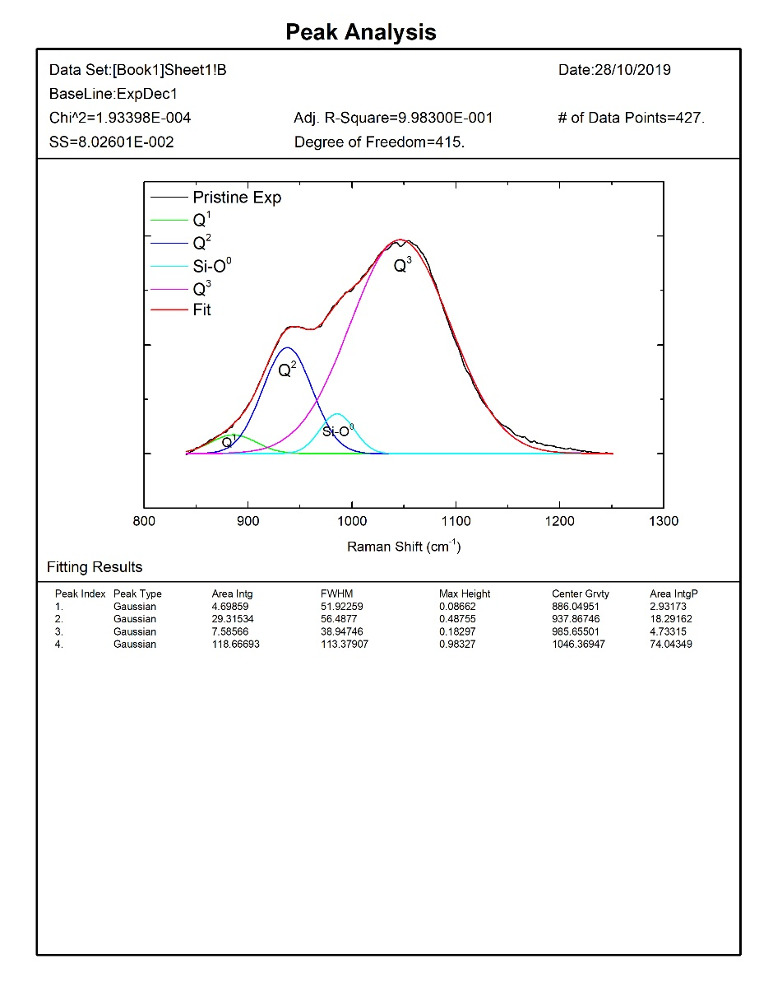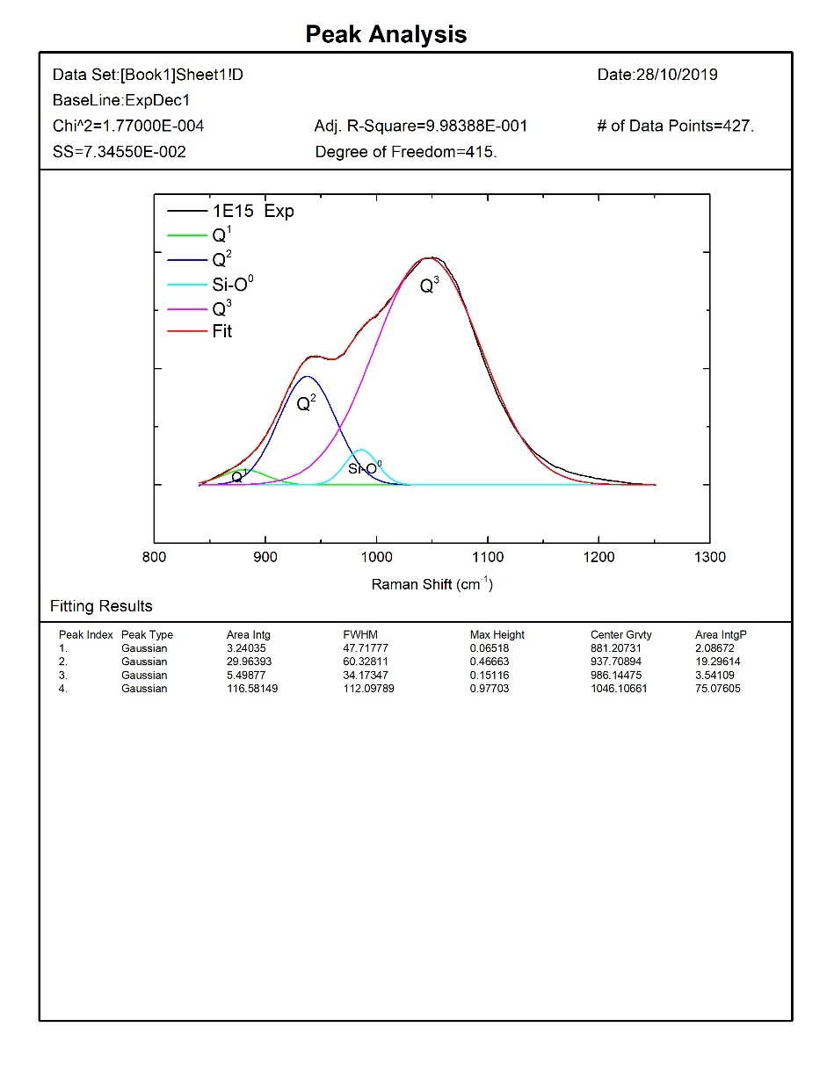

ii.

i.

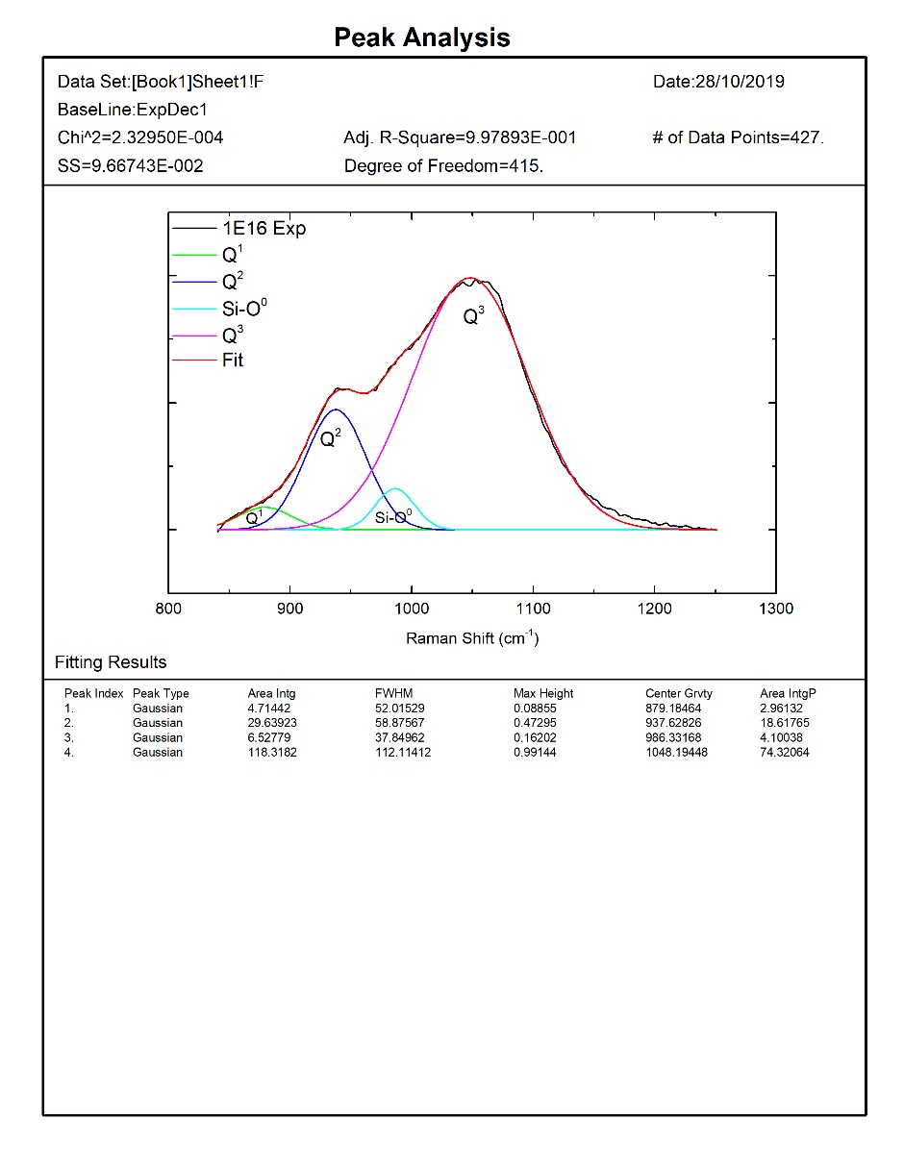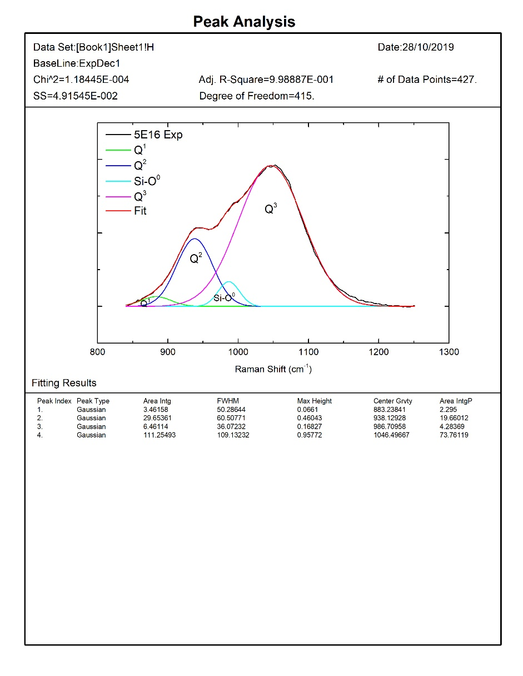

iii.

iv.

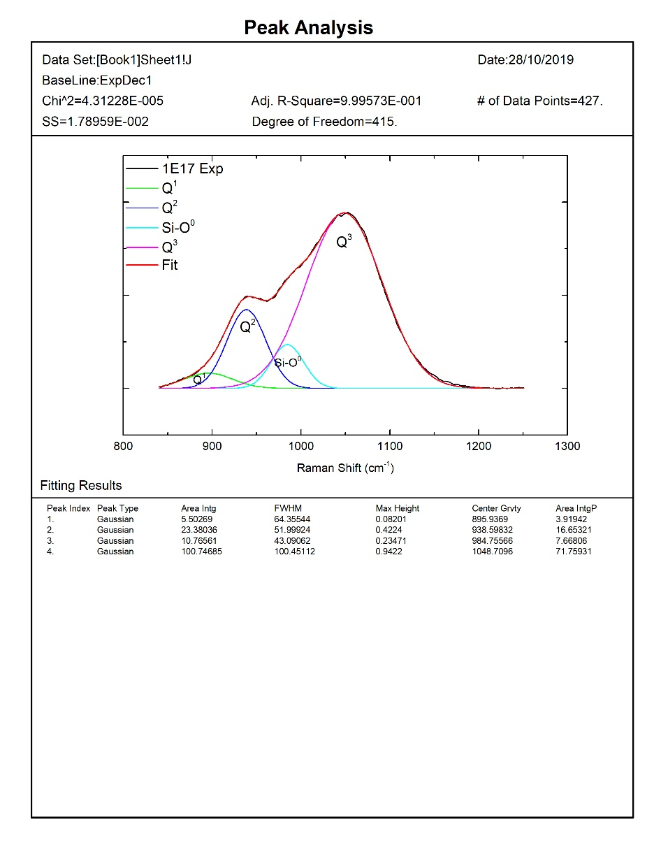

v.

Fig. 5. Deconvoluted Q-speciation region (840 -1250 cm-1) for pristine and He2+ irradiated Indian base glass. i) Pristine; and (ii-v) irradiated with (ii) 1 x 1015 ions/cm2; (iii) 1 x 1016 ions/cm2;(iv) 5 x 1016 ions/cm2; and (v) 1 x 1017 ions/cm2

In Fig. 6 showing the deconvoluted Raman spectra (i = pristine ii-v = irradiated samples), the Raman band between 975-1040 cm-1 is attributed to Q2 units; the band at 1050-1060 cm-1 is assigned to Q3 units; and the band at 1135 cm-1 is assigned to Q4 units.

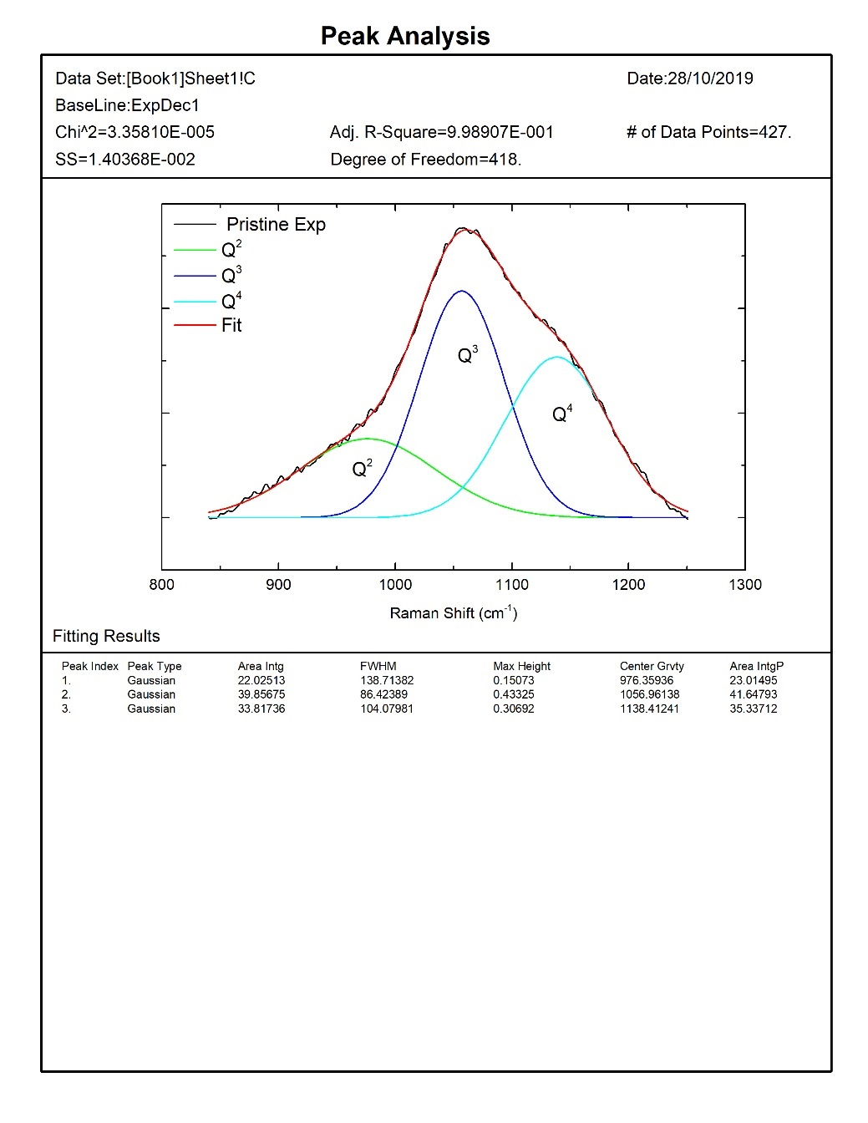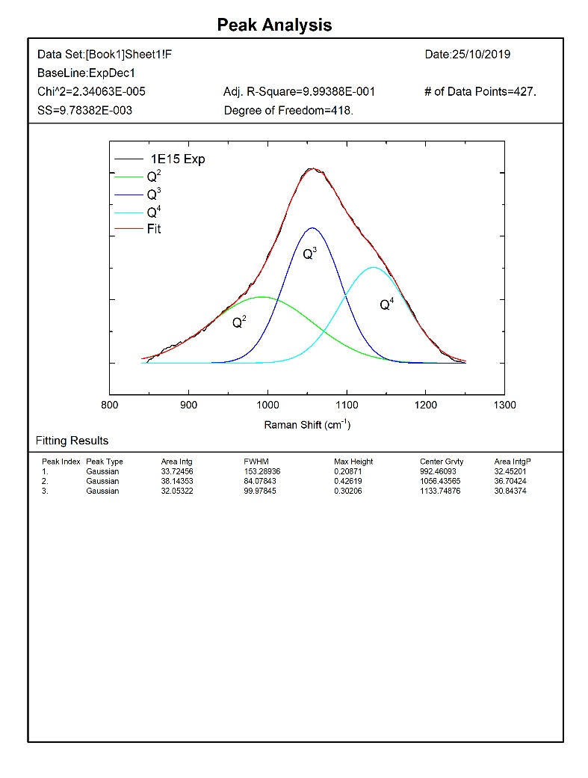

ii.

i.

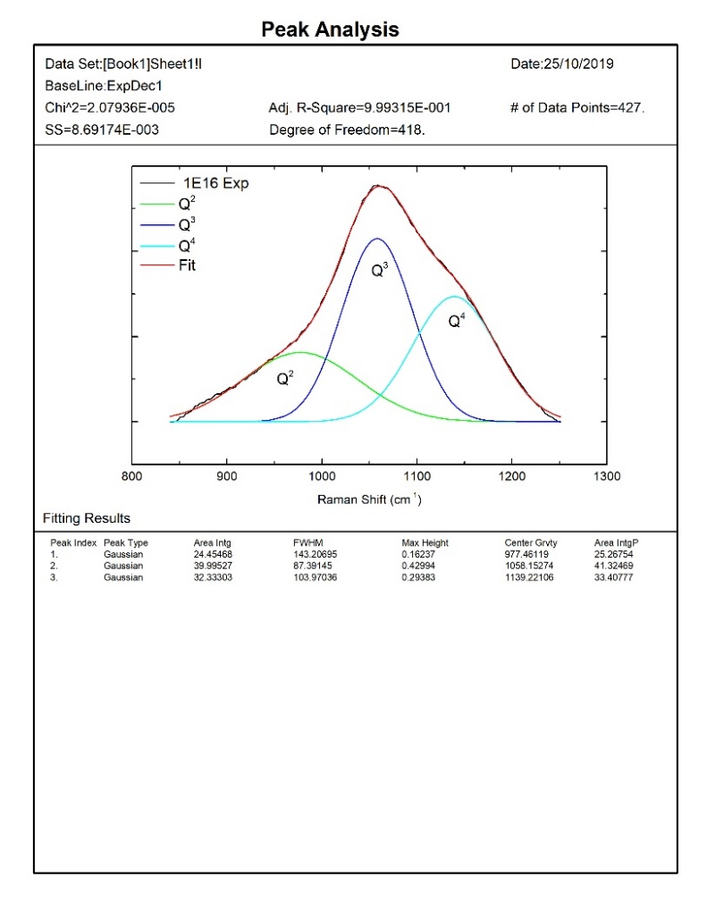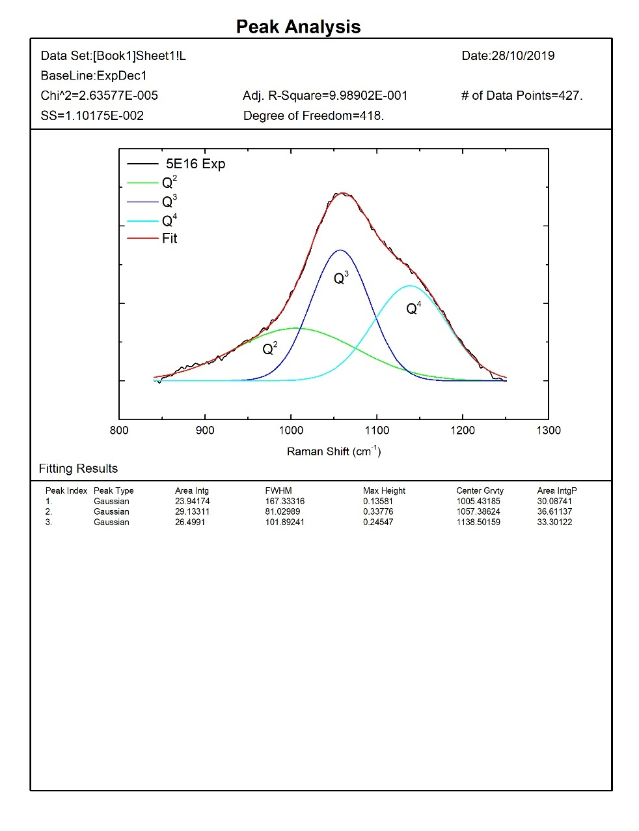

iii.

iv.

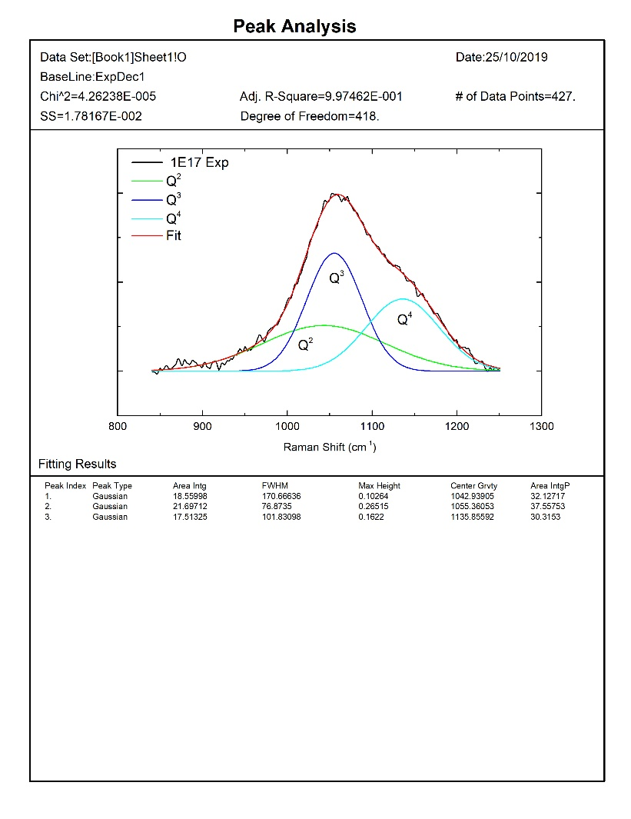

v.

Fig. 6. Deconvoluted Q-speciation region (840 -1250 cm-1) for the pristine and He2+ irradiated UK base glass. i) Pristine; and (ii-v) irradiated with (ii) 1 x 1015 ions/cm2; (iii) 1 x 1016 ions/cm2;(iv) 5 x 1016 ions/cm2; and (v) 1 x 1017 ions/cm2

**CONCLUSIONS**

The effects of alpha particles on representative UK and Indian HLW base glasses were investigated using He2+ implantation with a range of fluences, with the objective of improving our understanding of the types of radiation-induced defects that can occur in HLW glasses, and how/whether these are affected by glass composition. Room-temperature X-band EPR spectroscopy was carried out to investigate the types of defects forming upon He2+ ion implantation. Both glasses showed similar defect formation, which are broadly consistent with peroxy-radicals. Radiation-induced defects due to trapped charge carriers were not observed, although it is noted that EPR signal-to-noise ratios were limited by the small volumes of radiation-damaged glass. Structural changes were investigated using Raman spectroscopy. Some evidence was found for modest changes in the Si Qn distribution. A strong, broad Raman band at 1560-1, accompanied by growth of the nearby B-O band at 1450 cm-1, was observed in both glasses at high irradiation fluence although fluence corresponding to the onset of this band differs between the two glasses. The structural origins of the new band are being investigated but they may also be associated with B-O units, although formation of molecular O2 cannot be excluded at this stage as a possible contributing factor.

**REFERENCES**

1. Ewing, R., Weber, W. and Clinard, F. (1995). Radiation effects in nuclear waste forms for high-level radioactive waste. *Progress in Nuclear Energy*, 29(2), pp. 63-127.

2. Mohapatra, M., Kadam, R., Mishra, R., Dutta, D., Pujari, P., Kaushik, C., Kshirsagar, R., Tomar, B. and Godbole, S. (2011). Electron beam irradiation effects in Trombay nuclear waste glass. *Nuclear Instruments and Methods in Physics Research Section B: Beam Interactions with Materials and Atoms*, 269(19), pp. 2057-2062.

3. Weber, W. (2014). Radiation and Thermal Ageing of Nuclear Waste Glass. *Procedia Materials Science*, 7, pp. 237-246.

4. Gin, S., Jollivet, P., Tribet, M., Peuget, S. and Schuller, S. (2017). Radionuclides containment in nuclear glasses: an overview*. Radiochimica Acta*, 105(11), pp. 927-959.

5. Weber, W., Ewing, R., Angell, C., Arnold, G., Cormack, A., Delaye, J., Griscom, D., Hobbs, L., Navrotsky, A., Price, D., Stoneham, A. and Weinberg, M. (1997). Radiation Effects in Glasses Used for Immobilization of High-level Waste and Plutonium Disposition. *Journal of Materials Research*, 12(8), pp. 1948-1978.

6. Mazzoldi, P. and Miotello, A. (1986). Radiation effects in glasses. *Radiation Effects*, 98(1-4), pp. 39-54.

7. Mohapatra, M., Mishra, R., Kaushik, C. and Tomar, B. (2014). Investigation of Radiation Damage in Trombay Nuclear Waste Glasses by ESR and Photoluminescence Techniques. *Procedia Materials Science*, 7, pp. 247-251.

8. Abbas, A., Serruys, Y., Ghaleb, D., Delaye, J., Boizot, B., Reynard, B. and Calas, G. (2000). Evolution of nuclear glass structure under α-irradiation. *Nuclear Instruments and Methods in Physics Research Section B: Beam Interactions with Materials and Atoms*, 166-167, pp. 445-450.

9. Yang, K., Wang, T., Zhang, G., Peng, H., Chen, L., Zhang, L., Li, C., Tian, F. and Yuan, W. (2013). Study of irradiation damage in borosilicate glass induced by He ions and electrons. *Nuclear Instruments and Methods in Physics Research Section B: Beam Interactions with Materials and Atoms*, 307, pp. 541-544.

10.Peuget, S., Delaye, J. and Jégou, C. (2014). Specific outcomes of the research on the radiation stability of the French nuclear glass towards alpha decay accumulation. *Journal of Nuclear Materials*, 444(1-3), pp. 76-91.

11. McGann, O., Bingham, P., Hand, R., Gandy, A., Kavčič, M., Žitnik, M., Bučar, K., Edge, R. and Hyatt, N. (2012). The effects of γ-radiation on model vitreous wasteforms intended for the disposal of intermediate and high-level radioactive wastes in the United Kingdom. *Journal of Nuclear Materials*, 429(1-3), pp. 353-367.

12. Kilymis, D. and Delaye, J. (2013). Nanoindentation of pristine and disordered silica: Molecular Dynamics simulations. *Journal of Non-Crystalline Solids*, 382, pp. 87-94.

13. Delaye, J., Peuget, S., Bureau, G. and Calas, G. (2011). Molecular dynamics simulation of radiation damage in glasses. *Journal of Non-Crystalline Solids*, 357(14), pp. 2763-2768.

14. J.F. Ziegler, J.P. Biersack, *The Stopping and Range of Ions in Matter,* vol. 2-6, 1985. Pergamon*.*

15. Griscom, D., Merzbacher, C., Weeks, R. and Zuhr, R. (1999). Electron spin resonance studies of defect centers induced in a high-level nuclear waste glass simulant by gamma-irradiation and ion-implantation. *Journal of Non-Crystalline Solids*, 258(1-3), pp. 34-47.  
16. Mohapatra, M., Kadam, R., Mishra, R., Dutta, D., Pujari, P., Kaushik, C., Kshirsagar, R., Tomar, B. and Godbole, S. (2011). Electron beam irradiation effects in Trombay nuclear waste glass. *Nuclear Instruments and Methods in Physics Research Section B: Beam Interactions with Materials and Atoms*, 269(19), pp. 2057-2062.

17. Mohapatra, M., Kadam, R., Mishra, R., Kaushik, C., Tomar, B. and Godbole, S. (2012). Gamma Radiation-Induced Changes in Trombay Nuclear Waste Glass Containing Iron. *International Journal of Applied Glass Science*, 4(1), pp. 53-60.

18. Bonfils, J., Peuget, S., Panczer, G., Ligny, D., Henry, S., Noël, P., Chenet, A. and Champagnon, B. (2010). Effect of chemical composition on borosilicate glass behavior under irradiation. *Journal of Non-Crystalline Solids*, 356(6-8), pp. 388-393.

19. Mir, A., Monnet, I., Boizot, B., Jégou, C. and Peuget, S. (2017). Electron and electron-ion sequential irradiation of borosilicate glasses: Impact of the pre-existing defects. *Journal of Nuclear Materials*, 489, pp. 91-98.

20. Karakurt, G., Abdelouas, A., Guin, J., Nivard, M., Sauvage, T., Paris, M. and Bardeau, J. (2016). Understanding of the mechanical and structural changes induced by alpha particles and heavy ions in the French simulated nuclear waste glass. *Journal of Nuclear Materials*, 475, pp. 243-254.

21. Zhang, G., Wang, T., Yang, K., Chen, L., Zhang, L., Peng, H., Yuan, W. and Tian, F. (2013). Raman spectra and nano-indentation of Ar-irradiated borosilicate glass. *Nuclear Instruments and Methods in Physics Research Section B: Beam Interactions with Materials and Atoms*, 316, pp. 218-221.

22. Manara, D., Grandjean, A. and Neuville, D. (2009). Advances in understanding the structure of borosilicate glasses: A Raman spectroscopy study. *American Mineralogist*, 94(5-6), pp. 777-784.

23. Neuville, D., Cormier, L., Boizot, B. and Flank, A. (2003). Structure of β-irradiated glasses studied by X-ray absorption and Raman spectroscopies. *Journal of Non-Crystalline Solids*, 323(1-3), pp. 207-213.

**ACKNOWLEDGEMENTS**

This work is supported by Materials Engineering Research Institute, Sheffield Hallam University and the Government of India. The authors are grateful for beam time allocations at the Inter University Accelerator Center, India. The work presented here forms a part of the Ph.D. studies of P. Rautiyal.