# Terahertz Plasmonic Phase-Jump Manipulator for Liquid Sensing

Yi Huang, Shuncong Zhong*, Tingting Shi, Yao–chun Shen and Daxiang Cui

**Abstract:** Terahertz (THz) plasmonic sensors has been regarded as exciting advances in biomedical engineering, due to their real-time, label-free, and ultrasensitive monitoring features. But actually, its widespread application remains impeded by poor modulation properties of operating frequency, single amplitude characterization method, and limited to low-loss substances. In the work, an ultraprecision THz sensor is achieved with direct phase readout capacity via combining steerable plasmonic resonance and attenuated total reflection. Interestingly, the oft-neglected THz phase were found to be ideal for plasmonic sensing characterization. Detailed investigation shows that the reflected THz phase exhibits two entirely different jump responses to coupling gap. Remarkably, the Q-factor of phase spectra for optimal coupling gaps, are generally higher than that of fixed coupling gaps, which falls within the range of 9.7~43.4 (4~26 times higher than its counterpart in amplitude measurements) in liquids sensing. The unique phase-jump responses on metasurfaces pave the way for novel THz sensing methods.

**\*Corresponding authors:** **Shuncong Zhong,** Laboratory of Optics, Terahertz and Non-Destructive Testing, School of Mechanical Engineering and Automation, Fuzhou University, Fuzhou 350108, P. R. China; School of Mechatronic Engineering and Automation, Shanghai University, Shanghai 200072, China, e-mail: [zhongshuncong@hotmail.com](mailto:zhongshuncong@hotmail.com);

**Yi Huang:** Laboratory of Optics, Terahertz and Non-Destructive Testing, School of Mechanical Engineering and Automation, Fuzhou University, Fuzhou 350108, P. R. China, e-mail:737802921@qq.com;

**Tingting Shi:** Laboratory of Optics, Terahertz and Non-Destructive Testing, School of Mechanical Engineering and Automation, Fuzhou University, Fuzhou 350108, P. R. China, e-mail:1006272593@qq.com;

**Yao**–**chun Shen:** Department of Electrical Engineering and Electronics, University of Liverpool, L69 3BX, United Kingdom. China, e-mail: ycshen@liverpool.ac.uk

**Daxiang Cui:** Department of Bio-Nano Science and Engineering, Shanghai Jiaotong University, Shanghai 200030, P.R. China, e-mail: dxcui@sjtu.edu.cn

**Keywords:** Terahertz plasmonic sensor, phase jump, steerable plasmonic resonance, attenuated total reflection

## 1 Introduction

Terahertz (THz) radiation (0.1 THz-10 THz) has attracted tremendous attention because of its miraculous properties, which have inspired broad applications in communication, non-destructive, imaging, biomedical analytics and high-resolution spectroscopy [1–5]. In particular, THz waves have an absolutely non-ionizing radiation impact and are harmless to biological tissue that is usually sensitive to visible light [6]. More importantly, many complex molecules exhibit characteristic spectral absorption features that can be utilized to identify them due to their vibrational and rotational modes in the THz regime [7, 8]; this ability holds massive potential for THz technology in the fields of biological and chemical sensing [9, 10]. However, the absorption cross-sections of molecules are miniscule compared with terahertz wavelengths (a few hundred microns), resulting in rather weak interactions between molecules and THz radiation [11]. For this reason, the extensive use of THz spectroscopy in sensing applications is greatly impeded by the detection of small changes in terahertz optical properties after interacting with molecules.

Because of these limitations in THz sensing, there is an increasing awareness that THz technology may be combined with methods such as the use of strongly confined electromagnetic fields to enhance light-matter interactions and create sharp spectral features and thereby enable the measurement of small changes in the dielectric environment [12] (which is similar to surface plasmon resonance (SPR) sensing on metal-dielectric interfaces at visible frequencies) and produce a better sensing effect. In principle, THz-SPR technology combines the molecular fingerprints of THz technology and the ultrahigh sensitivity to changes in the dielectric environment, providing enormous advantages in many sensing applications. However, most metals, such as silver and gold, resemble a perfect electric conductor, as their intrinsic plasma frequencies are often in the ultraviolet frequency regime. As a result, surface plasmon polariton (SPP) modes are highly delocalized on smooth metal surfaces at THz frequencies [13, 14]. To engineer surface plasmons at lower frequencies, Pendry et al. theoretically demonstrated that highly confined SPP modes could be excited on highly conducting surfaces perforated by holes [15]. More interestingly, the optical properties of SPP modes can be tailored by properly designing the geometric parameters of spoof plasmon surfaces (SPSs). The existence of such geometrically controlled SPPs or spoof SPPs (SSPPs) provides new opportunities for controlling and directing radiation surfaces over a wide spectral range, from gigahertz (GHz) to mid-IR frequencies with peculiar electromagnetic properties [16]. More recently, integration of the SPSs (decorated with periodic subwavelength metallic structures, such as grating-like [17], periodic pits [18], annular holes [19], cylinder arrays [20], double split rings [21], square tubes and cylindrical rods [22]) with THz technology has demonstrated great potential for THz sensing, and achieved good performances. However, the modulation of operating frequency becomes tricky, primarily owing to the complex geometric patterns on SPSs, greatly limiting their practical applications in high-specificity THz sensing. Besides, for the case of polar liquids or aqueous analytes, the intensity of THz electromagnetic field can be significantly diminished because of the strong absorption in transmission mode [23–27] or the ability to properly identify any spectral shifts owing to small changes in specimens is greatly reduced due to the low Q-factor of THz amplitude spectra, resulting in poor sensing performance of conventional methods involving amplitude detection. The above limitations impede the progress of the metasurfaces for broader application in plasmonic sensing.

In this paper, both numerical and experimental studies on integrated phase-jump inversion and phase spectra shift toward a more reliable sensing method were performed. Instead of direct irradiation excitation, an attenuated total reflection (ATR) [28] technique is used to excite the SSPPs modes supported on a 1D corrugated SPSs. Benefiting from the huge momentum matching capabilities of a high refractive index HR-Si prism coupler, a strongly confined SSPPs mode with concentrated electric field distribution in the grooves can be excited. We turn our attention to an often neglected source of information in sensing studies: the phase of electromagnetic fields that is available through THz time-domain spectroscopy (THz–TDS) [29]. Although the phase-jump caused by SPR has been reported in the literatures [30–34], a complete and comprehensive description of the terahertz phase properties and its application for plasmonic sensing is still lacking. Our experimental study illustrates that the phase of reflected THz wave exhibits two entirely different response patterns near the optimum SPR condition, which corresponds well with the numerical results. Furthermore, the flexibility of tailoring the resonance frequencies of SSPPs modes by simply tuning the geometrical parameters of this SPS (i.e., the depth of grooves) is demonstrated. Finally, to investigate the influence of the THz phase response modes on the detection sensitivity, several different liquids with a good spread of refractive index value were selected as the sensing targets, and the corresponding experimental results were analysed. By introducing THz phase as an output response, a clearer picture of SPR state can be observed, presenting a remarkable improvement in the accuracy of sensing compared with that of amplitude detection. The proposed THz sensing method integrated the oft-neglected phase jumps information under SPR provide the possibility for developing more reliable plasmonic sensing of polar liquids or aqueous solutions.

## 2 Principle and design criteria of the phase readout plasmonic sensor

Our evanescent wave excited plasmonic sensor featuring a spoof plasmon surface (SPS) consisting of a periodic grooves array is shown in Figure 1a. The periodic grooves array is fabricated via conventional deep reactive ion etching (DRIE) of a 500 μm thick silicon wafers. Subsequently, a 600 nm thick layer of gold is sputtered onto the structured Si substrate surface (see Section S1, Supporting Information for details). In Figure 1a, the gold film and Si substrate are shown in yellow and green, respectively. Because the gold film is much thicker than the skin depth of gold at THz frequencies (approximately 80 nm at 1 THz), the fabricated SPS closely resembles a structured perfect electrical conductor (PEC) surface. Figure 1b shows an optical microscopy image of the corrugated metallic surface. The unit cell of the grooves array has a period of *p* = 60 μm, top width of *w*t = 31 μm, bottom width of *w*b = 21 μm and depth of *h* = 90 μm. The groove period *p* determine the operating frequency bands of corrugated spoof plasmon surface (*ω*<*c*/2*p*). The groove period of 60 μm indicates that diffraction effects are only manifested above 2.5 THz. Below this frequency, the subwavelength SPS behaves as a metasurface on which highly confined SPP modes can be supported [35]. The SSPPs supported on the SPS can be excited through the evanescent field generated by the total internal reflection of a TM-polarized THz beam at the bottom of an HR-Si prism (with refractive index of *n*p = 3.416, and internal incident angle *θ*in = 45°) with a coupling gap *g* between the prism base and the SPSs in the Otto prism coupling configuration [36]. Because of destructive interference among the incident THz waves, a portion of the radiation is coupled into spoof surface plasmon polaritons (SSPPs) wave and another portion is out-coupled from the SSPPs wave into free space [37]. Then, the modulated THz waves reflect off the prism base and exit from the other facet of the prism. As a result, the incident waves coupled to the SSPPs wave can be detected by changes in the modulated THz waves (include amplitude modulation and phase modulation). Benefiting from the huge momentum matching capabilities of high refractive index HR-Si prism (see Section S2, Supporting Information), a more highly confined SSPPs mode can be excited on the SPSs [17]. As clearly depicted in Figure 1c, the energy of electricfield is centralized in the grooves when the resonance occurs. This unique near-field distribution of the surface mode will tremendously promote the interaction between analyte (filled in the grooves) and SSPPs wave in sensing applications, thus rendering the evanescent wave excited plasmonic system capable of high sensitivity for sensing. More specifically, the excited surface resonance mode is associated with the coupling gap. Instead of just shifting happens in reflected spectrum, the phase of reflected THz wave also presents two entirely different response patterns with various coupling gap near the optimum SPR condition as illustrated by Figure 1d. We envisage that the adaptation of such a resonant THz phase response to a THz sensing application will help to achieve pinpoint accuracy capacities.

Figure 1. Schematic Working principle of the phase readout plasmonic sensor. (a) Schematic diagram of the proposed evanescent wave plasmonic sensor with spoof plasmon surface (SPS) consisting of periodic grooves array. Grooves are of period *p*, top width *w*t, bottom width *w*b, and depth *h*. *g* is the coupling gap between the HR-Si prism base and the surface of SPS. The SPP supported on the SPS can be excited through the evanescent field generated by the total internal reflection of THz beam. (b) Optical microscopy image of corrugated metallic surfaces with *p* = 60 μm, *w*t = 31 μm, *w*b = 21 μm and *h* = 90 μm. (c) The electric-field distributions for the SPS under SPR. (d) The coupling gap controlled terahertz resonant sensing through monitoring the phase-jump inversion.

The dispersion relation of the SSPPs via Equation S1 and finite element method (FEM) with COMSOL Multiphysics software are plotted in Figure. 2 (see Section S2 and S3, Supporting Information for details). We can see clearly that the scatter data (acquired according to the actual sizes of the fabricated SPSs) mainly locate between two dispersion relation curves of square grooves for *w*eff = *w*b and *w*eff = *w*t, which indicates that the SSPPs modes supported by the fabricated grooves have properties similar to that of square grooves. Particularly, the larger the refractive index filled in grooves, the lower the asymptotic frequency. Remarkably, larger momentum matching between SSPPs and the incident wave can be achieved by the high refractive index HR-Si prism, resulting in a larger departure of the propagation constant from the light line. Thus, the confinement of the SSPPs fields (which is directly proportional to vertical component of the wave vector[38]) increases (see Fig. 2). From the insets of Figure 2, we can further observe that the energy of the excited surface modes is centralized in the grooves owing to the strongly confinement of the SSPPs fields, suggesting an exceptionally good sensory perception of small changes in filled dielectric environment. In particularly, as a larger groove depth or refractive index correspond to a smaller vertical component of the wave vector, leading to a larger extension of the SSPPs fields in the coupling space. More importantly, the asymptotic frequency also can be easily tailored over a wide frequency range by the groove depth. Compared with the reported SPSs decorated with complex periodic geometric patterns [18–22], this 1D metasurface can be a perfect working platform for high-specificity THz-SPR sensing.

Figure 2. The dispersion relation of the SSPPs supported by corrugated metallic surfaces with different groove depths and refractive index filled in the grooves in the Brillioun zone. The curves are the calculation results of SPSs decorated with 1D array of square grooves through analytical model. The scatter data (rectangle, roundness, and diamond) are acquired according to the actual sizes of the fabricated SPSs by COMSOL. The dots A, B, and C are numerical results for the case of the momentum matching condition is fulfilled, *k*SSPPs = *k*ǁ. The insets show the electric field distributions for the unit cell of the grooves with different groove depths and filled refractive index.

## 3 Results and Discussion

### 3.1 A high Q-factor resonance with phase-jump inversion

SSPPs excitation experiments on an SPS were performed by THz time-domain spectroscopy (THz-TDS) in a nitrogen (*n* = 1.00) purged chamber with relative humidity less than 5%. The extracted THz experimental measurement results (see Section S4, Supporting Information) as a function of the frequency for various coupling gaps, *g*, are shown in Figure 3. Before testing, the prism was first attached to a tailor-made holder (which was fabricated by 3D printing) and then attached to a precisely controlled movable stage to direct it to the preset positions and fixed, so that to ensure the reliability the optical set up at the maximum degree. In testing, the SPSs containing samples were held parallel to the prism undersurface via another tailor-made holder, and then also attached to a high precision translation stage to control the coupling gap (its typical value mainly depend on the decaying length of the evanescent field, which is in a range of tens to hundreds micrometers [17]). Moreover, the reflectivity R and phase change were calculated via 2D numerical simulation using COMSOL software for comparison (see Section S3, Supporting Information). As follows from Figure 3a, we can clearly observe that all reflectivity spectra exhibit distinct dips caused by the transfer of energy from incident THz radiation into the SSPPs wave propagating. Moreover, there are various degree of changes both in width and position of these resonance spectra owing to the outcoupling of a portion of the SSPPs field into the HR-Si prism (which perturbs the propagation constant and causes an additional damping of the excited surface plasmon [38]). Previous theoretical studies have indicated that a full coupling between THz radiation and SSPPs wave occurs (i.e., *R* = 0) at an ideal coupling gap associated with the frequency and materials involved [32]. However, for evanescent wave sensors, it is difficult to experimentally determine the frequency of *R* = 0 when refractive index sensing is conducted by the conventional methods dependent on the shift of amplitude reflectivity spectra [31], since the minimum of *R* with nearly zero is obtained in a wide range of gap (changes between 0 and 3.48% for *g* varies from 35 to 50 μm, as shown in Figure 3a). Consequently, its coupling gap is often fixed for the amplitude detection based traditional methods in the actual test process, which inevitably leads to the increase of measurement error. That has forced scientific researchers to find new methods to better and easier assess the optimal resonance frequency.

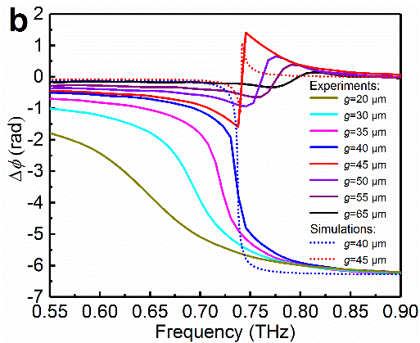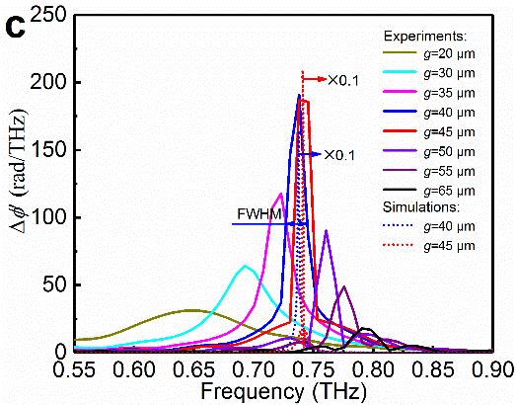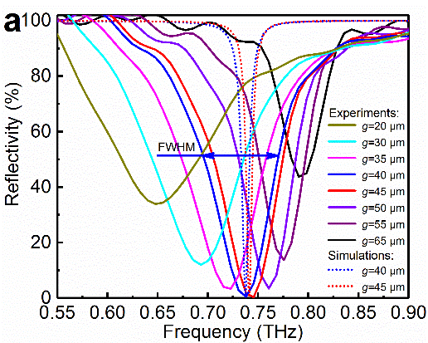

Figure 3. Extracted THz experimental measurement results for various coupling gaps. (a) Reflectivity and (b) phase changeas a function of the frequency for various coupling gaps, *g*. The solid lines represent the experimental measurements, and the dashed lines represent the simulated results. (c) The absolute gradient of the change in phase between the sample and reference spectrum, i.e.,.

Fortunately, the phase of the reflected THz wave exhibits quite different response characteristics to the gap near the optimum SPR condition, compared with that of the reflectivity spectra, as shown in Figure 3b. As it can be seen, a sharp change occurs in the phase change spectra in the region of SPR. The sharp change region displays a step-like lineshape at the smaller gap first, and then the steepness of the phase jump increases gradually as the gap increases to its optimum (i.e., *R* = 0). Remarkably, the sign of the slope overturns, and the slope decreases with a further increase in the gap size. Moreover, the phase change is not monotonic but possesses a minimum and a maximum in the resonant region. In short, the profile of the phase change transforms from a step-like lineshape into a Fano contour when the gap goes through its optimum value, i.e., *R* passes through the point *R* = 0, which confirms our theoretical derivation (see Section S5, Supporting Information). Actually, the phase-jump transition is associated with the absorptive and the radiative losses in a resonant cavity that obeys the coupled-mode theory [39, 40]. Specifically, the response state of phase-jump is determined by the inequality between absorptive and radiative quality factors (i.e., *Q*a and *Q*r, *Q*a is directly proportional to the coupling gap *g* and *Q*r is inversely proportional to *g* [32，38]). *R* = 0 occurs at the condition of *Q*a = *Q*r (for a certain coupling gap), and the phase spectrum sweeping across the resonance frequency between the overdamped (where the phase span variation is less than π) and the underdamped regime (where the phase span remains constant at 2π) if any of these two quality factors deviates from the equality condition [40]. This is the reason for the appearing of the phase-jump transition phenomenon. Therefore, these two unique phase change characteristics can be used to identify the resonance state of the excited surface mode. Figure 3a and 3b also show that the variation trend of the experimental reflectivity spectra and phase change spectra with different gaps are in good agreement with the simulated results (without consideration of the experimental damping mechanisms). The main difference between the experiments and simulations lies in the full width at half maximum (FWHM) of the reflectivity spectra. The primary reasons are the increase in absorption losses caused by the formation of hot spots at the structural imperfections in the fabricated metasurfaces and diffraction effects resulting from the scattering of the spoof SPP modes at the edges of the SPSs. Furthermore, we found that the phase change regions occur only at the dips of the reflectivity spectra. To demonstrate this effect more clearly, the absolute gradient of the phase change, i.e., , was calculated as shown in Figure 3c. Clearly, all of thespectra show sharper peaks than those of their corresponding reflectivity dips. (Note that the simulated phase spectra were multiplied by a modulation factor of 0.1 to account for the experimental damping mechanisms) Specifically, the phase-based Q-factor of 43.4 is much larger than its amplitude-based counterpart of 10.5 for *g* = 40 μm (Q-factor is quality factor for the characterization of the resonance properties of SSPPs, defined as the ratio of the resonant frequency to the FWHM [41]), imparting to the phase response the capability of higher resolution in spectral characterization. In addition, it should be noted that the variation trend of the FWHM inis different from that of the reflectivity spectra (which its FWHM broadened by radiative damping of SPPs that couple back to the prism with the diminution of the gap, as shown in Figure 3a). The gradient of the phase change is irrelevant to the width of the reflectivity spectra but defined by a certain parameter (such as the coupling gap) that reduces the minimum to zero, indicating that thespectra can further help to estimate the optimal resonance frequency. These results reveal that phase as an output response should provide new opportunities for high-performance refractive index sensing.

To explain these phase-jump response patterns, we also show the parametric plot of the experimental complex reflective coefficient *r*pnm/*r*pn at SPR for different coupling gaps in Figure 4. Note that the reflectivity and phase change can also be calculated with the Fresnel multilayer reflection theory for electromagnetic propagation through multilayer media [42] (i.e., prism/nitrogen/metasurface, see Section S5). The ratio of obtained electrical field correspond to the ratio of complex reflective coefficient *r*pnm/*r*pn i.e., The complex reflective coefficient *r*pnm/*r*pn varies along a spiral-shaped curve with increasing frequency for *g* = 40 μm, which is plotted as an example, as shown in Figure 4a. We can see clearly that both real and imaginary part of *r*pnm/*r*pn are close to zero near the resonance frequency (i.e., 0.738 THz). In order to have a more intuitionistic knowledge to the anomalous phase-jump behaviour, we plotted the variation of *r*pnm/*r*pn against frequency change from 0.55 THz to 0.9 THz for various coupling gaps on a complex plane, as shown in Figure 4b. The black arrow is an example of a complex reflective vector, where the polar angle and square of its length correspond toand *R*, respectively. There is a good agreement between the computations and the measurements. All trajectories of *r*pnm/*r*pn go from the lower side of the origin to its upper side as frequency increases. The obtained *r*pnm/*r*pn data between *g* = 20 and 40 μm indicate that the trajectories turning clockwise around the origin. As a result,is monotonic with the increase of frequency. So the sharp change region displays a step-like lineshape (as shown in Figure 3b). Furthermore, the outline of *r*pnm/*r*pn curve dwindles gradually as *g* increases and passes through the origin (i.e., *R* passes through the point *R* = 0) at *g* = 45 μm. The trajectories of *r*pnm/*r*pn between *g* = 45 and 65 μm indicate thatis not monotonic but possesses a minimum and a maximum in the resonant region. In this case, the phase jump region displays a Fano contour (as shown in Figure 3b). That’s why the phase change spectra show different shapes when *R* passes through the point *R* = 0.

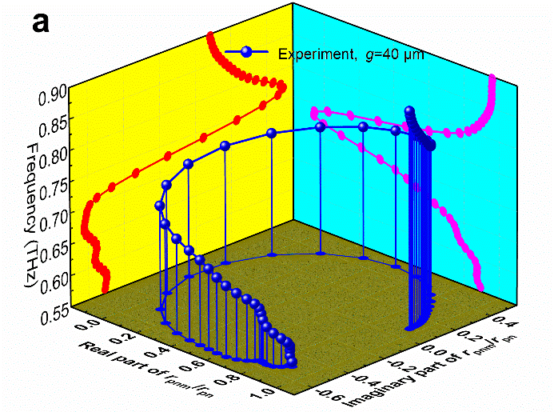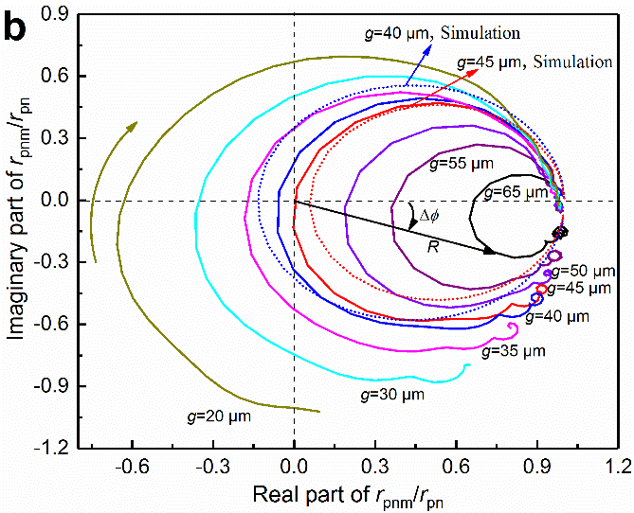

Figure 4. Parametric plot of experimental complex reflective coefficient *r*pnm/*r*pn at SPR for various coupling gaps. (a) 3D plot of the variation of complex reflective coefficient *r*pnm/*r*pn obtained from experimental results with frequency for *g* = 40 μm and (b) variation of complex reflective coefficients *r*pnm/*r*pn against frequency change from 0.55 THz to 0.9 THz for different gaps on a complex plane. The solid lines calculated from the experimental data, and the dashed lines represent the simulated results.

### 3.2 Grooves depth controlled SSPPs modes

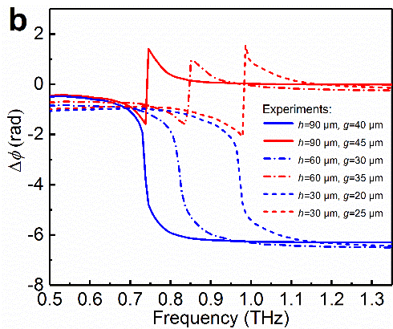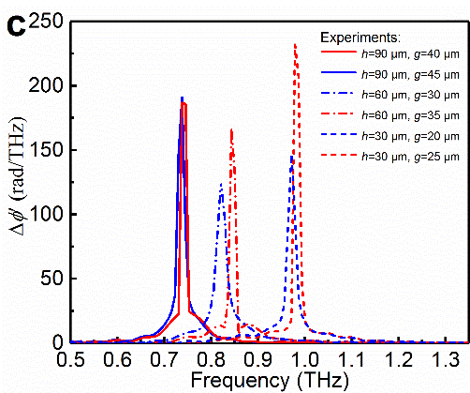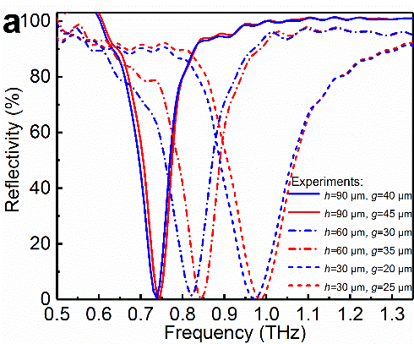

Figure 5. Experimental results of SPSs with different groove depths. (a) Reflectivity spectra, (b)spectra, and (c)spectra for three groove depths *h* = 30 μm, 60 μm and 90 μm.

Figure 5 plots the experimental reflection spectra a, phase change spectra b and absolute gradient of the phase change spectra c for three groove depths, *h* = 30, 60, and 90 μm (which obtained by a film-thickness meter due to their deep depths). The geometrical parameters of the other two groove cells are *p* = 60 μm, *w*t = 32 μm, *w*b = 21 μm, and *h* = 30 μm and *p* = 60 μm, *w*t = 31 μm, *w*b = 20 μm, and *h* = 60 μm, respectively. As it can be seen, the reflectivity spectra red-shift distinctly as the groove depth increases. The obtained optimal resonance frequencies (with step-like phase-jumps) are 0.971, 0.821, and 0.738 THz for *h* = 30, 60, and 90 μm, respectively. These experimental results agree well with theoretical predictions presented above (the cut-off frequency of the dispersion curve decreases with an increase in groove depth). Note that the groove width has a poor modulation of the resonant frequency due to the asymptotic frequency of the SPSs is quite insensitive to the groove width [29]. Moreover, the FWHM of the reflectivity spectra becomes narrower as the groove depth increases, indicating lower absorption losses for deep grooves than for shallow ones. Furthermore, similar to the case of *h* = 90 μm, the inversion of phase-jump also occur near their respective optimal resonance regions for the other two different groove depths. In addition, the FWHM of thespectra are obviously narrower than the values of the reflectivity spectra. These experimental results reconfirm that the extracted phase-jumps information can be used for high-performance refractive index sensing. The tuning of operating frequency by groove depth alone demonstrates that such an SPS offers significant design flexibility for high-specificity THz sensing.

Figure 6. Schematic diagrams of three coupling gaps controlled sensing methods for liquids. (a) Adjusting gaps to their own optimal levels, i.e., *R* ≈ 0 and all phase-jumps exhibit the same lineshape. (b) The gap is fixed at a smaller value to form step-like phase lineshape, and (c) The gap is fixed at a larger value to form Fano phase lineshape.

### 3.3 Sensing performance of the phase readout plasmonic sensor

Experimental verifications of the feasibility of such phase readout plasmonic sensor were performed via phase-jump direction interrogation for locating the optimum resonance frequency. To evaluate the advantage of the method integrated phase-jump inversion and phase spectra shift in the high precision refractive index sensing, the measurements were performed on the fabricated corrugated SPS with lower absorption losses (i.e., groove depth *h* = 90 μm) via three different coupling gaps controlled patterns (as shown in Figure 6). Note that a series of fluids witha good spread of refractive index values, i.e., gasoline (*n* = 1.41), alcohol (*n* = 1.45), liquid paraffin (*n* = 1.49), glycerin (*n* = 1.82) and water (*n* = 2.1), were filled in the grooves to enable us to explore the THz-SPR sensing ability of the fabricated sensor. Figure 7 shows the experimental reflectivity spectra,spectra, andspectra for the various liquid analytes with three coupling gaps controlled methods. From the results of the measurement (with adjusting gaps to their own optimal levels (as shown in Figure 6a), i.e., nitrogen (*g* = 40 μm), gasoline (*g* = 50 μm), alcohol (*g* = 50 μm), liquid paraffin (*g* = 50 μm), glycerin (*g* = 55 μm) and water (*g* = 60 μm)), we can discover that each analyte in a similar pattern of optimum plasmonic resonances at given measuring gaps, leading to each minimum of *R* is close to 0 (which varies between 0.1% and 0.8%) and all phase-jumps exhibit step-like lineshape (which can help us to identify the position of optimal resonance), as shown in Figure 7a and 7b. Moreover, the observed reflectivity spectra red-shift sharply with increasing *n* (which shifts from 0.738 THz for nitrogen to 0.331 THz for water), due to the superior sensitivity to changes in the dielectric environment of the excited tightly confined SSPPs mode on SPS. These experimental results are in good agreement with the dispersion relation prediction above.

Figure 7. Experimental results for liquids sensing with three coupling gaps controlled methods. (a) Reflectivity spectra, (b)spectra, and (c)spectra for optimal gaps; (d) Reflectivity spectra, (e)spectra, and (f)spectra for *g* = 40 μm; (g) Reflectivity spectra, (h)spectra, and (i)spectra for *g* = 65 μm.

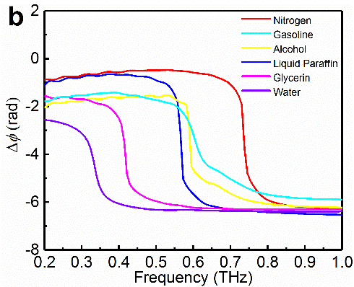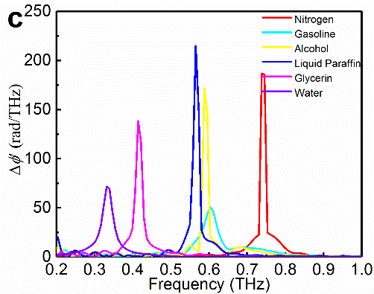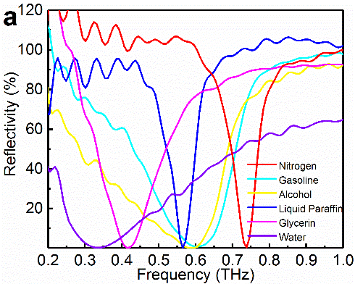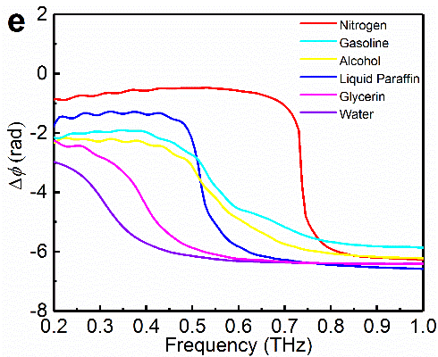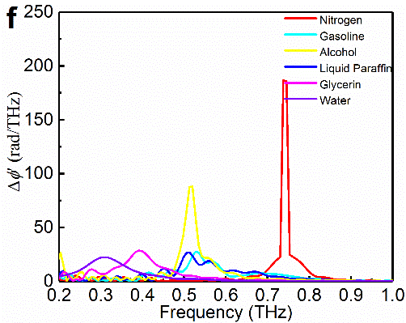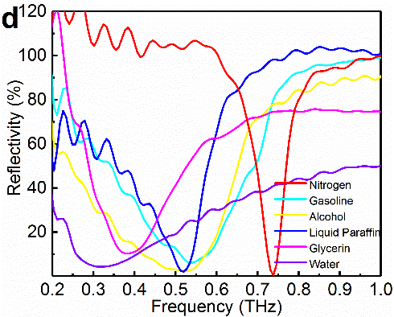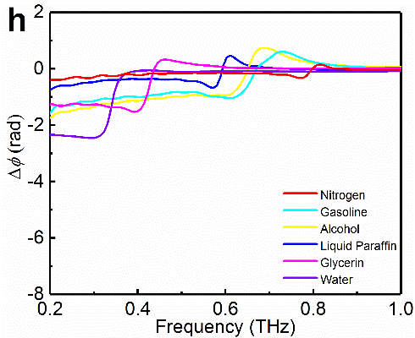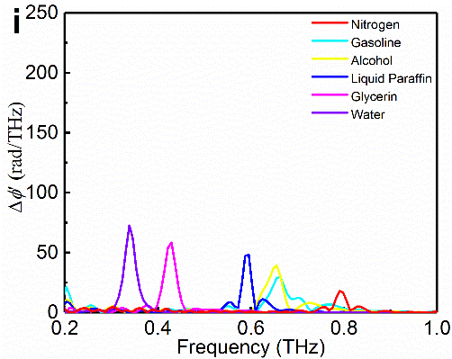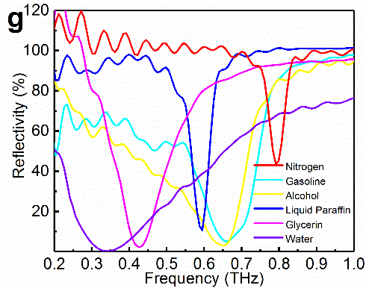

By comparison, the experimental spectra obtained by traditional method with a fixed gap [31, 32, 36] (as shown in Figure 6b and 6c) feature different resonant characteristics. In the case of *g* = 40 μm (as shown in Figure 7d-7f), the reflectivity dips red-shift and expand visibly along with increasing minimum values of *R*, owing to the additional damping of excited plasmonic modes at the smaller fixed gap [38]. Meanwhile, it is also accompanied with increasing regions of phase-jump, which can be seen more clearly in thespectra with lower peak values. However, it shows the drastically different characteristics in another case of *g* = 65 μm (as shown in Figure 7g-7i). The blue-shift of reflectivity dips is observed at the larger fixed gap. Beyond that, the sharp change regions of phase displays Fano contour, not step-like lineshape. Particularly, the sensing system can be in two different plasmonic resonance status simultaneously (as revealed in the patterns of phase-jump) over a wide spectral regimes, when the gap fixed between 40 μm and 65 μm. Furthermore, the comparison results of *g* = 40 μm and *g* = 65 μm (Figure 7d-7i) show that the measuring error has increasing tendency with the increase of refractive index for smaller fixed gap, but the similar happens in the smaller refractive index regions for larger fixed gap. More importantly, the fixed gap may perturbs the spectral shift caused by a tiny change in refractive index for spectral characterization (which can be seen more clearly by the spectra of gasoline, alcohol, and liquid paraffin). As a result, the traditional monitoring method of the tiny change of refractive index with fixed gap can't obtain satisfactional accurate outcome.

Figure 8. Comparison of Q-factors calculated by the experimental amplitude spectra and phase spectra. (a) for optimal gaps; (b) for *g* = 40 μm; (c) for *g* = 65 μm.

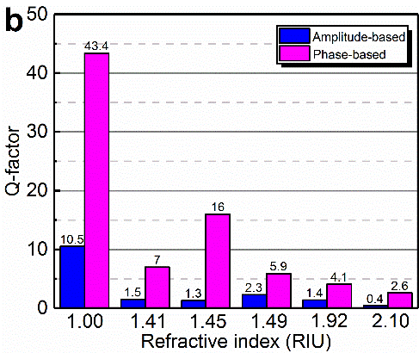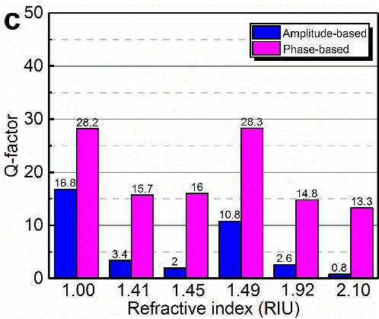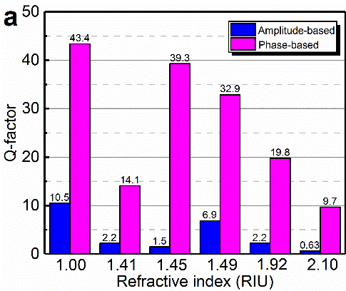

In addition, the reflectivity dip broadens significantly for fluids with higher loss (such as alcohol and water), which restrict its applications in highly absorbing liquids [43]. But allspectra exhibit a narrower spectral feature than do the reflectivity spectra (as shown in Figure 7c, 7f, and 7i). As we can see more clearly from Figure 8, all phase-based Q-factor are much larger than that calculated by amplitude spectra. Particularly, the Q-factor of phase spectra for optimal gaps, are generally higher than that in the other two cases. The ratio of phase-based Q-factor to its corresponding amplitude-based Q- factor generally falls within the range of 4~26 for various fluids, indicating that the phase readout at optimal gap has a special advantage in spectral characterization, especially in the detection of polar liquids or aqueous specimens.

Figure 9. The variation of resonance frequency versus refractive index of liquid for experiments and simulations and their corresponding linear fitting curves. The insets show the electric field distributions for the unit cell of the grooves filled with various refractive indices.

To better compare the sensitivity of plasmonic sensing based on conventional amplitude detection at a fixed gap with that of the new approach integrated phase-jump inversion and phase spectra shift at optimal gaps, the variation of resonance frequency versus refractive index of liquid for experiments and simulations are plotted in Figure 9. As we can be seen, the measuring values of the new methods mainly locate between the two scatter data for *g* = 40 μm and *g* = 65 μm, which are found to be in good agreement with simulated predictions. Moreover, the resonance frequency is linear distributing along the refractive index, especially in the case of the new method. The straight lines (red solid for optimal gaps, black dot-dash for *g* = 40 μm, pink double dot-dash for *g* = 65 μm, and blue dot for simulations) are linear fits given by andwith high R-Square of 0.994, 0.983, 0.989, and 0.973. Thus, the sensitivity *S*n, defined as the change in resonance frequency *f* per RIU, can be calculated by the absolute slope of the linear fitting curves. These given sensitivities of 0.370 THz/RIU, 0.373 THz/RIU, 0.411 THz/RIU, and 0.315 THz/RIU. Compared to the plasmonic sensors reported in literatures [24, 44, 45, 46] (For example, the frequency sensitivity of 10.8 GHz/RIU by a continuum metasurfaces sensor was achieved [45]; also, the maximum refractometric sensitivity about 0.05 RIU-1 for a dual-surface flexible THz Fano metasensor [46]), significant improvement of the sensitivity is achieved due to the greatly enhanced light-matter interaction in the grooves. For various refractive indices, all the electricfield distributions of excited SSPPs mode are centralized in the grooves, which are similar to that of nitrogen mentioned above, as shown in the inset of Figure 9. So unique and universal are the highly confined SSPPs mode of the fabricated SPSs that they can be used to enhance light-matter interactions, which is essentially considered to be important to plasmonic sensing.

## 4 Conclusions

In summary, we demonstrated a periodically corrugated metallic surface based THz sensing system with an Otto HR-Si prism coupling configuration. Comprehensive studies have been conducted on the THz sensing capabilities of SPSs. Remarkably, we focus on an oft-neglected source of information in the field of sensing: the phase of electromagnetic fields. The experimental results show that the amplitude responses of the electromagnetic fields are consistently accompanied by a sharp phase jump under SPR conditions. In particular, the phase change spectra transition from a step-like lineshape to a Fano contour when a system passes through the point *R* = 0 (strongly associated with the coupling gap), which is in good agreement with our numerical predictions. This unique transformation response of THz phase on SPSs provides a new opportunity to overcome some of the limitations facing the traditional method with amplitude measurements at fixed gap. The established method can free from the interference of the fixed gap (which may perturbs the spectral shift caused by a tiny change in refractive index for spectral characterization), and can be used for higher resolution in spectral characterization due to ultrahigh Q-factor of the phase spectra, especially in biosensing near physiological environments containing water. Meanwhile, for fixed gap, our numerical simulations indicate that the similar phase-jump inversion also occurs owing to the modulation of the optimum SPR condition(i.e., *R* = 0) caused by the tiny changes of refractive index (see Section S6, Supporting Information). Compared with the shift of reflectivity spectra, the direction changes of phase-jump resulting from the tiny changes of reflective index bring ultrahigh sensitivity to the small changes in substance placed on the SPS, which might provide a new possible method for the real-time monitoring of very small changes in the surrounding medium associated with biological and chemical reactions. More importantly, benefitting from the characteristic electricfield distributions of excited SSPPs mode in the design grooves, an ultrahigh sensitivity of 0.370 THz/RIU is achieved. In addition, we also experimentally showed that the resonance frequencies of SPPPs supported on this SPS can be effectively adjusted by changing the depth of grooves. These groove-depth-controlled SPPs demonstrate that such an SPS could be a highly flexible platform for high-specificity THz sensing.

## Supporting Information

Section S1: SPSs Fabrication

Section S2: Momentum matching between SSPPs and THz radia-tion

Section S3: Numerical simulations

Section S4: Experimental data processing

Section S5: Physical theoretical analysis of THz-phase jumps

Section S6: Phase-jump inversion response to tiny refractive index changes

Figure S1: 2D simulation model of the designed plasmonic sensor

Figure S2: Simulation results for tiny refractive index changes at fixed gap

## Acknowledgments

We thank G. Zheng for for helpful suggestion and discussion on the corrugated spoof plasmon surfaces processing. We also thank H. Yao for stimulating discussion on the simulation results. We gratefully acknowledge support from the National Natural Science Foundation of China (51675103), the State Key Laboratory of Mechanical System and Vibration (MSV-2018-07), and the Shanghai Natural Science Fund (18ZR1414200).

## References

1. Jornet J M, Akyildiz I F. Femtosecond-long pulse-based modulation for terahertz band communication in nanonetworks. IEEE Trans. Commun. 2014; 62: 1742–1754.
2. Zhong S. Progress in terahertz nondestructive testing: A review. Front. Mech. Eng. 2019; 14: 273–281.
3. Stantchev R I, Sun B, Hornett S M, Hobson P A, Gibson G M, Padgett M J, Hendry E. Noninvasive, near-field terahertz imaging of hidden objects using a single-pixel detector. Sci. Adv. 2016; 2: e1600190.
4. Siegel P H. Terahertz technology in biology and medicine. IEEE Trans. Microwave Theory 2004; 52: 2438–2447.
5. Siegrist K, et al. High-resolution terahertz spectroscopy of crystalline trialanine: extreme sensitivity to beta-sheet structure and cocrystallized water. J. Am. Chem. Soc. 2006; 128: 5764–5775.
6. Federici J F, et al. Thz imaging and sensing for security applications-explosives, weapons and drugs. Semicond. Sci. Technol. 2005; 20: S266–S280.
7. Walther M, Plochocka P, Fischer B, Helm H, Jepsen P U. Collective vibrational modes in biological molecules investigated by terahertz time-domain spectroscopy. Biopolymers 2010; 67: 310–313.
8. Xu W, Xie L, Ying Y. Mechanisms and applications of terahertz metamaterial sensing: a review. Nanoscale 2017; 9: 13864.
9. Withayachumnankul W, et al. T-ray sensing and imaging. Proc. IEEE 2007; 95: 1528–1558.
10. Markelz A G, Roitberg A, Heilweil E J. Pulsed terahertz spectroscopy of dna, bovine serum albumin and collagen between 0.1 and 2.0 THz. Chem. Phys. Lett. 2000; 320: 42–48.
11. Shi X, Qin J, Han Z. Enhanced terahertz sensing with a coupled comb-shaped spoof surface plasmon waveguide. Opt. Express 2017; 25: 278.
12. Homola J. Surface plasmon resonance sensors for detection of chemical and biological species. Chem. Rev. 2008; 108: 462.
13. O’Hara J F, Averitt R D, Taylor A J. Terahertz surface plasmon polariton coupling on metallic grating structures. Opt. Express 2004; 12: 6397.
14. Saxler J, et al. Time-domain measurements of surface plasmon polaritons in the terahertz frequency range. Phys. Rev. B 2004; 69: 1124–1133.
15. Pendry J B, Martínmoreno L, Garciavidal F J. Mimicking surface plasmons with structured surfaces. Science 2004; 305: 847–848.
16. Gao Z, Wu L, Gao F, Luo Y, Zhang B. Spoof Plasmonics: From Metamaterial Concept to Topological Description. Adv. Mater. 2018; 30: 1706683.
17. Huang Y, Zhong S, Shi T, Shen Y, Cui D. HR-Si prism coupled tightly confined spoof surface plasmon polaritons mode for terahertz sensing. Opt. Express 2019; 27: 34067–34078.
18. Williams C R, et al. Highly confined guiding of terahertz surface plasmon polaritons on structured metal surfaces. Nat. Photonics 2008; 2: 175–179.
19. Williams C R, et al. Dual band terahertz waveguiding on a planar metal surface patterned with annular holes. Appl. Phys. Lett. 2010; 96: 97.
20. Sahoo P K, Vogelsang K, Schift H, Solak H H. Surface plasmon resonance in near-field coupled gold cylinder arrays fabricated by euv-interference lithography and hot embossing. Appl. Surf. Sci. 2009; 256: 431–434.
21. Azad A K, Dai J, Zhang W. Transmission properties of terahertz pulses through subwavelength double split-ring resonators. Opt. Lett. 2006; 31: 634–636.
22. Hibbins A P, Evans B R, Sambles J R. Experimental verification of designer surface plasmons. Science 2005; 308: 670–672.
23. Reinhard B, et al. Metamaterial near-field sensor for deep-subwavelength thickness measurements and sensitive refractometry in the terahertz frequency range. Appl. Phys. Lett. 2012; 100: 221101.
24. Singh R, et al. Ultrasensitive terahertz sensing with high-Q fano resonances in metasurfaces. Appl. Phys. Lett. 2014; 105: 171101.
25. Drexler C, et al. Terahertz split-ring metamaterials as transducers for chemical sensors based on conducting polymers: a feasibility study with sensing of acidic and basic gases using polyaniline chemosensitive layer. Microchim. Acta 2014; 181: 1857–1862.
26. Cong L, et al. Experimental demonstration of ultrasensitive sensing with terahertz metamaterial absorbers: a comparison with the metasurfaces. Appl. Phys. Lett. 2015; 106: 031107.
27. Zhang Y, et al. A graphene based tunable terahertz sensor with double fano resonances. Nanoscale 2015; 7: 12682.
28. Hirori H, Yamashita K, Nagai M, Tanaka K. Attenuated total reflection spectroscopy in time domain using terahertz coherent pulses. Jpn. J. Appl. Phys. 2004; 43: L1287–L1289.
29. Huang Y, Zhong S, Shi T, Shen Y, Cui D. Trapping waves with tunable prism-coupling terahertz metasurfaces absorber. Opt. Express 2019; 27: 25647–25655.
30. Chen H-T, et al. A metamaterial solid-state terahertz phase modulator. Nat. Photonics 2009; 3: 148–151.
31. Ng B, et al. Spoof plasmon surfaces: a novel platform for THz sensing. Adv. Opt. Mater. 2013; 1: 543–548.
32. Yao H, Zhong S. High-mode spoof spp of periodic metal grooves for ultra-sensitive terahertz sensing. Opt. Express 2014; 22: 25149.
33. Zhang Y, et al. Gbps terahertz external modulator based on a composite metamaterial with a double-channel heterostructure. Nano Lett. 2015; 15: 3501–3506.
34. Zhang Y, et al. Large phase modulation of THz wave via an enhanced resonant active HEMT metasurface. Nanophotonics 2019; 8: 153–170.
35. Wood J J, et al. Spoof plasmon polaritons in slanted geometries. Phys. Rev. B 2012; 85: 075441.
36. Otto A. Excitation of nonradiative surface plasma waves in silver by the method of frustrated total reflection. Z. Phys. A: Hadrons Nucl. 1968; 216: 398–410.
37. Raether H. Surface Plasmons on Smooth and Rough Surfaces and on Gratings. Springer Berlin Heidelberg 1988.
38. Gan C H. Analysis of surface plasmon excitation at terahertz frequencies with highly doped graphene sheets via attenuated total reflection. Appl. Phys. Lett. 2012; 101: 111609.
39. Fan S, Suh W, Joannopoulos J D. Temporal coupled-mode theory for the Fano resonance in optical resonators. J. Opt. Soc. Am. A 2003; 20: 569–572.
40. Cong L, Pitchappa P, Lee C, Singh R. Active Phase Transition via Loss Engineering in a Terahertz MEMS Metamaterial. Adv. Mater. 2017; 29: 1700733.
41. Liang L, et al. Unity integration of grating slot waveguide and microfluid for terahertz sensing. Laser Photon. Rev. 2018; 12: 1800078.
42. Johnston K S, Karlsen S R, Jung C C, Yee S S. New analytical technique for characterization of thin films using surface plasmon resonance. Mater. Chem. Phys. 1995; 42: 242–246.
43. Huang Y, Zhong S, Shi T, Shen Y, Cui D. Terahertz phase jumps for ultra-sensitive graphene plasmon sensing. Nanoscale 2018; 10: 22466–22473.
44. Hu X, et al. Metamaterial absorber integrated microfluidic terahertz sensors. Laser Photon. Rev. 2016; 10: 962–969.
45. Srivastava Y K, et al. Terahertz sensing of 7 nm dielectric film with bound states in the continuum metasurfaces. Appl. Phys. Lett. 2019; 115: 151105.
46. Srivastava Y K, Cong L, Singh R. Dual-surface flexible THz Fano metasensor. Appl. Phys. Lett. 2017; 111: 201101.