RESEARCH ARTICLE
Comparative Judgement and the Visualisation of Construct formation in a Personal Learning Environment

ABSTRACT
The ways in which informal learning in a Personal Learning Environment (PLE) is coordinated are poorly understood. Conversation - with teachers, friends or family - contributes to the selection processes negotiating resources and activities. Institution-centric education has advantages not only in creating contexts for conversations, but in its ability to codify success and competence, while promising to bring cohesion and understanding to the disparate activities of education. However, since understanding is personal, how might it be codified within the person rather than the institution? Through analysing patterns of construct-making this paper attempts to empirically investigate and visualise the cohesion of personal understanding.
The paper draws on data from a transdisciplinary module called ‘Global Scientific Dialogue’. This featured a combination of innovative pedagogy, team-teaching and comparative judgement software to create a personalised learning experience. The comparative judgement technique used alongside an analytical approach that visualises learner comments makes it possible to track intellectual development over time. We show how it is possible to track ‘constructs’ which emerge as learners categorise the varied experiences which they are exposed to.
The analytical technique draws on the biological and mathematical theory of ‘anticipatory systems’ articulated by Daniel Dubois and Robert Rosen, alongside Kelly’s Personal Construct Theory. Meaning, we argue, is attributable to emerging patterns of anticipation involving the formation of constructs over time. Patterns in meaning-making among learners are discerned through identifying information entropy in the types of engagement with the comparative judgement software alongside analysis of learner reflections. These demonstrate both patterns of development over time, and differentiation among learners.
KEYWORDS
Personal Learning Environment, Cybernetics, Anticipatory Systems, Personal Construct Theory

1. Introduction: Understanding and Conversation in a Personal Learning Environment
Missing from accounts of Personal Learning Environments (PLE) is the role of conversations with teachers, peers, family and friends (Fiedler and Valjataga 2011; WITHHELD; Wilson et al. 2009). At a time when the relentless thrust of social media produces a barrage of phenomena to individuals, where algorithms are used to adjust the presentation of ‘timelines’, where everyone’s experience of the internet is different, and where individuals become as much workers for social media corporations as they do users of their services (so-called ‘pro-sumers’ (Elder-Vass 2016)), there is much for everyone talk about. Meanwhile the context within which conversations can be coordinated has itself succumbed to a technological frame. This paper presents an approach to codifying the impact of conversational learning within this technologically-transformed environment.

The PLE was conceived at a time before social media, and indeed the explosion of social media was seen by its champions as an opportunity for individuals to take ownership and control of their learning technology (Fiedler and Valjataga 2011). The rationale for this was simple: there was a need for adaptability and flexibility on the part of learners to deal with a fast-changing labour market, and that centrally-controlled institutional technology and rigid curricula could not provide this flexibility. Despite these arguments, most institutional technology management remains centralised with tools such as e-portfolio and Virtual Learning Environments. Furthermore, institutional support for integrating social media tools has faced difficulty in terms of data protection, monitoring, surveillance by social media corporations, and technical barriers such as multiple logins. in Consequently the PLE has remained a pedagogical niche.
Criticism of institutional centralisation of technology is not hard to come by. Fears about the corporate techno-colonisation of education through online platforms (Srnicek 2016), the encroaching managerial approach to education-as-a-business (Collini 2017), the ‘institutional isomorphism’ (Powell and DiMaggio 1991) of technomanagerial control within institutions, and concerns about learning analytics and surveillance (Zuboff 2019; Williamson 2017), are variously blamed for the rise in problems of mental health and wellbeing of staff and students. Meanwhile increasing casualisation of academic labour, and modularised programmes which not only ill-prepare students for the outside world, but leave students with increasingly incoherent learning experiences all threaten the future viability of formal systems of higher education.
If there is a heart to the critique, it rests on the increasing instrumentalisation of university life, and the lack of space - both within the curriculum and outside - for conversation. The word “conversation” comes from Latin “Con-versare” or “to turn together”: in essence, conversation is a dance. In the view of educationalists such as Pask (1975), philosophers such as Simondon (2017), sociologists such as Parsons (2012) or Schutz (1967), conversation involves a psychic tuning-in process whereby teacher and student understand each other through what Schutz calls a ‘pure We-relation’. Ultimately the point is to reveal (by the teacher) and establish (in the learner) a coherent understanding.
Our question here is whether there are ways in which personal learning in a world of technology may produce a coherent understanding which is socially codifiable beyond university assessment processes. In asking this, we accept one of the key features of a PLE: that persons and institutions are ‘whole systems’ (WITHHELD; Fiedler and Valjataga 2011), where each of these systems seeks to maintain its viability within a complex and dynamic environment. For individuals this means identifying resources and opportunities facilitating what Bandura would call self-efficacy(Bandura 1997). The institutional context of persons is not just the universities in which they study, but their families, communities, employers and the broader infrastructure of their societies. We argue that it must now be accepted that these whole systems have come under increasing threat from technology.
Individuals, institutions, businesses and societies are whole systems (Beer 1972; Luhmann 1996). As whole systems, we consider how the viability and coherence of the whole is maintained. This, we argue, is achieved when the total information and meaning within the system is conserved through various mechanisms. The effect of technology on this information-conservation process lies as the root-cause behind the recent direction of institutional development. As Ross Ashby, one of the pioneers of cybernetics, observed (Ashby 1965), technical systems “discard information”. Moreover, the information-discarding process creates a dynamic that demands ever-more technology to the extent that institutions are today full of technology, contributing to an ever-increasing complexity for learners and teachers.

2. Understanding the Impact of technology on the social fabric: Theoretical Rationale for Research

2.1. Whole Persons in their Environments
Cybernetic models have played an important role in giving form to the difficult metaphysical questions of teaching and learning (see for example Engestrom’s use of Bateson (Engeström 2014; Bateson 1987), Marton’s Variation Theory which exploits Pask, or Britain and Liber’s use of Beer to describe the Virtual Learning Environment (Britain 1999)). The essence behind any cybernetic model is to see systems whole. The PLE was described with Beer’s Viable System Model (Beer 1972; Beer 1995a). This describes an abstract model of any viable system where its basic constitution can be viewed as the interaction between operational functions containing the various processes which the system might perform in daily life (for example, talking with friends, going to lectures, writing assignments), alongside a ‘metasystem’ which coordinates these activities, provides resources, prevents conflicts between operations, asks questions about future developmental needs (for example, a career opportunity or a new direction for learning or research, or the identification of threats), and establishes a dynamic balance between growth and stability (WITHHELD). Beer later presented a simpler version of this model (Beer 1995b) emphasising the fundamental distinction between the operational ‘system’ - the ‘doing’ part of a system - and a ‘metasystem’ that manages uncertainties generated by the system’s operations. Beer argues, echoing arguments by Gödel, that all systems, by nature of the fact that a boundary must be drawn between the system and its environment (and between a personal ‘self’ and their environment), contain some essential undecidability which must be managed by their metasystem. This is shown in Figure 1.
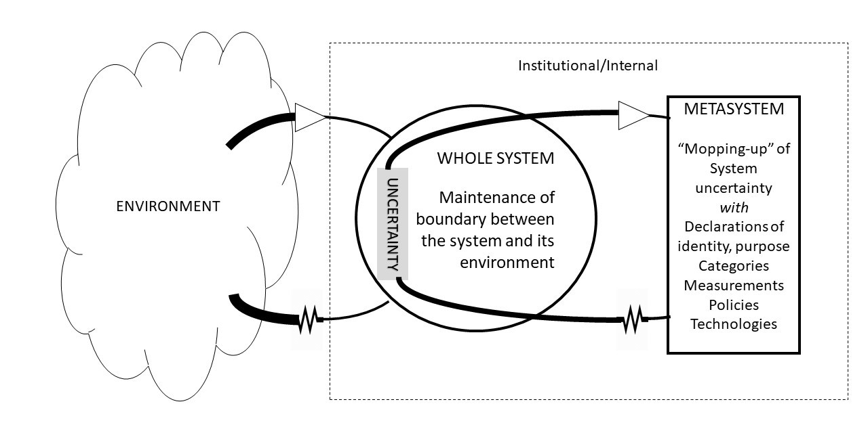
Figure 1. Whole system, metasystem and uncertainty
In such a model, technology can be seen to be both a cause of uncertainty, and a means of managing it. Uncertainty is created by technology because tools provide new options for performing tasks, many of which could be done in other ways. In creating a new option, the probability of selecting any particular option is decreased, thus increasing the uncertainty that any particular option might be selected. This becomes an organisational problem when particular communication or coordination tools have to be agreed within a team to ensure successful organisation (for example, “Which calendaring or videoconference system do we use?”). In a PLE which exists within an ever-expanding array of social software tools and services, this explosion of uncertainty also presents personal organisational problems. In most educational institutions today, this personal technological uncertainty has resulted in institutional technologies which seek to attenuate the technological choices available to individuals. Thus, Figure 1 can be expanded to show how individual uncertainty is managed by institutional technology. The management metasystem imposes technology on the learners’ operations as a way of mitigating the uncertainty that learners experience in the light of ever-increasing options produced by technology (Figure 2)
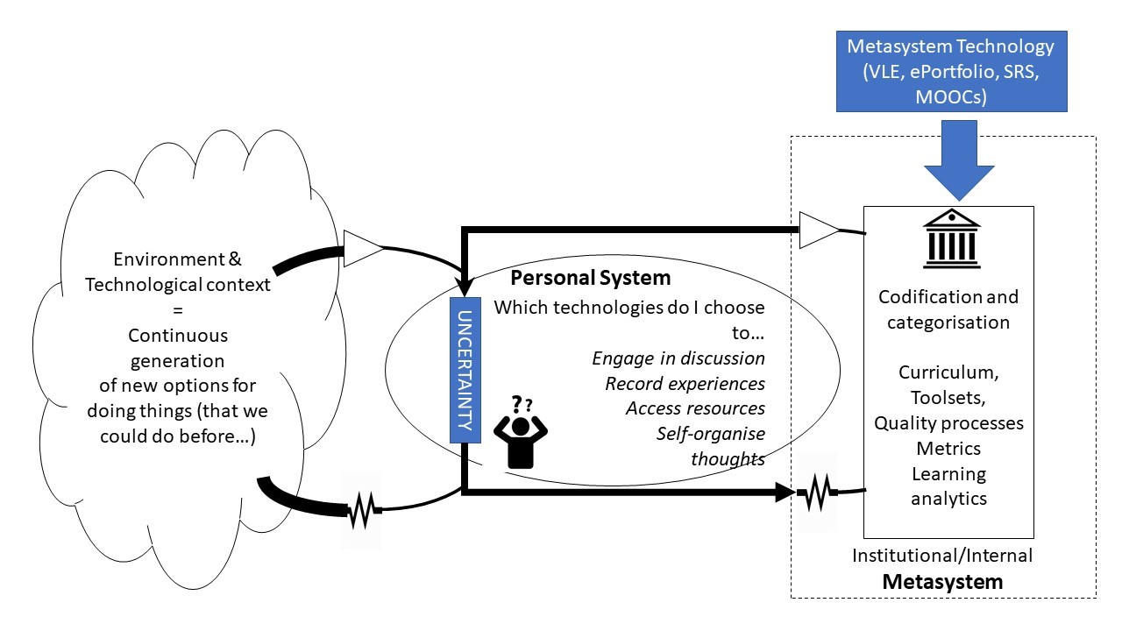
Figure 2. The institutional metasystem and the student’s uncertainty
At a broader societal level, money serves a function in attenuating uncertainty by codifying expectations in exchanges (Marx, 1990; Simmel, 2004). It is therefore unsurprising that efforts to manage environmental uncertainty produced by technology have both featured technological centralisation and marketisation. This helps to explain why centralised management of technology has maintained a role as a meta-system to the personal system, attenuating the technological choices available to the individual, and thus managing individual uncertainty by proxy. However, the disadvantage of this is that individuals, once they leave an institution, can be ill-equipped to manage technological uncertainty themselves. The role of the institutional meta-system in managing individual technological uncertainty has meant that pre-existing institutional hierarchies have become reinforced in the wake of new technological possibilities. Seen from this perspective, it is hardly surprising that personal coordination of learning has yet to dent traditional centralised structures and practices within education: indeed, it may have reinforced them.
We must, therefore, ask: is a personal technology possible which can be used to mitigate for the production of uncertainty in a personal system, and ensure that the metasystem is able to coordinate the operations of the system without imposing technologies?
A similar diagram to Figure 2 can be drawn for a person. As ‘whole systems’, ‘persons’ contain undecidable questions whose undecidability must be managed by a metasystem. The problem for persons, as with institutions, is that deep uncertainty within their ‘system’ can result in the development of an attenuative reflexive ‘metasystem’. For example, learners can develop rigid opinions, or ignore manifest inconsistencies in their intellectual positions on different topics. This is partly why educationalists point to the need for ‘unsettling’ learners (Morrow 2009; Young and Muller 2013) - particularly in higher education - where this can be seen as an intervention with the reflexive metasystem of the individual which, when it is disrupted, can cause a reconfiguration of the system whose uncertainty it manages.
Insight gained from modelling persons and institutions like this help to situate educational interventions which target the management of both personal and institutional uncertainty. There are a variety of ways in which a metasystem might be disrupted, and as Land has described (Land, Meyer, and Flanagan 2016), it is one of the functions of higher education that this should occur within the learning conversation. Yet the learning conversation is a relationship featuring both the metasystems of teachers and learners. While learner disruption is an important stage in the learning process, it is dependent on the extent to which teachers too are willing to be disrupted. So while it’s possible to disrupt the learner metasystem in various ways, and to provide the individual learner with new ways in which they might deal with uncertainty, it is equally possible (and may be necessary) to disrupt the metasystem of the teacher so that they are able to steer the learning conversation appropriately. But what does ‘effective steering’ look like? In order to answer this, we need to consider the ways that individuals (teachers and learners) build models to anticipate the world around them, and guide their actions accordingly.

2.2. Anticipatory Systems and Conversation
An anticipatory system is a concept that first emerged in biology, as a description of a system which contains a model of itself (Rosen 2012). It later acquired a mathematical presentation in the work of Dubois(1998). From a human perspective, the assertion that each of us has a mental representation of the world outside and our role in it is consistent with both constructivist and instructivist epistemology: the difference between these positions concerns not whether such a model exists, but the locus of agency for changing it. However, the principle that any whole system must contain a model of itself is more contestable. Without wanting to sideline important questions about the universality of anticipation, our focus here is on exactly how a ‘model of oneself in the environment’ might actually look and work, and it is to this question that we consider both Harri-Augstien’s work on learning conversations (Harri-Augstein and Thomas 2013), and Dubois’s work on ‘anticipatory systems’.
Any model of oneself (an anticipatory system) is constructed in the light of events which occur over time and reflexive processes which operate on interpretations of those events. There are naturally many possible models that might be constructed. The reflexive process leading to the selection of the appropriate anticipatory model must therefore be made according to how well any model constructs the past, interprets the present and predicts the future. This implies that the criteria for selection must be some some kind of discernible pattern connecting a view of history which can be used as a guide for the construction of the future. More precisely, recurring patterns at different levels of analysis, such as is seen in the self-similar patterns of fractals, would therefore be one of the criteria for the selection of an anticipatory model.
In human behaviour, anticipation is observable in many ways, but one of the most overt which presents phenomena for analysis is conversation. George Kelly considered that the process of constructing meaning came about through what he called “personal constructs” which, in his view, were anticipatory patterns derived from uses of language in different circumstances (Kelly, 2013). For example, conversation can be seen as the coordination between people attempting to understand the patterns used by the other. This is made more complex by the fact that the words and concepts used by people are not constant, but emerge over time. Technically, conversation, like most life-processes, is non-ergodic (Kauffman 2002): it displays an emergent ‘alphabet’ of features. This means that any discernible repeatable pattern in the use of words in conversation must take the form of relations between concepts - particularly patterns of repetition of concepts - over time.
Partly because of its emergent nature, no concept exists independently of any other. Yet, as Pask (1975) identified, the occurrences of concepts over time exhibit patterns of order and disorder which are analysable through information theoretical calculations. For example, for a period of learning, a single concept such as “hot” as understood by a learner, may be applied to numerous phenomena. The total information contained in this repetition can be calculated using the formulae of Shannon’s entropy (Shannon and Weaver 1949). This well-documented and important equation measures the ‘average surprisingness’ of elements in a message (Ulanowicz 2011). At a basic level, reoccurrence of a word like “hot” in a set of messages will reduce information entropy (because it becomes less surprising). This is not to say that a personal construct correlates to frequency of utterance of a word. Rather it is to say that frequency of utterance is an epiphenomenon, or an “imprint” of the meaning-making processes which sit behind the construct. It is this meaning that is constructed in the light of all the variables of communication in different settings and which steers the generation of utterances (Luhmann, 1996; Leydesdorff and Dubois, 2009). Thus, our interest lies in analysing the relationship between relative levels of Shannon entropy over time between different variables in communication situations as an index of the construction of an anticipatory system as shown in Figure 3.
In Figure 3, utterances produce Shannon information at the bottom of the diagram, labelled “The communication environment”. The introduction of a new concept or word is a surprising moment, occurring in the context of other factors such as physical movement or prosody. This ‘surprisingness’ raises the Shannon entropy of the pattern of words, making it available for analysis and reflection. An anticipatory system in learning, constructed as the interaction with the other two layers of the model in Figure 3, may be thought of as a system which models patterns of surprisingness in the light of events in the past, where the “semantic” element considers likely patterns of surprisingness in the future.
The potential significance of adopting this approach lies not just with analytical results, but with a new perspective on what happens as learners construct their understanding of the world, and how the coherence of learner understanding might be analysed and compared. As such, we are interested in the possibility that analysis of personal constructs may provide a richer indicator of emergent learner understanding than conventional assessment methods such as learning outcomes, which codify teacher expectations rather than learner understanding. However, in order to produce data on learner constructs, new technological approaches to capturing data are necessary.
Technology stimulates conversation by providing artefacts for people to talk about. Videos shared on YouTube, pages from Wikipedia, and documents shared on social media platforms provide a context for personal interactions. For Harri-Augstien and Thomas, the ‘learning conversation’ is the means by which individual uncertainty is managed through tracking the formation of constructs in the context of different forms of stimulus, where constructs are considered by Harri-Augstien and Thomas in the light of Kelly’s Personal Construct Theory. Since forms of stimulation are usually shared, conversation is the process whereby each individual probes others asking ‘what do you think of that?’. Following Kelly, and sociological models of the nature of conversation in Parsons (Parsons 2012), Luhmann (Luhmann 1996) and Schutz (Schutz 1967), in this conversational process, an anticipatory system may be thought of as a dynamic relation between multiple levels of selection as each learner attempts to coordinate their understanding with others. Looking again at Figure 3, these different levels of anticipation are illustrated as a three-layer model drawing on Dubois’s characterisation of anticipation. At the bottom level, there are the sequential ‘events’ of learning which occur over time common to everyone. Layer 2, shows the attempt by individuals to anticipate these sequences according to a model that is constructed in the light of past patterns. Level 3 considers that there are many possible anticipatory models, and that a further (and simultaneous) process is necessary to select the best-fitting model.
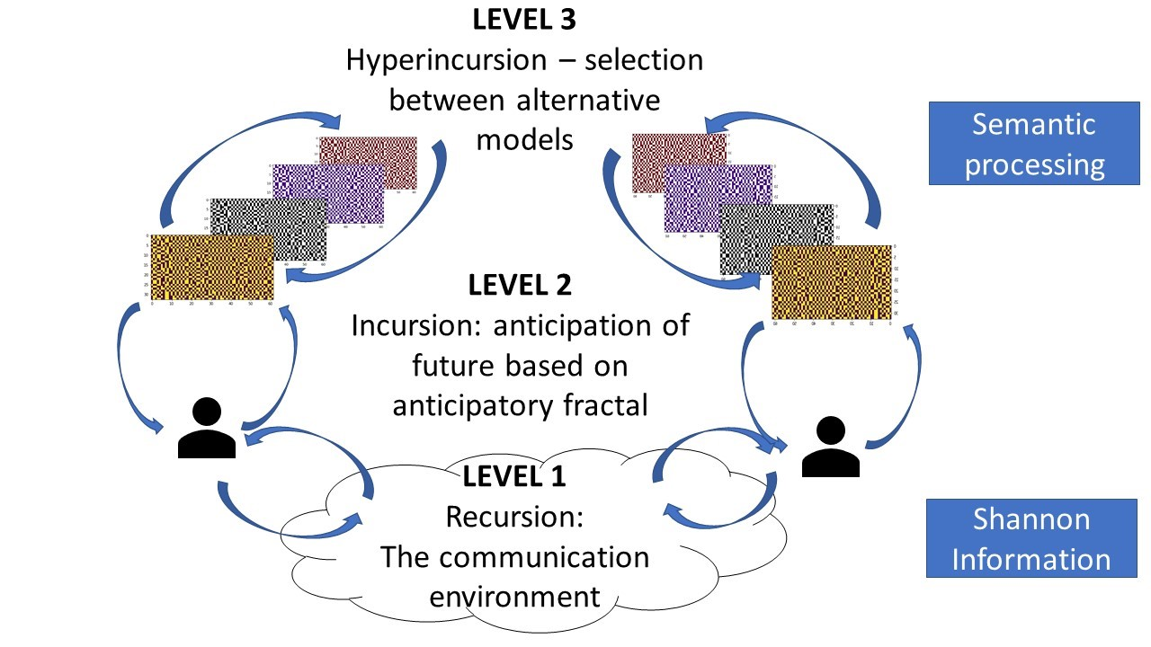
Figure 3. Conversation as an anticipatory system showing the relationship between Incursion and Hyperincursion
In learning conversations, it is suggested that this process occurs simultaneously between participants in a conversation. As with Parsons’s concept of ‘double contingency’ (Parsons 2012), each person constructs a model of the other in the light of the other’s utterances. Most significantly, the result of this anticipatory process is the production of a self-similar model which contains patterns relating one set of constructs to another.

3. Research Methods
In researching the personal coordination of understanding, we must create the conditions for the generation and recording of personal constructs, and use appropriate techniques to analyse the data. Our method of collecting data is to use a simple “comparative judgement” tool, specially developed for an educational course that was designed around conversation and inquiry.
The course was called ‘Global Scientific Dialogue’, conceived following the principles of a ‘conversation conference’ (Höhl and Sweeting 2015) and inspired by Beer’s experiments with organisational conversation (Beer 1994). The course ran over a concentrated period of 7 days. Like a conference, diverse perspectives and conversations were combined to produce individual learning experiences, so the Global Scientific Dialogue course was devised such that all 200 students would be exposed to conversations, activities and discussions around a set of challenging topics.
In the design of this, there were four principal challenges to address:
- It was important that learners could track their understanding as the course progressed, and this could feed into an assessment strategy.
- The course aim was to disrupt the metasystems of students so that resulting unmanaged uncertainty would be revealed in conversation
- It was important that the groups within which the students worked were relatively small, necessitating breaking up the entire group of 200 students and splitting them into 12 groups, each with a teacher as a facilitator
- It was important that teachers facilitated conversation rather than delivered knowledge, therefore something needed to be done to disrupt the metasystem of the teachers too, so that teachers and learners would be challenged with the same fundamental questions

3.1. Data Collection and Analytical Approach
To address challenge (1), a comparative judgement tool was used to present students which pairs of documents relating to the different course topics. Since the course was designed to expose students to a wide range of stimuli, the comparison exercise was presented to students as a way of providing “glue” that would help them make connections between the different concepts and ideas they were presented with in the face-to-face sessions. Students were asked which of the two documents they found more interesting and why. This software was organised into the same categories as the classrooms, and under each heading, learners could select which of two documents they found more interesting (Figure 4). They were encouraged to identify connections between these documents and the topics of their discussions in class.
Figure 4. Comparative judgement system asking students to compare two documents and ask them which was most interesting
The tool was intended to capture the formation of learner’s constructs over time. By presenting sometimes provocative ideas about the different areas of the course, and asking students to identify which they found more interesting at a point in time, data was collected and was used as part of the assessment portfolio that was considered in the light of a patchwork-text based assessment.
Within the classroom, there were a variety of different activities. These ranged from the use of ‘grow a game’ methodology for creating thinking, to the drawing of pictures to music, to the categorisation of data and the understanding of issues of big data, to engagement with fundamental questions about the differences between scientific disciplines. The course also featured a day where students could meet and discuss with a range of experts from a variety of disciplines. Many students expressed a view that they had been transformed by the experience, whether by meeting and working with new friends, or by engaging with disciplinary experts far from their own interests (which were largely in economics and management).
This software activity was intended to reinforce some of the transdisciplinary conversations and experiences the students were having in the classroom, and its fundamental approach to presenting disparate topics and simply asking which was preferable was very similar to the pedagogical approaches used in the classroom.

3.2. Methods of analysis for Conversation and Anticipation
Behind the data analytical approach adopted in this work was the idea that personal constructs contribute to an anticipatory model within which meaning is established by learners. Following Pask (1975) and Kelly (2013), and similar to the arguments of Rosen and Dubois, Harri-Augstien and Thomas argue that whatever self-organisation takes place, it must have both a sequential dimension over time as the learner progress from one learning episode to the next, and a reflexive dimension. The reflexive dimension is orthogonal to the temporal dimension, since reflexive processes constrain future utterances, while reflexive processes operate on interpretations of the past and anticipations of the future.
Constructs
Con
1
Con
2
Con
3
Con
4
Con
5
Con
6
Con
7
...
Event
₁
1
0
Event
₂
0
1
Event
₃
1
1
0
1
Event
₄
0
1
0
1
1
0
0
Event
₅
0
0
1
1
1
0
0
Event
₆
1
1
1
1
1
0
1
Table 1. The flow of time diachronically (y-axis) against the generation of constructs (x-axis)
One problem with conceiving learning like this is that what needs to be measured are the relations between constructs at different levels of analysis (i.e. the similarity between Con₅ and Con₇ and Con₁ and Con₂ in the above Table 1), not the presence of constructs themselves. Harri-Augstien and Thomas suggest with Kelly that constructs can be analysed as repeated statistical labels in a grid of words which Kelly called a Repertory Grid (Kelly 2013). In our analysis, we consider that the grid of words is less important than recurrent patterns or relations of words, and for this Shannon entropy can help establish a measure which considers relations in this way. If constructs are simply words, then the entropy of those words can be calculated over a period of time. However, so too can the relative entropy between one construct and another. Moreover, it is also possible to calculate the entropy between a construct and the relative entropy between other constructs. In other words, even in simple structures of constructs, rich dynamics of entropy may be unfolded through recursively analysing relations between elements.
Table 1 can be reconsidered in the light of Dubois’s explanation of an anticipatory system as a fractal. Dubois, drawing on Rosen’s work, has suggested that the dynamics of an anticipatory system consist of three interacting dimensions which together produce an emergent fractal which operates as a selection mechanism. In a learning process, for example, this would mean that a particular fractal structure associated with a basic ‘stimulus-response-correction’ such as something which induces pain which is then avoided (what Bateson calls ‘Learning 1’(Bateson 1987)) is recapitulated at a higher level according to a pattern which anticipates potential for “danger” (Bateson’s ‘Learning 2’).
The components of Dubois’s analysis are three features which he calls ‘recursion’, ‘incursion’ and ‘hyperincursion’. These are defined as:
- Recursion: Every event is a consequence of a preceding event (much in the way that a Markov process works);
- Incursion: Every event contributes to a model of what is happening which can be used to aniticipate future events;
- Hyperincursion: Every event considers a number of possible models of what is happening, alongside each model’s prediction of future states;
Dubois has explained his idea in terms of a mathematical example which demonstrates how the self-reference of an ‘incursive’ fractal can be operationalised. He illustrates how the fractal of the Sierpinski triangle can be produced, starting from a recursive equation which produces Pascal’s triangle (Dubois 1998):
X(n,t + l) = [X(n,t) + X(n − l,t)]mod2
This equation is ‘recursive’ because its future state, t+1 always depends on its past.
It produces the following pattern:
 | n = 0 | 1 | 2 | 3 | 4 | 5 | 6 | 7 | 8
t = 0 | 0 | 1 | 0 | 0 | 0 | 0 | 0 | 0 | 0
t = 1 | 0 | 1 | 1 | 0 | 0 | 0 | 0 | 0 | 0
t = 2 | 0 | 1 | 0 | 1 | 0 | 0 | 0 | 0 | 0
t = 3 | 0 | 1 | 1 | 1 | 1 | 0 | 0 | 0 | 0
t = 4 | 0 | 1 | 0 | 0 | 0 | 1 | 0 | 0 | 0
t = 5 | 0 | 1 | 1 | 0 | 0 | 1 | 1 | 0 | 0
t = 6 | 0 | 1 | 0 | 1 | 0 | 1 | 0 | 1 | 0
Table 2. Values from the recursive function showing an emerging Pascal triangle
He argues that the significance of the gradual emergence of a fractal in this process is that the self-similarity of the pattern is a template for how the pattern is likely to continue. This incursive version of the equation produces a pattern which amounts to an inversion of the recursive version:
X(n,t + l) = [X(n,t)) + X(n − l,t + l)]mod2
 | n = 0 | 1 | 2 | 3 | 4 | 5 | 6 | 7 | 8
t = 0 | 0 | 1 | 0 | 0 | 0 | 0 | 0 | 0 | 0
t = 1 | 0 | 1 | 1 | 1 | 1 | 1 | 1 | 1 | 1
t = 2 | 0 | 1 | 0 | 1 | 0 | 1 | 0 | 1 | 0
t = 3 | 0 | 1 | 1 | 0 | 0 | 1 | 1 | 0 | 0
t = 4 | 0 | 1 | 0 | 0 | 0 | 1 | 0 | 0 | 0
t = 5 | 0 | 1 | 1 | 1 | 1 | 0 | 0 | 0 | 0
t = 6 | 0 | 1 | 0 | 1 | 0 | 0 | 0 | 0 | 0
Table 3. Values from the incursive function, showing an emerging Sierpinski triangle

This equation is ‘incursive’ because each element depends on a preceding element, but an event at time t + 1 can depend on a preceding event at time t, while also drawing on a model which anticipates the event at time t+1. This multi-dimensional set of inter-relations is very close to how Kelly describes the emergence of constructs: a succeeding event may both depend on its immediate predecessor and on an emergent model of the past, present and future. At a more basic level, the instances at t indicate the flow of events, while the instances at n represent different levels of depth of a reflective process that considers those events. In real life, however, our categories of understanding are not similar binary values, but emergent categories. Is there a way in which Dubois’s n values may be reconceived to articulate an emergent set of categories which might also form a fractal in his anticipatory dynamics?
The construction of understanding, like all life processes, is what statisticians call a ‘non-ergodic’ process: categories of understanding are emergent, and the dynamics of the total system are not equivalent to the dynamics of a part of it. (Indeed, it should be said that one of the principal weaknesses of most learning analytic approaches is the implicit assumption that learning is ergodic!) This means that over time, our ways of understanding something, and the categories that we use, change. In contrast to Dubois’s simple n, we might conceive of an increasingly rich array, or alphabet, of categories to map across the emergent nature of what happens over time.
Following a new experience - whether it is a new idea, visual cue, or event, the model of the flow of events which predicts successive events is selected from a set of possibilities. Over time, events display a fluctuation in entropy, as there is a process of subtle variation and repetition. In terms of an anticipatory system, a single new experience contributes to an emergent model within which itself, its past and its possible future development can be mapped. Among those possible futures is the end of whatever set of experiences might be imagined can occur. Pask pointed out that all conversations come to an end, and that building up a model which anticipates the end is part of the process of creating a coherent understanding (see Pask (2020)).
The fundamental question in any study of conversation is “What drives the conversation?” – and perhaps more precisely, “What drives the conversation towards it’s end?” If an anticipatory systems steers the process of making utterances, then at some point, what is anticipated is “no utterance”. How does the system construct “no utterance”? In addressing this, we can suggest that the question lies at the root of how anticipatory systems can be conceptualised and analysed more generally. Since no real conversation completely stops, but may find points of pause, the construction of “nothing” at different levels of organisation can be seen to be driving force that structures patterns within the anticipatory system itself. There must be a mechanism whereby different orders of organisation within the system effectively cancel themselves out.
From an analytical point of view, we can consider that within Dubois’s abstract anticipatory system, in place of his n, we might propose an algebra which gradually accumulates levels at which elements complement each other, and ‘cancel out’. This basic idea of complementary algebraic values can then be seen as a variety of algebraic ‘rewrite system’ such as those described in mathematics (Hofstadter 1999), or Conway’s cellular automata (Gardiner, 1970) or physics (Rowlands 2014). Rowlands’s example has been particularly influential in our present approach, especially as Rowlands suggests that the ‘rewrite principle’ underpins fundamental symmetries in physics and consciousness as Pask describes.
To understand how this works, we present a simple example. The most unnatural thing in learning (as in life) is no variation. When an event occurs for a long period of time (for example, watching a video), there are always variations in the different parameters which constitute it. The entropy of these parameters can be seen to ‘dance’ around each other. Figure 5 shows the variation in entropy of two parameters in one of the measurements from the course: the length of comments over time, and variation in the types of documents examined.
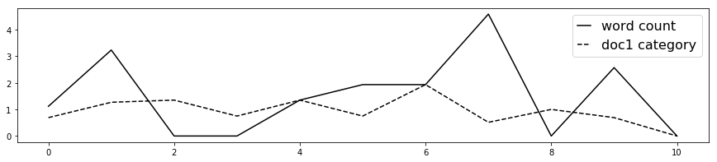
Figure 5. Simple example of Fluctuating entropies between two dimensions: word-count and document category
Entropy values are produced by taking raw data from these parameters, calculated with Shannon’s formula (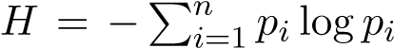) and smoothing them (through rounding) into an ‘alphabet’ of rounded values. The rate of change can be recorded as variation in values in this alphabet. Taking entropy measurements for these events over successive periods, reveals a pattern of fluctuation, from which fluctuation in one dimension can be related to fluctuation in another.
The two values in Figure 5 can be considered algebraically as two characters, A and B, which can be considered alongside the combined mutual interaction of AB. However, since in the case of each of these, there is an increase and a decrease in entropy, each element has both a positive (e.g. A) and negative (e.g. ¬A), or complementary, value. Therefore to indicate a two-valued alphabet, the whole set is:
A,¬A,B,¬B,AB,¬AB
The movements of the entropy lines in Figure 1 can be encoded as 1s and 0s according to the movement of the entropy. If the line goes up then A = 1 and ¬A = 0, and if the line goes down, A = 0 and ¬A = 1. Equally, if the gap between A and B increases, then AB = 1 and ¬AB = 0, while if the gap between A and B decreases then AB = 0 and ¬AB = 1. The flip-flopping pattern between A and ¬A, B and ¬B and AB and ¬AB creates a visual pattern. A table of these binary values from Figure 1 can then be created:

A | ¬A | B | ¬B | AB | ¬AB
0 1 | 0 | 1 | 0 | 1 | 0
1 0 | 1 | 1 | 0 | 0 | 1
2 0 | 1 | 0 | 1 | 1 | 0
3 1 | 0 | 1 | 0 | 1 | 0
4 1 | 0 | 0 | 1 | 0 | 1
5 0 | 1 | 1 | 0 | 1 | 0
6 1 | 0 | 0 | 1 | 1 | 0
7 0 | 1 | 1 | 0 | 0 | 1
8 1 | 0 | 0 | 1 | 1 | 0
9 0 | 1 | 0 | 1 | 0 | 1
Table 4. Figure 1 encoded as binary values for increases/decreases in entropy, where A = Direction of entropy of Word Count variation; B = Direction of entropy of document category variation; AB = Direction of relative entropy between A and B
From this table, a fractal-like pattern may be drawn as a grid, which provides a graphical indication of the degree of variation over time. This graphical presentation can then be related to looking at further dimensions. In learning, a single interpretation of an event develops into other interpretations based around other events. Different constructs emerge as the world unfolds. Producing A, ¬A, B, ¬B, C, ¬C, AB, ¬AB, AC, ¬AC, BC, ¬BC, ABC, ¬ABC. In growing in this way, we suggest that understanding produces a self-similar pattern as part of its anticipatory system at higher levels of organisation.

3.3. Pedagogical, Technological and Epistemological Organisation
Considering the four challenges of design, each required a technological component. Disrupting the metasystems of both the students (2) and the teachers (4) entailed innovation in the way that content was presented to students, and the way in which any disorientation in understanding could be managed through collaborative activity and discussion. The course was designed around a series of ‘rooms’ which were themed according to fundamental future-facing topics: ‘science’, ‘technology’, ‘intersubjectivity’, ‘dialogue and communication’, ‘creativity’ and ‘data and analysis’. Secondly, the students were supplied with comparative judgement software which contained documents reflecting the different topics of each of the rooms. Students would attend sessions in the different rooms, and were asked to participate in a comparative judgement activity at the end of each day, where they selected and justified which topics they found interesting.
Within each of the rooms, the topics of the course invited the presentation of ideas to prompt questions and disturb conventional thinking. For example, science presented the opportunity to introduce students to the uncertainties of quantum mechanics in its relationship to biology and consciousness. ‘Technology’ allowed students to be introduced to the techniques of AI, big data, and issues of surveillance. ‘Intersubjectivity’ invited students to consider the different means by which we tune-in to one another with different technological means, where ‘dialogue’ considered the ways group decisions are made and listening takes place. ‘Creativity’ focused on the expression of ambiguity through artistic practice (students were asked to draw a picture of piece of music).
In order to address challenge (2), each of the rooms was coordinated with a video containing a mashup of movie clips from the internet which could briefly introduce ideas, and then present students (and teachers) with an activity. This amounted to a kind of video ‘lesson plan’, and although teachers were free to run things differently, the classroom videos did serve to ensure that similar discussions and activities were happening in the different classrooms at roughly the same time.
The video lesson plan also addressed challenge (3). Teachers came from a variety of different disciplinary backgrounds, with different perspectives on what the purpose of teaching was. Facilitating conversation and creative activity was largely alien to most of them. Prior to the course, the same resources and approach had been used on the teachers themselves, so they had some understanding of what they needed to do. What was produced was a course for students alongside a large-scale team-teaching operation. There was a metasystemic disruption on everybody: both teachers and learners were similarly out of their comfort zones. In many cases, this resulted in the elimination of the teacher/student barrier, and for teachers and learners to engage in a more open conversation than either were used to. One student remarked that their teacher had said:
“Now I can see my students as people, where before they were just students”

4. Results
The comparative judgement software on the Global Scientific Dialogue programme produced metasystem disruption by presenting many different kinds of object to learners. In using the software alongside class-based activities, there was an opportunity for the metasystemic disruption to produce a set of text-based descriptions about the different objects which they compared, and an ordering of the different objects which identified which objects were more interesting than others. Taking these two things together produced a dataset which could then be used as the basis for further reflection and assessment.
The data has been visualised in a number of ways, although it is important to say that this is not the kind of visualisation that one normally encounters in work on “learning analytics”, which is principally aimed at institutional management of learner progress and attainment (see for example, Ginda et al (2019)). By contrast, our interest lies in creating classes of images of different states of dynamic systems (learners) which produce different kinds of learning behaviours. It is perhaps better compared to the studies that Pask produced identifying distinction between “holists” and “serialists” (1975), but our approach is more fine-grained. Like Pask, however, we seek to a deeper connection between the empirical data and an underlying ontology of learning.

4.1. Comparative Judgement structures
One of the striking features of the comparative judgement data is the fact that it produces distinct patterns of engagement. Clustering the comparison data by simply showing the connections between documents which were compared with one another produces a graphical presentation which has a set of distinct ‘types’. These are shown in Table 5.

Type 1: dispersed single comparisons  (n = 35) |  | Type 2: contiguous comparisons on a single topic  (n =50)
Type 3:  Production of loops  (n=23) | 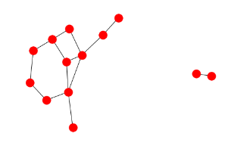 | Type 4: contiguous comparisons with production of loops (n = 17) | 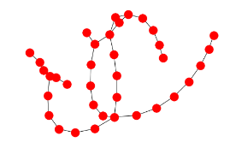
 | Type 5:  complex clusters of interactions between diverse documents  (n = 24) | 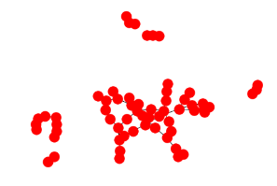

Table 5. Different types of clustering produced by student comparisons
These types of pattern reflect the ways in which different students preferred to use the software. The software presented learners with a set of images for comparison according to the particular category they selected. Some learners chose to engage with many different kinds of document, making many comparisons which were disparate across different fields (for example, Type 1). By contrast, some learners spent more time exploring documents within a particular section, producing contiguous chains of comparisons within a specific topic. Obviously not all learners engaged with the software to the same extent, but even among those who did not use it to a great extent, an interesting feature emerges in the production of ‘loops’ in the comparison. Type 3 illustrates a typical formation of two loops, where effectively the learner identifies that a > b, b > c and c > a. This paradox of categorisation clearly requires some kind of resolution, which further comparisons may be able to resolve. Type 4 indicates the combination of extended comparisons within a particular topic, alongside the production of these loops, while at a more complex level, type 5 illustrates the engagement where documents from a variety of different sources cluster in ‘tangles’. In total, 156 students produced 5024 comparison records. There was variance in the degree of participation.
These diagram types are distributed throughout the student dataset (indicated by the n values), inviting the question as to the correlation between the student’s reflections about their comparisons and the types of diagrams their engagement produced. The learners’ use of the software varied considerably, but particular attention can be focused on these types of diagram and the nature of specific phenomena, including loops.

4.2. The imprint of meaning in conversation
Short of directly capturing every utterance that occurred during the course, an ‘imprint’ of the likely conversational context that students selected their documents can be gained by examining the most popular categories of documents that the students chose as a general body. Since all students were working together, it can be assumed that students would share those themes they were most interested in with one another. Moreover, this conversational context might well have influenced the selection of documents for comparison in the first place. From 5024 comparisons, 4988 are classifiable through the weeks of the course, identifying the topics which engaged the students most shown in Table 6 (by order of number of comparisons).
category | Comparisons made
Creativity | 1031
Technology | 954
Science | 733
Interdisciplinarity | 572
Intersubjectivity | 532
Business Technology | 461
Scientific Dialogue | 447
Data | 258
Table 6. Counts of categories of compared documents across the dataset
The reason for considering the overall interest in particular subjects is that whatever judgements are made by students are made within a social context of conversation. Therefore, we can consider that the overall figures for interest in particular subjects will have some relationship to the ‘dominant conversations’ which occur in the social environment as students engage in the different activities on the course. Within these activities, there are certain themes which are of more interest to a larger number of people than others, and this means that conversations favour one kind of topic over another. This overall context therefore provides a frame for individual judgements made by the students, which contextualises the patterns of individual construct formation.

4.3. Personal Constructs and Anticipatory Systems
The fundamental thesis proposed here is that anticipation is the process which produces meaning and coherence in understanding. Anticipation arises within a social context in conversation, through which distinctions about the world are made. The comparative judgement exercise affords the opportunity for students to make distinctions and express their preferences, and that over time, this distinction-making process can help students see connections and patterns across different phenomena. If patterns are to be recognised across different phenomena, then some process must be able to identify a pattern at one level of experience, and relate it to a pattern at a different level of experience. This is the principle upon which the intersubjective conversation framework presented in section 2.2 (Figure 3) operates.
Empirically, the challenge is to transform raw data of comparison into patterns and to examine these patterns for recurrence at different levels. As Schutz identified, the patterns of intersubjective engagement involve a ‘spectrum’ of different sensory features. From an empirical perspective, we propose exploring the raw data of comparison using a similar approach, identifying different levels of description and considering how each level of description changes over time, and how each level of description’s changes relate to the changes in other levels of description.
Extending the simple example given previously, the data provided by students includes:
- Documents compared
- Categories of documents compared
- Frequency of comparisons
- Explanation of judgements
- Length of explanation of judgement
- Categories identified in explanation of judgements
Each of these data items can be considered as a graph line which indicates increase or decrease in the surprisingness of the data. For example, if the average length of a student’s response to begin with is 100 characters, but after 2 days, the average length of response is 1000 characters, then the transition from one to the other represents a ‘surprising’ moment where entropy will be increased. This surprising moment will likely have correlated in other aspects of the data. For example, there may be a shift in attention from one topic to another.
Different patterns of engagement produce different kinds of response from students. Sampling specific student responses gives some indication of the relationship between student responses and emergent understanding and overall patterns of engagement.

Student patterns of Type 1
Analysing the different dimensions of entropy in engagement with the software for students of type 1, produces the graph and grid pattern shown in Figure 6.
The Type 1 pattern suggests that engagement with the themes of the course was dispersed over a range of topics, but that this engagement was sometimes superficial - effectively a ‘scattergun’ approach. The graph of fluctuating entropies displays patterns which appear to bear this out: it appears that values generally move in similar directions, but to differing degrees, although the greatest variation relates to the length of text written by the student. This general pattern applies to the majority of graphs belonging to this type (n = 20)
Examining the comments written by this student also suggests a degree of superficiality and lack of coherence in the judgements made. This lack of coherence is shown in the grid-pattern displayed on the right-hand side of Figure 6 visualising the interrelationship between different shifts in entropy (the choice of documents, variation in the length of responses, variation in words and categories). A noticeable feature in Student A’s diagram is the repetition of a recurrent pattern between different values towards the end of the comparison period (vertical bands down in the figure)
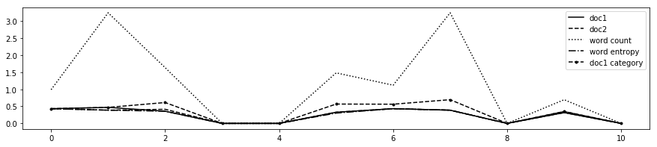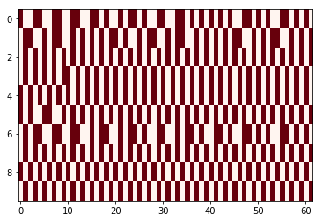
Figure 6. Entropy of constructs across a type-1 student’s comparisons as a graph and a fractal

Student patterns of Type 2 and 4
Not all students engaged with the comparison activities regularly, and patterns of engagement which are formed from sporadic concentrated bursts appear to be of type 2. The student represented by Figure 7 falls into this category. This is characterised by a lack of variety in the choice of documents. This potential indication of lack of engagement or curiosity would fit the general pattern of the types, in that single topic areas are focused on, rather than an exploration of the contrast between topics.
The level of interest shown by the students in these cases is also evidenced by the comments within this category, which tend to be generic: “I prefer document x to document y because x is more important to me”. Figure 7 shows a typical student graph from type 2, of which about 30 examples exist in the dataset. This lack of variety of response also is highlighted by the lack of activity within the graph:
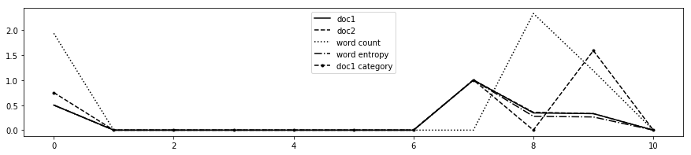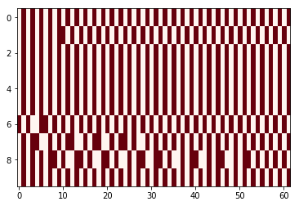
Figure 7. Short bursts of activity from student in type 2
A similar pattern is visible in type 4 (as one might expect, since type 4 is a more extended version of type 2), although here, in some cases there is more variation as students engaged with the software more. Figure 8 shows a student from type 4 whose data fits the type in being shallow. For example, when comparing documents about social networks, the student wrote (translated):
“document A is more interesting, the subject of the second is not close. I do not consider myself dependent on social networks”
However, while being superficial, this student did engage with the software continuously, varying how they said “A is more interesting than B”, producing a more varied fractal pattern shown below:
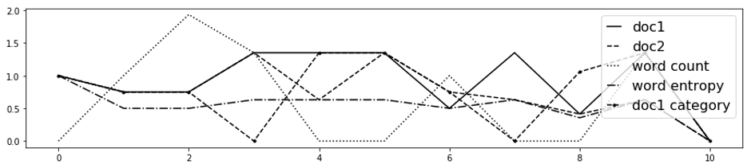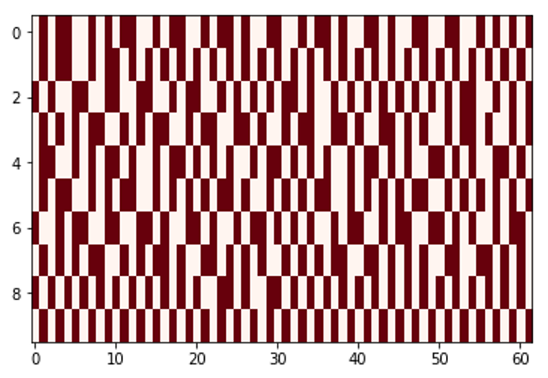
Figure 8. ‘noisy’ activity of student in type 4
What is noticeable about the fractal pattern is that it doesn’t appear to have any kind of structure to it. This is interesting when examining the fractal patterns of those students who engaged more deeply.

Student patterns of Types 3 and 5
Students whose patterns of engagement involved complex loops (type 3) and complex interlinkages (type 5) effectively set themselves ‘problems’ which they somehow had to address through their comments.
For students in type 3, there tended to be a greater deal of richness in the responses. For example, one student comparing documents about ‘hierarchies’ in organisations wrote:
“hierarchies are fairly stable structures because people are afraid of change because of the high degree of risk. However, the environment in which they exist is rather uncertain and anything can be expected, up to and including changes in the hierarchy”
However, this is a student who is not just thinking about organisational hierarchy, and the software had prompted them to consider other forms of organisation from biology. In response to a piece about biological organisation, they wrote:
“we use different organs of our body to express themselves. The mind and brain are such complex objects that their study can continue throughout history. And the interconnection of organs plays an important role in the proper functioning of the body as a whole”
In the student’s fractal representation, the variety of response shows a greater degree of order than shown in Figure 8, particularly with an increasing amount of variety towards the end of the course (Figure 9)
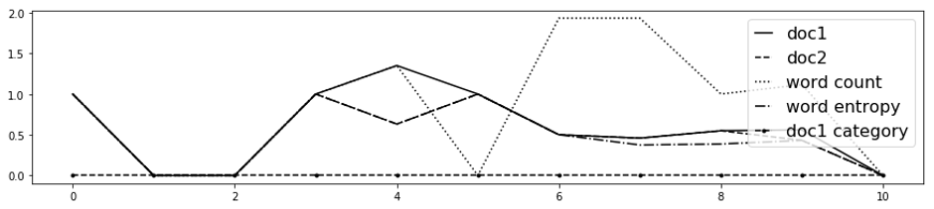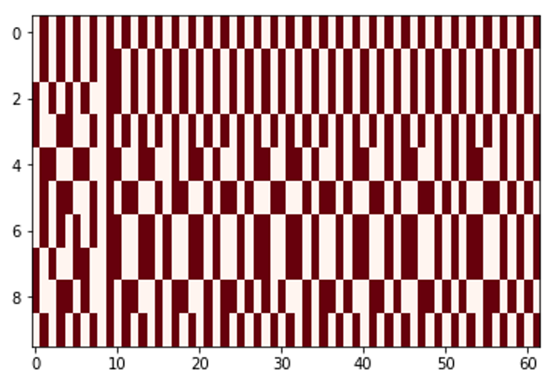
Figure 9. Increasing coherence of student in type 3 over time
For students in type 5, there is also a greater counterpoint in the ways in which high entropies in one dimension cross-cross with low entropies in another.
The complex web of comparisons that these students engaged in is also indicative of a richer range of kinds of documents they compared. Examining the entropies of the text they used to describe these documents, there is a pattern of divergence and convergence, as categories become more frequent in the descriptions provided.
Student comments in this instance are richer in their conceptual content. For example, when comparing documents about emerging technology, a student of type 5 notes:
Creating new technologies simplifies a person’s life and helps solve a number of problems, but at the same time creates new ones. The rapid development of the industry leads to pollution, the use of a large number of devices increases the level of stress. All this has a negative impact on human health. As a result, humanity faces an acute environmental problem. Scientists are finding ways to treat existing diseases, but every year there are new diseases. The creation of artificial intelligence will simplify human life, but can lead to a massive problem of unemployment
The grid-pattern produced for this student, also evident from the graph, is one of initial divergence (in choices of document, words, length of submission), gradually converging. This is visually striking in the fractal which displays a distinct repeated pattern at the beginning (left hand side), converging towards the end.
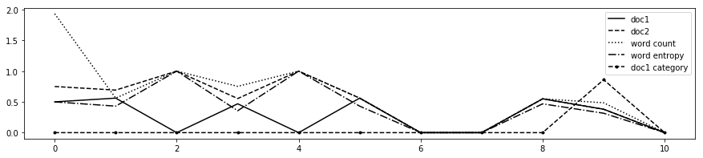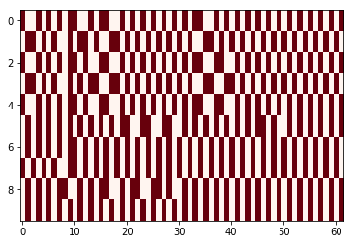
Figure 10. Entropy of constructs across a type 5 student’s comparisons as a graph and a fractal

5. Conclusion
The technological self-coordination of personal learning has thus far focused on the organisation of access to learning resources. This focus overlooked the importance of conversation, personal sense-making and accreditation. Visualisations of multiple dimensions of patterns of engagement appear to demonstrate differences in levels not only of engagement, but of understanding. While this study focused on post-hoc visualisation of student data, there is no reason why this visual feedback should not be given to the students as they progress in their personal activities. Visualising patterns of engagement allows for a meta-description of learning objectives to be explained to students and teachers, and for this to have an observable correlate which students can directly observe and manipulate. It remains to be seen if this immediate feedback will impact on the performance of students, and whether the increasing richness of patterns correlates to deeper understanding. We have presented an argument to suggest that it might, and that if this is the case, then self-assessment and self-direction of learning within a PLE is feasible.
Despite the apparently increasing dominance of institutionally-coordinated technology, the PLE has remained a topic of interest partly because ‘personal learning with technology’ is something we all do, and yet this natural learning behaviour sits at odds with the constraints of the formal curriculum and the toolsets of institutions. New meta-descriptions of personal engagement with learning are needed for an approach to personal learning which may yet overcome these constraints. Such developments are necessary, it has been argued, because of the fast-changing nature of the world coupled with the slow-moving bureaucracy of educational institutions. The present study of an institutionally-coordinated transdisciplinary module alongside personal tools for managing learning, may present new possibilities for learners to track the emergence of their intellectual development over time as they are presented with diverse experiences. The combination of diversity of experience and personal anticipation remains at the heart of all personal coordination in an increasingly complex world.

References
Ashby, William Ross (1965). Design for a brain: the origin of adaptive behaviour. 2nd ed., rev. Science paperbacks, no. 10.
Bandura, Albert (1997). Self Efficacy: The Exercise of Control. English. 1997 edition. New York: Worth Publishers. isbn: 978-0-7167-2850-4.
Bateson, Gregory (1987). Steps to an ecology of mind: collected essays in anthropology, psychiatry, evolution, and epistemology. isbn: 978-0-87668-950-9.
Beer, Stafford (1972). Brain of the firm: the managerial cybernetics of organization. isbn: 978-0-7139-0219-8.
- (1994). Beyond Dispute: The Invention of Team Syntegrity. English. First Edition edition. Chichester ; New York: John Wiley & Sons, Inc. isbn: 978-0-471-94451-5.
- (1995a). Heart of Enterprise. English. New Ed edition. Chichester ; New York: John Wiley & Sons. isbn: 978-0-471-94837-7.
- (1995b). Platform for Change. English. 1 edition. Chichester ; New York: Wiley. isbn: 978-0-471-94840-7.
Britain, Sandy;Liber (1999). A framework for pedagogical evaluation of virtual learning environments. url: http://www.leeds.ac.uk/educol/documents/00001237.htm
Collini, Stefan (2017). Speaking of Universities. English. London ; New York: Verso. isbn: 978-1-78663-139-8.
Dubois, Daniel M. (1998). “Computing anticipatory systems with incursion and hyperincursion”. In: AIP Conference Proceedings 437.1, pp. 3–30. issn: 0094-243X. doi: 10.1063/
1.56331. url: https://aip.scitation.org/doi/abs/10.1063/1.56331
Elder-Vass, Dave (2016). Profit and Gift in the Digital Economy. en. Google-Books-ID: f4YHDgAAQBAJ. Cambridge University Press. isbn: 978-1-316-79089-2.
Engestr¨om, Yrj¨o (2014). Learning by Expanding: An Activity-Theoretical Approach to Developmental Research. English. 2 edition. Cambridge University Press.
Gardner, Martin (1970). “Mathematical Games”. In: Scientific American 223.4. Publisher: Scientific American, a division of Nature America, Inc., pp. 120–123. issn: 0036-8733.
Ginda, Michael et al. (May 2019). “Visualizing learner engagement, performance, and trajectories to evaluate and optimize online course design”. en. In: PLOS ONE 14.5. Publisher: Public Library of Science, e0215964. issn: 1932-6203. doi: 10.1371/journal.pone.0215964. url: https : / / journals . plos . org / plosone / article ? id = 10 . 1371 / journal . pone . 0215964
Fiedler, Sebastian H. D. and Terje Valjataga (2011). “Personal Learning Environments: Concept or Technology?” en. In: International Journal of Virtual and Personal Learning Environments (IJVPLE) 2.4, pp. 1–11. issn: 1947-8518 DOI: 10.4018/jvple.2011100101. doi: 10.4018/jvple.2011100101.
Harri-Augstein, Sheila and Laurie Thomas (2013). Learning Conversations: The SelfOrganised Way to Personal and Organisational Growth. English. 1 edition. BookBaby.
Hofstadter, Douglas R. (1999). Godel, Escher, Bach: An Eternal Golden Braid. English. New Ed edition. New York: Basic Books. isbn: 978-0-465-02656-2.
Hohl, Michael and Ben Sweeting (2015). “Composing Conferences”. In: Constructivist Foundations 11.1.
Kauffman, Stuart (2002). Investigations. English. New Ed edition. New York: Oxford University Press. isbn: 978-0-19-512105-6.
Kelly, George A. (2013). A Theory of Personality: Psychology of Personal Constructs. English. New York: Norton. isbn: 978-0-393-00152-5.
Land, Ray, Jan H. F. Meyer, and Michael T. Flanagan, eds. (2016). Threshold Concepts in Practice. English. Rotterdam Boston Taipei: Sense Publishers. isbn: 978-94-6300-510-4.
Leydesdorff, Loet and Daniel M. Dubois (Dec. 2009). “Anticipation in Social Systems: theIncursion and Communication of Meaning”. In:arXiv:0912.1226 [physics].
Luhmann, Niklas (1996). Social Systems. isbn: 978-0-8047-2625-2.
Marx, Karl (1990). Capital: Critique of Political Economy v. 1. English. New Ed edition. London ; New York, N.Y: Penguin Classics. isbn: 978-0-14-044568-8.
Morrow, W. (2009). Bounds of democracy: epistemological access in higher education. HSRC
Press. url: http://repository.hsrc.ac.za/handle/20.500.11910/4739
Parsons, Talcott (2012). The Social System. English. New Orleans, LA: Quid Pro, LLC.
isbn: 978-1-61027-139-4.
Pask, Gordon (1975). Cybernetics of Human Learning and Performance. English. First Edition edition. London: Hutchinson. isbn: 978-0-09-119490-1.
– (2020). (2) Gordon Pask - On Consciousness - YouTube. url: https://www.youtube.com/ watch?v=kjH4v2UfDug (visited on 01/21/2020).
Powell, Walter W. and Paul J. DiMaggio, eds. (1991). The New Institutionalism in Organizational Analysis. English. 2nd edition. Chicago: University of Chicago Press. isbn: 978-0-226-67709-5.
Rosen, Robert (2012). Anticipatory Systems: Philosophical, Mathematical, and Methodological Foundations. en. 2nd ed. IFSR International Series in Systems Science and Systems Engineering. New York: Springer-Verlag. isbn: 978-1-4614-1268-7. url: https://www. springer.com/gp/book/9781461412687
Rowlands, Peter (2014). Foundations Of Physical Law, The. English. New Jersey: Wspc. isbn: 978-981-4618-37-3.
Schutz, A (1967). Phenomenology of the Social World (Studies in Phenomenology and Existential Philosophy). Northwestern University Press.
Shannon, Claude E. and Warren Weaver (1949). The Mathematical Theory of Communication. English. Urbana: University of Illinois Press. isbn: 978-0-252-72548-7.
Simmel, Georg (2004). The Philosophy of Money. en. Psychology Press. isbn: 978-0-415-34172- 1.
Simondon, Gilbert (2017). On the Mode of Existence of Technical Objects. English. Minneapolis, MN: University Of Minnesota Press. isbn: 978-1-937561-03-1.
Srnicek, Nick (2016). Platform Capitalism. English. Cambridge, UK ; Malden, MA: Polity Press. isbn: 978-1-5095-0487-9.
Ulanowicz, Robert (2011). “Towards Quantifying a Wider Reality: Shannon Exonerata”. eng. In: Information 2.4, pp. 624–634. issn: 2078-2489. doi: 10.3390/info2040624. url: http:
//www.mdpi.com/2078-2489/2/4/624/
Williamson, Ben (2017). Big Data in Education: The digital future of learning, policy and practice. English. 1 edition. Thousand Oaks, CA: SAGE Publications Ltd. isbn: 9781-4739-4800-6.
Wilson, Scott et al. (2009). “Personal Learning Environments: Challenging the dominant design of educational systems”. In: Journal of e-Learning and Knowledge Society 3.2.
Young, Michael and Johan Muller (2013). “On the powers of powerful knowledge”. en. In: Review of Education 1.3, pp. 229–250.
Zuboff, Professor Shoshana (2019). The Age of Surveillance Capitalism: The Fight for a Human Future at the New Frontier of Power. English. Profile Books. isbn: 978-1-78125685-5.

