Single-junction solar cells based on p-i-n GaAsSbN heterostructures grown by LPE
Abstract
In this paper we present single heterojunction p-i-n GaAsSbN/GaAs solar cells grown by low-temperature liquid phase epitaxy. Temperature-dependent photoluminescence measurements at a very low excitation power of 0.5 mW have been used to identify localized states in the bandgap of GaAsSbN which influence the photovoltaic properties of the cells. A power conversion efficiency of 4.15% was measured, under one sun AM1.5 conditions, which is promising for the first non-optimized LPE grown GaAsSbN/GaAs solar cell. The long-wavelength photosensitivity of the cells determined from external quantum efficiency and surface photovoltage measurements is extended down to 1.26 eV.

Introduction
There has been great interest in dilute nitride III-V-N materials during the last two decades, driven in part by their potential application in multijunction solar cells [1–10]. Multijunction solar cells currently achieve the highest efficiencies in practice. A conversion efficiency of 46.1% has been reported for four-junction solar cells under concentrated light, using wafer bonding to combine 2 two-junction solar cells grown on InP and GaAs substrates [11].The photovoltaic efficiency record is currently held by NREL for a six-junction inverted metamorphic concentrator solar cell which achieved 47.1% [1]. The bandgap combination of the subcells is a key factor for further improvements in the overall cell efficiency. Hopes for better results will be justified when suitable novel materials for intermediate subcells are found and grown with the appropriate crystal quality. Dilute nitride alloys such as InGaAsN or GaAsSbN can provide adjustable bandgaps between 1.2eV and 0.8 eV while remaining lattice-matched to GaAs or Ge substrates. The development of these materials is of great significance for high-efficiency multijunction solar cells, where they can be used to collect the low-energy photons. However, the device performance has not reached expectations, due to the low radiative efficiencies and low minority carrier diffusion lengths [6,7]. The issue of poor minority carrier diffusion length has been partially tackled by increasing the depletion region and with the use undoped layers to increase the current [8,9]. However, trap-assisted recombination dark current increases with the width of the depletion region which leads to the lowering of the open-circuit voltage.
It is therefore essential to improve the properties of dilute nitride compounds. There has been significant progress in the development of InGaAsN materials. InGaAsN solar cells grown by metalorganic chemical vapour deposition (MOCVD) with anti-reflection coatings (ARC) have achieved 13.2% efficiency based on a double-heterostructure single-junction, as reported by Kim et al. [12]. Solar Junction Corporation reported on the highest efficiency monolithic triple-junction solar cells of 43.5% under concentrated light for using InGaAsN instead of Ge as the lowest subcell [13].
Another dilute nitride material suitable for solar cell applications as an alternative to InGaAsN is GaAsSbN. GaAsSbN offers the possibility for independent tuning of the conduction and valence bands. While the bandgap of dilute nitrides is primarily reduced by lowering the conduction band minimum (CBM), the bandgap of antimonides is reduced by raising the valence band maximum (VBM) energy. Both of these mechanisms are explained through the band anti-crossing model. The incorporation of both Sb and N atoms into the crystal lattice enables lattice matching with GaAs or Ge. In addition, the incorporation also causes a large concentration of localized states which results in changed electronic and optical properties, and lower device performance, due to reduced carrier collection. Despite the beneficial features of this material it has not been as widely studied as InGaAsN, although interest in GaAsSbN has risen over the last few years [14–22]. Recent solar cells based on GaAsSbN have demonstrated efficiencies of 4% for a nonoptimized single-junction solar cell structure, without ARC coating grown by metalorganic chemical vapour deposition (MOCVD)[20] and 6% for molecular beam epitaxy (MBE) grown structures [19].
In this paper, we present the results of a liquid phase epitaxy (LPE) grown single-junction p-i-n GaAsSbN solar cell. To the best of our knowledge, no other groups have reported on LPE grown GaAsSbN/GaAs heterostructures. Temperature-dependent photoluminescent (PL) spectra at a low excitation power of 0.5mW have been measured and analyzed in order to identify the local states in the band gap since they increase the dark current of the cell. Solar cells samples with area 3.5x3.5mm² without ARC coating have been fabricated. They are measured under AM1.5 conditions and the results of the open-circuit voltage (V_{oc}), short-circuit current density (J_{sc}), fill factor (FF) and conversion efficiency (η) are reported.

2. Experimental Methods
The schematic structure of the single-junction solar cell investigated in this study is shown in Fig. 1. It employs a p-i-n structure based on compensated GaAsSbN layers grown via LPE. The epitaxial structure was grown in a horizontal LPE reactor using the “piston boat” technique. The details of the LPE growth of the structure is given in Ref. [23]. The content of Sb and N in the As sub-lattice was determined by energy-dispersive X-ray spectroscopy (EDX) and X-ray photoelectron spectroscopy (XPS) [21,23], and the values were found to be 6.7% and 0.1%, for Sb and N respectively. The lattice mismatch between the GaAsSbN layer and the GaAs substrate determined from X-ray diffraction (XRD) measurements and was found to be about 0.46%.
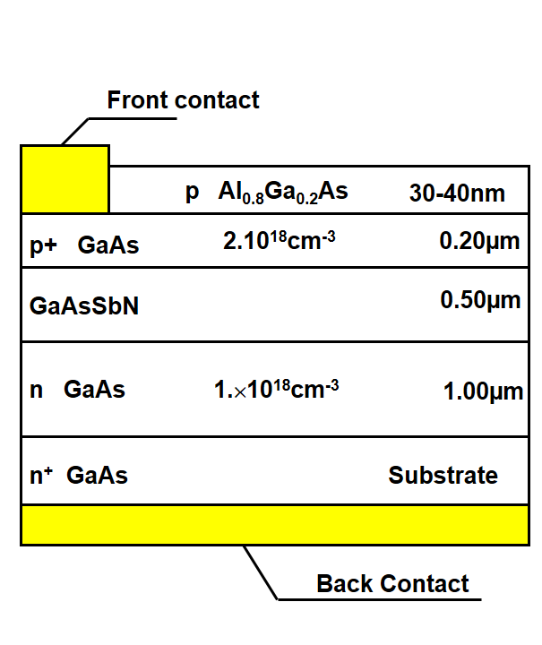

Fig. 1. Schematic structure of a single-junction p-i-n solar cell based on compensated GaAsSbN heterostructure grown by LPE.

Samples were processed into 3.5 × 3.5 mm photovoltaic mesa diodes comprising of a 3.25 mm diameter optical window using standard mask lithography. Firstly a common back n-contact was formed via thermal evaporation of an InGe/Au layer, which was subsequently annealed at 400 ºC for 1 minute. Following this, top ohmic contacts were defined via lithography consisting of 10 µm wide stripes, separated by 90 µm, across the optical window to ensure homogenous current injection. The contacts were deposited via thermal evaporation, which consisted of Au/Zn/Au layers, and subsequently followed by a 380 ºC anneal for 1 minute. Prior to the contact deposition the top Al_{0.8}Ga_{0.2}As layer was selectively etched using hydrogen peroxide and citric acid solution. The mesas were then etched using phosphoric acid, hydrogen peroxide and de-ionized water etchant. They were etched to a sufficient depth to ensure electrical isolation between adjacent devices.

Temperature dependent PL spectra were measured in the temperature range between 10 and 150 K in order to investigate the optical properties of the grown structures. The excitation was obtained with a laser light having an energy density of 100 nJ/cm2 (80 MHz repetition rate and 550 µW laser power) and wavelength of 680 nm provided by supercontinuum white laser (Fianium WhiteLase) monochromated with a tunable bandpass transmission filter (Fianium SuperChrome). The sample was mounted in a closed-loop He cryostat and its temperature was controlled through an Oxford Instruments ITC503 unit. The PL was collected and recorded by a fibre-coupled spectrometer (BWSpec Glacier X). Surface photovoltage (SPV) spectroscopy in metal-insulator-semiconductor (MIS) operation mode was undertaken. This technique was applied to study the optical absorption of the structures using the set-up and the measurement procedure as described elsewhere [24].

J-V measurements were undertaken using a calibrated TS Space Systems solar simulator with an AM1.5 spectrum at 1000 Wm⁻². The external quantum efficiency (EQE) measurements were performed using a Bentham PVE 300 system. A total of 8 different solar cell variants were produced, each sample having approximately 9 complete cells

3. Results and Discussion:
3.1 Photoluminescence Characterization
The temperature-dependent PL spectra of a solar cell epitaxial structure in the range 15 K -300K measured under low excitation intensity (~0.5 W/cm²) are depicted in Fig. 2. The peak with high intensity comes from p+ GaAs layer and the weak peak red-shifted to GaAs comes from GaAsSbN layer of the structure.

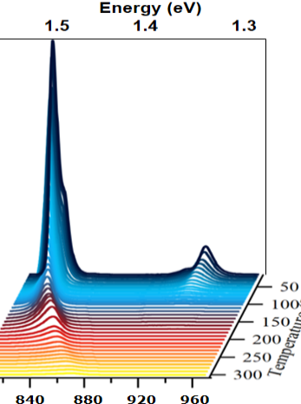
Fig. 2. Temperature dependent PL spectra of solar cell structure in the range 15-300K with step intervals of 10K.

Figure 3 presents the normalized PL peaks of the GaAsSbN layer in the structure measured at a different temperature range (11K−150K). The PL peak energy presents an anomalous, nearly S-shaped temperature behaviour. It is seen that there is a blue shift of the PL emission energy as the temperature is increased from 10K to about 70-80 K. With further increase of the temperature (beyond 90 K) the PL peak exhibits red shift. This type of behaviour is a well-known characteristic of carrier localization effects associated with band-tail states in the density of states [25–27]. The band tail of localized states depends on the degree of disorder of the compound. In the quaternary GaAsSbN compounds the incorporation of N and Sb into the crystal lattice locally modifies the conduction and valence band respectively, thus creating localized states and potential fluctuations. The blue-shift of the emission at low temperatures indicates that as the temperature increases the excitons gain sufficient thermal energy to transfer to higher-energy localized levels, thus increasing the emission energy. As the temperature increases further (above 90K) the higher energy localized states are gradually saturated, the excitons become almost delocalized and the PL peak energy decreases as a function of temperature due to reduction in the bandgap.
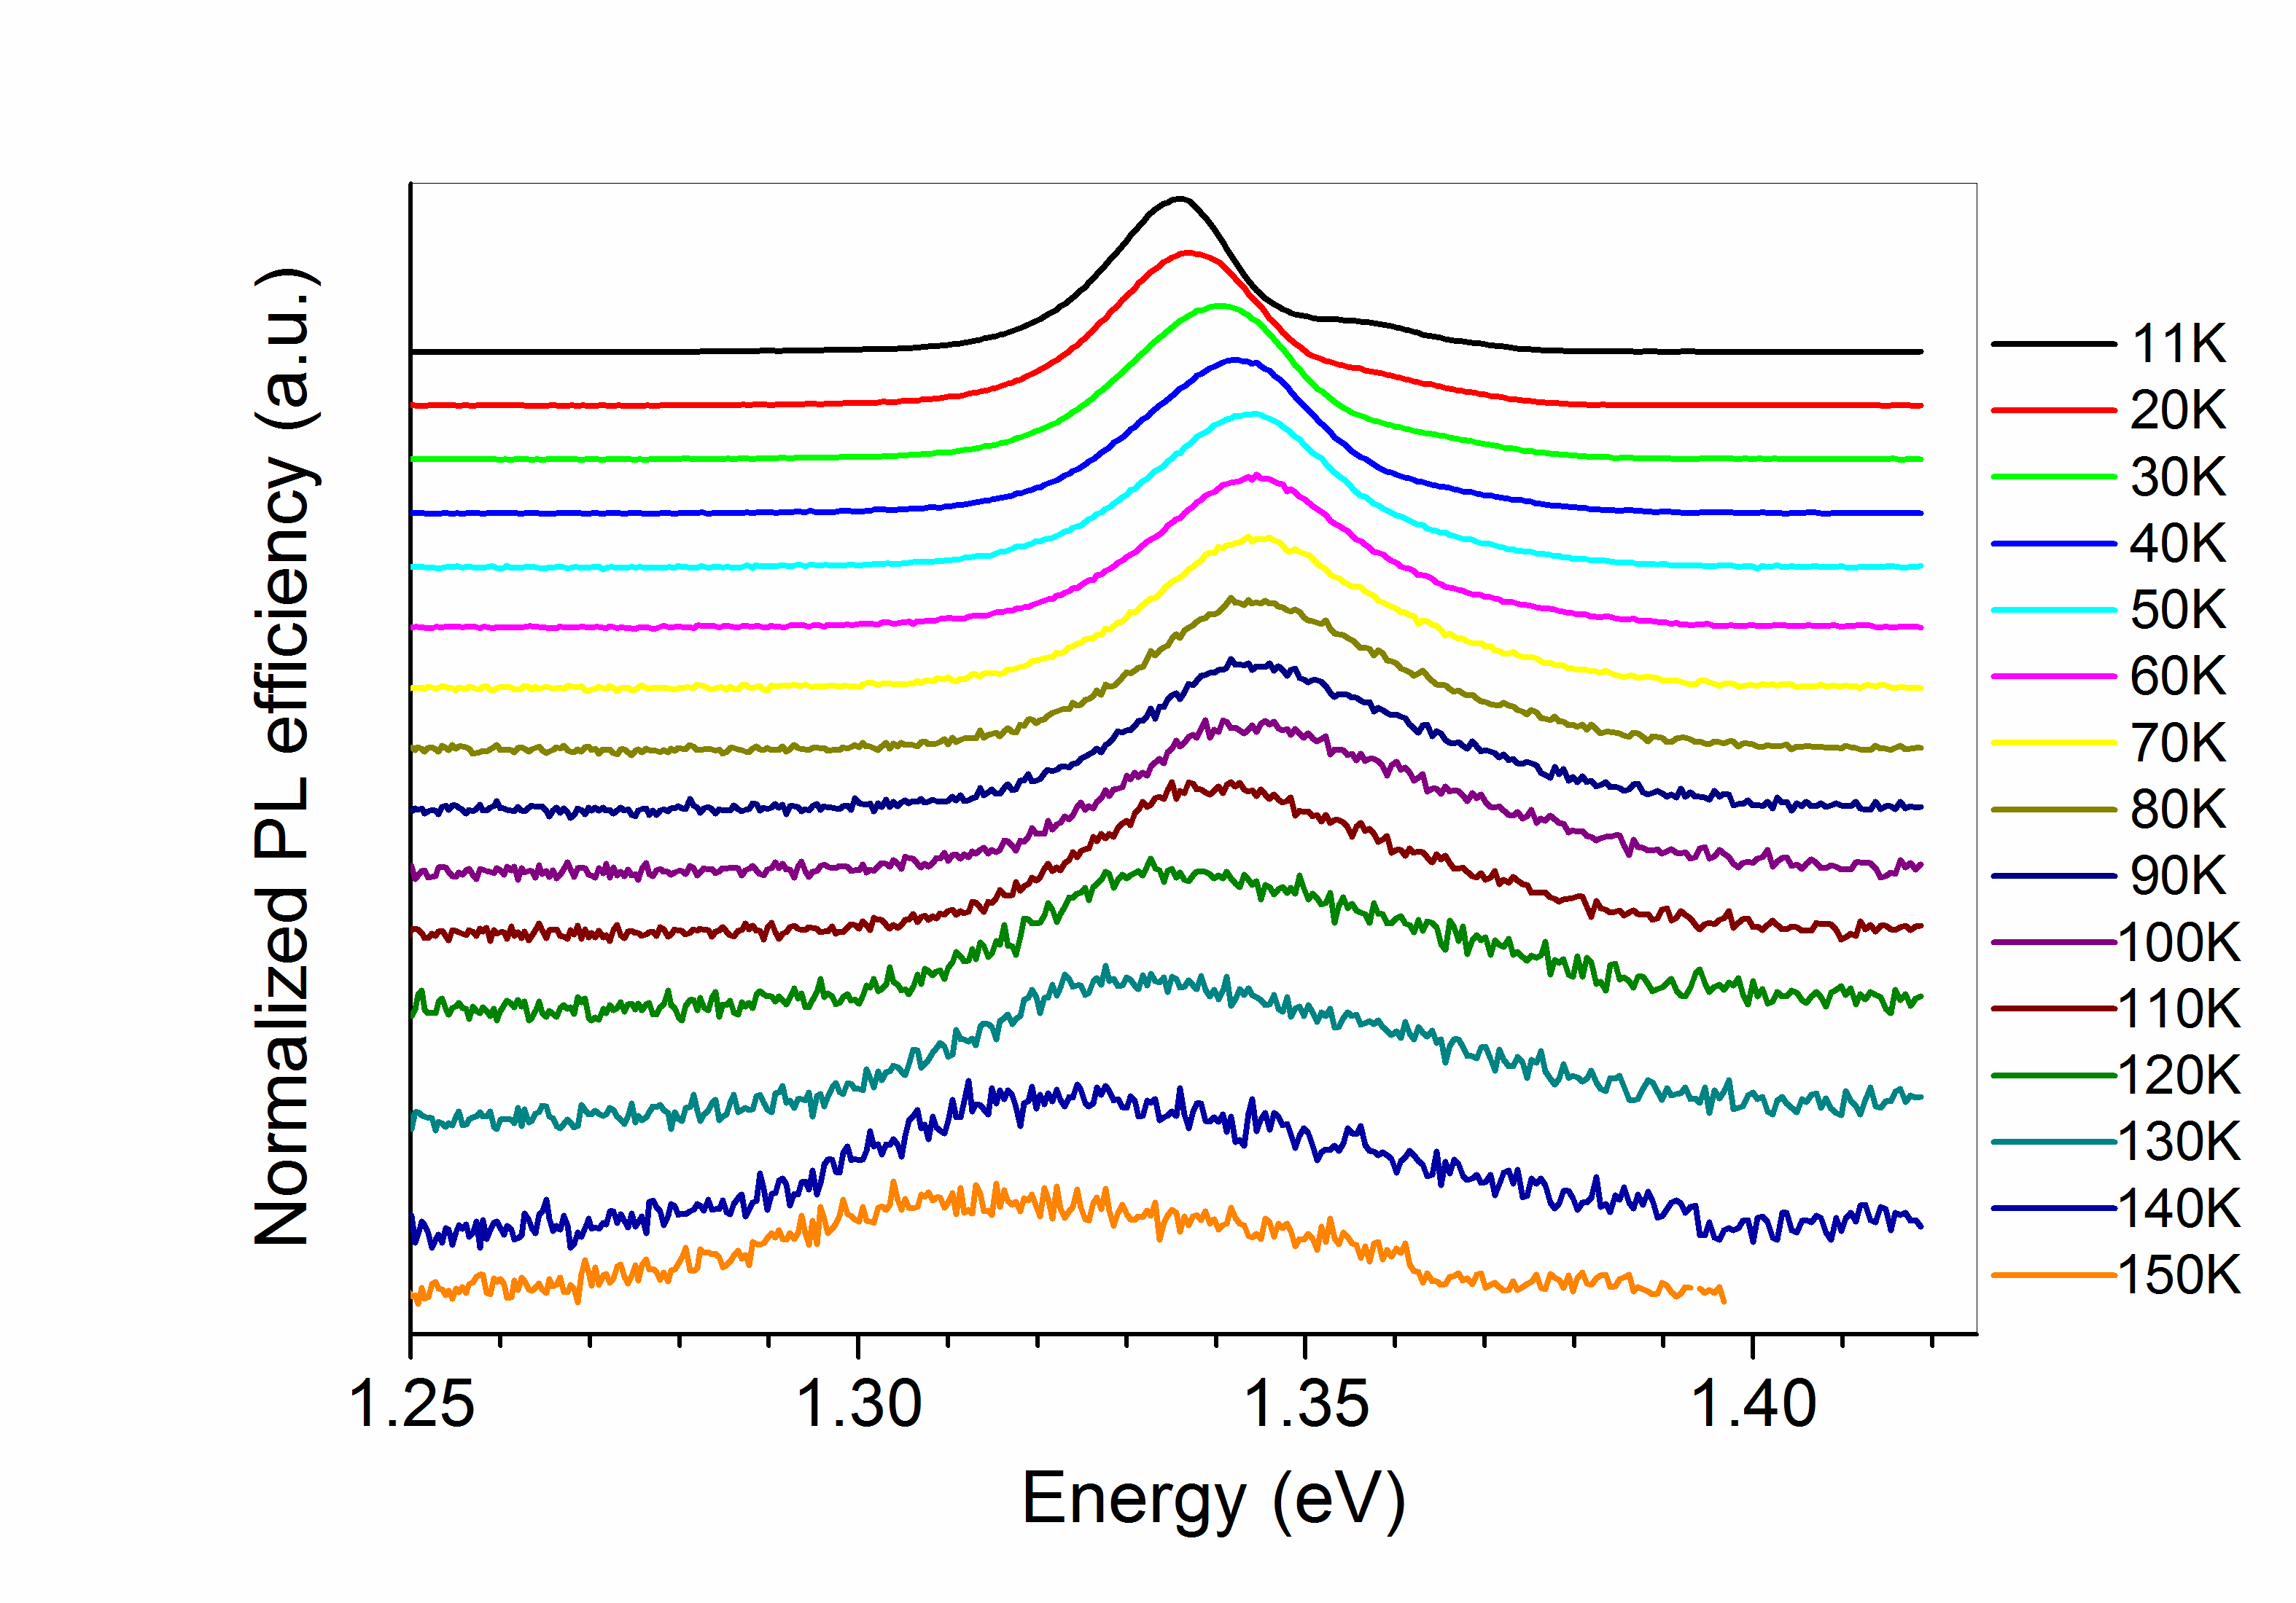
Fig. 3. Normalized PL spectra of GaAsSbN in a p-i-n solar cell structure varied from 11K (top) to 150 K (bottom) under excitation power 0.5 W/cm².

Fig. 4. Temperature dependence of the PL peak energy of GaAs and GaAsSbN in a
p-i-n solar cell structure.

Figure 4 illustrates the variations of the PL peak energies as a function of temperature for the p⁺-GaAs and the GaAsSbN layer in the structure. The PL peak energy for GaAs decreases monotonically with increasing temperature. Its temperature dependence is well fitted with Varshni’s relation E_{g}(T) = E₀ – aT²/(T+b) using the parameters typical for GaAs [28], namely E₀ = 1.519 eV for the bandgap at T = 0 K, and a = 5.4×10⁻⁴ eV.K⁻¹, and b = 204 K as fitting parameters. The GaAsSbN peak exhibits the non-typical S-curve (blue-red) behaviour. The first red-shift is missing, while the blue shift is only around 10 meV. This indicates that the potential fluctuations in these samples are relatively small and even at low temperature (20K) the excitons receive enough thermal energy to escape from the localized states and transfer to higher-energy localized states in the band-tail closer to the conduction band. The fit to the data above 90 K is obtained using Varshni’s relation with the following fitting parameters: E₀ = 1.363 eV, a = 1×10⁻³ eV.K⁻¹, and b = 414 K. The blue shift of the PL peak energy observed in this work is compared to the blue shift measured in MBE grown GaAsSbN/GaAs single quantum wells after annealing. It is nearly the same as the values reported in [29] for in-situ annealed samples, while in other works [26,30] larger values are observed. In our previous work [23] the temperature-dependent PL spectra of the p-i-n structures were measured under higher excitation intensity (5 W/cm²) and no blue shift of the PL peak position was observed at low temperatures. In the whole temperature range 20 – 300 K, the PL peak energy showed a monotonous decrease with increasing temperature. This behaviour was well fitted by an empirical Varshni relation [23].
Figure 5 shows the temperature dependence of the full width at half maximum (FWHM) for p⁺ GaAs and GaAsSbN layers. The FWHM values increase monotonically with temperature from 7.3 meV at 11 K to 15.2 meV at 150K for GaAs layer. The FWHM for GaAsSbN is 11.7 meV at 11K and increases slightly from 14.5 meV to 18 meV in the temperature range 20-60 K where the emission is dominated by localized excitons. FWHM values increase more rapidly with increasing temperature above 60K where the emission is dominated by delocalized excitons.
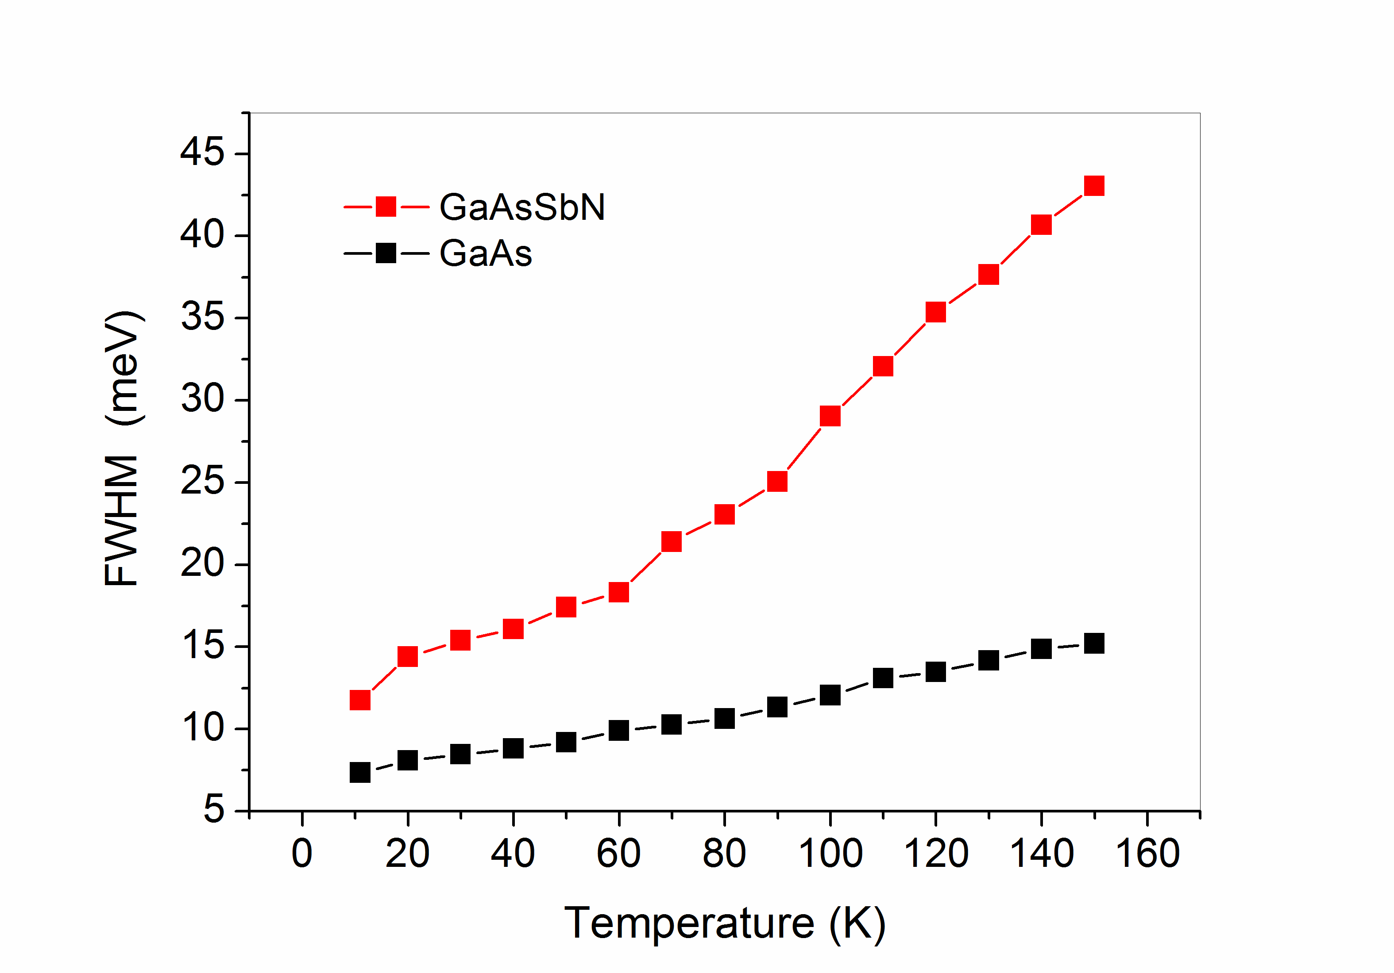

Fig. 5. Temperature dependence of FWHM of the PL peak energy of GaAs and GaAsSbN.

3.2. Surface photovoltage characterization
SPV spectroscopy has seldomly been used to study dilute nitride materials, e.g. the optical absorption [31] and the band offset [32] in InGaAsN/GaAs single quantum wells and the E₋ and E₊ transitions in GaNAs layers [33]. However, no other groups have reported on SPV investigations of GaAsSbN dilute nitride materials. We apply this method to study the optical absorption and photocarrier transport in the investigated structures. It is well known that in MIS operation mode the SPV amplitude spectrum emulates the optical absorption spectrum [34], while the SPV phase spectrum carries information about the direction of the energy band bending and therefore about the direction of the photocarrier movement [24]. The SPV measurements were performed at room temperature with a light modulation frequency of 94 Hz. The scanning was from high to low wavelengths, keeping the photon flux constant at each wavelength.

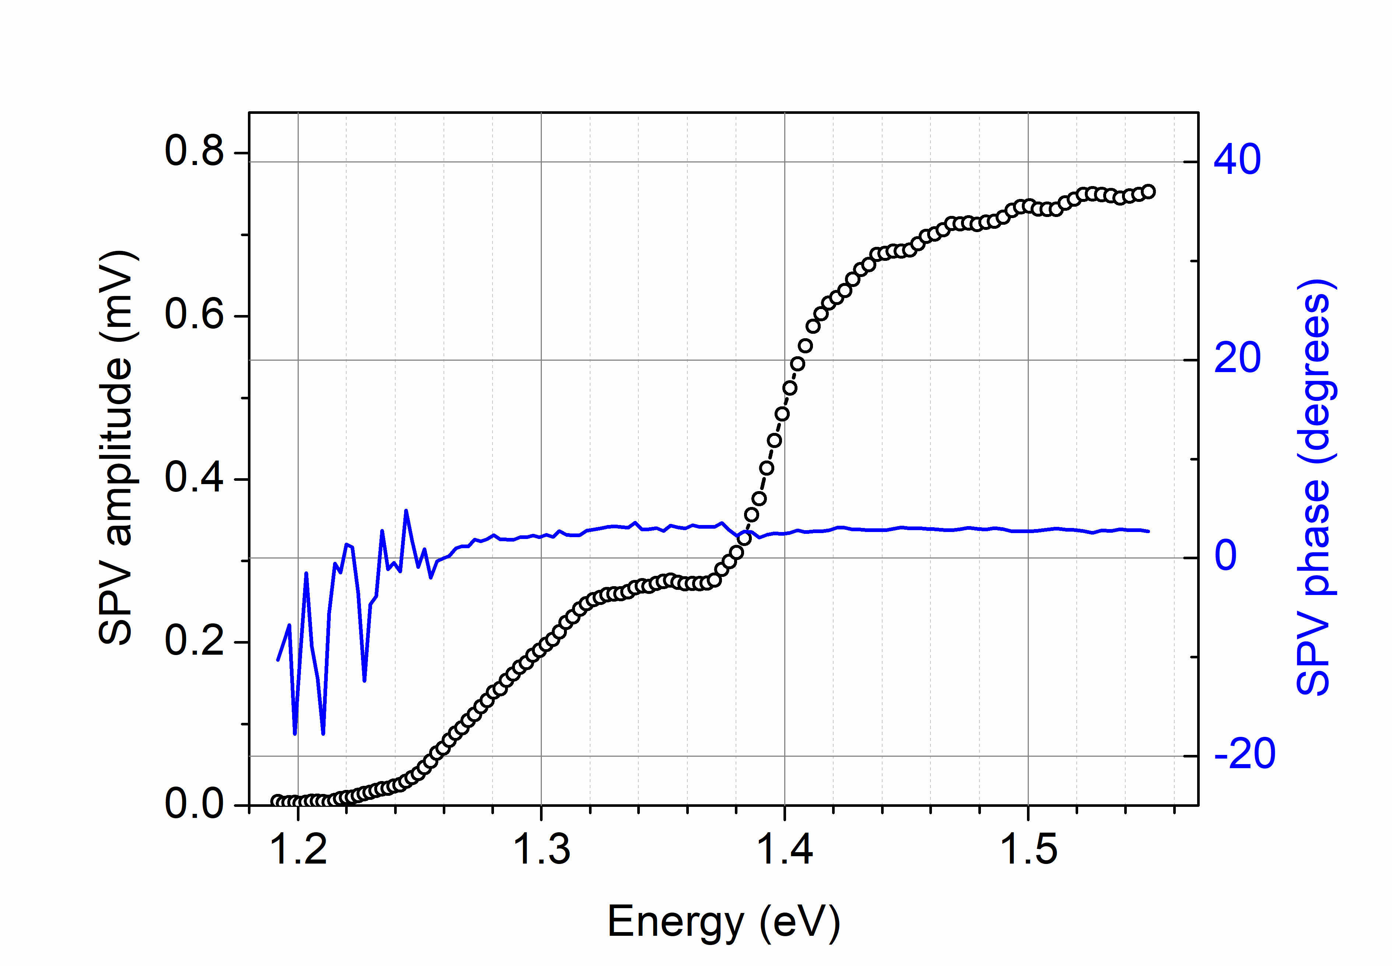

Fig. 6. SPV amplitude (symbol) and phase (line) spectra of a p-i-n solar cell based on compensated GaAsSbN measured at room temperature.

Figure 6 presents the SPV amplitude and phase spectra of a p-i-n single-junction solar cell structure based on compensated GaAsSbN. The amplitude spectrum reveals a step in the range of 1.24 – 1.38 eV and another one for energies above 1.38 eV. The latter step is related to the absorption in the GaAs layers. The step at low energy originates from the absorption in the GaAsSbN layer. We emphasize that the signals from GaAsSbN and GaAs are comparable in magnitude, which attests for good quality of the dilute nitride layer. The absorption edge of GaAsSbN determined from Tauc plot is 1.26 eV. The GaAsSbN layer is fully depleted taking into account its thickness (0.5 μm) and Hall concentration (~10¹⁵cm⁻³[23]). The carriers photogenerated in it are separated by the built-in electric field – the electrons swept towards the n-GaAs layer, while the holes – toward the p⁺-GaAs layer thus giving rise to photovoltage. The direction of the carrier drift is evidenced by the SPV phase values, which are close to zero degrees in agreement with the upward energy bands bending (in the direction towards the surface) in the p-i-n structure[24].

3.3 Photovoltaic characterization: J-V and EQE characteristics
A typical J-V curve for the GaAsSbN p-i-n solar cell is presented in Fig. 7a, with an efficiency of 4.15 %, an open-circuit voltage V_{oc}= 0.44 V, short-circuit current J_{sc} = 17.31 mAcm⁻² and fill factor FF = 54.5 %. The series resistance is R_{series}= 5.73 Ωcm² and shunt resistance is R_{shunt}=478 Ωcm². Nearly the same efficiency has been reported for single-junction 1 .25 eV GaAsSbN solar cells with 600 nm thickness of the GaAsSbN base layer grown by MOCVD [20]. The higher efficiency of about 6% has been achieved for 1.15 eV MBE grown GaAsSbN solar cells [19]. In both cases, an RTA annealing at 800 °C of the solar cells was performed, which significantly increased the open-circuit voltage values to 0.5 − 0.6 V due to the decrease in the density of the localized states. Typical values of V_{oc} measured in our cells based on as-grown LPE structures are around 0.4 V.
An example of a corresponding EQE graph is given in Fig. 7b. High EQE values of around 50% were measured in the wavelength range 550−850 nm, which suggests that the upper p⁺-GaAs emitter layer is of good quality despite being grown on GaAsSbN. A significant decrease of the EQE in the infrared part of the spectrum is due to the short minority carrier diffusion length in the dilute nitride layer because of the efficient recombination via localized defect levels. Nevertheless the EQE extends to approximately 1040 nm (1.19 eV) with an inflexion point at 1.26 eV in agreement with the SPV results for the bandgap of GaAsSbN. A slight reduction in EQE is observed at approximately 900 nm (1.377 eV), which can be associated with the onset of the optical transitions in GaAs in accordance with the SPV spectrum. The short wavelength photosensitivity of the structure is determined by the composition and thickness of the AlGaAs layer.

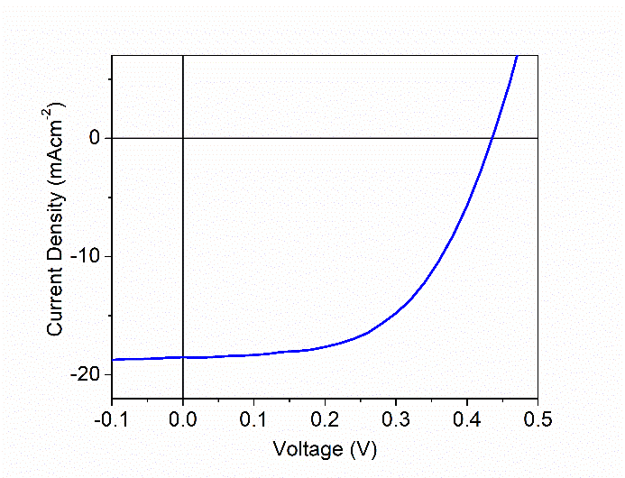 | 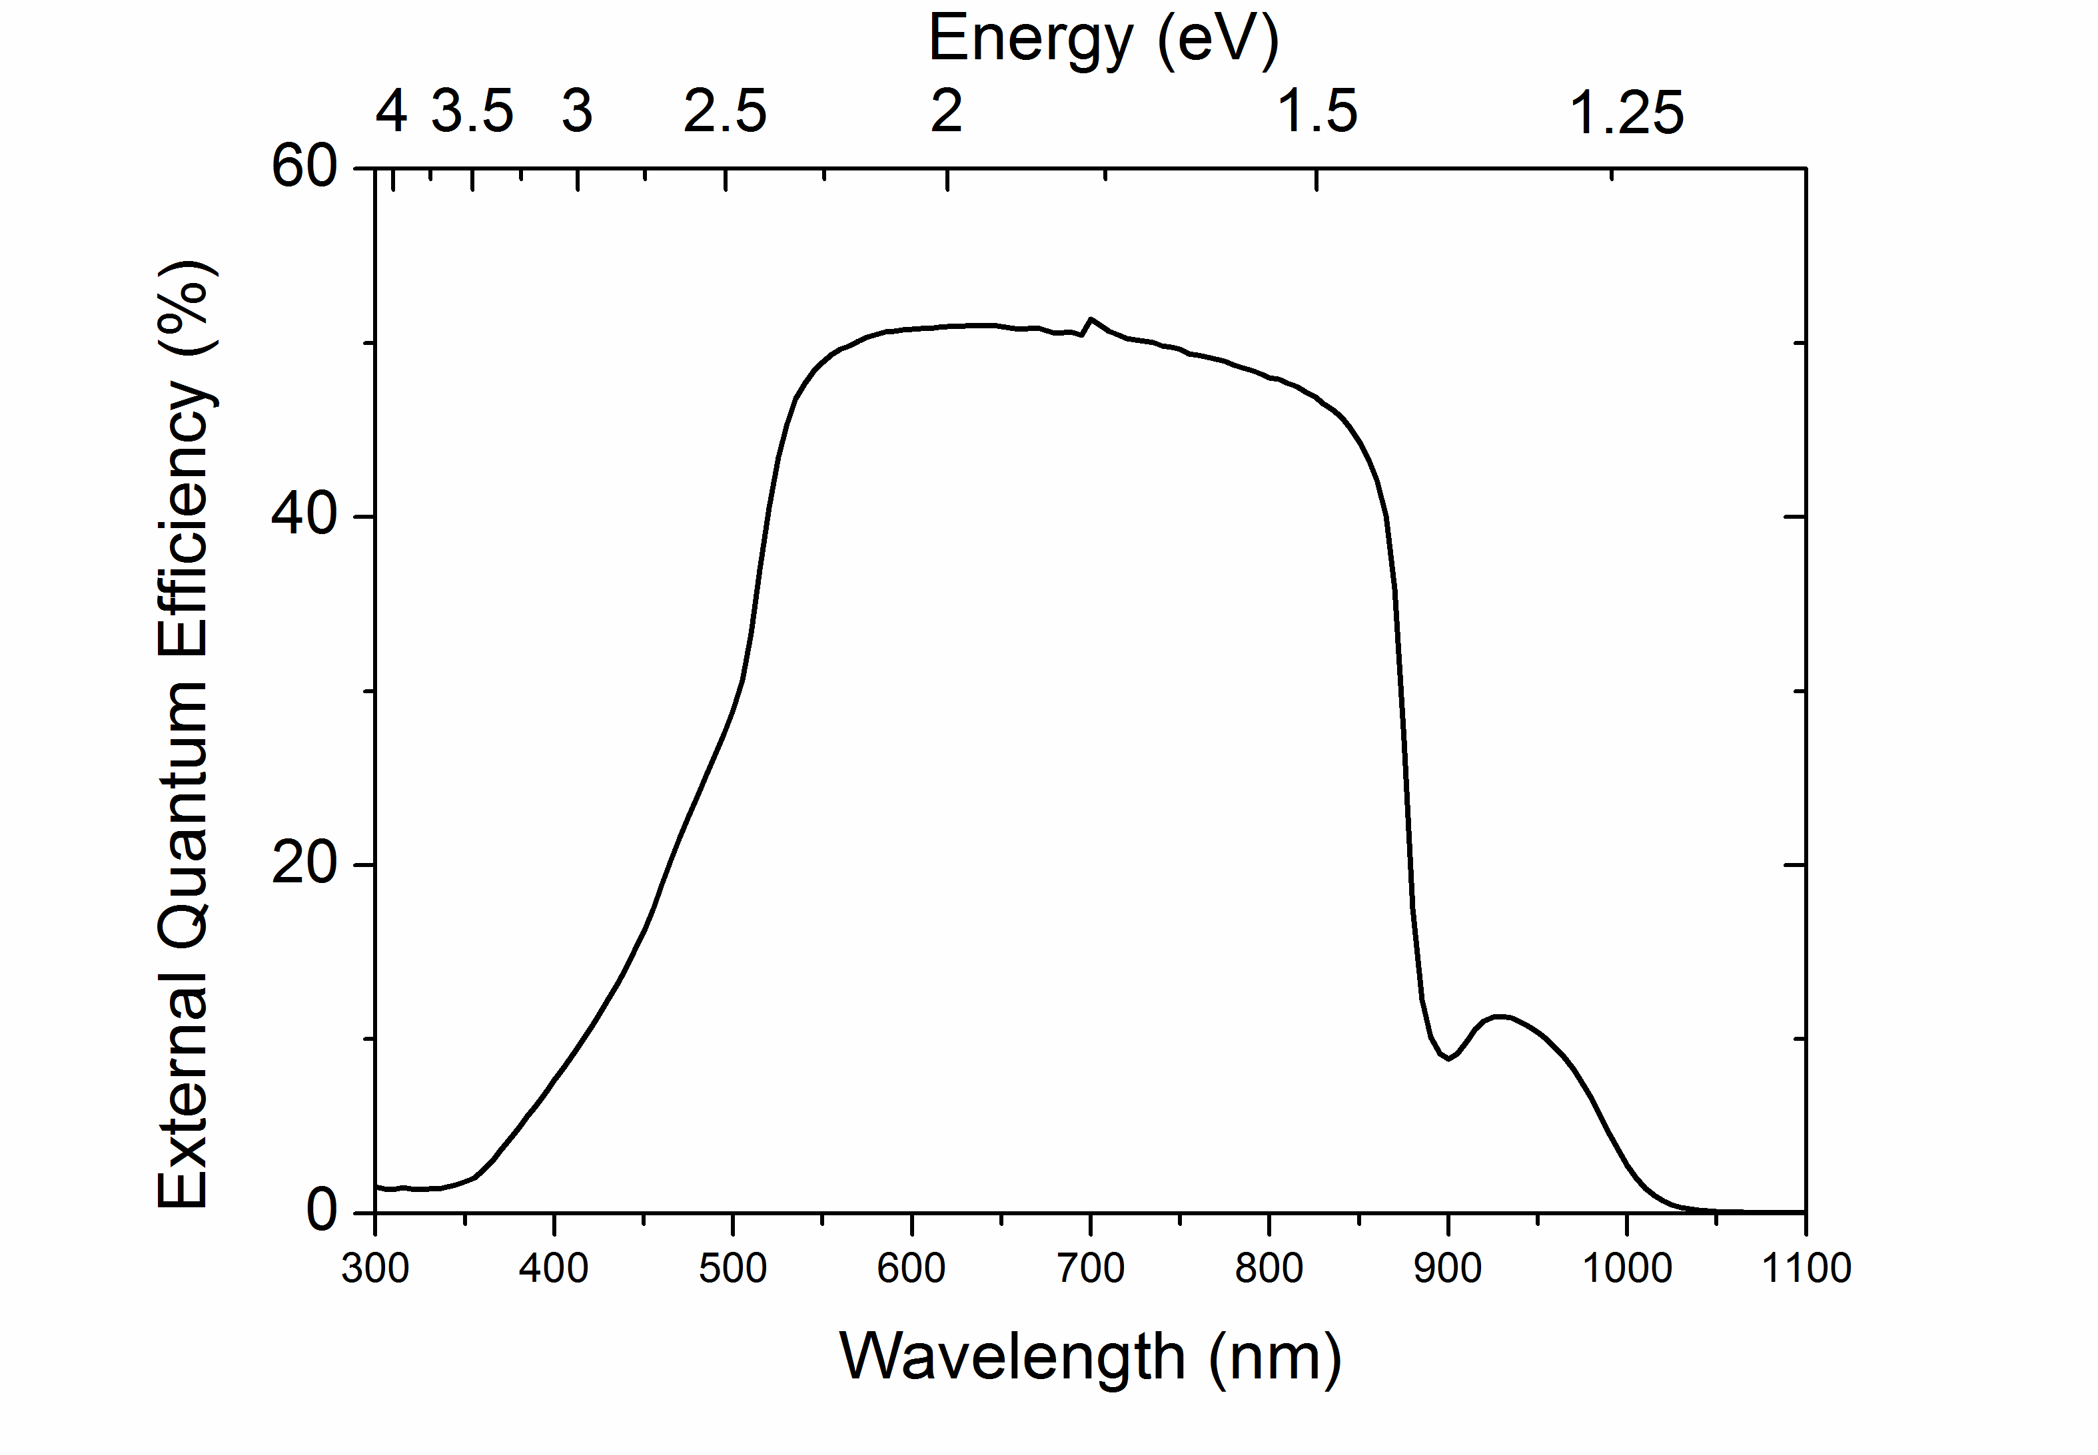
Fig. 7. a) J-V Curve of a GaAsSbN p-i-n solar cell b) EQE of a GaAsSbN p-i-n solar cell. The slight bump ≈700 nm is an instrument artefact caused by lamp switchover.

Conclusions
Single junction solar cells based on a p-i-n GaAsSbN/GaAs structure grown via LPE were developed and studied. Mesa 3.5×3.5 mm diodes with circular optical window 3.25 mm in diameter were fabricated using standard lithography and wet etch processing. n- and p- type ohmic contacts based on InGe/Au and Au/Zn/Au were deposited via thermal evaporation on the back and the front surface of the cells. Temperature-dependent PL measurements at low excitation power of 0.5 mW show a slight blue shift of the GaAsSbN PL emission energy at low temperatures from 10K to about 70 − 80 K, which led to the conclusion that the potential fluctuations are relatively small. SPV measurements provide information on the optical absorption and photocarrier transport in the investigated structures. The bandgap energy at room temperature of GaAsSbN determined from the optical absorption edge is 1.26 eV. Nearly the same IR photosensitivity behaviour was revealed from EQE measurements.
I-V curves were measured under standard test conditions (25℃, one sun AM1.5). A power conversation efficiency of 4.15 %, an open-circuit voltage of 0.44 V, short-circuit current of 17.31 mA/cm² and fill factor 54.5 % have been obtained for the cells without ARC coating. This is very promising result for the first LPE grown GaAsSbN/GaAs solar cells, especially given that these cells are non-optimized, and the record GaAsSbN/GaAs solar cell currently stands at 6% efficiency. Further improvements in materials quality and in device design are needed to ensure higher photovoltaic performance of these cells.

Acknowledgements
This work was supported by the Bulgarian Ministry of Education and Science under the National Research Program E+: Low Carbon Energy for the Transport and Households (grant agreement D01-214/2018).

References
[1] J.F. Geisz, M.A. Steiner, N. Jain, K.L. Schulte, R.M. France, W.E. McMahon, E.E. Perl, D.J. Friedman, Building a Six-Junction Inverted Metamorphic Concentrator Solar Cell, IEEE J. Photovoltaics. 8 (2018) 626–632. doi:10.1109/JPHOTOV.2017.2778567.
[2] A.J. Ptak, R. France, C.S. Jiang, M.J. Romero, Improved performance of GaInNAs solar cells grown by molecular-beam epitaxy using increased growth rate instead of surfactants, J. Cryst. Growth. 311 (2009) 1876–1880. doi:10.1016/j.jcrysgro.2008.09.184.
[3] J.S. Harris, The opportunities, successes and challenges for GaInNAsSb, in: J. Cryst. Growth, 2005: pp. 3–17. doi:10.1016/j.jcrysgro.2004.12.050.
[4] D.J. Friedman, J.F. Geisz, S.R. Kurtz, J.M. Olson, 1-eV solar cells with GaInNAs active layer, J. Cryst. Growth. 195 (1998) 409–415. doi:10.1016/S0022-0248(98)00561-2.
[5] N. Miyashita, N. Ahsan, Y. Okada, Effect of antimony on uniform incorporation of nitrogen atoms in GaInNAs films for solar cell application, Sol. Energy Mater. Sol. Cells. 111 (2013) 127–132. doi:10.1016/j.solmat.2012.12.036.
[6] S.W. Johnston, S.R. Kurtz, D.J. Friedman, A.J. Ptak, R.K. Ahrenkiel, R.S. Crandall, Observed trapping of minority-carrier electrons in p -type GaAsN during deep-level transient spectroscopy measurement, Appl. Phys. Lett. 86 (2005) 1–3. doi:10.1063/1.1865328.
[7] S.R. Kurtz, J.F. Klem, A.A. Allerman, R.M. Sieg, C.H. Seager, E.D. Jones, Minority carrier diffusion and defects in InGaAsN grown by molecular beam epitaxy, Appl. Phys. Lett. 80 (2002) 1379–1381. doi:10.1063/1.1453480.
[8] N. Miyashita, N. Ahsan, M.M. Islam, Y. Okada, Study on the device structure of GaInNAs(Sb) based solar cells for use in 4-junction tandem solar cells, in: Conf. Rec. IEEE Photovolt. Spec. Conf., 2012: pp. 954–956. doi:10.1109/PVSC.2012.6317760.
[9] A.J. Ptak, D.J. Friedman, S. Kurtz, J. Kiehl, Enhanced-depletion-width GaInNAs solar cells grown by molecular-beam epitaxy, in: Conf. Rec. Thirty-First IEEE Photovolt. Spec. Conf. 2005., 2005: pp. 603–606. doi:10.1109/PVSC.2005.1488203.
[10] R. Isoaho, A. Aho, A. Tukiainen, T. Aho, M. Raappana, T. Salminen, J. Reuna, M. Guina, Photovoltaic properties of low-bandgap (0.7–0.9 eV) lattice-matched GaInNAsSb solar junctions grown by molecular beam epitaxy on GaAs, Sol. Energy Mater. Sol. Cells. 195 (2019). doi:10.1016/j.solmat.2019.02.030.
[11] F. Dimroth, T.N.D. Tibbits, M. Niemeyer, F. Predan, P. Beutel, C. Karcher, E. Oliva, G. Siefer, D. Lackner, P. Fus-Kailuweit, A.W. Bett, R. Krause, C. Drazek, E. Guiot, J. Wasselin, A. Tauzin, T. Signamarcheix, Four-junction wafer-bonded concentrator solar cells, IEEE J. Photovoltaics. 6 (2016) 343–349. doi:10.1109/JPHOTOV.2015.2501729.
[12] T. Kim, L.J. Mawst, Y. Kim, K. Kim, J. Lee, T.F. Kuech, 13.2% efficiency double-hetero structure single-junction InGaAsN solar cells grown by MOVPE, J. Vac. Sci. Technol. A Vacuum, Surfaces, Film. 33 (2015) 021205. doi:10.1116/1.4906511.
[13] M. Wiemer, V. Sabnis, H. Yuen, 43.5% efficient lattice matched solar cells, in: K. VanSant, R.A. Sherif (Eds.), 2011: p. 810804. doi:10.1117/12.897769.
[14] N.L. Yurong, K.H. Tan, W.K. Loke, S. Wicaksono, D. Li, S.F. Yoon, P. Sharma, T. Milakovich, M.T. Bulsara, E.A. Fitzgerald, Performance of 1 eV GaNAsSb-based photovoltaic cell on Si substrate at different growth temperatures, Prog. Photovoltaics Res. Appl. 25 (2017). doi:10.1002/pip.2870.
[15] K.H. Tan, S. Wicaksono, W.K. Loke, D. Li, S.F. Yoon, E.A. Fitzgerald, S.A. Ringel, J.S. Harris, Molecular beam epitaxy grown GaNAsSb 1 eV photovoltaic cell, J. Cryst. Growth. 335 (2011) 66–69. doi:10.1016/j.jcrysgro.2011.09.023.
[16] T.W. Kim, K. Forghani, L.J. Mawst, T.F. Kuech, S.D. Lalumondiere, Y. Sin, W.T. Lotshaw, S.C. Moss, Properties of “bulk” GaAsSbN/GaAs for multi-junction solar cell application: Reduction of carbon background concentration, J. Cryst. Growth. 393 (2014) 70–74. doi:10.1016/j.jcrysgro.2013.10.034.
[17] L.F. Bian, D.S. Jiang, P.H. Tan, S.L. Lu, B.Q. Sun, L.H. Li, J.C. Harmand, Photoluminescence characteristics of GaAsSbN/GaAs epilayers lattice-matched to GaAs substrates, Solid State Commun. 132 (2004) 707–711. doi:10.1016/j.ssc.2004.09.016.
[18] K.-L.K.-I.K.-L.K.-I. Lin, K.-L.K.-I.K.-L.K.-I. Lin, B.-W. Wang, H.-H.H. Lin, Ij.-S. Hwang, K.-I.L. and K.-L.L. and B.-W.W. and H.-H.L. and J.-S. Hwang, I. Lin, L. Lin, W. Wang, H.-H.H. Lin, S. Hwang, Double-Band Anticrossing in GaAsSbN Induced by Nitrogen and Antimony Incorporation, Appl. Phys. Express. 6 (2013) 121202. http://search.ebscohost.com/login.aspx?direct=true&db=eoah&AN=33626127&site=ehost-live%0Ahttp://stacks.iop.org/1882-0786/6/i=12/a=121202.
[19] T. Thomas, N. Kasamatsu, K.H. Tan, S. Wicaksono, W.K. Loke, S.F. Yoon, A. Johnson, T. Kita, N. Ekins-Daukes, Time-resolved photoluminescence of MBE-grown 1 eV GaAsSbN for multi-junction solar cells, in: 2015 IEEE 42nd Photovolt. Spec. Conf. PVSC 2015, Institute of Electrical and Electronics Engineers Inc., 2015. doi:10.1109/PVSC.2015.7356069.
[20] T.W. Kim, Y. Kim, K. Kim, J.J. Lee, T. Kuech, L.J. Mawst, 1.25-eV GaAsSbN/Ge double-junction solar cell grown by metalorganic vapor phase epitaxy for high efficiency multijunction solar cell application, IEEE J. Photovoltaics. 4 (2014) 981–985. doi:10.1109/JPHOTOV.2014.2308728.
[21] M. Milanova, V. Donchev, K.L. Kostov, D. Alonso-Álvarez, P. Terziyska, G. Avdeev, E. Valcheva, K. Kirilov, S. Georgiev, Study of GaAsSb:N bulk layers grown by liquid phase epitaxy for solar cells applications, Mater. Res. Express. 6 (2019) 075521. doi:10.1088/2053-1591/ab179f.
[22] A. Gonzalo, L. Stanojević, A.D. Utrilla, D.F. Reyes, V. Braza, D. Fuertes Marrón, T. Ben, D. González, A. Hierro, A. Guzman, J.M. Ulloa, Open circuit voltage recovery in GaAsSbN-based solar cells: Role of deep N-related radiative states, Sol. Energy Mater. Sol. Cells. 200 (2019) 109949. doi:10.1016/j.solmat.2019.109949.
[23] M. Milanova, V. Donchev, B. Arnaudov, D. Alonso-Álvarez, P. Terziyska, GaAsSbN-based p-i-n heterostructures for solar cell applications grown by liquid-phase epitaxy, J. Mater. Sci. Mater. Electron. 31 (2019) 2073–2080. doi:10.1007/s10854-019-02728-5.
[24] V. Donchev, Surface photovoltage spectroscopy of semiconductor materials for optoelectronic applications Surface photovoltage spectroscopy of semiconductor materials for optoelectronic applications, Mater. Res. Express. 6 (2019) 103001. doi:10.1088/2053-1591/ab3bf.
[25] F.-I. Lai, S.Y. Kuo, J.S. Wang, H.C. Kuo, S.C. Wang, H.S. Wang, C.T. Liang, Y.F. Chen, Effect of nitrogen contents on the temperature dependence of photoluminescence in InGaAsN∕GaAs single quantum wells, J. Vac. Sci. Technol. A. 24 (2006) 1223–1227. doi:10.1116/1.2208996.
[26] S.A. Lourenço, I.F.L. Dias, J.L. Duarte, E. Laureto, V.M. Aquino, J.C. Harmand, Temperature-dependent photoluminescence spectra of GaAsSb/AlGaAs and GaAsSbN/GaAs single quantum wells under different excitation intensities, Brazilian J. Phys. 37 (2007) 1212–1219. doi:10.1590/S0103-97332007000800004.
[27] X. Gao, Z. Wei, F. Zhao, Y. Yang, R. Chen, X. Fang, J. Tang, D. Fang, D. Wang, R. Li, X. Ge, X. Ma, X. Wang, Investigation of Localized States in GaAsSb Epilayers Grown by Molecular Beam Epitaxy., Sci. Rep. 6 (2016) 29112. doi:10.1038/srep29112.
[28] J.S. Blakemore, Semiconducting and other major properties of gallium arsenide, J. Appl. Phys. 53 (1982). doi:10.1063/1.331665.
[29] J. Li, S. Iyer, S. Bharatan, L. Wu, K. Nunna, W. Collis, K.K. Bajaj, K. Matney, Annealing effects on the temperature dependence of photoluminescence characteristics of GaAsSbN single-quantum wells, J. Appl. Phys. 98 (2005) 013703. doi:10.1063/1.1931032.
[30] K. Nunna, S. Iyer, L. Wu, J. Li, S. Bharatan, X. Wei, R.T. Senger, K.K. Bajaj, Nitrogen incorporation and optical studies of GaAsSbN/GaAs single quantum well heterostructures, J. Appl. Phys. 102 (2007) 053106. doi:10.1063/1.2777448.
[31] B. Bansal, A. Kadir, A. Bhattacharya, B.M. Arora, R. Bhat, Alloy disorder effects on the room temperature optical properties of GaInNAs quantum wells, Appl. Phys. Lett. 89 (2006) 032110. doi:10.1063/1.2227618.
[32] M. Galluppi, L. Geelhaar, H. Riechert, M. Hetterich, A. Grau, S. Birner, W. Stolz, Bound-to-bound and bound-to-free transitions in surface photovoltage spectra: Determination of the band offsets for InxGa1-xAs and InxGa1-xAs1-yNy quantum wells, Phys. Rev. B - Condens. Matter Mater. Phys. 72 (2005) 155324. doi:10.1103/PhysRevB.72.155324.
[33] R. Kudrawiec, P. Sitarek, M. Gladysiewicz, J. Misiewicz, Y. He, Y. Jin, G. Vardar, A.M. Mintarov, J.L. Merz, R.S. Goldman, K.-M. Yu, W. Walukiewicz, Surface photovoltage and modulation spectroscopy of E− and E+ transitions in GaNAs layers, Thin Solid Films. 567 (2014) 101–104. doi:10.1016/j.tsf.2014.07.052.
[34] L. Kronik, Y. Shapira, Surface photovoltage phenomena: Theory, experiment, and applications, Surf. Sci. Rep. 37 (1999) 1–206. doi:10.1016/S0167-5729(99)00002-3.

