Multi-meridian corneal imaging of air-puff induced deformation for improved detection of biomechanical abnormalities
Andrea Curatolo^{1,*}, Judith S. Birkenfeld¹, Eduardo Martinez-Enriquez¹, James A. Germann¹, Geethika Muralidharan¹, Jesus Palaci², Daniel Pascual¹, Ashkan Eliasy³, Ahmed Abass³, Jędrzej Solarski⁴, Karol Karnowski⁴, Maciej Wojtkowski⁴, Ahmed Elsheikh^{3,5,6}, Susana Marcos¹
¹ Instituto de Óptica "Daza de Valdés", Consejo Superior de Investigaciones Científicas (IO, CSIC), Madrid, Spain
² 2EyesVision SL, Madrid, Spain
³ Biomechanical Engineering Group, University of Liverpool, Liverpool, United Kingdom
⁴ Physical Optics and Biophotonics Group, Institute of Physical Chemistry, Polish Academy of Sciences, Warsaw, Poland
⁵ Beijing Advanced Innovation Centre for Biomedical Engineering, Beihang University, Beijing, 100083, China
⁶ NIHR Biomedical Research Centre for Ophthalmology, Moorfields Eye Hospital NHS Foundation Trust and UCL Institute of Ophthalmology, United Kingdom
*andrea.curatolo@csic.es

Abstract: Corneal biomechanics plays a fundamental role in the genesis and progression of corneal pathologies, such as keratoconus, in corneal remodeling after corneal surgery, and in affecting the measurement accuracy of glaucoma biomarkers, such as the intraocular pressure (IOP). Air-puff induced corneal deformation imaging reveals information highlighting normal and pathological corneal response to a non-contact mechanical excitation. However, current commercial systems are limited to monitoring corneal deformation only on one corneal meridian. Here, we present a novel custom-developed swept-source optical coherence tomography (SSOCT) system, coupled with a collinear air-puff excitation, capable of acquiring dynamic corneal deformation on multiple meridians. Backed by numerical simulations of corneal deformations, we propose two different scan patterns, aided by low coil impedance galvanometric scan mirrors that permit an appropriate compromise between temporal and spatial sampling of the corneal deformation profiles. We customized the air-puff module to provide an unobstructed SSOCT field of view and different peak pressures, air-puff durations, and distances to the eye. We acquired multi-meridian corneal deformation profiles (a) in healthy human eyes in vivo, (b) in porcine eyes ex vivo under varying controlled IOP, and (c) in a keratoconus-mimicking porcine eye ex vivo. We detected deformation asymmetries, as predicted by numerical simulations, otherwise missed on a single meridian that will substantially aid in corneal biomechanics diagnostics and pathology screening.
© 2020 Optical Society of America under the terms of the OSA Open Access Publishing Agreement
OCIS codes: (110.4500) Optical coherence tomography; (330.4300) Vision system - noninvasive assessment; (330.4460) Ophthalmic optics and devices; (330.7327) Visual optics, ophthalmic instruments; (330.7333 Visual optics, refractive anomalies); (100.2960) Image analysis; (120.5800) Scanners.

- Introduction
Corneal biomechanics, corneal morphology, and intraocular pressure (IOP) are some of the most important factors influencing the balance of forces that help maintain a healthy eye and good vision [1]. Corneal biomechanics plays a fundamental role in the genesis and progression of corneal pathologies, such as keratoconus [2]. Several eye treatments also rely on the corneal biomechanical response [3, 4], including corneal implants for refractive correction, or corneal incisions in cataract surgery where the location and geometry of the incision modulates astigmatism correction. Moreover, the measurement accuracy of the IOP, a glaucoma biomarker, is influenced by corneal biomechanical properties [5].
Keratoconus is a progressive, non-inflammatory disorder resulting in thinning and protrusion of the cornea into a conical shape [2]. The corneal viscoelastic properties are altered in keratoconus [6], most evidently with a reduction of its stiffness, commonly in a focal eccentric region of the cornea [7]. Today, it is believed that changes in biomechanical properties take place prior to corneal thinning and steepening [3], in what is known as pre-clinical keratoconus. Keratoconus treatments [8] include, among others, collagen cross-linking for corneal stiffening and intrastromal corneal ring segment implants for flattening the cone, in mild to moderate cases, and corneal transplant in more advanced cases. Treatments for mild to moderate cases are focused on halting disease progression, as no cure to revert its course is available. Treatments will therefore benefit from an early detection, prior to the development of changes in corneal shape.
Early detection of keratoconus, or any corneal biomechanical abnormality, is an elusive task as it requires probing normal and pathological corneal tissue in vivo [9]. Until recently, most information on corneal mechanical properties came from ex vivo tests [10]. Several promising techniques have been developed in recent years to quantitatively measure the inherent corneal biomechanical properties in vivo. Among those, optical coherence elastography [11], and Brillouin microscopy [12, 13]. Each technique estimates the corneal elastic modulus under various mechanical model assumptions, depending on the raw physical variable being measured and the type of mechanical load applied to the cornea.
However, most of the clinical data to date is related to the corneal biomechanical response to non-contact tonometry, via a time-varying air-puff mechanical excitation, as it provides a more readily accessible biomarker of mechanical abnormality [14, 15]. Studies have shown that imaging of corneal deformation under air-puff excitation could reveal normal and pathological corneal response [16-18].
Scheimpflug imaging systems, like the Corvis ST (Oculus Optikgeräte GmbH, Germany) [19], can dynamically image a corneal cross-sectional plane intersecting the corneal apex (corneal meridian) during an air-puff induced corneal deformation event. However, this system can capture information only on the horizontal meridian [20], which limits the detection of corneal deformation asymmetry and its accuracy as keratoconus biomarker [9], especially for eccentric keratoconus patients, where the softer corneal region often occurs below the apex [21]. Numerical modelling of the eye and its internal structure [22, 23], based on mechanical finite element analysis (FEA), coupled with computational fluid dynamic (CFD) modelling of the air domain surrounding the eye [24, 25], can simulate air-puff induced corneal deformations and also guide the design of the corneal deformation imaging system.
Optical coherence tomography (OCT) [26] allows for the rapid acquisition of corneal topography and tomography images [27], and it has been used in combination with an air-puff stimulus [28]. A spectrometer-based OCT system was used to capture air-puff induced corneal deformation on the horizontal meridian [29]. Swept-source OCT (SSOCT) has been used to monitor corneal apex dynamics [30-32]. An advantage of OCT systems is the flexibility of programmable optical beam scan patterns, which can be designed to monitor multiple meridians. Yet, no system to date has managed to exploit both the axial scan speed advantage of SSOCT and ultra-fast laser scan systems abilities. A careful optical and scan system design choice would permit an appropriate compromise between temporal and spatial sampling of the corneal deformation profiles.
In this paper, we present a novel customized SSOCT system coupled with a collinear air-puff excitation unit, capable of acquiring unobstructed dynamic corneal deformation on multiple meridians, with two custom scan patterns and selected puff profiles at unprecedented scan rates, both on ex vivo and in vivo eyes (porcine and human, respectively). We show that our system can detect corneal deformation profiles and deformation asymmetries due to localized changes in biomechanical properties, as predicted by FEA, that are useful for corneal biomechanics diagnostics and pathology screening.
- Methods
  - Numerical models of healthy and keratoconic corneas
Two human eye numerical models [33], one for a healthy eye and one mimicking an early-stage (pre-clinical) keratoconic eye with an eccentric softened region, were created to study and compare their spatial-temporal deformation profiles. The material behavior of the cornea and of the scleral regions was assumed compatible with Ogden’s isotropic hyperplastic mechanical model [34], described by a parameter μ representing the initial stiffness (gradient of stress-strain relationship) [17]. μ was set to 0.054 MPa and 0.025 MPa, for the healthy and the incipient keratoconic area of the cornea, respectively.
The external pressure distribution was determined for the specific nozzle radius, maximum air velocity, puff duration, and distance to the eye, typical of a commercial air-puff corneal deformation imaging system (Corvis ST). Corneal deformation was simulated and the corneal displacements at 26 nodes along a horizontal and a vertical meridian were recorded.
  - Custom SSOCT system for ultrafast scans on multiple meridians
To successfully design an imaging system capable of monitoring a corneal deformation event lasting several milliseconds on multiple meridians, we identified five system requirements, namely: a) high axial rate, b) ultra-fast transverse scanning, c) reasonable axial resolution, d) large depth of field, and e) large field of view.
To attain a), we designed a custom OCT system using a MEMS-based vertical-cavity surface-emitting laser (VCSEL) swept-source (SL132120, Thorlabs, USA), centered at 1300 nm. The axial scan rate of 200 kHz allowed the recording of consecutive corneal positions every 5 μs. We chose a Mach-Zender interferometer configuration, and a dual balanced photodetector (PDB480C-AC, Thorlabs, USA), with 3dB-bandwidth from 30 kHz to 1.6 GHz. The photodetector signal was digitized by a 12-bit 8-lane PCI Express card (ATS 9360, Alazartech, Canada), which corresponds to an axial depth range of up to 26 mm in air, when sampling at 1.8 GHz.
To provide b) on multiple meridians for corneal deformation imaging, as well as three-dimensional (3D) scanning for corneal topography, we required a scanning system capable of both fast-and-slow axis raster scanning and fast and precise dual-axis step-and-hold scanning regimes. Therefore, we chose 3 mm-aperture galvanometric scanning mirrors (Saturn 1B, ScannerMAX, Pangolin, USA) with very-small-diameter moving magnets, along with special bearing materials, providing exceptionally high acceleration and root-mean-square (RMS) duty cycle and a 7.5 kHz small-angle bandwidth for rapid linear, repeatable scans [35]. Figure 1(a) shows the dual-axis (x, y) scanner pair in their mount. This choice allowed us to implement two scan patterns over a transverse range of 15 mm at a pattern repetition frequency of 1 kHz. The first pattern was a cross-meridian (x, y) scan, as seen in Fig. 1(d), while the second comprised of 3 horizontal planes, separated by 2 mm each, above and below the central meridian, as seen in Fig. 1(e). The scanners’ input voltage and the synchronization with the A- and B-scan triggers, were controlled by a data acquisition card (DAQ) (PCI-6731, National Instrument, USA).
To ensure scan linearity and full transverse range coverage, especially for the “corner points”, i.e., the extremities of the scan pattern in any given direction, we devised smart scan pattern adjustments.

Table 1. SSOCT system specifications
Central wavelength | 1300 nm
A-scan rate | 200 kHz
Axial resolution (FWHM) | 16 μm
Transverse resolution (at focus) | 40 μm
Depth of field | 5.15 mm
Axial depth range (maximum) | 26 mm
Transverse field of view (FOV) | 15 mm

Figure 1(b) shows the “cross-meridian” (x, y) scan input voltage signal over a 2 ms period (corresponding to 2 pattern repetitions), where the x and y scanners are alternatively held at a fixed central position, while the other scanner steps linearly through either the horizontal or vertical meridian in 320 μs and the OCT signal gets recorded. To transition from one meridian to another, both galvanometer-mirrors are moved at the same time along the 45° direction, joining two “corner points” in 140 μs. Most importantly, the input signal to both galvanometer-mirrors is held constant for 40 μs when it reaches a “corner point”.
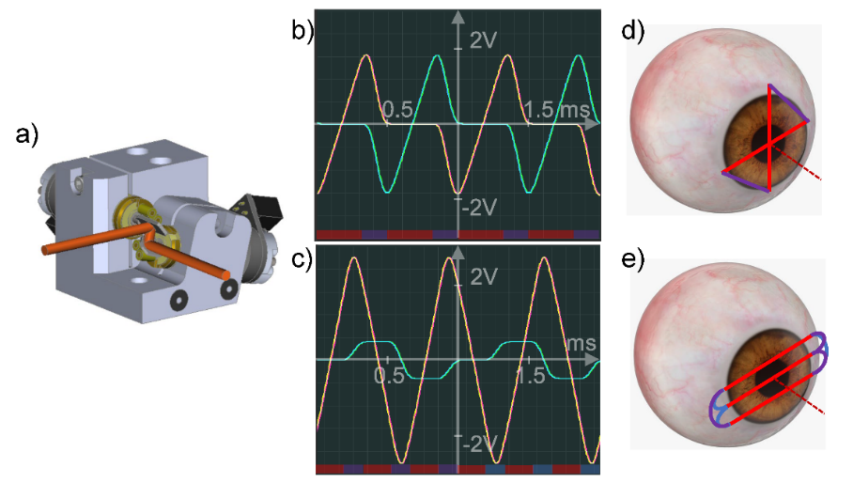
Fig. 1. Galvanometric scanning mirror system and ultra-fast transverse scanning patterns. (a) Saturn 1B system 3D CAD model. Graph of input voltage (yellow and cyan) and encoder position voltage (magenta and green) sent to and received from the system digital signal processing board for the x and y galvanometer, respectively, vs. time for the (b) “cross-meridian” pattern; and the (c) “three horizontal planes” pattern. Corresponding scan traces, represented on a schematic eye, where the red lines indicate the phases during OCT signal acquisition, and the purple and blue lines indicate transition phases without OCT acquisition, for the (d) “cross-meridian” pattern; and the (e) “three horizontal planes” pattern.
This permits to cover the full transverse range of 15 mm in the focal plane and overcome the mirror inertia through a change of direction, and it is confirmed by the encoder positional feedback traces (reading 2 V for a mechanical scan angle leading to a 15 mm range), where the galvanometer tracking latency is ~6 μs. Figure 1(c) shows the “three horizontal planes” (x, y) scan input voltage signal over a 2 ms period (corresponding to 2 pattern repetitions). In this case, the pattern resembles that of an alternate bidirectional raster scan, where the signal to y-galvanometer mirror is held constant during the plane scan. In contrast, the signal to the x-galvanometer mirror is stepped linearly through the plane alternatively from nasal to temporal and vice versa. In the transition phases from one plane to another, the signal to the x-galvanometer mirror is overshot past ±2 V and slowly decelerated until a change of direction, followed by increasing acceleration until the next plane starting position, whereby the scan velocity is kept constant. Meanwhile, the signal to the y-galvanometer mirror in the transition phases is stepped following a 5th order polynomial and kept constant in the recording phases. The duration of each plane scan is 200 μs, while the inter-plane transition duration is 135 μs.
The spectral 3dB-bandwidth of the source was 50 nm, corresponding to a full-width-at-half-maximum (FWHM) axial resolution of 16 μm in air, meeting the requirement from point c). To achieve d) and e), we designed the sample arm scan optics with a 2” aperture f-theta telecentric scan lens (LSM05, Thorlabs, USA), with a working distance of 93.8 mm, allowing for a custom air-puff unit to be inserted in front of it. We selected the sample arm optics to produce a transverse resolution of 40 μm at the focal plane, and a depth of field of 5.15 mm, i.e., enough to cover the full anterior chamber depth. The choice of a large aperture telecentric scan lens permitted a transverse field of view of 15 mm, i.e., enough to cover the white-to-white area (limbus and surrounding sclera) and monitor the arc length, with minimal optical and fan distortion [36]. Table 1 summarizes the source and axial system specifications.
In summary, in the first scan pattern (“Cross-meridian” pattern), we sampled 64 equidistant points, each one separated by 234 μm, on two orthogonal meridians, every 1 ms, with a duty cycle of 64%. In the second scan pattern (“Three horizontal planes” pattern), we sampled 40 equidistant points, each one separated by 375 μm, on three horizontal planes, each separated by 2 mm, every 1 ms, with a duty cycle of ~60%.
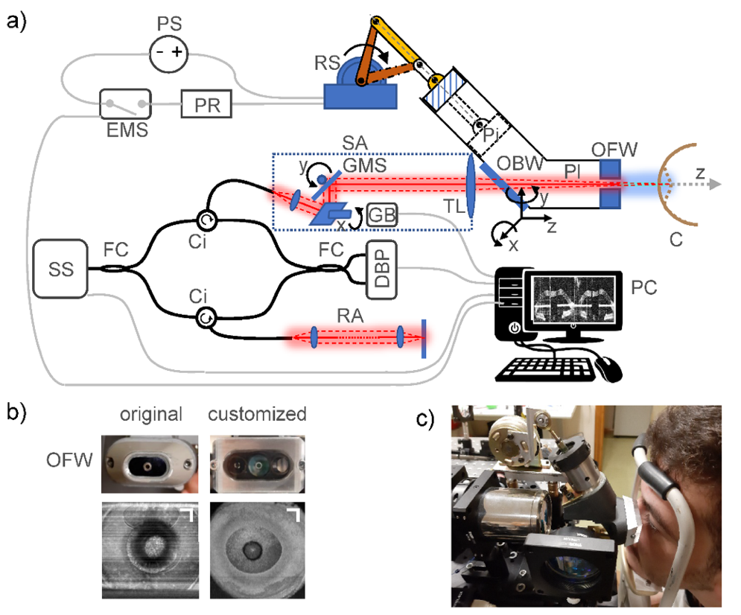
Fig. 2 (a) Schematic of SSOCT system coupled with the repurposed air-puff unit, where PS: power supply, EMS: voltage-controlled switch, PR: power resistor, RS: rotary solenoid, Pi: piston, Pl: plenum chamber, OBW: optical back window, OFW: optical front window, C: cornea; SS: swept laser source, FC: fiber couplers, Ci: circulators, DBP: dual balanced photodetector, RA: reference arm, SA: sample arm, GMS: galvanometer mirror system, GB: galvanometer digital signal processing board, TL: telecentric f-theta lens. PC: controlling computer. SA and the air-puff unit are aligned via a 5 degree-of-freedom stage. (b) Original and customized OFW. Top row: frontal photograph; bottom row: corresponding 3D OCT maximum intensity projection on the depth axis through the OFW. Scale bars: 2 mm. (c) Photograph of the front part of the system prototype with a subject aligned for measurement.

  - Control and coupling of air-puff unit for corneal mechanical excitation
We designed a system where corneal deformation was induced by a repurposed industry-standard, non-contact tonometer air-puff unit (NT 2000, Nidek Co., Japan) [29, 37]. The unit consisted of a rotary solenoid-driven piston, which we connected to custom-designed circuitry to provide a controlled voltage to the solenoid for varying the air-puff pressure and duration. Figure 2(a) represents a schematic of the SSOCT system coupled with the air-puff unit and its position with respect to the subject’s eye. Figure 2(c) is a photograph of a subject positioned in front of the system prototype. The custom circuitry consisted of a 48 V - 2 A linear DC power supply (PS), connected with the rotary solenoid (RS) in series with an exchangeable power resistor (PR) and a voltage-controlled switch (EMS), connected to a synchronized analog output of the DAQ card.
We characterized the spatial and temporal output pressure profile, using a pressure transducer with a 100 µs response time and 500 Pa sensitivity (WPS500X, Pico Technology, UK), mounted on a computer-controlled 3-axis translation stage. This resulted in an air-puff measurement resolution of 500 μm spatially and 200 μs temporally.
The air-puff unit was coupled to the SSOCT system via an optical window (OBW) at the back of the plenum chamber (Pl). To ensure unobstructed views of the corneal surface (C), we redesigned the front end of the plenum chamber to include the nozzle as to avoid producing a shadow in the corneal image beyond the circular nozzle wall, as occurred in previous work [30]. We machined a 2.4 mm wide hole in a transparent methacrylate window fitted to the front of the plenum chamber (OFW), acting as the puff outlet. Figure 2(b) shows the original and customized OFW. Our OFW provides a nearly entirely unobstructed SSOCT field of view, with a shadow thickness reduced to below 200 μm.
We mounted the air-puff unit on a 5-Degree of Freedom stage (x, y, z-translation and α-tip, β-tilt) for proper optomechanical alignment, i.e., for the air-puff ejection axis and OCT optical axis to be aligned and coincide. With such configuration, the subject’s eye pupillary axis [38] can be aligned with the OCT optical axis, via a chin and forehead rest mounted on a 3- Degree of Freedom stage (x, y, z-translation), and controlled by an operator. Eye tilts (nasal-temporal, primarily) are controlled through a movable visual stimulus. Therefore, after instrument alignment calibration and subject positional alignment, the air-puff outlet axis aims at the center of the pupil and is orthogonal to the corneal surface.
  - Image processing and deformation metrics
We developed digital image processing routines for quantification of the corneal deformation, after standard image generation from wavenumber-resampled spectra [39]. Due to the hole in the OFW functioning as an air-puff outlet, the light beam that scans the field of view transverses a shorter optical path length in the center of the image through the hole. This makes the image through the air-puff outlet appear at path length closer to the zero delay than the rest of the image. Moreover, due to a slight tilt between the hole centerline, i.e., the air-puff direction, and the normal to the OFW, the reflection from the OFW is reduced, allowing good image quality beyond the OFW. Registration of the optical path length-mismatched image center was applied, and the anterior corneal surface was then segmented along the different meridians for each frame. The surface segmentation was obtained by using adaptive thresholding, Canny edge detection, a priori knowledge of the measurements, and morphological operations as described previously [40].
Metrics of asymmetry of deformation were considered for differentiating healthy and “abnormal” corneal deformation profiles. The following metrics were applied on images obtained with the “cross-meridian” pattern: (1) Deflection area (DA) between the undeformed and deformed anterior cornea positions; (2) Asymmetry in deflection area (ADA), i.e., the difference between the nasal/temporal (or inferior/superior) DA referenced to the undeformed corneal apex [20, 41, 42]. These quantities can be tracked versus time, i.e., every 1 ms, during a deformation event. The DA will increase to a maximum when the corneal deformation is at maximum concavity, and then return to zero, with a peak value and profile influenced by the air-puff pressure profile, the IOP and the corneal viscoelastic properties [18].
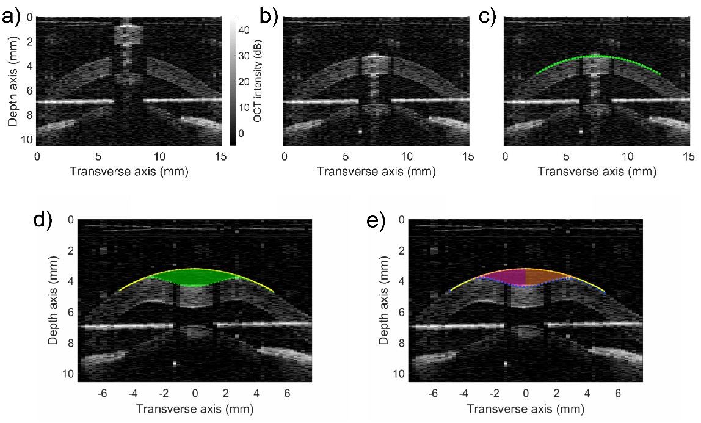
Fig. 3. Image processing and deformation metrics. (a) raw image, (b) registered image, (c) segmented image, (d) deflection area highlighted in green, and (e) deflection area partitioned in nasal and temporal profiles, referenced to the undeformed corneal peak position. For a left eye, the nasal DA is colored magenta and the temporal DA is colored orange. For the vertical meridian, the superior DA is colored purple, and the inferior DA is colored cyan (see Fig. 8(b).)
Figure 3 (top row) highlights the digital image processing steps described above, i.e., piece-wise registration and segmentation of the anterior corneal surface. Figure 3 (bottom row) illustrates the deformation metrics DA in green and its partition into nasal and temporal DA, to be subtracted from one another to obtain the ADA. For the vertical meridian, if the ADA is positive, the inferior DA is larger than the superior DA, i.e., the air-puff load is primarily taken from the inferior side, revealing a biomechanical weakness in the inferior side.
  - In vivo human healthy corneas
We tested the system on human eyes in vivo in two healthy volunteers (M, 30 y.o., F, 37 y.o.), to demonstrate our system’s ability to capture crucial corneal deformation information on several meridians for the first time. Human experiments have been conducted in accordance with the tenets of the Declaration of Helsinki and approved by the institutional research ethics committee and informed consent has been obtained. All images were acquired using the infrared light incident on the cornea with a visual angle α = 25.45 mrad and a power of 8.4 mW, well below the safety limit standard of 15.61 mW (Table A.3 of IEC 60825-1:2014). Alignment of each subject took place by adjusting the position of a chin and forehead rest (Fig. 2(c)), mounted on a three-axis translation stage, and by requesting the counter-lateral eye to fixate on an adjustable target, so that the pupillary axis of the eye under examination coincides with the optical axis of the OCT system, and passes through the center axis of the air-puff outlet.
  - Localized alteration of corneal mechanical properties in ex vivo models
Two freshly enucleated porcine eyes (animal aged 6 months), obtained from a local slaughterhouse (Justino Gutiérrez, S.L, Valladolid, Spain) were tested. Measurements started within 4 hours post-mortem, and the eyes were kept at approximately 4º C before sample preparation. To mimic an eccentric keratoconus of 6 mm diameter on the porcine cornea, we used localized application of collagenase (10 mg/mL collagenase type II with 15% dextran), following the protocol of Hong, et al. [43]. Collagenase is a protease capable of digesting native collagen fibrils commonly found in connective tissues and the corneal stroma, and therefore mechanically weakens the cornea. Uniaxial tensile tests were performed on porcine cornea strips approximately 30 minutes after the air-puff tests using a UStretch biomaterials testing machine (Cellscale, Canada) to verify the change in elasticity. Porcine cornea strips were surgically removed from both the untreated superior region and the treated region. The tangent elastic modulus (E_{t}) was estimated for 8% strain from the mean stress-strain fit to the raw curves, measured up to 12% strain, averaged over four stretch cycles. The modulus E_{t} was 5.67 ± 0.26 MPa and 1.91 ± 0.06 MPa for the untreated and treated regions, respectively, consistent with previous reports [43]. Although the uniaxial tensile test uses a specimen geometry with different boundary conditions of force and friction compared to the intact eye globe, the induced mechanical corneal softening provides a good model for keratoconus-mimicking corneas to test eccentric mechanical abnormalities as those found in keratoconus [20].
The porcine eyes were mounted in a 3D-printed holder [29] with an 18 mm circular aperture at the front and a small aperture at the back for a needle to perforate the sclera and control the IOP by varying the height of saline solution in a connected water column via a syringe.
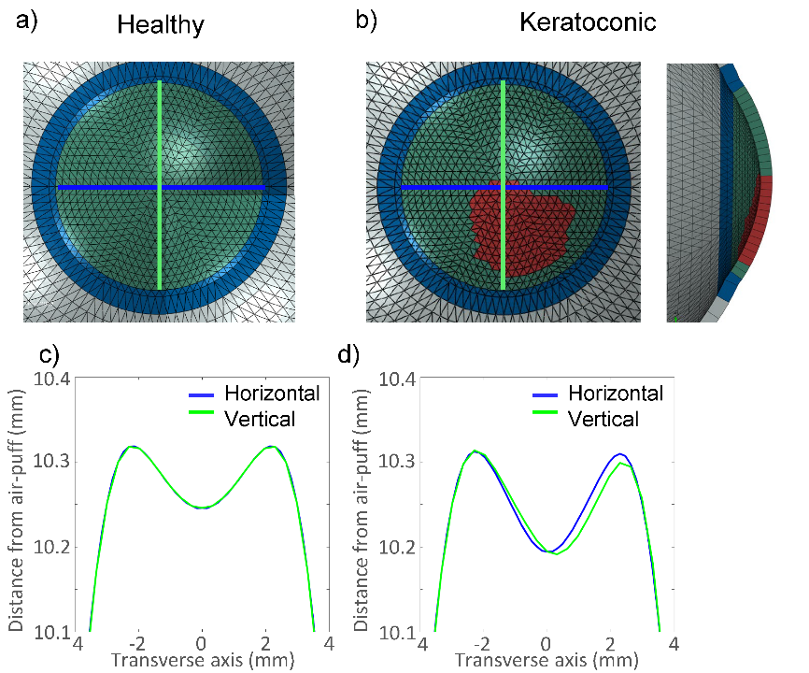
Fig. 4. Mechanical FEA simulations of healthy and early-keratoconic eye globes and deformation to an air-puff excitation typical of the Corvis ST instrument. Frontal view of (a) the healthy and (b) the early-keratoconic eye models. In the inset, a superior-inferior cross-sectional view of keratoconic eye. The position of the weakened area is visible in red. The monitoring planes are shown as light blue (horizontal) and green (vertical) lines. Deformation profiles of the anterior corneal surface at maximum concavity on the horizontal and vertical meridians, (c) for the healthy eye model at 15 mmHg and (d) the early-keratoconic eye model at 15 mmHg.
- Results
  - Corneal deformation simulations
Figure 4 shows a view of the healthy and early-keratoconic eye models, and the deformed anterior corneal surface at maximum concavity on both the horizontal and vertical meridians. For the healthy cornea, both the horizontal and vertical meridian deform equally, as the cornea possesses a radially symmetric deformation profile. The early-keratoconic eye shows a higher apical displacement, as well as a distinct asymmetry between the vertical and horizontal meridians. In fact, the position of maximum concavity of the vertical meridian shifted to the inferior side and the inferior shoulder is now lower than the superior counterpart. This result shows the importance of measuring corneal deformation to air-puff excitation on multiple meridians, confirming the premises that a multi-meridian instrument is required for better differentiating an early-keratoconic cornea from a healthy one. Moreover, as the asymmetry might be small in size, a thorough characterization and control of the measurement variables is required.
  - Air-puff characterization
To customize the air-puff specifications of our system, we first characterized the spatial-temporal air-puff pressure profile for different piston’s speeds, resulting in different air-puff output specifications. Two different power resistors (PR, with resistances of 4.7 and 33 Ω) which provided a steady-state voltage drop over the solenoid of 41.75 V and 23.30 V, respectively, when connected to the 48 V DC power supply (PS) were used, and both configurations tested with the air-puff outlet at distances to the sensor of 11 mm (standard), 9 mm and 13 mm (for the higher voltage). Table 2 summarizes the results for maximum pressure at the corneal apex, duration (temporal FWHM) and impact diameter (spatial FWHM).
Table 2. Air-puff characterization for different solenoid voltages
 | Lower voltage | Higher voltage
Maximum apical pressure | 7.28 kPa | 13.47 kPa
Duration (temporal FWHM) | 18.0 ms | 11.4 ms
Impact diameter (spatial FWHM) | 3.53 ± 0.02 mm | 3.49 ± 0.07 mm
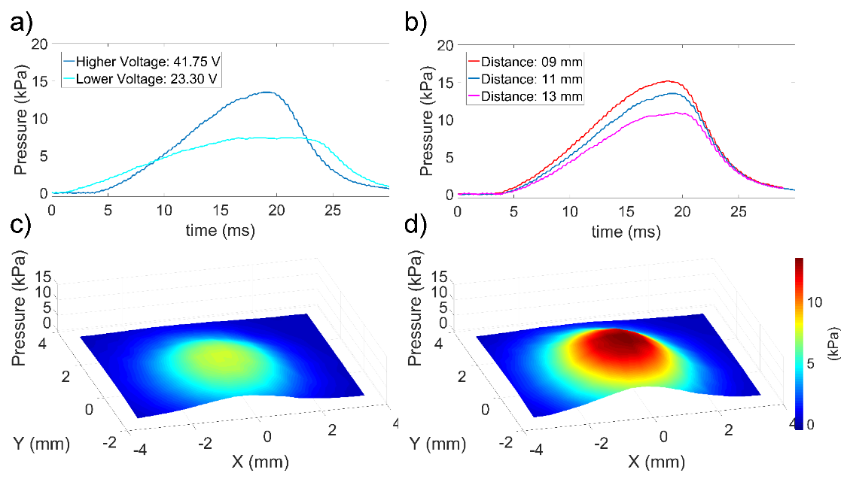
Fig. 5. Air-puff characterization for different solenoid voltages and different distances of the air-puff outlet to the sensor. (a) Apical temporal pressure profile for both low (23.30 V) and high (41.75 V) solenoid voltage configurations. (b) Apical temporal pressure profile for the higher voltage configuration for three air-puff outlet to corneal apex distances, 9 mm, 11 mm, 13 mm. Spatial pressure profiles at time of maximum apical pressure for (c) low solenoid voltage, and (d) high solenoid voltage configurations.
Figure 5(a) shows the apical temporal pressure profile for both voltage configurations. A higher solenoid voltage results in higher maximum pressure and shorter air-puff duration. Figure 5(b) shows the apical temporal pressure profile for all three distances from the air-puff outlet to the corneal apex, for the higher voltage configuration. The maximum pressure range increased by 38% from 13 mm to 9 mm. Figures 5(c) and 5(d) present the spatial pressure profile at the time of maximum apical pressure for the low and high solenoid voltage configuration, respectively. The spatial pressure profile is centrally symmetric and rather Gaussian, for either solenoid voltage configuration. At the same time, the temporal apical pressure profile is not symmetrical in its ascending and descending phase, in neither solenoid voltage configuration, although it is more symmetrical in the high voltage case. Hence, we chose to use the high voltage configuration in the remainder of the manuscript, to produce a corneal excitation more comparable to the Corvis ST and, therefore, provide more intelligible results with that system.
  - Demonstration in healthy humans
Figure 6 presents images of a human cornea before deformation and at the highest concavity with either optimized scan pattern of Fig. 1. The image-registration process explained in Sec. 2.4 has been applied to these images. For the “three horizontal planes” pattern, additional image processing involved horizontally mirroring every second plane, to maintain nasal-temporal orientation consistency. For the sake of presentation, the full axial range has been cropped to ~10.5 mm.
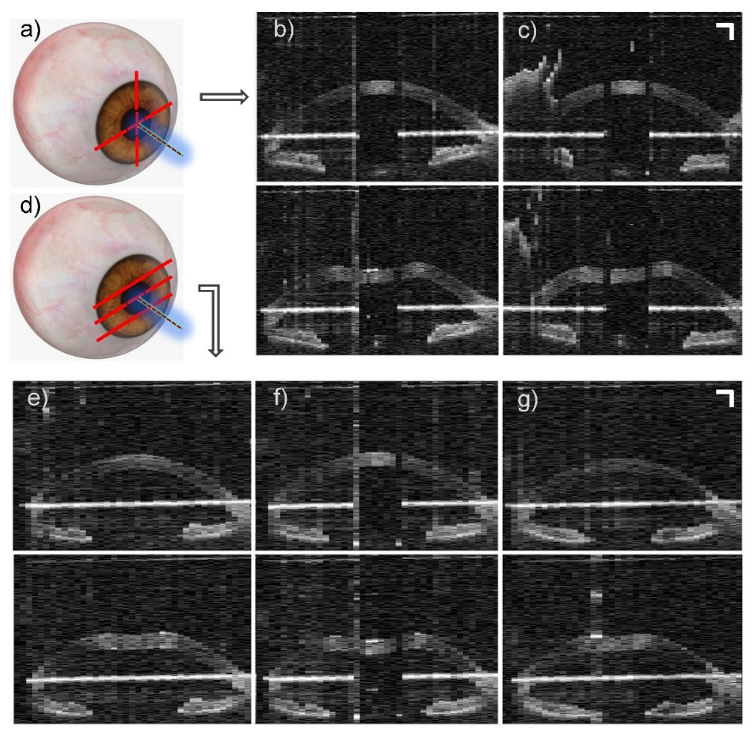
Fig. 6. (a) “Cross-meridian” scan pattern schematic. OCT in vivo human corneal deformation frames before air-puff (top) and at maximum deformation (bottom), for (b) horizontal meridian and (c) vertical meridian. (d) “Three horizontal planes” scan pattern schematic. OCT in vivo human corneal deformation frames before air-puff (top) and at maximum deformation (bottom), for (f) the horizontal meridian, (e) 2 mm above, and (g) 2 mm below. Scale bars: 1 mm.
In these images, cross-sections of a near-fully unobstructed cornea, iris and anterior lens surface are visible over a field of view of 15 mm. In the vertical meridian image (Fig. 6(b)), the subject’s eyelid and eyelashes can be seen in the superior portion (left) of the image. Also, the “mirror image” artifact of the air-puff unit front end window (OFW) appears to overlap with the limbal area. It is also evident how the central horizontal meridian is equally imaged using both scan patterns (Figs. 6(b) and 6(f)), albeit with lower sampling in the “three horizontal planes” case.
Figure 7 shows the DA and ADA quantification with time on another human corneal deformation scan using two orthogonal meridians (see also Visualization 1). The DA peaked at 3.2 mm² for both meridians. The ADA was lower than 0.35 mm² in all cases for both meridians. This scan is a prime example of a baseline measurement from a healthy cornea. It is interesting to notice how the DA curve closely follows the shape of the applied apical pressure profile, as in Fig. 5(b). There are some differences in the DA between the horizontal and vertical meridians, especially visible in the period between 14 and 16 ms, as this period coincides with the fast reduction of DA, after the peak apical pressure is reached. However, overall, the horizontal and vertical DAs follow a very similar curve. The ADA is for the most part very close to zero, as we would expect from a healthy cornea.
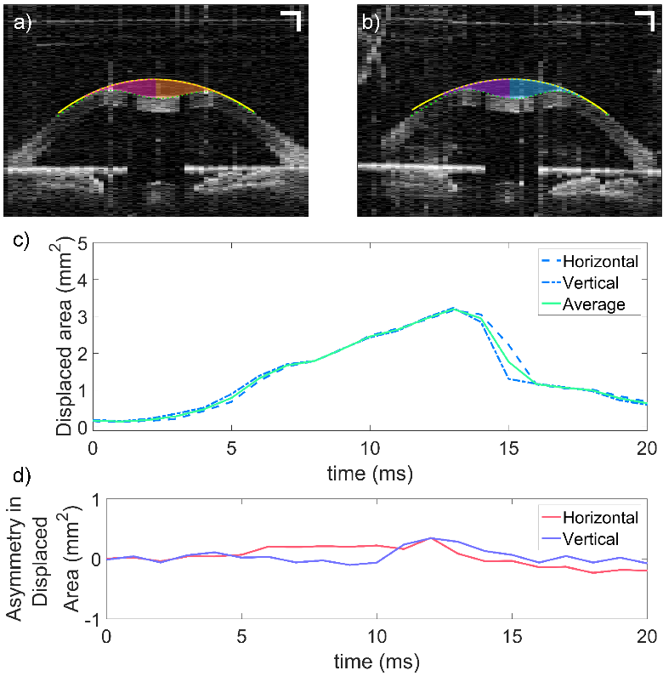
Fig. 7. “Cross-meridian” scan of in vivo human corneal deformation and related quantification. OCT images at maximum deformation of the (a) horizontal meridian with overlaid nasal (magenta) and temporal (orange) DA, and (b) vertical meridian with overlaid superior (purple) and inferior (cyan) DA. (c) The DA and (d) ADA quantification over time for both meridians. (see Visualization 1).
  - IOP influence in ex vivo porcine eyes
We tested the system on an ex vivo porcine eye, with controlled IOP within the physiological range, to characterize the influence of IOP on corneal deformation profiles on multiple meridians. Figure 8 presents the cross-meridian DA profiles over time, for different IOP (see also Visualization 2). The cross-meridian DA peaks reduce from a maximum of ~5.37 to 1.95 mm², with increasing IOP, from 15 to 30 mmHg, respectively.
This result indicates the strong influence of IOP on corneal deformation parameters, such as the DA. The DA temporal profile, like the temporal apical pressure profile, is not symmetrical in its ascending and descending phase, with a comparatively faster descending phase, owing to the interplay between the IOP and the corneal viscoelastic properties. Moreover, we do not observe any significant asymmetry in any meridian at any IOP level, as a consequence of the spatially homogeneous porcine corneal mechanical properties expected before any localized treatment.
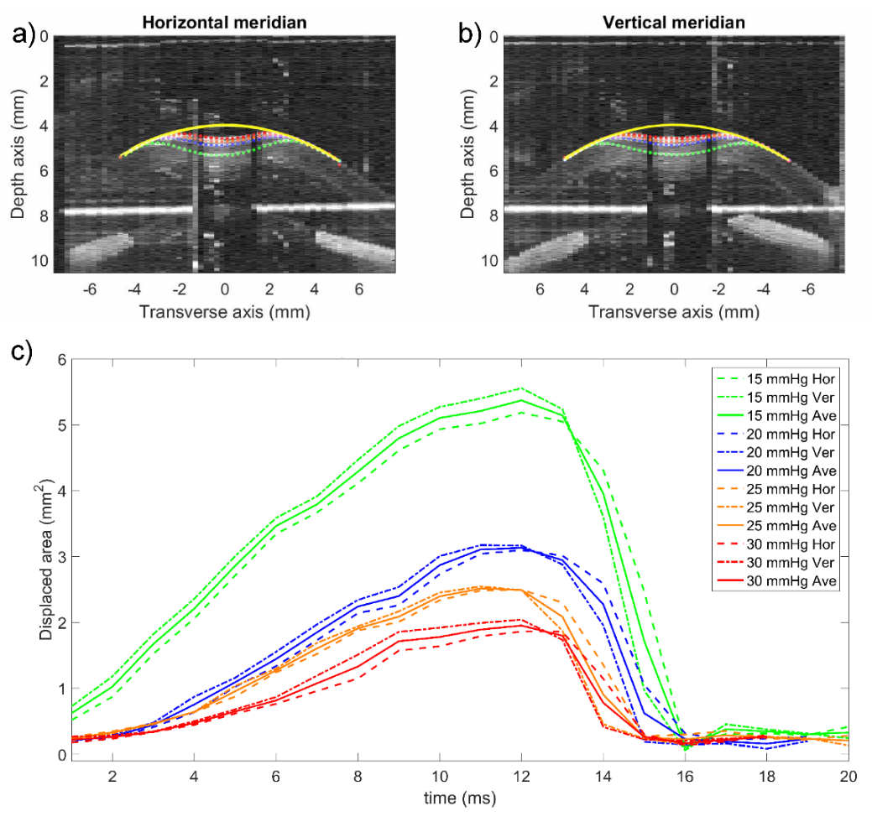
Fig. 8. Reduction of cross-meridian DA with increasing IOP from 15 mmHg to 30 mmHg. OCT image and segmented anterior corneal surface overlay of all IOP cases (15 mmHg: green, 20 mmHg: blue, 25 mmHg: orange, and 30 mmHg: red) at maximum deformation for (a) the horizontal meridian and (b) the vertical meridian (see Visualization 2). (c) DA temporal profile for horizontal (dashed) and vertical (dash-dot) meridians and their average (solid) for all IOP cases.
  - Deformation asymmetry detections on two meridians in an ex vivo keratoconic-mimicking model.
We imaged the corneal deformation on multiple meridians with our customized system before and after treatment. We ensured to reposition the holder after treatment in the same location with respect to our system as before treatment by visual landmarking. Figures 9(a) and 9(b) show a photograph of the porcine eye in the holder before and after treatment. The treated (softer) area is visible as an opaque area in the inferior half, bounded by a red circle, as well as a higher scattering region, contoured in red, in the OCT vertical meridian B-scan visible on the right.
Figure 9(c) shows the overlay of the horizontal and vertical meridians at maximum deformation before the treatment, encoded in the blue and green channels of an RGB image, respectively. Both corneal meridians overlap almost entirely, and the segmented anterior surface is also plotted in Fig. 9(e). The maximum deformation profile is nearly identical for both meridians, confirming that there are no appreciable differences in the mechanical properties of the untreated eye.
On the contrary, there is a distinct departure from the near-perfect overlap in Fig. 9(d) with a clear asymmetry in the vertical meridian at maximum deformation in the RGB overlay image.
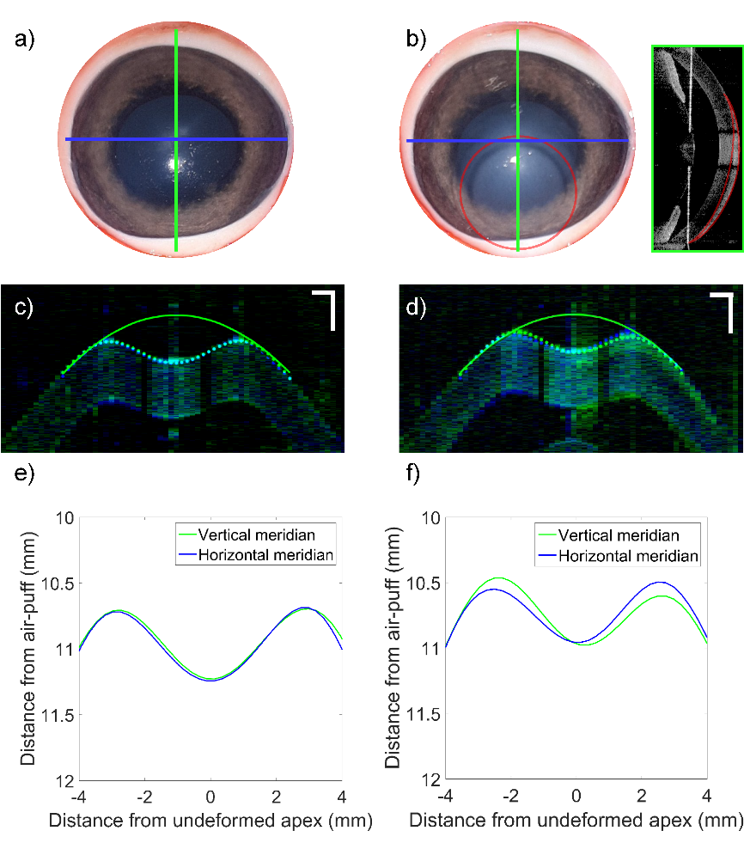
Fig. 9. “Cross-meridian” corneal deformation with our customized system before and after collagenase treatment. A photograph of the porcine eye (a) before, and (b) after treatment. The treated (softer) area is visible as an opaque area in the inferior half, bounded by a red circle, as well as a higher scattering region, contoured in red, in the OCT B-scan visible on the right inset. RGB overlay of the horizontal and vertical meridians at maximum deformation, encoded in the blue and green channels, respectively (c) before, and (d) after treatment. Scale bars: 1 mm. The segmented anterior cornea deformation profiles on the horizontal and vertical meridians are shown for the cases (e) before, and (f) after treatment.
This is confirmed in Fig. 9(f), where the asymmetric profile of the two meridians resembles the one predicted by numeric modeling for eccentric keratoconic eyes in Fig. 4(d). We further analyzed the deformation asymmetry by quantifying the ADA in both meridians, for both the untreated and treated cornea. Figures 10(a) and 10(b) show OCT overlays of the scans at maximum deformation before and after treatment for the horizontal and vertical meridians, respectively. Despite a different maximum deflection amplitude, further analysed in the discussion section, it is easy to see how the blue-dotted horizontal meridian deformation profiles are symmetrical to the axis normal to the cornea at the undeformed peak, both before and after treatment (see Visualization 3). This is numerically confirmed by the quantification of the ADA metric, which remained less than ±0.32 mm², for the horizontal meridian before and after treatment.
The same is not valid for the vertical meridian, where the green-dotted deformation profile after treatment clearly presents a smaller purple-shaded superior DA than its cyan-shaded inferior DA, while these two areas are more balanced before treatment. This means that the air-puff’s load is preferentially taken from the inferior area, which, as we know, is softer. In fact, the ADA peaked at 0.50 mm² for the vertical meridian after treatment, while it was below 0.30 mm² before treatment.
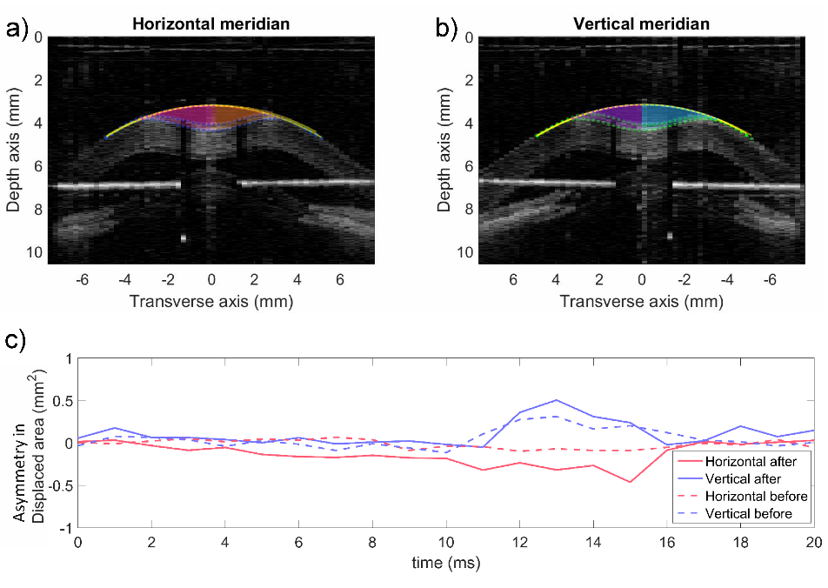
Fig. 10. “Cross-meridian” corneal deformation with our customized system before and after collagenase treatment. Grayscale overlay of the before and after treatment for (a) the horizontal and (b) vertical meridians at maximum deformation (see Visualization 3). (c) ADA quantification over time for both meridians, before (dashed line) and after treatment (solid line).
- Discussion
These results demonstrated the ability to detect abnormal corneal deformations with higher confidence, through a leap forward from the state of the art of monitoring only one corneal meridian.
As highlighted by Fig. 4(d), the main distinctive feature for an early keratoconic cornea is the deformation asymmetry, as the higher apical displacement could be due to a lower IOP. Therefore, we concentrated on deformation metrics that could quantify both the overall displacement and the asymmetry. We chose to use the DA as a metric of displacement, as a similar metric, called Deflection Area, is used in the Corvis ST [44]. As shown in Figs. 7(c) and 8(c), the temporal DA profile follows closely the apical pressure profile in Fig. 6(b). We chose to use the ADA as a metric of asymmetry for its intuitiveness, its easy visual interpretation, and the compounding effect at several transverse positions (30 data points) used for its calculation. Alternatively, other metrics of asymmetry have been proposed, for example, the ratio of displacement amplitudes at opposing points (at fixed increment distances, e.g., 0.5 mm, 1 mm, 1.5 mm) from either the undeformed peak position or the maximum concavity trough position [20]. This is an interesting approach that subsamples the information we can retrieve from the data points used in this manuscript’s ADA metrics.
This “sub-sampled” approach could be employed for cases where we intend to reduce the number of data points that monitor the deformation, to provide a more inexpensive screening device for corneal mechanical abnormalities. If these points were to be distributed over two or more meridians and provided that the sensitivity of this approach to detecting asymmetry is sufficient, a simple biomarker of keratoconus would be available from this asymmetry metrics.
One possible advantage of the ADA metric, especially in conjunction with FEA and CFD simulations, is the potential to analyze its temporal evolution to infer the location of the weakened region. That is, in Fig. 10(c) the ADA curve for the vertical meridian peaks after the maximum DA (not shown), which indicates the possibility that the air-puff load starts to push outwards, albeit with decreasing pressure, only after pushing the cornea to maximum concavity. As the outward-pushing air-puff reaches the center of the softer region, it encounters less resistance to deformation at that point, thereby increasing the ADA. We postulate that the delay between the DA peak and the ADA peak could be related to the distance of the center of the softer region. We plan to investigate this aspect further through combined FEA and CFD simulations.
The superior transverse FOV of 15 mm opens up the possibility to also monitor other biomechanically-influenced parameters, such as changes of the arc length, i.e., the distance along the corneal surface from limbus to limbus. This is believed to be a parameter of high diagnostic importance [41]. In addition, the proposed system is highly flexible in terms of customizing the air-puff parameter, therefore, with a stronger puff pressure and an appropriate specimen holder, it can be used for analyzing scleral biomechanics [45].
In the proposed version, the system presents a lower spatial (pixel) and temporal resolution than the Corvis ST instrument on a given meridian, as the latter provides a transverse FOV of 9 mm, with 640 pixels, and a frame rate of 4330 Hz, therefore a 10-fold increase in transverse data points and a roughly 4-fold increase in temporal data points. However, this reduction may still be compatible with a high sensitivity to corneal mechanical abnormalities detection, which, as we have seen in Sec. 3.5, is greatly enhanced by the ability to monitor two or three spatially-distributed meridians and planes.
In this manuscript, we have mostly focused on the analysis of the “Cross-meridian” scan pattern, as the most natural extension from a single horizontal meridian scan. However, we intend to further use and analyze the “three horizontal planes” scan pattern, as it covers a wider surface of the cornea and holds promise for keratoconus detection by direct comparison between the superior and inferior planes.
Yet, one drawback of the current implementation is the use of sequential meridian (or plane) scans. This could lead to an offset in time between DA maxima of horizontal and vertical meridians, as seen in Figs. 7(c) and 8(c), as one meridian scan samples the deformation effectively 500 μs after the other. With the use of faster multi MHz swept sources [46], like Fourier-domain mode-locked lasers, affording large coherence lengths, the use of space-division multiplexing [47] becomes feasible and could pave the way for simultaneous acquisition of all meridians (or planes), thereby allowing a fairer comparison between meridians.
A surprising result shown in Figs. 9(e) and 9(f) and Figs. 9(a) and 9(b) is that the maximum deflection amplitude after the collagenase treatment is smaller than before the treatment. This is counterintuitive and clashes with the expectation from that a partially softer cornea wound undergo a larger displacement, as indicated in Figs. 4(c) and 4(d). However, this effect could be explained by a potentially higher IOP in the treated case than in the untreated case, despite our effort to keep IOP constant. This is because, during the three-hour-long treatment, the IOP diminishes naturally, and to balance it, we had to manually increase it via a syringe, with the likely effect of overcompensating it. Additionally, dehydration could have also played a role, as hinted a peripheral corneal thickness uniformly shrunk by about 170 μm after treatment.
It is also important to notice that there seems to be a slight systematic offset towards a vertical asymmetry with ADA up to 0.35 mm² at maximum deformation, even when we do not expect any significant asymmetry, as is the case for Figs. 7(d) and 10(c), where we analyzed mechanically homogenous corneas. However, this effect is rather contained, and it appears to be systematic, therefore allowing for its calibration in a measurement. Notwithstanding this effect, the increase in ADA due to mechanical abnormalities in the vertical meridian is clear in Fig. 10(c). This effect could be due to the specific aerodynamics coupling of the air-puff with the deforming cornea, and the formation of a late onset downward shifting flow.
Another highly important element that could affect the ADA is the corneal and eye alignment with respect to the imaging system and the air-puff direction. Both decentration and tilts of the subject’s eye pupillary axis with respect to the air-puff direction, and by extension, the SSOCT sample arm’s optical axis, could have a confounding influence on the measured ADA, and result in both false positive or false negative detection of an abnormal cornea. One advantage of our current system is the presence in the field of view of the reflection from the OFW (see for example, Fig. 3, around a depth of 7 mm). Despite its artifactual nature, it permits to check for both air-puff unit orientation and centration and the exact estimation of the actual distance of the corneal apex to the air-puff outlet in every measurement. Further studies are underway to detect the effect of corneal decentration and tilt on the ADA and to automate the air-puff release with corneal centration to guarantee good measurement repeatability. Additionally, for a more rigorous clinical translation and validation, we are planning a patient study to test the accuracy of this new instrument with keratoconic, LASIK candidates and control human subjects.
- Conclusion
In this manuscript, we presented a novel air-puff induced corneal deformation SSOCT imaging system capable of detecting deformation on planes distributed over the corneal surface, for the first time. We validated the need for such an instrument via numerical simulation of both healthy and keratoconic corneal deformations with FEA models. We optimized the SSOCT system by selecting a galvanometer scanning mirror system with extremely low coil impedance, affording two scan patterns covering a transverse FOV of up to 15 mm, at a pattern repetition rate of 1 kHz. We provided nearly unobstructed views of the corneal surface through a modified collinear piston-based air-puff unit from a non-contact tonometer to induce corneal deformation. We controlled the piston’s speed, and hence the air-puff duration and maximum pressure, through custom electronics. We tested the spatial and temporal air-puff pressure profile and chose the one that mostly resembled the Corvis ST instrument. We tested the system on healthy human eyes in vivo and validated the obtained metrics of deformation and asymmetry in ex vivo porcine eyes. Firstly, we confirmed the strong influence of IOP on corneal deformation parameters. Secondly, we detected deformation asymmetries up to 0.50 mm² for the vertical meridian, otherwise missed on a single meridian in a keratoconus-mimicking ex vivo porcine eye, where the treated inferior area was made deliberately softer than the untreated superior cornea. We believe that our novel multi-meridian corneal deformation imaging system will substantially aid in corneal biomechanics diagnostics and pathology screening.
Funding.
This project has received funding from the European Union's Horizon 2020 research and innovation programs under the Marie Sklodowska-Curie grant agreement No 713694 (MULTIPLY project), under grant agreement No 779960 (IMCUSTOMEYE project) and under grant agreement No 666295 (CREATE project), and from the Spanish Government “Juan de la Cierva” program (FJC2018-038736-I.) and Fundacja na rzecz Nauki Polskiej program (MAB/2019/12).
Acknowledgment.
The authors wish to thank Dr Alberto de Castro, Lupe Villegas, and David Bronte-Ciriza from the Visual Optics and Biophotonics Laboratory at IO, CSIC for useful discussions and training on material testing.
Disclosures.
AC, JSB, SM: IO, CSIC (P), AE, AA, AE: University of Liverpool (P). KK, MW: Polish Academy of Sciences (P). All other authors declare no conflicts of interest.
References

1. M. J. A. Girard, W. J. Dupps, M. Baskaran, G. Scarcelli, S. H. Yun, H. A. Quigley, I. A. Sigal, and N. G. Strouthidis, "Translating Ocular Biomechanics into Clinical Practice: Current State and Future Prospects," Current Eye Research 40, 1-18 (2015).
2. H. R. Vellara and D. V. Patel, "Biomechanical properties of the keratoconic cornea: a review," Clinical and Experimental Optometry 98, 31-38 (2015).
3. C. J. Roberts and W. J. J. Dupps, "Biomechanics of corneal ectasia and biomechanical treatments," Journal of Cataract & Refractive Surgery 40, 991-998 (2014).
4. W. J. Dupps and S. E. Wilson, "Biomechanics and wound healing in the cornea," Experimental Eye Research 83, 709-720 (2006).
5. R. Vinciguerra, S. Rehman, N. A. Vallabh, M. Batterbury, G. Czanner, A. Choudhary, R. Cheeseman, A. Elsheikh, and C. E. Willoughby, "Corneal biomechanics and biomechanically corrected intraocular pressure in primary open-angle glaucoma, ocular hypertension and controls," British Journal of Ophthalmology 104, 121-126 (2020).
6. C. Edmund, "Corneal elasticity and ocular rigidity in normal and keratoconic eyes," Acta Ophthalmologica 66, 134-140 (1988).
7. B. J. Blackburn, M. W. Jenkins, A. M. Rollins, and W. J. Dupps, "A Review of Structural and Biomechanical Changes in the Cornea in Aging, Disease, and Photochemical Crosslinking," Frontiers in Bioengineering and Biotechnology 7 (2019).
8. M. Mohammadpour, Z. Heidari, and H. Hashemi, "Updates on Managements for Keratoconus," Journal of Current Ophthalmology 30, 110-124 (2018).
9. L. P. G. Esporcatte, M. Q. Salomão, B. T. Lopes, P. Vinciguerra, R. Vinciguerra, C. Roberts, A. Elsheikh, D. G. Dawson, and R. Ambrósio, "Biomechanical diagnostics of the cornea," Eye and Vision 7, 9 (2020).
10. J. W. Ruberti, A. S. Roy, and C. J. Roberts, "Corneal Biomechanics and Biomaterials," Annual Review of Biomedical Engineering 13, 269-295 (2011).
11. M. A. Kirby, I. Pelivanov, S. Song, L. Ambrozinski, S. J. Yoon, L. Gao, D. Li, T. T. Shen, R. K. Wang, and M. O'Donnell, Optical coherence elastography in ophthalmology (SPIE, 2017), Vol. 22, pp. 1-28, 28.
12. G. Scarcelli, R. Pineda, and S. Yun, "Brillouin Optical Microscopy for Corneal Biomechanics," Investigative ophthalmology & visual science 53, 185-190 (2011).
13. T. G. Seiler, P. Shao, A. Eltony, T. Seiler, and S.-H. Yun, "Brillouin Spectroscopy of Normal and Keratoconus Corneas," American Journal of Ophthalmology 202, 118-125 (2019).
14. C. J. Roberts, "Concepts and misconceptions in corneal biomechanics," Journal of Cataract & Refractive Surgery 40, 862-869 (2014).
15. R. B. Northrop, Noninvasive instrumentation and measurement in medical diagnosis (2001), pp. 1-546.
16. R. Vinciguerra, R. Jr, A. Elsheikh, C. Roberts, B. Lopes, E. Morenghi, C. Azzolini, and P. Vinciguerra, "Detection of Keratoconus With a New Biomechanical Index," Journal of Refractive Surgery 32, 803-810 (2016).
17. A. Eliasy, K.-J. Chen, R. Vinciguerra, B. T. Lopes, A. Abass, P. Vinciguerra, R. Ambrósio Jr., C. J. Roberts, and A. Elsheikh, "Determination of Corneal Biomechanical Behavior in-vivo for Healthy Eyes Using CorVis ST Tonometry: Stress-Strain Index," Frontiers in Bioengineering and Biotechnology 7(2019).
18. S. Kling and S. Marcos, "Contributing Factors to Corneal Deformation in Air Puff Measurements," Investigative Ophthalmology & Visual Science 54, 5078-5085 (2013).
19. J. Hong, J. Xu, A. Wei, S. X. Deng, X. Cui, X. Yu, and X. Sun, "A New Tonometer—The Corvis ST Tonometer: Clinical Comparison with Noncontact and Goldmann Applanation Tonometers," Investigative Ophthalmology & Visual Science 54, 659-665 (2013).
20. J. Birkenfeld, J. A. Germann, A. de Castro, A. de la Hoz, A. Curatolo, and S. Marcos, "Assessment of asymmetries in biomechanical properties from corneal deformation imaging," in ARVO Annual Meeting, (Investigative Ophthalmology & Visual Science, Vancover, Canada, 2019).
21. N. H. Demirbas and S. C. Pflugfelder, "Topographic Pattern and Apex Location of Keratoconus on Elevation Topography Maps," Cornea 17, 476-484 (1998).
22. A. Elsheikh, "Finite Element Modeling of Corneal Biomechanical Behavior," J Refract Surg. 26, 289-300 (2010).
23. A. Elsheikh, B. Geraghty, P. Rama, M. Campanelli, and K. M. Meek, "Characterization of age-related variation in corneal biomechanical properties," Journal of The Royal Society Interface 7, 1475-1485 (2010).
24. O. Maklad, A. Eliasy, K. Chen, V. Theofilis, and A. Elsheikh, "Simulation of Air Puff Tonometry Test Using Arbitrary Lagrangian–Eulerian (ALE) Deforming Mesh for Corneal Material Characterisation," International Journal of Environmental Research and Public Health 17, 54 (2019).
25. S. Kling, N. Bekesi, C. Dorronsoro, D. Pascual, and S. Marcos, "Corneal Viscoelastic Properties from Finite-Element Analysis of In Vivo Air-Puff Deformation," PLOS ONE 9, e104904 (2014).
26. M. Ang, M. Baskaran, R. M. Werkmeister, J. Chua, D. Schmidl, V. Aranha dos Santos, G. Garhöfer, J. S. Mehta, and L. Schmetterer, "Anterior segment optical coherence tomography," Progress in Retinal and Eye Research (2018).
27. S. Ortiz, D. Siedlecki, P. Pérez-Merino, N. Chia, A. de Castro, M. Szkulmowski, M. Wojtkowski, and S. Marcos, "Corneal topography from spectral optical coherence tomography (sOCT)," Biomed. Opt. Express 2, 3232-3247 (2011).
28. S. Marcos, C. Dorronsoro, K. Karnowski, and M. Wojtkowski, "OCT with air puff stimulus," in Corneal Biomechanics: From Theory of Practice, C. J. Roberts and J. Liu, eds. (Kugler Publications, 2016), pp. 115 - 136.
29. C. Dorronsoro, D. Pascual, P. Pérez-Merino, S. Kling, and S. Marcos, "Dynamic OCT measurement of corneal deformation by an air puff in normal and cross-linked corneas," Biomed. Opt. Express 3, 473-487 (2012).
30. K. Karnowski, D. Alonso-Caneiro, B. Kaluzny, A. Kowalczyk, and M. Wojtkowski, "Swept source OCT with air puff chamber for corneal dynamics measurements," in SPIE BiOS, (SPIE, 2012), 7.
31. D. Alonso-Caneiro, K. Karnowski, B. J. Kaluzny, A. Kowalczyk, and M. Wojtkowski, "Assessment of corneal dynamics with high-speed swept source Optical Coherence Tomography combined with an air puff system," Opt. Express 19, 14188-14199 (2011).
32. A. Jiménez-villar, E. Mączyńska, A. Cichański, M. Wojtkowski, B. J. Kałużny, and I. Grulkowski, "High-speed OCT-based ocular biometer combined with an air-puff system for determination of induced retraction-free eye dynamics," Biomed. Opt. Express 10, 3663-3680 (2019).
33. C. Whitford, H. Studer, C. Boote, K. M. Meek, and A. Elsheikh, "Biomechanical model of the human cornea: Considering shear stiffness and regional variation of collagen anisotropy and density," Journal of the Mechanical Behavior of Biomedical Materials 42, 76-87 (2015).
34. B. Geraghty, C. Whitford, C. Boote, R. Akhtar, and A. Elsheikh, "Age-Related Variation in the Biomechanical and Structural Properties of the Corneo-Scleral Tunic," in Mechanical Properties of Aging Soft Tissues, B. Derby and R. Akhtar, eds. (Springer International Publishing, Cham, 2015), pp. 207-235.
35. O. M. Carrasco-Zevallos, C. Viehland, B. Keller, R. P. McNabb, A. N. Kuo, and J. A. Izatt, "Constant linear velocity spiral scanning for near video rate 4D OCT ophthalmic and surgical imaging with isotropic transverse sampling," Biomed. Opt. Express 9, 5052-5070 (2018).
36. S. Ortiz, D. Siedlecki, I. Grulkowski, L. Remon, D. Pascual, M. Wojtkowski, and S. Marcos, "Optical distortion correction in Optical Coherence Tomography for quantitative ocular anterior segment by three-dimensional imaging," Opt. Express 18, 2782-2796 (2010).
37. A. Curatolo, J. S. Birkenfeld, J. A. Germann, A. De Castro, G. Muralidharan, M. Velasco, E. Martinez-Enriquez, and S. Marcos, "Customised optical coherence tomography system for corneal deformation imaging on multiple meridians," in XII Reunión Nacional de Óptica, Sedoptica, ed. (Castellón de la Plana, 2018).
38. S. Ortiz, P. Pérez-Merino, S. Durán, M. Velasco-Ocana, J. Birkenfeld, A. de Castro, I. Jiménez-Alfaro, and S. Marcos, "Full OCT anterior segment biometry: an application in cataract surgery," Biomed. Opt. Express 4, 387-396 (2013).
39. M. Gora, K. Karnowski, M. Szkulmowski, B. J. Kaluzny, R. Huber, A. Kowalczyk, and M. Wojtkowski, "Ultra high-speed swept source OCT imaging of the anterior segment of human eye at 200 kHz with adjustable imaging range," Opt. Express 17, 14880-14894 (2009).
40. E. Martinez-Enriquez, P. Pérez-Merino, M. Velasco-Ocana, and S. Marcos, "OCT-based full crystalline lens shape change during accommodation in vivo," Biomed. Opt. Express 8, 918-933 (2017).
41. E. Leão, T. Ing Ren, J. M. Lyra, A. Machado, R. Koprowski, B. Lopes, R. Vinciguerra, P. Vinciguerra, C. J. Roberts, A. Elsheikh, K. Krysik, and R. Ambrósio, "Corneal deformation amplitude analysis for keratoconus detection through compensation for intraocular pressure and integration with horizontal thickness profile," Computers in Biology and Medicine 109, 263-271 (2019).
42. Oculus, "Description of Corvis® ST Research Software," (2014).
43. C. W. Hong, A. Sinha-Roy, L. Schoenfield, J. T. McMahon, and W. J. Dupps, Jr, "Collagenase-Mediated Tissue Modeling of Corneal Ectasia and Collagen Cross-Linking Treatments," Investigative Ophthalmology & Visual Science 53, 2321-2327 (2012).
44. K. Yang, L. Xu, Q. Fan, D. Zhao*, and S. Ren*, "Repeatability and comparison of new Corvis ST parameters in normal and keratoconus eyes," Scientific Reports 9, 15379 (2019).
45. D. Bronte-Ciriza, J. S. Birkenfeld, A. de la Hoz, A. Curatolo, J. A. Germann, E. Martinez-Enriquez, and S. Marcos, "Scleral mechanical properties from air-puff OCT," Biomed. Opt. Express (submitted) (2020).
46. T. Klein and R. Huber, "High-speed OCT light sources and systems [Invited]," Biomed. Opt. Express 8, 828-859 (2017).
47. Y. Huang, M. Badar, A. Nitkowski, A. Weinroth, N. Tansu, and C. Zhou, "Wide-field high-speed space-division multiplexing optical coherence tomography using an integrated photonic device," Biomed. Opt. Express 8, 3856-3867 (2017).

