Article
Investigating the Role of Telomere and Telomerase Associated Genes and Proteins in Endometrial Cancer
Alice Bradfield ¹, Lucy Button ², Josephine Drury ¹, Daniel C. Green ³, Christopher J. Hill ¹ and Dharani K. Hapangama ^{1,4,}*
¹ Department of Women’s and Children’s Health, University of Liverpool, Crown St, Liverpool L69 7ZX, UK; a.j.bradfield@liverpool.ac.uk (A.B.); jadrury@liverpool.ac.uk (J.D.); C.J.Hill1@liv.ac.uk (C.J.H.)
² Faculty of Health and Life Sciences, University of Liverpool, Brownlow Hill, Liverpool L69 7ZX, UK; Lucy.Button@liverpool.ac.uk
³ Institute of Life Course and Medical Sciences, Faculty of Health and Life Sciences, University of Liverpool, Liverpool L7 8TX, UK; Daniel.Green@liverpool.ac.uk
⁴ Liverpool Women’s NHS Foundation Trust, Member of Liverpool Health Partners, Liverpool L8 7SS, UK
* Correspondence: dharani@liverpool.ac.uk
Received: 14 July 2020; Accepted: 30 August 2020; Published: date
Abstract: Endometrial cancer (EC) is the commonest gynaecological malignancy. Current prognostic markers are inadequate to accurately predict patient survival, necessitating novel prognostic markers, to improve treatment strategies. Telomerase has a unique role within the endometrium, whilst aberrant telomerase activity is a hallmark of many cancers. The aim of the current in silico study is to investigate the role of telomere and telomerase associated genes and proteins (TTAGPs) in EC to identify potential prognostic markers and therapeutic targets. Analysis of RNA-seq data from The Cancer Genome Atlas identified differentially expressed genes (DEGs) in EC (568 TTAGPs out of 3467) and ascertained DEGs associated with histological subtypes, higher grade endometrioid tumours and late stage EC. Functional analysis demonstrated that DEGs were predominantly involved in cell cycle regulation, while the survival analysis identified 69 DEGs associated with prognosis. The protein-protein interaction network constructed facilitated the identification of hub genes, enriched transcription factor binding sites and drugs that may target the network. Thus, our in silico methods distinguished many critical genes associated with telomere maintenance that were previously unknown to contribute to EC carcinogenesis and prognosis, including NOP56, WFS1, ANAPC4 and TUBB4A. Probing the prognostic and therapeutic utility of these novel TTAGP markers will form an exciting basis for future research.
Keywords: telomere; telomerase; endometrial cancer; prognosis; bioinformatics analysis; transcriptome; TCGA

1. Introduction
Endometrial cancer (EC) is the most common gynaecological cancer and fourth most common cancer in women in the UK [1]. Overall, EC has a good prognosis with 78% of patients achieving 10-year survival [1]. Currently, our only methods of determining which patients are more likely to suffer poor outcomes include clinicopathological features such as tumour grade, histological subtype and clinical stage [2]. Hysterectomy with or without adjuvant radiotherapy is curative for most patients. However, a small subset of patients will develop a disease recurrence that fails to respond to chemotherapy and thus experience shorter survival [2]. This group has proven difficult to identify at diagnosis, therefore a novel prognostic marker may be of particular benefit for these patients. With the rising incidence of EC and associated mortality [3], better provision of care will be essential in the future, further reinforcing the need for novel prognostic markers.
Historically, EC has been categorised into type I and type II cancers. Type I comprises 80% of EC diagnoses and consists of early grade, early stage tumours that are of the endometrioid subtype and are often oestrogen-responsive with a low rate of recurrence [4]. Type II cancers are high grade, have a high frequency of metastasis and are associated with poorer patient outcome [5]. Despite comprising only 20% of cases, type II cancers are responsible for 40% of EC-related deaths [4]. Type II EC includes grade 3 endometrioid and all other histological subtypes, including serous, clear cell, carcinosarcoma, squamous, mucinous, neuroendocrine and undifferentiated [6].
Telomeres are specialised structures that protect the ends of chromosomes and help to maintain genomic stability [7]. In addition to this, they limit cellular proliferation by shortening in length with each round of DNA replication until they reach a critical length, which induces permanent cell-cycle arrest [8–10]. Telomere length can be regulated by one of two mechanisms: the well-established telomerase dependent pathway or by the more recently described alternative lengthening of telomeres (ALT) pathway [11]. Telomerase is a reverse transcriptase enzyme that synthesizes telomeric DNA sequences using an RNA template (Figure 1) [7]. In contrast, the ALT pathway utilises homologous recombination repair to synthesise new telomeric DNA [11].
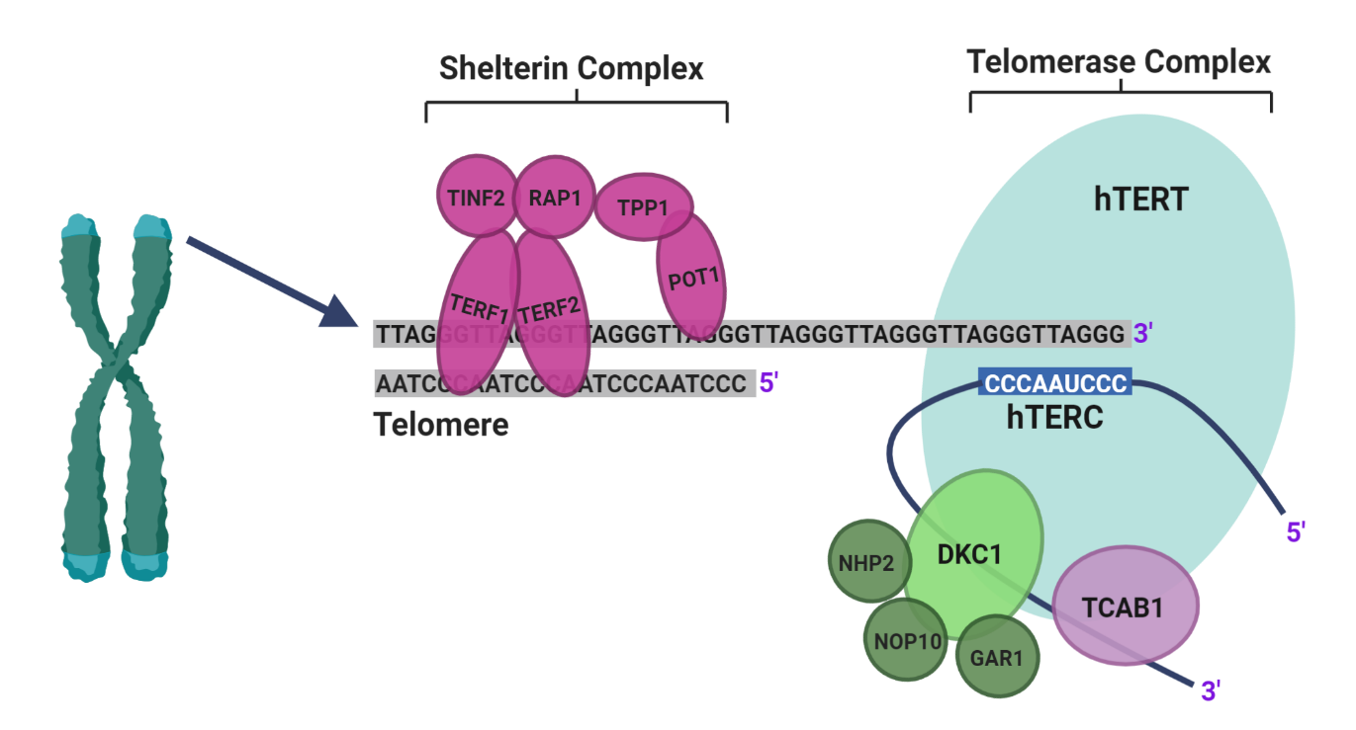
Figure 1. Schematic illustration of telomeres and the main components of telomerase, adapted from Hapangama et al. [12]. Telomerase is a holoenzyme comprising three core components: human telomerase reverse transcriptase (hTERT), human telomeric RNA component (hTERC) and dyskerin (DKC1). hTERT is a catalytic protein with transcriptase activity and hTERC provides the RNA template from which new telomeric DNA is synthesized [12]. NHP2, NOP10 and GAR1, in addition to DKC1, bind the H/ACA snoRNA motif at the 3′ end of hTERC and stabilise newly transcribed telomeric RNA. The H/ACA region also binds telomerase Cajal body protein 1 (TCAB1). The shelterin complex is made up of telomeric repeat binding factors 1 and 2 (TERF1 and TERF2), repressor/activator protein 1 (RAP1), protection of telomeres 1 (POT1), TERF1 interacting nuclear factor 2 (TINF2) and TPP1 (encoded by the gene ACD). POT1 binds directly to the single stranded 3′ end of the telomere and forms a heterodimer with TPP1. TERF1 and TERF2 bind to the double-stranded telomeric sequence [11]. (Created with BioRender.com).
The unlimited proliferative capacity of cancer cells can, in part, be attributed to aberrant telomerase activity, which is repressed in most somatic cells but present in up to 90% of cancers [12,13]. Furthermore, higher telomerase activity has been correlated with more aggressive/advanced cancers, suggesting that it may contribute to the poorer outcomes associated with some cancers [14,15]. These features make telomerase a useful therapeutic target and consequently, many telomerase-based therapies have been investigated as prospective anti-cancer treatments [16]. However, telomerase has a unique role in the benign endometrium, as this is one of the few somatic tissues to already exhibit significant telomerase activity [17–19]. The significant regenerative capacity of the endometrium may be the reason for this, as well as the cyclical endometrial proliferation and shedding with each menstrual cycle [12]. The endometrium expresses a dynamic pattern of telomerase activity throughout the cycle, in which levels are highest in the proliferative and lowest in the secretory phase [12,20–22]. Telomerase activity is also affected by steroid hormones, and it is upregulated by oestrogen and inhibited by progesterone [20]. It may be via this mechanism that progesterone administration slows tumour progression in the secondary management of EC [20,23].
Endometrial carcinogenesis is not well understood. Considering the unique role telomerase appears to play within the human endometrium, characterisation of telomere and telomerase associated genes and proteins (TTAGP) that are aberrantly expressed in EC may provide further insight into their diagnostic, prognostic and therapeutic utility. The aim of the current in silico study was therefore to investigate the role of TTAGPs in EC and identify potential prognostic markers and therapeutic targets of disease. This was undertaken with bioinformatic analysis of the RNA expression dataset for EC cohort from The Cancer Genome Atlas (TCGA) database.
2. Experimental Design
2.1. Identification of TTAGPs
A diagram displaying the workflow for the current study is shown in Figure 2a. Database searches were undertaken to compile a comprehensive list of genes and proteins that associate with telomerase and are involved in telomere maintenance (Figure 2b). A total of 3467 TTAGPs were identified from five databases: TelNet, National Center for Biotechnology Information (NCBI) – Gene (www.ncbi.nlm.nih.gov/gene/), Biological General Repository for Interaction Datasets (BioGRID) (https://thebiogrid.org/), Search Tool for the Retrieval of Interacting Genes/Proteins (STRING) (https://string-db.org/) and GPS-Prot (http://gpsprot.org/) [24–31]. TelNet contains over 2000 genes related to telomere maintenance and attributes a TelNet score to each gene, representing its significance to telomere maintenance (http://www.cancertelsys.org/telnet) [32]. Interactors for each component of the telomerase and shelterin complex were identified using BioGRID, STRING and GPS-Prot databases. The interaction score was set at medium confidence (≥0.400) throughout. Within the STRING database, first and second shell interactors were included for hTERT and DKC1, as these form core components of the telomerase holoenzyme, and all first shell interactors were included for the remaining proteins. Interactors for hTERC were excluded from STRING and GPS-Prot as it is a long non-coding RNA. Duplicates and genes that were non-human were manually removed to generate the final list.
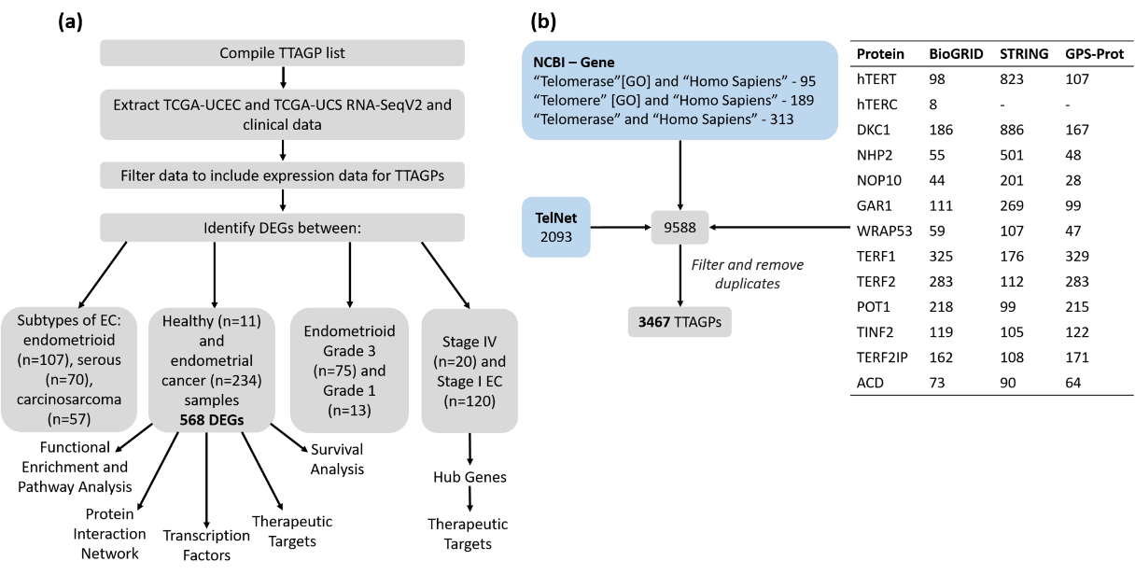
Figure 2. (a) Workflow diagram illustrating the in silico procedures. (b) Database searches for compiling the list of TTAGPs. The table displays the number of interactors identified for each protein within the telomerase and shelterin complex. WRAP53 and TERF2IP are the official gene symbols for TCAB1 and RAP1, respectively. TPP1 is encoded by the ACD gene.
2.2. TCGA Data Cohort
RNASeq and clinicopathological data for EC samples were downloaded from TCGA database (https://www.cancer.gov/tcga), using Broad Genome Data Analysis Centre (GDAC) FireHose (gdac.broadinstitute.org) (Figure 2a). A total of 234 cancer and 11 healthy patient samples had available normalised RNASeqV2 data and were included in the study. EC samples consisted of those from both the Uterine Corpus Endometrial Carcinoma (TCGA-UCEC) and Uterine Carcinosarcoma (TCGA-UCS) datasets. The interrogation of anonymous, public and freely available mRNA expression data provided by TCGA does not require ethics committee approval.
2.3. Identification of Differentially Expressed Genes (DEGs)
DEG analysis was performed between the following categories: cancer and healthy endometrium, histological subtypes of EC, grade 1 and 3 endometrioid tumours, and stage I and IV EC (Figure 2a). Tumours with mixed endometrioid and serous histology were categorised as serous tumours. Differential expression analysis was conducted using limma in the web application iDEP.91 (Integrated Differential Expression and Pathway analysis) (http://bioinformatics.sdstate.edu/idep/) [33]. A │log2FC > 1│ and false discovery rate (FDR) <0.01 were used as cut-off criteria for DEGs [34]. Venn diagrams were constructed using the Bioinformatics and Evolutionary Genomics web-tool (http://bioinformatics.psb.ugent.be/webtools/Venn/). Principle component analysis (PCA) was conducted using the prcomp function from the stats packages within R (https://cran.r-project.org/).
2.4. Functional Enrichment and Pathway Analysis
Enrichr (https://amp.pharm.mssm.edu/Enrichr/) was used for the functional analysis of DEGs [35,36]. Gene Ontology (GO) analysis was performed to elucidate the molecular functions, biological processes and cellular components associated with the DEGs. Kyoto Gene and Genome Encyclopaedia (KEGG) enrichment analysis was also performed to gain insight into the associated signalling pathways. Adjusted p < 0.05 was chosen as a cut-off. The web tool REVIGO (http://revigo.irb.hr/) was utilised to reduce redundancy of the GO terms and condense them into a smaller representative subset [37]. Similarity of GO terms was set at <0.5.
2.5. Protein–Protein Interaction (PPI) Network
A PPI network of DEGs was constructed with interaction data from STRING, and this was visualised with Cytoscape version 3.8.0 (http://www.cytoscape.org/) [28,38]. The minimum confidence score was set at 0.400 and only nodes with a degree ≥1 were included in the network. In order to identify modules within the network, the Molecular Complex Detection (MCODE) plug-in was used (degree cut-off ≥2) [39]. This identifies densely connected regions within a network based on topology. The Cytohubba plug-in was used to select the top 10 hub genes within the entire network, according to degree [40].
2.6. Identification of Key Transcription Factors (TFs)
oPOSSUM 3.0 (http://opossum.cisreg.ca/oPOSSUM3/) was used to identify over-represented transcription factor binding sites (TFBS) amongst the DEGs [41,42]. Human single site analysis was performed, in which the genes were compared against all 24,752 genes in the oPOSSUM database, using all vertebrate JASPAR CORE transcription factor profiles. Sequences were searched +/−2000 bp from the start sites of each gene. A conservation cut-off was set at 0.60 and a matrix score threshold at 80%. Results were analysed according to Fisher score. This score compares the proportion of a set of genes containing a particular TFBS motif to the proportion of the background set that contains the motif [41]. When analysed by Z-score, this showed some bias in identifying TFs with a lower GC content (Figure S1a). As a result, TFs were identified according to Fisher score that showed a more even distribution (Figure S1b). A Fisher score greater than 2 standard-deviations above the mean was used as a cut-off for selecting TFs. Due to the large number of genes included in the analysis, a control analysis was performed using 2 sets of 2000 randomly selected genes that were not differentially expressed in EC. This ensured that the results were not due to chance.
2.7. Therapeutic Targets
The Drug Gene Interaction Database (DGidb) was screened to identify known associated drugs for hub genes and enriched TFs [43].
2.8. Survival Analysis
The survival information for each DEG in EC was taken from The Human Protein Atlas (http://www.proteinatlas.org), which is based upon clinical information from all patients within the TCGA-UCEC dataset (n = 541) [44]. Genes that had a significant association with overall survival (p < 0.001, Log-rank test) were regarded as prognostic in EC. The cut off value for high and low expression differs for each gene, and is based upon the value which yields the maximal difference in survival and the lowest log-rank p-value.
3. Results
3.1. Identification of TTAGPs and EC-Associated DEGs
A total of 3467 TTAGPs were identified from database searches (Table S1). Out of these, 75 genes were not found within the TCGA datasets and consequently, 3392 genes were included in DEG analysis. TCGA RNA expression data and clinical data is available in Tables S2–S4. 568 telomerase associated DEGs were identified between EC (n = 234) and healthy endometrium (n = 11). A greater number of DEGs were upregulated (323) in cancer than downregulated (245) (Figure 3). A full list of DEGs with their associated TelNet scores and ranked by log2FC is available in Table S5. Of the 568 DEGs, 192 were not listed on TelNet and therefore did not have TelNet scores. The top 5 upregulated DEGs, ranked by log2FC, included JSRP1, IGF2BP3, FOXA1, CDC45 and BIRC5. The top 5 downregulated DEGs, by log2FC, were MYOCD, RSPO1, FOXL2, WT1 and ARHGAP20. Additional EC-associated DEGs with high TelNet scores included hTERT, BLM, FEN1, RUVBL1 and HSP90AA1, which were all upregulated.
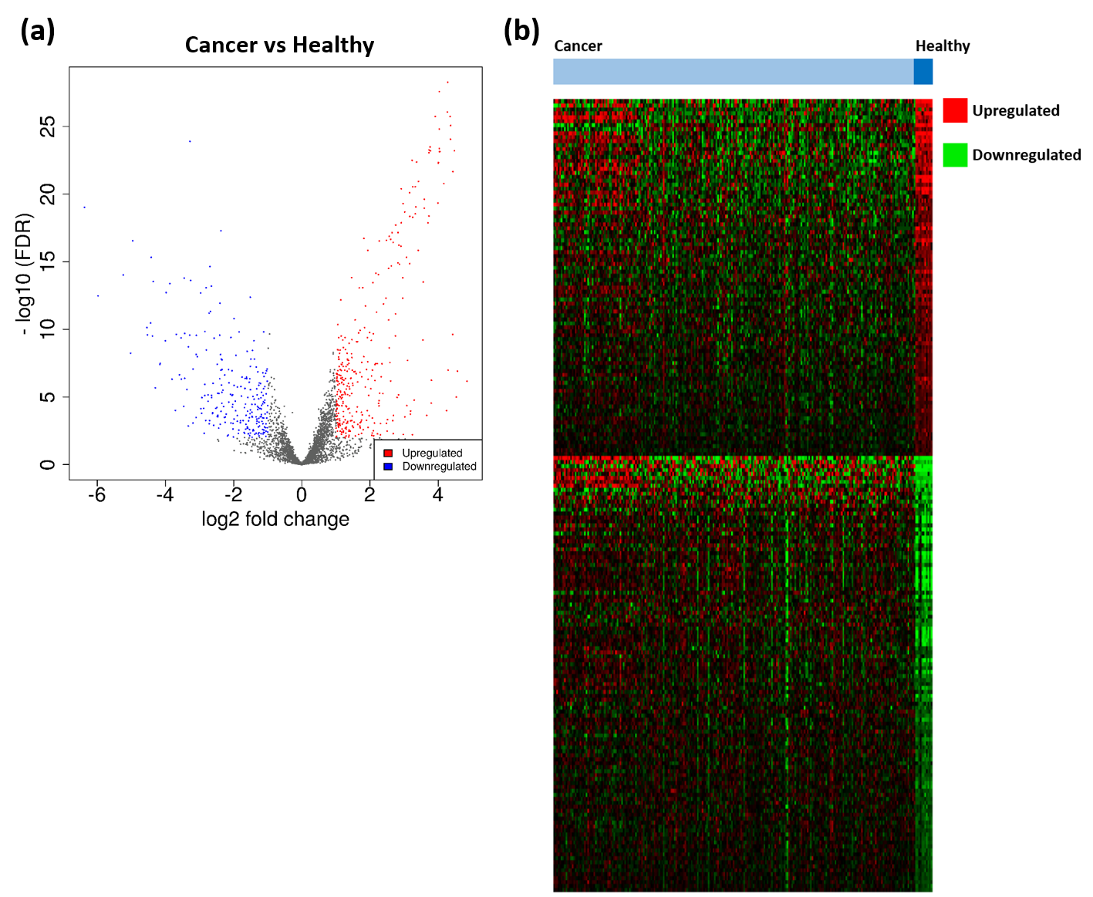
Figure 3. Differentially expressed genes (DEGs) identified between endometrial cancer (EC) and healthy endometrium. (a) Volcano plot of DEGs amongst cancer (n = 234) and healthy samples (n = 11). Significant DEGs are coloured; red dots represent upregulated genes, and blue dots represent downregulated genes. Cut-off criteria: │log2FC > 1│and false discovery rate (FDR) < 0.01. (b) Heatmap displaying the expression of 568 DEGs. Red denotes upregulated genes and green denotes downregulated genes.
3.2. DEGs Associated with Histological Subtypes of EC
A total of 631 DEGs were identified between endometrioid tumours (n = 107) and healthy (n = 11) endometrium, of which 341 were upregulated and 290 downregulated (Figure 4a, Table S6). Between serous tumours (n = 70) and healthy endometrium, 643 DEGs were identified. Out of which, 397 were upregulated and 246 were downregulated (Figure 4b, Table S7). There were 621 DEGs identified between carcinosarcoma (n = 57) and healthy endometrium, of which 406 were upregulated and 215 were downregulated (Figure 4c, Table S8). There were 220 genes consistently upregulated across all subtypes, including TERT, FEN1, BLM, PCNA, AURKA and PITX1 (Figure 4d, Table S9). There were 135 genes downregulated across all subtypes that were identified, such as KLF4, NR2F2, KLF2, EGR1, ETS2 and AR (Figure 4e, Table S10). There were 105 endometrioid-specific DEGs that were identified, and the highest upregulated genes included CEACAM5, S100P and PCSK9, and the highest downregulated genes were IQSEC3, H19 and ELOVL4. There were 58 genes dysregulated in only the serous subtype. The highest upregulated serous-specific genes were XAGE2, CCDC155 and AIM2, and the most highly downregulated were PCP4, TBX1 and DLG2. There were 159 carcinosarcoma-specific DEGs identified, including the upregulated genes MYOG, DMRT2 and SLC7A10, and the downregulated genes WDR38, PHYHD1 and POU5F1.
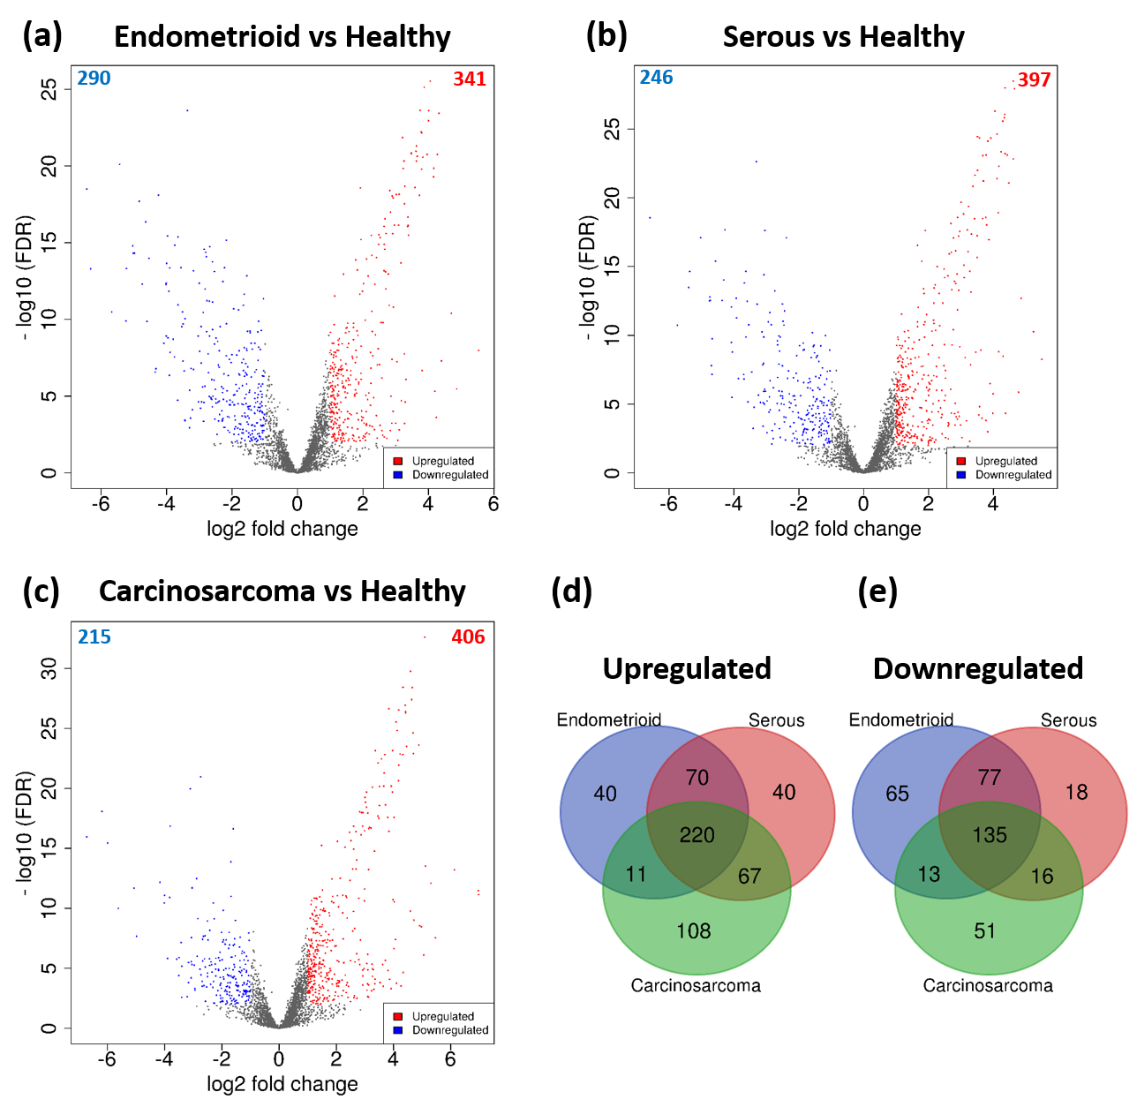
Figure 4. Volcano plots of DEGs between (a) endometrioid and healthy endometrium, (b) serous and healthy, and (c) carcinosarcoma and healthy. Significant DEGs are coloured; red dots represent upregulated genes, and blue dots represent downregulated genes. Cut-off criteria: │log2FC > 1│and FDR < 0.01. Venn diagrams displaying common (d) upregulated and (e) downregulated genes between each subtype.
Healthy controls separated from EC samples on a PCA plot of telomerase-associated transcripts and separation was determined by PC3 (Figure S2). There was also some separation of carcinosarcoma and endometrioid samples on the PCA plot and this was determined by PC2. From the PCA loading plot, we identified the top 50 genes from each principal component contributing to variance. PC3 included genes such as ARHGAP20, FOXL2, MYOCD, RSPO1 and IGF2BP3, whilst PC2 included MYOG, TUBB2B, CEACAM5, HGD and WDR38.
3.3. DEGs Associated with Tumour Grade and Clinical Stage
Between grade 1 (n = 13) and grade 3 (n = 75) endometrioid tumours, 37 genes were upregulated and four genes were downregulated (Figure 5a, Table S11). The most highly upregulated genes in grade 3 were CDC45, RAD51AP1, PKMYT1 and KIAA0101, whilst IGFBP4, GLI1, HIC1 and PTCH1 were downregulated. 166 DEGs were identified between clinical stage I (n = 120) and stage IV (n = 20) ECs, out of which 94 were upregulated and 72 were downregulated (Figure 5b, Table S12). The most highly upregulated DEGs included MAGEA4, SULT1E1, TDRD10, and XAGE2, and the most highly downregulated were DUT, SETDB1, SRP9 and ZNF140.
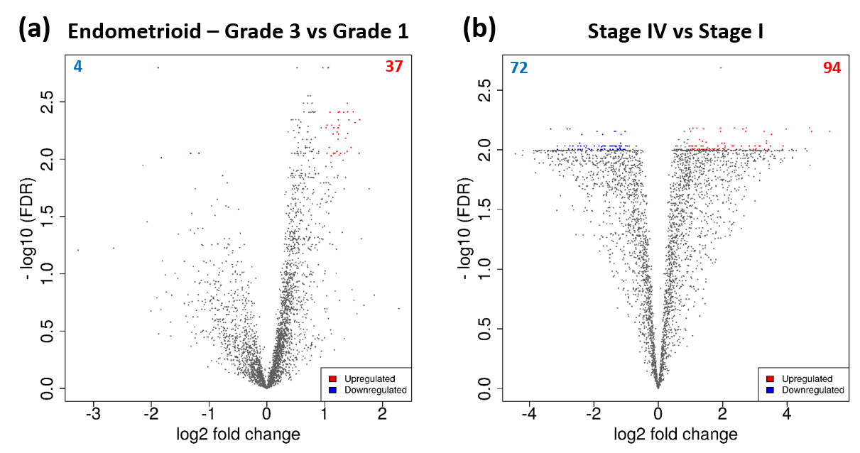
Figure 5. DEGs associated with tumour grade and clinical stage. Volcano plots of DEGs between (a) grade 1 and grade 3 endometrioid, and (b) stage I and IV EC. Significant DEGs are coloured; red dots represent upregulated genes, and blue dots represent downregulated genes. Cut-off criteria: │log2FC > 1│and FDR < 0.01.
3.4. Functional Enrichment and Pathway Analysis
GO function and KEGG pathway enrichment analysis was performed to assess the functional significance of the 568 telomere and telomerase associated DEGs. A total of 429 significant GO terms of biological process, 105 GO terms of molecular function and 44 GO terms of cellular component were identified from Enrichr. After using REVIGO, 48 biological process terms, 40 molecular function terms and nine cellular component terms remained. The full list of GO terms and KEGG pathways is presented in Tables S13–S19. Biological process terms were predominantly associated with regulation of transcription and cellular division (Figure 6a). For molecular function, DEGs showed significant enrichment in DNA binding and regulation of transcription (Figure 6b). The results amongst cellular component analysis showed that DEGs were enriched in the chromosome and spindle, suggesting a role within DNA replication (Figure 6c). There were 96 significant KEGG pathways identified and these included ‘cell cycle’ and ‘pathways in cancer’ (Figure 6d). Overall, many functional terms and pathways identified were associated with DNA replication, the cell cycle and regulation of transcription.
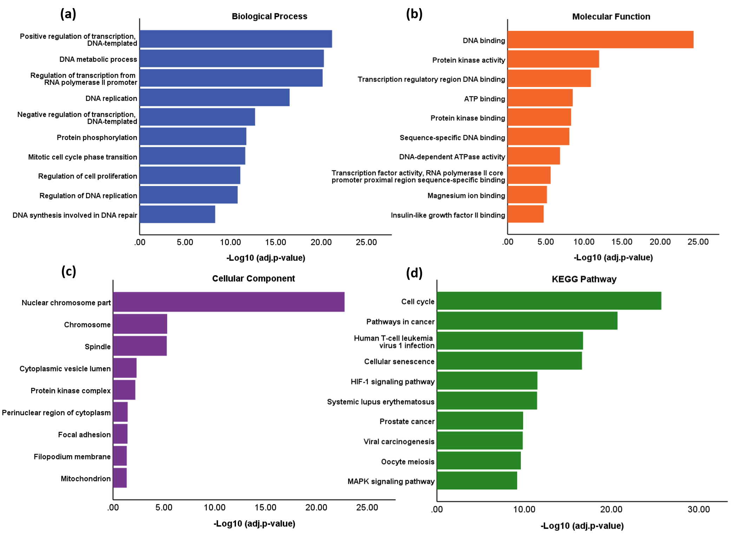
Figure 6. Functional Enrichment and Pathway Analysis of DEGs. GO terms and Kyoto Gene and Genome Encyclopaedia (KEGG) pathways were identified using Enrichr. The GO terms were subsequently revised into a smaller representative list using REVIGO (similarity <0.5). (a) Biological Process. (b) Molecular Function. (c) Cellular Component. (d) KEGG pathway.
3.5. PPI Network
The PPI network was constructed from DEGs with a degree ≥1 and consisted of 535 nodes (proteins) and 9001 edges (interactions), including 309 upregulated and 226 downregulated DEGs (Figure 7; Table S20). Using MCODE, a module with a score of 64.171 was identified (Figure 8a, Table S21). This was made up of 71 nodes and 2246 edges, and all nodes within the module were upregulated DEGs. Significant biological process GO terms for this module included ‘DNA replication’ and ‘mitotic cell cycle phase transition’ (Figure 8b, Tables S22–S28). For molecular function analysis, the module showed predominant enrichment in DNA binding. Significant cellular component GO terms included ‘nuclear chromosome part’, ‘spindle’ and ‘chromosome’. KEGG pathway analysis suggested an association with ‘cell cycle’, ‘DNA replication’ and ‘cellular senescence’ (Figure 8c). Taken together, the results suggest that this module is predominantly associated with DNA replication and cell cycle regulation.
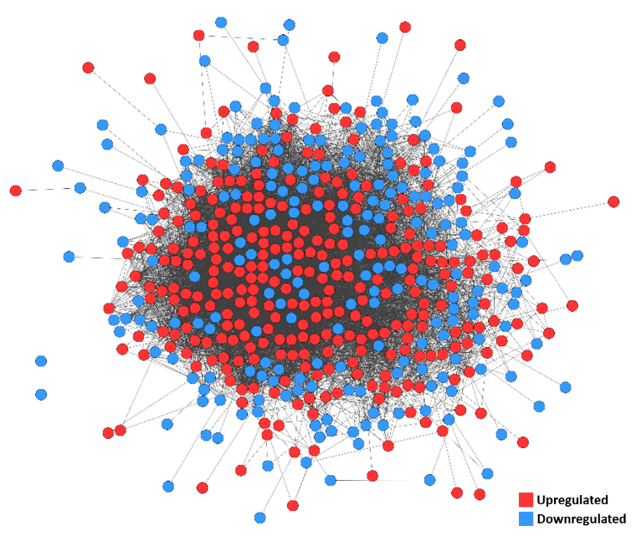
Figure 7. Protein–Protein Interaction (PPI) network of DEGs. Upregulated and downregulated DEGs are represented by red and blue nodes, respectively. Degree ≥1.
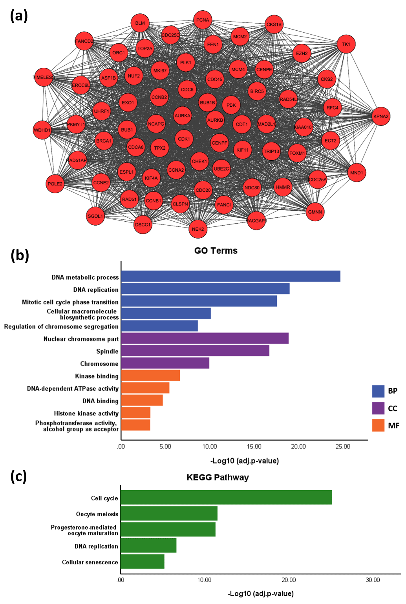
Figure 8. (a) The module identified in the PPI network of DEGs using Molecular Complex Detection (MCODE). MCODE score = 64.171. Degree cut-off ≥2. (b) GO terms and (c) KEGG pathways associated with the module. Abbreviations: BP—Biological Process; CC—Cellular Component; MF—Molecular Function. GO terms and KEGG pathways were identified using Enrichr (adjusted p < 0.05). The GO terms were subsequently summarised into a smaller representative list using REVIGO (similarity <0.5).
Using cytohubba, all nodes within the network were ranked according to degree and the top 10 were selected. This included GAPDH, CCNB1 and CDC6 (Figure 9a, Table S20). Degree represents the number of nodes within the network that a node interacts with and thus, nodes with a higher degree may be more likely to influence the regulation of others within the network. The top 10 hub genes were then also identified from DEGs between stage I and IV EC; NOP56 and NHP2 had the highest degrees of 29 and 28, respectively (Figure 9b, Table S29).
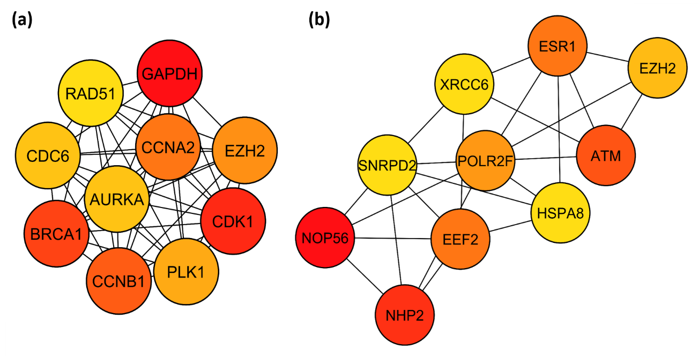
Figure 9. Top 10 hub genes of the PPI network constructed from (a) EC-specific DEGs and (b) stage I-IV DEGs, ranked according to degree. The hub genes were identified using Cytohubba. The colour of the node represents degree, with red representing a higher degree and yellow a lower degree.
3.6. Identification of Key TFs
From oPOSSUM analysis of DEGs, three enriched TFBS were identified: MZF1_5-13, ZEB1 and E2F1 (Table 1, Table S30). This is supported by results from the control analysis, in which none of these TFBS were above the cut-off criteria (Tables S31–S32). All three of the identified TFs have an association with telomeres and telomerase (Table S1). In addition, ZEB1 is downregulated and E2F1 is upregulated in EC compared to healthy endometrium (Table S5).
Table 1. Transcription factors (TFs) whose binding sites were enriched in the DEGs, and their associated Fisher score. oPOSSUM software was used to identify TFs with a Fisher score greater than 2 standard deviations above the mean.
TF | Fisher Score
E2F1 | 49.853
MZF1_5-13 | 54.086
ZEB1 | 50.209
3.7. Therapeutic Targets
Using the DGidb, known drugs associated with enriched TFs and hub genes from the PPI network, in addition to hub genes from stage I–IV DEGs, were identified (Table S33). This included metformin, ibrutinib, AURKA inhibitors, cordycepin, genistein, suramin, sodium butyrate, SS1(dsFv)-PE38 and AZD-6482. Everolimus (mammalian target of rapamycin (mTOR) inhibitor) and poly (ADP-ribose) polymerase (PARP) inhibitors, such as olaparib, veliparib, talazoparib, are known to target ataxia telangiectasia mutated (ATM) and breast cancer type 1 susceptibility protein (BRCA1). Multiple chemotherapy agents target the hub genes and TFs, including carboplatin, paclitaxel, doxorubicin, chlorambucil, carmustine and bendamustine. Mitogen-activated protein kinase (MEK) inhibitors, such as selumitinib, binimetinib and trimetinib, were identified that target ATM and EZH2. Many cyclin-dependent kinase inhibitors were also identified, such as variolin B, meriolin, alsterpaullone and dinaciclib, which target CCNA2 and CDK1. No drugs were associated with CCNB1, CDC6, MZF1, NOP56, NHP2, POLR2F, XRCC6 and SNRPD2.
3.8. Survival Analysis
Using prognostic data from The Human Protein Atlas, 69 out of 568 EC-specific DEGs had a significant effect upon overall survival in EC (Log-rank test, p < 0.001) (Table S34). Twenty DEGs had a favourable effect, in which high expression was associated with longer overall survival. The most significant favourable prognostic DEGs were ESR1, ANAPC4, RPS6KA1 and WFS1. There were 49 DEGs associated with an unfavourable prognosis, such as ERBB2, ARL4C, TUBB4A, TPX2, AURKA and CCNA2. This prognostic data is based only upon RNA expression data from the TCGA-UCEC dataset (n = 541), and thus does not include data from carcinosarcoma samples (TCGA-UCS). Out of 541 patients, a total of 91 deaths occurred. Some genes in the TTAGP list that were not dysregulated in EC compared to healthy endometrium were also found to be associated with prognosis, for example, NOP56 [44].
As genes dysregulated in higher grade or later stage disease may indicate that a tumour is more aggressive, the list of DEGs from the comparison of stage I and IV EC, and grade 1 and 3 endometrioid, were intersected with the list of prognostic genes (Figure 10, Table S35). There was very little overlap between the groups and no DEGs were common across all three groups. The 7 DEGs that were dysregulated in grade 3 endometrioid cancer and were also prognostic genes in EC (TPX2, AURKA, ATAD2, IGFBP4, CKS1B, NCAPG and RAD51AP1), were all upregulated and associated with poor prognosis, except IGFBP4 that was downregulated and linked with a favourable prognosis. Five DEGs were linked with both stage IV disease and prognosis; ESR1, CIRBP and GLTSCR2 were downregulated and linked with a favourable prognosis, whereas CDKN2B and MRPL47 were upregulated and associated with poor prognosis. Furthermore, two genes were commonly downregulated in both stage IV disease and grade 3 endometrioid (KIF4A and UBE2C).
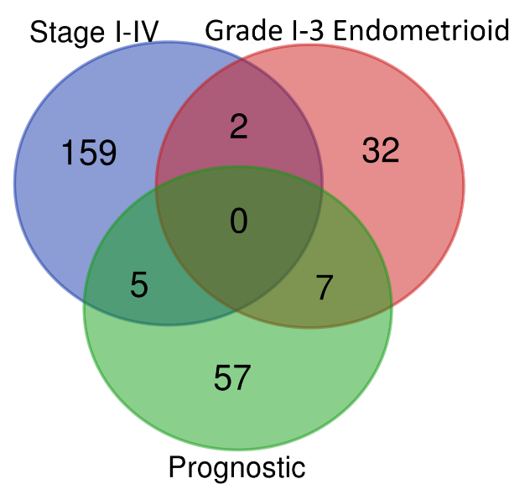
Figure 10. Venn diagram displaying the intersections of stage I-IV DEGs, Grades 1–3 DEGs and prognostic DEGs.
4. Discussion
Telomere maintenance is a complex, multistep process that is regulated by a large number of proteins as evidenced by our database search [32,45–47]. The dysregulation of many telomere maintenance genes and proteins have been linked to telomere shortening and telomerase activity in cancer [48]. Despite previous studies demonstrating that hTERT expression and telomerase activity correlate with poor survival in multiple cancers [14,49–54], this has not been seen in EC. This may be due to both hTERT expression and telomerase activity being normally active in the benign endometrium already [17–19,55]. In this study, by considering a wider network of TTAGPs, we have been able to identify genes and proteins that are linked, through their shared influence on telomere biology, to endometrial carcinogenesis, progression and survival.
When comparing the expression of TTAGPs between EC and healthy endometrium, hTERT and multiple associated genes, such as HSP90AA1 and RUVBL1, were upregulated, agreeing with prior reports of an increase in telomerase activity in EC [56,57]. Our work has highlighted some novel bio-targets relevant to telomere/telomerase biology that may play a role in EC. For example, JSRP1 was the most highly upregulated DEG. Little is known about its functions, except that it is involved in excitation–contraction coupling at the sarcoplasmic reticulum in skeletal muscle [58]. A fluorescence localisation screen has located it in close proximity to TERF1 [59]. BLM and FEN1 both bind to TERF2 and promote telomeric DNA synthesis via the ALT pathway [60–63]. They were both upregulated in EC. Despite being implicated in various cancer types, their role in EC has not been studied before [64–68]. Our methodology is validated by some TTAGPs relevant to EC that had previously been confirmed by other authors, for example; FOXA1 was also a highly upregulated DEG, which is known to regulate oestrogen receptor binding in breast cancer [69]. It interacts with NOP10 and GAR1—components of the telomerase complex [70]. A previous study has shown it to be overexpressed in EC compared to atypical hyperplasia and normal endometrium [71]. However, there is conflicting evidence regarding its effect on EC proliferation, with some studies proposing it stimulates growth, while others report an inhibitory effect [71–73]. Amongst the most significantly downregulated DEGs were MYOCD, RSPO1, FOXL2 and ARHGAP20. This is also supported by the PCA , in which these genes were shown to contribute to separation of cancer samples and healthy controls. FOXL2 is a telomerase TF and, consistent with our findings, a previous in vitro study has also reported FOXL2 to have lower expression in EC tissues than normal endometrium [32,74]. Some of the newly identified DEGs have not previously been examined in EC, but possess confirmed pro-carcinogenic functionalities that could explain their observed changes in this pathology. MYOCD, RSPO1 and ARHGAP20 are examples of this. MYOCD, which encodes myocardin, is required for cardiac and smooth muscle development and is a potent transcriptional co-activator which acts in concert with telomerase [32,75,76]. RSPO1 is involved in embryonic development and organogenesis and is predicted to interact with hTERT [77,78]. ARHGAP20 contributes to cellular regulation processes and has been found within a protein network surrounding TERF1, TERF2 and POT1 [79,80]. MYOCD, RSPO1 and ARHGAP20 have all been implicated in various cancers, including lung cancer [75,77,79]. Along with JSRP1, FEN1 and BLM, they have not been previously studied in EC and further investigation is warranted to understand how they may contribute to EC carcinogenesis.
The comparison of DEGs from different histological subtypes revealed that many genes were consistently dysregulated, compared with healthy tissue. BLM, AURKA and PITX1 were upregulated in each subtype and were more significantly upregulated in carcinosarcoma tumours than endometrioid. AURKA is known to enhance telomerase activity by binding to TERF1 [81], whilst PITX1 suppresses hTERT transcription by binding to the hTERT promoter [47,82]. Carcinosarcoma is a highly aggressive subtype of EC, with patients typically exhibiting early metastasis, rapid disease progression and poor survival [83]. Consequently, greater upregulation of a gene in carcinosarcoma tumours may signify an association with more aggressive disease/poor prognosis. Overexpression of BLM, AURKA and PITX1 has previously been linked with poor survival in breast, lung, bladder and pancreatic cancer [84–88]. Furthermore, AURKA has been shown to reduce EC cell proliferation and invasion in vitro and was associated with poor prognosis from the TCGA dataset [89]. Taken together with our findings, this suggests that BLM, AURKA and PITX1 may contribute to more aggressive disease. From this analysis, we also identified multiple subtype-specific DEGs. S100P was only found to be overexpressed in endometrioid tumours. It is predicted to affect telomere biology due to its close proximity to RAP1 [90]. Previous studies have also linked S100P expression with the squamous and adenosquamous subtypes of EC [91], but its association with endometrioid tumours has not been investigated. H19, which suppresses telomerase activity [92], was found to be highly downregulated in only the endometrioid subtype, in agreement with a previous study [93]. IQSEC3 was also significantly downregulated and is predicted to affect telomere maintenance due to its telomeric location [94]. XAGE2 and PCP4 were serous-specific DEGs that are both thought to interact with POT1 [90]. IQSEC3, XAGE2 and PCP4 have not been studied in EC previously, and further studies are necessary to investigate their associations with endometrioid and serous tumours. MYOG, which encodes myogenin, was only upregulated in carcinosarcoma tumours. Myogenin is a TF known to regulate myogenesis, and has also been shown to silence the hTERT gene [95]. It has not previously been studied in EC but has been linked with multiple sarcomatous cancers, such as rhabdomyosarcoma and leiomyosarcoma [96–98]. It may be a potential biomarker of carcinosarcoma tumours. From our analysis, we have identified many genes that may provide further insight into the pathogenesis of each of the subtypes and act as potential diagnostic/prognostic biomarkers or type specific molecular pathways. Many of these, such as BLM, PITX1 and MYOG, have not been studied in EC previously and provide the basis for future experiments.
Genes dysregulated according to tumour grade included CDC45 and RAD51AP1, which are both associated with the ALT pathway [99–101]. They have been linked with increased growth and progression in various cancers, including colorectal, ovarian and lung cancer [102–104], but have not previously been studied in EC. Between stages I and IV, MAGEA4 and TDRD10 were amongst the most highly upregulated DEGs, and DUT was the most downregulated. MAGEA4 has been shown to be located in close proximity to POT1 in a fluorescence localisation screen [90]. Previous studies have also linked overexpression of MAGEA4 with the carcinosarcoma subtype and with poor survival in high grade EC [105,106]. TDRD10 and DUT expression have both been linked with poor survival in cancer [107–109], but have never previously been studied in EC. TDRD10 is predicted to be associated with telomere maintenance due to its role in DNA repair [100], whilst DUT has been found at the telomeres of telomerase and ALT positive cell lines [110]. KIF4A, which has been found at telomeres in a telomerase-positive cell line [110], was downregulated in both stage IV EC and grade 3 endometrioid cancer. In accordance with this, previous studies have shown that inhibition of KIF4A contributes to decreased EC cell proliferation in vitro [111]. By investigating differences in gene expression between the extremes of clinical stages and histological grades, many novel genes have been identified, such as CDC45 and RAD51AP1, and their expression may indicate poor prognosis and play a role in the aggressiveness of the cancer.
Functional and pathway enrichment analysis of DEGs between EC and normal tissues revealed an association of those with DNA replication, cell cycle and regulation of transcription in EC. This is consistent with the proposed dysregulation of the cell cycle due to telomere-induced senescence in EC [12], enabling the EC cells to adapt their hallmark features such as replicative immortality [112]. Furthermore, many of these genes may further contribute to cellular immortality via their extra-telomeric functions in cell replication and tumour survival [113].
By constructing a PPI network, a significant module that had a functional role in DNA replication and cell cycle regulation was identified. From the network, most of the top 10 hub genes identified (CDK1, CCNA2, CCNB1, PLK1, CDC6 and AURKA) were also associated with similar cell cycle regulatory functions [89,114–117]. This further reinforces the fundamental involvement of TTAGPs in cellular division. Our findings are further validated by the identification of hub genes CCNA2, CDK1, AURKA and CCNB1 in the network of DEGs between EC and normal tissue, which are consistent with previous studies [118–122]. Therefore, it is not surprising that many of the identified hub genes have already been implicated in EC. Inhibition of EZH2, CDK1, PLK1 and AURKA have been shown to suppress EC cell proliferation and invasion, and increase cellular apoptosis in vitro [89,123–129]. PLK1, CDK1 and AURKA are involved in the phosphorylation of TERF1, which enables it to bind to telomeres as part of the shelterin complex [81,130]. Furthermore, a previous study has reported that EZH2 overexpression may correlate with poor prognosis in EC, but this was not found in the TCGA dataset [127]. EZH2 has been reported to interact with TERF2 and TERF2IP [131], of the shelterin complex, and also telomeric repeat-containing RNA (TERRA) [132,133]. In our survival analysis, AURKA and CCNA2 were identified as markers of unfavourable prognosis (Table S34), which is supported by previous immunohistochemical studies [122,134]. Polymorphisms within the RAD51 gene have been associated with EC progression and recurrence [135,136]. RAD51 is involved in homologous recombination repair, which is used to repair double strand breaks [137], and has been suggested to be part of the ALT pathway that utilises this repair mechanism to synthesise telomeric DNA [138,139]. The expression of CCNA2, CCNB1, CDC6 and GAPDH have all been implicated in various cancers, including lung, ovarian and pancreatic cancer [140–152]. CDC6 interacts with TERF1 and increased expression is associated with upregulation of hTERT [153,154]. CCNB1 expression has been shown to correlate with telomerase activity and CCNA2 has been found at telomeres in an ALT-positive cell line [101,110]. GAPDH binds telomeric DNA and protects telomeres against rapid degradation in response to ceramide and chemotherapeutic agents [155–157]. The top hub genes amongst the DEGs between stage I and IV EC were NOP56 and NHP2, which are both associated with poor prognosis in EC from the TCGA dataset [158]. NHP2 is a component of the telomerase complex (Figure 1) whilst NOP56 interacts with multiple components of the complex (Figure S3). It interacts with DKC1 and NOP10 and is predicted to bind NHP2 [159–161]. Many of the hub genes we identified appear to contribute to growth and progression of EC. CDC6, CCNB1, GAPDH, NHP2 and NOP56 are linked with carcinogenesis but have not been investigated previously in EC. Further studies are necessary to elucidate how they may contribute to EC pathogenesis.
Three enriched TFs were identified from the analysis of DEGs in EC and all were associated with telomere maintenance. E2F1 and MZF1 are both associated with downregulation of hTERT transcription and diminished telomerase activity, whereas ZEB1 upregulates hTERT expression [162–167]. E2F1 is involved in cell cycle regulation and apoptosis [168,169]. It regulates many cell cycle effector proteins such as CDC6 and CCNA2 [170,171]. It is upregulated in EC and associated with poor prognosis [169,172,173]. The upregulation of E2F1 in EC is largely consistent with the expression of several of its target genes, such as PDK4, BRCA1 and FOXM1 [174–176], in our differential expression analysis. ZEB1 (zinc-finger E-box binding protein 1), which is known to promote epithelial-to-mesenchymal transition (EMT) [177,178], is associated with increased invasion and metastasis in EC [165,179–184]. ZEB1 was downregulated in EC compared to healthy endometrium and the expression of its target genes, RPS6KA5, DNMT3B, EPCAM and KLF4, were generally consistent with this [185–187]. MZF1 is a SCAN domain-containing zinc finger protein which regulates transcription during various developmental processes [188]. Aberrant expression of MZF1 has been implicated in various cancer types, and can increase cancer cell proliferation, invasion and metastasis [166,188]. However, its role in EC has not been studied previously and remains to be clarified.
Multiple drugs already used in EC management were shown to interact with the identified hub genes and TFs; these included chemotherapeutic agents such as paclitaxel, carboplatin and doxorubicin [189]. In addition to this, our work highlighted metformin and mTOR inhibitors, such as everolimus, and they have already shown promise in early clinical trials for the treatment of EC [190–195]. In vitro studies have demonstrated the therapeutic benefit of AURKA inhibitors, cordycepin, genistein, suramin, sodium butyrate and ibrutinib [89,196–200]. The MEK inhibitor selumetinib has shown anti-tumour effects in EC cell culture [201], whilst binimetinib is yet to be studied in EC. The chemotherapy agents chlorambucil, carmustine and bendamustine are frequently used in the treatment of haematological cancers, such as non-Hodgkin lymphoma and chronic lymphocytic leukaemia, but are yet to be studied in EC [202–205]. Our data also identified many novel drug agents that demonstrate anti-tumour activity in vitro and in vivo, and these include the anti-mesothelin immunotoxin SS1 (dsFv)-PE38, the PI3K inhibitor AZD-6482 and the cyclin-dependent kinase inhibitors variolin B, meriolin, alsterpaullone and dinaciclib [206–213]. The therapeutic benefit of many of these drugs has not been investigated in EC and considering that they target key regulatory genes and TFs, it would seem prudent to assess their effectiveness in EC management.
The survival analysis revealed ERBB2, also known as HER2, to have the most significant association with poor prognosis in EC, in agreement with previous studies [214–217]. ERBB2 stimulates hTERT promoter activity and increases hTERT transcription [218,219]. Other genes significantly associated with unfavourable prognosis included ARL4C, TUBB4A and TPX2. Previous immunohistochemical studies have found similar results for ARL4C and TPX2 in EC [220,221], whereas no reports exist to date on TUBB4A in the endometrium. ARL4C has been shown to interact with TERF2 and TERF2IP [222], whilst TUBB4A interacts with TINF2 [160]. Knockdown of TPX2 has been demonstrated to result in diminished telomerase activity and its overexpression has been linked with increased invasion and metastasis [45,223,224]. In accordance with this, it was also found to be upregulated in grade 3 endometrioid cancer. The genes most significantly associated with favourable prognosis included ESR1, ANAPC4, RPS6KA1 and WFS1. ESR1 is a telomerase activating factor that binds to the hTERT promoter and its role in EC is well established [47,217,225]. The identification of RPS6KA1 and WFS1 is interesting as previous studies have reported their role in the promotion of tumour progression and metastasis in various cancers [226–229]. The role of ANAPC4 in cancer has not been studied in detail. RPS6KA1 interacts with TERF2IP to mediate telomere shortening and WFS1 had been found in close proximity to TERF1 in a fluorescence localisation screen [90,230]. ANAPC4 is predicted to influence telomere maintenance due to a yeast homologue having a role in telomere biology [231]. CIRBP, which has previously been found at the telomeres of a telomerase-positive cell line [110], was downregulated in stage IV disease and associated with a favourable prognosis. Previous studies have also linked loss of CIRBP expression with malignant progression of nasopharyngeal carcinoma [232]. RPS6KA1, WFS1, ANAPC4 and TUBB4A have not been investigated in EC prior to this, and further studies are indicated to elucidate how these genes may affect survival in cancer in general, as well as their role in EC.
The limitations to this study are reflected by the well-known deficiencies in the TCGA dataset. For example, it does not include all different subtypes of EC, such as clear cell carcinomas, which constitute 2–3% of EC diagnoses, and is more frequently diagnosed than carcinosarcoma [233]. The pathogenesis of clear cell carcinomas is not well described and identifying dysregulated genes within this subtype may further our understanding [234]. Furthermore, the TCGA-UCEC dataset does not contain survival data for all patients included in this study, thus limits our survival analysis, and it is not completely representative of the carcinosarcoma patients included in the differential expression analysis. In addition, the survival analysis only considered the prognostic value of dysregulated genes in EC compared with healthy endometrium. There may be genes that are not aberrantly expressed in this comparison, but their expression in cancer may correlate with survival. An example of this is NOP56, which interacts with DKC1 and NHP2 in the telomerase complex (Figure S3) and is associated with poor prognosis in the TCGA dataset [158]. Finally, many of the genes and proteins identified are suspected to contribute to carcinogenesis via their roles in telomere biology in addition to other extra-telomeric functions. Alterations in telomere biology function of these TTAGPs are not likely to be their only causative involvement in endometrial carcinogenesis, but they are likely to be influencing the carcinogenic aberrations in various other important cellular functions such as cell cycle progression, transcription or DNA replication. The intricate relationship between telomere/telomerase biology with these essential cellular functions makes it impractical to completely disentangle the exact functional pathway(s) through which these multi-function TTAGPs contribute to endometrial carcinogenesis.
In summary, our study fills a void in the current literature with no prior in silico study investigating the relationship between dysregulated or prognostic genes in EC relevant to telomerase and telomere maintenance. This study has highlighted that telomere maintenance underpins the functions of many of these genes and provides a novel outlook on EC pathogenesis and prognosis. Through our in silico methods, we have identified many critical genes associated with telomere maintenance, which are previously unknown to contribute to endometrial carcinogenesis and prognosis, such as NOP56, WFS1, ANAPC4 and TUBB4A. Further studies in a local, prospective cohort are required to validate these in silico results. Many of the potential biomarkers we have identified not only provide avenues for further research in EC, but our methods and protocol can be used as a template for initial hypothesis generating study into the role of TTAGPs in other cancers.
Supplementary Materials: The following are available online at www.mdpi.com/xxx/s1, Figure S1: TFBS Z-Score and Fisher Score, Figure S2: PCA, Figure S3: Telomerase and Shelterin Complex Interactions, Table S1: Telomere and Telomerase Associated Genes and Proteins, Table S2: TCGA RNASeqV2 Normalised Expression Data, Table S3: TCGA-UCEC Clinical Data, Table S4: TCGA-UCS Clinical Data, Table S5: DEGs-Cancer-Healthy, Table S6: DEGs-Endometrioid-Healthy, Table S7: DEGs-Serous-Healthy, Table S8: DEGs-Carcinosarcoma-Healthy, Table S9: Common Upregulated Genes Between EC Subtypes, Table S10: Common Downregulated Genes Between EC Subtypes, Table S11: DEGs-Endometrioid Grade 3–1, Table S12: DEGs-Stage IV-I, Table S13: Biological Process GO Terms for DEGs (Enrichr), Table S14: Molecular Function GO Terms for DEGs (Enrichr), Table S15: Cellular Compon ent GO Terms for DEGs (Enrichr), Table S16: KEGG Pathways for DEGs (Enrichr), Table S17: Revised Biological Process GO Terms for DEGs (REVIGO), Table S18: Revised Molecular Function GO Terms for DEGs (REVIGO), Table S19: Revised Cellular Component GO Terms for DEGs (REVIGO), Table S20: PPI Network Nodes, Table S21: Nodes of MCODE Module, Table S22: Biological Process GO Terms for Module (Enrichr), Table S23: Molecular Function GO Terms for Module (Enrichr), Table S24: Cellular Component GO Terms for Module (Enrichr), Table S25: KEGG Pathways for Module (Enrichr), Table S26: Revised Biological Process GO Terms for Module (REVIGO), Table S27: Revised Molecular Function GO Terms for Module (REVIGO), Table S28: Revised Cellular Component GO Terms for Module (REVIGO), Table S29: Stage IV-I DEGs–Node Scores, Table S30: TFBS, Table S31: TFBS Control Analysis 1, Table S32: TFBS Control Analysis 2, Table S33: Therapeutic Targets, Table S34: Survival Analysis, Table S35: Common DEGs Between Grades, Stages and Prognosis.
Author Contributions: Conceptualization, D.K.H.; Data curation and analysis, A.B. and D.C.G.; Writing—original draft, A.B.; Writing—review & editing, Figures A.B., L.B., J.D., D.C.G., C.J.H. and D.K.H.; All authors have read and agreed to the published version of the manuscript.
Funding: This work was supported by North West Cancer Research (A.B.); NHS Bursary (A.B.); the Wellbeing of Women (grant number RG2137, C.J.H., and D.K.H.). D.C.G. is funded by the MRC Versus Arthritis Centre for Integrated Research into Musculoskeletal Ageing (grant number MR/R502182/1).
Acknowledgments: The authors would like to thank Dean Hammond, of University of Liverpool, UK for supporting and advising on bioinformatic analysis and Andrea Varro for her support in obtaining funding for A.B. The authors also thank the contributors of the TCGA database and TelNet for providing these open access resources.
Conflicts of Interest: The authors declare no conflict of interest.
References
- Cancer Research UK. Uterine Cancer Statistics. Available online: https://www.cancerresearchuk.org/health-professional/cancer-statistics/statistics-by-cancer-type/uterine-cancer (accessed on 9 November 2019).
- Audet-Delage, Y.; Gregoire, J.; Caron, P.; Turcotte, V.; Plante, M.; Ayotte, P.; Simonyan, D.; Villeneuve, L.; Guillemette, C. Estradiol metabolites as biomarkers of endometrial cancer prognosis after surgery. J. Steroid Biochem. Mol. Biol. 2018, 178, 45–54, doi:10.1016/j.jsbmb.2017.10.021.
- Kitson, S.J.; Evans, D.G.; Crosbie, E.J. Identifying High-Risk Women for Endometrial Cancer Prevention Strategies: Proposal of an Endometrial Cancer Risk Prediction Model. Cancer Prev. Res. 2017, 10, 1–13, doi:10.1158/1940-6207.CAPR-16-0224.
- Billingsley, C.C.; Cansino, C.; O’Malley, D.M.; Cohn, D.E.; Fowler, J.M.; Copeland, L.J.; Backes, F.J.; Salani, R. Survival outcomes of obese patients in type II endometrial cancer: Defining the prognostic impact of increasing BMI. Gynecol. Oncol. 2016, 140, 405–408, doi:10.1016/j.ygyno.2016.01.020.
- Buhtoiarova, T.N.; Brenner, C.A.; Singh, M. Endometrial Carcinoma: Role of Current and Emerging Biomarkers in Resolving Persistent Clinical Dilemmas. Am. J. Clin. Pathol. 2016, 145, 8–21, doi:10.1093/ajcp/aqv014.
- Amant, F.; Mirza, M.R.; Koskas, M.; Creutzberg, C.L. Cancer of the corpus uteri. Int. J. Gynaecol. Obstet. Off. Organ Int. Fed. Gynaecol. Obstet. 2018, 143 (Suppl. 2), 37–50, doi:10.1002/ijgo.12612.
- Blackburn, E.H. Telomeres and telomerase: Their mechanisms of action and the effects of altering their functions. FEBS Lett. 2005, 579, 859–862, doi:10.1016/j.febslet.2004.11.036.
- von Zglinicki, T.; Saretzki, G.; Ladhoff, J.; d’Adda di Fagagna, F.; Jackson, S.P. Human cell senescence as a DNA damage response. Mech. Ageing Dev. 2005, 126, 111–117, doi:10.1016/j.mad.2004.09.034.
- Shay, J.W.; Wright, W.E. Role of telomeres and telomerase in cancer. Semin. Cancer Biol. 2011, 21, 349–353, doi:10.1016/j.semcancer.2011.10.001.
- Bernadotte, A.; Mikhelson, V.M.; Spivak, I.M. Markers of cellular senescence. Telomere shortening as a marker of cellular senescence. Aging (Albany NY) 2016, 8, 3–11, doi:10.18632/aging.100871.
- Alnafakh, R.A.; Adishesh, M.; Button, L.; Saretzki, G.; Hapangama, D.K. Telomerase and Telomeres in Endometrial Cancer. Front. Oncol. 2019, 9, doi:10.3389/fonc.2019.00344.
- Hapangama, D.K.; Kamal, A.; Saretzki, G. Implications of telomeres and telomerase in endometrial pathology. Hum. Reprod. Update 2017, 23, 166–187, doi:10.1093/humupd/dmw044.
- Yuan, X.; Larsson, C.; Xu, D. Mechanisms underlying the activation of TERT transcription and telomerase activity in human cancer: Old actors and new players. Oncogene 2019, 38, 6172–6183, doi:10.1038/s41388-019-0872-9.
- Clark, G.M.; Osborne, C.K.; Levitt, D.; Wu, F.; Kim, N.W. Telomerase activity and survival of patients with node-positive breast cancer. J. Natl. Cancer Inst. 1997, 89, 1874–1881, doi:10.1093/jnci/89.24.1874.
- Nault, J.C.; Ningarhari, M.; Rebouissou, S.; Zucman-Rossi, J. The role of telomeres and telomerase in cirrhosis and liver cancer. Nat. Rev. Gastroenterol. Hepatol. 2019, 16, 544–558, doi:10.1038/s41575-019-0165-3.
- Jafri, M.A.; Ansari, S.A.; Alqahtani, M.H.; Shay, J.W. Roles of telomeres and telomerase in cancer, and advances in telomerase-targeted therapies. Genome Med. 2016, 8, 69, doi:10.1186/s13073-016-0324-x.
- Hapangama, D.K.; Turner, M.A.; Drury, J.A.; Quenby, S.; Saretzki, G.; Martin-Ruiz, C.; Von Zglinicki, T. Endometriosis is associated with aberrant endometrial expression of telomerase and increased telomere length. Hum. Reprod. 2008, 23, 1511–1519, doi:10.1093/humrep/den172.
- Kyo, S.; Takakura, M.; Kohama, T.; Inoue, M. Telomerase activity in human endometrium. Cancer Res. 1997, 57, 610–614.
- Tanaka, M.; Kyo, S.; Takakura, M.; Kanaya, T.; Sagawa, T.; Yamashita, K.; Okada, Y.; Hiyama, E.; Inoue, M. Expression of telomerase activity in human endometrium is localized to epithelial glandular cells and regulated in a menstrual phase-dependent manner correlated with cell proliferation. Am. J. Pathol. 1998, 153, 1985–1991, doi:10.1016/s0002-9440(10)65712-4.
- Valentijn, A.J.; Saretzki, G.; Tempest, N.; Critchley, H.O.; Hapangama, D.K. Human endometrial epithelial telomerase is important for epithelial proliferation and glandular formation with potential implications in endometriosis. Hum. Reprod. 2015, 30, 2816–2828, doi:10.1093/humrep/dev267.
- Hapangama, D.K.; Kamal, A.M.; Bulmer, J.N. Estrogen receptor β: The guardian of the endometrium. Hum. Reprod. Update 2015, 21, 174–193, doi:10.1093/humupd/dmu053.
- Williams, C.D.; Boggess, J.F.; LaMarque, L.R.; Meyer, W.R.; Murray, M.J.; Fritz, M.A.; Lessey, B.A. A prospective, randomized study of endometrial telomerase during the menstrual cycle. J. Clin. Endocrinol. Metab. 2001, 86, 3912–3917, doi:10.1210/jcem.86.8.7729.
- Kim, J.J.; Chapman-Davis, E. Role of progesterone in endometrial cancer. Semin. Reprod. Med. 2010, 28, 81–90, doi:10.1055/s-0029-1242998.
- TelNet. TelNet. Available online: http://www.cancertelsys.org/telnet (accessed on 7 May 2020).
- NCBI. Gene. Available online: www.ncbi.nlm.nih.gov/gene/ (accessed on 7 May 2020).
- Stark, C.; Breitkreutz, B.J.; Reguly, T.; Boucher, L.; Breitkreutz, A.; Tyers, M. BioGRID: A general repository for interaction datasets. Nucleic Acids Res 2006, 34, D535–D539, doi:10.1093/nar/gkj109.
- BioGRID. BioGRID. Available online: https://thebiogrid.org/ (accessed on 4 June 2020).
- Szklarczyk, D.; Gable, A.L.; Lyon, D.; Junge, A.; Wyder, S.; Huerta-Cepas, J.; Simonovic, M.; Doncheva, N.T.; Morris, J.H.; Bork, P.; et al. STRING v11: Protein-protein association networks with increased coverage, supporting functional discovery in genome-wide experimental datasets. Nucleic Acids Res. 2019, 47, D607–D613, doi:10.1093/nar/gky1131.
- STRING. STRING. Available online: https://string-db.org (accessed on 4 June 2020).
- Fahey, M.E.; Bennett, M.J.; Mahon, C.; Jäger, S.; Pache, L.; Kumar, D.; Shapiro, A.; Rao, K.; Chanda, S.K.; Craik, C.S.; et al. GPS-Prot: A web-based visualization platform for integrating host-pathogen interaction data. BMC Bioinform. 2011, 12, 298, doi:10.1186/1471-2105-12-298.
- GPS-Prot. GPS-Prot. Available online: http://gpsprot.org/ (accessed on 4 June 2020).
- Braun, D.M.; Chung, I.; Kepper, N.; Deeg, K.I.; Rippe, K. TelNet—A database for human and yeast genes involved in telomere maintenance. BMC Genet. 2018, 19, 32, doi:10.1186/s12863-018-0617-8.
- Ge, S.X.; Son, E.W.; Yao, R. iDEP: An integrated web application for differential expression and pathway analysis of RNA-Seq data. BMC Bioinform. 2018, 19, 534, doi:10.1186/s12859-018-2486-6.
- Benjamini, Y.; Hochberg, Y. Controlling the False Discovery Rate: A Practical and Powerful Approach to Multiple Testing. J. R. Stat. Soc. Ser. B (Methodol.) 1995, 57, 289–300.
- Chen, E.Y.; Tan, C.M.; Kou, Y.; Duan, Q.; Wang, Z.; Meirelles, G.V.; Clark, N.R.; Ma’ayan, A. Enrichr: Interactive and collaborative HTML5 gene list enrichment analysis tool. BMC Bioinform. 2013, 14, 128, doi:10.1186/1471-2105-14-128.
- Kuleshov, M.V.; Jones, M.R.; Rouillard, A.D.; Fernandez, N.F.; Duan, Q.; Wang, Z.; Koplev, S.; Jenkins, S.L.; Jagodnik, K.M.; Lachmann, A.; et al. Enrichr: A comprehensive gene set enrichment analysis web server 2016 update. Nucleic Acids Res. 2016, 44, W90–W97, doi:10.1093/nar/gkw377.
- Supek, F.; Bošnjak, M.; Škunca, N.; Šmuc, T. REVIGO summarizes and visualizes long lists of gene ontology terms. PLoS ONE 2011, 6, e21800, doi:10.1371/journal.pone.0021800.
- Shannon, P.; Markiel, A.; Ozier, O.; Baliga, N.S.; Wang, J.T.; Ramage, D.; Amin, N.; Schwikowski, B.; Ideker, T. Cytoscape: A software environment for integrated models of biomolecular interaction networks. Genome Res. 2003, 13, 2498–2504, doi:10.1101/gr.1239303.
- Bader, G.D.; Hogue, C.W. An automated method for finding molecular complexes in large protein interaction networks. BMC Bioinform. 2003, 4, 2, doi:10.1186/1471-2105-4-2.
- Chin, C.H.; Chen, S.H.; Wu, H.H.; Ho, C.W.; Ko, M.T.; Lin, C.Y. cytoHubba: Identifying hub objects and sub-networks from complex interactome. BMC Syst. Biol. 2014, 8 (Suppl. 4), S11, doi:10.1186/1752-0509-8-s4-s11.
- Ho Sui, S.J.; Mortimer, J.R.; Arenillas, D.J.; Brumm, J.; Walsh, C.J.; Kennedy, B.P.; Wasserman, W.W. oPOSSUM: Identification of over-represented transcription factor binding sites in co-expressed genes. Nucleic Acids Res. 2005, 33, 3154–3164, doi:10.1093/nar/gki624.
- Mathew, D.; Drury, J.A.; Valentijn, A.J.; Vasieva, O.; Hapangama, D.K. In silico, in vitro and in vivo analysis identifies a potential role for steroid hormone regulation of FOXD3 in endometriosis-associated genes. Hum. Reprod. 2016, 31, 345–354, doi:10.1093/humrep/dev307.
- Cotto, K.C.; Wagner, A.H.; Feng, Y.Y.; Kiwala, S.; Coffman, A.C.; Spies, G.; Wollam, A.; Spies, N.C.; Griffith, O.L.; Griffith, M. DGIdb 3.0: A redesign and expansion of the drug-gene interaction database. Nucleic Acids Res. 2018, 46, D1068–D1073, doi:10.1093/nar/gkx1143.
- Uhlen, M.; Zhang, C.; Lee, S.; Sjöstedt, E.; Fagerberg, L.; Bidkhori, G.; Benfeitas, R.; Arif, M.; Liu, Z.; Edfors, F.; et al. A pathology atlas of the human cancer transcriptome. Science 2017, 357, doi:10.1126/science.aan2507.
- Luo, Z.; Wang, W.; Li, F.; Zhou, S.; Feng, X.; Xin, C.; Dai, Z.; Xiong, Y. Pan-cancer analysis identifies telomerase-associated signatures and cancer subtypes. Mol. Cancer 2019, 18, 106, doi:10.1186/s12943-019-1035-x.
- Cerone, M.A.; Burgess, D.J.; Naceur-Lombardelli, C.; Lord, C.J.; Ashworth, A. High-throughput RNAi screening reveals novel regulators of telomerase. Cancer Res. 2011, 71, 3328–3340, doi:10.1158/0008-5472.Can-10-2734.
- Ramlee, M.K.; Wang, J.; Toh, W.X.; Li, S. Transcription Regulation of the Human Telomerase Reverse Transcriptase (hTERT) Gene. Genes 2016, 7, 50, doi:10.3390/genes7080050.
- Uziel, O.; Yosef, N.; Sharan, R.; Ruppin, E.; Kupiec, M.; Kushnir, M.; Beery, E.; Cohen-Diker, T.; Nordenberg, J.; Lahav, M. The effects of telomere shortening on cancer cells: A network model of proteomic and microRNA analysis. Genomics 2015, 105, 5–16, doi:10.1016/j.ygeno.2014.10.013.
- Gay-Bellile, M.; Véronèse, L.; Combes, P.; Eymard-Pierre, E.; Kwiatkowski, F.; Dauplat, M.M.; Cayre, A.; Privat, M.; Abrial, C.; Bignon, Y.J.; et al. TERT promoter status and gene copy number gains: Effect on TERT expression and association with prognosis in breast cancer. Oncotarget 2017, 8, 77540–77551, doi:10.18632/oncotarget.20560.
- Tanaka, A.; Matsuse, M.; Saenko, V.; Nakao, T.; Yamanouchi, K.; Sakimura, C.; Yano, H.; Nishihara, E.; Hirokawa, M.; Suzuki, K.; et al. TERT mRNA Expression as a Novel Prognostic Marker in Papillary Thyroid Carcinomas. Thyroid 2019, 29, 1105–1114, doi:10.1089/thy.2018.0695.
- Hugdahl, E.; Kalvenes, M.B.; Mannelqvist, M.; Ladstein, R.G.; Akslen, L.A. Prognostic impact and concordance of TERT promoter mutation and protein expression in matched primary and metastatic cutaneous melanoma. Br. J. Cancer 2018, 118, 98–105, doi:10.1038/bjc.2017.384.
- Kulić, A.; Plavetić, N.D.; Gamulin, S.; Jakić-Razumović, J.; Vrbanec, D.; Sirotković-Skerlev, M. Telomerase activity in breast cancer patients: Association with poor prognosis and more aggressive phenotype. Med. Oncol. 2016, 33, 23, doi:10.1007/s12032-016-0736-x.
- Fernández-Marcelo, T.; Sánchez-Pernaute, A.; Pascua, I.; De Juan, C.; Head, J.; Torres-García, A.J.; Iniesta, P. Clinical Relevance of Telomere Status and Telomerase Activity in Colorectal Cancer. PLoS ONE 2016, 11, e0149626, doi:10.1371/journal.pone.0149626.
- Sanz-Casla, M.T.; Vidaurreta, M.; Sanchez-Rueda, D.; Maestro, M.L.; Arroyo, M.; Cerdán, F.J. Telomerase activity as a prognostic factor in colorectal cancer. Onkologie 2005, 28, 553–557, doi:10.1159/000088525.
- Long, N.; Liu, N.; Liu, X.L.; Li, J.; Cai, B.Y.; Cai, X. Endometrial expression of telomerase, progesterone, and estrogen receptors during the implantation window in patients with recurrent implantation failure. Genet. Mol. Res. 2016, 15, doi:10.4238/gmr.15027849.
- Lehner, R.; Enomoto, T.; McGregor, J.A.; Shroyer, A.L.; Haugen, B.R.; Pugazhenthi, U.; Shroyer, K.R. Quantitative analysis of telomerase hTERT mRNA and telomerase activity in endometrioid adenocarcinoma and in normal endometrium. Gynecol. Oncol. 2002, 84, 120–125, doi:10.1006/gyno.2001.6474.
- Maida, Y.; Kyo, S.; Kanaya, T.; Wang, Z.; Tanaka, M.; Yatabe, N.; Nakamura, M.; Inoue, M. Is the telomerase assay useful for screening of endometrial lesions? Int. J. Cancer 2002, 100, 714–718, doi:10.1002/ijc.10543.
- Yasuda, T.; Delbono, O.; Wang, Z.M.; Messi, M.L.; Girard, T.; Urwyler, A.; Treves, S.; Zorzato, F. JP-45/JSRP1 variants affect skeletal muscle excitation-contraction coupling by decreasing the sensitivity of the dihydropyridine receptor. Hum. Mutat. 2013, 34, 184–190, doi:10.1002/humu.22209.
- Lee, C.Y.; Horn, H.F.; Stewart, C.L.; Burke, B.; Bolcun-Filas, E.; Schimenti, J.C.; Dresser, M.E.; Pezza, R.J. Mechanism and regulation of rapid telomere prophase movements in mouse meiotic chromosomes. Cell Rep. 2015, 11, 551–563, doi:10.1016/j.celrep.2015.03.045.
- Stavropoulos, D.J.; Bradshaw, P.S.; Li, X.; Pasic, I.; Truong, K.; Ikura, M.; Ungrin, M.; Meyn, M.S. The Bloom syndrome helicase BLM interacts with TRF2 in ALT cells and promotes telomeric DNA synthesis. Hum. Mol. Genet. 2002, 11, 3135–3144, doi:10.1093/hmg/11.25.3135.
- Sobinoff, A.P.; Allen, J.A.; Neumann, A.A.; Yang, S.F.; Walsh, M.E.; Henson, J.D.; Reddel, R.R.; Pickett, H.A. BLM and SLX4 play opposing roles in recombination-dependent replication at human telomeres. EMBO J. 2017, 36, 2907–2919, doi:10.15252/embj.201796889.
- Saharia, A.; Stewart, S.A. FEN1 contributes to telomere stability in ALT-positive tumor cells. Oncogene 2009, 28, 1162–1167, doi:10.1038/onc.2008.458.
- Gomez, D.E.; Armando, R.G.; Farina, H.G.; Menna, P.L.; Cerrudo, C.S.; Ghiringhelli, P.D.; Alonso, D.F. Telomere structure and telomerase in health and disease (review). Int. J. Oncol. 2012, 41, 1561–1569, doi:10.3892/ijo.2012.1611.
- Cunniff, C.; Bassetti, J.A.; Ellis, N.A. Bloom’s Syndrome: Clinical Spectrum, Molecular Pathogenesis, and Cancer Predisposition. Mol. Syndromol. 2017, 8, 4–23, doi:10.1159/000452082.
- Gruber, S.B.; Ellis, N.A.; Scott, K.K.; Almog, R.; Kolachana, P.; Bonner, J.D.; Kirchhoff, T.; Tomsho, L.P.; Nafa, K.; Pierce, H.; et al. BLM heterozygosity and the risk of colorectal cancer. Science 2002, 297, 2013, doi:10.1126/science.1074399.
- Li, W.Q.; Hu, N.; Hyland, P.L.; Gao, Y.; Wang, Z.M.; Yu, K.; Su, H.; Wang, C.Y.; Wang, L.M.; Chanock, S.J.; et al. Genetic variants in DNA repair pathway genes and risk of esophageal squamous cell carcinoma and gastric adenocarcinoma in a Chinese population. Carcinogenesis 2013, 34, 1536–1542, doi:10.1093/carcin/bgt094.
- Yang, M.; Guo, H.; Wu, C.; He, Y.; Yu, D.; Zhou, L.; Wang, F.; Xu, J.; Tan, W.; Wang, G.; et al. Functional FEN1 polymorphisms are associated with DNA damage levels and lung cancer risk. Hum. Mutat. 2009, 30, 1320–1328, doi:10.1002/humu.21060.
- Sang, Y.; Bo, L.; Gu, H.; Yang, W.; Chen, Y. Flap endonuclease-1 rs174538 G>A polymorphisms are associated with the risk of esophageal cancer in a Chinese population. Thorac. Cancer 2017, 8, 192–196, doi:10.1111/1759-7714.12422.
- Hurtado, A.; Holmes, K.A.; Ross-Innes, C.S.; Schmidt, D.; Carroll, J.S. FOXA1 is a key determinant of estrogen receptor function and endocrine response. Nat. Genet. 2011, 43, 27–33, doi:10.1038/ng.730.
- Jozwik, K.M.; Chernukhin, I.; Serandour, A.A.; Nagarajan, S.; Carroll, J.S. FOXA1 Directs H3K4 Monomethylation at Enhancers via Recruitment of the Methyltransferase MLL3. Cell Rep. 2016, 17, 2715–2723, doi:10.1016/j.celrep.2016.11.028.
- Qiu, M.; Bao, W.; Wang, J.; Yang, T.; He, X.; Liao, Y.; Wan, X. FOXA1 promotes tumor cell proliferation through AR involving the Notch pathway in endometrial cancer. BMC Cancer 2014, 14, 78, doi:10.1186/1471-2407-14-78.
- Wang, J.; Bao, W.; Qiu, M.; Liao, Y.; Che, Q.; Yang, T.; He, X.; Qiu, H.; Wan, X. Forkhead-box A1 suppresses the progression of endometrial cancer via crosstalk with estrogen receptor α. Oncol. Rep. 2014, 31, 1225–1234, doi:10.3892/or.2014.2982.
- Abe, Y.; Ijichi, N.; Ikeda, K.; Kayano, H.; Horie-Inoue, K.; Takeda, S.; Inoue, S. Forkhead box transcription factor, forkhead box A1, shows negative association with lymph node status in endometrial cancer, and represses cell proliferation and migration of endometrial cancer cells. Cancer Sci. 2012, 103, 806–812, doi:10.1111/j.1349-7006.2012.02201.x.
- Shi, S.; Tan, Q.; Feng, F.; Huang, H.; Liang, J.; Cao, D.; Wang, Z. Identification of core genes in the progression of endometrial cancer and cancer cell-derived exosomes by an integrative analysis. Sci. Rep. 2020, 10, 9862, doi:10.1038/s41598-020-66872-3.
- Tong, X.; Wang, S.; Lei, Z.; Li, C.; Zhang, C.; Su, Z.; Liu, X.; Zhao, J.; Zhang, H.T. MYOCD and SMAD3/SMAD4 form a positive feedback loop and drive TGF-β-induced epithelial-mesenchymal transition in non-small cell lung cancer. Oncogene 2020, 39, 2890–2904, doi:10.1038/s41388-020-1189-4.
- Madonna, R.; De Caterina, R.; Willerson, J.T.; Geng, Y.J. Biologic function and clinical potential of telomerase and associated proteins in cardiovascular tissue repair and regeneration. Eur. Heart J. 2011, 32, 1190–1196, doi:10.1093/eurheartj/ehq450.
- Wu, L.; Zhang, W.; Qian, J.; Wu, J.; Jiang, L.; Ling, C. R-spondin family members as novel biomarkers and prognostic factors in lung cancer. Oncol. Lett. 2019, 18, 4008–4015, doi:10.3892/ol.2019.10778.
- Jiang, J.; Chan, H.; Cash, D.D.; Miracco, E.J.; Ogorzalek Loo, R.R.; Upton, H.E.; Cascio, D.; O’Brien Johnson, R.; Collins, K.; Loo, J.A.; et al. Structure of Tetrahymena telomerase reveals previously unknown subunits, functions, and interactions. Science 2015, 350, aab4070, doi:10.1126/science.aab4070.
- Herold, T.; Jurinovic, V.; Mulaw, M.; Seiler, T.; Dufour, A.; Schneider, S.; Kakadia, P.M.; Feuring-Buske, M.; Braess, J.; Spiekermann, K.; et al. Expression analysis of genes located in the minimally deleted regions of 13q14 and 11q22-23 in chronic lymphocytic leukemia-unexpected expression pattern of the RHO GTPase activator ARHGAP20. Genes Chromosomes Cancer 2011, 50, 546–558, doi:10.1002/gcc.20879.
- Giannone, R.J.; McDonald, H.W.; Hurst, G.B.; Shen, R.F.; Wang, Y.; Liu, Y. The protein network surrounding the human telomere repeat binding factors TRF1, TRF2, and POT1. PLoS ONE 2010, 5, e12407, doi:10.1371/journal.pone.0012407.
- Ohishi, T.; Hirota, T.; Tsuruo, T.; Seimiya, H. TRF1 Mediates Mitotic Abnormalities Induced by Aurora-A Overexpression. Cancer Res. 2010, 70, 2041, doi:10.1158/0008-5472.CAN-09-2008.
- Qi, D.L.; Ohhira, T.; Fujisaki, C.; Inoue, T.; Ohta, T.; Osaki, M.; Ohshiro, E.; Seko, T.; Aoki, S.; Oshimura, M.; et al. Identification of PITX1 as a TERT suppressor gene located on human chromosome 5. Mol. Cell. Biol. 2011, 31, 1624–1636, doi:10.1128/mcb.00470-10.
- Yoon, G.; Kim, Y.S.; Kim, B.G.; Bae, D.S.; Lee, J.W. Long-term recurrence-free survival in a patient with stage IVB uterine carcinosarcoma. J. Gynecol. Oncol. 2011, 22, 292–294, doi:10.3802/jgo.2011.22.4.292.
- Arora, A.; Abdel-Fatah, T.M.; Agarwal, D.; Doherty, R.; Moseley, P.M.; Aleskandarany, M.A.; Green, A.R.; Ball, G.; Alshareeda, A.T.; Rakha, E.A.; et al. Transcriptomic and Protein Expression Analysis Reveals Clinicopathological Significance of Bloom Syndrome Helicase (BLM) in Breast Cancer. Mol. Cancer 2015, 14, 1057–1065, doi:10.1158/1535-7163.Mct-14-0939.
- Zhao, M.; Chen, Z.; Zheng, Y.; Liang, J.; Hu, Z.; Bian, Y.; Jiang, T.; Li, M.; Zhan, C.; Feng, M.; et al. Identification of cancer stem cell-related biomarkers in lung adenocarcinoma by stemness index and weighted correlation network analysis. J. Cancer Res. Clin. Oncol. 2020, 146, 1463–1472, doi:10.1007/s00432-020-03194-x.
- Li, D.; Zhu, J.; Firozi, P.F.; Abbruzzese, J.L.; Evans, D.B.; Cleary, K.; Friess, H.; Sen, S. Overexpression of oncogenic STK15/BTAK/Aurora A kinase in human pancreatic cancer. Clin. Cancer Res. 2003, 9, 991–997.
- Sen, S.; Zhou, H.; Zhang, R.D.; Yoon, D.S.; Vakar-Lopez, F.; Ito, S.; Jiang, F.; Johnston, D.; Grossman, H.B.; Ruifrok, A.C.; et al. Amplification/overexpression of a mitotic kinase gene in human bladder cancer. J. Natl. Cancer Inst. 2002, 94, 1320–1329, doi:10.1093/jnci/94.17.1320.
- Song, X.; Zhao, C.; Jiang, L.; Lin, S.; Bi, J.; Wei, Q.; Yu, L.; Zhao, L.; Wei, M. High PITX1 expression in lung adenocarcinoma patients is associated with DNA methylation and poor prognosis. Pathol. Res. Pract. 2018, 214, 2046–2053, doi:10.1016/j.prp.2018.09.025.
- Umene, K.; Yanokura, M.; Banno, K.; Irie, H.; Adachi, M.; Iida, M.; Nakamura, K.; Nogami, Y.; Masuda, K.; Kobayashi, Y.; et al. Aurora kinase A has a significant role as a therapeutic target and clinical biomarker in endometrial cancer. Int. J. Oncol. 2015, 46, 1498–1506, doi:10.3892/ijo.2015.2842.
- Lee, O.H.; Kim, H.; He, Q.; Baek, H.J.; Yang, D.; Chen, L.Y.; Liang, J.; Chae, H.K.; Safari, A.; Liu, D.; et al. Genome-wide YFP fluorescence complementation screen identifies new regulators for telomere signaling in human cells. Mol. Cell. Proteom. 2011, 10, M110.001628, doi:10.1074/mcp.M110.001628.
- Jiang, H.; Hu, H.; Lin, F.; Lim, Y.P.; Hua, Y.; Tong, X.; Zhang, S. S100P is Overexpressed in Squamous Cell and Adenosquamous Carcinoma Subtypes of Endometrial Cancer and Promotes Cancer Cell Proliferation and Invasion. Cancer Investig. 2016, 34, 477–488, doi:10.1080/07357907.2016.1212206.
- El Hajj, J.; Nguyen, E.; Liu, Q.; Bouyer, C.; Adriaenssens, E.; Hilal, G.; Ségal-Bendirdjian, E. Telomerase regulation by the long non-coding RNA H19 in human acute promyelocytic leukemia cells. Mol. Cancer 2018, 17, 85, doi:10.1186/s12943-018-0835-8.
- Mokhtar, N.M.; Ramzi, N.H.; Yin-Ling, W.; Rose, I.M.; Hatta Mohd Dali, A.Z.; Jamal, R. Laser capture microdissection with genome-wide expression profiling displayed gene expression signatures in endometrioid endometrial cancer. Cancer Investig. 2012, 30, 156–164, doi:10.3109/07357907.2011.633290.
- Ning, Y.; Xu, J.F.; Li, Y.; Chavez, L.; Riethman, H.C.; Lansdorp, P.M.; Weng, N.P. Telomere length and the expression of natural telomeric genes in human fibroblasts. Hum. Mol. Genet. 2003, 12, 1329–1336, doi:10.1093/hmg/ddg139.
- Ma, H.; Urquidi, V.; Wong, J.; Kleeman, J.; Goodison, S. Telomerase reverse transcriptase promoter regulation during myogenic differentiation of human RD rhabdomyosarcoma cells. Mol. Cancer Res. 2003, 1, 739–746.
- Cessna, M.H.; Zhou, H.; Perkins, S.L.; Tripp, S.R.; Layfield, L.; Daines, C.; Coffin, C.M. Are myogenin and myoD1 expression specific for rhabdomyosarcoma? A study of 150 cases, with emphasis on spindle cell mimics. Am. J. Surg. Pathol. 2001, 25, 1150–1157, doi:10.1097/00000478-200109000-00005.
- Michelagnoli, M.P.; Burchill, S.A.; Cullinane, C.; Selby, P.J.; Lewis, I.J. Myogenin—A more specific target for RT-PCR detection of rhabdomyosarcoma than MyoD1. Med. Pediatr. Oncol. 2003, 40, 1–8, doi:10.1002/mpo.10201.
- Arbajian, E.; Köster, J.; Vult von Steyern, F.; Mertens, F. Inflammatory leiomyosarcoma is a distinct tumor characterized by near-haploidization, few somatic mutations, and a primitive myogenic gene expression signature. Mod. Pathol. 2018, 31, 93–100, doi:10.1038/modpathol.2017.113.
- Idilli, A.I.; Pagani, F.; Kerschbamer, E.; Berardinelli, F.; Bernabé, M.; Cayuela, M.L.; Piazza, S.; Poliani, P.L.; Cusanelli, E.; Mione, M.C. Changes in the Expression of Pre-Replicative Complex Genes in hTERT and ALT Pediatric Brain Tumors. Cancers 2020, 12, 1028, doi:10.3390/cancers12041028.
- Lovejoy, C.A.; Li, W.; Reisenweber, S.; Thongthip, S.; Bruno, J.; de Lange, T.; De, S.; Petrini, J.H.; Sung, P.A.; Jasin, M.; et al. Loss of ATRX, genome instability, and an altered DNA damage response are hallmarks of the alternative lengthening of telomeres pathway. PLoS Genet. 2012, 8, e1002772, doi:10.1371/journal.pgen.1002772.
- Barthel, F.P.; Wei, W.; Tang, M.; Martinez-Ledesma, E.; Hu, X.; Amin, S.B.; Akdemir, K.C.; Seth, S.; Song, X.; Wang, Q.; et al. Systematic analysis of telomere length and somatic alterations in 31 cancer types. Nat. Genet. 2017, 49, 349–357, doi:10.1038/ng.3781.
- Hu, Y.; Wang, L.; Li, Z.; Wan, Z.; Shao, M.; Wu, S.; Wang, G. Potential Prognostic and Diagnostic Values of CDC6, CDC45, ORC6 and SNHG7 in Colorectal Cancer. OncoTargets Ther. 2019, 12, 11609–11621, doi:10.2147/ott.S231941.
- Chudasama, D.; Bo, V.; Hall, M.; Anikin, V.; Jeyaneethi, J.; Gregory, J.; Pados, G.; Tucker, A.; Harvey, A.; Pink, R.; et al. Identification of cancer biomarkers of prognostic value using specific gene regulatory networks (GRN): A novel role of RAD51AP1 for ovarian and lung cancers. Carcinogenesis 2018, 39, 407–417, doi:10.1093/carcin/bgx122.
- Wu, Y.; Wang, H.; Qiao, L.; Jin, X.; Dong, H.; Wang, Y. Silencing of RAD51AP1 suppresses epithelial-mesenchymal transition and metastasis in non-small cell lung cancer. Thorac. Cancer 2019, 10, 1748–1763, doi:10.1111/1759-7714.13124.
- Resnick, M.B.; Sabo, E.; Kondratev, S.; Kerner, H.; Spagnoli, G.C.; Yakirevich, E. Cancer-testis antigen expression in uterine malignancies with an emphasis on carcinosarcomas and papillary serous carcinomas. Int. J. Cancer 2002, 101, 190–195, doi:10.1002/ijc.10585.
- Srdelić, S.; Kuzmić-Prusac, I.; Spagnoli, G.C.; Juretić, A.; Čapkun, V. MAGE-A4 and MAGE-A1 Immunohistochemical Expression in High-grade Endometrial Cancer. Int. J. Gynecol. Pathol. 2019, 38, 59–65, doi:10.1097/pgp.0000000000000470.
- de Almeida, B.P.; Apolónio, J.D.; Binnie, A.; Castelo-Branco, P. Roadmap of DNA methylation in breast cancer identifies novel prognostic biomarkers. BMC Cancer 2019, 19, 219, doi:10.1186/s12885-019-5403-0.
- Ladner, R.D.; Lynch, F.J.; Groshen, S.; Xiong, Y.P.; Sherrod, A.; Caradonna, S.J.; Stoehlmacher, J.; Lenz, H.J. dUTP nucleotidohydrolase isoform expression in normal and neoplastic tissues: Association with survival and response to 5-fluorouracil in colorectal cancer. Cancer Res. 2000, 60, 3493–3503.
- Takatori, H.; Yamashita, T.; Honda, M.; Nishino, R.; Arai, K.; Yamashita, T.; Takamura, H.; Ohta, T.; Zen, Y.; Kaneko, S. dUTP pyrophosphatase expression correlates with a poor prognosis in hepatocellular carcinoma. Liver Int. 2010, 30, 438–446, doi:10.1111/j.1478-3231.2009.02177.x.
- Déjardin, J.; Kingston, R.E. Purification of proteins associated with specific genomic Loci. Cell 2009, 136, 175–186, doi:10.1016/j.cell.2008.11.045.
- Hou, P.F.; Jiang, T.; Chen, F.; Shi, P.C.; Li, H.Q.; Bai, J.; Song, J. KIF4A facilitates cell proliferation via induction of p21-mediated cell cycle progression and promotes metastasis in colorectal cancer. Cell Death Dis. 2018, 9, 477, doi:10.1038/s41419-018-0550-9.
- Hanahan, D.; Weinberg, R.A. Hallmarks of cancer: The next generation. Cell 2011, 144, 646–674, doi:10.1016/j.cell.2011.02.013.
- Arndt, G.M.; MacKenzie, K.L. New prospects for targeting telomerase beyond the telomere. Nat. Rev. Cancer 2016, 16, 508–524, doi:10.1038/nrc.2016.55.
- Lu, S.; Sung, T.; Amaro, M.; Hirakawa, B.; Jessen, B.; Hu, W. Phenotypic Characterization of Targeted Knockdown of Cyclin-Dependent Kinases in the Intestinal Epithelial Cells. Toxicol. Sci. 2020, 10.1093/toxsci/kfaa092, doi:10.1093/toxsci/kfaa092.
- Chen, F.; Shen, C.; Wang, X.; Wang, H.; Liu, Y.; Yu, C.; Lv, J.; He, J.; Wen, Z. Identification of genes and pathways in nasopharyngeal carcinoma by bioinformatics analysis. Oncotarget 2017, 8, 63738–63749, doi:10.18632/oncotarget.19478.
- Berus, T.; Markiewicz, A.; Zwierzchowska, K.; Biecek, P.; Orlowska-Heitzman, J.; Romanowska-Dixon, B.; Donizy, P. Downregulation of Polo-like kinase-1 (PLK-1) expression is associated with poor clinical outcome in uveal melanoma patients. Folia Histochem. Cytobiol. 2020, doi:10.5603/FHC.a2020.0017.
- Yi, Z.Y.; Meng, T.G.; Ma, X.S.; Li, J.; Zhang, C.H.; Ouyang, Y.C.; Schatten, H.; Qiao, J.; Sun, Q.Y.; Qian, W.P. CDC6 regulates both G2/M transition and metaphase-to-anaphase transition during the first meiosis of mouse oocytes. J. Cell. Physiol. 2020, 235, 5541–5554, doi:10.1002/jcp.29469.
- Liu, Y.; Yi, Y.; Wu, W.; Wu, K.; Zhang, W. Bioinformatics prediction and analysis of hub genes and pathways of three types of gynecological cancer. Oncol. Lett. 2019, 18, 617–628, doi:10.3892/ol.2019.10371.
- Liu, L.; Lin, J.; He, H. Identification of Potential Crucial Genes Associated with the Pathogenesis and Prognosis of Endometrial Cancer. Front. Genet. 2019, 10, 373, doi:10.3389/fgene.2019.00373.
- Zhang, Y.; Zhang, W.; Li, X.; Li, D.; Zhang, X.; Yin, Y.; Deng, X.; Sheng, X. Prognostic factors and genes associated with endometrial cancer based on gene expression profiling by bioinformatics analysis. Arch. Gynecol. Obs. 2016, 293, 1287–1295, doi:10.1007/s00404-015-3886-8.
- Lv, S.; Xu, X.; Wu, Z. Identification of key candidate genes and pathways in endometrial cancer: Evidence from bioinformatics analysis. Oncol. Lett. 2019, 18, 6679–6689, doi:10.3892/ol.2019.11040.
- Huo, X.; Sun, H.; Cao, D.; Yang, J.; Peng, P.; Yu, M.; Shen, K. Identification of prognosis markers for endometrial cancer by integrated analysis of DNA methylation and RNA-Seq data. Sci. Rep. 2019, 9, 9924, doi:10.1038/s41598-019-46195-8.
- Oki, S.; Sone, K.; Oda, K.; Hamamoto, R.; Ikemura, M.; Maeda, D.; Takeuchi, M.; Tanikawa, M.; Mori-Uchino, M.; Nagasaka, K.; et al. Oncogenic histone methyltransferase EZH2: A novel prognostic marker with therapeutic potential in endometrial cancer. Oncotarget 2017, 8, 40402–40411, doi:10.18632/oncotarget.16316.
- Eskander, R.N.; Ji, T.; Huynh, B.; Wardeh, R.; Randall, L.M.; Hoang, B. Inhibition of enhancer of zeste homolog 2 (EZH2) expression is associated with decreased tumor cell proliferation, migration, and invasion in endometrial cancer cell lines. Int. J. Gynecol. Cancer 2013, 23, 997–1005, doi:10.1097/IGC.0b013e318296a265.
- Ihira, K.; Dong, P.; Xiong, Y.; Watari, H.; Konno, Y.; Hanley, S.J.; Noguchi, M.; Hirata, N.; Suizu, F.; Yamada, T.; et al. EZH2 inhibition suppresses endometrial cancer progression via miR-361/Twist axis. Oncotarget 2017, 8, 13509–13520, doi:10.18632/oncotarget.14586.
- Gu, Y.; Zhang, J.; Guan, H. Expression of EZH2 in endometrial carcinoma and its effects on proliferation and invasion of endometrial carcinoma cells. Oncol. Lett. 2017, 14, 7191–7196, doi:10.3892/ol.2017.7171.
- Roh, J.W.; Choi, J.E.; Han, H.D.; Hu, W.; Matsuo, K.; Nishimura, M.; Lee, J.S.; Kwon, S.Y.; Cho, C.H.; Kim, J.; et al. Clinical and biological significance of EZH2 expression in endometrial cancer. Cancer Biol. 2020, 21, 147–156, doi:10.1080/15384047.2019.1672455.
- Li, L.; Qu, Y.W.; Li, Y.P. Over-expression of miR-1271 inhibits endometrial cancer cells proliferation and induces cell apoptosis by targeting CDK1. Eur. Rev. Med. Pharm. Sci. 2017, 21, 2816–2822.
- Meng, X.; Laidler, L.L.; Kosmacek, E.A.; Yang, S.; Xiong, Z.; Zhu, D.; Wang, X.; Dai, D.; Zhang, Y.; Wang, X.; et al. Induction of mitotic cell death by overriding G2/M checkpoint in endometrial cancer cells with non-functional p53. Gynecol. Oncol. 2013, 128, 461–469, doi:10.1016/j.ygyno.2012.11.004.
- Wu, Z.Q.; Yang, X.; Weber, G.; Liu, X. Plk1 phosphorylation of TRF1 is essential for its binding to telomeres. J. Biol. Chem. 2008, 283, 25503–25513, doi:10.1074/jbc.M803304200.
- Oliviero, G.; Brien, G.L.; Waston, A.; Streubel, G.; Jerman, E.; Andrews, D.; Doyle, B.; Munawar, N.; Wynne, K.; Crean, J.; et al. Dynamic Protein Interactions of the Polycomb Repressive Complex 2 during Differentiation of Pluripotent Cells. Mol. Cell. Proteom. 2016, 15, 3450–3460, doi:10.1074/mcp.M116.062240.
- Chu, H.P.; Cifuentes-Rojas, C.; Kesner, B.; Aeby, E.; Lee, H.G.; Wei, C.; Oh, H.J.; Boukhali, M.; Haas, W.; Lee, J.T. TERRA RNA Antagonizes ATRX and Protects Telomeres. Cell 2017, 170, 86–101.e116, doi:10.1016/j.cell.2017.06.017.
- Marión, R.M.; Montero, J.J.; López de Silanes, I.; Graña-Castro, O.; Martínez, P.; Schoeftner, S.; Palacios-Fábrega, J.A.; Blasco, M.A. TERRA regulate the transcriptional landscape of pluripotent cells through TRF1-dependent recruitment of PRC2. Elife 2019, 8, doi:10.7554/eLife.44656.
- Townsend, M.H.; Ence, Z.E.; Felsted, A.M.; Parker, A.C.; Piccolo, S.R.; Robison, R.A.; O’Neill, K.L. Potential new biomarkers for endometrial cancer. Cancer Cell Int. 2019, 19, 19, doi:10.1186/s12935-019-0731-3.
- Michalska, M.M.; Samulak, D.; Romanowicz, H.; Smolarz, B. Association of polymorphisms in the 5’ untranslated region of RAD51 gene with risk of endometrial cancer in the Polish population. Arch. Gynecol. Obs. 2014, 290, 985–991, doi:10.1007/s00404-014-3305-6.
- Zeng, X.; Zhang, Y.; Yang, L.; Xu, H.; Zhang, T.; An, R.; Zhu, K. Association between RAD51 135 G/C polymorphism and risk of 3 common gynecological cancers: A meta-analysis. Medicine 2018, 97, e11251, doi:10.1097/md.0000000000011251.
- Heeke, A.L.; Pishvaian, M.J.; Lynce, F.; Xiu, J.; Brody, J.R.; Chen, W.J.; Baker, T.M.; Marshall, J.L.; Isaacs, C. Prevalence of Homologous Recombination-Related Gene Mutations Across Multiple Cancer Types. JCO Precis. Oncol. 2018, 2018, doi:10.1200/po.17.00286.
- Wu, G.; Jiang, X.; Lee, W.H.; Chen, P.L. Assembly of functional ALT-associated promyelocytic leukemia bodies requires Nijmegen Breakage Syndrome 1. Cancer Res. 2003, 63, 2589–2595.
- Olivier, M.; Charbonnel, C.; Amiard, S.; White, C.I.; Gallego, M.E. RAD51 and RTEL1 compensate telomere loss in the absence of telomerase. Nucleic Acids Res. 2018, 46, 2432–2445, doi:10.1093/nar/gkx1322.
- Ruan, J.S.; Zhou, H.; Yang, L.; Wang, L.; Jiang, Z.S.; Wang, S.M. CCNA2 facilitates epithelial-to-mesenchymal transition via the integrin αvβ3 signaling in NSCLC. Int. J. Clin. Exp. Pathol. 2017, 10, 8324–8333.
- Zhou, L.; Li, J.; Zhao, Y.P.; Cui, Q.C.; Zhou, W.X.; Guo, J.C.; You, L.; Wu, W.M.; Zhang, T.P. The prognostic value of Cyclin B1 in pancreatic cancer. Med. Oncol. 2014, 31, 107, doi:10.1007/s12032-014-0107-4.
- Bie, L.; Zhao, G.; Ju, Y.; Zhang, B. Integrative genomic analysis identifies CCNB1 and CDC2 as candidate genes associated with meningioma recurrence. Cancer Genet. 2011, 204, 536–540, doi:10.1016/j.cancergen.2011.08.019.
- Deng, Y.; Jiang, L.; Wang, Y.; Xi, Q.; Zhong, J.; Liu, J.; Yang, S.; Liu, R.; Wang, J.; Huang, M.; et al. High expression of CDC6 is associated with accelerated cell proliferation and poor prognosis of epithelial ovarian cancer. Pathol. Res. Pract. 2016, 212, 239–246, doi:10.1016/j.prp.2015.09.014.
- Jernman, J.; Välimäki, M.J.; Hagström, J.; Louhimo, J.; Haapasalo, H.; Arola, J.; Haglund, C. Cyclin A predicts metastatic potential of rectal neuroendocrine tumors. Hum. Pathol. 2014, 45, 1605–1609, doi:10.1016/j.humpath.2014.03.012.
- Ben Younes, K.; Doghri, R.; Mrad, K.; Ben Romdhane, N.; Ben Aissa-Fennira, F. Cyclin A2 as a potential differential marker of splenic diffuse red pulp small B-cell lymphoma: A report of the first case. Ann. Hematol. 2017, 96, 511–512, doi:10.1007/s00277-016-2860-2.
- Fang, Y.; Yu, H.; Liang, X.; Xu, J.; Cai, X. Chk1-induced CCNB1 overexpression promotes cell proliferation and tumor growth in human colorectal cancer. Cancer Biol. 2014, 15, 1268–1279, doi:10.4161/cbt.29691.
- Chen, S.; Chen, X.; Xie, G.; He, Y.; Yan, D.; Zheng, D.; Li, S.; Fu, X.; Li, Y.; Pang, X.; et al. Cdc6 contributes to cisplatin-resistance by activation of ATR-Chk1 pathway in bladder cancer cells. Oncotarget 2016, 7, 40362–40376, doi:10.18632/oncotarget.9616.
- Schek, N.; Hall, B.L.; Finn, O.J. Increased glyceraldehyde-3-phosphate dehydrogenase gene expression in human pancreatic adenocarcinoma. Cancer Res. 1988, 48, 6354–6359.
- Révillion, F.; Pawlowski, V.; Hornez, L.; Peyrat, J.P. Glyceraldehyde-3-phosphate dehydrogenase gene expression in human breast cancer. Eur. J. Cancer 2000, 36, 1038–1042, doi:10.1016/s0959-8049(00)00051-4.
- Tokunaga, K.; Nakamura, Y.; Sakata, K.; Fujimori, K.; Ohkubo, M.; Sawada, K.; Sakiyama, S. Enhanced expression of a glyceraldehyde-3-phosphate dehydrogenase gene in human lung cancers. Cancer Res. 1987, 47, 5616–5619.
- Hao, L.; Zhou, X.; Liu, S.; Sun, M.; Song, Y.; Du, S.; Sun, B.; Guo, C.; Gong, L.; Hu, J.; et al. Elevated GAPDH expression is associated with the proliferation and invasion of lung and esophageal squamous cell carcinomas. Proteomics 2015, 15, 3087–3100, doi:10.1002/pmic.201400577.
- Brzozowa-Zasada, M.; Kurek, J.; Piecuch, A.; Stęplewska, K. Correlation study of GAPDH, Bcl-2, and Bax protein immunoexpression in patients with colorectal adenocarcinoma. Przegla̜d Gastroenterol. 2018, 13, 322–331, doi:10.5114/pg.2018.79813.
- Tatsumi, Y.; Ezura, K.; Yoshida, K.; Yugawa, T.; Narisawa-Saito, M.; Kiyono, T.; Ohta, S.; Obuse, C.; Fujita, M. Involvement of human ORC and TRF2 in pre-replication complex assembly at telomeres. Genes Cells 2008, 13, 1045–1059, doi:10.1111/j.1365-2443.2008.01224.x.
- Yang, C.; Przyborski, S.; Cooke, M.J.; Zhang, X.; Stewart, R.; Anyfantis, G.; Atkinson, S.P.; Saretzki, G.; Armstrong, L.; Lako, M. A key role for telomerase reverse transcriptase unit in modulating human embryonic stem cell proliferation, cell cycle dynamics, and in vitro differentiation. Stem Cells 2008, 26, 850–863, doi:10.1634/stemcells.2007-0677.
- Nicholls, C.; Li, H.; Liu, J.P. GAPDH: A common enzyme with uncommon functions. Clin. Exp. Pharm. Physiol. 2012, 39, 674–679, doi:10.1111/j.1440-1681.2011.05599.x.
- Demarse, N.A.; Ponnusamy, S.; Spicer, E.K.; Apohan, E.; Baatz, J.E.; Ogretmen, B.; Davies, C. Direct binding of glyceraldehyde 3-phosphate dehydrogenase to telomeric DNA protects telomeres against chemotherapy-induced rapid degradation. J. Mol. Biol. 2009, 394, 789–803, doi:10.1016/j.jmb.2009.09.062.
- Sundararaj, K.P.; Wood, R.E.; Ponnusamy, S.; Salas, A.M.; Szulc, Z.; Bielawska, A.; Obeid, L.M.; Hannun, Y.A.; Ogretmen, B. Rapid shortening of telomere length in response to ceramide involves the inhibition of telomere binding activity of nuclear glyceraldehyde-3-phosphate dehydrogenase. J. Biol. Chem. 2004, 279, 6152–6162, doi:10.1074/jbc.M310549200.
- The Human Protein Atlas. The Human Protein Atlas. Available online: https://www.proteinatlas.org/ (accessed on 5 July 2020).
- Wan, C.; Borgeson, B.; Phanse, S.; Tu, F.; Drew, K.; Clark, G.; Xiong, X.; Kagan, O.; Kwan, J.; Bezginov, A.; et al. Panorama of ancient metazoan macromolecular complexes. Nature 2015, 525, 339–344, doi:10.1038/nature14877.
- Hein, M.Y.; Hubner, N.C.; Poser, I.; Cox, J.; Nagaraj, N.; Toyoda, Y.; Gak, I.A.; Weisswange, I.; Mansfeld, J.; Buchholz, F.; et al. A human interactome in three quantitative dimensions organized by stoichiometries and abundances. Cell 2015, 163, 712–723, doi:10.1016/j.cell.2015.09.053.
- Kustatscher, G.; Grabowski, P.; Schrader, T.A.; Passmore, J.B.; Schrader, M.; Rappsilber, J. Co-regulation map of the human proteome enables identification of protein functions. Nat. Biotechnol. 2019, 37, 1361–1371, doi:10.1038/s41587-019-0298-5.
- Zhang, Y.; Chen, L.; Yang, S.; Fang, D. E2F1: A potential negative regulator of hTERT transcription in normal cells upon activation of oncogenic c-Myc. Med. Sci. Monit. 2012, 18, RA12–RA15, doi:10.12659/msm.882192.
- Zhang, Y.; Zhang, A.; Shen, C.; Zhang, B.; Rao, Z.; Wang, R.; Yang, S.; Ning, S.; Mao, G.; Fang, D. E2F1 acts as a negative feedback regulator of c-Myc‑induced hTERT transcription during tumorigenesis. Oncol. Rep. 2014, 32, 1273–1280, doi:10.3892/or.2014.3287.
- Yu, P.; Shen, X.; Yang, W.; Zhang, Y.; Liu, C.; Huang, T. ZEB1 stimulates breast cancer growth by up-regulating hTERT expression. Biochem. Biophys. Res. Commun. 2018, 495, 2505–2511, doi:10.1016/j.bbrc.2017.12.139.
- Qin, Y.; Tang, B.; Hu, C.J.; Xiao, Y.F.; Xie, R.; Yong, X.; Wu, Y.Y.; Dong, H.; Yang, S.M. An hTERT/ZEB1 complex directly regulates E-cadherin to promote epithelial-to-mesenchymal transition (EMT) in colorectal cancer. Oncotarget 2016, 7, 351–361, doi:10.18632/oncotarget.5968.
- Fujimoto, K.; Kyo, S.; Takakura, M.; Kanaya, T.; Kitagawa, Y.; Itoh, H.; Takahashi, M.; Inoue, M. Identification and characterization of negative regulatory elements of the human telomerase catalytic subunit (hTERT) gene promoter: Possible role of MZF-2 in transcriptional repression of hTERT. Nucleic Acids Res. 2000, 28, 2557–2562, doi:10.1093/nar/28.13.2557.
- Peterson, M.J.; Morris, J.F. Human myeloid zinc finger gene MZF produces multiple transcripts and encodes a SCAN box protein. Gene 2000, 254, 105–118, doi:10.1016/s0378-1119(00)00281-x.
- Ertosun, M.G.; Hapil, F.Z.; Osman Nidai, O. E2F1 transcription factor and its impact on growth factor and cytokine signaling. Cytokine Growth Factor Rev. 2016, 31, 17–25, doi:10.1016/j.cytogfr.2016.02.001.
- Hu, J.; Shen, J.; Sun, J. CDK4/RB/E2Fs axis as potential therapeutic target of endometrial cancer. Biomed. Pharm. 2020, 125, 109870, doi:10.1016/j.biopha.2020.109870.
- Xiong, Z.; Ye, L.; Zhenyu, H.; Li, F.; Xiong, Y.; Lin, C.; Wu, X.; Deng, G.; Shi, W.; Song, L.; et al. ANP32E induces tumorigenesis of triple-negative breast cancer cells by upregulating E2F1. Mol. Oncol. 2018, 12, 896–912, doi:10.1002/1878-0261.12202.
- Mallik, I.; Davila, M.; Tapia, T.; Schanen, B.; Chakrabarti, R. Androgen regulates Cdc6 transcription through interactions between androgen receptor and E2F transcription factor in prostate cancer cells. Biochim. Biophys. Acta 2008, 1783, 1737–1744, doi:10.1016/j.bbamcr.2008.05.006.
- Mints, M.; Mushtaq, M.; Iurchenko, N.; Kovalevska, L.; Stip, M.C.; Budnikova, D.; Andersson, S.; Polischuk, L.; Buchynska, L.; Kashuba, E. Mitochondrial ribosomal protein S18-2 is highly expressed in endometrial cancers along with free E2F1. Oncotarget 2016, 7, 22150–22158, doi:10.18632/oncotarget.7905.
- Song, Y.; Chen, Q.T.; He, Q.Q. Identification of key transcription factors in endometrial cancer by systems bioinformatics analysis. J. Cell. Biochem. 2019, 120, 15443–15454, doi:10.1002/jcb.28811.
- Palomer, X.; Álvarez-Guardia, D.; Davidson, M.M.; Chan, T.O.; Feldman, A.M.; Vázquez-Carrera, M. The interplay between NF-kappaB and E2F1 coordinately regulates inflammation and metabolism in human cardiac cells. PLoS ONE 2011, 6, e19724, doi:10.1371/journal.pone.0019724.
- De Siervi, A.; De Luca, P.; Byun, J.S.; Di, L.J.; Fufa, T.; Haggerty, C.M.; Vazquez, E.; Moiola, C.; Longo, D.L.; Gardner, K. Transcriptional autoregulation by BRCA1. Cancer Res. 2010, 70, 532–542, doi:10.1158/0008-5472.Can-09-1477.
- Millour, J.; de Olano, N.; Horimoto, Y.; Monteiro, L.J.; Langer, J.K.; Aligue, R.; Hajji, N.; Lam, E.W. ATM and p53 regulate FOXM1 expression via E2F in breast cancer epirubicin treatment and resistance. Mol. Cancer 2011, 10, 1046–1058, doi:10.1158/1535-7163.Mct-11-0024.
- Franceschi, T.; Durieux, E.; Morel, A.P.; de Saint Hilaire, P.; Ray-Coquard, I.; Puisieux, A.; Devouassoux-Shisheboran, M. Role of epithelial-mesenchymal transition factors in the histogenesis of uterine carcinomas. Virchows Arch. 2019, 475, 85–94, doi:10.1007/s00428-019-02532-w.
- Caramel, J.; Ligier, M.; Puisieux, A. Pleiotropic Roles for ZEB1 in Cancer. Cancer Res. 2018, 78, 30–35, doi:10.1158/0008-5472.Can-17-2476.
- Xiao, Y.Y.; Lin, L.; Li, Y.H.; Jiang, H.P.; Zhu, L.T.; Deng, Y.R.; Lin, D.; Chen, W.; Zeng, C.Y.; Wang, L.J.; et al. ZEB1 promotes invasion and metastasis of endometrial cancer by interacting with HDGF and inducing its transcription. Am. J. Cancer Res. 2019, 9, 2314–2330.
- Romero-Pérez, L.; López-García, M.; Díaz-Martín, J.; Biscuola, M.; Castilla, M.; Tafe, L.J.; Garg, K.; Oliva, E.; Matias-Guiu, X.; Soslow, R.A.; et al. ZEB1 overexpression associated with E-cadherin and microRNA-200 downregulation is characteristic of undifferentiated endometrial carcinoma. Mod. Pathol. 2013, 26, 1514–1524, doi:10.1038/modpathol.2013.93.
- Singh, M.; Spoelstra, N.S.; Jean, A.; Howe, E.; Torkko, K.C.; Clark, H.R.; Darling, D.S.; Shroyer, K.R.; Horwitz, K.B.; Broaddus, R.R.; et al. ZEB1 expression in type I vs type II endometrial cancers: A marker of aggressive disease. Mod. Pathol. 2008, 21, 912–923, doi:10.1038/modpathol.2008.82.
- Feng, G.; Wang, X.; Cao, X.; Shen, L.; Zhu, J. ZEB1 expression in endometrial biopsy predicts lymph node metastases in patient with endometrial cancer. Dis. Markers 2014, 2014, 680361, doi:10.1155/2014/680361.
- Zhang, Y.; Xu, L.; Li, A.; Han, X. The roles of ZEB1 in tumorigenic progression and epigenetic modifications. Biomed. Pharm. 2019, 110, 400–408, doi:10.1016/j.biopha.2018.11.112.
- Liu, Y.; Nan, F.; Lu, K.; Wang, Y.; Liu, Y.; Wei, S.; Wu, R.; Wang, Y. Identification of key genes in endometrioid endometrial adenocarcinoma via TCGA database. Cancer Biomark. 2017, 21, 11–21, doi:10.3233/cbm-170164.
- Lindner, P.; Paul, S.; Eckstein, M.; Hampel, C.; Muenzner, J.K.; Erlenbach-Wuensch, K.; Ahmed, H.P.; Mahadevan, V.; Brabletz, T.; Hartmann, A.; et al. EMT transcription factor ZEB1 alters the epigenetic landscape of colorectal cancer cells. Cell Death Dis. 2020, 11, 147, doi:10.1038/s41419-020-2340-4.
- Vannier, C.; Mock, K.; Brabletz, T.; Driever, W. Zeb1 regulates E-cadherin and Epcam (epithelial cell adhesion molecule) expression to control cell behavior in early zebrafish development. J. Biol. Chem. 2013, 288, 18643–18659, doi:10.1074/jbc.M113.467787.
- Maturi, V.; Enroth, S.; Heldin, C.H.; Moustakas, A. Genome-wide binding of transcription factor ZEB1 in triple-negative breast cancer cells. J. Cell. Physiol. 2018, 233, 7113–7127, doi:10.1002/jcp.26634.
- Brix, D.M.; Bundgaard Clemmensen, K.K.; Kallunki, T. Zinc Finger Transcription Factor MZF1-A Specific Regulator of Cancer Invasion. Cells 2020, 9, doi:10.3390/cells9010223.
- Lee, Y.C.; Lheureux, S.; Oza, A.M. Treatment strategies for endometrial cancer: Current practice and perspective. Curr. Opin. Obs. Gynecol. 2017, 29, 47–58, doi:10.1097/gco.0000000000000338.
- Meireles, C.G.; Pereira, S.A.; Valadares, L.P.; Rêgo, D.F.; Simeoni, L.A.; Guerra, E.N.S.; Lofrano-Porto, A. Effects of metformin on endometrial cancer: Systematic review and meta-analysis. Gynecol. Oncol. 2017, 147, 167–180, doi:10.1016/j.ygyno.2017.07.120.
- Chu, D.; Wu, J.; Wang, K.; Zhao, M.; Wang, C.; Li, L.; Guo, R. Effect of metformin use on the risk and prognosis of endometrial cancer: A systematic review and meta-analysis. BMC Cancer 2018, 18, 438, doi:10.1186/s12885-018-4334-5.
- Slomovitz, B.M.; Jiang, Y.; Yates, M.S.; Soliman, P.T.; Johnston, T.; Nowakowski, M.; Levenback, C.; Zhang, Q.; Ring, K.; Munsell, M.F.; et al. Phase II study of everolimus and letrozole in patients with recurrent endometrial carcinoma. J. Clin. Oncol. 2015, 33, 930–936, doi:10.1200/jco.2014.58.3401.
- Acevedo-Gadea, C.; Santin, A.D.; Higgins, S.A.; Urva, S.; Ratner, E.; Silasi, D.A.; Azodi, M.; Rutherford, T.; Schwartz, P.E.; Abu-Khalaf, M.M. Phase I clinical trial of the mammalian target of rapamycin inhibitor everolimus in combination with oral topotecan for recurrent and advanced endometrial cancer. Int. J. Gynecol. Cancer 2014, 24, 528–533, doi:10.1097/igc.0000000000000085.
- Ray-Coquard, I.; Favier, L.; Weber, B.; Roemer-Becuwe, C.; Bougnoux, P.; Fabbro, M.; Floquet, A.; Joly, F.; Plantade, A.; Paraiso, D.; et al. Everolimus as second- or third-line treatment of advanced endometrial cancer: ENDORAD, a phase II trial of GINECO. Br. J. Cancer 2013, 108, 1771–1777, doi:10.1038/bjc.2013.183.
- Chao, A.; Lin, C.Y.; Wu, R.C.; Lee, Y.S.; Lee, L.Y.; Tsai, C.L.; Yang, L.Y.; Liu, H.; Chen, S.J.; Wang, T.H.; et al. The combination of everolimus and terameprocol exerts synergistic antiproliferative effects in endometrial cancer: Molecular role of insulin-like growth factor binding protein 2. J. Mol. Med. (Berl.) 2018, 96, 1251–1266, doi:10.1007/s00109-018-1699-5.
- Fong, P.; Ao, C.N.; Tou, K.I.; Huang, K.M.; Cheong, C.C.; Meng, L.R. Experimental and In Silico Analysis of Cordycepin and its Derivatives as Endometrial Cancer Treatment. Oncol. Res. 2019, 27, 237–251, doi:10.3727/096504018x15235274183790.
- Malloy, K.M.; Wang, J.; Clark, L.H.; Fang, Z.; Sun, W.; Yin, Y.; Kong, W.; Zhou, C.; Bae-Jump, V.L. Novasoy and genistein inhibit endometrial cancer cell proliferation through disruption of the AKT/mTOR and MAPK signaling pathways. Am. J. Transl. Res. 2018, 10, 784–795.
- Taylor, C.W.; Lui, R.; Fanta, P.; Salmon, S.E. Effects of suramin on in vitro growth of fresh human tumors. J. Natl. Cancer Inst. 1992, 84, 489–494, doi:10.1093/jnci/84.7.489.
- Terao, Y.; Nishida, J.; Horiuchi, S.; Rong, F.; Ueoka, Y.; Matsuda, T.; Kato, H.; Furugen, Y.; Yoshida, K.; Kato, K.; et al. Sodium butyrate induces growth arrest and senescence-like phenotypes in gynecologic cancer cells. Int. J. Cancer 2001, 94, 257–267, doi:10.1002/ijc.1448.
- Tamura, H.; Higa, A.; Hoshi, H.; Hiyama, G.; Takahashi, N.; Ryufuku, M.; Morisawa, G.; Yanagisawa, Y.; Ito, E.; Imai, J.I.; et al. Evaluation of anticancer agents using patient-derived tumor organoids characteristically similar to source tissues. Oncol. Rep. 2018, 40, 635–646, doi:10.3892/or.2018.6501.
- Schrauwen, S.; Depreeuw, J.; Coenegrachts, L.; Hermans, E.; Lambrechts, D.; Amant, F. Dual blockade of PI3K/AKT/mTOR (NVP-BEZ235) and Ras/Raf/MEK (AZD6244) pathways synergistically inhibit growth of primary endometrioid endometrial carcinoma cultures, whereas NVP-BEZ235 reduces tumor growth in the corresponding xenograft models. Gynecol. Oncol. 2015, 138, 165–173, doi:10.1016/j.ygyno.2015.04.028.
- Kim, D.Y.; Chung, J.S.; Jo, J.C.; Cho, S.H.; Shin, H.J. Phase II study of safety and efficacy of BEB (bendamustine, etoposide, and busulfan) conditioning regimen for autologous stem cell transplantation in non-Hodgkin lymphoma. Ann. Hematol. 2020, 99, 819–828, doi:10.1007/s00277-020-03942-6.
- Bogeljić Patekar, M.; Milunović, V.; Mišura Jakobac, K.; Perica, D.; Mandac Rogulj, I.; Kursar, M.; Planinc-Peraica, A.; Ostojić Kolonić, S. Bendamustine: An old drug in the new era for patients with non-hodgkin lymphomas and chronic lymphocytic leukemia. Acta Clin. Croat. 2018, 57, 542–553, doi:10.20471/acc.2018.57.03.18.
- Song, Y.; Park, S.Y.; Wu, Z.; Liu, K.H.; Seo, Y.H. Hybrid inhibitors of DNA and HDACs remarkably enhance cytotoxicity in leukaemia cells. J. Enzym. Inhib. Med. Chem. 2020, 35, 1069–1079, doi:10.1080/14756366.2020.1754812.
- Yerram, P.; Reiss, S.N.; Modelevsky, L.; Gavrilovic, I.T.; Kaley, T. Evaluation of toxicity of carmustine with or without bevacizumab in patients with recurrent or progressive high grade gliomas. J. Neurooncol. 2019, 145, 57–63, doi:10.1007/s11060-019-03266-0.
- Simone, M.; Erba, E.; Damia, G.; Vikhanskaya, F.; Di Francesco, A.M.; Riccardi, R.; Bailly, C.; Cuevas, C.; Fernandez Sousa-Faro, J.M.; D’Incalci, M. Variolin B and its derivate deoxy-variolin B: New marine natural compounds with cyclin-dependent kinase inhibitor activity. Eur. J. Cancer 2005, 41, 2366–2377, doi:10.1016/j.ejca.2005.05.015.
- Jarry, M.; Lecointre, C.; Malleval, C.; Desrues, L.; Schouft, M.T.; Lejoncour, V.; Liger, F.; Lyvinec, G.; Joseph, B.; Loaëc, N.; et al. Impact of meriolins, a new class of cyclin-dependent kinase inhibitors, on malignant glioma proliferation and neo-angiogenesis. Neuro Oncol. 2014, 16, 1484–1498, doi:10.1093/neuonc/nou102.
- Faria, C.C.; Agnihotri, S.; Mack, S.C.; Golbourn, B.J.; Diaz, R.J.; Olsen, S.; Bryant, M.; Bebenek, M.; Wang, X.; Bertrand, K.C.; et al. Identification of alsterpaullone as a novel small molecule inhibitor to target group 3 medulloblastoma. Oncotarget 2015, 6, 21718–21729, doi:10.18632/oncotarget.4304.
- Watanabe, T.; Sato, Y.; Masud, H.; Takayama, M.; Matsuda, H.; Hara, Y.; Yanagi, Y.; Yoshida, M.; Goshima, F.; Murata, T.; et al. Antitumor activity of cyclin-dependent kinase inhibitor alsterpaullone in Epstein-Barr virus-associated lymphoproliferative disorders. Cancer Sci. 2020, 111, 279–287, doi:10.1111/cas.14241.
- Han, Y.; Wei, Y.; Yao, J.; Chu, Y.Y.; Li, C.W.; Hsu, J.L.; Nie, L.; Hung, M.C. Inhibition of CDK2 reduces EZH2 phosphorylation and reactivates ERα expression in high-grade serous ovarian carcinoma. Am. J. Cancer Res. 2020, 10, 1194–1206.
- Leshem, Y.; King, E.M.; Mazor, R.; Reiter, Y.; Pastan, I. SS1P Immunotoxin Induces Markers of Immunogenic Cell Death and Enhances the Effect of the CTLA-4 Blockade in AE17M Mouse Mesothelioma Tumors. Toxins 2018, 10, 470, doi:10.3390/toxins10110470.
- Hassan, R.; Lerner, M.R.; Benbrook, D.; Lightfoot, S.A.; Brackett, D.J.; Wang, Q.C.; Pastan, I. Antitumor activity of SS(dsFv)PE38 and SS1(dsFv)PE38, recombinant antimesothelin immunotoxins against human gynecologic cancers grown in organotypic culture in vitro. Clin. Cancer Res. 2002, 8, 3520–3526.
- Xu, P.F.; Yang, J.A.; Liu, J.H.; Yang, X.; Liao, J.M.; Yuan, F.E.; Liu, B.H.; Chen, Q.X. PI3Kβ inhibitor AZD6482 exerts antiproliferative activity and induces apoptosis in human glioblastoma cells. Oncol. Rep. 2019, 41, 125–132, doi:10.3892/or.2018.6845.
- Berchuck, A.; Rodriguez, G.; Kinney, R.B.; Soper, J.T.; Dodge, R.K.; Clarke-Pearson, D.L.; Bast, R.C., Jr. Overexpression of HER-2/neu in endometrial cancer is associated with advanced stage disease. Am. J. Obs. Gynecol. 1991, 164, 15–21, doi:10.1016/0002-9378(91)90615-x.
- Morrison, C.; Zanagnolo, V.; Ramirez, N.; Cohn, D.E.; Kelbick, N.; Copeland, L.; Maxwell, G.L.; Fowler, J.M. HER-2 is an independent prognostic factor in endometrial cancer: Association with outcome in a large cohort of surgically staged patients. J. Clin. Oncol. 2006, 24, 2376–2385, doi:10.1200/jco.2005.03.4827.
- Saffari, B.; Jones, L.A.; el-Naggar, A.; Felix, J.C.; George, J.; Press, M.F. Amplification and overexpression of HER-2/neu (c-erbB2) in endometrial cancers: Correlation with overall survival. Cancer Res. 1995, 55, 5693–5698.
- Zhang, Y.; Zhao, D.; Gong, C.; Zhang, F.; He, J.; Zhang, W.; Zhao, Y.; Sun, J. Prognostic role of hormone receptors in endometrial cancer: A systematic review and meta-analysis. World J. Surg. Oncol. 2015, 13, 208, doi:10.1186/s12957-015-0619-1.
- Vageli, D.; Ioannou, M.G.; Koukoulis, G.K. Transcriptional activation of hTERT in breast carcinomas by the Her2-ER81-related pathway. Oncol. Res. 2009, 17, 413–423, doi:10.3727/096504009788912507.
- Goueli, B.S.; Janknecht, R. Upregulation of the Catalytic Telomerase Subunit by the Transcription Factor ER81 and Oncogenic HER2/Neu, Ras, or Raf. Mol. Cell. Biol. 2004, 24, 25–35, doi:10.1128/mcb.24.1.25-35.2004.
- Zhang, J.; Zhang, Q.; Sun, C.; Huang, Y.; Zhang, J.; Wang, Q. Clinical relevance of ARF/ARL family genes and oncogenic function of ARL4C in endometrial cancer. Biomed. Pharm. 2020, 125, 110000, doi:10.1016/j.biopha.2020.110000.
- Jiang, T.; Sui, D.; You, D.; Yao, S.; Zhang, L.; Wang, Y.; Zhao, J.; Zhang, Y. MiR-29a-5p inhibits proliferation and invasion and induces apoptosis in endometrial carcinoma via targeting TPX2. Cell Cycle 2018, 17, 1268–1278, doi:10.1080/15384101.2018.1475829.
- Huttlin, E.L.; Bruckner, R.J.; Paulo, J.A.; Cannon, J.R.; Ting, L.; Baltier, K.; Colby, G.; Gebreab, F.; Gygi, M.P.; Parzen, H.; et al. Architecture of the human interactome defines protein communities and disease networks. Nature 2017, 545, 505–509, doi:10.1038/nature22366.
- Huang, D.H.; Jian, J.; Li, S.; Zhang, Y.; Liu, L.Z. TPX2 silencing exerts anti‑tumor effects on hepatocellular carcinoma by regulating the PI3K/AKT signaling pathway. Int. J. Mol. Med. 2019, 44, 2113–2122, doi:10.3892/ijmm.2019.4371.
- Yang, Y.; Li, D.P.; Shen, N.; Yu, X.C.; Li, J.B.; Song, Q.; Zhang, J.H. TPX2 promotes migration and invasion of human breast cancer cells. Asian Pac. J. Trop. Med. 2015, 8, 1064–1070, doi:10.1016/j.apjtm.2015.11.007.
- Tomica, D.; Ramić, S.; Danolić, D.; Šušnjar, L.; Perić-Balja, M.; Puljiz, M. Impact of oestrogen and progesterone receptor expression in the cancer cells and myometrium on survival of patients with endometrial cancer. J. Obs. Gynaecol. 2018, 38, 96–102, doi:10.1080/01443615.2017.1328591.
- Yang, W.J.; Wang, H.B.; Wang, W.D.; Bai, P.Y.; Lu, H.X.; Sun, C.H.; Liu, Z.S.; Guan, D.K.; Yang, G.W.; Zhang, G.L. A network-based predictive gene expression signature for recurrence risks in stage II colorectal cancer. Cancer Med. 2020, 9, 179–193, doi:10.1002/cam4.2642.
- Yu, G.; Lee, Y.C.; Cheng, C.J.; Wu, C.F.; Song, J.H.; Gallick, G.E.; Yu-Lee, L.Y.; Kuang, J.; Lin, S.H. RSK promotes prostate cancer progression in bone through ING3, CKAP2, and PTK6-mediated cell survival. Mol. Cancer Res. 2015, 13, 348–357, doi:10.1158/1541-7786.Mcr-14-0384-t.
- Czaplinska, D.; Gorska, M.; Mieczkowski, K.; Peszynska-Sularz, G.; Zaczek, A.J.; Romanska, H.M.; Sadej, R. RSK1 promotes murine breast cancer growth and metastasis. Folia Histochem. Cytobiol. 2018, 56, 11–20, doi:10.5603/FHC.a2018.0001.
- Salhi, A.; Farhadian, J.A.; Giles, K.M.; Vega-Saenz de Miera, E.; Silva, I.P.; Bourque, C.; Yeh, K.; Chhangawala, S.; Wang, J.; Ye, F.; et al. RSK1 activation promotes invasion in nodular melanoma. Am. J. Pathol. 2015, 185, 704–716, doi:10.1016/j.ajpath.2014.11.021.
- Kotla, S.; Vu, H.T.; Ko, K.A.; Wang, Y.; Imanishi, M.; Heo, K.S.; Fujii, Y.; Thomas, T.N.; Gi, Y.J.; Mazhar, H.; et al. Endothelial senescence is induced by phosphorylation and nuclear export of telomeric repeat binding factor 2-interacting protein. JCI Insight 2019, 4, doi:10.1172/jci.insight.124867.
- Ungar, L.; Yosef, N.; Sela, Y.; Sharan, R.; Ruppin, E.; Kupiec, M. A genome-wide screen for essential yeast genes that affect telomere length maintenance. Nucleic Acids Res. 2009, 37, 3840–3849, doi:10.1093/nar/gkp259.
- Lin, T.Y.; Chen, Y.; Jia, J.S.; Zhou, C.; Lian, M.; Wen, Y.T.; Li, X.Y.; Chen, H.W.; Lin, X.L.; Zhang, X.L.; et al. Loss of Cirbp expression is correlated with the malignant progression and poor prognosis in nasopharyngeal carcinoma. Cancer Manag. Res. 2019, 11, 6959–6969, doi:10.2147/cmar.S211389.
- Bell, D.W.; Ellenson, L.H. Molecular Genetics of Endometrial Carcinoma. Annu. Rev. Pathol. 2019, 14, 339–367, doi:10.1146/annurev-pathol-020117-043609.
- Kim, S.R.; Cloutier, B.T.; Leung, S.; Cochrane, D.; Britton, H.; Pina, A.; Storness-Bliss, C.; Farnell, D.; Huang, L.; Shum, K.; et al. Molecular subtypes of clear cell carcinoma of the endometrium: Opportunities for prognostic and predictive stratification. Gynecol. Oncol. 2020, 158, 3–11, doi:10.1016/j.ygyno.2020.04.043.
© 2020 by the authors. Licensee MDPI, Basel, Switzerland. This article is an open access article distributed under the terms and conditions of the Creative Commons Attribution (CC BY) license (http://creativecommons.org/licenses/by/4.0/).

