OBESITY, DIABETES, COFFEE, TEA AND CANNABIS USE ALTER RISK FOR ALCOHOL-RELATED CIRRHOSIS IN TWO LARGE COHORTS OF HIGH-RISK DRINKERS

John B. Whitfield PhD FRCPath¹*, Steven Masson FRCP², Suthat Liangpunsakul MD³, Sebastian Mueller MD PhD⁴, Guruprasad P. Aithal PhD⁵, Florian Eyer MD⁶, Dermot Gleeson MD FRCP⁷, Andrew Thompson PhD⁸, Felix Stickel MD PhD⁹, Michael Soyka MD¹⁰, Ann K. Daly PhD², Heather J. Cordell DPhil¹¹, Tatiana Foroud PhD¹², Lawrence Lumeng MD^{3§}, Munir Pirmohamed PhD FRCP⁸, Bertrand Nalpas MD PhD^{13,14}, Jean-Marc Jacquet MD¹³, Romain Moirand MD PhD¹⁵, Pierre Nahon MD PhD¹⁶⁻¹⁸, Sylvie Naveau MD¹⁹, Pascal Perney MD PhD²⁰, Paul S. Haber MD PhD^{21,22}, Helmut K. Seitz MD⁴, Christopher P. Day MD², Philippe Mathurin MD PhD²³, Timothy R. Morgan MD²⁴, Devanshi Seth PhD^{21,22,25}*, for the GenomALC Consortium.

Keywords
Alcohol, cirrhosis, coffee, familial risk, cannabis, diabetes
¹Genetic Epidemiology, QIMR Berghofer Medical Research Institute, Queensland 4029, Australia
²Faculty of Medical Sciences, Newcastle University Medical School, Framlington Place, Newcastle upon Tyne NE2 4HH, United Kingdom
³Division of Gastroenterology and Hepatology, Department of Medicine, Indiana University, USA
⁴Department of Internal Medicine, Salem Medical Center and Center for Alcohol Research, University of Heidelberg, Zeppelinstraße 11e33, 69121 Heidelberg, Germany
⁵NIHR Nottingham Biomedical Research Centre, Nottingham University Hospitals and the University of Nottingham, Nottingham NG7 2UH, United Kingdom
⁶Division of Clinical Toxicology, Department of Internal Medicine 2, Klinikum rechts der Isar, School of Medicine, Technical University of Munich, Ismaninger Str. 22, 81675 Munich, Germany
⁷The Clinical Research Facility, O Floor, The Royal Hallamshire Hospital, Glossop Road, S10 2JF, United Kingdom
⁸MRC Centre for Drug Safety Science, Liverpool Centre for Alcohol Research, University of Liverpool, The Royal Liverpool and Broadgreen University Hospitals NHS Trust, and Liverpool Health Partners, Liverpool, L69 3GL, UK
⁹Department of Gastroenterology and Hepatology, University Hospital Zurich, Rämistrasse 100, CH-8901 Zurich, Switzerland
¹⁰Psychiatric Hospital University of Munich, Nussbaumsstr.7, 80336 Munich, Germany and Privatklinik Meiringen, Willigen, CH 3860 Meiringen, Switzerland
¹¹Institute of Genetic Medicine, Newcastle University, International Centre for Life, Central Parkway, Newcastle upon Tyne NE1 3BZ, United Kingdom
¹²Department of Medical and Molecular Genetics, Indiana University, USA
¹³Service Addictologie, CHRU Caremeau, 30029 Nîmes, France
¹⁴DISC, Inserm, 75013 Paris, France
¹⁵Univ Rennes, INRA, INSERM, CHU Rennes, Institut NUMECAN (Nutrition Metabolisms and Cancer), F-35000 Rennes, France
¹⁶APHP, Liver Unit, Hospital Jean Verdier, Bondy, France
¹⁷University Paris 13, Bobigny, France
¹⁸Inserm U1162 “Functional Genomics of Solid Tumors”, Paris, France
¹⁹Hôpital Antoine-Béclère, 157 Rue de la Porte de Trivaux, 92140 Clamart, France
²⁰Hôpital Universitaire Carémeau, Place du Pr. Robert Debré, 30029 Nîmes, France
²¹Drug Health Services, Royal Prince Alfred Hospital, Missenden Road, Camperdown, NSW 2050, Australia
²²Faculty of Medicine and Health, The University of Sydney, Sydney, NSW 2006, Australia
²³CHRU de Lille, Hôpital Claude Huriez, Rue M. Polonovski CS 70001, 59 037 Lille Cedex, France
²⁴Department of Veterans Affairs, VA Long Beach Healthcare System, 5901 East Seventh Street, Long Beach, CA 90822, USA
²⁵Centenary Institute of Cancer Medicine and Cell Biology, The University of Sydney, Sydney, NSW 2006, Australia

§ Dr Lumeng died on 21st June 2017

Corresponding authors
- John B Whitfield. QIMR Berghofer Medical Research Institute, 300 Herston Road, Brisbane, Queensland 4006, Australia. Fax: +61 7 3362 0101. John.Whitfield@qimrberghofer.edu.au
- Devanshi Seth. Centenary Institute, 93 Missenden Road, Camperdown, NSW 2050, Australia. Fax: +61 2 9565 6101. d.seth@sydney.edu.au

List of Abbreviations
HCC | Hepatocellular Carcinoma
BMI | Body Mass Index
HIV | Human Immunodeficiency Virus
AST | Aspartate aminotransferase
ALT | Alanine aminotransferase
GGT | Gammaglutamyl transferase
INR | International Normalised Ratio
WHR | Waist/hip ratio
OR | Odds Ratio
CI | Confidence Interval

Financial Support
National Institutes of Health and National Institute on Alcohol Abuse and Alcoholism U01- AA018389. The funds were used for recruitment of participants, including researcher/nurse time, data and sample collection. We confirm that funders had no role in the conduct of the study, data analysis or writing and that all authors, external and internal, had full access to all of the data (including statistical reports and tables) in the study and take responsibility for the integrity of the data and the accuracy of the data analysis. Further support to FS came from grants from the Swiss National Funds (SNF no. 310030_169196) and the Swiss Foundation for Alcohol Research (SSA).
Author contributions
DS, CPD, TRM, PM, PSH, HKS, JBW, BN, LL, FS, TF, AKD and HJC conceived and designed the study. Recruitment and data acquisition was done by SMa, SL, SMu, GPA, FE, DG, AT, FS, MS, AKD, MP, BN, J-MJ, RM, PN, SN, PP, HKS, PM, DS and TRM. JBW and DS led the analyses and writing of the manuscript. All authors read, critically reviewed and approved the final version. DS and TRM are the guarantors.
Competing interests
Authors declare support from the National Institutes of Health (NIH)/NIAAA, during the conduct of the study. Other support outside the submitted work is from Durect Corporation (SL) and INSERM (RM) during the conduct of the study; no financial relationships with any organisations that might have an interest in the submitted work in the previous three years; and no other relationships or activities that could appear to have influenced the submitted work.

Study Highlights
What is known:
- Lifetime alcohol exposure reported by patients with alcohol-related cirrhosis varies widely, and only some high-risk drinkers develop cirrhosis
What is new here:
- Susceptibility to cirrhosis among high-risk drinkers is affected by family history of alcohol-related liver disease
- Effects of obesity, diabetes, coffee consumption and beverage preference have been confirmed in data from two independent studies and this information should help in preventing or delaying cirrhosis in patients whose drinking places them at risk.

ABSTRACT
Background: Sustained high alcohol intake is necessary but not sufficient to produce alcohol-related cirrhosis. Identification of risk factors, apart from lifetime alcohol exposure, would assist in discovery of mechanisms and prediction of risk.
Methods: We conducted a multi-centre case-control study (GenomALC) comparing 1293 cases (with alcohol-related cirrhosis, 75.6% male) and 754 controls (with equivalent alcohol exposure but no evidence of liver disease, 73.6% male). Information confirming or excluding cirrhosis, and on alcohol intake and other potential risk factors, was obtained from clinical records and by interview. Case-control differences in risk factors discovered in the GenomALC participants were validated using similar data from 407 cases and 6573 controls from UK Biobank.
Results: The GenomALC case and control groups reported similar lifetime alcohol intake (1374 versus 1412 kg). Cases had a higher prevalence of diabetes (20.5% (262/1288) versus 6.5% (48/734), p = 2.27 x 10⁻¹⁸) and higher pre-morbid BMI (26.37 ± 0.16 kg/m²) than controls (24.44 ± 0.18 kg/m², p = 5.77 x 10⁻¹⁵). Controls were significantly more likely to have been wine drinkers, coffee drinkers, smokers and cannabis users than cases. Cases reported a higher proportion of parents who died from liver disease than controls (OR 2.25 95% CI 1.55 to 3.26). Data from UK Biobank confirmed these findings for diabetes, BMI, proportion of alcohol as wine and coffee consumption.
Conclusions: If these relationships are causal, measures such as weight loss, intensive treatment of diabetes or pre-diabetic states, and coffee consumption should reduce risk of alcohol-related cirrhosis.

Sustained high alcohol intake, often associated with alcohol dependence, can lead to alcohol-related liver diseases including cirrhosis. The usual progression is through fatty liver, frequent in high-risk drinkers but reversible with abstinence, to fibrosis and cirrhosis. Some patients will develop alcoholic hepatitis, and some will develop hepatocellular carcinoma (HCC), generally with cirrhosis as a precursor. Therefore, cirrhosis is not only the end-stage of liver damage, but also increases risk for other life-threatening conditions. Apart from abstinence from alcohol, supportive measures, and liver transplantation in selected abstinent patients, current treatment options for alcohol-related cirrhosis are limited.
The relationship between alcohol intake and cirrhosis has been recognised since the late eighteenth century (1), with subsequent efforts to quantify this association made by Pequignot (2) who noted an increased risk of cirrhosis in people drinking more than 40 grams of alcohol per day. It is known that women are more susceptible to liver damage from alcohol than men (3), and larger studies and meta-analyses (4) have refined the threshold for detectable risk from alcohol intake.
It is notable that only a minority of high-risk drinkers develop cirrhosis. It is difficult to find reliable estimates, but in Denmark 7.7% of patients diagnosed with harmful alcohol use and 8.8% of those diagnosed with alcohol dependence developed cirrhosis over the subsequent 15 years (5). Meta-analysis (6) showed that 7-16% of people in alcohol problem cohorts had cirrhosis after 8-12 years. Variation in susceptibility may be due to genetic variation, and/or presence of other environmental and lifestyle risk factors which increase the probability of liver damage. Apart from alcohol intake and gender, obesity (also associated with non-alcoholic liver disease) has the strongest evidence for increasing risk of alcohol-related cirrhosis. For instance, liver biopsy histology showed more severe abnormalities in patients with alcohol use disorders with greater body weight (7); this was confirmed in a subsequent study (8) which showed that being overweight was a risk factor for steatosis, hepatitis and cirrhosis in addition to the effects of age, gender and duration of alcohol abuse. Other studies have also found an association between obesity or body mass index (BMI) and liver disease (9, 10), fibrosis (11), alcoholic hepatitis (12) or HCC (13). There is evidence that coffee or tea consumption can reduce risk of liver disease or favourably affect biomarkers associated with liver disease (14-17). Smoking has been associated with increased risk of alcohol-related cirrhosis and of cirrhosis in general, particularly among women (18). A recent report showed that cannabis use protected against liver disease in patients with alcohol use disorders (19), possibly through effects on inflammation mediated by cannabinoid receptors (20).
There is a lack of hard data from twin or family studies on genetic risk for alcohol-related cirrhosis. Alcohol dependence is partially heritable (21) but twin studies on its consequences such as alcohol-related liver disease (22) have been limited by small numbers and lack of adjustment for heritable effects on alcohol exposure (23). Our earlier report (24) suggested that a history of liver disease in a parent with alcohol problems was associated with increased risk of alcohol-related cirrhosis. The known genetic risk loci for cirrhosis in PNPLA3 and HSD17B13 (25, 26) are associated with lipid metabolism and potentially with metabolic changes which accompany obesity.
The GenomALC Consortium (24) was initiated to gather data and samples for identification of risk factors for alcohol-related cirrhosis, including a case-control genetic association study. In this paper we focus on comparison of case and control groups for potential clinical and phenotype factors that alter disease risk including beverage preference, other substance use, family history, obesity and diabetes. Where we have identified potential risk-altering factors from our data, we have attempted validation using comparable data from the UK Biobank.
SUBJECTS AND METHODS
GenomALC Study
Recruitment and data collection were based on our published GenomALC protocol (24). Two groups of patients were recruited between 2012 and 2017 in six countries (Australia, France, Germany, Switzerland, UK and USA).. Cases were recruited through hepatology clinics and controls were recruited from psychiatric clinics or detoxification facilities. All participants gave written informed consent. The study was approved by appropriate Ethics Committees or Institutional Review Board at each site and conformed to the ethical guidelines of the 1975 Declaration of Helsinki. Data and samples were identified by a study-specific code with no personal information.
To be confident that participants either had or were at substantial risk of alcohol-related cirrhosis and to minimise the chance that cirrhosis was caused by factors other than alcohol, we recruited patients with alcohol intake of at least 80 grams per day for men and 50 grams per day for women for 10 years or more. Both cases and controls were required to have negative test results (antibody/antigen/viral load) for hepatitis B and C, and no clinical or serological evidence of human immunodeficiency virus (HIV). Unequivocal evidence of cirrhosis in cases was defined as imaging results (sonography, computed tomography, magnetic resonance imaging) compatible with cirrhosis; together with detectable ascites by imaging or paracentesis, and/or grade 2 or higher spontaneous hepatic encephalopathy, and/or moderate or large oesophageal varices on upper gastrointestinal endoscopy. Histological cirrhosis on biopsy was defined as Metavir fibrosis stage F4 or Ishak fibrosis stage 5 or 6. Liver stiffness (Fibroscan®) was accepted as diagnostic for cirrhosis if greater than 22 kPa in the presence of aspartate aminotransferase (AST) less than 100 u/l or ≥30 kPa if AST between 100-200 IU/L (27, 28) . Other causes of liver disease, including haemochromatosis, Wilson’s Disease, and autoimmune liver disease were excluded by laboratory tests or clinical criteria, and any patient who had received a liver transplant for a condition other than alcohol-related cirrhosis was also excluded. Controls met the alcohol intake criteria but with no evidence or history of liver disease, had normal results for liver function tests (AST, alanine aminotransferase (ALT), bilirubin, albumin, but not necessarily for gammaglutamyl transferase (GGT)), platelet count and International Normalised Ratio (INR), and/or had less than 6 kPa liver stiffness (Fibroscan®), while drinking or within seven days of abstinence.
Information was collected on demographics, self-reported ancestry, history of alcohol, tobacco and cannabis use, tea and coffee consumption, clinical symptoms, biopsy results if available, and biochemical and haematological test results. The data collection form (24) is available from the corresponding authors. Data were transferred to a central site, checked for anomalies and if necessary corrected after clarification, and stored in a secure password-protected system.
Analysis of familial transmission of risk for alcohol-related cirrhosis was based on participants’ responses to questions about their parents:
  - Did your father have problems with alcohol?
  - If YES, did he die of liver disease?
  - Did your mother have problems with alcohol?
  - If YES, did she die of liver disease?
This analysis was restricted to patients whose fathers or mothers were reported to have had ‘problems with alcohol’, and assumes that death from liver disease in a parent with alcohol problems is due to alcohol-related liver disease (potentially alcoholic hepatitis or HCC, as well as alcohol-related cirrhosis).
UK Biobank
Data from the UK Biobank (https://www.ukbiobank.ac.uk/, accessed 2018-11-07) on a population cohort of 502,616 participants from the UK were made available under approval number 18870. Baseline assessment included a demographic, lifestyle and health questionnaire and participants agreed to have their health records accessed for baseline and follow-up outcomes (29). Participants had given informed consent as described at http://www.ukbiobank.ac.uk/wp-content/uploads/2011/06/Consent_form.pdf and ethical approval was given under the UK Biobank Ethics and Governance framework (https://egcukbiobank.org.uk/).
For this analysis we extracted information on people who
- reported alcohol intake of ≥80 grams/day for men or ≥50 grams/day for women at the time of assessment, with self-reported similar or greater alcohol intake ten years previously, and no reported alcohol-related cirrhosis or other alcohol-related liver disease (controls, N = 6573); or
- had a diagnosis of alcohol-related cirrhosis (ICD10 code K70.3) (cases, N = 407).
Relevant information on these UK Biobank participants included age, sex, calculated BMI, waist/hip ratio (WHR), self-reported current alcohol intake, daily tea and coffee consumption, smoking status (never, former or current smoker), cannabis use (ever), and diabetes status (self-reported in response to the touchscreen question ‘Has a doctor ever told you that you have diabetes?’ and if Yes, confirmed by interview).
Data analysis
Data analyses used SPSS Version 22 (IBM Corp., 590 Madison Avenue New York, NY 10022). Alpha (p-value) <0.05 and Odds Ratio (OR) when 95% Confidence Interval (CI) excluded 1.00 were considered significant. Statistical tests for differences between case and control groups were based on contingency tests for categorical variables, and ANOVA for quantitative variables. Logistic regression analysis to evaluate independent predictors was based on stepwise entry until all significant (p < 0.05) variables had been entered. For evaluation of the effects of family history, the possibility of differential transmission of effects to male and female patients was taken into account using patient sex for stratification, testing for heterogeneity of OR across strata with the Breslow-Day test and, if no heterogeneity was found, estimating the common OR. Similarly, for testing whether case-control differences were consistent across country of recruitment, countries were treated as the strata and heterogeneity and common odds ratios were evaluated.

RESULTS
GenomALC participants – case-control comparisons
1293 cases and 754 controls were recruited between 2012 and 2017. There were 978 male and 315 female cases, and 555 male and 199 female controls. Clinical features of the cases are summarised in Supplementary Table 1. Most participants reported only ‘European’ ancestry, with the highest proportion in Germany (99%) and lowest in the US (88%).
Cases drank significantly less alcohol per day than controls, but had been drinking for significantly longer. Total lifetime alcohol intake did not differ significantly between male cases and controls, and in female cases was slightly lower than for controls (Table 1). A breakdown by country of recruitment is given in Supplementary Table 2, with comparisons of lifetime alcohol intake in cases and controls by country in Supplementary Figure 1. Controls reported taking a significantly higher proportion of their total alcohol in the form of wine (Table 2), but were less likely to report usually drinking with (rather than between) meals.
Forty eight percent of cases but only 28% of controls were currently living with a spouse or partner. There was no significant difference in years of education. Controls were more likely than cases to have been coffee drinkers during the time they were drinking alcohol heavily, and to have drunk more coffee per day, but there was no significant difference for tea consumption (Table 2). A slightly higher but statistically significant proportion of controls reported drinking green tea (7% of cases and 9% of controls). Most people in both groups were or had been smokers, but the proportion was significantly higher in controls (83%) than cases (72%). Regular cannabis use was about three times more common among the controls (27%) than cases (9%) (Table 2) but the proportion decreased with age (in both cases and controls) and the case-control difference was non-significant in patients aged over 60 years (Figure 1(a)).
Mean BMI was higher among the cases than the controls (Table 2). Because this difference might be secondary to the disease, e.g. through fluid retention in the cases or through inadequate diet in the controls, we also compared patients’ pre-morbid BMI. This was estimated from participants’ reports on their weight at age 40 (for those over 40) or else at age 20, with the intention of avoiding effects of the disease on BMI. Again, there was a highly significant difference with the cases having a higher mean for this measure of obesity.
A larger proportion of cases, 262 out of 1280, but only 48 out of 734 controls were reported to be diabetic (Odds Ratio 3.68, 95% CI 2.66 to 5.08) (Table 2). Information about whether reported diabetes was Type 1 or Type 2 was not available. As expected, the prevalence of diabetes increased with age (Figure 1(b)), and diabetes was significantly associated with cirrhosis risk only in patients aged over 40 years.
We also tested whether the differences between cases and controls showed variation between countries, with results shown in Supplementary Table 4.
When all the risk factors were tested together, using multiple logistic regression to identify independent effects on risk of alcohol-related cirrhosis (Table 3), the most significant effects were from cannabis use (protective), coffee and possibly tea consumption (each decreasing risk to a similar extent). Diabetes and pre-morbid BMI, but not current BMI, were associated with increased risk.
GenomALC participants – family history
Among those whose fathers had a reported alcohol problem, 21.5% of cases versus 9.4% of controls reported that their fathers died of liver disease (OR 2.64, 95% CI 1.68 to 4.14). Among those whose mothers had a reported alcohol problem, 17.9% of cases versus 12.5% of controls reported that their mothers died of liver disease (OR 1.53, 95% CI 0.79 to 2.97).

We also tested for differential effects by sex of the participants, analysing effects on sons and daughters (male and female patients) separately (Figure 2). Risk of cirrhosis was significantly increased in both male and female patients if the Father was reported as excessive alcohol user and to have died from liver disease. There were trends towards increased risk in both sexes if the Mother was affected, but these did not reach statistical significance. Combining data from all four groups gave an odds ratio of 2.25 (95% CI 1.55 – 3.26).
UK Biobank – case-control comparisons
Means and distributions of alcohol-related characteristics for cases and controls from UK Biobank are shown in Supplementary Table 3. Ages were similar, but reported alcohol intake differed substantially, largely because of the minimum current drinking level required for controls but not cases, but perhaps also from reduction or cessation of alcohol intake by cases with poor health.
There were significant differences (Table 4) between cases and controls for prevalence of diabetes, obesity, coffee consumption, and smoking but not for cannabis use. Beverage preferences also differed significantly, with controls taking a higher proportion of their alcohol as wine (32%, against 26% for cases) and cases taking a higher proportion as spirits (15%, against 8% for controls).
To test all potential risk factors simultaneously and attempt to identify independent effects, multivariate logistic regression was performed with results shown in Table 5. Cannabis use was excluded from the multivariate analyses because it was only available for a subset of the UK Biobank participants and its inclusion in an analysis involving listwise deletion greatly reduced the available numbers. Coffee and tea consumption, measures of obesity and prevalence of diabetes were independently significant. When both BMI and WHR were included, their effects were in opposite directions, with higher WHR associated with higher risk and higher BMI with lower risk. In this analysis, the proportion of alcohol taken as sprits was independently significant but the proportion as wine was not.

DISCUSSION
We have a number of important findings about factors associated with alcohol-related cirrhosis in high-risk drinkers. The novelty of the study lies in the fact that we used high-risk drinkers as controls, and well-defined selection of cases and controls allowed evaluation of the factors specifically altering risk for alcohol-related cirrhosis. Importantly, validation in an independent cohort enhances confidence in our results. Unlike previous studies that reported association with individual risk factors for alcohol-related cirrhosis, our study has simultaneously evaluated multiple potential aspects of risk in well characterised large cohorts of high-risk drinkers.
Alcohol use
Aspects of alcohol use, other than quantity, differed significantly between cases and controls and may affect risk of developing cirrhosis. In the GenomALC data, a higher proportion of total alcohol intake as wine was observed in the control group. When considered in the logistic regression model, a higher proportion of alcohol as wine was significantly associated with lower risk of cirrhosis but drinking with or between meals had no significant effect. The differential effect of wine, compared to other alcoholic beverages, is consistent with results of several previous studies (30-32) but we cannot distinguish between direct effects from some components of wine and confounding by other characteristics of drinkers who prefer wine. Nor can we be sure that we are seeing a protective effect of wine rather than a harmful effect associated with a preference for other beverages, because the UK Biobank data suggest that a higher proportion of alcohol taken as spirits is associated with higher risk of cirrhosis. It would be premature and potentially harmful to infer that wine consumption is beneficial.
Tea and coffee
We found replicated evidence for a protective effect of coffee consumption. In the GenomALC case-control comparison (Table 2) controls were more likely to have been a coffee drinker during the period of excessive drinking and to have drunk more coffee per day. In the UK Biobank data the number of cups of coffee per day was higher among the controls than cases (Table 4). These results are consistent with the reported protective effects of coffee on liver disease (14, 33), on liver function test abnormality (14, 34, 35), and (at least in moderate amounts) on overall mortality (36). This is the first study to demonstrate an independent association of coffee in subjects with well-characterised alcohol use and cirrhosis directly assessed for this analysis. However, there is still uncertainty about which components of coffee confer protection and whether it is protective after liver damage is already present.
The GenomALC case-control comparison showed marginally significant protective effects of tea consumption when both tea and coffee were included in the multivariate analysis (Table 3). At least among the cases, tea and coffee tended to be alternative beverages; tea drinkers were less likely to drink coffee and vice versa. There were not many users of green tea (<10%) in our cohort, and there was only marginally significant protective effect (Table 2). In similar UK Biobank comparisons, coffee and tea were each significantly associated with lower risk and had comparable effect sizes (Table 5).
Other substance use
Smoking was more common among controls than cases in the GenomALC participants (Table 2), and the UK Biobank data confirmed this (Table 4) with current smoking being more frequent and never smoking being less frequent in the controls. One interpretation could be that smoking is protective against cirrhosis, but this is contrary to its effects on most diseases and cannot be accepted without other evidence. It is possible that cases had more contact with the healthcare system than controls and had received more intensive and effective counselling about the risks of smoking, but this would not have affected the proportions who had never smoked. Even if smoking were protective against cirrhosis, its adverse impact on cardiovascular and respiratory diseases and cancers would outweigh any benefits.
There has been uncertainty about whether cannabis use is protective or harmful. However, a recent study of over 300,000 people with a past or current history of abusive alcohol use showed that cannabis use was associated with lower ORs for all stages of alcohol-related liver disease (19). Our GenomALC data showing cannabis use was more common among the controls confirms this (Table 2). In addition, multivariate regression in the GenomALC cohort corroborated the association of cannabis as an independent protective factor for cirrhosis (37-39). Nevertheless many of the controls were recruited from addiction clinics and may have had other substance use disorders (including for cannabis) that could confound these results. In the UK Biobank, cannabis use had no significant effect but the proportion of participants with information on cannabis use was small. We observed that among GenomALC participants, younger patients were more likely to have used cannabis (Figure 1(a)) but the ORs associated with reported cannabis use were consistent across age groups. There is independent evidence for a biological link between liver damage and cannabinoids and/or cannabinoid receptors (37-39), and for the therapeutic potential of several components of the cannabinoid system against liver cirrhosis (40).
Obesity, diabetes and metabolic risk
Our expectation, based on previous reports, was that obesity would be a risk factor for cirrhosis. This was confirmed in the GenomALC case-control comparison (Table 2), and when the effects of obesity and diabetes were considered together (Table 3) both were independently significant. Distinction between type 1 and type 2 diabetes was not specifically recorded in our data, but over 90% would be expected to be type 2 given the age range of our study participants (41). Results in the UK Biobank were similar (Tables 4, 5) but waist/hip ratio showed a stronger association than BMI. Prevalence of diabetes increased with age, as expected (Figure 1(b)), and high-risk drinkers who have diabetes in middle age are particularly likely to progress to cirrhosis. The association between obesity and/or diabetes and risk of cirrhosis, including alcohol-related cirrhosis, has been described in community based cohort studies (42-44) and may reflect a similarity with non-alcoholic liver disease, which is related to metabolic syndrome and dysregulation of carbohydrate and lipid metabolism.
Family History
Our data show that risk of alcohol-related liver disease is transmitted in families, as we previously reported for a subset of our patients (24). Familial/genetic risk is well-established for excessive alcohol intake or alcohol dependence (21), but not for the medical complications of alcohol use such as cirrhosis. The transmission from fathers to offspring was statistically significant, with a trend for similar risk transmission from mothers (Figure 2). This apparent difference in risk transmission from fathers and from mothers is likely due to chance, to lower incidence of cirrhosis in mothers (i.e. insufficient power) and/or recall bias by the study participants. Transmission of risk from parents to offspring is likely to be genetic, given the discovery in recent years of loci associated with alcohol-related cirrhosis (25, 26, 45). If differential transmission of risk from fathers and mothers is a real phenomenon, it may be mediated through genetic/epigenetic imprinting or other mechanisms of selective transmission from father versus mother; multigenerational epigenetic adaptation to hepatic wound healing response has been elucidated in animal models (46). Confirming or refuting such differential transmission will require replication in other studies with family data, or molecular studies on epigenetic changes in candidate genes (47).
Strengths and limitations
Our study design has both strengths and weaknesses. One of the issues to be addressed in planning a case-control study is the choice of appropriate criteria for the two groups. For the GenomALC cases, we restricted our recruitment to patients with alcohol-related cirrhosis and definition of criteria for this did not present any significant difficulty. The choice of controls was more complex; it is necessary to have a control group with alcohol intake which puts them at risk of cirrhosis and with similar lifetime alcohol exposure to the cases. In practice we recruited controls from clinics for treatment of substance use disorders and from detoxification facilities, accepting the risk that these controls might have different pattern of psychiatric comorbidities from the cases. In the data analysis, we sought to overcome the problem of non-causative differences between the GenomALC cases and controls by checking for consistency with results from a population-based second source of data, the UK Biobank.
The recruitment of GenomALC participants in six countries is a source of strength in that it provides diversity and allows comparison of results (see Supplementary Table 4). In general the results do not differ significantly across countries, except for cannabis use and possibly smoking status where heterogeneity is driven by stronger effects in France. The GenomALC participants were mostly of European descent and the extent to which our results can be generalised to other populations remains to be determined.
From the UK Biobank data, diagnoses of alcohol-related cirrhosis or alcohol-related liver disease were based on hospital discharge diagnoses or death certification. For the control group from UK Biobank, we cannot exclude liver disease and if it was present in a substantial proportion of these controls then power to detect effects on risk would be reduced. However, any such reduction in power may be mitigated by the much larger number of controls in the UK Biobank dataset. Reduction in power would lead to a failure to find a true difference between cases and controls (false negative result) rather than producing a significant but false difference (false positive).
The GenomALC study was not prospective as patients were assessed after diagnosis, however the research questions were planned and the data collected were for the purposes of these analyses. The lack of prospective design is not a problem for assessment of genetic risk for which these patients were primarily recruited, but recall may be biased by patients’ knowledge of their diagnosis, and some of the postulated risk factors such as BMI may change as a consequence of disease. Case-control differences may be causative but could also be due to modes of recruitment (particularly for other drug use, including smoking). Methods using instrumental variables such as Mendelian Randomisation can address causation, but they depend on genetic association results being available for the postulated causative factors.
Study design included definition of data and samples to be collected, but it is inevitable that questions will arise, often due to other research published during the course of a study, that were not envisaged at the outset. Although we have identified multiple risk factors for development of cirrhosis among high-risk drinkers, there are other factors such as variation in the microbiome (48), perhaps in turn associated with obesity, or infection with hepatotropic viruses other than B or C (49), about which we have no data.
A further limitation, which applies to many epidemiological studies, is that associations with risk may not reflect cause-and-effect relationships. For all risk factors, but particularly for the apparent effects of smoking, cannabis use and beverage preference (wine versus spirits) unmeasured confounders could produce the observed associations and we caution against changes in these areas without further evidence.
Conclusions
We identified significant associations between family history of liver disease; diabetes and obesity; tea, coffee, wine and cannabis consumption, and risk of cirrhosis. Our findings may have public health consequences if the causal relationships can be confirmed; measures such as weight loss, intensive treatment of diabetes or pre-diabetic states, and encouragement of coffee consumption may be useful lifestyle interventions to reduce the risk of alcohol-related cirrhosis.

ACKNOWLEDGEMENTS
We gratefully acknowledge the participation of patients as cases or controls in the GenomALC study, and the work of staff in Australia, France, Germany, Switzerland, UK and USA in screening, recruitment, data and sample collection and sample processing.
In part, this research has been conducted using the UK Biobank Resource (UK Biobank project ID number 18870).

REFERENCES
1. Duffin JM. Why does cirrhosis belong to Laennec? CMAJ 1987;137:393-6.
2. Pequignot G, Tuyns AJ, Berta JL. Ascitic cirrhosis in relation to alcohol consumption. Int.J.Epidemiol. 1978;7:113-120.
3. Tuyns AJ, Pequignot G. Greater risk of ascitic cirrhosis in females in relation to alcohol consumption. Int.J.Epidemiol. 1984;13:53-57.
4. Roerecke M, Vafaei A, Hasan OSM, et al. Alcohol Consumption and Risk of Liver Cirrhosis: A Systematic Review and Meta-Analysis. Am J Gastroenterol 2019;114:1574-1586.
5. Askgaard G, Leon DA, Kjaer MS, et al. Risk for alcoholic liver cirrhosis after an initial hospital contact with alcohol problems: A nationwide prospective cohort study. Hepatology 2017;65:929-937.
6. Askgaard G, Kjaer MS, Tolstrup JS. Opportunities to Prevent Alcoholic Liver Cirrhosis in High-Risk Populations: A Systematic Review With Meta-Analysis. Am J Gastroenterol 2019;114:221-232.
7. Iturriaga H, Bunout D, Hirsch S, et al. Overweight as a risk factor or a predictive sign of histological liver damage in alcoholics. Am.J.Clin Nutr. 1988;47:235-238.
8. Naveau S, Giraud V, Borotto E, et al. Excess weight risk factor for alcoholic liver disease. Hepatology 1997;25:108-111.
9. Liu B, Balkwill A, Reeves G, et al. Body mass index and risk of liver cirrhosis in middle aged UK women: prospective study. BMJ 2010;340:c912.
10. Hart CL, Morrison DS, Batty GD, et al. Effect of body mass index and alcohol consumption on liver disease: analysis of data from two prospective cohort studies. BMJ 2010;340:c1240.
11. Raynard B, Balian A, Fallik D, et al. Risk factors of fibrosis in alcohol-induced liver disease. Hepatology 2002;35:635-8.
12. Liangpunsakul S, Puri P, Shah VH, et al. Effects of Age, Sex, Body Weight, and Quantity of Alcohol Consumption on Occurrence and Severity of Alcoholic Hepatitis. Clin Gastroenterol Hepatol 2016;14:1831-1838 e3.
13. Nair S, Mason A, Eason J, et al. Is obesity an independent risk factor for hepatocellular carcinoma in cirrhosis? Hepatology 2002;36:150-5.
14. Klatsky AL, Morton C, Udaltsova N, et al. Coffee, cirrhosis, and transaminase enzymes. Arch Intern Med 2006;166:1190-5.
15. Saab S, Mallam D, Cox GA, 2nd, et al. Impact of coffee on liver diseases: a systematic review. Liver Int 2014;34:495-504.
16. Alferink LJM, Fittipaldi J, Kiefte-de Jong JC, et al. Coffee and herbal tea consumption is associated with lower liver stiffness in the general population: The Rotterdam study. J Hepatol 2017;67:339-348.
17. Petta S, Marchesini G. Coffee and tea breaks for liver health. J Hepatol 2017;67:221-223.
18. Dam MK, Flensborg-Madsen T, Eliasen M, et al. Smoking and risk of liver cirrhosis: a population-based cohort study. Scand J Gastroenterol 2013;48:585-91.
19. Adejumo AC, Ajayi TO, Adegbala OM, et al. Cannabis use is associated with reduced prevalence of progressive stages of alcoholic liver disease. Liver Int 2018;38:1475-1486.
20. Trebicka J, Racz I, Siegmund SV, et al. Role of cannabinoid receptors in alcoholic hepatic injury: steatosis and fibrogenesis are increased in CB2 receptor-deficient mice and decreased in CB1 receptor knockouts. Liver Int 2011;31:860-70.
21. Verhulst B, Neale MC, Kendler KS. The heritability of alcohol use disorders: a meta-analysis of twin and adoption studies. Psychol Med 2015;45:1061-72.
22. Hrubec Z, Omenn GS. Evidence of genetic predisposition to alcoholic cirrhosis and psychosis: twin concordances for alcoholism and its biological end points by zygosity among male veterans. Alcohol Clin Exp.Res. 1981;5:207-215.
23. Reed T, Page WF, Viken RJ, et al. Genetic predisposition to organ-specific endpoints of alcoholism. Alcohol Clin Exp.Res. 1996;20:1528-1533.
24. Whitfield JB, Rahman K, Haber PS, et al. Brief report: genetics of alcoholic cirrhosis-GenomALC multinational study. Alcohol Clin Exp Res 2015;39:836-42.
25. Buch S, Stickel F, Trepo E, et al. A genome-wide association study confirms PNPLA3 and identifies TM6SF2 and MBOAT7 as risk loci for alcohol-related cirrhosis. Nat Genet 2015;47:1443-8.
26. Abul-Husn NS, Cheng X, Li AH, et al. A Protein-Truncating HSD17B13 Variant and Protection from Chronic Liver Disease. N Engl J Med 2018;378:1096-1106.
27. Mueller S, Sandrin L. Liver stiffness: a novel parameter for the diagnosis of liver disease. Hepat Med 2010;2:49-67.
28. Mueller S, Seitz HK, Rausch V. Non-invasive diagnosis of alcoholic liver disease. World J Gastroenterol 2014;20:14626-41.
29. Sudlow C, Gallacher J, Allen N, et al. UK biobank: an open access resource for identifying the causes of a wide range of complex diseases of middle and old age. PLoS Med 2015;12:e1001779.
30. Becker U, Gronbaek M, Johansen D, et al. Lower risk for alcohol-induced cirrhosis in wine drinkers. Hepatology 2002;35:868-875.
31. Askgaard G, Gronbaek M, Kjaer MS, et al. Alcohol drinking pattern and risk of alcoholic liver cirrhosis: a prospective cohort study. J Hepatol 2015;62:1061-7.
32. Simpson RF, Hermon C, Liu B, et al. Alcohol drinking patterns and liver cirrhosis risk: analysis of the prospective UK Million Women Study. Lancet Public Health 2019;4:e41-e48.
33. Tverdal A, Skurtveit S. Coffee intake and mortality from liver cirrhosis. Ann Epidemiol 2003;13:419-23.
34. Tanaka K, Tokunaga S, Kono S, et al. Coffee consumption and decreased serum gamma-glutamyltransferase and aminotransferase activities among male alcohol drinkers. Int.J.Epidemiol. 1998;27:438-443.
35. Xiao Q, Sinha R, Graubard BI, et al. Inverse associations of total and decaffeinated coffee with liver enzyme levels in National Health and Nutrition Examination Survey 1999-2010. Hepatology 2014;60:2091-8.
36. Ding M, Satija A, Bhupathiraju SN, et al. Association of Coffee Consumption With Total and Cause-Specific Mortality in 3 Large Prospective Cohorts. Circulation 2015;132:2305-15.
37. Louvet A, Teixeira-Clerc F, Chobert MN, et al. Cannabinoid CB2 receptors protect against alcoholic liver disease by regulating Kupffer cell polarization in mice. Hepatology 2011;54:1217-26.
38. Patsenker E, Stoll M, Millonig G, et al. Cannabinoid receptor type I modulates alcohol-induced liver fibrosis. Mol Med 2011;17:1285-94.
39. Denaes T, Lodder J, Chobert MN, et al. The Cannabinoid Receptor 2 Protects Against Alcoholic Liver Disease Via a Macrophage Autophagy-Dependent Pathway. Sci Rep 2016;6:28806.
40. Dibba P, Li AA, Cholankeril G, et al. The Role of Cannabinoids in the Setting of Cirrhosis. Medicines (Basel) 2018;5.
41. Holman N, Young B, Gadsby R. Current prevalence of Type 1 and Type 2 diabetes in adults and children in the UK. Diabet Med 2015;32:1119-20.
42. Kotronen A, Yki-Jarvinen H, Mannisto S, et al. Non-alcoholic and alcoholic fatty liver disease - two diseases of affluence associated with the metabolic syndrome and type 2 diabetes: the FIN-D2D survey. BMC Public Health 2010;10:237.
43. Stepanova M, Rafiq N, Younossi ZM. Components of metabolic syndrome are independent predictors of mortality in patients with chronic liver disease: a population-based study. Gut 2010;59:1410-5.
44. Harman DJ, Ryder SD, James MW, et al. Obesity and type 2 diabetes are important risk factors underlying previously undiagnosed cirrhosis in general practice: a cross-sectional study using transient elastography. Aliment Pharmacol Ther 2018;47:504-515.
45. Tian C, Stokowski RP, Kershenobich D, et al. Variant in PNPLA3 is associated with alcoholic liver disease. Nat Genet 2010;42:21-3.
46. Zeybel M, Hardy T, Wong YK, et al. Multigenerational epigenetic adaptation of the hepatic wound-healing response. Nat Med 2012;18:1369-77.
47. Hardy T, Mann DA. Epigenetics in liver disease: from biology to therapeutics. Gut 2016;65:1895-1905.
48. Bajaj JS. Alcohol, liver disease and the gut microbiota. Nat Rev Gastroenterol Hepatol 2019;16:235-246.
49. Fantilli AC, Trinks J, Marciano S, et al. Unexpected high seroprevalence of hepatitis E virus in patients with alcohol-related cirrhosis. PLoS One 2019;14:e0224404.

Table 1. Comparison of alcohol consumption in cases and controls from the GenomALC study. Results are shown as means ± SEM. For the log-transformed alcohol measures, grams of alcohol per day and lifetime alcohol consumption, the means converted back to grams or kilograms (geometric means) are shown in italics.
 | Age (for cases, at diagnosis) | Log Alcohol grams/day | Years of excessive drinking | Log lifetime alcohol, kg
 | Male (978 cases, 555 controls)
Controls | 49.8 ± 0.41 | 2.333 ± 0.0010  215 grams | 21.9 ± 0.40 | 3.192 ± 0.013  1556 kg
Cases | 52.4 ± 0.28 | 2.282 ± 0.0095  191 grams | 25.1 ± 0.36 | 3.195 ± 0.011  1566 kg
p-values | 5.06 x 10⁻⁸ | 5.26 x 10⁻⁴ | 1.06 x 10⁻⁸ | 0.882
 | Female (315 cases, 199 controls)
Controls | 50.7 ± 0.72 | 2.239 ± 0.0167  173 grams | 18.57 ± 0.53 | 3.034 ± 0.020  1082 kg
Cases | 50.3 ± 0.52 | 2.160 ± 0.0016  144 grams | 19.4 ± 0.53 | 2.960 ± 0.020  912 kg
p-values | 0.603 | 0.0013 | 0.288 | 0.013
 | All (1293 Cases, 754 Controls)
Controls | 50.0 ± 0.36 | 2.308 ± 0.0085  203 grams | 21.0 ± 0.33 | 3.150 ± 0.011  1412 kg
Cases | 51.9 ± 0.25 | 2.252 ± 0.0084  179 grams | 23.7 ± 0.31 | 3.138 ± 0.010  1374 kg
p-values | 1.10 x 10⁻⁵ | 1.30 x 10⁻⁵ | 1.23 x 10⁻⁸ | 0.426

Table 2. Putative risk factors compared (one at a time) in the GenomALC cases and controls. N for the tested risk factors varied from 1070 to 1293 for cases and from 609 to 754 for controls. Means ± SE, or proportions.
 | Controls | Cases | p-value
Beer, percent of total alcohol* | 44.7 ± 1.58 | 41.7 ± 1.22 | 0.130
Wine, percent of total alcohol* | 37.7 ± 1.66 | 30.1 ± 1.18 | 1.76 x 10⁻⁴
Spirits, percent of total alcohol* | 35.1 ± 1.53 | 38.2 ± 1.22 | 0.124
Other, percent of total alcohol* | 5.5 ± 0.93 | 7.6 ± 0.78 | 0.101
Usually drink with meals /  between meals / both | 56/225/463  (7.5%/30.2%/62.2%) | 139/333/818  (10.8%/25.8%/63.4%) | 0.013
BMI, kg/m2 | 25.51 ± 0.19 | 27.47 ± 0.16 | 3.55 x 10⁻¹⁴
Premorbid BMI, kg/m2 | 24.44 ± 0.18 | 26.37 ± 0.15 | 5.77 x 10⁻¹⁵
Diabetes present | 48 out of 734 (6.5%) | 262 out of 1280 (20.5%) | 2.27 x 10⁻¹⁸
Tea drinker | 185 out of 751 (24.6%) | 273 out of 1288 (21.2%) | 0.078
Tea, cups per day† | 3.10 ± 0.23 | 3.07 ± 0.19 | 0.933
Green Tea drinker | 70 out of 749 (9.3%) | 85 out of 1283 (6.6%) | 0.030
Green Tea, cups per day† | 2.41 ± 0.22 | 2.29 ± 0.19 | 0.664
Coffee drinker | 502 out of 753 (66.7%) | 685 out of 1290 (53.1%) | 1.91 x 10⁻⁹
Coffee, cups per day† | 4.06 ± 0.19 | 3.46 ± 0.12 | 0.0053
Smoking, Ever | 624 out of 754 (82.8%) | 929 out of 1293 (71.8%) | 1.72 x 10⁻⁸
Cannabis user > 5 years | 200 out of 747 (26.8%) | 121 out of 1287 (9.4%) | 4.22 x 10⁻²⁴
* Note that although the percentages of alcohol as beer, wines, spirits or other for each person sum to
100%, the mean percentages for cases or controls do not. When the comparison was repeated using
the non-parametric Mann-Whitney U-test the results were similar; percentage of alcohol as wine
differed significantly (p < 0.001) between cases and controls but percentages as beer, spirits or other
alcoholic beverages did not (p > 0.05).
† In participants who reported drinking tea/green tea/coffee, as appropriate.
Table 3. Putative risk factors compared in the GenomALC cases and controls, using multivariate logistic regression to identify independent effects. Sex, age, daily alcohol intake and duration of excessive drinking are included to adjust for any deviation from case-control matching. N = 1362 with data on all of he listed predictors. OR, odds ratio per unit change in predictor variable; 95% CI, 95% confidence intervals.

 | OR | 95% CI | p-value
Variables in the equation:
Cannabis user (0=No, 1=Yes) | 0.331 | 0.237 – 0.464 | 1.18 x 10⁻¹⁰
Diabetic (0=No, 1=Yes) | 3.086 | 2.020 – 4.715 | 1.85 x 10⁻⁷
Premorbid BMI, kg/m2 | 1.057 | 1.031– 1.0884 | 1.12 x 10⁻⁵
Coffee drinker (0=No, 1=Yes) | 0.643 | 0.498 – 0.830 | 6.87 x 10⁻⁴
Ever smoker (0=No, 1=Yes) | 0.619 | 0.450 – 0.853 | 0.0033
Tea drinker (0=No, 1=Yes) | 0.701 | 0.517 – 0.952 | 0.023
Spirits, percent of total | 1.004 | 1.001 – 1.007 | 0.019
Duration of excessive drinking, years | 1.024 | 1.012 – 1.036 | 1.39 x 10⁻⁴
Variables not in the equation:
Sex |  |  | 0.438
Age, years |  |  | 0.944
Alcohol intake, grams/day |  |  | 0.223
BMI, kg/m2 |  |  | 0.122
Wine, percent of total |  |  | 0.549
Drink with meals? |  |  | 0.413
Green tea drinker (0=No, 1=Yes) |  |  | 0.897
Beer, percent of total |  |  | 0.447

Table 4. Putative risk factors compared (one at a time) in the UK Biobank participants.
Means ± SE and N, or proportions.

 | Controls | Cases | p-value
BMI, kg/m2 | 28.05 ± 0.06 (6534) | 28.87 ± 0.27 (401) | 6.51 x 10⁻⁴
Waist/Hip Ratio | 0.931 ± 0.001 (6550) | 0.969 ± 0.004 (403) | 7.67 x 10⁻²⁰
Diabetes present | 353 out of 6573 (5.4%) | 122 out of 407 (30.0%) | 4.05 x 10⁻⁵⁰
Red or white wine, percent of total alcohol | 32.3 ± 0.44% (6515) | 25.9 ± 2.12% (251) | 0.0049
Beer or cider, percent of total alcohol | 58.4 ± 0.47% (6525) | 57.4 ± 2.53% (253) | 0.679
Spirits, percent of total alcohol | 8.4 ± 0.23% (6526) | 15.4 ± 1.72% (254) | 9.65 x 10⁻⁹
Tea, cups per day | 3.24 ± 0.04 (6298) | 3.13 ± 0.18 (382) | 0.512
Coffee, cups per day | 2.18 ± 0.03 (6064) | 1.91 ± 0.12 (366) | 0.026
Smoking, Ever | 4895 out of 6557 (74.7%) | 283 out of 404 (70.0%) | 0.046
Cannabis (ordinal measure of number of occasions) | 0.930 ± 0.034 (1518) | 0.871 ± 0.211 (31) | 0.805

Table 5. Putative risk factors compared in the UK Biobank cases and controls. Multivariate logistic regression with stepwise inclusion of potential predictors of case-control status, to identify independent and significant effects. Sex and age are included to adjust for any deviation from case-control matching. OR, odds ratio per unit change in predictor variable; 95% CI, 95% confidence intervals. Note that cannabis information is not included as a potential predictor because it would reduce the available numbers too greatly.

 | OR | 95% CI | p-value
Variables in the equation:
Diabetic (0=No, 1=Yes) | 6.25 | 4.41 – 8.86 | 6.21 x 10⁻²⁵
Waist/Hip Ratio (WHR x 100) | 1.062 | 1.040 – 1.084 | 2.28 x 10⁻⁸
Spirits, percent of total alcohol | 1.011 | 1.006 - 1.017 | 8.51 x 10⁻⁵
Body mass index, kg/m2 | 0.940 | 0.908 – 0.974 | 5.90 x 10⁻⁴
Tea (cups per day) | 0.928 | 0.877 - 0.981 | 0.0088
Coffee (cups per day) | 0.915 | 0.851 - 0.984 | 0.017
Variables not in the equation:
Sex |  |  | 0.088
Smoking (Ever) |  |  | 0.156
Age, years |  |  | 0.589
Red or white wine, percent of total alcohol |  |  | 0.681
Beer or cider, percent of total alcohol |  |  | 0.834

LEGENDS TO FIGURES

Figure 1. Prevalence and Odds Ratios (ORs) by age group for (a) reported cannabis use, (b) diabetes, in GenomALC cases and controls. For cannabis use, Odds Ratios did not show significant heterogeneity between age groups (p = 0.200) but for diabetes Odds Ratios showed significant heterogeneity between age groups (p = 0.0044).

Figure 2. Odds ratios for alcoholic cirrhosis in male and female GenomALC participants, by reported parental death from liver disease (if the parent was reported to have had alcohol problems).

Figure 1.
a)
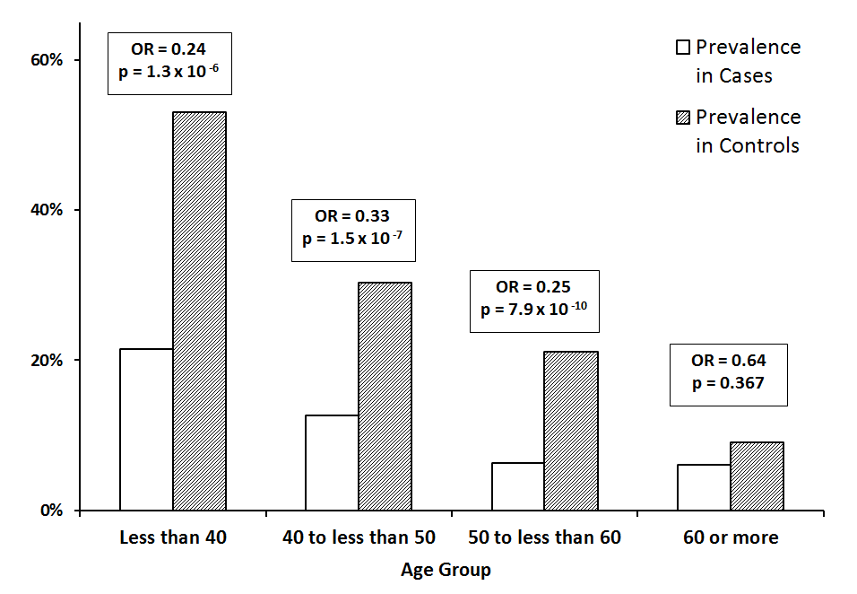
b)
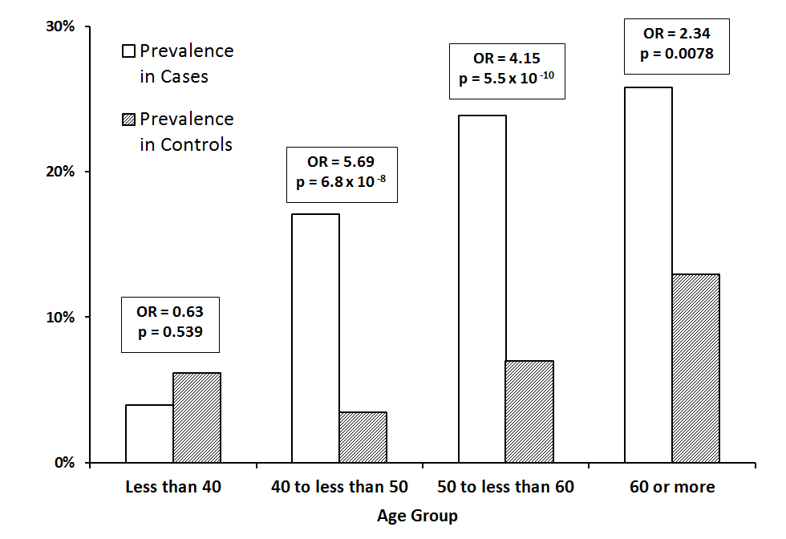
Figure 2.
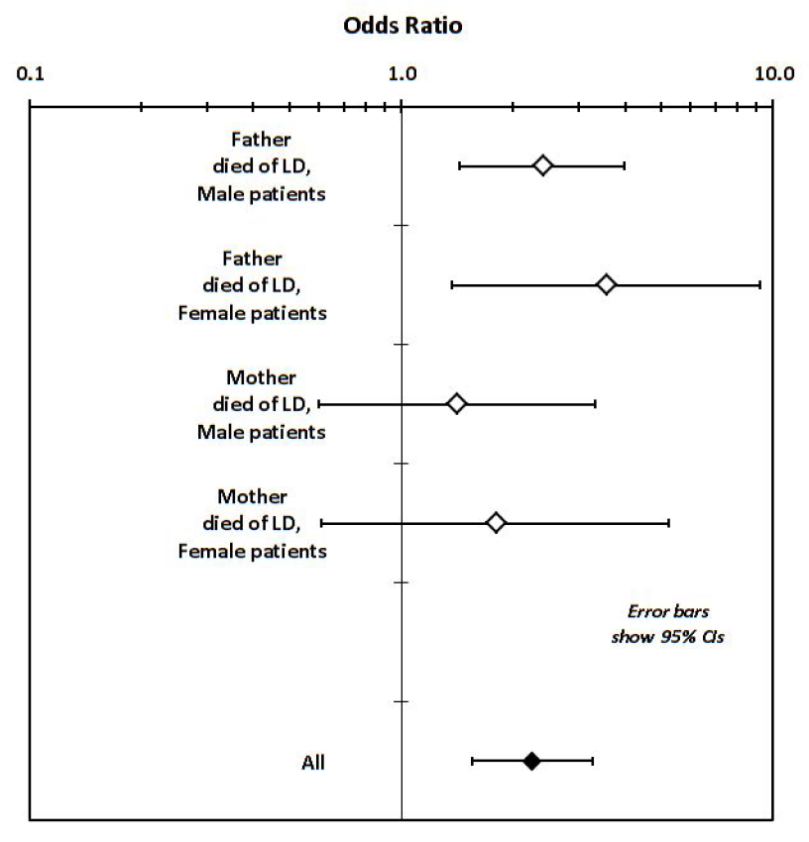

STROBE Statement—Checklist of items that should be included in reports of case-control studies

 | Item No | Recommendation | Section/Page
Title and abstract | 1 | (a) Indicate the study’s design with a commonly used term in the title or the abstract | Abstract/pg 6
 |  | (b) Provide in the abstract an informative and balanced summary of what was done and what was found | Abstract/pg 6
Introduction
Background/rationale | 2 | Explain the scientific background and rationale for the investigation being reported | Pg 7-8
Objectives | 3 | State specific objectives, including any prespecified hypotheses | Pg 8
Methods
Study design | 4 | Present key elements of study design early in the paper | Pg 9-11
Setting | 5 | Describe the setting, locations, and relevant dates, including periods of recruitment, exposure, follow-up, and data collection | Pg 9-11
Participants | 6 | (a) Give the eligibility criteria, and the sources and methods of case ascertainment and control selection. Give the rationale for the choice of cases and controls | Pg 9-11
 |  | (b) For matched studies, give matching criteria and the number of controls per case | Pg 9-11, 13, 15
Variables | 7 | Clearly define all outcomes, exposures, predictors, potential confounders, and effect modifiers. Give diagnostic criteria, if applicable | Pg 9-11
Data sources/ measurement | 8* | For each variable of interest, give sources of data and details of methods of assessment (measurement). Describe comparability of assessment methods if there is more than one group | Pg 9-11
Bias | 9 | Describe any efforts to address potential sources of bias | Matching of cases and controls for sex, age, alcohol exposure
Study size | 10 | Explain how the study size was arrived at | Pg 13, 15
Quantitative variables | 11 | Explain how quantitative variables were handled in the analyses. If applicable, describe which groupings were chosen and why | Pg 11-12
Statistical methods | 12 | (a) Describe all statistical methods, including those used to control for confounding | Pg 11-12
 |  | (b) Describe any methods used to examine subgroups and interactions | Pg 12
 |  | (c) Explain how missing data were addressed | Listwise deletion for logistic regressions, otherwise all available data were used.
 |  | (d) If applicable, explain how matching of cases and controls was addressed | Matching for age and sex at recruitment (Pg 9).
 |  | (e) Describe any sensitivity analyses | NA
Results
Participants | 13* | (a) Report numbers of individuals at each stage of study—eg numbers potentially eligible, examined for eligibility, confirmed eligible, included in the study, completing follow-up, and analysed | Potentially eligible – unknown.  Confirmed eligible and included – 2047. (Pg 13) and 6980 (Pg 11)  Follow-up – NA.
 |  | (b) Give reasons for non-participation at each stage | Criteria outlined on pp.9-11, or patient declined to participate.
 |  | (c) Consider use of a flow diagram | Not considered necessary.
Descriptive data | 14* | (a) Give characteristics of study participants (eg demographic, clinical, social) and information on exposures and potential confounders | Pg 13-15, Tables 1-5, Supp Table 3.
 |  | (b) Indicate number of participants with missing data for each variable of interest | See Tables and Table Legends
Outcome data | 15* | Report numbers in each exposure category, or summary measures of exposure | Tables 1-5
Main results | 16 | (a) Give unadjusted estimates and, if applicable, confounder-adjusted estimates and their precision (eg, 95% confidence interval). Make clear which confounders were adjusted for and why they were included | Tables 1-5
 |  | (b) Report category boundaries when continuous variables were categorized | N/A, except for Figure 1 (see Figure)
 |  | (c) If relevant, consider translating estimates of relative risk into absolute risk for a meaningful time period | N/A

Other analyses | 17 | Report other analyses done—eg analyses of subgroups and interactions, and sensitivity analyses | Comparisons by country of recruitment, Supp Table 4 and Supp Fig 1
Discussion
Key results | 18 | Summarise key results with reference to study objectives | Pg 17-20
Limitations | 19 | Discuss limitations of the study, taking into account sources of potential bias or imprecision. Discuss both direction and magnitude of any potential bias | Pg 21
Interpretation | 20 | Give a cautious overall interpretation of results considering objectives, limitations, multiplicity of analyses, results from similar studies, and other relevant evidence | Pg 22
Generalisability | 21 | Discuss the generalisability (external validity) of the study results | p. 21, (consistency between two sources of data (GenomALC, UK Biobank).
Other information
Funding | 22 | Give the source of funding and the role of the funders for the present study and, if applicable, for the original study on which the present article is based | Pg 4

*Give information separately for cases and controls.

Note: An Explanation and Elaboration article discusses each checklist item and gives methodological background and published examples of transparent reporting. The STROBE checklist is best used in conjunction with this article (freely available on the Web sites of PLoS Medicine at http://www.plosmedicine.org/, Annals of Internal Medicine at http://www.annals.org/, and Epidemiology at http://www.epidem.com/). Information on the STROBE Initiative is available at http://www.strobe-statement.org.

