Sampling procedures on reception plates to quantify structure-borne sound power from machinery

S. Reinhold¹ and C. Hopkins²*

¹ University of Applied Sciences Stuttgart, Schellingstr. 24, 70174 Stuttgart, Germany
² Acoustics Research Unit, School of Architecture, Abercromby Square, University of Liverpool, Liverpool, L69 7ZN, United Kingdom
*Corresponding author. Email: carl.hopkins@liverpool.ac.uk. Tel.: +44 1517944938

Abstract
Experimentally validated models of a heavyweight reception plate using finite element methods (FEM) have been used to assess reception plate measurements of structure-borne sound power injected by single- and multiple-contact, broadband sources. Measurements and FEM indicated high velocity levels near corners and edges of the plate; hence the reception plate power was underestimated by up to ≈9 dB below 100 Hz when using velocity measurements in the central zone of the plate. To avoid this problem, a sampling strategy was developed using an area-weighting approach for the velocity measurements. Measurement of the reception plate power using the area-weighted velocity level gave errors that were less than 2 dB between 20 and 2k Hz for both single- and multiple-contact sources. FEM simulations also identified an additional measurement constraint for a multiple-contact source representing white goods with either zero-phase or random-phase relationships between the four contact points. As the actual phase relationship is rarely known, potential bias can be avoided by excluding positions in the area between the contacts (typically the area underneath a machine) along with those within the estimated reverberation distance from each contact point.

1. Introduction
Machinery in buildings can cause the walls and floors to vibrate and radiate unwanted sound into other rooms. With knowledge of the structure-borne sound power input from a machine into the building structure it is possible to use the prediction model EN 12354-5 [] or Statistical Energy Analysis (SEA) models (e.g. []) to estimate the sound pressure level in a receiving room due to structure-borne sound transmission. For heavyweight buildings the structure-borne sound power can be measured using an isolated, heavyweight reception plate [] which is currently specified in EN 15657 []. The reception plate procedures cannot be used for a wall/floor forming part of a heavyweight building (i.e. a coupled reception plate) because significant errors occur due to energy returning from other connected walls and floors []. However, a source substitution method [] can be used to reduce the errors for both a coupled and isolated reception plate.

Building machinery tends to have a significant structure-borne sound power input at low-frequencies, often with tonal components that are related to the frequency of the mains electricity supply. Examples of structure-borne sound power measured according to the earlier version of EN 15657 (referred to as EN 15657-1 []) are shown in Fig. 1 for machinery with multiple-contact points or line contacts. The surface area projection of the underside of these machines (i.e. the side which is fixed to, or rests upon the supporting wall/floor) onto the heavyweight reception plate ranged from 0.3 to 0.5 m². These results demonstrate the importance of minimising the measurement uncertainty of the estimated power in the low-frequency range up to 250 Hz. In addition, they indicate that high levels of structure-borne sound power sometimes occur below 50 Hz; however, the lower frequency limit in EN 15657 is the 50 Hz one-third octave band. This provides the motivation to assess the accuracy of heavyweight reception plates in the low-frequency range.

Späh and Gibbs [3] developed and validated the reception plate approach in building acoustics using a 100 mm concrete slab that was supported on viscoelastic material around its perimeter. This viscoelastic material was used to avoid pronounced resonances in the vibrational response of the plate. The coverage area of the material was chosen to give a total loss factor for the plate that was similar to that for walls and floors in heavyweight buildings; however, this is not necessary for the reception plate approach to be valid. Acknowledging that the plate did not have many modes in one-third octave bands below 100 Hz, Späh and Gibbs assessed the spatial variation in vibration over the plate surface which indicated higher vibration levels near edges and corners. This led them to a sampling strategy based upon the majority of accelerometer positions being randomly chosen in the central zone of the plate with some positions along the edges. However, for the purpose of standardisation, it would be beneficial to have a validated, prescriptive approach that could be used to identify suitable measurement positions for any reception plate; this is developed in this paper. For a single-contact source (electrodynamic shaker) with a broadband noise input, Späh and Gibbs observed errors up to 5 dB below the 100 Hz one-third octave band, but errors were typically <1 dB in one-third octave bands between 125 and 1.25k Hz. In addition,
Höller and Gibbs [6] measured a multiple-contact source with a thick, metal reception plate (source mobility was an order of magnitude higher than the plate mobility) and observed errors up to ≈8 dB below 100 Hz.

Three issues remain unresolved for a laboratory that is setting up a new reception plate. Firstly, is it possible at the design stage to predict the total loss factor of a reception plate which is supported by viscoelastic material in order to determine how much damping material is needed? Secondly, can a prescriptive sampling strategy be developed which ensures that higher vibration levels near the edges of the plate can be incorporated without requiring a fine grid of measurement positions over the entire plate? Thirdly, how accurately can the power input be determined below the first bending mode of the reception plate? To address these questions, this paper develops experimentally validated models using Finite Element Methods (FEM) for an isolated reception plate on viscoelastic damping material. These models are used to estimate the power injected by point excitation using the reception plate approach. FEM models are then used to assess different sampling strategies for vibration measurements to minimise errors. In the real world, it is unusual for building machinery to have only one contact point. Hence, a multiple-contact source representing an idealisation of white goods (i.e. large household appliances) is considered to assess the sampling strategy that has been developed.

2. Experimental set-up
The experimental set-up used a heavyweight reception plate that satisfied EN 15657 to gather data in one-third octave bands from 20 to 2k Hz.

2.1 Reception plate
The experimental work in the laboratory used a 100 mm thick, concrete reception plate (2.0 m × 2.8 m) which was orientated horizontally. Underneath the plate was a 100 mm thick, viscoelastic layer that was distributed over an area of 2.73 m² around the edges as indicated in Fig. 2; this is referred to as ‘partial coverage’ with viscoelastic material. Four sheets of 25 mm viscoelastic material (Sylodamp HD30) were used to create a 100 mm thick layer with a high internal loss factor that was expected to increase the overall damping of the plate. The cavity between the reception plate and the supporting ground floor contained low density and low stiffness mineral wool which was originally included with the intention of reducing any resonances in the sound field within this cavity [3].

The measured properties of the concrete were the Young’s modulus (25.9 × 10⁹ N/m²) which was determined from longitudinal wavespeed measurements [2] and the density (2300 kg/m³). Poisson’s ratio was assumed to be 0.3 and the internal loss factor was assumed to be 0.005 [2].

2.2 Measurement methods
2.2.1 Injected structure-borne sound power
The injected power, W_{inj}, from an electrodynamic shaker was measured using a force transducer (Kistler Type 9311B) and two accelerometers (B&K Type 4533-B-001), one on each side of the driving-point which were averaged in the time domain to give the velocity; this allowed calculation of the injected power using
(1)
where is the complex force, is the complex velocity at the driving-point and indicates the complex conjugate. The two excitation positions used for the shaker measurements are indicated by points 1S and 5S in Fig. 2a. Narrowband powers from FFT analysis using a Hanning window were calculated with Eq. (1) and combined to give one-third octave band data.

Point force excitation perpendicular to the surface of the plate was applied using broadband noise into an electrodynamic inertial shaker (Data Physics Type IV40). This shaker has a suspension resonance of ≈30 Hz and a moving element resonance at ≈4k Hz as can be seen in the measured force spectrum shown on Fig. 3. This allows an assessment of broadband excitation for one-third octave bands from 50 to 2k Hz. However, an assessment of the reception plate approach near the suspension resonance is of interest because it gives the opportunity to assess broadband noise with a low-frequency tonal component.

2.2.2 Reception plate power
The structure-borne sound power that is determined from the reception plate, W_{rec}, is given by:
(2)
where ω is the angular frequency, m is the mass of the plate, η is the total loss factor of the plate and 〈v²〉 is the spatial-average mean-square velocity of the plate. In this paper, these calculations are carried out in one-third octave bands.

For reception plate measurements according to EN 15657 [4], the total loss factor is determined from the structural reverberation time, T_{s}, that is determined according to EN ISO 10848-1 []. This was measured with an MLS signal and reverse filter analysis using a Norsonic RTA 840 analyser to give T₅ below 100 Hz and T₂₀ above 100 Hz. The total loss factor was then calculated using
(3)
where f is the one-third octave band centre frequency.

Estimates of the total loss factor at individual mode frequencies were also determined from the modal peaks in the measured driving-point mobility, Y_{dp}, using
(4)
where Δf is the 3 dB bandwidth of the resonance frequency, f₀. The loss factors for all modes that lie within each one-third octave band were arithmetically averaged.

Measurements of the mean-square velocity for shaker positions 1S and 5S (see Fig. 2a) were taken at each point on a 21 × 29 grid covering the entire plate surface giving a total of 609 grid points with a spacing of 100 mm. This grid was sufficiently detailed that (a) contour plots could be used to give estimates of the lowest and highest velocity levels over the plate surface and (b) sampling of data from the grid could be used to assess sampling strategies.

All FFT analysis used a frequency resolution of 1 Hz, a frequency span of 6.4k Hz, a Hanning window with 66.67% overlap, linear averaging with 58 averages (equivalent to a time of 20 s) and a 7 Hz high-pass filter. EN 15657 does not currently specify whether filter or FFT analysis should be used to measure the mean-square velocity. In this paper, narrowband mean-square velocities from FFT analysis with the Hanning window were combined to give one-third octave band data by summing all narrowband energy between the bandedge frequencies of each one-third octave band and subtracting 10lg(3/2) to account for the Hanning window []. This approach was used because the focus is on the difference between the reception plate power and the injected power, where the latter is also determined from FFT analysis. Hence by measuring with narrow bands in both cases and combining into ‘ideal’ one-third octave bands, a fair comparison can be made. A comparison of filter and FFT analysis on the reception plate to determine one-third octave band values showed that they differed by only 0.1 dB on average with the largest difference in any band being 1.5 dB. Therefore, the findings in this paper should apply to reception plate measurements using either filter or FFT analysis.

2.2.3 Experimental Modal Analysis
Experimental Modal Analysis (EMA) was carried out on the reception plate using modal testing software (B&K PULSE MTC Type 7753). Postprocessing was carried out with a modal analysis software package (MEscope VES 6.0). The mode shapes and eigenfrequencies of the reception plate were obtained by multiple reference curve fitting of all measured sets of frequency response functions using the MEscope MDOF polynomial fit method with complex exponential curve fitting []. The software reports the modal damping in terms of the fraction of critical damping which was multiplied by two to give the loss factor. EMA loss factors for all modes that lie within each one-third octave band were arithmetically averaged. The modes were expected to be complex because the viscoelastic material is not distributed evenly over the surface of the reception plate. The EMA approach extracted these complex mode shapes. To give real values for analysis, the complex-to-real conversion was carried out using the widely practised, simple method described by Ewins [].

The excitation positions for EMA were defined by the same 21 × 29 measurement grid (100 mm spacing) that was used for the velocity measurements. Frequency response functions were determined using roving excitation over this grid with a force hammer (B&K Type 8206-003 with metal tip) and 12 stationary positions for the accelerometers (B&K Type 4533-B-001) to ensure that closely coupled modes or repeated roots were resolved.

A comparison of the mode shapes from EMA and FEM is carried out using the Modal Assurance Criterion (MAC) [11] which is given by
(5)
where {ϕ_{X}} and {ϕ_{A}} are the real-valued column vectors of the degrees of freedom for the EMA and FEM mode shapes respectively, and superscript T indicates the transpose.

2.2.4 Dynamic stiffness and damping of the viscoelastic material
The dynamic stiffness per unit area, s’, of the 100 mm thick viscoelastic material was determined using the experimental approach described in EN 29052-1 [] but with a load plate formed by a 100 mm cube of concrete (2.45 kg) to provide a similar static load to the reception plate. The internal loss factor, η_{int}, at the resonance frequency was determined from the 3 dB down points. This resulted in values of s’=27.1 MN/m³ and η_{int}=0.61. For input data to the FEM model it is necessary to relate these values to a linear mass–spring–dashpot system [2] with a spring stiffness, k, of 271003 N/m and a damping constant, R, of 497 Ns/m.

3. FEM modelling
FEM modelling is used to run numerical experiments to calculate the direct injected power and the reception plate power. Two models of the reception plate are created for comparison with the EMA results. The first is an idealised simplification of the reception plate where the plate is modelled as having free boundaries. The second represents the experimental set-up with the viscoelastic supports. ABAQUS v6.14 software is used to carry out direct steady-state dynamic analysis with a frequency sweep from 1 to 2.5k Hz. Vibration levels over the plate surface are predicted with 1 Hz resolution, and with 0.01 Hz resolution when calculating 3 dB down points from modal peaks to estimate the damping of the plate.

The concrete plate was modelled with the thin shell element STRI3, a three node triangular facet element. Element dimensions were less than one-eighth of the bending wavelength (side lengths of 50 mm, 50 mm and 70.7 mm) at the highest frequency (this was the upper bandedge of the 2k Hz one-third octave band). All models assume that the plate is in vacuo (i.e. no radiation coupling).

The viscoelastic material was incorporated using vertical, spring-dashpot elements underneath all nodes of the STRI3 elements that were resting on this material. These spring-dashpots connect the shell elements to a fictive, rigid, ground plane. The spring stiffness, k, and damping constant, R, that were determined experimentally (see Section 2.2.4) have to be modified for the FEM model depending on the coverage area of the viscoelastic material underneath the concrete plate and the number of nodes. This modification requires k and R to be multiplied by a correction factor. This correction factor is the product of two terms, the first term modifies the values to represent full coverage and the second term modifies the first term to represent partial coverage as given by

(6)
where N_{V} and N_{Total} are the number of nodes for the viscoelastic material and for the entire reception plate respectively, S_{V} is the area of the viscoelastic material underneath the reception plate and S_{LoadPlate} is the area of the load plate used to measure the dynamic stiffness (from Section 2.2.4, S_{LoadPlate}=0.01 m²). For the partial coverage with viscoelastic material that corresponds to the reception plate used in the experimental work, N_{V}=1264, N_{Total}=2337, S_{V}=2.73 m².

3.1 Calculation of damping
The total loss factor of the plate was estimated from the modal peaks in the driving-point mobility, Y_{dp}, from the FEM model in the same way as with the measurements. The loss factors for all modes that lie within each one-third octave band were arithmetically averaged.

3.2 Calculation of structure-borne sound power
Single- and multiple-contact source positions are investigated with all forces perpendicular to the plane of the reception plate. The single-contact source positions are the same as used in the experimental work and are indicated in Fig. 2a for which the injected power is calculated using Eq. (2). For multiple-contact source positions, four contacts are assumed to be arranged in a 0.6 × 0.6 m square representing the base of typical white goods. Harmonic point forces of equal magnitude are applied at these contacts with either zero- or random-phase. The excitation positions for the machine aligned with the edges of the plate and at an angle of 45° to the edges of the plate are shown in Figs. 2b and 2c respectively. For perpendicular forces at N contact points (i.e. where N=4) the injected power is calculated using []
(7)
where and are complex vectors at the driving-points, is the real, symmetric and non-negative mobility matrix of the receiving structure and the superscript denotes the complex conjugate transpose (Hermitian transpose) value. The term can be re-expressed as using orthogonal transformation where is the diagonal matrix of the real eigenvalues of and is the corresponding complex force vector [13,].

4. Results
Section 4.1 considers the experimental validation of the FEM model of the plate and viscoelastic material that forms the reception plate. This gives an understanding of the vibration field on the reception plate that is used in Section 4.2 to develop a sampling strategy for velocity measurements that is assessed with FEM and measurements for single-contact sources, and with FEM for multiple-contact sources.

4.1 Experimental validation of FEM model
4.1.1 Mode frequencies and mode shapes
The EMA results indicate that the lowest frequency mode is a whole body mode (20.0 Hz), the next two modes are rocking modes (24.2 and 28.9 Hz), and the higher modes are bending modes (45.9, 49.4, 93.5, 97.5, 118.0, 124.0, 167.8, 189.0, 236.3, 239.7 Hz; note that this only lists the bending modes in the low-frequency range up to 250 Hz). Figure 4 allows comparison of the eigenfrequencies from EMA with those from the two FEM models of the plate with free boundaries and the experimental set-up that has partial coverage with viscoelastic material. The FEM model for the free boundaries shows poor agreement for the first three eigenfrequencies because these are rigid body modes with zero frequency and a stiffness matrix which is zero. In contrast, for the FEM model of the experimental set-up that has partial coverage with viscoelastic material, the plate is restrained at the edges; hence the stiffness matrix is non-zero and there are three modes with non-zero eigenfrequencies that can be described as whole body or rocking modes. These modes from the FEM model show close agreement with EMA. This indicates that a FEM model assuming free boundaries is not appropriate to model the lowest frequency modes of practical realisations of reception plates which are resiliently supported at the edges. For the FEM model of the experimental set-up that has partial coverage with viscoelastic material, close agreement is achieved for the 13 eigenfrequencies in the frequency range from 20 to 250 Hz.

Figure 5 shows the mode count from EMA and FEM in one-third octave bands. Both rocking modes predicted by FEM fall within the 25 Hz band whereas the EMA rocking modes fall within the 25 and 31.5 Hz bands. No modes fall within the bandwidth of the 40, 63 and 80 Hz bands.

Figure 6 shows MAC for mode pairs below 250 Hz to facilitate comparison of mode shapes from EMA with those from the two different FEM models. For the FEM model of the plate that has free boundaries, strong correlation is only achieved at and above the fourth mode; the first three rigid body mode shapes that are determined through EMA are weakly correlated with FEM. In contrast, the FEM model of the experimental set-up that has partial coverage with viscoelastic material shows high correlation for all 13 modes; this indicates that the supports have been correctly incorporated in the FEM model.

The close agreement between experimental eigenfrequencies and mode shapes for the FEM model of the experimental set-up that has partial coverage with viscoelastic material shows that (a) simplistic assumptions about the actual reception plate having free boundaries are inappropriate at low frequencies and (b) the viscoelastic material has been correctly incorporated in FEM. In the remainder of the paper, only FEM models of the experimental set-up incorporating partial or full coverage with viscoelastic material will be considered.

4.1.2 Damping
EMA loss factors for the first three modes at 20.0, 24.2 and 28.9 Hz were 0.445, 0.442 and 0.632 respectively. For these whole body or rocking modes the damping was significantly higher than the EMA loss factors corresponding to the bending modes at 45.9, 49.4, 93.5, 97.5, 118.0, 124.0, 167.8 and 189.0 Hz which were 0.242, 0.192, 0.107, 0.114, 0.074, 0.055, 0.057 and 0.051 respectively.

Figure 7 allows comparison of the total loss factors for the reception plate from FEM (experimental set-up with the viscoelastic supports) with three different measurements. The driving-point mobility is used to calculate values at individual mode frequencies from FEM and measurements (average of five randomly distributed positions). In addition, EMA is used to determine loss factors at individual mode frequencies. All loss factors determined at individual mode frequencies are arithmetically averaged into one-third octave bands. This aids comparison with the one-third octave band data from structural reverberation time measurements. The internal loss factors of the concrete and the viscoelastic material are indicated on the graph as these provide estimates of the upper and lower bounds for the total loss factor. For the rigid body modes between 20 and 31.5 Hz the total loss factor of the plate is predominantly determined by the internal loss factor of the viscoelastic material, whereas at the highest frequency, 2k Hz, the viscoelastic material has significantly less effect on the total loss factor.

From Fig. 7 it is seen that there are differences between the measured loss factors determined from the three different methods; driving-point mobility (Y_{dp}), EMA and structural reverberation time (T_{s}). These differences are most apparent below 100 Hz where the whole body, rocking and bending modes are relatively widely spaced and the damping is highest. With structural reverberation time measurements using reverse-filter analysis the highest loss factor that can usually be determined is ≈0.13 [2] (i.e. ≈111 dB); this varies depending on the type of filter and for this experimental set-up it was possible to measure up to 113 dB. For this reason, it was necessary to use driving-point mobility or EMA to determine the high loss factors for the whole body or rocking modes below 40 Hz. However, between 50 and 2k Hz, the average absolute difference between the three measurement methods is only 1.0 dB.

Calculation of the structure-borne sound power using Eq. (2) requires an estimate of the total loss factor for all one-third octave bands. To determine this estimate for the experimental set-up, regression was carried out using all measured driving-point mobility and EMA data between 20 and 2k Hz but (for the reasons described above) only including structural reverberation time data between 50 and 2k Hz. Linear regression was carried out on the data after taking logarithms of frequencies and loss factors, such that this gives a curve when plotted with the frequency axis shown in Fig. 7. To determine this estimate for FEM there were loss factors available in all one-third octave bands between 100 and 2k Hz; however, due to a lack of modes it was not possible to determine loss factors in the 25, 31.5, 40, 63 and 80 Hz bands. Interpolation was used to estimate these missing values based on a straight line fit between (a) 20 and 50 Hz, and (b) 50 and 100 Hz. This is a pragmatic solution because a total loss factor is unlikely to drop down to the value of the internal loss factor in the presence of highly damped modes in adjacent bands. The comparison between the direct injected power and the reception plate power in Section 4.2.1 will be used to assess whether this approach is reasonable.

To check that the damping from the viscoelastic supports has been correctly incorporated in the FEM model it is reasonable to compare FEM and measurements that use the same method to determine the loss factor, i.e. using the driving-point mobility. In this case, the average absolute difference between FEM and measurements is ≈1 dB between 20 and 2k Hz. This agreement not only indicates that the viscoelastic supports have been correctly incorporated in FEM but that the mineral wool in the cavity does not have a significant effect on the overall damping of the reception plate. The average absolute difference between FEM driving-point mobility and structural reverberation time measurements between 100 and 2k Hz is 0.8 dB. However, between 500 and 2k Hz the average absolute difference is 1.6 dB and it is possible that the assumption of frequency-independent damping for the viscoelastic material that was made in the measurement procedure (section 2.2.4) is no longer appropriate at these higher frequencies (note that this does not affect the comparison of direct injected power and reception plate power because the FEM loss factors are used in Eq. (2)).

The agreement between FEM and measurements demonstrates that FEM can be used at the design stage to predict the total loss factors for new reception plates with different types and layouts of viscoelastic materials underneath the plate. Whilst high damping is generally beneficial it may not be necessary to completely cover the area underneath the reception plate with viscoelastic material. Numerical experiments to determine the damping with FEM are shown for partial coverage (as described in Section 2.1 for the actual reception plate) and full coverage in Fig. 8. This indicates that changing from partial to full coverage would increase the total loss factor by ≈6 dB. However, the damping was sufficiently high with full coverage, and the adjacent modes sufficiently close together that it was not possible to estimate the damping values below 160 Hz. This indicates that full coverage could be problematic for an experimental set-up because it would not always be possible to measure the total loss factor, and therefore Eq. (2) could not be used to estimate the structure-borne sound power.

Quantifying the loss factors allows estimates of the reverberation distance where the direct field response is equal to the response of the diffuse field; this distance is frequency-dependent due to bending waves being dispersive [2]. At and above 100 Hz the reverberation distance is <100 mm for both FEM and measurements. Between 20 and 100 Hz the highest value for the reverberation distance is 222 mm at 20 Hz for measurements, and 127 mm at 50 Hz for FEM; however, these values can only be considered an estimate in this low-frequency range where the assumption of a diffuse field is not appropriate. For this reason, a minimum distance of 100 mm is used from the excitation points in both the measurements and FEM models.

4.1.3 Spatial variation of vibration under point excitation
Figure 9 allows comparison of contour plots of one-third octave band velocity levels (20 to 2k Hz) from measurements and FEM (where the model represents the experimental set-up that has partial coverage with viscoelastic material) for single-contact source positions 1S and 5S. There is close agreement between the measured and predicted spatial variation of velocity over the plate surface. Considering these results in conjunction with the agreement seen in the eigenfrequencies, mode shapes and damping in previous sections, there is sufficient evidence to consider the FEM model as experimentally validated. Hence this model can be used to assess the sampling strategy for single- and multiple-contact excitation in Section 4.2 using numerical experiments with FEM.

In the 20 and 25 Hz bands for FEM and measurements, the velocity varies by up to ≈14 dB over the surface where the response is predominantly determined by the whole body and rocking modes. At and above 40 Hz where only bending modes dominate the response this variation increases up to ≈45 dB with areas in the central zone of the plate having the lowest velocity levels; this is particularly apparent with excitation position 5S in the 63 and 80 Hz bands. Up to 500 Hz, the highest velocity levels tend to occur in one or more corners, and/or along a narrow 100 mm strip along the edges (also noted by Späh and Gibbs [3]). Above 630 Hz the vibration field becomes more uniform over the plate surface as indicated by the standard deviation (that describes the spatial variation) decreasing from 4.6 dB at 630 Hz to 3.2 dB at 2k Hz. The existence of higher levels near corners and edge strips leads to the sampling strategy in the next section which is based on sampling from the central zone, corners (defined as being 100 mm from the plate edges) and 100 mm wide edge strips with a weighting that is dependent on each of these areas.

4.2 Sampling strategy to determine the reception plate power
In previous sections, the velocity levels were energetically averaged over a fine regular grid. For measurements, it is not usually practical to measure at a large number of grid positions. Therefore, a sampling strategy is sought that can be used to estimate the spatial-average velocity over the entire surface from a relatively small number of measurement positions. The results in Section 4.1.3 indicate that when a heavyweight reception plate is supported by viscoelastic material, the velocity levels vary significantly across the surface and that there are high velocity levels near corners and edge strips. Hence, by sampling over defined areas for corners, edge strips and the central zone, an area-weighted velocity level, L_{v,w}, can be defined as

(8)
where S_{Corners}, S_{EdgeStrips} and S_{CentralZone} are the surface areas for corners, edge strips and the central zone respectively (S_{Total}=S_{Corners}+S_{EdgeStrips}+S_{CentralZone}) and L_{v,Corners}, L_{v,EdgeStrips} and L_{v,CentralZone} are the spatial-average velocity levels for corners, edge strips and the central zone respectively.

This area-weighting approach avoids the need for a time-consuming grid of measurement positions over the entire plate surface but requires sufficient points to be sampled from the corners, edge strips and the central zone. For a reception plate area of at least 5.3 m², and a piece of machinery with a base area up to 0.36 m², it is feasible to measure up to eight central zone positions (the central zone defined as being ≥100 mm from boundaries with ≥800 mm between positions), four corner positions (the sampling area for each corner is defined as being within a 100 mm × 100 mm square), and two positions on each edge strip (the sampling area for each edge strip is defined as a 100 mm wide strip that starts 100 mm from the corners with a distance of ≥800 mm between positions).

Previous work on the measurement of low-frequency sound fields in rooms [] led to a procedure using sampling of high sound pressure levels in corners with an empirical weighting to estimate the room average sound pressure level below 100 Hz. A similar approach was initially considered for the reception plate and this gave reasonable estimates []. However, the wide frequency range over which corner and edge measurements are needed makes it less practical than with sound insulation measurements where the low-frequency range of interest was below 100 Hz. More importantly, the area-weighting approach in this paper avoids reliance on an empirical weighting that is likely to be specific to one reception plate; hence the area-weighting approach can be used with low mobility or high mobility reception plates as defined in EN 15657 [4].

4.2.1 Single-contact source assessed using FEM and measurements
Using the FEM model to give the most accurate estimate of the reception plate power, the average velocity is calculated from all nodes that define the plate surface for each of the five excitation positions. For this situation, the difference between the direct injected power and the reception plate power is shown in Fig. 10a; the largest absolute difference is 1.5 dB between 20 and 2k Hz. This confirms that the mesh size is satisfactory and that the low-frequency estimates of the total loss factor discussed in Section 4.1.2 were reasonable. Note that there are no indications of higher errors in the 20 and 25 Hz bands where only whole body and rocking modes occur, or in the 63 and 80 Hz bands where there are no bending modes within the bands. This indicates that the whole body and rocking modes are useful in extending the application of the reception plate approach down to frequencies below the lowest frequency bending mode. In addition, the high damping of the whole body and rocking modes (due to the viscoelastic material) influences the response in the frequency range between these modes and the lowest frequency bending mode. This is beneficial in avoiding the significant errors that would occur below the lowest frequency bending mode if the whole body and rocking modes were not present.

The next step is to investigate the differences in the reception plate power that can occur when sampling only from the central zone (≥500 mm from boundaries). This is shown using the FEM data in Fig. 10b where (in contrast to the small differences that occurred when using all nodes) there are large underestimates between 20 and 250 Hz (the largest is 7.8 dB at 63 Hz). However, use of the area-weighted velocity avoids these large differences with the largest absolute difference being 1.2 dB between 20 and 2k Hz – see Fig. 10c. To indicate the variation in choosing different measurement positions in the three different measurement areas, the 95% confidence intervals are shown from 10 different random sets of measurement positions. These confidence intervals are typically <1 dB which indicates that the approach is highly repeatable. The above results provide evidence that a prescriptive approach using an area-weighted velocity provides higher accuracy below 100 Hz than has been noted in previous work on reception plates [3,6].

Using the experimental data, the difference between the direct injected power and the reception plate power using all grid positions is shown in Fig. 10d for excitation positions 1S and 5S. The largest absolute difference is 2.9 dB between 25 and 80 Hz where there are only whole body modes, rocking modes and the first two bending modes, but this reduces to 1.3 dB between 100 and 2k Hz where there is at least one bending mode in each band (refer back to Fig. 5). The first two bending modes occur at 45.9 and 49.4 Hz which fall in the 50 Hz band for which the underestimate is ≈2 dB. The third bending mode occurs at 93.5 Hz and whilst no modes fall exactly in the 63 and 80 Hz bands, the underestimate in these bands is up to 3 dB. Note that the tonal component in the input force caused by the suspension resonance of the shaker at ≈30 Hz (refer back to Fig. 3) does not give rise to significantly larger errors in the 31.5 Hz band compared to other bands below 100 Hz.
Figure 10e indicates that when sampling from the central zone the large underestimates of the reception plate power below 100 Hz (the largest is 9.3 dB at 80 Hz) are similar to FEM (refer back to Fig. 10b); hence sampling only from the central zone is not an appropriate strategy at low-frequencies. Figure 10f shows that using the area-weighted velocity level to determine the reception plate power gives the largest absolute difference as 2.0 dB between 25 and 2k Hz. The 95% confidence intervals from 10 different random sets of measurement positions are typically <1 dB which is similar to the confidence intervals with the FEM data.

In Section 4.1.2, FEM was used to estimate the increase in the total loss factor by changing the area of viscoelastic material from partial to full coverage. However, it has been shown in this section that the errors are sufficiently low with partial coverage that there would be limited benefit in choosing full coverage. The latter also leads to potential problems in experimentally determining the damping. This illustrates the advantage of having a validated FEM model to make decisions on the required area of viscoelastic material.

4.2.2 Multiple-contact source assessed using FEM
When using the reception plate approach with multiple-contact sources, the phase relationships between the forces applied at the different contacts are rarely known. At low-frequencies it is reasonable to assume that some machines will have a zero-phase difference between the contacts, but with increasing frequency it is likely that the phase will differ, and the relationships could potentially be described as random. To illustrate the issues that occur with a zero-phase difference, Fig. 11a shows the difference between the direct injected power and the reception plate power using all grid positions for excitation positions 1MP, 2MP, 3MP and 4MP. At 500 Hz, the distance between the contact points along each side (i.e. 600 mm) corresponds to nearly one-half of the bending wavelength of the plate. Contour plots of velocity levels at 500 Hz over the plate surface are shown in Fig. 11b. These show that the highest velocity levels occur underneath the source when it is located in the central zone. The four zero-phase contacts ‘force’ the plate to have a high response by imposing a half-wavelength response between the contacts; this leads to overestimation of the reception plate power. This does not tend to occur when the source is near corners/edges because the magnitude and phase of the driving-point mobility at each of the four contacts can be significantly different, and the modal response is usually high near excited corners/edges.

For multiple-contact sources it may not be possible to access measurement positions underneath the machine and the potential issue of high vibration levels with zero-phase forces means that it is better to avoid potential bias by avoiding positions in the area between the contacts (with white goods and many other machines this is the area directly underneath the machine). For this reason, it is proposed to exclude all positions in the area between the contacts and up to 100 mm from each contact point based on the estimate for the reverberation distance described in Section 4.1.2. Using this approach in conjunction with the area-weighted velocity level, the difference between the direct injected power and the reception plate power is shown in Fig. 12. For zero-phase forces with the sides of the source aligned parallel to the plate edges (Fig. 12a) the largest absolute difference is 1.9 dB and when the source is aligned at an angle to the plate edges (Fig. 12b) it is 1.6 dB. However, there is more variation between the four different positions when parallel to the plate edges than when aligned at an angle to the plate edges. For random-phase forces the orientation is less critical and when parallel to the plate edges, Fig. 12c indicates that the largest absolute difference is 2.2 dB. It is concluded that, where possible, machines with a square or rectangular arrangement of contacts should be orientated at an angle to the sides of a rectangular reception plate but it is more important to average the results from several positions. These numerical simulations indicate that the approach using an area-weighted velocity level is also valid for multiple-contact sources.

5. Conclusions
A FEM model of a heavyweight reception plate supported on viscoelastic material has been experimentally validated. For laboratories designing a new reception plate, FEM modelling can be used to assess different damping materials, layout of the damping material and alternative plate shapes (e.g. irregular polygon). This FEM model and physical measurements have been used to assess the accuracy of sampling procedures when measuring structure-borne sound power injected by single- and multiple-contact sources on a reception plate.

For single-contact sources, sampling the velocity in the central zone of the reception plate underestimated the power by up to ≈9 dB below 100 Hz with both measurements and FEM. This was due to the exclusion of high velocity levels near the corners and edges of the plate; hence a sampling strategy was developed that used an area-weighting approach for corners, edge strips and the central zone to ensure consideration of these higher levels. This approach was validated with measurements and FEM for single-contact sources. FEM was then used to assess a multiple-contact source representing white goods with zero- or random-phase relationships between the four contact points. This indicated that when measuring the velocity, all positions in the area between the contacts (typically the area underneath the machine) and those within the estimated reverberation distance from each contact point should be excluded. In addition, machines with a rectangular arrangement of contacts on a rectangular reception plate should preferably be orientated at an oblique angle to the sides. Measurement of the reception plate power using the area-weighted velocity level gave errors that were less than 2 dB between 20 and 2k Hz for both single- and multiple contact sources.

FEM models with a frequency sweep from 1 to 2.5k Hz show that the reception plate approach is valid regardless of whether the modal response is determined by whole body modes, rocking modes, or bending modes. Experimental work using broadband noise with a low-frequency tonal component also indicates that it is valid with a single-contact source when the tone is in the frequency region between the highest rocking mode and the lowest bending mode. For this reason, it is appropriate to consider the lowest valid frequency in terms of the lowest mode (usually a whole body mode for a resiliently supported plate with free edges), rather than an arbitrary lower frequency limit such as 50 Hz. This is important due to the existence of machinery with significant structure-borne sound power down to 20 Hz.

Acknowledgements
The first author gratefully acknowledges funding from the German Federal Ministry of Education and Research (Grant No. 03FH089PB2) which provided funding to characterise the structure-borne sound power input from machinery shown in Fig. 1. The authors are grateful to Prof. Heinz-Martin Fischer and Prof. Berndt Zeitler at the University of Applied Sciences Stuttgart for supporting this research.

References

Figures
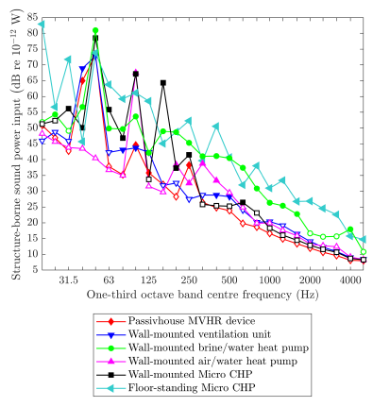
Figure 1. Examples of structure-borne sound power input from different building equipment measured using the reception plate according to EN 15657-1.

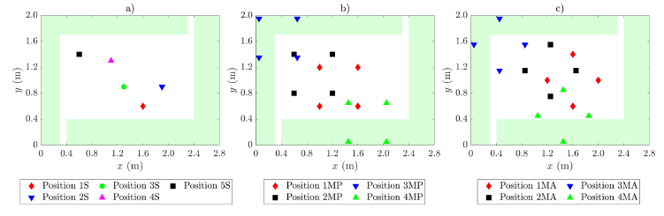
Figure 2. Reception plate using partial coverage with viscoelastic material: (a) single-contact source at positions 1S, 2S, 3S, 4S and 5S, (b) multiple-contact source (i.e. white goods with four contacts) with sides aligned parallel to the plate edges at positions 1MP, 2MP, 3MP and 4MP, and (c) multiple-contact source (i.e. white goods with four contacts) with sides aligned at an angle to the plate edges at positions 1MA, 2MA, 3MA and 4MA. Each graphic uses green shading to indicate the area covered with viscoelastic material underneath the plate.

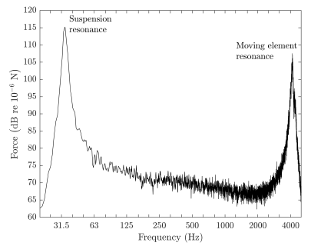
Figure 3. Measured force spectrum (narrowband) from the electrodynamic inertial shaker on the reception plate.

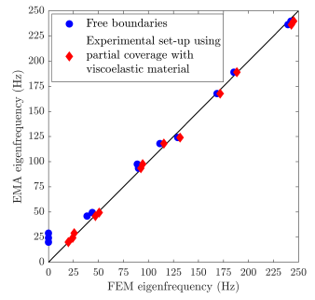
Figure 4. Reception plate using partial coverage with viscoelastic material: Comparison of eigenfrequencies from EMA with FEM for a reception plate with idealised free boundaries, and from EMA with FEM for the reception plate in the experimental set-up which had partial coverage with viscoelastic material.

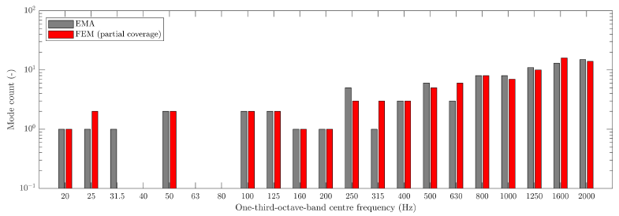
Figure 5. Reception plate using partial coverage with viscoelastic material: Mode count in one-third octave bands using EMA and FEM eigenfrequencies.

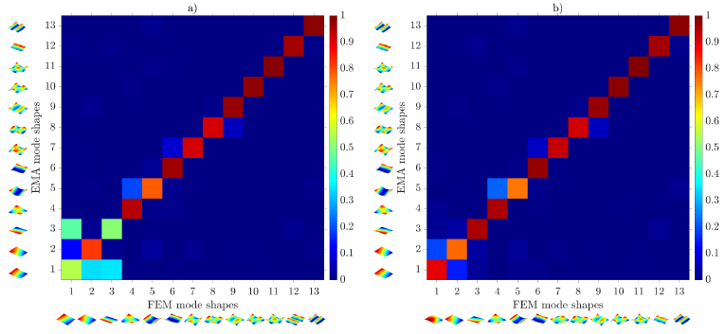
Figure 6. Reception plate using partial coverage with viscoelastic material: Comparison of EMA and FEM eigenfunctions using MAC: (a) idealised free boundaries, (b) experimental set-up using partial coverage with viscoelastic material.

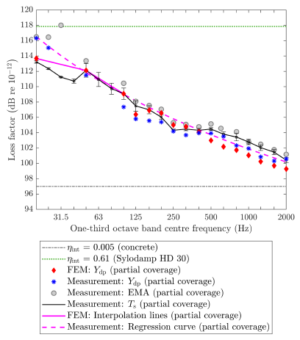
Figure 7. Reception plate using partial coverage with viscoelastic material: Comparison of loss factors determined from measurements using the driving-point mobility (Y_{dp}), EMA and structural reverberation time (T_{s}) and the FEM model of the experimental set-up with viscoelastic material underneath the plate using driving-point mobility (Y_{dp}).
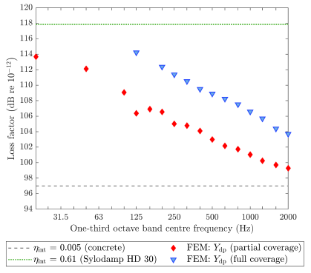
Figure 8. Reception plate using partial and full coverage with viscoelastic material: Comparison of loss factors determined from FEM models.
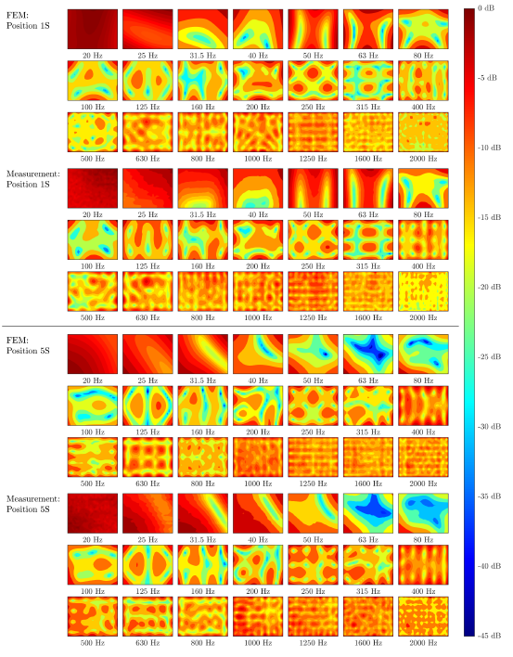
Figure 9. Reception plate using partial coverage with viscoelastic material: Contour plots of measured and predicted (FEM) velocity levels in one-third octave bands over the surface of the reception plate with single-contact source positions 1S and 5S. Velocity levels are normalised to the highest level on each individual contour plot.

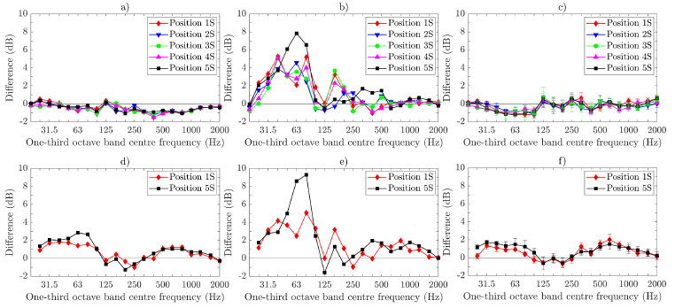
Figure 10. Reception plate using partial coverage with viscoelastic material – single-contact source: Difference between the direct injected power and the reception plate power. FEM for excitation positions 1S, 2S, 3S, 4S and 5S with plate velocities calculated using: (a) average of all nodes, (b) average of all central zone nodes that are ≥500 mm away from edges, (c) area-weighted average. Measurements for single-contact positions 1S and 5S using velocities calculated from: (d) average of all grid points, (e) average of all central zone grid points that are ≥500 mm away from edges, (f) area-weighted average. NB (c) and (f) also show the 95% confidence intervals from 10 different random sets of plate velocity positions that satisfy the area-weighting requirements.

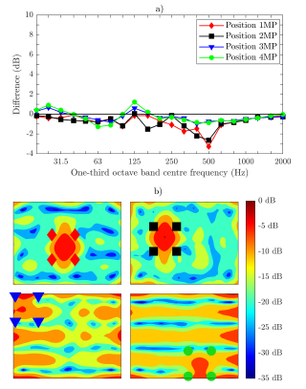
Figure 11. Reception plate using partial coverage with viscoelastic material: FEM simulation of a multiple-contact source (i.e. white goods with four contacts and sides aligned parallel to plate edges) with zero-phase difference between the forces for excitation positions 1MP, 2MP, 3MP and 4MP: (a) difference between the direct injected power and the reception plate power using an average of all nodes, (b) contour plots of velocity levels over the plate surface at 500 Hz with markers indicating the excitation positions.
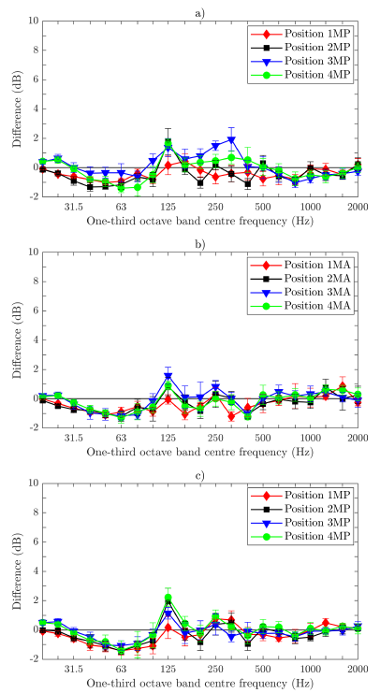
Figure 12. Reception plate using partial coverage with viscoelastic material: FEM simulation of a multiple-contact source (i.e. white goods with four contacts) – difference between the direct injected power and the reception plate power using the area-weighted velocity level (excluding all positions underneath the machine and up to 100 mm from each contact point): (a) zero-phase forces with the sides of the source aligned parallel to plate edges, (b) zero-phase forces with the sides of the source aligned at an angle to the plate edges, (c) random-phase forces with the sides of the source aligned parallel to the plate edges.

[] EN 12354-5:2009. Building acoustics – Estimation of acoustic performance of building from the performance of elements – Part 5: Sound levels due to the service equipment. European Committee for Standardization.
[] Hopkins C. Sound insulation, Butterworth-Heinemann, 2007. ISBN 978-0-7506-6526-1.
[] Späh MM and Gibbs BM. Reception plate method for characterisation of structure-borne sound sources in buildings: Assumptions and application, Appl Acoust 2009;70:361–368.
[] EN 15657:2017. Acoustic properties of building elements and of buildings – Laboratory measurement of structure-borne sound from building service equipment for all installation conditions. European Committee for Standardization.
[] Hopkins C and Robinson M. Using transient and steady-state SEA to assess potential errors in the measurement of structure-sound power input from machinery on coupled reception plates, Appl Acoust 2014;99:35–41.
[] Höller C and Gibbs BM. Source substitution method for obtaining the power transmission from vibrating sources in buildings. Appl Acoust 2018;141:240-249.
[] EN 15657-1:2009. Acoustic properties of building elements and of buildings – Laboratory measurement of airborne and structure borne sound from building equipment – Part 1: Simplified cases where the equipment mobilities are much higher than the receiver mobilities, taking whirlpool baths as an example. European Committee for Standardization.
[] ISO 10848-1:2017. Acoustics – Laboratory and field measurement of flanking transmission for airborne, impact and building service equipment sound between adjoining rooms – Part 1: Frame document. International Organization for Standardization.
[] Randall RB. Frequency analysis. Brűel & Kjær 1987. ISBN 87-87355-07-8.
[] MEscope Application Note 13 – Introduction to Modal Curve Fitting. http://appnotes.vibetech.com/AppNote13.pdf (Accessed 18/06/2020)
[] Ewins DJ. Modal Testing: Theory, Practice and Application. Wiley-Blackwell, 2nd edition. ISBN: 978-0863802188.
[] EN 29052-1:1992 Acoustics – Methods for the determination of dynamic stiffness – Part 1: Materials used under floating floors in dwellings. European Committee for Standardization.
[] Ji L, Mace BR, Pinnington RJ. A power mode approach to estimating vibrational power transmitted by multiple sources, J Sound Vib 2003;265:387–399.
[] Jianxin S, Moorhouse AT, Gibbs BM. Towards a practical characterisation for structure-borne sound sources based on mobility techniques, J Sound Vib 1995;185(4):737–741.
[] Hopkins C, Turner P. Field measurement of airborne sound insulation between rooms with non-diffuse sound fields at low frequencies. Appl Acoust 2005;66(12):1339-1382.
[] Reinhold S, Hopkins C, Zeitler B. Low-frequency structure-borne sound power measurements using heavyweight reception plates. Proceedings of 24th International Congress on Sound and Vibration, 2017, London.

