Bleeding risk in patients treated with aspirin vs. direct oral anticoagulants at doses approved for atrial fibrillation:
Systematic review and meta-analysis of randomized controlled trials

George Ntaios MD¹, Ioannis Leventis MD¹, Georgios Georgiopoulos MD²,
Konstantinos Makaritsis MD ¹, Gregory Y.H. Lip³

- Department of Internal Medicine, University of Thessaly, Larissa, Greece
- School of Biomedical Engineering and Imaging Sciences, King’s College, London, United Kingdom
- Liverpool Centre for Cardiovascular Science, University of Liverpool and Liverpool Heart & Chest Hospital, Liverpool, United Kingdom; and Aalborg Thrombosis Research Unit, Department of Clinical Medicine, Aalborg University, Aalborg, Denmark

Abstract/total word count: 196/
Tables/figures: 0/6

Supplemental files: 1

Corresponding author:
George Ntaios MD, MSc (Stroke Medicine), MSc (Research Methodology), PhD
Assistant Professor of Internal Medicine
Department of Internal Medicine, University of Thessaly, Larissa, Greece
Tel: +302413502888, Fax: +302413501557, e-mail: gntaios@med.uth.gr

Abstract

Background and purpose: A considerable proportion of patients with atrial fibrillation (AF) are still treated with aspirin despite current guidelines which do not recommend its use anymore. The level of evidence supporting a beneficial of aspirin compared to control/placebo for stroke prevention in AF is weak, being based on a single, prematurely terminated randomized controlled trial (RCT). These recommendations could be strengthened by the results of recent large RCTs in non-AF populations which compared aspirin vs. direct oral anticoagulant (DOACs) at doses approved for AF. We performed a systematic review and meta-analysis of bleeding outcomes in RCTs which compared aspirin vs. DOACs at doses approved for AF.
Methods: We searched PubMed and Scopus for phase-III RCTs of aspirin vs. DOACs at doses approved for AF (inception to 28/05/2019). The outcomes assessed were major-, intracranial-, gastrointestinal-, clinically-relevant-non-major- and fatal bleeding. We performed two subgroup analyses: one per patient population i.e. AF/non-AF population, and one per DOAC used. We also performed a meta-regression to assess the association with patient age.
Results: In 4 eligible trials (20,440 patients) comparing DOACs vs. aspirin, the ORs were as follows: for major bleeding, 1.55 (95%CI:0.99-2.45, relative-risk-reduction:55%, absolute-risk-reduction:0.6%, number-needed-to-harm:170) with moderate heterogeneity between AF/non-AF subgroups and large heterogeneity between different DOACs; and for intracranial bleeding, 1.48 (95%CI:0.71-3.10) with moderate heterogeneity between AF/non-AF subgroups and large heterogeneity between different DOACs. For gastrointestinal bleeding, the OR was 1.26 (95%CI:0.86-1.85) with no heterogeneity between subgroups; and for clinically-relevant-non-major bleeding, 1.42 (95%CI:1.18-1.70, relative-risk-reduction:40.2%, absolute-risk-reduction:0.9%, number-needed-to-harm:113) with low heterogeneity between AF/non-AF subgroups and large heterogeneity between different DOACs. Age at study recruitment was not a predictor of the magnitude of the OR for all bleeding outcomes.
Conclusions: The present meta-analysis and meta-regression does not provide support for the use of aspirin over DOACs in AF patients. Accordingly, the level of evidence of the related recommendations should be upgraded, which in turn may reduce further the proportion of AF patients treated with antiplatelets.

Key words: oral anticoagulation; aspirin; atrial fibrillation; non-vitamin-K antagonist oral anticoagulants; stroke prevention; bleeding; safety

Disclosures
Dr. Ntaios received speaker fees from Sanofi, Boehringer-Ingelheim, Galenica, Elpen, BMS/Pfizer, and Bayer; is an advisory board member for Boehringer Ingelheim; is a member of the Steering Committee of the NAVIGATE-ESUS trial.
Dr. Leventis: none related
Dr. Georgiopoulos: none related
Dr. Makaritsis: none related

Dr. Lip: Consultant for Bayer/Janssen, BMS/Pfizer, Medtronic, Boehringer Ingelheim, Novartis, Verseon and Daiichi-Sankyo. Speaker for Bayer, BMS/Pfizer, Medtronic, Boehringer Ingelheim, and Daiichi-Sankyo. No fees are directly received personally.

Funding
None

Introduction
Aspirin was recommended in the past as an alternative to oral anticoagulation for the prevention of thromboembolism in patients with atrial fibrillation (AF) and a CHA₂DS₂-VASc score of 1¹. The AVERROES trial (Apixaban Versus Acetylsalicylic Acid to Prevent Stroke in Atrial Fibrillation Patients Who Have Failed or Are Unsuitable for Vitamin K Antagonist Treatment) was the first large randomized controlled trial of a non-vitamin-K-antagonist oral anticoagulant (NOAC, also called direct oral anticoagulant, DOAC) vs. aspirin in an AF population and showed no significant difference in major bleeding between apixaban and aspirin². Current guidelines do not recommend the use of aspirin for stroke prevention³⁻⁵. The supposed beneficial effect of aspirin compared to placebo/control is supported by a single RCT which was prematurely terminated, with marked internal heterogeneity for the aspirin effect between anticoagulation-eligible and anticoagulation-ineligible patients [SPAF trial 1991].
A considerable proportion of AF patients worldwide are still treated with aspirin⁶⁻¹⁵. The phase-II GLORIA-AF (Global Registry on Long-Term Oral Antithrombotic Treatment in Patients with Atrial Fibrillation) investigators reported a global mean percentage of 11% aspirin-prescribed patients at baseline in newly diagnosed AF¹⁵. Of note, 20% of AF-patients with a CHA₂DS₂VASc score 1 and 10% of patients at high risk for ischemic stroke were treated with aspirin⁵. These high use of aspirin has been attributed to a perceived lower hemorrhagic risk of aspirin compared to oral anticoagulants. The GARFIELD-AF study (Global Anticoagulant Registry in the FIELD-Atrial Fibrillation) demonstrated increasing antiplatelet use with each increase in HAS-BLED score points¹⁶.
Recently, three large randomized controlled trials in non-AF populations compared aspirin vs. DOACs at doses which are approved for AF ^{17, 18, 19}. These studies provide further data about the safety profile of DOACs vs. aspirin and could be used to strengthen the level of evidence of the recommendations about the safety of antiplatelets in patients with AF.
In this context, we performed a systematic review and meta-analysis of randomized controlled trials which compared aspirin vs. a DOAC at doses approved for AF and reported bleeding outcomes.
Methods
This systematic review with meta-analysis was conducted in accordance with the Preferred Reporting of Systematic Review and Meta-Analysis (PRISMA) statement and was registered at the PROSPERO registry (CRD42019125520) ²⁰.

Search strategy and inclusion criteria
We searched PubMed (all fields) and Scopus (title-abstract-key words) without language restriction between first available date and 28/05/2019 for full-text articles of randomized controlled trials comparing aspirin with a DOAC regardless of the indication. The search items were: (DOAC OR DOAC OR new oral anticoagulant OR direct oral anticoagulant OR novel oral anticoagulant OR non-vitamin-K antagonist oral anticoagulant OR NOAC OR thrombin antagonist OR Xa inhibitor OR apixaban OR rivaroxaban OR dabigatran OR edoxaban) AND (aspirin OR acetylsalicylic acid) AND (randomized controlled trial) AND (bleeding OR hemorrhage OR haemorrhage). According to prespecified criteria, eligible studies for the meta-analysis had to be phase-III RCT of aspirin vs. a DOAC. We excluded trials that investigated DOACs at a dose that is not approved for AF.

Outcomes, data extraction and assessment of risk of bias
The outcomes assessed were major-, intracranial-, gastrointestinal-, clinically relevant non-major- and fatal bleeding. Data extraction was performed independently by the first and the last author using prespecified forms including information about the study design, eligibility criteria, number of patients, duration of follow-up and outcomes. An assessment of the risk of bias was done by the same investigators with the use of the Cochrane Collaboration’s tool focusing on sequence generation, allocation concealment, blinding, addressing incomplete outcome data, selective reporting and presence of other bias. Any discrepancy or uncertainty was resolved by consensus or discussion among all authors.

Statistical analysis
All analyses were performed on the intention-to-treat principle. Pooled results are presented as odds-ratios (OR) and 95% confidence intervals (CI), which were calculated for each outcome using the random-effects method. The mean effect size and CIs of individual studies were illustrated with forest plots. Statistical heterogeneity between trials was assessed by the I² index and considered as low, moderate or large for I² levels of 0-25%, 25%-50% and >50% respectively. We calculated differences in relative risk [relative risk reduction (RRR) or increase (RRI)], absolute risk [absolute risk reduction (ARR) or increase (ARI)] and numbers-needed-to-harm (NNH) to have an additional outcome. In pooled outcomes with substantial heterogeneity, we pre-specified two exploratory subgroup analyses: one per patient population i.e. AF and non-AF population, and one per DOAC used. Differences in pooled effect sizes between subgroups were compared with a test of interaction (Cochran’s Q test). Also, we performed a random-effects meta-regression to estimate the contribution of the participants’ mean age to the overall heterogeneity of bleeding outcomes.

All analyses were performed with the Review Manager 5 (RevMan) version 5.3 (Copenhagen: The Nordic Cochrane Centre, The Cochrane Collaboration, 2011). Meta-regression was conducted with STATA package, version 11.1 (StataCorp, College Station, Texas USA).

Results
The initial literature search in databases yielded 1161 potentially eligible articles, of which 4 met the inclusion criteria (Supplemental Figure 1) ^{17, 21, 18, 19}. The main characteristics of the 4 trials included in the meta-analysis are summarized in the supplemental Table 1. The DOACs tested in these trials were apixaban, dabigatran and rivaroxaban; there was no eligible trial of edoxaban. The median duration of follow-up ranged between 11 and 19 months. We did not identify any major risk of bias (supplemental Figure 2).
Among 20,440 patients included in the meta-analysis, 10,219 (50.0%) were allocated to a DOAC [2,695 (26.4%) to dabigatran; 2,808 (27.5%) to apixaban; 4,716 (46.1%) to rivaroxaban] and 10,221 (50.0%) to aspirin.

Major bleeding
During the total follow-up period, there were 318 major bleeding events. The rate was 1.8% (189 events) in DOAC-assigned patients and 1.3% (129 events) in aspirin-assigned patients (OR: 1.55, 95%CI:0.99-2.45, RRI:55%, ARI:0.6%, NNH:170), with large heterogeneity between studies (I²: 68%). The ORs for the AF and the non-AF population were 1.12 (95%CI:0.73-1.73) and 1.81 (95%CI:0.94-3.48) respectively, with moderate heterogeneity in-between (I²: 30.1%) (figure 1, panel A).
Compared with aspirin, the ORs were 1.12 (95%CI:0.73-1.73) for apixaban, 1.21 (95%CI:0.86-1.69) for dabigatran and 2.64 (95%CI:1.68-4.16, RRI:162%, ARI:0.9%, NNH:112) for rivaroxaban, with large heterogeneity between the DOAC used (I²: 78.1%) (figure 1, panel B).

Intracranial bleeding
During the total follow-up period, there were 118 intracranial bleeding events. The rate was 0.6% (66 events) in DOAC-assigned patients and 0.5% (52 events) in aspirin-assigned patients (OR: 1.48, 95%CI:0.71-3.10). There was significant heterogeneity between studies (I²: 62%). The ORs for the AF and the non-AF population were 0.84 (95%CI:0.38-1.88) and 1.76 (95%CI:0.64-4.82) respectively, with low heterogeneity in-between (I²: 20.6%) (figure 2, panel A).
Compared with aspirin, the ORs were 0.84 (95%CI:0.38-1.88) for apixaban, 1.00 (95%CI:0.61-1.64) for dabigatran and 3.85 (95%CI:1.56-9.46, RRI:285%, ARI:0.3%, NNH:277) for rivaroxaban, with large heterogeneity between the DOAC used (I²: 68.3%) (figure 2, panel B).

Gastro-intestinal bleeding
During the total follow-up period, there were 109 gastrointestinal bleeding events. The rate was 0.60% (61 events) in DOAC-assigned patients and 0.47% (48 events) in aspirin-assigned patients (OR:1.26, 95%CI:0.86-1.85). There was no sign of heterogeneity between studies (I²: 0%). The ORs for the AF and the non-AF population were 0.85 (95%CI:0.39-1.84) and 1.44 (95%CI:0.92-2.24) respectively, with low heterogeneity (I²: 24.9%) (figure 3, panel A).
Compared with aspirin, the ORs were 0.85 (95%CI:0.39-1.84) for apixaban, 1.23 (95%CI:0.70-2.16) for dabigatran and 1.84 (95%CI:0.91-3.72) for rivaroxaban, with no heterogeneity between the DOAC used (I²: 4.0%) (figure 3, panel B).

Clinically relevant non-major bleeding
During the total follow-up period, there were 538 clinically relevant non-major bleeding events. The rate was 3.1% (314 events) in DOAC-assigned patients and 2.2% (224 events) in aspirin-assigned patients (OR:1.42, 95%CI:1.18-1.70, RRI:40.2%, ARI:0.9%, NNH:113). There was low heterogeneity between studies (I²: 9%). The ORs for the AF and the non-AF population were 1.14 (95%CI:0.85-1.54) and 1.58 (95%CI:1.27-1.96) respectively, with large heterogeneity in-between (I²: 66.6%) (figure 4, panel A).
Compared with aspirin, the ORs were 1.14 (95%CI:0.85-1.54) for apixaban, 1.73 (95%CI:1.17-2.55, RRI: 70.7%, ARI: 1.1%, NNH: 93) for dabigatran and 1.52 (95%CI:1.17-1.96, RRI: 50.1%, ARI: 1.0%, NNH: 95) for rivaroxaban, with moderate heterogeneity between the DOAC used (I²: 39.2%) (figure 4, panel B).

Fatal bleeding
During the total follow-up period, there were 24 fatal bleeding events. The rate was 0.10% (10 events) in DOAC-assigned patients and 0.14% (14 events) in aspirin-assigned patients (OR:0.76, 95%CI:0.24-2.45). There was low heterogeneity between studies (I²: 30%). The ORs for the AF and the non-AF population were 0.66 (95%CI:0.19-2.35) and 0.85 (95%CI:0.12-6.10) respectively, with no heterogeneity in-between (I²: 0%) (figure 5, panel A).
Compared with aspirin, the ORs were 0.66 (95%CI:0.19-2.35) for apixaban, 0.17 (95%CI: 0.02-1.38) for dabigatran and 2.37 (95%CI:0.42-13.21) for rivaroxaban, with moderate heterogeneity between the DOAC used (I²: 45%) (figure 5, panel B).

The effect of age on outcomes of DOAC-assigned patients compared with aspirin-assigned
Age at study recruitment was not a predictor of the magnitude of the OR of the comparison between DOACs and aspirin for all bleeding outcomes: major bleeding: OR=0.976 (95%CI: 0.701-1.36) per year of age; intracranial bleeding OR=0.986 (95%CI 0.605-1.61) per year of age; clinically relevant non-major bleeding OR=0.985 per year of age (95% CI 0.896-1.08) (figure 6).

Discussion

In this meta-analysis of 4 RCTs and 20,440 patients, we found no significant difference between patients assigned to aspirin or DOAC at doses approved for AF for the outcomes of major-, intracranial and fatal bleeding. There was a higher rate of clinically relevant non-major bleedings and a trend for more major bleedings in DOAC-assigned patients compared with aspirin-assigned. Still, the clinical significance of these associations are limited, as it would require 113 and 170 patients respectively to be treated with a DOAC rather than aspirin to have one more event`. The risk of bleeding was not associated with the age of the patient or the specific DOAC used.
The evidence supporting aspirin for stroke prevention is weak [ref] and recent studies in elderly patients using warfarin [refs] or DOACs [refs] do not support the effectiveness nor safety of aspirin. A considerable proportion of patients with AF continue to be treated with antiplatelets ⁶⁻¹⁵, especially patients who are older or are considered frail. Indeed, the present meta-analysis shows a similar safety profile between aspirin and DOACs without any interaction with age. These findings could support the upgrade of the level of evidence of the related recommendations and potentially facilitate the further reduction of the proportion of AF patients who still receive antiplatelet treatment.
Strengths and Limitations
Strengths of the study include that it was conducted and reported in accordance with the PRISMA methodology; the large population; the calculation and reporting of absolute risk differences and numbers needed to harm; the use of the Cochrane Collaboration’s tool for assessing risk of bias; the performance of sensitivity analysis according to the patient population tested in the trials.
The present study is limited by the inherent shortcomings of most meta-analyses like differences in the selection criteria, definitions of comorbidities, outcomes and length of follow-up. In addition, two of the included trials were prematurely terminated^{18, 21}. Also, another limitation is that much of the evidence which is included in the present meta-analysis has to be considered as indirect, given that three of the four included trials studied non-AF populations. Still, we argue that this indirectness does not bias our conclusions significantly for two reasons: firstly, there was low or no heterogeneity between the AF and the non-AF populations for the three of the five outcomes assessed (intracranial- gastrointestinal- and fatal bleeding). Second, for the other two outcomes (major- and clinically relevant non-major bleeding) for which heterogeneity was present between the AF and the non-AF population, the comparison of bleeding risk in the non-AF population favored aspirin. Hence, if the aforementioned indirectness indeed biased the overall results and conclusions, this would be against DOACs, which means that the true estimate of the safety profile of DOACs against aspirin in a population that would be free of indirectness-bias (i.e. a purely AF population) would have been even more favorable.

In conclusion, this meta-analysis does not provide any support for the use of aspirin over DOACs in patients with AF. Accordingly, the level of evidence of the related recommendations could be upgraded, which in turn may reduce further the proportion of AF patients who are treated with antiplatelets.

Acknowledgements
We are thankful to Professor Robert G. Hart for kindly sharing data from the NAVIGATE ESUS trial.
References
1. January CT, Wann LS, Alpert JS, Calkins H, Cigarroa JE, Cleveland JC, Conti JB, Ellinor PT, Ezekowitz MD, Field ME, Murray KT, Sacco RL, Stevenson WG, Tchou PJ, Tracy CM, Anderson JL, Halperin JL, Albert NM, Bozkurt B, Brindis RG, Creager MA, Curtis LH, DeMets D, Guyton RA, Hochman JS, Kovacs RJ, Ohman EM, Pressler SJ, Sellke FW, Shen WK and Yancy CW. 2014 AHA/ACC/HRS guideline for the management of patients with atrial fibrillation: A report of the American College of cardiology/American heart association task force on practice guidelines and the heart rhythm society. Circulation. 2014;130:e199-e267.
2. Connolly SJ, Eikelboom J, Joyner C, Diener H-C, Hart R, Golitsyn S, Flaker G, Avezum A, Hohnloser SH, Diaz R, Talajic M, Zhu J, Pais P, Budaj A, Parkhomenko A, Jansky P, Commerford P, Tan RS, Sim K-H, Lewis BS, Van Mieghem W, Lip GYH, Kim JH, Lanas-Zanetti F, Gonzalez-Hermosillo A, Dans AL, Munawar M, O'Donnell M, Lawrence J, Lewis G, Afzal R and Yusuf S. Apixaban in Patients with Atrial Fibrillation. New Engl J Med. 2011;364:806-817.
3. Kirchhof P, Benussi S, Kotecha D, Ahlsson A, Atar D, Casadei B, Castella M, Diener HC, Heidbuchel H, Hendriks J, Hindricks G, Manolis AS, Oldgren J, Popescu BA, Schotten U, Van Putte B and Vardas P. 2016 ESC Guidelines for the management of atrial fibrillation developed in collaboration with EACTS. European heart journal. 2016;37:2893-2962.
4. January CT, Wann LS, Calkins H, Chen LY, Cigarroa JE, Cleveland JC, Ellinor PT, Ezekowitz MD, Field ME, Furie KL, Heidenreich PA, Murray KT, Shea JB, Tracy CM and Yancy CW. 2019 AHA/ACC/HRS Focused Update of the 2014 AHA/ACC/HRS Guideline for the Management of Patients With Atrial Fibrillation. Circulation. 0:CIR.0000000000000665.
5. Lip GYH, Banerjee A, Boriani G, Chiang Ce, Fargo R, Freedman B, Lane DA, Ruff CT, Turakhia M, Werring D, Patel S and Moores L. Antithrombotic Therapy for Atrial Fibrillation: CHEST Guideline and Expert Panel Report. Chest. 2018;154:1121-1201.
6. Sur NB, Wang K, Di Tullio MR, Gutierrez CM, Dong C, Koch S, Gardener H, Garcia-Rivera EJ, Zevallos JC, Burgin WS, Rose DZ, Goldberger JJ, Romano JG, Sacco RL and Rundek T. Disparities and Temporal Trends in the Use of Anticoagulation in Patients With Ischemic Stroke and Atrial Fibrillation. Stroke; a journal of cerebral circulation. 2019;50:1452-1459.
7. McIntyre WF, Conen D, Olshansky B, Halperin JL, Hayek E, Huisman MV, Lip GYH, Lu S and Healey JS. Stroke-prevention strategies in North American patients with atrial fibrillation: The GLORIA-AF registry program. Clinical cardiology. 2018;41:744-751.
8. Huisman MV, Rothman KJ, Paquette M, Teutsch C, Diener HC, Dubner SJ, Halperin JL, Ma CS, Zint K, Elsaesser A, Bartels DB and Lip GY. The Changing Landscape for Stroke Prevention in AF: Findings From the GLORIA-AF Registry Phase 2. Journal of the American College of Cardiology. 2017;69:777-785.
9. Huisman MV, Ma CS, Diener HC, Dubner SJ, Halperin JL, Rothman KJ, Teutsch C, Schoof N, Kleine E, Bartels DB and Lip GY. Antithrombotic therapy use in patients with atrial fibrillation before the era of non-vitamin K antagonist oral anticoagulants: the Global Registry on Long-Term Oral Antithrombotic Treatment in Patients with Atrial Fibrillation (GLORIA-AF) Phase I cohort. Europace : European pacing, arrhythmias, and cardiac electrophysiology : journal of the working groups on cardiac pacing, arrhythmias, and cardiac cellular electrophysiology of the European Society of Cardiology. 2016;18:1308-18.
10. Huisman MV, Rothman KJ, Paquette M, Teutsch C, Diener HC, Dubner SJ, Halperin JL, Ma C, Zint K, Elsaesser A, Bartels DB and Lip GY. Antithrombotic Treatment Patterns in Patients with Newly Diagnosed Nonvalvular Atrial Fibrillation: The GLORIA-AF Registry, Phase II. The American journal of medicine. 2015;128:1306-1313.e1.
11. Ntaios G, Sagris D, Gioulekas F, Galanis P, Pardali C, Vemmou A, Koroboki E, Papavasileiou V, Vassilopoulou S, Manios E, Makaritsis K, Spengos K, Mitsikostas DD, Milionis H and Vemmos K. 20-year trends of characteristics and outcomes of stroke patients with atrial fibrillation. International journal of stroke : official journal of the International Stroke Society. 2018;13:707-716.
12. Dorsch M, Pokorney S, Birmingham M, House JA, Moore K, James B, Mashni S, Thomas K, Anstrom K, Naccarelli G, Berger P, Fermann G, Granger CB and Hylek E. ORAL ANTICOAGULATION UNDERUSED AND ASPIRIN OVERUSED FOR ATRIAL FIBRILLATION WITH ADVANCED CHRONIC KIDNEY DISEASE STATUS. Journal of the American College of Cardiology. 2019;73:408.
13. Apenteng PN, Gao H, Hobbs FR and Fitzmaurice DA. Temporal trends in antithrombotic treatment of real-world UK patients with newly diagnosed atrial fibrillation: findings from the GARFIELD-AF registry. BMJ open. 2018;8:e018905.
14. Verheugt FWA, Gao H, Al Mahmeed W, Ambrosio G, Angchaisuksiri P, Atar D, Bassand J-P, Camm AJ, Cools F, Eikelboom J, Kayani G, Lim TW, Misselwitz F, Pieper KS, van Eickels M, Kakkar AK and Investigators ftG-A. Characteristics of patients with atrial fibrillation prescribed antiplatelet monotherapy compared with those on anticoagulants: insights from the GARFIELD-AF registry. European heart journal. 2017;39:464-473.
15. Huisman MV, Rothman KJ, Paquette M, Teutsch C, Diener HC, Dubner SJ, Halperin JL, Ma CS, Zint K, Elsaesser A, Bartels DB, Lip GY and Investigators G-A. The Changing Landscape for Stroke Prevention in AF: Findings From the GLORIA-AF Registry Phase 2. Journal of the American College of Cardiology. 2017;69:777-785.
16. Camm AJ, Accetta G, Ambrosio G, Atar D, Bassand J-P, Berge E, Cools F, Fitzmaurice DA, Goldhaber SZ, Goto S, Haas S, Kayani G, Koretsune Y, Mantovani LG, Misselwitz F, Oh S, Turpie AGG, Verheugt FWA and Kakkar AK. Evolving antithrombotic treatment patterns for patients with newly diagnosed atrial fibrillation. Heart. 2017;103:307-314.
17. Weitz JI, Lensing AWA, Prins MH, Bauersachs R, Beyer-Westendorf J, Bounameaux H, Brighton TA, Cohen AT, Davidson BL, Decousus H, Freitas MCS, Holberg G, Kakkar AK, Haskell L, van Bellen B, Pap AF, Berkowitz SD, Verhamme P, Wells PS and Prandoni P. Rivaroxaban or Aspirin for Extended Treatment of Venous Thromboembolism. New England Journal of Medicine. 2017;376:1211-1222.
18. Hart RG, Sharma M, Mundl H, Kasner SE, Bangdiwala SI, Berkowitz SD, Swaminathan B, Lavados P, Wang Y, Wang Y, Davalos A, Shamalov N, Mikulik R, Cunha L, Lindgren A, Arauz A, Lang W, Czlonkowska A, Eckstein J, Gagliardi RJ, Amarenco P, Ameriso SF, Tatlisumak T, Veltkamp R, Hankey GJ, Toni D, Bereczki D, Uchiyama S, Ntaios G, Yoon B-W, Brouns R, Endres M, Muir KW, Bornstein N, Ozturk S, O’Donnell MJ, De Vries Basson MM, Pare G, Pater C, Kirsch B, Sheridan P, Peters G, Weitz JI, Peacock WF, Shoamanesh A, Benavente OR, Joyner C, Themeles E and Connolly SJ. Rivaroxaban for Stroke Prevention after Embolic Stroke of Undetermined Source. New England Journal of Medicine. 2018;378:2191-2201.
19. Diener HC, Sacco RL, Easton JD, Granger CB, Bernstein RA, Uchiyama S, Kreuzer J, Cronin L, Cotton D, Grauer C, Brueckmann M, Chernyatina M, Donnan G, Ferro JM, Grond M, Kallmunzer B, Krupinski J, Lee BC, Lemmens R, Masjuan J, Odinak M, Saver JL, Schellinger PD, Toni D, Toyoda K, Committee R-SES and Investigators. Dabigatran for Prevention of Stroke after Embolic Stroke of Undetermined Source. The New England journal of medicine. 2019;380:1906-1917.
20. Liberati A, Altman DG, Tetzlaff J, Mulrow C, Gøtzsche PC, Ioannidis JPA, Clarke M, Devereaux PJ, Kleijnen J and Moher D. The PRISMA statement for reporting systematic reviews and meta-analyses of studies that evaluate healthcare interventions: explanation and elaboration. BMJ. 2009;339:b2700.
21. Connolly SJ, Eikelboom J, Joyner C, Diener HC, Hart R, Golitsyn S, Flaker G, Avezum A, Hohnloser SH, Diaz R, Talajic M, Zhu J, Pais P, Budaj A, Parkhomenko A, Jansky P, Commerford P, Tan RS, Sim KH, Lewis BS, Van Mieghem W, Lip GY, Kim JH, Lanas-Zanetti F, Gonzalez-Hermosillo A, Dans AL, Munawar M, O'Donnell M, Lawrence J, Lewis G, Afzal R, Yusuf S, Committee AS and Investigators. Apixaban in patients with atrial fibrillation. The New England journal of medicine. 2011;364:806-17.

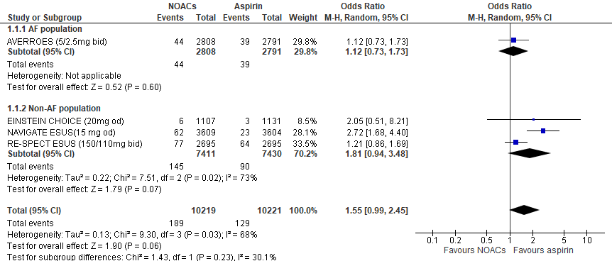
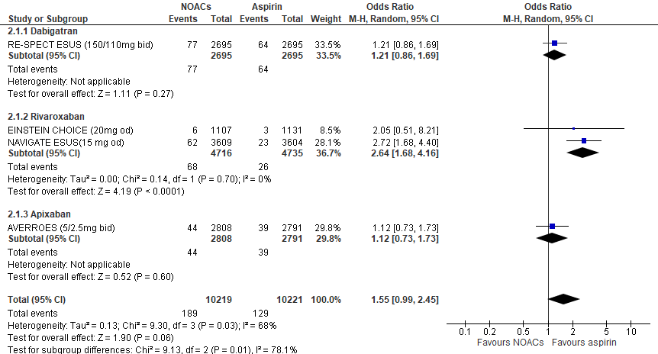

Figure 1: Forest plot of the effect of DOACs compared to aspirin on major bleeding per patient population (panel A) and DOAC studied (panel B).

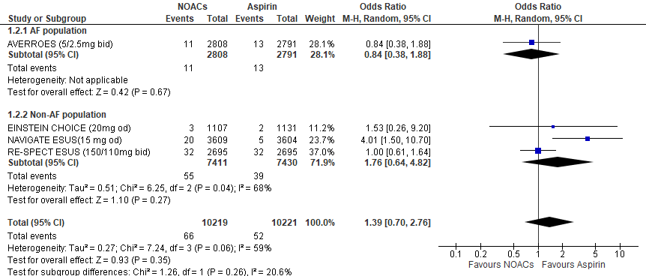
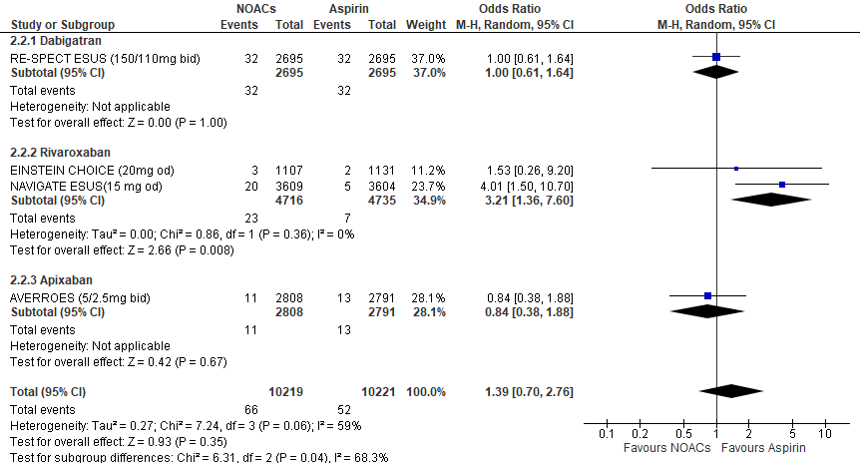

Figure 2: Forest plot of the effect of DOACs vs. aspirin on intracranial bleeding per patient population (panel A) and DOAC studied (panel B).

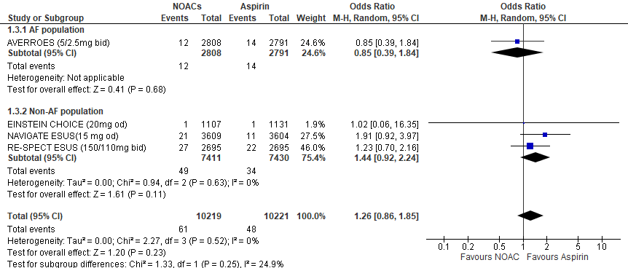
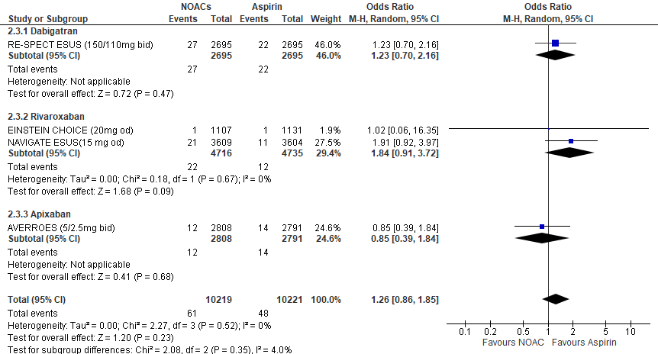

Figure 3: Forest plot of the effect of DOACs vs. aspirin on gastrointestinal bleeding per patient population (panel A) and DOAC studied (panel B).

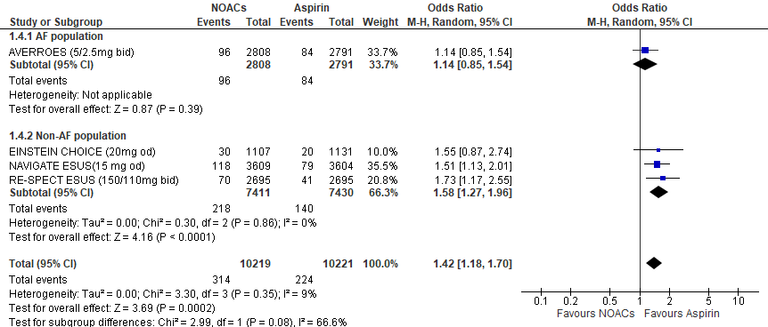
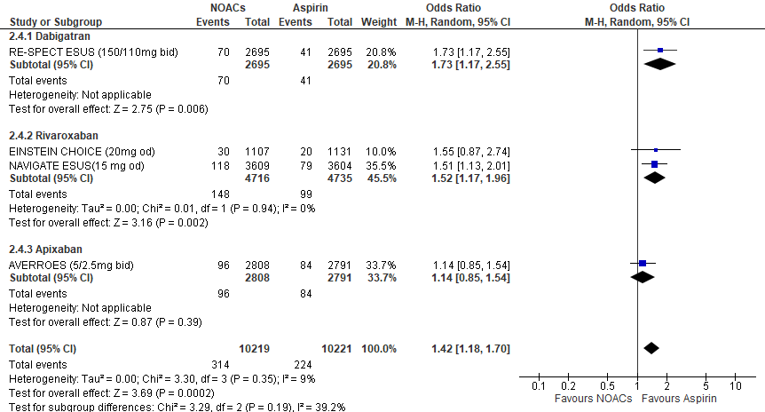

Figure 4: Forest plot of the effect of DOACs vs. aspirin on clinically relevant non-major bleeding per patient population (panel A) and DOAC studied (panel B).

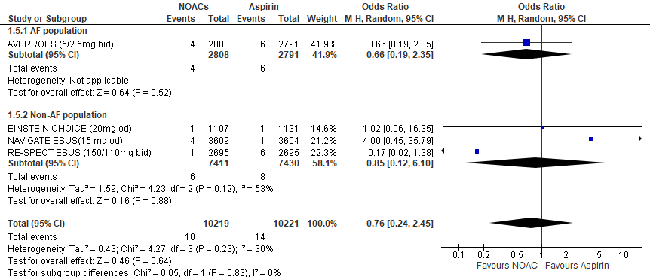
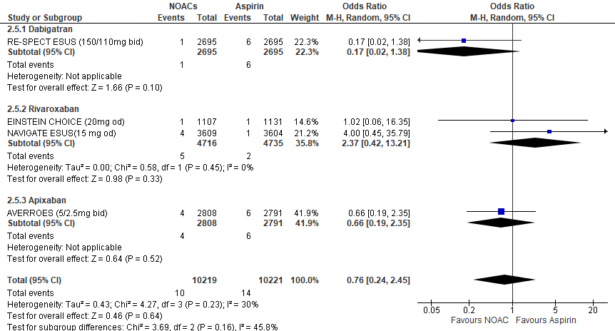

Figure 5: Forest plot of the effect of DOACs vs. aspirin on fatal bleeding per patient population (panel A) and DOAC studied (panel B).

Figure 6: Bubble plot with random-effects meta-regression line for the association of age with the logOR risk of major bleeding (panel A), intracranial bleeding (panel B) and clinically relevant non-major bleeding (panel C) between DOACs and aspirin.

