Prevalence of potential drug-drug interactions in patients of the Swiss HIV Cohort Study in the era of HIV integrase inhibitors
Elisabeth Deutschmann¹, Heiner C. Bucher^{1,2}, Steffen Jaeckel³, Sara Gibbons⁴, Katie McAllister⁴, Alexandra U. Scherrer^{5,6}, Dominique Braun⁵, Matthias Cavassini⁷, Anna Hachfeld⁸, Alexandra Calmy⁹, Manuel Battegay², Michela Cipriani¹⁰, Luigia Elzi¹¹, James Young¹, Beatriz Lopez-Centeno¹², Juan Berenguer¹³, Saye Khoo⁴, Giusi Moffa¹*, Catia Marzolini^{2,4}* and the Swiss HIV Cohort Study
¹Basel Institute for Clinical Epidemiology and Biostatistics, Department of Clinical Research, University Hospital Basel, University of Basel, Basel, Switzerland
²Division of Infectious Diseases & Hospital Hygiene, University Hospital Basel and University of Basel, Basel, Switzerland
³EYE T services, Freiburg, Germany
⁴Department of Pharmacology, University of Liverpool, UK
⁵Division of Infectious Diseases and Hospital Epidemiology, University Hospital Zurich, University of Zurich, Switzerland
⁶Institute of Medical Virology, University of Zürich, Switzerland
⁷Division of Infectious Diseases, University Hospital Lausanne, Lausanne, Switzerland
⁸ Department of Infectious Diseases, Bern University Hospital, University of Bern, Bern, Switzerland
⁹Division of Infectious Diseases, University Hospital Geneva, Geneva, Switzerland
¹⁰Division of Infectious Diseases and Hospital Epidemiology, Canton Hospital St. Gallen, St. Gallen, Switzerland
¹¹ Ospedale Regionale di Bellinzone e Valli, Bellinzona, Switzerland
¹² Subdirección General de Farmacia y Productos Sanitarios. Servicio Madrileño de Salud (SERMAS), Spain
¹³ Hospital General Universitario Gregorio Marañón (IiSGM), Madrid, Spain
*equal contribution
Running title: DDIs in the era of HIV integrase inhibitors
Abstract: 250 words
Text: 3000 words
Tables: 4
Figures: 2
Keypoints: The use of unboosted integrase inhibitors has reduced the prevalence of potential drug-drug interactions in the SHCS compared to ten years ago although to a lower extent than anticipated due to a higher use of comedications as the HIV population ages.
Keywords: HIV, drug-drug interactions, prevalence, Swiss HIV Cohort Study, modern antiretroviral therapy
Correspondence:
Prof. Catia Marzolini
Division of Infectious Diseases and Hospital Epidemiology
University Hospital Basel
Basel, Switzerland
Email: catia.marzolini@usb.ch
Phone: +41 61 265 21 14

Abstract
Background: Prevalence of potential drug-drug interactions (PDDIs) between antiretroviral drugs (ARVs) and comedications was high in 2008 in a Swiss HIV Cohort Study (SHCS) survey. We reassessed the prevalence of PDDIs in the era of HIV integrase inhibitors (INIs), which are characterized by more favorable interaction profiles.
Methods: The prevalence of PDDIs in treated HIV infected individuals was assessed for the period: 01-12/2018 by linkage of the Liverpool HIV drug interactions and SHCS databases. PDDIs were categorized as harmful (red flagged), of potential clinical relevance (amber flagged) or of weak clinical significance (yellow flagged).
Results: In 9’298 included individuals, median age was 51 years (IQR 43; 58), and 72% were males. Individuals received unboosted INI (40%), boosted ARV (30%), and non-nucleoside reverse transcriptase inhibitor (NNRTIs) (29%) based regimens. In the entire cohort, 68% received > 1 comedication, 14% had polypharmacy (> 5 comedications) and 29% had > 1 PDDI. Among individuals with comedication, the prevalence of combined amber and yellow PDDIs was 43% (33% amber, mostly with cardiovascular drugs and 20% yellow flagged PDDIs) compared to 59% in 2008. Two % had red flagged PDDIs (mostly with corticosteroids), remaining unchanged compared to the 2008 survey. Compared to 2008 fewer individuals received boosted ARVs (-23%) and NNRTIs (-12%) and more INIbased regimens (%) but the use of comedications was higher.
Conclusions: Prevalence of PDDIs in 2018 in an aging HIV cohort with higher use of comedications and use of unboosted INIs was lower compared to 2008, but the prevalence of potential severe DDI’s remained unchagend. Corticosteroids were major components of the clinically relevant PDDIs.

- Introduction
Life expectancy of people living with HIV (PLWH) has significantly improved with potent antiretroviral drugs (ARVs) [1, 2], but at the same time, comorbidities in HIV positive populations have increased [3] and are higher than in age-matched HIV negative individuals [4, 5]. Chronic immune activation, unhealthy lifestyle, viral co-infections or ARV toxicity may be related to higher comorbidities in HIV positive individuals [6] and treatment of these comorbidities exposes PLWH to higher risk of drug-drug interactions [7]. ARVs are among the medications with the highest potential for interactions decreasing or increasing plasma drug levels of comedication or ARV, which may result in treatment failure or drug toxicity [8].
A previous analysis of the Swiss HIV Cohort (SHCS) from 2008 has shown a high prevalence of potential drug-drug interactions (PDDIs) between ARVs and comedications. Two percent respectively 59% of ARV treated cohort participants with comedications had contraindicated or potentially clinically significant interactions that required dose adjustment or close monitoring at a time when most of the first line HIV treatments consisted of highly interacting protease inhibitors or efavirenz, a non-nucleoside reverse transcriptase inhibitor (NNRTI) [9]. In recent years, ARVs like unboosted integrase inhibitors (INIs) with improved interaction profiles have been introduced [10], and are among the preferred HIV treatment options in current guidelines [11, 12]. To date, only one large Spanish population study has analysed PDDIs with contemporary ARVs showing that 4%, 25% and 14% of PLWH receiving comedications had contraindicated, potentially clinically significant and weak clinical relevance interactions, respectively [13].
This work aimed to assess the prevalence and risk factors of PDDIs between ARVs and comedications in the SHCS in 2018 and to compare the prevalence with a previous analysis performed in 2008.
- Methods
  - Swiss HIV Cohort Study
The SHCS is a nationwide prospective cohort enrolling HIV-positive individuals aged > 16 years [14]. In 2018, 9657 individuals were followed in one of the HIV clinics or specialized HIV practices in the country. The SHCS collects information on socio-demographic characteristics, on the clinical course as well as immunological, virological and clinical chemistry laboratory data, ARV treatment and, since 2015, all prescribed and over-the-counter comedications. Medications are systematically coded using the World Health Organization Anatomical Therapeutic Chemical (ATC) classification system [15]. For the purpose of this analysis, drugs in coformulated drug combinations for both ARVs and comedications were counted and analysed separately. For instance, the HIV drug Triumeq® was inputted as dolutegravir, acabavir and lamivudine and the comedication Co-enalapril® as enalapril and hydrochlorothiazide.
  - Data selection
All SHCS participants treated with an ARV with a study visit between January 2018 and December 2018 were included in the analysis. If patients had more than one visit during this observation period only the first visit was considered.
  - Analysis of potential drug-drug interactions
The University of Liverpool HIV drug interaction database was used to detect PDDIs between ARVs and comedications [16]. The database categorizes the severity of interactions using flags: red flag for contraindicated drug-drug interactions with risk of serious adverse events or impaired ARV efficacy; amber flag for potential clinically significant interactions manageable by dose adjustment or clinical monitoring; green flag for no interaction. In 2017, the Liverpool drug interaction website was revised by implementing a yellow flag for interactions of weak clinical relevance with no need of a priori dosage adjustment or monitoring. In order to be able to compare the prevalence of PDDIs in 2018 and 2008, yellow and amber flags drug-drug interactions were merged. For the determination of the number of PDDIs, ritonavir or cobicistat were not counted as separate ARV as these agents are used to boost coadministered protease inhibitors or elvitegravir (only with cobicistat). In individuals with multiple drug-drug interactions, only the highest severity PDDIs was considered for the calculation of the prevalence of PDDIs. X
  - Data management
Medications classified by ATC code were extracted from the SHCS and all existing ARV-comedication pairs were created. The drugs listed in the Liverpool HIV interaction database were coded similarly using the ATC code. The coded SHCS drug pairs were used to extract information about the severity of PDDIs from the Liverpool HIV interaction database via an application programming interface (API) script. The comedications listed in the Liverpool database enabled to code the severity of PDDIs for 67% of the existing SHCS ARV-comedication pairs. An expert pharmacologist in the field of drug interactions (CM) checked the quality of the automated data extraction and, in addition, coded the severity of PDDIs for comedications not listed in the Liverpool HIV drug interaction database. In the end, the severity of PDDIs was coded for 97% of the SHCS ARV-comedication pairs.
  - Statistical analysis
We used absolute numbers, percentages, medians and interquartile ranges (IQR) to report socio-demographic characteristics and prevalence of PDDIs. Logistic regression at an alpha level of 0.05 was conducted to investigate factors associated with PDDIs, defined as having at least one red or amber flag PDDI. The model was adjusted with the following variables: age, gender, ethnicity, body mass index, illicit drug use, duration of HIV infection, prior AIDS defining condition, viral load, CD4 cell count, ARV drug class, backbone and concurrent use of various therapeutic classes. A P value of <.05 was considered to be statistically significant. The analysis was conducted using SAS 9.4

3. Results
  - Study population and their medications
The study population included 9298 PLWH who were followed in the SHCS during the study period and who were on ARV treatment (Figure 1). Median age of study participants was 51 years (IQR, 43-58), and the majority were males (n = 6735, 72%), and virologically suppressed (n = 8431, 91%). Most commonly used ARV regimens were based on unboosted INIs (n = 3716, 40%), NNRTIs (n = 2658, 29%), boosted ARVs (n = 2544, 27%) and boosted ARVs + NNRTIs (n = 256, 3%). The most commonly used backbones were tenofovir alafenamide (TAF) / emtricitabine (FTC) (n = 3256, 35%) and abacavir (ABC) / lamivudine (3TC) (n = 2874, 31%) (Table 1).
Overall, 6324 (68%) individuals had > 1 comedication (Figure 1). The most commonly prescribed comedications (n = 18’363) were cardiovascular drugs (27%), central nervous system (CNS) drugs (21%) and gastrointestinal & metabolism drugs (16%), and - with lower frequencies -genitourinary drugs (6%), blood drugs (i.e. antiplatelets or anticoagulants) (6%), respiratory drugs (5%), musculoskeletal drugs (5%) and anti-infectives (4%). Individuals receiving comedications tended to be older, having lower CD4 cell count and to be treated with unboosted INI containing regimens (Table 1). Polypharmacy, defined as the concurrent use of > 5 non-HIV comedications, was observed in 1336 (14.4%) individuals and was slightly more common in males (14.8%) and older patients (6.3%, 17.6% and 33.3% for the age categories 18-49 years, 50-64 years and > 65 years, respectively). Of interest, the use of cardiovascular drugs and proton pump inhibitors was markedly increased in > 65 years old individuals compared to the remaining age groups whereas the use of CNS drugs was only moderately increased in elderly compared to young adults. Use of analgesic drugs or anti-infectives was comparable across age groups (Supplementary figure).
  - Prevalence of potential drug-drug interactions
Of 58’287 drug pairs we identified 158 red, 3311 amber, 1679 yellow and 53’139 green flag drug-drug interactions. In the entire cohort, the prevalence of individuals with > 1 PDDI was 29% (n = 2730). Of individuals receiving > 1 comedication (n = 6324), the prevalence of PPDI was 43% and of those 153 (2%) individuals had a red, 2093 (33%) an amber and 1259 (20%) individuals a yellow flag PDDI (Figure 1). Common red and amber flag PDDIs found in the study population are shown in tables 2 and 3. The most frequently encountered red flag PDDIs included the coadministration of boosted ARVs and corticosteroids (n = 31, 20%) or quetiapine (n = 31, 20%) followed by the coadministration of atazanavir or rilpivirine with proton pump inhibitors (n = 25, 16%) (Table 3). It should be highlighted that even though quetiapine is contraindicated with strong CYP3A4 inhibitors, coadministration is possible with potent inhibitors provided that quetiapine dose is reduced to one sixth of the original dose [16]. This interaction was mostly managed correctly, as reduction of quetiapine dose was performed in 75% of the cases. When considering individuals with > 1 PDDI (n = 2730), amber flag PDDIs involved mostly the coadministration of boosted ARVs with antidepressants (n = 605, 22%) or statins (n = 570, 21%) (Table 2). Other common amber flag PDDIs included the coadministration of INIs with divalent cations (n = 322, 12%). The simultaneous intake of these drugs should be avoided as they can form a complex at the level of the gastrointestinal tract thereby reducing the absorption of INIs [17-19]. This interaction can be overcome by separating the intake of these drugs. Available information on the timing of administration indicated that this interaction was correctly managed in 34% of the cases whereas administration errors were observed in 26% of the cases.
  - Factors associated with potential drug-drug interactions
In the multivariable analysis, factors independently associated with an increased risk for red or amber flag PDDIs were treatments with NNRTIs, boosted ARVs or boosted ARVs and NNRTI compared to a treatment with unboosted INIs (Table 4). Treatment with the following therapeutic classes was also associated with an increased risk of red or amber flag PDDIs: cardiovascular drugs, blood drugs, gastrointestinal & metabolism drugs, musculoskeletal drugs, CNS drugs, hormones, genitourinary drugs & reproductive hormones, anti-infectives and antineoplastic drugs. Finally, the risk of having PDDIs was also higher with increasing age, for individuals with illicit drug use or with a longer history of HIV infection.
  - Comparison of the comedication use in 2018 and 2008
The use of comedications in 2018 was compared with our previous analysis from 2008 (figure 2). Both analyses showed a similar pattern of comedication use with cardiovascular and CNS being the most prescribed drug classes. However, with the exception of anti-infectives, diuretics, antidiarrheals and H2 blockers, other drug classes were more commonly prescribed in 2018 compared to 2008.
  - Comparison of the prevalence of potential drug-drug interactions in 2018 and 2008
The prevalence of red flag PDDIs was 2% both in 2018 and in 2008. However, the merged prevalence of amber and yellow flag PDDIs (taking into account yellow flag PDDIs and counting individuals once if they had one amber plus one yellow flag PDDI) was reduced from 59% in 2008 to 43% in 2018. Of interest, the prevalence of PDDIs with erectile agents increased in 2018 compared to 2008 (10% vs 3%) whereas interactions with methadone decreased (6% vs 19%) (Table 2).

- Discussion
The prevalence of PDDIs in the SHCS in 2018 was 2%, 33% and 20% for red, amber and yellow flag PDDIs. A comparable picture was observed in a large Spanish population analysis performed in 2017 with 4%, 26% and 14% of red, amber and yellow flag PDDIs when considering ARV treated individuals on comedications [13]. Of interest, the prevalence of PDDIs in these two cohorts was also similar to a recent analysis conducted in a rural Tanzanian HV cohort showing a prevalence of 33% and 18% for amber and yellow flag PDDIs, respectively [20]. In the Spanish and in our cohort, amber PDDIs mostly occurred between boosted ARVs and cardiovascular or CNS drugs. The high use of cardiovascular and CNS drugs is explained by the aging of the HIV population [3] and the fact that mental health problems are common among PLWH [21].
The occurrence of red flag PDDIs in the SHCS did not change in 2018 compared to 2008 with a prevalence of 2% similarly to what has been reported in other recent UK, US and Australian cohort studies [22-24]. The persistence of red flag PDDIs is problematic as contraindicated interactions have been associated with increased healthcare costs in a French HIV cohort [25] and increased risk of hospitalizations in a US HIV cohort [26]. In our study, the most prevalent red flag PDDIs were the association of boosted ARVs with corticosteroids resulting in an increased corticosteroid exposure and related higher risk of developing a Cushing syndrome [27]. Of interest, this red flag PDDI was also shown to be the most prevalent interaction in two large European HIV cohort studies [13, 25]. Potential explanations for the recurrence of this interaction may relate to the fact that corticosteroids are often administered via non-oral routes thus leading to an underestimation of the magnitude of the interaction. In addition, corticosteroids are used across a large variety of medical specialties and therefore are often prescribed by non-HIV physicians who are not aware of the risk of interactions with ARVs. Another common red flag PDDI was the association of atazanavir or rilpivirine with proton pump inhibitors leading to a reduced absorption of the ARV and related increased risk of treatment failure [28, 29]. This interaction was also among the top red flag interactions reported in a French cohort [25].
Although the prevalence of red and amber flag PDDIs remains significant, our results indicatethat interactions can be managed correctly. For instance, quetiapine dose was appropriately reduced to one sixth of the original dose when coadministered with boosted ARVs in xx% of the cases and INIs were separated from divalent cations in 34% of the cases although this number might be underestimated as information on the timing of administration was not always available.
In the multivariable analysis, the use of INIs was significantly associated with a lower risk of having PDDIs, however, older age was associated with a higher risk. As demonstrated by this large cohort study, PDDIs remain an issue in the era of INIs in the context of an aging HIV population with more comedications and more complex treatments [30]. Thus, vigilance should to be maintained and periodic review of prescriptions is warranted to prevent prescribing errors. Future developments of the SHCS based on this work should aim to implement a real time flagging of all newly entered comedications to allow immediate feedback to clinicians and real time monitoring of drug interactions
The prevalence of PDDIs in the SHCS has decreased only by 16% in 2018 compared to 2008 despite the fact that first line treatments have shifted over the years from ARVs with a high to those with a low potential for interactions [10]. This modest reduction is explained by a large proportion of PLWH still treated with boosted ARVs or NNRTIs and by a higher prevalence of comedication use nowadays compared to ten years ago likely due to the aging of the HIV population. This statement is indeed supported by the higher use of cardiovascular drugs in 2018 compared to 2008 as illustrated in Figure 2. Conversely, the use of anti-infectives and antidiarrheals is reduced in 2018 compared to 2008. This observation could relate to the current recommendation to initiate ARV treatment regardless of CD4 cell count, which was shown to reduce AIDS related events in the INSIGHT START study [31], thereby reducing the risk of opportunistic infections and related use of anti-infectives. The reduction in antidiarrheals likely relates to the improved tolerability of modern ARVs unlike the protease inhibitor nelfinavir, known to cause diarrhoea and commonly used in 2008.
When comparing the type of interactions within the SHCS in 2018 and 2008, the pattern was comparable as most frequent interactions were with cardiovascular drugs and CNS drugs. Of interest, more interactions were observed with erectile dysfunction agents in 2018 compared to 2008. This observation could relate to the aging of the HIV population and related increase in erectile dysfunction due to comorbidities like diabetes mellitus, hypertension and depression [32]. Conversely, fewer interactions with methadone were observed in 2018 compared to 2008. This finding could be explained by the fact that intravenous drug users represent a smaller percentage of individuals in the SHCS compared to 2008 as indicated by the distribution of the mode of HIV infection in the participants of the SHCS over the years [14]. X
Some limitations should be acknowledged. It was not feasible to analyse dose adjustments or clinical consequences of PDDIs at a large-scale. Thus, we cannot exclude that some interactions were managed appropriately as demonstrated with selected examples. Furthermore, the number of PDDIs could be underestimated as comedications prescribed by other healthcare specialists may not always be entered in the SHCS database. There are no information on drug history for patients hospitalized or in nursing homes. Recreational drugs are not reported in the SHCS therefore interactions with these substances were not accounted for. Finally, report of PDDIs relied on the electronic prescribing system in 2018 but on the chart review in 2008. This study has several strengths. Since 2015, an online drug entry system for the SHCS allows the prospective systematic documentation of all medications thereby providing a comprehensive analysis of the medication use for the Swiss HIV population. Nearly all ARV-comedication pairs in the SHCS (n = 58’287, 97%) were coded for the risk of PDDIs, thus this analysis provides to date the most representative and comprehensive picture of the prevalence of PDDIs in an ARV treated HIV population. Finally, this is the first analysis comparing the prevalence of PDDIs at two time points in the same population thus enabling to determine the impact of contemporary ARVs use on the reduction of PDDIs.
In conclusion, the prevalence of PDDIs in the SHCS has decreased in the past decade however to a lower extent than anticipated as less than half of the population was on unboosted INIs regimens and due to a higher comedications use nowadays. In PLWH with multimorbidity and polypharmacy, unboosted INIs should be preferred due to their lower potential to cause interactions. The persistent detection of red flag PDDIs emphasizes the need for integrated multidisciplinary care, medication reconciliation, regular medication review and the systematic use of comprehensive drug interaction search tools.
X

Notes
Members of the Swiss HIV Cohort Study
Aebi-Popp K, Anagnostopoulos A, Battegay M, Bernasconi E, Böni J, Braun DL, Bucher HC, Calmy A, Cavassini M, Ciuffi A, Dollenmaier G, Egger M, Elzi L, Fehr J, Fellay J, Furrer H, Fux CA, Günthard HF (President of the SHCS), Haerry D (deputy of "Positive Council"), Hasse B, Hirsch HH, Hoffmann M, Hösli I, Huber M, Kahlert CR (Chairman of the Mother & Child Substudy), Kaiser L, Keiser O, Klimkait T, Kouyos RD, Kovari H, Ledergerber B, Martinetti G, Martinez de Tejada B, Marzolini C, Metzner KJ, Müller N, Nicca D, Paioni P, Pantaleo G, Perreau M, Rauch A (Chairman of the Scientific Board), Rudin C, Scherrer AU (Head of Data Centre), Schmid P, Speck R, Stöckle M (Chairman of the Clinical and Laboratory Committee), Tarr P, Trkola A, Vernazza P, Wandeler G, Weber R, Yerly S.
Financial support
This study has been financed within the framework of the Swiss HIV Cohort Study, supported by the Swiss National Science Foundation (grant #177499), by SHCS project #805 and by the SHCS research foundation. The Basel Institute for Clinical Epidemiology and Biostatistics is supported by Stiftung Institut für klinische Epidemiologie. CM was supported by a grant of the Swiss National Science Foundation (grant #166204). The data are gathered by the Five Swiss University Hospitals, two Cantonal Hospitals, 15 affiliated hospitals and 36 private physicians (listed in www.shcs.ch/180-health-care-providers).
Potential conflict of interest
HCB has received in the 36 months prior to the submission of this manuscript grants, support for travelling, consultancy fees and honorarium from Gilead, BMS, Viiv Healthcare and Roche that were not related to this project. He serves as the president of the association contre le HIV et autres infections transmissibles. In this function he has received support for the Swiss HIV Cohort Study from ViiV Healthcare, Gilead, BMS, MSD and Abbvie. CM has received a research grant from Gilead and speaker honoraria for her institution from MSD.All other authors report no potential conflict of interest. All authors have submitted the ICMJE From for Disclosure of Potential Conflicts of Interest. Conflicts that the editors consider relevant to the content of the manuscript have been disclosed.

References
1. Antiretroviral Therapy Cohort C. Survival of HIV-positive patients starting antiretroviral therapy between 1996 and 2013: a collaborative analysis of cohort studies. Lancet HIV 2017; 4(8): e349-e56.
2. Gueler A, Moser A, Calmy A, et al. Life expectancy in HIV-positive persons in Switzerland: matched comparison with general population. AIDS 2017; 31(3): 427-36.
3. Hasse B, Ledergerber B, Furrer H, et al. Morbidity and aging in HIV-infected persons: the Swiss HIV cohort study. Clin Infect Dis 2011; 53(11): 1130-9.
4. Guaraldi G, Orlando G, Zona S, et al. Premature age-related comorbidities among HIV-infected persons compared with the general population. Clin Infect Dis 2011; 53(11): 1120-6.
5. Schouten J, Wit FW, Stolte IG, et al. Cross-sectional comparison of the prevalence of age-associated comorbidities and their risk factors between HIV-infected and uninfected individuals: the AGEhIV cohort study. Clin Infect Dis 2014; 59(12): 1787-97.
6. Sabin CA, Reiss P. Epidemiology of ageing with HIV: what can we learn from cohorts? AIDS 2017; 31 Suppl 2: S121-S8.
7. Marzolini C, Back D, Weber R, et al. Ageing with HIV: medication use and risk for potential drug-drug interactions. J Antimicrob Chemother 2011; 66(9): 2107-11.
8. Marzolini C, Livio F. Prescribing issues in elderly individuals living with HIV. Expert Rev Clin Pharmacol 2019; 12(7): 643-59.
9. Marzolini C, Elzi L, Gibbons S, et al. Prevalence of comedications and effect of potential drug-drug interactions in the Swiss HIV Cohort Study. Antivir Ther 2010; 15(3): 413-23.
10. Gibbons S, Marzolini C, Moss C, et al. Drug interaction profiles for first line antiretroviral therapy and selected fixed-dose antiretroviral combinations over 20 years of the Liverpool drug interaction website. European AIDS Clinical Society conference 2019; abstract BDP1/3.
11. Guidelines for the Use of Antiretroviral Agents in Adults and Adolescents with HIV. 2019. Available at: https://aidsinfo.nih.gov/guidelines. Accessed on February 15, 2020.
12. Guidelines from the European AIDS Clinical Society, version 10 2019. Available at: https://www.eacsociety.org/files/2019_guidelines-10.0_final.pdf. Accessed on February 15, 2020.
13. Lopez-Centeno B, Badenes-Olmedo C, Mataix-Sanjuan A, et al. Polypharmacy and drug-drug interactions in HIV-infected subjects in the region of Madrid, Spain: a population-based study. Clin Infect Dis 2019 [epub ahead of print].
14. Swiss HIV Cohort Study. 2019. Available at: https://shcs.ch. Accessed on February 15 2020.
15. ATC code. 2019. Available at : https://www.whocc.no/atc_ddd_index/. Accessed on August 1, 2019.
16. Liverpool HIV drug interactions. 2019. Available at: https://www.hiv-druginteractions.org. Accessed on August 1, 2019.
17. Kiser JJ, Bumpass JB, Meditz AL, et al. Effect of antacids on the pharmacokinetics of raltegravir in human immunodeficiency virus-seronegative volunteers. Antimicrob Agents Chemother 2010; 54(12): 4999-5003.
18. Ramanathan S, Mathias A, Wei X, et al. Pharmacokinetics of once-daily boosted elvitegravir when administered in combination with acid-reducing agents. J Acquir Immune Defic Syndr 2013; 64(1): 45-50.
19. Song I, Borland J, Arya N, Wynne B, Piscitelli S. Pharmacokinetics of dolutegravir when administered with mineral supplements in healthy adult subjects. J Clin Pharmacol 2015; 55(5): 490-6.
20. Schlaeppi C, Vanobberghen F, Sikalengo G, et al. Prevalence and management of drug-drug interactions with antiretroviral treatment in 2069 people living with HIV in rural Tanzania: a prospective cohort study. HIV Med 2020; 21(1): 53-63.
21. Anagnostopoulos A, Ledergerber B, Jaccard R, et al. Frequency of and Risk Factors for Depression among Participants in the Swiss HIV Cohort Study (SHCS). PLoS One 2015; 10(10): e0140943.
22. Halloran MO, Boyle C, Kehoe B, et al. Polypharmacy and drug-drug interactions in older and younger people living with HIV: the POPPY study. Antivir Ther 2019; 24(3): 193-201.
23. Patel N, Borg P, Haubrich R, McNicholl I. Analysis of drug-drug interactions among patients receiving antiretroviral regimens using data from a large open-source prescription database. Am J Health Syst Pharm 2018; 75(15): 1132-9.
24. Siefried KJ, Mao L, Cysique LA, et al. Concomitant medication polypharmacy, interactions and imperfect adherence are common in Australian adults on suppressive antiretroviral therapy. AIDS 2018; 32(1): 35-48.
25. Demessine L, Peyro-Saint-Paul L, Gardner EM, Ghosn J, Parienti JJ. Risk and Cost Associated With Drug-Drug Interactions Among Aging HIV Patients Receiving Combined Antiretroviral Therapy in France. Open Forum Infect Dis 2019; 6(3): ofz051.
26. Sangiovanni RJ, Jakeman B, Nasiri M, Ruth L, Mahatme S, Patel N. Short Communication: Relationship Between Contraindicated Drug-Drug Interactions and Subsequent Hospitalizations Among Patients Living with HIV Initiating Combination Antiretroviral Therapy. AIDS Res Hum Retroviruses 2019; 35(5): 430-3.
27. Elliot ER, Theodoraki A, Jain LR, et al. Iatrogenic Cushing's syndrome due to drug interaction between glucocorticoids and the ritonavir or cobicistat containing HIV therapies. Clin Med (Lond) 2016; 16(5): 412-8.
28. Crauwels H, van Heeswijk RP, Stevens M, et al. Clinical perspective on drug-drug interactions with the non-nucleoside reverse transcriptase inhibitor rilpivirine. AIDS Rev 2013; 15(2): 87-101.
29. Zhu L, Persson A, Mahnke L, et al. Effect of low-dose omeprazole (20 mg daily) on the pharmacokinetics of multiple-dose atazanavir with ritonavir in healthy subjects. J Clin Pharmacol 2011; 51(3): 368-77.
30. Courlet P, Livio F, Guidi M, et al. Polypharmacy, Drug-Drug Interactions, and Inappropriate Drugs: New Challenges in the Aging Population With HIV. Open Forum Infect Dis 2019; 6(12): ofz531.
31. Group ISS, Lundgren JD, Babiker AG, et al. Initiation of Antiretroviral Therapy in Early Asymptomatic HIV Infection. N Engl J Med 2015; 373(9): 795-807.
32. Wang Q, Young J, Bernasconi E, et al. The prevalence of erectile dysfunction and its association with antiretroviral therapy in HIV-infected men: the Swiss HIV Cohort Study. Antivir Ther 2013; 18(3): 337-44.

Table 1: Characteristics of the study population
Characteristics | All  (N = 9298) | On ARV only  (N = 2974) | On ARV + comedications  (N = 6324)
Median age, years (IQR) | 51 (43-58) | 46 (38-53) | 53 (46-60)
Male sex, n (%) | 6735 (72.4) | 2180 (73.3) | 4555 (72.0)
White ethnicity, n (%) | 7207 (77.5) | 2101 (70.6) | 5106 (80.7)
HIV acquisition mode, n (%)  MSM  Heterosexual  IDU  Others or unclear | 4330 (46.6)  3514 (37.8)  665 (7.2)  789 (8.4) | 1515 (50.9)  1165 (39.2)  103 (3.5)  191 (6.4) | 2815 (44.5)  2349 (37.1)  562 (8.9)  598 (9.5)
Current illicit drug use, n (%) | 139 (1.5) | 20 (0.7) | 119 (1.9)
CD4 current, cells/uL, n (%)  < 350  350 – 500  > 500 | 892 (9.6)  1401 (15.1)  6898 (74.2) | 227 (7.6)  463 (15.6)  2238 (75.3) | 665 (10.5)  938 (14.8)  4660 (73.7)
HIV-1 RNA, < 20 copies/mL, n (%) | 8431 (90.7) | 2674 (89.9) | 5757 (91.0)
ARV drug class, n (%)  unboosted INIª  NNRTI  boosted ARV^{b}  boosted ARV + NNRTI  others | 3716 (40.0)  2658 (28.6)  2544 (27.4)  256 (2.7)  124 (1.3) | 1076 (36.2)  946 (31.8)  858 (28.9)  46 (1.5)  48 (1.6) | 2640 (41.7)  1712 (27.1)  1686 (26.7)  210 (3.3)  76 (1.2)
Backbone, n (%)  TAF + FTC  ABC + 3TC  TDF + FTC  others | 3256 (35.0)  2874 (30.9)  2078 (22.4)  1090 (11.7) | 958 (32.2)  918 (30.9)  842 (28.3)  256 (8.6) | 2298 (36.3)  1956 (30.9)  1236 (19.5)  834 (13.2)
ªunboosted INIs include bictegravir, dolutegravir and raltegravir; ^{b}boosted ARVs include protease inhibitors boosted with ritonavir or cobicistat and elvitegravir boosted with cobicistat.
Abbreviations: ABC, abacavir; ARV, antiretroviral drug; FTC, emtricitabine; IDU, injection drug use; INI, integrase inhibitor; MSM, men who have sex with men; NNRTI, non-nucleoside reverse transcriptase inhibitor; TAF, tenofovir alafenamide; TDF, tenofovir disoproxil fumarate; 3TC, lamivudine.
Table 2: Prevalence of selected amber flag drug-drug interactions in 2018 versus 2008
ARV | Comedication | Prevalence 2018  n (%)ª | Prevalence 2008  (%)^{b} [9]
bARV/NNRTI | antidepressants | 605 (22.2) | 139 (23.2)
bARV/NNRTI | statins | 570 (20.9) | 123 (20.5)
bARV/NNRTI | anxiolytics/sedatives | 379 (13.9) | 99 (16.5)
bARV/NNRTI | erectile agents | 285 (10.4) | 17 (2.8)
bARV/NNRTI | hormones | 206 (7.5) | 40 (6.7)
bARV/NNRTI | methadone | 174 (6.4) | 115 (19.2)
bARV | beta-blockers | 170 (6.2) | 40 (6.7)
bARV/NNRTI | calcium channel inhibitors | 145 (5.3) | 34 (5.7)
bARV/NNRTI | antipsychotics | 114 (4.2) | 37 (6.2)
bARV/NNRTI | narcotic analgesics | 102 (3.7) | 27 (4.5)
TDF | valaciclovir | 61 (2.2) | 14 (2.3)
bARV/NNRTI | anticonvulsants | 52 (1.9) | 19 (3.2)
INI | divalent cations^{c} | 322 (11.8) | NA
INI | metformin | 105 (3.8) | NA
a, the denominator is the number of individuals with > 1 PDDI in 2018 (n = 2730); b, the denominator is the number of individuals with > 1 PDDI in 2008 (n = 599); c, antacids or supplements containing divalents cations (i.e. calcium, magnesium, aluminium, iron, zinc).
Abbreviations: bARV, boosted antiretroviral drug; INI, integrase inhibitor; NA, not applicable; NNRTI, non-nucleoside reverse transcriptase inhibitor; TDF, tenofovir disoproxil fumarate

Table 3: Description of potential red flag drug-drug interactions (N = 158)
ARV drug | Comedication | Risks related to interaction | N | %
bARV | fluticasone, mometasone, triamcinolone | Cushing syndrome | 31 | 19.6
bARV | quetiapine | QT prolongation (note: quetiapine dose was reduced to 1/6 in 75% of the cases) | 31 | 19.6
ATV, RPV | proton pump inhibitors | ARV treatment failure | 25 | 15.8
bARV | clopidogrel | reduced efficacy for clopidogrel | 18 | 11.4
bARV | domperidone | QT prolongation | 16 | 10.1
EFV, NVP | ketoconazole | reduced efficacy for ketoconazole | 9 | 5.7
bARV | alfuzosin, aliskiren, lecarnidipine | severe hypotension | 8 | 5.1
bARV | simvastatin | rhabdomyolysis | 4 | 2.5
bARV | midazolam, triazolam | respiratory depression | 4 | 2.5
EFV | contraceptive | contraceptive failure | 3 | 1.9
bARV | eplerenone | hyperkalemia | 3 | 1.9
DTG, NVP | phenobarbital, primidone | ARV treatment failure | 2 | 1.3
bARV | amiodarone | cardiac arrhythmias | 1 | 0.6
bARV | sirolimus | sirolimus related side effects | 1 | 0.6
SQV | trazodone | QT prolongation | 1 | 0.6
bARV | rivaroxaban | bleeding | 1 | 0.6
Abbreviations: ATV, atazanavir, bARV, boosted antiretroviral drug; DTG, dolutegravir; EFV, efavirenz; NVP, nevirapine; RPV, rilpivirine; SQV, saquinavir

Table 4 Factors associated with potential red or amber flag drug-drug interactions
Factors | Adjusted OR | (95% CI) | P Value
Age, per 10 years older | 1.10 | (1.03-1.18) | .006
Male gender | 1.14 | (0.97-1.33) | .103
White ethnicity | 1.00 | (0.84-1.20) | .959
Body mass index, kg/m^{2a}  Obese vs normal  Overweight vs normal  Underweight vs normal | 0.90  0.98  1.30 | (0.74-1.09)  (0.85-1.13)  (0.95-1.78) | .270  .813  .103
Current illicit drug use | 1.98 | (1.27-3.09) | .003
Years since HIV infection, per 10 years | 1.12 | (1.04-1.22) | .003
Prior AIDS defining condition | 1.10 | (0.95-1.27) | .195
CD4 cell count, cells/uL  350-500 vs > 500  < 350 vs > 500 | 1.00  1.19 | (0.84-1.19)  (0.97-1.46) | .977  .090
HIV-1 RNA > 20 copies/mL | 0.90 | (0.72-1.14) | .385
ARV drug class  NNRTI vs unboosted INI^{b}  Boosted ARV^{c} vs unboosted INI  Boosted ARV + NNRTI vs unboosted INI | 4.55  12.35  19.52 | (3.78-5.49)  (10.27-14.86)  (13.13-29.00) | <.001  <.001  <.001
Backbone  TAF/FTC vs ABC/3TC  TDF/FTC vs ABC/3TC | 0.89  1.11 | (0.74-1.06)  (0.90-1.37) | .201  .317
Therapeutic classes  Cardiovascular drugs  Blood drugs  Gastrointestinal & metabolism drugs  Musculoskeletal drugs  CNS drugs  Hormones  Respiratory system drugs  Genitourinary drugs & reproductive hormones  Anti-infectives  Herbals  Antineoplastic drugs  Others | 1.26  1.39  2.72  1.38  1.77  2.27  0.82  1.87  2.04  0.67  1.14  1.40 | (1.09-1.46)  (1.16-1.66)  (2.39-3.10)  (1.16-1.65)  (1.55-2.01)  (1.70-3.04)  (0.61-1.10)  (1.44-2.43)  (1.66-2.50)  (0.42-1.05)  (0.58-2.21)  (1.18-1.66) | .002  <.001  <.001  <.001  <.001  <.001  .179  <.001  <.001  .082  .709  <.001
ªweight categories are defined as follows: obese, body mass index (BMI, kg/m²) > 30; overweight, BMI 25 up to < 30; normal, 18.5 up to 25; underweight < 18.5; ^{b}unboosted INIs include bictegravir, dolutegravir and raltegravir; ^{c}boosted ARVs include protease inhibitors boosted with ritonavir or cobicistat and elvitegravir boosted with cobicistat.
Abbreviations: ABC, abacavir; ARV, antiretroviral drug; CI, confidence interval; CNS, central nervous system; FTC, emtricitabine; INI, integrase inhibitor; NNRTI, non-nucleoside reverse transcriptase inhibitor; OR, odds ratio; TAF, tenofovir alafenamide; 3TC, lamivudine, vs, versus.

Figure 1: Participants inclusion and prevalence of potential drug-drug interactions
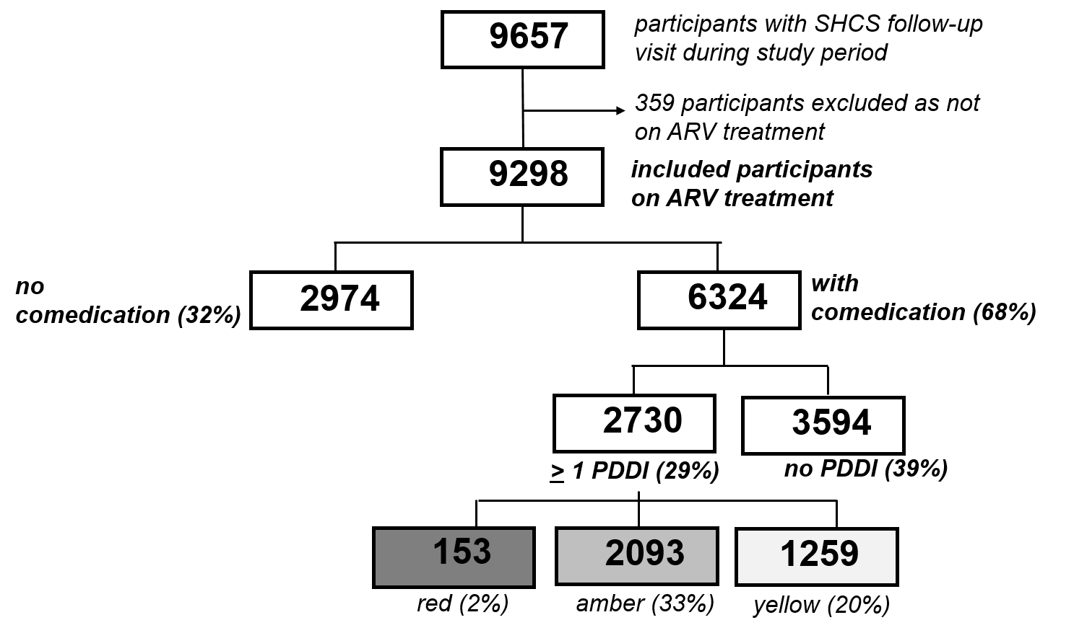

Figure 2: Comedication use in SHCS participants in 2018 versus 2008
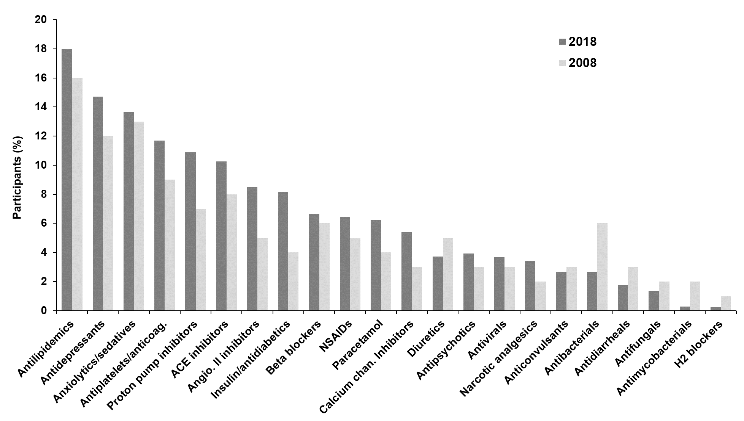

Supplementary figure: Use of selected comedications in 2018 by age categories
Cardiovascular drugs GI drugs CNS drugs Analgesics Anti-infectives
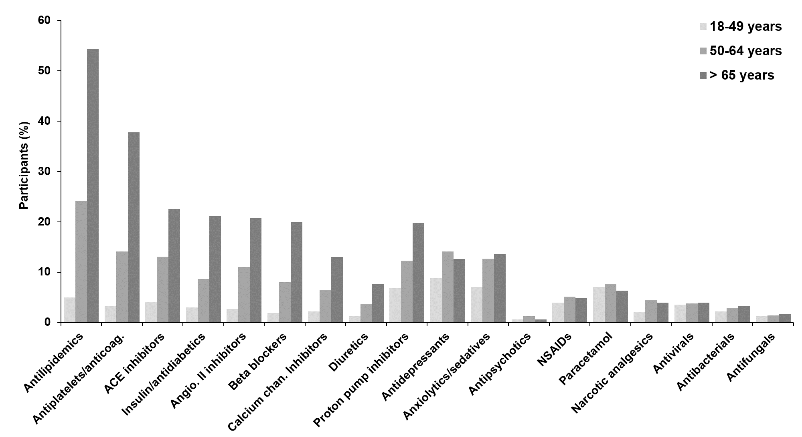
CNS, central nervous system; GI, gastrointestinal

