Swell-dominated sediment re-suspension in a silty coastal seabed

Jianwei Niu 1,2, Jishang Xu 1,2,3,4*, Guangxue Li 1,2,3,4, Ping Dong 5, Jinghao Shi 1,2, Lulu Qiao 1,2,3,4

1. Key Lab of Submarine Geosciences and Prospecting Techniques (Ministry of Education), Ocean University of China, Qingdao 266100, China;

2. College of Marine Geosciences, Ocean University of China, Qingdao 266100, China;

3. Engineering Research Center of Marine Petroleum Development and Security Safeguard (Ministry of Education), Ocean University of China, Qingdao 266100, China;

4. Qingdao National Laboratory for Marine Science and Technology, Qingdao 266100, China;

5. School of Engineering, University of Liverpool, Liverpool L69 3GS, U.K.

Highlights

* The height of swell strongly affected sediment resuspension in coastal seabed.
* Large swell coming from offshore (NE in our study area) dominated sediment resuspension events in offshore zone (water depth >10 m).
* During and after swell, residual currents are the major dynamics that transport sediment from coastal areas.

# Abstract

Waves and swell are fundamentally important for sediment re-suspension in estuary and coastal areas, especially for silty sediments, which can be easily suspended by waves, but the differential effects of swell and waves are still unclear. Integrated field observations were made from November 2012 to March 2013 including waves, currents, and suspending sediments on the offshore seabed of the Huanghe Delta to explore the mechanism of sediment re-suspension in silty coastal zones. During the five months of observation, there were more than 30 winter wind events that affected the study area and induced sediment re-suspension with varying suspended sediment concentration. The observed wave composition was separated into swell and wind waves using a bandpass filter. Results show that large swell (with significant height > 1.0 m) coming from the offshore direction (NE in our study area) dominated sediment resuspension in the coastal seabed due to the fact that this wind direction had the longest average fetch. Winds from the onshore direction usually had smaller swell due to their short fetch and caused limited sediment re-suspension. The residual currents caused by NE winds also transport larger sediment. An individual NE wind event could transport sediment 8–13.6 t/m2 and 5.1–8.2 t/m2 in directions parallel and perpendicular, respectively, to the isobaths, which is much higher than the sediment transportation during an individual NW wind event, which could transport 1.5–4 t/m2 and 0.6–5 t/m2 parallel and perpendicular, respectively, to the isobaths. Our research shows that large swell and the accompanying residual currents caused by NE winds (from offshore direction) are a vital driving force for sediment resuspension and transportation in the offshore zone.

Key words: sediment resuspension; swell; silty seabed; sediment transport

# 1. Introduction

Waves and currents play important roles in sediment re-suspension in shallow coastal waters. Waves are locally generated by wind or propagate from the open sea, while currents are partly driven by tidal, wind, and density differences (Green and Coco, 2014). The waves in nature are composed of various components (e.g., wind waves, swell, infragravity waves). Swell is a series of waves that break in the surf zone (Thornton and Guza, 1982), while infragravity waves (frequency: 0.005–0.04 Hz) may be a few centimeters high in deep water (Aucan and Ardhuin, 2013; Crawford et al., 2015; Inch et al., 2017) or over 1 m high in nearshore environment (Guza and Thornton, 1982; Senechal et al., 2011; Fiedler et al., 2015). Diverse wave components possibly make distinct contributions to sediment movement as well as seabed variations, so it is necessary to discriminate the differing contributions of swell and wind waves on sediment resuspension and transportation in the coastal seabed.

Many studies have investigated the roles of wind wave and swell playing in suspending sediment with different environments. Based on field observations in various bays and estuaries, the distinct mechanisms of sediment re-suspension under two types of waves have been identified. Wind waves can resuspend sediment from the bed with 2–12 m water depth (You et al., 2007), while swell is possibly more important for sediment re-suspension in the inner shelf zone (Jing and Rodd, 1996). Early in 1986, Oradiwe (1986) investigated the hydrodynamic conditions and sediment budget in Monterey Bay, California and found that the swell produced by an open ocean are the most important source of wave energy in the bay, with larger sizes and longer periods than local wind waves resulting in much more damage in the form of shoreline erosion. Jing (1996) investigated two high sediment re-suspension events in Cleveland Bay, California, and found that swell were the most important factor in sediment resuspension during high suspended sediment concentration (SSC) events, while wind waves seemed to have a limited effect on SSC levels. In a comprehensive field study in Moreton Bay, Australia, You and Yin (2006) compared sediment resuspension dynamics between deep water (the main entrance and the central bay) and shallow water (small bays) and found that the dominant driving force in deep water is a combination of ocean swell and tidal currents, whereas in shallow water, wind waves predominate. Jia et al. (2014) calculated the bottom shear stresses (BSSs) and analyzed their effect on sediment re-suspension based on observations in the Modaomen Estuary, China. Their results showed that the swell-induced BSS are the most important part of the total BSS. In addition to these field studies, Dalyander et al. (2013) used numerical modeling to analyze the bottom shear stress in the entire Mid-Atlantic Bight (MAB) and determined that the contribution of swell to bottom shear stress in the middle MAB is much higher than that of local wind waves. All of these studies considered the mechanism of sediment re-suspension in the deep water within bays and estuaries, and suggested that swell is the dominant physical force. These investigations are limited by their duration and have not investigated the resuspension process under different types of swell. Hence, this research examines the components of natural random waves and their different action on sediment re-suspension based on long time observation to understand the mechanisms of sediment re-suspension and transportation during different stormy winter winds.

The Huanghe Delta is frequently hit by strong winds during the winter, which results in various wave components that possibly have different effects on sediment suspension. Our research focuses on the area outside of the Huanghe Delta (the inner shelf of Bohai Sea) where both swell and wind waves are strong during the winter. The different the roles of various wave components play in sediment re-suspension within the inner shelf sea are identified in this paper.

# 2. Study area

Our study area was located on the east side of the modern Huanghe Delta, where the surface sediments consist mainly of silty sand and clay (Yang et al. 2011). Tidal current in this region is irregular and shows semi-diurnal characteristics. There is an amphidromic point of the semi-diurnal M2 tide in the northeast portion of the delta (Yang et al., 2011).

In winter, strong winds (usually >11 m/s) primarily come from the NE and NW. Yang et al. (2011) pointed out that strong winds exceeding grade eight occur an average of 6.4 times each year during the winter season. The prevailing winter winds generate high sediment resuspension events and the sediment is transported by currents into both Laizhou Bay and the Bohai Strait (Wang et al., 2016).

The prevailing wave direction in this area is from the NE, and the maximum observed wave height is 5.2 m (Zang, 1996). Sediment is re-suspended and transported in winter and deposited in summer because the wave energy is strong in winter and much weaker in summer, which could lead to seasonal variation in shelf sediment transport (Zhang et al., 1995). In addition, surface sediment could be resuspended easily due to the shallow water depth. Therefore strong winter hydrodynamics are the major reason for sediment resuspension (Yang et al., 2011).

Field observations were made from November 1, 2012 to March 30, 2013, on the subaqueous Huanghe Delta at observation station KD47, which is located at 119.1982°E and 37.9244°N (Fig. 1). Historical data, including bathymetry, coastline, tidal constituents, water-level, and tidal current, were collected according to study of Wang et al. (2017).The observation station is outside of the intertidal zone where the water depth ranged from 9.8–13 m with an average depth of about 11.6 m during the observation period. The isobaths are also in NW-SE direction, with water depth deepening to the northeast. As shown in Fig. 1, the longest wind fetch at observation site KD47 is from the NE direction, while the fetches from the N and NW are much less than that of the NE direction. This kind of topography benefits large waves and swell from the NE due to the fact that the winds from the NE have longer fetch and are moving over deeper water. The surface sediment type near the site is silty (*d50*=0.052 mm, clay content *CC*=6.8%) and the grain size accumulation curve of surface sediment near the observation site (*kd1*) is shown in Fig. 2.

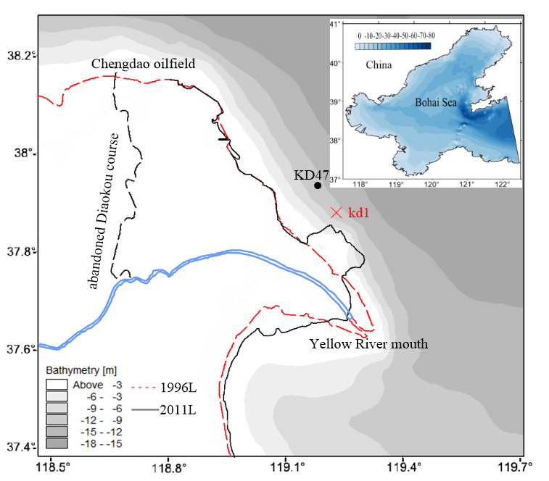

Fig. 1 The site location and bathymetry. The bathymetry survey was carried out in 2002 and the shoreline shown is the low tide line in 1996 and 2011.

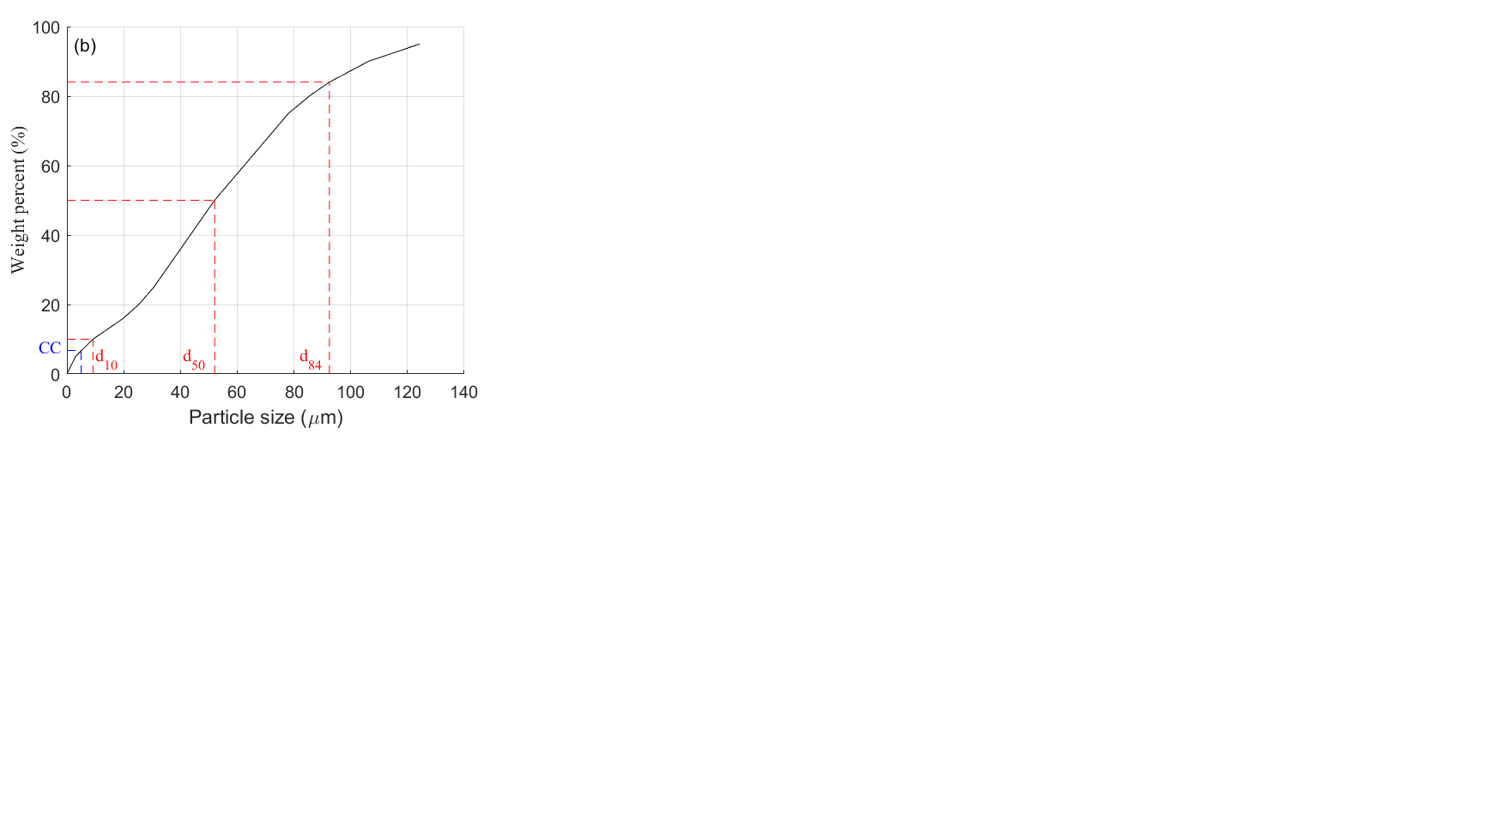

Fig. 2 The grain size accumulation curve of surface sediment.

# 3. Materials and methods

3.1 Site setup

The SSC and accompanying hydrodynamics were simultaneously measured with an instrumented tripod that was equipped with an up-looking Acoustic Doppler Current Profiler (ADCP) at z =70 cm, and an Optical Backscatter Sensor (OBS) at z = 40 cm (z is the height from the seabed). The current profile and OBS measurements were configured to simultaneously sample every 10 minutes from November 1 to December 26, 2012 and every 30 minutes from December 27, 2012 to March 30, 2013. The wave measurement was set to sample every one hour from November 1 to December 26, 2012 and two hours from December 27, 2012 to March 30, 2013 at a frequency of 1 Hz.

Because of water sampling difficulties during windy conditions, we collected the surface sediment near the instrumented positions and made laboratory OBS sensor calibrations to establish the relationship between the SSC and the measured count values acquired from the OBS (R2=0.976).

3.2 Data and methodology

The tidal elevation and tidal current were predicted using a T-Tide harmonic analysis based on the observation data (Pawlowicz et al., 2002). The observed raw waves contain both swell and wind wave components. We separated the observed raw wave data into wind waves and swell by bandpass filtering with a band separation frequency of 0.14 Hz, which was usually considered as the dividing line between swell and wind wave (Elgar et al., 1992; Kris et al., 2017).

The wind data are from Climate Forecast System Reanalysis (CFSR), collected at one-hour intervals. The intensity and direction of winter winds strongly affect the wave energy distribution, which can be reflected in wave components, heights and periods. Fig. 3 shows the wave energy spectrum distribution during part of the observation period. It can be seen that high wave energy waves were concentrated in the low frequency range during strong winter wind events. These high energy waves have high potential for sediment resuspension and seabed erosion.

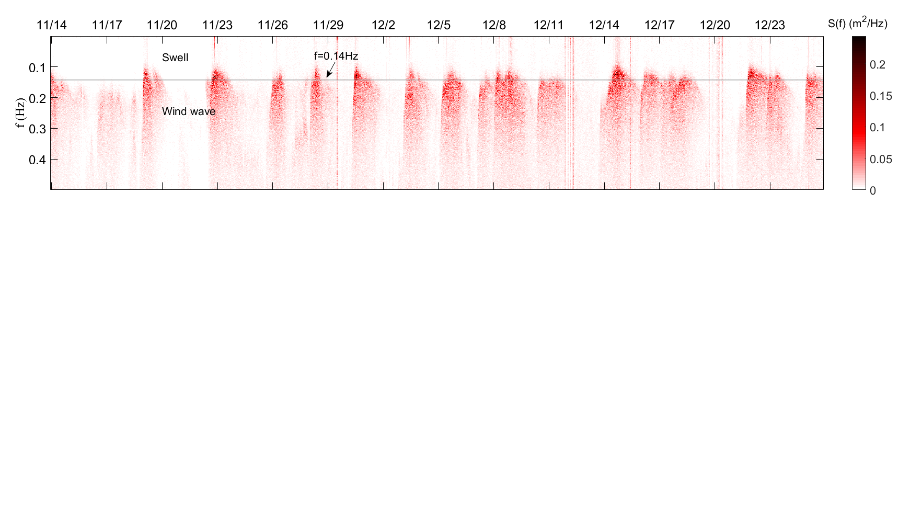

Fig. 3 The wave energy spectrum distribution during November 12 to December 26, 2012. The frequency f=0.14 Hz in the figure shows the separation frequency of local wind waves and swell.

In this study, the bottom shear stress is calculated using formulas from Soulsby (1993, 2005). For a current in water depth *h*, with depth-averaged velocity , density *ρ*, and bed roughness height *z*0 (*z*0/h=10-4), the bed shear stress *τc* is given by

, (1)

where . (2)

For a wave with period *T*, and orbital velocity *Uw*, the bed shear stress *τw* is given by

, (3)

where *fw* is the wave friction coefficient. The wave friction factor depends solely on the bed roughness *kb* that is relative to the wave-orbital semi-excursion at the bed *Ab* (Nielsen, 1992). Soulsby (1997) proposed

, (4)

where *f*w is the wave friction coefficient, *Ab*=*UwT*. *Kb* is given as 2πD50/12, where *D50* is the median grain size of the bed sediment. For tidal current induced shear stress, the predicted current speed is used. For swell and wind waves, the significant wave height and average wave period are used.

# 4. Results

4.1 Hydrodynamic conditions

The observation lasted for five months throughout the long windy winter. The strong winds were mainly from the NE and NW. The observed maximum wind speed was 17.25 m/s, on March 22, 2013. Only 20 percent of the wind speed observations exceeded 10 m/s, and those exceeding 15 m/s were only from the NE and NW directions.

Generally, the height and period of local wind waves depend on fetch length, wind speed, wind event duration, and water depth (Green et al., 2014). Fig. 4 shows the observed wind velocity and wave height during the entire observation period. There is a significant difference between the directions of winds and waves, which is due to the waves being affected by wave refraction. The prevailing wave direction was NE, although other wind directions frequently occurred. Strong waves are also mainly from the NE, while waves from the S direction are seldom generated due to local landforms near the observation site. The potential for wave development under NE winds is much greater than from other directions. In the blue box of Fig. 4 (I and V), under equivalent wind power, the significant wave height caused by NE winds was approximately 1 m higher than that generated by NW winds. This is possibly caused by the superposition of wind waves and swell.

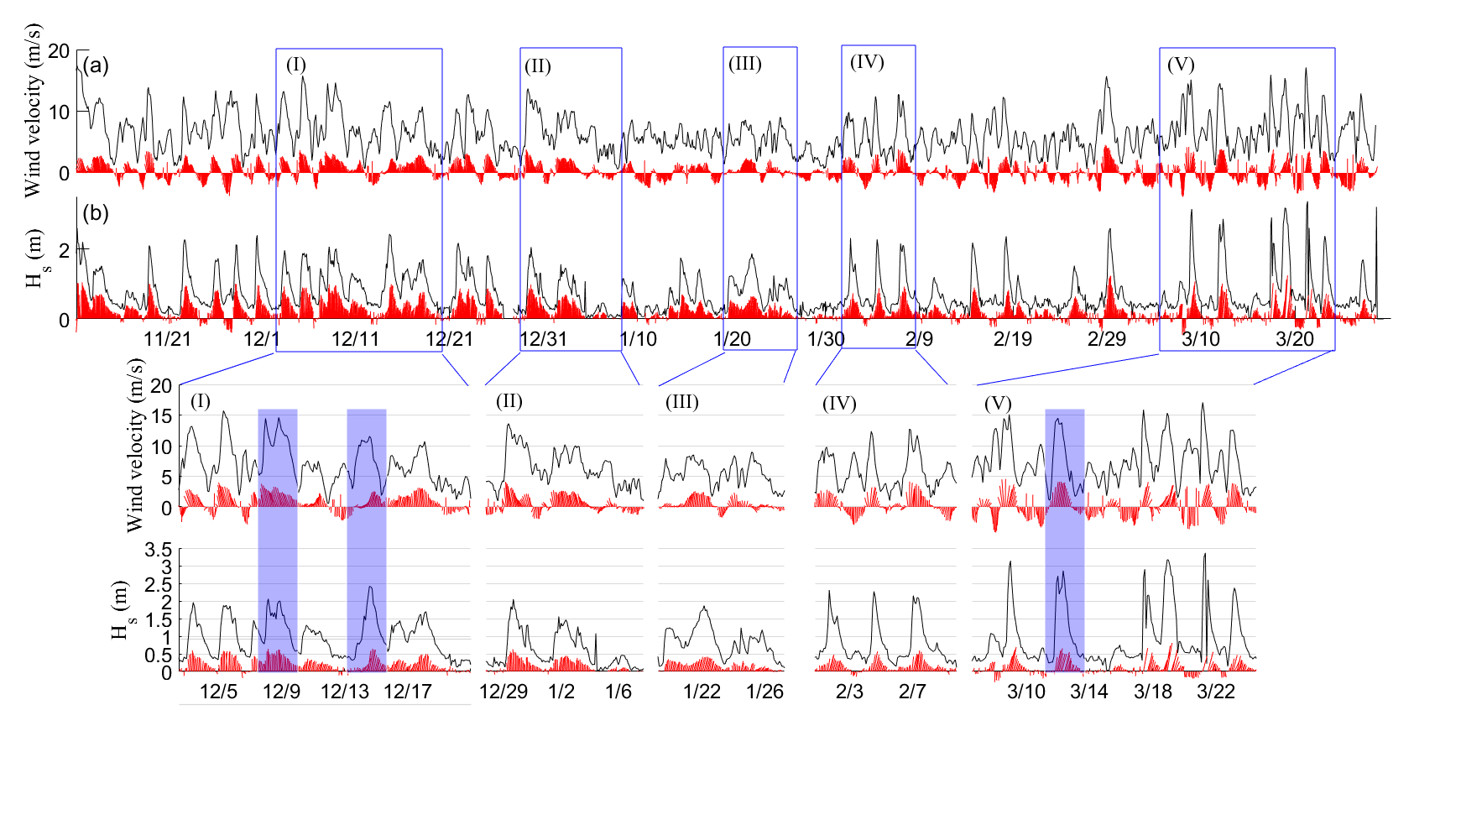Fig. 4 Time series of waves and corresponding winter winds during the entire observation period (top graph) with detailed comparisons from (I)–(V) (bottom graph). Red vectors show the direction of winds (a) or waves (b), and black curves show wind velocity (a) or wave height (b).

Winter winds strongly impact water dynamics because the water depth is relatively shallow in the study area. Temporal variation of water level and current speed during the observation period are shown in Fig. 5. Based on T-Tide harmonic analysis, the prediction of water level and residual water level are provided in Fig. 5 (a), in which the residual water level variation could be much larger than the tidal range (the maximum water elevation induced by wind stress was 2.65 m). It can be seen from Fig. 5 (a) that frequent winter winds lead to changing water level and all extreme water levels appear during and after wind action. The observed maximum instantaneous current velocity was 0.96 m/s, which includes tide speed and residual current of 0.47 m/s and 0.70 m/s, (Fig. 5 (c)). The strong residual current usually appears after large wind action which would transport a large amount of re-suspended sediment during winter wind events. In addition, the wind-induced current was much smaller than the tidal current in general, although the maximum residual current speeds caused by wind stress were higher than the maximum tide speeds during extremely windy storms.

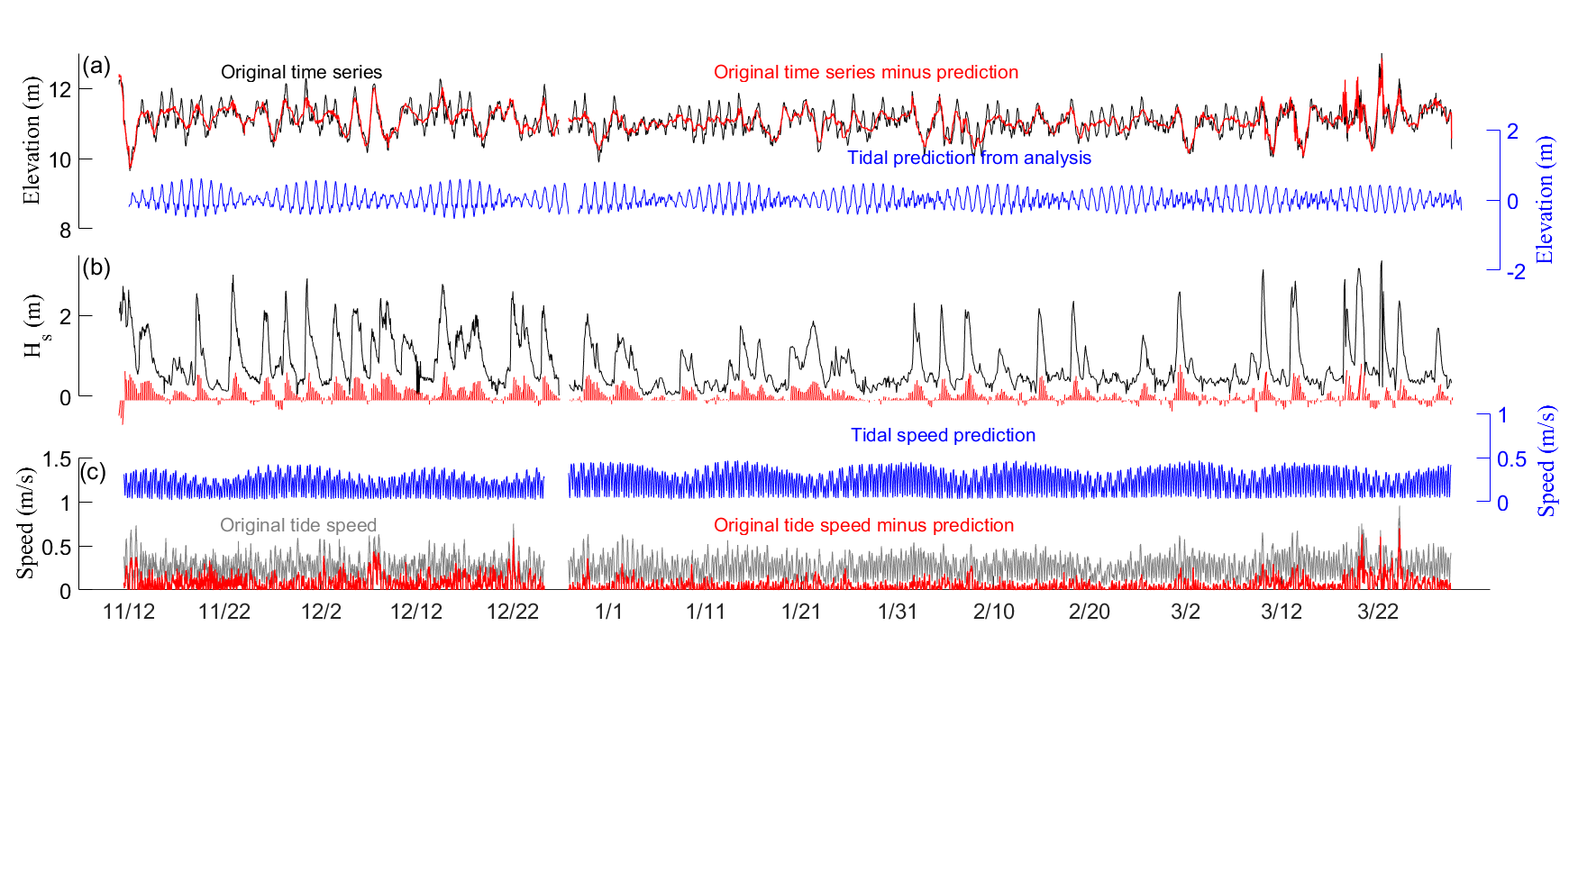

Fig. 5 Temporal variation of water level, wave height, and flow speed during the observation period. (a) Black line: original water level; blue line: tide level; red line: residual water level. (b) Significant wave height (black line) and wave direction (red line); (c) Gray line: original current speed; blue line: tide speed; red line: residual current speed.

The detailed wave series are shown in Fig. 6, where it can be seen that the height of wind waves induced by equivalent wind speeds were approximately equal (regardless of wind direction), but the wave height of swell under NE wind action was much larger. The maximum swell period was about 11 s (the average swell period was 8.9 s) and the average wind wave period was about 3.8 s, as shown in Fig. 6 (c). The wind wave periods declined rapidly as the wind speed decreased from its peak, while the swell decrease tended to lag behind the changes in the wind wave period.

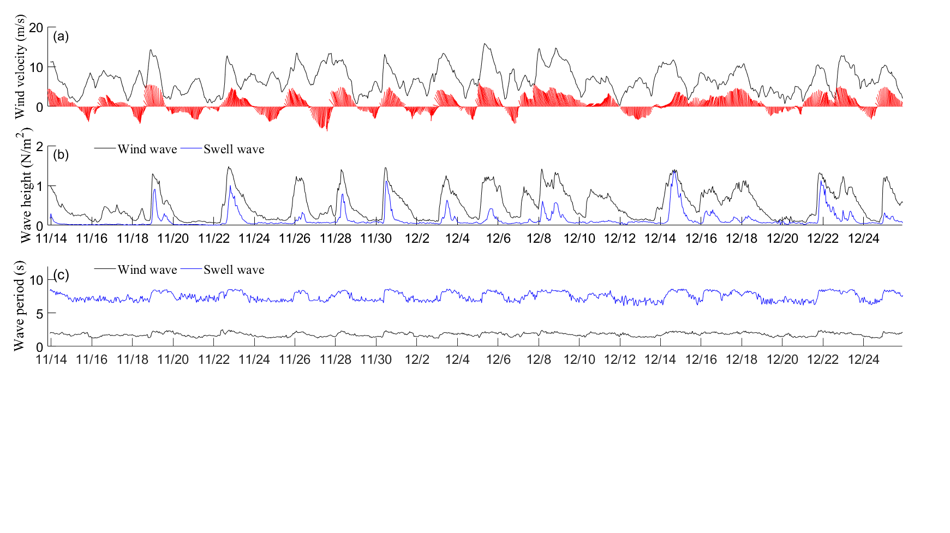

Fig. 6 Time series of local wind waves and swell and corresponding winter winds from November 12, 2012 to December 26, 2012. (a) Wind series and corresponding wind directions; (b) Wind wave height and swell height; (c) Wind wave period and swell period.

4.2 Shear stresses

The wavelength and orbital velocity of swell are much greater than those of the wind waves because of the larger wave periods. From November 14, 2012 to December 26, 2012, a huge difference existed between the orbital velocities of the swell and wind waves (Fig. 7b). The maximum orbital velocity of the swell reached 0.44 m/s while that of the wind waves was less than 0.07 m/s. The height of the swell was smaller than that of the wind waves, which indicates that the wind waves had much less effect on the motion of surface sediment than the swell. Based on the significant wave height, the average wave period and the depth-averaged current speed, the wind wave-, swell- and current-induced shear stresses are calculated (Fig. 7c). The difference in the shear stress induced by waves and swell is much greater than that of orbital velocity. The swell-induced shear stress became the principal component of bottom shear stress. When the height of swell was more than 1 m, the swell-induced shear stress reached nearly 0.85 N/m2, which was much larger than the current-induced shear stress. When the height was smaller than 1 m, the shear stresses induced by swell and current are close to the range of 0.37–0.58 N/m2. This implies that the swell and currents were the main dynamic factors in changes to the suspended sediment.

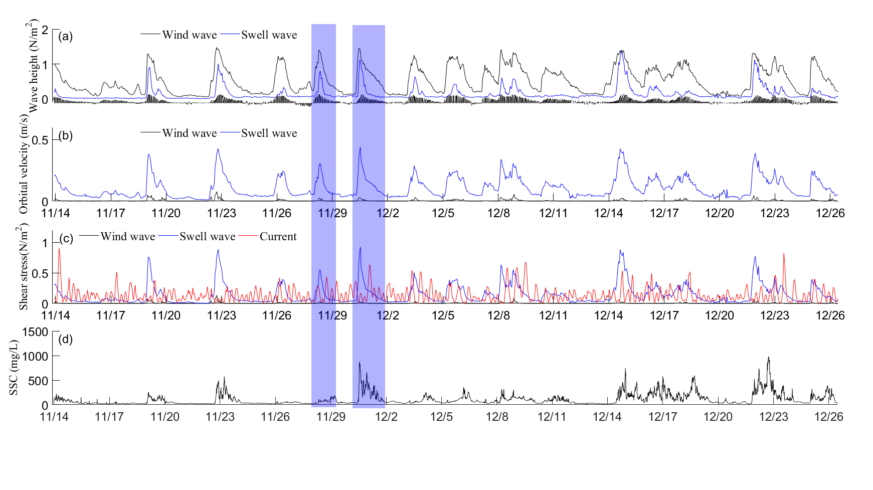

Fig. 7 Maximum orbital bottom velocity and bottom shear stress of the swell and wind waves from November 14, 2012 to December 26, 2012. (a) The height of wind waves and swell; (b) Maximum bottom orbital velocity of wind waves and swell; (c) Shear stress of wind waves, swell and currents; (d) The changing of bottom SSC. (Blue box: two contrasting cases under NW and NE winter winds.)

4.3 Sediment re-suspension during winter wind action

Fig. 7d illustrates changes in the near-bottom SSC under different wave directions from November 14, 2012 to December 26, 2012. During our observation period, more than one quarter of the days had strong winds that generated large waves with significant wave heights larger than 1 m. The bottom sediment was strongly disturbed during strong winter wind action, although sediment suspension was difficult for tidal currents to generate on calm days. As shown in Fig. 7d, all of the SSCs during the winter wind events were significantly higher than those on normal days, but the SSC levels show marked variations under the different wave action directions due to the swell wave height differences. With respect to the two events from November 28 to December 2 under equivalent NW wind and NE wind conditions (blue box in Fig. 7), the swell wave heights were 0.79 m and 1.11 m, the wind wave heights were 1.4 and 1.45 m, and the peak SSCs were 113.9 and 871.2 mg/L (an eightfold difference between two events).

Fig. 8 shows the variation of bottom SSC as well as the corresponding wave and current conditions during two typical wind events with NW and NE winds. According to the intensity of waves, swell, and SSC, the growth process of swell during winter wind events is characterized by four stages: (I) swell growth; (II) strong wave action; (III) wave decay; (IV) wave damping out. In stage (I), the winds and swell gradually grow to their peak, and the bottom SSCs increase from about 20 to 100 mg/L during both NE and NW events. In stage (II), the difference in swell development (swell height, period, or energy distribution) in NE and NW winds strongly affects the variation in bottom SSC. During this stage, the strong swell disturbs the seabed and increases the bottom SSC from near 100 to 1000 mg/L (Fig. 8(d), stage (II)), while the weak swell in the NW wind event has only a moderate effect on the bottom SSC (Fig. 8(c), stage (II)). When the waves begin to decay (stage III), the hydrodynamic forces become weak, causing the wave-induced shear stress to decrease, which benefits the settlement of suspended sediment. We can see that the bottom SSC decreases from near 1000 mg/L to 150 mg/L during stage III in Fig. 8(d). It should be noted that both wave and current have contribution substantial effect on the maintenance of sediment suspension in stage III. In stage IV, the residual current could transport sediment to the observation site leading to an increase in bottom SSC.

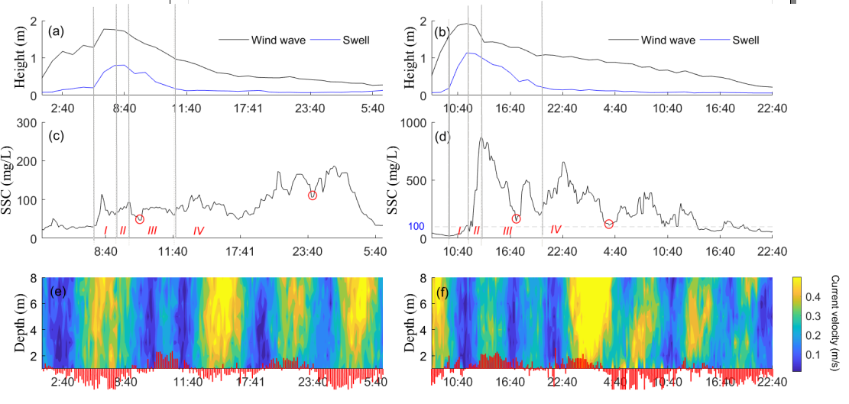

Fig. 8 Comparison of bottom SSC and the corresponding wave and current conditions during two typical windy events from the NW [(a), (c) and (e)] and NE [(b), (d) and (f)] direction. (a), (c) and (e) show the wave height, SSC and current during November 28 to 29, 2012; (b), (d) and (f) show the wave height, SSC and current during November 30 to December 1.

Fig. 9 shows the relationship of the peak SSCs during stage II and the corresponding significant wave height of swell for each wind event from different directions. As shown that there is a much higher potential of swell development with NE wind events (significant swell height usually > 1.0 m) and all of the high SSC events occur during these periods. The swell during NW wind events is smaller (significant swell height is usually < 1.0 m) and its corresponding bottom SSC in stage II is below 250 mg/L. If the wind changes from NW to NE, the peak swell height almost reaches that of NE events but the corresponding bottom SSC are much smaller than a NE event. Taken as a whole, swell controls the incipient motion of the seabed sediment and the NE wind events have the greatest potential to suspend seabed sediment.

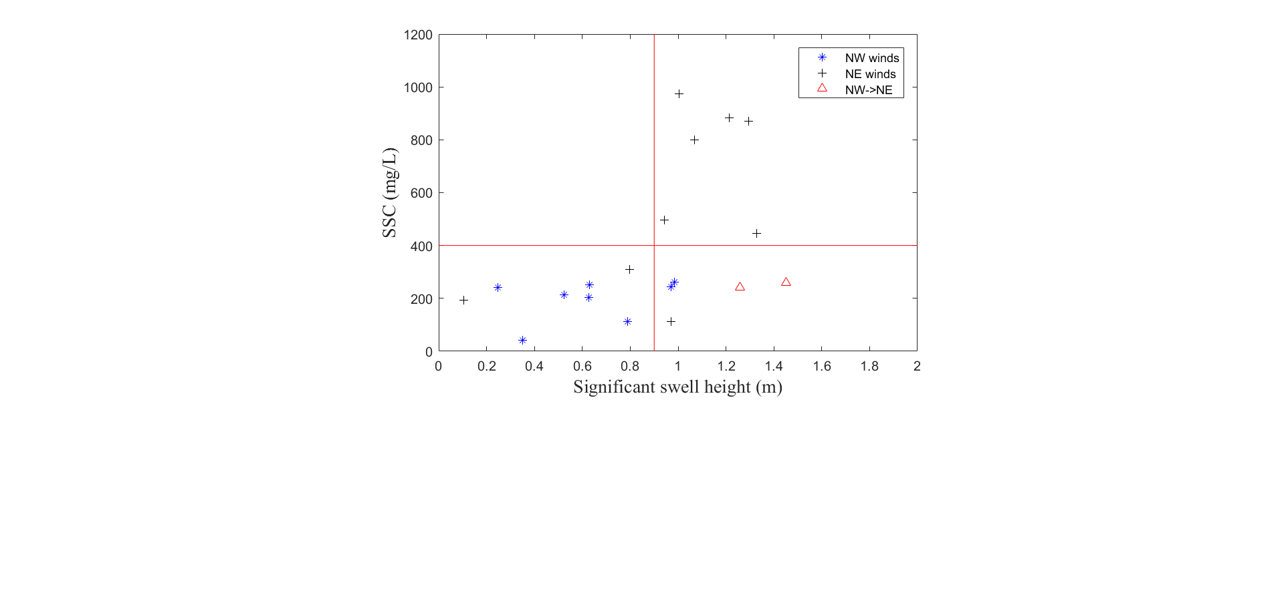

Fig. 9 Peak SSC in stage II and its corresponding swell heights during different winter wind events

The degree of seabed consolidation is another key parameter that affects the process of re-suspension. We can see that the sediments were easily re-suspended on December 16 and 17 after the strong wave action that occurred on December 15 (Fig. 7d), which indicates that the sediments are more easily re-suspended if they were recently strongly disturbed. The sediment of the Huanghe Delta needs 1–2 days after deposition to form an over-consolidated hard shell (Jia et al., 2014).

4.4 Sediment transportation during winter wind action

Sediment transportation from other areas is possibly another contributor to local SSC. As Fig. 7d (blue box) shows, the observed SSC rapidly reached its peak during NE wave action, but was delayed for 13–15 hours during NNW and N wave action. This indicates that high SSC under NE winds is induced by in-site re-suspending, while under NNW and N winds the enhanced SSC is mainly caused by off-site sediment transport.

The sediment motion and transportation under different wind directions displayed different trends. Fig. 10 and Fig. 11 show the detailed influence of different wave directions on sediment transport. For NW wind events (corresponding to NNW and N waves), a constant southeast residual current could lead to the constant transport of sediment toward the deeper sea, which can be decomposed into a direction parallel (SE, Fig.10f) and perpendicular to the isobaths (NE, Fig.10g). The accumulated sediment mass could be as much as 49.32 t/m2 in the SE direction and 13.95 t/m2 in the NE direction under continuous NW winds from December 4th to 10th.. Other individual NW wind events could transport sediment 1.5–4 t/m2 in SE direction and 0.6–5 t/m2 in NE direction from the observation site to deeper sea. In particular, during NW winds a significant part of SSC is from off-site transportation (from the zone that closer to the shore) instead of in-site suspension.

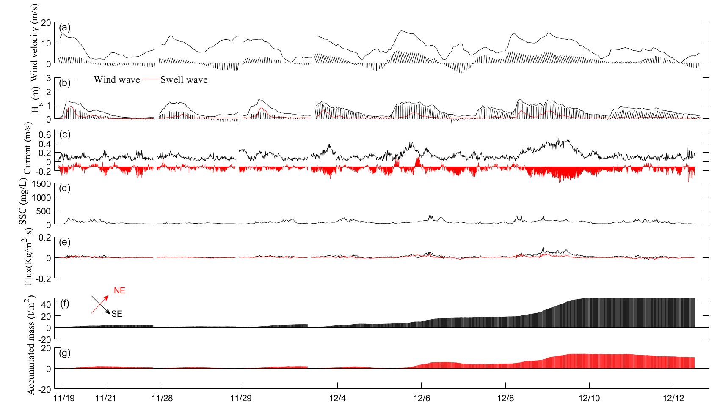

Fig. 10 The sediment transport flux and accumulated mass during NW wind events. (NE and NW are the direction of parallel and perpendicular to the isobaths respectively). (a) Wind velocity and direction; (b) Wind wave, swell height and wave direction; (c) SSC series; (d) The sediment flux across the site every second; (f) The accumulated mass of transportation sediment during different event.

The sediment transport trend during NE winds events shows different characteristics (Fig. 11). First, the individual NE wind events transport sediment 8–13.6 t/m2 parallel to the isobaths direction and 5.1–8.2 t/m2 perpendicular to the isobaths are much stronger than individual NW wind events, and a large proportion of sediment come from in-site suspension. Secondly, the residual currents are relatively smaller and their directions are variable, therefore they could not lead to constant transport of sediment. However, the net transport is still toward to deeper sea during the entire winter. Finally, the SSCs and residual current speeds remained high for about 10–15 hours after NE wind action, but the direction of residual currents is highly variable, creating uncertainty about the net transport mass and transport direction.

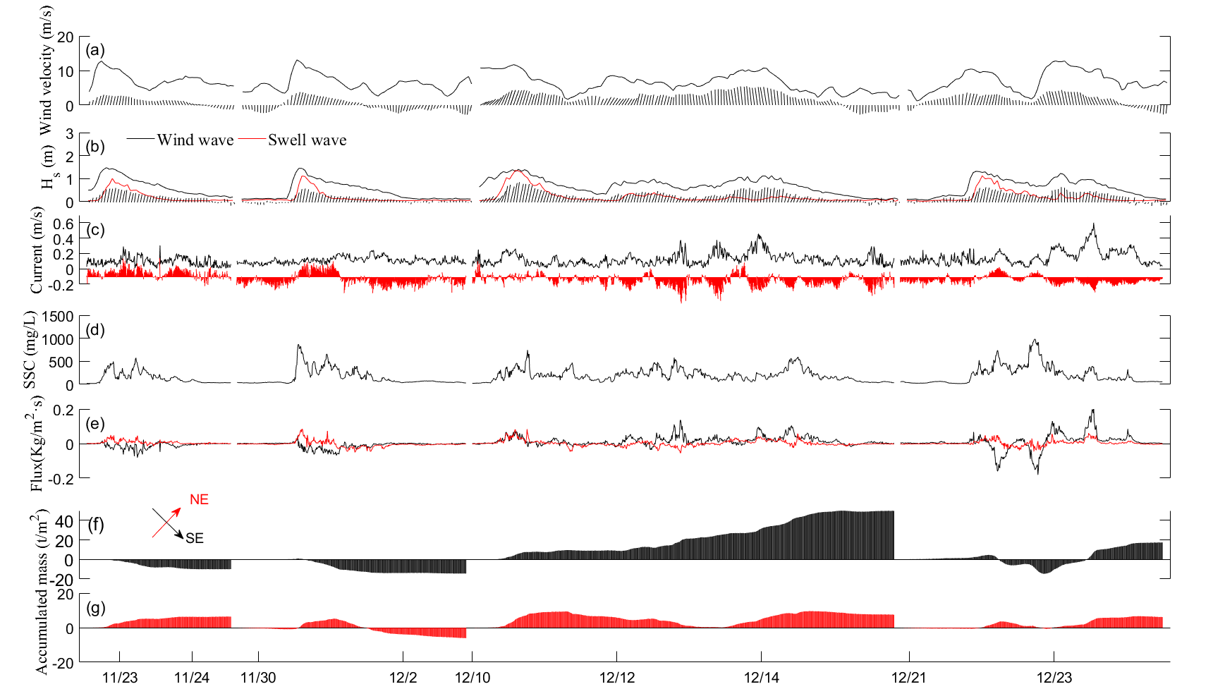

Fig. 11 The sediment transport flux and accumulated mass during NE winds (NE and NW are the directions parallel and perpendicular to the isobaths). (a) Wind velocity and direction; (b) Wind wave, swell height and wave direction; (c) SSC series; (d) The sediment flux across the site every second; (f) The accumulated mass of transportation sediment during different events.

In short, strong wind events are the major means of sediment transport from study area to the deeper sea, and NW winds lead to constant transport of sediment while NE winds lead to uncertainty in the net transport during different events. However, due to the fact that the resuspension ability under NE winds is much stronger, a larger volume of seabed sediments are resuspended and transported away, so the seabed is strongly eroded during this process.

# 4. Discussion of sediment re-suspension mechanism under winter winds

Waves and currents are important dynamic forces in sediment re-suspension in shallow coastal waters (Warrick, 2013), but the composition of bottom shear stresses varies with water depth. It can be inferred from the research results that the bottom shear stress in the inner shelf area near the Huanghe Delta is swell dominated during strong winter wind events, although the development potential of swell in this area is strongly affected by the local terrain The orientation of the isobaths is NW–SE and the longest fetch is NE, so swell develop more easily in the NE direction. The NE winter wind plays the most important role in sediment re-suspension. However, additional information about this mechanism is still required. Waves also play an important role in seabed liquefaction (Jia et al., 2014), which possibly accelerates the sediment suspension (Zang et al., 2007). During this observation period, the fact that, the SSCs could reach peak rapidly under the influence of large NE swells may be related to the liquefaction of surface sediment. The SSCs association with small swell may be due to the shear action of oscillating water in an un-liquefaction condition. It is necessary to carry out field observations on the response of soil to random waves in order to discriminate between the different contributions of swell induced shear stress and seabed liquefaction for sediment re-suspension.

Overall, waves are the most important engines for the processes of sediment re-suspension and coastal seabed erosion, but different wave components possibly have distinct functions for sediment resuspension as well as soil liquification (Niu et al., 2019). The traditional statistical approach using wave parameters would inevitably inaccurately represent the vital function of principal components. In this article, the swell is the major dynamics factor that dominates the motion of surface seabed sediment. It would be difficult to assess the role of swell accurately using the significant wave height and average wave period based on the original raw wave data. It is necessary to conduct more detailed investigations on principal components of random waves within different coastal zone environments and quantify their impact on sediment dynamics.

# 5. Conclusions

(1) Swell controls the incipient motion of sediment in the inner shelf zone, and swell that is larger than 1 m is responsible for all the strong resuspension events. The differences in swell heights strongly affect the process of sediment resuspension.

(2) Due to topographic effects, the development potential of swell from different directions tends to show significant variations, which further affect the sediment motion and transport. In this study, large swell from the NE direction was responsible for most of the sediment suspension events.

(3) Winter winds and the accompanying residual currents are the major mechanism for transporting sediment toward the deeper sea. Based on the calculation of flux and transport mass, NW winds that blow offshore constantly transport sediment toward the deeper sea, while the transport mass under a NE wind event is variable due to the changing of residual current direction.

# Acknowledgments

This study was supported by the Natural Science Foundation of China [Grant Nos. 41976198, 51479182, 41806072], the National Key Research and Development Program of China [Grant No. SQ2017YFGH001475], and the Taishan Scholar Project granted to Guangxue Li. We thank LetPub (www.letpub.com) for its linguistic assistance during the preparation of this manuscript.

# References

Aucan, J., Ardhuin, F., 2013. Infragravity waves in the deep ocean: an upward revision. Geophys. Res. Lett. 40, pp. 3435–3439.

Crawford, W., Ballu, V., Bertin, X., et al., 2015. The sources of deep ocean infragravity waves observed in the North Atlantic Ocean. J. Geophys. Res. 120, pp. 5120–5133.

Dalyander, P.S., Butman, B., Sherwood, C.R., et al, 2017. Characterizing wave-and current- induced bottom shear stress: US middle Atlantic continental shelf. Continental Shelf Research, 52, 73-86.

Elgar, S., Herbers, T.H.C., Okihiro, M., et al., 1992. Observations of infragravity waves. J. Geophys. Res. 97, pp. 15573–15577.

Fiedler, J. W., Brodie, K. L., McNinch, J. E., et al., 2015. Observations of runup and energy flux on a low-slope beach with high-energy, long-period ocean swell. Geophys. Res. Lett. 42, pp. 9933–9941.

Green, M.O., Coco, G., 2014. Review of wave-driven sediment resuspension and transport inestuaries, Rev. Geophys., 52, pp. 77–117.

Guza, R. T., Thornton, E. B., 1982. Swash oscillations on a natural beach. J. Geophys. Res. 87, pp. 483–491.

Inch, K., Davidson, M., Masselink, G., et al., 2017. Observations of nearshore infragravity wave dynamics under high energy swell and wind-wave conditions. Continental Shelf Research, 138, pp. 19-31.

Jia, L., Ren, J., Nie, D., et al., 2014. Wave-current bottom shear stresses and sediment re- suspension in the mouth bar of the Modaomen Estuary during the dry season. Acta Oceanologica Sinica, 33(7), pp. 107-115.

Jia, Y., Zhang, L., Zheng, J., et al, 2014. Effects of wave-induced seabed liquefaction on sediment re-suspension in the Yellow River Delta. Ocean Engineering, 89, pp.146-156.

National Center for Atmospheric Research Staff (Eds). Last modified 08 Nov 2017. "The Climate Data Guide: Climate Forecast System Reanalysis (CFSR)." Retrieved from <https://climatedataguide.ucar.edu/climate-data/climate-forecast-system-reanalysis-cfsr.>

Niu, J., Xu, J.S., Dong, P., et al., 2019. Pore water pressure responses in silty sediment bed under random wave action. Scientific Reports, 9(1): p. 11685.

Jing, L., Ridd, P. V., 1996. Wave-current bottom shear stresses and sediment resuspension in Cleveland Bay, Australia. Coastal Engineering, 29(1–2), pp. 169–186

Oradiwe, E. N.. (1986). Sediment budget for monterey bay. Thesis Collection, pp. 20

Pawlowicz, R., Beardsley, B., Lentz, S., 2002. Classical tidal harmonic analysis including error estimates in MATLAB using T_TIDE, Computers and Geosciences 28, 929-937

Senechal, N., Coco, G., Bryan, K.R., et al., 2011. Wave runup during extreme storm conditions. Coastal Res., SI56, pp. 1706–1710.

Soulsby, R. L., Hamm, L., Klopman, G., et al. 1993. Wave-current interaction within and outside the bottom boundary layer. Coastal Engineering, 21, pp. 41–69

Soulsby R. 1997. Dynamics of Marine Sands, a Manual for Practical Applications. London: Thomas Telford Publications, pp. 249

Thornton, E. B., Guza, R.T., 1982. Energy saturation and phase speeds measured on a natural beach. J. Geophys. Res. 87, pp. 9499–9508.

Wang, A., Wang, H, Bi, N., et al., 2016. Sediment Transport and Dispersal Pattern from the Bohai Sea to the Yellow Sea. Journal of Coastal Research, 74, pp. 104-116.

Wang, N., Li, G., Qiao, L., et al, 2017. Long-term evolution in the location, propagation, and magnitude of the tidal shear front off the Yellow River Mouth[J]. Continental Shelf Research, 137:1-12.

Warrick, J. A., 2013. Dispersal of fine sediment in nearshore coastal waters. Journal of Coastal Research, 29(3), pp. 579–596

Yang, Z.S., Ji, Y., Bi, N., et al., 2011. Sediment transport off the Huanghe (Yellow River) delta and in the adjacent Bohai Sea in winter and seasonal comparison. Estuarine, Coastal and Shelf Science, 93(3), pp.173-181.

You, Z.J., Yin, B.S. (2007). Fine sediment resuspension dynamics in Moreton Bay. China Ocean Engineering, 21(2), 267-280.

Zang, Q.Y., 1996. Nearshore Sediment along the Yellow River Delta. Ocean Press, Beijing (in Chinese).

Zhang, J., Huang, W.W., Liu, M.G., 1985. Distribution of suspended materials and its seasonal change in Huanghe River estuary as well as the nearby sea area. Journal of Shandong College of Oceanology 15 (2), pp. 96-104 (in Chinese, with English abstract).