Penetrating neck injuries
AM Khan
JC Fleming
JP Jeannon

British Journal of Hospital MedicineVol. 79, No. 2

Abstract:
Penetrating neck injuries (PNI) are becoming common due to the increasing prevalence of knife and gun crimes. The immediate and long-term consequences of injury to the neck can be significant doe to the close relationship of important anatomical structures in a confined space. Delayed recognition of major injury and inadequate treatment results in high morbidity and mortality. Developing a clear understanding of the underlying anatomy, common mechanisms of injury and principles in management will provide first responders, emergency doctors and trauma surgeons with confidence in appropriate evidence based management. Early involvement of Otolaryngologists or Head and Neck Surgeons is advisable. Two cases of PNI from the June 2017 London Bridge terror attack are discussed.

Introduction:
Penetrating trauma is increasingly common with rising knife crimes, gun crimes and terrorism related ballistics in the civilian arena (House of Commons Library, 2017). Neck trauma is responsible for 2.29% of all trauma related attendances with a case fatality rate of 17.76% (American College of Surgeons, 2016). The incidence of penetrating neck injuries (PNI) currently stands at 4.3 cases per 100,000 people in London (Harris et al., 2012). Although trauma incidence in the UK is relatively low by international comparisons, all emergency departments will likely encounter PNI, highlighting the need for efficient and accurate patient management. It is important for Emergency Departments to employ a systematic method for managing these complex cases, not helped by a paucity of high quality literature on this subject. A clear understanding of neck anatomy, typical mechanisms of injury, ‘hard signs’ of severe trauma and proven principles of patient management should allow clinicians to provide optimal safe care.
Anatomy of Neck:
Neck anatomy is complex (Table 1). Structures are best appreciated by considering the main fascial planes of the neck, namely the superficial and the deep cervical fasciae. The superficial fascia embraces the platysma muscle in the neck and is continuous with the superficial musculoaponeurotic system of the face. Injuries that do not penetrate this layer are invariably innocuous as there are no superficial vital structures. The deep cervical fascia is composed of three separate layers that encase many of the structures of the neck (Table 2). Conceptually these can be considered as tubes traversing the neck between the thorax and head. All three layers merge to form the carotid sheaths which surrounds the common carotid artery, internal jugular vein, vagus nerve and the deep cervical lymph nodes.
The most widely accepted anatomical classification used in PNI separates the anterior neck into three zones, namely: 1. clavicles to cricoid cartilage; 2. cricoid cartilage to angle of mandible; 3. angle of mandible to base of skull (Monson et al., 1969). There are many important structures that should be considered at each of these levels (Figure 1). Traditionally, the zones of the neck have a bearing on subsequent management, however improved trauma imaging modalities have made use of neck zones less important. Injuries of the posterior triangle of the neck are considered separately.

Mechanism of Injury
Penetrating injuries can be classified as low velocity and high velocity. The most common causes of penetrating neck injury (PNI) are low velocity stab wounds (SW) and high velocity gunshot wounds (GSW). Understanding the exact mechanism of injury for each incident is important in predicting the possible injuries that might arise.
Stab Wounds
SW are low velocity injuries caused due to knives, razor blades, broken glass shards or other sharp instruments which tend to cut through the skin and subcutaneous tissue dividing structures. There has been a recent trend amongst crime gangs towards the use of large hunting knives with long serrated blades that are designed to inflect maximal soft tissue injury. Clinicians should be weary of the small entry wound sites typical of sharp objects. There is often an unclear depth of penetration and a breach of platysma that should raise concerns of serious injury to vital structures. Multiple SW may present a particular problem with several entry wounds. Zone 1 is the most commonly affected area (Madsen et al., 2016). Haemopneumothorax is eight times more common in SW compared to GSW. This may be due to the trajectory often being from high to low during stabbings. Laceration of the inominate and subclavian vessels should also be considered.
Gunshot Wounds
All GSW are high-energy with the potential to cause devastating injury. The amount of energy imparted to tissue depends upon several factors including the type of weapon, size (calibre) of the weapon’s muzzle, distance between weapon and contact tissue and finally the property (mass and velocity) of the projectile. With higher velocity injuries, more surrounding tissue is disrupted by the energy-transfer. In handgun GSW, there is typically a small entry and exit wound. The tissue between these two points is lacerated and crushed. In high-energy GSW which typically result from rifle or automatic weapons are more unpredictable and often have unclear exit wounds due to the widespread shock wave and cavitations damage from the ballistic round. These result in significant destruction of soft tissues which significantly increases the amount of trauma to the patient.
GSW are more common in zone 2 of the neck. If the larynx is damaged, emergency tracheostomy is the usual course of action. Oesophageal injuries, spinal cord injury, brachial plexus injury and cervical spine injuries are more common in GSW compared to SW (Madesen et al., 2016).
Clinical Presentation and Investigative Modalities
All patients who present in trauma should be managed according to the Advanced Trauma Life Support (ATLS®) principles with immediate resuscitation with emphasis on the Airway, Breathing & Circulation (ABC) pathway (American College of Surgeons, 2012). This is followed by rapid identification of life-threatening injuries in an organised fashion with immediate correction of any physiological irregularities. In the context of PNI, stabilisation of the airway may be compromised due to the injury transgressing the airway therefore basic and advanced airway management techniques (such as cricothyroidotomy or tracheostomy) may need to be employed. In threatened airway cases, pre-emptively establishing a definitive airway should be paramount; eleven percent of patients require immediate airway management in the pre-hospital setting or on arrival to the Emergency Department (Mandavia et al., 2000). The most common technique is rapid sequence induction with direct laryngoscopy and placement of an endotracheal tube. Direct laryngoscopy provides the advantage of visualising the supraglottic area. Other possible techniques in a suspected difficult intubation include awake fibre-optic nasointubation, although caution must be exercised if there is any risk of skull base injury to avoid inadvertent intracranial passage. Intubation of patients directly through neck wounds has also been described. It is not uncommon for patients to require immediate cricothyrotomy or surgical tracheostomy by appropriate specialists depending on the nature of neck injury.
Once resuscitation has been achieved, a systematic secondary survey to evaluate the severity and extent of the trauma is needed. A focused head and neck examination should aim to identify any aerodigestive, vascular or nervous abnormalities. Penetrating injuries that obviously do not breach the superficial cervical fascia do not require exploration and can be closed primarily. For deeper injuries, ‘hard signs’ should be recognized during the primary survey (Table 4). These patients will need to undergo emergency operative management. Both entry and exit wounds should be identified in the context of their respective neck zones.
Although physical examination is effective in revealing most life-threatening vascular injuries, the absence of signs or symptoms does not rule out sinister pathology (Fogelman and Stewart, 1956). Therefore patient’s who lack ‘hard signs’ should undergo further investigations prior to determining the next stages in management (Figure 2). The literature appreciates both a classic and selective approach to managing these patients (Shiroff et al., 2013). The anatomically driven classic approach mandates surgical exploration for all zone 2 neck wounds that breach platysma and simple observation or digital subtraction angiography (DSA) for zones 1 and 3 injuries. This approach is now widely considered outdated as it is time-intensive, requiring multiple specialities to coordinate management, has a low-diagnostic yield and a high non-therapeutic rate from mandatory surgical exploration. Additionally, mandatory neck exploration is not practical in countries with very high incidence of penetrating trauma.
The selective ‘no-zone’ approach of managing PNI mandates those who lack ‘hard signs’ to be observed and undergo Computed Tomography Angiography (CTA). CTA has revolutionized trauma care with the distinct advantages of speed, high-resolution and high sensitivity (up to 100%) in assessing injuries in all three zones (Inaba et al., 2006). Further investigative studies are then chosen according to the patient’s symptoms and findings on CTA. These can be tailored to identify vascular (angiography), laryngo-tracheal (flexible nasendoscopy or bronchoscopy), oesophageal (oesophagoscopy or oesphagography) or nervous (magnetic resonance imaging) injuries.
Cervical Spine:
The merit of neck immobilisation in all PNI is debatable with only 1.4% of casualties benefiting from the intervention (Arishita et al., 1989). Suspicions should be raised in the context of gunshot wounds (GSW) as the evidence suggests this mechanism is six times more likely to cause cervical injuries than stab wounds (SW) (Madsen et al., 2016). This is especially true if the projectile travels in a transcervical trajectory. The use of hard collars in all penetrating injuries may result in missing potentially life-threatening signs diagnosed on an exposed neck (Barkana et al., 2000). This demonstrates the need for thorough assessment of the neck during the primary survey, ideally with manual head immobilisation whilst hard collars are temporarily removed.
Aerodigestive Tract:
Accurate assessment of the patient’s airway is paramount. The aforementioned ‘hard signs’ of stridor, hoarseness, bubbling wounds and subcutaneous emphysema suggest underlying laryngo-tracheal injury. Trauma teams should also consider direct (haemorrhage, foreign body) and indirect (expanding haematoma) causes of airway obstruction. Even a small amount of bleeding within the tight neck compartment may lead to life-threatening airway compromise, secondary to lymphatic obstruction and oedema.
Oesophageal injury is relatively uncommon but there should be a low threshold for further investigation if penetrating trauma occurs within its proximity. The mortality is as high as 26% due to patient subsequently developing mediastinitis (Asensio and Bernie, 1997). A small tear in the oesophagus or pharynx can be managed conservatively with insertion of a nasogastric tube (NGT) and enteral feeding. A water soluble contrast study is performed at an interval in order to evaluate the integrity of the pharynx or oesophagus. A large pharyngeal or oesophageal leak that results in a pharyngo-cuteanous fistula for example may require neck exploration and repair.
Vascular:
The vascular system is the most commonly affected in PNI (Bell et al., 2007). Following vessel injury, a haematoma may form which temporarily tamponades the bleeding. A traumatic aneurysm may result from arterial injury which may also result is temporary cessation of bleeding. More significant bleeding may only occur when the patient is moved or dressings removed. In massive haemorrhage, active bleeding should be controlled with direct pressure in the first instance. Another recognised technique to control bleeding is the use of an 18- or 20-French Foley catheter balloon inserted into the wound and inflated to tamponade surrounding vessels (Navasaria et al., 2006). Military personal have been trialling battlefield haemostatic powder agents based on chiatin that is derived from marine animal exoskeleton. This is inserted into the wound and direct pressure applied and is used to act as a tamponade and assist stabilisation until evacuation to a medical facility. Patients with significant bleeding from zone 2 should undergo immediate operative exploration. Due to the difficulty in obtaining adequate vascular exposure, haemorrhage from zone 1 and 3 benefits from angiography and endovascular repair in the first instance if the patient’s condition is stable. Failure of endovascular repair warrants immediate open surgical exploration and repair.
Principles in Management
Operative management strategies vary depending on the clinical situation. A full description of surgical technique is beyond the scope of this article. However a number of key principles should be observed. Surgery can be divided into the following phases: access or approach, control and identification of the extent of injury followed by repair and reconstruction.
In the context of major haemorrhage the initial goal is to identify and control bleeding vessels. Defects of the common carotid, internal carotid or external carotid arteries should be repaired if possible. Larger defects may require ligation, primary re-anastomosis or grafting with autologous vein, polyester (Dacron) or polytetraflourethylene (PTFE) material. If the patient is haemodynamically stable then endovascular repair by specialist neurointerventional radiologists or vascular surgeons may be attempted (McNeil et al., 2002).
Great care must be taken when selecting an operative approach. The ideal incision should allow adequate exposure of the injured zone with the ability to extend the incision if necessary. A plan for closure and whether a graft or flap is required should also be made. Incisions may be incorporated into existing neck wounds to allow wound debridement and optimisation on closure. This will also provide evidence of the path of missile/weapon trajectory as the wound is exposed. Alternatively more commonly used head and neck surgery approaches can be utilised, providing a broad exposure to important structures and a degree of familiarity for the surgeon. Common incisions for zone 2 injuries are placed along the anterior border of the sternocleidomastoid muscle between the angle of the mandible and sternoclavicular joint. If access to zone 3 is required intraoperatively, the incision can be extended horizontally between the angle of mandible and mastoid process. Similarly, extension of the incision from the sternoclavicular joint along the superior border of the clavicle allows access to zone 1. Multidisciplinary involvement with otolaryngology maxillofacial, neurosurgical and thoracic teams should be supported.
Once a flap has been raised, careful dissection through the zone of injury should commence. The carotid sheath and its contents will be encountered deep to sternocleidomastoid. Obtaining adequate exposure of the common, internal and external carotid artery should ensue. This will allow proximal and distal control of the vessel as options for open repair are considered as described above. The most common vascular structure damaged is the internal jugular vein due to its lateral position, relative size and thin wall (Madsen et al., 2016). The internal jugular vein can be repaired and if necessary ligated.
Roughly 10% of vascular injuries following PNI will involve the carotid artery (Bell et al., 2007). All patients who are neurologically intact should have their carotid artery repaired if possible. Even those with neurological deficit pre-operatively should be considered for repair instead of ligation (Liekweg and Greenfield, 1978). Sacrifice of the carotid artery should not be adopted due to the risk of serious cerebro-vascular accident.
If the injury affects the cervical oesophagus then repair in a one or two-layered fashion should ensue. The surrounding strap muscles or sternocleidomastoid can bolster this repair. There should be liberal use of drains to reduce the risk of mediastinitis. Repair of laryngeal injury is dependent on the size of the defect. Primary aims are to allow future swallowing, speech and a safe airway. In simple lacerations, primary closure may be possible.
In more complex injury a tracheostomy may be necessary to bypass the upper airway during laryngeal repair and recovery, with the resultant oedema that will likely develop. It will also facilitate a safer return to theatre in the event of delayed presentation of other neurovascular injuries. Depending on the structures damaged, different approaches may be taken. Adequate exposure of the larynx can be obtained by performing a thyrotomy. This will allow visualisation of the hyoid, cricoid and thyroid components of the larynx. Repair of these structures can ensue with an aim of rigid fixation, aretenoid re-suspension and cricoid stabilisation. Ensuring sufficient haemostasis is paramount.
In the cases of gun shot trauma there may be significant tissue loss which may need debridement and reconstruction.

Case 1.
Patient A was a 34 year old woman, with a single stab injury from a hunting knife as part of the London Bridge Terror attack in June, 2017. She walked into the A&E Department with a 3cm left lateral neck injury in Zone 2 and a ‘sucking neck wound’. It was noted that when she spoke or coughed air leaked out of the neck.
ABC of resuscitation instituted and primary and secondary survey identified no other injury.
The patient was intubated with endotracheal tube by an anaesthetist as she developed progressive airway obstruction over the next few minutes. She was noted to have a difficult intubation due to oedema. A CT scan was performed that identified no vascular injury.
The neck wound was explored under general anaesthetic where a 9cm horizontal laceration to larynx through the thyrohyoid membrane was found with perforation of the pharynx and oesophagus and partial separation of the epiglottis from the larynx. Both carotid sheaths were intact. These injuries were repaired in layers with vicryl. A temporary tracheostomy was inserted. A gastrograffin study at day 7 showed complete healing of the pharynx (Figure 3). She was successfully de-cannulated at day 8 and the NGT was removed at day 14. She has subsequently made a full recovery.

Case 2.
Patient B was a 32 year old woman who received a single stab injury to left lateral zone 2 of the neck with a hunting knife as part of the same terrorist attack.
ABC resuscitation protocol was performed revealing no airway or acute vascular injuries. A CT scan was performed (Figure 4) that identified soft tissue injury around the left hypopharynx with free air indicating perforation of the pharynx.
She was taken to the operating theatre and the neck was explored. This revealed no vascular injury and the pharyngeal defect was repaired in layers. She made a complete recovery and was discharged on the seventh post-operative day

Conclusion:
A reasonable understanding of PNI is important in all first responders, emergency physicians and trauma surgeons due to increasing prevalence of knife and gun crimes. A structured approach to management by way of ATLS principles with emphasis on airway breathing and circulation is important. A selective rather than mandatory neck exploration should be utilised depending upon severity and extent of injuries. Damaged structures can be postulated based on the trajectory of insult and zone of neck involved. Patients with ‘hard signs’ should undergo emergency operative or endovascular repair. All other patients will require CTA and subsequent management of any identified injuries by a multidisciplinary surgical team.

Key Points:
- Penetrating neck injuries are increasingly common due to increasing knife and gun crime
- Structured ATLS approach to managing the patient is mandatory and allows early identification of life-threatening injuries.
- PNI with ‘Hard Signs’ mandates surgical exploration
- Common structures injured include the vasculature, aerodigestive tract, nerves and cervical spine.
- Surgical specialism from Head and Neck/ENT, Cardiothoracic, Vascular and Neurosurgical specialists should be sought early to allow appropriate patient management.
References
American College of Surgeons (2016). National Trauma Data Bank 2016 Annual Report. National Trauma Data Bank. American College of Surgeons.
Arishita, G., Vayer, J., Bellamy, R. (1989). Cervical spine immobilization of penetrating neck wounds in a hostile environment. Journal of Trauma, 29, pp.332-7
Asensio, J., Bernie, J. (1997). Penetrating esophageal injuries: time interval of safety for preoperative evaluation – how long is safe? The Journal of Trauma, 43(2), pp. 319-24
ATLS Student Course Manual: Advanced Trauma Life Support. (2012). 9th ed. American College of Surgeons.
Barkana, Y., Stein, M., Scope, A., Maor, R., Abramovich, Y., Friedman, Z. and Knoller, N. (2000). Prehospital stabilization of the cervical spine for penetrating injuries of the neck - is it necessary?. Injury, 31(5), pp.305-9.
Bell, R., Osborn, T., Dierks, E., Potter, B. and Long, W. (2007). Management of Penetrating Neck Injuries: A New Paradigm for Civilian Trauma. Journal of Oral and Maxillofacial Surgery, 65(4), pp.691-705.
Fogelman, M. Stewart, R. (1956). Penetrating wounds of the neck. The American Journal of Surgery, 91, pp. 581-93
Harris, R., Olding, C., Lacey, C., Bentley, R., Schulte, K., Lewis, D., Kandasamy, N. and Oakley, R. (2012). Changing incidence and management of penetrating neck injuries in the South East London trauma centre. The Annals of The Royal College of Surgeons of England, 94(4), pp.235-239.
House of Commons Library (2017). Firearm Crime Statistics: England & Wales. [online] London: House of Commons Library. Available at: http://researchbriefings.parliament.uk/ResearchBriefing/Summary/CBP-7654 [Accessed 22 Sep. 2017].
House of Commons Library (2017). Knife Crime Statistics. [online] London: House of Commons Library. Available at: http://researchbriefings.parliament.uk/ResearchBriefing/Summary/SN04304#_ftn1 [Accessed 22 Sep. 2017].
Inaba, K., Munera, F., McKenney, M., Rivas, L., de Moya, M., Bahouth, H. and Cohn, S. (2006). Prospective Evaluation of Screening Multislice Helical Computed Tomographic Angiography in the Initial Evaluation of Penetrating Neck Injuries. The Journal of Trauma: Injury, Infection, and Critical Care, 61(1), pp.144-149.
Liekweg Jr, W. and Greenfield, L. (1978). Management of penetrating carotid artery injury. Annals of Surgery, 188(5), pp.587-92.
Madsen, A., Laing, G., Bruce, J. and Clarke, D. (2016). A comparative audit of gunshot wounds and stab wounds to the neck in a South African metropolitan trauma service. The Annals of The Royal College of Surgeons of England, 98(7), pp.488-495.
Mandavia, D., Qualls, S., Rokos, I. (2000). Emergency Airway Management in Penetrating Neck Injury. Annals of Emergency Medicine, 35(3), pp. 221-5
McNeil, J., Chiou, A., Gunlock, M., Grayson, D., Soares, G. and Hagino, R. (2002). Successful endovascular therapy of a penetrating zone III internal carotid injury. Journal of Vascular Surgery, 36(1), pp.187-90.
Monson, D., Saletta, J. and Freeark, R. (1969). Carotid vertebral trauma. Journal of Trauma, 9(12), pp.987-99.
Navasaria, P., Thoma, M., Nicol, A. (2006). Foley Catheter Balloon Tamponade for Life-threatening Hemorrhage in Penetrating Neck Trauma. World Journal of Surgery, 30, pp.1265-8
Shiroff, A., Gale, S., Martin, N., Marchalik, D., Petrov, D., Ahmed, H., Rotondo, M. and Gracias, V. (2013). Penetrating neck trauma: a review of management strategies and discussion of the 'No Zone' approach. American Journal of Surgery, 79(1), pp.23-9.

System | Components
Respiratory | Larynx  Trachea
Vascular | Innominate Artery and Vein  Internal and External Carotid Artery and Branches  Internal and External Jugular Vein and Tributaries
Gastrointestinal | Oropharynx  Oesophagus
Endocrine | Thyroid gland  Parathyroid glands
Lymphatic | Lymphatic network and lymph nodes
Nervous | Spinal Cord  Cranial Nerves  Cervical Plexus  Brachial Plexus
Skeletal | Vertebral column  Mandible  Hyoid
Muscular | Platysma  Sternocleidomastoid  Suprahyoid musculature  Infrahyoid ‘strap’ musculature  Musculature surrounding vertebral column and skull
Table 1: Anatomical components of the neck

Layer | Relevant Anatomy | Contents
Investing | Superior Attachment: Superior nuchal line,  Mastoid process, Inferior border of mandible  Inferior Attachment: Thoracic outlet | Parotid gland  Submandibular gland  Sternocleidomastoid  Trapezius
Pre-tracheal | Situated anteriorly in neck  Superior Landmark: Hyoid bone  Inferior Landmark: Fuses with pericardium | Viscera:  Trachea, oesophagus, thyroid  Muscular:  Infrahyoid muscles
Prevertebral | Superior Attachment: Base of skull  Anterior: Transverse processes and vertebral bodies of vertebral column  Posterior: Ligamentum nuchae  Inferior: Endothoracic fascia of ribs | Vertebral Column
Table 2: Layers of deep cervical fascia

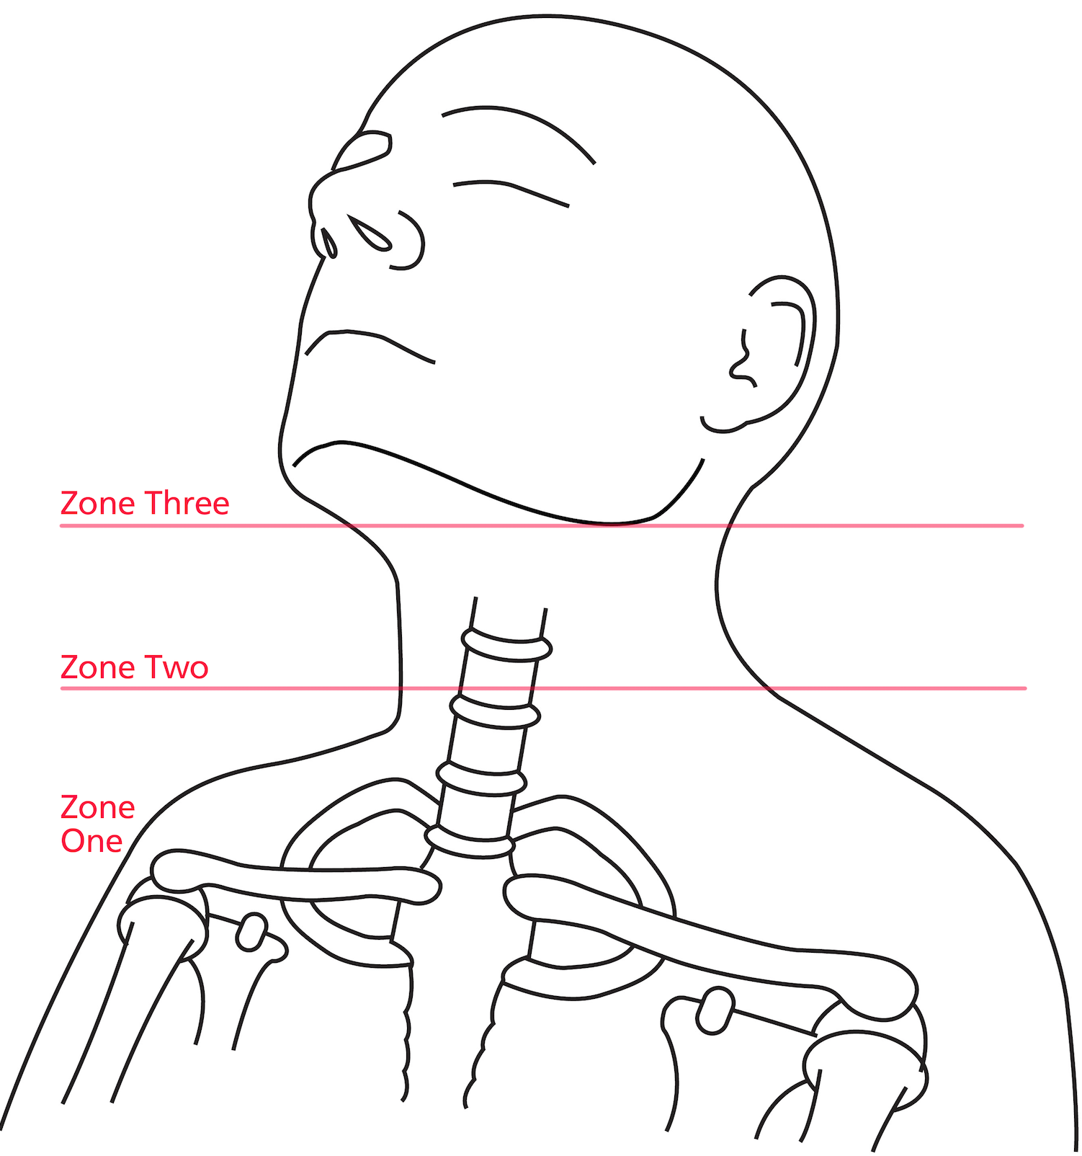
Figure 1: Zones of the Neck

Structure | Contents
Vessels  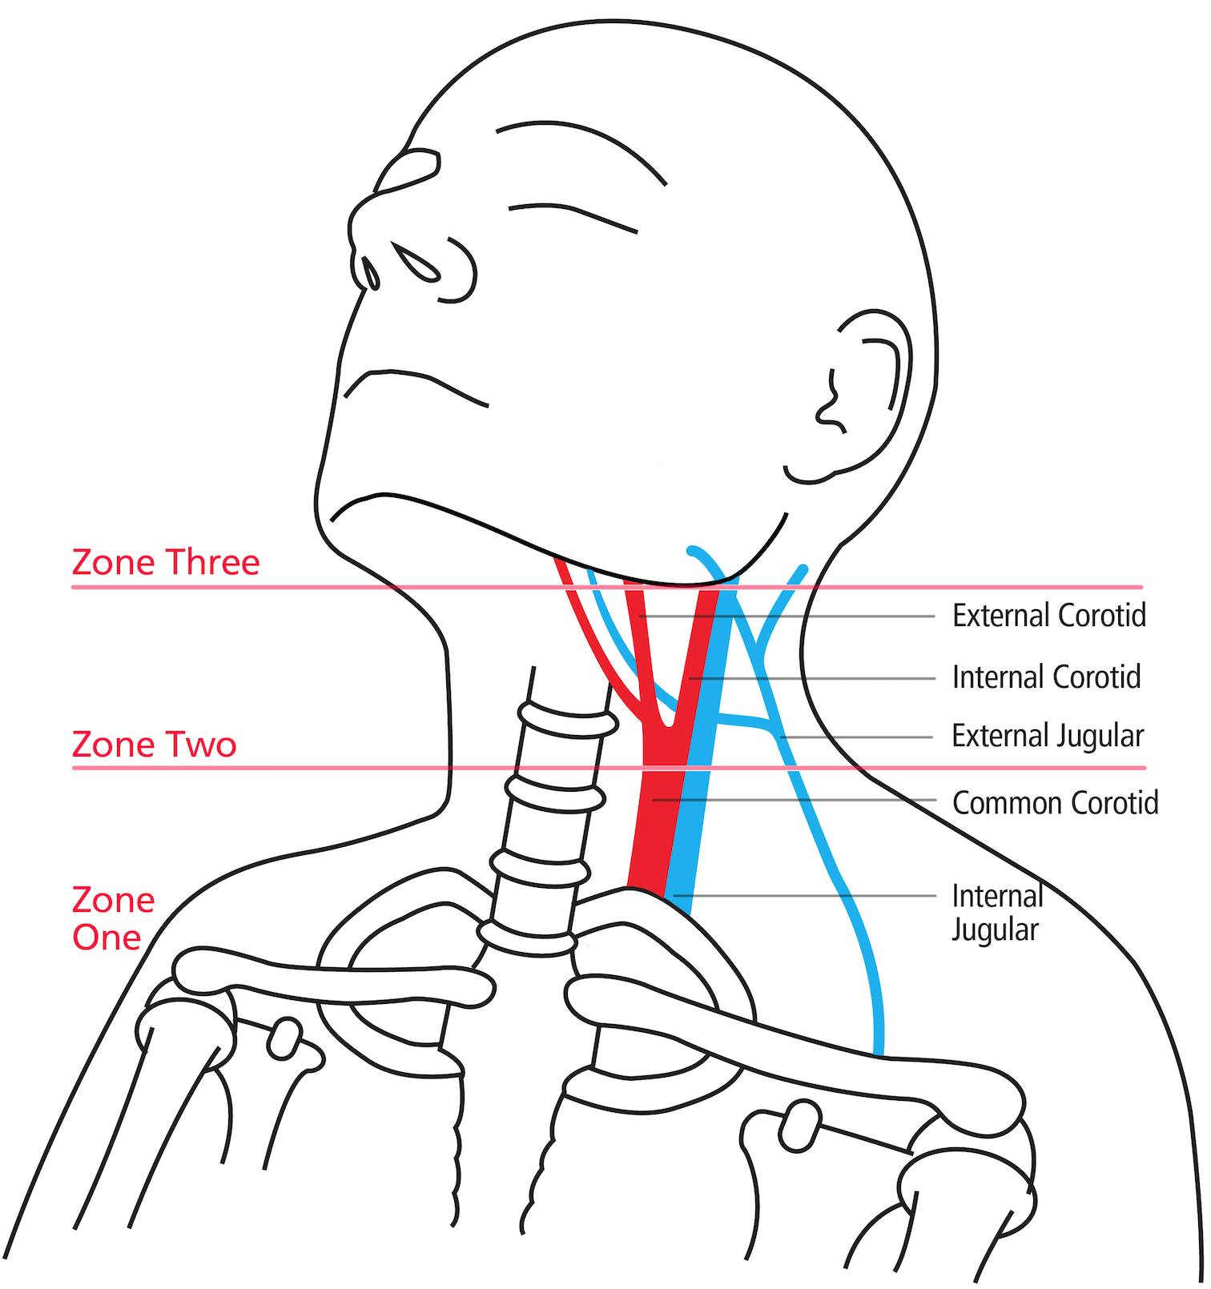 | Zone One:  Inominate Vessel, Vertebral Artery, Proximal Carotid Artery, Internal Jugular Vein  Zone Two:  Common Carotid Artery branching into the Internal and External Carotid Artery. Facial and Lingual Artery  Vertebral Artery  Internal Jugular Vein and External Jugular Vein  Zone Three:  Internal Carotid Artery  Vertebral Artery
Nerves  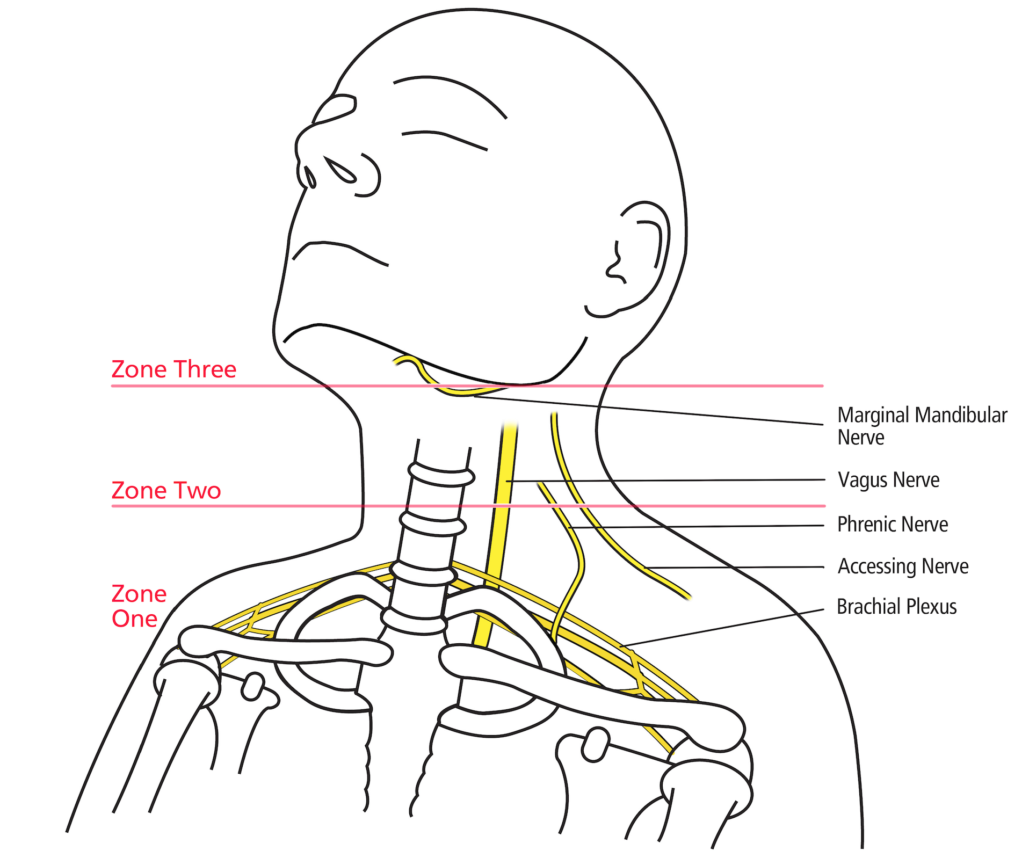 | Zone One:  Brachial Plexus  Phrenic Nerve  Zone Two:  Spinal Accessory Nerve  Facial Nerve  Vagus Nerve  Recurrent Laryngeal nerve  Cervical plexus  Lingual nerve  Hypoglossal nerve  Zone Three:  Cranial Nerves IX, X, XI and XII
Viscera  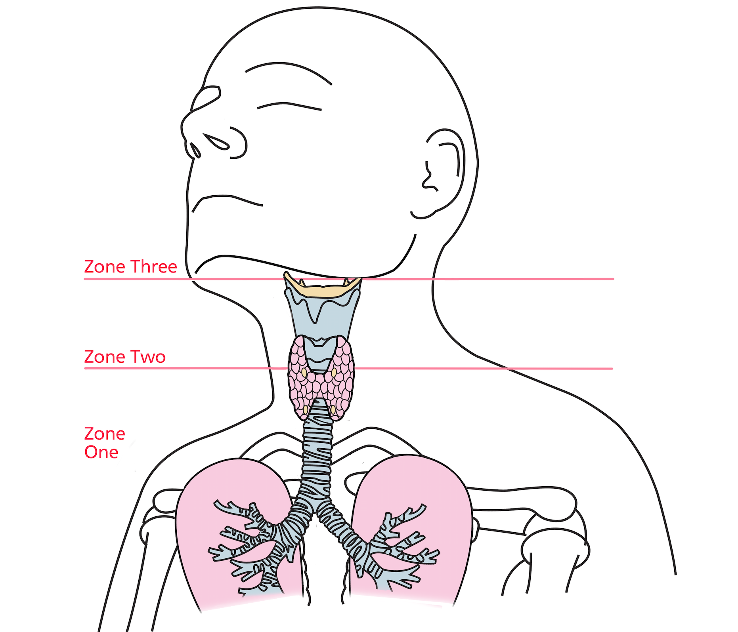 | Zone One:  Apex of Lung  Oesophagus  Trachea  Zone Two:  Larynx  Oesophagus  Trachea  Thyroid and Parathyroid Glands  Zone Three:  Parotid Gland  Submandibular Gland
Table 3: Contents of the Neck

Hard Signs
Pulsatile bleeding
Airway compromise
Expanding haematoma
Bubbling wound/significant air escape
Subcutaneous emphysema
Massive haemorrhage and refractory shock
Stridor or hoarseness
Table 4: Indications for immediate surgical management in penetrating neck trauma

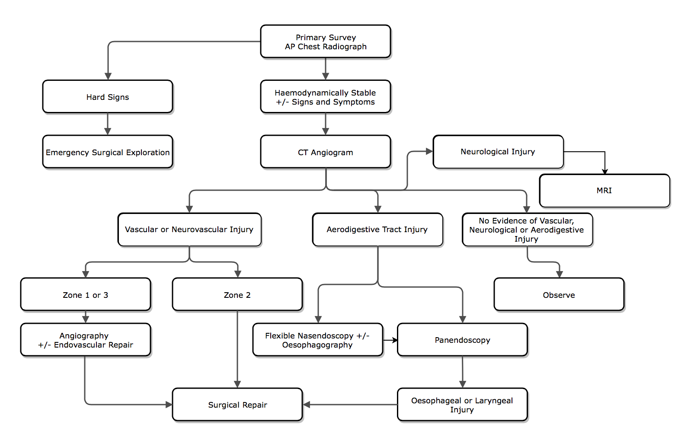
Figure 2: Algorithm for Managing PNI

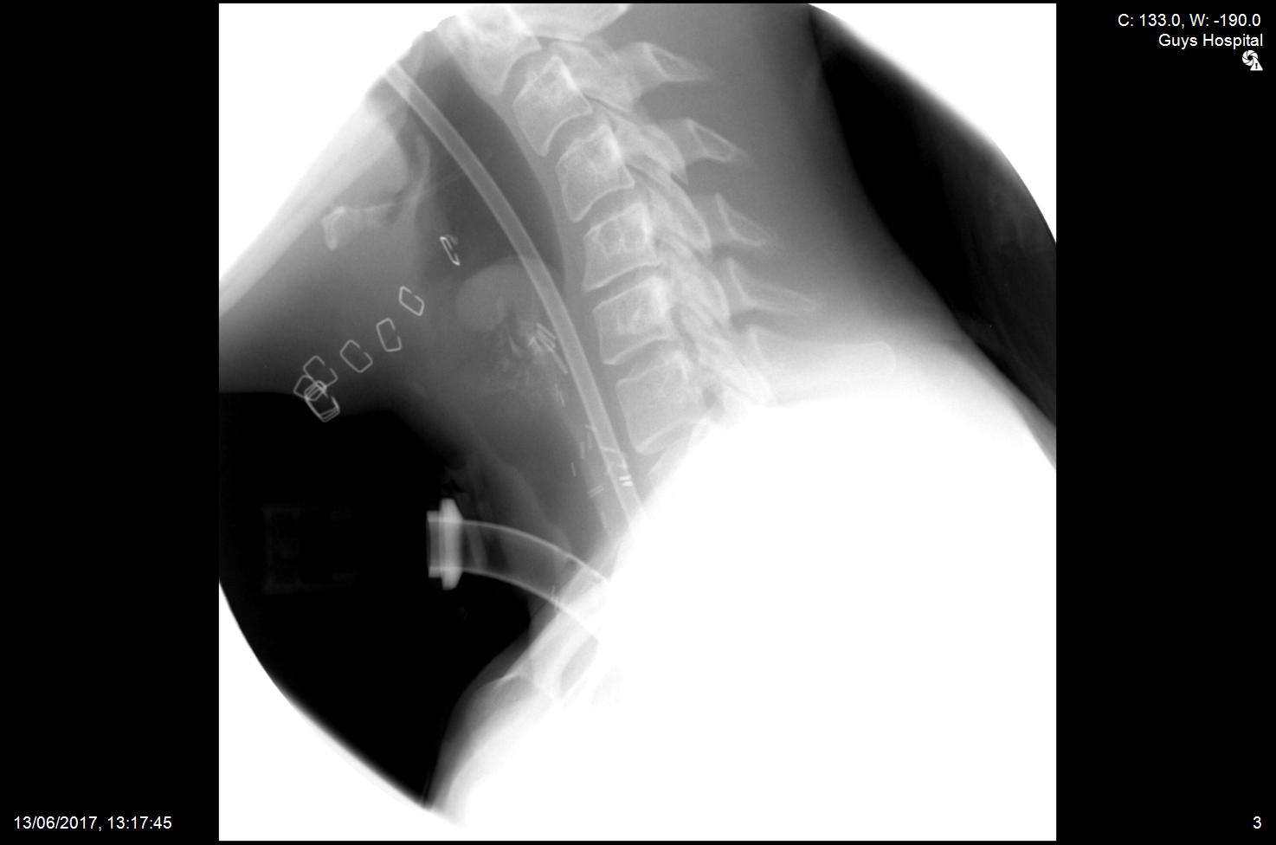

Figure 3: Lateral radiograph during gastrograffin study showing the post operative appearance at day seven. Note the surgical clips, NGT and trachesotomy in situ. Significant oedema of the posterior glottis should also be noted.

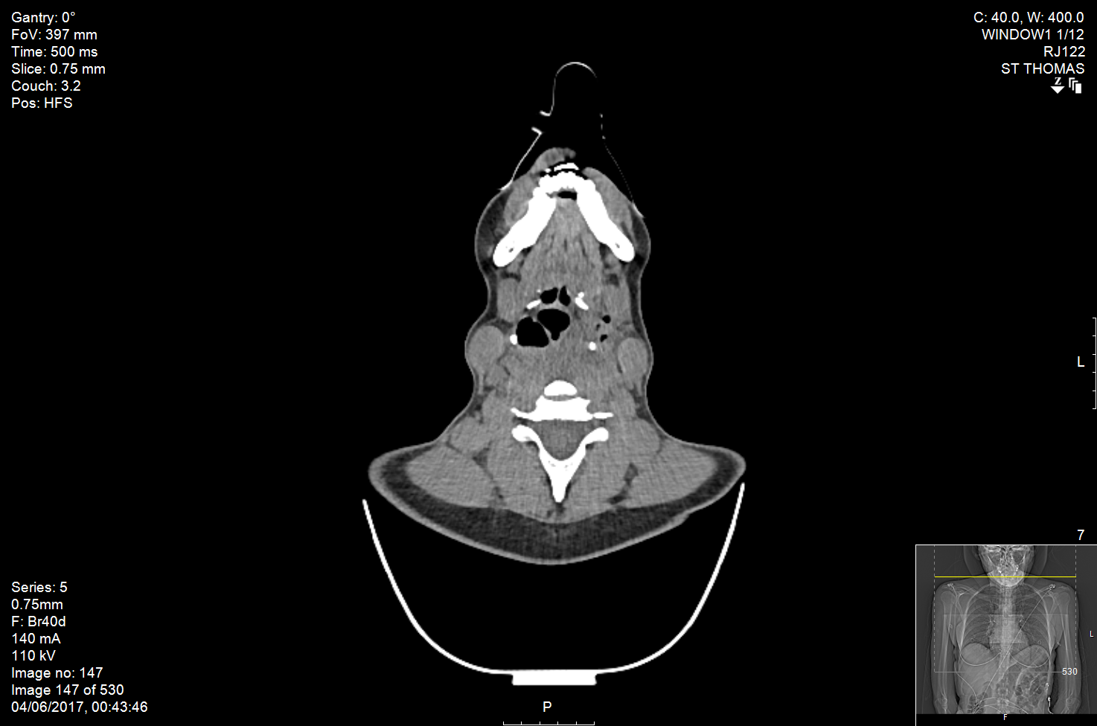

Figure 4: Axial CT scan of the neck with soft tissue injury to left hypopharynx with gas locules indicating a pharyngeal laceration.

