SUPPLEMENTARY MATERIAL
Altered patterns of compositional and functional disruption of the gut microbiota in typhoid fever and non-typhoidal febrile illness
B.W. Haak¹, H.K. de Jong², S. Kostidis³, M.A. Giera³, R.R. Maude⁴, R. Samad⁵, L. Wijedoru⁴, A. Ghose⁵, M.A. Faiz^{4,6}, C.M. Parry^{4,7,8,9}, W.J. Wiersinga^{1,2}
1. Center for Experimental and Molecular Medicine (CEMM), Amsterdam University Medical Centers, Location AMC, Amsterdam, The Netherlands
2. Department of Medicine, Division of Infectious Diseases, Amsterdam University Medical Centers, Location AMC, Amsterdam, The Netherlands
3. Center for Proteomics and Metabolomics, Leiden University Medical Center, Leiden, The Netherlands
4. Mahidol-Oxford Tropical Medicine Research Unit (MORU), Faculty of Tropical Medicine, Mahidol University, Bangkok, Thailand
5. Chittagong Medical College Hospital, Chittagong, Bangladesh
6. Dev Care Foundation, Dhaka, Bangladesh
7. Liverpool School of Tropical Medicine, Liverpool, United Kingdom
8. Institute of Infection and Global Health, University of Liverpool, United Kingdom
9. School for Tropical Medicine and Global Health, Nagasaki University, Nagasaki, Japan

Corresponding author: Bastiaan W. Haak. Center for Experimental and Molecular Medicine (CEMM), Amsterdam University Medical Centers, Location AMC, Room G2-105, Meibergdreef 9, 1105 AZ Amsterdam, The Netherlands. b.w.haak@amsterdamumc.nl
Alternate corresponding author: W. Joost Wiersinga. Center for Experimental and Molecular Medicine (CEMM), Amsterdam University Medical Centers, Location AMC, Meibergdreef 9, 1105 AZ Amsterdam, The Netherlands. w.j.wiersinga@amsterdamumc.nl

Supplementary Table 1: Overview of infectious diagnoses, microbiological data and antibiotic exposure prior to faecal sampling
Characteristic | Fever, no typhoid (n=46) | Typhoid (n=17) | P
INFECTION TYPE
Typhoid fever, n (%) | 0 (0.0) | 14 (100)
Lower respiratory tract infection, n (%) | 17 (36.9) | 0 (0.0)
Urinary tract infection, n (%) | 13 (28.2) | 0 (0.0)
Acute febrile illness, n (%) | 10 (21.7) | 0 (0.0)
Cholecystitis, n (%) | 2 (4.3) | 0 (0.0)
Tuberculosis, n (%) | 2 (4.3) | 0 (0.0)
Malaria, n (%) | 2 (4.3) | 0 (0.0)
MICROBIOLOGICAL DATA
S. Typhi PCR, positive/taken (%) | 0/46 (0.0) | 6/14 (42.8)
Blood cultures, positive/taken (%) | 7/46 (15.2) | 8/14 (57.1)
S. Typhi | 0 | 8
Escherichia coli | 1 | 0
Serratia liquefaciens | 1 | 0
Other (suspected contaminants) | 5 | 0
HISTORY OF PRIOR ANTIBIOTIC EXPOSURE
Antibiotics prior to faecal sampling, n (%) | 40 (87.0) | 14 (100.0) | 0.360
Cephalosporin, n (%) | 31 (67.4) | 11 (82.4) | 0.641
Cephalosporin exposure in days, median [IQR] | 2.00 [1.00, 3.00] | 2.00 [1.00, 5.50] | 0.578
Penicillin, n (%) | 9 (19.6) | 1 (7.1) | 0.118
Penicillin exposure in days, median [IQR] | 2.00 [1.00, 2.00] | 1.00 [1.00, 1.00] | 0.287
Fluoroquinolone, n (%) | 9 (19.6) | 8 (57.1) | 0.017
Fluoroquinolone exposure in days, median [IQR] | 6.00 [4.00, 7.00] | 2.00 [1.00, 5.50] | 0.262
Metronidazole, n (%) | 5 (10.9) | 3 (21.4) | 0.570
Metronidazole exposure in days, median [IQR] | 2.00 [1.00, 2.00] | 2.00 [1.50, 2.50] | 0.752
Macrolide , n (%) | 9 (19.6) | 3 (21.4) | 1.000
Macrolide exposure in days, median [IQR] | 2.00 [1.00, 2.00] | 2.00 [1.50, 3.50] | 0.695

Abbreviations: IQR, interquartile range; PCR, polymerase chain reaction
Supplementary Table 2: Differences in beta diversity among groups
Group | UniFrac (unweighted) |  | UniFrac (weighted)
Control vs Fever, no typhoid | P =0.001 | R² = 0.046 | P = 0.001 | R² = 0.140
Control vs Typhoid | P = 0.001 | R² = 0.080 | P = 0.037 | R² = 0.063
Typhoid vs Fever, no typhoid | P = 0.014 | R² = 0.027 | P = 0.504 | R² = 0.016

Differences in microbiota composition among groups were tested for using permutational multivariate analysis of variance (PERMANOVA) on beta diversity matrices. False discovery rate was adjusted for with Benjamini-Hochberg.

Supplemental Figure 1: Overview of microbiota composition and alpha diversity of each patient, combined with a timeline of hospitalization stay
Figure legend
Overview of the microbiota composition (left panel), alpha diversity (Shannon index), combined with a timeline of hospitalization stay and antibiotic exposure of each patient. Non-typhoidal febrile illness patients are displayed at the top. Typhoid fever patients are displayed at the bottom.
Each bar represents one patient; microbiota taxa are indicated with colours and expressed in percentage of the total DNA reads. Only genera that made up ≥5 of the total microbiota in at least one sample are included; other genera are pooled within their respective phyla, or within the Ruminococcaceae and Lachnospiraceae families.
Supplementary Figure 2: Differentially abundant bacterial taxa between patients with typhoid fever (green) and non-typhoidal febrile illness (blue)

Supplementary Figure 3: Correlation between the presence of butyrate-producing bacteria and absolute butyrate concentration
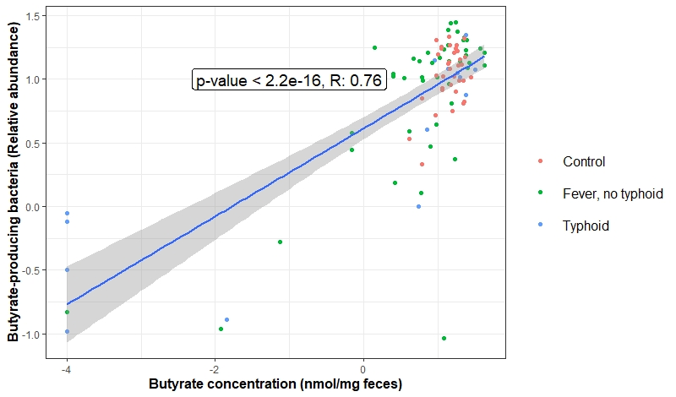

Scatter plot of butyrate concentrations (nmol/mg feces after log10 transformation, x-axis) versus relative abundance of butyrate-producing bacteria (percentage after log10 transformation, y-axis). The line represents the linear regression fit (tested for linearity with Wald tests) and the shade the corresponding 95% confidence interval. Corresponding Pearson correlation coefficients and p-values are also displayed in the figure.

Supplementary Figure 4: Correlation between the abundance of butyrate-producing bacteria (A) and microbiota diversity (B) with length of hospital stay

Scatter plot of hospital length of stay (days, x-axis) versus (A) microbiota diversity (Shannon Index, y-axis) or (B) relative abundance of butyrate-producing bacteria (% after log10 transformation, y-axis). The line represents the linear regression fit (tested for linearity by Wald tests) and the shade the corresponding 95% confidence interval. Corresponding Pearson correlation coefficients and p-values are displayed in the figure.

