Synergistic effect in bi-metallic phospho-boride electrocatalyst for alkaline water oxidation
Avani Chunduri,*^{[a]} Suraj Gupta,*^{[b]} Maulik Patel,^{[b]} Mark Forster,^{[c]} Alexander J. Cowan,^{[c]} Nainesh Patel*^{[a]}

[a] A. Chunduri, Dr. N. Patel
Department of Physics, University of Mumbai,
Vidyanagari, Santacruz (East), Mumbai 400098, India.
Email: avanic06@gmail.com
nainesh11@gmail.com
[b] Dr. S. Gupta, Dr. M. Patel
School of Engineering, University of Liverpool,
Liverpool, L69 3GH, United Kingdom.
Email: Suraj.Gupta@liverpool.ac.uk
suraj422000@gmail.com
[c] Dr. M. Forster, Prof. A. J. Cowan
Department of Chemistry and
Stephenson Institute for Renewable Energy,
University of Liverpool, Liverpool, United Kingdom.

Abstract
New oxygen evolution reaction (OER) electrocatalysts based on low-cost elements, which set new benchmark levels of activity, are vital if water electrolysis is to be applied on a global scale. Herein, we report a low-cost bi-metallic phospho-boride catalyst that shows outstanding OER activity of ~195 mV to achieve 10 mA/cm², in alkaline water electrolysis, with a minimal catalyst loading of 0.3 mg/cm². The contrasting electron transfer property of the metal borides and phosphides when combined in phospho-boride modulates the electron density of the Co atom, yielding highly active CoOOH species at lower potentials. The addition of Mo at low levels further enhances the activity by increasing the surface area and by formation of nano-crystalline domains. The combined contributions from each of the components results in new benchmark mass activity of 666 A/g at 300 mV overpotential. This work presents a new avenue towards fabricating electrode materials with exceptional performances.

Hydrogen (H₂) produced from electrochemical water-splitting, through intermittent renewables (solar and wind), possesses all the essential features as a storage medium. However, the sluggish half-reaction of the oxygen evolution reaction (OER), involving 4 electrons, remains one of the bottlenecks in achieving higher operating efficiencies for water electrolyzers. In search for noble-metal free OER electrocatalysts, pronounced progress has been accomplished in the last few years by engaging more abundant and low-cost first-row transition metals.^{[1,2]} In the form of oxides/hydroxides/oxy-hydroxides, metals such as Ni, Co and Fe have shown satisfactory performances in alkaline electrolytes.^{[3–7]} Layered double hydroxides (LDHs) of these transition metals have even surpassed the most active and stable IrO₂ and RuO₂ catalysts, largely due to their higher surface areas, but in turn suffer from poor conductivity.^{[8,9]} In addition to these, compounds of transition-metals in the form of phosphides,^{[10,11]} sulphides,^{[12,13]} borides,^{[14,15]} selenides,^{[16,17]} nitrides,^{[18,19]} and carbides^{[20,21]} have emerged as promising low-cost alternatives. In majority of the cases, these compounds are proposed to act as pre-catalysts that transform into reactive oxy-hydroxy (*OOH) species on the surface during OER, while still providing conducting pathways through the core.^{[22,23]}
Despite *OOH formation being the crucial step in OER, the activity and quantity of these species depend on the initial features of the pre-catalyst such as: the composition, primary interactions, and positioning of the constituent elements; the pre-catalyst morphology; and the structure and defects present.^{[22,23]} Among several strategies implemented to tune these features, the promoting effect of multi-metallic compounds comprising of two or more transition-metals is reported,^{[24,25]} but multi-component compounds with two metals and two non-metals (or metalloids) have rarely been explored.^{[26,27]} Recently, metal compounds containing P and B together, herein termed as phospho-boride (PB), showed improved electrocatalytic rates, owing to their unique properties which are different from either borides or phosphides.^{[28–30]} For instance, in metal borides, B donates electrons to Co while in metal phosphides, Co donates electrons to P. This opposing electron transfer mechanisms in metal borides and phosphides, when combined in a PB, generates metal sites with an optimal electronic density for interaction with reactants and products.^{[29–31]} Although this characteristic of a single-metal PB is established, the synergistic effect created by presence of multi-metals in PBs has been seldom investigated.
Herein, we report for the first time, a bi-metallic phospho-boride catalyst (Co-Mo-PB), synthesized by a simple chemical reduction technique. We show that by tuning the composition of B and P, it is possible to facilitate the formation of active CoOOH species at low overpotentials. It is proposed that this is achieved through balancing the differing electron transfer characteristics (from B to Co and Co to P) in Co-Mo-PB to produce an optimum electron density over Co sites. At the same time, Mo is included to increase the surface area and produce nano-crystalline domains containing under-coordinated sites. The specific role played by each element in creating a synergistic effect and producing an outstanding OER activity is investigated.
Co-Mo-PB catalysts were synthesized using a chemical reduction method by varying the molar ratios of Mo and B/P. Amongst all the permutations (Table S2), $χ_{Mo}$ and B/P molar ratios, with 2% and 1, respectively, displayed the outstanding OER activity (overpotential below 200 mV for 10 mA/cm²). Thus, all the physical characterizations were limited to this optimized Co-Mo-PB catalyst, along with the control samples. Although, SEM (Fig. S1) and STEM (Fig. S2 and Fig. 1a, 1b and 1c) micrographs obtained from all the four catalyst powders showed similar particle morphology, the catalysts containing Mo (Co-Mo-B and Co-Mo-PB) exhibit smaller particle size (~10-20 nm) in comparison to Co-B and Co-PB (~30-50 nm). Another distinct feature observed with inclusion of Mo is the formation of nano-crystalline domains within the particles (Fig. 1b, 1c and Fig. S2g and h), with lattice fringes (0.18 nm and 0.21 nm) corresponding to Co and Co₂B phases.^{[32]} As completely amorphous morphology is detected in Co-PB and Co-B catalysts, the key role of Mo in the formation of such a short-range order separated by the grain boundaries is highlighted: a feature beneficial for catalysis.^{[33–35]} However, XRD reveals that there exists no overall crystallinity (long-range ordering) in all the catalyst powders (Fig. S3).^{[36–38]} Elemental mapping (Fig.1d) shows the uniform distribution of Co, Mo, P, B and O in the catalyst powder with predominant concentration of Co and oxygen. BET surface area measurements (Fig. S4), showed that the catalysts with Mo displayed higher surface areas, with Co-Mo-PB recording the highest value (63.5 m²/g) followed by Co-Mo-B, whereas that of Co-B and Co-PB are lower. BET surface area values are in good agreement with STEM results which displayed smaller particle size for Mo-based catalyst powders. Thus, it becomes clear that Mo acts as a barrier to avoid the growth and agglomeration of the particles during the synthesis,^{[39]} achieving higher surface areas.
The deconvoluted Co 2p_{3/2} peak obtained from the XPS spectra (Fig. 1e) shows two prominent peaks positioned at 778.0 eV and 780.9 eV corresponding to metallic Co and Co²⁺ (Co(OH)₂) states, respectively. The deconvoluted peaks (Fig. 1f) of Mo 3d_{5/2} represent the oxides of Mo (Mo⁴⁺ and Mo⁶⁺). B1s state (Fig. 1g) comprises of two peaks centered at 187.7 eV and 191.1 eV attributed to elemental and oxidized forms of boron, respectively, with a positive shift (0.6 eV) in the elemental boron peak position as compared to pure B (187.1 eV). This indicates an electron density shift towards Co from boron in Co-B bond: a phenomenon quite common in case of amorphous metal borides.^{[14]} The P 2p level (Fig. 1h) is composed of metallic phosphorous (129.3 eV) and oxy-phosphorous (133.1 and 135.9 eV), with a noticeable negative shift (0.9 eV) in metallic peak compared to pure P (130.2 eV). This shift represents the electron transfer towards P in Co-Mo-PB, a consequence of the ensemble effect,^{[40]} as also noticed in Co-P and Co-PB.^{[29]} This interplay of electrons (from B to Co and Co to P) is an important phenomenon responsible for modulating the electron density over Co sites, facilitating the OER process.^{[29]} Based on the surface atomic concentration (Table S1) obtained from XPS, Co-Mo-PB can be chemically expressed as Co_{0.62}Mo_{0.02}P_{0.07}B_{0.29}. The surface atomic concentrations (Table S1) indicate that the percentage of Co present on the surface increases after involvement of P, evident from the distinct enhancement observed in Co-PB and a marginal enhancement in Co-Mo-PB catalyst, suggesting that P enhances the migration of Co atoms on the surface but that Mo does not.^{[41,42]} Thus B and P play crucial roles in modulating the electron density over Co sites while P also assists in populating the surface with Co atoms. In contrast, it was previously reported for Co-Mo-B that the introduction of Mo into the OER does not modify the nature of the catalytic/surface sites or change the local kinetics of electron transfer.^{[32]}
From anodic linear sweep voltammetry (LSV) curves (Fig. S6) in 1M KOH, the overpotential value (Table S2) required to achieve the standard current density of 10 mA/cm² (η₁₀) is depicted for three sets of samples, with varying percentage of$χ_{Mo}$and molar ratios of B/P (Fig. 2a). Amongst these, Co-Mo-PB with $χ_{Mo}$ and B/P molar ratio of 2% and 1, respectively, operated with an extremely low overpotential η₁₀ ≈ 195 mV. The overpotentials required to record 10 mA/cm² from Co-Mo-PB, Co-B, Co-PB, Co-Mo-B, and RuO₂ are 195 mV, 343 mV, 290 mV, 281 mV and 360 mV respectively (Fig. 2b), with corresponding Tafel slope (Fig. S7) values reported in Table S3. In control samples, when Mo or P is incorporated with B (Co-Mo-B and Co-PB), the OER performance improves to a certain extent. However, only after inclusion of both these elements together with B, the synergic effect is created in Co-Mo-PB to substantially reduce the overpotentials by 165 mV than that recorded for the commercially used RuO₂ catalyst, at the same loading.
The results were repeated and replicated at least 5 times and the final overpotential value (η₁₀ = 194.8 ± 14.1 mV) reported here is the average of all these trials (Fig. S8a). After validating the obtained results, the OER activity of Co-Mo-PB was compared with the best non-noble transition metal-based catalysts from the literature (Table S4). As commercial electrolyzers target minimal catalyst loadings (<0.5 mg/cm²),^{[43]} thus comparison of only those catalysts are made here that reported a loading below 0.5 mg/cm² in alkaline electrolytes and without using any substrates (to eliminate the effect of substrates such as metal foams, porous carbon, carbon nanotubes, graphene, etc.). From Fig. 2c, it becomes distinctly clear that Co-Mo-PB displays the highest OER activity with a benchmark overpotential value (η₁₀~195 mV), while 100 mA/cm² is attained at just ~280 mV. Indeed, the OER performance even surpasses the commercially preferred NiFe LDH catalyst (η₁₀= 270 mV).^{[9]} In literature, there are indeed a few electrocatalysts (Table S5) that report overpotential values lower than that reported for Co-Mo-PB, but all these catalysts employ a large amount of catalyst loading (5-10 mg/cm²) and hence do not offer a fair comparison. To eliminate the effect of loading amount, mass activity is reported for these catalysts and is compared with that of Co-Mo-PB, at 220 mV of overpotential, in Fig. 2d. The mass activity of Co-Mo-PB is ~2.4 times higher than the best catalyst (Ni_{x}Fe_{1-x}S₂) in the list,^{[44]} establishing its excellent OER activity even amongst the electrocatalysts from literature that report the lowest overpotentials to date. Zhang et al. compared the mass activity of a number of low-cost OER catalysts at overpotentials of 300 mV, where 3DNG-CoAl shows the highest mass activity of ~60 A/g.^{[6]} In comparison, Co-Mo-PB exhibited an extremely high mass activity of 666 A/g (at 300 mV overpotential), which is an order of magnitude higher than the ones reported by Zhang et al., ascertaining its benchmark activity.^{[6]}
To understand the reasons for this significant activity, different electrochemical parameters such as charge transfer resistance (R_{ct}), electrochemical surface area (ECSA), pre-oxidation behavior, and turnover frequency (TOF) were investigated and the results are summarized in Table S3. R_{ct} value was determined by fitting the Nyquist plot (Fig. 3a) from EIS with an equivalent circuit (inset of Fig. 3a). Co-PB depicts the lowest R_{ct} value of 5.63 Ω owing to higher metallicity of the surface created by Co atom enrichment in presence of P (seen from Table S1). On the contrary, the presence of Mo oxides, acting as a barrier to reduce the agglomeration of particle also inhibits the conduction of charges, resulting in highest R_{ct} of 20.16 Ω for Co-Mo-B. A balance of both these phenomena is observed in Co-Mo-PB catalyst to record a R_{ct} value of 9.63 Ω. Following the trend in BET surface area, an enhancement in ECSA (Fig. 3b) was also observed in Co-Mo-PB, as compared to other control catalysts, thus indicating large number of active sites on the surface. The plots of BET normalized (I_{BET}) and C_{DL} normalized current density (I_{CDL}) against the applied potential (Fig. S10) shows that Co-Mo-PB remains the best catalyst by not only providing greater number of active sites but the activity of each site is superior to its counterparts. TOF values, at 1.50 V (vs RHE), suggest that involvement of either Mo or P in Co-B increases the activity per site by 1.9 or 4.6 times, respectively, while combination of these two elements in Co-Mo-PB produces the highest enhancement of 14.5 times in OER activity per site.
All four catalysts exhibit a pre-oxidation peak in the potential range of 1.05 - 1.20 V (Fig. 3c) attributed to the formation of CoOOH species.^{[45,46]} The intensity of this oxidation peak and the corresponding peak area are the indicators of the number of CoOOH species, suggesting that Co-Mo-PB prevails over the control samples in formation of these active species. Amongst the control samples, both ternary compounds (Co-Mo-B and Co-PB) produce a greater number of CoOOH species than mono-metallic Co-B. Another important feature is the shifting of peak position to lower potentials in the catalysts containing P (Co-PBO and Co-Mo-PB), thus indicating the pivotal role of P in facilitating the formation of CoOOH species. It is well-known that *OOH species are the vital intermediates in enhancing the OER activity, even if the formation of these species is a kinetically challenging step, as suggested by DFT calculations.^{[47,48]} The effect of electronic modulation on the OER/HER rates is well-reported in literature and here the electronic modulation of Co sites, induced by the unique interplay of electrons, facilitates the formation of CoOOH species.^{[49–51]} In the case of Co-Mo-PB, the simultaneous inclusion of Mo, P and B creates a synergistic effect to generate the maximum number of active CoOOH species at lower potential, leading to highest OER activity. The stability of Co-Mo-PB towards OER was established by recycling (500 cycles) and chronoamperometry (10 h) tests (Figure S12), depicting fair robustness of the catalyst, with minimal degradation. Faradaic efficiency tests were performed to confirm that the observed current is due to water oxidation alone and the reaction product is pure oxygen. Fig. 3d shows a good agreement with the theoretical and observed values of O₂, yielding a Faradaic efficiency of 100 ± 4%.
To investigate the physical and chemical changes in the catalyst after OER, STEM images obtained from post-OER tests of Co-Mo-PB (Fig 4a) indicate a complete transformation from a 3D particle-like morphology to 2D graphene-like thin sheets. In addition, hexagonal particles wrapped with these thin sheets were also detected. HR-STEM images of the hexagonal structures reveal (Fig 4b, c) the lattice fringes, endorsing an ordered crystal structure with an interplanar spacing of 0.22 nm, consistent with (003) planes of CoOOH.^{[29]} Elemental maps (Fig 4d) confirm that hexagonal crystallite structure is composed primarily of Co and O, while B, P and Mo is distributed throughout the sample, mainly expected in the sheets surrounding the crystalline structure. In post-OER XPS spectra, deconvolution of Co 2p level (Fig 4e) presents only oxidized phases with peaks centered at 781.4 eV and 779.8 eV attributed to CoOOH species.^{[52]} On comparing the peak positions with pure γ-CoOOH (781.6 & 780.4 eV) and Co-PB (781.8 & 780.2 eV),^{[52]} CoOOH species in Co-Mo-PB are found to be in a reduced state. Such electron-rich CoOOH species are being reported as more active for OER.^{[52]} Thus, post-OER STEM and XPS results of Co-Mo-PB confirm that formation of surface CoOOH species is the dominating factor facilitating OER. ICP-AES analysis (Table S6) of electrolyte post OER test reveals a small amount of B leaching into the electrolyte, which is assigned to a consequence of the morphological evolution.
Upon correlating the results obtained from physical characterization and the measured electrochemical parameters, the role of each element in enhancing the catalytic performance of Co-Mo-PB is defined here. Co serves as the active center whose activity is enhanced by contributing effects from the other elements. In amorphous Co-based borides, owing to the well-established phenomenon of reverse electron transfer, boron plays the role of donating electrons to Co sites and avoids their complete oxidation. These partially reduced Co atoms are kinetically preferred pre-catalysts to form active CoOOH species during OER. Incorporation of B and P together modulates the electron density of Co sites, optimizing the interaction with reactants, as established from DFT calculations in our previous work.^{[29]} The advantage of this phenomenon is experimentally evident from the fact that a lower potential is required to form CoOOH species and also higher activity per site is obtained, as suggested from the TOF value. We have experimental evidence that the addition of low levels of Mo in form of oxide inhibits agglomeration and growth of particles during synthesis, likely by acting as an atomic barrier, to enhance physical surface area and in turn ECSA. Although the nature of this barrier is not fully understood, it might create stress-induced effects during synthesis to partially crystallize the particles and form nano-sized domains.^{[53]} Under-coordinated atoms present in the grain boundaries of these nano-crystalline domains, produces more active CoOOH sites (from XPS) for OER to establish high TOF value. Thus, the promoting features of all the elements in Co-Mo-PB combine synergistically to offer an exceptionally lower overpotential.
In summary, a bi-metallic phospho-boride catalyst (Co-Mo-PB), synthesized by a facile method, achieves record sub-200 mV overpotential to attain 10 mA/cm² for OER in alkaline media, with minimal loading (0.3 mg/cm²). The explicit role played by each element (Mo, P and B) in the pre-catalyst significantly elevates the number and activity of active Co species (CoOOH) on the catalyst surface along with the charge conductivity. This leads to extremely high mass activity (666 A/g), setting a benchmark for OER electrocatalysis. The present findings may open a fresh perspective towards tuning the multi-component catalyst system to design electrocatalysts with exceptional activity for renewable energy applications.
Experimental Section
Synthesis of catalyst powder:
Co-Mo-PB powder catalysts were synthesized by a chemical reduction method using sodium borohydride (NaBH₄) (0.3 M) as a reducing agent as well as precursor for boron. An aqueous mixture of metal ions (0.05 M) was prepared by using cobalt chloride (CoCl₂ 6H₂O) and sodium molybdate (Na₂MoO₄. 2H₂O) salts, and later sodium hypophosphite (NaH₂PO₂) was added to this mixture and stirred for 15 mins. Later, NaBH₄ was added to this mixture and the solution was continuously stirred for another 30 mins. To ensure the complete reduction of metal ions, a general strategy of using three times the molar ratio of reducing agent NaBH₄ was used. The obtained black powder was washed thoroughly with distilled water followed by 2-propanol to eliminate all the undesirable impurities and by-products and finally dried under vacuum at room temperature. To acquire different molar ratio of B/P, the molar concentrations of NaBH₄ and NaH₂PO₂ were varied, while concentration of Mo and Co was tuned by adjusting the molar percentage ($χ_{Mo}$ = [Mo/(Mo+Co)]) of their respective metal salts. Several samples were synthesized by keeping either $χ_{Mo}$ (1, 2, 3 and 4%) or B/P molar ratio (0.5, 1, 3, 5 and 7) constant and varying the other. Amongst these large combinations, we present the three most suitable sets of samples for simplicity. The screening of the powder catalysts was carried out based on their OER performance (overpotential value at 10 mA/cm² current density). In the first set (SET-1), keeping the percentage of $χ_{Mo}$ constant at 3% (selected based on our previous work) B/P molar ratio was varied (0.5, 1, 3, 5 and 7) and for the second set (SET-2), B/P ratio was set as 5 (selected based on our previous work) and $χ_{Mo}$ molar concentration was varied (1, 2, 3 and 4%).^{[29,54]} For the thirds et (SET-3) presented here, B/P molar ratio was maintained at 1 (selected based on OER performance of SET-1 and SET-2) while molar concentration of $χ_{Mo}$ was varied (1, 2, 3 and 4%). As control samples, Co-B, Co-Mo-B and Co-PB were also synthesized by the same procedure but in the absence of precursor of the eluded element and the molar ratio ($χ_{Mo}$ and B/P) was chosen based on the optimized concentration of Co-Mo-PB catalyst.
Preparation of working electrode:
As working electrode, 3mm diameter glassy carbon (GC) electrode coated with the catalyst powder was used. To coat the catalyst powder onto the GC electrode, a homogeneous ink of catalyst was prepared by ultrasonication of 2 mg catalyst powder in 1ml of ethanol. Nafion solution, as a binder, was prepared by ultrasonication of 20 µl Nafion (perfluorinated, 5%) in 0.5 ml of ethanol. At first, 10 µl of Nafion is drop-casted on to the GC electrode, and after drying under IR lamp, 10 µl of catalyst ink is drop-casted and dried. A constant catalyst loading of 0.3 mg/cm² is ensured for each electrochemical measurement.
Electrochemical measurements:
For testing the electrochemical activity of the catalyst powders, a potentiostat system from Gamry (Interface 1010E) was used. Three-electrode system with Pt electrode (2 mm) as counter and a Hg/HgO (0.3M KOH) as reference, were used for all the electrochemical tests. The best-performing Co-Mo-PB catalyst was also tested with graphite as a counter electrode to ensure the repeatability of results. 1M KOH (pH 14) solution as an electrolyte was maintained at room temperature for all the testing. In order to prevent accumulation of bubbles over the working electrode, the electrolyte was continuously stirred during each measurement. For OER, the scan rate of 10 mV/s is maintained for all the anodic linear sweep voltammetry (LSV) measurements performed in the range of 0.0 V to 0.9 V (vs Hg/HgO) with a step size of 2 mV. Before acquiring the final LSV curve, the catalyst was subjected to cyclic voltammetry (CV) scans (15 cycles) in the same potential range at 50 mV/s, to stabilize the observed current. The electrolyte was purged with oxygen gas for about 15 min prior to each measurement. Uncompensated resistance (R_{s}) was determined with the help of electrochemical impedance spectroscopy (EIS) and the same value was used for calculation of overpotential (ƞ) values. For impedance spectroscopy, Nyquist plots were recorded at a potential of 0.6 V (vs Hg/HgO) in the frequency range of 1 MHz to 1 kHz with an input sine wave of amplitude 5 mV. EIS data was fit with an appropriate equivalent circuit to obtain R_{ct}. Tafel slope values were obtained by linear fitting the plot of “log(i) vs ƞ”. Turnover frequency (TOF) values were calculated at the potential of 1.50V (vs RHE) using the procedure mentioned in our previous work.^{[15]} To determine the electrochemical surface area, cyclic voltammetry (CV) was performed at different scan rates (20, 40, 60, 80, 100 mV/sec) in the potential range of -0.35 to -0.15 V (vs Hg/HgO). The electrolyte is purged with argon gas for 15 min before initiating CV measurement. The slope, obtained by linear fitting the plot of Δj [the difference in anodic and cathodic current densities at -0.25V] vs scan rate, is employed to calculate the value of the double layer capacitance (C_{DL}).^{[55]} Slow scan CV with a scan rate of 2 mV/s was performed in the pre-OER region to investigate the oxidation phenomenon on the catalyst surface. Faradaic efficiency (FE) tests were performed by measuring the evolved oxygen gas during a chronoamperometric test, using a bench-top NeoFox fluorometer coupled with a FOSPOR photoluminescence probe and purpose-built electrochemical cell. The probe tip was placed into the headspace of the cell to monitor the O₂ concentration before, during and after electrochemistry. The cell was degassed thoroughly for 1 hour with argon to provide an initial O₂ concentration of 0%. The Faradaic efficiency was calculated using the total charge passed and the ratio between the final O₂ concentration measured and the 100% theoretical O₂ yield calculated based on total charge passed. Due to a detection time lag, there is a delay between O₂ generated and O₂ measured. Each measurement was carried out in duplicate to confirm the obtained results. Our Faradaic efficiency measurements have a standard deviation of ~4%. Stability of the catalyst was established by recycling for 500 cycles and chronoamperometry tests for 10 h.
Keywords
Oxygen evolution reaction, metal phospho-borides, mass activity, low-cost electrocatalysts, alkaline water oxidation.
Acknowledgements
A. Chunduri and N. Patel acknowledge WOS-A scheme (SR/WOS-A/PM-115/2016(C)) under DST for their financial support. N. Patel acknowledge UGC and SERB-DST for providing financial support through Faculty recharge program and Extra Mural project (FILE NO. EMR/2016/003028). S. Gupta acknowledges the research grant from UK Commonwealth Scholarship Commission through Commonwealth Rutherford Fellowship (INRF-2017-139). M. Patel acknowledges the seed funding obtained from EPSRC-GCRF No. 141131/155337. M. Patel and S. Gupta also acknowledge Research England (UK) for funds through the Industrial Strategy HEIF Allocation 2019-2020 Pump Priming Fund Round 6 (Project No. 163792). M. Forster and A. J. Cowan acknowledge financial support from the INTERREG Atlantic Area programme (Grant reference EAPA_190_2016) and the EPSRC (EP/P034497/1). We also acknowledge the use of electron microscopy facilities at Albert Crewe Centre, Liverpool.

Conflicts of interest
There are no conflicts to declare.
References
[1] H. Xu, H. Shang, C. Wang, L. Jin, C. Chen, C. Wang, Y. Du, Appl. Catal. B Environ. 2020, 265, 118605.
[2] G. Liu, M. Wang, Y. Wu, N. Li, F. Zhao, Q. Zhao, J. Li, Appl. Catal. B Environ. 2020, 260, 118199.
[3] C. C. L. McCrory, S. Jung, J. C. Peters, T. F. Jaramillo, J. Am. Chem. Soc. 2013, 135, 16977–16987.
[4] K. L. Nardi, N. Yang, C. F. Dickens, A. L. Strickler, S. F. Bent, Adv. Energy Mater. 2015, 5, 1500412.
[5] W. Hao, R. Wu, R. Zhang, Y. Ha, Z. Chen, L. Wang, Y. Yang, X. Ma, D. Sun, F. Fang, Adv. Energy Mater. 2018, 8, 1801372.
[6] B. Zhang, Z. Qi, Z. Wu, Y. H. Lui, T.-H. Kim, X. Tang, L. Zhou, W. Huang, S. Hu, ACS Energy Lett. 2018, 4, 328–336.
[7] Y. Zhang, X. Wang, F. Luo, Y. Tan, L. Zeng, B. Fang, A. Liu, Appl. Catal. B Environ. 2019, 256, 117852.
[8] Z. Cai, X. Bu, P. Wang, J. C. Ho, J. Yang, X. Wang, J. Mater. Chem. A 2019, 7, 5069–5089.
[9] M. Gong, Y. Li, H. Wang, Y. Liang, J. Z. Wu, J. Zhou, J. Wang, T. Regier, F. Wei, H. Dai, J. Am. Chem. Soc. 2013, 135, 8452–8455.
[10] J. Wang, F. Ciucci, Appl. Catal. B Environ. 2019, 254, 292–299.
[11] L. Yang, L. Zhang, Appl. Catal. B Environ. 2019, 259, 118053.
[12] O. Mabayoje, A. Shoola, B. R. Wygant, C. B. Mullins, ACS Energy Lett. 2016, 1, 195–201.
[13] M. Lee, H.-S. Oh, M. K. Cho, J.-P. Ahn, Y. J. Hwang, B. K. Min, Appl. Catal. B Environ. 2018, 233, 130–135.
[14] S. Gupta, M. K. Patel, A. Miotello, N. Patel, Adv. Funct. Mater. 2020, 30, 1906481.
[15] S. Gupta, N. Patel, R. Fernandes, R. Kadrekar, A. Dashora, A. K. Yadav, D. Bhattacharyya, S. N. Jha, A. Miotello, D. C. Kothari, Appl. Catal. B Environ. 2016, 192, 126–133.
[16] X. Zhao, X. Li, Y. Yan, Y. Xing, S. Lu, L. Zhao, S. Zhou, Z. Peng, J. Zeng, Appl. Catal. B Environ. 2018, 236, 569–575.
[17] S. Wang, P. He, L. Jia, M. He, T. Zhang, F. Dong, M. Liu, H. Liu, Y. Zhang, C. Li, J. Gao, L. Bian, Appl. Catal. B Environ. 2019, 243, 463–469.
[18] X. Peng, C. Pi, X. Zhang, S. Li, K. Huo, P. K. Chu, Sustain. Energy Fuels 2019, 3, 366–381.
[19] H. Chu, D. Zhang, B. Jin, M. Yang, Appl. Catal. B Environ. 2019, 255, 117744.
[20] M. Kim, S. Kim, D. Song, S. Oh, K. J. Chang, E. Cho, Appl. Catal. B Environ. 2018, 227, 340–348.
[21] J.-H. Kim, K. Kawashima, B. R. Wygant, O. Mabayoje, Y. Liu, J. H. Wang, C. B. Mullins, ACS Appl. Energy Mater. 2018, 1, 5145–5150.
[22] B. R. Wygant, K. Kawashima, C. B. Mullins, ACS Energy Lett. 2018, 3, 2956–2966.
[23] S. Jin, ACS Energy Lett. 2017, 2, 1937–1938.
[24] F. Qin, Z. Zhao, M. K. Alam, Y. Ni, F. Robles-Hernandez, L. Yu, S. Chen, Z. Ren, Z. Wang, J. Bao, ACS Energy Lett. 2018, 3, 546–554.
[25] B. Zhang, X. Zheng, O. Voznyy, R. Comin, M. Bajdich, M. García-Melchor, L. Han, J. Xu, M. Liu, L. Zheng, F. P. G. De Arquer, C. T. Dinh, F. Fan, M. Yuan, E. Yassitepe, N. Chen, T. Regier, P. Liu, Y. Li, P. De Luna, A. Janmohamed, H. L. Xin, H. Yang, A. Vojvodic, E. H. Sargent, Science (80-. ). 2016, 352, 333–337.
[26] H. Liang, A. N. Gandi, C. Xia, M. N. Hedhili, D. H. Anjum, U. Schwingenschlögl, H. N. Alshareef, ACS Energy Lett. 2017, 2, 1035–1042.
[27] D. Dong, X. Xu, C. Ma, L. Gong, L. Su, J. Wang, Int. J. Hydrogen Energy 2020, 45, 4545–4555.
[28] P. W. Menezes, A. Indra, I. Zaharieva, C. Walter, S. Loos, S. Hoffmann, R. Schlögl, H. Dau, M. Driess, Energy Environ. Sci. 2019, 12, 988–999.
[29] A. Chunduri, S. Gupta, O. Bapat, A. Bhide, R. Fernandes, M. K. Patel, V. Bambole, A. Miotello, N. Patel, Appl. Catal. B Environ. 2019, 118051.
[30] J. Kim, H. Kim, S.-K. Kim, S. H. Ahn, J. Mater. Chem. A 2018, 6, 6282–6288.
[31] W. Tang, X. Liu, Y. Li, Y. Pu, Y. Lu, Z. Song, Q. Wang, R. Yu, J. Shui, Nano Res. 2020, 1–8.
[32] S. Gupta, N. Patel, R. Fernandes, S. Hanchate, A. Miotello, D. C. Kothari, Electrochim. Acta 2017, 232, 64–71.
[33] R. Zhang, L. Wang, Y.-H. Ma, L. Pan, R. Gao, K. Li, X. Zhang, J.-J. Zou, J. Mater. Chem. A 2019, 7, 10010–10018.
[34] Y. Heo, S. Choi, J. Bak, H. Kim, H. Bin Bae, S. Chung, Adv. Energy Mater. 2018, 8, 1870146.
[35] X. Feng, K. Jiang, S. Fan, M. W. Kanan, J. Am. Chem. Soc. 2015, 137, 4606–4609.
[36] G. Liu, D. He, R. Yao, Y. Zhao, M. Wang, N. Li, J. Li, Int. J. Hydrogen Energy 2018, 43, 6138–6149.
[37] H. Chen, S. Ouyang, M. Zhao, Y. Li, J. Ye, ACS Appl. Mater. Interfaces 2017, 9, 40333–40343.
[38] Y. Li, B. Huang, Y. Sun, M. Luo, Y. Yang, Y. Qin, L. Wang, C. Li, F. Lv, W. Zhang, Small 2019, 15, 1804212.
[39] N. Patel, R. Fernandes, A. Miotello, J. Catal. 2010, 271, 315–324.
[40] E. J. Popczun, J. R. McKone, C. G. Read, A. J. Biacchi, A. M. Wiltrout, N. S. Lewis, R. E. Schaak, J. Am. Chem. Soc. 2013, 135, 9267–9270.
[41] N. Patel, R. Fernandes, A. Miotello, J. Power Sources 2009, 188, 411–420.
[42] S.-P. Lee, Y.-W. Chen, J. Mol. Catal. A Chem. 2000, 152, 213–223.
[43] S. Shiva Kumar, V. Himabindu, Mater. Sci. Energy Technol. 2019, 2, 442–454.
[44] X. Xu, F. Song, X. Hu, Nat. Commun. 2016, 7, 12324.
[45] W. K. Behl, J. E. Toni, J. Electroanal. Chem. Interfacial Electrochem. 1971, 31, 63–75.
[46] E. Potvin, L. Brossard, J. Appl. Electrochem. 1995, 25, 462–471.
[47] Z. Xue, X. Zhang, J. Qin, R. Liu, J. Mater. Chem. A 2019, 7, 23091–23097.
[48] X. Lv, W. Wei, H. Wang, B. Huang, Y. Dai, Appl. Catal. B Environ. 2019, 255, 117743.
[49] M. Cabán-Acevedo, M. L. Stone, J. R. Schmidt, J. G. Thomas, Q. Ding, H.-C. Chang, M.-L. Tsai, J.-H. He, S. Jin, Nat. Mater. 2015, 14, 1245–1251.
[50] J. Mohammed-ibrahim, H. Moussab, J. Energy Chem. 2020.
[51] H. Sun, X. Xu, Z. Yan, X. Chen, L. Jiao, F. Cheng, J. Chen, J. Mater. Chem. A 2018, 6, 22062–22069.
[52] H. Wang, E. Feng, Y. Liu, C. Zhang, J. Mater. Chem. A 2019, 7, 7777–7783.
[53] H. Wu, Z. Wang, H. Fan, J. Am. Chem. Soc. 2014, 136, 7634–7636.
[54] S. Gupta, N. Patel, R. Fernandes, S. Hanchate, A. Miotello, D. C. Kothari, Electrochim. Acta 2017, 232, 64–71.
[55] S. Gupta, A. Yadav, S. Bhartiya, M. K. Singh, A. Miotello, A. Sarkar, N. Patel, Nanoscale 2018, 10, 8806–8819.

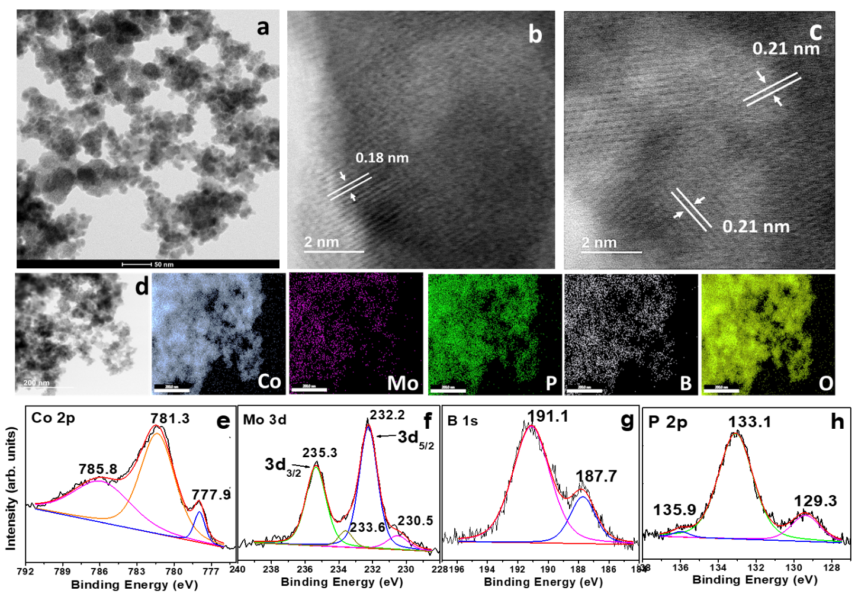
Fig. 1: (a) STEM and (b and c) HR-STEM images along with (d) elemental mapping obtained from as-prepared Co-Mo-PB catalyst powder. XPS spectra obtained from (e) Co 2p, (f) Mo 3d, (g) B 1s and (h) P 2p levels of as-prepared Co-Mo-PB catalyst powder.

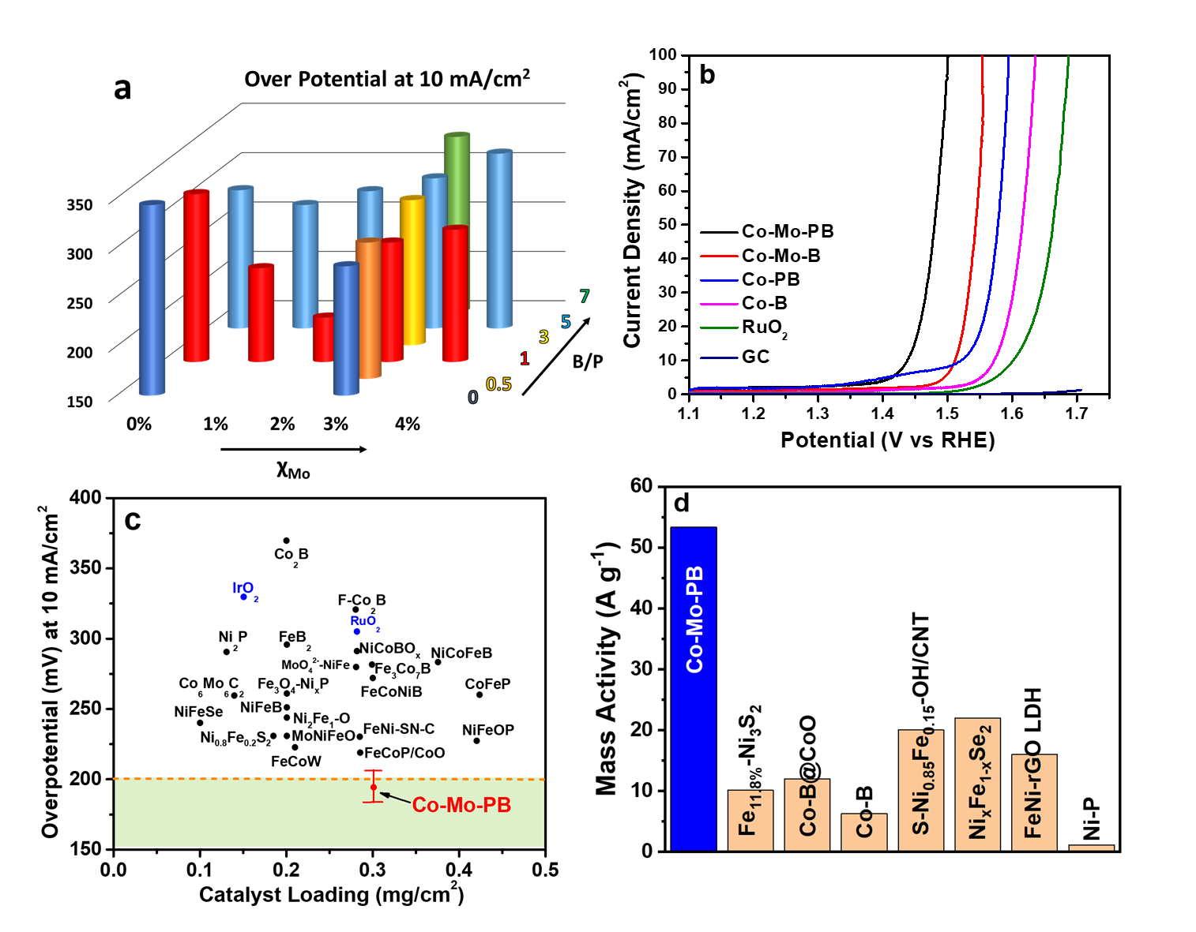
Fig. 2: (a) Plot of overpotential value at 10 mA/cm² current density of the selected sets of Co-Mo-PB catalyst with varying $χ_{Mo}$ and B/P molar ratio. (b) LSV (iR-corrected) of Co-Mo-PB along with Co-B, Co-PB, Co-Mo-B, RuO₂ and GC, recorded at a scan rate of 10mV/s in 1 M KOH. (c) Comparison of OER performance of low-cost transition metal electrocatalysts from literature, with catalyst loading < 0.5mg/cm², in alkaline medium (see Table S4 for references). (d) Comparison of mass activity at overpotential of 220 mV for the catalysts reporting overpotential values below 200 mV for a current density of 10 mA/cm² (see Table S5 for references).

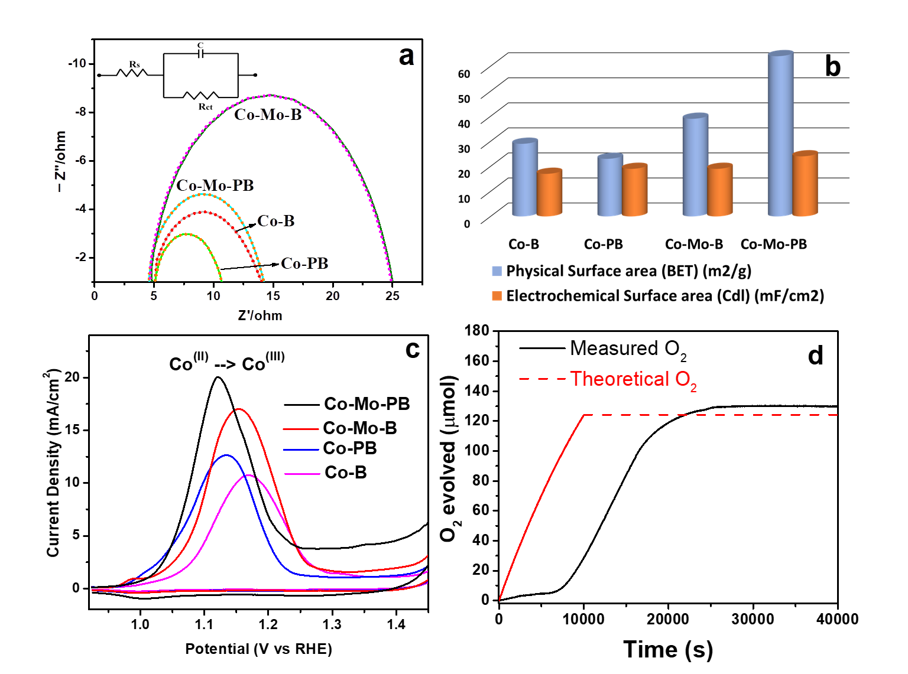
Fig. 3: (a) Nyquist curves obtained from EIS, (b) comparison of physical and electrochemical surface area, (c) pre-OER oxidation peaks obtained at scan rate of 2 mV/s for all catalysts; (d) Faradaic efficiency graphs comparing the theoretical and measured values of O₂ gas produced.

Fig. 4: (a) STEM image, (b, c) HR-STEM images, and (d) elemental mapping obtained from Co-Mo-PB post OER tests; (e) XPS spectra obtained from Co 2p level of post-OER Co-Mo-PB and Co-PB catalysts.

Table of Contents

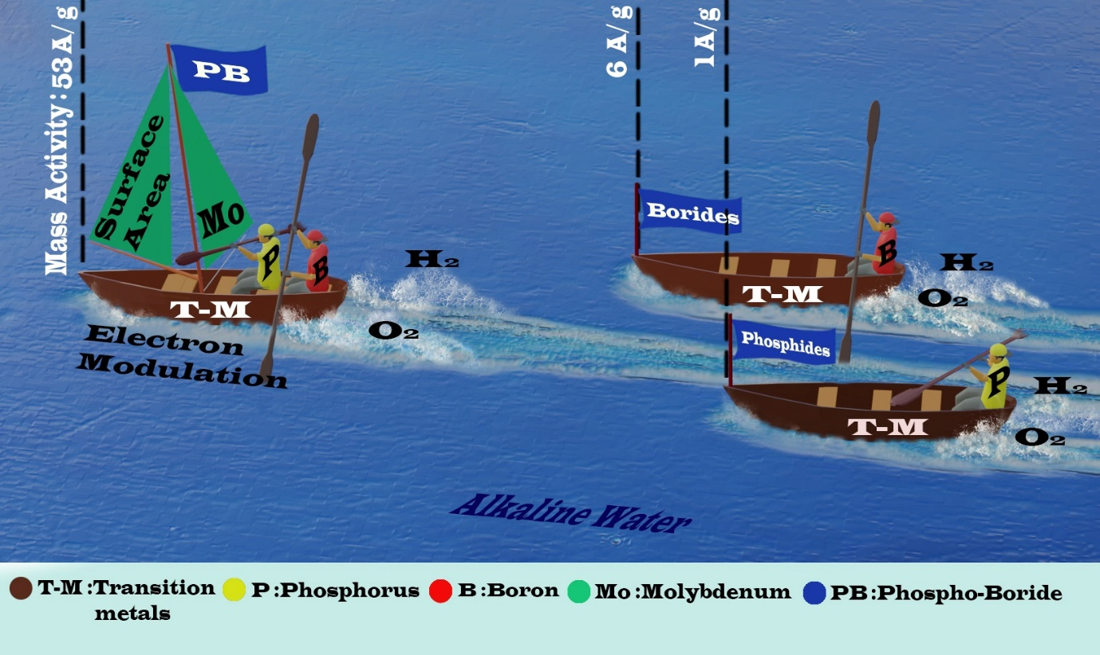
The electrocatalytic performance of a novel bi-metallic phospho-boride catalyst for oxygen evolution reaction in alkali electrolyte is investigated. The unique configuration offers electron modulation of active Co sites and an enhanced surface area to achieve a new benchmark mass activity, with a minimal catalyst loading, making it one of the most active OER catalysts to date.

