RESPONSE ANALYSIS OF EXISTING RC BUILDINGS WITH CORRODED REBARS UNDER EARTHQUAKE SEQUENCES

L. Di Sarno(1) & F. Pugliese(2)

(1) Senior Lecturer, Institute for Risk and Uncertainty and Civil Engineering and Industrial Design, University of Liverpool, Liverpool, United Kingdom, Luigi.Di-Sarno@liverpool.ac.uk;

(2) PhD Student, Institute for Risk and Uncertainty and Civil Engineering and Industrial Design Department, University of Liverpool, Liverpool, United Kingdom, Francesco.Pugliese@liverpool.ac.uk;

Abstract
Multiple consecutive earthquakes are unpredictable events with uncommon characteristics that occur in many countries around the world and affect significantly the seismic response of reinforced concrete (RC) structures causing often more damage if compared to single strong ground motions. Accumulation of structural damage, the increment of the state of deformation, loss of stiffness and strength of structural components are the main consequences of earthquake sequences. Limited research has been conducted on the inelastic response of RC structures subjected to multiple earthquakes and very few studies can be found on this phenomenon when structures are exposed to aggressive environments. As a result, earthquake sequences and corrosion penetration have become extremely important for their impact on the seismic response of existing RC structures. This study aims at investigating the nonlinear dynamic performance of a typical existing four-storey RC building with corroded smooth rebars under a sequence of mainshock and aftershock. Both stress- strain models for the concrete and the steel reinforcements were modified according to the level of the corrosion rate. The seismic performance of the corroded building was evaluated through the use of a finite element approach by performing nonlinear dynamic analyses. The structure was subjected to different levels of corrosion and parameters such as inter- storey drift checked against the limit States of Limited Damage, Significant Damage and Near Collapse defined via non- linear static analyses. Seismic fragility curves are shown for the selected limit states and each level of corrosion. Finally, the nonlinear response of the corroded RC building under multiple earthquakes indicates that there is a need for studying this phenomenon to provide relevant indications of the structural-safety level for conventionally-designed RC structures subjected to earthquake sequences and highly-corrosive environments.
Keywords: Corrosion; Multiple Earthquakes; Structural Modelling; Finite Element Approach; Nonlinear Dynamic Analysis;

Introduction
Existing reinforced concrete (RC) structures designed primarily for gravity loads are extremely vulnerable to ground motion excitations. Some historical and recent earthquakes have shown the occurrence of a series of aftershocks characterized by intensities comparable with mainshocks, which caused a significant risk for further structural damage and an increase of financial losses due to repairing or even a collapse [1]. Nevertheless, in code-based design RC structures are designed to withstand a single earthquake, buildings may experience the occurrence of multiple earthquakes over a short time, and it is not feasible to consider a repair- solution. Accumulated damage due to earthquake sequences has been verified and confirmed during post- earthquake field surveys [2,3]. According to these investigations, it was noted a relevant loss of strength and stiffness in RC structural members, which also caused structural failures.
Although there is yet a debate on the fundamental characteristics and differences between mainshocks and aftershocks, some studies have been conducted on the effect of multiple earthquakes on the performance of RC structures and very few when RC building are exposed to harsh environments. Amadio et al. (2003) [4] studied the effects of repeated earthquakes on the response of single-degree-of-freedom (SDOF) with nonlinear behaviour and a moment steel frame. They considered three different hysteretic models: elastic-perfect plastic without hardening (EPP), elastic-perfect plastic with hardening (EPH) and hysteretic model with stiffness degradation (EPD). Results showed that all models reduced significantly the behaviour factor (also termed q-

factor) and, particularly, the EPP model seems to be the most conservative model regarding the behaviour factor as characterized by a higher reduction. Li and Ellingwood (2007) [16] proposed a new methodology to include the damage due to aftershocks of an already mainshock-damaged building in the performance-based assessment by investigating the effect of multiple sequences (mainshock-aftershock) on a 9-storey and 20- storey steel moment framed buildings. Results showed that parameters such as duration and frequency contents of an aftershock may significantly affect the structural response and, the probability of having small damage due to aftershock depends upon the damage generated by the mainshock. Hatzigeorgiou and Beskos (2009)
[5] conducted a study on an effective and appropriate method to compute the maximum inelastic displacement ratio of a structure under repeated earthquakes while examining several parameters, e.g. period of vibration, viscous damping, force reduction factors. They combined mainshock and aftershock motions using time-gap equals to five-to-nine the single event duration. Results showed that the maximum horizontal displacement ratio increases for earthquake sequences even more than 100%, compared to single ground motion. These ratio values depend strongly onto the natural frequency of the single degree of freedom (SDOF) and accumulated damage due to the decrease of the post-yielding stiffness. Similar results were found by Sabegh and Ruiz- Garcia (2015) [6] who investigated the nonlinear response of SDOF systems subjected to the Varzaghan-Ahar earthquake sequences. They studied the trend of the force-reduction factor and the inelastic displacement ratio and found that technical codes, which account for single ground motions, underestimate the values of lateral strength and peak inelastic displacement for long-period structures under earthquake sequences. Di Sarno (2013) [1] studied the effects of ground motion sequences on the inelastic response of RC framed structures. Results demonstrated that an adequate hysteretic degradation model, which accounts for stiffness and strength degradation, should be used to accurately predict nonlinear responses of RC buildings. Song et al. (2014) [7] investigated the influence of duration and frequency content of multiple earthquakes on the collapse of buildings. The results of their studies demonstrated that aftershocks with long duration and low-frequency contents play a significant role in the structural collapse capacity of an already post-mainshock damaged building. Furthermore, they provided an insight into the correlation between the mainshock and the aftershock in terms of significant duration and mean period. However, this study was not exhaustive as they examined only one natural earthquake sequence.
A parametric study on the inelastic response of eight RC frames subjected to forty-five earthquake sequences was carried out by Hatzigeorgiou and Liolios (2009) [8]. They used five real ground motion sequences recorded at the same station over a short time. Every sequential ground motion simply became a single ground motion whereas a time-gap of 100 seconds is considered to bring the frame to rest before the aftershock and cease any move due to damping. Results demonstrated that the maximum horizontal displacement due to the multiple ground motions is larger than a single earthquake, which is due to a more flexible structure damaged by the mainshock. Besides, seismic sequences led to larger inter-storey drift ratios, even where a single ground motion produce damage just into non-structural components. Finally, Incremental Dynamic Analyses (IDA) showed that sequential motions bring the frames to either failure or strongly inelastic response compared to an elastic or slightly inelastic behaviour of single ground motion-subjected structures. Similar results were obtained by Oyguc et al. (2018) [9] who carried out a numerical study on the seismic response of three plan- asymmetric buildings subjected to Tohoku earthquake sequence. They found that multiple earthquakes impose higher horizontal displacement due to the damage accumulated from the mainshock. Furthermore, insight into the different inelastic response between regular and irregular RC structures was given. Results showed that irregular RC buildings seem to undergo higher displacement and damage accumulation effects compared to regular RC framed buildings. To the best of authors’ knowledge, Panchireddi and Ghosh (2018) [10] presented a unique study on multi-span box-girder RC bridge subjected to sequential ground motions and different levels of corrosion. They considered four levels of corrosion over a time-span of 100 years and compared the damage index for the case of non-corroded and corroded RC bridge. Results showed that corrosion has a significant impact on the seismic vulnerability of the RC bridge, especially when subjected to multiple shocks. These observations explicitly indicated that a non-corroded RC bridge is expected to undergo slight damage due to an earthquake while severe damage if exposed to aggressive external agents. When corrosion is triggered, the damage index increases, which may result in severe damage or even collapse.

2

Assessing the seismic vulnerability of RC structures through the use of a probabilistic approach plays an important role in the global performance of an existing RC structure. This evaluation is commonly carried out by the so-called fragility analysis which is a reliable method to account for the uncertainties in the demand,
e.g. the seismic response, and capacity parameters that, typically, for ground motions is the PGA. Many studies have been conducted on the fragility assessment of RC structures. Ryu et al. (2011) developed a strategy for generating fragility curves of a typical 5-storey New Zealand building though the use of the incremental dynamic analysis (IDA) while SDOF damped oscillator was used to model the structure. This proposed methodology eases the probability assessment for the increasing level of damage due to an aftershock in a motion sequence. A numerical fragility assessment on three different RC frames was carried out by Hosseinpour and Abdelnaby (2017). Constitutive models for concrete and steel were modified according to the cyclic degradation and the likely occurrence of inelastic buckling while four-hundred sixty-four as- recorded ground motions were employed in the numerical models. Four limit states were chosen to generate the fragility curves. Results showed that aftershocks without previous damaging mainshock have the lowest probability of exceedance for all four limit states; building with different number of storey have different fragility curves; the intensity measure (IM) in terms of PGA works well for building with three stories while spectral acceleration is more reliable for other types of building; and, fragility curves depend strongly on the ground motion characteristics. Aldelnaby (2018) [14] used three different configurations of RC frames to investigate their seismic vulnerability by employing two-hundred forty sequences from the Tohoku earthquake in Japan. Various design approaches were defined to generate the limit states to compute the probability of exceedance and build the fragility. A comparison was given for the fragility assessment when the frames were subjected to mainshock only, sequence, aftershock only without damage from previous mainshock and aftershock only considering the structure damaged by the previous mainshock only. Clearly, results showed that the damage accumulation due to mainshocks is relevant for the following aftershocks, some aftershocks have a significant impact after the occurrence of a mainshock and, the seismic response of a seismic-designed building is almost the same when subjected to either sequence or mainshock.
The most significant contribution of this study is the development of fragility curves for typical existing RC buildings built in the 60s and 70s exposed to both corrosion and multiple sequences. Corrosion was applied externally on beams and columns as to simulate a real exposure, and the inelastic response investigated through the Incremental Dynamic Analysis (IDA) developed by [11]. Advanced constitutive models for concrete and steel reinforcement were modified according to the level of corrosion [12] to accurately simulate the nonlinear response of the existing RC building. A selection of fourteen ground motion sequences occurred all around the world were employed for performing the IDA. The scaling factors for IDAs were chosen to force the structure to fail. Fragility curves were built through the use of limit states from non-linear static analyses. The inter- storey drift ratios were chosen as engineering seismic demand, while the PGA as intensity measure. Results show that modern seismic codes are no longer conservative regarding multiple earthquakes and corrosion impact, and thus, considering the critical and uncertain aspects of these phenomena, the outcomes suggest the inclusion of degrading factors in design and risk mitigation of severely damaged RC structures.

Ground Motion Selection
In seismic-design codes, ground motion records to evaluate the nonlinear response of RC structures are chosen to reflect the features of the site location which does not take into account multiple events. To reliably study the nonlinear response of RC existing buildings exposed to a different level of corrosion under multiple earthquakes, an ensemble of fourteen ground motions was selected. These natural as-recorded multiple earthquakes contain different characteristics in terms of duration, magnitude and frequency contents (Table 1) which may give significant indications on the seismic response of RC buildings subjected to harsh environments and sequential motions. Each sample earthquake consists of two horizontal components to simulate a far-field condition. Elastic response spectra were calculated for each examined ground motions. Figure 1 shows that aftershocks can be comparable to or even higher than the mainshock. The latter observation explains the significance of evaluating the seismic response of structures under multiple earthquakes.

3

X-Direction Y-Direction | X-Direction Y-Direction
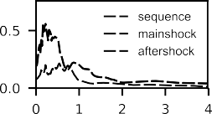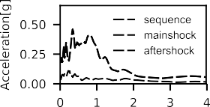  Armenia | 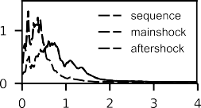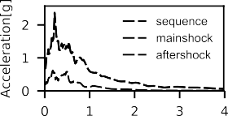  Chile
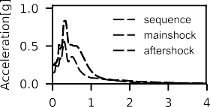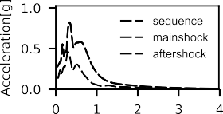  Greece | 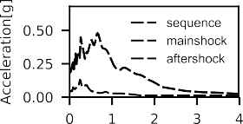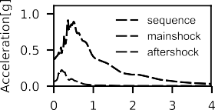  India
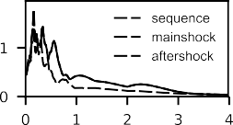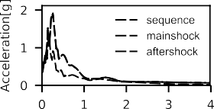  Iran | 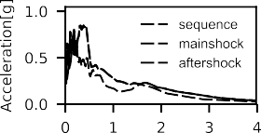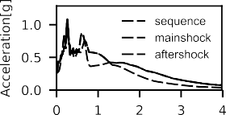  Italy Emilia
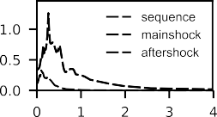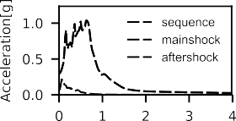  Italy Friuli | 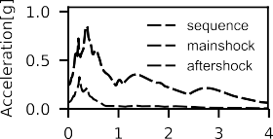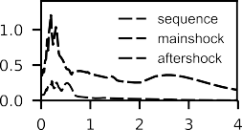  Italy Irpinia
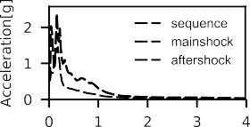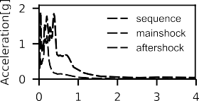  Italy Umbria | 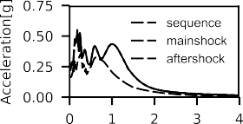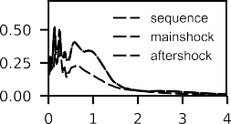  New Zealand - Christchurch
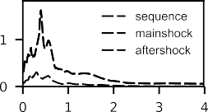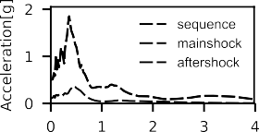  New Zealand Edgecumbe | 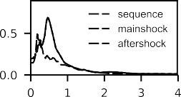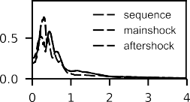  New Zealand Weber
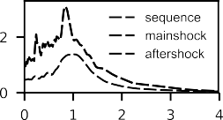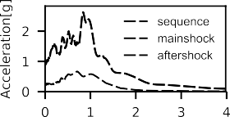  Taiwan | 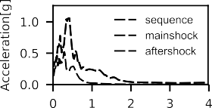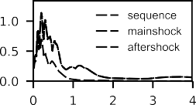  Turkey
Figure 1. Elastic Response Spectrum for all-natural motions
The aforesaid strong motions have been scaled up to reach the structural collapse. The fundamental period of the RC building among the two directions, x-axis and y-axis, was selected to pick the spectral acceleration (Sa (T1, 5%)), being used as the initial indication of the value to attain the inelastic behaviour. The fourteen records were then scaled down to reach a maximum acceleration compatible with the IM. Mainshock and one-

4

aftershock were employed using a unique record with a time gap, which is an acceptable time to bring the structure to the rest and cease any move due to damping, equals to thirty times the fundamental period of the building. As suggested in [7], a trend between the mainshock and aftershock is herein provided in terms of significant duration and mean period to investigate two main parameters of the multiple earthquakes.

Table 1. Seismology properties (Keynote: MS = Mainshock; AS = Aftershock; SD = Significant Duration; IA = Intensity Area; P = Predominant Period)

Date | Earthquake |  | PGAx | PGAy | SDx | SDy | IAx | IAy | Px | Py
 |  |  | [g] | [g] | [sec] | [sec] | [m/s] | [m/s] | [s] | [s]
07/12/1988 | Armenia | MS | 0.20 | 0.18 | 7.90 | 10.15 | 0.31 | 0.24 | 0.22 | 0.34
 |  | AS | 0.08 | 0.04 | 9.24 | 12.54 | 0.06 | 0.02 | 0.54 | 0.22
03/03/1985 | Chile Valparaiso | MS | 0.39 | 0.68 | 40.88 | 35.96 | 6.81 | 15.07 | 0.14 | 0.22
 |  | AS | 0.18 | 0.19 | 16.86 | 19.59 | 0.68 | 0.73 | 0.52 | 0.18
13/09/1986 | Greece Kalamata | MS | 0.25 | 0.14 | 2.70 | 4.11 | 0.28 | 0.08 | 0.32 | 0.30
 |  | AS | 0.15 | 0.27 | 2.82 | 1.87 | 0.11 | 0.30 | 0.30 | 0.34
29/03/1999 | India Chamoli | MS | 0.19 | 0.37 | 14.60 | 8.98 | 0.29 | 0.80 | 0.66 | 0.36
 |  | AS | 0.04 | 0.07 | 8.80 | 5.06 | 0.01 | 0.02 | 0.24 | 0.22
11/08/2012 | Iran Varzaghan | MS | 0.45 | 0.36 | 5.58 | 8.28 | 1.45 | 0.80 | 0.18 | 0.18
 |  | AS | 0.51 | 0.54 | 6.97 | 5.95 | 1.65 | 1.88 | 0.16 | 0.26
20/05/2012 | Italy Emilia | MS | 0.26 | 0.26 | 5.60 | 5.99 | 0.69 | 0.84 | 0.32 | 0.26
 |  | AS | 0.22 | 0.29 | 7.54 | 6.97 | 0.76 | 1.28 | 0.10 | 0.26
11/09/1976 | Italy Friuli | MS | 0.34 | 0.30 | 4.14 | 4.93 | 0.79 | 1.21 | 0.26 | 0.64
 |  | AS | 0.12 | 0.08 | 1.46 | 2.20 | 0.03 | 0.01 | 0.10 | 0.10
23/11/1980 | Italy Irpinia | MS | 0.25 | 0.36 | 15.08 | 15.24 | 1.19 | 1.39 | 0.36 | 0.20
 |  | AS | 0.07 | 0.08 | 14.06 | 13.90 | 0.07 | 0.07 | 0.22 | 0.22
26/09/1997 | Italy Nocera Umbria | MS | 0.56 | 0.49 | 4.95 | 4.35 | 3.29 | 2.80 | 0.16 | 0.38
 |  | AS | 0.52 | 0.31 | 4.73 | 4.10 | 0.86 | 0.70 | 0.18 | 0.16
22/02/2011 | New Zealand Christchurch | MS | 0.22 | 0.18 | 4.00 | 3.33 | 0.22 | 0.17 | 1.00 | 0.58
 |  | AS | 0.17 | 0.16 | 7.05 | 7.89 | 0.20 | 0.13 | 0.18 | 0.14
02/03/1987 | New Zealand Edgecumbe | MS | 0.32 | 0.50 | 6.47 | 7.79 | 1.67 | 1.91 | 0.40 | 0.36
 |  | AS | 0.08 | 0.11 | 9.50 | 10.60 | 0.09 | 0.11 | 0.30 | 0.46
13/05/1990 | New Zealand Weber | MS | 0.15 | 0.19 | 9.88 | 8.98 | 0.17 | 0.23 | 0.18 | 0.20
 |  | AS | 0.20 | 0.26 | 12.90 | 12.49 | 0.38 | 0.43 | 0.46 | 0.30
21/09/1999 | Taiwan Chi-Chi | MS | 0.95 | 0.91 | 21.76 | 21.89 | 9.31 | 6.97 | 0.84 | 0.84
 |  | AS | 0.47 | 0.22 | 2.73 | 5.25 | 1.80 | 0.43 | 1.04 | 0.70
12/11/1999 | Turkey Duzce | MS | 0.30 | 0.30 | 16.94 | 17.78 | 1.58 | 1.87 | 0.42 | 0.20
 |  | AS | 0.15 | 0.22 | 6.66 | 5.88 | 0.15 | 0.29 | 0.28 | 0.12
After examining the mainshock-aftershock motions in Table 1, it was noticed that the mean values (using the square root of sum of square SRSS law) of the PGA are 0.51g and 0.29g along x and y respectively. This can be simply explained by the energy released from mainshock which is far larger than aftershocks. The most commonly used approach to calculate the earthquake energy is the Arias intensity. The Arias Intensity of all groups of motions was computed and the mean calculated. The mean values were 3.2m/sec and 0.7 m/sec for the mainshock and aftershock respectively. These latter values confirm how the fractures triggering the mainshock is larger than the following aftershock. From qualitative analysis, the as-recorded natural motions have different features and the use of artificial and often unscaled records seems to not be appropriate for non- linear dynamic analyses. Artificial records do not match the seismic hazard of the local site and can even lose any possible bond with short-time aftershocks.

5

Figure 2. Significant Duration Correlation
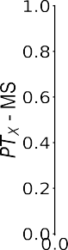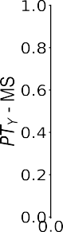
Figure 3. Predominant Period Correlation
Figures 2 and 3 show a mild correlation between mainshocks and aftershocks for the duration and no correlation for the frequency contents. However, this latter can be taken as a general indication as there is not yet an agreement on the mainshock-aftershock properties and correlations.

Fragility Curves via Incremental Dynamics Analysis (IDA)
The IDA procedure is herein used to predict and assess the nonlinear seismic response of an existing RC structure with rebars subjected to different levels of corrosion. The IDA involves ground motions (Mainshock, Aftershock and Mainshock-Aftershock sequence) properly scaled through the use of coefficients to ideally catch the linear and nonlinear response of RC structures. A relationship between a damage measure quantity (EDP) and an intensity measure (IM) is then obtained by interpolating these two parameters. In this study, the damage measure (EDP) is related to the maximum inter-storey displacement (ϑMAX), which is correlated to the dynamic instability or failure, the interpolation of the parameters and the structural damage stated in the Eurocode. The procedure for employing the coefficients to scale ground motions up is related to the failure of the structure by using the SRSS formulation to combine the earthquakes in both directions, x and y. To perform the IDA, the hunt-fill algorithm [13] was configured to use an elastic initial step of 0.005 g and five more steps to hunt the first non-convergence in terms of the infinite value of the inter-storey displacement, while other two steps were specified to reach up the inelastic response (“flatline”). A total of eight points were then designed to attain a good compromise between time-consuming and result accuracy. A total of nine IDAs were performed per each record via an advanced finite element approach using different levels of corrosion (CR = 0%, CR=10% and CR=20%). Then, the seismic fragility analysis is carried out. Fragility curves are extremely important for evaluating the global and local response of RC structures as they give a relevant indication on the probability of exceedance of a certain limit. The formulation is given in eq. (1):
 |  | $$P\left({EDP}_{i}≥{EDP}_{LS}|IM=x\right)=Ф\left[\frac{1}{β_{i}}ln\left(\frac{IM}{{LS}_{i}}\right)\right]$$ | (1)
where P is the probability of exceedance of a certain limit state based on ground motion intensity, Φ is the
probability density function of a normal distribution, βi is the lognormal standard deviation, and LSi is the

6

median value that represented a ground motion intensity that has 50% probability for occurrence of the limit state from the nonlinear static analyses.
In addition to a probabilistic model, a fragility assessment requires the evaluation of the structural capabilities of all different components, so three different limit states are specifically used in this study such as Limited Damage (LD), Significant Damage (SD) and Near Collapse (NC). The seismic vulnerability assessment depends upon the definition of these structural limits. To identify these local and global parameters, non-linear static analyses were performed on the existing RC building considering the average of three different lateral loading patterns and all levels of corrosions. The maximum inter-storey drift ratio threshold values are then retrieved (Table2).
Table 2. Limit States threshold values. (Keynote: NC = Near Collapse; SD = Significant Damage; LD = Limited Damage)

Corrosion Rate [%] | NC | SD | LD
0 | 2.30 | 1.87 | 1.06
10 | 1.69 | 1.44 | 0.93
20 | 1.21 | 1.17 | 0.90

Case Study Building
The testbed for this study is an existing four-storey RC building (SeismoSoft Sample Models, 2018) situated near the sea in San Benedetto del Tronto (Italy). The cross-section of the columns is 350x350 mm2 for the ground floor and 300x300 mm2 for the other floors respectively, both with 6 longitudinal rebars Φ16mm and transverse stirrups Φ6mm with spacing 150mm. The beams have different cross-sections and the longitudinal reinforcements mostly consist of Φ14 mm and Φ10 mm diameters. The concrete’s compressive strength was
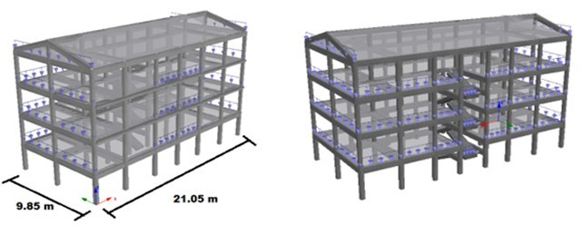
16.73 MPa both for columns and beam, while the steel reinforcement had yielding stress of 440 MPa. Rigid diaphragms were implemented to model the slabs as to ensure in-plane stiffness properties, and exhibit neither membrane deformation nor report the associated forces, while all the joints were connected through fully- supported-rigid-connections (all degrees of freedom are restrained) to the ground. An accurate loading analysis was conducted and applied for the beams (loading-range [6.51 kN/m; 8.81 kN/m]). The full model is given in Figure 5. Then, corrosion was applied externally for all columns and beams as to simulate a real exposure to an aggressive environment which will mainly produce corrosion on unprotected RC components whereas inside elements are protected by infills. Constitutive models for concrete and steel were modified according to the procedure reported in [12], while Chang-Mander model for concrete and Monti-Nuti model for steel were used as proposed in [14,15]
Figure 5. Finite Model of the sample Structure implemented in SeismoStruct: a) North and b) South Views

Discussion and Results
This section shows a comparison of fragility curves in terms of PGA for all three limit states when the existing RC building is subjected to mainshock-only, aftershock-only and mainshock-aftershock sequence. Such fragility curves quantify the effect of corrosion on the seismic vulnerability at different levels of exposure. These proposed fragility curves could be useful for engineering applications in evaluating the seismic vulnerability of existing RC structures exposed to harsh environments with an externally real attack.

7

  - Limited Damage

The results for the limit state of limited damage are herein presented. Figures 6 shows a comparison of the seismic vulnerability when the structure is exposed to different levels of corrosion and subjected to three different earthquake conditions. The case of aftershock-only seems to be the least vulnerable at any level of the earthquake intensity. The latter observation can be explained by the seismological features of the natural motions such as shorter duration and no large frequency range compared to mainshocks, even if the IDAs were performed to reach up the collapse of the structure for each case.

MS | AS | SQ
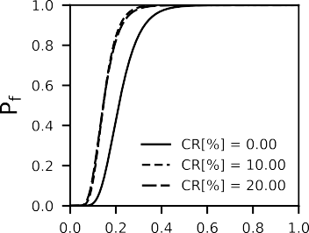 | 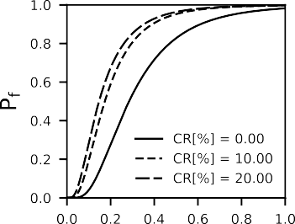 | 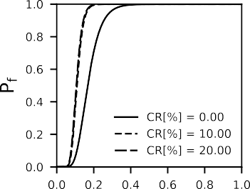
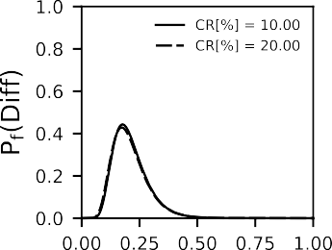 | 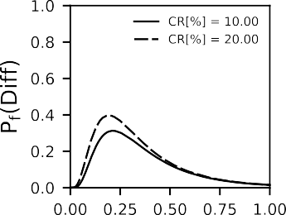 | 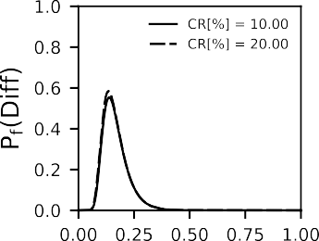
Figure 6. Fragility Curves (Mainshock-MS; Aftershock-AS; Sequence-SQ)

It is evident the relevant impact of corrosion on the seismic vulnerability of the RC building, especially for the mainshock and the sequence. As the limited state occurs at the low-scaled ground motions, small variations of the initial stiffness and the local inelastic response of the building can result in modest inter-storey drift-ratio differences, whereas the corrosion penetration is not relevant yet. The trends for the aftershock-only with corrosion rates CR=10% and CR=20% clearly illustrate an increase in the failure probability by 30% and 40% respectively, reflecting the loss of stiffness and lateral strength at common PGA range. On the other hand, the sequence shows a significant effect on the seismic vulnerability of the existing structure for the selected exceedance probabilities as the increase is almost 60% compared to the un-corroded case, because of an already mainshock-damaged building with the following damage accumulation and residual displacements. A no- symmetric external exposure on an irregular RC building may cause contrasting inelastic behaviour with the increment of the corrosion attack. Inter-storey displacement can either increase or decrease depending upon the level of the corrosion penetration which is acting differently on the seismic response of the aged structure. Although the effect of corrosion increased the exceedance probability for this limit state by 45% and 60% for mainshock and sequence respectively, there is a gap of less than 2% between CR=10% and CR=20%, which forced the existing building to resist PGA not higher than 0.25g compared to 0.4g of the as-built pristine edifice.

8

  - Severe Damage
The fragility curves of the limit state of Severe damage are shown in Figure 7. The limits are defined in Table 2 by considering three different levels of corrosion. Comparison of fragility curves associated with severe damage and limited damage clearly show that the building requires a higher PGA to reach this specific damage SD. Furthermore, the effect of different levels of corrosion is here more relevant in any case.

MS | AS | SQ
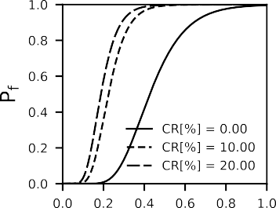 | 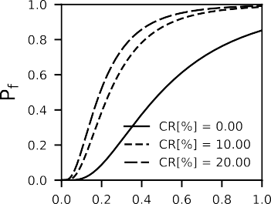 | 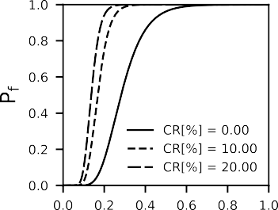
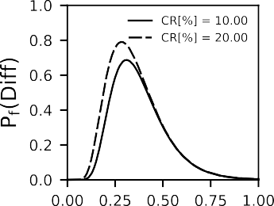 | 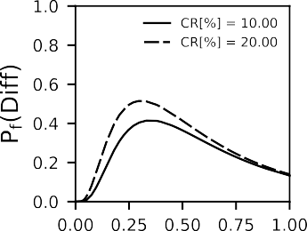 | 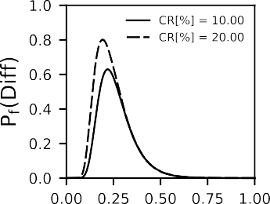
Figure 7. Fragility Curves (Mainshock-MS; Aftershock-AS; Sequence-SQ)
Results from the mainshock-aftershock sequence point out a relevant seismic vulnerability of the building, even in the pristine condition. As a result, the difference between the un-corroded and corroded building through failure probability is 80% and 60% for CR=20% and CR=10% respectively. An earthquake with a PGA geometric combination of 0.22g gives a failure probability almost equals to 100% for the sequence, while aftershock and mainshock provide a lesser seismic fragility. When subjected to the aftershock-only, the pristine structure exhibits an essential lateral strength and can easily withstand PGAs up to 0.8. Differently, when corrosion occurs, the increase in the inter-storey displacements weakens the capacity of the building to resist large earthquake and distribute the inelasticity at each level. In the last case, a PGA value of 0.4g gives 38% of exceeding the severe damage, where CR=10% and CR=20% shows a failure probability of 80%, which doubles the risk of collapse.
A more substantial impact can be noted when the building is subjected to the mainshock. From a statistical standpoint, there is an extreme reduction of the maximum earthquake acceleration beyond which the structure fails to reach the limit state of SD. The total resistance of the deteriorated structure is quantified by a maximum value of the motion acceleration of 0.4g compared to an initial value of 0.8g. Furthermore, the comparison between mainshock and sequence shows how the damage accumulation of the building after a mainshock dramatically increased the seismic vulnerability of the RC building, reducing its capacity to small values of PGAs (0.2g) with the higher corrosion attack (CR=20%).

  - Near Collapse
This section focuses on the seismic vulnerability for the limit state of near collapse, which commonly indicates the end of the service life. The values for this limit state, as above-mentioned, were defined based on earlier

9

investigations defined in [18], which are related to the need for a sequence of limit states, even for aggressive environments triggering the phenomenon of corrosion. The imminent decrease of the lateral strength and ductility with the increase of the corrosion level affect significantly the inelastic behaviour of the building; thus, when the structure enters into the non-linear behaviour, the effects of corrosion dramatically reduce the seismic resistance.

MS | AS | SQ
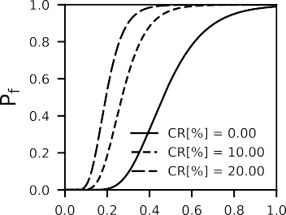 | 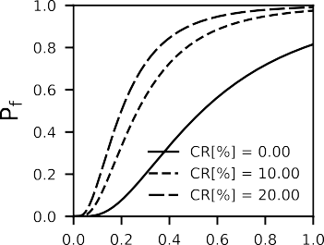 | 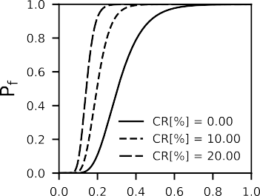
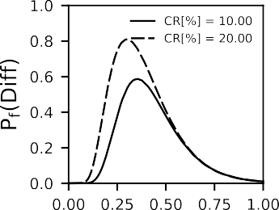 | 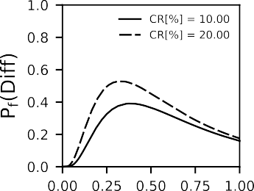 | 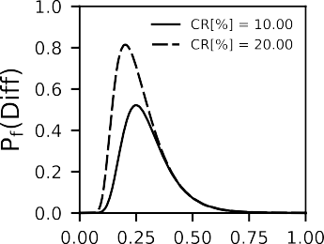
Figure 8. Fragility Curves (Mainshock-MS; Aftershock-AS; Sequence-SQ)
Figure 8 shows that an existing RC building with corrosion rates between 10% and 20% withstands potentially reduced values of the maximum ground motion acceleration with a significant increase of the failure probability. In addition to this, a large difference can be noted between the fragility curves, which is mostly the result of the attainment of the non-elastic behaviour, especially for the mainshock and sequence.
Mainshock and sequence motions show a critical increase in the probability of exceedance when corrosion occurs, which is mostly due to extensive damage, higher PGA and wide-range of frequency contents. Particularly, the PGA range decreases significantly from 0.2g-0.8g (meaning imminent collapse) for the pristine building to 0.15g-0.4g for the maximum exposure. On the other hand, the aftershock condition seems to force the structure to keep up with its elastic behaviour for high critical PGAs, assuming lesser values of the seismic vulnerability. This observation is owing to restricted-range frequencies and short duration which allows the structure to exploit its resistance. Results essentially demonstrate that the structure is capable to resist large displacement without failing until PGA of 0.8g, even for highly corroded environments. Yet, there is a consistent increment of the probability of exceedance, by 40% and 50% for CR=10% and CR=20% respectively, compared to the as-built structure accordingly.
Considering the mean value of the PGAs from the group of all ground motions (PGAMEAN = 0.51g), the probability of failure for all three un-corroded cases is lesser than 100% (from 42% in the aftershock case to 85% for the sequence), while a relevant increase can be observed when corrosion occurs, which is quantified by the 100% (imminent failure) for the mainshock and sequence, and more than 80% for the aftershock.

10

- Conclusions and future work
A portfolio of fragility curves in terms of PGA was developed based on the parametric study of an existing four-storey RC building exposed to corrosion and subjected to three earthquake conditions. The limit states of Limited damage, Severe Damage and Near Collapse were obtained from non-linear static analyses considering three different lateral loading patterns and used as a median value representing a ground motion intensity that has 50% probability of occurrence. To assess the seismic vulnerability, the existing building was implemented via an advance Finite Element approach (FEM). The following conclusions have been drawn according to the results obtained from this study:
- The fragility curves of the existing RC building were developed for three limit states defined via non- linear static analyses. From observations, the limited damage showed a small difference between the un-corroded and corroded building, mostly due to the change of the local seismic response of the structure and low-scaled ground motions. Inter-storey drift ratios seem to behave differently depending upon the level of corrosion applied. Thus, the structure with CR=10% and CR=20% exhibits a difference in the failure probability of less than 3. Nevertheless this small variation, it was observed a consistent increment in the exceedance probability, by 40% and 60% for mainshock and sequence respectively with the increase of the corrosion rate.
- Severe damage showed a clearer difference between the un-corroded and corroded building. Corrosion affects severely the inelastic response of the existing building increasing the maximum inter-storey displacement by 60% and 80% (CR=10% and CR=20%) for mainshock and sequence respectively. Conversely, corrosion seems to have a lesser impact when the building is subjected to aftershock whereas a substantial increase (40% and 50% - CR=10% and CR=20%) in the maximum inter-storey displacement can be noted. Results obtained from the Near Collapse demonstrated that this limit state had the higher failure probability and clearance between CR=10% and CR=20% as a result of different inelastic response for various corrosion rates. More than 80% increment of the failure probability in comparison with the un-corroded RC building was obtained.
- When fragility curves were investigated, mainshock and sequence showed higher seismic vulnerability compared to the aftershock condition. The probability of exceedance was 40% for the aftershock-only compared to 80% of mainshock-only and sequential motions. Considering the mean value of the as- natural ground motions, the seismic vulnerability of the aged building was found to be increased up to 100% for mainshock and sequence. On the other hand, the maximum increase in seismic fragility for the aftershock-only was 80%.
- The probabilistic approach demonstrates that there is an extreme reduction of the maximum earthquake acceleration beyond which the structure fails to reach the examined limit state. The total resistance of the deteriorated structure is reduced by 50% as the maximum value of the motion acceleration can withstand is 0.4g compared to an initial value of 0.8g of the pristine building.
- Subsequent aftershocks can induce high damage and lead to completely different seismic response of an already damaged structure from preceding mainshocks. Results clearly showed a dramatic increase in the seismic vulnerability for earthquake sequences, even for a pristine building.
- Inter-storey drift ratios stated in the Eurocode are no longer conservative for multiple sequences and existing RC structure exposed to corrosion. The latter finding could lead to overestimated non-linear response. Thus, there is a need for establishing new inter-storey drift limit accounting for multiple sequence and corrosion.
- The maximum inter-storey displacement was used as engineering demand parameter to determine the fragility curves. Although widely used, it seems future investigations of the corrosion impact on different inter-storey levels are needed to give essential indication even on the local effects of corrosion on the seismic response of RC buildings. As a result of these changes, the maximum inter-storey displacement may be no longer higher than the un-corroded case and, it is obvious to obtain overlap and intersection between fragility curves with different corrosion rates.
- A more detailed study should also investigate the effects of corrosion on additional relevant response quantities, e.g. local buckling of steel reinforcement, local and global ductility and chord rotations, among others.

11

- Acknowledgements
The authors would like to acknowledge the gracious support of this work through the EPSRC and ESRC Centre for Doctoral Training on Quantification and Management of Risk and Uncertainty in Complex Systems Environments Grant No. (EP/L015927/1)

References
- L. Di Sarno (2013), Effects of multiple earthquakes on inelastic structural response, Engineering Structures, Volume 56, 2013, Pages 673-681, ISSN 0141-0296, https://doi.org/10.1016/j.engstruct.2013.05.041.
- Priestley MJN. He Whittier Narrows, California Earthquake of October 1, 1987-damage to the I-5/I-605 separator. Earthquake Spectra 1988; 4(2):389-405.
- Elnashai AS, Bommer JJ, Martinez-Pereira A, (1998). Engineering implications of strong-motion records from recent earthquakes. In: Proceedings of Eleventh European Conference on Earthquake Engineering. CD-ROM. Paris; 1998
- Amadio, C., Fragiacomo, M., Rajgelj, S. (2003). The effects of repeated earthquake ground motions on the non-linear response of SDOF systems. Earthquake Engineering and Structural Dynamics, 32 (2), pp. 291-308
- George D. Hatzigeorgiou, Dimitri E. Beskos (2009). Inelastic displacement ratios for SDOF structures subjected to repeated earthquakes. Engineering Structures, Volume 31, Issue 11, Pages 2744-2755, ISSN 0141-0296, https://doi.org/10.1016/j.engstruct.2009.07.002.
- Saman Yaghmaei-Sabegh, Jorge Ruiz-García (2016). Nonlinear response analysis of SDOF systems subjected to doublet earthquake ground motions: A case study on 2012 Varzaghan–Ahar events. Engineering Structures, Volume 110, Pages 281-292, ISSN 0141-0296, https://doi.org/10.1016/j.engstruct.2015.11.044.
- Ruiqiang Song, Yue Li, John W. van de Lindt (2014). Impact of earthquake ground motion characteristics on collapse risk of post-mainshock buildings considering aftershocks, Engineering Structures, Volume 81, Pages 349-361, ISSN 0141-0296, https://doi.org/10.1016/j.engstruct.2014.09.047.
- George D. Hatzigeorgiou, Asterios A. Liolios (2010). Nonlinear behaviour of RC frames under repeated strong ground motions, Soil Dynamics and Earthquake Engineering, Volume 30, Issue 10, Pages 1010-1025, ISSN 0267- 7261, https://doi.org/10.1016/j.soildyn.2010.04.013.
- Resat Oyguc, Cagatay Toros, Adel E. Abdelnaby (2018). Seismic behaviour of irregular reinforced-concrete structures under multiple earthquake excitations, Soil Dynamics and Earthquake Engineering, Volume 104, Pages 15-32, ISSN 0267-7261, https://doi.org/10.1016/j.soildyn.2017.10.002.
- Panchireddi, B and Ghosh, Jayadipta (2019). Cumulative vulnerability assessment of highway bridges considering corrosion deterioration and repeated earthquake events, Bulletin of Earthquake Engineering, Volume 17, Pages 1603- 1638, ISSN=1573-1456, doi=10.1007/s10518-018-0509-3.
- Vamvatsikos D, Cornell CA (2002): Incremental dynamic analysis. Earthquake Engineering & Structural Dynamics, 31 (3), 491-514.
- Di Sarno L, Pugliese F (2019) Critical review of models for the assessment of the degradation of reinforced concrete structures exposed to corrosion, Conference SECED 2019. Earthq Risk Eng Towards Resil World. https://doi.org/10.6084/m9.figshare.12152778.
- Vamvatsikos, D. and Cornell C.A. (2004). Applied Incremental Dynamic Analysis, Earthquake Spectra, Volume 20, Pages 523-553, https://doi.org/10.1193/1.1737737.
- Abdelnaby, Adel E. (2018). Fragility Curves for RC Frames Subjected to Tohoku Mainshock-Aftershocks Sequences. Journal of Earthquake Engineering, Volume 22, Pages 902-920, Taylor & Francis, https://doi.org/10.1080/13632469.2016.1264328.
- Hosseinpour, F. & Abdelnaby, A.E.(2017). Fragility curves for RC frames under multiple earthquakes, Soil Dynamics and Earthquake Engineering, Volume 98, 2017, Pages 222-234, ISSN 0267-7261, https://doi.org/10.1016/j.soildyn.2017.04.013.
- Li, Q. & Ellingwood, B. R. (2007). Performance evaluation and damage assessment of steel frame buildings under main shock–aftershock earthquake sequences. Earthquake Engineering and Structural Dynamics, Volume 36 Issue 3, Pages 405-42. https://doi.org/10.1002/eqe.667.
- Ryu, H, Luco, N., Uma, S.R. & Liel, A.B. (2011). Developing fragilities for mainshock-damaged structures through incremental dynamic analysis. Proceedings of the Ninth Pacific Conference on Earthquake Engineering Building an Earthquake-Resilient Society 14-16 April, 2011, Auckland, New Zealand.
- Di Sarno, L., Pugliese, F. Numerical evaluation of the seismic performance of existing reinforced concrete buildings with corroded smooth rebars. Bull Earthquake Eng 18, 4227–4273 (2020). https://doi.org/10.1007/s10518-020-00854-8

12

