Abstract: PB2377
Type: Publication Only
Background
Beta-thalassemia is an inherited blood disorder characterized by reduced levels of functional hemoglobin, resulting in variable phenotypes ranging from clinically asymptomatic individuals to severe anemia. Patients with beta-thalassemia may require regular blood transfusions, supported by appropriate iron chelation therapy (ICT), throughout their life. Quality of life (QoL) benefits can be quantified in the form of health state utility values (HSUVs). Utilities are defined as the strength of an individual’s preference for being in a particular health state, quantified into an index value, typically scaled between 0 (death) and 1 (full health). To date, no study has examined the utility impacts of differing transfusion burden (TB) and ICT.
Aims
To determine how the general public in the UK value beta-thalassemia health states associated with differing TB and ICT.
Methods
Relevant beta-thalassemia literature relating to symptom and QoL impact (including physical, functional, and emotional well-being), and the safety profile of treatments were reviewed to draft health state descriptions. Eleven health states informed by a targeted review were developed. Three burden levels were used for the transfusion-dependent (TD) health states: high (>7 units transfused, 4 transfusion visits every 12 weeks); medium (>5 to ≤7 units, 3 transfusion visits every 12 weeks); and low (≤5 units, 2–3 transfusion visits every 12 weeks). Two burden levels were used for the non-TD (NTD) health states (high and low burden of anemia). Within the TD burden levels, the available ICT treatment strategies were implemented: oral; subcutaneous (SC); and oral or SC (O-SC). The descriptions were validated for clinical accuracy and completeness by hematologists with experience in thalassemia care (n=3) and thalassemia patient representatives (n=2). A composite time trade-off (cTTO) study was undertaken following the standardized valuation study protocol version 2.1 for the EQ-5D-5L instrument. Interviews were conducted using this EuroQol valuation technology (EQ-VT). Individuals were recruited at random via street recruitment and invited to participate in the cTTO study with 1-hour interviews conducted in Manchester, UK. Descriptive statistics were computed for HSUV, and the difference in mean utility values within and between the TB health states tested.
Results
200 individuals were recruited. Of 200 responses, 12 were removed from the utility value estimates in accordance with TTO general practice; participants who did not trade any time at all (non-traders; n=10) or those who gave the same utility value for 100% of the health states (n=2). Participant mean (standard deviation [SD]) age was 41.5 (16) years (range 18–81) and comprised 88 (46.8%) female participants. The HSUVs ranged from 0.79 (SD 0.34) for NTD (low burden of anemia) with oral ICT, to 0.37 (SD 0.50) for high TB with SC ICT (Table). A significant difference (P<0.01) was identified between TB health states. However, mean differences were not consistently found to be statistically significant within all TB health states for differing ICT treatment modalities.
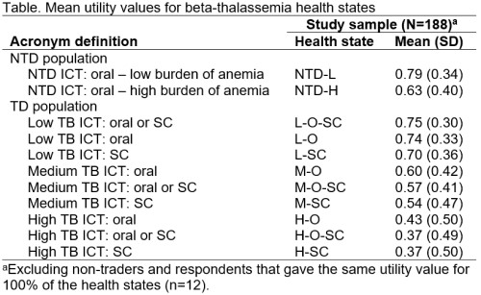
Conclusion
This study examines utility valuations across a range of NTD and TD beta-thalassemia health states. In NTD and TD beta-thalassemia, higher burden of anemia and higher TB levels, respectively, were found to be significantly associated with lower utility valuations in beta-thalassemia from the perspective of the UK general population. Differential use of ICT may also contribute to QoL impact in beta-thalassemia.
Session topic: 27. Thalassemias
Keyword(s): Beta thalassemia, Iron chelation, Quality of life, Transfusion

