COVID-19: The return of football fans
Alexander John Bond¹, David Cockayne², Jan Andre Lee Ludvigsen³, Kieran Maguire², *Daniel Parnell², Daniel Plumley⁴, Paul Widdop⁵, Rob Wilson⁴
¹Centre for Social Justice in Sport & Society, Carnegie School of Sport, Leeds Beckett University, UK
²Centre for Sport Business, University of Liverpool Management School, University of Liverpool, Liverpool, UK.
³School of Justice Studies, Liverpool John Moores University, Liverpool, UK.
⁴ Sheffield Business School, Sheffield Hallam University, Sheffield, UK.
⁵Manchester Metropolitan Institute of Sport, Manchester Metropolitan University, Manchester, UK.

*Corresponding author
Daniel Parnell*, Centre for Sport Business, University of Liverpool Management School, University of Liverpool, Liverpool, UK.
Twitter: @parnell_daniel ORCID: https://orcid.org/0000-0001-5593-0633
David Cockayne, Centre for Sport Business, University of Liverpool Management School, University of Liverpool, Liverpool, UK.
Twitter: @cockaynedc ORCID: https://orcid.org/0000-0002-5473-6967
Jan Andre Lee Ludvigsen, School of Justice Studies, Liverpool John Moores University, Liverpool, UK.
Twitter: @jaludvigsen ORCID: http://orcid.org/0000-0002-0085-2321
Kieran Maguire, Centre for Sport Business, University of Liverpool Management School, Liverpool, UK.
Twitter @KieranMaguire
Alexander John Bond, Centre for Social Justice in Sport & Society, Carnegie School of Sport, Leeds Beckett University, UK.
Twitter: @AlBondSportBiz ORCID: https://orcid.org/0000-0002-9667-4143
Daniel Plumley, Sheffield Business School, Sheffield Hallam University, Sheffield, UK.
Twitter: @DrDanPlumley ORCID: https://orcid.org/0000-0001-7875-0969
Paul Widdop, Manchester Metropolitan Institute of Sport, Manchester Metropolitan University, Manchester, UK.
Twitter: @Fire_and_Skill ORCID: https://orcid.org/0000-0003-0334-7053
Rob Wilson, Sheffield Business School, Sheffield Hallam University, Sheffield, S1 1WB
Twitter; @DrRob_Wilson ORCHID: https://orchid.org/0000-0002-9657-7570

Abstract
COVID-19 has sent a shockwave into society and sport. As result of this is sport and football resuming without spectators – fans or supporters, has brought a number of financial issues that has threatened the sustainability and future of many clubs. This commentary unpicks what has happened and some of the tensions, decision-making and consequences surrounding the return of spectators. The commentary presents case that spectators are key to the survival of football clubs and that the United Kingdom Government must reverse their decision to not let spectators return. Now more than ever, these words hold substance, meaning and truly matter to clubs and their networked communities, “Football without fans is nothing”.

Keywords: Networks; COVID-19; Football; Finance; Fans; Spectators;

Introduction
On Friday 13th March 2020 professional football across the United Kingdom (UK) was suspended. In early April, the suspension of live matches was extended mirroring broader changes globally in both football and sport. COVID-19 generated an exogenous “market shock” to the football system, wiping clear the European football calendar for the first time since WWII. Since March 2020, stakeholders including club owners, investors, broadcasters, advertisers and the football ecosystem have been forced to reconcile the downstream impact of event cancellations, modifying operational and commercial strategies on a scale not previously experienced (Parnell et al. 2020a).

Central to the concerns of commercial stakeholders as well as the athletes themselves are those who willingly give their time and money to come and support their teams at live events - the fans or spectators, what the market would wrongly define as customers. A football club co-exists in a symbiotic relationship with its spectators, the greater the loyalty the more resources will flow from them to the football club. In return the football club provides an identity, a cultural icon, escapism and a focus for social interaction. This juxtaposed relationship, creates tension, and ironically football’s fairly defiant response to the economic recession of 2007-2012, and its growing commercial prowess over the past two decades, has unintentionally taken the presence of spectators, and their loyalty, for granted. The market growth and acceleration of commercialisation and globalisation of football over the past twenty years has created a chasm like disconnect between supporters and football elites, nurturing hierarchies and distinct boundaries between competition organisers, leagues, clubs, athletes, and spectators.

COVID-19 has reminded us that spectators are directly involved in the value creation process, and that their voice, influence and legitimacy extends far beyond turning up to a live game once or twice a week (Bond et al., 2020). For example, broadcasters are fully aware of their devalued product when no spectators sitting in the stands. The symbiotic nature of the relationship between fan and club is one in which they co-create a product that is irreducible to either one alone. This biweekly co-created ritual is key to the sustainability of many football clubs, and the entire ecosystem of the sport. In this commentary, we present the fan, or spectator as central to this view of football as a living eco-system of networked stakeholders that work together to co-create the market and its value, rather than simply as a taken-for-granted component of a more mechanical, top-down economic structure. In this paper we aim to outline the consequence of no spectators in football stadia to professional football clubs and build the case for the return of spectators.

What happened
Football is a socially constructed product, in that sense we can treat it as a world, as in the Beckerian sense (Becker, 1982), such as that of art and music, with a division of labour, co-creation of the product, set of conventions and interactions, people working together to get things done, no part is irreducible over the other. Across the networked ‘Football World’ (Parnell et al., 2020), the reintroduction of spectators and fans to stadiums is a critical point of discussion, as there can be no co-creation if only one exists. For some clubs, especially those in the lower leagues, spectators must return to avoid financial collapse. However, the return of spectators – following football’s initial return behind closed doors – is likely to be a gradual and a highly politicised process, which will saliently highlight the social class hierarchies that still dog leisure and cultural pursuits.

In the UK, any decision to ‘let fans back in’ is likely to directly depend on local, regional and national restrictions and guidelines, as well as political decision-making. We have already seen the UK Government, on the 22nd September 2020, pause the planned reintroduction of spectators, which was due to commence from the 1st October 2020. This decision was made in response to broader COVID-19 restrictions in the UK; coming a few days after numerous clubs had already staged pilot events with over 2,000 spectators (FSA, 2020). However, recent changes in the situation with COVID-19, sporting bodies were told by the Department of Culture Media and Sport (DCMS) that spectators might not be reintroduced into stadiums until March 2021 at the earliest (Roan, 2020). This is particularly unpalatable to many, given the fact that cultural institutions and the prime concert halls and opera houses in London are starting to open their doors to live audiences, even though they are indoor, class politics abound in our leisure pursuits.

For spectators to return, Carmody et al. (2020, p. 947) note that event organisers 'must accept' that risk assessments must be undertaken, determined by local transmission rates, community spread and the demographic of spectators/athletes. Accordingly, measures must be implemented, so the benefits of the relevant event outweigh the risks (ibid.). Indeed, sporting events and mass crowds can increase the risk of COVID-19 transmission; however, not acting almost guarantees the loss of lower league clubs and which will cause a cascading domino effect placing the sustainability of the football pyramid across leagues in the UK, in jeopardy.

As we widen our gaze across European football and beyond, this is a globalised game least we forget, there are notable green shoots of recovery. Indeed, there are early positive signs to suggest that a return of spectators is possible through the emergence of innovative ideas that can assist a safe return. For instance, the Danish club FC Midtjylland set up two large screens in their stadium car park, so supporters could drive-in, park up and watch live matches from their vehicles while socially distancing (BBC Sport, 2020). In the German Bundesliga, home spectators were welcomed back inside the stadiums in September 2020. Here, spectators populated between 10 and 25 per cent of the stadiums and followed strict social distancing measures (Eckner, 2020). Brighton Hove Albion FC admitted 2,524 supporters for their 1-1 draw with Chelsea FC in a friendly match on 29th August. Social distancing measures were in place around the ground and for seating in the sparsely populated stands, this pilot event, part of DCMS plan for a phased return of spectators (DCMS, 2020), demonstrated what can be achieved by collective action. These are by no means perfect solutions, but in the interim, they can provide a way for clubs to regain some control of their revenue streams, and broadcasters can start to repackage their products. The UK Governments decision to end the phased return of spectators threatens the sustainability of many football clubs.

The importance of income
As Wilson et al (2020) indicate, the financial consequences of COVID-19 are severe for football’s finances. This is particularly obvious outside the top tier of the game, the English Premier League, notably the English Football Championship (EFL), Scottish Premiership and Scottish Championship. The financial resilience of clubs at these levels is crucial. Some, well managed clubs, having longer lead time before they hit a crisis point than others. Yet, the collapse of clubs would have a major impact upon the economic life of the many towns and small cities they serve and have a devastating social cost that is yet to be fully recognised. Indeed, football clubs are deeply entwined in their communities, they will have a major impact on health, wellbeing, social capital, happiness, and identity of its inhabitants.

Clubs generate revenue from three main sources, matchday, commercial and broadcasting (see Plumley et al, 2017a, Plumley et al, 2017b). Indeed, clubs in the EFL are more dependent on matchday revenue than their Premier League counterparts (Wilson et al, 2018). Consequently, due to present rules ensuring that games are played behind closed doors, many clubs will feel a degree of financial pain through lost revenues. A seat in a stadium is, after all, a perishable asset.

Figure 1: Premier League Clubs, Matchday income 2018/19
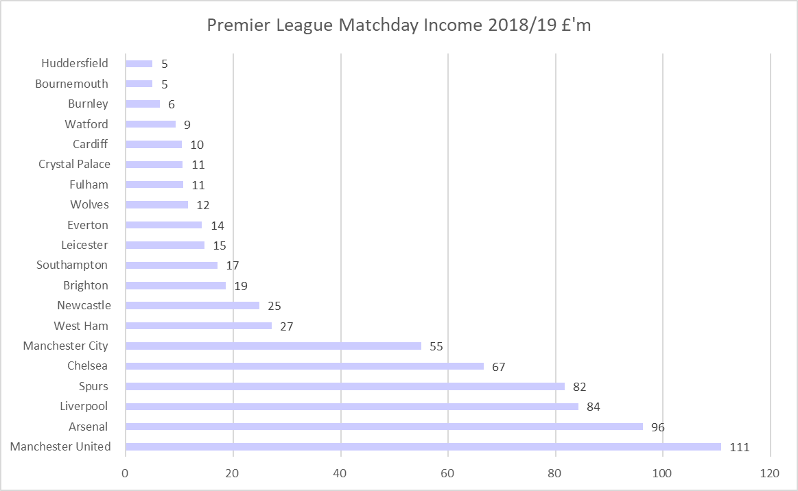

While Premier League clubs earned a collective £680 million based on the most recent accounts (see Figure 1), EFL matchday income is smaller in absolute terms (£155m; £55m; and £38m respectively for clubs in the Championship, League One and League Two). More strikingly, the dependency on matchday income, increases significantly further down the football pyramid (see figure 2). Therefore, returning paying spectators to matches is essential for the survival of many clubs in the so-called, football family (or Football World). This precarity is particularly prominent for the Scottish Premiership. For example, one mid-table club is losing up to £160,000 for a match against one of the two big clubs (i.e., Rangers FC and Celtic FC), amounting to matchday revenue from home and away spectators. It is worth noting that matchday spectators have become marginalised as an income source. Figure 3 outlines the history of how matchday income has become marginalised during the Premier League years.

Figure 2: Proportion of matchday income

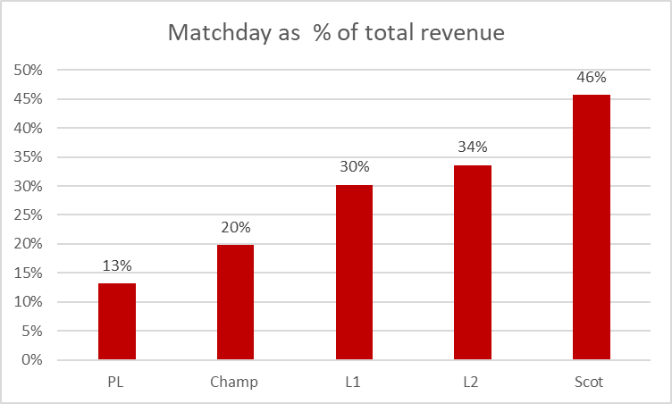

Figure 3: Premier League Matchday Income as % of Total 1993-2019

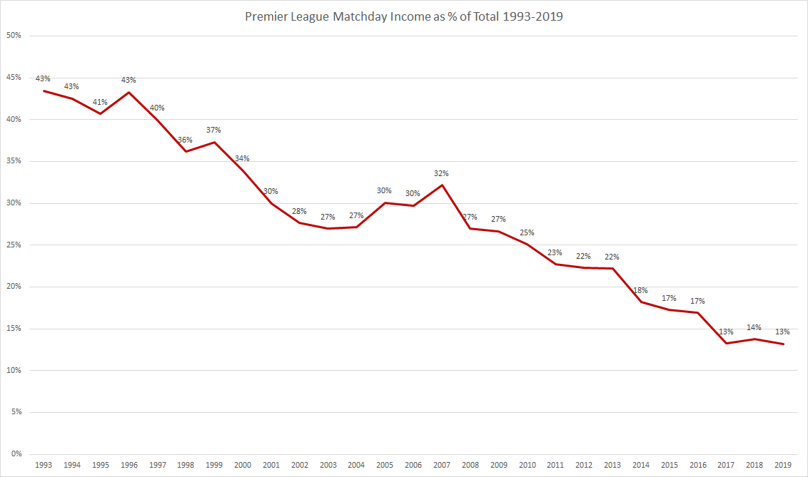

As noted previously, football as a product relies on a variety of people working together to co-create. Indeed, lower league clubs also generate sponsorship income from local partners. These endorsements rely on spectators being in the stadium, and given the current lack of exposure from the current behind-closed-doors rules, many will be reluctant to pay, further reducing revenue generating capacity (BBC, 2020). This is an issue, considering the disparity in revenue generating capacity causes EFL clubs to overstretch themselves financially, raising concerns around unstable expenditure. For example, median broadcasting revenue in the Premier League is £126 million compared to £8 million in the Championship and £1.4m and £1.1m in Leagues One and Two. Premier League clubs generated a collective £5.1 billion in 2018/19. Of which, 61% was spent on wages and a further 25% on transfer fees amortisation costs leading to an operating loss of £395 million in a pre-COVID-19 world (see figure 4).

Figure 4: Operating Profits and Losses in the English Premier League 2018-19
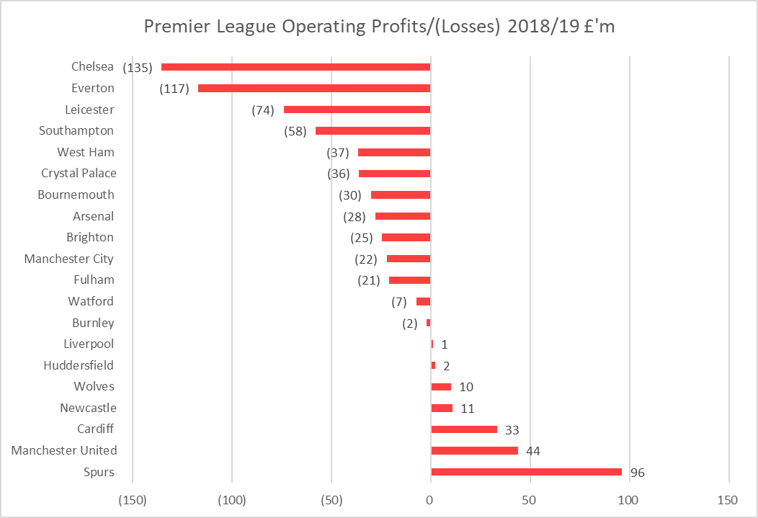

Sales of playing talent helped reverse a loss-making position for some clubs, yet the common misconception that football is awash is undoubtedly made apparent here. Things are acute in the Championship, partly due to club owners gambling on player recruitment, especially with those coming with high wage and transfer costs. Without the matchday income, so crucial to the cash flow of these clubs, many will spiral into financial oblivion (see Figure 5). Setting motion, the social as well as the economic cost to smaller towns and cities, often in the North of England.

Figure 5: Championship Wages: Turnover
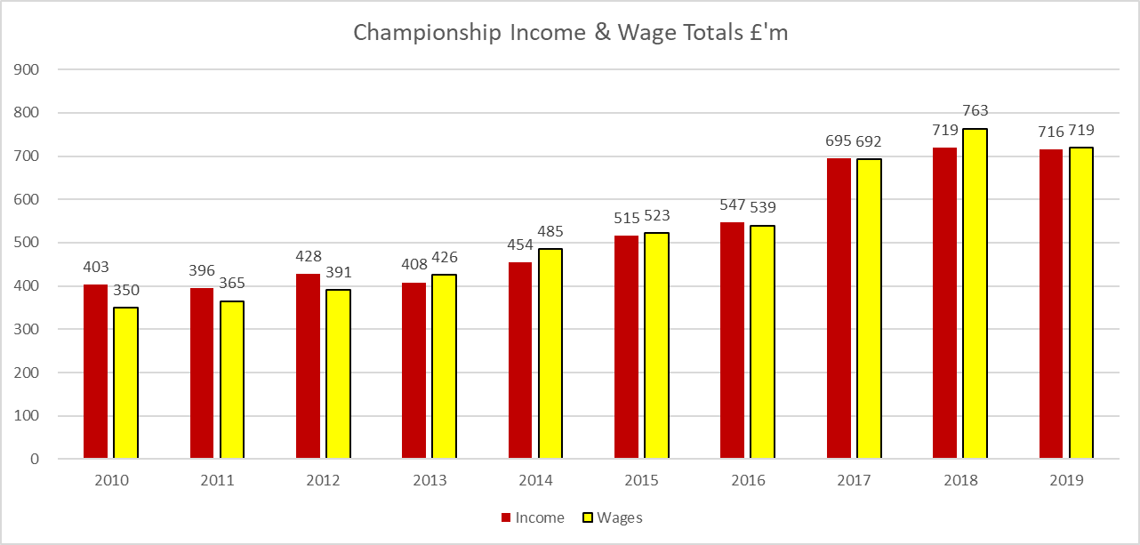

Additional money has found its way into the Championship in the form of parachute and solidarity payments (see Wilson et al, 2018, 2020). However, it too has resulted in that money being spent predominantly on player wages. In six years out of the last seven, wages have exceeded income. Parachute payments are counterproductive as they encourage an arms race of spending in pursuit of a route to the Premier League for the clubs in receipt of them. For those without, excessive spending ensues to keep pace. A lack of independent governance and creative accounting have meant that any attempts at cost control in the form of Financial Fair Play (now rebranded as Profitability and Sustainability) Rules have failed.

The tangible impact of COVID-19
Having given evidence to a parliamentary committee, Chairman of the EFL, Rick Parry has laid bare the impact of COVID-19 on the finances of the EFL. Since taking over as Chairman in 2019, his key objective was to restore some ‘financial sanity’ to the lower leagues (Independent, 2020). Parry made it clear that the EFL would lose £50m in gate revenue across its membership in the 2019/20 season and a further £250m if games continued to be played behind closed doors in 2020/21 (InSport, 2020). Such a hole in club finances will inevitably lead to insolvency for some. There is somewhat of a Darwinian feel around football if this impasse is not reversed, with the stronger clubs getting stronger and the weaker clubs perishing along the way. The economic reality is that that without change the economically powerful will look to make a power grab, increase market share, and develop new markets for all their subsidiary of products, academies, fans, players etc. This is how capitalism works.

In the Premier League, billions of pounds in TV income is at stake if there is no football taking place, heaping pressure on the need to broadcast games even if the stadiums are empty. The Premier League can survive with behind-closed-doors games, with matches beamed worldwide, but outside the Premier League it is bums on seats that is needed. Take Luton Town, a club familiar with financial troubles having gone into administration three times between 1999 and 2007, the crisis is the worst they have faced. Graeme Jones, the manager who parted company with the Hatters early into the pandemic, became the first manager in the EFL to leave his job as a cost-cutting measure during the pandemic. His CEO, Gary Sweet said at the time;
‘[the situation is] graver now than it was back then’ when comparing the impact of the pandemic to administration in 2002 and further financial issues in the 2007-08 season. Football can't survive going a year without supporters - this is a problem and a challenge for the game, not just for Luton Town. If you go back to those two periods - at the end of the day if we weren't there back then somebody would've bought the club. Right now, there's not really a queue of people willing to buy football clubs’.
BBC Sport Online, 2020

In Scotland the situation is no better. The balance between survival depends significantly on the return of spectators. One mid-table Scottish Premiership Club has reported the overall impact of COVID-19 this season will cost at least £2.5m in lost revenue from spectators, which is about 40% of this club’s total income. This loss adds to about £0.5m of lost revenue from cancelled fixtures at the end of the 2019/20 season. Football Supporters Association chair Malcolm Clarke sums up the situation:
“Football fans have watched with dismay as large-scale indoor spectator events, such as concerts and theatre productions, have resumed with significant crowds in recent weeks while they remain locked out of their clubs.
There is zero logic in this. Under the professional guidance of the Sports Ground Safety Authority clubs across the country have worked extremely hard over the summer to implement social distancing and getting their grounds as COVID-secure as possible.
Government should recognise these efforts and the test events that successfully readmitted supporters by bringing football into line with other sectors.”

What is the way out for clubs?
At present, restaurants, bars, cinemas and concerts are generally open for business across different regions, albeit operating within the specified guidelines. Thousands of people are socialising safely in these premises every day, except bars and lounges within football clubs – who are treated differently. Additionally, football stadiums benefit from being outdoors - therefore, with the right social distancing measures in place, there seems no reason to prevent spectators from returning. Furthermore, given the stadium capacity is often underutilised compared to Premier League clubs (Figure 6), it would seem reasonable most EFL clubs could easily adopt measures which protect spectators. Football clubs have the additional benefit of knowing exactly who everyone is within the club, lounges and bars on a matchday, as most are seasonal hospitality clients or season ticket holders, and clubs now have robust systems for capturing unique data about spectators, so they are well equipped to track and trace is spectators. The decision by the UK Government not to let football spectators return is more politics than evidence-based. This decision is preventing football clubs from generating much-needed revenue on matchdays and will ultimately break the already fragile football ecosystem.

Figure 6. Occupancy Rates for English Football Pre-COVID-19
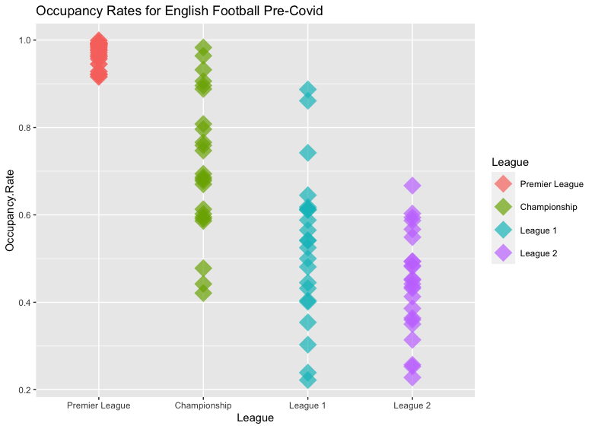

The pandemic started with wage cuts and deferrals for players and a heavy uptake of the government's job retention scheme and furlough scheme. However, as the longer-term repercussions of the pandemic have been laid bare, clubs who rely on matchday income will have to be proactive and think up innovative ways to keep up some level of cash flow. While we argue spectators need to be allowed back to games to ensure football survives, there are things clubs can do. Firstly, clubs need to think more creatively. The normal non-football income from activity, such as; wedding venues, conferences and concerts are not available due to social distancing measure. Therefore, they must think strategically about what assets they can leverage and monetise – such as using technology and the digital world to extend their product beyond the game. Secondly, clubs need to make much tougher financial decisions. Thirdly, this period has again highlights a common statement: ‘Football without fans is nothing” and provide further evidence towards the networked Football World. If you co-create a product, then cannot isolate a partner (i.e., the spectator), the product won’t be as good. We must shift from talking about fans rather than to them. Moreover, it shows the importance spectators play in the football ecosystem and raises questions for clubs on how the treat and involve them. Finally, perhaps the winner takes all narrative and the dream of promotion should be cast aside in the short term. Football is more than just a business, their place in our communities and society is difficult to calculate, yet at present, if the UK Government do not change their policy and allow spectators to return, they threaten the sustainability of our entire football infrastructure.

Disclosure
No potential conflict of interest was reported by the author(s).

References
BBC. (2020). FC Midtjylland provide drive-in for return game against AC Horsens. https://www.bbc.co.uk/sport/football/52875444.

BBC Sport Online. (2020). EFL: How coronavirus is affecting lower-league clubs, players, fans and livelihoods. Last accessed 16th October 2020 https://www.bbc.co.uk/sport/football/52680375

Bond, A. J., Widdop, P., Cockayne, D., & Parnell, D. (2020). Prosumption, Networks and Value during a Global Pandemic: Lockdown Leisure and COVID-19. Leisure Sciences, https://doi.org/10.1080/01490400.2020.1773985

Carmody S, Murray A, Borodina M, et al. (2020) When can professional sport recommence safely during the COVID-19 pandemic? Risk assessment and factors to consider. British Journal of Sports Medicine, 54, 945-948.doi:10.1136/bjsports-2020-102539

Department of Culture Media and Sport (2020). Brighton and Hove Albion versus Chelsea, on Saturday 28 August, was far more than just a pre-season friendly. Department of Culture Media and Sport, https://dcms.shorthandstories.com/BrightonSpectatorPilot/index.html

Eckner, C. (2020). Bundesliga: Fans return to stadiums - how did it go?. BBC Sport. https://www.bbc.co.uk/sport/football/54229045

Football Supporters Association (2020). Petition secures Parliamentary debate on fan lock out. Football Supporters Association. https://thefsa.org.uk/news/petition-secures-parliamentary-debate-on-fan-lock-out/

Independent. (2020). Project Big Picture; Why, sooner or later, English football needs to change. Last accessed 16th October 2020; https://www.independent.co.uk/sport/football/premier-league/project-big-picture-rick-parry-liverpool-manchester-united-football-league-efl-b985407.html.

InSport. (2020). The importance of getting fans back to live sports events. Last accessed 16th October 2020 https://www.crowdcast.io/e/yeo304ys

Parnell, D., Bond, A.J., Widdop, P. & Cockayne, D. (2020b). Football Worlds: business and networks during COVID-19. Soccer & Society, https://doi.org/10.1080/14660970.2020.1782719

Parnell, D., Widdop, P., Bond, A.J. & Wilson, R. (2020a). COVID-19, networks and sport. Managing Sport and Lesiure, https://doi.org/10.1080/23750472.2020.1750100

Plumley, D., Wilson, R., & Ramchandani, G. (2017a). Towards a model for measuring holistic performance of professional Football clubs. Soccer & Society, 18(1), 16-29.

Plumley, D. J., Wilson, R., & Shibli, S. (2017b). A holistic performance assessment of English Premier League football clubs 1992-2013. Journal of Applied Sport Management, 9(1).

Roan, D. (2020). Coronavirus: Fans may not be able to return to sporting events until at least end of March. BBC Sport. https://www.bbc.co.uk/sport/54246745

Sky Sports. (2020b). EFL clubs allowed up to 1,000 fans for pilot event matches this weekend. https://www.skysports.com/football/news/11095/12072568/efl-clubs-allowed-up-to-1-000-fans-for-pilot-event-matches-this-weekend.
Wilson, R., Plumley, D., Mondal, S., & Parnell, D. (2020). Challenging parachute payments and unmasking English football’s finances. Managing Sport and Leisure, 1-6.

Wilson, R., Ramchandani, G., & Plumley, D. (2018). Parachute payments in English football: Softening the landing or distorting the balance? Journal of Global Sport Management, 3 (4), 351–368.

