Title: The relevance of surgical margins in clinically early oral squamous cell carcinoma
Authors:
(Corresponding author) Mandeep S Bajwa^{a, b} msbajwa@liverpool.ac.uk
David Houghtonª drhoughton@doctors.org.uk
Kapil Javaª kapiljava@hotmail.com
Asterios Triantafyllou^{a, d} triantaf@liverpool.ac.uk
Owais Khattakª owais8611@gmail.com
Fazilet Bekirogluª fbekiroglu@doctors.org.uk
Andrew G Schache^{a, b} schache@liverpool.ac.uk
James S Brown ^{a, b} brownjs@doctors.org.uk
James A McCaul^{e} jim.mccaul@mac.com
Simon N Rogers^{a, f} snrogers62@icloud.com
Derek Lowe^{c} astraglobeltd@btconnect.com
Jeremy McMahon^{e} jeremymcmahon@nhs.net
Richard J Shaw^{a, b} rjshaw@liverpool.ac.uk

ª Liverpool Head & Neck Centre, Aintree University Hospital, Liverpool UK
^{b} Department of Molecular & Cli nical Cancer Medicine, University of Liverpool, Liverpool UK
^{c} Astraglobe Ltd, Congleton, Cheshire
^{d} Department of Oral Pathology, School of Dentistry, University of Liverpool, Liverpool UK
^{e} Department of Oral & Maxillofacial Surgery, NHS Greater Glasgow & Clyde, Glasgow UK
^{f} Edge Hill University, Ormskirk UK

Abstract
Objectives: There is controversy regarding surgical margins in the management of
early oral squamous cell carcinoma (OSCC). The main objectives of this study were to assess the: relevance of the margin independent of tumour variables; threshold for a safe margin; relevance of dysplasia at the margin.
Materials & Methods: UK based retrospective multicenter cohort study of patients with previously untreated and clinically early OSCC between 1998 - 2016. All patients had surgery as the primary modality and had surgical staging of the neck. Minimum follow-up was 2 years. Margins were cla􀁖􀁖ified a􀁖: clea􀁕 􀂕5.0mm; clo􀁖e 1.0-4.9mm; involved not cut-through (INC-T) 0.1-0.9mm; cut-through (C-T) 0mm.
Results: 669 patients were included. After adjusting for tumour variables Cox multivariate regression analysis demonstrated that close margins had similar survival outcomes to clear margins (Hazard Ratio(HR) 0.99 (95%CI 0.50-1.95) for Local Recurrence Free Survival (LRFS); HR 1.08 (95%CI 0.7- 1.66) for Disease Free Survival (DFS); HR 0.74 (95%CI 0.44-1.25) for
Disease Specific Survival (DSS); HR 0.80 (95%CI 0.58-1.11) for Overall Survival (OS)). C-T margins had significantly worse LRFS (HR 5.01 (95%CI 2.02-12.39)) and DFS (HR 2.58 (95%CI 1.28-5.20)). INC-T margins had significantly worse DFS (HR 1.98 (95% CI 1.01-3.87)). Time dependent receiver operating characteristic curve analysis did not demonstrate a
clear margin threshold for LRFS within 24 months (AUC = 0.53 (95%CI 0.41- 0.64)). Dysplasia at the margin did not influence LRFS or DFS.
Conclusion: Only resection margins <1mm independently affected survival outcomes. This should be considered when making decisions regarding adjuvant treatment.The relevance of surgical margins in clinically early oral squamous cell carcinoma

Introduction
The aim of surgical resection of Oral Squamous Cell Carcinoma (OSCC) is complete clearance of the tumour with an uninterrupted margin of normal tissue. The most widely accepted definition of complete excision is a margin of at least 5.0 mm on histological assessment. A margin of 1.0 – 4.9 mm is considered ‘close’ and a margin of <1.0 mm is considered ‘involved’.

Prescription of adjuvant radiotherapy following close or involved surgical margins is premised on a relative reduction in the risk of local recurrence.(1-3) Current guidance from the National Comprehensive Cancer Network (NCCN) Head and Neck Cancer (version 1.2016) suggests giving post-operative concurrent chemoradiotherapy for high-risk disease.(4) This guidance is based on the European Organization for Research and Treatment of Cancer (EORTC) 22931 study(5) and the Radiation Therapy Oncology Group (RTOG) 9501 study(6). However, these studies did not adequately represent patients with early OSCC, and the definitions of a high-risk surgical margin were markedly different. EORTC 22931 defined a high-risk margin as <5mm and RTOG 9501 defined high risk as the presence of tumour at the margin.(5, 6) A number of studies have since attempted to quantify what constitutes a safe margin in OSCC as the distance at which recurrence becomes significantly more likely and arrived at thresholds between 1 – 3 mm.(7-10) There is also published data that suggests close or involved margins maybe associated with adverse disease biology and that the size of the margin does not independently influence patient outcomes.(11-13)

The significance of dysplasia at the surgical resection margin is similarly contentious, with some evidence correlating dysplasia at the margin with inferior local control, a feature warranting adjuvant therapy (14-16), whilst other data demonstrates neither adverse effects on survival nor benefit from radiotherapy.(17)

The aims and objectives of the current study are to use a large UK based multicentre cohort of patients with early OSCC:
- To describe the relationship between margin status and survival outcomes.
- Determine the ideal threshold for a safe margin.
- To describe the relationship between tumour variables and the surgical margin.
- To establish the relevance of the surgical margin independent of adverse tumour variables.
- To establish the relevance of dysplasia at the surgical margin.
- To explore the stage allocations for early oral cancer between AJCC 7th and 8th editions.

Patients & Methods
This study is a retrospective multicentre cohort study based in two large UK centres (Aintree University Hospital, Liverpool and Queen Elizabeth University Hospital, Glasgow). Patients were identified from their respective local head and neck cancer databases. The case notes, electronic records and pathology reports were reviewed between 1998 – 2016 for Aintree University Hospital and 2006 – 2016 for Queen Elizabeth University Hospital. Inclusion and exclusion criteria are reported in Table 1. Patients were followed up for a minimum of 2 years and up to 5 years. Margins were classified as clear (≥5mm), close (1 – 4.9mm) and involved (<1mm). involved margins were further classified into ‘involved not cut-through’ (INC-T) and cut-through (C-T). INC-T margins were defined as 0.1 – 0.9mm i.e. <1mm but without evidence of tumour at the cut edge of the specimen. C-T margins demonstrated evidence of tumour at the cut edge of the specimen. Pathology slides were not re-examined, and margin status was based on the main tumour specimen i.e. marginal biopsies or frozen sections were not incorporated into the analysis.

Data collected included: pathological staging using both American Joint Committee on Cancer (AJCC) 7th and 8th editions; size of resection margin for both mucosal and deep margins; depth of invasion (DOI); diameter of index tumour; tumour differentiation; the presence of dysplasia at the margin; description of the invasive front (i.e. cohesive or non-cohesive); presence of lymphovascular invasion (LVI) or perineural invasion (PNI). Nodal disease was categorized as no nodal disease (N–), nodal disease without extracapsular spread (N+ no ECS) and nodal disease with extracapsular spread (N+ with ECS). Data on whether the patient underwent post-operative radiotherapy (PORT) or post-operative concurrent chemoradiotherapy (POCRT) was also collected. The decision to offer patients adjuvant treatment was made by the local head and neck multidisciplinary team (MDT). Outcomes of interest were local recurrence free survival (LRFS), disease free survival (DFS), disease specific survival (DSS) and overall survival (OS).

Statistical analysis
Statistical analysis was performed using SPSS software version 25.
Contingency tables were used to correlate the margin status to tumour variables and use of adjuvant therapy using the chi-squared test.
Kaplan-Meier curves for LRFS, DFS, DSS and OS were produced according to margin status. Survival was calculated from the date of surgery to the date of event or last follow-up. 5-year cumulative survival percentages were reported with their associated standard error (SE). Differences in survival were calculated using the log-rank test; the chi-squared value and degrees of freedom (df) were reported in addition to the P value.
Time dependent Receiver Operating Characteristic (ROC) curve analysis was performed to determine the ideal threshold for LRFS within 24 months. Patients with C-T margins were excluded.
Multivariate cox regression analysis was performed to assess whether surgical margin status was independently associated with poorer outcome by adjusting for the tumour variables of depth of invasion (≤5.0 mm, 5.1-10.0 mm, >10.0 mm), diameter (≤10.0 mm, 10.1-16.0 mm, 16.1-21.0 mm, 21.1-26.0 mm, >26.0 mm), invasive front (cohesive, non-cohesive), lymphovascular invasion (yes/no), perineural invasion (yes/no), ECS/pN (N+ with ECS, N+ no ECS, N –), adjuvant RT and/or CT (yes/no). Results were presented in the form of Hazard ratios (HR) and 95% confidence intervals (CI) with clear margin status being the control group.
The relevance of dysplasia at the margin was further analysed using a Kaplan-Meier curve for LRFS and DFS. Differences in LRFS and DFS were calculated using the log-rank test. The presence of dysplasia was binary.

Results
A total of 669 patients met the inclusion criteria. The mean age at surgery was 60.9 years (s.d. 11.8, range 23 - 90 years).

Relationship between tumour variables and the surgical margin
Table 2 provides a detailed summary of the cohort of patients included within this study and how the variables studied were related to the surgical margin.

Margins were analysed as peripheral, deep and overall (peripheral and deep combined). Table 2 demonstrates the rates of clear, close, INC-T and C-T overall margins within the cohort according to other tumour variables. The percentage of patients with involved margins <1mm (i.e. INC-T + C-T) was 10.2%.

Oral Cavity Subsite
The oral cavity subsites represented were: 367(55.1%) oral tongue; 178(26.7%) floor of mouth; 51(7.7%) buccal mucosa; 39(5.9%) retromolar trigone; 18(2.7%) mandibular alveolus; 5(0.8%) maxillary alveolus; 6(0.9%) hard palate; 2(0.3%) mucosal lip. For the purposes of statistical analysis mandibular alveolus, maxillary alveolus, hard palate and mucosal lip were grouped together and named ‘Other’. Tongue lesions had the highest rate of clear margins (51.0%). ‘Buccal’ and ‘Other’ sites had the highest rate of C-T margins (9.8% and 12.9% respectively).

Pathological Staging
There was no significant association of AJCC 7th edition T stage with margin status (p = 0.13) whereas there was for AJCC 8th edition T stage (p = 0.001). AJCC 7th edition (p=0.04) and AJCC 8th edition (p=0.09) showed similar trends of association with margin status. Regarding overall stage the AJCC 8th edition had many more stage III cases than AJCC 7th edition and was more strongly associated with margin status (p = 0.009) than was AJCC 7th edition (p = 0.09).

Depth of Invasion
Tumours ≤5mm had the highest clear margin rate (52.2%) and the lowest INC-T and C-T margin rate (2.5% and 1.4% respectively). The rate of clear margins reduced as DOI increased and the rate of INC-T and C-T margins increased as DOI increased. The association between DOI and margin status was statistically significant (p < 0.001).

Diameter
Tumours ≤10.0mm diameter had the highest clear margin rate (57.1%) and tumours >21.0mm had the highest rate of margins <1mm (i.e. INC-T and C-T margins combined). The association between diameter and margin status was statistically significant (p = 0.01).

Differentiation
Most tumours were moderately differentiated (544, 82.7%). Counterintuitively it was the poorly differentiated tumours that had the highest rate of clear margins (72.1%) and the association of differentiation with margin status was statistically significant (p=0.02). Margin status was similar for both well and moderately differentiated tumours indicating that differentiation was not a useful predictor of margin status.

Invasive Front
Most tumours were categorized as non-cohesive (552, 84.8%). Nevertheless, non-cohesive tumours were associated with a lower clear margin rate (38.9% versus 70.7%) and higher INC-T/C-T margin rate (12.0% versus 2.0%). The association of invasive front with margin status was statistically significant (p < 0.001).

Lymphovascular Invasion
LVI was present in 14.2% of tumours. There was a tendency for tumours with LVI to have a higher rate of INC-T (10.8% versus 5.2%) and C-T margins (6.5% versus 3.2%) compared to tumours with no evidence of LVI. Tumours with LVI also had a marginally lower rate of clear margins (39.8% versus 46.1%). The association with margin status was of borderline statistical significance (p = 0.06).

Perineural Invasion
PNI was present in 21.8% of tumours. There was a tendency for tumours with PNI to have a higher rate of INC-T (9.7% versus 5.4%) and C-T margins (6.2% versus 3.3%) compared to tumours with no evidence of PNI. Tumours with PNI also had a marginally lower rate of clear margins (38.6% versus 46.2%). The association with margin status was of borderline statistical significance (p = 0.07).

Nodal Disease and ECS
‘N–‘ Patients had lower rates of INC-T and C-T margins. ‘N+ no ECS’ Patients had a worse margin profile while ‘N+ with ECS’ patients had the worst, and the association with margin status was statistically significant (p = 0.008), as it was for ECS independently (p = 0.002). Figure 1 shows Kaplan-Meier curves for the relationship between nodal status and LRFS. ‘N–‘ patients had a 5-year LRFS of 95%, SE 1% as compared with 86%, SE 4% for ‘N+ with ECS’ patients and 78%, SE 6% for ‘N+ with ECS’ patients, log rank test (chi-squared value = 20.0, df = 2, p < 0.001).

Use of Adjuvant Treatment
Patients, unsurprisingly, who had involved margins (INC-T or C-T) received more adjuvant therapy (p < 0.001). The PORT and POCRT groups had similar rates of close and involved margins.

Relationship between margin classification and survival outcomes
Figure 2 shows the Kaplan-Meier curves for LRFS, DFS, DSS and OS according to margin classification. Figure 2A demonstrates that clear and close margins were not significantly different in terms of LRFS (5-year LRFS: clear margins 94%, SE 1%; close margins 93%, SE 2%), whereas INC-T margins had worse LRFS (86%, SE 6% at 5 years) and C-T margins, as expected, had the worst LRFS (59%, SE 11% at 5 years), Log-rank test, chi-squared value = 41.8, df = 3, p < 0.001.

Figure 2B demonstrates how margin classification influenced DFS. Clear and close margins had comparable DFS (5-year DFS: clear margins 86%, SE 2%; close margins 83%, SE 2%) whereas INC-T had worse DFS (61%, SE 8% at 5 years) and C-T margins had the worst DFS (50%, SE 10% at 5-years), Log-rank test, chi-squared value = 36.9, df = 3, p < 0.001.

Figure 2C demonstrates how margin classification influenced DSS. Clear and close margins had comparable DSS (5-year DSS for both: 89%, SE 2%) whereas INC-T margins had worse DSS (72%, SE 7% at 5 years) and C-T margins did equally badly (73%, SE 10% at 5 years), Log-rank test, chi-squared value = 21.0, df = 3, p < 0.001.

Figure 2D demonstrates how margin classification influenced OS. Clear and close margins ran a similar course (5-year OS: clear margins 74%, SE 3%; close margins 77%, SE 3%) whereas INC-T margins had worse OS (63%, SE 8% at 5 years) and C-T margins had the worst OS (53%, SE 11% at 5 years), Log-rank test, chi-squared value = 23.2, df = 3, p < 0.001.

Determining the ideal threshold for a safe margin
In the ROC analysis for margin status in relation to local recurrence no single threshold was identified. Figure 3 shows that there are 2 discrete elevations, points A and B, above the diagonal line. Point A corresponds to a threshold of 0.6mm (sensitivity 0.14, specificity 0.97) and point B corresponds to a threshold of 2.7mm (sensitivity 0.41, specificity 0.71). The area under the curve (AUC) was recorded as 0.53 (95% CI 0.41 – 0.64).

Relevance of surgical margin independent of adverse tumour variables
Table 3 uses hazard ratios to assess whether surgical margin status was independently associated with poorer outcome after adjusting for adverse tumour variables in a multivariate cox regression analysis for each of the survival outcomes of interest. The adverse tumour variables adjusted for were nodal status (using AJCC 8th ed.) and ECS, PNI, LVI, DOI, diameter, invasive front and use of adjuvant therapy.

Close and INC-T margins had similar risk in regard to LRFS as for clear margins. C-T margins had significantly worse relative risk (HR 5.01, 95% CI 2.02 – 12.39). Close margins had similar risk in regard to DFS as clear margins, however INC-T and C-T margins had increasingly worse relative risk (HR 1.92, 95% CI 0.98-3.78 and 2.48, 95% CI 1.23-4.99 respectively). A similar increasing trend was seen with DSS and OS though none of the confidence intervals could rule out the possibility of no difference in risk compared with clear margins.

Relevance of dysplasia at the margin
Table 2 demonstrates that the surgical margin profile of patients with dysplasia at the margin was were similar to patients without (p = 0.79). Figure 4A demonstrates that patients found to have ysplasia at the margin of resection had similar LRFS in this case series (chi-squared value = 0.63, df = 1, p = 0.45). Figure 4B also demonstrates that dysplasia at the margin did not significantly influence DFS (chi-squared value = 0.07, df = 1, p = 0.79).

Discussion
This study benefits from a large consecutive cohort of UK patients from similar representative populations. Patients were excluded if they did not undergo a neck dissection, in doing so we have also excluded some of those patients with small superficial tumours. All neck dissections were ‘elective’ and performed for the purposes of staging (only patients who were clinically N0 were included). The study is limited by its retrospective nature and the potential variability in the reporting of histological margins by differing pathologists. Some pathologists rounded the margin to the nearest millimeter thereby reducing precision in the analysis. However, this variability in pathology reporting is representative of ‘real world’ clinical practice and with such a large sample size is expected that the effects will be diluted.

Several studies have used ROC curves to re-define the threshold between a clear and a close margin as the optimal threshold for LRFS by taking the largest difference between true-positive and false-positive results. Zanoni et al(7) reported a threshold of 2.2mm, AUC 0.671; Tasche et al(18) reported 1.0mm, AUC 0.7; Wong et al(9) reported 1.0mm AUC, 0.582. Figure 3 demonstrates the ROC curve for this cohort of patients. No definitive threshold was found, instead two discrete elevations, corresponding to 0.6mm and 2.7mm were seen. The AUC was 0.523 suggesting that margin size is a very poor classifier for local recurrence. In fact, none of the studies produced acceptable AUC values thereby undermining the principle of defining a margin threshold using this methodology.

Univariate analysis using contingency tables suggested the following variables were statistically significant predictors of involved margins: presence of nodal disease and ECS, increasing N stage (using AJCC 7th edition), increasing DOI, non-cohesive invasive front, increasing diameter, increasing T stage (using AJCC 8th edition) and tumour subsite (highest rate of involved margins seen in buccal mucosa). The presence of PNI and LVI were associated with higher rates of involved margins but were of borderline statistical significance. The buccal mucosa subsite has previously been shown to have worse local control compared to other subsites. However, this does not translate into worse DSS.(12, 19) This picture of higher rates of involved margins, worse local control but equivalent DSS suggests that this phenomenon may be related to the surgical resection rather than a more aggressive disease biology as suggested by some authors.(20) It has also been proposed that fewer buccal tumours present as T1 lesions and this correspondingly skews the outcomes.(19) The margin profile of patients receiving PORT and POCRT was similar suggesting that the use of POCRT is withheld in a proportion of patients who had INC-T or C-T margins.

Both AJCC 7th and 8th editions have performed inconsistently in this specific cohort of patients with regards to margin status. The inclusion criteria for this study was cT1/2 N0 using AJCC 7th ed. As a result, pathological staging using AJCC 8th ed. frequently upstaged tumours on the basis of DOI. Given that nodal disease and ECS were such strong independent predictors of margin status, the strength of correlation between pN stage using AJCC 8th edition and margin status was weaker than expected.

This study of patients with clinically early OSCC demonstrates that only those with margins <1mm (i.e. INC-T and C-T) do significantly worse than patients with clear or close margins in terms of survival outcomes. The association between margins <1mm and adverse tumour variables has demonstrated that disease biology has a prominent role in margin status and needs to be accounted for in any analysis. This interaction between disease biology and margins is perhaps most striking in Figure 1 where the presence of nodal disease and ECS are associated with worse LRFS. This analysis is powerful because nodal disease is a strong marker of biological aggression and using LRFS as the outcome foregoes the variability in the examination and reporting of histological margins.(21) After adjusting for the indicators of biological aggression and use of adjuvant therapy, no evidence for a difference in survival outcomes between clear and close margins was apparent.

Margin status in early OSCC is critical given its greater influence on the prescription of adjuvant therapy than in late disease. If we consider patients who have undergone primary surgery for OSCC to be on a spectrum of ‘risk of recurrence’, the decisions regarding adjuvant therapy at the extremes of the spectrum tend not to be controversial. It is the patients who are at intermediate risk of recurrence who pose the greatest challenge in decision making. This intermediate risk category can be defined as patients with close margins and one or two unfavourable pathological features such as N1 disease with no ECS, poor differentiation, loss of cohesion at the invasive front, PNI or LVI.(22) Any decision regarding the use of PORT needs to consider the potential benefit weighed up against the potential morbidity as well as the reduction in future salvage options. A systematic review found that most of the evidence in this field is retrospective and fails to show a clear benefit for PORT in the intermediate risk category.(23) Ch’ng et al(24) reviewed their own institutions practice of not offering PORT to patients with close margins unless they had other features of aggressive disease (tumour thickness >4mm, infiltrative pattern of invasion, PNI and buccal mucosa subsite); they excluded patients with nodal disease. The study found that a close margin alone or in the presence of one other adverse feature was associated with a 97% local control rate. This dropped to 80% in patients with a close margin and ≥2 adverse features. The reference group that received PORT had a local control rate of 90% and was not significantly different (p = 0.55).(24)

While dysplasia at the margin did not seem to influence LRFS and DFS in this cohort of patients, the analysis was limited by pathological reporting since the grade of dysplasia was not reported in a significant proportion of patients. Also, the presence of dysplasia may have been under reported in this retrospective dataset because only the presence of severe dysplasia is mandated in the Royal College of Pathologists’ minimum dataset for the histopathology reporting of oral cavity mucosal malignancies.(25) The ability to use this data to make any firm conclusions are further compromised by previously published data on the determinants of malignant transformation in oral dysplasia that suggests that grade is of only borderline significance.(26) Therefore we cannot exclude the possibility that there may have been cases who did not have their mild/moderate dysplasia at the margin reported and subsequently developed local recurrence. Additionally, this observational series does not assess the potential benefit of further removing this dysplastic tissue, however, the caveat regarding reporting of margin dysplasia noted above must be included in any consideration.

In summary, the main finding of this study is that close margins are not independently associated with worse outcomes when compared to clear margins. The balance between removing enough surrounding tissue to maximise disease control while conserving enough to preserve function still remains. This data is insufficient to change surgical practice in terms of the size of clinical margin. The results of this study are most relevant to decisions regarding the role of adjuvant therapy since it is only margins <1mm that are independently associated with worse outcomes. This study has also shown that DOI, diameter, loss of cohesion and nodal disease with ECS are strong markers of biological aggression. PNI and LVI, previously reported markers of aggression, were of borderline statistical significance in this study.

References
1. Fridman E, Na'ara S, Agarwal J, Amit M, Bachar G, Villaret AB, et al. The role of adjuvant treatment in early-stage oral cavity squamous cell carcinoma: An international collaborative study. Cancer. 2018;124(14):2948-55.
2. Anderson CR, Sisson K, Moncrieff M. A meta-analysis of margin size and local recurrence in oral squamous cell carcinoma. Oral Oncol. 2015;51(5):464-9.
3. Smits RW, Koljenovic S, Hardillo JA, Ten Hove I, Meeuwis CA, Sewnaik A, et al. Resection margins in oral cancer surgery: Room for improvement. Head Neck. 2016;38 Suppl 1:E2197-203.
4. National Comprehensive Cancer Network (NCCN). Head & Neck Cancer (version 1.2016) [Available from: https://www.nccn.org/professionals/physician_gls/pdf/head‐and‐neck.pdf. Accessed December 30, 2019.
5. Bernier J, Domenge C, Ozsahin M, Matuszewska K, Lefebvre JL, Greiner RH, et al. Postoperative irradiation with or without concomitant chemotherapy for locally advanced head and neck cancer. N Engl J Med. 2004;350(19):1945-52.
6. Cooper JS, Pajak TF, Forastiere AA, Jacobs J, Campbell BH, Saxman SB, et al. Postoperative concurrent radiotherapy and chemotherapy for high-risk squamous-cell carcinoma of the head and neck. N Engl J Med. 2004;350(19):1937-44.
7. Zanoni DK, Migliacci JC, Xu B, Katabi N, Montero PH, Ganly I, et al. A Proposal to Redefine Close Surgical Margins in Squamous Cell Carcinoma of the Oral Tongue. JAMA Otolaryngol Head Neck Surg. 2017;143(6):555-60.
8. Nason RW, Binahmed A, Pathak KA, Abdoh AA, Sandor GK. What is the adequate margin of surgical resection in oral cancer? Oral Surg Oral Med Oral Pathol Oral Radiol Endod. 2009;107(5):625-9.
9. Wong LS, McMahon J, Devine J, McLellan D, Thompson E, Farrow A, et al. Influence of close resection margins on local recurrence and disease-specific survival in oral and oropharyngeal carcinoma. Br J Oral Maxillofac Surg. 2012;50(2):102-8.
10. Buchakjian MR, Ginader T, Tasche KK, Pagedar NA, Smith BJ, Sperry SM. Independent Predictors of Prognosis Based on Oral Cavity Squamous Cell Carcinoma Surgical Margins. Otolaryngol Head Neck Surg. 2018;159(4):675-82.
11. Sutton DN, Brown JS, Rogers SN, Vaughan ED, Woolgar JA. The prognostic implications of the surgical margin in oral squamous cell carcinoma. Int J Oral Maxillofac Surg. 2003;32(1):30-4.
12. Rogers SN, Brown JS, Woolgar JA, Lowe D, Magennis P, Shaw RJ, et al. Survival following primary surgery for oral cancer. Oral Oncol. 2009;45(3):201-11.
13. Barry CP, Ahmed F, Rogers SN, Lowe D, Bekiroglu F, Brown JS, et al. Influence of surgical margins on local recurrence in T1/T2 oral squamous cell carcinoma. Head Neck. 2015;37(8):1176-80.
14. Loree TR, Strong EW. Significance of positive margins in oral cavity squamous carcinoma. Am J Surg. 1990;160(4):410-4.
15. Weijers M, Snow GB, Bezemer PD, van der Wal JE, van der Waal I. The clinical relevance of epithelial dysplasia in the surgical margins of tongue and floor of mouth squamous cell carcinoma: an analysis of 37 patients. J Oral Pathol Med. 2002;31(1):11-5.
16. Sopka DM, Li T, Lango MN, Mehra R, Liu JC, Burtness B, et al. Dysplasia at the margin? Investigating the case for subsequent therapy in 'low-risk' squamous cell carcinoma of the oral tongue. Oral Oncol. 2013;49(11):1083-7.
17. Chen TC, Chang HL, Yang TL, Lou PJ, Chang YL, Ko JY, et al. Impact of dysplastic surgical margins for patients with oral squamous cell carcinoma. Oral Oncol. 2019;97:1-6.
18. Tasche KK, Buchakjian MR, Pagedar NA, Sperry SM. Definition of "Close Margin" in Oral Cancer Surgery and Association of Margin Distance With Local Recurrence Rate. JAMA Otolaryngol Head Neck Surg. 2017;143(12):1166-72.
19. Shaw RJ, McGlashan G, Woolgar JA, Lowe D, Brown JS, Vaughan ED, et al. Prognostic importance of site in squamous cell carcinoma of the buccal mucosa. Br J Oral Maxillofac Surg. 2009;47(5):356-9.
20. Bachar G, Goldstein DP, Barker E, Lea J, O'Sullivan B, Brown DH, et al. Squamous cell carcinoma of the buccal mucosa: outcomes of treatment in the modern era. Laryngoscope. 2012;122(7):1552-7.
21. Shaw RJ, Lowe D, Woolgar JA, Brown JS, Vaughan ED, Evans C, et al. Extracapsular spread in oral squamous cell carcinoma. Head Neck. 2010;32(6):714-22.
22. Brown JS, Blackburn TK, Woolgar JA, Lowe D, Errington RD, Vaughan ED, et al. A comparison of outcomes for patients with oral squamous cell carcinoma at intermediate risk of recurrence treated by surgery alone or with post-operative radiotherapy. Oral Oncol. 2007;43(8):764-73.
23. Brown JS, Shaw RJ, Bekiroglu F, Rogers SN. Systematic review of the current evidence in the use of postoperative radiotherapy for oral squamous cell carcinoma. Br J Oral Maxillofac Surg. 2012;50(6):481-9.
24. Ch'ng S, Corbett-Burns S, Stanton N, Gao K, Shannon K, Clifford A, et al. Close margin alone does not warrant postoperative adjuvant radiotherapy in oral squamous cell carcinoma. Cancer. 2013;119(13):2427-37.
25. Helliwell TR, Woolgar JA. Dataset for histopathology reporting of mucosal malignancies of the oral cavity. Royal College of Pathologists; 2013.
26. Ho MW, Risk JM, Woolgar JA, Field EA, Field JK, Steele JC, et al. The clinical determinants of malignant transformation in oral epithelial dysplasia. Oral Oncol. 2012;48(10):969-76.

Tables
Inclusion Criteria | Exclusion Criteria
Oral Cavity SCC | Previously treated Oral Cavity SCC
Surgery primary modality | Previous radiotherapy
Clinical T1 or T2 N0 (using AJCC 7th ed.) | Neoadjuvant chemotherapy
Surgical staging of the neck (END or SLNB) | Synchronous tumour

Table 1. Inclusion and exclusion criteria. SCC, squamous cell carcinoma; END, elective neck dissection; SLNB, sentinel lymph node biopsy.

 | Clear Margin >5mm (%) | Close Margin 1.0 – 4.9mm (%) | INC-T Margin 0.1 – 0.9mm (%) | C-T Margin 0mm (%) | Total | P value
Closest Peripheral Margin | 359 (53.7) | 270 (40.4) | 22 (3.3) | 16 (2.4) | 667
Closest Deep Margin | 429 (64.1) | 197 (29.4) | 28 (4.2) | 11 (1.6) | 665
Closest Overall Margin | 296 (44.2) | 303 (45.3) | 42 (6.3) | 26 (3.9) | 667
Age |  |  |  |  | 667 | 0.39
<55 | 78 (42.4) | 90 (48.9) | 11 (6.0) | 5 (2.7) | 184
55-64 | 98 (47.1) | 92 (44.2) | 12 (5.8) | 6 (2.9) | 208
65-74 | 90 (45.9) | 83 (42.3) | 15 (7.7) | 8 (4.1) | 196
≥75 | 30 (38.0) | 38 (48.1) | 4 (5.1) | 7 (8.9) | 79
Site |  |  |  |  | 666 | 0.003
Oral Tongue | 187 (51.0) | 154 (42.0) | 18 (4.9) | 8 (2.2) | 367
Floor of Mouth | 65 (36.5) | 88 (49.4) | 17 (9.6) | 8 (4.5) | 178
Buccal | 16 (31.4) | 27 (52.9) | 3 (5.9) | 5 (9.8) | 51
Retromolar | 15 (38.5) | 21 (53.8) | 2 (5.1) | 1 (2.6) | 39
Other* | 13 (41.9) | 12 (38.7) | 2 (6.5) | 4 (12.9) | 31
pT AJCC 7 |  |  |  |  | 667 | 0.13
T1 | 150 (45.6) | 156 (47.4) | 13 (4.0) | 10 (3.0) | 329
T2 | 132 (42.4) | 136 (43.7) | 27 (8.7) | 16 (5.1) | 311
T3/T4 | 14 (51.9) | 11 (40.7) | 2 (7.4) | 0 (0.0) | 27
pN AJCC 7 |  |  |  |  | 667 | 0.04
N0 | 222 (45.4) | 228 (46.6) | 25 (5.1) | 14 (2.9) | 489
N1 | 39 (43.8) | 37 (41.6) | 6 (6.7) | 7 (7.9) | 89
N2 | 35 (39.3) | 38 (42.7) | 11 (12.4) | 5 (5.6) | 89
Stage AJCC 7 |  |  |  |  | 667 | 0.09
I | 127 (46.7) | 130 (47.8) | 9 (3.3) | 6 (2.2) | 272
II | 90 (44.8) | 88 (43.8) | 15 (7.5) | 8 (4.0) | 201
III | 37 (41.6) | 38 (42.7) | 7 (7.9) | 7 (7.9) | 89
IV | 42 (40.0) | 47 (44.8) | 11 (10.5) | 5 (4.8) | 105
pT AJCC 8 |  |  |  |  | 666 | 0.001
T1 | 103 (51.8) | 87 (43.7) | 7 (3.5) | 2 (1.0) | 199
T2 | 136 (45.0) | 134 (44.4) | 16 (5.3) | 16 (5.3) | 302
T3/T4 | 57 (34.5) | 81 (49.1) | 19 (11.5) | 8 (4.8) | 165
pN AJCC 8 |  |  |  |  | 667 | 0.09
N0 | 222 (45.4) | 228 (46.6) | 25 (5.1) | 14 (2.9) | 489
N1 | 31 (44.3) | 30 (42.9) | 4 (5.7) | 5 (7.1) | 70
N2 | 25 (38.5) | 29 (44.6) | 8 (12.3) | 3 (4.6) | 65
N3 | 18 (41.9) | 16 (37.2) | 5 (11.6) | 4 (9.3) | 43
Stage AJCC 8 |  |  |  |  | 666 | 0.009
I | 90 (51.1) | 78 (44.3) | 6 (3.4) | 2 (1.1) | 176
II | 104 (47.3) | 98 (44.5) | 10 (4.5) | 8 (3.6) | 220
III | 55 (35.5) | 78 (50.3) | 13 (8.4) | 9 (5.8) | 155
IV | 47 (40.9) | 48 (41.7) | 13 (11.3) | 7 (6.1) | 115
DOI |  |  |  |  | 666 | <0.001
≤5.0mm | 144 (52.2) | 121 (43.8) | 7 (2.5) | 4 (1.4) | 276
5.1 – 10.0mm | 102 (43.6) | 104 (44.4) | 14 (6.0) | 14 (6.0) | 234
>10.0mm | 50 (32.1) | 77 (49.4) | 21 (13.5) | 8 (5.1) | 156
Diameter |  |  |  |  | 655 | 0.01
≤10.0mm | 60 (57.1) | 42 (40.0) | 3 (2.9) | 0 (0.0) | 105
10.1 – 16mm | 53 (39.3) | 69 (51.1) | 6 (4.4) | 7 (5.2) | 135
16.1 – 21.0mm | 59 (45.7) | 62 (48.1) | 4 (3.1) | 4 (3.1) | 129
21.1 – 26.0mm | 60 (40.3) | 67 (45.0) | 13 (8.7) | 9 (6.0) | 149
>26.0mm | 54 (39.4) | 62 (45.3) | 15 (10.9) | 6 (4.4) | 137
Dysplasia at Margin |  |  |  |  | 655 | 0.79
Not present | 256 (44.8) | 259 (45.3) | 34 (5.9) | 23 (4.0) | 572
Present | 34 (41.0) | 39 (47.0) | 7 (8.4) | 3 (3.6) | 83
Differentiation |  |  |  |  | 658 | 0.02
Well | 31 (43.7) | 34 (47.9) | 4 (5.6) | 2 (2.8) | 71
Moderate | 227 (41.7) | 258 (47.4) | 36 (6.6) | 23 (4.2) | 544
Poor | 31 (72.1) | 9 (20.9) | 2 (4.7) | 1 (2.3) | 43
Invasive Front |  |  |  |  | 651 | <0.001
Cohesive | 70 (70.7) | 27 (27.3) | 1 (1.0) | 1 (1.0) | 99
Non-cohesive | 215 (38.9) | 271 (49.1) | 41 (7.4) | 25 (4.5) | 552
LVI |  |  |  |  | 655 | 0.06
Not present | 259 (46.1) | 256 (45.6) | 29 (5.2) | 18 (3.2) | 562
Present | 37 (39.8) | 40 (43.0) | 10 (10.8) | 6 (6.5) | 93
PNI |  |  |  |  | 664 | 0.07
Not present | 240 (46.2) | 234 (45.1) | 28 (5.4) | 17 (3.3) | 519
Present | 56 (38.6) | 66 (45.5) | 14 (9.7) | 9 (6.2) | 145
Nodal Disease |  |  |  |  | 667 | 0.008
N– | 220 (45.3) | 228 (46.9) | 24 (4.9) | 14 (2.9) | 486
N+ no ECS | 48 (42.5) | 51 (45.1) | 8 (7.1) | 6 (5.3) | 113
N+ with ECS | 28 (41.2) | 24 (35.3) | 10 (14.7) | 6 (8.8) | 68
ECS |  |  |  |  | 667 | 0.002
Not present | 268 (44.7) | 279 (46.6) | 32 (5.3) | 20 (3.3) | 599
Present | 28 (41.2) | 24 (35.3) | 10 (14.7) | 6 (8.8) | 68
Adjuvant Therapy |  |  |  |  | 666 | <0.001
None | 244 (51.3) | 204 (42.9) | 14 (2.9) | 14 (2.9) | 476
PORT | 28 (23.9) | 62 (53.0) | 18 (15.4) | 9 (7.7) | 117
POCRT | 24 (32.9) | 36 (49.3) | 10 (13.7) | 3 (4.1) | 73

Table 2. Relationship between tumour variables and margin classification. INC-T, involved not cut-through margin; C-T, cut-through margin; DOI, depth of invasion; LVI, lymphovascular invasion; PNI, perineural invasion; ECS, extracapsular spread; PORT, post-operative radiotherapy; POCRT, post-operative chemoradiotherapy.
*Other = mandibular alveolus, maxillary alveolus, hard palate and mucosal lip combined.
Outcome | Margin Status | Hazard Ratio | 95% CI for Hazard Ratio | P Value
Local Recurrence Free Survival (n=630) | Clear | 1.0 (REF) |  | 0.002
 | Close | 0.99 | 0.50 – 1.95
 | INC-T | 1.09 | 0.30 – 3.94
 | C-T | 5.01 | 2.02 – 12.39
Disease Free Survival (n=631) | Clear | 1.0 (REF) |  | 0.02
 | Close | 1.07 | 0.70 – 1.65
 | INC-T | 1.92 | 0.98 – 3.78
 | C-T | 2.48 | 1.23 – 4.99
Disease Specific Survival (n=628) | Clear | 1.0 (REF) |  | 0.12
 | Close | 0.74 | 0.44 – 1.25
 | INC-T | 1.36 | 0.62 – 2.95
 | C-T | 1.94 | 0.78 – 4.80
Overall Survival (n=631) | Clear | 1.0 (REF) |  | 0.04
 | Close | 0.80 | 0.58 – 1.11
 | INC-T | 1.47 | 0.84 – 2.58
 | C-T | 1.62 | 0.85 – 3.10

Table 3. Multivariate cox regression analysis was performed to assess whether surgical margin status was independently associated with poorer outcome after adjusting for adverse tumour variables using hazard Ratios. Clear margins category was the reference/control group. INC-T, involved not cut-through margins; C-T, cut-through margins.

Figures
Figure 1. Kaplan-Meier curve for the relationship between nodal status and local recurrence free survival (LRFS). Blue line, node negative (N–); red line, node positive without extracapsular spread (N+ no ECS); green line, node positive with extracapsular spread (N+ with ECS). SE, standard error.

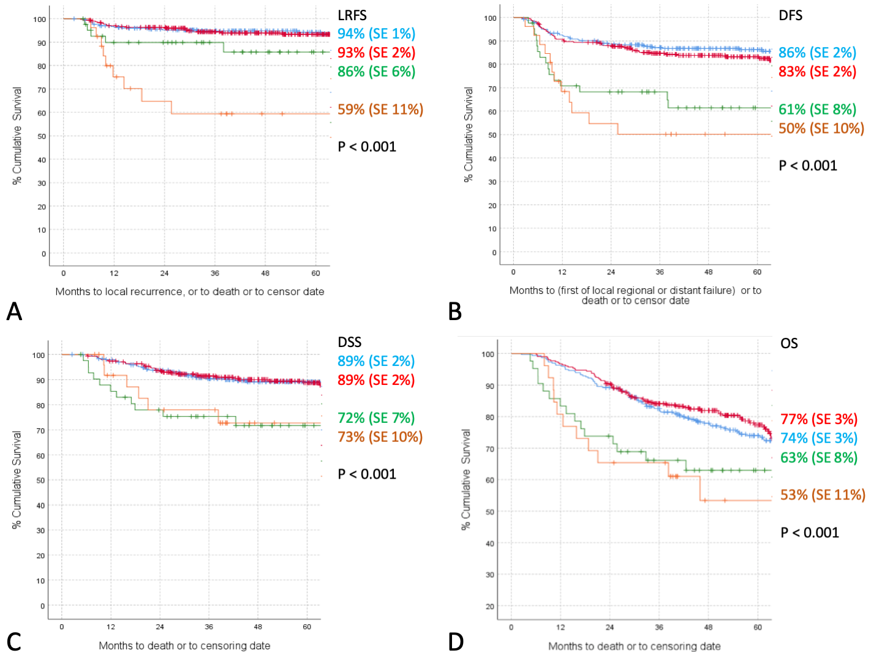

Figure 2. Relationship between margin classification and survival outcomes. Blue line, clear margin; red line, close margin; green line, involved not cut-through (INC-T) margin; orange line, cut-through (C-T) margin. A) Relationship between margin classification and local recurrence free survival (LRFS). B) Relationship between margin classification and disease-free survival (DFS). C) Relationship between margin classification and disease specific survival (DSS). D) Relationship between margin classification and overall survival (OS). SE, standard error
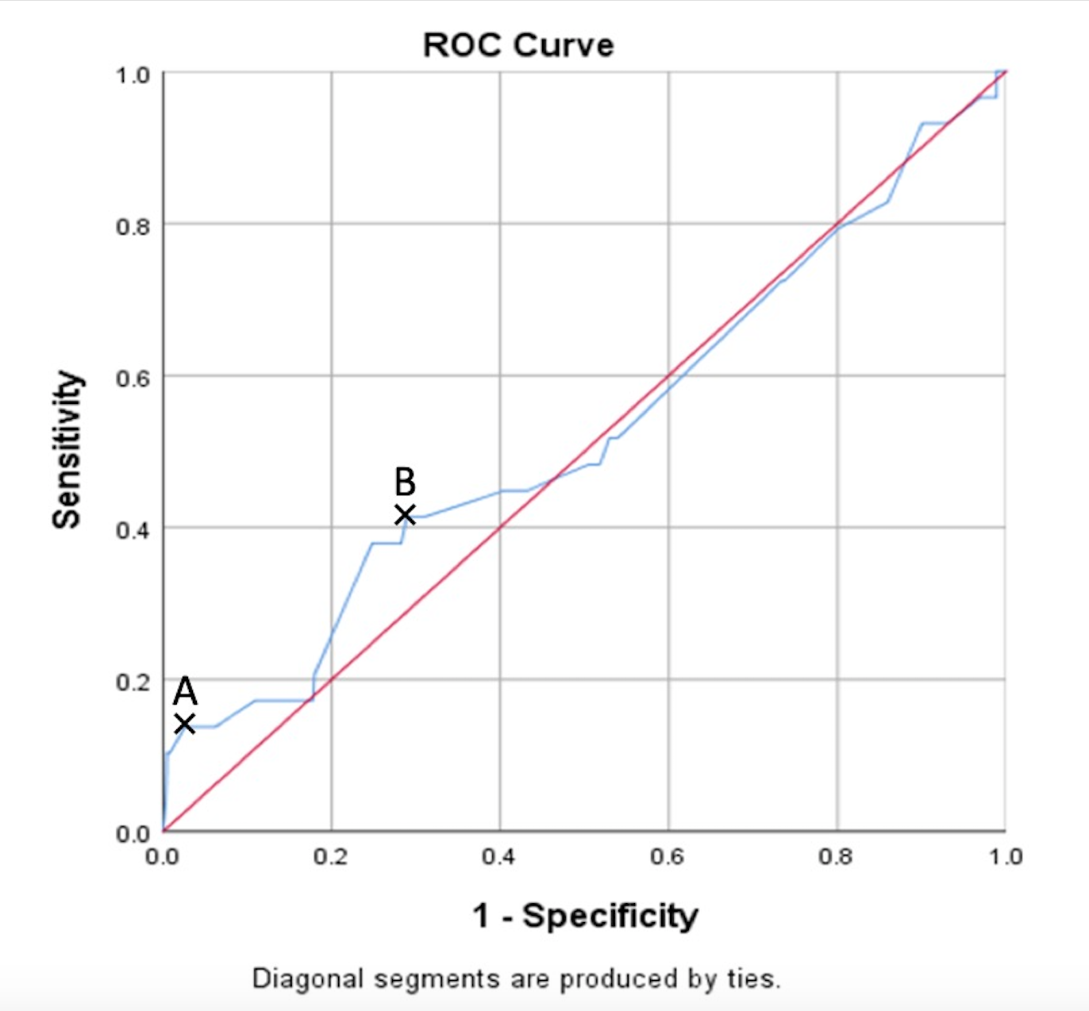

Figure 3. Receiver operating characteristic curve for the size of the surgical margin in relation to local recurrence excluding cut-through (C-T) margins. Point A indicates most specific threshold of 0.6mm (sensitivity 0.14, specificity 0.97), point B indicates most sensitive threshold of 2.7mm (sensitivity 0.41, specificity 0.71. Area under the curve (AUC) = 0.53 (95% CI 0.41 – 0.64).

Figure 4. Kaplan-Meier curves demonstrating the relationship between presence of dysplasia at the margin and A) local recurrence free survival (LRFS) and B) disease free survival (DFS). Blue line, no dysplasia present at margin; red line, dysplasia present at margin. SE, standard error.

