Risks and Outcomes of Gastrointestinal Malignancies in Anticoagulated Atrial Fibrillation Patients Experiencing Gastrointestinal Bleeding – A Nationwide Cohort Study

Ting-Yung Chang, M.D. ^{1,2}, Tze-Fan Chao, M.D.^{1,2}, Chern-En Chiang, M.D.^{1,2,3}, Yenn-Jiang Lin, M.D.^{1,2}, Shih-Lin Chang, M.D.^{1,2}, Li-Wei Lo, M.D.^{1,2}, Yu-Feng Hu, M.D.^{1,2}, Ta-Chuan Tuan, M.D.^{1,2,}, Jo-Nan Liao, M.D.^{1,2}, Fa-Po Chung, M.D. ^{1,2}, Tzeng-Ji Chen, M.D.⁴,
Gregory Y. H. Lip, M.D.⁵*, Shih-Ann Chen, M.D.^{1,2}*

¹Division of Cardiology, Department of Medicine, Taipei Veterans General Hospital, Taipei, Taiwan. ²Institute of Clinical Medicine, and Cardiovascular Research Center, National Yang-Ming University, Taipei, Taiwan. ³General Clinical Research Center, Taipei Veterans General Hospital, Taipei, Taiwan. ⁴Department of Family Medicine, Taipei Veterans General Hospital, Taipei, Taiwan. ⁵Liverpool Centre for Cardiovascular Science, University of Liverpool & Liverpool Heart and Chest Hospital, Liverpool, United Kingdom; and Aalborg Thrombosis Research Unit, Department of Clinical Medicine, Aalborg University, Aalborg, Denmark.
[*Joint senior authors]
Running title: GI cancers in anticoagulated AF patients after GI bleeding
Total word count:

Address for correspondence
Tze-Fan Chao, M.D.
Division of Cardiology, Department of Medicine, Taipei Veterans General Hospital,
No. 201, Sec. 2, Shih-Pai Road, Taipei, Taiwan.
Tel: 886-2-2875-7156; Fax: 886-2-2873-5656 E-Mail: eyckeyck@gmail.com
Abstract
Background: Oral anticoagulants (OACs) may serve as a type of “screening test” for the diagnosis of occult gastrointestinal (GI) tract malignancies through a clinical presentation with bleeding. We aimed to investigate the 1-year incidence and predictors of GI cancers after GI bleeeding events among patients with atrial fibrillation (AF) treated with warfarin or NOACs. Second, we aimed to compare the risk of mortality after GI cancers between patients treated with warfarin or NOACs.
Methods: A total of 10,845 anticoagulated AF patients who experienced hospitalizations due to GI bleeding without prior history of GI cancers were identified from the Taiwan National Health Insurance Research Database. Patients were followed up for incident GI cancers for up to 1 year.
Results: Within 1 year after GI bleeding, 290 (2.67%) patients were diagnosed to have GI tract cancers. More patients treated with NOACs were diagnosed to have GI cancers than those receiving warfarin (68/1,759; 3.87% [NOACs] versus 222/9,086; 2.44% [warfarin], p<0.001) with an odds ratio (OR) 1.606 (95% CI 1.208-2.117, p <0.001). Age (OR 1.025 (95%CI 1.012 – 1.037) per 1 year increment) and male sex (1.356 (95%CI 1.050 – 1.700)) were independently associated with the diagnosis of GI cancers within 1 year after GI bleeding. Among 290 patients diagnosed to have GI cancers, 131 (45.2%) experienced mortality within 1 year. The risk of mortality was lower for patients treated with NOACs compared to those receiving warfarin (23.5% versus 51.8%) with an adjusted hazard ratio (aHR) 0.441 (95% CI 0.262 - 0.744, p<0.001).
Conclusions: Incident GI cancers were diagnosed in 1 in 37 AF patients at 1 year after OAC-related GI bleeding, which were more common among patients treated with NOACs (1 in 26) compared to warfarin (1 in 41). Detailed surveys for occult GI cancers were necessary for these patients, especially for the elderly males.

Key words: atrial fibrillation, NOACs, warfarin, gastrointestinal bleeding, cancer
Introduction
Stroke prevention with oral anticoagulants (OACs) is the cornerstone of holistic management of atrial fibrillation (AF).^{1,2} Four pivotal randomized trials comparing warfarin and non-vitamin K antagonist OACs (NOACs) demonstrated that NOACs were at least as effective as warfarin for stroke prevention and much safer regarding the risk of intracranial hemorrhage.³ Unexpectedly, these trials showed that some NOACs were associated with an increased risk of major gastrointestinal (GI) bleeding in comparison with warfarin.³
Although patients treated with OACs are at risk of bleeding, bleeding may be the first manifestation of underlying cancer. In previous studies on warfarin, most bleeding events occurred within the first year of therapy,^{4,5} and GI tract malignancies were related to the occurrences of GI bleeding.⁶⁻⁸ In a subgroup analysis of the RE-LY (Randomized Evaluation of Long Term Anticoagulant Therapy) trial, 8.1% of major GI bleeding events were found to be from GI cancers.⁹ Also, Clemens et al. reported that the higher incidence of GI bleeding with the NOACs might be related to pre-existing malignancies.¹⁰ In a recent analysis of COMPASS trial (Cardiovascular Outcomes for People Using Anticoagulation Strategies) which enrolled patients with atherosclerosis treated with aspirin or rivaroxaban or both, GI cancers were diagnosed in around 9.5% of patients with major GI bleeding events.¹¹
Therefore, OACs may serve as a kind of “screening test” for the diagnosis of occult GI tract malignancies through a clinical presentation with bleeding. However, these findings mainly came from randomized trials, and data from routine daily practice are limited.
In the present natiowide study, we investigated the 1-year incidence and predictors of GI cancers after GI bleeeding events among AF patients treated with warfarin or NOACs. Second, we aimed to compare the risk of mortality after GI cancers between patients treated with warfarin or NOACs.
Methods
This study used the “National Health Insurance Research Database (NHIRD)” provided by the Health and Welfare Data Science Center (HWDC), Ministry of Health and Welfare (MOHW), Taiwan. The National Health Insurance (NHI) system is a mandatory universal health insurance program that offers comprehensive medical care coverage to all Taiwanese residents. NHIRD consists of detailed health care data from over 23 million enrollees, representing more than 99% of Taiwan’s population. In this cohort dataset, the patients’ original identification numbers have been encrypted to protect their privacy, but the encrypting procedure was consistent, so that a linkage of the claims belonging to the same patient was feasible within the NHI database and can be followed continuously. The descriptions about Taiwan NHIRD have been reported in our previous studies.¹²⁻¹⁹
Study cohort and study design
From January 1, 1996 to December 31, 2015, a total of 142,754 incident AF patients aged > 20 years receiving OACs were identified from NHIRD. AF was diagnosed using the International Classification of Diseases (ICD), Ninth Revision, Clinical Modification (ICD-9-CM) codes (427.31). To ensure the accuracy of diagnosis, we defined patients with AF only when it was a discharge diagnosis or confirmed for at least 2 times in the outpatient department. The diagnostic accuracy of AF using this definition in NHIRD has been validated previously.²⁰ Among the study population, 11,632 patients experienced hospitalizations due to GI bleeding and 10,845 of them without priory history of GI tract cancers have constituted the study cohort. Patients were followed up for incident GI cancers up to 1 year. The flowchart of study design and the number of incident GI cancers diagnosed at 1 year after GI bleeding is shown in Figure 1.
Predictors of GI cancers and risk of mortality after GI cancers were diagnosed
Factors associated with the occurrences of GI cancers within 1 year after the hospitalizations due to GI bleeding were analyzed. We also investigated the 1-year risk of all-cause mortality of patients after the diagnosis of GI tract cancers. The risk of mortality was compared between patients treated with warfarin or NOACs for all study period (1996-2015) and the era of NOACs (year 2012-2015).
Statistical analysis
Data are presented as the mean value (standard deviation [SD]) for continuous variables and proportions for categorical variables. Differences between continuous values were assessed using the unpaired two-tailed t-test, and differences between nominal variables were compared by the chi-squared test. The clinical factors associated with incident GI cancers were identified using logistic regression analysis with results presented as odds ratio with 95% confidence interval (CI). Factors with a p value<0.1 in the univariate analysis were included in the multivariate model. The 1-year risk of all-cause mortality after incident GI cancers was compared between patients treated with warfarin and NOACs using the Cox regression analysis adjusted for the index year when GI tract cancers were diagnosed and variables different between patients treated with warfarin and NOACs, including age, sex, CHA₂DS₂-VASc score, HAS-BLED-score, COPD, autoimmune diseases, cancers other than GI tracts. All statistical significances were set at a p < 0.05.
Results
Clinical characteristics of patients with or without GI cancers within 1 year after GI bleeding
Within 1 year after GI bleeding, 290 (2.67%) patients were diagnosed to have GI tract cancers (esophageal cancer in 10, gastric cancer in 92 and colon cancer in 188) (Figure 2). More patients treated with NOACs were diagnosed to have GI cancers than those receiving warfarin (68/1,759; 3.87% [NOACs] versus 222/9,086; 2.44% [warfarin], respectively; p<0.001) with an odds ratio (OR) of 1.606 (95% CI 1.208-2.117, p <0.001)(Figure 2).
Table 1 presents the characteristics of study population and patients with or without GI cancers within 1 year after GI bleeding. Patients diagnosed to have GI cancers were older (79.4 versus 77.0 yrs, p<0.001) and tended to have more males (59.7% versus 54.1%, p = 0.060) compared to those without GI cancers. There were no significant differences regarding comorbidities between the 2 groups, except for alcoholism. The CHA₂DS₂-VASc and HAS-BLED scores did not differ significantly.
Risks and predictors of GI cancers
Factors associated with incident GI cancers after GI bleeding are shown in Table 2. Age (OR 1.025 (95%CI 1.012 – 1.037, p<0.001) per 1 year increment) and male sex (1.356 (95%CI 1.050 – 1.700, p = 0.018)0 were the only 2 factors independently associated with the diagnosis of GI cancers within 1 year after GI bleeding.
Figure 3 shows the percentages of patients diagnosed to have GI cancers within 1 year after GI bleeding, stratified by age and gender. The percentages increased from 0.6% for patients aged < 50 years to 3.10% for those aged > 80 years. For males, the risk was higher among the elderly (age 70-79 years and > 80 years), while a higher risk of GI cancers was observed for females aged < 50 years and > 80 years.
Risk of mortality after incident GI cancers were diagnosed
Among 290 patients diagnosed to have GI cancers, 131 (45.2%) of them experienced mortality within 1 year. The risk of mortality was lower for patients treated with NOACs compared to those receiving warfarin (23.5% versus 51.8%) with an adjusted hazard ratio (aHR) of 0.441 (95% CI 0.262 - 0.744, p<0.001)(Table 3A and Figure 4A). Among patients identified between year 2012 – 2015, the 1-year risk of all-cause mortality after incident GI cancers was still lower for patients treated with NOACs compared to warfarin (aHR = 0.537; 95% CI 0.299 – 0.964, p = 0.037) (Table 3B and Figure 4B).
Discussion

In this nationwide observational study, we investigated the risks, predictors and mortality of GI cancers revealed by GI bleeding associated with the use of warfarin or NOACs. Our principal findings are as follows: (i) at 1 year after GI bleeding, incident GI cancers were diagnosed in 1 in 37 (2.67%) treated with OACs; (ii) more patients treated with NOACs (1 in 26; 3.87%) were diagnosed to have GI cancers than those receiving warfarin (1 in 41; 2.44%); (iii) age and male gender were clinical factors associated with the diagnosis of GI cancers after GI bleeding; and (iv) the 1-year risk of all-cause mortality after GI cancers were lower among NOAC users who experienced GI bleeding than warfarin users.
Risk of GI cancers after GI bleeding
GI bleeding could be the first sign of GI cancers among patients receiving antithrombotic drugs, including antiplatelet agents or warfarin. However, data regarding this issue in the era of NOACs are relatively limited, with only sub-analyses of the RE-LY and COMPASS trials.^{9,11} Our study is the first non-trial report on this issue, and the number of patients (n = 10,845) with OAC-associated GI bleeding in our study was larger than that of the RE-LY (n = 546) or COMPASS (n = 296) trials. We demonstrated that 2.67% of patients who experienced GI bleeding were diagnosed to have GI cancers within the subsequent 1 year. The percentage (2.67%, 1 in 37) we observed was substantially lower than that of the RE-LY (8.1%, 1 in 12) and COMPASS (9.5%, 1 in 10) trials.^{9,11} This may reflect the differences between the settings of clinical trials and routine daily practice. In busy ‘real world’ daily practice, physicians may also miss to arrange surveys for occult GI cancers for patients suffering GI bleeding, and therefore, the attempts to improve the awareness of this issue is important. Clinical surveys should be performed to detect GI cancers especially for elderly males since age and male sex were factors significantly associated with the diagnosis of GI cancers after GI bleeding in our study.
Interestingly, we demonstrated that patients treated with NOACs who experienced GI bleeding were more likely to be diagnosed to have GI cancers than warfarin. A possible explanation is that the international normalized ratios of warfarin is usually suboptimal in Asian AF patients, even in randomized trials,^{21,22} and therefore, the “screening test” with warfarin for the diagnosis of occult GI malignancies through a clinical presentation with bleeding may be less evident compared to NOACs. Also, oral dabigatran ingestion would result in the presence of active intraluminal anticoagulant within the GI tract which may promote bleeding from friable GI cancers.⁹
Risk of mortality after GI cancers
A lower risk of mortality after GI cancers were diagnosed was observed for patients treated with NOACs compared to warfarin. Since NOACs were only available in Taiwan after year 2012, it is possible the treatments for GI cancers have improved and survival is better compared to the warfarin only era (before year 2012). Even if we only compared the risk of mortality between patients treated with warfarin and NOACs from year 2012 to 2015, the risk of mortality was still lower for patients with GI cancer revealed by NOACs. Hence, NOACs may serve as a stronger “stress test” than warfain, and may be able to disclose GI cancers at a earlier stage, leading therefore, to a better prognosis.
Limitations
There are several limitations of the present study. First, it was a retrospective analysis of a nationwide insurance database, and there was no universal and pre-specified algorithm for the surveys of GI cancers for patients experiencing GI bleeding. Therefore, the percentages of GI cancers at 1 year after GI bleeidng we reported here could be underestimated. Second, although we have showed a lower risk of all-cause mortality after incident GI cancers revealed by NOAC-associated GI bleeding, data about the stages, detailed treatments of GI cancers and definite cause of mortality were not available in the registry database. Lastly, the present study only enrolled Taiwanses AF patients, and whether our findings could be explorated to other populations whose backgroud risks of GI cancers were different was uncertain.
Conclusion
Incident GI cancers were diagnosed in 1 in 37 AF patients at 1 year after OAC-related GI bleeding, which were more common among patients treated with NOACs (1 in 26) compared to warfarin (1 in 41). Detailed surveys for occult GI cancers were necessary for these patients, especially for the elderly males.

Acknowledgments
1. This work was supported in part by grants from the Ministry of Science and Technology (MOST 107-2314-B-075-062-MY3), Taipei Veterans General Hospital (V108B-015, V108B-027, V108C-090), Research Foundation of Cardiovascular Medicine and Szu-Yuan Research Foundation of Internal Medicine, Taipei, Taiwan.
2. This study is based on data from the Health and Welfare Data Science Center (HWDC), Ministry of Health and Welfare (MOHW), Taiwan. The interpretation and conclusions contained herein do not represent those of HWDC, MOHW, Taiwan.
Disclosures
None
References
1. Lip G, Freedman B, De Caterina R, Potpara TS. Stroke prevention in atrial fibrillation: Past, present and future. Comparing the guidelines and practical decision-making. Thromb Haemost 2017;117:1230-1239.
2. Lip GYH. The ABC pathway: an integrated approach to improve AF management. Nat Rev Cardiol 2017;14:627-628.
3. Ruff CT, Giugliano RP, Braunwald E, Hoffman EB, Deenadayalu N, Ezekowitz MD, Camm AJ, Weitz JI, Lewis BS, Parkhomenko A, Yamashita T, Antman EM. Comparison of the efficacy and safety of new oral anticoagulants with warfarin in patients with atrial fibrillation: a meta-analysis of randomised trials. Lancet 2014;383:955-962.
4. Barada K, Abdul-Baki H, El H, II, Hashash JG, Green PH. Gastrointestinal bleeding in the setting of anticoagulation and antiplatelet therapy. Journal of clinical gastroenterology 2009;43:5-12.
5. Landefeld CS, Beyth RJ. Anticoagulant-related bleeding: clinical epidemiology, prediction, and prevention. Am J Med 1993;95:315-328.
6. Jaffin BW, Bliss CM, LaMont JT. Significance of occult gastrointestinal bleeding during anticoagulation therapy. Am J Med 1987;83:269-272.
7. Short NJ, Connors JM. New oral anticoagulants and the cancer patient. The oncologist 2014;19:82-93.
8. Prandoni P, Lensing AW, Piccioli A, Bernardi E, Simioni P, Girolami B, Marchiori A, Sabbion P, Prins MH, Noventa F, Girolami A. Recurrent venous thromboembolism and bleeding complications during anticoagulant treatment in patients with cancer and venous thrombosis. Blood 2002;100:3484-3488.
9. Flack KF, Desai J, Kolb JM, Chatterjee P, Wallentin LC, Ezekowitz M, Yusuf S, Connolly S, Reilly P, Brueckmann M, Ilgenfritz J, Aisenberg J. Major Gastrointestinal Bleeding Often Is Caused by Occult Malignancy in Patients Receiving Warfarin or Dabigatran to Prevent Stroke and Systemic Embolism From Atrial Fibrillation. Clinical gastroenterology and hepatology 2017;15:682-690.
10. Clemens A, Strack A, Noack H, Konstantinides S, Brueckmann M, Lip GY. Anticoagulant-related gastrointestinal bleeding--could this facilitate early detection of benign or malignant gastrointestinal lesions? Ann Med 2014;46:672-678.
11. Eikelboom JW, Connolly SJ, Bosch J, Shestakovska O, Aboyans V, Alings M, Anand SS, Avezum A, Berkowitz SD, Bhatt DL, Cook-Bruns N, Felix C, Fox KAA, Hart RG, Maggioni AP, Moayyedi P, O'Donnell M, Ryden L, Verhamme P, Widimsky P, Zhu J, Yusuf S. Bleeding and New Cancer Diagnosis in Patients With Atherosclerosis. Circulation 2019;140:1451-1459.
12. Chao TF, Liu CJ, Wang KL, Lin YJ, Chang SL, Lo LW, Hu YF, Tuan TC, Chen TJ, Lip GY, Chen SA. Using the CHA2DS2-VASc score for refining stroke risk stratification in 'low-risk' Asian patients with atrial fibrillation. J Am Coll Cardiol 2014;64:1658-1665.
13. Chao TF, Liu CJ, Wang KL, Lin YJ, Chang SL, Lo LW, Hu YF, Tuan TC, Chen TJ, Lip GY, Chen SA. Should atrial fibrillation patients with 1 additional risk factor of the CHA2DS2-VASc score (beyond sex) receive oral anticoagulation? J Am Coll Cardiol 2015;65:635-642.
14. Chao TF, Wang KL, Liu CJ, Lin YJ, Chang SL, Lo LW, Hu YF, Tuan TC, Chung FP, Liao JN, Chen TJ, Chiang CE, Lip GY, Chen SA. Age Threshold for Increased Stroke Risk Among Patients With Atrial Fibrillation: A Nationwide Cohort Study From Taiwan. J Am Coll Cardiol 2015;66:1339-1347.
15. Chao TF, Liu CJ, Tuan TC, Chen SJ, Wang KL, Lin YJ, Chang SL, Lo LW, Hu YF, Chen TJ, Chiang CE, Chen SA. Rate-control treatment and mortality in atrial fibrillation. Circulation 2015;132:1604-1612.
16. Chao TF, Liu CJ, Liao JN, Wang KL, Lin YJ, Chang SL, Lo LW, Hu YF, Tuan TC, Chung FP, Chen TJ, Lip GY, Chen SA. Use of Oral Anticoagulants for Stroke Prevention in Patients With Atrial Fibrillation Who Have a History of Intracranial Hemorrhage. Circulation 2016;133:1540-1547.
17. Chao TF, Lip GYH, Liu CJ, Lin YJ, Chang SL, Lo LW, Hu YF, Tuan TC, Liao JN, Chung FP, Chen TJ, Chen SA. Relationship of Aging and Incident Comorbidities to Stroke Risk in Patients With Atrial Fibrillation. J Am Coll Cardiol 2018;71:122-132.
18. Chao TF, Liu CJ, Lin YJ, Chang SL, Lo LW, Hu YF, Tuan TC, Liao JN, Chung FP, Chen TJ, Lip GYH, Chen SA. Oral Anticoagulation in Very Elderly Patients With Atrial Fibrillation: A Nationwide Cohort Study. Circulation 2018;138:37-47.
19. Chao TF, Lip GYH, Lin YJ, Chang SL, Lo LW, Hu YF, Tuan TC, Liao JN, Chung FP, Chen TJ, Chen SA. Age threshold for the use of non-vitamin K antagonist oral anticoagulants for stroke prevention in patients with atrial fibrillation: insights into the optimal assessment of age and incident comorbidities. Eur Heart J 2019;40:1504-1514.
20. Chang CH, Lee YC, Tsai CT, Chang SN, Chung YH, Lin MS, Lin JW, Lai MS. Continuation of statin therapy and a decreased risk of atrial fibrillation/flutter in patients with and without chronic kidney disease. Atherosclerosis 2014;232:224-230.
21. Hori M, Connolly SJ, Zhu J, Liu LS, Lau CP, Pais P, Xavier D, Kim SS, Omar R, Dans AL, Tan RS, Chen JH, Tanomsup S, Watanabe M, Koyanagi M, Ezekowitz MD, Reilly PA, Wallentin L, Yusuf S, Investigators R-L. Dabigatran versus warfarin: effects on ischemic and hemorrhagic strokes and bleeding in Asians and non-Asians with atrial fibrillation. Stroke 2013;44:1891-1896.
22. Chao TF, Chen SA, Ruff CT, Hamershock RA, Mercuri MF, Antman EM, Braunwald E, Giugliano RP. Clinical outcomes, edoxaban concentration, and anti-factor Xa activity of Asian patients with atrial fibrillation compared with non-Asians in the ENGAGE AF-TIMI 48 trial. Eur Heart J 2019;40:1518-1527.

Table 1. Baseline characteristics of AF patients with or without incident GI tract cancers

 | All  (n=10,845) | With incident GI tract cancers  (n=290) | Without incident GI tract cancers  (n=10,555) | P value
Age (years), mean (SD) | 77.02 (10.64) | 79.36 (8.38) | 76.95 (10.69) | < 0.001
Age≧75 years, n(%) | 7140 (65.8) | 227 (78.3) | 6913 (65.5) | < 0.001
Age 65-74 years, n(%) | 2306 (21.3) | 44 (15.2) | 2262 (21.4) | 0.004
Sex (male), n (%) | 5886 (54.3) | 173 (59.7) | 5713 (54.1) | 0.060
Comorbidities and medications, n (%)
Hypertension | 9737 (89.8) | 258 (89.0) | 9479 (89.8) | 0.641
Diabetes mellitus | 5004 (46.1) | 136 (46.9) | 4868 (46.1) | 0.794
Heart failure | 8056 (74.3) | 203 (70.0) | 7853 (74.4) | 0.108
Prior stroke/TIA | 5925 (54.6) | 171 (59.0) | 5754 (54.5) | 0.130
Vascular disease | 2099 (19.4) | 46 (15.9) | 2053 (19.5) | 0.101
COPD | 5507 (50.8) | 151 (52.1) | 5356 (50.7) | 0.656
Autoimmune diseases | 1093 (10.1) | 28 (9.7) | 1065 (10.1) | 0.808
Cancers other than GI tract | 1540 (14.2) | 42 (14.5) | 1498 (14.2) | 0.889
Chronic kidney disease | 3315 (30.6) | 79 (27.2) | 3236 (30.7) | 0.199
Abnormal liver function | 3915 (36.1 ) | 106 (36.6) | 3809 (36.1) | 0.871
Use of anti-platelet drugs | 1952 (18.0) | 53 (18.3) | 1899 (18.0) | 0.901
Use of NSAIDs | 874 (8.1) | 22 (7.6) | 852 (8.1) | 0.764
Alcoholism | 379 (3.5) | 4 (1.4) | 375 (3.6) | 0.002
CHA₂DS₂-VASc score, mean (SD) | 5.37 (1.82) | 5.52 (1.64) | 5.37 (1.83) | 0.137
HAS-BLED score, mean (SD) | 4.24 (1.17) | 4.30 (1.10) | 4.23 (1.17) | 0.348

AF = atrial fibrillation; COPD = chronic obstructive pulmonary disease; GI = gastrointestinal; NSAIDs = non-steroidal anti-inflammatory drugs; SD = standard deviation; TIA = transient ischemic attack

Table 2. Factors associated with the diagnosis of incident GI tract cancers within 1 year after GI bleeding

 | Univariate logistic regression |  | Multivariate logistic regression*
 | ORs (95%CI) | P value | ORs (95%CI) | P value
Age, per 1 year increment | 1.024 (1.011 – 1.036) | < 0.001 | 1.025 (1.012-1.037) | <0.001
Sex (male) | 1.253 (0.988 – 1.589) | 0.063 | 1.356 (1.050-1.700) | 0.018
Hypertension | 0.915 (0.630 – 1.329) | 0.641
Diabetes mellitus | 1.032 (0.817 – 1.303) | 0.794
Heart failure | 0.803 (0.622 – 1.036) | 0.091 | 0.803 (0.621-1.038) | 0.094
Prior stroke/TIA | 1.119 (0.946 – 1.520) | 0.133
Vascular diseases | 0.781 (0.568 – 1.074) | 0.128
COPD | 1.054 (0.835 – 1.322) | 0.656
Autoimmune diseases | 0.952 (0.642 – 1.413) | 0.808
Cancers other than GI tract | 1.024 (0.735 – 1.426) | 0.889
Chronic kidney disease | 0.847 (0.652 – 1.100) | 0.213
Abnormal liver function | 1.020 (0.801 – 1.300) | 0.871
Use of anti-platelet drugs | 1.019 (0.754 – 1.379) | 0.901
Use of NSAIDs | 0.935 (0.602 – 1.452) | 0.764
Alcoholism | 0.380 (0.141 – 1.024) | 0.056 | 0.443 (0.163-1.206) | 0.111
CHA₂DS₂-VASc score | 1.046 (0.980 – 1.116) | 0.117
HAS-BLED score | 1.049 (0.949 – 1.160) | 0.348

*Variables with a p value <0.1 were included in the multivariate logistic regression model

AF = atrial fibrillation; CI = confidence interval; COPD = chronic obstructive pulmonary disease; GI = gastrointestinal; NSAIDs = non-steroidal anti-inflammatory drugs; ORs = odds ratio; SD = standard deviation; TIA = transient ischemic attack

Table 3. Risk of mortality at 1 year after the diagnosis of GI tract cancers of patients treated with NOACs compared to warfarin

- Year 1996-2016

 | Number of incident GI tract cancers | Number of mortality at 1 year | aHR (95%CI)* | P value
Warfarin | 222 | 115 (51.8%) | - | -
NOACs | 68 | 16 (23.5%) | 0.441 (0.262 – 0.744) | < 0.001

(B) Year 2012-2015

 | Number of incident GI tract cancers | Number of mortality at 1 year | aHR (95%CI)* | P value
Warfarin | 87 | 45 (51.7%) | - | -
NOACs | 68 | 16 (23.5%) | 0.537 (0.299 – 0.964) | 0.037

*Adjustments for the year when GI tract cancers were diagnosed and variables different between patients treated with warfarin and NOACs, including age, sex, CHA₂DS₂-VASc score, HAS-BLED-score, COPD, autoimmune diseases, cancers other than GI tracts

aHR = adjusted hazard ratio; CI = confidence interval; GI = gastrointestinal; NOACs = non-vitamin K antagonist oral anticoagulants

Figure Legends
Figure 1 A flowchart of the enrollment of the study cohort. From January 1, 1996 to December 31, 2015, a total of 142,754 incident AF patients aged > 20 years receiving OACs were identified from NHIRD. Among the study population, 11,632 patients experienced hospitalizations due to GI bleeding and 10,845 of them without priory history of GI tract cancers have constituted the study cohort. Patients were followed up for incident GI cancers up to 1 year.
AF = atrial fibrillation; GI = gastrointestinal; NHIRD = National Health Insurance Research Database; NOACs = non-vitamin K antagonist oral anticoagulants; OACs = oral anticoagulants

Figure 2 Types of GI cancers and the risks of cancers 1 year after GI bleeding. Within 1 year after GI bleeding, 290 (2.67%) patients were diagnosed to have GI tract cancers (esophageal cancer in 10, gastric cancer in 92 and colon cancer in 188). More patients treated with NOACs were diagnosed to have GI cancers than those receiving warfarin (68 in 1,759; 3.87% [NOACs] versus 222 in 9,086; 2.44% [warfarin], p<0.001) with an odds ratio of 1.606 (95% CI 1.208-2.117, p <0.001).
CI = confidence interval; GI = gastrointestinal; NOACs = non-vitamin K antagonist oral anticoagulants

Figure 3 Percentages of patients diagnosed to have GI cancers within 1 year after GI bleeding stratified by age and gender. The percentages of cancers increased from 0.6% for patients aged < 50 years to 3.10% for those aged > 80 years. For males, the risk was higher among the elderly (age 70-79 years and > 80 years), while a higher risk of GI cancers was observed for females aged < 50 years and > 80 years.
GI = gastrointestinal

Figure 4 Cumulative incidence curves of all-cause mortality after incident GI cancers. Among 290 patients diagnosed to have GI cancers, 131 (45.2%) of them experienced mortality within 1 year. The risk of mortality was lower for patients treated with NOACs compared to those receiving warfarin (23.5% versus 51.8%; log rank p = 0.003)(Figure 4A). Among patients identified between year 2012 – 2015, the 1-year risk of all-cause mortality after incident GI cancers was still lower for patients treated with NOACs compared to warfarin (log rank p = 0.006)(Figure 4B).
GI = gastrointestinal; NOACs = non-vitamin K antagonist oral anticoagulants

Figure 1

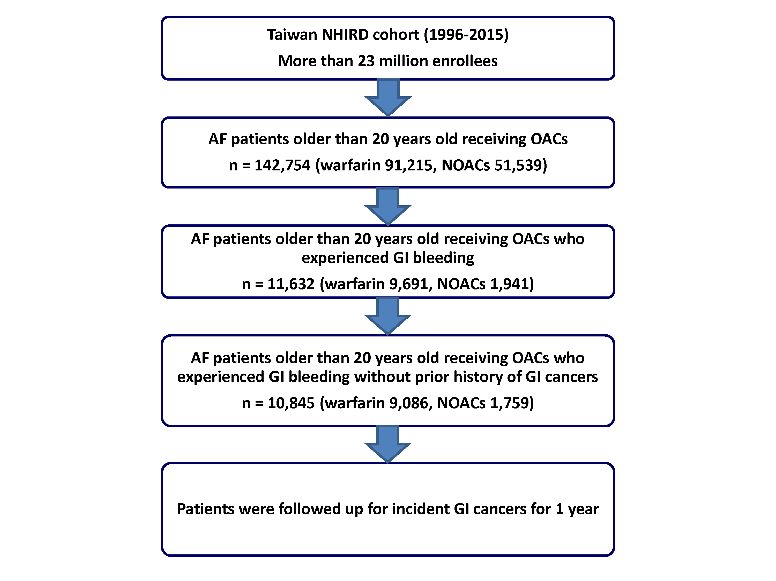
Figure 2

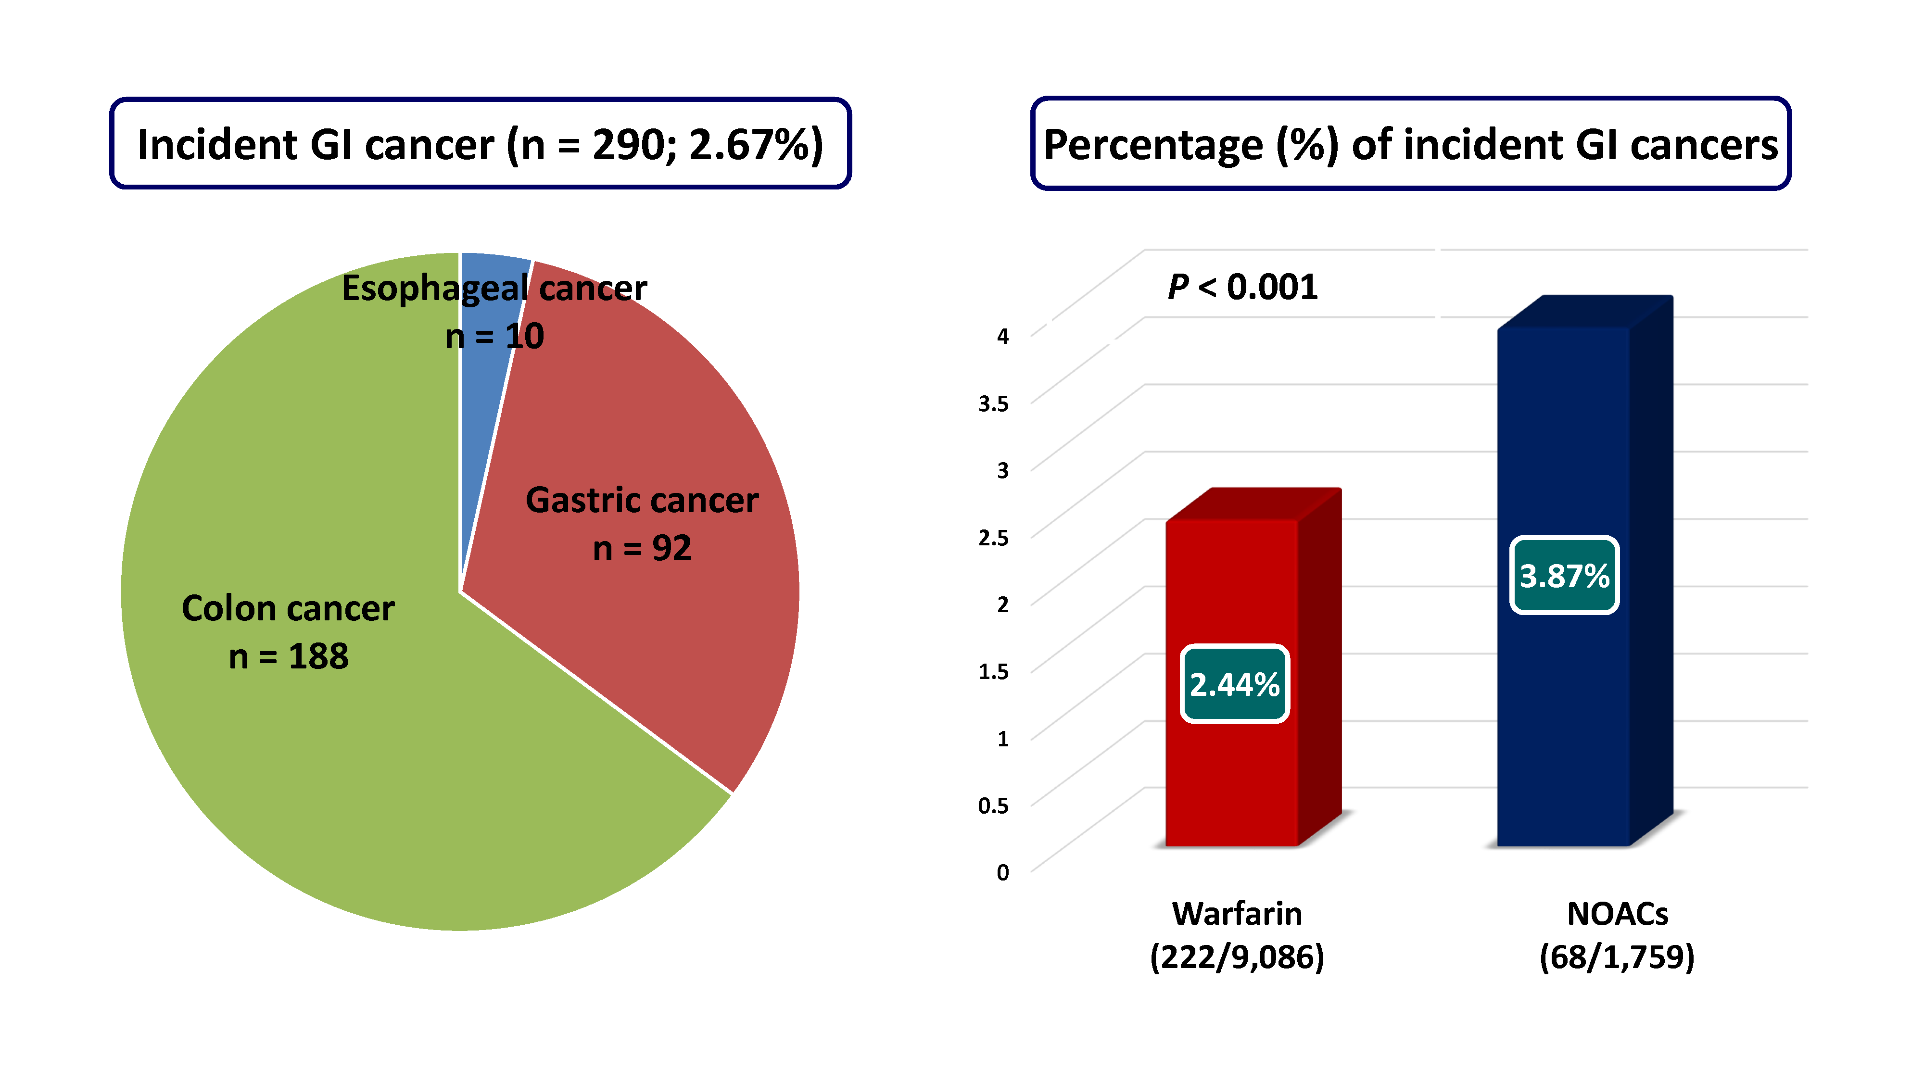
Figure 3
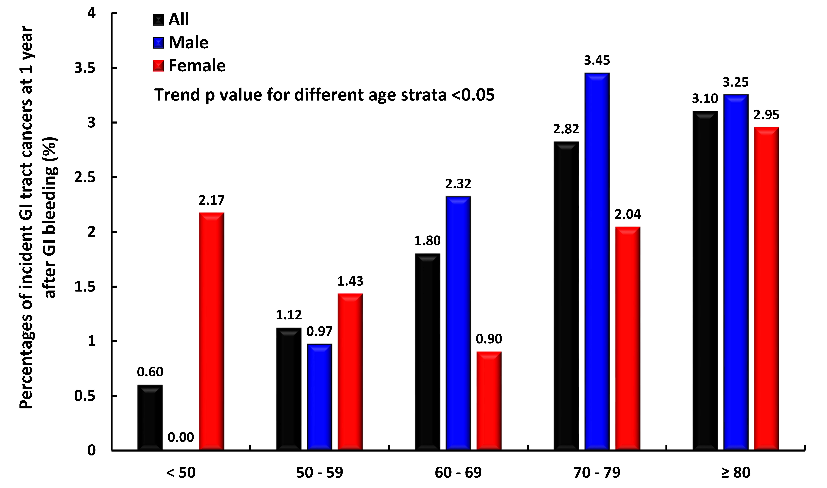
Figure 4


