Visualising Liminal Military Landscape: a Small Scale Study of Armed Forces Day in the United Kingdom.
Ross McGarry
Department of Sociology, Social Policy and Criminology, University of Liverpool, Liverpool, UK
Corresponding author. Email: S.R.Mcgarry@liverpool.ac.uk

Visualising Liminal Military Landscape: a Small Scale Study of Armed Forces Day in the United Kingdom.
Armed Forces Day is a military centric event in the UK introduced into the public calendar during 2009 following recommendations made from The Report of Inquiry into National Recognition of Our Armed Forces. Despite the significance of these events requiring the situating and performance of military values, personnel, equipment and activities within otherwise civic spaces, academic research and critical commentary into the implementation and development of Armed Forces Day is limited. Influenced by autoethnographic work from critical human geography focussing on the materiality, spatiality and embodied experiences of military airshows, and seeking to extend some insights from the seminal text Military Geographies (Woodward 2004), the aim of this paper is to observe the situatedness and performance of Armed Forces Day to be what is defined herein as “liminal military landscape”. Through conducting a small scale study of Armed Forces Day 2017 in Liverpool, employing observational techniques including notetaking and documentary photography, during this event urban space was found to undergo spatial “transitions”; have “portals” opened through which temporality and materiality invoked past experience into the present; and create newly established liminal “thresholds” waiting to be crossed between the seemingly contiguous spaces of civic and military.
Keywords: Military geographies, liminality, autoethnography, visual methods

1. Introduction
Studying the military occupation of and interactions with space, landscape and environment, and the experience of encounters within and through such places, is referred to within scholarly accounts as “military geography” (Woodward 2017). Developed during the nineteenth century as ‘a discipline self-consciously focused on the demands of military power’ (Woodward 2016, 64), military geography remains connected to its “traditional” state-centric heritage as a ‘sub-discipline of geography which applies geographical principles to the solution of military problems’ (Jackman 1962: 8). Although traditional military geography remains focussed on conventional geographical concerns such as spatiality, place, environment and landscape (Woodward 2017), contemporary critical military geography is ‘sympathetic to a range of conceptual foci including the affective, the embodied, the representational and the cultural’, though loyal to methodological traditions prioritising analysis drawn from personal encounters of observation, watching, seeing, experiencing and being in place (Woodward 2016, 64). To aid the continued advancement of critical military geography, Woodward (2005, 731) proposed two ‘avenues for conceptual and empirical study.’ First, a more complete explanation was said to be needed of how ‘military power works to produce the geographies that it does’, including better means to describe the origins of such power and the ways in which it functions (Woodward 2005, 731). And second, a focus on studies of the mundane and prosaic were necessary to observe marginalised events, activities and artefacts as mediums of insight into geopolitical systems ‘often protected by their ordinariness from critical gaze’ (Woodward 2005, 731).
Following the advocacy of Woodward (2005) and Bernazolli and Flint (2009, 395-397) examining how military influences shape the ‘everyday construction of place’, this article derives from a small scale study of UK Armed Forces Day (AFD) employing autoethnographic methods. Adding to a dearth of research into how military presence in place impacts upon social and cultural processes (Bernazolli and Flint 2009), the following discussion brings military geography into dialogue with the concept of liminality as a response to recent calls for the advancement of geographic research within critical military studies concerned with space and place (Rech et al., 2015). The purpose of doing so is to expose AFD to critical scrutiny by disrupting its “everyday” assumptions (Åhäll 2016; 2019). The aim of which is to demonstrate how such events envelop those who attend in coercive military logics, values, practices and experiences, beyond that which are most obviously hawkish recruitment vehicles or merely ‘military looking’ props and activities (Åhall 2016, 160).
The argument is constituted by two substantive parts. It first introduces and helps problematise AFD as a site which annually lionises the institutional arrangements, values and practices of the British military within quotidian settings. The theoretical and conceptual scaffold of the discussion is then outlined, including insights from the seminal text Military Geographies and commentary on “military landscapes” (Woodward 2004) which are brought into dialogue with the concept of “liminality” (Van Gennep 1960; 1967; 1969). In doing so, the aim is to analyse the flagship event of AFD 2017, hosted by the city of Liverpool, UK and taking place mainly across its waterfront during the 24th and 25th June (Figure 1), to be what is defined herein as “liminal military landscape”: an otherwise civic space occupied in some way by a military presence which locates those engaging within it, either knowingly or unknowingly, in ambiguous space between that considered “civilian” and “military”.
This is achieved during the second part of the discussion which first outlines some methodological influences from ethnographic work within critical human geography (Rech 2015; Rech and Williams 2016) employing an analytic autoethnographic approach (Anderson 2006) using both textual and visual observational methods. This is followed by some contextualising comments of AFD as evidence of military geography. Then, the penultimate section of the discussion explores the liminal spaces created within and through the military landscape of AFD 2017. Noted to be operating “at scale” (Woodward 2004; 2005) these illustrate the influences military presence has upon civic spaces, causing them to undergo spatial “transitions”, open “portals” through which temporality and materiality invoke past experience into the present, and establish new liminal “thresholds” waiting to be crossed between the seemingly contiguous spaces of civic and military (Van Gennep 1960; Turner 1967; 1969; Thomassen 2014). Principally it is argued that the events and activities at AFD 2017 variously located people within liminal spaces situated and overlapping between what can be perceived as “civilian” and “military”, an awareness of which is easily obscured without experience of both.
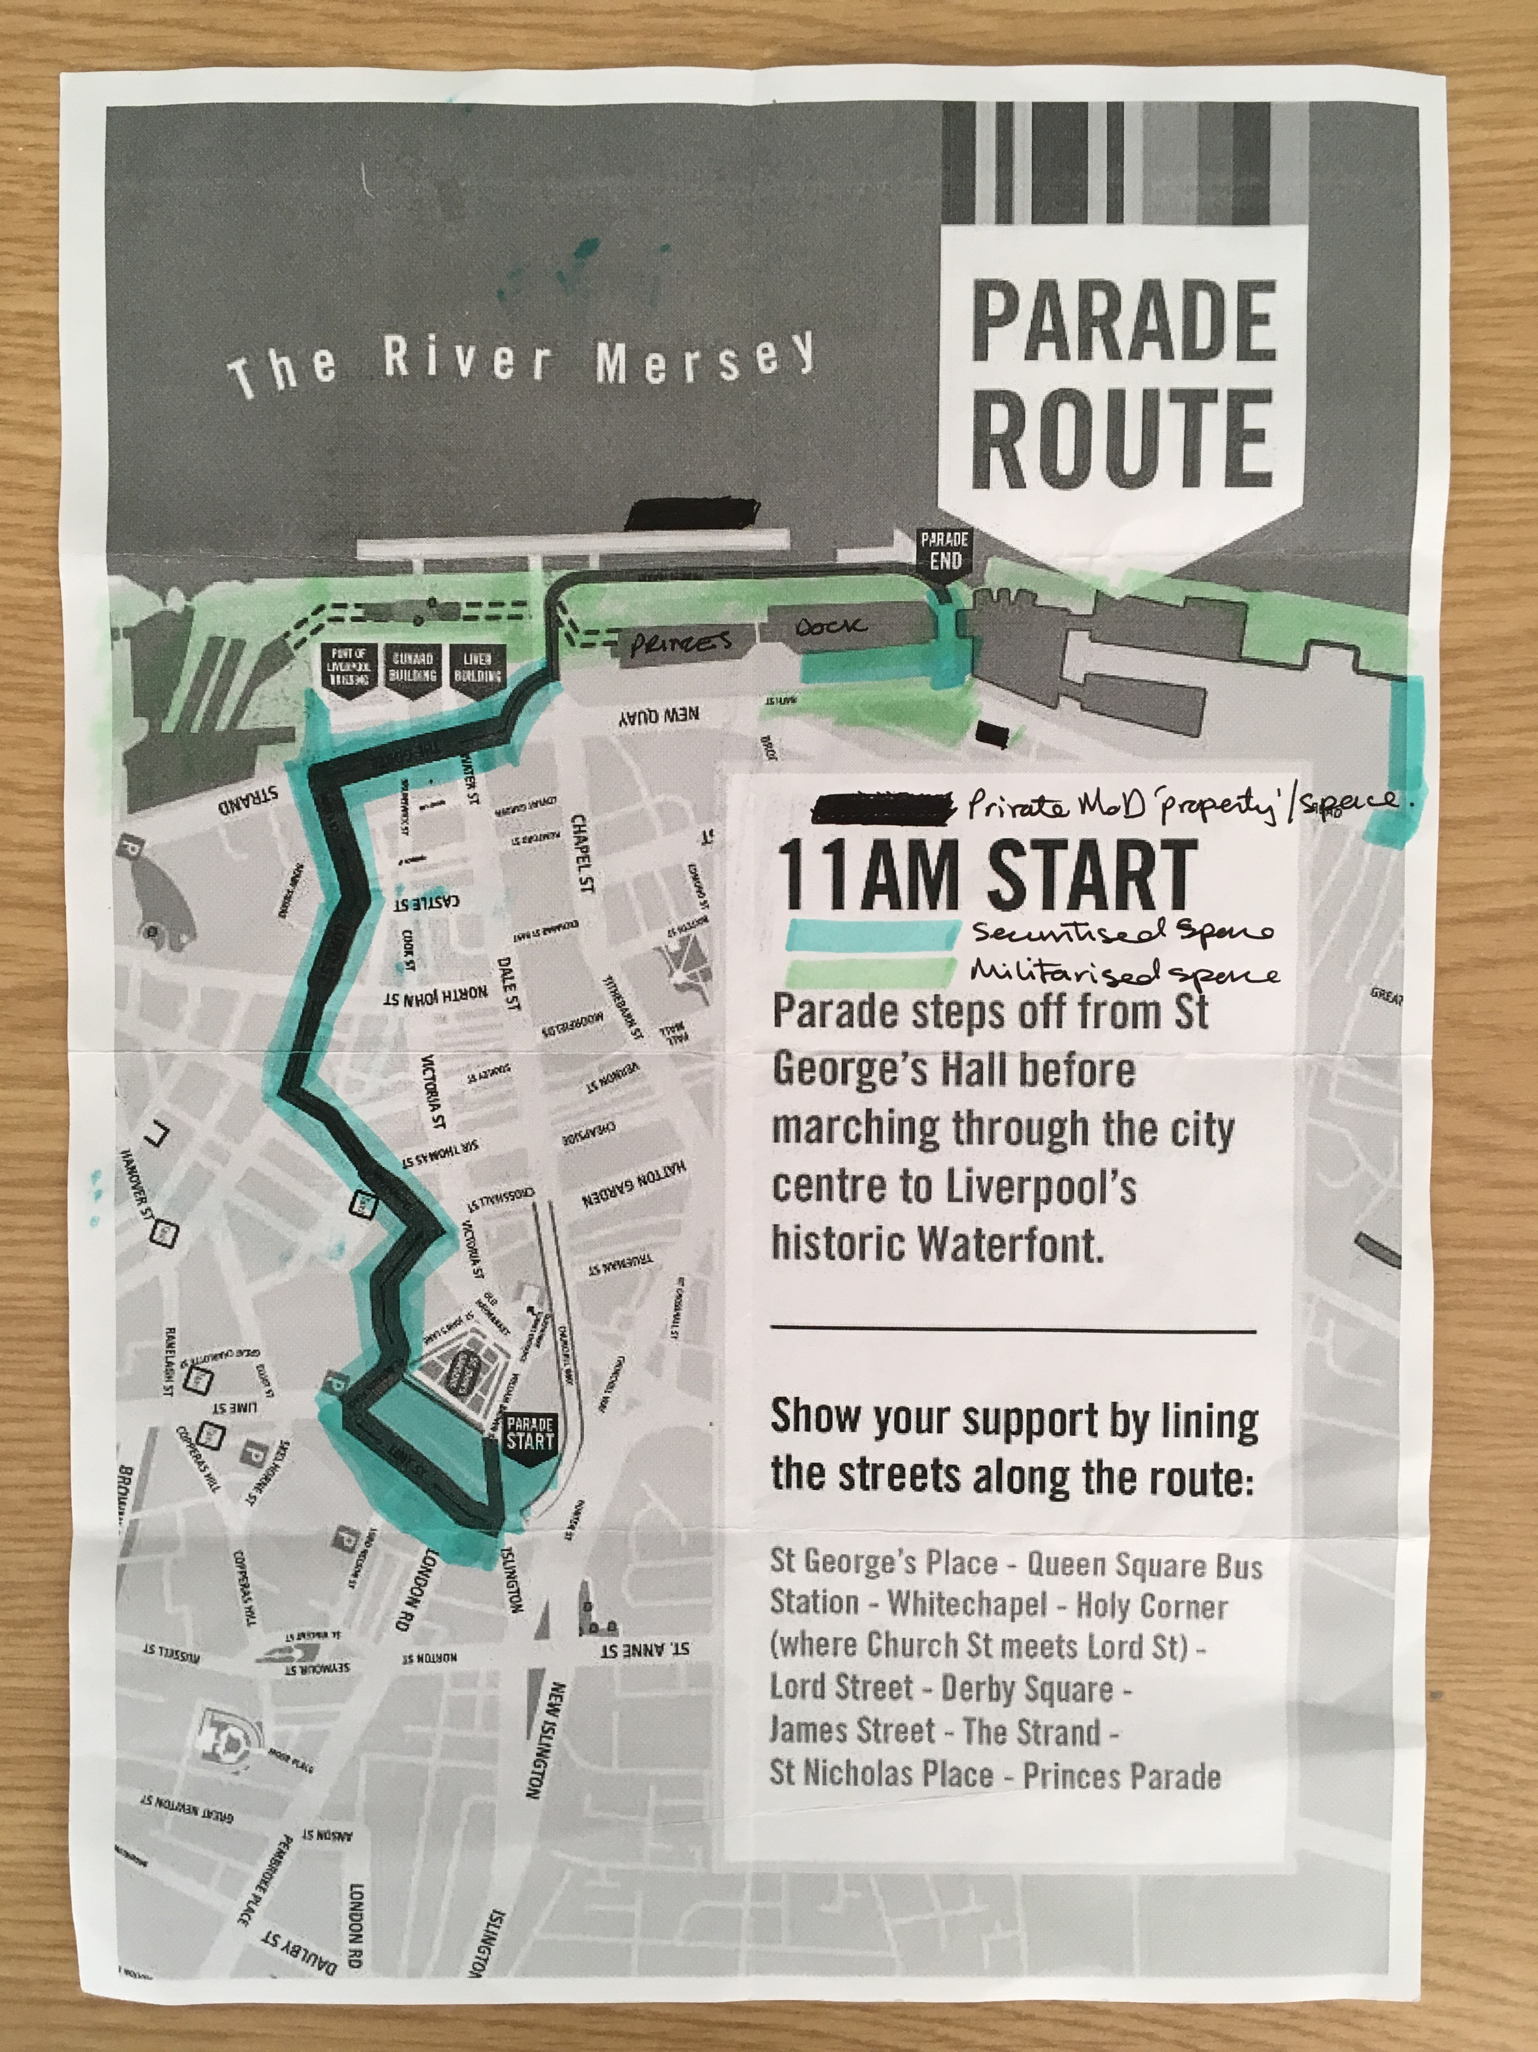
Figure 1. AFD “ephemera”: photocopied and annotated keepsake map of AFD 2017

2. Introducing and problematising UK Armed Forces Day
The development of civil-military relations in the UK during the past decade derives from publication of the Report of Inquiry into National Recognition of Our Armed Forces (Davies et al 2008). This document (the Report) put forth and successfully implemented initiatives fostering wider civic recognition for the UK Armed Forces within social, cultural and political life. The Report aimed to stem an alleged ‘erosion’ of public support for the UK Armed Forces by fostering ‘not so much exhortation as more opportunities for contact and for the expression of that strong latent feeling of appreciation and admiration which [allegedly] so evidently exists’ for the military and its personnel (Davies et al 2008, 4, my insert).
The recommendations made within the Report were initiated against a modest remit, ‘to set in train, across a broad front, a range of initiatives, none of which individually may be, or perhaps should be, very dramatic, but which taken together will move matters forward in the right direction over time’ (Davies et al 2008, 5). One key feature of the Report was a recommendation to introduce a national ‘Armed Forces and Veteran’s Day’ in the UK (Davies et al 2008, 7). Formally introduced in the UK as AFD during 2009 (replacing Veterans’ Day), this event is now a fixed part of the public calendar. Taking place during the final weekend of June each year, ‘Armed Forces Day is a chance to show your support for the men and women who make up the Armed Forces community’, comprised of serving fulltime and reservist personnel, ex-military personnel, cadets and the families of those serving (Armed Forces Day, n.d.a, online).
The wider socio-cultural repercussions of the Report have been variously addressed by scholars and activists (Gee 2014; Ware 2014; Sangster 2014; Rech 2016; McGarry 2017; Dixon 2018). Yet, despite being a major development of the Report, similar commentary relating to AFD is significantly more limited (Sangster 2017; Palmer 2017; McGarry 2019; Rech and Yarwood 2019), despite its “mundanity” and “ordinariness” being an obvious site to think critically about an everyday presence of the military (Enloe 2000) in relation to military geographies (Woodward 2004) and critical military studies (Basham et al 2015). For Gee (2014, 99), such critical scrutiny is important to ensure pro-military tropes and militarised constructions of each event don’t go unchallenged, not least because,
By lionising and in some cases fetishising the armed forces, initiatives like Armed Forces Day serve to normalise a swollen military force as part of a healthy order of society – even one facing no military threats for the foreseeable future.
The current scarcity of research produced on AFD may be due to some idiosyncrasies of military geography noted by Woodward (2005) reducing the prospects for studying critically the military occupation of space. Indeed, as Woodward (2005, 730) points out, military geographies ‘are hard to research. Information is often not available because it just has not been collected, or is not available in forms that have any real utility for social scientific research’, reflecting a more general absence of in-depth studies into how localised space and place come to entrench, enact or resist processes of militarisation and ideologies of militarism (Bernazolli and Flint 2009).
In an attempt to foreground the practice and practical aspects of doing military geography, this article proposes an innovative engagement with alternative conceptual and perceptual ways of “seeing” AFD as “liminal military landscape”. Doing so first requires a more complete appreciation of what is meant by “military geographies”, and a grasp of two key ideas: “military landscapes” and “liminality”. The following sections deal with these ideas and concepts in turn.

3. Studying military geographies and landscapes
A seminal text in the study of military occupation of space is Rachael Woodward’s (2004) Military Geographies, a text unique in addressing how militarism and activities of the British military estate ‘creates spaces, places, environments and landscapes with reference to a distinct moral order’ (Woodward 2004, 3). The case it makes for studying critically the geographies through which locations become influenced and controlled by military installations, values and practices remains compelling. It set an important marker in contemporary critical studies of military occupied spaces, demonstrating how ‘militarism as the extension of military influence into economic, social and political life is culturally, locationally and temporally specific’ (Woodward 2004, 3). Indeed, for Woodward (2004) military geographies are ubiquitous but not always apparent. They exist in myriad forms that are ‘representational as well as material and experiential’, and ‘surround us’ via the documentation and demarcation of physical and non-physical space across a variety of locations, installations, and mediums; including maps, statistical data, information systems, signage and so on (Woodward 2004, 4). Positioned as a counterpoint to more state-centric and entirely masculinised uses of military geography (Jackman 1962; Galgano and Palka 2011; Lohman and Fuhriman 2019), as Woodward (2004, 9) makes clear, ‘the point, to me, is that military geographies are not politically neutral, and our study of military geographies should not pretend to be otherwise’. Achieved by challenging the ways space is controlled through the military use of domestic land, interrogating ‘the shaping of space by economic forces exerted by the military presence and its activities’, and questioning the impact militaries have on the natural environment and how these impacts are responded to and controlled by military estates (Woodward 2004, 39).
A central tenet of Woodward’s (2004, 153) Military Geographies ‘lies in unpicking and laying bare the mechanics and politics of military control’, a primary function of which is said to be the ‘control of physical presence’. However, this illuminates a central problematique within Military Geographies. At its core is an assumption of military presence within space being contingent upon fixity, meaning there is little scope for militarily orientated events such as AFD to be understood as temporal, be they fleeting, short-lived, or temporary activities. A way through this dilemma is a concern for how the ‘military imagination of landscape’ is represented and achieved (Woodward 2004, 104). Conceptualised as “military landscapes”, these are settings initially understood through a variety of composite interpretations; from rationalist ways of seeing and reading physical landscapes through field craft for trained soldiers as a means of controlling space, to the construction and representation of gendered and national identities serving to legitimise space currently or previously occupied by militaries, and often shaped by rurality (Woodward 2004). As Woodward (2004, 108, my insert) describes, ‘Military landscapes in this sense refers to the ideas and politics behind military readings of physical features [of space] and their purposes.’ Intrinsic to such readings are the ways militaries (re)imagine the spaces they occupy through their physical presence, and for the militarised purposes they intend them to serve (Woodward 2004). Military Geographies therefore provides foundational knowledge for how events such as AFD can be both conceptualised and disrupted.
Using the notion of military landscapes, Woodward (2004) therefore shifts our attention to studying the practical and the situated within space and place. That which is or once was occupied by military installations or activities as political and politicised locations of representation, control, power and resistance (Woodward 2004). In her later work, Woodward (2014) makes-way for the study of military landscapes to include urbanised events, such as AFD, that help demarcate ‘militarisation as an affective, and embodied, normalisation of war in the everyday’ (Åhäll 2019, 151). For example, discerning the “spatial configuration” and “morphology” of urban space is said to assist in observing the normativity of ‘military presences and priorities, seen through the configuration of domestic, civilian spaces according to military norms’, through which civilian experiences of space, place and event become shaped and reconfigured (Woodward 2014, 43). And, although spaces formerly occupied by militaries are said to help observe continuities between past and present military control, Woodward’s (2014, 46) framing of these as ‘post-military landscapes’ leads us closer to the possibility of studying AFD as military landscape. For example, focusing on AFD 2018 in Plymouth Rech and Yarwood (2019, 194) argue that changes to military structures in the present may ‘play host to processes of re-imagination’, whereby contemporary understandings of military history - as represented through such events - may be discordant with accuracies of the past.
These developments are presented in Woodward’s (2019a) most recent contribution to the study of military geographies. Here, as in her original work, Woodward (2004; 2019b, 4) observes that the study of military geography should importantly take a view at a ‘range of scales’. Demonstrated well by Rech and Yarwood (2019), this means the networks and connections constructed by military activity and militarism at events such as AFD are encouraged to be recognised as having different registers, be they ‘global and international … national and regional … specific urban areas or rural localities, through to the distinctively local and individual’ (Woodward 2019, 4). Understanding military landscapes in these more recent terms thereby affords ways of considering the ‘contraction and reshaping of armed force’ whereby military and civilian worlds are understood to be ‘co-constituted’ and ‘comprise a complex web of entanglements’ rather than existing as distinct paradigms (Woodward 2019, 8). These observations reflect some fundamental principles of critical military studies (Basham et al., 2015). They are also well established within feminist scholarship as ways of challenging the military occupation and transformation of space and place, and the routine embodiment of war preparedness in everyday settings (Enloe 2000; Henry and Natanel 2016). In particular, that which has ‘“travelled” to non-military contexts’ and requires disruption as an artefact of “common sense” (Åhäll 2016: 161), such as AFD.
Taken together, an alignment with Military Geographies and a focus on military landscapes become frameworks to expose situated events such as AFD to critical scrutiny. But translating these conceptual ideas into something which accesses the quotidian nature of how militarism and processes of militarisation are experienced and practiced requires more specific theoretical and methodological instruments. Those that gives affordance to the ways military presence in place engages directly with forms of materiality and embodiment, to help evidence the blurring of space and experience into that of military landscape.

4. From liminal geographies to “liminal” (military) landscape
Deriving from Van Gennep’s (1960) The Rites of Passage and later Turner’s (1967) The Forest of Symbols and The Ritual Process (Turner 1969), ‘liminality emerges in the in-between of a passage’, distinguishing rites of passage for individuals or groups in transition between different statuses, from events which mark a common passage of time (Thomassen 2014, 2). In these terms, liminality is the middle of three stages in universally recognisable “rites of passage” (Van Gennep 1960).
First are ‘rites of separation’, and the last a newfound frame of ‘rites of incorporation’, or ‘post liminal rites’ (Van Gennep 1960, 11, 21). The mid-stage between rites of “separation” and “incorporation” are known as ‘transition’, ‘threshold’ or ‘liminal’ rites, and this stage as the ‘liminal period’ (Van Gennep 1960, 11, 21). Given their stated ‘pattern’ (Thomassen 2014, 3), “rites of passage” are suggested to be evident in many social processes, from the transition of life to death, to rituals related to marriage and funeral ceremonies (Van Gennep 1960). As Thomassen (2012) further notes, Turner (1967; 1969) revived Van Gennep’s (1960) notion of the “liminal period” as a state of “betwixt and between”. As Turner (1967, 94) observes, “rites of separation” ‘comprises symbolic behaviour signifying the detachment of the individual from an earlier fixed point in the social structure or a set of cultural conditions (a “state”).’ The altering of a “state” is accompanied by “transition rites” within the “liminal period”, whereby ‘the state of the ritual subject (the “passenger”) is ambiguous; he passes through a realm that has few or none of the attributes of the past or coming state” (Turner 1967, 94). Indeed, this is what it means to be “liminal”, to be “betwixt and between” (Turner 1967). Finally, “rites of incorporation” - the transition or ‘passage’ through the “liminal period” for the “ritual subject” - achieves ‘a stable state once more, and, by virtue of this, has rights and obligations of a clearly defined and “structural type”…’ (Turner 1967, 94).
To observe liminality in these terms is therefore to engage in an understanding of personal and social interactions and events, and to be within “liminal space” is to be in a process of finding ‘a new frame to settle within’ during transition from one “state” of being to another (Thomassen 2014, 4). In its broadest conceptualisation then, liminality ‘refers to any “betwixt and between” situation or object, any in-between place or moment, a state of surprise, a moment of freedom between two structured world-views or institutional arrangement’ (Thomassen 2014, 7).

Liminal geographies
The concept of liminality, as described above, has been used so widely within the social sciences and across such an array of disciplines that a complete review of literature utilising it is suggested to be ‘utterly impossible and probably also futile to undertake’ (Thomassen 2014: 7). But despite its broadness of appeal and usage, within geography liminality is suggested to have been exposed to a ‘relative neglect’, be this in relation to examining changing social statuses and identities or the transformational experiences of people and place (McConnell 2017, 142). Although this is not to assume the concept has gone without use. Taking, for example, McConnell’s (2017, 143) recent development of “liminal geopolitics”, the concept has been loyally interpreted to explore ‘the simultaneously symbolic and quotidian nature of diplomatic practice’ in the creation of international diplomatic spaces. Framed as ‘liminal diplomacy’ (McConnell 2019, 53) it has been deployed to analyse ‘boundary positions and subjectivities defined by inbetweenness’ amongst stateless nations unrepresented by the United Nations (McConnell 2017). Liminality has also been brought into conversation with assemblage theory to illustrate the creative diplomatic practices of representatives from British Overseas Territories (McConnell and Dittmer 2018), and used to highlight the often ambiguous ‘liminal political subjectivities’ of diasporas (Ho and McConnell 2019). The term has also been used with conceptual accuracy in other more militarily orientated research variously concerned with space and spatiality, people and place. For example, Herman and Yarwood (2014) explore the importance of military spaces when acquiring a military identity, and the varying liminal states of “betweenness” experienced by military veterans in transition back to civilian life when finally detached from military landscapes and economies (Woodward 2004). Whereas Murakami (2014) instead pays attention to Turner’s (1969) later notions of “pilgrimage” and “communitas” with regard to the commemorative practices of World War Two Burma Campaign veterans experiencing liminality collectively. While others have analysed the liminal nature of public space in environments effected by conflict, including social and political reconfigurations in Baghdad influenced by the “anti-structures” of movable blast walls within the city (Murrani 2016), and a state of “permanent liminality” has been proposed of Derry and Bilbao, as places seemingly in transition from conflict but whose “transitional optics” is betrayed by the imagery, sentiment and political activities of those inhabiting these places (Murphy and McDowell 2019).
However, echoing some concerns expressed by Thomassen (2014) and McConnell (2017), liminality is not always deployed sympathetically. For example, methodological observations of townscapes occupied for the purposes of publicly mourning repatriated military personnel killed at war as constituting ‘liminal space’ (McGarry 2016, 133) makes use of the term without carefully establishing its meaning. The notion of liminality is therefore described and employed here underwritten by these cautionary notes. The contributions sought to be made from its use in this article are to demonstrate the blurring of that considered civic and military via unfolding spatial “transitions”, experiential “portals” opening, and “thresholds” being created and crossed within urban space.

Liminal (military) landscape: patterns of experience, transition and spatiality
Although not constituted by order or structure, such ‘liminal experiences do have a “form” or a recognisable “pattern”’, as performed through Van Gennep’s (1960) original model (Thomassen 2012, 32) meaning they are situated events, inasmuch,
Liminality is very essentially a spatial concept … Van Gennep clearly saw territorial border zones or border lives, thresholds or portals, as structurally identical with the immediate period of a ritual passage: spatial and geographical progression correlates with the ritual marking of a cultural passage (Thomassen 2014, 91, my emphasis).
Liminal patterns are therefore related to space and place. This concerns the transition through boundaries between zones, articulated “at scale” (Woodward 2004), evident via the crossing of thresholds as banal but ritualistic as the passage in a doorway, as intimate as an opening in the body (such as a wound), or experienced as movement across geopolitical borders (Thomassen 2012; 2014). Liminality therefore has an ‘inherent spatiality’ (McConnell 2017, 143), but for Thomassen (2014) still requires fundamental loyalty, in one form or another, to Van Gennep’s (1960) original interpretation. This includes recognition that ‘[t]he qualities of liminality pertain to human experiences – experiences of a certain kind’, meaning they connect people with place, and that which is sensate with spatiality (Thomassen 2014, 4). Furthermore, for Thomassen (2014, 15) the experience of being liminal occurs only in particular contexts, ‘namely, that it has to do with the passage of a threshold and therefore with transition. If it is not about transition, it is not about liminality.’
This three-fold means of conceptualising liminality constituting transitions, experiential passage through thresholds and portals, and pertaining to spatiality, is usefully adapted to military landscapes such as AFD. As demonstrated at events similar to military airshows, Rech (2014b; 2015; 2016; 2019) found there to be a focussed engagement with the public; seeking to capture the experience of “being” military or creating space to encourage people to “become” military (via direct interaction or formal recruitment) through the materialities and activities on display. Such transactions resulting from transition through “rites of passage” between civilian and military contexts are well established rituals documented within John Hockey’s (1986) seminal book Squaddies: Portrait of a Subculture (see Carré 2019 for a contemporary account). Many of the transitions taking place within the “liminal period”, and undertaken as “initiations” documented by Turner (1967, 93, 95, 99-101), lend themselves to processes of joining ritualistic and masculinised institutional contexts such as the military; recognisable through a close reading of basic military training and its masculine “organisational socialisation” (see Hockey 1986, chapter 3). As Hockey (1986, 34, my insert) points out,
Becoming “Trained Soldiers” and passing out of the [training] depot fits Van Gennep’s formulation for it entails not only a change of status from civilian to solider, but also from being a boy to being a man.
By contrast - and as originally suggested only to pertain to doorways as thresholds - such rites of entering space (i.e. institutionalised contexts) also ‘have their counterparts in rites of exit, which are either identical or the reverse’ (Van Gennep 1960, 24). Herman and Yarwood (2014) have carefully observed such “rites of exit” from military institutionalisation, documenting the counter transition from military to civilian life as “liminal” experiences (see also Cooper et al 2018 for a Bourdieusian account). Indeed, McConnell and Dittmer (2018, 154) note liminality to be the ‘inverse of resilience’, a term routinely - but seldom critically - applied to experiences of military institutionalisation and life thereafter (McGarry, et al. 2015).
Akin to situated accounts of liminality found across a variety of different landscapes (Andrews and Roberts 2012), the second part of this discussion uses the above framing of liminal military landscape to explore “transitions”, “portals” and “thresholds” in relation to ‘the everyday’ of AFD 2017 (Henry and Natanel 2016: 851). This begins with a note on the observational and visual methods employed to document first-hand experiences of this militarily-orientated event as a situated account of military geography and landscape.

5. Making (analytic) autoethnographic observations as a “show-goer”
As demonstrated by the work of Rech (2015; 2016; 2019), ‘the exploration of landscapes is primarily an exercise in looking, in visual engagement and interaction’ (Woodward 2014, 47). Following approaches from Rech (2015; 2019) and Rech and Williams (2016, 271, 279) studying British military airshows by attending events to ‘emulate the show-goer’ and encounter the military estate and its personnel ‘on their own terms’, the current study employed an “analytic” autoethnographic (Anderson 2006) approach to experiencing militarily related contexts (Taber 2010). Drawing directly on experiences of the location, institutions and interest groups being studied as an “opportunistic” complete member researcher at AFD 2017 (Anderson 2006), including previous occupational experience of the British military, knowledge as a social researcher, and being a resident of the city of Liverpool, this study achieved what previous contemporary work on military airshows and AFD could not; making experientially rich observations informed by a former military “insider-outsider” positionality (Higate and Cameron 2006).
Influenced by Rech and Williams (2016), a suite of ethnographic methods were utilised throughout the fieldwork to make landscape visible, this included observational hand-written fieldnotes (Emerson et al 2007) and photography as a methodological practice captured via a digital camera (Heng 2016). Photography was not used to produce mimetic images of the events taking place however, but instead to use ‘photographs as evocation’ and ‘illustration’, to capture place, space and interaction and ‘convey the qualities of materiality more directly to the viewer’ (Rose 2008, 155). Photographs were taken to capture events in ways that disrupted depictions of place and space, and ‘perhaps even answer back’ (Rose 2008, 155) to prevalent normative public representations of AFD (see Armed Forces Day n.d.c.). This visual “invocation” was undertaken first utilising a “shooting script” (Suchar 1997) based on research questions derived from immersion with literature pertaining to military airshows. Some responses to these questions are found in Figures 1-3 as “material”, “ephemeral” (Rech 2019) and “visual” (Rech 2015) engagements. They demonstrate some of what has already been observed of airshows and AFD as military recruitment and charity giving events that fetishize and normalise a range of mundane, extravagant and violent military activities and technologies (Rech 2019; Rech and Yarwood 2019), made evident by the visuality of looking and seeing via “observant practice” (Rech 2015). They reflect the situated and diffuse nature of “liberal militarism”, the promotion and reassertion of the supposed necessity of military power as a means of securitisation, made evident by the ‘interlockings of the geopolitical and the everyday’ (Basham 2018, 34).
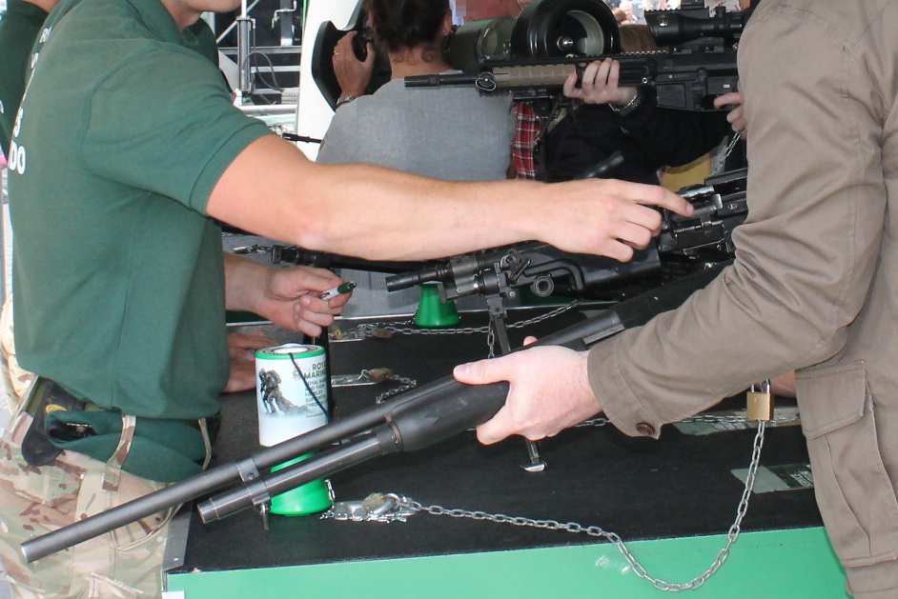
Figure 2. “Ephemeral” engagement with military artefacts: Royal Marines display table
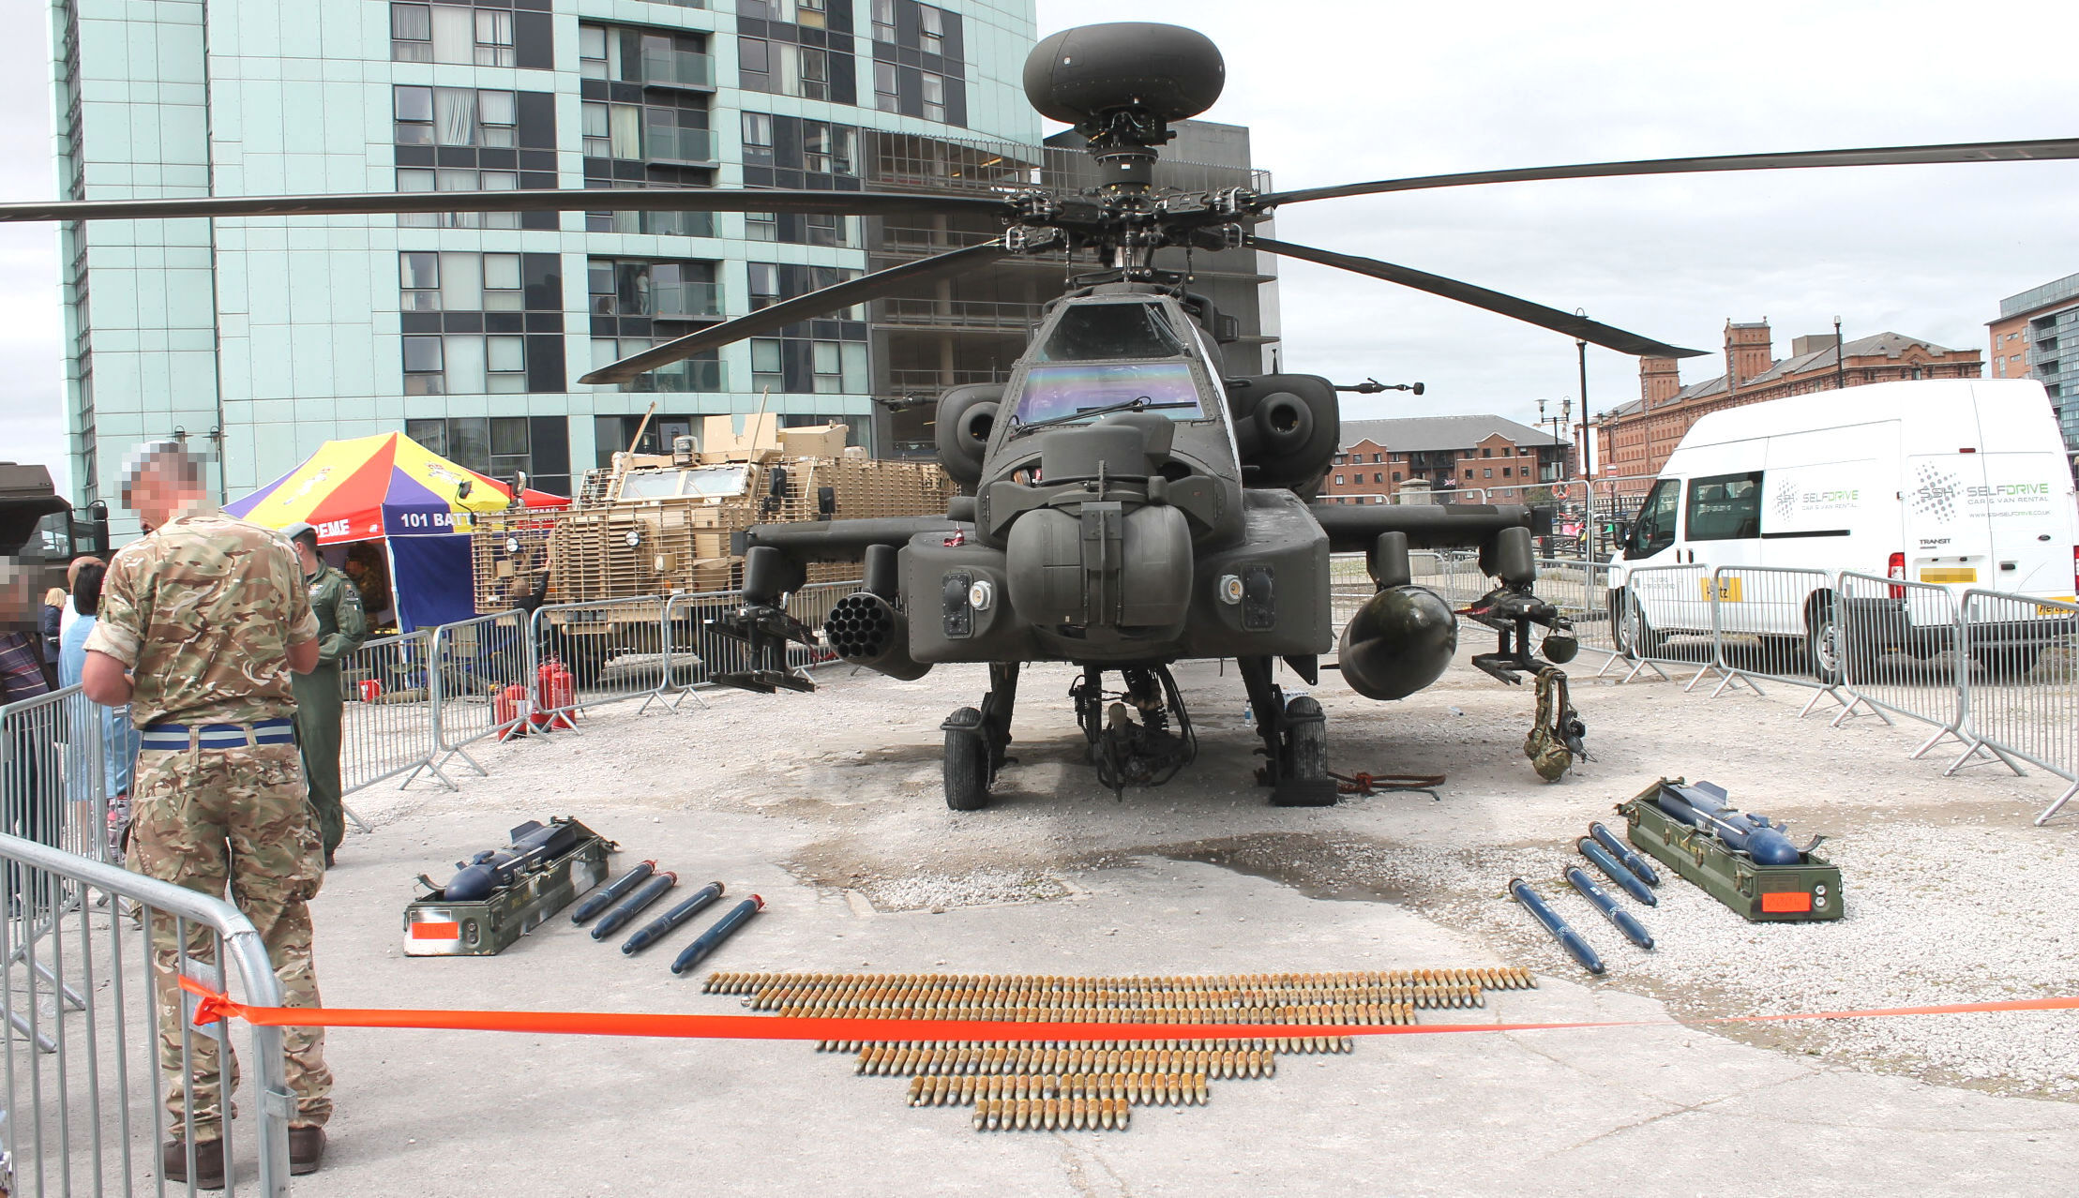
Figure 3. “Visual cultures of militarism”: Apache helicopter, ammunition and missiles

The second use of photo-documentation was via a “piquing of interest” (Rech and Williams 2016), namely taking photographs when opportunities arose to capture emergent observations not considered within the confines of the “shooting script”. In doing so, ‘the strange character of military landscaping’ that is often suppressed either through its concealment or via “liminality” was made evident (Woodward 2014, 43). This is reflected in Figures 4-9 and represent how liminality was discovered throughout AFD 2017 as instances of transitions, portals and thresholds engaging people to “be” or “become” military (Van Gennep 1960; Turner 1967; 1969; Thomassen 2014); offering departures from previous studies of being in place at military airshows, and providing a different yet complimentary reading of the few current works produced on AFD (Sangster 2017; Palmer 2017; McGarry 2019; Rech and Yarwood 2019).
The remainder of this discussion turns to explore these autoethnographic observations of AFD, first as a site of military geography and then as liminal military landscape.

6. Armed Forces Day as military geography
First taking place in Chatham, Kent during 2009 AFD has arguably grown in popularity and scale. If selected to host national AFD the town or city is awarded £25,000 to subsidise the event, supplemented by local council and private company funding, including sponsorship by military arms manufacturers (Culture Liverpool 2017). And, despite admissions that ‘Armed Forces Day is not a charitable event’ it is openly supported by a range of Cobseo (2017) (ex)military charities who benefit from the overall activities taking place (Armed Forces Day n.d.a, online). Although there are no strict rules on what can be included within AFD events a “digital toolkit” is made available to the public, including a specific “brand guide” (Armed Forces Day n.d.b.) ensuring each AFD has recognisable uniformity. Each event involves a similar diet of activities, including military marching parades, flypasts, tented information stalls and military themed activities. Taken together, as documented by Danilova (2015, 92-93) from AFD 2010 in Nottingham,
In its current state, Armed Forces Day acts as a de facto military recruitment fair with each branch of the UK armed forces publicising its services as ‘opportunities’ “to see the world” and “be the best”. This recruitment drive expresses itself through a range of militarised activities directed at children and the wider public. It encourages support for the armed forces and implicitly glorifies wars … the main practical aspects of this “support” are twofold; they include donations to service-related charities and a military recruitment exercise through publicising a range of interactive and military-centric activities for children, youngsters and other potential recruits.
Further illustration of AFD 2014 in Stirling offers different insight. Concordant with Rech’s (2016) observations, Palmer (2017) notes AFD 2014 as an instrument of youth engagement, with its foci being children as participants in militarised activities, whereby the normalising of violence was encouraged as forms of “play”. And, different to Woodward’s (2014: 46) ‘post-military landscapes’, Rech and Yarwood’s (2019, 192) study of AFD 2018 in Plymouth demonstrates how contemporary structural changes to the British military and its re-imagining are performed via the “post-military city” by way of military parades, events and other celebratory activities, offering,
a more nuanced analysis of how communities transition with and alongside the military establishment, and presumes that space and place are key matters in post-military transition.
As demonstrated through activities and practices similar to those found at military airshows, including military recruitment (Rech, 2014b; 2015; 2016; 2019), AFD similarly foregrounds various things occurring at the same time, collectively giving affordance to a ‘shaping of space by economic forces exerted by the military presence and its activities, and the consequent impact on social relations’ (Woodward 2004, 39).
But this is not to suggest clear demarcations exist between that which we consider civilian and military at these events, as Baker et al (2015, 147) point out,
The civil-military divide shifts, reforms and reasserts itself in some spaces and not others; it has a temporality and spatiality to it that’s constantly blurring, shifting and moving. What is really interesting is the power relations that are facilitated when the civil-military divide is invoked or when it becomes blurred and how, of course, it becomes blurred, entrenched and so on.
For example, although AFD 2018 in Plymouth appropriated the city’s military history, port and monuments (Rech and Yarwood 2019), AFD 2017 both celebrated and obscured “martial politics” in place across Liverpool (Howell 2018). Starting at St George’s Hall the commencement of the marching parade began at a setting known for annually commemorating the Armistice around St George’s Plateau (Figure 4). Here, place provided a stage for the “dance” of militarisation to begin blurring distinctions between civic and military, remembrance and entertainment in quite obvious ways (Åhall 2016); juxtaposing the Liverpool Cenotaph, scores of marching service personnel, an armoured vehicle, armed civilian police, and civilian onlookers. Indeed, as noted by Palmer (2017), the opening sequence of AFD (Figure 4) is a confused amalgam of situated remembrance practices (Åhall 2016), combined with the once fringe public spectacle of military homecoming parades.

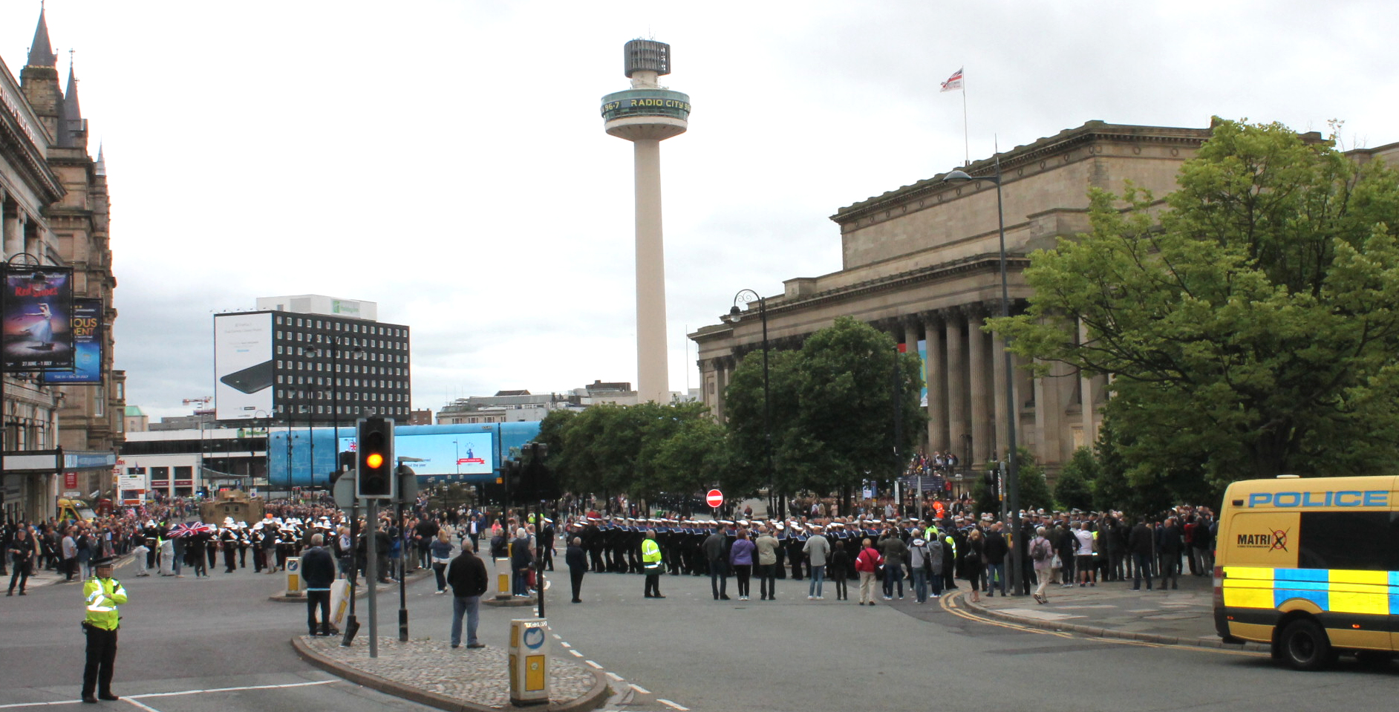
Figure 4. The “dance of militarisation”: St George’s Hall and St George’s Plateau

Whereas, a particular vision of Rech and Yarwood’s (2019) “post-military” landscape, altered by civic publics rubbing-up “with” and “alongside” the military estate through commercial space, is depicted in Figure 5, exhibiting for the public ‘a choreographed security practice in the everyday’ (Åhall 2016, 155). These routinised military bodies, undertaking the perfunctory practice of marching in-step (Palmer 2017) and intentionally displaced from the private martial settings where this activity becomes a “rite of passage” (Van Gennep 1960), were contingent and validated by onlookers peering in on this performative military “initiation” (Turner 1967). At the parade’s end point, Liverpool’s waterfront (and the city more widely) is a place with an entrenched history of profiteering and economic growth from involvement in the transatlantic slave trade (Tibbles 2018). This went without acknowledgement during AFD 2017. Instead, the HMS Iron Duke was moored in the River Mersey at the ferry landing stage terminal (Figure 9) and the area surrounding Princes Dock gave affordance to the activities taking place as a key tourist attraction. In doing so, unlike at St George’s Plateau, the end point of the parade at Liverpool’s waterfront had its “martial politics” (Howell 2018) concealed during AFD 2017, as did the Royal Navy’s own complex history and involvement with transatlantic slavery (Olusoga 2016). These histories were instead supplanted by a vision of “militarisation”, performed through contemporary objects and activities, that were merely ‘military looking’ (Åhall 2016, 160).
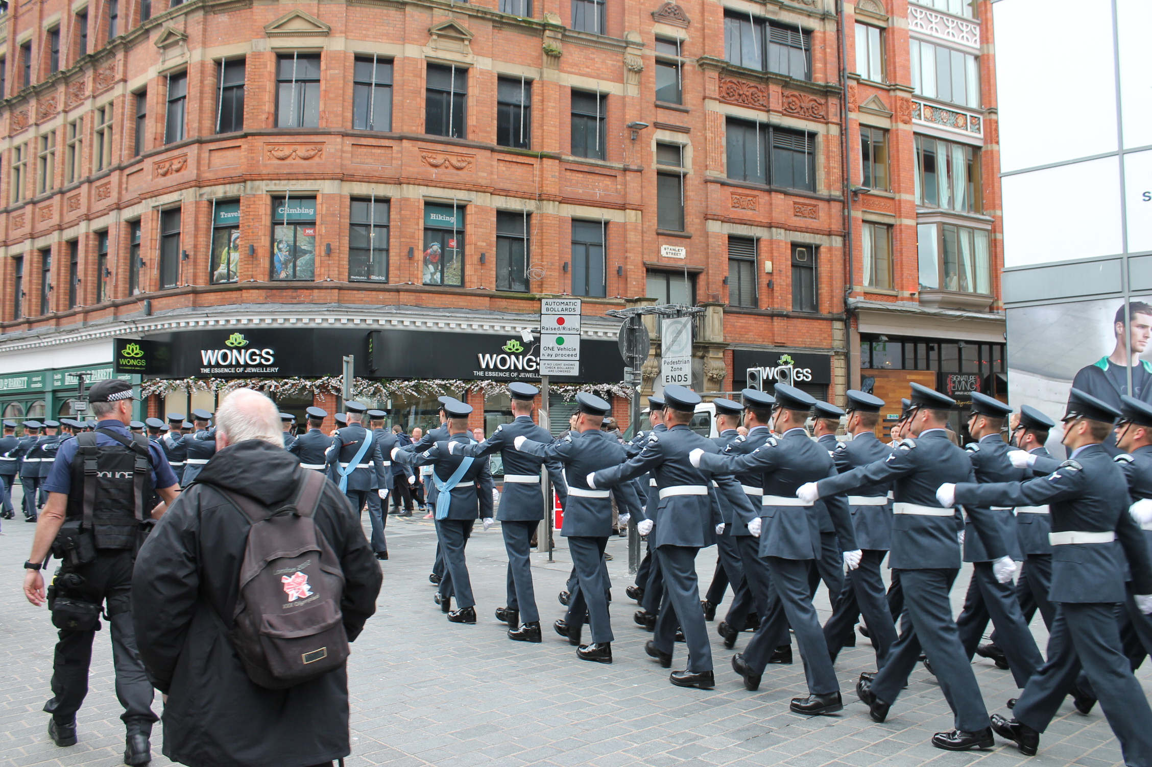
Figure 5. “Post military city”: marching military parade through the high-street

7. Armed Forces Day, Liverpool, 2017 as liminal military landscape
With these critical observations in mind, and aided by documentary photographs and observational fieldnotes, this final analysis section focuses on the transitions, portals and thresholds of liminality that situated “show-goers” within “betwixt and between” (Turner 1967) spaces of military logics, practices and frames of understanding at AFD 2017.

Transitions
Employing “rephotography” to capture change in landscape from one “state” to the next (Rieger 2011), a day prior to AFD 2017 I walked and photographed the parade route early morning from St George’s Hall to Princes Dock (Figure 1). For the most part there was no evidence that AFD was imminent and the city looked familiar as the working day rumbled awake. Once at the waterfront however, transitions became noticeable indicating that civic landscape had begun changing to be occupied by military ephemera (Rech 2019). As I note,
A Typhoon aircraft was being unloaded from a flatbed truck by civilians (i.e. none were in uniforms to indicate otherwise). Sat neatly and uniformly on the frame of the truck, just below the nose of the aircraft was a pay-load of six missiles. Presumably these were not armed, but they certainly look and feel out of place in this civic space that I know well, and frequently enjoy for its proximity to the River Mersey and views of surrounding architecture (Fieldnotes, 23rd June 2017).

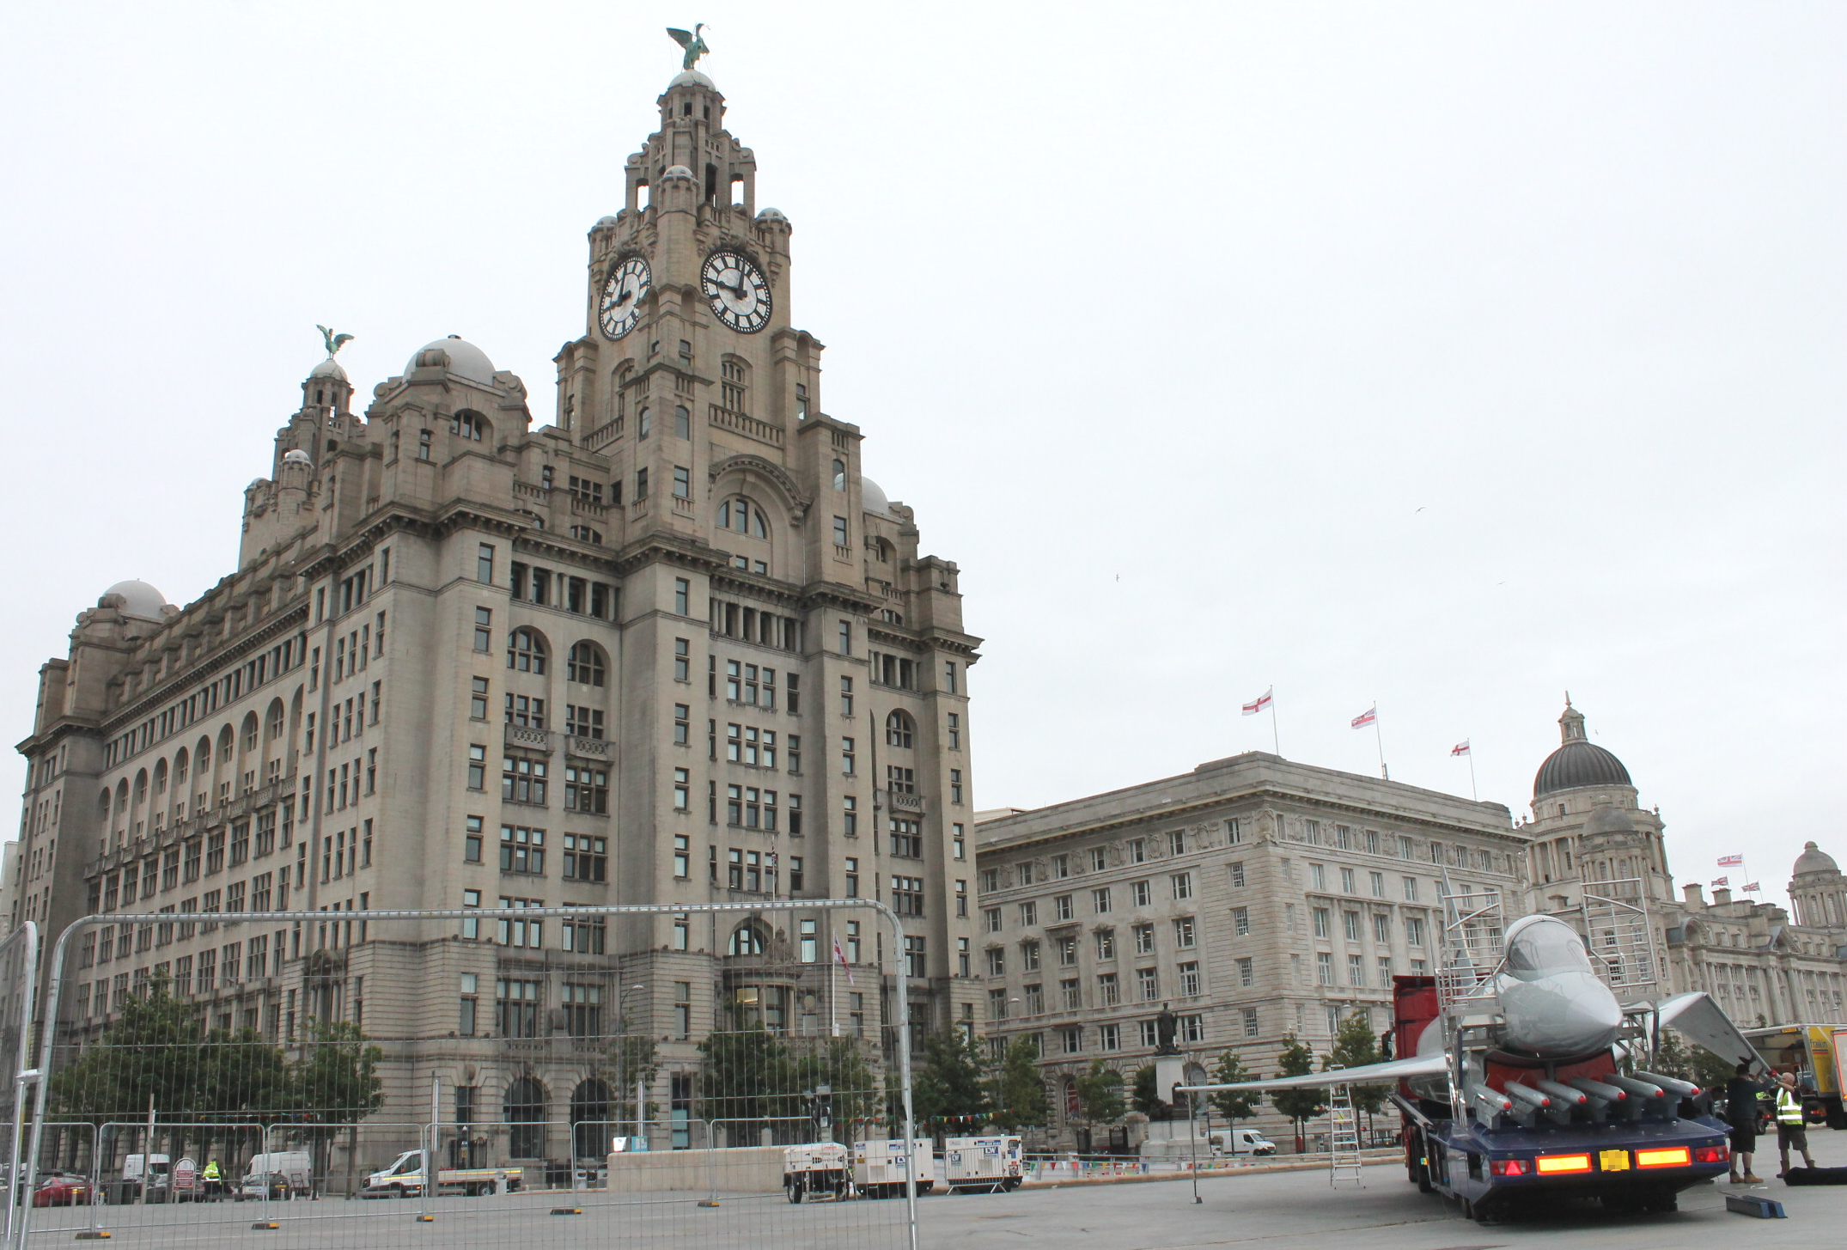
Figure 6. An unfolding “transition”: outside the Liverpool Liver Building

Concentrating on the left of the image in Figure 6, the recognisable architecture of the Liver Building, adorned with Liver Birds looking out across the River Mersey and over the city, is a geographic signifier of place. Familiar civic activity can be seen at ground level: a parked flatbed van, pedestrian generators, and high metal fencing are all indicators of urban space in transition. Follow the bunting that crosses from behind the fencing from left to right of the image, and the nature of this transition becomes evident. Atop the Cunard Building and Port of Liverpool Building, Union Flags had been replaced with insignias of AFD; making public a change in civic identity and signifying a marker of unfamiliar occupation at Liverpool’s waterfront. As per my notes, the presence of vehicular military technology and ordinance within this space (to the foreground in Figure 6) was arresting and uncommon, transitioning a previously accessible public space which I pass through frequently to become restricted and inaccessible. The two men unfolding the wing in Figure 6 give nuance to the in-motion transition occurring within this “betwixt and between” space across Liverpool’s waterfront (Turner 1967); transitioning public space with the imposition of three military “villages” (Figures 7, 8 and 9) where the main AFD activities would be contained.
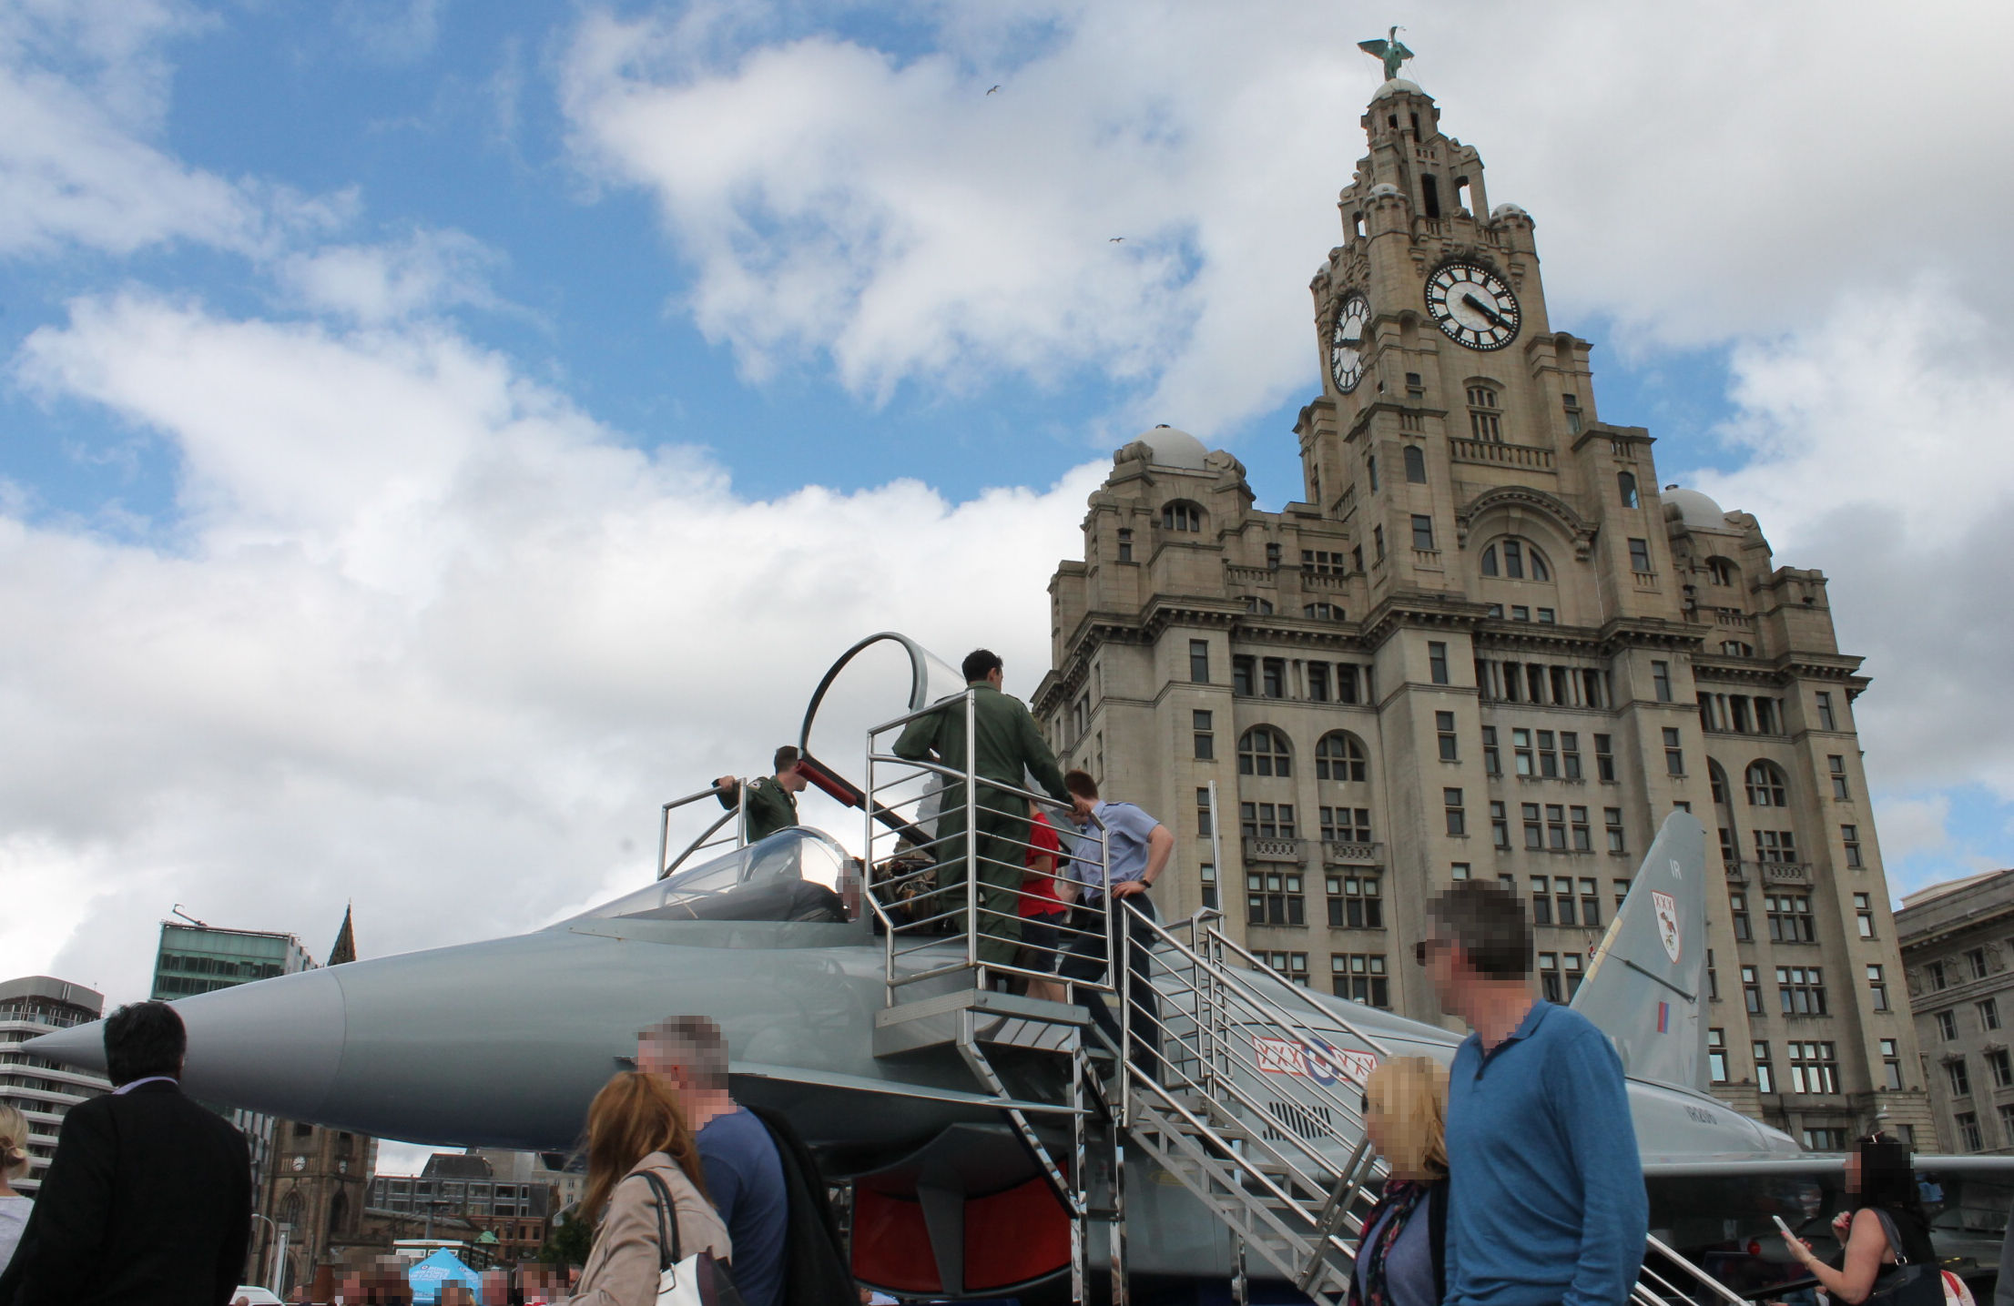
Figure 7. A “transition” unfolded: recruitment prop at the “RAF Village”

Once fully unloaded, the fighter jet (Figure 7) helped transition this space into a local “economic military geography” of recruitment and exhibition within the “RAF Village” (Woodward 2004); enticing interaction from children and adults invited to sit in, and be educated about, the technological capabilities of the aircraft by ‘skilled custodians’ (Palmer 2017, 145). It became both a recruitment prop and an emblem of (in)security, that which ‘normalizes militarism by failing to challenge it’, a disposition perhaps reinforced by a general public ambivalence to British military activity via ‘the desire for an everyday’ (Basham 2018, 40).

Portals
The following day, while walking through the “Army Village” I was confronted with a variety of side-entrance trailers and display tables exhibiting many different types of military paraphernalia and weaponry for public engagement. Figure 8 depicts my encounters within such spaces where, through interaction, I came to perceive the military ephemera (Rech 2019) around me as portals into liminal experience (Thomassen 2014). The first of which is represented in the SA80 assault rifles secured to the display table, complete with shaped Combat Solider 95 Disruptive Pattern Material (CS95 DPM) tablecloth. Regular show-goers were unfamiliar and often fascinated with these artefacts, usually through their size, weight, and destructive capabilities. For me however, I observe from my notes,
I was able to handle, arm, and fire an SA80, which I found I remained familiar with. I had however forgot quite how heavy and cold this weapon is – the materiality of such weapons is one of the issues that had compelled me to leave the military; I felt no pleasure in holding this weapon again, nor desire to keep hold of it. It did not feel as it perhaps meant to (i.e. empowering, masculine, “macho”), it felt heavy, cold and clumsy in my hands (Fieldnotes, 24th June 2017).
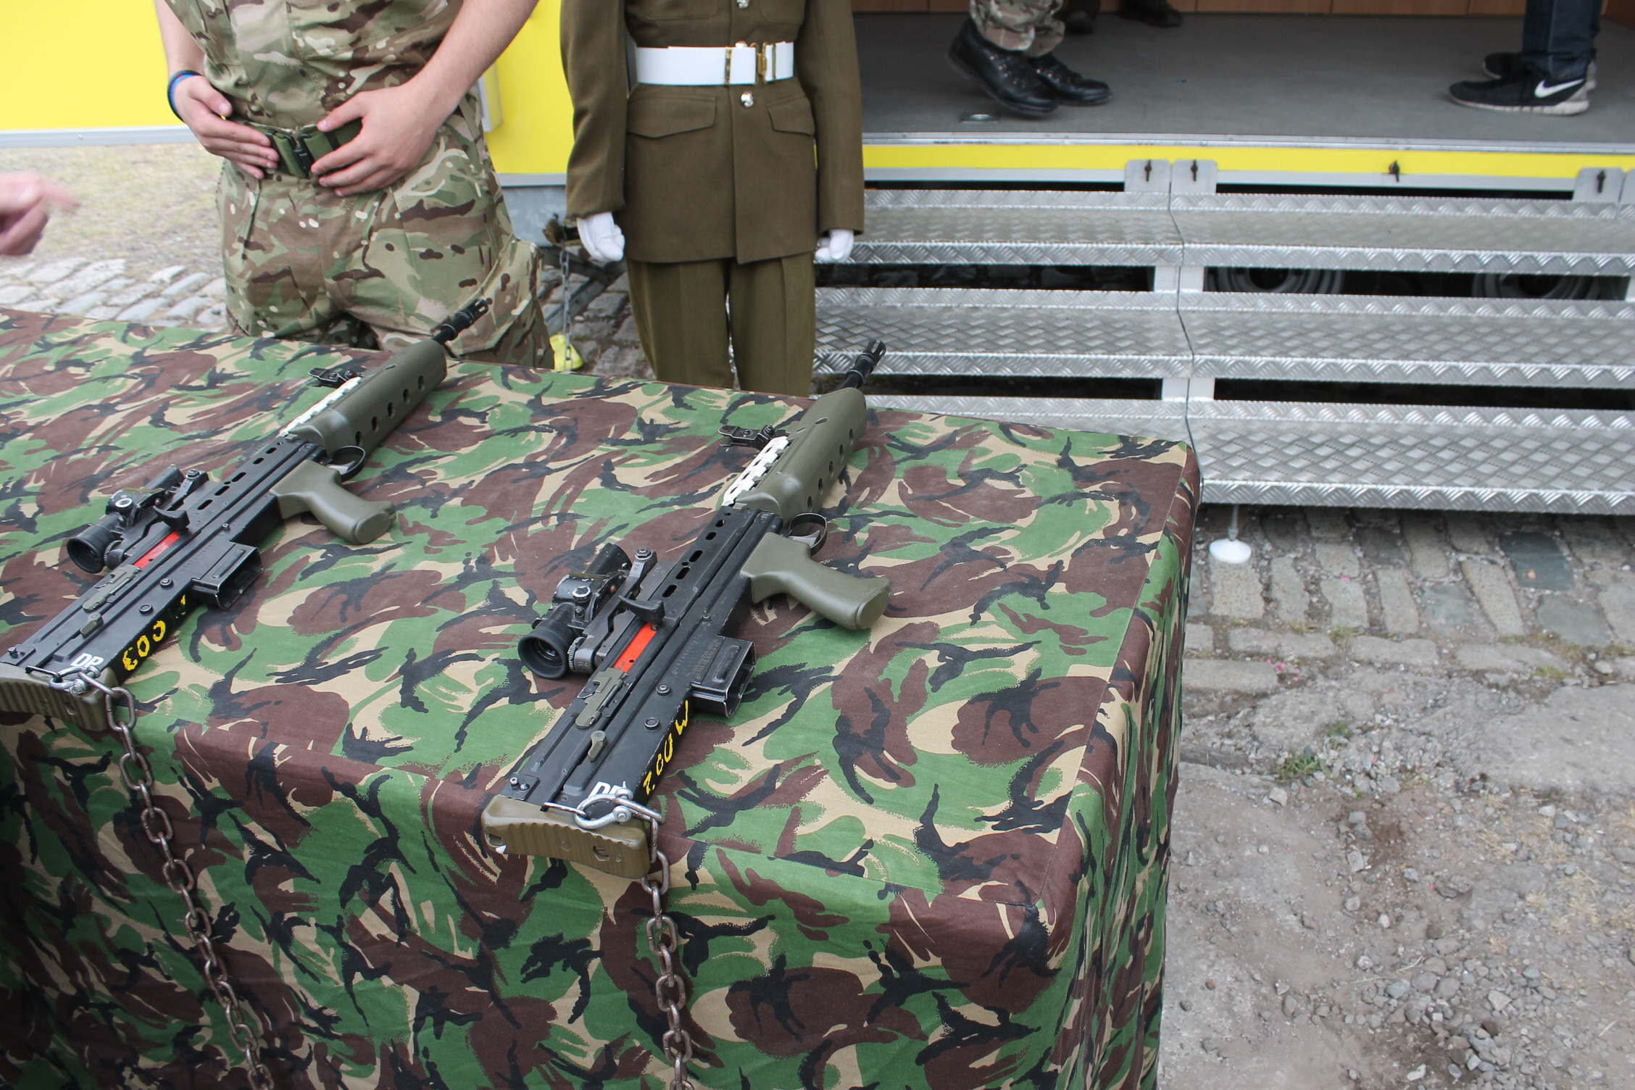
Figure 8. “Portals” to liminal experience: weapons, shoes and military bodies

Through handling these weapons, regular “show-goers” were seemingly invited via fetishism and function to experience something divisible from themselves, situated between immediate civilian life and abstract military logics. For example, when I held these weapons I was reminded of the responsibility that comes with carrying, firing, cleaning, storing and maintaining such military technologies. They became portals to liminal experience infused with burden and functionality; my memories of them being things to be interacted with through a great deal of repetition, automation and caution (see Hockey 1986; 2002), not fascination and pleasure.
But, as Thomassen (2014, 7) makes clear, and as demonstrated by this example, ‘[l]iminality explains nothing. Liminality is. It happens. It takes place. And human beings react to liminal experiences in different ways’. Illuminated instead by these portals was an unevenness between that distinguishable as civilian and military (Howell 2018). Through interaction with these artefacts made accessible via an “everyday” public event, for me their intended materiality became portals connecting my military past and civilian present. Although unnoticeable and inaccessible to those stood around me, handling the SA80 temporally and sensorially invoked “everyday” experiences of being liminal as a virtue of military service. Past experiences contextualised through touching these displaced artefacts which I had only ever handled in their associated martial contexts (e.g. on firing ranges, patrols, or overseas posting).
The second portal is illustrated by the bodies on display in Figure 8. The training shoes in the far upper corner of the image were similar to those I wore while stood in front of the desk in the foreground. We existed either side of the liminal space “betwixt and between” our positions (Turner 1967). He perhaps entering “rites of separation” (Van Gennep 1960) from his civilian life, represented by the “bulled” shoes opposite which he may eventually be polishing, standing and marching in; and I, from a vantage point of “post liminal rites”, having progressed through the liminal period of military service and able to see the portals through which the public were unknowingly invited to step through (Van Gennep 1960). As represented by the torsos of the uniformed soldier and mannequin off-centre in the frame, my own body had once been similarly transformed and clothed. In Figure 8, the soldier’s posture is fixed and firm, and the mannequin unnaturally rigid but not unrepresentative of a drilled soldier standing to attention. Perhaps indiscernible from their dispositions I know that the camouflaged human body within Figure 8 once moved spontaneously, as I do again. For now, it is transformed through oppressive and disciplined mechanisation (Hockey 2002) with, as Bourdieu (2000, 141) describes, a new ‘bodily hexis’, those of ‘dispositions, which are meant to be as durable as the indelible inscriptions of tattooing, and the collective principles of vision and division’ (see also Cooper et al 2018). Becoming military in these ways demands automation, obedience and uniformity of the body as a corporeal marker of having been transformed into a “good machine” (MacLeish 2015). So too I recognise these bodies, like my own, would eventually experience “rites of exit” (Van Gennep 1960). Transported back through the portals from which they entered the military, only to be faced with a further “liminal period” to encounter and negotiate as they are one day forced to (re)discover their new frames of reference within unfamiliar civilian lives (Herman and Yarwood 2014).

Thresholds
During the final day of AFD 2017 I explored an extended part of the “Navy Village” aboard the Royal Navy’s HMS Iron Duke (Figure 9). This experience was different to the unfolding liminal transitions and emergent portals that availed themselves through other events and activities. From my notes, I observe,
The only time that I have felt under observation and conscious of being in the presence of a functioning / active military is when boarding the HMS Iron Duke. Prior to boarding, the security threat level was advertised next to a marquee where my bag was searched. A notice also stated that ID cards must be worn at all times, although none were issued so this presumably only pertained to military personnel (Fieldnotes, 25th June 2017).
From experience of serving and living on several military bases in the UK and elsewhere, I recognise these as indicators of a threshold into the liminal space of military realms. Within Figure 9, the two poles connected to blue ribbon flanking the queuing “show goers” became the subtle entry point into a Ministry of Defence (MoD) establishment. This may have gone unnoticed to me had it not been for the white sandwich-board visible in the bottom left of the image. The opposite side of this board facing “show goers” indicated what was known during my service as the BIKINI alert state; a colour coded indicator of threat levels advertised at the entry to any given MoD installation. Crossing this “threshold” meant “show-goers” became exposed to less intrusive checks and regulation than one would receive entering a military base. But having one’s bag searched by a member of the Royal Navy - sat behind a desk under the marquee out of shot to the left of the image - meant we were undergoing “threshold rites” (Van Gennep 1960, 11, 21); countervailing the liminal military landscape of AFD sprawled across the waterfront, but continuous whilst on board HMS Iron Duke.
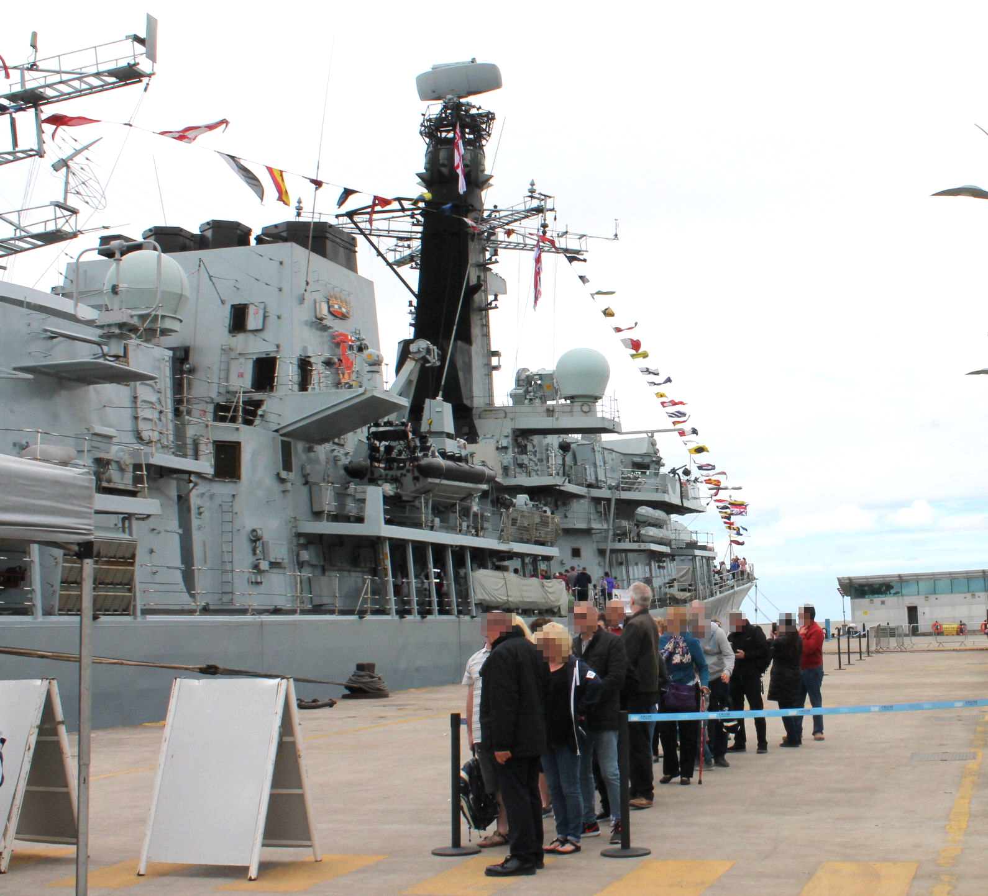
Figure 9. Crossing a liminal “threshold”: queuing for entry aboard HMS Iron Duke

Having crossed the threshold and travelled the ramp into this liminal military space, my movement and agency aboard HMS Iron Duke were intentionally made restricted, and my presence as an outsider within this environment made apparent. As I continue in my fieldnotes,
Upon boarding, a notice that armed sentries would be guarding the ship at all times was advertised, made real by a young sailor with an SA80 slung around his body at the entrance to the ship. He is the first person to be seen once boarding, indicating a change of context and interaction with the military. What this means is that I am now entering military property and no longer interacting and moving freely within civic space, as per the rest of AFD. This is made more noticeable by only being able to walk around the perimeter of the ship and enter one part of its interior to its rear, wherein display tables presented medical supplies and crockery, and weapon systems were arranged on the floor (Fieldnotes, 25th June 2017).
Shepherding our movement around the perimeter of the ship created what Rech (2015) details as “enclavic spatiality” (seen also in Figure 3 and 6). Evident on board HMS Iron Duke, “enclavic spaces” such as this are noted to be securitised and regulated locations, either made accessible or prohibited, public or private, intentionally separating ‘the spaces of display from spaces of spectatorship’ (Rech 2015, 540). Although a much less bounded public event than an airshow, HMS Iron Duke (Figure 9) or proximity to other functioning weapons technologies (Figure 3) became ‘patterned by boundaries allowing and/or blocking access for the purpose of secrecy, security and safety’ (Rech 2015, 538). Having experienced this “enclavic space”, I note,
Changing the physical context has changed the ways in which I felt in relation to the military, and it had also changed some of their interaction with the public. The sentries did not seem approachable and I felt less welcome than in civic space. This does make evident that the realities of the military environment are quite different than what is being presented to the public off board the HMS Iron Duke. One can only know the military once under its literal and discursive practices and values it seems (Fieldnotes, 25th June 2017).
Situated amid otherwise civic spaces, my interactions as a “show-goer” at AFD 2017 therefore caused me to perceive a heavy military presence in Liverpool as “matter out of place” (Douglas 1966). Beyond enabling “betwixt and betweenness”, experiencing liminal transitions, portals and thresholds during AFD 2017 disrupted the patterning and classification of what I considered civic and military. But this does not necessarily mean the military presence seen within Figures 2-9 were “out of place”. Instead, the situatedness of military vehicles, personnel and weapons during AFD 2017 perhaps instead mediated Liverpool’s “martial politics” for onlookers, to be seen, not seen or obscured from sight and seeing (Howell 2018).

8. Conclusion: studying military landscape as critical military studies
This article has demonstrated methodological and conceptual advances to researching military occupied spaces for the canons of both critical military geography and critical military studies. Key to the underlying significance presented by this research are the autoethnographic and visual approaches taken to study aspects of the military estate via AFD, undertaken without being compelled to formally engage with the institutionalised constraints of the military, thereby liberating what could be researched, how, where, when and by whom (Jenkings et al 2011).
However, borrowing from the conclusions of Lohman and Fuhriman (2019, 22), ‘for critical military geography, processes that unfold in one location may or may not be directly replicated in a different geographic context’. This means that although transitions to and from military realms may have some commonalities, observing them as liminal experiences made evident through the military occupation of space and place does not necessarily make them relatable to other similar experiences or contexts. And, akin to Murakami’s (2014) own reflections, although the autoethnographic observations recounted during this discussion are authentic accounts of being “betwixt and between” (Turner 1967), it does not make them universally translatable phenomena in the ways Van Gennep (1960) had expressed of ritual processes. They amount to ‘one particular discourse … instead of a thorough empirical description’ constituted by polyvocal accounts of similar experiences (Murakami 2014: 351). To this end, each AFD is not inevitably ritualistic nor experienced similarly by others in different locations or at different times. Instead, the ‘bodily, personal and everyday experiences’ documented here are intended to disrupt “common sense” and ‘create ruptures and dissonances that make us think anew’ about everyday military influences at events such as AFD (Åhäll 2016: 158-159). Following McConnell (2017), at its most effective then liminality has been used in this article for its ambivalent quality, as a means of unsettling representation, activity and experience at a national militarily orientated event ‘which is situated amidst the people and places militarism affects’ (Rech 2014, 244).
But this is not to underplay the contribution this research makes to the advancement of studying military landscape. As Rech et al (2015) point out, the foregrounding of how contemporary ways of studying militaries and militarism are undertaken (via representation, mapping across landscape, and operating from the individual to the geopolitical as illustrated by the findings of this research) dovetail with many espoused features of critical military studies that help inform its further contemporary development (see Basham et al 2015). Throughout Rech’s work on military recruitment and airshows it is frequently noted how understudied such research within critical human geography has been to-date, advocating for it to be expanded by more nuanced approaches operating under the rubric of critical military studies (Rech 2014b; Rech et al 2015). Understood in concert with Woodward’s (2004) notion of “military landscapes”, this article has taken seriously Rech’s advocacy through a thoughtful engagement with innovative methods, and development of nuanced theoretical insights, ‘that makes the familiar strange and investigates the self-evident’ (Back 2007, 166). The significance of the contributions made by this article to critical military geography and critical military studies are therefore threefold.
First, Rech (2014b, 251) points out that ‘a critical approach to recruitment and militarism should, rather, emphasise the specific effects of military promotion and a “becoming military” for individuals.’ This is important to keep foregrounded. To remain aware that in many – if not all – facets of militarily orientated events such as airshows or AFD, publics are always, in one way or another, invited to engage in the practices and value systems of military realms “at scale” (Woodward 2004; 2005), and as normative encounters with everyday militarism both mundane (Tidy 2015) and exceptional (Enloe 2000). Second, seeking to adopt approaches to militarily orientated events that embrace the experiences of such, means engaging with messy embodied and sensate interactions with people, places and artefacts; an approach commensurate with critical military studies requiring observational, seeing and aural techniques recorded via (auto)ethnographic and visual practices (Rech 2015). This article has taken its lead from such methodological instruction and provides some necessary advancement to studying events such as AFD empirically and critically. Finally, Rech (2019, 2) points out that the ‘experiential aspects’ of contemporary military recruitment campaigns ‘might also be seen at a range of the UK’s military-themed events like airshows, or at increasingly common civic occasions like Armed Forces Day’. Thereby illustrating the relevance of redirecting some of the conceptual and methodological ideas from fieldwork undertaken in critical human geography to research other military-centric events as sites of critical military studies scholarship. Such existing ideas have been offered further nuance and insight throughout this article via a novel theoretical approach to studying military landscape as liminal spaces.
On this concluding point, following Basham and Bulmer (2017), Rech (2019, 19) suggests that a critical military studies approach should be one that is avoidant of making hackneyed (re)observations of the already observed, and be instead ‘one that embraces the possibility for new, surprising or alternative uses of/for things, and so for novel readings of the stories of militarised peoples, places and identities.’ Indeed, throughout this article extant work from critical military geography has intentionally been advanced to make evident such possibilities via observations of liminality upon and through military landscape such as AFD. This article hopes to have further extended Woodward’s (2005) clarion call for studying critically the everydayness of military geographies, and for more substantive attention to paid to liminal military landscapes.

Acknowledgements
Removed

References
Åhäll, L. 2019. “Feeling Everyday IR: Embodied, affective, militarising movement as choreography of war.” Cooperation and Conflict 54(2) 149–166.
Åhäll, L. 2016. “The dance of militarisation: a feminist security studies take on ‘the political’”. Critical Studies on Security, 4(2): 154-168.
Anderson, L. 2006. “Analytic Autoethnography.” Journal of Contemporary Ethnography 35(4): 373-395.
Andrews, H. and Roberts, L. 2012. “Introduction: Re-Mapping Liminality.” In Liminal Landscapes: Travel, Experience and Spaces In-Between, edited by H. Andrews. and L. Roberts. Routledge: Oxon.
Armed Forces Day. n.d.a. About?, available from: https://www.armedforcesday.org.uk/about/
Armed Forces Day. n.d.b. Brand Guide, available from: https://www.armedforcesday.org.uk/wp-content/uploads/2020/06/DDC-20-006_AFW_2020_Brand_Guide.pdf
Armed Forces Day. n.d.c. Official Imagery, available from:
https://www.armedforcesday.org.uk/get-involved/events-toolkits-resources/official-imagery/
Back, L. 2007. The Art of Listening. London: Bloomsbury Publishing Plc.
Baker, C., Basham, V., Bulmer, S., Gray, H. and Hyde, A. 2016. “Encounters with the military: Toward a feminist ethics of critique?” International Feminist Journal of Politics, 18(1): 140-154.
Basham, V.M., Belkin, A., and Gifkins, J. 2015. “What is Critical Military Studies?” Critical Military Studies, 1 (1): 1-2.
Basham, V.M. and Bulmer, S. 2017. Critical Military Studies as Method: an Approach to Studying Gender and the Military.” In The Palgrave International Handbook of Gender and the Military, edited by R. Woodward and C. Duncanson. Palgrave Macmillan: Basingstoke.
Basham, V.M. 2018. “Liberal militarism as insecurity, desire and ambivalence: Gender, race and the everyday geopolitics of war.” Security Dialogue, 49(1-2): 32-43.
Bernazolli, R.N. and Flint, C. 2009. “Power, place and militarism: towards a comparative geographic analysis of militarization.” Geography Compass, 3(1): 393-411.
Bourdieu, P. 2000. Pascalian Mediations. Oxford: Blackwell Publishers Ltd.
Carré, P. 2019. “Naming of Parts: Observations of Institutional Socialization in the First Week of British Army Phase 1 Training.” Journal of Contemporary Ethnography, 48 (3): 377-401.
Cobseo. 2017. Cobseo: The Confederation of Service Charities - Regulations, available from: https://www.cobseo.org.uk/assets/files/2018/09/Cobseo-Regulations-2017-final.pdf
Cooper, L., Caddick, N., Godier, L., Cooper, A. and Fossey, M. 2018. “Transition from the military into civilian life: An exploration of cultural competence.” Armed Forces & Society, 44 (1): 156-177.
Culture Liverpool. 2017. ““Dedicated to developing technology that keeps our armed forces safe” @BAESystemsplc sponsors @ArmedForcesDay 2017 #SaluteOurForces” Twitter, available from: https://twitter.com/CultureLPool/status/876484854870929408/photo/1?ref_src=twsrc%5Etfw&ref_url=https%3A%2F%2Fwww.forceswatch.net%2Fblog%2Flets-give-peace-a-chance-on-armed-forces-day
Danilova, N. 2015. The Politics of War Commemoration in the UK and Russia. Basingstoke: Palgrave MacMillan.
Davies, Q., Clark, B., and Sharp, M. 2008. Report of Inquiry into National Recognition of ‘our’ Armed Forces, available from: http://data.parliament.uk/DepositedPapers/Files/DEP2008-1296/DEP2008-1296.pdf
Dixon, P. 2018. Warrior Nation: War, Militarisation and British Democracy. London: ForcesWatch.
Douglas, M. 1966/2002. Purity and Danger: an Analysis of Concept of Pollution and Taboo. Oxon: Routledge.
Emerson, R. M., Fretz, R. I. and Shaw, L. L. 2007. “Participant Observation and Fieldnotes.” In Handbook of Ethnography, edited by P. Atkinson., A. Coffey., S. Delamont., J. Loftland and L. Loftland. Sage: London.
Enloe, C. 2000. Maneuvers: The International Politics of Militarizing Women’s Lives. California: University of California Press.
Galgano, F.A. and Palka, E.J. 2011. Modern Military Geography, edited by Galgano, F.A. and Palka, E.J. Oxon: Routledge.
Gee, D. 2014. Spectacle, Reality, Resistance: Confronting a Culture of Militarism. London: ForcesWatch.
Heng, T. 2016. Visual Methods in the Field: Photography for the Social Sciences. Oxon: Routledge.
Henry, M. and Natanel, K. 2016. “Military as diffusion: the politics of gender, space and the everyday.” Gender, Place & Culture: a Journal of Feminist Geography, 23(6): 850-856.
Herman, A. and Yarwood, R. 2014. “From services to civilian: The geographies of veterans’ post-military lives.” Geoforum, 53: 41-50.
Higate, P. and Cameron, A. 2006. “Reflexivity and Researching the Military.” Armed Forces & Society, 32 (2): 219-233.
Ho, E.L.E. and McConnell, F. 2019. “Conceptualizing “diaspora diplomacy”: territory and populations betwixt the domestic and foreign.” Progress in Human Geography, 43(2): 235-255.
Hockey, J. 2002. “‘Head down, Bergen on, mind in neutral’: the infantry body.” Journal of Political and Military Sociology, 30 (1) (Summer): 148-171.
Hockey, J. 1986. Squaddies: Portrait of a Subculture. Exeter: Exeter University Press.
Home Office. 2019, 23 July. “Threat level system updated to include all forms of terrorism”, available from: https://www.gov.uk/government/news/threat-level-system-updated-to-include-all-forms-of-terrorism
Howell, A. 2018. “Forget ‘militarisation’: race, disability and the ‘martial politics’ of the police and the university.” International Feminist Journal of Politics, 20(2): 117-136.
Jackman, A.H. 1962. “The Nature of Military Geography.” The Professional Geographer, 14 (1): 7-12.
Jenkings, K.N., Woodward, R., Williams, A.J., Rech, M.F., Murphy, A.L. and Bos, D. 2011. “Military occupations: methodological approaches and the military-academy research nexus.” Sociology Compass, 5 (1): 37-51.
Liverpool City Council. 2018. Freedom of Information Request 603691. Liverpool: Liverpool City Council Information Team.
Lohman, A.D. and Fuhriman, C. 2019. “Approaches to researching and teaching military geography.” In A Research Agenda for Military Geographies, edited by R. Woodward. Edward Elgar Publishing: Cheltenham.
McConnell, F. 2019. “Rethinking the geographies of diplomacy. Diplomatica, 1: 46-55.
McConnell, F. 2017. “Liminal geopolitics: the subjectivity and spatiality of diplomacy at the margins.” Transactions, 42: 139-152.
McConnell, F. and Dittmer, J. 2018. “Liminality and the diplomacy of the British Overseas Territories: an assemblage approach.” Environment and Planning D: Society and Space, 36(1): 139-158.
McGarry, R. 2019. “Repurposing Liverpool’s Waterfront as a Liminal ‘Military Landscape’: a Photographic Essay.” Visual Ethnography. Special Edition: Visualising the City, 8 (1): 71-82.
McGarry, R. 2017. “Demystifying the ‘Victimised State’: a Civil-Military Crisis in Waiting?” Illness, Crisis and Loss: Special Issue, 25 (1): 63-84.
McGarry, R. 2016. “Conducting ‘Community Orientated’ Military Research.” In The Routledge Companion to Military Research Methods, edited by A.J. Williams, R. Woodward, K.N. Jenkings and M. Rech. Abingdon: Routledge.
McGarry, R., Walklate, S. and Mythen, G. 2015. “A Sociological Analysis of Military Resilience: Opening Up the Debate.” Armed Forces and Society, 41(2): 352-378.
MacLeish, K. 2015. “The ethnography of good machines.” Critical Military Studies, 1 (1): 11–22.
Ministry of Defence. 2008. The Government’s Response to the Report of Inquiry into National Recognition of Our Armed Forces, available from: https://assets.publishing.service.gov.uk/government/uploads/system/uploads/attachment_data/file/28287/govt_response_recognition_armed_forces.pdf
Murakami, K. 2014. “Commemoration reconsidered: Second World War veterans’ reunion as pilgrimage.” Memory Studies, 7 (3): 339-353.
Murphy, J. and McDowell, S. 2019. “Transitional optics: Exploring liminal spaces after conflict.” Urban Studies, 56 (12): 2499-2514.
Murrani, S. 2016. “Baghdad’s thirdspace: Between liminality, anti-structures and territorial mappings.” Cultural Dynamics, 28 (2): 189-210.
Olusoga, D. 2017. Black and British: a Forgotten History. Pan Books: London
Palmer, R.W. 2017. “Twenty-First Century Celebrations of the British Armed Forces: The Rise of the Biopolitical Military Professional.” Unpublished PhD Thesis, University of Manchester.
Rech, M.F. 2019. “Ephemera(l) Geopolitics: The Material Cultures of British Military Recruitment.” Geopolitics, doi:10.1080/14650045.2019.1570920
Rech, M.F. 2016. “Children, Young People and the Everyday Geopolitics of British Military Recruitment.” In Children, Young People and Critical Geopolitics, ed. P. Hopkins and M. Benwell, 45–60. Oxon: Routledge.
Rech, M.F. 2015. “A Critical Geopolitics of Observant Practice at British Military Airshows.” Transactions of the Institute of British Geographers 15 (4): 536-548.
Rech, M.F 2014a. “Be Part of the Story: A Popular Geopolitics of War Comic Aesthetics and Royal Air Force Recruitment.” Political Geography, 39: 36-47.
Rech, M.F 2014b. “Recruitment, Counter-Recruitment and Critical Military Studies.” Global Discourses, 4 (2-3): 244-262.
Rech, M.F., Bos, D., Jenkings, K.N., Williams, A. and Woodward, R. 2015. “Geography, Military Geography, and Critical Military Studies.” Critical Military Studies, 1 (1): 47-60.
Rech, M.F. and Williams, A.J. 2016. “Researching the Military at Airshows: a Dialogue About Ethnography and Autoethnography.” In The Routledge Companion to Military Research Methods, edited by A.J. Williams, R. Woodward, K.N. Jenkings and M. Rech. Abingdon: Routledge.
Rech, M.F. and Yarwood, R. 2019. “Exploring post-military geographies: Plymouth and the spatialities of Armed Forces Day.” In A Research Agenda for Military Geographies, edited by R. Woodward. Edward Elgar Publishing: Cheltenham.
Rieger, J.H. 2011. “Rephotography for documenting social change 1.” In The SAGE Handbook of Visual Research Methods, edited by E. Margolis and L. Pauwels. London: Sage.
Rose, G. 2008. “Using Photographs and Illustrations in Human Geography.” Journal of Geography in Higher Education, 31 (1): 151-160.
Royal Navy Press Office. 2017. Advice to veterans attending Armed Forces Day Liverpool 2017, available from: https://www.armedforcesday.org.uk/wp-content/uploads/2017/05/AFD-National-Event-Guidance-for-Veterans-2.pdf
Sangster, E. 2017. “Militarism the whole family can enjoy.” Morning Star, available from: https://morningstaronline.co.uk/a-ebd5-militarism-the-whole-family-can-enjoy-1
Sangster, E. 2014. “The creep of militarism into our civil institutions.” openDemocracy, available from: https://www.opendemocracy.net/en/opendemocracyuk/creep-of-militarism-into-our-civil-institutions/
Suchar, C.S. 1997. “Grounding Visual Sociology Research in Shooting Scripts.” Qualitative Sociology, 20 (1): 33-55.
Taber, N. 2010. “Institutional ethnography, autoethnography, and narrative: an argument for incorporating multiple methodologies.” Qualitative Research, 10 (1): 5-25.
Thomassen, B. 2014. Liminality and the Modern: Living Through the In-Between. Ashgate Publishing Ltd: Farnham.
Thomassen, B. 2012. “Revisiting Liminality: the Danger of Empty Spaces.” In Liminal Landscapes: Travel, Experience and Spaces In-Between, edited by H. Andrews. and L. Roberts. Routledge: Oxon.
Tibbles, A. 2018. Liverpool and the Slave Trade. Liverpool: Liverpool University Press.
Tidy, J. 2015. “Forces sauces and eggs for soldiers: food, nostalgia, and the rehabilitation of the British military.” Critical Military Studies, 1(3): 220-232.
Turner, V.W. 1969. The Ritual Process. Routledge & Keegan Paul: London.
Van Gennep, A. 1960. The Rites of Passage. Chicago University Press: Chicago.
Ware, V. 2014. “Militarising Communities: the Armed Forces Community Covenant.” Red Pepper, available from: https://www.redpepper.org.uk/militarising-communities-the-armed-forces-community-covenant/
Woodward, R. 2019. “Introduction: A Research Agenda for Military Geography.” In A Research Agenda for Military Geographies, edited by R. Woodward. Edward Elgar Publishing: Cheltenham.
Woodward, R. 2017. “Military Geography.” In The International Encyclopedia of Geography, edited by D. Richardson., N. Castree., M.F. Goodchild., A. Kobayashi., W. Liu., and R.A. Marston. New Jersey, USA: John Wiley & Sons Ltd.
Woodward, R. 2016. “Researching Military Geographies.” In Researching the Military, edited by H. Carreiras., C Castro., and S. Frederic. Oxon: Routledge.
Woodward, R. 2014. “Military Landscapes: Agendas and Approaches for Future Research.” Progress in Human Geography, 38 (1): 40-61.
Woodward, R. 2005. “From Military Geography to Militarism’s Geographies: Disciplinary Engagements with the Geographies of Militarism and Military Activities.” Progress in Human Geography, 29 (6): 718-740.
Woodward, R. 2004. Military Geographies. Blackwell Publishing Ltd: Oxford.

Figure 1. AFD “ephemera”: photocopied and annotated keepsake map of AFD 2017
Figure 2. “Ephemeral” engagement with military artefacts: Royal Marines display table
Figure 3. “Visual cultures of militarism”: Apache helicopter, ammunition and missiles
Figure 4. The “dance of militarisation”: St George’s Hall and St George’s Plateau
Figure 5. “Post military city”: marching military parade through the high-street
Figure 6. An unfolding “transition”: outside the Liverpool Liver Building
Figure 7. A “transition” unfolded: recruitment prop at the “RAF Village”
Figure 8. “Portals” to liminal experience: weapons, shoes and military bodies
Figure 9. Crossing a liminal “threshold”: queuing for entry aboard HMS Iron Duke

Note

These spaces included Liverpool City centre, Princes Promenade, various locations along the waterfront, Pier Head Cruise Liner terminal carpark, and Princess Dock (see Royal Navy Press Office 2017).
See also the subsequent Ministry of Defence (2008) response to this report.
Or “states” as preferred by Turner (1969).
Turner (1967, 92) clarifies “a state” to be a ‘relatively fixed condition’ meaning many things, including changes in one’s maturity, mental health, or even profession and social status.
The approximate cost of organising AFD 2017 in Liverpool was £226,000. The collective income from MoD funding and sponsorship from Cammell Laird, Peel, The Royal British Legion, BAE Systems and Vodafone totalled approximately £164,000. The total cost to Liverpool City Council was approximately £64,000 (Liverpool City Council 2018).
A Mastiff, see here: https://www.army.mod.uk/equipment/protected-patrol-vehicles/
This has since been replaced by “UK Threat Levels” to indicate the current threat posed to the UK from terrorism (see Home Office 2019).

