Graphical Review
The role of myoglobin in the evolution of mammalian diving capacity - The August Krogh principle applied in molecular and evolutionary physiology

Author: Michael Berenbrink

Address: Department of Evolution, Ecology, and Behaviour, Biosciences Building, Crown Street, University of Liverpool, Liverpool, L69 7ZB, United Kingdom

Email for correspondence: Michael.Berenbrink@liverpool.ac.uk

Highlights:
- The role of myoglobin as an oxygen store in mammalian divers is reviewed
- A molecular signature of myoglobin tracks mammalian dive capacity evolution
- Myoglobin evolution is a paradigm for species adaptation in proteins
- The August Krogh principle is extended from use for organisms to include proteins

Abstract
After the Devonian tetrapod land invasion, groups of terrestrial air-breathing and endothermic mammals repeatedly went back to live in the sea, relying on air intake at the surface for extended breath-hold dives to forage underwater, often at great depths and even in the coldest oceans. Studies on the physiological mechanisms behind prolonged breath-hold diving have a long history, including August Krogh’s estimates of the maximal dive duration of the blue whale. Yet the molecular underpinnings of such extreme physiological adaptations are only beginning to be understood. The present review focuses on the molecular properties of the respiratory protein myoglobin that has repeatedly evolved an elevated net positive surface charge in several distantly related groups of diving mammals. This has enabled substantial increases of maximal myoglobin concentration in muscle cells, and hence muscle oxygen storage capacity and maximal dive duration. Using myoglobin net surface charge as a marker has allowed unprecedented insights into the evolution of mammal diving capacity and into the general mechanisms of adaptive protein evolution. From these findings it is argued, in an extension of the August Krogh principle, that for a large number of problems in molecular and evolutionary physiology there will be some protein of choice, or a few such proteins, on which it can be most conveniently studied.

Key words: Oxygen, respiration, haemoglobin, adaptation, protein, cetaceans

Oxygen availability and demand in aquatic and terrestrial vertebrates
The call for molecular oxygen (O₂) and the greatly different access to it in animals in different environments are to this day central themes in comparative physiology and biochemistry as already outlined in the classic 1941 monograph of Nobel laureate August Krogh entitled ‘The comparative physiology of respiratory mechanisms’ that is publicly available as digitised reprint (Krogh, 1959)]. This is perhaps nowhere more clearly demonstrated as in the multiple past and ongoing evolutionary transitions of vertebrates between aquatic and terrestrial environments, including the recurring evolution of amphibious lifestyles in fishes (Wright & Turko, 2016) and multiple independent returns of reptiles, birds and mammals to an aquatic lifestyle (Kelley & Pyenson, 2014). Dry air at sea level contains 209.48 mL L⁻¹ O₂ at standard conditions of 0°C and 1 atmosphere of pressure (STPD), as determined with characteristic precision by Krogh already in 1919, and this value is less than halved at the reduced atmospheric pressure at an altitude as high as 5 000 m. In contrast, air-equilibrated seawater at 20°C contains 5.31 mL L⁻¹ O₂ (STPD), or just a 40th of the value in surface air (Krogh, 1941). The factorial difference between O₂ levels in air and seawater would have been similar during changes in the Earth’s atmospheric O₂ levels over geological time (Schachat et al., 2018), such that when early tetrapods in the Devonian took the much celebrated first steps to life on land (Clack, 2007), they began to evolve in a ‘sea of O₂’ instead (Donald, 1964; Figure 1). Hence, the independent evolution in birds and mammals of elevated metabolic rates, endothermy, and highly active live styles with powered flight or sustained high-speed running, have arguably been facilitated by the greater access to O₂ in air. The safety margin for such lifestyles is, however, surprisingly small (Stirt & Sullivan, 1981) as for example human on-board O₂ stores are sufficient to sustain basal metabolic rate only for about 2 min when access to O₂ is impaired and neuronal structures start to become impaired by a lack of O₂ already after a few seconds (Rahn, 1964).
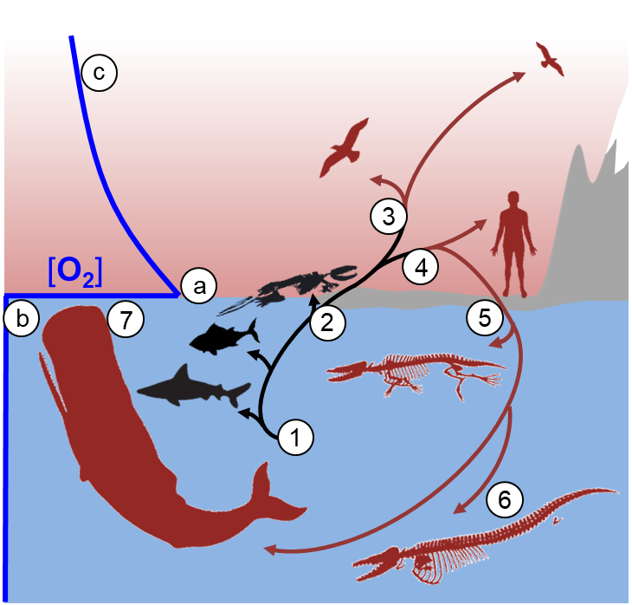
Figure 1: O₂ availability in air and water and consequences for major steps in vertebrate evolution. The O₂ concentration of dry air at sea level (a) is up to 40 times higher than in full-strength seawater at 20°C (b) and declines by less than 50% even at altitudes of 5 000 m (c). Vertebrates initially evolved and radiated in a low O₂ environment in the ocean (1), giving rise to living groups such as sharks and teleost fishes. The evolutionary step onto land of early tetrapods (2) led to the immersion into a sea of O₂ instead and enabled the independent evolution of high aerobic metabolic rates, active lifestyles, and endothermy in birds and mammals (3, 4; dark red lineages and silhouettes). Secondary land-to-water transitions of high metabolic-rate tetrapods, such as early cetaceans (5), were followed by anatomical adaptations for energy-efficient aquatic locomotion such as increased streamlining and body size, and limb modifications (6, 7), but they always remained dependent on intermittent surfacing and O₂ uptake from air like today’s sperm whales (7).
It thus seems extraordinary that more than 30 different lineages of terrestrial tetrapods since the Devonian went back to live in the sea (Kelley & Pyenson, 2015) with some of them having evolved the ability to hold their breath and actively forage in the depths of cold oceans for more than an hour and sometimes even two hours at a time (Schorr et al., 2014). Much has been learned in the decades since Krogh’s (1941) monograph about the often extraordinary diving capacities of marine mammals and some of the underlying physiological mechanisms (comprehensively reviewed by Ponganis, 2015), yet the molecular genetic underpinnings and the evolution of extreme diving capacity in mammals are only beginning to be understood (McGowen et al. 2014). This review highlights the use of the sequence-derived net surface charge of the O₂-binding protein myoglobin as a molecular marker that provides insights into the evolution of diving capacity in all major lineages of mammalian divers and serves as a paradigm for the convergent evolution of mechanisms of physiological adaptation to intermittent O₂ supply in mammals (Mirceta et al., 2013; McGowen et al. 2014; Kelley & Pyenson, 2014). This is used to make the case for extending the application of the August Krogh principle (Textbox 1) from animals also to proteins such as haemoglobin and myoglobin.

Textbox 1: The August Krogh Principle (Krebs, 1975)
"For a large number of problems there will be some animal of choice, or a few such animals, on which it can be most conveniently studied” (Krogh, 1929)

Predicting Mammalian Diving Capacity
Body mass is perhaps the single best predictor of comparative mammalian diving capacity, because it affects both the size of the total on-board body O₂ store and the rate at which it is used (Figure 2) as already realised by August Krogh (1934) when he estimated the dive duration of the blue whale. This has since been expanded to include also avian, ectotherm vertebrate, and even invertebrate divers (Verberk et al., 2020).
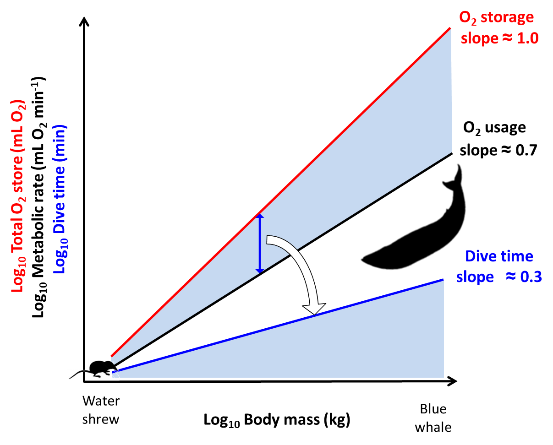
Figure 2: Predicted scaling of maximum dive duration with body mass in mammals ranging from water shrew to blue whale. On a double logarithmic plot, the total body O₂ store of mammals tends to increase in direct proportion to body mass (slope close to unity, red line), while metabolic rate increases less steeply, commonly with a slope between 0.67 and 0.75 (O₂ usage, black line). At a given body mass, dividing the available O₂ store by the rate at which it is consumed gives the time after which it is predicted to be depleted and the animal needs to surface to avoid use of energetically less efficient anaerobic pathways of energy metabolism. This is a form of calculated aerobic dive limit (Kooyman et al., 2020; this issue). On logarithmic axes, this predicted dive time for a given body mass corresponds to the vertical distance between the O₂ storage and usage lines (blue arrow), whereas the slope of the line relating dive time to body mass (0.3; blue line) is obtained as the difference between the slopes of the O₂ storage and usage lines (0.3; blue line). In this numerical example 10-fold larger mammals have 10-fold larger O₂ stores, but only 5-fold higher metabolic rates, meaning O₂ stores can support dive times twice as long.

Yet using body mass alone as a predictor leaves a lot of the observed variation in maximal active dive times (t_{max}) of mammals unexplained, as indicated by the differences in t_{max} between approximately similar-sized moose, polar bear, dugong, and female elephant seal (Figure 3A).
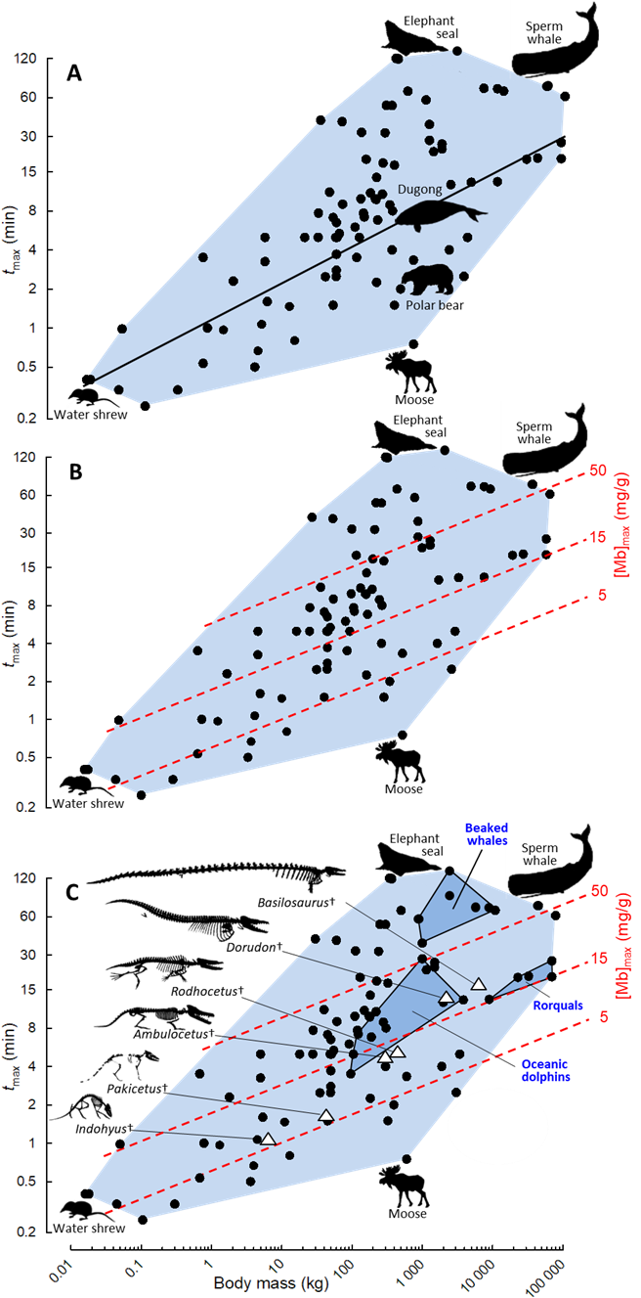
Figure 3: Diving capacity in living and extinct mammalian divers. Observed maximal active dive time (t_{max}) and body mass in living species (black circles) and as predicted based on body mass alone (A, black line), based on body mass and maximal muscle myoglobin concentrations ([Mb]_{max}; B, series of red dashed lines), and based on reconstructed fossil body mass and [Mb]_{max} values estimated by ancestral reconstructions of myoglobin net surface charge (C, open triangles). Silhouettes indicate selected living mammalian divers while skeletons indicate fossil species resembling consecutive stages (left to right) during the land-to-water transition of the ancestors of today’s whales. Convex polygons encompass body mass and t_{max} of all diving mammals (light blue area) or selected groups of modern whales (dark blue areas and labels). Modified after Mirceta et al. (2013).

The silhouettes of these mammals in Figure 3A highlight the role of anatomical adaptations such as streamlined body shape and limb modifications that increase the energetic efficiency of underwater locomotion and hence lower diving O₂ usage in the most accomplished mammalian divers. This is also evident in fossils documenting successive stages in the land-to-water transition of early whales (Figure 1; Kelley & Pyenson, 2015) and helps refine reconstructions of the evolution of dive capacity beyond those merely based on reconstructed body mass of fossils. Yet, as a soft tissue characteristic, the evolution of the body O₂ store during mammalian land-to-water transitions is difficult to reconstruct from fossils. Although the volumes of the three major body O₂ storage compartments blood, lung, and muscle tend to scale isometrically with body mass, in living species these compartments show major differences in the degree to which they may be filled with O₂ at the start of a dive or can be depleted of O₂ before the end of a dive, giving rise to large differences in the total size and partitioning of mass-specific O₂ stores in diving mammals (Figure 4). Thus, including the maximally observed concentration of O₂-storing myoglobin in skeletal muscle tissue ([Mb]_{max}) as a second predictor in addition to body mass greatly improves the accuracy of t_{max} estimates (Mirceta et al., 2013; Figure 3B). Inclusion of information on known species differences in the size of blood or lung O₂ stores will likely further improve such predictions, but such data are less frequently available for mammalian divers than [Mb]_{max} (Ponganis, 2015), reducing the number of species available for more complex comparative modelling of maximum dive capacities.
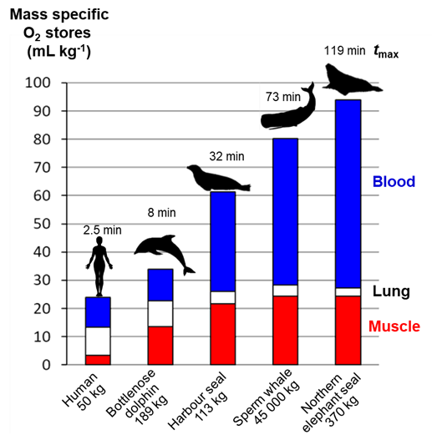
Figure 4: Size and partitioning of mass-specific body O₂ stores in mammalian divers compared to humans (silhouettes). Total mass-specific O₂ stores may be increased by more than threefold in marine mammals, chiefly by increases in blood and muscle O₂, while the contribution of lung O₂ decreases with increasing maximal submergence time (t_{max}). The size of available O₂ stores may differ due to species differences in diving lung air volume and the extent of maximal lung oxygen depletion; the total volumes of arterial and mixed venous blood, their concentration of haemoglobin and its degrees of O₂ saturation at the beginning and end of a dive; finally, the total amount of skeletal muscle, its concentration of myoglobin and degree of O₂ saturation at the beginning and end of a dive. An increased mass-specific muscle O₂ store compared to humans is the most consistent hallmark of proficient diving capacity in this example, because mass-specific lung O₂ stores are similar in humans and bottlenose dolphin. The t_{max} value for humans is based on observations on sea food-gathering female Japanese Ama divers. Adapted from information compiled in Mirceta et al. (2013) and Ponganis (2015).
It is worthwhile to point out here that due to the higher O₂-affinity of myoglobin compared to haemoglobin, the myoglobin O₂ store in blood-perfused muscles could only be effectively utilised after the haemoglobin O₂ store in blood has been significantly and even dangerously depleted. It thus comes as no surprise that high [Mb]_{max} in mammals is in all known cases associated with a strong dive response that includes peripheral vasoconstriction that strongly reduces blood perfusion of locomotory muscles during a dive and preserves the blood O₂ store for other tissues (Ponganis, 2015). Conversely, the Florida manatee, which has a muted dive response, has a low [Mb]_{max} value, based on the pale colour of its muscles, which contrasts again with the related extinct giant Steller’s sea cow, that reportedly had “meat redder than that of any land animal” (Steller, 1751) and may have been the first mammal for which peripheral vasoconstriction upon facial submergence and hence a dive response has been described (Mirceta et al., 2013).

A molecular marker for maximal muscle myoglobin concentration
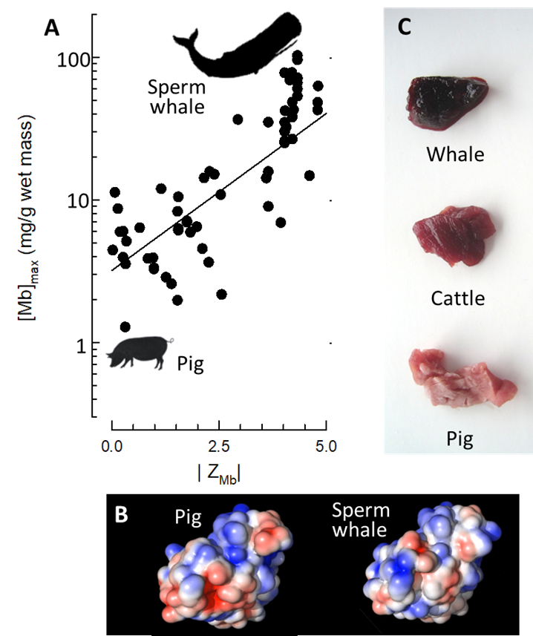
Myoglobin was the first protein whose structure was resolved at the atomic level in Nobel Prize-winning work (Kendrew et al., 1960) and is arguably one of the best characterised of all proteins. In a clear example of the August Krogh principle (Textbox 1) it was myoglobin of the sperm whale that was identified as the most suited protein for these studies, closely followed by seal myoglobin, not least because of the ease with which high quantities of the protein could be extracted from their muscles (Kendrew, 1962). Yet it was only in 2013 that it was demonstrated that the elevated maximum concentrations of myoglobin ([Mb]_{max}) in the muscles of diving mammals were closely matched with an elevated net surface charge of the protein (Z_{Mb}), which could moreover be accurately modelled from its amino acid sequence (Mirceta et al., 2013; Figure 5). The increase in Z_{Mb} may protect against deleterious protein self-aggregation at very high concentrations by charge repulsion and/or increase the folding stability of myoglobin and its precursor apomyoglobin (Mirceta et al., 2013; Isogai et al., 2018). Regardless of the precise molecular nature of the correlation, Z_{Mb} has emerged from these studies as a molecular marker for [Mb]_{max}. This not only provided the opportunity to estimate [Mb]_{max} in species in which it had not been measured just from its myoglobin sequence, but also allowed the application of ancestral sequence reconstruction methods to infer the myoglobin sequences in the ancestors of today’s diving mammals and from that to model Z_{Mb} -and hence estimate [Mb]_{max}- along the ancestral lineages leading to modern diving mammals (Mirceta et al., 2013; Figure 6).
Figure 5: Correlation between maximal myoglobin concentration in mammalian muscle and its net surface charge. A, increases in myoglobin net surface charge (Z_{Mb}) in diving compared to terrestrial mammals are associated with an exponential increase in its maximal concentration in muscle ([Mb]_{max}). B, Z_{Mb} can be determined from the amino acid sequences of species as modelled onto the tertiary structure of the protein and by summing up of the number of positive and negative charges of surface residues (blue and red colours, respectively). C, the greatly increased concentrations of O₂-storing myoglobin in the muscles of whales compared to cattle and pig give them an almost black colour and are thought to be enabled by simultaneous increases in Z_{Mb} that prevent myoglobin aggregation by charge repulsion. Data in A from Mirceta et al. (2013).

Using these estimates of [Mb]_{max} together with reconstructions of fossil body mass in ancestors representing key stages in the land-to-water transitions of diving mammals then allowed to trace the evolutionary increase in t_{max} in the major groups of mammalian divers (Mirceta et al., 2013; Figure 3C).

Species adaptation in protein molecules
The reconstruction of the molecular evolution of myoglobin in more than 100 terrestrial and diving mammals also provided insights into the widespread convergent nature of the adaptation of multiple groups of diving mammals to intermittent access to O₂ (Mirceta et al., 2013). Different lineages of diving mammals, such as whales and seals, accumulated sometimes convergent and sometimes parallel amino acid substitutions at various sites on the protein surface to arrive at similarly elevated Z_{Mb} and hence predicted [Mb]_{max} values (Figure 6). For instance, the patterns of amino acid substitutions suggest that the deep diving sperm whales and beaked whales experienced parallel gains of an extra positively charged histidine to increase Z_{Mb} above the level of all other species of cetaceans, and further that phocid seals and otariid seals experienced additional convergent increases in Z_{Mb} and hence in predicted diving capacity after they last shared a common ancestor (Figure 6A, B).

Directions for future work in this area include testing the limits of the Z_{Mb} signature by modelling the dive capacity of semi-aquatic diving mammals and determining the evolutionary rates at which this signal may evolve. It is also not yet known whether myoglobin in diving birds or reptiles shows similar adaptations, or what the exact molecular nature of the relationship between [Mb]_{max} and Z_{Mb} is. It is also conceivable that an additional protein of choice, e.g. a member of the mitochondrial respiratory electron transport chain, may show signatures related to altered diving O₂ consumption rates in mammalian divers. Such a molecular marker for alterations in diving metabolic rates may further improve the non-invasive prediction of maximal dive capacities from body mass and molecular sequence information alone and allow even more refined ancestral reconstructions of diving capacity. The same approach could conceivably be utilised to assess the diving capacity and hence aspects of the feeding ecology in living divers that are too small (water shrews, star-nosed mole) to be equipped with time depth recorders, or too elusive or rare for such studies like some beaked whale species, river dolphins or otter species.

The results on whales and seals suggest that myoglobin is ideally suited to trace the evolution of mammalian diving capacity, much like haemoglobin seems ideally suited to study the problem of how vertebrates adapt to lowered O₂ concentrations in their respiratory media at the protein level, as suggested by Nobel laureate Max Perutz (1983) in a seminal review entitled ‘Species adaptation in a protein molecule’ (for a comprehensive recent treatise see Storz, 2019). Since then myoglobin experienced a second wave of research interest (Cossins & Berenbrink, 2008) linked to the discovery of wide-spread non-muscle expression and of novel functions involving for example modulation of tissue nitric oxide levels and enabling the hypoxic vasodilatory response even at very low O₂ partial pressures (e.g. Cossins et al., 2009; Helbo et al., 2011; Totzeck et al., 2012). More recently the comparative study of myoglobin and haemoglobin has revealed fundamental insights into the evolution of complex multi-subunit molecular machines (Pillai et al., 2020; Berenbrink 2020). It thus appears justified in the age of molecular and evolutionary physiology to paraphrase August Krogh (1929) and extend the August Krogh principle as popularised by yet another Nobel laureate (Krebs, 1975; Textbox 1), to:
"For a large number of problems in molecular and evolutionary physiology there will be some protein of choice, or a few such proteins, on which it can be most conveniently studied.”
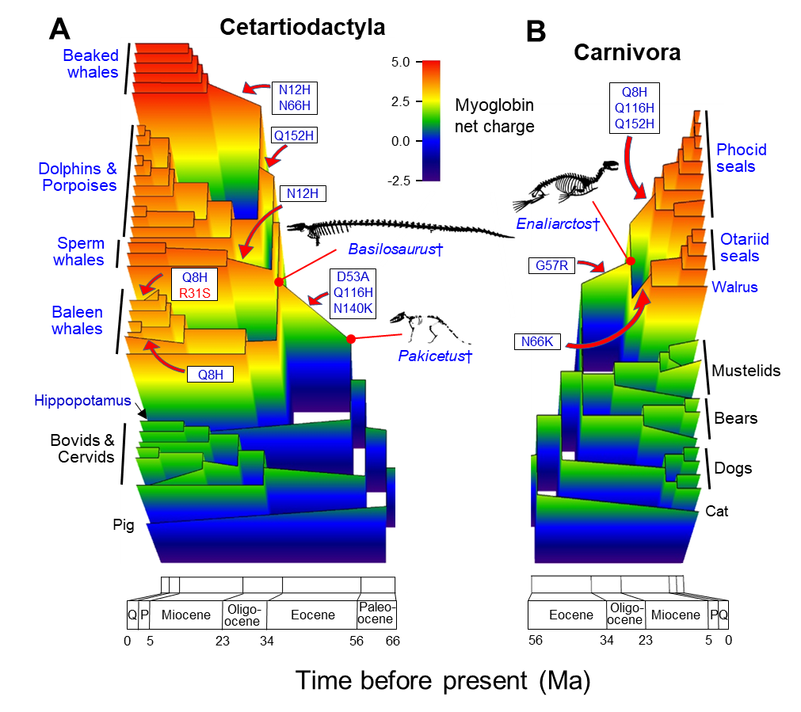
Figure 6: Three-dimensional evolutionary reconstructions of myoglobin net surface charge in whales and seals. Myoglobin net surface charge (Z_{Mb}, z-axis, colour-coded, at pH = 6.5) is mapped onto the phylogenies (x-y planes) of whales (A) and seals (B) within the orders Cetartiodactyla and Carnivora, respectively. Groups and species of diving and terrestrial mammals are labelled in blue and black fonts, respectively. Selected key charge-increasing (blue font) and charge-decreasing (red font) amino acid substitutions are indicated along their respective branches (red arrows) with positional numbers and in one-letter amino acid code. Estimated Z_{Mb} values of selected extinct species
(†, skeletons) thought to resemble direct ancestors at branch points of the phylogenies are also indicated (red dots and lines). Time is given in million years before present with geological epochs or periods. P, Pliocene; Q, Quarternary. Seal and whale myoglobin underwent convergent evolutionary increases in Z_{Mb} which in living mammals directly correlates with exponentially elevated maximal muscle myoglobin concentrations ([Mb]_{max}) compared to terrestrial species (Figure 5A). This relationship can be used to reconstruct the size of the muscle O₂ store in ancestors of today’s diving mammals and together with their reconstructed body mass help to estimate ancestral dive capacity (Figure 3C). Adapted from Mirceta et al. (2013).

August Krogh was well known for designing and building his own laboratory apparatuses for highly precise measurements, for example noting already more than 100 years ago an increase in carbon dioxide content of the atmosphere by 0.001 to 0.007% in the streets of Copenhagen from a then normal value of 0.030%, due to various sources of combustion (Krogh 1919), which today in the age of rising atmospheric carbon dioxide levels and global heating has taken on a new relevance. He may have been surprised to have received the Nobel Prize in Physiology or Medicine for work that in his own words required “nothing more than patient observation under the microscope and simple probing with fine needles” (Krogh, 1920). But of course, much of this celebrated work on capillaries was done on frogs, which have unusually large erythrocytes and capillaries compared to mammals (e.g. Snyder and Sheafor, 1989), facilitating microscopic observations and highlighting yet again the importance of choosing the most suitable organism -or protein- for solving problems in biology.

Funding sources
This research did not receive any specific grant from funding agencies in the public, commercial, or not-for-profit sectors.

References
Berenbrink, M. (2020). Evolution of a molecular machine. Nature 581, 388-389.

Clack, J. A. (2007). Devonian climate change, breathing, and the origin of the tetrapod stem group. Integrative and Comparative Biology 47, 510-523.

Cossins, A., & Berenbrink, M. (2008). Myoglobin's new clothes. Nature 454, 416-417.

Cossins, A. R., Williams, D. R., Foulkes, N. S., Berenbrink, M., & Kipar, A. (2009). Diverse cell-specific expression of myoglobin isoforms in brain, kidney, gill and liver of the hypoxia-tolerant carp and zebrafish. Journal of Experimental Biology 212, 627-638.

Donald, K. W. (1964). Oxygen Stores of Man, Discussion. In: Oxygen in the Animal Organism (pp. 618-619). Pergamon Press, Oxford.

Helbo, S., Dewilde, S., Williams, D. R., Berghmans, H., Berenbrink, M., Cossins, A. R., & Fago, A. (2012). Functional differentiation of myoglobin isoforms in hypoxia-tolerant carp indicates tissue-specific protective roles. American Journal of Physiology-Regulatory, Integrative and Comparative Physiology 302, R693-R701.

Kelley, N. P., & Pyenson, N. D. (2015). Evolutionary innovation and ecology in marine tetrapods from the Triassic to the Anthropocene. Science 348, aaa3716.

Kendrew, J. C., Dickerson, R. E., Strandberg, B. E., Hart, R. G., Davies, D. R., Phillips, D. C., & Shore, V. C. (1960). Structure of myoglobin: A three-dimensional Fourier synthesis at 2 Å. resolution. Nature 185, 422-427.

Kendrew, J. C. (1962). Myoglobin and the structure of proteins. Nobel Lecture. NobelPrize.org. Nobel Media AB 2020.
https://www.nobelprize.org/prizes/chemistry/1962/kendrew/lecture/
[accessed 27/10/2020]

Kooyman, G. L., McDonald, B. I., Williams, C. L., Meir, J. U., & Ponganis, P. J. (2020). The aerobic dive limit: after 40 years, still rarely measured but commonly used. Comparative Biochemistry and Physiology A [this issue].

Krebs, H. A. (1975) The August Krogh principle. Journal of experimental Zoology 194, 221-226.

Krogh, A. (1919.) The composition of the atmosphere. Kgl. Danske Vid. Selsk. Math. fys. Medd. 1, 3-19.

Krogh, A. (1920). A contribution to the physiology of the capillaries. Nobel Lecture. NobelPrize.org. Nobel Media AB 2020. https://www.nobelprize.org/prizes/medicine/1920/krogh/lecture/
[accessed 27/10/2020]

Krogh, A. (1929). Progress in physiology. Am. J. Physiol. 90, 243-260.

Krogh, A. (1934). Physiology of the blue whale. Nature 133, 635-637.

Krogh, A. (1941). The Comparative Physiology of Respiratory Mechanisms. University of Pennsylvania Press, Philadelphia.

Krogh, A. (1959). The Comparative Physiology of Respiratory Mechanisms. New Edition, University of Pennsylvania Press, Philadelphia. https://www.biodiversitylibrary.org/item/28810#page/7/mode/1up]
[accessed 27/10/2020]

McGowen, M. R., Gatesy, J., & Wildman, D. E. (2014). Molecular evolution tracks macroevolutionary transitions in Cetacea. Trends in Ecology & Evolution 29, 336-346.

Mirceta, S., Signore, A. V., Burns, J. M., Cossins, A. R., Campbell, K. L., & Berenbrink, M. (2013). Evolution of mammalian diving capacity traced by myoglobin net surface charge. Science 340, 1234192.

Perutz, M. F. (1983). Species adaptation in a protein molecule. Molecular Biology and Evolution 1, 1-28.

Pillai, A.S., Chandler, S.A., Liu, Y., Signore, A.V., Cortez-Romero, C.R., Benesch, J.L., Laganowsky, A., Storz, J.F., Hochberg, G.K. and Thornton, J.W., 2020. Origin of complexity in haemoglobin evolution. Nature 581, 480–485.

Ponganis, P. J. (2015). Diving Physiology of Marine Mammals and Seabirds. Cambridge University Press.

Rahn, H. (1964). Oxygen stores of man. In: Oxygen in the Animal Organism (pp. 609-619). Pergamon Press, Oxford.

Schachat, S. R., Labandeira, C. C., Saltzman, M. R., Cramer, B. D., Payne, J. L., & Boyce, C. K. (2018). Phanerozoic pO₂ and the early evolution of terrestrial animals. Proceedings of the Royal Society B: Biological Sciences 285, 20172631.

Schorr, G. S., Falcone, E. A., Moretti, D. J., & Andrews, R. D. (2014). First long-term behavioral records from Cuvier’s beaked whales (Ziphius cavirostris) reveal record-breaking dives. PLoS one 9, e92633.

Snyder, G. K., & Sheafor, B. A. (1999). Red blood cells: centerpiece in the evolution of the vertebrate circulatory system. American Zoologist 39, 189-198.

Steller, G. W. (1751). De Bestiis Marinis, or, The Beasts of the Sea. Miller, W. (Translator), Miller, J. E. (Translator); & Royster, P. (Transcriber and Editor). Faculty
Publications, University of Nebraska-Lincoln Libraries. 17.
https://digitalcommons.unl.edu/libraryscience/17 [accessed 27/10/2020]

Stirt, J.A., Sullivan, S.F., 1981. Oxygen stores. Int. Anesthesiol. Clin. 19, 71–83.

Storz, J. F. (2019). Hemoglobin: Insights into Protein Structure, Function, and Evolution. Oxford University Press.

Totzeck, M., Hendgen-Cotta, U. B., Luedike, P., Berenbrink, M., Klare, J.P., Steinhoff, H.J., Semmler, D., Shiva, S., Williams, D., Kipar, A., Gladwin, M.T., Schrader, J., Kelm, M., Cossins, A. T. & Rassaf, T. (2012). Nitrite regulates hypoxic vasodilation via myoglobin-dependent nitric oxide generation. Circulation 126, 325-34.

Verberk, W. C., Calosi, P., Brischoux, F., Spicer, J. I., Garland Jr, T., & Bilton, D. T. (2020). Universal metabolic constraints shape the evolutionary ecology of diving in animals. Proceedings of the Royal Society B 287, 20200488.

Wright, P. A., & Turko, A. J. (2016). Amphibious fishes: evolution and phenotypic plasticity. Journal of Experimental Biology 219, 2245-2259.

