Title: Family income matters! Tracking of habitual car use for school journeys and associations with overweight/obesity in UK youth.

*Rob J. Noonan

*Corresponding author:
Rob J Noonan
Appetite and Obesity Research Group
Department of Psychology
University of Liverpool
L69 7ZA
UK
Email: r.noonan@liverpool.ac.uk

Abstract
Introduction: The aims of this study were to assess associations between car use for school journeys in early childhood and car use for school journeys in later childhood and adolescence, (ii) determine whether an income gradient to habitual car use for school journeys and overweight/obesity exists in the UK, and (iii) assess the extent to which habitual car use for school journeys through childhood and into adolescence is associated with overweight/obesity in adolescence.
Methods: Data is from sweep three, four, five and six of the UK Millennium Cohort Study. Subjects consisted of 8494 children (4251 girls). Stature and body mass were assessed at age 5 and 14 years and children were categorised as normal weight or overweight/obesity. Commute mode to and from school was parent/carer reported at age 5, 7, 11 and 14 years and habitual car use for school journeys was determined. Family income at age 5 years was determined using equivalised household income. Adjusted logistic and multinomial logistic regression analyses were conducted.
Results: Car use for school journeys at age 5 was positively associated with car use for school journeys at age 7, 11 and 14 years (p<0.001). Family income at child age 5 was inversely associated with overweight/obese at age 5 and 14 years and positively associated with habitual car use (p<0.001). Habitual car use for school journeys was not associated with overweight/obesity at age 14 years.
Conclusions: Car use for school journeys in early childhood is positively associated with car use for school journeys in later childhood and adolescence. Children living in the highest income households have the lowest rates of overweight/obesity, and there is an income gradient to habitual car use for school journeys. Habitual car use for school journeys through childhood and into adolescence is not positively associated with overweight/obesity in adolescence.

Keywords: active school commuting; motorised transport; overweight; family income.

1. Introduction
In the UK (Department for Transport, 2019) and some other developed countries including Australia (van der Ploeg et al. 2008), Canada (Gray et al. 2014) and the United States (McDonald et al. 2011), more children than ever before are driven to and from school by car, and fewer walk, cycle or use public transport. The prevalence of car use for school journeys is much higher among children compared to adolescents owing to greater use of buses and public transport during adolescence (Department for Transport, 2019). However, changes in car use for school journeys between childhood and adolescence is not well documented in large population cohorts.
Environmental impacts of car use for school journeys include increased traffic congestion around schools, noise pollution and carbon emissions leading to greater exposure to pollutants (Cepeda et al. 2017; Dosanjh, 2011; Liu & Grigg, 2018; Zhanga & Batterman, 2013). Public health strategies to encourage car users to switch to more environmentally friendly modes of travel during the school commute (i.e., walking or cycling and public transport) need to be targeted at those who use cars for school journeys most frequently, but little is known about habitual car use for school journeys over time.
In the UK, there has been a progressive political focus on reducing car use for school journeys [and increasing walking/cycling] to curb childhood obesity rates (HM Government, 2016). Childhood obesity rates in England are among the highest in Europe with roughly one third of children overweight or obese by the time they enter secondary school (Health and Social Care Information Centre, 2019). The poorest neighbourhoods in England have the highest prevalence of childhood overweight/obesity (Noonan & Fairclough, 2018; Noonan, 2019).
Although motorised modes of commuting including car use for school journeys limits energy expenditure which is an important aspect of energy balance (Hills, Andersen & Byrne, 2011), several population level studies have reported lower rates of overweight/obesity among children who commute to school by motorised transport (Chaufan et al. 2015; Noonan, 2020; Noonan et al. 2017a). These studies though were cross-sectional and did not distinguish between different modes of motorised transport (i.e., car use vs public transport) or ‘mixed commuting’ modes (i.e., consistent before and after school). As such, the extent to which car use for school journeys throughout childhood and adolescence (referred to as habitual car use herein) is associated with weight status in adolescence is unknown.
To fill these knowledge gaps, the present study used data from the UK Millennium Cohort Study, an ongoing population-based observational study of families residing in the UK, to explore car use for school journeys across childhood and adolescence. The aims of the study were threefold: to (i) assess associations between car use for school journeys in early childhood and car use for school journeys in later childhood and adolescence, (ii) determine whether an income gradient to habitual car use for school journeys and overweight/obesity exists in the UK, and (iii) assess the extent to which habitual car use for school journeys through childhood and into adolescence is associated with overweight/obesity in adolescence.
2. Methods
Participants
Data were from sweep three, four, five and six of the UK Millennium Cohort Study (MCS). The MCS is a nationally representative UK sample of children born between September 2000 and January 2002. The sample design allowed for over-representation of ethnic minority and socially disadvantaged families. The first sweep of MCS was conducted between 2001 and 2002. Data were collected on 18 819 children in 18 533 families from parents/carers (referred to as parents herein) at home addresses when children were 9 to 11 months old (Hansen, 2012). Subsequent data collection sweeps were at ages 3, 5, 7, 11 and 14 years. To enable consistent and accurate comparisons across time points, only singleton children whose main parent/carer provided complete data for the variables of interest at age 5, 7, 11 and 14 years were included in the present analysis. The resulting study population comprised 8494 children (4251 female). This secondary analysis did not require ethical approval.
Measures
Weight status
At child age 5 and 14 years, stature was measured to the nearest millimetre using a portable stadiometer (Leicester Height Measure, Seca, Birmingham, UK), and body mass was measured to the nearest 0.1 kg using Tanita HD-305 scales (Tanita UK Ltd, Middlesex, UK). BMI was calculated from stature and body mass (kg m⁻²). The International Obesity Taskforce age-specific and gender-specific BMI cut-points were used to classify children as normal weight or overweight/obese (Cole et al. 2000).
Family income
At child age 5 years, parent/carer reported family income was assessed using quintiles of household income equivalised according to the Organisation for Economic Co-operation and Development household equivalence scale (Agalioti-Sgompou et al. 2017; Organisation for Economic Co-operation and Development, 2013).
School commuting behaviour
At each time point; child age 5, 7, 11 and 14 years, school commute mode to and from school was reported by the main parent/carer. School commute mode was assessed using the following responses: public transport, school or local authority bus, car or other vehicle, bicycle, walk, and other. First, categorical variables were created to represent car use (car or other vehicle vs all other modes of transport) to school, from school and both. A summary variable was then created to represent habitual car use to and from school. Habitual car use for school journeys was determined based on whether the same commuting mode (i.e., car use) was reported at each time point; age 5, 7, 11 and 14 years. Participants were classified into one of five groups to reflect the pattern of commuting to and from school over time: used a car to and from school at all four time points (habitual car user), three time points, two time points, one time point or never used a car (habitual non-car user).

Confounders
Potential confounding factors were selected a priori based on previous evidence (Chillon et al. 2010; Owen et al. 2012). At child age 5 years, child age, gender and ethnicity were parent/carer reported. Ethnic group categories were based on census categories (Kelly, 2008) and included White, Mixed, Indian, Pakistani and Bangladeshi, Black or Black British, and Other Ethnic group.
Analyses
Descriptive statistics were calculated for participant characteristics and car use prevalence at each age. Differences in the prevalence of car use for school journeys between age 5 and subsequent ages (7, 11 and 14 years) was analysed by Chi-squared tests. Exploratory analyses (not presented) confirmed that there were no interactions between family income quantiles and gender. Therefore, boys and girls were grouped together, and analyses were conducted for the full sample. To assess study aim 1, a series of logistic regression analyses investigated associations between car use for school journeys at age 5 years and car use for school journeys at subsequent time points; age 7, 11 and 14 years. Analyses were adjusted for age, gender, ethnicity, and family income quantile at age 5 years. To assess study aim 2, multinomial logistic regression analyses examined whether an income gradient to habitual car use for school journeys and overweight/obesity exists in the UK. The highest family income quantile at child age 5 was the reference category. Analyses were adjusted for age, gender and ethnicity. To assess study aim 3, multinomial regression analyses examined associations between habitual car use for school journeys and overweight/obesity at age 14 years. Analyses were adjusted for age, gender, ethnicity, family income quantile and weight status at age 5 years. Analyses were conducted using SPSS v. 25 (SPSS Inc.; Chicago, IL) and statistical significance was set at p < 0.05.

3. Results
Of the 8494 participants (4251 female), 17.3% were in the lowest family income category and 21.3% were in the highest family income category. The ethnic origin of the participants was 85.5% White. At age 5 and 14 years, 19.8% and 26.2% of participants were overweight/obese, respectively. Of the 1684 participants classified as overweight/obese at age 5 years, overweight/obesity persisted in 62.8% of the participants at age 14 years. The focus of this study was on car use for school journeys only. Data relating to other modes of transport to and from school are presented in supplementary file A.
Descriptive data on the patterns of car use for school journeys between age 5 and 14 years by family income quantile are shown in Figure 1. The prevalence of car use for school journeys to and from school increased from 42.1% to 42.2% between age 5 and 7 years and then declined to 38.1% at age 11 (p < 0.001) and to 17.4% at age 14 years (p < 0.001). Habitual car use for school journeys was reported among 7.6% of participants, and 20.0%, 15.5%, 18.2% and 38.6% of participants commuted to and from school by car across three, two, one or no wave, respectively.

[FIGURE 1 NEAR HERE]

Study aim 1
Logistic regression analyses revealed that car use for school journeys at age 5 was positively associated with car use for school journeys at age 7, 11 and 14 years (Table 1). The strength of association decreased with participant age. Participants who were driven to and from school by car at age 5 were more likely to be driven to and from school by car at age 7 (OR = 19.21; 95% CI = 17.25 - 21.40) age 11 (OR = 7.41; 95% CI = 6.73 - 8.16), and age 14 years (OR = 2.29; 95% CI = 2.05 - 2.56).

Table 1. Adjusted logistic regression associations between car use for school journeys at age 5 and car use for school journeys at age 7, 11 and 14 years.
 | Unadjusted  Odds ratio (95% CI) | Adjusted  Odds ratio (95% CI)
Age 7 | 19.61 (17.62 - 21.81) *** | 19.21 (17.25 - 21.40) ***
Age 11 | 7.72 (7.02 - 8.49) *** | 7.41 (6.73 - 8.16) ***
Age 14 | 2.31 (2.07 - 2.58) *** | 2.29 (2.05 - 2.56) ***
Adjusted for age, gender, ethnicity and family income quantile. Car use for school journeys at age 5 years was reference category. CI = confidence interval. ***P < 0.001.

Study aim 2
There was an income gradient to overweight/obesity at age 14 but not age 5 years (Figure 2). At age 5 the highest income children were less likely to be overweight/obese compared to the second to highest (OR = 1.27; 95% CI = 1.09 - 1.48), third to highest (OR = 1.19; 95% CI = 1.02 - 1.39), second to lowest (OR = 1.29; 95% CI = 1.09 - 1.52), and lowest income children (OR = 1.28; 95% CI = 1.07 - 1.54). At age 14 the highest income children were less likely to be overweight/obese compared to the second to highest (OR = 1.26; 95% CI = 1.09 - 1.45), third to highest (OR = 1.46; 95% CI = 1.27 - 1.69), second to lowest (OR = 1.74; 95% CI = 1.50 - 2.03), and lowest income children (OR = 1.79; 95% CI = 1.52 - 2.10).
There was a steep income gradient to habitual car use to and from school (Figure 2). The highest income children were more likely to be habitually driven to and from school by car compared with the second to highest (OR = 0.34; 95% CI = 0.25 - 0.47), third to highest (OR = 0.45; 95% CI = 0.35 - 0.57), second to lowest (OR = 0.50; 95% CI = 0.40 - 0.63), and lowest income children (OR = 0.65; 95% CI = 0.53 - 0.79).

[FIGURE 2 NEAR HERE]

Study aim 3
Adjusted logistic regression analyses revealed that habitual car use for school journeys between age 5 and 14 years was not positively associated with overweight/obesity at age 14 years (Table 4).

[FIGURE 3 NEAR HERE]

4. Discussion
This large prospective study provides evidence that car use for school journeys at age 5 is positively associated with car use for school journeys at age 7, 11 and 14 years. Family income at age 5 is inversely associated with overweight/obesity at age 5 and 14 years, and a steep family income gradient to habitual car use for school journeys exists in the UK. Habitual car use for school journeys between age 5 and 14 years was not positively associated with overweight/obesity at age 14 years.
Compared with children that were not driven to and from school by car at age 5 years, children that were driven to and from school by car at age 5 years were more likely to be driven to and from school by car at age 7, 11 and 14 years. Car use for school journeys decreased with age with only 17% of participants driven to and from school at age 14. Parent concerns over children’s safety are much higher in childhood than in adolescence and young children are afforded with the least freedom to commute between school and home independent of adult supervision (Carver et al. 2014). The growth in personal car ownership (with most UK families now owning two vehicles; Department for Transport, 2019) and subsequent increase in cars on the school to home route has compounded parental fears over children’s safety and created a social trap where parents drive their children to and from school as a form of protection from other vehicles (Noonan et al. 2017b). There are a range of challenges to reducing the total number of car users, but changing parent perceptions regarding children’s safety during the school commute [and their resultant behaviour] can and has been achieved in other parts of Europe including the Netherlands (The Guardian, 2015) through continued traffic calming and safer route measures (e.g., speed restrictions, pedestrian crossings and traffic-calming devices) which ensure neighbourhoods are safe for pedestrians and cyclists (Pucher & Dijkstra, 2003; Saelens & Handy, 2008). This however will require much strong political will and investment than the present.
Children living in the highest income households in the UK at age 5 years were most likely to be driven to and from school by car throughout childhood and adolescence. Higher motorised school commuting rates have been reported among affluent children previously (Pabayo et al. 2011; Titheridge et al. 2014) but no study has revealed an income gradient to car use for school journeys in the UK over time. One potential reason for this finding is that high income parents are most likely to exercise choice over school-selection (Francis & Hutchings, 2013) and most likely to have access to a family car (DeWeese et al. 2013; Lansley, 2016), enabling them to overcome the longer school-home commuting distances. Currently, less than half of all children in England attend their local school (Department for Transport, 2019). Although the school choice policy enables greater social mobility by enabling children from low income families to access higher achieving schools outside of their immediate neighbourhood (Burgess & Briggs, 2010), it also challenges efforts to promote walking/cycling to school by increasing commuting distances; the strongest determinant of motorised transport for school journeys (D’Haese et al. 2011; Noonan et al. 2017a). In such contexts, efforts to specifically reduce car use for school journeys may be unrealistic, however, the broader public health message from this finding is the need to advocate greater public transport use.
In this large nationally representative study habitual car use for school journeys throughout childhood and adolescence was not positively associated with overweight/obesity in adolescence. This finding is to some extent consistent with previous cross-sectional research in the UK (Noonan, 2020; Noonan et al. 2017a) and US (Chaufan et al. 2015). At first glance, it seems counterintuitive that children who are driven to and from school throughout childhood and adolescence would not be at greater risk of overweight/obese, but that is because the development of overweight/obesity is equally as much about energy intake as it is energy expenditure (Foresight, 2007). Research shows that the wealthier a child’s family is the more likely they are to report a balanced diet (Noonan, 2018). Wealthier children are also more likely to partake in structured/organised sports (Noonan et al. 2017c) which tend to be vigorous in nature and result in greater energy expenditure relative to low intensity activities including walking to school (Butte et al. 2018). Therefore, UK policies and initiatives to reduce childhood overweight/obesity need to promote and support the uptake and maintenance of healthy eating behaviours as well as other movement behaviours that complement walking/cycling to school.
Moreover, the data show that children living in the highest income households in the UK at age 5 years are likely to contribute the greatest health and environmental costs associated with car use during the school commute. To change car user behaviour at the population level requires changing parent attitudes and indeed social norms towards driving children to and from school. This could be achieved through advertising and education on the health and environmental effects of motorised transport including traffic congestion, noise pollution, air pollution and pedestrian injuries instead of weight loss per say (Cepeda et al. 2017; Dosanjh, 2011; Liu & Grigg, 2018; Zhanga & Batterman, 2013). However, such strategies will be maximised by improving built environment infrastructure within neighbourhoods and around schools (e.g., improve connections between streets and create wide sidewalks) and implementing policies (e.g., widespread traffic calming measures, pedestrianisation, and investment in public transport system), that encourage and support walking/cycling to and from school. The main challenge to reducing car use for school journeys both now and into the future arises from the multinational corporations that produce cars and oil who have strong vested interests in increasing and maintaining the use of such commodities. These multinational corporations are central to the world economy (Manley, Mihalyi & Heller, 2019) and have advertising budgets that dwarf public health campaigns promoting non-motorised modes of commuting including walking/cycling to and from school (Woodcock & Aldred, 2008).
This longitudinal study represents the first to investigate habitual school commuting behaviour between childhood and adolescence in a large UK cohort. Although the analyses were adjusted for known confounding factors there are other important lifestyle factors that contribute to energy balance including overall physical activity level and energy intake that were not considered, as they were outside the scope of the present study. These potential mediators should be the focus of future research exploring behavioural mechanisms linking family income and child weight. Furthermore, the distance between home and school is among the strongest of influences on school commuting behaviour but was not collected in MCS. This limitation could explain the family income related differences in car use with low income children living closer to school.

5. Conclusions
This study revealed that car use for school journeys in early childhood is strongly associated with car use for school journeys in later childhood and adolescence. Children living in the highest income households in the UK have the lowest rates of overweight/obesity, and there is an income gradient to habitual car use for school journeys. Habitual car use for school journeys through childhood and into adolescence is not positively associated with overweight/obesity in adolescence.

6. References
Agalioti-Sgompou, V.; Atkinson, M.; Church, D.; Johnson, J.; Mostafa, T.; Murphy, T.; Peters, A.; Rosenberg, R. (2017). Millennium Cohort Study: MCS6 Derived Variables; Centre for Longitudinal Studies, University of London: London, UK.
Butte NF, Watson KB, Ridley K, et al. (2018). A Youth Compendium of Physical Activities: Activity Codes and Metabolic Intensities. Med Sci Sports Exerc, 50, 246–56.
Carver, A., Panter, J. R., Jones, A. P., & van Sluijs, E. M. F. (2014). Independent mobility on the journey to school: A joint cross-sectional and prospective exploration of social and physical environmental influences. Journal of Transport & Health 1, 25–32.
Cepeda, M., Schoufour J2, Freak-Poli R3, Koolhaas CM2, Dhana K2, Bramer WM4, Franco OH. (2017). Levels of ambient air pollution according to mode of transport: a systematic review. Lancet Public Health, 2(1), e23-e34.
Chaufan, C., Yeh, J., Ross, L., & Fox, P. (2015) You can’t walk or bike yourself out of the health effects of poverty: active school transport, child obesity, and blind spots in the public health literature, Critical Public Health, 25(1), 32-47.
Chillon, P., Ortega, F.B., Ruiz, J.R., et al., 2010. Active commuting to school in children and adolescents: an opportunity to increase physical activity and fitness. Scand. J. Public Health 38, 873–879.
Cole TJ, Bellizzi MC, Flegal KM, et al. (2000). Establishing a standard definition for child overweight and obesity worldwide: international survey. BMJ, 320, 1240–43.
Department for Transport. (2019). National Travel Survey: England 2018. Statistical Release-National Travel Survey. London: Department for Transport.
Department for Transport. (2019). Vehicle Licensing Statistics: Annual 2018. London: Department for Transport.
DeWeese, R.S.; Yedidia, M.J.; Tulloch, D.L.; Ohri-Vachaspati, P. Neighborhood Perceptions and Active School Commuting in Low-Income Cities. Am. J. Prev. Med. 2013, 45, 393–400.
D’Haese, S.; De Meester, F.; De Bourdeaudhuij, I.; Deforche, B.; Cardon, G. Criterion distances and environmental correlates of active commuting to school in children. Int. J. Behav. Nutr. Phys. Act. 2011, 8, 88.
Dosanjh, A. (2011). Childhood asthma and anthropogenic CO2 emissions. J Asthma Allergy, 4, 103–105.
Foresight. (2007). Foresight Report: Tackling Obesities: Future Choices – Project Report (2nd ed). London: Government Office for Science.
Francis, B., & Hutchings, M. (2013). Parent Power? Using money and information to boost children’s chances of educational success. London: The Sutton Trust.
Gray, C., Larouche, R., Barnes, J. D., et al. (2014). Are we driving our kids to unhealthy habits? Results from the active healthy kids Canada 2013 report card on physical activity for children and youth. Int J Environ Res Public Health. 2014;11(6):6009–20.
The Guardian. (2015). How Amsterdam became the bicycle capital of the world. Available at: https://www.theguardian.com/cities/2015/may/05/amsterdam-bicycle-capital-world-transport-cycling-kindermoord.
Hansen, K. (2012). Millennium Cohort Study First, Second, Third and Fourth Surveys: A Guide to the Datasets, 6th ed.; Centre for Longitudinal Studies, University of London: London, UK.
Health and Social Care Information Centre. (2019). Statistics on Obesity, Physical Activity and Diet, England, 2019. Leeds, UK: Health and Social Care Information Centre.
Hills, A.P.; Andersen, L.B.; Byrne, N.M. Physical activity and obesity in children. Br. J. Sports Med. 2011, 45,866–870.
HM Government. (2016). Childhood Obesity: A Plan for Action: Chapter 2. London: HM Government.
Kelly, Y. (2008). Ethnicity Coding for the Millennium Cohort Study, First Survey, 2001–2003; Centre for Longitudinal Studies, University of London UK Data Service: London, UK.
Lansley, G. (2016). Cars and socio-economics: Understanding neighborhood variations in car characteristics from administrative data. Reg. Stud. Reg. Sci. 2016, 3, 264–285.
Liu NM, & Grigg J. Diesel, children and respiratory disease. BMJ Paediatr Open, 2018;2:e000210.
Manley, D., Mihalyi, D., & Heller, P. R. P. (2019). Hidden Giants: It’s time for more transparency in the management and governance of national oil companies. Finance and Development. Washington: International Monetary Fund.
McDonald NC, Brown AL, Marchetti LM, Pedroso MS. (2011). U.S. school travel, 2009 an assessment of trends. Am J Prev Med, 41(2), 146–51.
Noonan, R. J. (2018). Poverty, weight status and dietary intake among UK adolescents. International Journal of Environmental Research and Public Health, 15, 1224.
Noonan, R. J. (2019). The effect of childhood deprivation on weight status and mental health in childhood and adolescence: longitudinal findings from the Millennium Cohort Study. Journal of Public Health, 41(3), 456-461.
Noonan, R. J. (2020). To what extent do unhealthy behaviour indicators explain the neighbourhood deprivation gradient in overweight among 11-year-old English children? SSM - Population Health,
Noonan, R. J., Boddy, L. M., Knowles, Z. R., & Fairclough, S. J. (2017a). Fitness, fatness and active school commuting among Liverpool Schoolchildren. Int J Environ Res Public Health, 14:995.
Noonan, R. J., Boddy, L. M., Fairclough, S. J. & Knowles, Z. R. (2017b). Parental perceptions on children’s out-of-school physical activity and family-based physical activity interventions. Early Child Development and Care, 187(12), 1909-1924.
Noonan, R. J., & Fairclough, S. J. (2018). Is there a deprivation and maternal education gradient to child obesity and moderate-to-vigorous physical activity? Findings from the Millennium Cohort Study. Pediatric Obesity, 13(7), 458-464.
Noonan, R. J., Fairclough, S. J., Knowles, Z. R., & Boddy, L. M. (2017c). Context matters! Sources of variability in weekend physical activity among families: A repeated measures study. BMC Public Health, 17:330.
Organisation for Economic Co-operation and Development. (2013). OECD Framework for Statistics on the Distribution of Household Income, Consumption and Wealth; Organisation for Economic Co-Operation and Development Publishing: Paris, France.
Owen, C. G., Nightingale, C. M., Rudnicka, A. R., van Sluijs, E. M. F., Ekelund, U., Cook, D. G., & Whincup, P. H. (2012). Travel to School and Physical Activity Levels in 9–10 Year-Old UK Children of Different Ethnic Origin; Child Heart and Health Study in England (CHASE). PLoS ONE, 7(2): e30932.
Pabayo, R., Gauvin, L., Barnett, T.A., 2011. Longitudinal changes in active transportation to school in Canadian youth aged 6 through 16 years. Pediatrics 128, E404–E413.
Titheridge, H.; Christie, N.; Mackett, R.; Hernández, D.O.; Ye, R. Transport and Poverty: A Review of the Evidence; UCL Transport Institute, University College London: London, UK, 2014.
van der Ploeg HP, Merom D, Corpuz G, Bauman AE. Trends in Australian children traveling to school 1971–2003: burning petrol or carbohydrates? Prev Med. 2008;46(1), 60–62.
Woodcock, J., & Aldred, R. (2008). Cars, corporations, and commodities: Consequences for the social determinants of health. Emerging Themes in Epidemiology, 5:4.
Zhanga, K., & Batterman, S. (2013). Air pollution and health risks due to vehicle traffic. Sci Total Environ, 0, 307–316.

Acknowledgements
The author is grateful to the participating families of the Millennium Cohort Study, the Centre for Longitudinal Studies, UCL Institute of Education for the use of these data and to the UK Data Archive and UK Data Service for making them available. However, they bear no responsibility for the analysis or interpretation of these data.

Declaration of conflicting interests
The author declares no conflict of interest.

Funding
The research was supported by the University of Liverpool.

List of figure captions
Figure 1. Percentage of participants commuting to and from school by car between age 5 and 14 years by family income quantile. * P < 0.001.
Figure 2. Adjusted odds ratios for overweight/obesity at age 5 and 14 years and habitual car use for school journeys between age 5 and 14 years according to family income quantile. Adjusted for age, gender and ethnicity. Reference category was highest family income quantile.
Figure 3. Adjusted odds ratios for overweight/obesity at age 14 years according to level of car use for school journeys between age 5 and 14 years. ª Adjusted for age, gender and ethnicity; ^{b} + family income quantile; ^{c} + weight status at child age 5 years. Reference group was habitual car use for school journeys (i.e., car use at 4 time points). Overweight/obese according to IOTF classification for age 5 and 14 years.

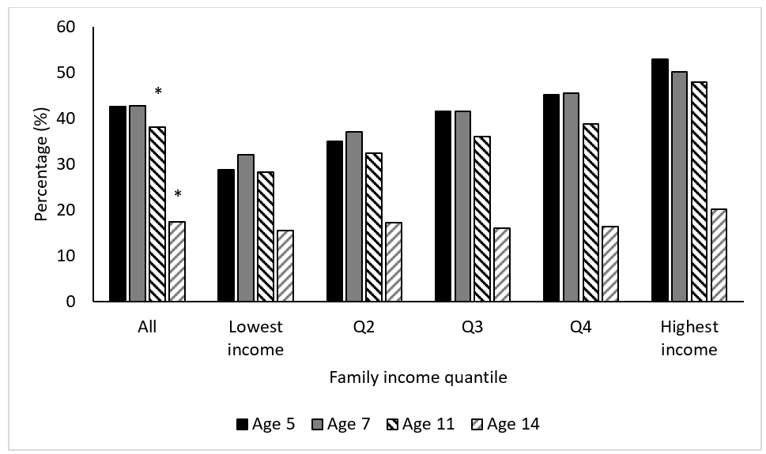
Figure 1. Percentage of participants commuting to and from school by car between age 5 and 14 years by family income quantile. * P < 0.001.

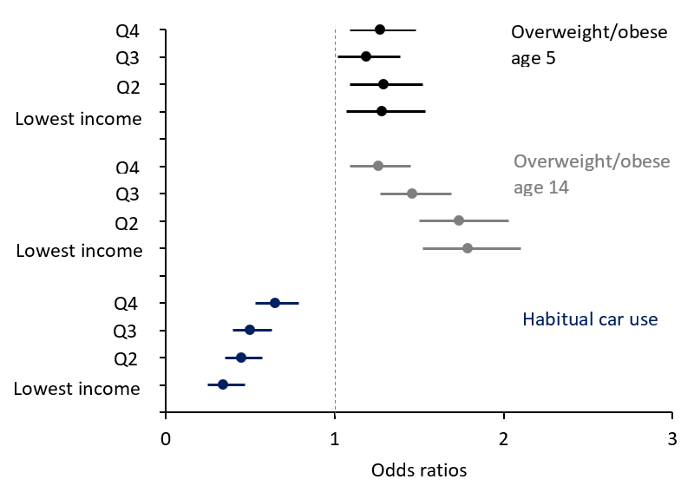
Figure 2. Adjusted odds ratios for overweight/obesity at age 5 and 14 years and habitual car use for school journeys between age 5 and 14 years according to family income quantile. Adjusted for age, gender and ethnicity. Reference category was highest family income quantile.

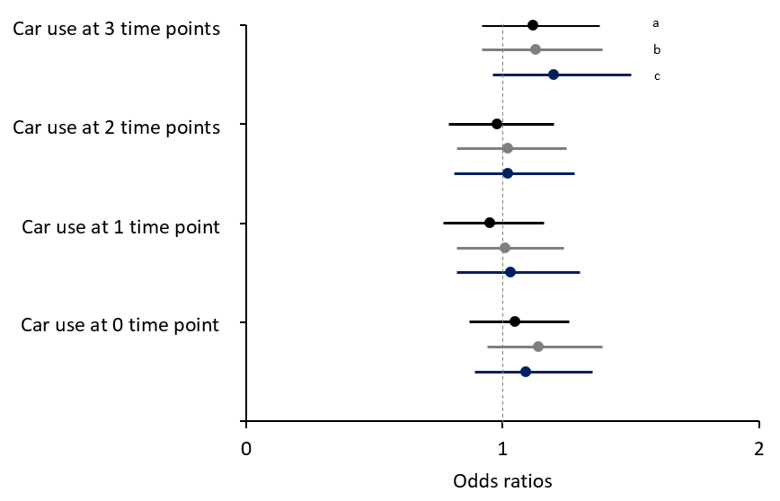
Figure 3. Adjusted odds ratios for overweight/obesity at age 14 years according to level of car use for school journeys between age 5 and 14 years. a Adjusted for age, gender and ethnicity; b + family income quantile; c + weight status at child age 5 years. Reference group was habitual car use for school journeys (i.e., car use at 4 time points). Overweight/obese according to IOTF classification for age 5 and 14 years.

