Long-term environmental tolerance of the non-indigenous Pacific oyster to expected contemporary climate change conditions

Kathryn E. Pack^{1,2,*}, Marc Rius^{1,3}, Nova Mieszkowska^{2,4}

¹ School of Ocean and Earth Science, National Oceanography Centre Southampton, University of Southampton, Southampton, United Kingdom
² Marine Biological Association, Plymouth, United Kingdom
³ Centre for Ecological Genomics and Wildlife Conservation, Department of Zoology, University of Johannesburg, Auckland Park, South Africa
⁴ School of Environmental Sciences, University of Liverpool, Liverpool, United Kingdom

* Corresponding author: Kathryn E. Pack, kep2g11@soton.ac.uk

Highlights:
• Long-term effects of climate change on non-indigenous species are rarely studied
• Pacific oysters were exposed to warming, ocean acidification and reduced salinity
• Warming and ocean acidification predicted for the year 2100 did not affect fitness
• Low salinity reduced clearance rates and increased oxygen consumption rates
• Long-term observations highlighted potential seasonal trends in physiological rates

Abstract: The current global redistribution of biota is often attributed to two main drivers: contemporary climate change (CCC) and non-indigenous species (NIS). Despite evidence of synergetic effects, however, studies assessing long-term effects of CCC conditions on NIS fitness remain rare. We examined the interactive effects of warming, ocean acidification and reduced salinity on the globally distributed marine NIS Magallana gigas (Pacific oyster) over a ten-month period. Growth, clearance and oxygen consumption rates were measured monthly to assess individual fitness. Lower salinity had a significant, permanent effect on M. gigas, reducing and increasing clearance and oxygen consumption rates, respectively. Neither predicted increases in seawater temperature nor reduced pH had a long-term physiological effect, indicating conditions predicted for 2100 will not affect adult physiology and survival. These results suggest that M. gigas will remain a globally successful NIS and predicted CCC will continue to facilitate their competitive dominance in the near future.
Key words: Climate change, invasive species, Magallana gigas, mesocosm, multiple stresses, seasonality

Introduction
Non-indigenous species (NIS) and contemporary climate change (CCC) are two of the most significant threats to global biodiversity. From their main points of introduction (e.g. agricultural exploitations, harbours and aquaculture sites), NIS can spread to surrounding areas and establish new populations, becoming invasive (Eno et al., 1997; Manchester & Bullock, 2000; Richardson et al., 2000; Jensen et al., 2004; Hellmann et al., 2008). In addition, NIS can negatively impact native biodiversity and alter the structure and functioning of ecosystems (Nichols et al., 1990; Carlton & Geller, 1993; Travis, 1993; Grosholz Edwin et al., 2000). Knowledge of the potential impacts of CCC on marine NIS has advanced rapidly in recent years through the use of laboratory and field experiments (for example Lemasson et al., 2018; Miranda et al., 2019; Nguyen et al., 2020), habitat suitability modelling (for example Sarà et al., 2018; D’Amen & Azzurro, 2019; Zhang et al., 2020) and mechanistic modelling (Thomas et al., 2016). Mounting evidence suggests that CCC is likely to facilitate NIS spread and alter the current global distribution of species (Dukes & Mooney, 1999; Carlton, 2000; Occhipinti-Ambrogi, 2007; Hellmann et al., 2008; Rahel & Olden, 2008; Occhipinti-Ambrogi & Galil, 2010; Smith et al., 2012).
Anthropogenic activities have led to both an increase in global temperatures and ocean acidification over the last 150 years (Caldeira & Wickett, 2003; Caldeira & Wickett, 2005; Gattuso et al., 2015; IPCC, 2019). It is expected that by the end of the century, global surface temperatures and ocean pH will rise by 2 - 4°C and decrease by 0.3 - 0.4 units, respectively, relative to 1986 – 2005 (Caldeira & Wickett, 2003; Sabine et al., 2004; Caldeira & Wickett, 2005; IPCC, 2019). In response to these environmental changes, species distributions are shifting to higher latitudes and altitudes, or deeper depths in the oceans (Parmesan & Yohe, 2003; Parmesan et al., 2005; Helmuth et al., 2006; Hickling et al., 2006; Mieszkowska et al., 2006; Cheung et al., 2009; Rijnsdorp et al., 2009; Chen et al., 2011; Pecl et al., 2017). Range expansions and increases in abundance have already been reported on NIS that have experienced a 50-year period of warming (Rius et al., 2014). Consequently, range expansions of NIS are expected throughout this century in both marine and terrestrial ecosystems (Occhipinti-Ambrogi, 2007; Rahel & Olden, 2008; Pecl et al., 2017). A meta-analysis of NIS performance under CCC conditions showed that NIS displayed more positive responses to increased ocean acidification and warming than native species (Sorte et al., 2013), probably due to successful NIS being able to survive across a wider range of these parameters, although genetic diversity can either be very similar or completely different between native and invasive populations (Le Cam et al. 2019) . Overall, the potential positive effects of CCC on NIS may ultimately facilitate NIS dominance in the near future.
The environmental factors linked to CCC rarely act in isolation and interactions between multiple environmental stressors are known to exacerbate the effects of CCC on species performance (Przeslawski et al., 2005; Staudt et al., 2013; Delorme & Sewell, 2014; Przeslawski et al., 2015). It is, therefore, crucial to study the combined effects of multiple abiotic stressors on species physiology to fully understand how CCC will affect the success of NIS. However, assessments of the effects of multiple stressors, particularly those using more than 2 stressors, are uncommon with the majority of CCC experiments focusing on short-term exposures (Kroeker et al., 2013). Although these experiments provide key insights into how CCC affects the physiology of both native and NIS, short-term experiments may not account for the acclimation of the species to experimental conditions and only provide limited evidence of chronic stress responses (Hollister et al., 2005; Leuzinger et al., 2011; Dupont et al., 2013; Smith & Dukes, 2013; Stewart et al., 2013; Suckling et al., 2015). Data from long and short-term experiments have revealed contrasting results (Form & Riebesell, 2011; Dupont et al., 2013; Munday et al., 2013; Suckling et al., 2015), with species showing acclimation and resilience only in long-term and/or trans-generational exposure to abiotic stressors (Donelson et al., 2011; Munday, 2014; Palumbi et al., 2014; Suckling et al., 2015; Ross et al., 2016). Long-term studies are, therefore, crucial for accurate predictions of the effects of CCC on species fitness. Another advantage of long-term experiments is that they can encompass seasonal changes in environmental conditions, which are often overlooked in short-term experiments. By including maximum and minimum temperatures, an assessment can be made of the effects of stressors across phenological cycles.
In this study we assess how changes in key environmental conditions, as predicted under CCC at the end of the 21st century, interact and affect the long-term performance of the highly successful marine NIS the Pacific oyster, Magallana gigas (Thunberg, 1793). From its native range in northeast Asia, M. gigas has been introduced into over 65 countries for use in aquaculture worth approximately $1.2 – $1.4 billion per year (Fig. S1a). M. gigas has already established wild populations in more than 17 countries (Fig. S1b), making it a globally successful NIS (Herbert et al., 2016). M. gigas is classified as an invasive species due to its ability to spread and form extensive reefs, modifying the habitats and threatening indigenous biodiversity (Richardson et al., 2000; Lejart & Hily, 2005; Smaal et al., 2008; Troost, 2010; Holm et al., 2016).
There are a wealth of studies investigating environmental change on M. gigas fitness, however, contrasting results have shown both neutral/positive (Havenhand & Schlegel, 2009; Falkenberg et al., 2019) and negative (Kurihara et al., 2007; Lannig et al., 2010; Barros et al., 2013; Lemasson et al., 2018) effects of warming and ocean acidification on adult and larval stages. Whilst the majority of these experiments have shown the short-term sensitivity of M. gigas to CCC, M. gigas may acclimate and express resilience to these conditions in the long-term. Further investigation is, therefore, needed to assess the effects of prolonged, seasonal exposure of adult M. gigas to predicted CCC conditions and how the long-term interactive effects between altered abiotic factors will contribute to their continued success.
Here, M. gigas were exposed to varying levels of three abiotic stressors, temperature, pH and salinity, over a ten-month period. We hypothesized that: (1) long-term exposure to expected CCC conditions and reduced salinity would negatively affect M. gigas fitness, and (2) environmental conditions will have synergistic interactions, ultimately affecting the performance of M. gigas.

Methods

Mesocosm set up and conditions
We created a mesocosm system with 12 independent experimental treatments (Fig. 1). Each treatment consisted of a closed system with a header and footer tank circulating approximately 200 litres of natural, untreated, filtered seawater from Plymouth Sound through six, nine litre experimental tanks. The 12-level (2 temperature x 3 pH treatments x 2 salinity) factorial experiment included different temperature (ambient and +4 °C), pH (ambient at 8.1, 7.7 and 7.5), and salinities (34 and 20) levels (Fig. 1). Temperature and pH were chosen to reflect ambient and forecasted projections from both IPCC and UKCP09 reports (Jenkins et al., 2009; Lowe et al., 2009; Hughes et al., 2017; IPCC, 2019). Reduced salinity is a key range limiting factor for marine species, often having a negative impact on species physiology and survival (Cognetti & Maltagliati, 2000; Paavola et al., 2005; Braby & Somero, 2006; Pourmozaffar et al., 2020), and thus salinity was manipulated to reflect the tolerance range of M. gigas with conditions experienced in northwest Europe as intertidal coastal and estuarine organisms. Salinities above 20 are regarded as important for the establishment of Pacific oysters and adult oysters having been observed in salinities ranging from 20 (Scandinavian coast (Wrange et al., 2010)) to more than 35. M. gigas are also common in estuaries where salinity fluctuates on a semi-diurnal basis. Each of the 12 treatments was run for 10 months between June 2018 to March 2019.

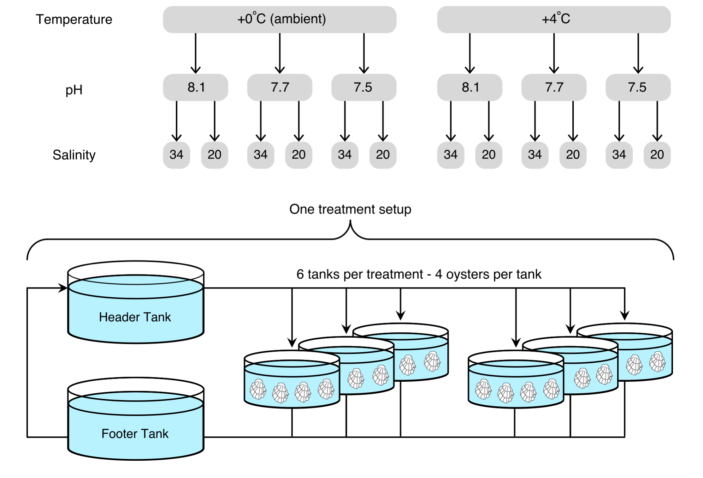
Figure 1. Experimental design used for the 12-level factorial experiment and the layout of each closed treatment system. Treatment refers to the 12 independent combinations of the environmental parameters. The six, nine litre tanks per treatment acted as the replicates.

The pH was regulated using Aqua Medic pH computers, which administered CO₂ when the pH deviated by 0.02 above the treatment value. To reflect seasonality in natural systems, daylength and temperature were adjusted at the start of every month, with seawater temperature reflecting the average sea surface temperature at L4 station in the Western English Channel off the coast of Plymouth (www.westernchannelobservatory.org.uk) (Fig. 2). Air temperature was used to control ambient seawater temperature and was adjusted to 2°C below the monthly average at L4 to achieve the desired seawater temperatures. Seawater temperature in the +4°C treatments were achieved by placing heaters in the reservoir tanks. Seawater temperatures varied by ±0.5°C across the two temperature levels. Total alkalinity for each treatment was measured every other week using an Alkalinity Titrator (Model AS-ALK2, Apollo SciTech, Bogart). The water chemistry recorded for each treatment is shown in Table S1.

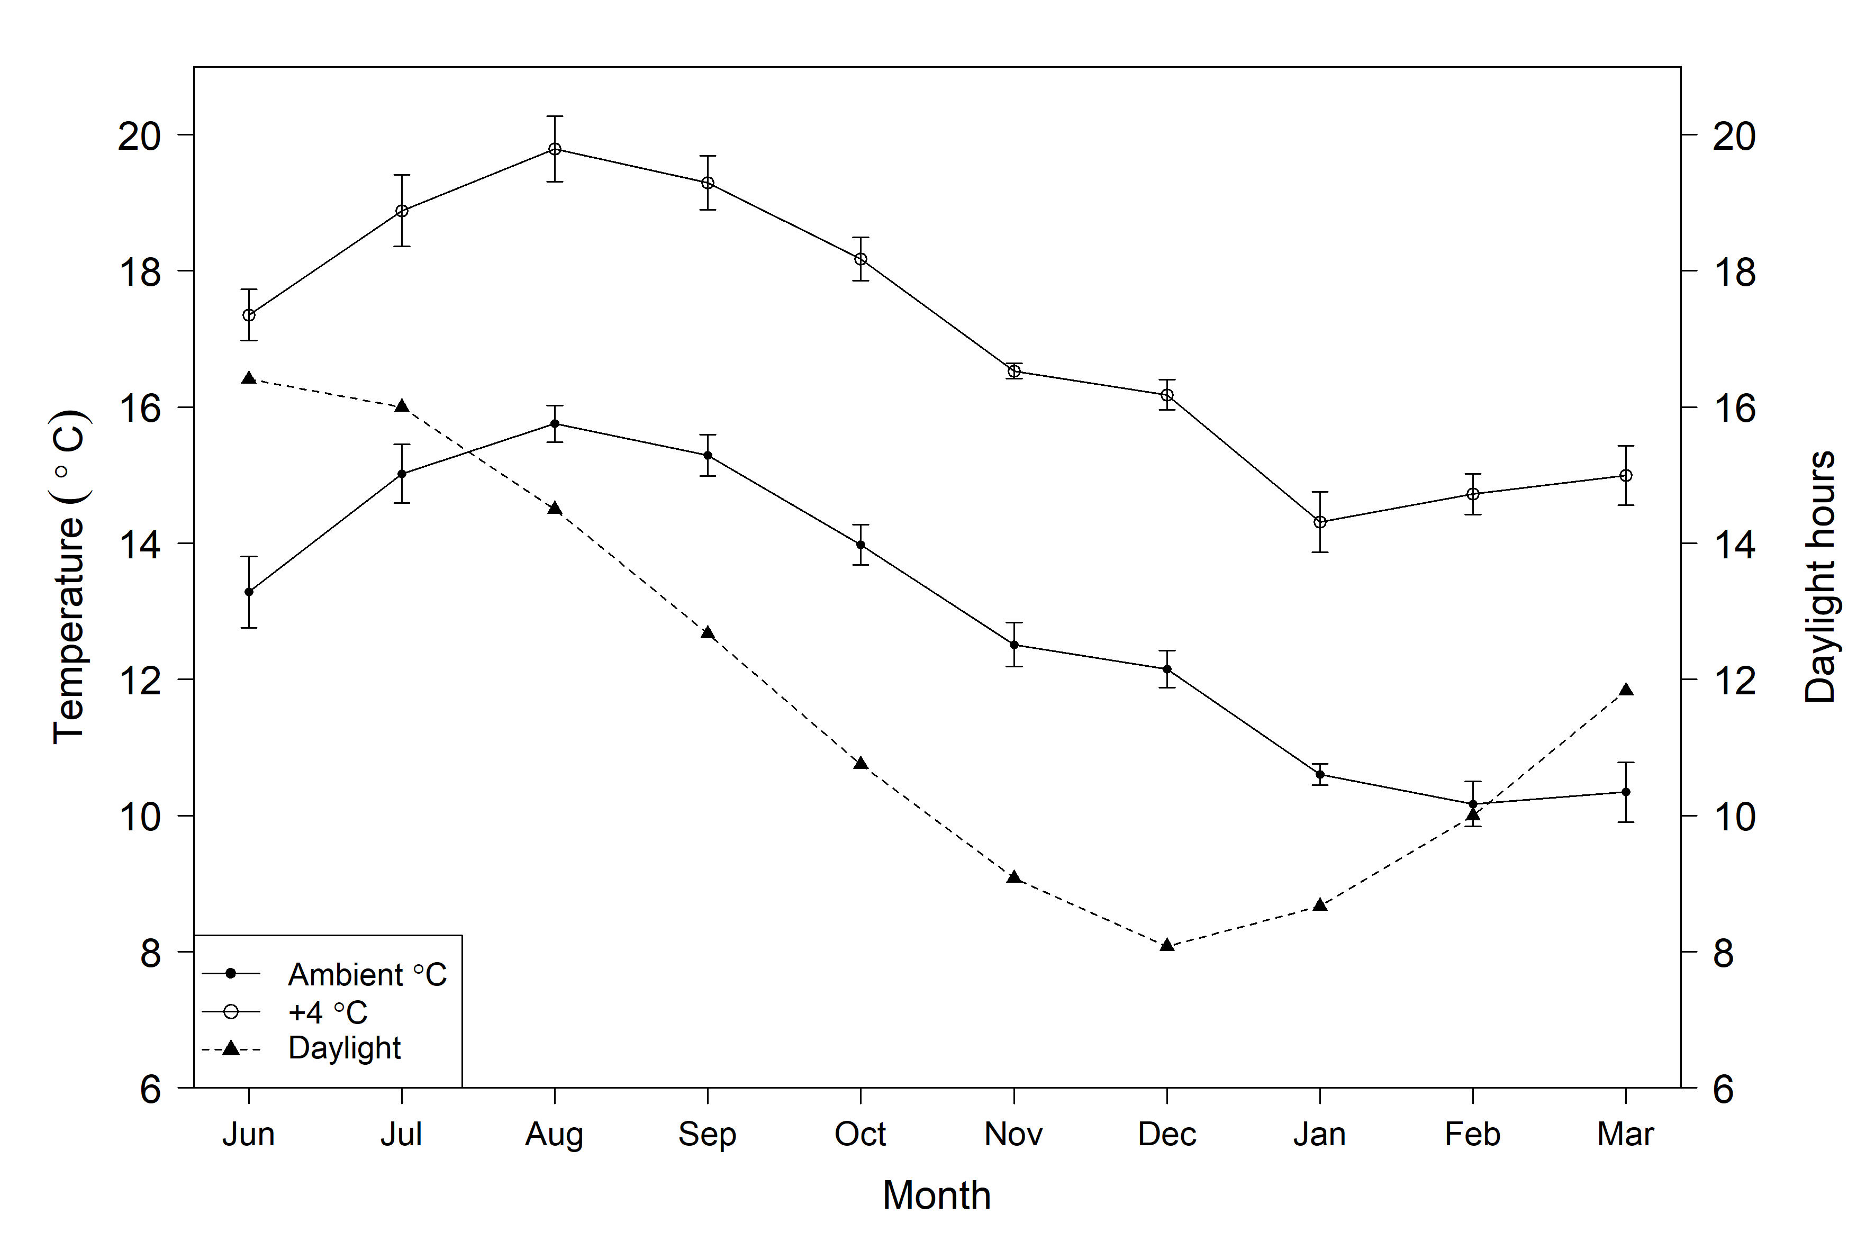
Figure 2. Monthly mean seawater temperature (ambient and +4ºC) and daylight hours in the mesocosm system between June 2018 and March 2019.

Adult M. gigas individuals (60 - 113 mm maximum length) were collected at the end of March 2018 from the low intertidal zone of the River Yealm estuary (50.3098°N, 4.0537°W), which is 15 km away from the laboratories of the Marine Biological Association of the United Kingdom (50.3641°N, 4.1391°W) where the experiments were conducted. The collected individuals were placed in insulated containers that were transported to the laboratory within one hour. Once cleaned of epibionts, a total of 288 oysters were randomly allocated to tanks, with 24 M. gigas per treatment across six replicate tanks, i.e. four oysters per tank (based off Utting & Spencer, 1991) (Fig. 1). M. gigas were initially acclimated to their temperature and salinity treatments for four weeks prior to introducing CO₂ to the systems, then acclimated for a further four weeks before measuring physiological parameters. Oysters were fed with a diet of Isochrysis galbana and Tetraselmis sp. (Instant Algae® by Reed Mariculture) five days a week at an amount equivalent to 2% of the mean oyster dry weight (dry weights based on destructively sampling a representative sample of oysters from the Yealm Estuary) (Helm & Bourne, 2004). The concentration of food in the tanks at each feed was in the order of x10⁸ cells per litre. Tanks were checked prior to feeding and dead oysters removed; only 11 oysters died over the duration of the experiment. A 10% water change with filtered seawater occurred twice a week; freshwater was added to reduce salinity to 20 in half of the treatments.

  - Growth
Initially, all 288 oysters were weighed to the nearest 0.01g prior to treatment exposure to obtain a baseline weight. Weight of the oysters was then assessed at the start of each month (with the exception of January and February). Every oyster was removed from their tank, carefully dried to remove excess water from the shell and total live wet weight (shell and wet tissue) of each individual oyster was measured. Weight change was then determined as the difference in the monthly weight compared to baseline weight.

  - Physiological measurements
Physiological measurements were taken during the fourth week of each month, after M. gigas were exposed to the monthly environmental conditions for three weeks. Daily feeding was stopped two days prior to measuring physiological parameters to obtain values at a routine metabolic rate. Oysters were returned to their respective tanks after physiological measurements were taken.
    - Clearance rate
The clearance rates for M. gigas (i.e. the volume of water cleared of algal cells per hour) were measured to assess their efficiency to remove seston within each treatment. Clearance rates were measured on six individual oysters from each treatment (one randomly selected from the replicate tanks). Oysters were placed in an enclosed chamber with 1 litre of filtered seawater with temperature, pH and salinity levels matching their respective treatments. Once the oyster was visibly feeding (valves open) a concentration of 2 x 10⁸ cells per litre (below pseudofaeces production threshold) of Isochrysis sp. was added to the water and the oyster left to feed for 30 minutes. Strong, continuous aeration was used to keep the water constantly mixed and prevent the settlement of algae cells. Water samples at the beginning and end of each 30-minute period were collected and the cell concentration of each sample analyzed using a Beckman Coulter Counter Z Series. Clearance rate (CR) was calculated from the exponential decrease in cells using the following equation described in Coughlan (1969):
$$CR=V×\ln\left(C0\right)-ln⁡(C1)/t$$
where V is the volume of water in the enclosed chamber, C1 and C2 are the concentration of cells before and after 30 minutes, respectively, and t is the time in hours. Clearance rates were then standardized to 1 g total wet weight of the oyster. Total wet weight was used to standardize the rates due to oyster size and condition having an effect on physiological parameters. As a control, tanks were run without oysters to assess potential algal settlement during clearance rate measurements.
Due to unforeseen circumstances, the clearance rates in August from all four treatments with a pH of 8.1 were removed from the analysis due to an equipment failure leading to measurements being unreliable.
    - Oxygen consumption
Oxygen removal from the water by M. gigas, a proxy for metabolic demand (Treberg et al., 2016), was measured monthly (last week of every month) using a fibre-optic oxygen logger (Piccolo2; PyroScience). Oxygen consumption rates were obtained from four oysters per treatment (one randomly selected from four tanks per treatment). Individuals were isolated in a closed chamber with 1 litre of seawater with temperature, pH and salinity levels matching their respective treatments. Oysters were left to acclimatize to the chamber for at least 15 minutes before measuring oxygen concentration. Once the oysters began to uptake oxygen (valves opened), after the acclimatizing period, oxygen concentration was recorded every second for a minimum of 30 minutes. If the oyster closed its values during the recording, the timer was restarted when valves were opened to ensure 30 minutes of continuous oxygen decline in the water. Seawater was continuously stirred during each trial with a magnetic stirrer to ensure oxygen was equally mixed throughout the water. If the individual remained shut for more than 60 minutes, and therefore was not taking up oxygen, the individual was replaced with another from within the same tank. Oxygen in the water did not fall below 70% saturation during any of the trials and therefore did not limit oxygen consumption (Ren et al., 2000). Oxygen removal in control tanks, without oysters, was measured for each treatment each month to determine the potential rate of decline from bacterial respiration.
Oxygen consumption was estimated as the rate of oxygen decrease per second in the chamber. Linear regression was used to obtain the average rate of oxygen consumption. The rate was taken after the first ten minutes of the oyster consuming oxygen to allow time for the oyster to reach a steady state of respiration. The rate of change was then scaled up to obtain a rate of uptake per hour and standardized to 1 g total wet weight of the oyster by dividing the rate by the total wet weight (including shell) of the oyster.

  - Data analysis
Weight change from baseline, clearance rates and oxygen consumption rates were analysed separately using linear, mixed effect, repeated measures analysis of variance (RM-ANOVA) models with an autocorrelated error structure (Quinn & Keough, 2002). The models included a term for month and the 12 treatments (see details in Fig. 2) were fitted as a 2x2x3 factorial with main effects, 2-factor interactions, and the 3-factor interaction (Quinn & Keough, 2002). Month-by-treatment interactions were also fitted. For weight change, individual oyster was used in the model as the repeated measure, and for clearance and oxygen consumption rates, tank was used as the repeated measure.
Assumptions of parametric tests were checked by analyzing: normality, which was assessed by plotting theoretical quantiles with versus standardized residuals (Q-Q plots) and using Shapiro-Wilk test; and homogeneity of variances, which was tested by plotting residuals versus fitted values and Levene test. All assumptions were met, except for clearance rate where there was evidence of non-normality. A non-parametric ANOVA (randomization test) was performed and the results were consistent with the parametric test, therefore, given the conclusions are the same, we have reported the values from the parametric model. All models were fitted in R (R Core Team, 2019).

Results
  - Growth
Oysters lost an average of approximately 0.5g in weight in the first month after establishment in the mesocosm. Weight increased at the start of the experiment before decreasing for all treatments to a minimum in September (Fig. 3a). There were statistically significant interactions between month and the three treatment factors however, as no clear or consistent treatment-related trends were observed (Fig. 3b, c, d).
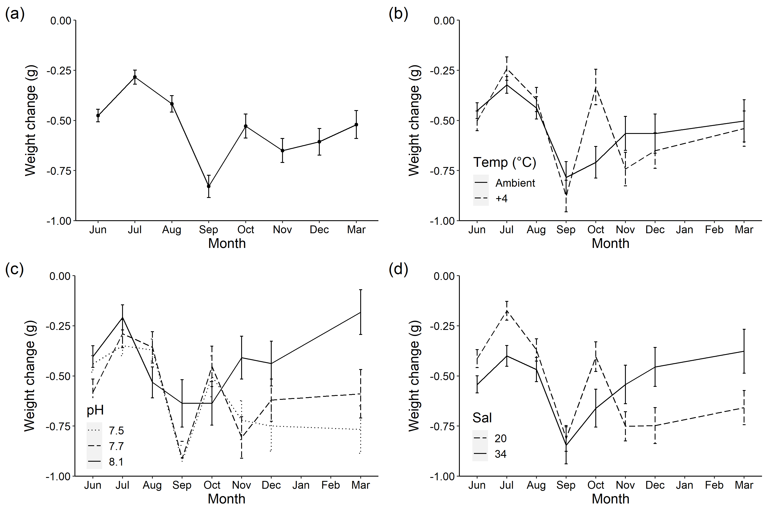
Figure 3. Mean weight change (l hr⁻¹ ± standard error) from their baseline weight at collection between June 2018 and March 2019 (a) across all treatments, (b) averaged for treatments at ambient or +4 °C to investigate temperature effect (c) averaged for treatments at a pH of 8.1, 7.7 or 7.5 to investigate pH effects and (d) averaged for treatments at a salinity of 20 or 34 to investigate salinity effect.

  - Clearance rate
Overall, mean clearance rates were highest at the beginning of the experiment in June and July 2018 at a maximum of 0.024 (±0.001) l hr⁻¹, standardized to 1g total weight. Clearance rate then decreased by more than half in August at 0.011 (±0.001) l hr⁻¹ and reached a minimum in January 2019 at 0.005 (±0.0004) l hr⁻¹. Clearance rate was also relatively stable between November 2018 and March 2019 (Fig. 4a).
The estimate of the autocorrelation parameter for both clearance rate models was 0.04 indicating almost complete independence of the measurements over time. There was no significant three-factor or two-factor interaction between any of the factors nor was there a significant long-term effect of temperature or pH (Fig. 4b, c). There was a statistically significant difference between the two salinity levels, with a larger volume of water cleared in a salinity of 34 compared a salinity of 20 (Table 1, Fig. 4d). There was no significant interaction between month and salinity, therefore the difference between the salinity levels was constant over time. Oysters in a salinity of 20 cleared an estimated 0.0016 (±0.0004) l hr⁻¹ less per month, approximately 20% less than those in a salinity of 34.
Overall, mean clearance rate across all treatments did not change with actual temperature of the water (Weighted linear regression: R² = 0.38, F_{1, 8} = 4.78, p = 0.06). Further, the salinity effect (difference between the two salinity levels per month) did not correlate actual temperature (Weighted linear regression: R² = 0.39, F_{1, 8} = 5.02, p = 0.06).

Table 1. Repeated measures ANOVA output stating the degrees of freedom, F-statistic and p-values for each individual factor and their interactions. Significant effects are denoted with an asterisk.
 | Clearance rate |  |  | Oxygen consumption rate
 | df | F (df, 94) | P | df | F (df, 101) | P
Month | 9 | 112.1 | <0.0001* | 9 | 21.8 | <0.0001*
Temperature | 1 | 0.04 | 0.83 | 1 | 11.29 | 0.001*
pH | 2 | 0.11 | 0.90 | 2 | 1.44 | 0.24
Salinity | 1 | 10.1 | <0.002* | 1 | 7.37 | 0.009*
Temp X pH | 2 | 0.95 | 0.39 | 2 | 0.71 | 0.50
Temp X Salinity | 1 | 0.72 | 0.40 | 1 | 0.06 | 0.81
pH X Salinity | 2 | 0.85 | 0.43 | 2 | 1.17 | 0.32
Temp X pH X Salinity | 2 | 1.68 | 0.19 | 2 | 0.35 | 0.71
Month X Temp | 9 | 0.21 | 0.99 | 9 | 2.05 | 0.03*
Month X pH | 18 | 0.72 | 0.78 | 18 | 0.89 | 0.59
Month X Salinity | 9 | 1.63 | 0.11 | 9 | 0.77 | 0.65

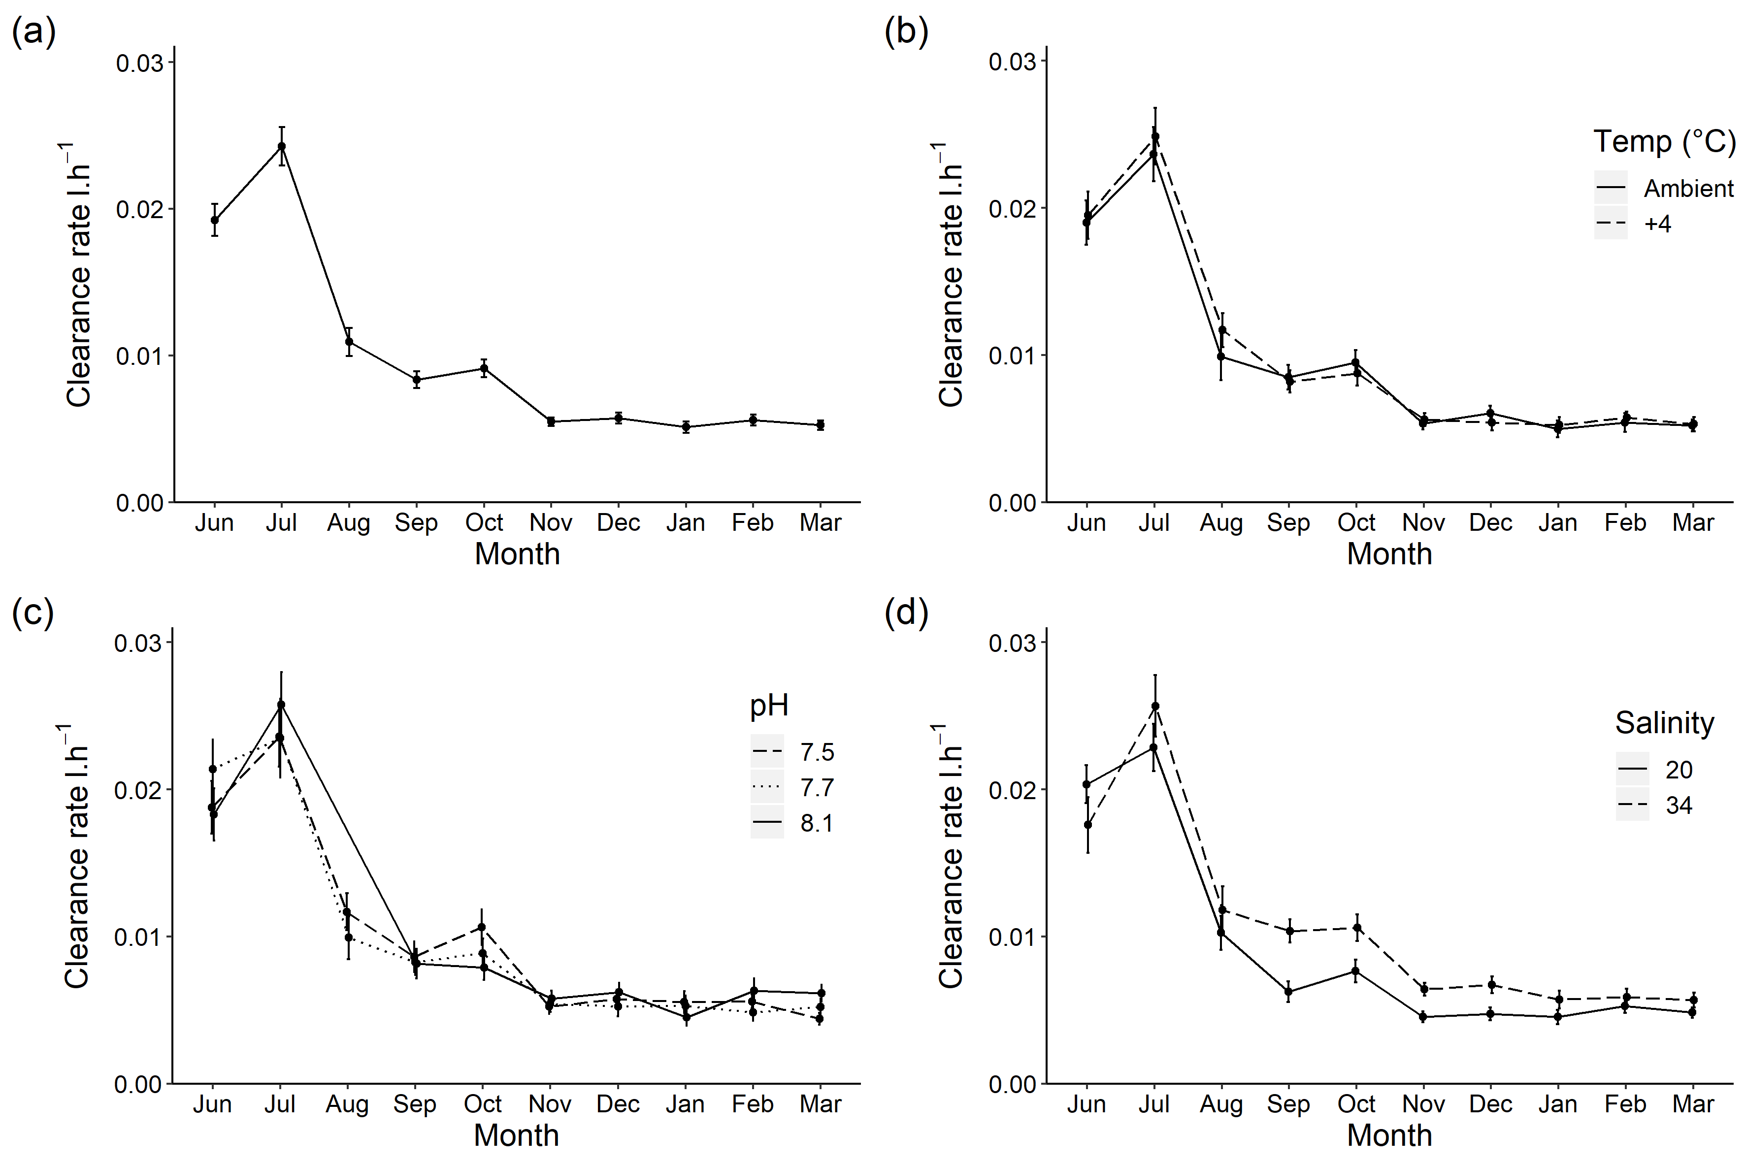
Figure 4. Mean clearance rates (l hr⁻¹ ± standard error) between June 2018 and March 2019 (a) across all treatments, (b) averaged for treatments at ambient or +4 °C to investigate temperature effect, (c) averaged for treatments at a pH of 8.1, 7.7 or 7.5 to investigate pH effects and (d) averaged for treatments at a salinity of 20 or 34 to investigate salinity effect. All rates are standardized to 0.01g total weight.

  - Oxygen consumption
Mean oxygen consumption rate across all treatments was highest between June and September 2018 before decreasing between September 2018 at 0.0077 (±0.0024) mg hr⁻¹, standardized to 1g total weight, to March 2019 at 0.0038 (±0.0019) mg hr⁻¹ (Fig. 5a). This decrease coincided with a decrease of 6°C between the warmest and coldest months of the experiment. Consumption was high at the beginning of the experiment although temperatures in June and July 2018 are similar to those in October and November 2018 where rates were lower.
The estimate of the autocorrelation parameter for oxygen consumption rate models was 0.04 indicating almost complete independence of the measurements over time. There was no significant interaction between any of the three experimental factors. There was a significant effect of temperature (Table 1, Fig. 5b). This was observed as those at +4°C had either equal to or higher oxygen consumption rates than the ambient treatments. There was a significant interaction between month and temperature, therefore, the difference in oxygen consumption rates between the temperature levels was not constant over time. There was, however, a large difference between factors during the first couple of months and minimal difference in oxygen consumption rates between August and January (Fig. 5b).
Oxygen consumption rate had no long-term trend with pH (Fig. 5c) and overall, the effect of pH was not statistically significant. There was a statistically significant effect of salinity (Table 1, Fig. 5d). There was no significant interaction between month and salinity, therefore the observed differences between the two salinity levels was constant over time. On average, a salinity of 20 led to an estimated 0.00056 (±0.0002) mg hr⁻¹ more oxygen being consumed, approximately 10%, compared to those kept at a salinity of 34.
Oxygen consumption increased significantly with increasing actual temperature (Fig. S2) (Weighted linear regression: R² = 0.89, F_{1, 8} = 66.42, p <0.001) at 0.0004 mg hr⁻¹ every 1°C increase. The salinity effect was not significantly affected by actual temperature.
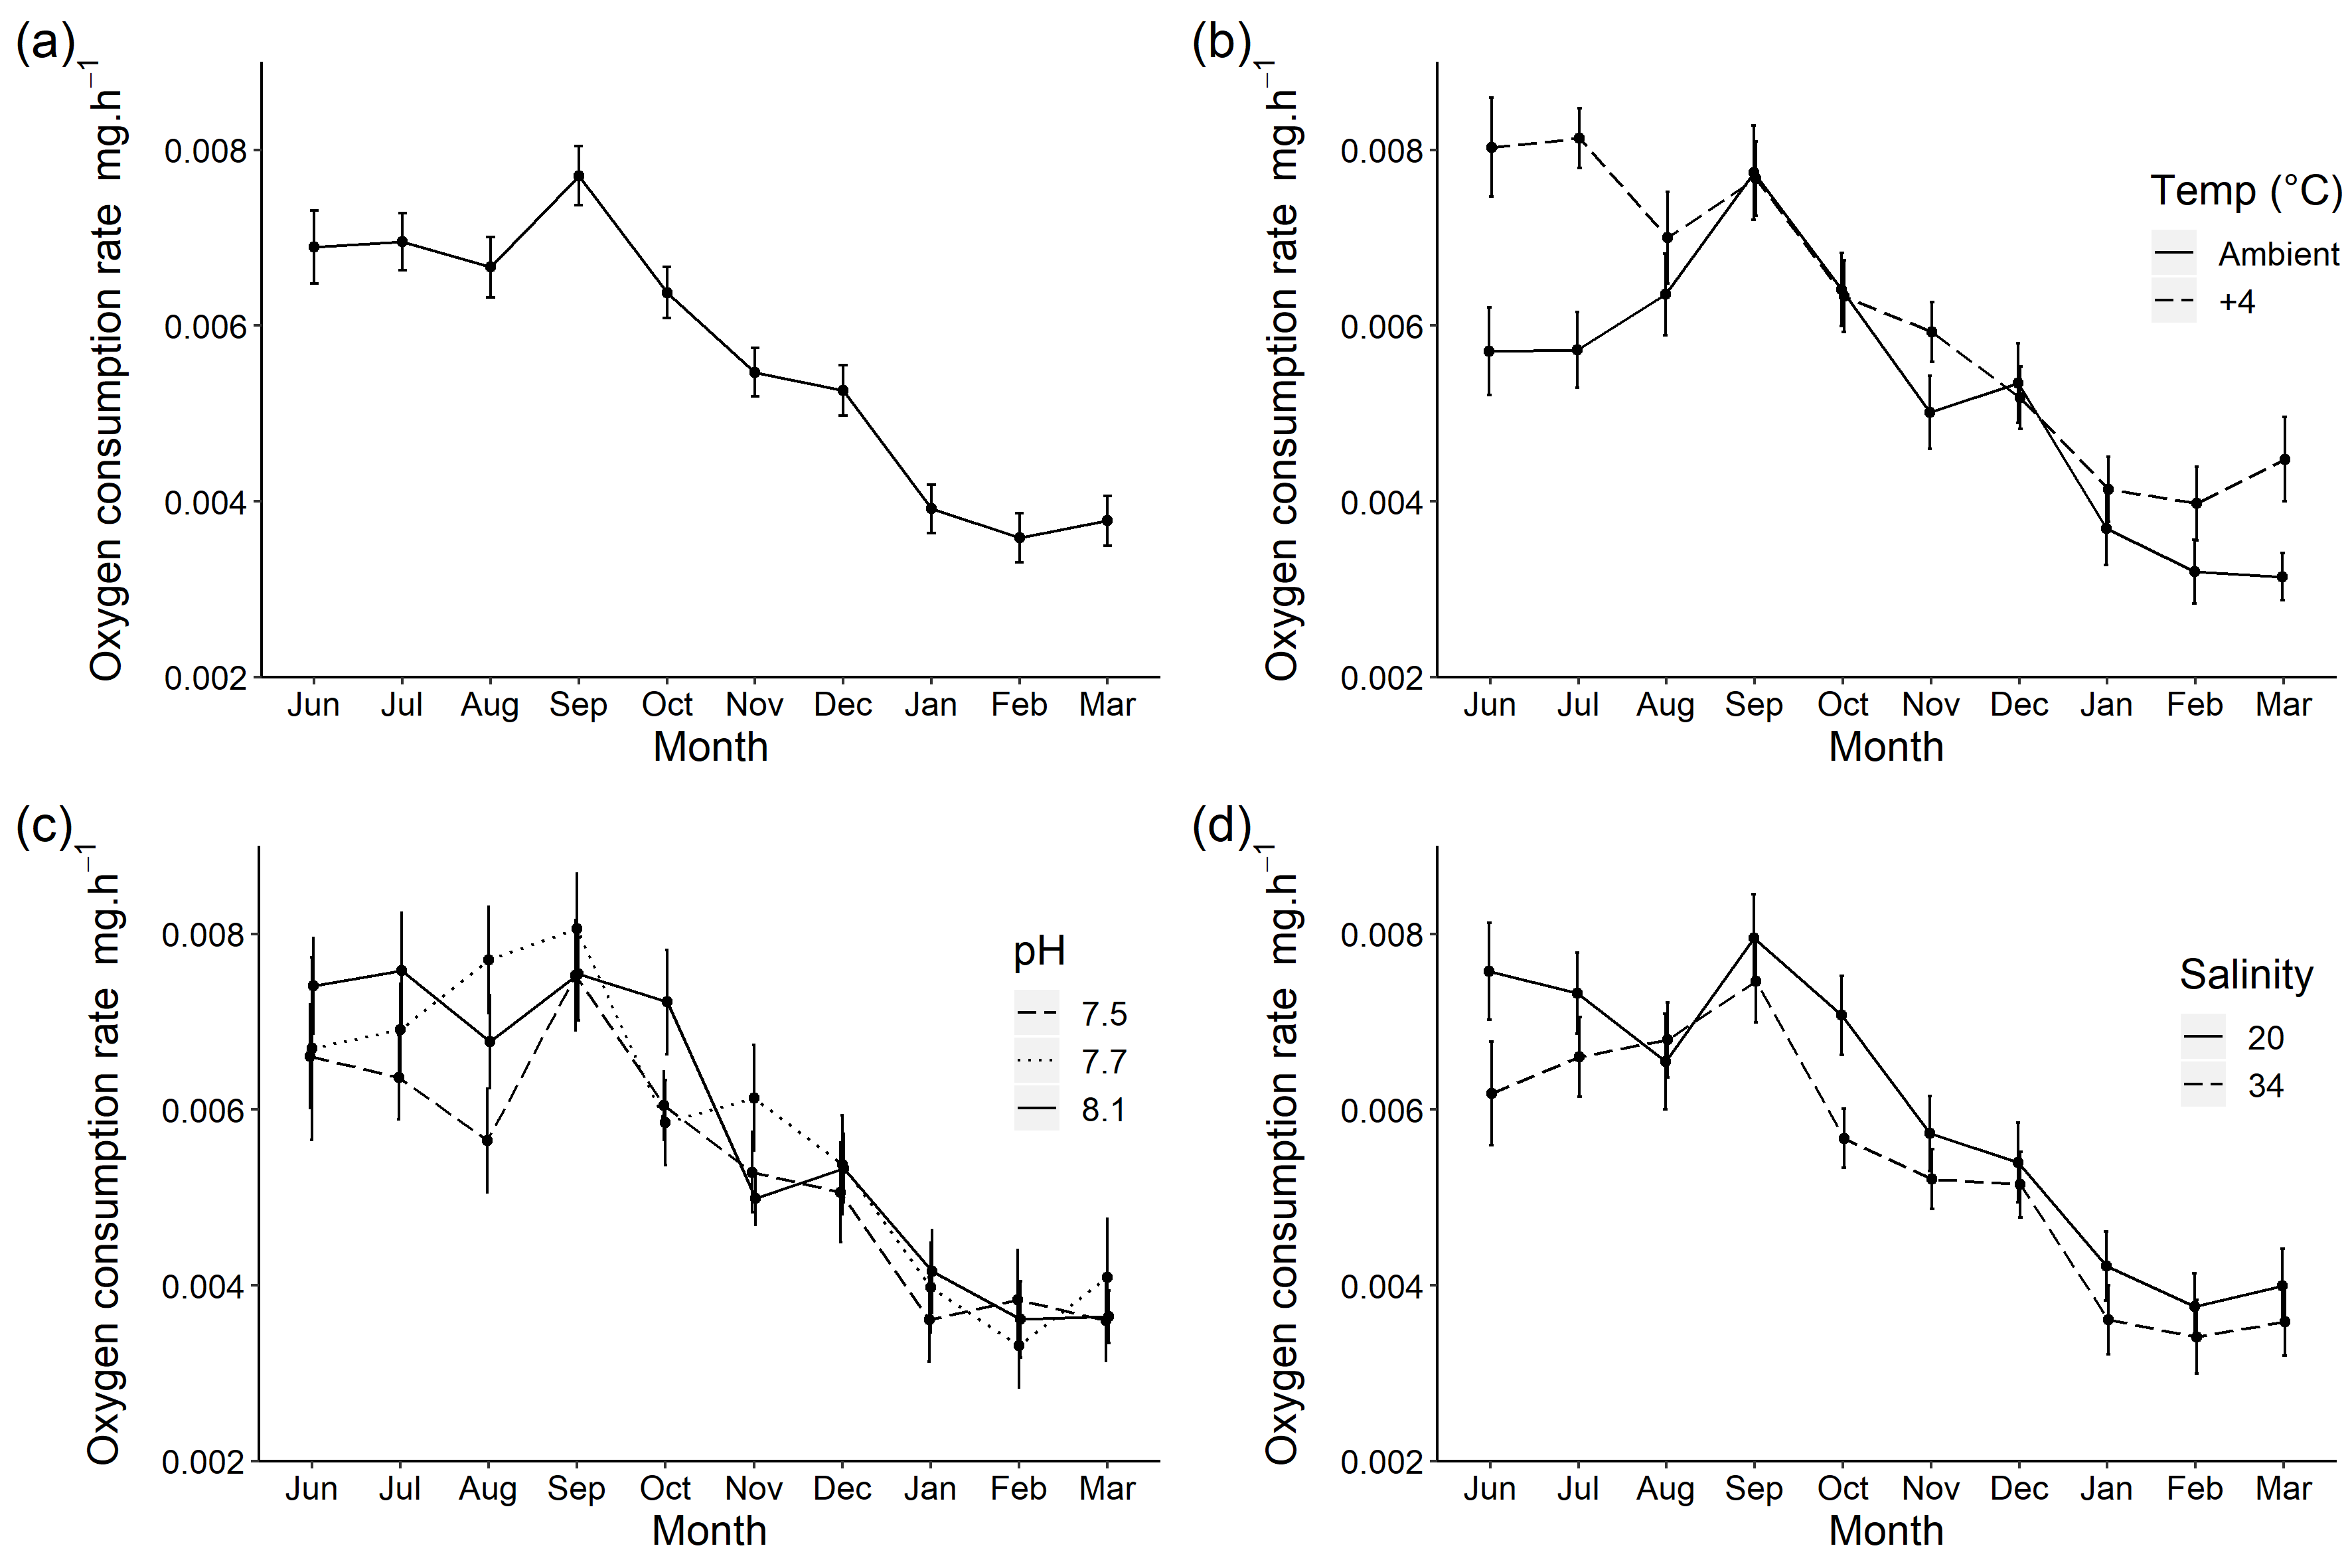
Figure 5. Mean oxygen consumption rates (mg hr⁻¹ ± standard error) between June 2018 and March 2019 (a) averaged across all treatments (b) averaged across treatments at ambient or +4 °C to investigate temperature effect, (c) averaged across treatments at a pH of 8.1, 7.7 or 7.5 and (d) averaged across treatments at a salinity of 20 or 34. All rates are standardized to 0.01 g total weight.

Discussion
Our long-term mesocosm experiment showed that reduced salinity conditions had a statistically significant, persistent impact on the physiology of M. gigas. In turn, water temperature and pH had little to no impact on clearance and oxygen consumption rates of M. gigas. This suggests that key environmental conditions as predicted by the end of the century will not negatively affect adult physiology and survival of this highly successful NIS. Our study highlights the importance of conducting long-term, seasonal experiments to fully understand the tolerance of NIS to abiotic stressors.
Broad environmental tolerance and phenotypic plasticity to environmental change are common traits of NIS compared to native species in marine and terrestrial environments (Daehler, 2003; Funk, 2008; Davidson et al., 2011; Tepolt & Somero, 2014). The ability of a species to alter its physiology and morphology to novel environmental conditions, such as CCC, may give them a competitive advantage over other species and, in the case of NIS, enable them to spread to a wide range of habitats (Stachowicz et al., 2002; Davidson et al., 2011). Our results support growing evidence that successful NIS have high environmental tolerance and will tolerate predicted future environmental conditions.
Salinity had a constant effect on M. gigas physiology over the duration of the experiment. It may, therefore, be physiologically necessary for M. gigas individuals to increase oxygen consumption rates and decrease clearance rates to ensure survival in areas of freshening. Other physiological studies have shown that M. gigas have faster growth and gonadal development at a salinity of 30 and reduced growth and larval mortality at lower salinities (Shumway & Koehn, 1982; Muranaka & Lannan, 1984; Brown & Hartwick, 1988; His et al., 1989). Environmental stressors such as low salinity result in changes in water chemistry (Dickinson et al., 2012; Casas et al., 2018b) and osmotic pressure (Maoxiao et al., 2019), which in turn increases energy expenditure (increase metabolic rate) or reduced energy storage capacity leading to reduced fitness, survival and growth (Lannig et al., 2006; Dickinson et al., 2012; Maoxiao et al., 2019). Our results showed that a salinity of 20 led to an increase in energy demand of M. gigas, as shown by an increased oxygen uptake (Hawkins & Hilbish, 1992; Lannig et al., 2006; Sokolova et al., 2012), therefore, may have had a negative impact on performance. This negative effect of salinity has also been observed in European flat oysters (Ostrea edulis) and eastern oysters (Crassostrea virginica) (Hutchinson & Hawkins, 1992; Dickinson et al., 2012).
Decreased clearance rates with salinity have already been reported as a stress response in other bivalves (Wang et al., 2011). Our results are consistent with the results found in Gray & Langdon (2018) with M. gigas which showing a decrease in clearance rates under reduced salinity conditions. Sarà et al. (2008) described how clearance rate decreased with lower salinities in the non-indigenous bivalve Brachidontes pharaonis but salinity followed the normal-shaped tolerance curve (decline in rates towards the extremes) and concluded this species can tolerate a wide range of salinities. Although lower salinities may be less favourable, M. gigas may be able to tolerate and survive these conditions better over the long-term compared to indigenous species. Whilst lower salinities may reduce the fitness of M. gigas, areas with low salinity such as estuaries have fewer competing species and predators, therefore, settlement will likely occur in these locations if conditions are tolerable to larval stages (Gunter, 1955).
It has been proposed that organisms inhabiting coastal areas and exposed to a range of temperatures and carbonate chemistry are more likely tolerant of future warming and ocean acidification (Range et al., 2012). M. gigas individuals used in our experiment were collected from a low-intertidal, estuarine environment that is classed as highly stressful for marine organisms as temperature, salinities and pH fluctuate on a daily basis (Lannig et al., 2006; Range et al., 2012). Local adaptation to this type of environment may explain why our manipulation of temperature and pH showed little to no long-term effect on M. gigas physiology. Although ocean acidification has been shown in many cases to suppress the growth and important physiological processes such as feeding and respiration (Range et al., 2012; Barros et al., 2013; Gazeau et al., 2013; Ivanina et al., 2013; Bressan et al., 2014; Zhao et al., 2017), some species show neutral or positive effects to near-future pH levels (Ries et al., 2009; Matoo et al., 2013; Gazeau et al., 2014). Zhang et al. (2012) found that M. gigas have an extensive set of genes that leads to unique adaptation to the stressful conditions of intertidal and estuarine environments. Further, both adult and early life-history stages of M. gigas have shown to have a high degree of plasticity in their physiology, such as thermal stress (Hamdoun et al., 2003), resource allocation and feeding (Honkoop et al., 2003; Ernande et al., 2004; Dutertre et al., 2007), reproductive timing (Fabioux et al., 2005), growth (Bayne, 2002; Taris et al., 2006), and circadian rhythms (Mat et al., 2012).
No clear temperature effect was observed in clearance rates whereby the overall rates were relatively similar between the highest and lowest temperatures. A similar trend has been recorded in Crassostrea virginica with no difference in clearance rate between individuals in the winter (17 °C) and summer (27 °C) (Casas et al., 2018b). Seasonality can have an important influence on physiological energetics. Studies have shown that clearance rates in bivalves are not always temperature dependent as seasonal cycles in life history traits (reproduction and growth) can lead to variation in filtration rates in bivalves, typically with reduced feeding in the winter months and an increase in spring and summer (Hornbach et al., 1984; Viergutz et al., 2012; Rahman et al., 2020). For example, Viergutz et al. (2012) showed that at peaks in clearance rate of the invasive bivalve Corbicula fluminea likely corresponded to spawning patterns increasing food (energy) demand. In our study, M. gigas clearance rates were not directly influence by seawater temperature, however, high rates were measured in the spring/early summer (at the start of the experiment). These rates were followed with a decrease in oyster weight in all treatments. M. gigas typically spawn between July and October in Europe which leads to a substantial decrease in wet meat weight (up to 50%) (Enríquez-Díaz et al., 2009; Bernard et al., 2016; Reise et al., 2017; Ubertini et al., 2017; Balić et al., 2020). It is, therefore, likely that an increase in energy demand (and, therefore, clearance rate) occurred prior to spawning.
Whilst a seasonal pattern in clearance rate is likely to have been observed, acclimation to new environmental conditions at the start of the experiment may have also led to increased clearance rates through an increased stress response. Acclimation can be characterized by an initial stress response (for example, increased metabolic rate) followed by a stabilization of the organism’s response (Suckling et al., 2015). The acclimation of species to new environmental conditions can take several months (Dupont et al., 2013; Suckling et al., 2015; Pintor et al., 2016) and, as clearance rates were high at the very start of the experiment, the effects of species acclimation on M. gigas cannot be fully ruled out.
A seasonal effect on oxygen consumption was observed across all treatments in line with changes in SST. Similar trends in oxygen consumption rates have been reported in situ for M. gigas where the highest and lowest oxygen consumption rates occurred in the summer and winter, respectively (Mao et al., 2006; Casas et al., 2018b). Increasing oxygen consumption with actual temperature agrees with several studies on marine bivalves (Bougrier et al., 1995; Ren et al., 2000; Sarà et al., 2008; Casas et al., 2018b), reflecting an increase in physiological and biochemical reactions with warming. Seasonality in metabolic demand may also reflect life history cycles, which are often linked to seawater temperature (Clarke, 1993; Casas et al., 2018a). Oxygen consumption rates also showed a significant effect of temperature with month, however, the effect of +4°C was variable. Rates were similar to that of the ambient temperature treatment with the exception of June and July and, to a lesser extent, February and March where +4°C is associated with higher oxygen consumption rate (Fig. 4b). The effects of end of the century temperatures on M. gigas may, therefore, be dependent on time of the year.
Although the adult oysters used in this study exhibited no negative effect with ocean acidification, studies on early life stages have shown vastly different results. Ocean acidification has been shown to have a negative effect on the development and calcification of early life stage M. gigas under pH values predicted for 2100 and 2300 (Kurihara et al., 2007; Parker et al., 2010) and varying effects on fertilization due to intraspecific differences between populations (Havenhand & Schlegel, 2009; Parker et al., 2010; Barros et al., 2013). Studies over multiple generations are rare but give an important insight on the potential carry-over effects between different life stages. These studies would increase understanding regarding trans-generational acclimation which has been shown in a variety of species to reduce the effects of CCC (Donelson et al., 2011; Munday, 2014; Parker et al., 2015; Ross et al., 2016). For a more complete understanding of the long-term effects of CCC on individual species, it is crucial for future work to incorporate individuals from multiple populations and multiple generations into their experimental designs to investigate both intraspecific differences and the potential acclimation of a species through trans-generational carry-over effects to environmental change.

- Conclusion
This is the first long-term multiple stressor study on M. gigas and demonstrated that a globally distributed NIS is tolerant to key CCC stressors, as predicted for the end of the century. Our results imply that NIS with broad environmental tolerances like M. gigas may thrive under expected CCC conditions, potentially leading to an increase in NIS populations and further impacting native biodiversity (Dubois et al., 2006; Kelly et al., 2008; Lejart & Hily, 2011; Anglès d'Auriac et al., 2017). Although previous studies have shown negative synergistic effects of CCC factors on organism fitness, we found no interactive effects between any of the three stressors over the long-term. However, further long-term, trans-generational studies are required to investigate the presence of possible synergistic effects across multiple life-history stages (Rius et al., 2010). Our results also demonstrated how seasonality may influence physiological rates importance of allowing the studied organism to reach a physiologically stable state (Suckling et al., 2015), which is key for interpreting laboratory experiments of differing temporal lengths. Ultimately, the long-term effects of CCC on NIS are still relatively unknown and continued research in this area will advance our understanding on the physiological resilience of NIS to environmental change.

Acknowledgments
We would like to thank Dr. Simon Pack for his expertise and advice with statistics and James Robbins for proof reading drafts of this paper. We also thank the volunteers and interns who helped with the day-to-day maintenance of the mesocosm system, specifically Katherine McGregor and Michael Cooper for their help and enthusiasm, and Kevin Atkins for his technical support. This work was supported by the Natural Environmental Research Council [grant number NE/L002531/1].

References
Anglès, D'auriac MB, Rinde, E, Norling, P, Lapègue, S, Staalstrøm, A, Hjermann, DØ and Thaulow, J (2017) Rapid expansion of the invasive oyster Crassostrea gigas at its northern distribution limit in Europe: Naturally dispersed or introduced? PloS One 12, e0177481.
Balić, DE, Radonić, I, Varezić, DB, Zorica, B, Arapov, J, Stagličić, N, Jozić, S, Peharda, M, Briski, E and Lin, Y (2020) Reproductive cycle of a non-native oyster, Crassostrea gigas, in the Adriatic Sea. Mediterranean Marine Science 21, 146-156.
Barros, P, Sobral, P, Range, P, Chícharo, L and Matias, D (2013) Effects of sea-water acidification on fertilization and larval development of the oyster Crassostrea gigas. Journal of Experimental Marine Biology and Ecology 440, 200-206.
Bayne, BL (2002) A physiological comparison between Pacific oysters Crassostrea gigas and Sydney Rock oysters Saccostrea glomerata: food, feeding and growth in a shared estuarine habitat. Marine Ecology Progress Series 232, 163-178.
Bernard, I, Massabuau, JC, Ciret, P, Sow, M, Sottolichio, A, Pouvreau, S and Tran, D (2016) In situ spawning in a marine broadcast spawner, the Pacific oyster Crassostrea gigas: Timing and environmental triggers. Limnology and Oceanography 61, 635-647.
Bougrier, S, Geairon, P, Deslous-Paoli, JM, Bacher, C and Jonquières, G (1995) Allometric relationships and effects of temperature on clearance and oxygen consumption rates of Crassostrea gigas (Thunberg). Aquaculture 134, 143-154.
Braby, CE and Somero, GN (2006) Following the heart: temperature and salinity effects on heart rate in native and invasive species of blue mussels (genus Mytilus). Journal of Experimental Biology 209, 2554.
Bressan, M, Chinellato, A, Munari, M, Matozzo, V, Manci, A, Marčeta, T, Finos, L, Moro, I, Pastore, P, Badocco, D and Marin, MG (2014) Does seawater acidification affect survival, growth and shell integrity in bivalve juveniles? Marine Environmental Research 99, 136-148.
Brown, JR and Hartwick, EB (1988) Influences of temperature, salinity and available food upon suspended culture of the Pacific oyster, Crassostrea gigas: I. Absolute and allometric growth. Aquaculture 70, 231-251.
Caldeira, K and Wickett, ME (2003) Anthropogenic carbon and ocean pH. Nature 425, 365.
Caldeira, K and Wickett, ME (2005) Ocean model predictions of chemistry changes from carbon dioxide emissions to the atmosphere and ocean. Journal of Geophysical Research: Oceans 110.
Carlton, JT and Geller, JB (1993) Ecological roulette: the global transport of nonindigenous marine organisms. Science 261, 78-82.
Carlton, JT 2000. Global change and biological invasions in the oceans. In: Mooney, HA and Hobbs, RJ (eds.) Invasive species in a changing world. Washington D.C: Island Press, 31-53.
Casas, SM, Filgueira, R, Lavaud, R, Comeau, LA, La Peyre, MK and La Peyre, JF (2018a) Combined effects of temperature and salinity on the physiology of two geographically-distant eastern oyster populations. Journal of Experimental Marine Biology and Ecology 506, 82-90.
Casas, SM, Lavaud, R, La Peyre, MK, Comeau, LA, Filgueira, R and La Peyre, JF (2018b) Quantifying salinity and season effects on eastern oyster clearance and oxygen consumption rates. Marine Biology 165, 90.
Chen, IC, Hill, JK, Ohlemüller, R, Roy, DB and Thomas, CD (2011) Rapid range shifts of species associated with high levels of climate warming. Science 333, 1024.
Cheung, WWL, Lam, VWY, Sarmiento, JL, Kearney, K, Watson, R and Pauly, D (2009) Projecting global marine biodiversity impacts under climate change scenarios. Fish and Fisheries 10, 235-251.
Clarke, A (1993) Seasonal acclimatization and latitudinal compensation in metabolism: do they exist? Functional Ecology 7, 139-149.
Cognetti, G and Maltagliati, F (2000) Biodiversity and adaptive mechanisms in brackish water fauna. Marine Pollution Bulletin 40, 7-14.
Coughlan, J (1969) The estimation of filtering rate from the clearance of suspensions. Marine Biology 2, 356-358.
D’Amen, M and Azzurro, E (2020) Integrating univariate niche dynamics in species distribution models: A step forward for marine research on biological invasions. Journal of Biogeography 47, 686– 697.
Daehler, CC (2003) Performance comparisons of co-occurring native and alien invasive plants: implications for conservation and restoration. Annual Review of Ecology, Evolution, and Systematics 34, 183-211.
Davidson, AM, Jennions, M and Nicotra, AB (2011) Do invasive species show higher phenotypic plasticity than native species and, if so, is it adaptive? A meta-analysis. Ecology Letters 14, 419-431.
Delorme NJ and Sewell, MA (2014) Temperature and salinity: two climate change stressors affecting early development of the New Zealand sea urchin Evechinus chloroticus. Marine Biology 161, 1999-2009.
Dickinson GH, Ivanina, AV, Matoo, OB, Pörtner, HO, Lannig, G, Bock, C, Beniash, E and Sokolova, IM (2012) Interactive effects of salinity and elevated CO2 levels on juvenile eastern oysters, Crassostrea virginica. Journal of Experimental Biology 215, 29-43.
Donelson, JM, Munday, PL, Mccormick, MI and Pitcher, CR (2011) Rapid transgenerational acclimation of a tropical reef fish to climate change. Nature Climate Change 2, 30.
Dubois, S, Commito, JA, Olivier, F and Retière, C (2006) Effects of epibionts on Sabellaria alveolata (L.) biogenic reefs and their associated fauna in the Bay of Mont Saint-Michel. Estuarine, Coastal and Shelf Science 68, 635-646.
Dukes, JS and Mooney, HA (1999) Does global change increase the success of biological invaders? Trends in Ecology & Evolution 14, 135-139.
Dupont, S, Dorey, N, Stumpp, M, Melzner, F and Thorndyke, M (2013) Long-term and trans-life-cycle effects of exposure to ocean acidification in the green sea urchin Strongylocentrotus droebachiensis. Marine Biology 160, 1835-1843.
Dutertre, M, Barillé, L, Haure, J and Cognie, B (2007) Functional responses associated with pallial organ variations in the Pacific oyster Crassostrea gigas (Thunberg, 1793). Journal of Experimental Marine Biology and Ecology 352, 139-151.
Eno, NC, Clark, RA and Sanderson, WG (1997) Non-native marine species in British waters: A review and directory, Peterborough: JNCC.
Enríquez-Díaz, M, Pouvreau, S, Chávez-Villalba, J and Le Pennec, M (2009) Gametogenesis, reproductive investment, and spawning behavior of the Pacific giant oyster Crassostrea gigas: evidence of an environment-dependent strategy. Aquaculture International 17, 491.
Ernande, B, Boudry, P, Clobert, J and Haure, J (2004) Plasticity in resource allocation based life history traits in the Pacific oyster, Crassostrea gigas. I. Spatial variation in food abundance. Journal of Evolutionary Biology 17, 342-356.
Fabioux, C, Huvet, A, Le Souchu, P, Le Pennec, M and Pouvreau, S (2005) Temperature and photoperiod drive Crassostrea gigas reproductive internal clock. Aquaculture 250, 458-470.
Falkenberg, LJ, Styan, CA and Havenhand, JN (2019) Sperm motility of oysters from distinct populations differs in response to ocean acidification and freshening. Scientific Reports 9, 7970.
FAO (2019) FAO yearbook. Fishery and Aquaculture Statistics 2017/FAO annuaire. Statistiques des pêches et de l’aquaculture 2017/ FAO anuario. Estadísticas de pesca y acuicultura 2017. Rome, 1-109.
Form, AU and Riebesell, U (2011) Acclimation to ocean acidification during long‐term CO2 exposure in the cold‐water coral Lophelia pertusa. Global Change Biology 18, 843-853.
Funk, JL (2008) Differences in plasticity between invasive and native plants from a low resource environment. Journal of Ecology 96, 1162-1173.
Gattuso, J-P, Magnan, A, Billé, R, Cheung, WW, Howes, EL, Joos, F, Allemand, D, Bopp, L, Cooley, SR and Eakin, CM (2015) Contrasting futures for ocean and society from different anthropogenic CO2 emissions scenarios. Science 349, aac4722.
Gazeau, F, Parker, LM, Comeau, S, Gattuso, J-P, O’Connor, WA, Martin, S, Pörtner, H-O and Ross, PM (2013) Impacts of ocean acidification on marine shelled molluscs. Marine Biology 160, 2207-2245.
Gazeau, F, Alliouane, S, Bock, C, Bramanti, L, López Correa, M, Gentile, M, Hirse, T, Pörtner, H-O and Ziveri, P (2014) Impact of ocean acidification and warming on the Mediterranean mussel (Mytilus galloprovincialis). Frontiers in Marine Science 1, 1-12.
Gbif.Org. 7 October 2019. GBIF Occurrence Download https://doi.org/10.15468/dl.qtnjkf [Online]. [Accessed 7th October 2019].
Gray, MW and Langdon, CJ (2018) Ecophysiology of the Olympia Oyster, Ostrea lurida, and Pacific Oyster, Crassostrea gigas. Estuaries and Coasts 41, 521-535.
Grosholz Edwin, D, Ruiz Gregory, M, Dean Cheryl, A, Shirley Kim, A, Maron John, L and Connors Peter, G (2000) The impacts of a nonindigenous marine predator in a California Bay. Ecology 81, 1206-1224.
Gunter, G (1955) Mortality of oysters and abundance of certain associates as related to salinity. Ecology 36, 601-605.
Hamdoun, AM, Cheney, DP and Cherr, GN (2003) Phenotypic plasticity of HSP70 and HSP70 gene expression in the Pacific oyster (Crassostrea gigas): implications for thermal limits and induction of thermal tolerance. The Biological Bulletin 205, 160-169.
Havenhand, JN and Schlegel, P (2009) Near-future levels of ocean acidification do not affect sperm motility and fertilization kinetics in the oyster Crassostrea gigas. Biogeosciences 6, 3009-3015.
Hawkins, AJS and Hilbish, TJ (1992) The costs of cell volume regulation: protein metabolism during hyperosmotic adjustment. Journal of the Marine Biological Association of the United Kingdom 72, 569-578.
Hellmann, JJ, Byers, JE, Bierwagen, BG and Dukes, JS (2008) Five potential consequences of climate change for invasive species. Conservation Biology 22, 534-543.
Helmuth, B, Mieszkowska, N, Moore, P and Hawkins, SJ (2006) Living on the edge of two changing worlds: forecasting the responses of rocky intertidal ecosystems to climate change. Annual Review of Ecology, Evolution, and Systematics 37, 373-404.
Herbert, RJH, Humphreys, J, Davies, CJ, Roberts, C, Fletcher, S and Crowe, TP (2016) Ecological impacts of non-native Pacific oysters (Crassostrea gigas) and management measures for protected areas in Europe. Biodiversity and Conservation 25, 2835-2865.
Hickling, R, Roy, DB, Hill, JK, Fox, R and Thomas, CD (2006) The distributions of a wide range of taxonomic groups are expanding polewards. Global Change Biology 12, 450-455.
His, E, Robert, R and Dinet, A (1989) Combined effects of temperature and salinity on fed and starved larvae of the mediterranean mussel Mytilus galloprovincialis and the Japanese oyster Crassostrea gigas. Marine Biology 100, 455-463.
Hollister, RD, Webber, PJ and Tweedie, CE (2005) The response of Alaskan arctic tundra to experimental warming: differences between short- and long-term responses. Global Change Biology 11, 525-536.
Holm MW, Davids, JK, Dolmer, P, Holmes, E and Nielsen, T (2016) Coexistence of Pacific oyster Crassostrea gigas (Thunberg, 1793) and blue mussels Mytilus edulis Linnaeus, 1758 on a sheltered intertidal bivalve bed? Aquatic Invasions 11, 155-165.
Honkoop, PJC, Bayne, BL and Drent, J (2003) Flexibility of size of gills and palps in the Sydney rock oyster Saccostrea glomerata (Gould, 1850) and the Pacific oyster Crassostrea gigas (Thunberg, 1793). Journal of Experimental Marine Biology and Ecology 282, 113-133.
Hornbach, DJ, Way, C, Wissing, TE and Burky, AJ (1984) Effects of particle concentration and season on the filtration rates of the freshwater clam, Sphaerium striatinum Lamarck (Bivalvia: Pisidiidae). Hydrobiologia 108, 83-96.
Hughes, SL, Tinker, J, Dye, S, Andres, O, Berry, DI, Hermanson, L, Hewitt, N, Holliday, NP, Kent, EC, Kennington, K, Inall, M and Smyth, T (2017) Temperature. MCCIP Science Review 2017, 22-41.
Hutchinson, S and Hawkins, LE (1992) Quantification of the physiological responses of the European flat oyster Ostrea edulis L. to temperature and salinity. Journal of Molluscan Studies 58, 215-226.
IPCC (2019) Technical summary. In: PöRtner, HO, Roberts, DC, Masson-Delmotte, V, Zhai, P, Poloczanska, E, Mintenbeck, K, Tignor, M, AlegríA, A, Nicolai, M, Okem, A, Petzold, J, Rama, B and Weyer, NM (eds.) IPCC special report on the ocean and cryosphere in a changing climate, 39-69.
Ivanina, AV, Dickinson, GH, Matoo, OB, Bagwe, R, Dickinson, A, Beniash, E and Sokolova, IM (2013) Interactive effects of elevated temperature and CO2 levels on energy metabolism and biomineralization of marine bivalves Crassostrea virginica and Mercenaria mercenaria. Comparative Biochemistry and Physiology Part A: Molecular & Integrative Physiology 166, 101-111.
Jenkins, G, Perry, M and Prior, J (2009) UKCIP08: the climate of the United Kingdom and recent trends. Exeter: Met Office Hadley Centre, 1-119.
Jensen, AC, Humphreys, J, Caldow, RWG, Grisley, C and Dyrynda, PEJ (2004) Naturalization of the Manila clam (Tapes philippinarum), an alien species, and establishment of a clam fishery within Poole Harbour, Dorset. Journal of the Marine Biological Association of the United Kingdom 84, 1069-1073.
Kelly, JR, Proctor, H and Volpe, JP (2008) Intertidal community structure differs significantly between substrates dominated by native eelgrass (Zostera marina L.) and adjacent to the introduced oyster Crassostrea gigas (Thunberg) in British Columbia, Canada. Hydrobiologia 596, 57-66.
Kroeker, KJ, Kordas, RL, Crim, R, Hendriks, IE, Ramajo, L, Singh, GS, Duarte, CM and Gattuso, J-P (2013) Impacts of ocean acidification on marine organisms: quantifying sensitivities and interaction with warming. Global Change Biology 19, 1884-1896.
Kurihara, H, Kato, S and Ishimatsu, A (2007) Effects of increased seawater pCO2 on early development of the oyster Crassostrea gigas. Aquatic Biology 1, 91-98.
Lannig, G, Flores, JF and Sokolova, IM (2006) Temperature-dependent stress response in oysters, Crassostrea virginica: Pollution reduces temperature tolerance in oysters. Aquatic Toxicology 79, 278-287.
Lannig, G, Eilers, S, Pörtner, HO, Sokolova, IM and Bock, C (2010) Impact of ocean acidification on energy metabolism of oyster, Crassostrea gigas—changes in metabolic pathways and thermal response. Marine Drugs 8, 2318-2339.
Lejart, M and Hily, C (2005) Proliferation of Crassostrea gigas (Thunberg) in the Bay of Brest: First estimations of the stock and its impact on the global functioning of the ecosystem. 8th International Conference on Shellfish Restoration. Brest, France.
Lejart, M and Hily, C (2011) Differential response of benthic macrofauna to the formation of novel oyster reefs (Crassostrea gigas, Thunberg) on soft and rocky substrate in the intertidal of the Bay of Brest, France. Journal of Sea Research 65, 84-93.
Lemasson, AJ, Hall-Spencer, JM, Fletcher, S, Provstgaard-Morys, S and Knights, AM (2018) Indications of future performance of native and non-native adult oysters under acidification and warming. Marine Environmental Research 142, 178-189.
Leuzinger, S, Luo, Y, Beier, C, Dieleman, W, Vicca, S and Körner, C (2011) Do global change experiments overestimate impacts on terrestrial ecosystems? Trends in Ecology & Evolution 26, 236-241.
Lowe, JA, Howard, TP, Pardens, A, Tinker, J, Holt, J, Wakelin, S, Milne, G, Leake, J, Wolf, J, Horsburgh, K, Reeder, T, Jenkins, G, Ridley, J, Dye, S and Bradley, S (2009) UK Climate Projections science report: Marine and coastal projections. Exeter: Met Office Hadley Centre, 1-99.
Manchester, SJ and Bullock, JM (2000) The impacts of non-native species on UK biodiversity and the effectiveness of control. Journal of Applied Ecology 37, 845-864.
Mao, Y, Zhou, Y, Yang, H and Wang, R (2006) Seasonal variation in metabolism of cultured Pacific oyster, Crassostrea gigas, in Sanggou Bay, China. Aquaculture 253, 322-333.
Maoxiao, P, Xiaojun, L, Donghong, N, Bo, Y, Tianyi, L, Zhiguo, D and Jiale, L (2019) Survival, growth and physiology of marine bivalve (Sinonovacula constricta) in long-term low-salt culture. Scientific Reports 9, 2819.
Mat, AM, Massabuau, J-C, Ciret, P and Tran, D (2012) Evidence for a plastic dual circadian rhythm in the oyster Crassostrea gigas. Chronobiology International 29, 857-867.
Matoo, OB, Ivanina, AV, Ullstad, C, Beniash, E and Sokolova, IM (2013) Interactive effects of elevated temperature and CO2 levels on metabolism and oxidative stress in two common marine bivalves (Crassostrea virginica and Mercenaria mercenaria). Comparative Biochemistry and Physiology Part A: Molecular & Integrative Physiology 164, 545-553.
Mieszkowska, N, Kendall, MA, Hawkins, SJ, Leaper, R, Williamson, P, Hardman-Mountford, NJ and Southward, AJ (2006) Changes in the range of some common rocky shore species in Britain — a response to climate change? Hydrobiologia 555, 241-251.
Miranda, R, Coleman, MA, Tagliafico, A, Rangel, MS, Mamo, LT, Barros, F and Kelaher, BP (2019) Invasion-mediated effects on marine trophic interactions in a changing climate: positive feedbacks favour kelp persistence. Proceedings of the Royal Society B 286, 20182866.
Munday, PL, Warner, RR, Monro, K, Pandolfi, JM, Marshall, DJ and Wootton, T (2013) Predicting evolutionary responses to climate change in the sea. Ecology Letters 16, 1488-1500.
Munday, PL (2014) Transgenerational acclimation of fishes to climate change and ocean acidification. F1000prime Reports 6, 1-7.
Muranaka, MS and Lannan, JE (1984) Broodstock management of Crassostrea gigas: Environmental influences on broodstock conditioning. Aquaculture 39, 217-228.
Nguyen, HM, Yadav, NS, Barak, S, Lima, FP, Sapir, Y and Winters, G (2020) Responses of invasive and native populations of the seagrass Halophila stipulacea to simulated climate change. Frontiers in Marine Science 10, 812.
Nichols, FH, Thompson, JK and Schemel, LE (1990) Remarkable invasion of San Francisco Bay (California, USA) by the Asian clam Potamocorbula amurensis. II. Displacement of a former community. Marine Ecology Progress Series 66, 95-101.
Occhipinti-Ambrogi, A (2007) Global change and marine communities: alien species and climate change. Marine Pollution Bulletin 55, 342-352.
Occhipinti-Ambrogi, A and Galil, B (2010) Marine alien species as an aspect of global change. Advances in Oceanography and Limnology 1, 199-218.
Paavola, M, Olenin, S and Leppäkoski, E (2005) Are invasive species most successful in habitats of low native species richness across European brackish water seas? Estuarine, Coastal and Shelf Science 64, 738-750.
Palumbi, SR, Barshis, DJ, Traylor-Knowles, N and Bay, RA (2014) Mechanisms of reef coral resistance to future climate change. Science 344, 895-898.
Parker, LM, Ross, PM and O’Connor, WA (2010) Comparing the effect of elevated pCO2 and temperature on the fertilization and early development of two species of oysters. Marine Biology 157, 2435-2452.
Parker, LM, O’Connor, WA, Raftos, DA, Pörtner, H-O and Ross, PM (2015) Persistence of positive carryover effects in the oyster, Saccostrea glomerata, following transgenerational exposure to ocean acidification. PLoS One 10, e0132276.
Parmesan, C and Yohe, G (2003) A globally coherent fingerprint of climate change impacts across natural systems. Nature 421, 37-42.
Parmesan, C, Gaines, S, Gonzalez, L, Kaufman, DM, Kingsolver, J, Townsend Peterson, A and Sagarin, R (2005) Empirical perspectives on species borders: from traditional biogeography to global change. Oikos 108, 58-75.
Pecl, GT, Araújo, MB, Bell, JD, Blanchard, J, Bonebrake, TC, Chen, IC, Clark, TD, Colwell, RK, Danielsen, F, Evengård, B, Falconi, L, Ferrier, S, Frusher, S, Garcia, RA, Griffis, RB, Hobday, AJ, Janion-Scheepers, C, Jarzyna, MA, Jennings, S, Lenoir, J, Linnetved, HI, Martin, VY, Mccormack, PC, Mcdonald, J, Mitchell, NJ, Mustonen, T, Pandolfi, JM, Pettorelli, N, Popova, E, Robinson, SA, Scheffers, BR, Shaw, JD, Sorte, CJB, Strugnell, JM, Sunday, JM, Tuanmu, M-N, Vergés, A, Villanueva, C, Wernberg, T, Wapstra, E and Williams, SE (2017) Biodiversity redistribution under climate change: Impacts on ecosystems and human well-being. Science 355, 6332.
Pintor, AF, Schwarzkopf, L and Krockenberger, AK (2016) Extensive acclimation in ectotherms conceals interspecific variation in thermal tolerance limits. PloS One 11, e0150408.
Pourmozaffar ,S, Tamadoni Jahromi, S, Rameshi, H, Sadeghi, A, Bagheri, T, Behzadi, S, Gozari, M, Zahedi, MR and Abrari Lazarjani, S (2020) The role of salinity in physiological responses of bivalves. Reviews in Aquaculture 12, 1548-1566.
Przeslawski, R, Davis, AR and Benkendorff, K (2005) Synergistic effects associated with climate change and the development of rocky shore molluscs. Global Change Biology 11, 515-522.
Przeslawski, R, Byrne, M and Mellin, C (2015) A review and meta-analysis of the effects of multiple abiotic stressors on marine embryos and larvae. Global Change Biology 21, 2122-2140.
Rahel, FJ and Olden, JD (2008) Assessing the effects of climate change on aquatic invasive species. Conservation Biology 22, 521-533.
Rahman, MA, Henderson, S, Miller-Ezzy, PA, Li, XX and Qin, JG (2020) Analysis of the seasonal impact of three marine bivalves on seston particles in water column. Journal of Experimental Marine Biology and Ecology 522, 151251.
Range, P, Piló, D, Ben-Hamadou, R, Chícharo, MA, Matias, D, Joaquim, S, Oliveira, AP and Chícharo, L (2012) Seawater acidification by CO2 in a coastal lagoon environment: effects on life history traits of juvenile mussels Mytilus galloprovincialis. Journal of Experimental Marine Biology and Ecology 424-425, 89-98.
Reise, K, Buschbaum, C, Büttger, H, Rick, J and Wegner, KM (2017) Invasion trajectory of Pacific oysters in the northern Wadden Sea. Marine Biology 164, 68.
Ren, JS, Ross, AH and Schiel, DR (2000) Functional descriptions of feeding and energetics of the Pacific oyster Crassostrea gigas in New Zealand. Marine Ecology Progress Series 208, 119-130.
Richardson, DM, Pyšek, P, Rejmánek, M, Barbour, MG, Panetta, FD and West, CJ (2000) Naturalization and invasion of alien plants: concepts and definitions. Diversity and Distributions 6, 93-107.
Ries, JB, Cohen, AL and Mccorkle, DC (2009) Marine calcifiers exhibit mixed responses to CO2-induced ocean acidification. Geology 37, 1131-1134.
Rijnsdorp, AD, Peck, MA, Engelhard, GH, Möllmann, C and Pinnegar, JK (2009) Resolving the effect of climate change on fish populations. ICES Journal of Marine Science 66, 1570-1583.
Rius, M, Turon, X, Dias, GM and Marshall, DJ, 2010. Propagule size effects across multiple life‐history stages in a marine invertebrate. Functional Ecology 24, 685-693.
Rius, M, Clusella-Trullas, S, Mcquaid, CD, Navarro, RA, Griffiths, CL, Matthee, CA, Von Der Heyden, S and Turon, X (2014) Range expansions across ecoregions: interactions of climate change, physiology and genetic diversity. Global Ecology and Biogeography 23, 76-88.
Ross, PM, Parker, LM and Byrne, M (2016) Transgenerational responses of molluscs and echinoderms to changing ocean conditions. ICES Journal of Marine Science 73, 537-549.
Sabine, CL, Feely, RA, Gruber, N, Key, RM, Lee, K, Bullister, JL, Wanninkhof, R, Wong, CS, Wallace, DWR, Tilbrook, B, Millero, FJ, Peng, T-H, Kozyr, A, Ono, T and Rios, AF (2004) The oceanic sink for anthropogenic CO2. Science 305, 367-371.
Sarà, G, Romano, C, Widdows, J and Staff, FJ (2008) Effect of salinity and temperature on feeding physiology and scope for growth of an invasive species (Brachidontes pharaonis - MOLLUSCA: BIVALVIA) within the Mediterranean sea. Journal of Experimental Marine Biology and Ecology 363, 130-136.
Sarà G, Porporato, EMD, Mangano, MC and Mieszkowska, N (2018) Multiple stressors facilitate the spread of a non-indigenous bivalve in the Mediterranean Sea. Journal of Biogeography 45, 1090-1103.
Shumway, SE and Koehn, RK (1982) Oxygen consumption in the American oyster Crassostrea virginica. Marine Ecology Progress Series 9, 59-68.
Smaal, AC, Kater, BJ and Wijsman, J (2008) Introduction, establishment and expansion of the Pacific oyster Crassostrea gigas in the Oosterschelde (SW Netherlands). Helgoland Marine Research 63, 75.
Smith, AL, Hewitt, N, Klenk, N, Bazely, DR, Yan, N, Wood, S, Henriques, I, Maclellan, JI and Lipsig-Mummé, C (2012) Effects of climate change on the distribution of invasive alien species in Canada: a knowledge synthesis of range change projections in a warming world. Environmental Reviews 20, 1-16.
Smith, NG and Dukes, JS (2013) Plant respiration and photosynthesis in global-scale models: incorporating acclimation to temperature and CO2. Global Change Biology 19, 45-63.
Sokolova, IM, Frederich, M, Bagwe, R, Lannig, G and Sukhotin, AA (2012) Energy homeostasis as an integrative tool for assessing limits of environmental stress tolerance in aquatic invertebrates. Marine Environmental Research 79, 1-15.
Sorte, CJB, Ibáñez, I, Blumenthal, DM, Molinari, NA, Miller, LP, Grosholz, ED, Diez, JM, D'antonio, CM, Olden, JD, Jones, SJ and Dukes, JS (2013) Poised to prosper? A cross-system comparison of climate change effects on native and non-native species performance. Ecology Letters 16, 261-270.
Stachowicz, JJ, Terwin, JR, Whitlatch, RB and Osman, RW (2002) Linking climate change and biological invasions: ocean warming facilitates nonindigenous species invasions. Proceedings of the National Academy of Sciences of the United States of America 99, 15497-15500.
Staudt, A, Leidner, AK, Howard, J, Brauman, KA, Dukes, JS, Hansen, LJ, Paukert, C, Sabo, J and Solórzano, LA (2013) The added complications of climate change: understanding and managing biodiversity and ecosystems. Frontiers in Ecology and the Environment 11, 494-501.
Stewart, RI, Dossena, M, Bohan, DA, Jeppesen, E, Kordas, RL, Ledger, ME, Meerhoff, M, Moss, B, Mulder, C and Shurin, JB 2013. Mesocosm experiments as a tool for ecological climate-change research. Advances in Ecological Research. Elsevier 48, 71-181.
Suckling, CC, Clark, MS, Richard, J, Morley, SA, Thorne, MaS, Harper, EM, Peck, LS and Webb, T (2015) Adult acclimation to combined temperature and pH stressors significantly enhances reproductive outcomes compared to short‐term exposures. Journal of Animal Ecology 84, 773-784.
Taris, N, Ernande, B, Mccombie, H and Boudry, P (2006) Phenotypic and genetic consequences of size selection at the larval stage in the Pacific oyster (Crassostrea gigas). Journal of Experimental Marine Biology and Ecology 333, 147-158.
Tepolt, CK and Somero, GN (2014) Master of all trades: thermal acclimation and adaptation of cardiac function in a broadly distributed marine invasive species, the European green crab, Carcinus maenas. Journal of Experimental Biology 217, 1129-1138.
Thomas, Y, Pouvreau, S, Alunno-Bruscia, M, Barillé, L, Gohin, F, Bryère, P and Gernez, P (2016) Global change and climate-driven invasion of the Pacific oyster (Crassostrea gigas) along European coasts: a bioenergetics modelling approach. Journal of Biogeography 43, 568-579.
Travis, J (1993) Invader threatens Black, Azov Seas. Science 262, 1366.
Treberg, JR, Killen, SS, Maccormack, TJ, Lamarre, SG and Enders, EC (2016) Estimates of metabolic rate and major constituents of metabolic demand in fishes under field conditions: methods, proxies, and new perspectives. Comparative Biochemistry and Physiology Part A: Molecular & Integrative Physiology 202, 10-22.
Troost, K (2010) Causes and effects of a highly successful marine invasion: Case-study of the introduced Pacific oyster Crassostrea gigas in continental NW European estuaries. Journal of Sea Research 64, 145-165.
Ubertini, M, Lagarde, F, Mortreux, S, Le Gall, P, Chiantella, C, Fiandrino, A, Bernard, I, Pouvreau, S and Roque D'orbcastel, E (2017) Gametogenesis, spawning behavior and larval abundance of the Pacific oyster Crassostrea gigas in the Thau lagoon: evidence of an environment-dependent strategy. Aquaculture 473, 51-61.
Utting, SD and Spencer, BE (1991) The hatchery culture of bivalve mollusc larvae and juveniles. Laboratory leaflet 68. Lowestoft: Ministry of Agriculture, Fisheries and Food Directorate of Fisheries Research.
Viergutz, C, Linn, C and Weitere, M (2012) Intra- and interannual variability surpasses direct temperature effects on the clearance rates of the invasive clam Corbicula fluminea. Marine Biology 159, 2379-2387.
Wang, Y, Hu, M, Wong, WH, Shin, PKS and Cheung, SG (2011) The combined effects of oxygen availability and salinity on physiological responses and scope for growth in the green-lipped mussel Perna viridis. Marine Pollution Bulletin 63, 255-261.
Wrange, A-L, Valero, J, Harkestad, LS, Strand, Ø, Lindegarth, S, Christensen, HT, Dolmer, P, Kristensen, PS and Mortensen, S (2010) Massive settlements of the Pacific oyster, Crassostrea gigas, in Scandinavia. Biological Invasions 12, 1145-1152.
Zhang, G, Fang, X, Guo, X, Li, L, Luo, R, Xu, F, Yang, P, Zhang, L, Wang, X, Qi, H, Xiong, Z, Que, H, Xie, Y, Holland, PWH, Paps, J, Zhu, Y, Wu, F, Chen, Y, Wang, J, Peng, C, Meng, J, Yang, L, Liu, J, Wen, B, Zhang, N, Huang, Z, Zhu, Q, Feng, Y, Mount, A, Hedgecock, D, Xu, Z, Liu, Y, Domazet-Lošo, T, Du, Y, Sun, X, Zhang, S, Liu, B, Cheng, P, Jiang, X, Li, J, Fan, D, Wang, W, Fu, W, Wang, T, Wang, B, Zhang, J, Peng, Z, Li, Y, Li, N, Wang, J, Chen, M, He, Y, Tan, F, Song, X, Zheng, Q, Huang, R, Yang, H, Du, X, Chen, L, Yang, M, Gaffney, PM, Wang, S, Luo, L, She, Z, Ming, Y, Huang, W, Zhang, S, Huang, B, Zhang, Y, Qu, T, Ni, P, Miao, G, Wang, J, Wang, Q, Steinberg, CEW, Wang, H, Li, N, Qian, L, Zhang, G, Li, Y, Yang, H, Liu, X, Wang, J, Yin, Y and Wang, J (2012) The oyster genome reveals stress adaptation and complexity of shell formation. Nature 490, 49.
Zhao, X, Shi, W, Han, Y, Liu, S, Guo, C, Fu, W, Chai, X and Liu, G (2017) Ocean acidification adversely influences metabolism, extracellular pH and calcification of an economically important marine bivalve, Tegillarca granosa. Marine Environmental Research 125, 82-89.

Supplementary Figures
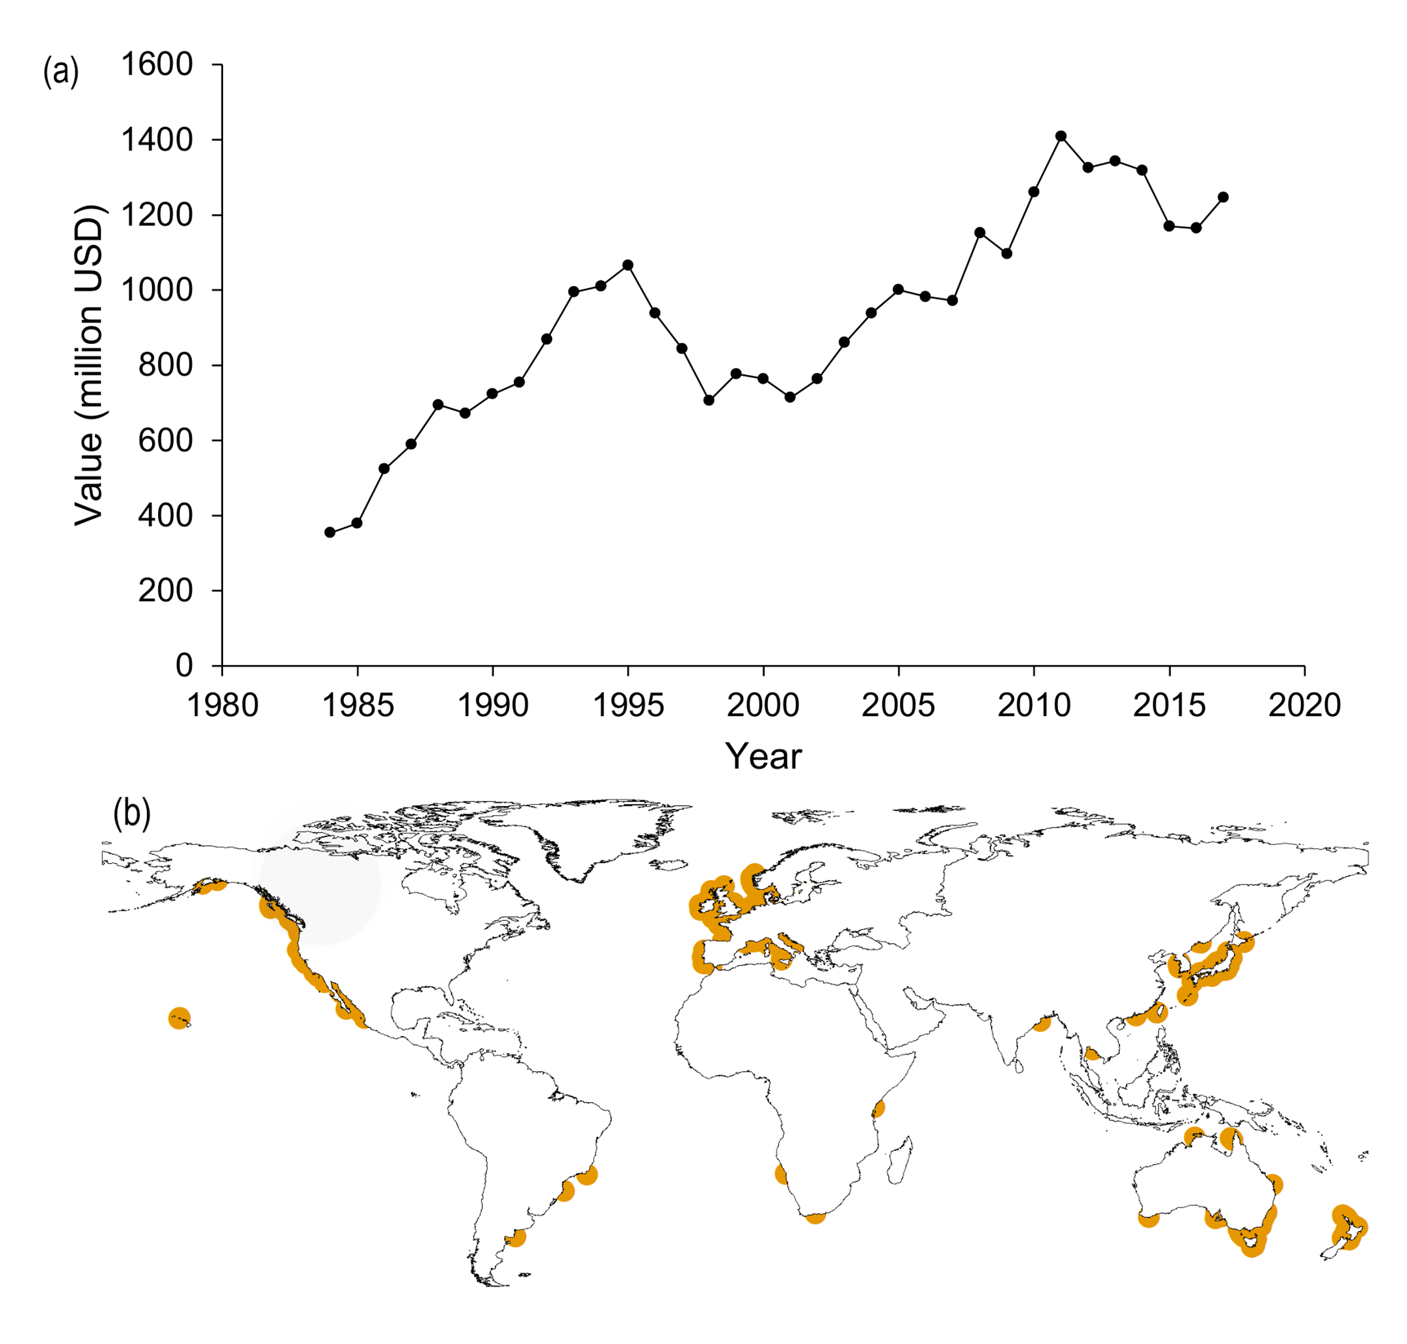
Figure S1. (a) The global aquaculture value of M. gigas between 1984 and 2017 (FAO, 2019) and (b) the global distribution of wild Magallana gigas from Global Biodiversity Information Facility (GBIF, accessed: 7th October 2019).

Table S1. Mean (± standard deviation) salinity, pH and total alkalinity for each of the 12 treatments over 10 months. Salinity and pH were monitored every 1-2 days, and total alkalinity measured every 2 weeks for the duration of the experiment.
Treatment temperature (°C) - salinity - pH | Salinity | pH | Total alkalinity (umol kg-1)
Ambient - 20 - 7.5 | 19.9 ± 0.9 | 7.54 ± 0.05 | 2302.6 ± 95.3
Ambient - 20 - 7.7 | 20.2 ± 1.1 | 7.70 ± 0.04 | 1807.4 ± 98.4
Ambient - 20 - 8.1 | 21.2 ± 1.6 | 8.05 ± 0.04 | 2293.9 ± 15.4
Ambient - 34 - 7.5 | 33.5 ± 1.8 | 7.54 ± 0.04 | 2334.6 ± 95.2
Ambient - 34 - 7.7 | 33.0 ± 1.4 | 7.72 ± 0.03 | 1838.5 ± 88.2
Ambient - 34 - 8.1 | 33.9 ± 1.2 | 8.01 ± 0.03 | 2304.6 ± 92.0
+4 - 20 - 7.5 | 20.4 ± 1.1 | 7.51 ± 0.06 | 2317.0 ± 93.1
+4 - 20 - 7.7 | 21.3 ± 1.1 | 7.72 ± 0.04 | 1828.0 ± 81.5
+4 - 20 - 8.1 | 20.5 ± 1.3 | 8.10 ± 0.06 | 1835.4 ± 81.4
+4 - 34 - 7.5 | 34.3 ± 0.9 | 7.53 ± 0.06 | 2332.7 ± 92.1
+4 - 34 - 7.7 | 34.1 ± 1.9 | 7.72 ± 0.03 | 1833.4 ± 102.9
+4 - 34 - 8.1 | 34.0 ± 1.8 | 8.07 ± 0.05 | 1810 ± 105.1

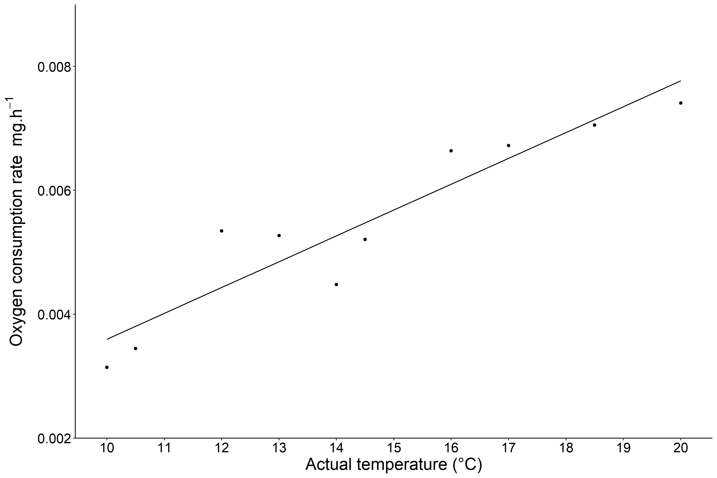
Figure S2. Mean oxygen consumption rates (mg hr⁻¹) across all treatments against average monthly temperature of the water. Temperature was based on mean monthly SST from the Western Channel Observatory L4 station data. Data were weighted by sample size and standardized to 1g oyster (R² = 0.87).

