Photoluminescence in the bill of the Atlantic puffin Fratercula arctica.

Dunning, Jamie.
School of Life Sciences, The University of Nottingham, University Park, Nottingham, NG7 2RD, United Kingdom
Diamond, Antony. W.
Atlantic Laboratory for Avian Research, University of New Brunswick, Fredericton NB, Canada E3B 5A3.
Christmas, Stephen, E.
Clinical Infection, Microbiology & Immunology, Institute of Infection & Global Heath, University of Liverpool, UK.
Cole, Emma-Louise.
College of Science, Swansea University, Singleton Park, Swansea, SA2 8PP, United Kingdom
Holberton, Rebecca. L.
Laboratory of Avian Biology, School of Biology & Ecology, University of Maine, Orono ME, U.S.A.
Jackson, Hannah, J.
School of Life Sciences, The University of Nottingham, University Park, Nottingham, NG7 2RD, United Kingdom
Kelly, Kevin. G.
Biology Dept., University of New Brunswick, Fredericton NB, Canada E3B 5A3
Rivera Rojas, Indira
Long Island University – Post, NY, U.S.A.
*Hanley, Daniel.
Long Island University – Post, NY, U.S.A.
daniel.hanley@liu.edu

Abstract
Here we report the discovery of fluorescence of parts of the ornamental bill of the Atlantic puffin Fratercula arctica (hereafter puffin) and quantify fluorescent traits for the first time within the Alcidae. We used both exposure to ultraviolet (UV) wavelengths and spectrophotometry to assess the fluorescent ornamentation of the puffin bill, first in freshly dead specimens and then in three wild caught birds. This adds to the body of research suggesting a possible role for fluorescence in signalling and mate selection within the family, although further comparative research is required to better understand functionality.

Introduction
The occurrence of photoluminescent ornamentation is well described in birds (Boles 1990, 1991; Pearn et al. 2001; Arnold et al. 2002). Such ornaments may enhance signal reception and intensity, which can impact on mate choice and inform sexual selection (Bennet & Cuthill 1999; Hunt et al. 1999; Pearn et al. 2001; Arnold et al. 2002) Here we report photoluminescent properties of specific portions of the Atlantic puffin, Fratercula arctica bill. We used a strong ultraviolet (UV) excitation light source and recorded the emission spectrum from wild caught puffins, and document the first report of weak fluorescence in this species.
The bill of the Atlantic puffin Fratercula arctica (hereafter puffin) is a large, colourful ornament, which is subjected to a series of annual and life-time changes (Harris 2014) and is featured prominently in the most obvious displays of puffins (head-jerking and billing) (Cramp 1985). As the breeding season approaches the hard dermal plates (the cere and lamellae) develop on the inner bill, and form the yellowish band around the blueish proximal nasal and sub-nasal plates (Bureau, 1878, Harris 2014). These seasonal morphological adaptations of the bill suggest an important role of bill morphology on breeding: either mate acquisition or foraging for offspring. The functional significance of this unique bill morphology has not yet been fully explored.
For example, we have observed previously undescribed apparent fluorescence on the puffin bill. Fluorescence and phosphorescence (hereafter photoluminescence) occurs when an object absorbs energy from an excitation light, which causes an electron in an excited single state to move to a higher energy triplet state and energy is re-emitted in form of longer wavelength light as it transitions back to its original state (Nassau 1997; Needham 1974) These photoluminescent properties, though generally weak in natural systems, have been documented in a range of organisms and a range of functions from predator deterrence (Andrews et al. 2007) to prey capture have been proposed (Haddock et al. 2005). Here we document weak photoluminescence on the cere and the lamella (Fig.2) of the puffin.

Methods
Initial observations of photoluminescence were documented on recently deceased puffins in late May 2010 on Machias Seal Island in the Bay of Fundy, Canada (44°30'08.3"N 67°06'04.5"W) and in early May 2016 on North Haven, Skomer Island, UK (51°44'08.8"N 5°17'47.0"W). Although unsexed, bill morphology (Harris 2014) indicated that the UK puffin was a second-year bird and the Canadian bird was an adult. The presence of ornamental fluorescence in the Canadian puffin was measured while fresh, while the UK bird was housed in a freezer maintained at -80ºC. No obvious signs of injury or known cause of death for either bird. Both puffins photographed under a black light torch (Fig. 1) document the presence and location of emission. The Canadian and UK puffin samples were illuminated by a MiniMAX UV-5NF (lambda max = 365nm; Spectroline, USA) and a Vansky 3w 12-LED (lambda max = 395 nm; Shenzhen Wansikai Network Technology Co., Ltd, Guangdong, China) black light, respectively.
Then, on XXXXXX we quantified emission spectra of three live puffins on Petit Manan, Maine (44°22′3.29″ N, 67°51′51.7″ W), USA. We used a high power UV torch (lambda max = 375) mounted with a UV bandpass filter (peak transmission = 380nm), which removed XX% of the excitation energy from the visible range (Figure 2a). We then used a field portable spectrometer (Jaz, Ocean Optics) mounted with a XXX µm slit and custom XXX µm fibre optic cables, in a dark room. Integration time was set at XX to maximize signal the signal to noise ratio. Excitation spectra were quantified both by examining the intensity (counts) against a non-fluorescent white standard (WS-SL-1) and by measuring absolute irradiance (Figure 2a). Because emission spectra were relatively weak, we measured against the cere which was the largest fluorescent surface on the live puffins we measured. The UV-torch was held approximately ~2cm from the cere (~45° relative to the cere), while the fibre was held approximately ~2mm from the cere (~90° relative to the cere). All emission spectra were normalized in arbitrary units (au.) and we report the wavelength at maximum emission, the full width at half maximum (fwhm). In order to protect the eyes of live puffins measured for this study, we developed a specially shaped opaque eye-shield (or ‘sunglasses’) made from felt and waterproof neoprene, which were held in place around the head of the puffins secured over the nasal saddle (IMAGES?).

Results
We illustrate that luminescence is most apparent on the cere and the lamella (Fig.2) surrounding the inner bill in both puffins. After blocking harmful UV radiation form the puffins’ eyes (DESCRIBE IRRADIANCE WITHOUT GLASSES, THEN WITH), we quantified the emission within the cere for three live birds, and found that their emission spectra were consistent: wavelength at maximum emission (lambda max = 492.0±0.58 nm) and fwhm (96.7±1.8 nm; table 1). These values were similar to those values obtained from a dead puffin stored at -80 °C for ~1 year (lambda max = 494nm, fwhm = 82 nm; Table 1).

Discussion
Here we document photoluminescent properties of the puffin bill. The bill fluorescence occurs within a region that undergoes seasonal development; these plates are formed prior to the breeding season and are discarded at the end of the breeding season. Similarly, previous research has found that the ornamental bill plates of the crested auklet Aethia cristatella fluoresce under blue light (Wails et al. 2017), and just like the seasonal ornaments of the puffin these are associated with the breeding cycle, suggesting that photoluminescence may serve a similar function for these two alcid species. Although the function of this apparent fluorescence is currently unknown, current evidence indicates that a number of other seabirds use bill morphology for signalling purposes.
Photoluminescent properties serve a number of important roles in nature, such as deterring predators (Andrews et al. 2007), enhancing signals (Arnold et al. 2002; Bennett et al. 1996; Hunt et al. 1997, 2001; Pearn et al. 2003), chick provisioning at dark subterranean nest sites (Hunt et al. 2003), and luring underwater prey (Haddock et al. 2005). The latter two explanations seem the most relevant for puffins that congregate in large breeding colonies (Cramp 1985) and who feed their young prey from the shallow waters 30-40km outside their breeding colonies (Spencer 2012). Either explanation would require experimentation.
Fluorescence in the bill and head in the Alcidae is evidently more widespread than previously considered. We recommend further study to explore bill fluorescence in auk family. Given that the fluorescent regions are developed in the puffins during the breeding season and shed over the non-breeding season, we expect to find a link to sexual selection and signalling, although it may also function to aid additional foraging or chick provisioning pressures during the breeding season. Probable florescence has since been detected in museum specimens of several other Alcidae taxa, whereas it is absent in others (Dunning & Bond, unpublished); a comprehensive study of UV reflectance and fluorescence in the family is clearly warranted, alongside photoreceptor sensitivity and avian visual modelling. Future studies should also consider behaviour and ecology to understand the pattern of prevalence and functionality of this characteristic more widely within this notably diverse family (Bédard 1969, Gaston and Jones 1998).

Acknowledgements
We thank Alex Bond at the Natural History Museum (NHM), Tring as well as the University of Nottingham Schools of Life Sciences and Physics & Astronomy, particularly Kate Durrant, Angus Davison, Tom Reader & Paul Munday. We also thank Matilda Elgood Field for her patience and initial comments on the draft manuscript and Catherine Jardine for photography & field assistance on Machias Island. Puffin sunglasses were developed at the Interaction Research Studio, University of Goldsmiths, London. No licence was required for handling of the Skomer Island puffin. Machias Seal Island research is under permit from the Canadian Wildlife Service and Animal use protocols from the University of New Brunswick.

REFERENCES

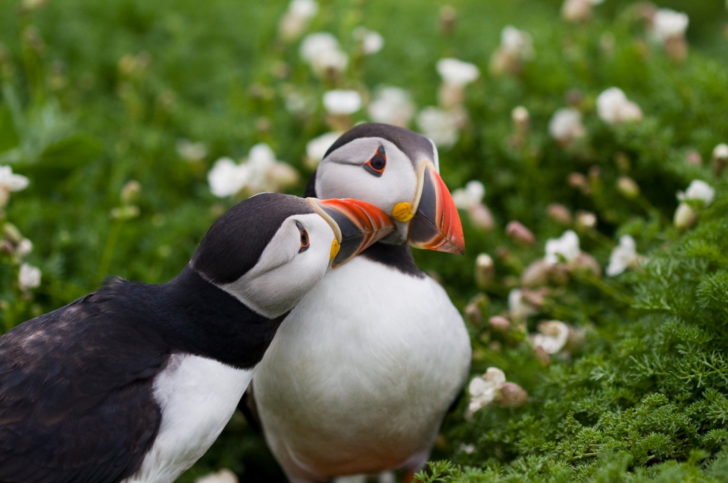
Figure 1. Atlantic puffins engaged in billing behaviour associated with sexual signalling (Photo T Finch).
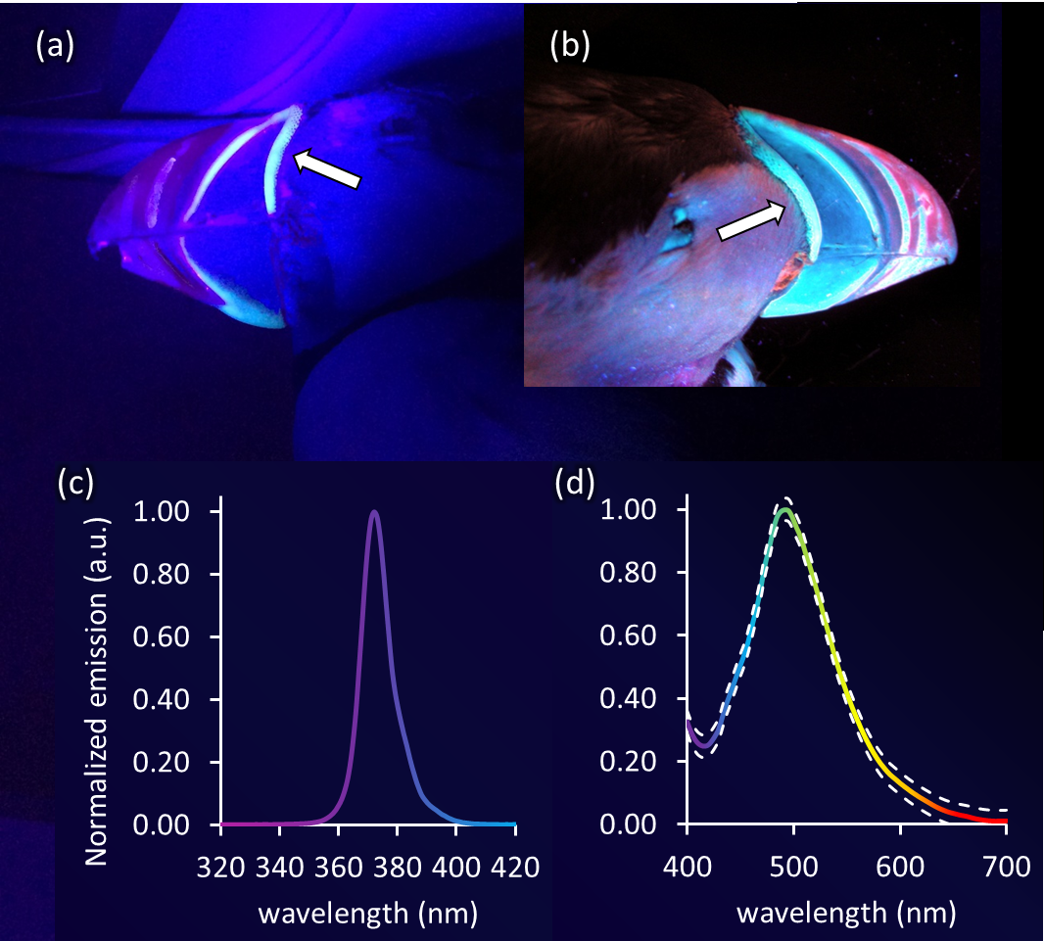
Figure 2.
We identified photoluminescence on the cere (arrow) and lamellae of puffins found deceased in (a) UK and (b) Canada. The (b) irradiance of the excitation spectrum, for which we used a band pass filter (XXX) to modify the irradiance of the XXXXX UV torch, and the resultant (d) normalized emission spectra of cere from three live puffins (solid) with approximate 95% confidence intervals (dashed). For more details see the Methods and Results sections.

Table 1.
specimen | Lambda max | fwhm
EG70 | 493 | 96
GZ08 | 491 | 100
DA07 | 492 | 94
frozen | 494 | 82

