Received 00th January 20xx,
- State Key Laboratory of Chemical Engineering, Center for Chemistry of High-Performance & Novel Materials, Department of Chemistry, Zhejiang University, Hangzhou 310027, P. R. China. Fax and Tel: +86-571-8795-3189; E-mail: jiekecheng@zju.edu.cn; fhuang@zju.edu.cn
- Department of Chemistry and Centre for Materials Discovery, University of Liverpool, Liverpool L69 7ZD, U.K. E-mail: ming.liu@liverpool.ac.uk
Accepted 00th January 20xx
DOI: 10.1039/x0xx00000x
www.rsc.org/
Vapochromic crystals: understanding vapochromism from the perspective of crystal engineering
Errui Li,ª Kecheng Jie,*ª Ming Liu,*^{b} Xinru Sheng,ª Weijie Zhuª and Feihe Huang*ª
Vapochromic materials, which undergo colour and/or emission changes upon exposure to certain vapours or gases, have received increasing attention recently because of their wide range of applications in, e.g., chemical sensors, light-emitting diodes, and environmental monitors. Vapochromic crystals, as a specific kind of vapochromic materials, can be investigated from the perspective of crystal engineering to understand the mechanism of vapochromism. Moreover, understanding the vapochromism mechanism will be beneficial to design and prepare task-specific vapochromic crystals as one kind of low-cost ‘electronic nose’ to detect toxic gases or volatile organic compounds. This review provides important information in a broad scientific context to develop new vapochromic materials, which covers organometallic or coordination complexes and organic crystals and exhibits different mechanisms of vapochromic behaviour. In addition, recent examples of supramolecular vapochromic crystals and metal-organic-frameworks (MOFs) vapochromic crystals are introduced.

- Introduction
Vapochromic materials have drawn increasing attention for last few decades since the first definition in 1988,¹⁻⁹ because these materials are promising candidates for intelligent devices that relay environmental conditions by changing colour. Vapochromism, as the name suggests, refers to a reversible or irreversible change of a compound or material in colour and/or emission driven by gas and/or vapour adsorption/desorption. Since Mann and his colleagues first proposed the concept of "electronic nose" based on vapochromic materials in 1997,¹⁰ vapochromism has been expected to be a key function in the development of ‘electronic noses’ that can detect harmful volatile organic (and inorganic) chemicals in the environment. In such circumstances, various vapour stimuli-responsive materials including vapochromic organometallic complexes, coordination complexes and newly-developed metal-free vapochromic organic materials have been used in many fields, e.g., chemical sensors, light-emitting diodes, and environmental monitors.^{8,11−17} Moreover, different monitoring strategies were also explored, such as optical or electronic signal changes, mass spectrometry detection, and ion mobility trapping technique.¹⁸⁻²² Nevertheless, the technology simplification and unique synergy of the selectivity and sensitivity are still required in the further development of vapour sensors. This vapochromic character effectively simplifies the monitoring operation. However, the vapochromic systems are still restricted by some drawbacks: (i) the vapochromic substrate is usually single and also unfriendly to the environment; (ii) they suffer from poor stability, as these materials will gradually degrade result in reduced sensitivity upon exposure to vapours for a certain period; (iii) strict operation conditions limit their applications scenarios. Therefore, further exploration of vapochromic systems with high stability, simple operation condition, and explicit response mechanism is in great demand, aiming at the application of vapochromic materials more widely in gas sensing.

Crystal design is the state of the art strategy for the development of functional vapochromic materials, as adsorption properties and colour change can be controlled by rational design of molecular crystals without reliance on the solvatochromic behaviour of the molecules. Not only extensively-explored vapochromic organometallic and coordination complexes but also the newly-developed organic crystals are now contributing extensively to our understanding of these important materials.²³⁻²⁵ In recent years, the development of metal−organic frameworks and supramolecular macrocyclic compounds has also enriched the scope of vapochromic crystals.²⁶⁻²⁹ Different types of vapochromic crystals determine the diversity of the vapochromism mechanisms, which also means that they can be utilized in selective and specific detection of vapours according to their distinctive vapochromic characteristics. In addition, vapochromic crystals effectively avoid the drawbacks of conventional vapochromic materials and sensors, e.g., single vapochromic substrate performance, poor stability, and inability to continuously monitor in the field. More importantly, understanding vapochromism from the perspective of crystal engineering and studying the intermolecular interactions in the context of crystal lattices can be an important guide for the potential and precise design of direct analytes for the detection of volatile organic compounds.

This review will be categorized by different types of vapochromic crystals, covering organometallic or coordination complexes and organic crystals. Particular attention will be mainly focused on the discussion of vapochromic behaviour in different crystals especially pure organic crystals, different mechanisms of vapochromic behaviour, and the explanation of the mechanism from the perspective of crystal engineering, providing reference for the design, synthesis and application of more types of new vapochromic materials.

- Vapochromic organometallic and coordination complexes
The two largest families of vapochromic crystals are composed of platinum(II)- and gold(I)-containing compounds, which represent the two most important classes of vapochromic substances. In many of the platinum(II) and gold(I) compounds, the vapochromic response is the result of changes in intermolecular interactions (e.g., weak metal−metal interactions, π-stacking, hydrogen bonding, and CH···π interactions) upon analyte uptake into the crystal lattice. This is also true for several of the vanadium-, cobalt-, nickel-, copper-, and metalloporphyrin-based vapochromic crystals. Based on the extent of previous academic research, here will be brief summaries about several major types of vapochromic organometallic and coordination complexes.

Actually, Mann and co-workers for the first time reported the vapochromic behaviour of one-dimensionally stacked platinum(II) [Pt(II)] systems in 1995.³⁰ They demonstrated that a Magnus’ green salt, [Pt(p-CN–C₆H₄–C₁₀H₂₁)₄][Pd(CN)₄] showed a reversible change in its colour and luminescence in the presence of various volatile organic solvent vapours such as chloroform, acetone, and benzene. Later, the concept of an ‘electronic nose’ based on vapochromic materials was first proposed by Mann and co-workers in 1997.¹⁰ Their impressive work suggested that intermolecular metallophilic interactions between Pt(II) ions could induce useful chromophore properties in vapochromic materials. Since then, reports on vapochromism based on Pt(II) compounds have sprung up.^{9,31−49} As there are already lots of related reports and reviews,^{9,31−49} these will not be elaborated here.

Since attractive aurophilic interactions have an order-of-magnitude strength similar to hydrogen bonding, they should feature prominently in the crystal engineering toolbox as a design implement to increase structural dimensionality. Numerous supramolecular structures based on gold(I) [Au(I)] complexes have been designed and reported, many of which show inter- or intramolecular Au···Au interactions.^{9,50−71} Luminescence is another attractive property of gold(I) complexes. Hence, plenty of reports on vapochromism based on Au(I) compounds have emerged, leading to the comprehensive summary of these works.^{9,50−71} We will not describe them in detail here.

In addition to Pt(II)- and Au(I)-containing compounds, there are also several vanadium-, cobalt-, nickel-, copper-, and metalloporphyrin-based vapochromic crystals. The vapochromism of some of these vapochromic crystals is the direct consequence of changes in the ligand field around the metal, leading to significant changes in the d–d and/or metal-to-ligand charge transfer absorptions. The other vapochromism is the result of changes in weak intermolecular interactions. There are also many excellent reports and reviews available for reference.^{9,72−87}

- Vapochromic organic crystals
Unlike the blossoming studies of metal-containing vapochromic crystals, vapochromic organic crystals were not reported for the first time until 2010. Despite the popularity of organic materials with controlled fluorescence, the development of novel multi-stimulus-responsive compounds with multi-colour emission remains challenging due to the lack of clear guidelines for molecular structure design. As vapochromic organic molecules reported so far have no structural or chemical similarities and only a handful reports on vapochromic organic crystals are available, there are no general guidelines regarding how to achieve vapochromic organic materials. The reported mechanisms for the observed colour changes include intermolecular interactions, such as charge transfer and π−π interactions, and a structural change of the organic molecules, such as conformational change or intramolecular H⁺ transfer. In the following sections, we will introduce vapochromism of organic crystals based on these four mechanisms separately. In most cases, organic crystals may contain several vapochromic mechanisms at the same time. Vapochromism may also be the result of the synergy of several mechanisms. In each section, we selected the main mechanism-driven vapochromic organic crystals as the related examples.

  - Vapochromism based on charge transfer
As is well known, the formation of intramolecular charge transfer (ICT) fluorophores is highly dependent on the nature of the donor or acceptor segment.⁸⁸⁻⁹⁰ In order to obtain a molecule possessing multiple emission states in response to stimuli, it is a good choice to apply stimuli-induced gradual alteration of electron-donating or accepting strength of an ICT-type molecule stimulate which may tune its emission and accordingly generate multi-colour fluorescence. In this regard, vapochromic organic crystals based on intramolecular or intermolecular charge transfer interactions are one of the most common types of vapochromic crystals. Usually, luminescent or fluorescent organic molecules bearing a donor and/or acceptor segments are firstly designed and synthesized. Self-assembly of these molecules into crystals would afford functional vapochromic materials. When stimulated by vapours, the charge transfer interactions in such molecules are affected, which in turn results in a change in crystal colour or fluorescent properties.

To create new organic functional materials, Naota and coworkers described the first vapochromic organic crystal 1a utilizing 1,4,5,8-naphthalenetetracarboxylic diimide (NDI) bearing two pyrrole imine (PI) tethers (Fig. 1a, left).⁹¹ Orange crystal 1a·MeOH could be easily obtained by recrystallization of 1a from MeOH. Each molecule has an S-shape folding conformation through the intramolecular donor-receptor interactions between NDI and PI units (Fig. 1b, left). Surprisingly, a thermally stable red-purple solid 1a was obtained by the desolvation of 1a·MeOH, in which the intramolecular stacking of each unit was enhanced without crystal decomposition (Fig. 1b, right). They found that the guest-free, porous solid 1a exhibited strong adsorption properties and molecular shape-dependent colour changes upon exposure to a variety of organic vapours (Fig. 1a, right). The vapochromic behaviour generates from vapour-induced change in crystal packing and intermolecular stacking interactions. In detail, the inclusion of the guest vapour into the S-shaped template decreased the intramolecular PI-NDI interactions, accompanied by increasing intermolecular NDI-NDI and PI-PI interactions (Fig. 1b). And such flexible, open–close motions of the S-shaped template could be repeated during reversible adsorption/desorption processes without degradation of the crystal packing.
Fig. 1 (a) Molecular structure of compound 1a and colour changes of 1a solids after exposure to saturated vapours of various volatile organic compounds. (b) Crystal packing and intermolecular stacking interactions of 1a·MeOH and 1a.

Wang and coworkers designed and synthesized compound 2 with an electron donor-acceptor structure (Fig. 2a).^{92,93} In this compound, the π-conjugated skeleton endows this molecule with abundant aggregation modes. Meanwhile, the cyano stilbene group can rotate freely, thus resulting in diverse emission properties in the solid state or in solution, as shown by the molecular packing of the crystals (Fig. 2b). Moreover, the aromatic-amine group is responsive to an acid stimulus, which may induce significant changes in photophysical properties by disrupting the D-A nature.^{94,95} Upon exposure to CF₃COOH (TFA) vapour, the orange solids exhibited a phase transition to blue emissive state and the application of triethylamine (NEt₃) vapour could recover its original colour (Fig. 2a, bottom). These changes can be attributed to the protonation effects of TFA on Lewis-basic nitrogen, which can effectively disrupt the D-A nature and then affect the photophysical property of the entire molecule.^{96,97} Surprisingly, the grinding and heating treatments also effectively induce the change in fluorescence between orange-red and yellow (Fig. 2a, top).
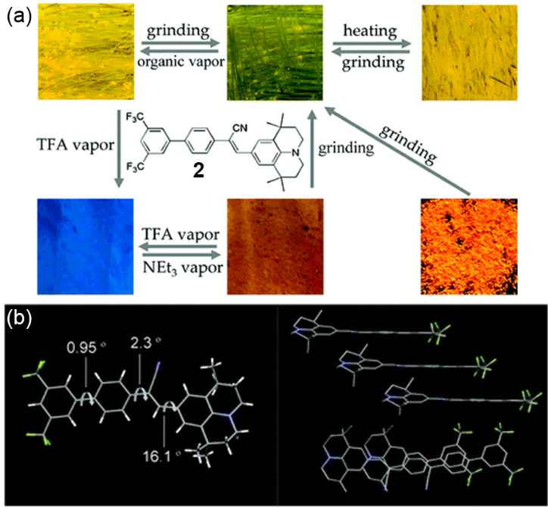
Fig. 2 (a) Molecular structure of compound 2 and stimuli-responsive behaviour of 2 upon grinding, heating, and acid and base vapour treatments. (b) Molecular and packing structure of 2.

By controlling the molecular solid-state structure through weak interactions, supramolecular chemistry provides a versatile approach to tuning and switching solid-state luminescence.^{98–102} Based on this, Draper and coworkers synthesized an organic luminescent acid 3, 2-cyano-3(4-(diphenylamino)phenyl)acrylic acid (Fig. 3a). They found that the systems based on 3 and amines (pyridine, pyrrolidine, piperidine and morpholine) exhibited blue shifted luminescence compared to the parent acid.¹⁰³ In particular, the co-crystal 3·piperridine gave a CH₃CN selective supramolecular luminescence host system. The switching of the luminescence was demonstrated by exposing the solids to amine vapour and HCl solution (Fig. 3b). As analyzed from the 3·piperridine co-crystals, the nitrogen atom on piperidine was found to have H-bond interactions with the carboxylic acid of 3 (Fig. 3a). There are two additional CH₃CN molecules in the crystal lattice, which are omitted for clarity. Subtle changes in H-bond interactions and deprotonation are the exact cause of the gradual blue shift in solid-state luminescence of 3·piperridine. Luminescent host systems can also be produced by co-crystallization of 3 with other amines, such as propylamine, dimethylaminopyridine and (1S,2R)-2-amino-1,2-diphenylethanol.¹⁰⁴ Similarly, the chiral luminescent host system based on 3 and (1S,2R)-2-amino-1,2-diphenylethanol (3a) also shows robust and reversible CH₃CN-selective luminescent sensing (Fig. 3c).
Fig. 3 (a) 3-amine supramolecular luminescent systems. Normalized solid-state solvent dependent luminescence of 3·piperridine (b) and 3a (c) (excitation λ = 370 nm).

Zhang and coworkers synthesized a compound, di(triphenylamine)-thiazolothiazole 4, with a donor–acceptor–donor structure (Fig. 4a, left). In this molecule, the acceptor thiazolothiazole unit can react with different acids and exhibit varying electron-accepting strength.¹⁰⁵ Specifically, different stimuli-responsive fluorescence states of 4 can be achieved by protonation or coordination of the thiazolothiazole fragments after treatment with different acids (Fig. 4c). The green luminescence of solid of 4 (524 nm) can be smoothly transferred to yellow (576 nm), red (640 nm), and near infrared (739 nm) emissive states with a huge Δλ_{em} of 215 nm after exposure to HCl, TFA, and BBr₃, respectively (Fig. 4b). Similar acid-responsive fluorescence changes can also be observed in solution and a vacuum deposited film, which was demonstrated by experimental data and theoretical calculations. In order to reveal the reasons why this compound has different luminescence before and after protonation, their single crystal structures were obtained (Fig. 4d). Compared to the neutral crystal, the protonated crystal exhibits a similar molecular conformation whereas its thiazolothiazole ring has a shorter length of the C=N double bonds. In addition, the angle between the plane of the thiazolothiazole and the adjacent benzene ring is about 16° for the neutral crystal and about 23° for the protonated crystal. Therefore, protonation should be the main cause of the observed acid-induced fluorescence diversification. Acids with different strengths will adjust the electron-accepting intensity of the thiazolothiazole unit, which in turn affects the intramolecular charge transfer to varying degrees. It is worth mentioning that with the intelligent sensitivity of 4 to acids, the authors for the first time prepared thermal-evaporated OLEDs based on the neutral and protonated species, and achieved multi-colour electroluminescence (EL) with medium current efficiency.
Fig. 4 (a) Chemical structure of 4. (b) Emission spectra of solids, neutral and vapourized by various acids. (c) The fluorescence colour-change mechanism between acid and base vapour stimuli. (d) Molecular structures of neutral and protonated crystals of 4.

According to previous reports, molecules containing nitrogen or oxygen can respond to acids because of the easy availability of the lone pair on nitrogen or oxygen for proton binding.^{105–109} In particular, some acid-responsive compounds also show vapochromic properties. A few typical examples are shown in Fig. 5. These crystals exhibit reversible vapochromic behaviors after exposure to acid or base vapours. Based on theoretical calculations and single crystal structure analysis, acid/base responsive emission is attributed to structural changes and the transformation of the compound’s frontier molecular orbitals in the protonation–deprotonation process.
Fig. 5 Chemical structures of 5, 6 and 7 and the photographs of their acid/base responsive emission.

Nair and coworkers synthesized two donor–π–acceptor type fluorophores consisting of anthracene as the donor and benzoxazole (8) or benzothiazole (9) as the acceptor, which exhibited different mechanochromism and acido-chromism (Fig. 6a).¹¹⁰ The acidochromic behaviour of these molecules was studied by coating the solution of 8 or 9 on filter paper to prepare a rewritable media. In the case of 8, the letters were clearly visible when written with TFA, but would be self-erased within two hours. On the other hand, the letters written on the 9-containing filter paper were stable and would only be erased when they were fumed with ammonia (Fig. 6b). Detailed studies and crystal structures indicated that changes of the heteroatoms in the benzoxazole/benzothiazole moieties (oxygen and sulfur, respectively) significantly affected the intramolecular and intermolecular electronic interactions of the molecules, leading to this observation. As shown in Fig. 6c, in the case of 8, the benzoxazole moieties interact through a weak edge-to-edge π-stack, whereas in 9, the ring overlap is more pronounced, making the π-stack a stronger face-to-face type and leading to the restoration of the molecular ordering in 9. As a result, the complex formed between 8 and TFA will be less stable, resulting in a rapid dissociation. However, the electron density of the nitrogen atom in 9 may be higher due to the presence of less electronegative sulfur, thus resulting in the formation of a stable complex.
Fig. 6 (a) Chemical structures of 8 and 9. (b) Photographs of filter papers coated with 8 and 9 under different conditions. (c) Interactions between acceptor moieties and donor moieties in 8 and 9 obtained from single crystal X-ray analysis.

The same group reported another luminescence switching of two acceptor-donor-acceptor type linear π-conjugated oligomers induced by thermal stimulation.¹¹¹ The molecule consists of 1,4-bisdodecyloxy)-2,5-divinylbenzene as a donor and benzoxazole or benzothiazole (10 and 11, respectively) as acceptors (Fig. 7a). The pristine form of red-emitting 10 (P-form) was found to be stable at room temperature, but would be converted to another stable form (H-form) with yellow-green emission when heated at ∼80 °C. When exposed to the vapours of dichloromethane, chloroform, toluene and tetrahydrofuran, it can be restored to the original P-form. Similar phenomena can also be observed for 11. Experimental results confirmed that ambient oxygen and moisture had no effect on the luminescence switching phenomenon, and no chemical decomposition could be observed in several luminescence switching cycles. Solvent vapours can act as a medium for rearrangement of H-forms into P-types, which is associated with close interactions and efficient energy migration.

There is another donor–acceptor–donor molecule, 4,4’-(acenaphtho[1,2-b]quinoxaline-8,11-diyl)bis(N,N-diphenylaniline) (12) reported by Pei (Fig. 7b).¹¹² Analogously, 12, in which the bulky triphenylamine moiety is used as the electron donor while the acenaphtho[1,2-b]quinoxaline unit is used as the electron acceptor core, exhibits good piezochromic property upon applying pressure. The changed fluorescence can be recovered by heating or solvent fuming. Theoretical calculation results showed that this fluorescence change from green to orange was caused by the transition from a stable crystalline structure to a metastable amorphous phase, which in turn affects the intermolecular charge-transfer.
Fig. 7 (a) Chemical structures of 10 and 11 and photographs of the pristine and heated samples of 10 under 365 nm UV light. (b) Chemical structures of 12 and its reversible switching of the emission colour on filter paper.

Novel luminescent materials with aggregation-induced emission (AIE) have attracted great interest since the AIE concept was first reported by Tang in 2001.^{113,114} Studies on the mechanism of the AIE phenomenon have been vigorously explored, including restricted intramolecular rotation, intramolecular coplanarization, inhibition of intramolecular photochemical or photophysical process, relatively loose molecular packing, J-aggregate formation, and special excimer formation.^{115,116} In fact, for each molecule, the formation of the AIE phenomenon is often the result of several factors. Hence, AIE luminogens have also been utilized as ideal materials for vapochromism.

For example, Cheng and coworkers reported a multi-stimuli responsive luminescent material, 10-bromo-N,N-di-p-tolyl-9-amine (13), which can sensitively respond to vapour, piezo and temperature stimuli reversibly with drastic colour changes (Fig. 8a).¹¹⁷ The crystalline 13 sample obtained from n-hexane exhibited a vapochromism behaviour with emission colours changing from yellow orange to green upon exposure to dichloromethane (DCM) solvents. Interestingly, the initial emission can be recovered by heating the sample at 70 °C. Single crystal X-ray studies and theoretical calculations reveal that the switchable emission may be due to the different stacking modes of 13 molecules and the change from Br-based interaction to anthracene-based one, resulting in a larger energy gap. Intuitively, the crystals obtained from n-hexane show that the molecules are arranged in a head-to-tail manner, in which the Br group (head) interacts with hydrogen and carbon on the two tolyl groups (tail) of the other molecule (Fig. 8b). For 13-DCM crystals, the anthracene groups are packaged in a head-to-head manner, in which each anthracene group overlaps with two other intermolecular groups via π-π stacking (Fig. 8c). However, the other anthracene-based compound without Br group does not show such switching of the emission by external stimuli.
Fig. 8 (a) Chemical structure of 13 and its photographs under different conditions. Crystal packing of 13: (b) crystalized from n-hexane; (c) crystalized from DCM.

Dong and coworkers synthesized a symmetrical compound 2-(bis(4-(9H-carbazol-9-yl)phenyl)methylene)malononitrile (14) with the electron donor (carbazole) and the acceptor (two cyano groups), which is AIE and CIEE (crystallization induced emission enhancement)^{118,119} active and can form four morphologies with varied emissions and efficiencies (Fig. 9a).¹²⁰ This donor-π-acceptor type luminogen exhibit unique fluorescence properties due to their intramolecular charge transfer (ICT) transitions. Upon exposure to thermal, solvent vapour or mechanical stimuli, luminogen 14 can form green, yellow-green and orange emissive crystals, as well as orange-emitting amorphous solids. The twisted conformation provides different packing patterns as analyzed from the single crystal structures obtained from different solvents (Fig. 9b). It is just the presence of different solvents that facilitates emission switching of the luminogen through tuning the morphology.
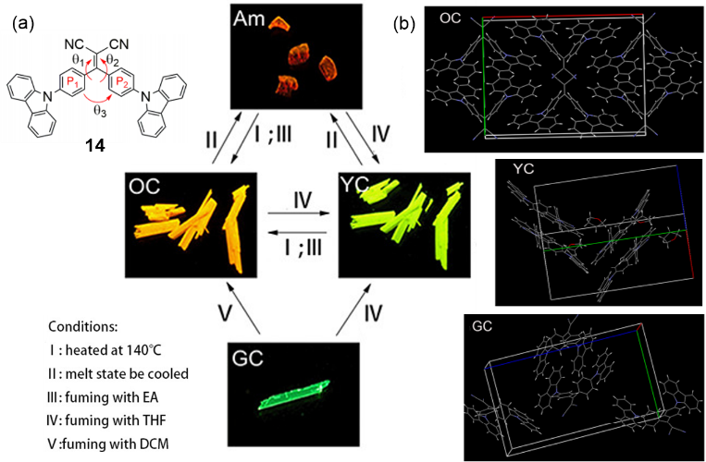
Fig. 9 (a) Chemical structure of 14 and its reversible switching of the emission under different conditions. (b) Crystal packing of OC, YC, and GC.

In addition, other AIE and CIEE active compounds have been shown in Fig. 10, which also exhibit multi-coloured emission switching in the solid state through vapour and other stimuli.¹²¹⁻¹³³ Their appearance has further enriched vapochromic fluorescent materials.
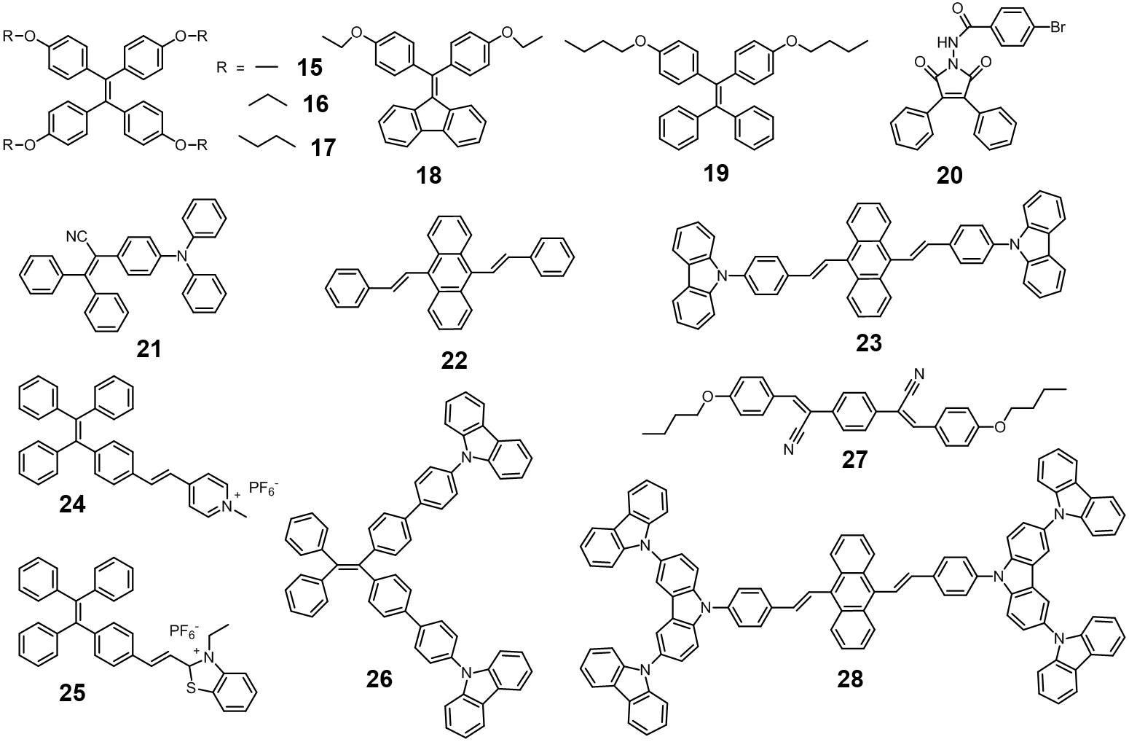
Fig. 10 Chemical structures of AIE luminogens.

  - Vapochromism based on π−π Interaction
In addition, vapochromic organic crystals based on π−π interactions have also been widely investigated. The introduction of an aromatic group into a molecule not only induces intermolecular π−π interactions, but also endows the molecule itself with luminescent or fluorescent properties. The enhancement or destruction of vapour-induced π−π interactions may lead to the changes in the apparent colour of the crystals. In many cases, vapochromism is often the result of synergy between π-π interaction and other interactions.

When designing solid-state luminescence switching molecules, the existence of metastable solid/crystalline states is indispensable with π-π stacking and hydrogen bonding as two factors to determine the solid-state/crystalline molecular packing mode.¹³⁴⁻¹⁴⁰ Wang and coworkers designed and synthesized a series of 2,7-diphenylfluorenone derivatives, all of which have typical AIE properties with high solid-state fluorescence quantum yields (Fig. 11).¹⁴¹ The fluorenone with a planar aromatic configuration and containing an exposed oxygen atom is a good candidate for solid-state luminescence switching because planar aromatics are prone to form π−π stacking and exposed oxygen atoms are potential hydrogen-bonding sites. Interestingly, 29 can form red crystal 29R and yellow crystal 29Y from tetrahydrofuran (THF) and DCM, respectively, which have totally different luminescent properties. When stimulated by mechanical and organic solvent vapours, a reversible phase change occurred between the two crystals. For example, grinding the 29Y yellow crystalline powder yielded a red powder that exhibited the same luminescence as 29R. The red crystalline powder was then exposed to DCM vapour and the yellow powder was obtained again. To study the mechanism of the reversible phase transition in depth, single crystal structures of 29 were obtained. For the red crystal 29R, a characteristic molecule pairs can be observed in the crystal packing (Fig. 11a). π-π Stacking interaction connects the two adjacent molecules, which plays an important role in the molecular packing. There are also weak C-H···O hydrogen bonds in the 29R crystal, which merely hold the molecular pairs together to form a 3D structure. However, in the yellow crystal 29Y, there are no π-π interactions in the crystal. The molecules are arranged in a 2D sheet by hydrogen bonding, and then stacked into a 3D structure by a weak CH···π interaction. Therefore, the phase transition of the yellow crystal 29Y to the red crystal 29R is a structural transition from a kinetically stable hydrogen bond-directed stack to a thermodynamically stable π-π stacking guide. In addition, compound 30 also has two different single crystal structures, 30O and 30Y. Similar to 29, after heating 30O at 90 °C for 1 min, the colour rapidly changed from orange to bright yellow. When the heated crystals were exposed to DCM vapour for 1 min, they were changed back to orange crystals again. As can be seen from the crystal structure of 30O, it is the π-π stacking-bound excimer that generates the orange emission of the crystal upon excitation. Meanwhile, weak hydrogen bonds and C–H···π interactions also play a role in stabilizing the crystal structure (Fig. 11b). However, in the 30Y crystal structure, the hydrogen bond is the main intermolecular force in the packing, which stabilizes the crystal structure. Based on the crystal structure, the authors speculate that, upon heating the orange crystal 30O, the molecule has enough energy to overcome the CH···π interaction and form a hydrogen bond with another molecule, inducing the phase transformation from a π–π stacking-directed structure (30O) to a hydrogen bond-directed structure (30Y).
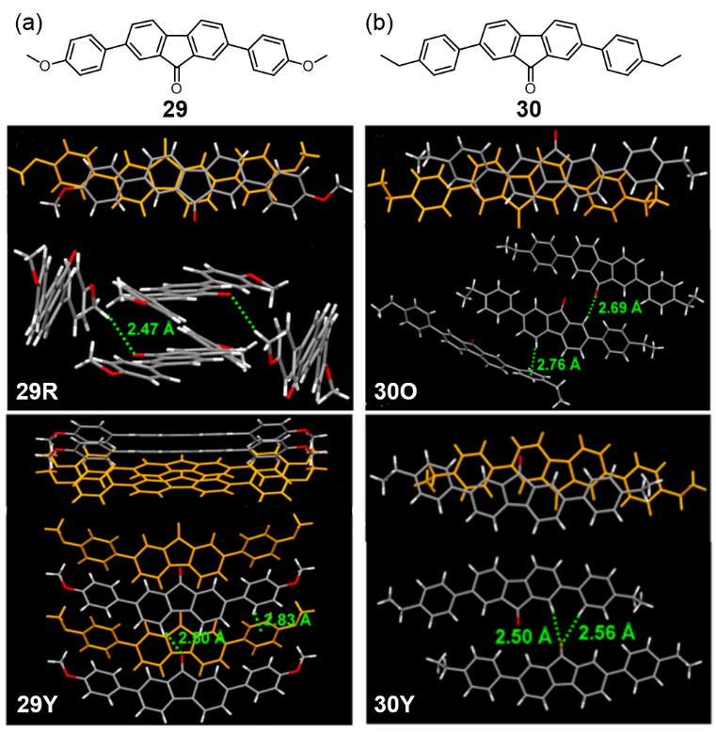
Fig. 11 (a) Chemical structure of 29 and its crystal packing of 29R and 29Y. (b) Chemical structure of 30 and its crystal packing of 30O and 29Y.

Hisaeda and coworkers reported a naphthalenediimide‐based porous supramolecular host (31), which was a complex of N,N’-dipyrid-3-yl-1,4,5,8-naphthalenediimide (NDI) linked to two tris(pentafluorophenyl)borane (TPFB) by boron-nitrogen dative bonds as Lewis acid–base pairs (Fig. 12a).^{142,143} This molecule showed a turn‐on fluorogenic and chromogenic response to the vapours of small aromatic hydrocarbons such as benzene, toluene, xylene, and trimethylbenzene. After 31 being heated at 150 °C for 4 h and pestled for approximately 15 min, the amorphous supramolecular host (31a) was obtained. When 31a was exposed to small molecule organic vapours, a colour change occurred in response to the vapours of all small aromatic hydrocarbons other than benzene and a new absorption band appeared in the visible region (> 400-550 nm) (Fig. 12c). As the electron donating strength of the aromatic hydrocarbon increases, the position of the absorption band is red-shifted because a charge-transfer complex is formed between the electron-deficient NDI and electron-rich aromatic hydrocarbon in the solid state. In addition, in the XRD curve of 31a⋅guest complexes, all 31a⋅guest complexes have similar structures and show the highly ordered arrangement of the NDI and the aromatic molecules in the aggregated states (Fig. 12b). But this system shows negligible responses to the vapours of common organic solvents (for example, aliphatic hydrocarbons, alcohols, ketones, and halogenated molecules). And it is the amorphous-to-crystal transition that results in guest-dependent colour changes and fluorescence emission.
Fig. 12 (a) Chemical structure of 31. (b) The process of detection of aromatic hydrocarbon vapours by 31a. (c) Photographs of 31a and 31a·(guest) with various aromatic hydrocarbons in daylight (upper row) and under a UV lamp (365 nm, bottom row).

Bai and coworkers combined the 4,4,5,5-tetramethyl-[1,3,2] dioxaborolane (Bpin) group and pyrene to develop a new type of self-recovering mechanoluminescent and vapochromic material.¹⁴⁴ They found that pyrene boronic acid cyclic esters with a 5-membered ring (32) solids showed reversible fluorescence changes from blue to green under shear. Interestingly, when the shear sample was left at room temperature for 5 minutes or exposed to various solvent vapours, the fluorescence recovered immediately, while pyrene boronic acid cyclic esters with a 6-membered ring (33) did not. It is well known that the pyrene derivatives can exhibit two kinds of excimers under different conditions.^{145,146} The blue fluorescence is derived from a pyrene excimer with a partially overlapping stack, while the green emission band is consistent with the formation of a sandwich-packing excimer. In order to explore the origin of vapochromic behaviour, the authors performed fluorescence measurements at low temperatures and obtained single crystal structures of two compounds. They found that the change in fluorescent properties of 32 are essentially due to the thermo-dynamic movement of the molecules. When they are mechanically sheared, they firstly form a green sandwich-like packing excimer. However, the weak non-covalent interaction of 32 and its strong crystallization tendency promoted the rearrangement of molecules from the sandwich packing to a more stable crystalline state, and partially overlapped the pyrenes, thus reverting to blue fluorescence (Fig. 13a, bottom). In contrast, in the crystal structure of 33, the 6-membered cyclic ester groups are clustered on the same side of the dimers (Fig. 13b, bottom). The high steric hindrance restricts the formation of the sandwich-like dimer, which will be easier for the anti-parallel partially stacking dimer of 32 under mechanical shearing.
Fig. 13 Chemical structure of 32 and 33 and their crystal packing.

Chujo and coworkers report the synthesis of o‐carborane‐based anthracene,¹⁴⁷⁻¹⁴⁹ in which o-carborane are substituted at the 9- and 10- positions of anthracene (Fig. 14a). Such anthracene derivatives have a rich emission behaviour, such as AIE, crystallization‐induced emission (CIE), aggregation‐caused quenching (ACQ), thermochromism, vapochromism, and mechanochromism. When crystals of 34⋅solvent were heated at 200 °C for 10 min or scraped with a spatula, solvent molecules would be lost in the crystals, thus changing the emission behaviour. After the externally stimulated solids were again exposed to the corresponding solvent vapour for 10 min, the original emission was recovered to the same as the original 34⋅solvent crystal. Interestingly, this scratching and solvent annealing process could be repeated at least ten times. In addition to this, upon exposing the 34⋅solvent crystals to another solvent vapour at room temperature, a mutually substituted structure could be obtained by solvent exchange (Fig. 14b). The crystals containing different solvent vapours exhibit slightly different emissions. In order to better understand the mechanism of the emission behaviour of 34, the authors obtained three single crystal structures from different solvents. Crystal structure analysis revealed that the anthracene rings of two molecules of 34 form a π-stacked dimer and each solvent molecule is incorporated into each crystal lattice (Fig. 14a). For different solvent molecules, the overlap area of the anthracene and the distance between the centers are different, which affects the charge-transfer emission and ultimately causes different discolouration phenomena.
Fig. 14 (a) Structure of p-stacked dimer and ORTEP drawings of 34·CH₂Cl₂, 34·C₆H₆, and 34·CHCl₃. (b) Vapochromism of the 34·solvent crystals.

3.3 Vapochromism based on conformational changes
Besides the above two intermolecular interactions, the vapochromism mechanism of vapochromic organic crystals also includes changes in the molecular structures, such as conformational change and intramolecular H⁺ transfer. Molecules containing flexible groups or chains are induced to change in conformation when subjected to vapour stimulation, resulting in differences in optical properties, especially fluorescent properties.

Miao and coworkers designed and synthesized a difunctional hydrocarbon 35 bearing two non-planar dibenzocycloheptatriene moieties linked by three cumulative C=C double bonds.¹⁵⁰ Such flexible conjugated molecules can adopt two conformations in their crystals, namely, syn-35 and anti-35 (Fig. 15a). Of particular interest is that the molecular crystals not only function as p-type semiconductors but also exhibit vapochromic behaviour with high selectivity (Fig. 15b). When specific volatile molecules, such as toluene and m-xylene, are selectively captured in the crystal lattice, the guest-free crystals of the syn conformer change to the clathrate crystals of the anti conformer, with the colour change from red to orange. The anti orange clathrate crystal does not lose the guest molecules under vacuum at room temperature, but releases the guest molecules and converts it back into a red crystalline solids of the syn conformer when heated at 200 °C for 5 minutes. The selective vapochromism can be attributed to the changes of π-π interactions induced by a particular guest molecule (Fig. 15c). At the same time, it is accompanied by a change from the syn conformer to the more stable anti conformer, which is confirmed by theoretical calculations.
Fig. 15 (a) Chemical structure of 35 and its crystal structures of syn-35 and anti-35. (b) Photographs of powders of syn-35 after exposure to various organic vapours. (c) Molecular packing of syn-35 and 3(anti-35)·m-xylene.

Based on the crystal engineering studies using the cation-π interaction between a pyridinium and a benzene ring, Yamada and coworkers reported the synthesis of 4'-methoxy-4-azachalcone hydrochloride (36a·HCl) (Fig. 16a).^{151–154} The crystals have a head-to-tail columnar motif stabilized by cation–π interactions accompanied with yellow anhydrous phase (Fig. 16b). A new polymorphic red hydrate phase (36a·HCl·H₂O) was also investigated.¹⁵⁵ Interestingly, exposing the yellow anhydrous crystals of 4'-alkoxy-4-indolone to water vapour gave red hydrate crystals. On the other hand, the anhydrous phase was recovered by dehydrating the hydrate phase by heating. A comparison of the crystal structures of the anhydrate and hydrate crystals confirmed a significant change in the molecular arrangement during the hydration-dehydration processes: the changes in the orientation mode from head-to-tail to head-to-head and the displacement of chloride ions and water molecules are involved in the crystal transformations (Fig. 16c). It can be speculated that the changes in orientation mode and H-bond network and changes in the location of the counter ion toward the pyridinium ring are responsible for significant colour changes. Similar phenomena were observed with 36b·HCl (4'-ethoxy-4-azachalcone hydrochloride) and 36b·HCl·H₂O. Surprisingly, the hydration of dehydrated 36b·HCl was much faster than that of 36a·HCl, and the vapochromic efficiency was faster.
Fig. 16 (a) Formation of hydrate and anhydrate crystals and their reversible changes in the crystalline state. (b) Crystal packing of 36a·HCl and 36a·HCl·H₂O. (c) Schematic representation of the crystal transformations between anhydrate and hydrate crystals with significant changes in the arrangement of molecules.

It is worth mentioning that diarylmaleimide was reported as the first solid state luminescence switching material.¹⁵⁶ Ling and coworkers synthesized a herringbone structured compound, 3,4-dithienyl maleimide (37), in which maleimide serves as the core for its electron-deficiency and structural modification flexibility and thiophene as an aromatic substituent for its excellent optoelectronic properties and twist flexibility (Fig. 17a).¹⁵⁷ It was found that 37 can form three types of crystalline polymorphs, emitting intense red (RC), orange (OC) and yellow (YC) fluorescences, respectively, as well as amorphous brown solids (BS) with weak orange fluorescence (Fig. 17b). Additionally, 37 exhibited on/off luminescence switching under external stimuli such as heat, pressure and solvent. Fluorescence response experiments showed that OC can be converted to an amorphous solid BS by grinding. The crushing OC broke its surface structure and made it become YC, while the grinding of OC or YC destroyed the stacking of the molecules to produce amorphous BS. Simple heat treatment or acetone vapour treatment restored the orderly aggregation of YC from BS. If the BS and OC are heated to melt and then cooled to room temperature, YC can be obtained again. The reason for these phenomena can be clearly explained by the single crystal structure analysis.
For RC crystals, two tail-to-tail molecules are arranged into columns by intermolecular π-π stacking interactions, which is further held together by weak N-H⋯O and C-H⋯S interactions, forming a 3D wave structure (Fig. 17c, upper row). However, for OC crystals, head-to-tail molecules are shifted along the b-axis based on N-H⋯O and C-H⋯O interactions to form a 3D structure (Fig. 17c, bottom row). Although YC and OC have the same molecular conformation and intermolecular packing mode, they exhibit different colour and emission. One possible explanation is that different photophysical properties are derived from their different surface structures. Based on the crystal structure and photophysical studies, the photophysical properties of the crystal, including absorption and emission, should be determined by the filling structure and conformation and may be affected by the surface structure or particle size.
Fig. 17 (a) Chemical structure of 37 and its structural features. (b) Reversible switching of 37 between four-colour luminescence states under multiple external stimuli. (c) Molecular structures and simplified packing structures of 37RC and 37OC.

Another compound (2,5-bis[N,N-di-(4-chlorophenyl)methylamino]-3,6-dicyanopyrazine (38) with multicolour fluorescent emissions was reported by Matsumoto and coworkers (Fig. 18a). In addition to the crystal structures of three non-solvate forms (38Y, 38YO and 38R) that have been reported,^{158,159} this compound also exhibits vapochromic behaviour.^{160,161} They found that 38O with orange emission was immediately obtained by adding a small amount of benzene to the yellow-emitting 38Y powder. In addition, 38O can be converted to 38Y upon heating at 35 °C. 38O can also be obtained by treating 38Y with benzene vapour at room temperature (Fig. 18b). Conformation analysis indicated that the pyrazine ring, cyano group and amino group in the molecule were almost in the same plane and similar to 38Y, whereas the amino geometry of 38O was significantly different from 38Y. The sum of the three angles around the amino nitrogen in 38O was 359.6°, indicating the sp²-like hybridization of nitrogen. In contrast, hybridization of the amino nitrogen of 38Y is considered to be sp³-like. The presence of benzene induces a difference in molecular configuration and packing mode, which in turn leads to a difference in fluorescence emission (Fig. 18c).
Fig. 18 (a) Chemical structure of 38. (b) Colour change of 38Y induced by exposure to benzene vapour. (c) Crystal packing of 38Y and 38O.

Ma and coworkers prepared a stimulus responsive luminophor (39) composed of benzophenone and an aromatic amine that exhibits weak luminescence due to its highly distorted structure (Fig. 19a).¹⁶² The exchange of the emitting switch can be reversibly transformed by grinding–vapour or grinding–heating treatment. At the molecular level, the luminescence intensity of luminophors is usually associated with intramolecular interactions and intermolecular packing.^{163–167} The luminescence switching of this compound is primarily due to the synergy between the planarization of the twisted conformation and the weak intermolecular interactions. In detail, in the crystalline state (Fig. 19c), the luminogens may adopt a more twisted conformation to suit the crystal lattice, thereby exhibiting weak luminescence. When amorphizated by mechanical force, the molecular structure becomes slightly planar to increase intramolecular conjugation. Moreover, adjacent molecules are not close to each other due to mutually repulsive dipole interactions, which diminishes intermolecular interactions. As a result, the luminescence of the ground powders become brighter.
Fig. 19 (a) Molecular structure and dihedral angle of 39 single-crystals. (b) Luminescence spectra of 39 in different states. (c) Proposed mechanism for external stimuli induced luminescence on–off switching in 39.

Based on previous studies on bent π-conjugated molecules, Iyoda and coworkers designed and synthesized “molecular tweezers” functionalized with different numbers of cyano groups and different substituents, which are structurally composed of anti and syn isomers.¹⁶⁸ Cyclooctatetraene (COT) is the simplest and smallest nonplanar cyclic unsaturated hydrocarbon.¹⁶⁹ The introduction of COT into a molecule not only gives these compounds flexibility, but also imparts the fluorescence emission properties to these compounds. Interestingly, compound 40 exhibited vapochromic properties. When the solid sample was exposed to THF vapour, a blue emission gradually appeared (Fig. 20b). In contrast, when the powder was exposed to CH₂Cl₂ vapour, the emission colour turned green. Solvated crystal structures were obtained to explain the mechanism. In the 40·THF crystal structure (Fig. 20d), the molecules form a well-ordered crystal structure through π-π interactions between the terminal benzene rings, despite the presence of the repulsion between terminal propoxy groups and embedded THF. In contrast, in the structure of 40·CH₂Cl₂ (Fig. 20c), there are CH···N and CH···O interactions but no π-π stacking interactions, and the embedded CH₂Cl₂ exists only in the crystal lattice. The quick and reversible change of vapochromism in this solid-state structure is due to the rapid equilibrium between 40·THF and 40·CH₂Cl₂, which has been further elucidated by using Density Functional Theory (DFT) calculations and fluorescence decay distributions.
Fig. 20 (a) Chemical structure of 40. (b) Photographic images of vapochromism of 40 under 365 nm UV light. Crystal structures of 40·CH₂Cl₂ (c) and 40·THF (d) and their packing structures.

Chang and coworkers synthesized four types of C₃ symmetric molecules containing cyano-vinylene bridges and a phenyl ring core, wherein 41 and 42 have a cyano group at the α-position to the phenyl ring core while 43 and 44 have a cyano group at the β-position to the core (Fig. 21a). It is worth noting that only compounds bearing bromine groups exhibit piezochromism and vapochromism, whereas their structural analogues 41 and 43 without bromine groups do not show such behaviour.¹⁷⁰ After grinding, the colour of 42 and 44 changed from opaque bright-yellow solids to colorless solids. When the ground samples were excited at 365 nm, 44 showed a blue-shifted emission, while the luminescence of 42 almost quenched (Fig. 21b). When the ground samples of 42 and 44 were exposed to the vapour of ethyl acetate (EA) or THF, their initial luminescent colours were restored. The recovery of luminescence and fixation indicates that the organic solvent vapour provides sufficient driving force for molecular rearrangement into ordered phases. The crystal structure prediction was carried out using the Polymorph Predictor module of Materials Studio.^{171,172} Although 42 has a twisted conformation between the phenyl ring core and branches (Fig. 21c), 44 has a perfect planar structure (Fig. 21d). This structural difference in the crystalline state is attributed to the different positions and steric effects of the nitrile groups in each molecule. It is also the difference in the degree of conformational torsion that should be responsible for different piezochromism and vapochromism.^{173,174}
Fig. 21 (a) Chemical structure of 41, 42, 43 and 44. (b) PL spectra of the ground samples, 42 and 44, recorded after vapour-exposure (λ_{ex} = 365 nm). Optimized structures of (c) 42 and (d) 44 calculated with the Polymorph Predictor in Materials Studio 6.1.

  - Vapochromism based on intramolecular H⁺ transfer
The unique vapochromism mechanism of vapochromic organic crystals is intramolecular H⁺ transfer. The dehydration/hydration transformations will be accompanied by a proton transfer, which causes the switching of the molecular structure and hence vapochromic behaviour.

Uekusa and coworkers found that 5-Aminoisophthalic acid (45) underwent reversible colour change upon exposure to solvent vapours via pseudopolymorphic transformations between the pale-pink hemihydrate and the yellow anhydrous crystals (Fig. 22a).¹⁷⁵⁻¹⁷⁷ By exposing the hemihydrate crystals to methanol, ethanol, or acetonitrile vapour, the white crystals gradually become a yellow anhydrous crystals, which will return into the hemihydrate crystals in the presence of moisture. X-ray structural analysis revealed that the in the hemihydrate crystal structure (Fig. 22b), one of the carboxylic acid groups is deprotonated to form a carboxylate anion (COO⁻), and the amino group is protonated to form a tetrahedral cation (NH₃⁺), thus forming a zwitterion. In the anhydrous phase (Fig. 22c), the amino group adopts a flat NH₂ conformation and the molecule of 45 is in a nonionic form where proton transfer does not occur. The dehydration/hydration transformations were revealed to be accompanied by a proton transfer, which induces the switching of the molecular form between zwitterion and nonion.
Fig. 22 (a) Chemical structures of the 45 hemihydrate phase (left) and anhydrous phase (right). (b) Crystal packing structures of the 45 hemihydrate phase (left) and anhydrous phase (right).

Besides, they also studied the vapochromic property of pipemidic acid (46) based on an intramolecular H⁺ transfer.¹⁷⁸ The colorless trihydrate phase transformed into a yellow anhydrous phase upon exposure to acetonitrile vapour, which returned to the trihydrate phase under high humidity (Fig. 23). Interestingly, enoxacin (47), analogous compound of 46, did not show colour change upon dehydration. Specially, they utilized ab initio powder X-ray diffraction (PXRD) analysis (or SDPD, structure determination from PXRD data) to explore the mechanism rather than single crystal X-ray diffraction analysis. In 46 crystal structure, the dehydration transformation is associated with intramolecular proton transfer from the zwitterionic to non-zwitterionic form. However, this does not occur in 47 crystals owing to the differences in hydrogen bonding in the molecular arrangements.^{179,180}
By the way, the SDPD is a powerful technique for the analysis of the three-dimensional crystal structures from X-ray diffraction (XRD) when single crystals cannot be obtained because of grinding, solid state reactions, desolvation, or polymorphic transformations. This may offer researchers another tool to study organic solid-state vapochromic materials.¹⁸¹⁻¹⁸⁴
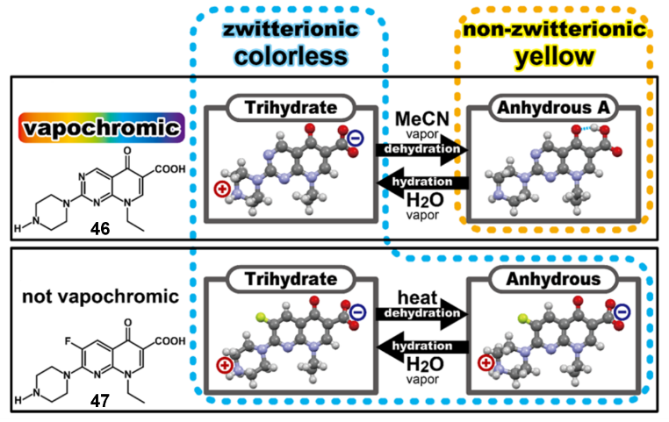
Fig. 23 The vapochromic behaviour of 46 and phase transformations of 47.

Xue and coworkers synthesized a triphenylamine-based benzoxazole derivative (48) (Fig. 24a), where the triphenylamine unit serves as a donor, and the benzoxazole moiety serves as an electron acceptor.¹⁸⁵ The microcrystal of 48 has an emission maximum at 473 nm, accompanied by a shoulder peak at 510 nm, which leads to blue-green fluorescence (B-form) discernible by the naked eye. The B-form film was subjected to mechanical shearing, which resulted in the formation of a yellow-green ground film with green fluorescence (G-form) (Fig. 24b). Fuming of the ground G-form film using organic solvents resulted in the re-appearance of the same diffraction peaks as those of the crystal in the XRD patterns and the birefringence patterns upon polarizing microscopy observation. These results suggest that the permeation of solvent vapours in the ground film increases the mobility of 48 molecules, which promotes the rearrangement of the molecules from a metastable amorphous structure to a more stable crystalline B-form state. The crystal packing of 48 (Fig. 24d) depicts the molecular structure and intermolecular interactions of adjacent molecules. The molecule adopts a non-planar conformation, which induces anti-parallel alignment due to slight overlap between adjacent molecules, with weak π-π interactions. In addition, one 48 molecule forms four weak CH-π hydrogen bonds with three adjacent molecules, which clearly explains why the molecular packing in the crystal can be easily changed by external mechanical stimulation.
Besides, when the ground G-form film was exposed to HCl vapour, the yellow-green film immediately turned into a dark-red film (R-form), which emitted weak red fluorescence with a maximum at 639 nm (Fig. 24c) and had three absorption peaks at 507, 534, and 595 nm. No birefringence patterns can be observed, indicating a disordered film. Interestingly, this red film can be transferred into an orange film (O-form), emitting strong orange fluorescence with a maximal emission peak at 564 nm, having three absorption peaks at 445, 491, and 530 nm, and exhibiting birefringence patterns. The result illustrates that the treatment of solvent promotes the phase transition from a disordered state to a crystalline state.
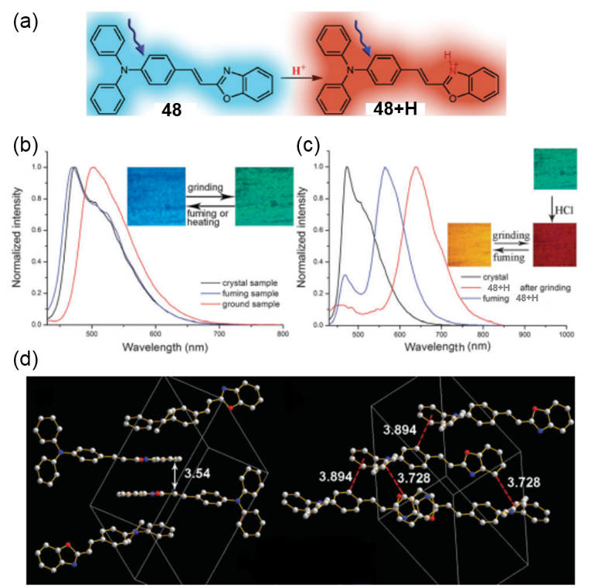
Fig. 24 (a) Chemical structure of 48 and the presentation of its emissions before and after proton binding. Normalized fluorescence spectra (b) of 48 and (c) 48+H upon external stimuli. (d) Crystal packing of 48 with different intermolecular interactions.

Tian and coworkers provided insights into the origin of the fluorescence responsive to protonation–deprotonation stimuli through the study on the crystals of a new stimuli-responsive molecule 9,10-bis((E)-2-(pyridin-3-yl)vinyl)anthracene (49) (Fig. 25a).¹⁸⁶ The photoluminescence spectra of the 49 powder exhibit a strong green emission peak at 525 nm. After fumed by HCl vapour, the emission of the powder shifted to 586 nm under 365 nm UV illumination (Fig. 25b). The fumed powder was recovered to exhibit green light (λ_{em} = 534 nm) after fumed by trimethylamine (TEA). The different emissions of the two crystals should originate from the different stacking modes and the protonation of pyridine moieties. In the single crystal structure of 49 (Fig. 25c, left), the distance between the centroids of adjacent molecules is 6.342 Å, and the anthracene planes are completely separated from each other so that the interactions between molecules are weak. While in the 49·HCl crystal structure (Fig. 25c, right), adjacent molecules inside each column are close to each other due to the strong hydrogen bonds, and the distance between centroids decreases to 4.993(2) Å. Though there is no π–π overlap between adjacent molecules in both crystals, the approach may end up in the enhancement of excitonic coupling between the transition dipoles of neighboring molecules compared to that in 49 crystals, which will lead to a red shift in the emission.
Fig. 25 (a) Chemical structure of 49. (b) Fluorescence microscope images of the 49 powders treated by HCl vapour and then TEA vapour. (c) Crystal packing structures of 49 and 49·HCl.

Akutagawa and coworkers reported 2-(2′- hydroxyphenyl)benzothiazole (HBT)-based sulfonic acid (50) as a new solid-state ESIPT (excited-state intramolecular proton transfer) fluorescent molecule that responds to the adsorption-desorption of organic bases and amines.¹⁸⁷ According to the residual electron density from the differential Fourier map, the structure of 50 showed that the protonated nitrogen atom was confirmed to form the benzothiazolium (BTz) cationic ring structure, referred to as HBTz⁺. The highly acidic proton on the −SO₃H group of 50 was transferred to the nitrogen site of the BTz ring via intramolecular acid−base reaction and proton transfer, resulting in a zwitterionic structure that bears both the anionic −SO₃⁻ moiety and the cationic HBTz⁺ ring. After exposure to pyridine (Py) vapour, the solid-state fluorescence spectra of crystal 50 indicated a large red-shift of approximately 65 nm, where the fluorescence colour drastically changed from weak blue to strong green (Fig. 26a). The 50·Py crystal showed the anionic moiety 50⁻ bearing the −SO₃⁻ group. Furthermore, neutral Py was also converted to the pyridinium cation (HPy⁺) after adsorption, where the proton transfer occurred at the nitrogen site of Py, forming the electrostatic intermolecular hydrogen-bonded N−H⁺···⁻O₃S− pair (Fig. 26c). On the contrary, strong intramolecular O−H···N hydrogen bonds were observed between the −OH group and the nitrogen site of the BTz ring in the emissive cis-conformation, which forbids the formation of the HBTz⁺ ring. After desorption of Py from the 50·Py crystals at 200 °C, the initial fluorescence spectra with λ^{F} max = 450 nm and weak blue emission was recovered.
Moreover, the adsorption of propylamine (PA) show a stepwise feature. They found that adsorption of 2 moles of PA into crystal 50 caused ∼30 nm blue-shift. Whereas after desorption of 1 mole PA, fluorescence colour clearly changed from strong blue to strong green (Fig. 26b). The single crystal X-ray diffraction of 50·(PA)₂ showed that two acidic protons at the −SO₃H and −OH groups were deprotonated to form the dianionic structure 50²⁻ bearing −SO₃⁻ and −O⁻ groups (Fig. 26d), which was crystallized with 2 moles of propylammonium (HPA⁺). The trans-conformation of the dianionic 50²⁻moiety in the 50·(PA)₂ crystal was consistent with the weak blue non-ESIPT fluorescence. However, the 50·PA crystals contained monoanionic 50⁻ bearing one −SO₃⁻ group and one HPA⁺ cation (Fig. 26e). The intramolecular O−H···N hydrogen-bonded cis-conformation was consistent with the strong green ESIPT fluorescence of the 50·PA crystals.
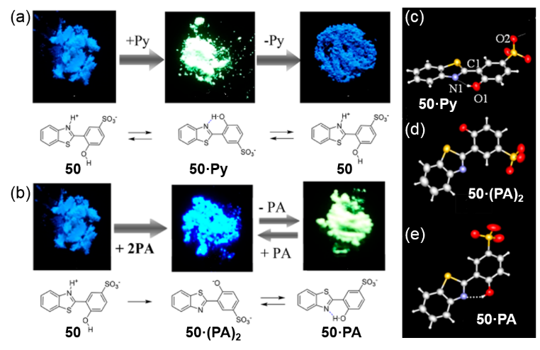
Fig. 26 (a) Photographs showing emission colour change in solid-state 50 for the Py adsorption−desorption cycle under UV irradiation at 365 nm. (b) Photographs of the stepwise PA adsorption−desorption cycle coupled with ESIPT fluorescence chromism in crystal 50. (c) Crystal structures of 50·Py, 50·(PA)₂ and 50·PA.

Douhal and coworkers first reported the porous hydrogen-bonded organic framework (HOF) from a hexaazatrinaphthylene derivative with carboxyphenyl groups (51) that exhibits acid-responsive colour changes (Fig. 27a).¹⁸⁸ Precise structures of both 1,2,4-trichlorobenzene solvate 51·TCB and activated HOF with permanent porosity 51a were successfully determined by single-crystalline X-ray diffraction analysis. Yellow crystalline bulks of activated 51a immediately turned into redish-brown by adding a drop of 37% HCl aqueous solution. Subsequence heating of the brown bulks resulted in the recovery of the original yellow colour due to the removal of HCl. The peaks in the PXRD patterns disappeared by adding a drop of HCl, while the original pattern could be completely recovered after heating the HCl-dropped sample. The disappearance of the PXRD patterns is presumably attributed to the disorder of the framework by adding HCl and/or scattering of diffracted X-ray by disordered Cl⁻ and H₃O⁺ ions filling the void. To exclude the second factor and estimate the only effects of HCl, 51a was exposed to the vapour of HCl. Colour was changed upon exposing to HCl vapour simultaneously, and new peaks at 4.86, 5.78, 9.78, and 11.7° appeared in PXRD patterns in addition to the original peaks. The new peaks disappeared when the sample was heated to remove HCl and back to the original yellow solid. These results indicate that addition of HCl and protonation of the hexaazatrinaphthylene (HATN) core perturbs the structure of the original framework, resulting changes and decay of PXRD patterns. When the HOF crystals are exposed to HCl vapours, the absorption and emission spectra show insignificant changes (Fig. 27b). The absorption spectrum exhibits a new band at 500−600 nm, while the emission spectrum is strongly quenched. Remarkably, from the single crystal structure and characterization analysis, the authors believe that due to the protonation of the pyranyl nitrogen atom embedded in its π-conjugated core 51a shows reversible vapour acid-induced colour changes from yellow to reddish-brown and the ON/OFF of its emission.
Fig. 27 (a) Chemical structure of 51. (b) HCl-responsive colour changes of crystalline bulks of 51a. (c) Crystal structures of solvate 51·TCB and activated form 51a.

- Vapochromic supramolecular crystals
In recent years, the continuous development of supramolecular macrocyclic compounds has also enriched the scope of vapochromic crystals. Numerous supramolecular hosts or complexes, such as Pt(II)-functionalized supramolecular metallacycle, trinuclear Cu(I) pyrazolate complexes, calixcrowns, pillararenes and so on, also exhibit unique properties in the field of vapochromism, especially the host−guest interaction induced vapochromism. The special feature of supramolecular vapochromic crystals is that gas- or vapour-responsive detection can be achieved by the synergistic effect of different host−guest interactions such as hydrogen bonding, π−π stacking and CH-π interactions. Generally speaking, the supramolecular crystals have a higher bonding strength with the analytes than the organic crystals. Supramolecular crystals also have a non-negligible advantage in that they can be used to adsorb analytes while detecting the analytes, especially volatile toxicants.¹⁸⁹⁻²²⁹

4.1 Vapochromic luminescent metal complexes
The first kind of vapochromic supramolecular system is the formation of the luminescent metal complexes that leads to vapochromism. With the rich spectroscopic and luminescence properties associated with unique metal-metal interactions, metal complexes have provided an excellent platform for the design of luminescent chemosensors.²³⁰⁻²³⁶ In view of the need to find host molecules that are capable of selectively recognizing specific guest molecules at specific receptor sites and producing measurable physical changes, attentions have been focused on the molecular design of supramolecular chemosensors involved in optical signal transduction, particularly in luminescent signaling. Yam systematically summarized the study of luminescent Au(I) complexes with various functional acceptor groups for cation and/or uranium ion binding based on supramolecular recognition.^{17,237-242}
Lintang and coworkers reported the study on vapochromic response to ethanol by using phosphorescent trinuclear metal pyrazolate complexes (52) based on supramolecular assembly of weak intermolecular metal-metal interactions (Fig. 28a).^{243,244} They found that the Cu(I) complex showed a pronounced and positive response to ethanol vapours in 5 minutes. The emission band of 52 showed a blue-shift and its corresponding apparent colour changed from orange to green (Fig. 28b and 28c). However, the Au(I) or Ag(I) complexes with similar supramolecular structures did not show such vapochromism. Designing a suitable ligand and matching well with metal ions endows the chemosensor with good sensing capability owing to the formation of weak intermolecular hydrogen between the O atom on the methoxy group of the benzyl ring and the −OH group of the detected vapours.
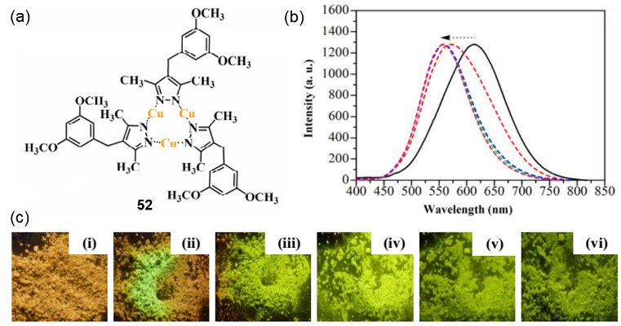
Fig. 28 (a) Molecular structure of trinuclear pyrazolate complexes of 52. (b) Emission spectral changes of 52 upon exposure to ethanol from 0 (black solid line) to 5 mins (red, blue, green, orange and pink dash line, respectively) and their photography images (c).

In addition, supramolecular metallacycles via coordination-driven self-assembly can also be used as one kind of the excellent vapochromic materials. Yang and coworkers successfully prepared a new discrete supramolecular metallacycle 53 functionalized with an alkynylplatinum(II) bzimpy moiety by ingenious design, and showed reversible colour changes in the solid state between yellow and red induced by CH₂Cl₂ vapour or mechanical grinding (Fig. 29c).²⁴⁵ Further geometric structure analysis showed that the existence of a chair-shaped metallacycle at the core facilitates close molecular stacking through intermolecular Pt···Pt and π−π stacking interactions, thus allowing such a highly stable vapochromic system (Fig. 29a). When another white metallacycle 54 was exposed to CH₂Cl₂ vapour, no obvious colour change was observed (Fig. 29b and d), which indicated that the existence of the alkynylplatinum(II) bzimpy moiety is necessary for vapochromic behaviour in this study.
Fig. 29 (a) Geometric structure of 53 optimized by the PM6 semiempirical molecular orbital method. (b) Single-crystal structure of 54 shown from different perspectives. Photographs showing the changes in colour of 53 (c) and 54 (d) after being exposed to CH₂Cl₂ vapour.

4.2 Vapochromic macrocyclic compounds with luminophores or fluorophores
The second kind of vapochromic supramolecular system is the introduction of luminophores or fluorophores into macrocyclic compounds. The goodexample is a supramolecular assembly fabricated from perylene bisimides and cyclodextrin conjugates, which was reported by Liu and coworkers in 2009.^{[246]} By forming a well-ordered crystalline arrangement via π-π stacking interactions, perylene bisimides can produce strong solid-state fluorescence and thus act as a fluorescent probe in the building block (Fig. 30a). At the same time, permethyl-β-cyclodextrin acts as the molecular receptor that provides analytes binding site. In addition, they used the poly(vinylidene fluoride) membrane-embedded building block as a new vapour detecting material. These sensitive membranes exhibited fluorescence quenching to several saturated vapours of volatile organic compounds including not only organic amines and nitro-based compounds but also general organic solvents within a short response time (Fig. 30b and 30c). In addition to photo-induced electron transfer, fluorescence changes were thought to be attributable to analyte inclusion and concomitant changes in the packing of the building blocks.
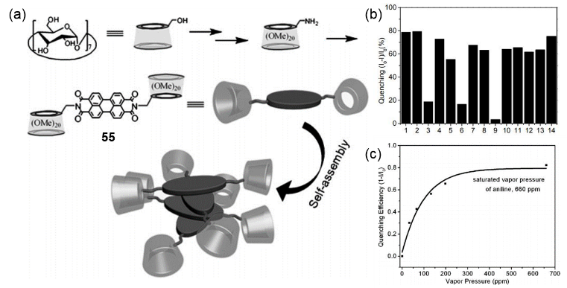
Fig. 30 (a) The synthetic route and structural illustration of 55 and its self-assembly mode. (b) Fluorescence response of the PVDF membrane-embedded 55 to the saturated vapours of various compounds with a response time of 10 s: 1, o-methyl-aniline; 2, aniline; 3, benzylamine; 4, butylamine; 5, triethylamine; 6, hydrazine; 7, nitroethane; 8, nitromethane; 9, nitrobenzene; 10, chloroform; 11, toluene; 12, chlorobenzene; 13, methanol; 14, acetonitrile. (c) The fluorescence quenching efficiency as a function of the vapour pressure of aniline.

Dalcanale and coworkers chose the fluorescent phosphonate cavitands as molecular receptors.^{[247]} They introduced a fluorophore into a cavitand at the phosphonate site. The reason for choosing the fluorophore 2-anilinophthalene (2-AN) is that the charge-transfer from the aniline to the naphthalene moiety would occur in its excited state, resulting in a fluorescence change (Fig. 31a and 31b). Two cavitand isomers with different P=O orientations were then synthesized and introduced into the PVC thin films for alcohol vapour detection (Mi film, PVC film containing inward oriented P=O isomer; Mo film, PVC film containing outward oriented P=O isomer). They found that the fluorescence intensity of the Mi films changed significantly when exposed to the C₁-C₄ alcohol series except 1-butanol, while Mo film showed negligible responses to all C₁–C₄ alcohols (Fig. 31c). By studying the single crystal structures of the phosphonate cavitands and alcohols, they clarified that the synergistic effect between CH-π interactions and the H-bonding of the alcohol to the P=O induces a detectable red-shift of the fluorescence emission of the 2,6-AN fluorophore. In addition, the intra-cavity H-bonding in inward oriented P=O isomer is more favored than the extra-cavity form due to the cavity free-volume effect.
Fig. 31 Structure of the fluorescent phosphonate cavitands Mi (a) and Mo (b). (c) Relative fluorescence intensity changes (λ_{ex} = 350 nm, λ_{ex} = 460 nm) of PVC films containing the receptor Mi (dark gray) or Mo (light gray) exposed to different alcohols in N₂.

Ogoshi and coworkers for the first time reported coloured crystals of pillar[4]arene[1]quinone exhibited alkaneshape-selective vapochromic behaviour.^{[248]} The pillar[4]arene[1]quinone (56) containing four 1,4-diethoxybenzene units and one benzoquinone unit is crystalline brown powder after activation by removing the solvent. The authors found that the colour of activated crystals changed colour from dark-brown to light-red after exposure to linear alkane vapours. However, no colour changes were observed on exposure to branched or cyclic alkanes. Besides, the colour of the activated crystals changed to black after uptake of methanol vapour. To reveal these multi-vapochromism results, they grew the alkane- and methanol-containing single crystals. They explained that the same host molecules were induced to form different structures by different guest molecules, reflecting in the difference of intermolecular π-stacking interactions between the benzoquinone and 1,4-diethoxybenzene units. And the different π-stacking arrangements in the crystal structures will affect the charge-transfer complexation, resulting in the vapour-dependent colour change.
Fig. 32 Crystal structures of 56 prepared from methanol and n-hexane and photographs showing colour changes of 56 crystals after being exposed to different vapours.

To further expand its practical application, we utilized the same macrocycle to detect and adsorb volatile low-molecular-weight aliphatic aldehydes.^{[249]} When desolvated 56 crystals were exposed to aliphatic aldehydes with different carbon chain lengths, they quantitatively adsorb vapours of these aldehydes, accompanied by different colour changes. Crystal structure analyses showed a similar mechanism for different colour changes after adsorption of different aldehydes. It has also been demonstrated that 56 crystals showed good selectivity for two-component aldehyde vapours detection and excellent adsorption cycling performance.
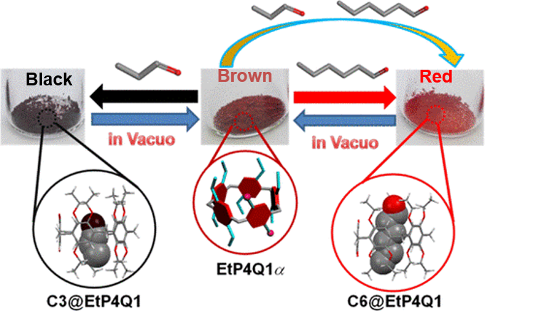
Fig. 33 Photographs showing colour changes of 56 crystals after being exposed to different aliphatic aldehyde vapours and their crystal structures.

In recent years, our group pioneered studies on nonporous adaptive crystals (NACs) of pillararenes whose intrinsic pores can be triggered by vapourized guests, displaying outstanding performance in adsorption and separation.²⁵⁰⁻²⁵⁵ We reported an unique solid−vapour postsynthetic modification of 56 NACs, which showed vapochromic phenomena.²⁵⁶ Upon exposure to different aliphatic amine vapours, the powders of 56 gradually completed the colour change from dark-brown to black, dark purple, gray or wine over time (Fig. 34a). The single crystals obtained by in situ solution growth indicated that in addition to the presence of common host−guest complexes, two molecules of amine molecules are attached to the backbone of each macrocyclic host. It has also been shown by other characterization methods that vapochromism is the result of a combination of physical adsorption process and chemical reaction process. First, amines are physically adsorbed into cavities of 56 molecules and slowly react due to their juxtapsition with the benzoquinone units (Fig. 34b). Moreover, the process displays both reactant-size and -shape selectivities because of the rigid cavity of 56 and the different binding strengths of various amines with 56.
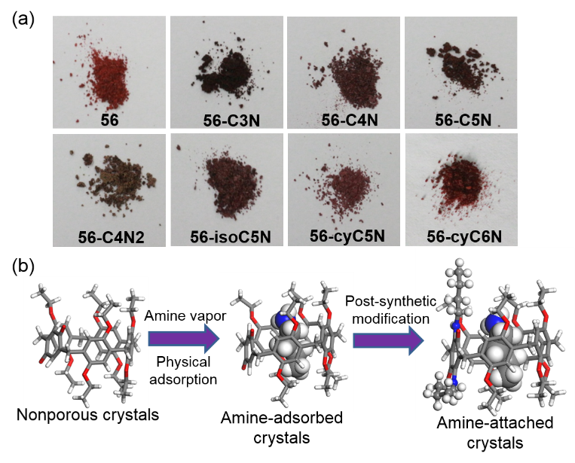
Fig. 34 (a) Photographs showing colour changes of 56 crystals after being exposed to aliphatic amine vapours. (b) Schematic representation of the postsynthetic modification in 56 by capturing butanamine vapour.

We also reported the first NACs with vapor-induced fluorochromism.²⁵⁷ The introduction of the conjugated anthracene moieties imparts particular fluorescent properties to the entire macrocyclic molecule. When the 57 crystals are exposed to different ketone vapors, they exhibited vapochromic behavior with selectivity to the length of alkyl chains. As shown in Figure 35a, exposing activated 57 crystals to 2-butanone (C4), 2-pentanone (C5), and 2-hexanone (C6) vapors induced a significant blue shifts in fluorescence, while 2-heptanone (C7) and 2-octanone (C8) vapors did not cause any fluorescence change. The optical properties of crystalline materials are closely related to their crystal structures. In the 57-C3 (C3 = acetone) single crystal structure (Fig. 35b), two adjacent 57 molecules were in face-to-face position with a short distance between anthracene units, demonstrating strong π−π interaction and the formation of an H-aggregated anthracene excimer. However, structural analysis of 57-C4, similar to 57-C5 and 57-C6, showed that the 57 pair was staggered apart because the ketone molecules occupied the spaces between the host molecules (Fig. 35c). Therefore, anthracene excimers disassembled into J-aggregated monomers, showing a blue-shifed green emission. In contrast, PXRD results indicated that absorption of C7 and C8 vapors did not change the structure of the 57 crystals. Due to their large molecular volumes, C7 and C8 molecules were restricted in cavities of host molecules rather than occupying the spaces between host molecules, thereby preserving the integrity of the anthracene excimers and maintaining yellow fluorescence.
Fig. 35 (a) Chemical structure of 57 and photographs of crystals exposed to different ketones taken under sunlight (upper) and 365 nm UV light (lower). A pair of 57 molecules in the 57-C3 single crystal structure (b) and in the 57-C4 single crystal structure (c).

4.3 Vapochromism based on volatile and coloured guests
The third kind of vapochromic supramolecular system is the vapochromism induced by the volatile and coloured guests, mainly including iodine. After the supramolecular host capturing the sublimated iodine vapour, the host−guest complexes exhibit the colour of the iodine vapour itself and does not autonomously fade the colour in a short period of time. In 2009, Cooper and coworkers reported that covalently bonded organic cages can assemble into crystalline microporous crystals (Fig. 36a).^{[258,259]} They then utilized these porous organic cages as hosts for the three-dimensional arrangement of guests, such as halogens and organometallics.^{[260]} Especially, when the cages are exposed to solid iodine, iodine sublimed into the porous crystals over time at ambient temperature, with a pronounced colour change from white to almost black (Fig. 36b). By analyzing the crystal structures for the iodine-loaded species (Fig. 36c), I@CC3, they found the iodine atoms form a diamondoid chain arrangement. Actually, iodine appears to take the form of I₅⁻ within the I@CC3 structure, and this species is stabilized and oriented by the cage molecules, which leads to marked conductivity enhancement.
Fig. 36 (a) Chemical structure of 58. (b) Photographs showing the colour change when a single crystal of 58 was exposed to iodine vapour. (c) Crystal packing for I@58 showing 3-D diamondoid pore network filled with iodine.

Afterwards, Hardie and coworkers synthesized some new Pd₃L₂ metallo-cryptophane cages constructed from chiral tripodal cavitand ligands with a cyclotriveratrylene scaffold (59) (Fig. 37a).^{[261,262]} They found that the crystalline complex 59·(CH₃NO₂)₈ exhibits guest uptake behaviour in a single crystal-to-single crystal fashion. Crystals of 59·(CH₃NO₂)₈ were immersed in a solution of iodine for a week to obtain complex 59·(H₂O)·(I₂)₃ (Fig. 37b). Meanwhile, single crystals of the complex 59·(CH₃NO₂)₈ were placed under vacuum and exposed to iodine vapours. As a result, iodine vapours were absorbed by the crystals immediately, whose colour was changed from colorless to dark brown. Unlike conventional porous organic cages, once absorbed, I₂ cannot be easily extracted from the crystal lattice (Fig. 37d), indicating the potential of these materials to act as a sequestering agent for radioactive I₂.
Fig. 37 (a) Chemical structure of the 59. (b) Experimental set-up for I₂-vapour up-take experiment and optical micrographs showing colour change before and after I₂-uptake. (c) and (d) Crystal structures of complex 59·(CH₃NO₂)₈ and 59·(H₂O)·(I₂)₃.

We also attempted to capture iodine by using NACs of per-ethylated pillar[6]arene (60).^{[263]} We found that iodine could sublime into nonporous crystals of 60 over time, and there was an apparent colour change of the crystals from white to dark-brown (Fig. 38a). However, smaller or larger size of pillararenes, like pillar[7]arene or pillar[5]arene, hardly adsorbed iodine vapour and only small quantity adsorbed was ascribed to the crystal surface loading. We proved that the uptake of iodine leads to a structural transformation of 60 in the solid state, which may be the main cause of colour change. Specifically, in the single crystal structure of iodine-doped 60 (Fig. 38b), each adsorbed iodine molecule is located between two adjacent and distorted 60 molecules to form a linear supramolecular polymer. And these 60 crystals can also be reused many times without losing iodine capture capacity.
Fig. 38 (a) Photographs showing colour change of 60 crystals after being exposed to iodine vapour. (b) Single crystal structure of I₂@60 and packing mode.

Li and coworkers also reported iodine capture by using new macrocyclic compounds.^{[264]} They first designed and synthesized two new macrocycles by a one-step condensation reaction, terphen[n]arenes (TPns) (n = 3–6) and quaterphen[n]arenes (QPns) (n = 3–6) (Fig. 39a). Interestingly, different from TP3 crystals, the cyclic pentamers and hexamers form supramolecular organogels driven by intermolecular π···π stacking interactions. And their corresponding xerogels can also serve as adsorptive materials to capture volatile iodine and show some changes in optical properties (Fig. 39b).
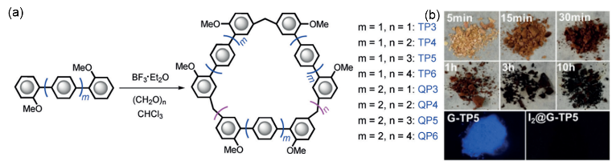
Fig. 39 (a) Synthesis of TPns and QPns (n = 3–6). (b) Colour changes after adsorption of iodine by G-TP5 and fluorescence images of G-TP5 before and after iodine uptake under a UV lamp (365 nm).

- Vapochromic metal–organic frameworks
Metal−organic frameworks (MOFs) also known as a coordination polymers or coordination networks, are a class of fascinating materials assembled from inorganic and organic components. They are both fundamentally important and technologically relevant.²⁶⁵⁻²⁷⁴ This new type of novel organic-inorganic hybrid materials are certainly promising as multifunctional luminescent materials because both the inorganic and organic moieties can provide the platforms to generate luminescence, while metal−ligand charge transfer-related luminescence within MOFs increases another dimensional luminescent functionalities. The combination of luminescence and accessible porosity in these materials gives them the ability of transducing the host–guest chemistry to detectable changes in their luminescence and makes them promising candidates for sensing and detection applications. Some of the typical examples are introduced in the following.

Li and coworkers designed and synthesized a microporous metal–organic framework [Zn₂(bpdc)₂(bpee)] (bpdc = 4,4’-biphenyldicarboxylate; bpee = 1,2-bipyridylethene) (61) (Fig. 40a).²⁷⁵ The guest-free 61 is highly luminescent in the solid state at room temperature, which can be obtained by heating under vacuum or by evacuation following solvent exchange with methanol and dichloromethane. The potential of 61 in explosive detection was demonstrated. When exposed to 2,4-Dinitrotoluene (DNT) and 2,3-dimethyl-2,3-dinitrobutane (DMNB) vapours within 10 seconds, the fluorescence quench percentages of 61 almost reached a maximum of about 85% and 84%, respectively (Fig. 40b, right). After quenching, the photoluminescence of 61 can be recovered by simple heating for about 1 minute. The excellent sensing capability of 61 can be attributed to its infinite 3D framework structure and inherent microporosity, which facilitates a stronger interaction between DNT and DMNB and the host framework, such as π-π interactions. The authors further speculated that the redox quenching mechanism is similar to that in conjugated polymer systems. It is worth mentioning that this microporous crystalline metal−organic material can be used to detect trace explosives in the vapour phase.
Fig. 40 (a) Perspective view of the 3D structure of 61. (b) Schematic representation of the fluorescence quenching before and after exposure to the analyte vapours.

Another similar example is luminescent Li-based MOF (62) reported by Moon and coworkers.²⁷⁶ The luminescent MOF has been shown to act as a detector of toxic and explosive aromatic compounds containing nitro groups (Fig. 41a). They provided direct evidence for alteration of the electronic structure of 62 upon nitrobenzene sensing by single-crystal-to-single-crystal transformation. The single crystal analysis of 62·nitrobenzene clearly shows that there are strong π-π interactions between nitrobenzene and the benzene ring of the ligand in 62, and the CH···π interactions between adjacent ligands in the framework (Fig. 41b). Vapochromism can also be attributed to the charge-transfer transition between the aromatic ring of the electron-rich ligand moiety and the electron-deficient nitrobenzene molecule.
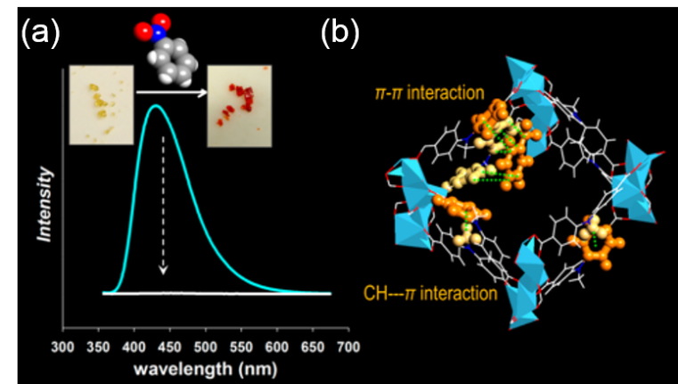
Fig. 41 (a) Photographs showing colour change of 62 crystals and the fluorescence quenching before and after exposure to nitrobenzene vapour. (b) Crystal structure of 62·nitrobenzene.

It is essential that vapochromic materials can detect a single substance, but in many cases they cannot discriminate between molecules with similar structure. Sensor materials capable of distinguishing a series of molecules with small structural differences have been studied with great effort.^{72,86,277-285} Kitagawa and coworkers reported a MOF host (63), which can accommodate aromatic guests with different substituents and exhibit different photoluminescence in solution or in solid state.²⁸⁶ They introduced the photoactive organic moiety, 1,4,5,8-naphthalenediimide (NDI), into the porous framework as a scaﬀold because of its characteristic photophysical properties. They found that the synthesized MOF exhibited dynamic structural transformation due to the dislocation of two chemical non-interconnected frameworks. In the crystal structure of the interpenetrating MOF 63·(DMF)₄ (Fig. 42a), one of the frameworks of 63 is intergrown at the center of the void that is created by another framework, remaining two types of void spaces. Dried crystal structure 63·DMF (Fig. 42b) can be obtained by heating 63·(DMF)₄ crystals in vacuum through a single-crystal-to-single-crystal transition, in which the framework sheared itself to minimize the void spaces due to the removal of the DMF molecules. The aromatic VOCs were successfully introduced into the entangled framework by immersing 63·DMF in the liquid of each aromatic VOC (Fig. 42c). Structural analysis also showed that the framework could accommodate each VOC by guest exchange. It is the dynamic structural transformation that causes the aromatic guest molecules are strongly confined in the nanopores. And the resulting host−guest interaction generates enhanced and distinguishable emissions based on the charge-transfer characteristics of the NDI and VOC (Fig. 42d).
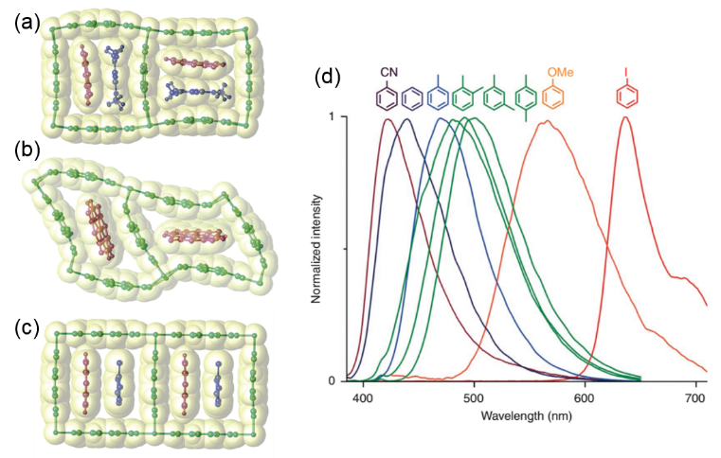
Fig. 42 Crystal structures of (a) 63·(DMF)₄; (b) 63·DMF; (c) 63·(toluene)2.5. (d) Normalized luminescent spectra of 63⊃VOCs after excitation at 370 nm.

Oxygen sensing is a challenging and significant project because of its wide existence in food science, environmental analysis, space research, biochemistry and other fields.^{287,288} Luminescence quenching is one of the most studied oxygen sensing mechanisms for its high efficiency, high sensitivity and simplicity.^{16,289} For example, Lin and coworkers synthesized a Zn-based MOF (64) using Ir(2-phenylpyridine)₃ derivatives.²⁹⁰ The authors found that when 64 was gradually loaded with O₂ from 0.05 to 1.0 atm, the luminescence intensity at 538 nm was gradually decreased. Furthermore, after alternating cycles of O₂ loading at 0.1 atm and O₂ removal under vacuum, the luminescence of 64 can be reversibly quenched with <5% of the original luminescence loss after eight cycles (Fig. 43a). Chief of all is that the Ir(2-phenylpyridine)₃ derivatives can impart a high phosphorescent property to the MOF. Hence, its metal to ligand charge-transfer phosphorescence can be easily quenched by molecules having a triplet ground state. Another example of luminescent MOFs for sensing oxygen was reported by Rosi and coworkers.²⁹¹ In this work, Yb³⁺ was encapsulated in MOF (Yb³⁺@65) by a post-synthetic cation exchange method, which showed a clear Yb³⁺-center emission at 980 nm. Porous anionic MOF was chosen to sensitize and protect lanthanide ions. Approximately 40% emission signal decrease of Yb³⁺@65 was observed during the first 5 minutes of introducing O₂ at ambient pressure. In addition, the Yb³⁺ signal maintains its original luminescence intensity after several cycles of exposure to O₂ and N₂. Another example is the Zn-based MOF (66) reported by Zhang.²⁹² After testing various gases, namely N₂, CO₂ and O₂ (the main constituents in the air), the fluorescence of 66 is selectively quenched by O₂ as shown in Fig. 43b. The superior sensing performance of the 66 is due to its unique framework structure, which not only provides high oxygen permeability, but also allows the fluorophores to be well isolated from each other to avoid self-quenching.
Fig. 43 (a) Reversible oxygen adsorption of 64. (b) Reversible quenching/recovery of luminescence upon alternating exposure to oxygen and vacuum for 66.

Summary and Outlook
Based on the works in this review, some common structural features can be extracted in most of organic materials with switchable solid state luminescence. First, a planar π-conjugated chromophore or core is essential for luminescence. Second, the chromophore or core is replaced by two or more rotatable aromatic rings, which have a huge effect on the wavelength and quantum yield of the emission, like AIE. Finally, the molecules usually contain specific groups (such as CF₃, amino or cyano groups), which strongly influence the molecular packing mode through intermolecular interactions.^{293–297}
As described above, considerable progress has been achieved in the field of vapochromic crystals over the past decades. Not only the extensively explored vapochromic organometallic and coordination complexes but also newly-developed vapochromic organic crystals have been discussed. The development of MOFs and supramolecular macrocyclic compounds has also enriched the scope of vapochromic crystals. Hence, studying vapochromism from the perspective of crystal engineering has important guiding significance for crystal engineering and materials science. Vapochromic organic crystals are emerging, and meanwhile their mechanisms are being constantly studied and clarified. With the synergy of multiple mechanisms, vapochromic organic crystals exhibit different properties from vapochromic metal-containing crystals, such as solution processability and rich structural composition. Dynamic reversibility, high selectivity and rich environmental responsiveness are the strong advantages of vapochromic supramolecular crystals. In particular, the host−guest recognition properties of supramolecular macrocycles can induce a new vapochromic mechanism. As for MOFs, the structural design of organic ligands, the perfect matching of metals and ligands, and the precise regulation of channel size make MOFs an excellent vapochromic candidate that can be tuned for task-specific applications at the atomic scale. Meanwhile, the presence of controllable and highly ordered channels in these crystals has broadened the applications of vapochromic crystals, especially the detection of small gas molecules.
Moreover, applications of vapochromic crystals in numerous areas including chemical sensors, light-emitting diodes, and environmental monitors have been achieved. One superiority of vapochromic crystals to other vapochromic materials is the avoidance of the expensive analytical instruments and inability to continuously monitor in the field. In spite of the advantages and applications they have in various areas, there still plenty of room for vapochromic crystals research to develop sensors with high sensitivity and resolution like biological indicator and cross-reactive array.
Considering that vapochromic crystals mentioned above play significant parts in potential and precise design of direct analytes of volatile organic compounds, the search of any novel kind of vapochromic crystals which may accelerate the development of new vapochromic crystals with unexpected features. There is no doubt that further substantial achievements on vapochromic crystals are closely associated with the intense collaborations of experts from different research fields.

Acknowledgements
This work was supported by the National Natural Science Foundation of China (21434005, 91527301) and the Fundamental Research Funds for the Central Universities.
References
[1] C. C. Nagel, Eur. Pat., 277033, 1988.
[2] P. C. Jurs, G. A. Bakken and H. E. McClelland, Chem. Rev., 2000, 100, 2649.
[3] K. J. Albert, N. S. Lewis, C. L. Schauer, G. A. Sotzing, S. E. Stitzel, T. P. Vaid, and D. R. Walt, Chem. Rev., 2000, 100, 2595.
[4] M. Hissler, J. E. McGarrah, W. B. Connick, D. K. Geiger, S. D. Cummings and R. Eisenberg, Coord. Chem. Rev., 2000, 208, 115.
[5] N. S. Lewis, Acc. Chem. Res., 2004, 37, 663.
[6] K. M.-C. Wong and V. W.-W. Yam, Coord. Chem. Rev., 2007, 251, 2477.
[7] F. Rock, N. Barsan and U. Weimar, Chem. Rev., 2008, 108, 705.
[8] X. Zhang, B. Li, Z.-H. Chen and Z.-N. Chen, J. Mater. Chem., 2012, 22, 11427.
[9] O. S. Wenger, Chem. Rev., 2013, 113, 3686.
[10] C. A. Daws, C. L. Exstrom, J. R. Sowa Jr. and K. R. Mann, Chem. Mater. 1997, 9, 363.
[11] M. H. Keefe, K. D. Benkstein and J. T. Hupp, Coord. Chem. Rev., 2000, 205, 201.
[12] E. Fernández, A. Laguna and J. M. López-De-Luzuriaga, Coord. Chem. Rev., 2005, 249, 1423.
[13] A. Luquin, C. Elosúa, E. Vergara, J. Estella, E. Cerrada, C. Bariáin, I. R. Matías, J. Garrido and M. Laguna, Gold Bull., 2007, 40, 225.
[14] M. J. Katz, K. Sakai and D. B. Leznoff, Chem. Soc. Rev., 2008, 37, 1884.
[15] M. N. Fiddler, I. Begashaw, M. A. Mickens, M. S. Collingwood, Z. Assefa and S. Bililign, Sensors, 2009, 9, 10447.
[16] Q. A. Zhao, F. Y. Li and C. H. Huang, Chem. Soc. Rev., 2010, 39, 3007.
[17] X. M. He and V. W.-W. Yam, Coord. Chem. Rev., 2011, 255, 2111.
[18] M. Serrano, M. Silva and M. Gallego, Anal. Chim. Acta, 2013, 784, 77.
[19] G. Dugo, A. Rotondo, D. Mallamace, N. Cicero, A. Salvo, E. Rotondo and C. Corsaro, Physica A., 2015, 420, 258.
[20] Y. Li, F. Yi, Y. Zheng, Y. Wang, J. Ye and Q. Chu, J. Sep. Sci., 2015, 38, 2873.
[21] J. Obermeier, P. Trefz, K. Wex, B. Sabel, J. K. Schubert and W. J. Miekisch, Breath Res., 2015, 9, 016008.
[22] C. Liu, B. Wyszynski, R. Yatabe, K. Hayashi and K. Toko, Sensors, 2017, 17, 382.
[23] L. You, D. Zha and E. V. Anslyn, Chem. Rev., 2015, 115, 7840.
[24] V. W.-W. Yam, V. K.-M. Au and S. Y.-L. Leung, Chem. Rev., 2015, 115, 7589.
[25] R. Paolesse, S. Nardis, D. Monti, M. Stefanelli and C. D. Natale, Chem. Rev., 2017, 117, 2517.
[26] L. E. Kreno, K. Leong, O. K. Farha, M. Allendorf, R. P. V. Duyne and J. T. Hupp, Chem. Rev., 2012, 112, 21105.
[27] Y. Cui, Y. Yue, G. Qian and B. Chen, Chem. Rev., 2012, 112, 1126.
[28] J. Heinea and K. Müller-Buschbaum, Chem. Soc. Rev., 2013, 42, 9232.
[29] Y. Cui, B. Chen and G. Qian, Coord. Chem. Rev., 2014, 273, 76.
[30] C. L. Exstrom, J. R. Sowa, C. A. Daws, D. Janzen and K. R. Mann, Chem. Mater., 1995, 7, 15.
[31] M. Albrecht, M. Lutz, A. L. Spel and G. v. Koten, Nature, 2000, 406, 970.
[32] W. Ku, M. C. W. Chan, K.-K. Cheung and C.-M. Che, Organometallics, 2001, 20, 2477.
[33] M. Kato, A. Omura, A. Toshikawa, S. Kishi and Y. Sugimoto, Angew. Chem. Int. Ed., 2002, 41, 3183.
[34] M. Kato, S. Kishi, Y. Wakamatsu, Y. Sugi, Y. Osamura, T. Koshiyama and M. Hasegawa, Chem. Lett., 2005, 34, 1368.
[35] S. C. F. Kui, S. S.-Y. Chui, C.-M. Che and N. Zhu, J. Am. Chem. Soc., 2006, 128, 8297.
[36] J. Forniés, S. Fuertes, J. A. López, A. Martín and V. Sicilia, Inorg. Chem., 2008, 47, 7166.
[37] P. Du, J. Schneider, W. W. Brennessel and R. Eisenberg, Inorg. Chem., 2008, 47, 69.
[38] A. Kobayashi, H. Hara, S. Noro and M. Kato, Dalton Trans., 2010, 39, 3400.
[39] J. Ni, L.-Y. Zhang, H.-M. Wen and Z.-N. Chen, Chem. Commun., 2009, 3801.
[40] A. Kobayashi, Y. Fukuzawa, H.-C. Chang and M. Kato, Inorg. Chem., 2012, 51, 7508.
[41] T. Ohba, A. Kobayashi, H.-C. Chang and M. Kato, Dalton Trans., 2013, 42, 5514.
[42] L.-Y. Zhang, L.-J. Xu, X. Zhang, J.-Y. Wang, J. Li and Z.-N. Chen, Inorg. Chem., 2013, 52, 5167.
[43] N. Kitani, N. Kuwamura, T. Tsuji, K. Tsuge and T. Konno, Inorg. Chem., 2014, 53, 1949.
[44] T. Ohba, A. Kobayashi, H.-C. Chang, T. Kouyama, T. Kato and M. Kato, Dalton Trans., 2014, 43, 7514.
[45] J. R. Berenguer, J. Fernández, B. Gil, E. Lalinde and S. Sánchez, Chem. Eur. J., 2014, 20, 2574.
[46] R. Zhang, Z. Liang, A. Han, H. Wu, P. Du, W. Lai and R. Cao, CrystEngComm, 2014, 16, 5531.
[47] A. Kobayashi, S. Oizumi, Y. Shigeta, M. Yoshida and M. Kato, Dalton Trans., 2016, 45, 17485.
[48] Y. Li, L. Chen, Y. Ai, E. Y.-H. Hong, A. K.-W. Chan and V. W.-W. Yam, J. Am. Chem. Soc., 2017, 139, 13858.
[49] M. J. Bryant, J. M. Skelton, L. E. Hatcher, C. Stubbs, E. Madrid, A. R. Pallipurath, L. H. Thomas, C. H. Woodall, J. Christensen, S. Fuertes, T. P. Robinson, C. M. Beavers, S. J. Teat, M. R. Warren, F. Pradaux-Caggiano, A. Walsh, F. Marken, D. R. Carbery, S. C. Parker, N. B. McKeown, R. Malpass-Evans, M. Carta and P. R. Raithby, Nat. Commun., 2017, 8, 1800.
[50] R. L. White-Morris, M. M. Olmstead, F. L. Jiang, D. S. Tinti and A. L. Balch, J. Am. Chem. Soc., 2002, 124, 2327.
[51] Y. A. Lee and R. Eisenberg, J. Am. Chem. Soc., 2003, 125, 7778.
[52] J. Lefebvre, R. J. Batchelor and D. B. Leznoff, J. Am. Chem. Soc., 2004, 126, 16117.
[53] D. B. Leznoff and J. Lefebvre, Gold Bull., 2005, 38, 47.
[54] E. J. Fernández, J. M. López-De-Luzuriaga, M. Monge, M. E. Olmos, R. C. Puelles, A. Laguna, A. A. Mohamed and J. P. Fackler, Inorg. Chem., 2008, 47, 8069.
[55] H. Ito, T. Saito, N. Oshima, N. Kitamura, S. Ishizaka, Y. Hinatsu, M. Wakeshima, M. Kato, K. Tsuge and M. Sawamura, J. Am. Chem. Soc., 2008, 130, 10044.
[56] M. J. Katz, T. Ramnial, H. Z. Yu and D. B. Leznoff, J. Am. Chem. Soc., 2008, 130, 10662.
[57] A. Deák, T. Tunyogi and G. Pálinkás, J. Am. Chem. Soc., 2009, 131, 2815.
[58] C. E. Strasser and V. J. Catalano, J. Am. Chem. Soc., 2010, 132, 10009.
[59] M. Osawa, I. Kawata, S. Igawa, M. Hoshino, T. Fukunaga, D. Hashizume, Chem. Eur. J., 2010, 16, 12114.
[60] A. Laguna, T. Lasanta, J. M. López-de-Luzuriaga, M. Monge, P. Naumov and M. E. Olmos, J. Am. Chem. Soc., 2010, 132, 456.
[61] T. Lasanta, M. E. Olmos, A. Laguna, J. M. López-de-Luzuriaga and P. Naumov, J. Am. Chem. Soc., 2011, 133, 16358.
[62] S. H. Lim, M. M. Olmstead and A. L. Balch, J. Am. Chem. Soc., 2011, 133, 10229.
[63] A. Deák, T. Tunyogi, Cs. Jobbágy, Z. Károly, P. Baranyai and G. Pálinkás, Gold Bull., 2012, 45, 35.
[64] I. O. Koshevoy, Y.-C. Chang, A. J. Karttunen, M. Haukka, T. Pakkanen and P.-T. Chou, J. Am. Chem. Soc., 2012, 134, 6564.
[65] J. R. Shakirova, E. V. Grachova, A. S. Melnikov, V. V. Gurzhiy, S. P. Tunik, M. Haukka, T. A. Pakkanen and I. O. Koshevoy, Organometallics, 2013, 32, 4061.
[66] S. H. Lim, M. M. Olmstead and A. L. Balch, Chem. Sci., 2013, 4, 311.
[67] A. Saha, Z. Panos, T. Hanna, K. Huang, M. Hernández-Rivera and A. A. Martí, Angew. Chem. Int. Ed., 2013, 52, 12615.
[68] H. Sun, S. Liu, W. Lin, K. Y. Zhang, W. Lv, X. Huang, F. Huo, H. Yang, G. Jenkins, Q. Zhao and W. Huang, Nat. Commun., 2014, 5, 3601.
[69] C. Jobbágy and A. Deák, Eur. J. Inorg. Chem., 2014, 4434.
[70] R. J. Roberts, D. Le and D. B. Leznoff, Chem. Commun., 2015, 51, 14299.
[71] S. Ibánez and E. Peris, Chem. Eur. J., 2018, 24, 8424.
[72] L. G. Beauvais, M. P. Shores and J. R. Long, J. Am. Chem. Soc., 2000, 122, 2763.
[73] E. Cariati, X. H. Bu and P. C. Ford, Chem. Mater., 2000, 12, 3385.
[74] M. Kojima, H. Taguchi, M. Tsuchimoto, and K. Nakajima, Coord. Chem. Rev., 2003, 237, 183.
[75] E. Y. Lee and M. P. Suh, Angew. Chem., Int. Ed., 2004, 43, 2798.
[76] L. Helm and A. E. Merbach, Chem. Rev., 2005, 105, 1923.
[77] G. Mínguez Espallargas, M. Hippler, A. J. Florence, P. Fernandes, J. van de Streek, M. Brunelli, W. I. F. David, K. Shankland, and L. Brammer, J. Am. Chem. Soc., 2007, 129, 15606.
[78] G. Mínguez Espallargas, J. van de Streek, P. Fernandes, A. J. Florence, M. Brunelli, K. Shankland and L. Brammer, Angew. Chem., Int. Ed., 2010, 49, 8892.
[79] S. M. Mobin, A. K. Srivastava, P. Mathur and G. K. Lahiri, Dalton Trans., 2010, 39, 1447.
[80] A. N. Ley, L. E. Dunaway, T. P. Brewster, M. D. Dembo, T. D. Harris, F. Baril-Robert, X. B. Li, H. H. Patterson and R. D. Pike, Chem. Commun., 2010, 46, 4565.
[81] B. Li, R. J. Wei, J. Tao, R. B. Huang, L. S. Zheng, and Z. P. Zheng, J. Am. Chem. Soc., 2010, 132, 1558.
[82] A. Kobayashi, M. Dosen, M. Chang, K. Nakajima, S. Noro, and M. Kato, J. Am. Chem. Soc., 2010, 132, 15286.
[83] M. Chang, A. Kobayashi, K. Nakajima, H. C. Chang, and M. Kato, Inorg. Chem., 2011, 50, 8308.
[84] G. Kang, Y. Jeon, K. Y. Lee, J. Kim and T. H. Kim, Cryst. Growth Des., 2015, 15, 5183.
[85] R. R. Ramazanov, A. I. Kononov, A. M. Nesterenko, J. R. Shakirova, I. O. Koshevoy, E. V. Grachova and S. P. Tunik, J. Phys. Chem. C, 2016, 120, 25541.
[86] L. Bai, A. Jana, H. P. Tham, K. T. Nguyen, P. Borah and Yanli Zhao, small, 2016, 12, 24, 3302.
[87] A. S. Sergeenko, J. S. Ovens and D. B. Leznoff, Inorg. Chem., 2017, 56, 7870.
[88] A. P. Kulkarni, X. Kong and S. A. Jenekhe, Adv. Funct. Mater., 2006, 16, 1057.
[89] A. P. Kulkarni, Y. Zhu, A. Babel, P. Wu and S. A. Jenekhe, Chem. Mater., 2008, 20, 4212.
[90] J. M. Hancock, A. P. Gifford, Y. Zhu, Y. Lou and S. A. Jenekhe, Chem. Mater., 2006, 18, 4924.
[91] E. Takahashi, H. Takaya and T. Naota, Chem. Eur. J., 2010, 16, 4793.
[92] C. Dou, L. Han, S. Zhao, H. Zhang and Y. Wang, J. Phys. Chem. Lett., 2011, 2, 666.
[93] B.-K. An, D.-S. Lee, J.-S. Lee, Y.-S. Park, H.-S. Song and S. Y. Park, J. Am. Chem. Soc., 2004, 126, 10232.
[94] A. Zucchero, J. Tolosa, L. Tolbert and U. Bunz, Chem. Eur. J., 2009, 15, 13075.
[95] M. Nishizaka, T. Mori and Y. Inoue, J. Phys. Chem. Lett., 2010, 1, 2402.
[96] Y. Sagara, T. Mutai, I. Yoshikawa and K. Araki, J. Am. Chem. Soc., 2007, 129, 1520.
[97] H. Li, X. Zhang, Z. Chi, B. Xu, W. Zhou, S. Liu, Y. Zhang and J. Xu, Org. Lett., 2011, 13, 556.
[98] Y. Mizobe, M. Miyata, I. Hisaki, Y. Hasegawa and N. Tohnai, Org. Lett., 2006, 8, 4295.
[99] Y. Mizobe, N. Tohnai, M. Miyata and Y. Hasegawa, Chem. Commun., 2005, 1839.
[100] Y. Imai, K. Murata, K. Kawaguchi, T. Sato, R. Kuroda and Y. Matsubara, Org. Lett., 2007, 9, 3457.
[101] Y. Mizobe, T. Hinoue, A. Yamamoto, I. Hisaki, M. Miyata, Y. Hasegawa and N. Tohnai, Chem. Eur. J., 2009, 15, 8175.
[102] N. Nishiguchi, T. Kinuta, Y. Nakano, T. Harada, N. Tajima, T. Sato, M. Fujiki, R. Kuroda, Y. Matsubara and Y. Imai, Chem. Asian J., 2011, 6, 1092.
[103] S. P. Anthony, S. Varughese and S. M. Draper, Chem. Commun., 2009, 7500.
[104] S. P. Anthony, C. Delaney, S. Varughese, L. Wang and S. M. Draper, CrystEngComm, 2011, 13, 6706.
[105] K. Wang, S. Huang, Y. Zhang, S. Zhao, H. Zhang and Y. Wang, Chem. Sci., 2013, 4, 3288.
[106] J. Tolosa, K. M. Solntsev, L. M. Tolbert and U. H. F. Bunz, J. Org. Chem., 2010, 75, 523.
[107] T. Zhou, T. Jia, S. Zhao, J. Guo, H. Zhang and Y. Wang, Cryst. Growth Des., 2012, 12, 179.
[108] J. B. Arockiam and S. Ayyanar, Sensor. Actuat. B-Chem., 2017, 242, 535.
[109] Y. Dong, J. Zhang, X. Tan, L. Wang, J. Chen, B. Li, L. Ye, B. Xu, B. Zou and W. Tian, J. Mater. Chem. C, 2013, 1, 7554.
[110] K. C. Naeem, A. Subhakumari, S. Varughesec and V. C. Nair, J. Mater. Chem. C, 2015, 3, 10225.
[111] K. C. Naeem and V. C. Nair, Mol. Syst. Des. Eng., 2018, 3, 142.
[112] Z.-H. Guo, Z.-X. Jin, J.-Y. Wang and J. Pei, Chem. Commun., 2014, 50, 6088.
[113] J. Luo, Z. Xie, J. W. Y. Lam, L. Cheng, H. Chen, C. Qiu, H. S. Kwok, X. Zhan, Y. Liu, D. Zhu and B. Z. Tang, Chem. Commun., 2001, 1740.
[114] B. Z. Tang, X. W. Zhan, G. Yu, P. P. S. Lee, Y. Q. Liu and D. B. Zhu, J. Mater. Chem., 2001, 11, 2974.
[115] J. W. Chen, C. C. W. Law, J. W. Y. Lam, Y. P. Dong, S. M. F. Lo, I. D. Williams, D. B. Zhu and B. Z. Tang, Chem. Mater., 2003, 15, 1535.
[116] Y. N. Hong, J. W. Y. Lam and B. Z. Tang, Chem. Commun., 2009, 4332.
[117] P. Rajamalli, P. Gandeepan, M.-J. Huang and C.-H. Cheng, J. Mater. Chem. C, 2015, 3, 3329.
[118] J. Wang, J. Mei, R. Hu, J. Z. Sun, A. Qin and B. Z. Tang, J. Am. Chem. Soc., 2012, 134, 9956.
[119] Y. Dong, J. W. Y. Lam, A. Qin, Z. Li, J. Sun, H. H.-Y. Sung, I. D. Williams and B. Z. Tang, Chem. Commun., 2007, 40.
[120] H. Tian, X. Tang and Y. Q. Dong, Molecules, 2017, 22, 2222.
[121] C. Li, X. Luo, W. Zhao, C. Li, Z. Liu, Z. Bo, Y. Dong, Y. Q. Dong and B. Z. Tang, New J. Chem., 2013, 37, 1696.
[122] X. Zhou, H. Li, Z. Chi, X. Zhang, J. Zhang, B. Xu, Y. Zhang, S.Liu and J. Xu, New J. Chem., 2012, 36, 685.
[123] C. Li, X. Luo, W. Zhao, Z. Huang, Z. Liu, B. Tong and Y. Dong, Sci. China Chem., 2013, 56, 1173.
[124] S.-J. Yoon, J. W. Chung, J. Gierschner, K. S. Kim, M.-G. Choi, D. Kim and S. Y. Park, J. Am. Chem. Soc., 2010, 132, 13675.
[125] X. Zhang, Z. Chi, X. Zhou, S. Liu, Y. Zhang and J. Xu, J. Phys. Chem. C, 2012, 116, 23629.
[126] R. Zheng, X. Mei, Z. Lin, Y. Zhao, H. Yao, W. Lv and Q. Ling, J. Mater. Chem. C, 2015, 3, 10242.
[127] H. Tian, P. Wang, J. Liu, Y. Duan and Y. Q. Dong, J. Mater. Chem. C, 2017, 5, 12785.
[128] X. Luo, W. Zhao, J. Shi, C. Li, Z. Liu, Z. Bo, Y. Q. Dong and B. Z. Tang, J. Phys. Chem. C, 2012, 116, 21967.
[129] N. Zhao, Z. Yang, J. W. Y. Lam, H. H. Y. Sung, N. Xie, S. Chen, H. Su, M. Gao, I. D. Williams, K. S. Wong and B. Z. Tang, Chem. Commun., 2012, 48, 8637.
[130] N. Zhao, M. Li, Y. Yan, J. W. Y. Lam, Y. L. Zhang, Y. S. Zhao, K. S. Wong and B. Z. Tang, J. Mater. Chem. C, 2013, 1, 4640.
[131] Y. Gong, Y. Tan, J. Liu, P. Lu, C. Feng, W. Z. Yuan, Y. Lu, J. Z. Sun, G. He and Y. Zhang, Chem. Commun., 2013, 49, 4009.
[132] S. Varughese, J. Mater. Chem. C, 2014, 2, 3499.
[133] Y. Hong, J. W. Y. Lama and B. Z. Tang, Chem. Soc. Rev., 2011, 40, 5361.
[134] Z. Chi, X. Zhang, B. Xu, X. Zhou, C. Ma, Y. Zhang, S. Liu and J. Xu, Chem. Soc. Rev., 2012, 41, 3878.
[135] Y. Sagara, T. Mutai, I. Yoshikawa and K. Araki, J. Am. Chem. Soc., 2007, 129, 1520.
[136] M. Sase, S. Yamaguchi, Y. Sagara, I. Yoshikawa, T. Mutai and K. Araki, J. Mater. Chem., 2011, 21, 8347.
[137] H. Zhang, Z. Zhang, K. Ye, J. Zhang and Y. Wang, Adv. Mater., 2006, 18, 2369.
[138] Z. Zhang, D. Yao, T. Zhou, H. Zhang and Y. Wang, Chem. Commun., 2011, 47, 7782.
[139] Y. Zhao, H. Gao, Y. Fan, T. Zhou, Z. Su, Y. Liu and Y. Wang, Adv. Mater., 2009, 21, 3165.
[140] C. Dou, D. Chen, J. Iqbal, Y. Yuan, H. Zhang and Wang, Y. Langmuir, 2011, 27, 6323.
[141] M.-S. Yuan, D.-E. Wang, P. Xue, W. Wang, J.-C. Wang, Q. Tu, Z. Liu, Y. Liu, Y. Zhang and J. Wang, Chem. Mater., 2014, 26, 2467.
[142] T. Ono, M. Sugimoto and Y. Hisaeda, J. Am. Chem. Soc., 2015, 137, 9519.
[143] S. Hatanaka, T. Ono and Y. Hisaeda, Chem. Eur. J., 2016, 22, 10346-10350.
[144] T. Wang, N. Zhang, K. Zhang, J. Dai, W. Bai and R. Bai, Chem. Commun., 2016, 52, 9679.
[145] Y. Tsujii, T. Itoh, T. Fukuda and T. Miyamoto, Langmuir, 1992, 8, 936.
[146] N. Tamai, J. Yonezawa, Y. Nishimura, I. Yamazaki and I. Yamazaki, J. Phys. Chem., 1992, 96, 1967.
[147] A. Sousa-Pedrares, C. Vinas and F. Teixidor, Chem. Commun., 2010, 46, 2998.
[148] A. Ferrer-Ugalde, A. González-Campo, C. Vinas, J. Rodríguez-Romero, R. Santillan, N. Farfán, R. Sillanpää, A. Sousa-Pedrares, R. Núnez and F. Teixidor, Chem. Eur. J., 2014, 20, 9940.
[149] H. Naito, Y. Morisaki and Y. Chujo, Angew. Chem. Int. Ed., 2015, 54, 5084.
[150] H. Xia, D. Liu, K. Song and Q. Miao, Chem. Sci., 2011, 2, 2402.
[151] J. C. Ma and D. A. Dougherty, Chem. Rev., 1997, 97, 1303.
[152] S. Yamada and C. Morita, J. Am. Chem. Soc., 2002, 124, 8184.
[153] S. Yamada and Y. Tokugawa, J. Am. Chem. Soc., 2009, 131, 2098.
[154] S. Yamada, Y. Tokugawa, Y. Nojiri and E. Takamori, Chem. Commun., 2012, 48, 1763.
[155] S. Yamada, A. Katsuki, Y. Nojiri and Y. Tokugawa, CrystEngComm, 2015, 17, 1416.
[156] H. C. Yeh, W. C. Wu and C. T. Chen, Chem. Commun., 2003, 404.
[157] Z. Lin, X. Mei, E Yang, X. Li, H. Yao, G. Wen, C.-T. Chien, T. J. Chow and Q. Ling, CrystEngComm, 2014, 16, 11018.
[158] S. Matsumoto, Y. Uchida and M. Yanagita, Chem. Lett., 2006, 35, 654.
[159] Y. Akune, H. Gontani, R. Hirosawa, A. Koseki and S. Matsumoto, CrystEngComm, 2015, 17, 5789.
[160] Y. Akune, R. Hirosawa, H. Takahashi, M. Shiroc and S. Matsumot, RSC Adv., 2016, 6, 74506.
[161] Y. Akune, R. Hirosawa, N. Endo, S. Hatano, T. Hosokai, H. Satoc and S. Matsumoto, CrystEngComm, 2017, 19, 1947.
[162] Y. Zhang, J. Sun, G. Zhuang, M Ouyang, Z. Yu, F. Cao, G. Pan, P. Tang, C. Zhang and Y. Ma, J. Mater. Chem. C, 2014, 2, 195.
[163] D. Oelkrug, A. Tompert, J. Gierschner, H. J. Egelhaaf, M. Hanack, M. Hohloch and E. Steinhuber, J. Phys. Chem. B, 1998, 102, 1902.
[164] R. Deans, J. Kim, M. R. Machacek and T. M. Swager, J. Am. Chem. Soc., 2000, 122, 8565.
[165] B. K. An, S. K. Kwon, S. D. Jung and S. Y. Park, J. Am. Chem. Soc., 2002, 124, 14410.
[166] A. Dreuw, J. Plöner, L. Lorenz, J. Wachtveit, J. E. Djanhan, J. Brüning, T. Metz, M. Bolte and M. U. Schmidt, Angew. Chem. Int. Ed., 2005, 44, 7783.
[167] S. P. Anthony, ChemPlusChem, 2012, 77, 518.
[168] T. Nishiuchi, K. Tanaka, Y. Kuwatani, J. Sung, T. Nishinaga, D. Kim and M. Iyoda, Chem. Eur. J., 2013, 19, 4110.
[169] W. B. Person, G. C. Pimentel and K. S. Pitzer, J. Am. Chem. Soc., 1952, 74, 3437.
[170] Y. Lim, I. Choi, H. Lee, I. W. Kim and J. Y. Chang, J. Mater. Chem. C, 2014, 2, 5963.
[171] N. Panina, F. J. J. Leusen, F. F. B. J. Janssen, P. Verwer, H. Meekes, E. Vlieg and G. Deroover, J. Appl. Crystallogr., 2007, 40, 105.
[172] K.-H. Kim, D. H. Jung, D. Kim, A. Lee, K. Choi, Y. Kim and S.-H. Choi, Dyes Pigm., 2011, 89, 37.
[173] Y. Morisaki, L. Lin and Y. Chujo, J. Polym. Sci., Part A: Polym. Chem., 2009, 47, 5979.
[174] T. Ben, H. Ren, S. Ma, D. Cao, J. Lan, X. Jing, W. Wang, J. Xu, F. Deng, J. M. Simmons, S. Qiu and G. Zhu, Angew. Chem. Int. Ed., 2009, 48, 9457.
[175] A. J. Dobson and R. E. Gerkin, Acta Crystallogr., Sect. C, 1998, 54, 1503.
[176] C. B. Aakeroy, D. P. Hughes, J. M. McCabe and M. Nieuwenhuyzen, Supramol. Chem., 1998, 9, 127.
[177] K. Fujii, A. Sakon, A. Sekine and H. Uekusa, Cryst. Growth Des., 2011, 10, 4305.
[178] A. Sakon, A. Sekine and H. Uekusa, Cryst. Growth Des., 2016, 8, 4635.
[179] I. Fonseca, S. Martinez-Carrera and S. Garcia-Blanco, Acta Crystallogr., Sect. C, 1986, 42, 1618.
[180] M. Parvez, S. Arayne, N. Sultana and A. Z. Siddiqi, Acta Crystallogr., Sect. C: Cryst. Struct. Commun., 2004, 60, o281.
[181] F. Guo and K. D. M. Harris, J. Am. Chem. Soc., 2005, 127, 7314.
[182] E. Y. Cheung, K. D. M. Harris, T. Kang, J. R. Scheffer and J. Trotter, J. Am. Chem. Soc., 2006, 128, 15554.
[183] M. B. J. Atkinson, I. Halasz, D. K. Bucar, R. E. Dinnebier, S. V. Santhana Mariappan, A. N. Sokolov and L. R. MacGillivray, Chem. Commun., 2011, 47, 236.
[184] K. Fujii, H. Uekusa, M. Fukano and H. Koshima, CrystEngComm, 2011, 13, 3197.
[185] P. Xue, P. Chen, J. Jia, Q. Xu, J. Sun, B. Yao, Z. Zhang and R. Lu, Chem. Commun., 2014, 50, 2569.
[186] J. Zhang, J. Chen, B. Xu, L. Wang, S. Ma, Y. Dong, B. Li, L. Ye and W. Tian, Chem. Commun., 2013, 49, 3878.
[187] Y. Nakane, T. Takeda, N. Hoshino, K. Sakai and T. Akutagawa, J. Phys. Chem. C., 2018, 28, 16249.
[188] I. Hisaki, Y. Suzuki, E. Gomez, Q. Ji, N. Tohnai, T. Nakamura and A. Douhal, J. Am. Chem. Soc., 2019, 141, 2111.
[189] T. Ogoshi, S. Kanai, S. Fujinami, T. A. Yamagishi and Y. Nakamoto, J. Am. Chem. Soc., 2008, 130, 5022.
[190] Z. Zhang, Y. Luo, J. Chen, S. Dong, Y. Yu, Z. Ma and F. Huang, Angew. Chem., Int. Ed., 2011, 50, 1397.
[191] P. J. Cragg and K. Sharma, Chem. Soc. Rev., 2012, 41, 597.
[192] Y. Yao, M. Xue, J. Chen, M. Zhang and F. Huang, J. Am. Chem. Soc., 2012, 134, 15712.
[193] M. Xue, Y. Yang, X. Chi, Z. Zhang and F. Huang, Acc. Chem. Res., 2012, 45, 1294.
[194] G. Yu, Y. Ma, C. Han, Y. Yao, G. Tang, Z. Mao, C. Gao and F. Huang, J. Am. Chem. Soc., 2013, 135, 10310.
[195] K. Jie, Y. Yao, X. Chi and F. Huang, Chem. Commun., 2014, 50, 5503.
[196] C. Li, Chem. Commun., 2014, 50, 12420.
[197] K. Jie, Y. Zhou, Y. Yao and F. Huang, Chem. Soc. Rev., 2015, 44, 3568.
[198] K. Yang, Y. Pei, J. Wen and Z. Pei, Chem. Commun., 2016, 52, 9316.
[199] Y. Zhou, E. Li, R. Zhao and K. Jie, Org. Lett., 2018, 20, 4888.
[200] Y. Wang, K. Xu, B. Li, L. Cui, J. Li, X. Jia, H. Zhao, J. Fang and C. Li, Angew. Chem. Int. Ed., 2019, 58, 10281.
[201] Y. Zhou, K. Jie, R. Zhao and F. Huang, J. Am. Chem. Soc., 2019, 141, 11847.
[202] D. Cao, Y. Kou, J. Liang, Z. Chen, L. Wang and H. Meier, Angew. Chem., Int. Ed., 2009, 48, 9721.
[203] C. Han, G. Yu, B. Zheng and F. Huang, Org. Lett., 2012, 14, 1712.
[204] X. Shu, W. Chen, D. Hou, Q. Meng, R. Zheng and C. Li, Chem. Commun., 2014, 50, 4820.
[205] Z.-Y. Li, Y. Zhang, C.-W. Zhang, L.-J. Chen, C. Wang, H. Tan, Y. Yu, X. Li and H.-B. Yang, J. Am. Chem. Soc., 2014, 136, 8577.
[206] G. Yu, K. Jie and F. Huang, Chem. Rev., 2015, 115, 7240.
[207] K. Jie, Y. Zhou, Y. Yao, B. Shi and F. Huang, J. Am. Chem. Soc., 2015, 137, 10472.
[208] W. Si, P. Xin, Z.-T. Li and J.-L. Hou, Acc. Chem. Res., 2015, 48, 1612.
[209] X.-Y. Hu, X. Liu, W. Zhang, S. Qin, C. Yao, Y. Li, D. Cao, L. Peng and L. Wang, Chem. Mater., 2016, 28, 3778.
[210] W.-B. Hu, W.-J. Hu, X.-L. Zhao, Y. A. Liu, J.-S. Li, B. Jiang and K. Wen, J. Org. Chem., 2016, 81, 3877.
[211] H.-B. Cheng, Z. Li, Y.-D. Huang, L. Liu and H.-C. Wu, ACS Appl. Mater. Interfaces, 2017, 9, 11889.
[212] J. L. Atwood, L. J. Barbour, A. Jerga and B. L. Schottel, Science, 2002, 298, 1000.
[213] J. L. Atwood, L. J. Barbour and A. Jerga, Angew. Chem., Int. Ed., 2004, 43, 2948.
[214] L. Fang, M. A. Olson, D. Benitez, E. Tkatchouk, W. A. Goddard III and J. F. Stoddart, Chem. Soc. Rev., 2010, 39, 17.
[215] Z. Zhang, G. Yu, C. Han, J. Liu, X. Ding, Y. Yu and F. Huang, Org. Lett., 2011, 13, 4818.
[216] T. Ogoshi, R. Sueto, K. Yoshikoshi and T.-A. Yamagishi, Chem. Commun., 2014, 50, 15209.
[217] L.-L. Tan, H. Li, Y. Tao, S. X.-A. Zhang, B. Wang and, Y.-W. Yang, Adv. Mater., 2014, 26, 7027.
[218] Q. Duan, Y. Cao, Y. Li, X. Hu, T. Xiao, C. Lin, Y. Pan and L. Wang, J. Am. Chem. Soc., 2013, 135, 10542.
[219] Y. Cao, X. Y. Hu, Y. Li, X. Zou, S. Xiong, C. Lin, Y. Z. Shen and L. Wang, J. Am. Chem. Soc., 2014, 136, 10762.
[220] X. Sun and T. D. James, Chem. Rev., 2015, 115, 8001.
[221] M. Xue, Y. Yang, X. Chi, X. Yan and F. Huang, Chem. Rev., 2015, 115, 7398.
[222] T. Ogoshi, R. Sueto, K. Yoshikoshi, Y. Sakata, S. Akine and T.-A. Yamagishi, Angew. Chem., Int. Ed., 2015, 54, 9849.
[223] T. Ogoshi, R. Sueto, Y. Hamada, K. Doitomi, H. Hirao, Y. Sakata, S. Akine, T. Kakuta and T.-A. Yamagishi, Chem. Commun., 2017, 53, 8577.
[224] Z. V. Singh, L.-L. Tan, M. G. Cowan, Y.-W. Yang, W. Zhang, D. L. Gin and R. D. Noble, J. Membr. Sci., 2017, 539, 224.
[225] N. Song, T. Kakuta, T.-A. Yamagishi, Y.-W. Yang and T. Ogoshi, Chem, 2018, 4, 2029.
[226] F. Guo, Y. Sun, B. Xi and G. Diao, Supramol. Chem., 2018, 30, 81.
[227] L.-L. Tan, Y. Zhu, Y. Jin, W. Zhang and Y.-W. Yang, Supramol. Chem., 2018, 30, 648.
[228] J.-R. Wu and Y.-W. Yang, J. Am. Chem. Soc., 2019, 141, 12280.
[229] Y. Zhou, K. Jie, R. Zhao, E. Li and F. Huang, Research, 2019, 5406365.
[230] J. H. K. Yip and J. Prabhavathy, Angew. Chem. Int. Ed., 2001, 40, 2159.
[231] E. M. Gussenhoven, J. C. Fettinger, D. M. Pham, M. M. Malwitz and A. L. Balch, J. Am. Chem. Soc., 2005, 127, 10838.
[232] C.-M. Che and S.-W. Lai, Coord. Chem. Rev., 2005, 249, 1296.
[233] S. Y. Ho, E. C.-C. Cheng, E. R. T. Tiekink and V. W.-W. Yam, Inorg. Chem., 2006, 45, 8165.
[234] V. W.-W. Yam and E. C.-C. Cheng, Chem. Soc. Rev., 2008, 37, 1806.
[235] J. Y. Lee, S. Y. Lee, W. Sim, K.-M. Park, J. Kim and S. S. Lee, J. Am. Chem. Soc., 2008, 130, 6902.
[236] J. Y. Lee, H. J. Kim, J. H. Jung, W. Sim and S. S. Lee, J. Am. Chem. Soc., 2008, 130, 13838.
[237] H.-Y. Chao, W. Lu, Y. Li, M. C. W. Chan, C.-M. Che, K.-K. Cheung and N. Zhu, J. Am. Chem. Soc., 2002, 124, 14696.
[238] S. L. Tobey and E. V. Anslyn, J. Am. Chem. Soc., 2003, 125, 10963.
[239] V. W.-W. Yam, S.-K. Yip, L.-H. Yuan, K.-L. Cheung, N. Zhu and K.-K. Cheung, Organometallics, 2003, 22, 2630.
[240] C.-K. Li, X.-X. Lu, K. M.-C. Wong, C.-L. Chan, N. Zhu and V. W.-W. Yam, Inorg. Chem., 2004, 43, 7421.
[241] I. O. Koshevoy, L. Koskinen, M. Haukka, S. P. Tunik, P. Y. Serdobintsev, A. S. Melnikov and T. A. Pakkanen, Angew. Chem. Int. Ed., 2008, 47, 3942.
[242] I. O. Koshevoy, Y.-C. Lin, A. J. Karttunen, P.-T. Chou, P. Vainiotalo, S. P. Tunik, M. Haukka and T. A. Pakkanen, Inorg. Chem., 2009, 48, 2094.
[243] H. O. Lintang, N. F. Ghazalli and L. Yuliati, Indones. J. Chem., 2017, 17, 191.
[244] H. O. Lintang, N. F. Ghazalli and L. Yuliati, Conf. Ser.: Mater. Sci. Eng., 2018, 349, 012023.
[245] B. Jiang, J. Zhang, J.-Q. Ma, W. Zheng, L.-J. Chen, B. Sun, C. Li, B.-W. Hu, H. Tan, X. Li and H.-B. Yang, J. Am. Chem. Soc., 2016, 138, 738.
[246] Y. Liu, K.-R. Wang, D.-S. Guo and B.-P. Jiang, Adv. Funct. Mater., 2009, 19, 2230.
[247] F. Maffei, P. Betti, D. Genovese, M. Montalti, L. Prodi, R. D. Zorzi, S. Geremia and E. Dalcanale, Angew. Chem. Int. Ed., 2011, 50, 4654.
[248] T. Ogoshi, Y. Shimada, Y. Sakata, S. Akine and T. Yamagishi, J. Am. Chem. Soc., 2017, 139, 5664.
[249] E. Li, K. Jie, Y. Zhou, R. Zhao, B. Zhang, Q. Wang, J. Liu and F. Huang, ACS Appl. Mater. Interfaces, 2018, 10, 23147.
[250] K. Jie, M. Liu, Y. Zhou, M. A. Little, S. Bonakala, S. Y. Chong, S. Y. Stephenson, L. Chen, F. Huang and A. I. Cooper, J. Am. Chem. Soc., 2017, 139, 2908.
[251] K. Jie, Y. Zhou, E. Li, Z. Li, R. Zhao, M. Liu and F. Huang, J. Am. Chem. Soc., 2018, 140, 3190.
[252] K. Jie, M. Liu, Y. Zhou, M. A. Little, A. Pulido, S. Y. Chong, A. Stephenson, A. R. Hughes, F. Sakakibara, T. Ogoshi, F. Blanc, G. M. Day, F. Huang and A. I. Cooper, J. Am. Chem. Soc., 2018, 140, 6921.
[253] K. Jie, Y. Zhou, E. Li and F. Huang, Acc. Chem. Res., 2018, 51, 2064.
[254] K. Jie, Y. Zhou, E. Li, R. Zhao and F. Huang, Angew. Chem. Int. Ed., 2018, 57, 12845.
[255] E. Li, Y. Zhou, R. Zhao, K. Jie and F. Huang, Angew. Chem. Int. Ed., 2019, 58, 3981.
[256] E. Li, K. Jie, Y. Zhou, R. Zhao and F. Huang, J. Am. Chem. Soc., 2018, 140, 15070.
[257] Q. Li, H. Zhu and F. Huang, J. Am. Chem. Soc., 2019, 141, 13290.
[258] T. Tozawa, J. T. A. Jones, S. I. Swamy, S. Jiang, D. J. Adams, S. Shakespeare, R. Clowes, D. Bradshaw, T. Hasell, S. Y. Chong, C. Tang, S. Thompson, J. Parker, A. Trewin, J. Bacsa, A. M. Z. Slawin, A. Steiner and A. I. Cooper, Nat. Mater., 2009, 8, 973.
[259] T. Hasell and A. I. Cooper, Nat. Rev. Mater., 2016, 1, 16053.
[260] T. Hasell, M. Schmidtmann and A. I. Cooper, J. Am. Chem. Soc., 2011, 133, 14920.
[261] T. K. Ronson, L. P. Fisher, L. P. Harding and M. J. Hardie, Angew. Chem. Int. Ed., 2007, 46, 9086.
[262] J. J. Henkelis, C. J. Carruthers, S. E. Chambers, R. Clowes, A. I. Cooper, J. Fisher and M. J. Hardie, J. Am. Chem. Soc., 2014, 136, 14393.
[263] K. Jie, Y. Zhou, E. Li, Z. Li, R. Zhao and F. Huang, J. Am. Chem. Soc., 2017, 139, 15320.
[264] B. Li, B. Wang, X. Huang, L. Dai, L. Cui, J. Li, X. Jia and C. Li, Angew. Chem. Int. Ed., 2019, 58, 3885.
[265] H. Li, M. Eddaoudi, M. O’Keeffe and O. M. Yaghi, Nature, 1999, 402, 276.
[266] G. Férey, Chem. Soc. Rev., 2008, 37, 191.
[267] R. J. Kuppler, D. J. Timmons, Q.-R. Fang, J.-R. Li, T. A. Makal, M. D. Young, D. Yuan, D. Zhao, W. Zhuang and H.-C. Zhou, Coord. Chem. Rev., 2009, 253, 3042.
[268] M. D. Allendorf, C. A. Bauer, R. K. Bhakta and R. J. T. Houk, Chem. Soc. Rev., 2009, 38, 1330.
[269] J. Rocha, L. D. Carlos, F. A. A. Paz and D. Ananias, Chem. Soc. Rev., 2011, 40, 926.
[270] S. T. Meek, J. A. Greathouse and M. D. Allendorf, Adv. Mater., 2011, 23, 249.
[271] O. Shekhah, J. Liu, R. A. Fischer and C. Wöll, Chem. Soc. Rev., 2011, 40, 1081.
[272] H.-C. Zhou, J. R. Long and O. M. Yaghi, Chem. Rev., 2012, 112, 673.
[273] Z. Hu, B. J. Deibert and J. Li, Chem. Soc. Rev., 2014, 43, 5815.
[274] B. Chen, S. Xiang and G. Qian, Acc. Chem. Res., 2010, 43, 1115.
[275] A. Lan, K. Li, H. Wu, D. H. Olson, T. J. Emge, W. Ki, M. Hong and J. Li, Angew. Chem. Int. Ed., 2009, 48, 2334.
[276] T. K. Kim, J. H. Lee, D. Moon andH. R. Moon, Inorg. Chem., 2013, 52, 589.
[277] Q.-K. Liu, J.-P. Ma and Y.-B. Dong, Chem. Commun., 2011, 47, 7185.
[278] G.-B. Li, L. Li, J.-M. Liu, T. Yang and C.-Y. Su, Cryst. Growth Des., 2013, 13, 1518.
[279] M.-H. Zeng, Y.-X. Tan, Y.-P. He, Z. Yin, Q. Chen and M. Kurmoo, Inorg. Chem., 2013, 52, 2353.
[280] M.-J. Dong, M. Zhao, S. Ou, C. Zou and C.-D. Wu, Angew. Chem. Int. Ed., 2014, 53, 1575.
[281] F. Drache, V. Bon, I. Senkovska, M. Adam, A. Eychmüller and S. Kaskel, Eur. J. Inorg. Chem., 2016, 4483.
[282] C. Zhang, L. Sun, Y. Yan, Y. Liu, Z. Liang, Y. Liu and J. Li, J. Mater. Chem. C, 2017, 5, 2084.
[283] C. Chen, H. Rao, S. Lin and J. Zhang, Dalton Trans., 2018, 47, 8204.
[284] P. Hu, L. Yin, A. Kirchon, J. Li, B. Li, Z. Wang, Z. Ouyang, T. Zhang and H.-C. Zhou, Inorg. Chem., 2018, 57, 7006.
[285] L. Li, Y. Hua, Y. Guo, H.-Y. Wang, X.-N. Li and H. Zhang, New J. Chem., 2019, 43, 3428.
[286] Y. Takashima, V. M. Martínez, S. Furukawa, M. Kondo, S. Shimomura, H. Uehara, M. Nakahama, K. Sugimoto and S. Kitagawa, Nat. Comms., 2011, 2, 168.
[287] S. E. J. Williams, P. Wootton, H. S. Mason, J. Bould, D. E. Iles, D. Riccardi, C. Peers andP. J. Kemp, Science, 2004, 306, 2093.
[288] A. Persson, E. Gross, P. Laurent, K. E. Busch, H. Bretes and M. de Bono, Nature, 2009, 458, 1030.
[289] X.-J. Zhu, S.-T. Fu, W.-K. Wong, J.-P. Guo and W.-Y. Wong, Angew. Chem. Int. Ed., 2006, 45, 3150.
[290] Z. Xie, L. Ma, K. E. de Krafft, A. Jin and W. Lin, J. Am. Chem. Soc., 2010, 132, 922.
[291] J. An, C. M. Shade, D. A. Chengelis-Czegan, S. p. Petoud and N. L. Rosi, J. Am. Chem. Soc., 2011, 133, 1220.
[292] R.-B. Lin, F. Li, S.-Y. Liu, X.-L. Qi, J.-P. Zhang and X.-M. Chen, Angew. Chem. Int. Ed., 2013, 52, 13429.
[293] E. Kim and S. B. Park, Chem. Asian J., 2009, 4, 1646.
[294] S. P. Anthony, ChemPlusChem, 2012, 77, 518.
[295] Y. Sagara, T. Mutai, I. Yoshikawa and K. Araki, J. Am. Chem. Soc., 2007, 129, 1520.
[296] X. Luo, J. Li, C. Li, L. Heng, Y. Q. Dong, Z. Liu, Z. Bo and B. Z. Tang, Adv. Mater., 2011, 23, 3261.
[297] Y. Dong, J. W. Lam, A. Qin, J. Sun, J. Liu, Z. Li, H. H. Sung, I. D. Williams, H. S. Kwok and B. Z. Tang, Chem. Commun., 2007, 3255.

Errui Li was born in China in 1993. He got his B.S. degree from Hefei University of Technology in 2016. Then he joined the laboratory of Prof. Feihe Huang at Zhejiang University to pursue his Ph.D. in chemistry. From December 2018 to May 2019, he was a visiting Ph.D. student in the group of Prof. Hong-Cai Zhou at the Texas A&M University. His current research is focused on pillararene-based host−guest chemistry and nonporous adaptive crystals.
Errui Li

Kecheng Jie was born in Zhejiang, China in 1989. After obtaining his B.S. degree from Zhejiang University in 2012, he joined Prof. Feihe Huang’s group at the same university and completed his Ph.D. in 2017. From August 2017 to September 2019, he was a postdoctoral fellow with Prof. Sheng Dai at the University of Tennessee and Oak Ridge National Laboratory. In October 2019, he started to work as a Marie Curie Fellow with Prof. Jonathan Nitschke at the University of Cambridge. His current research interests are metal-organic cages and porous crystalline solids.
Kecheng Jie

Ming Liu received his Ph.D degree in supramolecular chemistry in 2009 under the guidance of Prof. Feihe Huang, from Department of Chemistry, Zhejiang University, China. Then he worked as a postdoctoral fellow in East Paris Institute of Chemistry and Materials Science for one year, where he worked on synthesis of artificial polymeric ion channels. From June 2011, Ming joined Prof. Andy Cooper’s group in University of Liverpool as a research associate. His research interests include functional supramolecular materials and their applications in separation and environmental pollutants removal.
Ming Liu
Xinru Sheng was born in China in 1996. She obtained her B.S. from Huazhong University of Science and Technology in 2018. Then she joined the laboratory of Prof. Feihe Huang at Zhejiang University to pursue her Master degree in supramolecular chemistry. Now her current research is focused on nonporous adaptive crystals.
Xinru Sheng
Weijie Zhu
Weijie Zhu was born in China in 1996. He obtained his B.S. from Hunan Normal University in 2018. Then he joined the laboratory of Prof. Feihe Huang at Zhejiang University to pursue his Ph.D. in supramolecular chemistry. Now his current research is focused on nonporous adaptive crystals.
Feihe Huang is Changjiang Scholar Chair Professor of Zhejiang University. His current research is focused on nonporous adaptive crystals (NACs). Awards and honours he has received include Chinese Chemical Society AkzoNobel Chemical Sciences Award, The Cram Lehn Pedersen Prize in Supramolecular Chemistry, and Royal Society of Chemistry Polymer Chemistry Lectureship award. His publications have been cited more than 22519 times. His h-index is 80. He sits/sat on the Advisory Boards of Chem Soc Rev, ChemCommun, Acta Chim Sinica, Macromolecules, ACS Macro Lett, and Polym Chem. He is an Editorial Board Member of Mater Chem Front.
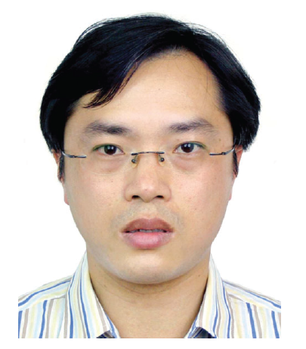
Feihe Huang

Graphical Abstract：
