Probenecid increases the concentration of 7-chlorokynurenic acid derived from the prodrug 4-chlorokynurenine within the prefrontal cortex

Running title: Probenecid increases 7-Cl-KYNA within the PFC

Waseema Patelª, Lara Rimmerª, Martin Smithª, Lucie Mossª, Mark A. Smith^{b,c}, H. Ralph Snodgrass^{b}, Munir Pirmohamedª, Ana Alfirevicª & David Dickens^{a*}

ª Department of Pharmacology and Therapeutics, University of Liverpool, Liverpool, UK.
^{b} VistaGen Therapeutics, Inc., 343 Allerton Ave, South San Francisco, California, 94080, USA.
^{c} Medical College of Georgia, 1120 15th St, Augusta, Georgia, 30912, USA.

*Correspondence to: Dr David Dickens
Department of Pharmacology and Therapeutics
University of Liverpool, Liverpool, UK
Contact: +44 (0)151 795 5391
Email: david.dickens@liverpool.ac.uk

Conflict of interest statement: Drs. M. Smith and R. Snodgrass own stock in VistaGen Therapeutics, which holds the commercial rights to L-4-chlorokynurenine (4-Cl-KYN, AV-101).

Funding sources: Research support from VistaGen Therapeutics, Inc is acknowledged.

Abbreviations: MDD, major depressive disorder; NMDA, N-methyl-D-aspartate; 4-Cl-KYN, L-4-chlorokynurenine; NMDAR, NMDA receptor; BBB, blood-brain barrier; 7-Cl-KYNA, 7-chlorokynurenic acid; SNPS, single nucleotide polymorphisms; LAT1, L-type amino acid transporter 1; HEK, human embryonic kidney; DMEM, Dulbecco’s Modified Eagles medium; FBS, foetal bovine serum; PBS, phosphate buffered saline; SLC, solute carrier; OAT, organic anion transporter; MRP4, multidrug resistance protein 4; SDS, sodium dodecyl sulfate; RIPA, radioimmunoprecipitation assay buffer; HRP, horseradish peroxidase; PVDF, polyvinylidene fluoride; IP, intraperitoneally; HPLC, high performance liquid chromatography; phe, phenylalanine; PFC, prefrontal cortex; PAH, para-aminohippuric acid; E3S, estrone 3-sulfate; CSF, cerebrospinal fluid

Abstract
Recent advances in the understanding of depression have led to increasing interest in ketamine and the role that N-methyl-D-aspartate (NMDA) receptor inhibition plays in depression. L-4-chlorokynurenine (4-Cl-KYN, AV-101), a prodrug, has shown promise as an antidepressant in preclinical studies, but this promise has not been realised in recent clinical trials. We sought to determine if transporters in the CNS could be playing a role in this clinical response. We used radiolabelled uptake assays and microdialysis studies to determine how 4-Cl-KYN and its active metabolite, 7-chlorokynurenic acid (7-Cl-KYNA), cross the blood-brain barrier (BBB) to access the brain and its extracellular fluid compartment. Our data indicates that 4-Cl-KYN crosses the blood-brain barrier via the amino acid transporter LAT1 (SLC7A5) after which the 7-Cl-KYNA metabolite leaves the brain extracellular fluid via probenecid sensitive organic anion transporters, (OAT 1/3; SLC22A6 and SLC22A8), and MRP4 (ABCC4). Microdialysis studies further validated our in vitro data, indicating probenecid may be used to boost the bioavailability of 7-Cl-KYNA. Indeed, we found coadministration of 4-Cl-KYN with probenecid caused a dose-dependent increase by as much as an 885-fold increase in 7-Cl-KYNA concentration in the prefrontal cortex. In summary, our data show 4-Cl-KYN crosses the BBB using LAT1, while its active metabolite, 7-Cl-KYNA is rapidly transported out of the brain via OAT1/3 and MRP4. We also identify a hitherto unreported mechanism by which the brain extracellular concentration of 7-Cl-KYNA may be increased to produce significant boosting of the drug concentration at its site of action that could potentially lead to an increased therapeutic effect.

Keywords: LAT1, L-4-chlorokynurenine, 7-chlorokynurenic acid, probenecid, transporters, MRP4
Introduction
Major depressive disorder (MDD) is a major cause of disability worldwide, with up to one-third of patients as having ‘treatment resistant depression’ because of lack of response to currently available drugs [1]. Current antidepressants are also limited by the lag time of weeks to months between treatment and maximum therapeutic effect [2]. There is thus an unmet need for a safe and effective fast-acting antidepressant.
Ketamine has a rapid antidepressant effect (within hours) at subanesthetic doses via a complex mechanism of action that includes inhibition of the N-methyl-D-aspartate receptor (NMDAR) [3]. Ketamine is also effective in patients with treatment-resistant depression [4]. However, unwanted adverse effects and the requirement for the intravenous administration to be performed in a clinical setting, limit the utility of ketamine as a treatment option for depression.
L-4-chlorokynurenine (4-Cl-KYN, AV-101), a synthetic chlorinated form of a tryptophan metabolite, has shown promise as a novel antidepressant in rodents [5]. 4-Cl-KYN is a prodrug, which after passage across the blood-brain barrier (BBB), is metabolised by kynurenine aminotransferases in astrocytes to form the active compound, 7-chlorokynurenic acid (7-Cl-KYNA), one of the most potent and selective antagonist of the NMDAR Gly_{B} site known [6-9]. The antagonism of the NMDAR at the Gly_{B} subsite by 7-Cl-KYNA is thought to produce its antidepressant and antinociceptive effects [5, 10].
4-Cl-KYN has a mechanism of action like that of ketamine, acting via antagonism of the NMDAR. In addition, 4-Cl-KYN is thought to have antidepressant effects similar to ketamine in rodents, but without the associated adverse effects [5, 11, 12]. Despite the promising results of 4-Cl-KYN in a rodent model, recently completed clinical trials have shown that 4-Cl-KYN, either as monotherapy or as adjunctive therapy, failed to show efficacy as an antidepressant [13, 14]. The lack of efficacy in humans has been postulated to be due to poor CNS levels of the prodrug and active metabolite, resulting in inadequate concentrations at the site of action [13].
There is therefore a need to understand what factors determine the movement of 4-Cl-KYN into the CNS, as well as the efflux of 7-Cl-KYNA out of the CNS. Thus far, there has been a suggestion that a large neutral amino acid transporter is involved in the transport of 4-Cl-KYN as shown by the fact that leucine can inhibit the uptake of 4-Cl-KYN into the brain [8]. Moreover, the blood concentrations of endogenous tryptophan metabolites such as L-kynurenine in healthy individuals have been linked with single nucleotide polymorphisms (SNPs) in the L-type amino acid transporter, LAT1 [13, 15]. LAT1 is predominantly expressed in tissues that require a constant supply of amino acids such as the brain, placenta and various tumours [16, 17]. LAT1 is a pH and Na⁺ independent antiporter of neutral amino acids with a 1:1 stoichiometry. The transporter is located at both the apical and basolateral membrane of endothelial cells of the BBB, and transport of amino acids by LAT1 is bidirectional [18].
Interestingly, there is also evidence to suggest that probenecid-sensitive transporters are involved in the transport of kynurenic acid [19, 20]. Thus, these data lead us to hypothesise that probenecid sensitive transporters, such as organic anion transporters, that are known to be expressed at the BBB may be involved in the transport of 7-Cl-KYNA.
In this study, our aims were to (a) determine whether 4-Cl-KYN is a substrate of LAT1 and characterise the uptake kinetics of 4-Cl-KYN by LAT1; (b) understand how 7-Cl-KYNA, which is responsible for NMDAR antagonism, leaves the brain extracellular fluid, with a focus on probenecid sensitive transporters; and (c) determine if the concentrations of 4-Cl-KYN and/or 7-Cl-KYNA could be increased at their site of action by boosting the brain concentration of 7-Cl-KYNA through inhibition of drug transporters.
Methods
Cell culture
HEK 293 cells were cultured in Dulbecco’s modified Eagles media (DMEM) supplemented with 10% foetal bovine serum (FBS) at 37ºC in a 5% CO₂ humidified chamber.

Stable cell line generation
HEK 293 cells stably expressing LAT1 or matched empty vector cells were used to study the interaction of 4-Cl-KYN with LAT1 as previously described [21, 22]. Cell lines expressing the organic anion transporters, OAT1 and OAT3 were created by stable transfection of HEK 293 cells. Transfections were performed using Lipofectamine 2000 according to the manufacturer’s instructions. Briefly, pcDNA3.1+/C-(K)DYK vectors expressing the transporter of interest (OAT1; NM_004790, OAT3; NM_001184732 or vector only) were introduced into HEK 293 cells. Cells were then expanded and selected via G418 resistance and single cell colonies were isolated. Expression was validated via PCR. Cells from the colonies with the highest expression of the protein of interest were then expanded for experiments.

Transient transfections
HEK 293 cells stably expressing OAT3 or the matched empty vector (pcDNA3.1+/C-(K)DYK) were transfected with multidrug resistance protein 4 (MRP4; NM_005845.4) or the corresponding empty vector (pcDNA3.1+/C-HA) using Lipofectamine 2000 according to the manufacturer’s instructions. Briefly, cells were plated at a density of 1 x 10⁶ cells/well and transfected with 2.5µg of DNA/well the following day. All experiments were carried out 24 hrs after transfection (detailed below).

Drugs and radiochemicals
4-Cl-KYN was a gift from VistaGen Therapeutics, Inc. and was dissolved in a small volume of 1M NaOH and then titrated to pH 7.4 using phosphate buffered saline (PBS). 7-Cl-KYNA and anti-DDDDK (FLAG) antibody were purchased from Abcam. 7-Cl-KYNA was dissolved in a small volume of 1M HCl and then titrated to pH 7.4 in PBS. All other compounds were purchased from Sigma-Aldrich, except for JPH203 (Selleckchem), lipofectamine (Invitrogen), ORF clones (Genscript), HEK 293 cells (ATCC), anti-mouse horseradish peroxidase (HRP) linked antibody (Cell Signaling Technology) and Pierce western blotting substrate (Thermo Fischer). 4-Cl-KYN and all amino acids used in this study were L-stereoselective. Unless otherwise stated, all compounds were solubilised in dimethyl sulfoxide according to manufacturer’s instructions.
[¹⁴C]-4-Cl-KYN (specific activity= 55.5 mCi/mmol) and [¹⁴C]-7-Cl-KYNA (specific activity= 77.7 mCi/mmol) was obtained from Moravek Inc. [³H]-phenylalanine (specific activity= 100 Ci/mmol) and [³H]-para-aminohippuric acid (specific activity= 40 Ci/mmol) were obtained from American Radiolabeled Chemical Inc. [³H]-estrone 3-sulfate (specific activity= 49.2 Ci/mmol) was obtained from Perkin Elmer.

Radiolabelled uptake assays
For HEK 293 cells stably expressing the protein of interest, cells were plated the day before an experiment. HEK 293 cells transiently expressing the protein of interest were plated 2 days prior to the experiment. All cells were >80% confluent at the time of an experiment. Before each experiment, culture media was removed and cells were washed with Hanks solution (Hanks balanced salt solution, 25 mM HEPES, pH 7.4). Cells were then incubated with 0.15µCi/ml of the radiolabelled compound of interest for 3 mins unless otherwise stated. Solutions were supplemented with an unlabelled version of the compound of interest to give the final concentration desired. Following incubation, excess radiolabelled compound was removed, and cells were washed 3 times with ice cold Hanks solution. Cells were then incubated in 5% sodium dodecyl sulfate (SDS) for 15 mins at 37ºC. The lysate was collected, and scintillation fluid added. Cells unexposed to radiolabelled chemicals were used to quantify cell density at the time of the experiment. Cells were counted manually using a haemocytometer.
All test compounds and concentrations were chosen in accordance with the FDA guidelines for in vitro drug interaction studies [23]. Briefly, to test whether 4-Cl-KYN and 7-Cl-KYNA were substrates for the transporters of interest, a range of concentrations that would cover clinically relevant concentrations of the compounds were chosen. Conversely, for experiments testing whether 4-Cl-KYN and 7-Cl-KYNA inhibit transport, high concentrations of each compound were chosen to maximise any possible inhibitory effect of the test drugs.

Trans-stimulation assays
HEK 293 cells were plated the day before an experiment and were >80% confluent at the time of the experiment. As earlier, culture media was removed, and cells were washed with Hanks solution. Cells were incubated with 0.15 µCi/ml of [³H]-phenylalanine in transport buffer at 37ºC for 3 mins to load the cells with phenylalanine. Excess phenylalanine was then removed, and cells were washed with warm transport buffer. Cells were then incubated with either 1 mM leucine, 4-Cl-KYN or 7-Cl-KYNA for 3 mins. The uptake was then stopped by washing cells in ice-cold transport buffer [24]. Cells were then incubated in 5% SDS for 15 mins at 37ºC. The lysate was collected, and scintillation fluid added

Western blot studies
HEK 293 cells expressing OAT3 were plated as described for radiolabeled uptake assays. 24 hrs after transfection of MRP4, cells were gently washed with ice-cold PBS and then incubated with radioimmunoprecipitation assay (RIPA) buffer containing protease inhibitors. The lysates were centrifuged at 13000 rpm for 30 mins at 4ºC to remove cell debris and the subsequent supernatant was used for western blot studies.
Lysates were heated to 37ºC for 20 mins after which lysates were onto loaded a 10% polyacrylamide gel, separated by SDS-PAGE and then transferred to a polyvinylidene fluoride (PVDF) membrane. The membranes were incubated with 5% non-fat dry milk in tris-buffered saline containing 0.1% tween 20 (TBST) for 1 hr. Membranes were then rinsed with TBST and incubated with an anti-FLAG rabbit polyclonal antibody (1:2000) to probe for OAT3 or a mouse monoclonal antibody (1:4000) to probe for β-actin, overnight at 4ºC. Membranes were again washed with TBST after which the membranes were incubated with anti-rabbit IgG (1:3000) or anti-mouse IgG (1:4000) HRP-linked antibody to probe for OAT3 and β-actin, respectively. Blots were developed using Pierce enhanced chemiluminescence substrate and processed using ImageJ software.

Animals and surgery
All experiments utilised adult Sprague-Dawley rats housed on a 12 hr light/dark cycle at room temperature (22ºC ± 2ºC) with a humidity of 50%, and food and water was made available ad libitum. These experiments were conducted by Charles Rivers Laboratories (South San Francisco) with the approval from their Institutional Animal Care and Use Committee.
Prior to surgery, rats were anesthetised using isoflurane (2% and 800 ml/min O₂). Rats were administered carprofen during and after surgery to induce analgesia; lidocaine and epinephrine were used for local analgesia at the injection site. Microdialysis probes were positioned in the prefrontal cortex; probe tips were set to the coordinates 3.4 mm anteroposterior to bregma, -0.8 mm lateral to midline and 5 mM ventral to the dura. The incisor bar was set at -3.3 mm. Probes were attached to the skull via stainless steel screws and dental cement. Following surgery, animals were returned to their home cage with conditions as earlier.

Microdialysis studies
Microdialysis studies were performed by Charles Rivers Laboratories (South San Francisco), and were conducted one day after surgery. NM-PAN 6/4 microdialysis probes were connected to a microperfusion pump used to perfuse artificial cerebrospinal fluid (147 mM NaCl, 3 mM KCl, 1.2 mM CaCl₂ and 1.2 mM MgCl₂) at a flow rate of 1.5 µl/min. The outlet probe was connected to an automated fraction collector. Microdialysis samples were collected at 30 min intervals at baseline, and compounds of interest (4-Cl-KYN and probenecid) were then administered intraperitoneally (IP) with samples being taken at 30 min intervals. Samples were collected into 0.02 M formic acid and 0.04% ascorbic acid in purified H₂O and analysed by Charles Rivers Laboratories. Probe recovery was determined by the ratio of the compound (4-Cl-KYN or 7-Cl-KYNA) in the dialysate to the bath and are expressed as percentage. In vitro recoveries were 21 ± 1.5% and 15.2 ± 1.9% for 4-Cl-KYN and 7-Cl-KYNA, respectively. These values were used to correct the compound levels in the interstitial fluid samples in vivo.

Quantification of analytes for microdialysis studies
Concentrations of compounds of interest were quantified via high performance liquid chromatography (HPLC) coupled with tandem mass spectrometry detection in the multiple reaction monitoring mode. All analytes collected during microdialysis were separated by liquid chromatography.

4-Cl-KYN, 7-Cl-KYNA, KYN and KYNA
Analytes were separated on a reversed phase Atlantis T3 C18 column at a temperature of 30°C, at a flow rate of 0.2 ml/min. Mobile phase A consisted of ultrapure water with 0.1% formic acid. Mobile phase B was acetonitrile with 0.1% formic acid.

Quinolinic acid
Analytes were separated on a reversed phase Synergi MAX-RP C12 column, held at a temperature of 25°C, at a flow rate of 0.3 ml/min. Mobile phase A consisted of ultrapure H2O with 0.2% TFA. Mobile phase B was ACN with 0.2% TFA.

Statistics and brain pharmacokinetic parameter calculation
Data are presented as mean ± SD unless otherwise stated. A p value <0.05 was considered statistically significant. Data from uptake assays were analysed by one-way ANOVA. Microdialysis data was analysed using two-way ANOVA or an unpaired t-test as appropriate. Analyses were carried out on Graphpad Prism v8. Prefrontal cortex pharmacokinetic values were calculated by non-compartmental analysis using Simbiology model analyzer within Matalab R2020a (MathWorks).
Results
The pro-drug 4-Cl-KYN is a substrate for LAT1, with increased selectivity for LAT1
To investigate whether 4-Cl-KYN is a substrate of LAT1 (SLC7A5), we used radiolabelled uptake assays to track the movement of the compound into LAT1-expressing HEK 293 stable cell-lines (HEK 293-LAT1). We first validated this approach by measuring the uptake of tritium labelled phenylalanine ([³H]-phe) over 3 mins in the presence and absence of the LAT1 inhibitor, JPH203 [25]. Our data show that [³H]-phe (10 µM total) increased by 2.3-fold in HEK 293-LAT1 cells compared with control HEK 293 cells, and this increase was inhibited by JPH203 (10 µM; Fig. 1A). These data suggested that [³H]-phe was being transported into the cells via LAT1. Using a similar approach, we also found that [¹⁴C]-4-Cl-KYN (10 µM) concentrations increased by 9.2-fold in HEK 293-LAT1 cells compared with HEK 293 cells after 3 mins, and this uptake was also sensitive to inhibition with JPH203 (Fig.1B). Thus, these data indicate that 4-Cl-KYN was being transported into HEK 293 cells via LAT1.
We then tested whether the active metabolite of 4-Cl-KYN (7-Cl-KYNA) was also a substrate for LAT1. Unlike 4-Cl-KYN, however, we found that [¹⁴C]-7-Cl-KYNA (10 µM) showed little accumulation in HEK 293-LAT1 cells and JPH203 had no effect (Fig.1C), indicating that 7-Cl-KYNA is unlikely to be a substrate for LAT1.
Given our finding that 4-Cl-KYN was a LAT1 substrate, we undertook experiments to better understand how 4-Cl-KYN uptake would compare to that of the model substrate phenylalanine. Using trans-stimulation assays, we showed that 4-Cl-KYN was able to compete with LAT1 substrates such as phenylalanine and leucine whilst 7-Cl-KYNA could not (Fig.S1). Additionally, our trans-stimulation assays showed that tryptophan metabolites could also compete with phenylalanine for uptake via LAT1 (Fig.S1D). LAT1 mediated uptake of phenylalanine and 4-Cl-KYN did not differ significantly, suggesting that the uptake of these compounds via LAT1 itself did not differ (Fig.1D). However, we found that there was a greater uptake of phenylalanine (Fig.1A) compared to 4-Cl-KYN (Fig.1B) in the control HEK 293 cells, suggesting that 4-Cl-KYN may be more selective for uptake via LAT1 than endogenous amino acids such as phenylalanine.
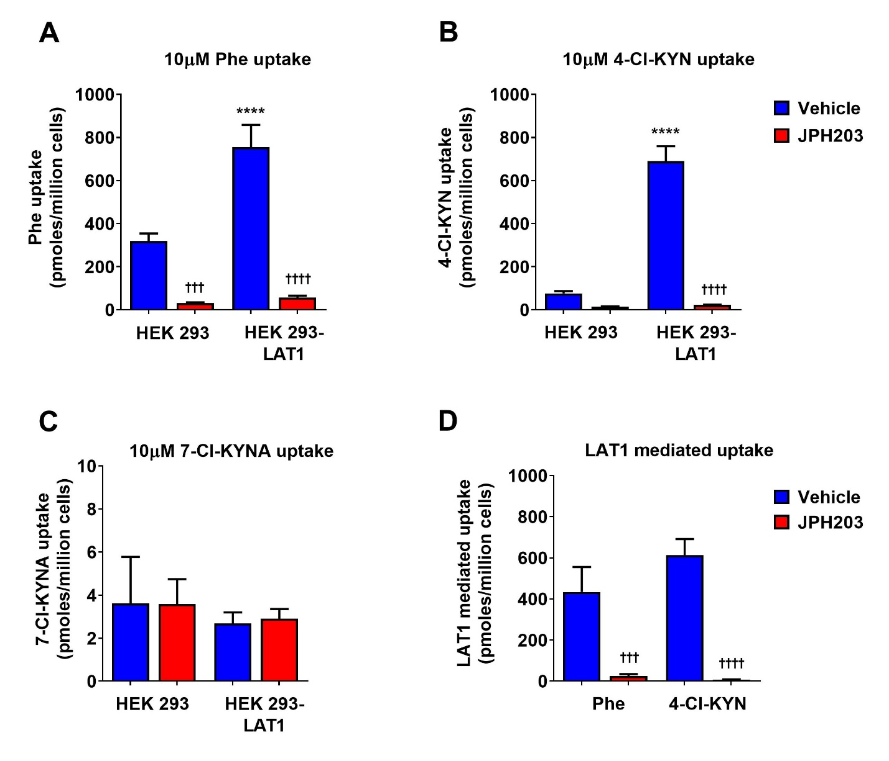
Figure 1. 4-Cl-KYN is a substrate for and shows increased selectivity for transport via LAT1. Mean changes in uptake of (A) phenylalanine (Phe; 10 µM), (B) L-4-chlorokynurenine (4-Cl-KYN; 10 µM) or (C) 7-chlorokynurenic acid (7-Cl-KYNA; 10 µM) after exposure for 3 mins in the presence of absence of JPH203 (10 µM). (D) Changes in LAT1 mediated uptake under conditions indicated. LAT1 mediated uptake was determined by subtracting the uptake in HEK 293 control cells from the uptake in HEK 293-LAT1 cells. Data are mean ± SD (n=3). ****p<0.0001 when compared to control HEK 293 cells. †††p<0.001, ††††p<0.0001 when compared to matched vehicle treated cells.

Physiological amino acids competitively inhibit 4-Cl-KYN transport via LAT1
We next adapted our cell-based assays to further model the conditions in vivo by including physiological plasma concentrations of amino acids in our assay solutions (Supplementary T1), formulated as previously described [26]. We co-incubated amino acids with a concentration of 4-Cl-KYN (250 µM) similar to that found in the plasma of patients taking 4-Cl-KYN in recently completed clinical trials [14]. Experiments investigating the interaction of 4-Cl-KYN with LAT1 thereafter reflected these conditions.
We first repeated the uptake assays described earlier (Fig.1B) with the higher concentration of 4-Cl-KYN (250 µM). The data were similar to that shown in Fig. 1B with a substantial increase in 4-Cl-KYN uptake in HEK 293-LAT1 cells that was sensitive to inhibition by JPH203 (Fig.2A). Next, we repeated the assay but with the introduction of physiological concentrations of amino acids [26]. This showed that 4-Cl-KYNA still accumulated to a greater extent in the HEK 293-LAT1 cells when compared with control cells, but the uptake of 4-Cl-KYNA was substantially lower when compared to 4-Cl-KYNA uptake in the absence of physiological concentrations of amino acids (Fig.2B & C). These data suggest that 4-Cl-KYN probably competes for LAT1 uptake with amino acids found in plasma.
Thus far, all assays performed measured the uptake of the compounds at 3 mins. Therefore, we next characterised the uptake of 4-Cl-KYN over a 1-hour time course. This showed that 4-Cl-KYN uptake increased for approximately 10 mins after which there was a small but insignificant decline in the amount of 4-Cl-KYN accumulating within HEK 293-LAT1 cells. Uptake in HEK 293 control cells and cells exposed to 4-Cl-KYN in the presence of JPH203 showed no substantial uptake of 4-Cl-KYN (Fig.2D).
In order to understand the uptake kinetics of 4-Cl-KYN, we exposed HEK 293-LAT1 cells to concentrations of 4-Cl-KYN ranging from 3 µM - 10 mM in the absence and presence of physiological concentrations of amino acids (Fig. 2E & H). We found that the V_{max} for 4-Cl-KYN uptake was similar in the presence (4522 ± 1759 pmoles/million cells/min) or absence (6048 ± 969.1 pmoles/million cells/min) of physiological concentrations of amino acids (Fig.2F). However, the K_{m} increased when HEK 293-LAT1 cells were exposed to 4-Cl-KYN in the presence of physiological amino acid concentrations (577.2 ± 117.2 µM in the absence of physiological amino acids vs 1799 ± 645.2 µM in the presence of physiological amino acids; Fig.2G). As the K_{m} indicates the concentration at which the uptake of 4-Cl-KYN reaches half maximum, this increase in the amount of concentration of 4-Cl-KYN suggest that there is likely to be competitive inhibition of 4-Cl-KYN uptake via LAT1 in vivo. This is further validated by the Lineweaver-Burk plot, in which the enhanced view shows little change in the y-intercept but a change in the slope when 4-Cl-KYN is measured in the absence and presence of physiological amino acids. These changes are again indicative of competitive inhibition (Fig. 2H).
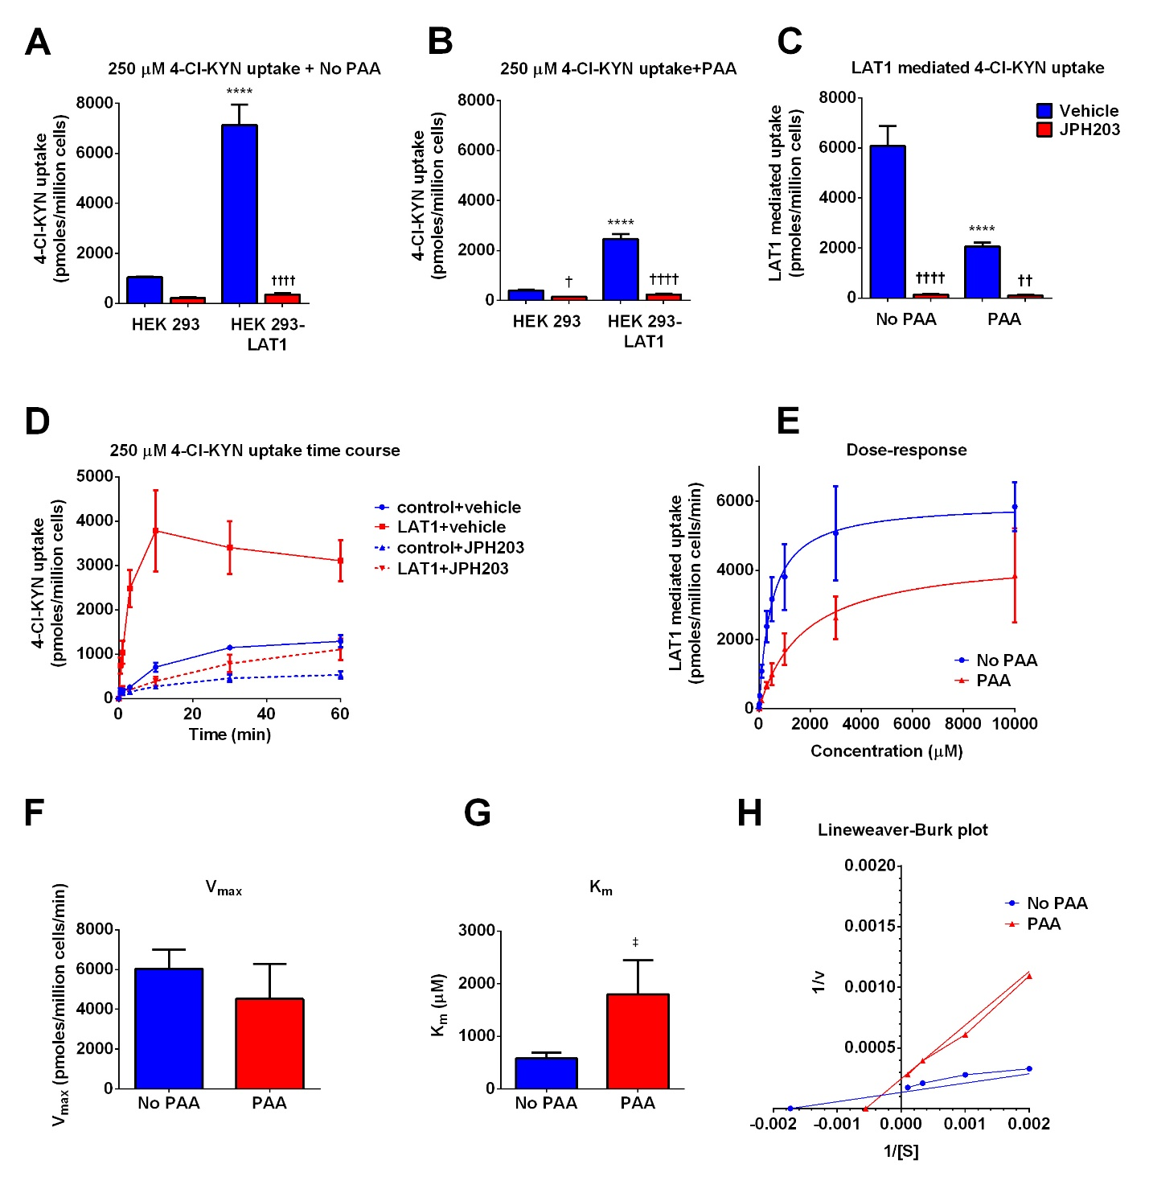
Figure 2. Physiological amino acids competitively inhibit 4-Cl-KYN uptake via LAT1. Mean changes in uptake of L-4-chlorokynurenine (4-Cl-KYN; 250 µM) in HEK 293 cells when cells were exposed to the average plasma concentration of 4-Cl-KYN (similar to that observed in patients in 4-Cl-KYN clinical trials) in (A) standard transport buffer (No PAA) or (B) transport buffer containing physiological amino acids (PAA). (C) Changes in LAT1 mediated uptake under conditions indicated. LAT1 mediated uptake was determined by subtracting the uptake in HEK 293 control cells from the uptake in HEK 293-LAT1 cells. (D) Mean changes 4-Cl-KYN (250 µM) uptake in HEK 293 cells under conditions indicated when cells were exposed to 4-Cl-KYN with physiological amino acids in the absence and presence of the inhibitor, JPH203 (10 µM). (E) Dose response curve for 4-Cl-KYN uptake. 4-Cl-KYN uptake was measured after 3 mins at concentrations indicated; cells were exposed to 4-Cl-KYN in transport buffer without endogenous amino acids (No PAA) or buffer containing physiological concentrations of amino acids (PAA). Mean changes in (F) V_{max} and (G) K_{m} under conditions indicated. (H) The mean values of the data from E were transformed to produce a Lineweaver-Burk plot demonstrating uptake kinetics of 4-Cl-KYN. A close-up of the lower range of values has been shown to demonstrate the effect of PAA on the y-intercept and slope. Data are mean ± SD (n=3). ****p<0.0001 when compared to control HEK 293 cells. †p<0.05, ††p<0.01, ††††p<0.0001 when compared to matched vehicle treated cells. ‡p<0.05 when compared to No PAA.

7-Cl-KYNA crosses the blood-brain barrier via organic anion transporters and MRP4
4-Cl-KYN is converted to 7-Cl-KYNA in astrocytes after passage across the BBB [6-8]. Therefore, to fully understand the brain pharmacokinetic parameters for 4-Cl-KYN, we sought to fully characterise the bidirectional passage of both compounds across the BBB, and to understand how 7-Cl-KYNA undergoes efflux via transporters at the BBB.
The recently demonstrated lack of efficacy of 4-Cl-KYN as an adjunctive treatment for major depressive disorder has been hypothesised to be due insufficient CNS exposure to 7-Cl-KYNA [27]. Given that previous studies have found that probenecid increases kynurenic acid concentration in the brain extracellular fluid, we investigated whether this would also apply to 4-Cl-KYN and 7-Cl-KYNA [20, 28].
We generated cells stably expressing OAT3 (SLC22A8; Fig.S2), a probenecid-sensitive transporter and validated the cell system by demonstrating that probenecid led to a significant increase in the uptake of the model compound [³H]-estrone 3-sulfate (E3S; 100 nM) (Fig.3A). Co-incubation of high concentrations of 4-Cl-KYN and 7-Cl-KYNA with E3S did not affect OAT3-mediated uptake of E3S (Fig.3B). We next tested whether 4-Cl-KYN and 7-Cl-KYNA were substrates for OAT3 by measuring the uptake of these compounds at concentrations like those found in human plasma. We found that 4-Cl-KYN was not a substrate for OAT3, as the range of concentrations tested showed no significant increase in uptake of 4-Cl-KYN when compared to control HEK 293 cells. Furthermore, the OAT3 inhibitor probenecid had no effect on 4-Cl-KYN uptake. On the other hand, 7-Cl-KYNA was a substrate for OAT3, as evidenced by the probenecid sensitive increase in the uptake of 7-Cl-KYNA in HEK 293-OAT3 cells (Fig.3C & D). We found that 7-Cl-KYNA was also a substrate for OAT1 (SLC22A6; Fig.S3)
To further model the transporters found in brain endothelial cells, we co-expressed MRP4 (ABCC4) in HEK 293-OAT3 cells and control HEK 293 cells, as MRP4 has been shown to be involved in the excretion of organic anions and drugs [29]. We found that the uptake of 7-Cl-KYNA in HEK 293-OAT3 cells expressing MRP4 was lower compared to HEK 293-OAT3 cells (Fig. 3E). These data suggest that 7-Cl-KYNA is a substrate for MRP4 in addition to OAT3.
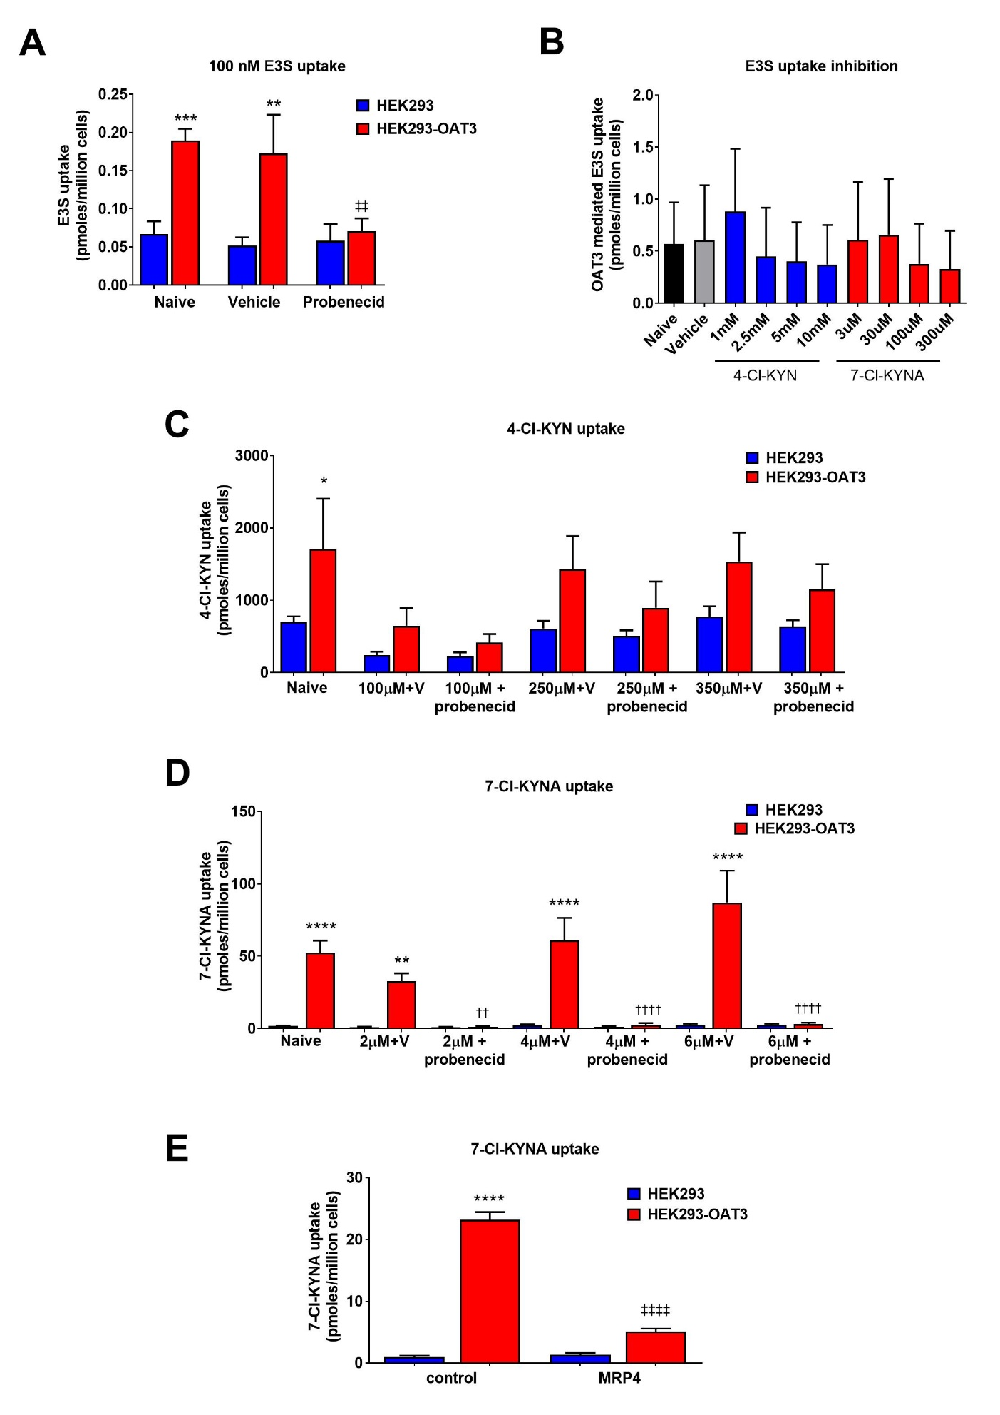
Figure 3. 7-Cl-KYNA is a substrate for organic anion transporter (OAT) 3 and MRP4. (A) Uptake of [³H]-estrone 3-sulfate (E3S) under conditions indicated in control HEK 293 cells and HEK 293-OAT3 cells. Cells were exposed 100 nM E3S and 1 mM probenecid. (B) Uptake of [³H]-E3S under conditions indicated. OAT3 mediated uptake of E3S was determined by subtracting the uptake in HEK 293 control cells from the uptake in HEK 293-OAT3. Cells were exposed 100 nM E3S in the presence of the concentrations of L-4-chlorokynurenine (4-Cl-KYN) or 7-chlorokynurenic acid (7-Cl-KYNA) indicated. Uptake of (C) [¹⁴C]-4-Cl-KYN and (D) [¹⁴C]-7-Cl-KYNA under conditions indicated (V; vehicle). Naïve cells were exposed to 250 µM 4-Cl-KYN or 2 µM 7-Cl-KYNA. (E) Uptake of [¹⁴C]-7-Cl-KYNA under conditions indicated. HEK 293-OAT3 cells were transiently transfected with either empty vector (control; pcDNA3.1+/C-HA) or MRP4. Cells were exposed 2 µM 7-Cl-KYNA and 1 mM probenecid. Data are mean ± SD (n=3). *p<0.05, **p<0.01, ***p<0.001, ****p<0.0001 compared to matched HEK 293 cells, ††p<0.01, ††††p<0.01 compared to matched HEK 293-OAT3 cells, ‡‡p<0.01, ‡‡‡‡p<0.0001 compared to control + vehicle HEK 293-OAT3 cells.

Probenecid increases the bioavailability of 4-Cl-KYN in the prefrontal cortex
We next sought to validate our in vitro data by performing microdialysis studies in Sprague-Dawley rats by testing the effect of co-administration of 4-Cl-KYN and probenecid on the availability of clinically relevant metabolites. We measured changes in the concentrations of compounds of interest within the extracellular fluid of the prefrontal cortex (PFC). The concentrations of probenecid used approximated the clinical dosage in patients being treated for gout.
Our data show that co-administration of 4-Cl-KYN with probenecid resulted in a dose-dependent increase in the concentration of 4-Cl-KYN and 7-Cl-KYNA in the PFC. For example, the C_{max} for 7-Cl-KYNA increased to 2.63 µM with 4-Cl-KYN and probenecid (both dosed at 100 mg/kg) compared to 77 nM seen when 4-Cl-KYN was administered alone (Supplementary T3 & Fig.4). Additionally, the effect of probenecid was found to extend to kynurenine and kynurenic acid, endogenous metabolites in the kynurenine pathway (Fig.S4). The increase in C_{max} PFC levels of these compounds were time- and dose-dependent (Supplementary T2 & Fig.5A & B). In addition to the large increase (885-fold) in the concentration of the active metabolite, 7-Cl-KYNA, when 4-Cl-KYN was co-administered with the highest probenecid dose (270 mg/kg), there was large increase in drug exposure with a 107-fold increase in AUC for 7-Cl-KYNA (Fig.5D). Although much less dramatic, this trend was also seen in the plasma concentration of the compounds, with a corresponding 5 fold increase in the concentration of 7-Cl-KYNA (4-Cl-KYN vs 4-Cl-KYN + 270 mg/kg probenecid; Fig.5E & F) and the ratio of 7-Cl-KYNA to 4-Cl-KYN in the PFC (Fig. 5G) and plasma (Fig. 5H). Furthermore, these increases were reflected by an increase in the PFC t_{max} and C_{max} for 7-Cl-KYNA when 4-Cl-KYN was administered with probenecid (270 mg/kg; Table 1).

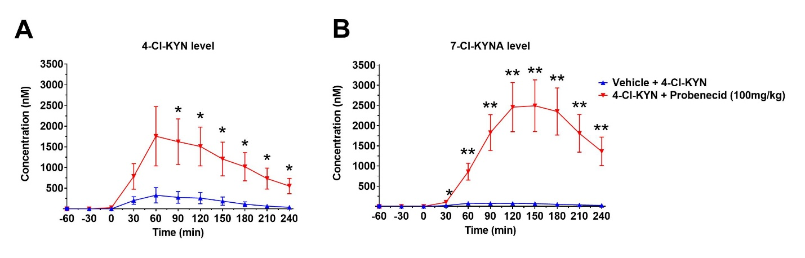
Figure 4. Coadministration of 4-Cl-KYN and probenecid causes an increase in 4-Cl-KYN and 7-Cl-KYNA in the prefrontal cortex. Levels of (A) L-4-chlorokynurenine (4-Cl-KYN) and (B) 7-chlorokynurenic acid (7-Cl-KYNA) in the prefrontal cortex (PFC) of adult male Sprague-Dawley rats following IP administration (T=0) of 4-Cl-KYN and probenecid alone or in combination (100 mg/kg, each). Data are mean ± SEM (n=4-6/group). *p<0.05, **p<0.01 compared to 4-Cl-KYN alone.
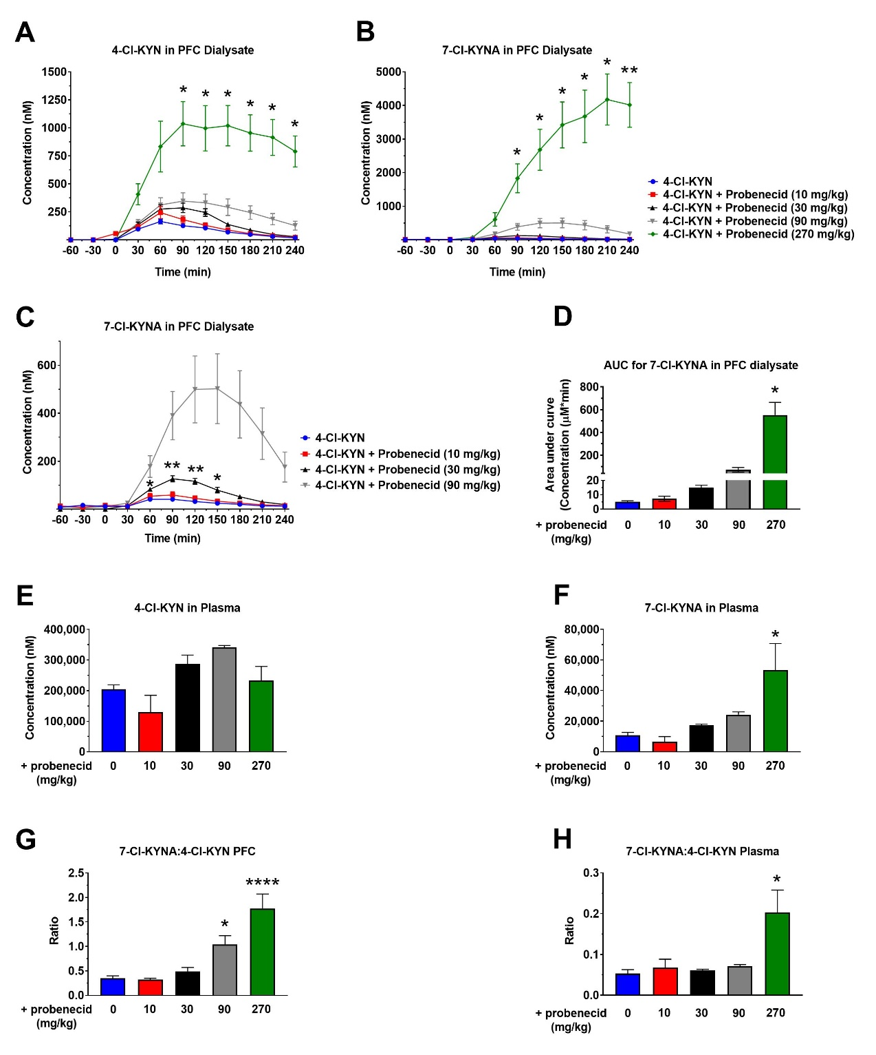
Figure 5. Levels of 7-Cl-KYNA within the prefrontal cortex are preferentially increased via coadministration of 4-Cl-KYN and probenecid. Levels of (A) L-4-chlorokynurenine (4-Cl-KYN) and (B) 7-chlorokynurenic acid (7-Cl-KYNA) in the PFC of adult male Sprague-Dawley rats following IP administration (T=0) of 4-Cl-KYN (100 mg/kg) alone or in combination to probenecid at multiple doses. (C) Time-dependent PFC levels of 7-Cl-KYNA following dosing with 4-Cl-KYN and various concentration of probenecid. (D) Summary of changes in area under the curve (AUC) for 7-Cl-KYNA from data presented in (B; n=6-7/group). Levels of (E) 4-Cl-KYN and (F) 7-Cl-KYNA in the plasma of adult male Sprague-Dawley rats 90 min post IP administration of 4-Cl-KYN (100 mg/kg) alone or in combination to probenecid at multiple doses. Change in the 7-Cl-KYNA:4-Cl-KYN ratio in the (G) PFC and (H) plasma at 90 mins post exposure. Data are mean ± SEM (n=3-4/group). *p<0.05, **p<0.01, ****p<0.0001 compared to 4-Cl-KYN alone.

 | 4-Cl-KYN (100mg/kg) | 4-Cl-KYN + Prob (10mg/kg) | 4-Cl-KYN + Prob (30mg/kg) | 4-Cl-KYN + Prob (90mg/kg) | 4-Cl-KYN + Prob (270mg/kg)
T_{max} (min) | 73 (6) | 80 (6) | 100 (6) | 145 (9) **** | 210 (8) ****
C_{max} (nM) | 44 (5) | 60 (13) | 128 (12) | 516 (145) | 4212 (745) ****
AUC₀₋₂₄₀ (nM*min) | 5867 (581) | 7627 (1568) | 15507 (1528) | 72947 (20922) | 554308 (110990) ****
T_{half} (min) | 84 (11) | 74 (13) | 41 (3) * | 53 (9) | N.D
Terminal rate constant (nM/min) | 0.0095 (0.0016) | 0.010 (0.0014) | 0.0171 (0.0011) * | 0.0149 (0.0021) | N.D
Table 1. Effect of probenecid on the pharmacokinetic parameters for 7-Cl-KYNA in the prefrontal cortex of rats. Sprague Dawley rats were administered L-4-chlorokynurenine (4-Cl-KYN) at 100mg/kg and probenecid at the doses indicated after which changes in 7-chlorkynurenic acid (7-Cl-KYNA) were measured via microdialysis. Data are mean ± SEM (n=3-4/group). *p<0.05, ****p<0.0001 compared to 4-Cl-KYN (100 mg/kg).

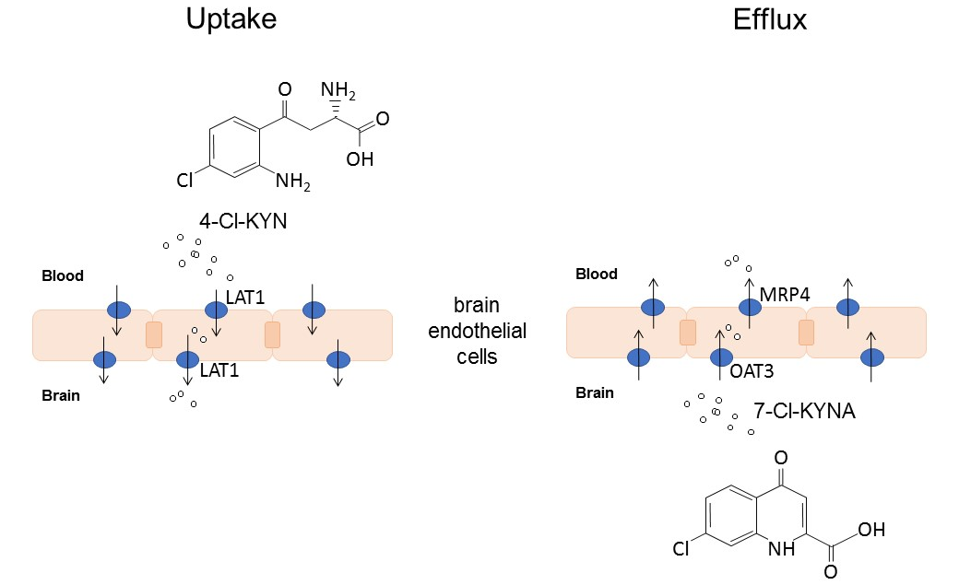
Figure 6. Passage of 4-Cl-KYN and 7-Cl-KYNA across the blood-brain barrier. Diagram summarising the passage of the prodrug, L-4-chlorokynurenine (4-Cl-KYN) across the blood-brain barrier via the amino acid transporter LAT1. Exit of the active metabolite (7-chlorokynurenic acid; 7-Cl-KYNA) from the brain extracellular fluid is shown on the right (efflux). Probenecid increases the concentration of 7-Cl-KYNA in the brain extracellular fluid via inhibition of the OAT3 and MRP4 transporters.

Discussion
The prodrug, 4-Cl-KYN, has shown promise as a novel antidepressant and anti-hyperalgesic in pre-clinical studies [5, 10]. However, 4-Cl-KYN has not shown efficacy in two clinical trials [14, 27]. To understand the reasons for this, we have characterised the movement of 4-Cl-KYN and its active metabolite, 7-Cl-KYNA, across the BBB. Theoretically, an increase in the concentration of 7-Cl-KYNA in the brain extracellular fluid may be a strategy for improving the efficacy of 4-Cl-KYN.
We found that 4-Cl-KYN was a substrate for LAT1, whilst the active metabolite, 7-Cl-KYNA, was not. LAT1 is already known to transport clinically relevant drugs such as gabapentin and L-DOPA [21, 30]. Our findings are consistent with previous studies which have alluded to the fact that 4-Cl-KYN and the non-chlorinated endogenous analog (L-kynurenine) of 4-Cl-KYN are transported by an L-type amino acid transporter at the BBB and compete for uptake with leucine [8, 31, 32]. Moreover, our data further corroborates work by an earlier study that showed L-leucine uptake is inhibited by the transport of 4-Cl-KYN across the BBB [8]. Our data also adds to the growing body of evidence which shows therapeutic ranges of 7-Cl-KYNA concentration can be attained within the brain via systemic 4-Cl-KYN administration [8].
Following the identification of the transporter responsible for 4-Cl-KYN, we sought to characterise the uptake kinetics using an in vitro model that more accurately reflects plasma conditions in vivo. This is important as previous studies have shown that cell culture environment can drastically affect expression of proteins and the response to stimuli [26]. These adapted conditions revealed that 4-Cl-KYN is likely to compete for uptake via LAT1 with amino acids in vivo. Furthermore, these assays revealed that the amino acids are likely to competitively inhibit the uptake of 4-Cl-KYN by LAT1. This is consistent with the situation with L-DOPA, where amino acids such as leucine compete at the level of LAT1 with L-DOPA for uptake into the brain extracellular fluid [30, 33]. This has been linked to an oscillating response to L-DOPA in Parkinson’s disease patients, with a reduction of effect after meals because of reduced uptake of L-DOPA through competition with amino acid transporters at the BBB [33]. This may also happen with 4-Cl-KYN, but additional studies will be needed to investigate this further.
Inadequate concentrations of 7-Cl-KYNA in the brain have been hypothesised to be responsible for the lack of an antidepressant effect of 4-Cl-KYN [27]. The balance between influx and efflux of a compound is an important determinant of the CNS exposure of that compound, with elevated concentration and duration at the site of action likely to increase efficacy. It is known that brain extracellular fluid concentrations of kynurenic acid can be increased by using kynurenine in the presence of probenecid [20, 28]. Thus, we sought to determine whether 4-Cl-KYN administered jointly with therapeutic concentrations of probenecid could increase the concentrations of 7-Cl-KYNA.
Our findings show that 7-Cl-KYNA interacted with both OAT1 and OAT3. Previous studies have found that kynurenic acid is a probenecid-sensitive substrate of human and rodent OAT1 and OAT3 when expressed in X. laevis oocytes [34, 35]. Rodent OAT3 is expressed at the BBB, at both the luminal and abluminal membrane of brain endothelial cells and is responsible for the passage of compounds from the brain to blood [14]. Rodent OAT1 is thought to be predominantly expressed in the kidneys, with some expression at the BBB, and is responsible for the excretion of compounds [36]. In humans, OAT1 and 3 have been found to be expressed within epithelial cells at the choroid plexus, with their expression linked to the efflux of substances such as neurotransmitter metabolites from the cerebrospinal fluid (CSF) [37]. Furthermore, there is evidence to show expression and function of OAT3 at the human BBB, albeit lower than rodents, suggesting OAT3 may be involved in 7-Cl-KYNA efflux at the human BBB [38]. Human OAT1 and 3 are also expressed in renal proximal tubules and are thought to be important for the maintenance of renal excretion [39]. Although kynurenic acid is a substrate for both rodent and human OAT1 and 3, transport by OAT3 is similar for both species, but rodent OAT1 has a lower transport capability [35]. Thus, further experiments will be needed to fully understand how the substrate affinity for 7-Cl-KYNA may differ between OATs.
To further understand the bidirectional movement of 7-Cl-KYNA across cells, we also investigated the interaction of the compound with the efflux transporter MRP4. Kynurenic acid has been shown to be an MRP4 substrate using MRP4 overexpressing membrane vesicles [40]. MRP4 is known to be expressed at the BBB in rodents and humans [41, 42]. In particular, MRP4 is known to be expressed within astrocytes, the basolateral membrane of the choroid plexus and on the luminal side of brain endothelial cells in the human brain [42, 43]. Our findings show that 7-Cl-KYNA, like kynurenic acid, is a substrate for this probenecid sensitive transporter. As MRP4 is implicated in the extrusion of compounds, our data provide a fuller picture of the movement of 4-Cl-KYN and its active metabolite across the BBB (Fig. 6). Since both OAT3 and MRP4 are expressed at the choroid plexus, our findings suggest that low 7-Cl-KYNA concentrations within the CSF of patients given 4-Cl-KYN as monotherapy, could possibly be increased by using probenecid. In keeping with this, our in vitro findings were validated by using in vivo microdialysis studies within the prefrontal cortex of rats, where a large increase in 7-Cl-KYNA concentration in the prefrontal cortex was observed when 4-Cl-KYN was administered with probenecid (90 and 270 mg/kg). The increase in 7-Cl-KYNA concentration may be sufficient to cause antagonism of the NMDA receptor. Indeed, the IC₅₀ for 7-Cl-KYNA at the glycine site of the NMDAR has been reported to be 0.56 µM in rat cortical slices [9]; our data showed that probenecid at 90 mg/kg and 270 mg/kg coadministration achieved a C_{max} of 0.5µM and ~4 µM for 7-Cl-KYNA, respectively. Furthermore, it is possible that the concentration of 7-Cl-KYNA may be higher in the synapses due to the production and secretion by surrounding astrocytes [20, 44, 45].
Our study used concentrations of probenecid which are comparable to the clinical dosage of probenecid seen in human patients. Patients are usually given 500-1000 mg/day of probenecid, and at the highest dosage, patients may be administered 2 g/day as an adjunctive therapy. Our calculations approximate that 90 mg/kg of probenecid in rats is equivalent to an average human dose of ~870 mg and 270 mg/kg in rats is equivalent to a human dose of ~2.6 g [46]. We found the increases in 7-Cl-KYNA to be significant with doses of probenecid at 90, 100 and 270 mg/kg. However, the PFC PK data were somewhat variable for 90 mg/kg, these data suggest that there may be an optimal concentration of probenecid between 90-270 mg/kg that would cause a sustained increase in 7-Cl-KYNA within the PFC along with increases in parameters such as T_{max} and C_{max.}
In addition to changes in the prefrontal cortex, we also measured changes in 4-Cl-KYN and 7-Cl-KYN concentrations in plasma. Our data showed that whilst probenecid resulted in modest increases in plasma levels of 4-Cl-KYN and 7-Cl-KYNA, these increases were dramatically less than the changes in the prefrontal cortex. 7-Cl-KYNA showed a 5-fold increase in plasma compared to an 885-fold increase in the PFC dialysate when 4-Cl-KYN was administered with probenecid (270 mg/kg). This has important positive implications for the safety and potential clinical use of 4-Cl-KYN with probenecid since the systemic levels with the adjunctive use of probenecid with 4-Cl-KYN would be expected to be much less than the therapeutically targeted CNS levels.
In summary, our data have shown that probenecid can markedly increase the levels of 7-Cl-KYNA, the active metabolite of 4-Cl-KYN, in the brain prefrontal cortex with only modest increases in blood levels. Given that both 4-Cl-KYN and probenecid have a good safety profile in patients, these data highlight a potential new treatment strategy of 4-Cl-KYN plus probenecid for the management of patients with major depressive disorder, as well as other indications that could benefit from a reduction in NMDAR signaling.

Acknowledgements: We would like to thank Drs. Holden Janssens and Arash Rassoulpour at Charles Rivers Laboratories South San Francisco for their help with the microdialysis studies.
Supporting information: The following supporting information is available free of charge at the ACS website
Figure S1. Trans-stimulation of LAT1 substrates by 4-Cl-KYN.
Figure S2. Expression of organic anion transporter 3.
Figure S3. Transport of 7-Cl-KYNA by organic anion transporter 1.
Figure S4. Effect of 4-Cl-KYNA administration on endogenous kynurenine metabolite concentrations in the rat prefrontal cortex.
Table S1. Concentrations of physiological amino acids used in uptake experiments.
Table S2. Pharmacokinetic parameters for 7-Cl-KYNA in the prefrontal cortex of rats.
Table S3. Pharmacokinetic parameters for 7-Cl-KYNA ± probenecid in the prefrontal cortex of rats.

References
1. Rush, A.J., et al., Acute and longer-term outcomes in depressed outpatients requiring one or several treatment steps: a STAR*D report. Am J Psychiatry, 2006. 163(11): p. 1905-17.
2. Insel, T.R. and P.S. Wang, The STAR*D trial: revealing the need for better treatments. Psychiatr Serv, 2009. 60(11): p. 1466-7.
3. Berman, R.M., et al., Antidepressant effects of ketamine in depressed patients. Biol Psychiatry, 2000. 47(4): p. 351-4.
4. Zarate, C.A., Jr., et al., A randomized trial of an N-methyl-D-aspartate antagonist in treatment-resistant major depression. Arch Gen Psychiatry, 2006. 63(8): p. 856-64.
5. Zanos, P., et al., The Prodrug 4-Chlorokynurenine Causes Ketamine-Like Antidepressant Effects, but Not Side Effects, by NMDA/GlycineB-Site Inhibition. J Pharmacol Exp Ther, 2015. 355(1): p. 76-85.
6. Wu, H.Q., F.G. Salituro, and R. Schwarcz, Enzyme-catalyzed production of the neuroprotective NMDA receptor antagonist 7-chlorokynurenic acid in the rat brain in vivo. Eur J Pharmacol, 1997. 319(1): p. 13-20.
7. Salituro, F.G., et al., Enzyme-activated antagonists of the strychnine-insensitive glycine/NMDA receptor. J Med Chem, 1994. 37(3): p. 334-6.
8. Hokari, M., et al., Facilitated brain uptake of 4-chlorokynurenine and conversion to 7-chlorokynurenic acid. Neuroreport, 1996. 8(1): p. 15-8.
9. Kemp, J.A., et al., 7-Chlorokynurenic acid is a selective antagonist at the glycine modulatory site of the N-methyl-D-aspartate receptor complex. Proc Natl Acad Sci U S A, 1988. 85(17): p. 6547-50.
10. Yaksh, T.L., R. Schwarcz, and H.R. Snodgrass, Characterization of the Effects of L-4-Chlorokynurenine on Nociception in Rodents. J Pain, 2017. 18(10): p. 1184-1196.
11. Zhu, W.L., et al., Glycine site N-methyl-D-aspartate receptor antagonist 7-CTKA produces rapid antidepressant-like effects in male rats. J Psychiatry Neurosci, 2013. 38(5): p. 306-16.
12. Liu, B.B., et al., 7-Chlorokynurenic acid (7-CTKA) produces rapid antidepressant-like effects: through regulating hippocampal microRNA expressions involved in TrkB-ERK/Akt signaling pathways in mice exposed to chronic unpredictable mild stress. Psychopharmacology (Berl), 2015. 232(3): p. 541-50.
13. Park, L.T., et al., A Randomized Trial of the N-Methyl-d-Aspartate Receptor Glycine Site Antagonist Prodrug 4-Chlorokynurenine in Treatment-Resistant Depression. Int J Neuropsychopharmacol, 2020. 23(7): p. 417-425.
14. Urquhart, B.L. and R.B. Kim, Blood-brain barrier transporters and response to CNS-active drugs. Eur J Clin Pharmacol, 2009. 65(11): p. 1063-70.
15. Long, T., et al., Whole-genome sequencing identifies common-to-rare variants associated with human blood metabolites. Nat Genet, 2017. 49(4): p. 568-578.
16. Boado, R.J., et al., Selective expression of the large neutral amino acid transporter at the blood-brain barrier. Proc Natl Acad Sci U S A, 1999. 96(21): p. 12079-84.
17. Gaccioli, F., et al., Expression and functional characterisation of System L amino acid transporters in the human term placenta. Reprod Biol Endocrinol, 2015. 13: p. 57.
18. Fotiadis, D., Y. Kanai, and M. Palacin, The SLC3 and SLC7 families of amino acid transporters. Mol Aspects Med, 2013. 34(2-3): p. 139-58.
19. Lou, G.L., C. Pinsky, and D.S. Sitar, Kynurenic acid distribution into brain and peripheral tissues of mice. Can J Physiol Pharmacol, 1994. 72(2): p. 161-7.
20. Miller, J.M., U. MacGarvey, and M.F. Beal, The effect of peripheral loading with kynurenine and probenecid on extracellular striatal kynurenic acid concentrations. Neurosci Lett, 1992. 146(1): p. 115-8.
21. Dickens, D., et al., Transport of gabapentin by LAT1 (SLC7A5). Biochem Pharmacol, 2013. 85(11): p. 1672-83.
22. Dickens, D., et al., Modulation of LAT1 (SLC7A5) transporter activity and stability by membrane cholesterol. Sci Rep, 2017. 7: p. 43580.
23. FDA, In Vitro Drug Interaction Studies — Cytochrome P450 Enzyme- and Transporter-Mediated Drug Interactions. Guidance for Industry. 2020, Food and Drug Administration Center for Drug Evaluation and Research.
24. Gutbier, S., et al., Design and evaluation of bi-functional iron chelators for protection of dopaminergic neurons from toxicants. Arch Toxicol, 2020.
25. Oda, K., et al., L-type amino acid transporter 1 inhibitors inhibit tumor cell growth. Cancer Sci, 2010. 101(1): p. 173-9.
26. Cantor, J.R., et al., Physiologic Medium Rewires Cellular Metabolism and Reveals Uric Acid as an Endogenous Inhibitor of UMP Synthase. Cell, 2017. 169(2): p. 258-272.e17.
27. Park, L.T., et al., A Randomized Trial of the N-methyl-d-aspartate Receptor Glycine Site Antagonist Prodrug 4-chlorokynurenine in Treatment-Resistant Depression. Int J Neuropsychopharmacol, 2020.
28. Vecsei, L., et al., Kynurenine and probenecid inhibit pentylenetetrazol- and NMDLA-induced seizures and increase kynurenic acid concentrations in the brain. Brain Res Bull, 1992. 28(2): p. 233-8.
29. Klaassen, C.D. and H. Lu, Xenobiotic transporters: ascribing function from gene knockout and mutation studies. Toxicol Sci, 2008. 101(2): p. 186-96.
30. Kageyama, T., et al., The 4F2hc/LAT1 complex transports L-DOPA across the blood-brain barrier. Brain Res, 2000. 879(1-2): p. 115-21.
31. Fukui, S., et al., Blood-brain barrier transport of kynurenines: implications for brain synthesis and metabolism. J Neurochem, 1991. 56(6): p. 2007-17.
32. Gal, E.M. and A.D. Sherman, Synthesis and metabolism of L-kynurenine in rat brain. J Neurochem, 1978. 30(3): p. 607-13.
33. Nutt, J.G., et al., The "on-off" phenomenon in Parkinson's disease. Relation to levodopa absorption and transport. N Engl J Med, 1984. 310(8): p. 483-8.
34. Uwai, Y., H. Honjo, and K. Iwamoto, Interaction and transport of kynurenic acid via human organic anion transporters hOAT1 and hOAT3. Pharmacol Res, 2012. 65(2): p. 254-60.
35. Uwai, Y., H. Hara, and K. Iwamoto, Transport of Kynurenic Acid by Rat Organic Anion Transporters rOAT1 and rOAT3: Species Difference between Human and Rat in OAT1. Int J Tryptophan Res, 2013. 6: p. 1-6.
36. Sekine, T., S.H. Cha, and H. Endou, The multispecific organic anion transporter (OAT) family. Pflügers Archiv, 2000. 440(3): p. 337-350.
37. Alebouyeh, M., et al., Expression of human organic anion transporters in the choroid plexus and their interactions with neurotransmitter metabolites. J Pharmacol Sci, 2003. 93(4): p. 430-6.
38. Uchida, Y., et al., Quantitative targeted absolute proteomics of human blood–brain barrier transporters and receptors. Journal of neurochemistry, 2011. 117(2): p. 333-345.
39. Cha, S.H., et al., Identification and characterization of human organic anion transporter 3 expressing predominantly in the kidney. Mol Pharmacol, 2001. 59(5): p. 1277-86.
40. Dankers, A.C., et al., Hyperuricemia influences tryptophan metabolism via inhibition of multidrug resistance protein 4 (MRP4) and breast cancer resistance protein (BCRP). Biochim Biophys Acta, 2013. 1832(10): p. 1715-22.
41. Hoshi, Y., et al., Quantitative atlas of blood-brain barrier transporters, receptors, and tight junction proteins in rats and common marmoset. J Pharm Sci, 2013. 102(9): p. 3343-55.
42. Nies, A.T., et al., Expression and immunolocalization of the multidrug resistance proteins, MRP1-MRP6 (ABCC1-ABCC6), in human brain. Neuroscience, 2004. 129(2): p. 349-60.
43. Leggas, M., et al., Mrp4 confers resistance to topotecan and protects the brain from chemotherapy. Mol Cell Biol, 2004. 24(17): p. 7612-21.
44. Roberts, R.C., et al., Immunocytochemical localization of kynurenine aminotransferase in the rat striatum: a light and electron microscopic study. J Comp Neurol, 1992. 326(1): p. 82-90.
45. Lee, S.C. and R. Schwarcz, Excitotoxic injury stimulates pro-drug-induced 7-chlorokynurenate formation in the rat striatum in vivo. Neurosci Lett, 2001. 304(3): p. 185-8.
46. Nair, A.B. and S. Jacob, A simple practice guide for dose conversion between animals and human. J Basic Clin Pharm, 2016. 7(2): p. 27-31.

For table of contents use only
Probenecid increases the concentration of 7-chlorokynurenic acid derived from the prodrug 4-chlorokynurenine within the prefrontal cortex
Waseema Patelª, Lara Rimmerª, Martin Smithª, Lucie Mossª, Mark A. Smith^{b,c}, H. Ralph Snodgrass^{b}, Munir Pirmohamedª, Ana Alfirevicª & David Dickens^{a*}
ª Department of Pharmacology and Therapeutics, University of Liverpool, Liverpool, UK.
^{b} VistaGen Therapeutics, Inc., 343 Allerton Ave, South San Francisco, California, 94080, USA.
^{c} Medical College of Georgia, 1120 15th St, Augusta, Georgia, 30912, USA.

