**CaO catalyst for multi-route conversion of oakwood biomass to value-added chemicals and fuel precursors in fast pyrolysis**

Jyoti GUPTA,*a* Konstantinos PAPADIKIS,*b* Elena Yu. KONYSHEVA,*c,d,\** Yi LIN,*a*   
Ivan V. KOZHEVNIKOV *e*

*a* Department of Chemistry, Xi'an Jiaotong-Liverpool University, Suzhou, 215123, China

*b* Department of Civil Engineering, Xi'an Jiaotong-Liverpool University, Suzhou, 215123, China

*c* Department of Chemical and Environmental Engineering, University of Nottingham Ningbo China, Ningbo, 315100, China

*d* Institute of Solid State Chemistry, the Ural Branch of the Russian Academy of Sciences, Pervomayskaya Str. 91, Ekaterinburg, 620990, Russian Federation

*e* Department of Chemistry, University of Liverpool, L69 7ZD Liverpool, UK

* Corresponding author: Elena Yu. KONYSHEVA

E-mail: [elena.konysheva@nottingham.edu.cn](mailto:elena.konysheva@nottingham.edu.cn)

[elena.konysheva@googlemail.com](mailto:elena.konysheva@googlemail.com)

Full postal address:

PMB 323, Department of Chemical and Environmental Engineering

Faculty of Science and Engineering

University of Nottingham Ningbo China

199 Taikang East Road, Ningbo

China, 315100

**Abstract**

The impact of CaO on oakwood pyrolysis was explored by the Py-GC/MS at 500oC. Ca(OH)2 presents on the CaO surface, indicating its partial hydration (noted as CaOOH). CaOOH promoted the ketonisation of carboxylic acids to aliphatic ketones, furfural to cyclopentanone/2-cyclopentenone, facilitated the elimination of the phenolic compounds. The catalyst loading did not show any significant effect on the formation of acetone, while a noticeable reduction in the phenolics was revealed. CO2, acids, furans, aldehydes, ether groups were almost entirely eliminated with increase in the catalyst loading and the fractions of alcohols, esters, sugars, and alkoxybenzene decreased noticeably. The use of partially hydrated CaOOH in the CFP can create conditions when by-products generated during ketonisation reactions and phenolics upgrading (CO2, H2O, CO) interact through the adsorption enhance water-gas-shift reaction and through coking reactions with formation of H2 used for hydrogenation during multistep conversion of furfural to cyclopentanone in a vapor phase.

**Keywords:**

Partially hydrated CaO; Oakwood biomass conversion; Catalytic fast pyrolysis; Ketonisation; Furfural transformation.

# 1. Introduction

In recent decades, with increasing demand for fossil fuels and growing concerns on climate change, biomass has attracted growing attention as a carbon-based renewable energy source. Biomass, as inexpensive and readily available feedstock, is composed of biopolymers that can be decomposed to obtain various products such as fuels, materials and value-added chemicals [1]. Fast pyrolysis is one of the most important and efﬁcient methods for the conversion of biomass feedstock into value-added chemicals and liquid transportable fuel [2]. However, bio-oil derived through fast pyrolysis is not suitable for direct application in the existing petroleum-based infrastructure [3] as it is a complex mixture of acidic and oxygenated compounds, which result in water solubility, storage, and corrosion problems [4]. Catalytic fast pyrolysis (CFP) of biomass is of great importance in controlling the chemical composition, and improving the quality and stability of the liquid product. The oxygen content can be decreased through different processes: cracking, decarbonylation, decarboxylation, hydrocracking, hydrodeoxygenation, hydrogenation, esterification, and etherification of phenols. Each reaction pathway will require specific catalyst, optimal catalyst loading and the best operational conditions.

Ketonic decarboxylation followed by aldol condensation process is one of important chemical reaction pathway for the catalytic fast pyrolysis vapors upgrading, where deoxygenation occurs through [dehydration](https://www.sciencedirect.com/topics/physics-and-astronomy/dehydration) (H2O) and [decarboxylation](https://www.sciencedirect.com/topics/physics-and-astronomy/decarboxylation) (CO2) processes. In general, a high fraction of carboxylic acids is produced during the fast pyrolysis of biomass. For fuel applications, carboxylic acids are not desirable due to their corrosive properties and the reduction in their content is typically required. The ketonisation route offers great advantages for this process since it does not only remove the highly reactive acidic carboxyl groups and reduces the oxygen content in the liquid product, but also provides an efficient path to form carbon-carbon bonds between low-molecular-weight acids [5-8]. Moreover, ketone products are highly stable, higher energy and desirable molecules since they can easily couple with other bio-oil products (via aldol condensation and hydrogenation/alkylation) to create longer chain molecules that fall into the fuel range. Besides, by ketonisation, free fatty acids would result in a long chain of aliphatic ketones that can be sent to the refinery unit for hydrocracking and isomerization to obtain diesel-like fuels. Deoxygenation of bio-oil in the form of CO2 is also desirable since it would reduce the requirement for an external H2 source, and would also increase the [H/C ratio](https://www.sciencedirect.com/topics/engineering/h-c-ratio) of the final products [8]. Thermodynamically, if the CO2 formed during the fast pyrolysis is absorbed, then it may promote the [decarboxylation](https://www.sciencedirect.com/topics/earth-and-planetary-sciences/decarboxylation) of carboxyl compounds, eventually promoting deoxygenation in the form of CO2.

Many oxide catalysts have been considered for ketonisation reactions, including Fe3O4, Al2O3, TiO2, ZnO, Cr2O3, ZrO2, CeO2, CeZrOx, ZSM-5 zeolite, MgO, CaO, CaO/ZnO/AlOx, and Ni/CaO-La2O3 catalysts produced through in situ reduction of La1-xCaxNiO3 [7,9-18]. The use of these metal oxides for bio-oil upgrading is especially attractive because of their significantly lower cost than noble metals. However, metal oxides are generally less resistant to deactivation than noble metals. Another challenge for the usage of metal oxides is that they generally suffer from lower activity and selectivity than more expensive commercial catalysts. The presence of some typical pyrolysis products (for instance, furfural, guaiacol, and eugenol) can inhibit the ketonisation activity of Ce-based catalysts [11,13,15]. For CaO/ZnO/AlOx catalysts, furfural addition decreases acetic acid conversion from 94 to 88% as well whilst phenol addition has lower impact on the catalytic activity and it depends on a catalyst composition [17]. During exploration of acetic acid steam reforming under steady state conditions it was found that the presence of calcium oxide in Ni/CaO-La2O3 catalysts promotes hydrogen formation through stronger water conversion and limits the ketonisation reaction [18]. The bulk and surface mechanisms were suggested for the ketonisation reaction over metal oxide catalysts that will be governed by different factors: temperature, metal-oxygen bond strength and basicity of a catalyst [7,9,10,12,13].

Although furfural is considered as a promising chemical platform [19], the co-existence of an aromatic ring and an aldehyde group in its structure makes it very reactive and could block active sites on a catalyst during the ketonisation reaction [11]. One possible strategy could be to eliminate or convert it during the fast pyrolysis process. In general, furfural can be transformed to more than 80 compounds [19,20]. Cyclopentanone, being one of them, is quite promising as it is less reactive and can be used in the synthesis of pharmaceuticals, fungicides, rubber chemicals, flavors, fragrances and can be converted to biofuels [19,21]. The most widely discussed pathway to convert furfural to cyclopentanone is through liquid-phase hydrogenation over catalysts containing transition metals [21-27]. In the vapor-phase, cyclopentanone can be obtained through cyclisation of 1,6-hexanediol over CeO2-MnOx solid solution [28], dimethyl adipate over nanostructured ceria-zirconia solid solution [29], and dehydrogenation of cyclopentanol over Cu-based catalyst [30]. Recently it was reported that together with 2-methylfuran (main product), 2-cyclopentenone and cyclopentanone can be formed as by-products in the vapor phase over Ru or Pd /TiO2 supported catalysts when furfural existed in the experiments as a model compound or in the vapor produced through the pyrolysis of Red Oak sawdust under hydrogen stream, suggesting that the water molecules directly participate in the reaction [31].

CaO as a solid base catalyst has many advantages such as a high activity, environmentally friendly material, mild reaction conditions typically are required, long catalyst lifetime, and low catalyst cost. It could demonstrate a good catalytic behavior as in several upgrading processes and for direct deoxygenation of biomass in the fast pyrolysis. As it was previously mentioned, CaO and Ca-based catalysts can be employed for ketonisation reaction [7,9,14,17,18]. The application of CaCO3 and CaO during pyrolysis of bituminous coal facilitated the decomposition of phenolics to CO (through keto-enol shift as the initial step, which is strongly base-catalyzed reaction) or their condensation to species polycyclic furans remaining in the char [32]. High-quality liquid fuel with reduced phenolic components can be obtained from coal with 10-20 wt% CaO heated slowly to 500 - 650°C in a batch reactor [33]. The combination of thermogravimetric analysis and Fourier transformation Infrared spectroscopy (TG-FTIR) proved that CaO additives played the roles of both CO2 sorbent and tar reduction catalyst during pyrolysis of wheat-straw [34]. It was shown that the release of several components (CO, CH4 and toluene) decreased in the presence of CaO. The yields of phenol and formic acid decreased as well, indicating the strong catalytic effect of CaO on tar reduction. In contrast to phenol, CH4 and toluene yields were not affected by further increase in the CaO loading. The direct deoxygenation effect of CaO was studied during biomass fast pyrolysis in a fluidized-bed reactor at 520oC [35]. The oxygen content in the bio-oil was reduced to 21% at CaO/biomass = 5:1 mass ratio. The main oxygen containing compounds (levoglucosan, formic acid, and acetic acid) were reduced in these experiments, but the yields of furfural and furfuryl alcohol were found to increase. X-ray diffraction (XRD) and FTIR analyses of the solid residues obtained at different temperatures confirmed the presence of some organic calcium salts at 350oC, which decomposed below 400oC to form easily regenerated CaCO3. The application of nano CaO as the catalyst in CFP with poplar wood at 600oC reduced the fraction of phenols from 26.5% to 13.0% and anhydrosugars from 10.1% to 1.2%; and selectively promoted ketonic compounds, hydrocarbons and light compounds (acetaldehyde, acetone, 2-butanone, 2-cyclopentenone, and methanol), but the fraction of furfural remained almost the same as in the experiment without the catalyst [36].

The hydration of CaO, which is a strong basic oxide, could play an essential role in its CFP activity as during preparation and storing the catalyst can interact with atmospheric water to form Ca(OH)2 thereby influencing the upgrading process and product distribution. Therefore, the catalytic activity of CaO cannot be interpreted unambiguously and trace amount of Ca(OH)2 must be taken into account. Hydroxyl groups existing on the surface of alkaline earth oxides were considered as active sites for aldol addition of acetone [37]. The inverse correlation between the ketonisation activity and the strength of catalysts’ base sites was found for metal oxides, indicating that the relatively weak catalyst basicity is important for the ketonisation reaction, in particular, when CO2 is one of the reaction’s products [12]. It should be taken into account that a partial hydration of CaO results in the formation of several surface sites with different basic properties [38]. To date, the impact of CaO hydration on the products conversion in catalytic fast pyrolysis has not been discussed explicitly in the literature, but this becomes particular important during transfer from laboratory tests to industrial applications.

The aim of this paper is to explore the application of CaO catalyst with micron/submicron size for multi-route deoxygenation of pyrolyzed vapor through promotion of aliphatic and cyclic ketonisation, as well as decreasing the phenolics fraction, which are of great potential for economically feasible industrial applications and environmental benifits. Consideration of the catalyst/biomass ratio in combination with FTIR, TG and quantitative XRD analyses can give an insight into the application of partially hydrated calcium oxide as a catalyst during the CFP process.

# 2. Materials and Experimental techniques

## 2.1 Materials

In this study, oakwood (OW) with the average particle size of 500 μm was used as the biomass feedstock. Prior to the experiments, the OW was dried at 105°C for 24 h in an oven and further stored in a desiccator. Lignin and hemicellulose were also used separately for the validation of certain product transformations in the catalytic fast pyrolysis. Highly active and basic calcium oxide powder was obtained through calcination of CaCO3 (> 99.9%, Sigma-Aldrich, China) at 950 oC for 5 h in a tube furnace under flowing dry air. After calcination, the obtained calcium oxide was cooled down under flowing dry air in the same furnace, then immediately placed in the dry containers and stored in a desiccator. The following abbreviation CaOOH will be used further in the text for the catalyst as its surface was found to be partially hydrated which will be discussed in section 3.1. Acetic acid, acetone, furfural, cyclopentanone and 2-cyclopentenone (all with >99.9% purity, Alladin, China) were used for the calibration and quantification of experimental products, whereas methanol (99.5% purity, Aladdin, China) was used as the solvent.

## 2.2 Experimental techniques for materials characterization

Elemental analysis of OW was performed on a Vario MACRO (Elementar, Germany) cube elemental analyzer to identify C, H, N, and O content. The elemental composition of the dried OW was (wt. %) C 44.2 ± 0.5, H 6.0 ± 0.1, and N 0.20 ± 0.005. In this setup, the sulfur content could not be measured, however the typical content of sulfur in lignocellulosic biomass is quite low (< 1 wt.% [39]), and thus, considered as negligible. Oxygen was assumed to be the balance (49.7 wt. %). The X-ray powder diffraction patterns of catalysts were collected before and after catalytic fast pyrolysis experiments on a Bruker D8 Advance diffractometer (Bruker AXS, Germany) with Cu-Kα radiation equipped with a LynxEYE high-speed detector in the range of 15-90 degrees 2*θ* with a step size of 0.017o and counting for 1 s in each point. The XRD phase analysis was carried out by using DIFFRAC.EVA 3.1 software with Crystallography Open Database. The Rietveld method [40] with the program TOPAS 4.2 [41] were used to estimate the mole ratios of the constituents in the multiphase compositions from the XRD data [42,43]. The size of nano crystallites with spherical-like shape can be calculated by using the Scherrer equation [44]. Infrared spectra of catalysts were recorded before and after fast pyrolysis experiments on an FTIR spectrometer (Agilent technology Cary 600 series, USA) in the wavenumber range of 400-4000 cm-1, using the KBr pellet technique. The surface area was measured by the Brunauer Emmett-Teller (BET) nitrogen adsorption (multipoint method: P/Po = 0.04-0.32) on a 3H-2000PS2 analyzer (Beishide Instruments – S&T, China) in the static volumetric mode. The pore size distribution and pore volume were estimated by the Barret-Joyner-Halenda (BJH) method from the desorption curve. Three measurements were conducted for each sample. Thermogravimetric analysis (TGA) was performed on a STA 449 F3 Jupiter instrument (Netzsch, Germany) under air in the temperature range of 25–900 °C with the heating and cooling rates of 10 and 20 °C min-1, respectively. The effect of buoyancy was corrected using blank runs with alumina crucibles under the same condition. Scanning electron microscopy (SEM) in combination with Energy Dispersive X-ray analysis (EDX) was carried out on JEOL JSM-6510 (JEOL, Japan) equipped with INCA ENERGY 250 X-Act elemental analyzer (Oxford Instruments, UK).

## 2.3 Fast pyrolysis analysis

A CDS Pyroprobe (Py) 5200 pyrolyzer (CDS Analytical, USA) in combination with 7890A/5975C gas chromatograph (GC)/mass spectrometer (MS) (Agilent technology, USA) was used to carry out non-catalytic and catalytic fast pyrolysis of OW. Py-GC/MS has been extensively used for pyrolysis of various types of feedstock due to the advantage of online analysis of the evolution of gases. An analytical balance with a sensitivity of 0.01 mg was used, and the weighing process of the biomass and the catalysts was strictly controlled. In the non-catalytic pyrolysis experiments, 1 mg of biomass was placed into the quartz tube, packed with a small amount of quartz wool (QW) on both sides of the biomass. To study the upgrading impact in ex-situ fast pyrolysis experiments, the CaOOH catalyst was placed on both sides of the OW (Fig. 1), to allow the pyrolysis vapors flow through the catalyst layers.

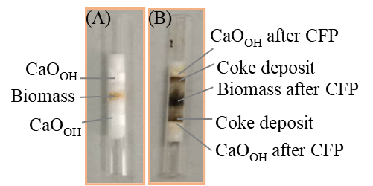

Fig. 1. CaOOH with OW in the layer method at 2:1:2 wt. ratio (A) before and (B) after CFP.

In this arrangement, OW and catalyst were in the layered form in different weight (wt.) ratios. To ensure that the direct physical contact between the solid catalyst and the biomass will not influence the distribution of the pyrolysis products, the OW and catalyst powder were separated by quartz wool. The amount of OW used in each experiment was kept constant at 1 mg, whereas the catalyst to biomass wt. ratio was varied according to CaOOH (*x*:1:*x*), where *x =* 0.5, 1, 2, 3, 4 mg of the catalyst. The reaction product validation experiments with 1 mg of hemicellulose and 1 mg of lignin were carried out in a similar setup, i.e. non-catalytically and catalytically in the CaOOH (2:1:2) wt. ratio.

The details of the measurement method are presented elsewhere [45, 46] and included in the supporting information. The fast pyrolysis measurements were carried out at 500°C as it was found to be the optimal conditions in previous related studies [2]. Each type of experiments was repeated three times to ensure reproducibility. The identiﬁcation of the compounds in the chromatograms was performed by comparing the mass spectra of the peaks with standard spectra of organic compounds from the NIST library to obtain the most probable matches. As the Py-GC/MS technique does not allow product collection, direct quantitative analysis of the compounds is not possible. Two approaches were applied for data quantification. The chromatographic peak area of a compound is considered proportional to its quantity. Therefore, it can give a first estimation of the yield changes of the total detected compounds by comparison of the total chromatographic peak areas obtained in experiments without and with the catalyst [47,48]. As indicated, the composition of the pyrolysis vapors was particularly complex, so in order to understand the changes in the yields of the products, all the detected compounds were classiﬁed into twelve groups, including CO2, acids, esters, furans, aldehydes, ketones, alcohols, phenols, alkoxy benzenes, sugars, ether and other compounds (OC). Small, unidentiﬁable peaks were grouped as the non-identiﬁed (NI) compounds. The second approach allows to quantitatively evaluate the yield of selected (the most abundant compounds) through an additional product calibration curve.

## 2.4. Product calibration

For the quantitative analysis of the data obtained by the Py-GS/MS technique, five compounds of great significance (i.e. high peak area or considered to be further involved in subsequent transformations) were selected for calibration. Known concentrations of the compounds, which are very close to the compound under analysis, were added to the solvent. Five calibration solutions for each investigated compound were prepared, and methanol was used as the solvent. The calibration experiments were performed three times for each concentration of each selected compound. The corresponding peaks were identified, and a calibration curve was plotted as “compound mass per OW mass (μg mg-1 OW) *vs.* peak area”. The molecular weights, boiling points, retention time, and concentrations for all compounds used in the calibration process are given in Table S1. The calibration curves for acetic acid, acetone, furfural, cyclopentanone and 2-cyclopentenone are presented in Figs. S1-S5. The correlation coefficient (R2) for each calibration curve is > 0.99.

# 3. Results and discussion

## 3.1 Chemical, structural and morphological stability of catalyst before and after CFP

The CaOOH catalyst was obtained through calcination of CaCO3 at 950oC. The peaks related to the initial precursor disappeared completely in the XRD pattern (Fig. S6) and new peaks related to calcium oxide with cubic symmetry (space group $Fm\bar{3}m$, no. 225) were revealed. The sharp diffraction peaks of calcium oxide indicate its good crystallinity [49]. However, more detailed consideration of the XRD pattern of the fabricated catalyst (Fig. 2A) indicates the presence of several very wide peaks related to Ca(OH)2 phase with trigonal symmetry (space group $P\bar{3}m1$, no. 164) in spite of the calcination under dry flowing air. This correlates well with the high basicity of CaO and its high capability to adsorb water. This indicates clearly that water adsorption can easily take place during catalyst preparation under normal conditions. Interestingly, in the obtained catalyst the diffraction peaks {001} and {010} at 18.1 and 28.7 degrees 2*θ* for Ca(OH)2 are more intense relatively to the strongest {011} peak at 34.1 degrees 2*θ* than it would be expected for the individual Ca(OH)2 bulk phase, suggesting that the formation of Ca(OH)2 phase on the surface of polycrystalline calcium oxide material occurs along specific crystallographic directions. According to the quantitative phase analysis, the obtained catalyst apart from CaO contains up to 7.3 mol% Ca(OH)2 (Fig. 2C). This correlates well with IR data (Fig. 3). In the IR spectrum of the catalyst there were no bands at 873 and 712 cm-1 associated with vibrations of CO32- in calcite [50,51] and the band at around 1420 cm-1 becomes less intense and narrower, indicating the decomposition of CaCO3. The wide and strong band at around 499 cm-1 corresponds to the vibrations of Ca-O bonds. A band at 3642 cm−1 in the fabricated catalyst can be assigned to isolated OH groups [52,53], indicating that partial hydration takes place at the surface of the calcium oxide solid crystallites. Crystallites in CaOOH have cube- or rectangular-like shape with the average edge length of around 2-10 µm and consist of co-sintered particles with a size of around 555 ± 277 nm (Fig. 4A). The size of the Ca(OH)2 particles evaluated from the XRD data directly by using the Scherrer equation [44] is in the nano range (12 ± 4 nm) and cannot be identified by SEM analysis. The specific surface area the CaOOH catalyst was found to be 8.7±0.2 m2 g-1. The CaOOH catalyst does not possess microporosity (Fig. S7). The macroporosity with the total volume of 1.00 ml g-1 prevails over mesopososity with the total volume of 0.17 ml g-1.

For CFP, the same catalyst was used with 1 mg of OW in the CaOOH (*x*:1:*x*) wt. ratio, where *x =* 0.5, 1, 2, 3, 4 mg. According to XRD analysis, in all experiments independent of the catalyst to biomass ratios, a new prominent peak appeared at approximately 29.5° 2*θ* values (Figs. 2B), indicating the formation of CaCO3 phase through the absorption of CO2 by calcium oxide [51,54]. The peaks related to Ca(OH)2 can be identified in the XRD patterns as well. This is in good accords with IR data as additional bands related to CaCO3 phase (2980, 2875, 2513, 1795, 1418, 873 and 712 cm-1) appeared in the spectra after CFP (Fig. 3). The sharp band at around 3642 cm-1 can be revealed as before and after CFP indicating the presence of OH groups and formation of Ca(OH)2. Due to a very high background at low angles in the XRD patterns (Fig. 2B) it was impossible to identify the presence of calcium acetate, Ca(OAc)2, by XRD, but IR spectroscopy gives some evidence for its presence. Note that Ca(OAc)2 can form different hydrates: Ca(OAc)2×*x* H2O (*x* = 0.5 and 1) [55,56]. The obtained IR spectra were compared to the reference spectra of Ca(OAc)2×1H2O [52]. The following bands should be observed in the case of Ca(OAc)2×1H2O formation: broad bands at 1475-1760 cm-1, 2800-2990 cm-1, 3000-3630 cm-1 and sharp/narrow bands at 950 cm-1, 1020-1080 cm-1 [52]. There is no sharp band at around 950 cm-1 for all CaOOH after CFP (independently of catalyst:OW ratio), but there is a wide weak band at approximately 1020 cm-1 for CaOOH (0.5:1:0.5 - 3:1:3) after CFP. Moreover, for the same catalysts a wide band was observed at around 3500 cm-1 and a wide asymmetrical shoulder in the range of 1500-1600 cm-1, suggesting that a very small fraction of Ca(OAc)2×*x*H2O exists at the surface of CaOOH (0.5:1:0.5 - 3:1:3) after CFP. In contrast to CaOOH (0.5:1:0.5 - 3:1:3), the IR spectrum of CaOOH (4:1:4) looks differently. There are no bands close to 1020 cm-1 and 3500 cm-1; the band at approximately 1450-1500 cm-1 is narrow, less asymmetric with blue shift (towards 1500 cm-1).

The quantitative XRD analysis indicates that the fraction of CaO phase dominates in all CaOOH after CFP (Fig. 2C). The fraction of Ca(OH)2 decreases slightly for CaOOH (0.5:1:0.5 - 2:1:2) compared to CaOOH initial, suggesting OH- group consumption during CFP. The fraction of Ca(OH)2 in CaOOH (3:1:3 and 4:1:4) with a higher loading is almost the same as in the CaOOH initially. A small fraction of CaCO3 (4.6-6.5 mol. %) is formed after CFP in the experiments with a low catalyst loading (0.5:1:0.5 - 1:1:1) and its fraction gradually increased up to 20 mol.% with the rise in the catalyst loading up to 4:1:4 wt. ratio.

The shape and size of the catalyst’s crystallites did not change after CFP (4-14 µm) showing that the catalyst maintained its structural stability (Fig. 4B). However, the surface of crystallites is not as smooth as it was initially and small grains within these large crystallites become even more distinguishable.

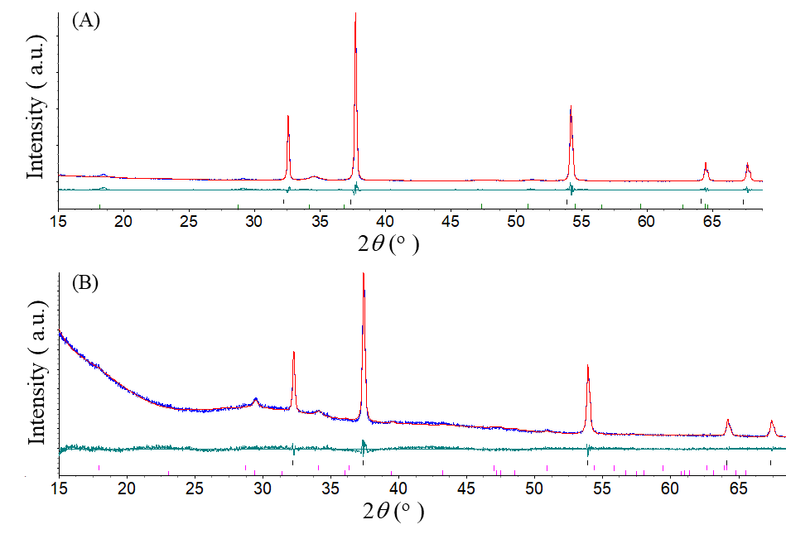



Fig. 2. Rietveld refinement of XRD patterns: (A) CaOOH initial and (B) CaOOH (2:1:2) after CFP with quartz wool. The measured data are presented as blue line, the calculated pattern is shown as the red line, the green line represents the difference between measured and calculated data. Vertical bars show calculated reflections for the following phases: (A) CaO (upper), Ca(OH)2 (lower) and *R*wp = 5.24%, *R*p = 10.12%, *R*exp = 7.67%, GOF = 1.93. (B) CaO (upper), Ca(OH)2 (middle), CaCO3 (lower) and *R*wp = 2.74%, *R*p = 3.88%, *R*exp = 3.03%, GOF = 1.42. (C) Phase composition of CaOOH catalysts after CFP with OW in different wt.% ratios.



Fig. 3. IR spectra of CaOOH, CaCO3 and CaOOH after CFP with OW in different wt.% ratios.

(A) 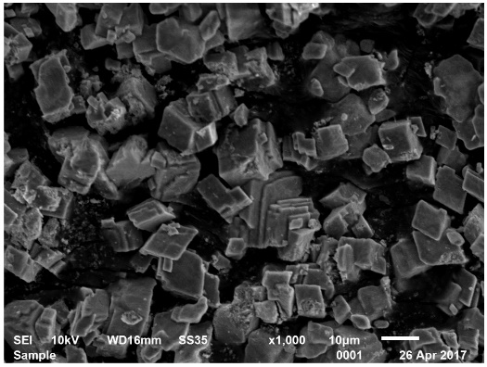 (B) 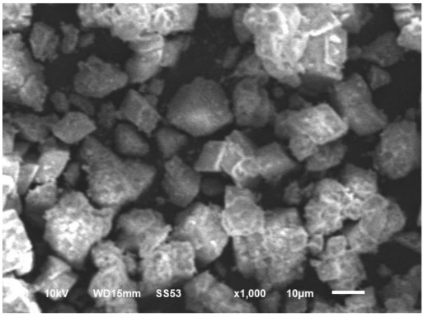

Fig. 4. SEM images of (A) CaOOH initial and (B) CaOOH (2:1:2) after CFP.

Thermogravimetric analysis was performed on the CaOOH (2:1:2) after CFP, which apart from the catalyst contains biomass residues and small amount of quartz wool (Fig. 5). The CaOOH (2:1:2) catalyst changed color from grey (after CFP) to white (after TG analysis). The weight loss (in total 24 wt. %) was revealed to occur in several steps in the temperature range of 25-900°C. The gradual weight loss during heating to about 405 °C (1.5 wt. %) is associated with desorption of physiosorbed water or water from Ca(OAc)2×*x*H2O [57]. Further weight loss was observed in the range of 405-454°C (3 wt. %) and it was accompanied by a small exothermic effect at 439°C. The combustion of char could start occurring in this temperature range [58]. It could also be associated with the decomposition of Ca(OAc)2 as it is known from the literature that after dehydration, it decomposes exothermally at around 400oC [56,57,59]. Note that there is almost no change in the weight with further increase in the temperature range of 460-530 °C, but a small exothermic effect was also observed in the same temperature range. In this temperature range several competitive processes could take place. From one side it can be related to the Ca(OH)2 decomposition as it occurs at 512 °C when the water partial pressure in equilibrium with the solid phase reaches 101 kPa [60] and the decomposition temperature can decrease gradually to around 441°C with linear lowering the water partial pressure to 20 kPa [61]. According to the quantitative XRD, there is 4.8 mol % Ca(OH)2 in the CaOOH (2:1:2) after CFP (Fig. 2C), therefore the expected weight loss will be only 1.4 wt. %. On the other hand, CO2 residuals from the flowing air can interact with CaO cleaned surface forming CaCO3 that will result in the increase in the weight. In addition, coke formed during CFP (Fig. 1B) can be oxidized forming CO2 that will interact with CaO forming CaCO3 as well. The signiﬁcant weight loss in the range of 630-818 °C (19.5 wt. %) accompanied by a strong exothermic peak at around 838 °C can be related to complete coke oxidation followed by CO2 release and CaCO3 decomposition into CaO. Since CaOOH (2:1:2) after CFP contains around 8.8 mol % CaCO3, the weight loss at this stage due to the CaCO3 decomposition could be expected as around 6.4 wt. %, indicating a high fraction of coke formation during CFP that correlates well with the presented in Fig. 1B.

One can speculate that surface calcium cations act as active sites for several competitive processes: for formation of Ca(OAc)2, for furfural conversion, for CaCO3 formation, and as basic sides on the surface in the form of hydroxyl and O2- groups. At a low catalyst loading there is a competition between above mentioned processes and final surface coverage associated with its catalytic activity will be governed by several factors (surface defects, free Gibbs energy of formation of Ca(OAc)2, CaCO3 and Ca(OH)2, partial pressure of CO2, H2O, acetic acid; and crystallographic orientation of CaO crystallites), but at a higher catalyst loading this competition become less or even negligible. Partial hydration of CaOOH associated with the existence of surface hydroxyl groups, which basicity is weaker than for O2- sites, could partially inhibit formation of CaCO3, hold mild basicity of catalyst and thereby promote the ketonisation reaction and furfural conversion.



Fig. 5. TGA/DTA curves of CaOOH (2:1:2) after CFP under flowing air.

## 3.2 Effect of CaOOH on the fast pyrolysis vapors composition of OW

The main compounds detected during the non-catalytic fast pyrolysis of OW were identified by GC/MS, and the results are tabulated in Table 1. The comparison of the chromatograms derived from the non-catalytic and catalytic fast pyrolysis of OW by CaOOH are shown in Fig. S8. Further we will discuss the impact of the catalyst loading on the product distribution by using the total chromatographic area for semi-quantitative description and concentration (in μg mg-1 OW) for quantitative description.

### 3.2.1 Effect of catalyst loading

The total absolute chromatographic peak area obtained from the pyrolysis of 1 mg of OW with different CaOOH catalyst loadings shows a declining pattern with increasing catalyst loading (Fig. S9), indicating that the application of CaOOH results in lower total volatile fraction of the pyrolysis vapors. This is primarily due to cracking reactions to lighter gases, repolymerization to heavier non-volatile fractions, as well as char/coke forming routes.

The phenols, followed by the groups of ketones, acids and alcohols, are the dominant compound types in the non-catalytic run, whilst the rest of the compound groups, including CO2, are also present at significant proportions (Fig. S10). A noticeable decrease in the absolute peak

Table 1. Main identified products from non-catalytic fast pyrolysis of OW.

|  |  |  |  |  |  |  |
| --- | --- | --- | --- | --- | --- | --- |
| No | | RT | | Compounds | | Group |
| 1 | 1.42 | | Carbon dioxide | | CO2 | |
| 2 | 1.54 | | Glycidol | | Alcohol | |
| 3 | 1.70 | | 2,3-epoxybutane | | Ether | |
| 4 | 1.90 | | Acetic acid | | Acid | |
| 5 | 2.01 | | 1-Hydroxy-2-propanone | | Ketone | |
| 6 | 2.69 | | 1-(Acetyloxy)-2-propanone | | Ester | |
| 7 | 2.84 | | Succinaldehyde | | Aldehyde | |
| 8 | 3.42 | | Furfural | | Furfural | |
| 9 | 3.76 | | 2-Furanmethanol | | Alcohol | |
| 10 | 4.94 | | 2(5H)-furanone | | Ketone | |
| 11 | 5.07 | | 2-Hydroxy-2-cyclopenten-1-one | | Ketone | |
| 12 | 6.67 | | 2,2-Diethyl-3-methyl-1,3-oxazolidine | | *a)* OC | |
| 13 | 8.09 | | 2-Methylphenol | | Phenol | |
| 14 | 8.90 | | 2-Methoxyphenol | | Phenol | |
| 15 | 9.34 | | Cyclopropyl carbinol | | Alcohol | |
| 16 | 10.32 | | 2-Hydroxy-6-methyl-3-cyclohexen-1-carboxylic acid | | Acid | |
| 17 | 10.98 | | 5-Hydroxy-9-oxabicyclo[3.3.1]nonan-2-one | | Ketone | |
| 18 | 11.71 | | Creosol | | Phenol | |
| 19 | 13.55 | | 5-Hydroxymethylfurfural | | Furfural | |
| 20 | 13.95 | | 3-Methoxy-1,2-benzenediol | | Phenol | |
| 21 | 14.06 | | 4-Ethyl-2-methoxyphenol | | Phenol | |
| 22 | 15.10 | | 4-Ethenyl-2-methoxyphenol | | Phenol | |
| 23 | 16.29 | | 2,6-Dimethoxyphenol | | Phenol | |
| 24 | 16.50 | | 3-(Hydroxymethyl)-5-methoxyphenol | | Phenol | |
| 25 | 17.56 | | 2-Methoxy-5-[(1E)-propenyl]phenol | | Phenol | |
| 26 | 18.68 | | 2-Methoxy-4-propenylphenol | | Phenol | |
| 27 | 18.74 | | 1,2,4-Trimethoxy benzene | | *b)* AB | |
| 28 | 20.66 | | 1,2,3-Trimethoxy-5-methylBenzene | | Phenol | |
| 29 | 21.74 | | 3′,5′-Dimethoxyacetophenone | | Ketone | |
| 30 | 22.56 | | 4-Allyl-2,6-dimethoxyphenol | | Phenol | |
| 31 | 24.10 | | 4-Hydroxy-3,5-dimethoxybenzaldehyde | | Aldehyde | |
| 32 | 24.20 | | 2-Allyl-1,4-dimethoxy-3-methyl-benzene | | *b)* AB | |
| 33 | 25.73 | | 1-(4-Hydroxy-3,5-dimethoxyphenyl)ethanone | | Ketone | |
| 34 | 25.89 | | 4-(1E)-3-hydroxy-1-propenyl)-2-methoxyphenol | | Phenol | |
| 35 | 26.05 | | Tetradecanoic acid | | Acid | |
| 36 | 26.55 | | Desaspinidol | | Ketone | |
| 37 | 29.77 | | Hexadecanoic acid | | Acid | |

*a)* Other compounds. *b)* Alkoxybenzene.

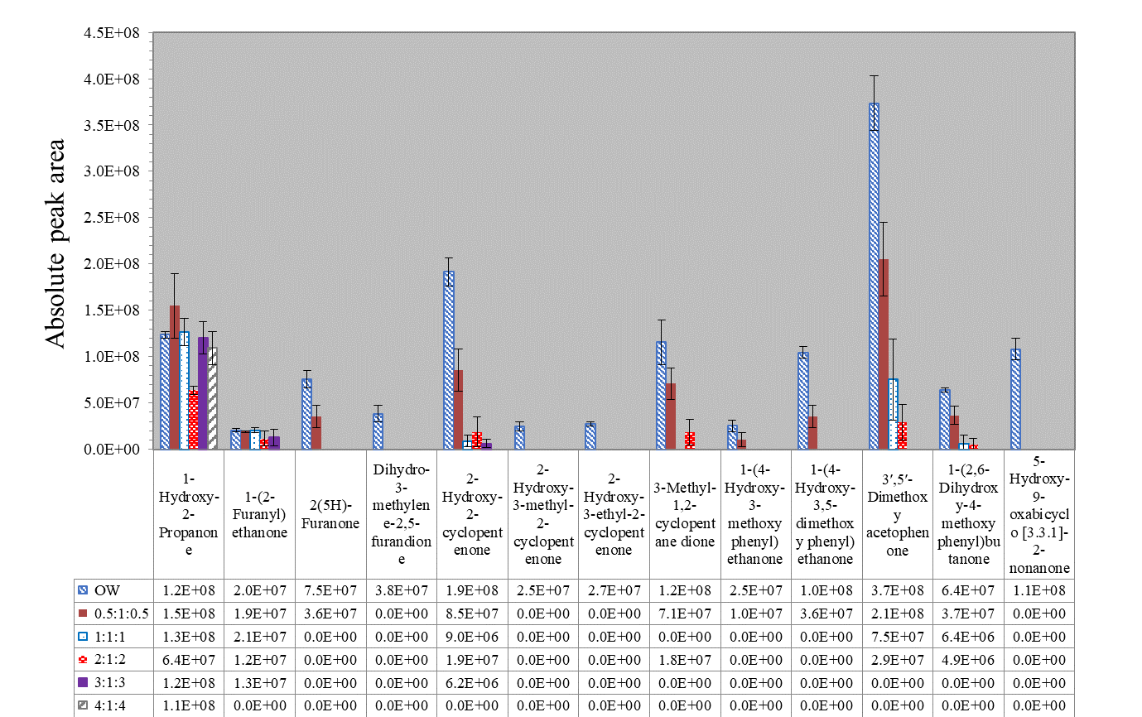

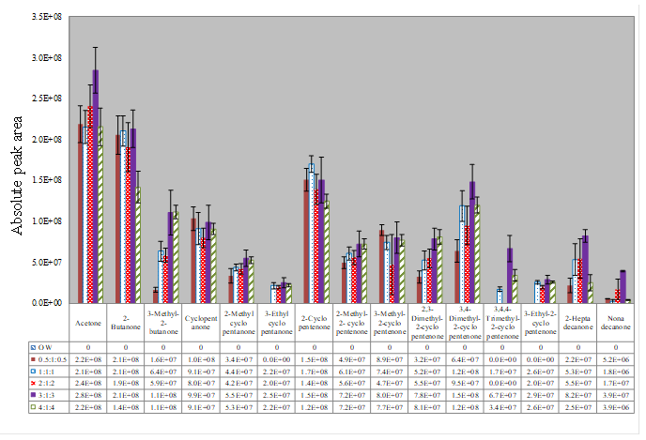

Fig. 6. Comparison of the ketone distribution after experiment with oakwood(OW) only and after CFP with CaOOH in different wt. ratios.

Table 2. Newly formed compounds in catalytic fast pyrolysis of OW with CaOOH in different catalyst loadings.

|  |  |  |  |  |  |  |  |  |
| --- | --- | --- | --- | --- | --- | --- | --- | --- |
| Peak | R.T. | Compound | Group | CaO:OW:CaO wt. ratio (layer method) | | | | |
| 0.5:1:0.5 | 1:1:1 | 2:1:2 | 3:1:3 | 4:1:4 | |
| **1** | 1.55 | Acetone | Ketone | Present | Present | Present | Present | Present | |
| **2** | 1.72 | 2-Butanone | Ketone | Present | Present | Present | Present | Present | |
| **3** | 1.99 | 3-Methyl-2-butanone | Ketone | Present | Present | Present | Present | Present | |
| **4** | 2.84 | Cyclopentanone | Ketone | Present | Present | Present | Present | Present | |
| **5** | 3.39 | 2-Cyclopentenone | Ketone | Present | Present | Present | Present | Present | |
| **6** | 3.50 | 2-Methyl cyclopentanone | Ketone | Present | Present | Present | Present | Present | |
| **7** | 4.49 | 2-Methyl-2-cyclopentenone | Ketone | Present | Present | Present | Present | Present | |
| **8** | 4.72 | Spiro[2,4]heptan-4-one | Ketone | Present | Present | Present | --- | --- | |
| **9** | 5.07 | 3,4-Dimethyl-2-cyclopentenone | Ketone | Present | Present | Present | Present | Present | |
| **10** | 5.43 | 3-Ethylcyclopentanone | Ketone | --- | Present | Present | Present | Present | |
| **11** | 5.71 | 3-Methyl-2-cyclopentenone | Ketone | Present | Present | Present | Present | Present | |
| **12** | 6.12 | 2,4-Hexadien-1-ol | Alcohol | Present | --- | Present | Present |  | |
| **13** | 6.42 | 2,3-Dimethyl-2-cyclopentenone | Ketone | Present | Present | Present | Present | Present | |
| **14** | 7.29 | 3-Methyl-1,2-cyclopentanedione | Ketone | Present | Present | Present | --- | --- | |
| **15** | 8.39 | 3-Ethyl-2-cyclopentenone | Ketone | --- | Present | Present | --- | --- | |
| **16** | 9.89 | 4,4-Diethylspiro[2.3]hexan-5-one | Ketone | --- | Present | Present | Present | Present | |
| **17** | 12.43 | 2-(Hydroxymethyl)cyclohexanone | Ketone | Present | --- | Present | --- | --- | |
| **18** | 19.01 | 3-Hydroxydodecanoic acid | Acid | --- | Present | Present | --- | --- | |
| **19** | 26.54 | 2-Hexadecanone | Ketone | --- | Present | Present | --- | --- | |
| **20** | 28.69 | 2-Heptadecanone | Ketone | Present | Present | Present | Present | Present | |
| **21** | 32.62 | 2-Nonadecanone | Ketone | Present | Present | Present | Present | Present | |

areas of almost all groups (including even initially less abundant alcohols, esters, sugars, and alkoxybenzene) can be observed with the application of increasing catalyst loadings, except for the ketonic and oxygen containing (OC) groups. It is important that the CO2, acids, furans, aldehydes and ether groups were almost entirely eliminated with increasing catalyst loadings, whereas no specific trend can be identified in the formation of the increasing ketonic compounds with catalyst loading. However, the composition of the ketone’s group has been significantly affected as many newly formed ketones are detected after the application of CaOOH in different ratios (Fig. 6 and Table 2). The application of the CaOOH primarily favors the formation of aliphatic (e.g. acetone, 2-butanone, 2-heptadecanone) and cyclic (e.g. cyclopentanone, 2-cyclopentenone) ketones in the expense of primarily acetic acid and furfural, as more analytically described in sections 3.2.2 and 3.2.3. To further investigate the impact of CaOOH on the fast pyrolysis of OW, the calibration curves of the most significant reactants and products, i.e. acetic acid, acetone, furfural, cyclopentanone and 2-cyclopentenone have been constructed (see Figs. S1–S5 in the supporting information) in order to provide a quantitative basis for the analysis of these results.

### 3.2.2 Effect of CaO on acidic compounds

Non-catalytic fast pyrolysis of OW primarily favored the formation of acetic acid and hexadecanoic acid in the acidic group as shown in Fig. 7A. The application of CaOOH at different ratios completely eliminated the aforementioned compounds giving rise to the newly formed ketonic compounds of acetone and 2-heptadecanone as can also be seen in Figs. 6 and 7A. The formation of acetone through the elimination of acetic acid is a strong indicator of a ketonisation reaction taking place on CaOOH catalyst. The formation of C16, C17, C19 – aliphatic ketones shown in Table 2, can be associated with the ketonisation and cracking reactions of C14, C16 – fatty acids [62]. However, as shown in Fig. 7A, the production of CO2, a product of the ketonisation reaction, was significantly reduced for the catalyst loadings of 0.5:1:0.5 and 1:1:1, whilst it was completely eliminated at higher catalyst loadings. The progressive CO2 elimination with increasing catalyst loadings can be associated with its adsorption on the surface of CaO crystals resulting in the formation of CaCO3, as was also previously presented in Fig. 2B. The quantitative phase analysis demonstrates that the fraction of CaCO3 increases noticeably after the application of CaOOH catalyst in 4:1:4 wt. ratio (Fig. 2C). The catalyst loading did not show any significant effect on the formation of acetone (10.93, 10.74, 12.02, 14.22 and 10.76 μg mg-1 OW with 0.5:1:0.5 to 4:1:4 wt. ratios respectively) as the acetic acid (20.07μg mg-1 OW) was completely eliminated at all catalyst loadings (Fig. 7B).

In order to further validate the promotion of the ketonisation reaction of acetic acid on CaOOH, 1mg of hemicellulose, which is the major macromolecule of biomass responsible for the production of acetic acid, was also pyrolyzed with 2:1:2 wt. ratio (CaOOH:Hemicellulose:CaOOH). Catalytic pyrolysis of hemicellulose also strongly indicated the promotion of the ketonisation reaction over CaOOH as shown in Fig. 7C, where approximately 16 μg mg-1 OW of acetic acid were completely eliminated and converted to approximately 8 μg mg-1 OW of acetone. The final quantified product ratios (i.e. acetone almost half of the mass of acetic acid) are also in line with the ketonisation reaction expectation of two molecules of acetic acid forming one molecule of acetone.

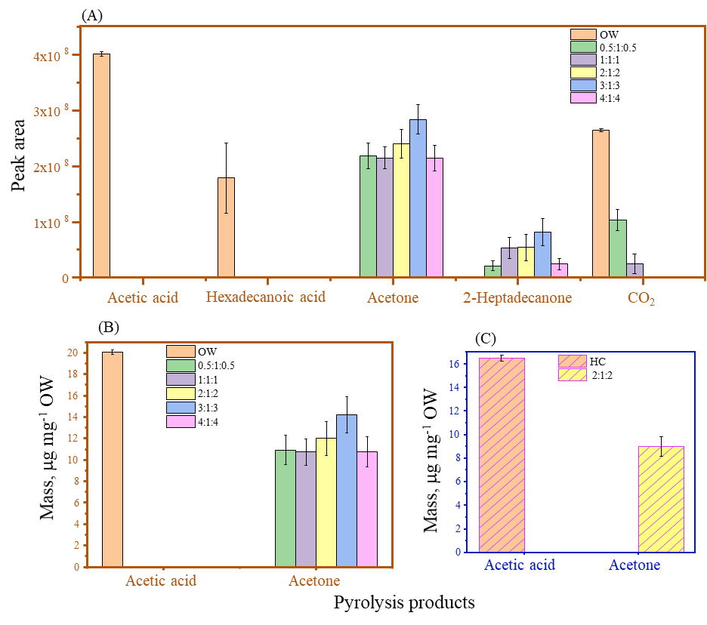

Fig. 7. Effect of CaOOH on acidic compounds.

***Mechanistic pathway of acetic acid conversion to acetone***. The lattice energy of CaO is 3414 kJ mol-1, which is lower than for MgO (3795 kJ mol-1) and higher than for CaCO3 (2804 kJ mol-1) [63,64]. It is already well known that low lattice energy oxides, including CaO, interact strongly with acetic acid [7]. In this reaction route, the formation of acetone proceeds through a bulk ketonisation mechanism based on the intermediate formation and subsequent decomposition of Ca(OAc)2. The decomposition products of Ca(OAc)2 proceed at high temperature to form two intermediate alkyl and acyl radicals (Fig. 8B). The combination of these two radicals results in the formation of acetone with the formation of CaCO3 (Fig. 8C).



Fig. 8. Bulk ketonisation mechanism for acetic acid conversion into acetone over CaOOH catalyst.

### 3.2.3 Effect of CaOOH on furfural

Non-catalytic fast pyrolysis of OW favored the formation of some major furans such as furfural and 5-hydroxymethyl furfural (5-HMF), as shown in Fig. 9A. The application of CaOOH at different ratios completely eliminated furfural, whilst 5-HMF was progressively decreased with increasing catalyst loading and completely eliminated for catalyst loadings greater and equal to 2:1:2. The formation of 2-butanone and 3-methyl-2-butanone could be associated with the elimination of the 5-HMF. The reaction proceeds through ring opening that leads to the formation of levulinic acid [65,66] with subsequent decarboxylation to form 2-butanone, which further undergoes condensation reactions to form 3-methyl-2-butanone. Non-catalytic fast pyrolysis produced 1.73 μg mg-1 OW of furfural, which after its elimination by CaOOH resulted in the appearance of cyclopentanone and 2-cyclopentenone compounds. More specifically, cyclopentanone was obtained in the range of 1.03, 0.91, 0.80, 0.99 and 0.91 μg mg-1 OW with increasing catalyst loading. In addition, 2-cyclopentenone was found in 1.50, 1.70, 1.40, 1.50, 1.25 μg mg-1 OW for the same increase in catalyst as shown in Fig. 9B. As it is evident from the elimination of furfural, the increase in the catalyst loading did not significantly affect the amounts of the produced cyclopentanone.

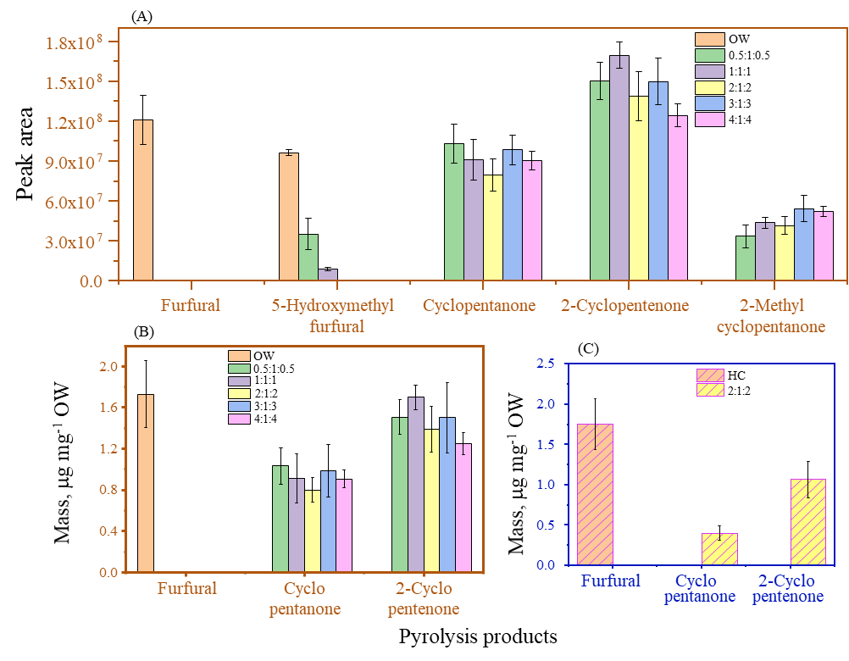

Fig. 9. 1Effect the CaOOH catalyst loading on the distribution of furfural, 5-HMF and cyclic ketones.

Several additional alkyl-substituted cyclic ketones such as 2-methylcyclopentanone, 3-ethylcyclopentanone, 3-methyl-2-cyclopentenone, 2,3- dimethyl-2-cyclopentenone, 3,4-dimethyl-2-cyclopentenone, 3,4,4-trimethyl-2-cyclopentenone, 3-ethyl-2-cyclopentenone were obtained in lower yields with the application of CaOOH (Fig. 6). The cyclic ketones present in the non-catalytic run such as 2-hydroxy-2-cyclopentenone, 2-hydroxy-3-methyl-2-cyclopentenone and 2-hydroxy-3-ethyl-2-cyclopentenone either decreased or were completely eliminated during the catalytic runs with increasing catalyst loadings (Fig. 6). The increased yield of 2-cyclopentenone in the catalytic runs can also be associated with dehydration and side chain cracking reactions occurring on the aforementioned cyclic ketones. Similarly, furan compounds containing the ketone group such as 2-(5H)-furanone and dihydro-3-methylene- 2,5-furandione, either decreased or eliminated by CaOOH catalyst, whilst 2-furan methanol remained unaffected.

Furfural is primarily a product of the thermal decomposition of hemicellulose. Hence, to further investigate and validate the conversion of furfural into cyclopentantone, 1 mg of hemicellulose was catalytically pyrolyzed at 2:1:2 wt. ratio (CaOOH:Hemicellulose:CaOOH). A similar outcome was observed in the case of hemicellulose pyrolysis, where furfural was completely eliminated with simultaneous formation of cyclopentanone and 2-cyclopentenone, as shown in Fig. 9C. However, the relative proportions of the formed ketonic compounds to the initial amount of furfural are lower for the case of hemicellulose pyrolysis. This can be attributed to the fact that in the complete biomass pyrolysis, cyclopentenones are also originated by the decomposition of cellulose.

***Mechanistic pathway of furfural conversion to cyclopentanone.*** Catalytic fast pyrolysis of biomass involves a complex combination of basic reactions, such as dehydration, dehydrogenation, decarbonylation, decarboxylation, side chain cracking and rearrangement, demethylation, condensation etc. During these complex processes, gases such H2, CO, CO2, as well as H2O are produced which actively participate in subsequent catalytic reactions that lead to the final products. Note, that the catalyst is partially hydrated therefore water molecules can be in additionally provided through recombination of hydroxyl groups at the surface. The conversion mechanism of furfural to cyclopentanone in a vapor phase over CaOOH catalyst is shown in detail in Fig. 10. The reaction in a vapor phase is initiated through a hydrogenation step in which furfural is subsequently converted to furfuryl alcohol. The hydrogen for hydrogenation could be supplied through an absorption enhanced water gas shift reaction (AEWGSR) over CaO [68,69], through the formation and subsequent dissociation of a carboxyl from the produced CO and H2O during the decarbonylation and dehydration reactions in CFP. Hydrogen is also supplied through coking reactions which involve dehydrogenation, dehydration, side chain cracking and other reactions of coke precursor compounds. One can suggest that coke can act as the hydrogenation catalyst in steps (1). (8), (9) and (12) [67]. Note that traces of furfuryl alcohol were detected by TG/MS during CFP thereby supporting this conversion mechanism. Further dehydroxylation of furfuryl alcohol by CaO more likely occurs, step (2). The latter can occur by interaction of furfuryl alcohol with Ca2+ at the surface of CaO to form a strong bond between the cation and OH- group as shown in Fig. 10. One can suggest that it is enough Ca2+ surface sites for promotion of this reaction as quantitative XRD analysis demonstrates that CaO fraction in the catalyst even after CFP is very high (Fig. 2C): 86.4 4 mol% in CaOOH (2:1:2) and 71.4 mol% in CaOOH (4:1:4). The formation of the furfuryl alcohol oxycation species is thermodynamically favorable, step (3). Further rearrangement of stabilized cationic species through cascade reactions leads to the existence of



Fig. 10. A proposed mechanism for the conversion of furfural into cyclopentanone over CaOOH catalyst.

unstable intermediates, steps (4) and (5). Further, the steps (9) and (6) can occur simultaneously as in the system hydrogen was already formed through AEWGSR and coking reactions, and at the same time the hydroxylated CaO existed. In step (10), the hydroxylated CaO deprotonates the intermediate formed in step (9) during hydrogenation to release water, which is followed by subsequent dehydration of the intermediate in step (10) resulting in the formation of stable and visible 2-cyclopentenone, step (11). Simultaneously, in step (6), the intermediate formed in step (5) can be dehydrated over hydroxylated CaO with the formation of 4-hydroxy-2- cyclopentenone. It is interesting to note that the latter was not detected by GC-MS among the products. Instead, its isomer 2-hydroxy-2-cyclopentenone with the same boiling point is formed during OW fast pyrolysis and its fraction decreases with the increase in the catalyst loading (Fig. 6). In addition, no mass-spectrum for 4-hydroxy-2-cyclopentenone could be found in the NIST library. Hence, it is reasonable to hypothesize that what has been detected as 2-hydroxy-2-cyclopentenone could potentially be 4-hydroxy-2-cyclopentenone and further hydrogenation could occur in step (8) after deprotonation, step (6), with subsequent dehydration, step (7). Finally, hydrogenation in the presence of coke [67] and with hydrogen supplied through AEWGSR (since CO2 molecules interact with the catalyst forming CaCO3) can convert 2-cyclopentenone exclusively into cyclopentanone [23, 26, 70], step (12). A higher fraction of 2-cyclopentenone compare to that one for cyclopentanone was always revealed in the vapor phase independently on the catalyst loading suggesting that hydrogenation could be the limiting step in obtaining a higher fraction of cyclopentanone.

### 3.2.4 Effect of CaO on phenolics

A large number of phenolic compounds were produced during the non-catalytic fast pyrolysis of OW. The impact of CaOOH catalyst on the phenolic compounds will be described in terms of percentage change in the absolute chromatographic peak area. The impact of the application of CaOOH was in the significant reduction of the phenolic products associated with the thermal decomposition of lignin (Fig. 11). The major impact can be seen on the heavy phenols, as there was a significant reduction in the compounds containing methoxy groups. Light phenols with methyl groups on their side chains were not significantly affected by the catalytic fast pyrolysis with CaOOH.

To further investigate the catalytic effect of CaOOH on the heavy phenolic fraction, 1 mg of lignin was pyrolyzed at a catalyst loading of 2:1:2 wt. ratio. The catalytic pyrolysis of lignin further validated the impact of CaOOH on the methoxy group containing phenolic compounds which were completely eliminated with the only exception of 2-methoxy phenol (guaiacol) which was significantly reduced. Considering the reduction observed in the total chromatographic peak area for increasing catalyst loading (Fig. S9) together with the elimination of the methoxy group containing phenols, it can be speculated that the heavier phenolic fraction underwent condensation reactions that resulted in the increased formation of coke. The coke deposit on the catalyst can be clearly seen in Fig. 1B. The reduction of the heavy phenols can be beneficial to the final pyrolysis product as it will result to a less oxygenated pyrolyzate, however excessive coke deposition can significantly affect the catalytic activity and performance.

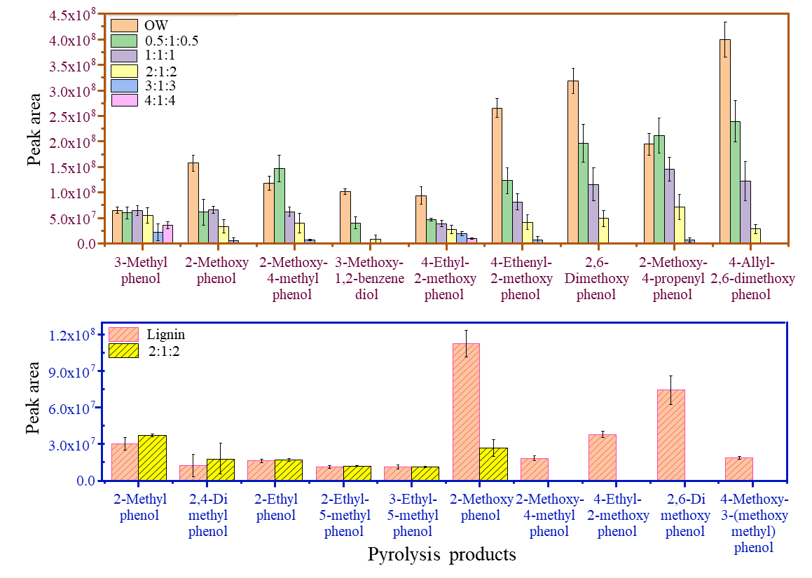

Fig. 11. Effect of CaOOH catalyst loading on the distribution of specific phenolic compounds in the experiments with OW and lignin.

# 4. Conclusions

A low-cost, partially hydrated CaO (CaOOH) was prepared and applied in the fast pyrolysis process in a Py-GC/MS experimental configuration at 500oC. The layer method was used in the experiments where 1mg of biomass was placed between two layers of the applied catalyst, separated by quartz wool, at different weight ratios, i.e. CaOOH(*x*:1:*x*) wt. ratio, where *x =* 0.5, 1, 2, 3, 4 mg. The CaOOH catalyst was characterized before and after each catalytic run and its impact on the distribution of pyrolysis products was investigated.

The CaOOH catalyst demonstrated good structural stability after the catalytic runs. The formation of CaCO3 was detected at generally increasing mole percentages with increasing catalyst loading after each experiment, ranging from 6.5…4.6 mol.% to 20.3 mol.% for catalyst to biomass wt. ratios, CaOOH(*x*:1:*x*), of 0.5:1:0.5 and 1:1:1 to 4:1:4. The results showed the excellent capacity of the CaOOH catalyst to absorb CO2 at the reaction conditions as this reaction product was gradually decreased and eventually completely eliminated from the pyrolysis product distribution with increasing catalyst loadings. Indications on the formation of calcium acetate, Ca(OAc)2, were also present in the examined IR spectra of the catalyst after CFP, that further supports the hypothesis that the acetic acid ketonisation reaction to acetone proceeds through the intermediate formation of its calcium salt.

The application of CaOOH in the fast pyrolysis process resulted primarily to the conversion of acetic acid to acetone through a ketonisation reaction route, the transformation of furfural to cyclopentanone through a combination of reactions (hydrogenation, dehydroxylation, hydration followed by hydrogenation/deprotonation and dehydration) and to the elimination of the heavy (methoxy) phenols with simultaneous formation and deposition of coke. There were good indicators that the ketonisation of acetic acid to acetone proceeded through the formation and subsequent decomposition of calcium acetate. The production of 2-butanone and 3-methyl-2-butanone could be possibly associated with the ring opening reactions of 5-HMF that lead to the formation of levulinic acid with subsequent decarboxylation and condensation reactions. However, additional studies are necessary to confirm the aforementioned conversion route on CaOOH. The transformation of furfural to cyclopentanone was further enhanced by H2 supplied through coking reactions and the absorption enhanced water gas shift reaction of CO and H2O over CaOOH. 2-cyclopentenone, a major intermediate of the furfural to cyclopentanone conversion reaction route, was detected at large proportions, which could be attributed to the dehydration and side chain cracking reactions of the cyclic ketones present in the non-catalytic runs.

The study showed that partially hydrated CaO (CaOOH) can be an effective catalyst for the multi-route upgrading of the fast pyrolysis vapors into value added chemicals and fuel precursors with good structural stability. Future studies should focus on the impact of the CO2 absorption on the catalyst’s activity and reusability in the fast pyrolysis process, as well as the effect of the environmental conditions on water absorption and subsequently catalyst hydration.

**Acknowledgement**

Authors gratefully acknowledge for financial support PhD Scholarship (PGRS-13-02-10) and Research Development Fund (RDF-13-02-14) at Xi'an Jiaotong-Liverpool University. EK acknowledges the Provincial Key Laboratory of Carbonaceous Wastes Processing and Process Intensification at University of Nottingham Ningbo China for partial financial support.

# References

[1] M. Fitzpatrick, P. Champagne, M.F. Cunningham, R.A. Whitney, A biorefinery processing perspective: Treatment of lignocellulosic materials for the production of value-added products, **Bioresour Technol**, 101 (2010) 8915-8922.

[2] A.V. Bridgwater, G.J.R. Peacocke, Fast pyrolysis processes for biomass, **Renew Sust Energ Rev**, 4 (2000) 1-73.

[3] W.H. Chen, B.J. Lin, M.Y. Huang, J.S. Chang, Thermochemical conversion of microalgal biomass into biofuels: a review, **Bioresour Technol**, 184 (2015) 314-327.

[4] Q. Lu, W.M. Xiong, W.Z. Li, Q.X. Guo, X.F. Zhu, Catalytic pyrolysis of cellulose with sulfated metal oxides: a promising method for obtaining high yield of light furan compounds, **Bioresour Technol**, 100 (2009) 4871-4876.

[5] S. Shylesh, A.A. Gokhale, K. Sun, A.M. Grippo, D. Jadhav, A. Yeh, C.R. Hob, A.T. Bell, Integrated catalytic sequences for catalytic upgrading of bio-derived carboxylic acids to fuels, lubricants and chemical feedstocks, Sustain Energy Fuels 1 (2017) 1805-1809.

[6] B. Valle, A. Remiro, N. Garcнa-Gуmez, A.G Gayubo, J. Bilbao, Recent research progress on bio-oil conversion into bio-fuels and raw chemicals: a review, J Chem Technol Biotechnol, 94 (2019) 670-689.

[7] T.N. Pham, T. Sooknoi, S.P. Crossley, D.E. Resasco, Ketonization of carboxylic acids: mechanisms, catalysts, and implications for biomass conversion, ACS Catal, 3 (2013) 2456-2473.

[8] C. Liu, H. Wang, A.M. Karim, J. Sun, Y. Wang, Catalytic fast pyrolysis of lignocellulosic biomass, Chem Soc Rev, 43 (2014) 7594-7623.

[9] R. Pestman, R.M. Koster, A. van Duijne, J.A.Z. Pieterse, V. Ponec, Reactions of carboxylic acids on oides: 2. Bimolecular reaction of aliphatic acids to ketones, J Catal, 168 (1997) 265-272.

[10] R.W. Snell, B.H. Shanks, Insights into the ceria-catalyzed ketonization reaction for biofuels applications, ACS Catal, 3 (2013) 783-789.

[11] S.H. Hakim, B.H. Shanks, J.A. Dumesic, Catalytic upgrading of the light fraction of a simulated bio-oil over CeZrOx catalyst, Appl Catal B: Environ, 142 (2013) 368-376.

[12] S.T. Almutairi, E.F. Kozhevnikova, I.V. Kozhevnikov, Ketonisation of acetic acid on metal oxides: Catalyst activity, stability and mechanistic insights, Appl Catal A Gen 565 (2018) 135-145.

[13] S. Shao, X. Xiang, X. Li, H. Zhang, R. Xiao, Y. Cai, Synergy in the selective production of ketone platform compounds from biomass pyrolysis vapors over CeO2 Catalysts, Ind Eng Chem Res 59 (2020) 6460-6469.

[14] A.C. Psarras, C.M. Michailof, E.F. Iliopoulou, K.G. Kalogiannis, A.A. Lappas, E. Heracleous K.S. Triantafyllidis, Acetic acid conversion reactions on basic and acidic catalysts under biomass fast pyrolysis conditions, Molecul Catal 465 (2019) 33-42.

[15] M.A. Jackson, Ketonization of model pyrolysis bio-oil solutions in a plug-flow reactor over a mixed oxide of Fe, Ce, and Al. Energy Fuels, 27 (2013) 3936-3943.

[16] G.A.H. Mekhemer, S.A. Halawy, M.A. Mohamed, M.I. Zaki, Ketonization of acetic acid vapour over polycrystalline magnesia: in situ Fourier transform infrared spectroscopy and kinetic studies, J Catal 230 (2005) 109-122.

[17] H. Ling, Z. Wang, L. Wang, C. Stampfl, D. Wang, J. Chen, J. Huang, Composition-structure-function correlation of Ca/Zn/AlOx catalysts for the ketonization of acetic acid, Catal Today 351 (2020) 58-67.

[18] R.B.S. Junior, R.C. Rabelo-Neto, R.S. Gomes, F.B. Noronha, R. Fréty, S.T. Brandão, Steam reforming of acetic acid over Ni-based catalysts derived from La1-xCaxNiO3 perovskite type oxides, Fuel 254 (2019) 115714(9).

[19] R. Mariscal, P. Maireles-Torres, M. Ojeda, I. Saґdaba, M. Loґpez Granados, Furfural: a renewable and versatile platform molecule for the synthesis of chemicals and fuels, Energy Environ Sci 9 (2016) 1144-1189.

[20] B. Kamm, P.R. Gruber, M. Kamm, Biorefineries - Industrial processes and products: Status Quo and Future Directions, Wiley-VCH Verlag GmbH & Co., Weinheim, 2006.

[21] M.L. [Granados,](https://www.scopus.com/authid/detail.uri?authorId=57212525829&amp;eid=2-s2.0-85058750158) Cyclopentanone and its derived biofuels in “Furfural: An entry point of lignocellulose in biorefineries to produce renewable chemicals, polymers, and biofuels”. M.L. Granados, D.M. Alonso Eds. Sustainable chemistry series. New Jersey: World Scientific Publishing Co (2018) Vol. 2, 157-168.

[22] M. Hronec, K. Fulajtarová, T. Liptaj, Effect of catalyst and solvent on the furan ring rearrangement to cyclopentanone, Appl Catal A Gen 437-438 (2012) 104-111.

[23] M. Hronec, K. Fulajtárová, I. Vávra, T. Soták, E. Dobročka, M. Mičušík, Carbon supported Pd–Cu catalysts for highly selective rearrangement of furfural to cyclopentanone, Appl Catal B Environ 181 (2016) 210-219.

[24] Y. Zhang, G. Fan, L. Yang, F. Li, Efficient conversion of furfural into cyclopentanone over high performing and stable Cu/ZrO2 catalysts, Appl Catal A Gen, 561 (2018) 117-126.

[25] R. Fang, H. Liu, R. Luque, Y. Li, Efficient and selective hydrogenation of biomass-derived furfural to cyclopentanone using Ru catalysts, Green Chem 17 (2015) 4183-4188.

[26] M. Dohade, P.L. Dhepe, Efficient method for cyclopentanone synthesis from furfural: understanding the role of solvents and solubility in a bimetallic catalytic system, Catal Sci Technol 8 (2018) 5259-5269.

[27] G.S. Zhang, M.M. Zhu, Q. Zhang, Y.M. Liu, H.Y. He, Y. Cao, Towards quantitative and scalable transformation of furfural to cyclopentanone with supported gold catalysts, Catal. Sci. Technol 18 (2016) 2155-2164.

[28] T. Akashi, S.Sato, R. Takahashi, T. Sodesawa, K. Inui, Catalytic vapor-phase cyclization of 1,6-hexanediol into cyclopentanone, Catal Commun 4 (2003) 411-416.

[29] P. Sudarsanam, L. Katta, G. Thrimurthulu, B. M. Reddy, Vapor phase synthesis of cyclopentanone over nanostructured ceria–zirconia solid solution catalysts, J Ind Eng Chem 19 (2013) 1517-1524.

[30] H. Miki, Investigation of industrial process to produce cyclopentanone by dehydrogenation of cyclopentanol using copper–zinc catalyst, J Jpn Petrol Inst 62 (2019) 282-295.

[31] T. Omotoso, L.V. Herrera, T. Vann, N.M. Briggs, L.A. Gomez, L. Barrett, D. Jones, T. Pham, B. Wang, S.P. Crossley, Stabilization of furanics to cyclic ketone building blocks in the vapor phase, Appl Catal B Environ 254 (2019) 491-499.

[32] H.D. Franklin, W.A. Peters, F. Cariello, J.B. Howard, Effects of calcium minerals on the rapid pyrolysis of a bituminous coal, Ind. Eng. Chem. Process Des. Dev. 20 (1981) 670-674.

[33] M.R. Khan, Production of high quality liquid fuels from coal by mild pyrolysis of coal-lime mixtures, Fuel Sci Technol Int 5 (1987) 185-231.

[34] L. Han, Q. Wang, Q. Ma, C. Yu, Z. Luo, K. Cen, Influence of CaO additives on wheat-straw pyrolysis as determined by TG-FTIR analysis, J Anal Appl Pyrol, 88 (2010) 199-206.

[35] Y. Lin, C. Zhang, M. Zhang, J. Zhang, Deoxygenation of bio-oil during pyrolysis of biomass in the presence of CaO in a fluidized-bed reactor, Energy & Fuels, 24 (2010) 5686-5695.

[36] Q. Lu, Z.F. Zhang, C.Q. Dong, X.F. Zhu, Catalytic upgrading of biomass fast pyrolysis vapors with nano metal oxides: an analytical Py-GC/MS study, Energies, 3 (2010) 1805-1820.

[37] G. Zhang, H. Hattori, K. Tanabe, Aldol addition of acetone, catalyzed by solid base catalysts: magnesium oxide, calcium oxide, strontium oxide, barium oxide, lanthanum (III) oxide and zirconium oxide, Appl Catal, 36 (1988) 189-197.

[38] T. Iizuka, H. Hattori, Y. Ohno, J. Sohma and K. Tanabe, Basic sites and reducing sites of calcium oxide and their catalytic activities, J. Catal 22 (1971) 130-139.

[39] C.Q. Dong, [Z.F. Zhang](https://www.sciencedirect.com/science/article/pii/S0196890411003669#!), [Q. Lu](https://www.sciencedirect.com/science/article/pii/S0196890411003669#!), Y.P. Yang, Characteristics and mechanism study of analytical fast pyrolysis of poplar wood, Energ Convers Manage 57 (2012) 49-59.

[40] H.M. Rietveld, A profile refinement method for nuclear and magnetic structures. J Appl Crystallogr 2 (1969) 65-71.

[41] R.W. Cheary, A.A. Coelho, A fundamental parameters approach to X-ray line-profile fitting. J Appl Cryst. 25 (1992) 109-121.

[42] E.Yu. Konysheva, M. Kuznetsov, Fluctuation of surface composition and chemical states at the hetero-interface in composites comprised of a phase with perovskite structure and a phase related to the Ruddlesden–Popper family of compounds, RSC Adv 3 (2013) 14114-14122.

[43] E. Konysheva, E. Suard, J.T.S. Irvine, Effect of oxygen nonstoichiometry and oxidation state of transition elements on high-temperature phase transition in A-site deficient La0.95Ni0.6Fe0.4O3 perovskite, Chem Mater 21 (2009) 5307-5318.

[44] J.I. Langford, A.J.C. Wilson, Seherrer after sixty years: a survey and some new results in the determination of crystallite size, J Appl Cryst 11 (1978) 102-113.

[45] J. Gupta, K. Papadikis, I.V. Kozhevnikov, E.Yu. Konysheva, Exploring the potential of red mud and beechwood co-processing for the upgrading of fast pyrolysis vapours, J Anal Appl Pyrol 128 (2017) 35-43.

[46] A. Baimoldina, K. Papadikis, E.Yu. Konysheva, Diverse impact of nano/microsize α-Fe2O3 shape on the catalytic fast pyrolysis of pinewood: Py-GC/MS study, J Anal Appl Pyrol 139 (2019) 145-155.

[47] Q. Lu, X.C. Yang, C.Q. Dong, Z.F. Zhang, X.M. Zhang, X.F. Zhu, Influence of pyrolysis temperature and time on the cellulose fast pyrolysis products: Analytical Py-GC/MS study, J Anal Appl Pyrol, 92 (2011) 430-438.

[48] Q. Lu, X.M. Zhang, Z.B. Zhang, Y. Zhang, X.F. Zhu, C.Q. Dong, Catalytic fast pyrolysis of cellulose mixed with sulfated titania to produce levoglucosenone: analytical Py-GC/MS study, BioResources, 7 (2012) 2820-2834.

[49] J.P. Singh, W.C. Lim, S.O. Won, J. Song, K.H. Chae, Synthesis and characterization of some akaline-earth-oxide nanoparticles, [J Korean Phys Soc](https://link.springer.com/journal/40042), 72 (2018) 890-899.

[50] F.A. Andersen, L. Brecevic, Infrared spectra of amorphous and crystalline calcium carbonate, Acta Chem Scand, 45 (1991) 1018-1024.

[51] M. Galván-Ruiz, J. Hernández, L. Baños, J. Noriega-Montes, M.E. Rodríguez-García, Characterization of calcium carbonate, calcium oxide, and calcium hydroxide as starting point to the improvement of lime for their use in construction, J Mater Civil Eng, 21 (2009) 694-698.

[52] NIST Standard Reference Database 69: NIST Chemistry WebBook. [https://webbook.nist.gov/chemistry](https://webbook.nist.gov/chemistry/name-ser/). Last access 28 September 2020.

[53] M. Khachani, A. El Hamidi, M. Halim, S. Arsalane, Non-isothermal kinetic and thermodynamic studies of the dehydroxylation process of synthetic calcium hydroxide Ca(OH)2, J. Mater. Environ. Sci. 5 (2014) 615-624.

[54] X. Chen, Y. Chen, H. Yang, W. Chen, X. Wang, H. Chen, Fast pyrolysis of cotton stalk biomass using calcium oxide, **Bioresour Technol**, 233 (2017) 15-20.

[55] R.L. Frost, A.W. Musumeci, E.R. Waclawik, A spectroscopic study of the mineral paceite (Ca(OAc)2). Spectrochim Acta A Mol Biomol Spectrosc 67 (2007) 649-661.

[56] S. Li, I. Huskić, N. Novendra, H.M. Titi, A. Navrotsky, T. Friščić, Mechanochemical synthesis, accelerated aging, and thermodynamic stability of the organic mineral paceite and its cadmium analogue, ACS Omega 4 (2019) 5486-5495.

[57] M. Bilton, A.P. Brown, S.J. Milne, Investigating the optimum conditions for the formation of calcium oxide, used for CO2 sequestration, by thermal decomposition of Ca(OAc)2, J. Phys.: Conf. Ser. 371 (2012) 012075 (4pages).

[58] C. Guizani, M. Jeguirim, S. Valin, L. Limousy, S. Salvador, Biomass chars: the effects of pyrolysis conditions on their morphology, structure, chemical properties and reactivity. Energies, MDPI 10 (2017) 796 (18).

[59] W. Zhang, L. Li, Thermal behavior and properties of CaCu3Ti4O12 ceramic synthesized by organo-metallic compound, Appl. Phys. A 124 (2018) 653(6).

[60] P.E. Halstead, A.E. Moore, The thermal dissociation of calcium hydroxide. J Chem Soc, 769 (1957) 3873-3875.

[61] F. Schaube, A. Kohzer, J. Schütz, A. Wörner, H. Müller-Steinhagen, De- and rehydration of Ca(OH)2 in a reactor with direct heat transfer for thermo-chemical heat storage. Part A: Experimental results, Chem Eng Res Des 91 (2013) 856–864.

[62] T. Maluangnont, C. Dararat, T. Kulrat, S. Soontontaweesub, T. Anothaiwalaikul, P. Bunprechawong, R. Chanda, J. Kanchanawarin, P. Kidkhunthod, T. Sooknoi, Production of liquid fuel from palmitic acid over nanocrystalline CeO2-based catalysts with minimal use of H2, Catal Commun, 102 (2017) 123-126.

[63] M.T. Weller, T. Overton, J. Rourke, F.A. Armstrong, Inorganic chemistry, 6th Ed., Oxford University Press: Oxford. 2014. pp 912.

[64] D.R. Lide, CRC Handbook of Chemistry and Physics; CRC Press LLC: Boca Raton, FL. 2004. pp 2712.

[65] Y. Shao, X. Hu, Z. Zhang, K. Sun, G. Gao, T. Wei, S. Zhang, S. Hu, J. Xiang, Y. Wang, Direct conversion of furfural to levulinic acid/ester in dimethoxymethane: Understanding the mechanism for polymerization, Green Energy & Environment, 4 (2019) 400-413.

[66] A. Herbst, C. Janiak, Selective glucose conversion to 5-hydroxymethylfurfural (5-HMF) instead of levulinic acid with MIL-101Cr MOF-derivatives, New J Chem 40 (2016) 7958-7967.

[67] C. H. Collett, J. McGregor, Things go better with coke: the beneficial role of carbonaceous deposits in heterogeneous catalysis, Catal. Sci. Technol. 6 (2016) 363–378.

[68] B. Li, L. Wei, H. Yang, X. Wang, H. Chen, The enhancing mechanism of calcium oxide on water gas shift reaction for hydrogen production, Energy 68 (2014) 248-254.

[69] B. Valle, N. Garcia-Gomez, A. Remiro, A.G. Gayubo, J. Bilbao, Cost-effective upgrading of biomass pyrolysis oil using activated dolomite as a basic catalyst, Fuel Process Technol 195 (2019) 106142(10).

[70] K.F. Milan Hronec, M. Micusik, Influence of furanic polymers on selectivity of furfural rearrangement, Appl Catal A Gen, 468 (2013) 426-431.