Metabolism in action: stable isotope probing using vibrational spectroscopy and SIMS reveals kinetic and metabolic flux of key substrates

Malama Chisanga,^{a, b} Howbeer Muhamadali,^{c} Danielle Mcdougall,^{d} Yun Xu,^{c} Nicholas Lockyer,^{d} and Royston Goodacre^{*c}
ªSchool of Chemistry, Manchester Institute of Biotechnology, University of Manchester, Manchester, UK, M1 7DN
^{b}School of Mathematics and Natural Sciences, Department of Chemistry, Copperbelt University, Kitwe, Zambia
^{c}Department of Biochemistry, Institute of Integrative Biology, University of Liverpool, Liverpool, UK, L69 7ZB
^{d}School of Chemistry, Photon Science Institute, University of Manchester, Manchester, UK, M13 9PL

*Corresponding author:
Royston Goodacre, E-mail: roy.goodacre@liverpool.ac.uk, Tel: 0151 795 7689

Keywords: Raman spectroscopy, FT-IR spectroscopy, Secondary ion mass spectrometry, Isotope probing, Kinetics, Metabolism, Metabolic fingerprinting, Phenol degradation

ABSTRACT
Microbial communities play essential functions which drive various ecosystems supporting animal and aquatic life. However, linking bacteria with specific metabolic functions is difficult, since microbial communities consist of numerous and phylogenetically diverse microbes. Stable isotope probing (SIP) combined with single-cell tools has emerged as a novel culture-independent strategy for unravelling microbial metabolic roles and intertwined interactions in complex communities. In this study, we applied Raman and Fourier-transform infrared (FT-IR) spectroscopies, secondary ion mass spectrometry (SIMS) with SIP to probe the rate of ¹³C incorporation in Escherichia coli at 37 and 25°C. Our results indicate quantitative enrichment and flow of ¹³C into E. coli at various time points. Multivariate and univariate analyses of Raman and FT-IR data demonstrated distinctive ¹³C concentration-dependent trends that were due to vibrational bands shifting to lower frequencies and these shifts were a result of incubation time and metabolic rate. SIMS results were in complete agreement with the spectroscopy findings, and confirmed the detected levels of ¹³C incorporation into microbial biomass at the investigated conditions. Having established that FT-IR and Raman spectroscopy with SIP can measure metabolism kinetics in this simple system, we have applied the kinetics concept to study the metabolism of phenol by Pseudomonas putida and metabolic interactions within a two-species consortia with E. coli that could not degrade phenol. Raman spectroscopy combined with SIP identified quantitative shifts in P. putida due to temporal assimilation of phenol. Although E. coli was unable to grow on phenol, in co-culture with P. putida, general metabolic probing using deuterated water for SIP revealed that E. coli displayed increasing metabolic activity, presumably due to cross feeding from metabolites generated by P. putida. This study clearly demonstrates that Raman and FT-IR combined with SIP provide rapid and sensitive detection of carbon incorporation rates and microbial interactions. These novel findings may guide the identification of primary substrate consumers in complex microbial communities in situ, which is a key step towards the characterisation of novel genes, enzymes and metabolic flux analysis in microbial consortia.
INTRODUCTION
Microbial communities play vital ecological functions which support essential environmental and mammalian biological systems. The fundamental theme of contemporary microbial ecology and functional genomics is to obtain detailed understanding of functions for individual members of a multi-species consortium and link them to phylogeny¹; with a view to being able to modulate these functions for industrial application. Stable isotopic probing (SIP) has become a powerful tool to achieve this goal, since it discerns functions of metabolically active microbes directly within complex environments. In the past decade, SIP has been extensively applied in parallel with single-cell tools to detect microbes linked with the metabolism of a particular substrate (usually labelled with ¹³C or ¹⁵N isotopes)². High-throughput molecular techniques combined with density-gradient centrifugation are perhaps the most commonly applied approaches for identification of DNA/RNA biomarkers of labelled and unlabelled cells^{3, 4}. Whilst delivering a wealth of valuable information about phylogeny and metabolic genes, DNA and RNA SIP tools exhibit high detection limit for cellular isotopic content (>50 and >15 atom%, respectively)^{3, 5}. Thus, long incubation times are needed for cell replication and optimal isotopic enrichment of DNA³. By contrast, Raman spectroscopy provides rapid and sensitive measurements with detection limit of ~10 atom%)⁶, and physiological heterogeneity of intact bacterial cells in situ.
Raman spectroscopy is a high-throughput technique where Stokes scattered light is measured to detect biomolecular dynamics⁷ and isotopic content⁸ of polarisable molecular bonds. The application of FT-IR as a complementary tool to identify environmental microbes has also been proved useful^{9, 10}. FT-IR generates spectral information from chemical bonds whose permanent dipole moments change upon absorption of infrared light. Combining Raman and FT-IR with SIP offers comprehensive whole-organism biochemical fingerprints which are used to unravel intertwined metabolic networks and functions of microbes in complex consortia, since Raman and FT-IR bands shift to lower wavenumber (redshift) upon assimilation of heavy atoms. When secondary ion mass spectrometry (SIMS) (detection limit of 0.1 atom%)¹¹ is used in parallel, heavy atoms assimilated by bacteria can be probed to supplement Raman and FT-IR data^{12, 13}.
To date however, FT-IR and Raman-based SIP studies have mainly focused on functional characterisation of fully or quantitatively labelled microbes;^{14, 15} the latter based on growing microbes on predefined mixtures of natural and label substrates¹⁶. Although this discerns niche roles such as nutrient fixation^{17, 18}, and degradation of pollutants^{19, 20}, it does not provide clear insights into rates of substrate turnover and metabolic activity with respect to time. Moreover, lengthy incubation time required to ensure full isotopic labelling complicates phylogenetic resolution of key substrate degraders, due to excessive cross-feeding of labelled metabolites from primary consumers to the rest of the habitat⁸. Thus, neighboring microbes assimilating labelled metabolic products may also display redshifted bands. To overcome this challenge, there is a need to perform a systematic, quick and robust time-course SIP study to allow for sampling of bacteria over time and to determine kinetics of isotopic labelling^{8, 14, 21}.
In this study, we first investigate the kinetics of ¹³C isotope incorporation by E. coli cultivated in minimal medium containing ¹³C-glucose as a sole carbon source under aerobic conditions. For the first time we demonstrate novel utility of Raman, FT-IR and SIMS combined with SIP to assess and quantify the incorporation rate of ¹³C by E. coli, and to monitor the flow of ¹³C into biomolecules at various time points. The Raman and FT-IR bands related to carbon bond vibrations are observed to be redshifted progressively due to cumulative assimilation of ¹³C between 0 and 4 h at 37 and 25°C. SIMS data also displayed concentration-dependent trends along a time gradient that were wholly consistent with quantitative ¹³C level detected by Raman and FT-IR. This initial study was designed to establish that the quantitative kinetic uptake of ¹³C substrates was possible using this simple model system, before extending this novel kinetic approach to investigating cross-feeding, via reverse SIP (rSIP) and deuterated water (D₂O) labelling⁸, in a two-component community where P. putida was able to catabolise phenol whilst E. coli did not grow when phenol was the sole carbon source. Reverse labelling was achieved by exposing ¹³C-labelled cells to minimal medium containing ¹²C-phenol (MMP) as the only carbon source, with or without 30% D₂O. Co-labelling with D₂O was applied to probe the general metabolic activity²² and interaction between P. putida and E. coli in phenolic media.
EXPERIMENTAL METHODS
Growth conditions
Unless otherwise stated, all chemicals were purchased from Fisher (Fisher Scientific, UK).
Kinetic measurements of ¹³C incorporation in E. coli
Wild type E. coli K-12 MG1655 was grown in minimal medium (MM) supplemented with 5 g/L of 99 atom% uniformly labelled ¹³C-glucose (Sigma Aldrich, UK), as a sole carbon source. Bacterial growth were performed in replicates (n = 4) in 5 mL volumes in sterile Falcon tubes (Greiner Bio-One, Germany). Prior to incubation, 200 µL of cell samples for each condition were transferred to a clean and sterile 96-well plate to monitor the growth profiles via optical density at 600 nm (OD₆₀₀). All cells were incubated at 37 and 25°C in a Multitron shaker incubator (INFORS-HT Bottmingen, Switzerland) shaking at170 rpm. Cells were collected at 20 min intervals, between 0 and 4 h at 37 and 25°C to probe ¹³C assimilation at various time points. In quantitative SIP study, E. coli was grown in MM containing varying ratios of ¹²C/¹³C-glucose and harvested in the early stationary growth phase after 16 h as reported previously²³.
Study of phenol metabolism by bacteria
E. coli K-12 MG1655 and P. putida ATCC 700369 were grown axenically in minimal medium (MM) containing 5 g/L of 99 atom% uniformly labelled ¹³C-glucose (Sigma Aldrich, UK) (MMG). Cells were harvested after 16 h of incubation to ensure complete incorporation of ¹³C-glucose and utilised as inoculant for subsequent experiments. After normalising OD₆₀₀, cells were inoculated as 5 mL aliquots (n = 4) in MM supplemented with industrially relevant concentration¹ (0.2 g/L) of ¹²C-phenol (Sigma Aldrich, UK) (MMP), as the only carbon source at pH of 7, as mono and co-cultures with or without 30% D₂O. Here, 30% D₂O was used since this optimal D₂O level does not significantly affect metabolism²². For co-culture analysis, the inoculum was prepared in sterile deep 6-well plates in which E. coli and P. putida shared the same MMP, although the cells were physically separated by means of sterile culture inserts having 0.4 µm pore size (BD Biosciences, U.S.A). E. coli and P. putida were incubated at 37 and 30°C, respectively, and sampled at 0, 1, 2, 4, 8 and 18 h time intervals.
Sample preparation, spectral measurements and data processing for Raman and FT-IR
After incubation, all sample aliquots were collected by centrifugation for 5 min at 4000 g and 4°C using a bench top Eppendorf Centrifuge 5810 R (Hamburg, Germany). After discarding the supernatant, the collected biomass was washed twice using 5 mL of physiological saline (0.9% NaCl) to remove any remaining media components following the above centrifugation parameters. The cell pellets were collected and stored at -80°C prior to further investigation. Detailed instrumental, sample measurement parameters and data processing steps for Raman and FT-IR are similar to our previously published protocols¹⁶, and are clearly presented in the supplementary information (SI) section.
SIMS analysis for kinetics measurements of ¹³C incorporation in E. coli
For SIMS analysis, 1 x 1 cm Si wafers (Agar Scientific, UK) were prepared by sonication in hexane followed by methanol and stored in glass vial containing 80% ethanol. Each pelleted sample of E. coli collected at 0, 1, 2, 3, 4 and 16 h time points at 25 and 37°C was resuspended in ammonium formate solution (150 mM, 50 µL) and the resulting solution was pipetted onto clean Si wafers. Prior to SIMS analysis, Si wafers containing cellular biomaterial were placed in a desiccator under vacuum to remove any water and traces of ammonium formate.
Quantitative ToF-SIMS spectra of cells were acquired using a BioToF-SIMS instrument (Kore Technology Ltd, Ely, UK). The primary ion beam of choice was a Wein filtered Au₃⁺ liquid metal ion gun (LMIG) operated at 20 keV with a continuous beam flux of 0.6 nA and a pulse time of 100 ns. Data were acquired in delayed-extraction mode, providing mass resolving power of ~1000. The mass range within 0-1000 Da consisting of metabolites of interest was selected. In order to acquire representative information from the whole sample on each Si wafer, SIMS spectra were measured from three different regions of each sample. This allowed for detailed information through the layers of biomass. All SIMS spectra were collected in positive polarity mode using a post-acceleration voltage of 7 kV.
Quantitative analysis of ¹³C incorporation by E. coli via PLSR for kinetic measurements
To effect quantitative analysis, univariate and partial least-squares regression (PLSR)²⁴ were utilised. PLSR model was trained with Raman and FT-IR data measured from E. coli grown for 16 h in varying ¹²C/¹³C-glucose ratios, and subsequently employed to predict the amount of ¹³C in E. coli cultivated at different sampling time points at 37 and 25°C temperatures.
RESULTS AND DISCUSSION
Analysis of kinetic measurements of ¹³C incorporation in E. coli
Raman metabolic fingerprints
Figure 1a represents typical mean Raman spectra of E. coli grown on ¹³C-glucose, showing various distinguishable band redshifts at t = 16 h (red line) relative to the peaks of unlabelled cells at t = 0 h (blue line). The observed spectral redshifts reflect an increase in the reduced mass and a corresponding decrease in vibrational frequency of ‘heavier’ bonds when ¹²C is substituted with ¹³C in biomolecules²⁵. By visual inspection, many peaks shifted from standard ¹²C positions to lower wavenumbers upon assimilation of ¹³C isotope by cells. The Raman band at 1002 cm⁻¹ assigned to benzene ring vibrations in phenylalanine displayed a shift to 965 cm⁻¹ within just 20 min of cell incubation as shown on Figure S1a, suggesting intense metabolic activity and rapid uptake and assimilation of ¹³C and also demonstrates the high sensitivity of the Raman technique. The redshifted band detected at 965 cm⁻¹ reached maximum intensity after 16 h of growth, indicating 100% ¹³C incorporation in phenylalanine. On closer inspection, the phenylalanine band initially shifted to 986 cm⁻¹ when ¹²C in a benzene ring were partially replaced with ¹³C, indicating the formation of isotopomers as intermediates of metabolism¹⁴. Similarly, an intense band at 1654 cm⁻¹ corresponding predominantly to C=O stretch in amide I (ref ²⁶), shifted to 1620 cm⁻¹ on complete ¹³C substitution by cells. It is worth mentioning that the Raman biomarker band for phenylalanine and amide I at 1002 and 1654 cm⁻¹ displayed quantitative redshifts due to gradual ¹³C substitution over time (Figure S1a, b). This observation was supported by PC1 loadings plots (Figure S2c, d) that revealed these bands (phenylalanine and amide I) to be the major input wavenumber shifts affected by ¹³C labelling, and hence influenced the clustering patterns observed on PCA scores plots in Figure 2a – where the trends in these ordination plots were entirely related to incubation time. Several other important diagnostic vibrations of lower intensities at 1573, 1338, 1250, 781, 828 and 642 cm⁻¹, ascribed to ring breathing in guanine, adenine, amide III, cytosine, uracil and tyrosine, respectively, were also affected by isotope labelling of E. coli cells as detailed in Table S1(ref ^{27, 28}). Though dominated by carbon vibrations (Figure 1a) in biomolecules, some bands such as: 622 cm⁻¹ (N–H stretch) and 1100 cm⁻¹ (>PO₂⁻ symmetric stretch)^{29, 30} did not display detectable redshifts irrespective of the level of ¹³C uptake since they are not linked to carbon atom(s).
Next all Raman data were subjected to PCA to visualise any cellular ¹³C isotope-driven patterns over time and quantitative ¹³C assimilation as shown in Figure 2a. The PCA scores illustrated in Figure 2a are plotted from the Raman data measured from quantitatively enriched E. coli that were harvested in the early stationary growth phase (t = 16 h) to achieve complete ¹³C enrichment, and E. coli samples for kinetics experiments that were mainly collected in the lag and early log phases. As can be seen in Figure 2a and Figure S2 (a, b), PCA scores plots show time and concentration-dependent trends for Raman spectra of cells sampled at various time points and those cultivated on increasing ¹²C/¹³C ratios. Clustering trends on PCA scores indicate that ¹³C incorporation was quantitative and so should be predictable. The first principal component (PC1) revealed a linear increase in ¹³C incorporation from right (t = 0 h and 0% ¹³C) to left (t = 16 h and 100% ¹³C) as the most dominant effect. PC1 is extracted to contain the most natural variance in the data, and this observation is not surprising as carbon is considered the most abundant element in cells, and thus the majority of the detected band shifts are carbon-related modes. As can be seen in Figure 2a, E. coli harvested at t = 0 h and those cells incubated on 0% ¹³C, similar to cells collected at t = 16 h and 100% ¹³C-glucose assimilation, clustered in the same space, whilst cells labelled with intermediate ¹³C levels also clustered accordingly. This suggests that cells harvested at t = 0 h were mainly composed of ~100% natural ¹²C-molecules, and the level of ¹³C in cells increased linearly with sampling time at 20 min intervals, achieving maximum (100%) ¹³C incorporation by t = 16 h (Figure S1). The second PC (PC2) on Figure S2 (c, d) explained a minimal effect compared to PC1 which only separated the samples based on metabolic states, and thus the PC2 loadings are not discussed in detail.
FT-IR metabolic fingerprints
FT-IR data also exhibited peak shifts to lower wavenumber for E. coli grown in, and hence labelled with ¹³C. As opposed to Raman data that was dominated by symmetrical vibrations in molecules, absorbance of infrared light was prominently characterised by functional groups in peptides, proteins and lipid signals^{31, 32}. This is clearly evident on FT-IR spectra in Figure 1b-d, where major peaks arising from amide I (mainly C=O stretch), amide II (C–N stretch and N–H bending) and lipids (COO– stretch) vibrations^{33, 34}, showed clear peak shifts from 1654, 1544 and 1400 cm⁻¹ to 1616, 1531 and 1373 cm⁻¹, respectively, after assimilating ¹³C atom into biomolecules over time (Figure S1c, d). It is also important to note that the amide I and lipid bands indicated complete redshifts within 20 min of cell growth, suggesting quick uptake of ¹³C, which supports the Raman finding. For clearer visualisation of redshifts on FT-IR spectra for E. coli sampled at 0 and 20 min, separate PCA plots were constructed (Figure S3). Several carbon-related vibrations of lower intensity including aromatic C=C–H (lipids) detected around 3100 cm⁻¹, C–O and N–H bending coupled with C–N stretch (amide III)^{30, 34} (Figure 1c, d), were also affected by ¹³C enrichment as shown in Table S2. Some FT-IR bands were unaffected by ¹³C uptake, confirming that such modes are not related to carbon vibrations as explained above. When investigated by PCA scores (Figures 2b and S4a, b) and loadings, FT-IR data exhibited similar ¹³C isotope-induced clustering trends to the Raman data. PC1 showed specific time and concentration gradients from left to right for cells collected at various time points and those incubated for 16 h on varying amounts of ¹²C/¹³C-glucose. As one may have predicted, PC1 loadings (Figure S4c, d) for FT-IR data confirmed the amide I and amide II to be the main inputs linked with PCA (Figure 2b), whereas PC2 only distinguished between different E. coli growth phases at 37 and 25°C as already explained on the Raman data above.
Kinetics of ¹³C isotope incorporation by E. coli
The next stage of the analysis was to investigate the kinetics of isotope assimilation which was readily monitored by band redshifts. In order to achieve this, PLSR multivariate models were generated, where the input data consisted of Raman and FT-IR data from E. coli which were cultured for 16 h on varying ratios of ¹²C/¹³C as the training set, with the ¹²C/¹³C ratio as the target output. These models were then applied to predict the levels of ¹³C enrichment in cells harvested over time (the independent hold out dataset). Univariate analysis based on the ratio of ¹²C/¹³C was also calculated via regression of peak intensities of the amide I, fatty and amino acids, and polysaccharides for Raman and FT-IR data. These bands were employed to generate separate standard curves to determine the level of ¹³C incorporation into various biomolecules as a function of time (¹³C incorporation rate) and metabolic activity (37 vs. 25°C). The outputs from PLSR and univariate standard curves were compared with growth rates and OD₆₀₀ of cells harvested at different time points at 37 and 25°C (Figure 3). Figure 3 (a, b) demonstrates ¹³C incorporation trends for cells grown at 37°C that closely mimicked growth profiles; although the OD₆₀₀ of cells is not changing significantly and the cells are still in the lag phase at 25°C, the incorporation of ¹³C occurred at a high rate and was not limited by cell replication.
It is clear on Figure 3 (b-d) that the ¹³C content of cells increased linearly with incubation time (correlation coefficient (R²) close to 1 on Figure 3c, d), and that ¹³C levels in E. coli grown in varying ratios of ¹³C-glucose precisely coincided with predicted ¹³C amounts in E. coli sampled at various time points. The concentration of incorporated ¹³C predicted by PLSR (Figure 3b) were in complete agreement with univariate analysis based on amide I for FT-IR and Raman, and SIMS intensity ratios (Figure 3c, d). The trend lines (dotted black lines) fitted on the amide I and SIMS intensity data indicate continuous linear increase in ¹³C levels in the cells grown at 25°C over time (Figure 3c). By comparison, these ratios display decreasing gradients and ¹³C enrichment when cells entered the log phase at 37°C (Figure 3d) which entirely agrees with the observed ¹³C clustering trends on PCA scores from 2 h onwards (Figure 2). The line gradients were also employed to monitor the rate of ¹³C incorporation in cellular fatty acids, proteins and polysaccharides for FT-IR data (Figure 4), and in proteins and nucleic acids for Raman data (Figure S5). The results clearly demonstrate that whilst ¹³C was assimilated in biomolecules at increasing rates, the amide I (FT-IR data Figure 4) were labelled much more rapidly compared to amide II and fatty acids as indicated by larger slope. The Raman data also revealed similar trends where the amide I and phenylalanine were labelled faster (Figure S5). The Raman data were collected in a limited spectral range (unlike FT-IR data) which did not cover lipid bands and so ¹³C incorporation rate in fatty acids/lipids is not included on Figure S5. The quicker rate of ¹³C incorporation in proteins is not surprising since proteins are synthesised faster in the lag phase of bacterial growth to facilitate cell growth and division³⁵. Importantly, there is a good match between the rate and order of ¹³C flow into amides and amino acids and Raman and FT-IR spectral redshifts detected in 20 min of cell incubation at 37°C in this study. These results agree with recent SIP studies which have demonstrated redshifts for amides and phenylalanine are observable for E. coli grown in as low as 10% (v/v) of ¹³C-glucose^{14, 16}.
Although cells cultivated at different time intervals at 37°C exhibited higher ¹³C incorporation rates at all other time points, they appeared to have assimilated same levels of ¹³C atom as cells grown at 25°C on the last time point (16 h), as indicated by intersected curves on Figure 4. In addition, E. coli exhibited the highest metabolic rate and ¹³C uptake in the lag phase between 0 and 20 min at 37°C, which is entirely consistent with observed redshifts for phenylalanine (in Raman; Figure S1a) and amide I (in FT-IR; Figures S1c and S3) bands. It is postulated that at this adaptation stage, cells produce enzymes that facilitate rapid uptake and utilisation of available energy sources to replenish nutrients and prepare for long term survival³⁵. Therefore, bacteria generally accumulate sufficient cellular biomass to support cell division³⁶. However, cells exhibited lower rate of ¹³C incorporation between 2 and 4 h at 37 and 25°C. The slower rate of ¹³C incorporation is also reflected by similarity in quantified levels of ¹³C-glucose by HPLC (Figure S6), and slower growth rates between 2 and 4 h.
SIMS spectral analysis
To confirm and supplement the Raman and FT-IR spectral findings, SIMS was applied to probe cellular ¹³C composition and time-dependent isotope uptake by E. coli. Quantitative levels of ¹³C in cells were calculated by generating [¹³CH₃/(¹²CH₃ + ¹³CH₃)] intensity ratios for clearly resolved biomolecular ion peaks at mass-to-charge ratio (m/z) of 16 (¹³CH₃) and 15 (¹²CH₃) in SIMS spectra from the same bacterial samples analysed above (Figure 3c, d). At t = 0 h, the ¹³CH₃ signal was below the limit of detection (LOD) at both 37 and 25°C. Whilst at t = 1 h, the ¹³CH₃ signal was above the LOD for both temperatures but below the limit of quantification for cells grown at 37°C. After 1 h, quantifiable SIMS data were generated which showed an increase of the [¹³CH₃/(¹²CH₃ + ¹³CH₃)] relative ratio up to 16 h of growth at both 37 and 25°C (Figure S7) due to gradual accumulation of ¹³C by E. coli. Again ¹³C enrichment at various time points (t > 2 h) were consistently higher at 37°C compared to cells incubated at 25°C. The calculated median percentages of ¹³C for SIMS data precisely matched cellular ¹³C quantities predicted by PLSR and univariate tools for Raman and FT-IR data (Figures 3 and 4), indicating high sensitivity and robustness of all metabolic profiling tools applied in this study.
Linking bacterial identity to phenol metabolism via reverse ¹²C labelling in co-cultures
Having established that Raman and FT-IR can both provide data on the differential kinetic incorporation of ¹³C into differing cellular biomass, a more complex two-component bacterial system was investigated that included co-culture of P. putida, which could catabolise phenol, with E. coli, which was unable to grow when phenol was the sole carbon source. In addition, this experiment used D₂O as an isotope labelling strategy to provide evidence of cross feeding from one bacteria to another as reported recently^{22, 37}. D₂O labelling highlights the general metabolism of bacteria and cross-feeding in microbial consortia regardless of whether bacteria are able or unable to breakdown substrates they are grown in. Though P. putida and E. coli rarely co-exist, they are usually found in the same environmental niches such as the soil and water³⁸. Previous research has shown that P. putida and E. coli species interact with each other in co-cultures and such interaction results in transcriptional dynamics associated with central carbon substrate metabolism and activation of efflux pumps³⁹. There is also evidence that TOL catabolic plasmid encoding pollutant-degrading enzymes can be transferred from P. putida to E. coli in co-cultures⁴⁰. These reported microbial interactions motivated this study aimed at probing phenotypes of P. putida and E. coli, and how these bacteria influence each other’s metabolic capability in co-cultures containing phenol as a single carbon source.
Initially P. putida and E. coli were grown on ¹³C-glucose as the sole carbon supply in order to isotopically label both bacteria with ¹³C isotope. Figure 5a shows carbon-based Raman bands for P. putida that shifted from lower (¹³C) to higher (¹²C) wavenumber (so-called reverse stable isotope probing (rSIP)⁸ after 18 h of cell growth on ¹²C-phenol. Since phenol is present as the sole carbon source in co-cultures, the observed blueshifts were driven by catabolism of phenol and subsequent uptake of ¹²C isotope, which was the basis of identifying the phenol degrading P. putida. Examination of the Raman spectra in Figure 5 (a, b) shows that the band ascribed to phenylalanine modes, which was initially at 965 cm⁻¹ (due to all 6 carbons in the benzene ring being ¹³C), underwent a large (∆+37 cm⁻¹) shift back to 1002 cm⁻¹ on complete incorporation with phenol-derived ¹²C. In addition to displaying time-related blueshifts, phenylalanine band (965→1002 cm⁻¹) displayed splitting patterns for co-cultures of P. putida harvested after 8 h in MMP with 30% D₂O due to the general metabolic activity of cells (Figure 5a). The three peaks detected at 965, 992 and 1002 cm⁻¹ highlight the formation of isotopomers of phenylalanine, consisting of varying levels of ¹³C and/or ¹H substitution by ¹²C and/or D isotopes in benzene during anabolic bioprocesses^{14, 41}, similar to the Raman findings discussed already. Band shift associated with D assimilation in lipids⁸ was also detected at 1104 cm⁻¹ from 1124 cm⁻¹. The reverse isotopic effect was also observed in C=O stretch in amide I (1622→1662 cm⁻¹) and ring modes in nucleobases (766→783 cm⁻¹)²⁹. According to multivariate analysis of Raman spectra for P. putida from co-culture (Figure S8), bands for amide I and nucleobases reverted to ¹²C positions within 4 h, whilst complete blueshift for phenylalanine was not apparent until 8 h. This signifies faster incorporation of ¹²C into amides and nucleobases than phenylalanine, that was confirmed by plotting peak intensity ratios with incubation time (Figure 6a, b). Previous research has demonstrated the applicability of RNA-SIP for the detection of phenol-degrading P. putida under similar conditions to those applied in the present study¹. Given that ¹³C-RNA fractions from P. putida were identified after 24 h of exposure to ¹³C-phenol, compared to 4 h at which this organism was detected via rSIP, our results provide complementary or alternative protocol for phenol metabolism studies. Low intensity bands in the fingerprint region exhibited reverse shifts to ¹²C positions (Figure 5a, b). All of these carbon-mediated Raman modes moved progressively back to standard wavenumber positions due to cumulative assimilation of ¹²C, further confirming step-wise turnover of phenol by P. putida.
By contrast, Raman bands for E. coli from MMP axenic and co-cultures remained at ¹³C points (Figure 5c, d), and their corresponding intensity ratios did not change over time. This agrees with OD₆₀₀ readings that remained unchanged throughout the incubation time (Figure S9), reflecting the inability of E. coli to mineralise phenol, which was the only carbon source.
D₂O labelling unravels metabolic activity of P. putida and E. coli in co-cultures
D₂O labelling is considered a reliable means to probe the general metabolic activity of bacteria, and this is proved to be valuable for probing response of microbes to contaminants^{8, 42}. Here, we use this strategy to assess metabolic behaviour of P. putida and E. coli in MMP co-cultures. Although peak blueshifts due to ¹³C → ¹²C rSIP incorporation for metabolically active P. putida from co-culture were only distinguishable after 4 h of exposure to phenol, metabolic activity due to the incorporation of D₂O could be detected after 2 h (Figure 5a). This metabolic activity was revealed by the appearance of a broad band in the “silent region” of a Raman spectrum at 2172 cm⁻¹ for P. putida from MMP with 30% D₂O (Figure 5a). This peak is assigned to C–D stretch resulting from intracellular H→D reactions on aliphatic backbone chains of molecules produced in lipid synthetic pathways^{22, 43}. Thus, Raman spectroscopy sensitively elucidated the metabolic action of P. putida before reverse carbon-based spectral blueshifts were detectable.
On the other hand, E. coli was quiescent in axenic mono-cultures, as there was no reverse labelling with natural carbon isotopes, but became metabolically active after 2 h when co-cultivated with P. putida in MMP with 30% D₂O, as evidenced by the C–D band at 2172 cm⁻¹ that can be seen in Figure 5c. Additional Raman peaks derived from C–D stretch modes²² were detected at 992 and 1101 cm⁻¹. The C–D bands were absent from the Raman spectra of E. coli harvested from MMP with H₂O only co-cultures (Figure 5d). The resuscitation of metabolic activity in E. coli could be plausibly explained by the cross-feeding of metabolic degradation products from P. putida as illustrated previously using different bacteria⁸. Nevertheless, one would expect distinctive carbon-based band blueshifts as a consequence of cross-feeding, but regardless of incubation time no cell growth (Figure S9a, b) or blueshifts (Figure 5c, d) were detected for E. coli despite being metabolically activity in co-culture. That is to say, there is no evidence of ¹²C assimilation; however, the incorporation of D atom suggests metabolic activity in E. coli. This was perhaps due to the assimilated ¹²C being below the detection limit of Raman spectroscopy¹¹. Likewise, OD₆₀₀ remained constant at all time points (Figure S9a, b), depicting independence of metabolic behaviour from cell replication²². Therefore, probing bacterial cell metabolism with D₂O labelling overcame the shortfall in Raman sensitivity at our investigated conditions, and revealed metabolic behaviour of bacteria when the level of incorporated ¹²C was perhaps too weak and thus below detection limits.
The incorporation rate and level of D₂O in P. putida and E. coli were quantified based on the intensity ratio plot [C–D/(C–H + C–D)] for Raman bands detected at 2172 cm⁻¹ (C–D) and 2930 cm⁻¹ (C–H) in MMP co-cultures at different time points. It is clear that the increase in intensity ratios for C–D and C–H spectral bands over time observed on Figure 6 (c, d) indicates increasing incorporation rate of D and metabolic activity. This observation proposed increased cellular activity in co-cultures of P. putida and E. coli, since water is involved in nearly all metabolic processes. As a negative control, the C–D bands were not observed in cells grown in MMP with H₂O co-cultures (Figure 5a, d).
To explore the reverse ¹²C and D effects and induced functional phenotypes for P. putida in co-cultures further, PCA was used. Figure 6 (e, f) shows PCA scores plots, which differentiate P. putida based on the quantity of ¹²C, D and sampling time. As expected at t = 0 h, P. putida biomass was dominated by ~100% ¹³C from growth on ¹³C-glucose, whilst the cells sampled between 1 and 8 h absorbed increasing levels of ¹²C from phenol until complete assimilation (~100% ¹²C) was detected after 18 h. According to the PC1, P. putida sampled between 0 and 4 h were discriminated from those collected at 8 and 18 h based on cumulative uptake of ¹²C and D (Figure 6e). The PC1 loadings (Figure S10) identified nucleobases (762→783 cm⁻¹), phenylalanine (965→1004 cm⁻¹), amide I (1620→1661 cm⁻¹) and C–D (2172 cm⁻¹) peaks, as major features linked with clustering patterns on Figure 6e. PC2 showed similar distribution of data for P. putida assimilating ¹²C and D, and sampling time, increasing from top (t = 0 h) to bottom (t = 4 h), which was clearly confirmed by PC2 loadings (Figure S10b). The PCA scores (Figure 6f) and loadings (Figure S11) plots for Raman data of P. putida from MMP with H₂O co-cultures exhibited identical clustering trends to those grown in MMP with 30% D₂O co-cultures (Figures 6e and S10), except those patterns caused by incorporation of D isotope.
The PCA scores for mono cultures of E. coli (Figure S12) did not display any recognisable trends pertaining to rSIP and D₂O labelling. By comparison, E. coli from MMP with 30% D₂O co-culture (Figure 6g) revealed a clustering pattern dominated by C–D vibrations in lipids²², consistent with the spectral finding in Figure 5c. The PC1 loadings in Figure S13a demonstrates this to be the case by revealing a unique band at 992 cm⁻¹ and a clear redshift from 1124 cm⁻¹ to 1101 cm⁻¹, and band intensity ratio dynamics, though no spectral blueshifts were detected. However, PC2 loadings plot identified C–D peaks as the main variables differentiating E. coli at t = 0 h from E. coli cells harvested at successive time points. This observation is perhaps not surprising, considering that E. coli became active but did not appear to assimilate adequate levels of the ¹²C available in MMP to initiate detectable blueshifts. Similarly, PCA scores for E. coli from MMP with H₂O co-cultures (Figure 6h) indicated revived metabolic activity, however this finding was more distinct with D₂O labelling as can be seen on Figure 6g. The clustering profiles along PC1 (Figure 6g, h) were mainly induced by peak intensity dynamics rather than by ¹²C isotope incorporation, and this reasoning was clearly supported by the PC loadings plots on Figure S13 and Figure S14. While Raman, FT-IR and SIMS phenotypic fingerprints have demonstrated the capability to track ¹³C-glucose intake in E. coli and phenol metabolism overtime in axenic and co-cultures of P. putida and E. coli, this has been performed on cell colonies, and hence this needs to be translated to single cell metabolism analysis. Raman spectroscopy and nano-SIMS can probe bacterial metabolism at the single cell level, however, FT-IR can only analyse cell colonies due to poor spatial resolution though optical photothermal infrared⁴⁴ and atomic force microscopy-infrared⁴⁵ are allowing single cell phenotypic studies.
CONCLUSIONS
We have demonstrated the application of highly sensitive and reproducible Raman, FT-IR and SIMS-SIP – augmented with chemometrics – for rapid detection of ¹³C incorporation of E. coli along a time gradient; which, to the best of our knowledge, has never been reported before. High-throughput Raman, FT-IR and SIMS spectral profiles provided distinct bacterial identity, functional activity and ¹³C incorporation rate in E. coli at different time points. Kinetic analysis of isotope incorporation elucidated cross-feeding process and allowed the detection of primary consumers of phenol in a two-species community of P. putida and E. coli. Importantly, isotopic labelling has revealed quicker incorporation of ¹³C from glucose in amide I, phenylalanine and fatty acids whilst phenol-derived ¹²C were assimilated quickly into amides and nucleobases. Reverse and D₂O SIP of community bacteria highlights the utility of low-cost tools for studying the metabolism of noxious compounds whose labelled analogues are costly or synthetically unamenable. Combining time course SIP and metagenomics may open up new avenues for probing the flow of essential nutrients in individual cells and within multi-species consortia.
CONFLICTS OF INTEREST
The authors have no conflicts of interest to declare.
ACKNOWLEDGEMENTS
MC thanks the Commonwealth Scholarship Commission, UK for PhD funding (Grant No. ZMCA-2016-152). HM and RG thank the European Commission’s Seventh Framework Program for funding (STREPSYNTH; Project No. 613877). HM also thanks the University of Liverpool for funding and support. RG is indebted to UK BBSRC (BB/L014823/1) for funding for Raman spectroscopy. We thank Rehana Sung for assistance with HPLC instrument.

REFERENCES
1. M. Manefield, A. S. Whiteley, R. I. Griffiths and M. J. Bailey, Appl. Environ. Microbiol., 2002, 68, 5367-5373.
2. W. E. Huang, M. Q. Li, R. M. Jarvis, R. Goodacre and S. A. Banwart, in Advances in Applied Microbiology, Vol 70, eds. A. I. Laskin, S. Sariaslani and G. M. Gadd, Elsevier Academic Press Inc, San Diego, 2010, vol. 70, pp. 153-186.
3. S. Radajewski, I. R. McDonald and J. C. Murrell, Curr. Opin. Biotechnol., 2003, 14, 296-302.
4. J. D. Neufeld, J. Vohra, M. G. Dumont, T. Lueders, M. Manefield, M. W. Friedrich and J. C. Murrell, Nat. Protoc., 2007, 2, 860-866.
5. M. Manefield, A. S. Whiteley, N. Ostle, P. Ineson and M. J. Bailey, Rapid Commun. Mass Spectrom., 2002, 16, 2179-2183.
6. W. E. Huang, K. Stoecker, R. Griffiths, L. Newbold, H. Daims, A. S. Whiteley and M. Wagner, Environ. Microbiol., 2007, 9, 1878-1889.
7. P. Heraud, J. Beardall, D. McNaughton and B. R. Wood, FEMS Microbiol. Lett., 2007, 275, 24-30.
8. Y. Wang, Y. Z. Song, Y. F. Tao, H. Muhamadali, R. Goodacre, N. Y. Zhou, G. M. Preston, J. Xu and W. E. Huang, Anal. Chem., 2016, 88, 9443-9450.
9. E. S. Wharfe, R. M. Jarvis, C. L. Winder, A. S. Whiteley and R. Goodacre, Environ. Microbiol., 2010, 12, 3253-3263.
10. L. Corte, R. di Cagno, M. Groenewald, L. Roscini, C. Colabella, M. Gobbetti and G. Cardinali, Food Microbiol., 2015, 48, 206-215.
11. W. R. Abraham, Appl. Microbiol. Biotechnol., 2014, 98, 4817-4828.
12. S. A. Eichorst, F. Strasser, T. Woyke, A. Schintlmeister, M. Wagner and D. Woebken, FEMS Microbiol. Ecol., 2015, 91, 106-119.
13. S. E. McGlynn, G. L. Chadwick, C. P. Kempes and V. J. Orphan, Nature, 2015, 526, 531-U146.
14. M. Q. Li, W. E. Huang, C. M. Gibson, P. W. Fowler and A. Jousset, Anal. Chem., 2013, 85, 1642-1649.
15. L. Cui, K. Yang, G. W. Zhou, W. E. Huang and Y. G. Zhu, Anal. Chem., 2017, 89, 5794-5801.
16. H. Muhamadali, M. Chisanga, A. Subaihi and R. Goodacre, Anal. Chem., 2015, 87, 4578-4586.
17. L. Cui, K. Yang, H. Z. Li, H. Zhang, J. Q. Su, M. Paraskevaidi, F. L. Martin, B. Ren and Y. G. Zhu, Anal. Chem., 2018, 90, 5082-5089.
18. T. Jochum, A. Fastnacht, S. E. Trumbore, J. Popp and T. Frosch, Anal. Chem., 2017, 89, 1117-1122.
19. B. N. V. Kumar, S. Guo, T. Booklitz, P. Rosch and J. Popp, Anal. Chem., 2016, 88, 7574-7582.
20. J. B. Xu, D. Zhu, A. D. Ibrahim, C. C. R. Allen, C. M. Gibson, P. W. Fowler, Y. Z. Song and W. E. Huang, Anal. Chem., 2017, 89, 13305-13312.
21. S. Pawelczyk, D. Bumann and W. R. Abraham, J. Appl. Microbiol., 2011, 110, 1065-1073.
22. D. Berry, E. Mader, T. K. Lee, D. Woebken, Y. Wang, D. Zhu, M. Palatinszky, A. Schintimeister, M. C. Schmid, B. T. Hanson, N. Shterzer, I. Mizrahi, I. Rauch, T. Decker, T. Bocklitz, J. Popp, C. M. Gibson, P. W. Fowler, W. E. Huang and M. Wagner, Proc. Natl. Acad. Sci. U. S. A., 2015, 112, E194-E203.
23. M. Chisanga, H. Muhamadali, R. Kimber and R. Goodacre, Faraday Discuss., 2017, 205, 331-343.
24. S. Wold, M. Sjostrom and L. Eriksson, Chemometrics Intell. Lab. Syst., 2001, 58, 109-130.
25. R. Goodacre, D. Graham and K. Faulds, Trac-Trends Anal. Chem., 2018, 102, 359-368.
26. M. Chisanga, H. Muhamadali, D. I. Ellis and R. Goodacre, Appl. Spectrosc., 2018, 72, 987-1000.
27. Y. Wang, Y. T. Ji, E. S. Wharfe, R. S. Meadows, P. March, R. Goodacre, J. Xu and W. E. Huang, Anal. Chem., 2013, 85, 10697-10701.
28. J. De Gelder, K. De Gussem, P. Vandenabeele and L. Moens, J. Raman Spectrosc., 2007, 38, 1133-1147.
29. C. Xie, J. Mace, M. A. Dinno, Y. Q. Li, W. Tang, R. J. Newton and P. J. Gemperline, Anal. Chem., 2005, 77, 4390-4397.
30. K. Maquelin, C. Kirschner, L. P. Choo-Smith, N. van den Braak, H. P. Endtz, D. Naumann and G. J. Puppels, J. Microbiol. Methods, 2002, 51, 255-271.
31. M. J. Baker, J. Trevisan, P. Bassan, R. Bhargava, H. J. Butler, K. M. Dorling, P. R. Fielden, S. W. Fogarty, N. J. Fullwood, K. A. Heys, C. Hughes, P. Lasch, P. L. Martin-Hirsch, B. Obinaju, G. D. Sockalingum, J. Sule-Suso, R. J. Strong, M. J. Walsh, B. R. Wood, P. Gardner and F. L. Martin, Nat. Protoc., 2014, 9, 1771-1791.
32. M. Giordano, M. Kansiz, P. Heraud, J. Beardall, B. Wood and D. McNaughton, J. Phycol., 2001, 37, 271-279.
33. A. Barth, Biochim. Biophys. Acta-Bioenerg., 2007, 1767, 1073-1101.
34. D. Naumann, D. Helm and H. Labischinski, Nature, 1991, 351, 81-82.
35. J. Zhu and C. B. Thompson, Nat. Rev. Mol. Cell Biol., 2019, 20, 436–450.
36. D. Schultz and R. Kishony, BMC Biol., 2013, 11, 120-122.
37. Y. Wang, J. B. Xu, L. C. Kong, T. Liu, L. B. Yi, H. J. Wang, W. E. Huang and C. M. Zheng, Microb. Biotechnol., 2020, 13, 572-583.
38. L. Gonzales-Siles and A. Sjoling, Environ. Microbiol., 2016, 18, 741-751.
39. C. Molina-Santiago, Z. Udaondo, B. F. Cordero and J. L. Ramos, Environ. Microbiol. Rep., 2017, 9, 441-448.
40. M. I. Ramosgonzalez, M. A. Ramosdiaz and J. L. Ramos, J. Bacteriol., 1994, 176, 4635-4641.
41. P. Kubryk, J. S. Kolschbach, S. Marozava, T. Lueders, R. U. Meckenstock, R. Niessner and N. P. Ivleva, Anal. Chem., 2015, 87, 6622-6630.
42. O. O. Olaniyi, K. Yang, Y. G. Zhu and L. Cui, Appl. Microbiol. Biotechnol., 2019, 103, 1455-1464.
43. S. H. Kopf, A. L. Sessions, E. S. Cowley, C. Reyes, L. Van Sambeek, Y. Hu, V. J. Orphan, R. Kato and D. K. Newman, Proc. Natl. Acad. Sci. U. S. A., 2016, 113, E110-E116.
44. D. L. Zhang, C. Li, C. Zhang, M. N. Slipchenko, G. Eakins and J. X. Cheng, Sci. Adv., 2016, 2, 7.
45. A. Dazzi, C. B. Prater, Q. C. Hu, D. B. Chase, J. F. Rabolt and C. Marcott, Appl. Spectrosc., 2012, 66, 1365-1384.

Figures
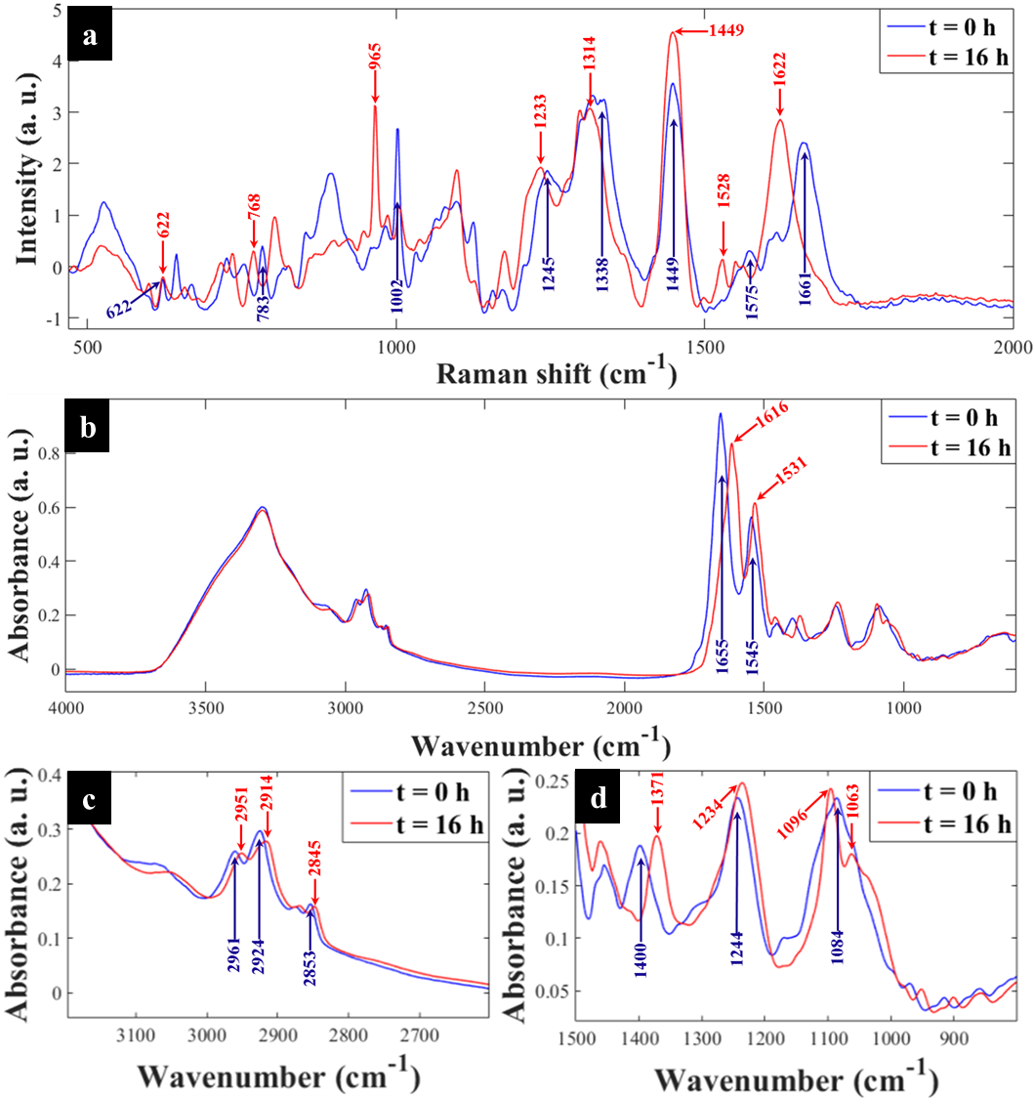
Figure 1. Typical (a) Raman and (b) FT-IR spectra of E. coli grown on ¹³C-glucose as the only source of carbon and sampled at t = 0 h (blue trace) and t = 16 h (red trace), (c, d) illustrate magnified spectral regions for FT-IR bands. After 16 h of incubation full incorporation of ¹³C by cells has resulted in characteristic carbon-related vibrations being redshifted. In this figure the major ¹²C to ¹³C shifted band positions are indicated by blue (t = 0 h or 0% ¹³C) and red (t = 16 h or 100% ¹³C) arrows, respectively. All major Raman and FT-IR bands affected by ¹³C incorporation and their corresponding molecular assignments are summarised in Tables S1 and S2.

Figure 2. PCA scores plot from (a) Raman (b) FT-IR spectra of E. coli cultivated on 100% ¹³C and collected at different time points at 37°C (triangular traces) and 25°C (circular traces), compared to the same E. coli grown in varying ratios of 5g/L total ¹²C/¹³C-glucose for 16 h (square traces). These plots show trends in PCA scores that link to clear quantitative clustering patterns with respect to time (37°C: triangles); 25°C: circles) and ¹³C incorporation by cells (square symbols) from t = 0 h and 0% ¹³C (right) to t = 16 h (100% ¹³C). A gradient arrow is included to guide visualisation of the increasing time points and corresponding ¹³C enrichments. Total explained variance (TEV) for each PC is provided in parentheses.
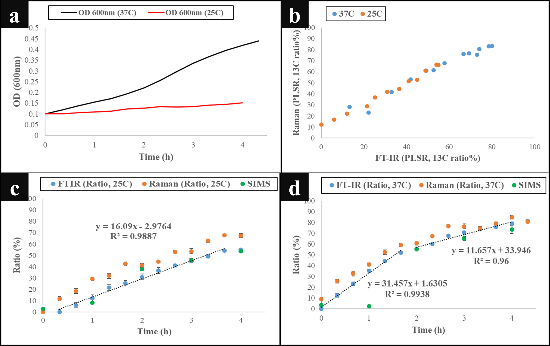
Figure 3. (a) Growth profiles (OD₆₀₀) of E. coli grown in minimal medium at 37 and 25°C, illustrating higher optical density for cells grown at 37°C than cells cultivated at 25°C. (b) Plot of FT-IR vs Raman PLSR predicted ¹³C content of the cells, indicating the results are in agreement. Predicted levels of ¹³C content in cells using the shift in amide I band upon incorporation of ¹³C by cells (1616/1654 cm⁻¹ for FT-IR spectra and 1622/1661 cm⁻¹ for Raman spectra) and m/z of 16 (¹³CH₃) and 15 (¹²CH₃) ([¹³CH₃/(¹²CH₃ + ¹³CH₃)] for SIMS spectra) at (c) 25 and (d) 37°C growth temperatures.
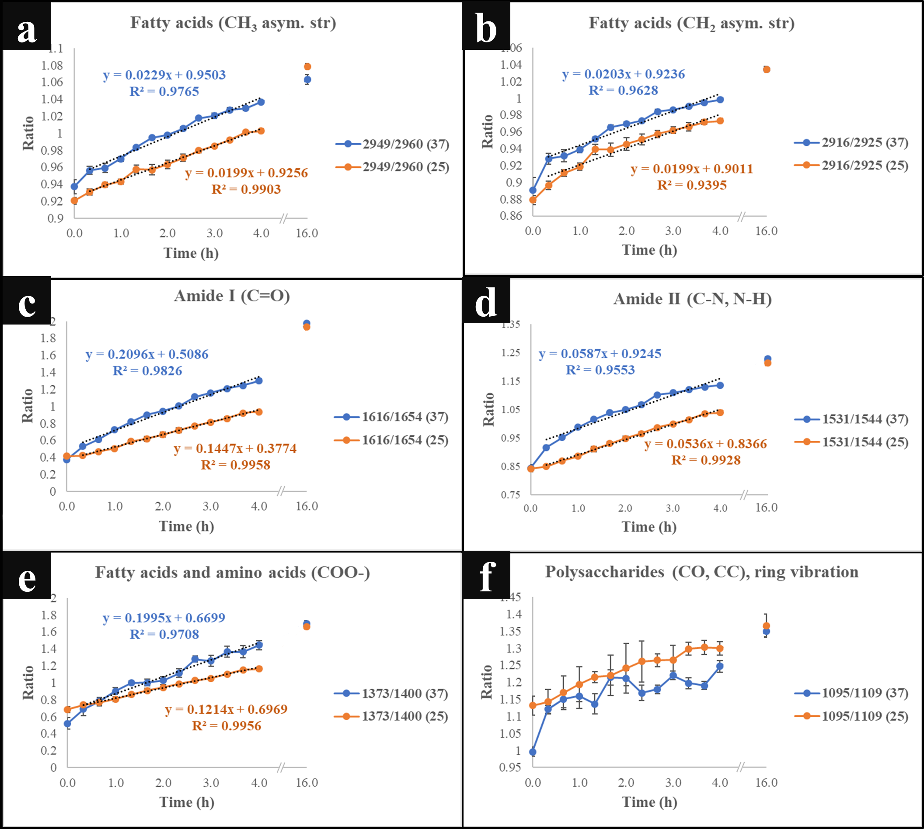
Figure 4. Plots of ¹³C/¹²C for different FT-IR vibrational bands representing various biomolecules, (a, b, e) fatty acids (c, d) amides and (f) polysaccharides, indicating the incorporation rate of ¹³C isotope at the investigated temperatures (37 and 25°C) over time. Each point on the graphs represents the mean of at least five replicates, and the error bars on each time point indicate standard deviation. The details of which ratios are plotted are provided within each figure.
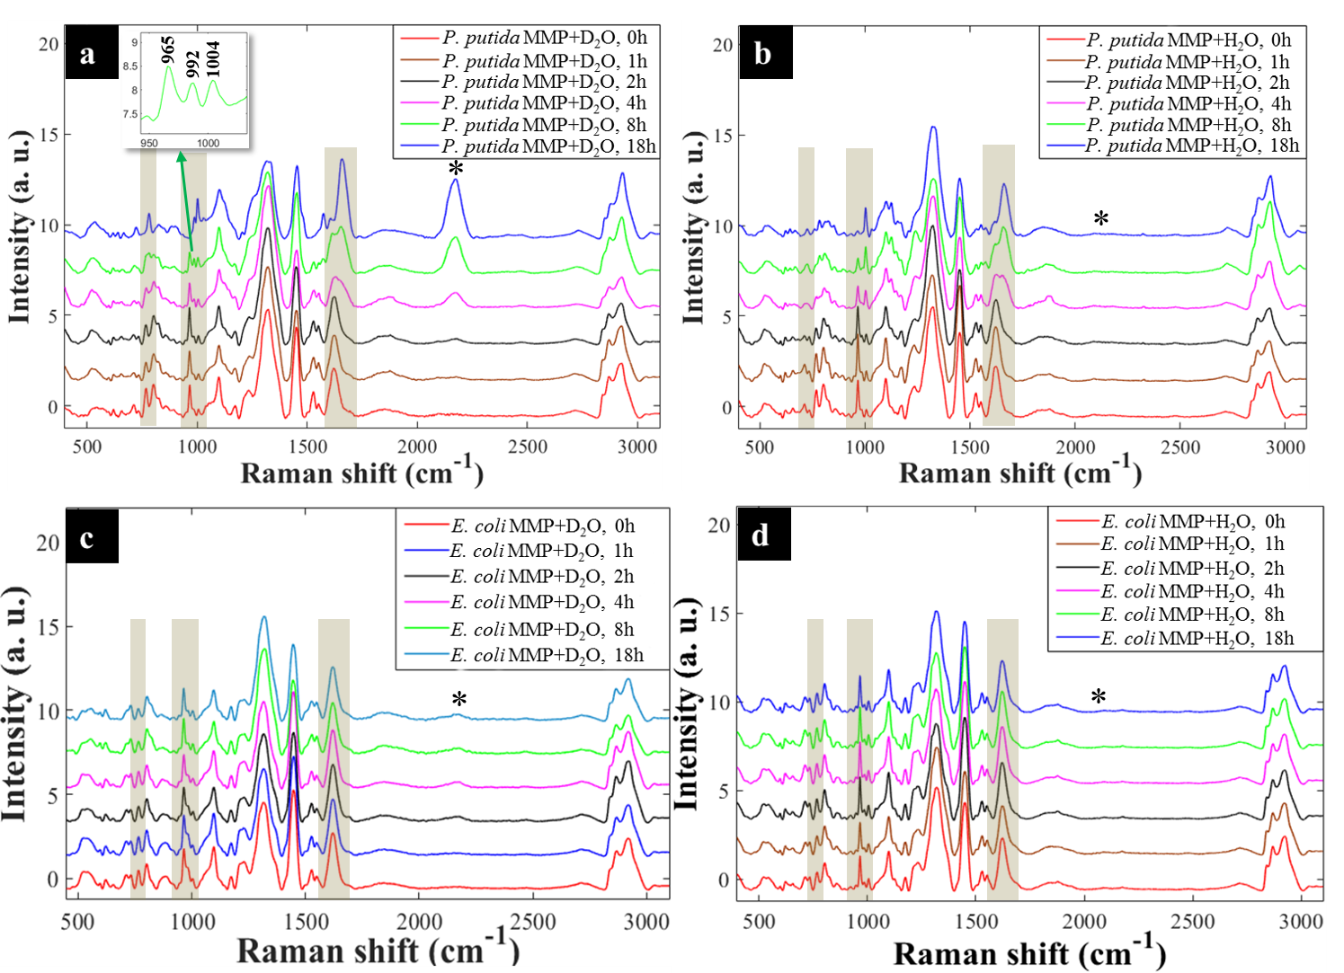
Figure 5. Reverse labelling of initially ¹³C-enriched P. putida illustrating major carbon-based Raman band shifts (regions marked with yellow shades and asterisks (*)) for cells cultivated in MMP co-cultures supplemented with: (a) 30% D₂O, Raman bands shifted progressively from ¹³C back to ¹²C spectral positions at 766→783 cm⁻¹, 965→1004 cm⁻¹ and 1622→1661 cm⁻¹ (yellow shades), and dynamic intensities of the C–D band (*) observed at 2172 cm⁻¹ increased during 18 h of incubation, (b) H₂O, Similarly, major Raman modes shifted steadily from ¹³C back to ¹²C positions, whilst the C–D band (*) was obviously not detected during 18 h of growth. Reverse labelling of initially ¹³C-labelled E. coli from co-culture in MMP with: (c) 30% D₂O at various time points. The major Raman bands (yellow shaded regions) did not show any blueshifts throughout 18 h; however, the C–D peak (*) appeared at 2172 cm⁻¹ after 2 h of incubation, (d) H₂O at different time points. No blueshift in major Raman bands were displayed, and a C–D peak (*) was, as expected, not detected. An insert in (a) shows an expansion from 950–1004 cm⁻¹ for clear visualisation of peak splitting.
Figure 6. (a, b) Dynamic intensity ratios for nucleobases, amide I and phenylalanine Raman bands of initially ¹³C-enriched P. putida in MMP co-culture with (a) 30% D₂O and (b) H₂O, showing increasing ¹²C incorporation during reverse SIP. Nucleopbases and amide I appeared to be labelled faster than phenylalanine. (c, d) Intensity ratio plots (C–D/(C–H + C–D)) for (c) P. putida and (d) E. coli in co-culture in MMP with or without 30% D₂O at various time points during 18 h of growth. The intensity ratios for P. putida and E. coli cultivated with 30% D₂O increased over time whilst those for bacteria cultivated in H₂O remained the same across18 h. (e-h) PCA scores of Raman data for initially ¹³C-enriched P. putida in co-culture in MMP with (e) 30% D₂O, displaying D₂O and ¹²C concentration-dependent clustering trends, (f) H₂O, demonstrating ¹²C concentration-mediated clusters at various time points (g) PCA scores of Raman spectra for initially ¹³C-enriched E. coli in co-culture in MMP with (c) 30% D₂O, showing intensity ratio dynamics and D₂O concentration-driven distributions, (h) H₂O, illustrating intensity ratio induced clusters at different time points.

