Title: Enhancement of galanthamine production through elicitation and NMR-based metabolite profiling in Narcissus pseudonarcissus cv. Carlton in vitro callus cultures
ª Aleya Ferdausi, ^{b} Xianmin Chang, ^{c} Meriel Jones
ª PhD, Institute of Integrative Biology, University of Liverpool, Liverpool, United Kingdom.
Present address: Associate Professor, Department of Genetics and Plant Breeding, Bangladesh Agricultural University, Mymensingh-2202, Bangladesh.
ª Corresponding author email: aferdausi.gpb@bau.edu.bd

Abstract
Plants are the unique sources of secondary metabolites (terpenes, phenolic and alkaloid) used as pharmaceuticals, food additives and industrial produces. However, very limited information is known about their biosynthesis in plants. Elicitors are chemicals often used to activate the accumulation of such metabolites in plant in vitro cultures. Since the ancient past, Narcissus is well-known for its ornamental purposes and medicinal versatility with diverse pharmaceutically important alkaloids including galanthamine, lycorine, haemanthamine and narciclasine. In this research, callus cultures induced from N. pseudonarcissus cv. Carlton bulb explants were subjected to MS media supplemented with growth regulators, yeast extract, methyl jasmonate, chitosan and trans-cinnamic acid for the determination of galanthamine content using GC-MS. Bulbs showed 538 to 1109 µg g⁻¹ FW (fresh weight) and callus cultures subjected to MS medium without elicitors produced 7.88 µg g⁻¹ FW of galanthamine. Whereas, callus cultures grown on MS with methyl jasmonate, chitosan and 25% sucrose showed approximately 5.6, 3 and 2 fold increased galanthamine production respectively. NMR (Nuclear Magnetic Resonance) depicted that the concentration of metabolites related to galanthamine production, tyrosine, tyramine, 3-chlorotyrosine, were higher in bulb tissue than callus. However, these metabolites were present in higher concentrations in elicitor-treated calluses, leading to the higher galanthamine accumulation than the non-treated calluses. Furthermore, the notable metabolites detected in elicitor-treated callus cultures were amino acids, phenols and sugar alcohols. The metabolites in media extracts were mainly related to sucrose and galactose metabolism. The results suggested that the application of elicitors could be a potential approach for enhanced production of valuable metabolites in Narcissus in vitro culture.
Keywords: Narcissus pseudonarcissus, callus, elicitors, galanthamine, metabolites, NMR

Introduction
The genus Narcissus belongs to the family Amaryllidaceae has been found to contain alkaloids with pharmaceutical properties including galanthamine (Gal) (Torras-Claveria et al. 2013) which is approved for the treatment of early to mid-stage Alzheimer's disease (Berkov et al. 2014). Narcissus possesses the occurrence and distributions of medicinally important alkaloids over more than 100 species (Bastida et al. 2006) and the most abundant alkaloids are lycorine (anti-tumour) (Szlávik et al. 2004), haemanthamine (anti-viral) (Osorio et al. 2010), narciclasine (anti-cancer) (Takos and Rook, 2013) and galanthamine (acetylcholinesterase inhibitor) (Berkov et al. 2014). Plants grown in natural conditions mostly show a higher accretion of secondary metabolites than when cultured in vitro (Isah et al. 2018). Secondary metabolism relies on the required enzymes to be produced in specific, organized tissues which could be a reason for lower secondary metabolites production in tissue culture as it often results into unorganized or undifferentiated tissues such as callus (Karuppusamy, 2009; Dias et al. 2016). Although field derived bulbs produce more galanthamine and associated metabolites than in vitro grown callus, bulblets and shoots in Narcissus (Torras-Claveria et al. 2013; Ferdausi et al. 2020), biotechnological approach for secondary metabolites production in plant cell or organ cultures has become an alluring and cost effective alternative to the classical approaches (Ramirez-Estrada et al. 2016). Plant in vitro culture includes a controlled physical and chemical environment for the synthesis of bioactive compounds independent of climatic and soil factors, and produces uniform, sterile plant materials free from all natural contaminants. Purification of the metabolite could be easier from this uniform material than from whole plants which can reduce the production costs (Nalawade and Tsay, 2004).

Elicitation is the process to enhance the accumulation of metabolites by in vitro production systems due to the addition of trace amounts of elicitors (Ramirez-Estrada et al. 2016; Dias et al. 2016) which are complex mixtures of chemicals obtained from either fungal or bacterial extracts, or pure chemical compounds or physical treatments (Ivanov et al. 2013; Saliba et al. 2015). An appropriate concentration of elicitors and their duration of exposure often play an important role in the elicitation process (Namdeo, 2007). A lower concentration is preferable for higher Amaryllidaceae alkaloids accumulation in culture systems and it usually requires two to six wk of elicitor exposure (Ptak et al. 2008; Schumann et al. 2013). Methyl jasmonate, chitosan (a fungal elicitor) and yeast extracts are the most widely used elicitors in plant cell culture systems (Ramirez-Estrada et al. 2016). Optimization of culture media with sucrose is an important approach to enhance the Gal and other alkaloids production (Georgiev et al. 2009). Furthermore, precursors are chemical compounds which precede other compounds in a metabolic pathway and precursors feeding plays important role in elicitation for the production of secondary metabolites (Isah et al. 2018). The common reported precursors of Amaryllidaceae alkaloids are tyrosine, phenylalanine, tyramine, trans-cinnamic acid (TCIN), norbelladine and 4-O-methylnorbelladine (Kilgore and Kutchan, 2016). It was reported that the addition of a precursor such as TCIN and 4'-O-methylnorbelladine often resulted in higher yields of Amaryllidaceae alkaloids and other secondary metabolites (Tahchy et al. 2010; El Tahchy et al. 2011; Ramirez-Estrada et al. 2016).

The knowledge on metabolomic studies can provide both the qualitative and quantitative measures of metabolites contained within cells, tissues and organs (Yang et al. 2009), hence could provide a comprehensive metabolic picture of an organism (Kim et al. 2010). Gas Chromatography-Mass Spectrophotometry (GC-MS) and Nuclear Magnetic Resonance (NMR)-based metabolomic analyses are selective, comprehensive, reproducible, rapid, and require simple sample preparation (Van Der Kooy et al. 2009; Zhao et al. 2013). The NMR spectrum can postulate the structural information on metabolites, including chemical shifts and coupling constants (Zhi et al. 2012) from plant tissues including crude extracts of cell cultures (Schripsema, 2010). Therefore, a metabolomic approach was undertaken in this research to determine the effect of elicitors on the accumulation of galanthamine and other associated metabolites in N. pseudonarcissus callus cultures which revealed the higher production of galanthamine and other notable metabolites such as tyrosine, tyramine and 3-chlorotyrosine in calluses were influenced with the elicitor treatment. The observations would be beneficial to comprehend the Narcissus plant biology related to secondary metabolites production under in vitro condition.

Materials and methods
Plant materials, treatments and culture conditions
Narcissus pseudonarcissus L. bulbs from variety 'Carlton' supplied by New Generation Daffodil Ltd. UK were used for in vitro callus (Fig. 1a) induction and small bulblets regeneration (Fig. 1b) from callus. The detailed tissue culture method of calluses and regenerated bulblets growth has been described in our previously published paper (Ferdausi et al. 2020). Twin-scale explants were cultured on modified Murashige and Skoog (MS;Murashige and Skoog, 1962) medium, T1 (Table 1), to obtain callus cultures and regenerated bulblets. MS media, ascorbic acid and all the growth regulators were purchased from Duchefa Biochemie (Netherlands), polyvinylpyrrolidone from Sigma-Aldrich (UK) and yeast extract from Thermo Scientific (Germany).

The T1 medium was modified with different combinations and concentrations of elicitors (Table 1). All the compounds used as elicitors were purchased from Sigma-Aldrich (UK). Methyl jasmonate was purchased in liquid form and the original methyl jasmonate liquid was sterilised through a sterile filter of 0.22 µm, before adding to the autoclaved media. Chitosan was dissolved in 1:3 (HCl: sterile water) by heating and added to the media before autoclaving. Trans-cinnamic acid and yeast extract were added directly to the culture media as powder and then the media were autoclaved (121 ºC, 108 kPa and 30 min).

Sterile media and elicitors were handled inside a laminar hood; two callus pieces or regenerated bulblets (each ~200 mg) were placed on each Petri plate, sealed with a single layer of parafilm, incubated in a culture room (24±2 ºC, 12 h photoperiod) for 30 d. Three replicates of calluses and regenerated bulblets developed from three different bulbs were incubated in three replicates of each media treatments.

Alkaloid extraction and analysis using GC-MS
After 30 d of incubation in media with different elicitors, calluses and regenerated bulblets along with field grown bulb samples were harvested and cut into small pieces, weighed (approximately 100 mg) and transferred into 1.5 mL microfuge tubes. The media surrounding the calluses (approximately 5 cm) were also transferred to 5 mL plastic tubes and all samples stored at -80 ºC. Vacuum dried media (approximately 100 mg) were weighed and transferred to a 1.5 mL microfuge tube. Methanol extracts of samples (calluses, regenerated bulblets, media extracts and bulb tissues) were analysed using GC-MS to quantify the amount of galanthamine on fresh weight (FW) basis following the protocol described by our previous paper (Ferdausi et al. 2020). The fresh weight basis was used as using fresh material is much better than dried materials in industry. It has been observed that about 60% galanthamine might be lost during the drying process as well as using fresh materials save drying costs in industry (personal communication with Agroceutical Products Ltd. UK, 2020). Carlton bulb (a series of different extracts) was used as control for all analyses. All samples were run in a total of 6 batches; 3 batches for plant tissue samples (callus and regenerated bulblets) and 3 batches for media extracts, including 24 samples in a single batch. Standards were run with each batch of samples including at the start, in the middle after 12 samples and at the end of 24 samples.

Metabolite profiling using NMR
Calluses were harvested after 7 and 30 d of incubation and used for NMR analysis. Fresh ice-cold solvent solution was prepared with 50% HPLC grade acetonitrile and 50% double distilled water. 500 μL ice-cold solvent solution was added to all 1.5 mL microfuge tubes with approximately 20 mg frozen Carlton bulb tissue and callus along with 20 μL of respective media. The microfuge tubes were placed in an ice bath and sonicated with a probe sonicator (Soniprep 150 plus, MSE, UK) to disrupt cellular membranes for three bursts of 30 s at 10 kHz to prevent heating. Sonication was done only once for media while three times for tissues. After vortexing for 1 min the materials were centrifuged at 12000 g for 10 min at 4 ºC and the supernatant was collected, flash frozen in liquid nitrogen and lyophilised overnight in Freeze dryer Lyolab 3000, Thermo Fisher Scientific, UK. Phosphate buffer was added to each microfuge tube containing frozen lyophilised samples, vortexed for 1 min and was centrifuged at 12000 g for 2 min at room temperature. 600 μL of supernatant from each sample was removed without disturbing the sample pellet and pipetted carefully into 5 mm NMR tubes (Sigma Aldrich, UK) (Lubbe et al. 2013). The NMR Centre, University of Liverpool, supplied all chemicals and instruments to run this experiment. Sodium phosphate, TSP, NaN₃, HPLC grade acetonitrile and ²H₂O were purchased from Sigma Aldrich (UK) and used for sample extraction. The NMR data was measured and processed following the protocol described in our previous paper (Ferdausi et al. 2020). The samples for NMR analysis were run in three batches. Three replicates of Carlton bulb, calluses and media extracts were used in each batch.

Statistical analysis
MetaboAnalyst (Xia et al. 2015) was used for univariate analyses (one-way ANOVA and post-hoc analysis), multivariate analysis (PCA) and clustering analysis (heatmap) to process the NMR spectra. MetPA (Metabolomics Pathway Analysis), a web-based tool to analyse and visualize the metabolomic data within the biological context of metabolic pathways (Xia et al. 2010) was used for pathway analyses.

Results
Quantification of galanthamine
Galanthamine was quantified in elicitor treated callus cultures and regenerated bulblets from calluses. Carlton bulb (a series of different extracts) was used as control and the amount of galanthamine in bulb tissues varied from 538 to 1109 µg Gal g⁻¹ Fresh Weight (FW) across all sets of calculations (Table 2).

Callus grown on media without any elicitors (T1) contained a very low amount of galanthamine (7.88 µg Gal g⁻¹ FW). Whereas, T1 medium modified with different elicitors showed an increased production of galanthamine in calluses. A two-fold increased galanthamine (17.70 µg Gal g⁻¹ FW) production was found in callus cultured on T2 medium, supplemented with 2.5% sucrose than T1; a 5.6 fold enhanced amount (44.41 µg Gal g⁻¹ FW) was observed when the T1 medium was supplemented with methyl jasmonate (T4); and a three-fold higher production of galanthamine (23.29 µg Gal g⁻¹ FW) was obtained in callus from T5 medium, supplemented with chitosan. On the other hand, T3 medium which was supplemented with yeast extract showed no production of galanthamine and medium T6 supplemented with trans-cinnamic acid did not show any increased galanthamine production (Table 2).

Regarding regenerated bulblets which were directly grown from callus, there was no significant effect of elicitor treatments (T2 to T6) on galanthamine level (Table 2). Elicitor treated regenerated bulblets showed lower amount of galanthamine contents which were varied from 3.59 to 9.54 µg Gal g⁻¹ FW, when compared with bulblets grown on T1 medium without elicitor treatment (7.03 µg Gal g⁻¹ FW) (Table 2).

All media extracts used for callus and bulblet cultures were also analysed for galanthamine content. Nonetheless, galanthamine was completely absent from all media extracts modified with elicitors. The only exception was the presence of a trace amount of galanthamine (3.00 µg Gal g⁻¹ FW) in T1 media extract.

Metabolites identification in calluses and in media
The distinct presence of metabolites (NMR signals) in callus and media was generated using one-way ANOVA (heatmap) analysis and the samples were grouped according to the presence of metabolites using multivariate Principle Component Analysis (PCA) on MetaboAnalyst (Xia et al. 2015), to determine the effect of elicitors (T2 to T6) on callus metabolite production, where medium without elicitors (T1) was used as control. Representative ¹H-NMR spectra for callus cultures grown on different media treatments showing the major groups of metabolites with their relative positions (ppm) are shown in Fig. 2.

Data normalization by mean and pareto-scaling, p-value threshold of 0.05 and Fisher’s LSD was used as parameters for ANOVA post-hoc analyses. The ANOVA analysis revealed that 82 peaks (out of 156) were significantly different among the callus samples, whereas 59 peaks (out of 63) were significantly different among media extracts. The ANOVA post-hoc analysis for all metabolites in calluses and media samples with p-values and Fisher’s LSD are represented in Table S1 and Table S2.

It was observed that the relative concentrations of metabolites related to tyrosine and phenylalanine metabolism; two precursors for galanthamine biosynthesis were present in higher concentrations in Carlton bulb than the in vitro calluses grown on different media treatments (Fig. 3). The detection of high amount of tyrosine, tyramine and 3-chlorotyrosine in bulb tissue could relate to the higher accumulation of galanthamine in Carlton bulb than callus (Table 2). The results also showed that the metabolites related to galanthamine biosynthesis (tyrosine, tyramine and 3-chlorotyrosine) were mostly present in higher concentrations in calluses treated with different elicitors (T2-T6) than callus cultures obtained from T1 medium without any elicitors. The precursor metabolites showed various levels of their concentrations among the callus samples obtained from media T2 to T6 (Fig. 3).

Metabolite clustering in callus
The heatmap generated from ANOVA post-hoc analysis (Fig. 4) represented the top thirty metabolites in callus cultured on different media treatments over three incubation periods. Calluses from T1 media harvested before treatment (0D) and T6 harvested after 30 d (30D) of incubation showed a clear separation from the other treatments. One replicate (T10D3) showed only trace amount of metabolites compared with the other two replicates, T10D1 and T10D2 (on left hand side). Metabolites found in calluses harvested before treatment (T1) had relative high concentrations of betaine, proline, carnitine, arginine and xylose. The medium treatment T6 for 30 days (T630D) showed the presence of vanillate, thymol, serotonin, unknown compound (UN), melatonin, mandelate, fumarate and trans-aconitate in relatively high amounts (bottom right hand side). The treatment T3 could also be distinguished from the others based on a spectrum of metabolites (top right hand side). The other samples from treatments T1, T2, T4 and T5 contained very low levels of metabolites, being grouped by the absence of distinguishing features (Fig. 4).

Principal Component Analysis
A three-component model PCA for callus explicated 96.6% of the total variance with 4th and 5th component adding additional 1.6% and 0.6% variance respectively. The first two principal components accounted for maximum variance of 93.6% (Fig. 5a). The score scatter plot of PC1 and PC2 indicated the separation of callus samples according to the media treatments and days of incubation (Fig. 5b). The calluses from media T1 to T6, after 7 d and 30 d of incubation were separated into closely laying small clusters along PC2. Calluses from T1 (T10D), harvested prior to treatment showed very clear separation from all other media treatments, and it was separately grouped from the callus cultures grown on the same medium harvested after 7 d (T17D) and 30 (T130D) d. The three replications of T10D showed overall distribution along the high and low PC1 scored area and on negative scored area along PC2. The calluses from media T2 and T3 harvested after both 7 and 30 d, formed two separate groups. Calluses from media T4 and T5 after 30 d of incubation formed one overlapping cluster and distributed in the middle scored region of both PCs. Finally, callus from medium T6 harvested after 30 d of culture (T630D) lies in one further separate group from the other treatments and lied on the high scored region of PC2 (Fig. 5b).
The corresponding loadings of callus clusters in score plot are represented in a loading plot (Fig. 5c) showing the distribution of metabolites responsible for the sample separation. The most important signals assigned to callus from medium T1, harvested prior to treatment were glucuronate, carnitine, proline, arginine, lactate and valine. Nevertheless, most of the metabolite signals of calluses grown on media supplemented with elicitors showed overlapped distribution and were densely situated on the loading plot. The distinctive signals assigned for their separation were mainly galactitol, choline, glucitol, alanine, betaine, asparagine, glutamate, mandelate, trans-aconitate, 4-pyridoxate, tyrosine, formate and glycolate (Fig. 5c).

A total variance of 69.2% in the entire dataset with an additional 11.4%, 6.2% and 5.5% variance accounted for the 3rd, 4th and 5th components, to finally comprise a total of 92.3% variance (Fig. 6a) was observed in a two-component model PCA for media extracts. The score scatter plot (Fig. 6b) of PC1 and PC2 showed separate clusters of T3 and T6 from other media extracts where T6 was arranged along with the negative scored region of both PCs. The media extracts of T1, T2, T4 and T5 showed overlapped distribution along the positive and negative scored region of PC1 and positive scored region along PC2. The corresponding loading plot (Fig. 6c) was very difficult to determine the signal loadings for the media cluster groups as they were densely situated on the clusters. They have therefore been divided into two groups i.e. metabolites for medium T6 were assigned for unknown compounds (3), acetylsalicylate, galactose and tartrate and the metabolites assigned for the separation of T1-T5 were mainly glucose, sucrose, betaine, O-acetylcholine and sn-glycero-3-phosphocholine (Fig. 6c).

Pathway analysis
Metabolites identified in callus cultures and in their respective media extracts were subjected to MetaboAnalyst pathway analysis (MetPA). The MetPA revealed that the alanine, aspartate and glutamate metabolism, arginine and proline metabolism, pantothenate and CoA biosynthesis, tyrosine metabolism and galactose metabolism were the notable pathways in callus with relatively high impact and maximum number of identified metabolites as pathway contributors (Table 3). Alanine, aspartate and glutamate metabolism showed a combination of highest impact factor (0.25) with highest number (5) of pathway contributor metabolites. The second pathway which had significant impact (0.20) with highest number of pathway contributor metabolites (5) was arginine and proline metabolism. Tyrosine metabolism was also found as an important pathway in calluses with high impact value (0.18). On the other hand, galactose metabolism, starch and sucrose metabolism, glyoxylate and dicarboxylate, pantothenate and CoA biosynthesis and Alanine, aspartate and glutamate metabolism were identified as the notable pathways with high impact and maximum number of identified metabolites as pathway contributors in media extracts (Table 3).

Discussion
The nature of tissue and growth environment often affects secondary metabolite production in plants. Galanthamine (Gal) is one of the well reported alkaloids in Narcissus (Berkov et al. 2011; Lubbe et al. 2013; Berkov et al. 2014) which showed a higher accumulation in field grown N. pseudonarcissus cv. Carlton bulb than in vitro cultures in the present study. Previous findings on the amount of Gal from leaf and bulb tissues of Narcissus field grown ornamental varieties contained 200 to 4500 µg Gal g⁻¹ DW (dry weight) (Torras-Claveria et al. 2013) while the callus cultures often showed very low amount of Gal production of 0.03 to 0.11 µg Gal g⁻¹ DW (Codina, 2002) and of 30 to 60 µg Gal g⁻¹ DW (Berkov et al. 2014) in Narcissus confusus, which are in accordance with our findings.

Notable elicitors include methyl jasmonate, yeast extract, TCIN and chitosan (Schumann et al. 2012; Giri et al. 2012; Ivanov et al. 2013; Ramirez-Estrada et al. 2016; Kilgore and Kutchan, 2016) which were used to observe their effect on Gal and other metabolites production in callus. Results in this trial showed that methyl jasmonate was the best elicitor for the higher Gal accumulation in calluses among the four elicitors used. Methyl jasmonate has attracted the most attention for its effective elicitation in several plants for the accumulation of different alkaloids (Schumann et al. 2012; Ivanov et al. 2013; Giri et al. 2012). It showed similar results of enhanced Gal production in N. confusus shoot-clumps (Colque et al. 2004) and L. aestivum shoot cultures (Schumann et al. 2012 and 2013; Ivanov et al. 2013). In another study, liquid-shake cultured shoot-clumps of N. confusus were treated with methyl jasmonate (12 to 112 mg L⁻¹) and chitosan (50 to 500 mg L⁻¹). The results showed that high concentrations of methyl jasmonate and chitosan had an adverse effect on explant growth in general but methyl jasmonate resulted increased Gal and other related alkaloids accumulation (Colque et al. 2004). Purified fungal components, such as the cell-wall component chitosan, have been used as more convenient and reproducible fungal elicitors for the higher accumulation of alkaloids (Taleb et al. 2013), which showed 3 fold increased Gal production than control in present study. Yeast extract is a fungal elicitor and also serves as the major source of nitrogen in culture media (Molnár et al. 2011), however, in present study the supplementation of yeast extract showed no production of Gal in callus.

Concentrations of trans-cinnamic acid (TCIN) ranging from 250 to 1000 mg L⁻¹ were used to investigate yields of alkaloids in N. confusus shoot clump cultures. The highest dose (1000 mg L⁻¹ TCIN), after two wk of culture, showed increased production of Gal and N-formyl-galanthamine although this level inhibited growth of cultures (Bergoñón et al. 1996). However, in our study TCIN supplementation did not show significant differences in Gal production.

NMR-based metabolomics has crucial application in differentiation of plants originated from different environments or obtained from different treatments (Kim et al. 2010). One of the key challenges of plant secondary metabolite profiling and analysis is to find an optimal balance between accuracy and coverage of metabolite identification (Oksman-Caldentey and Saito, 2005). NMR-based metabolomic analysis often results in misidentification of compounds if an organism specified database is not used (Kim et al. 2011). However, several previous studies reported the metabolites identification in Narcissus using NMR (Lubbe et al. 2013; Berkov et al. 2011).

Our findings suggested the presence of higher number of metabolites in elicitor treated in vitro derived calluses than the media extracts. It could be due to the slow release of metabolites from tissues to their corresponding media (Yang et al. 2009; Mahmud et al. 2015). Naturally plants contain a huge diversity of primary and secondary metabolites and the most common metabolites observed in plants by NMR were sugars, amino acids, organic acids and other phenolic compounds (Kim et al. 2010) which were also observed in Narcissus callus cultures.
Prior to multivariate analysis it was mandatory to know if there was any significant differences among signals identified using ¹H-NMR, as data with multiple overlapped signals was obtained initially. ANOVA analysis was found to be a helpful tool to identify significant differences between datasets for the quantification of sugars, sugar alcohols, primary and secondary metabolites in Narcissus bulbs before PCA analysis (Lubbe et al. 2012 and 2013) which was performed in present study to determine the differences among the sample data. More than 52% and 90% signals (metabolites) were found significantly different among calluses and media extracts respectively. High amount of amino acids, organic acids and carbohydrates have often been reported during callus growth and in vitro tissue differentiation (Palama et al. 2010; Yang et al. 2009; Blanc et al. 2002) which were also found in Narcissus calluses (Fig. 5c). The metabolites obtained from calluses in this study showed similar findings to those obtained from NMR analysis of C. roseus callus where alanine, valine, asparagine, choline, glucose and sucrose were measured (Yang et al. 2009). NMR-based metabolomics profile of embryogenic and non-embryogenic callus of sugarcane showed the presence of similar metabolites such as valine, alanine, glutamine, asparagine, choline and galactose (Mahmud et al. 2015).

Proline, betaine and choline that have been reported as abiotic stress related metabolites in plants (Rivero et al. 2014) also found to be present in Narcissus callus. The presence of choline was also reported previously for its relation to plant stress adaptation in Arabidopsis thaliana (Tasseva et al. 2004). Detection of these metabolites could relate to the stressed situation such as high external osmolarity, limited water supply during callus growth as well as tissue disorganisation of callus. High amounts of asparagine, choline, glucose and sucrose were reported previously in both C. roseus and sugarcane calluses (Yang et al. 2009; Mahmud et al. 2015). Elevated asparagine, glucose and sucrose have also been reported earlier in an NMR-based metabolomic study on protocorm callus cultures of Vanilla panifolia (Palama et al. 2010).

The detection of Gal using NMR was not possible in this study due to the lack of reference library related to alkaloids (Chenomx). However, precursors for the biosynthesis of galanthamine and other Amaryllidaceae alkaloids such as tyrosine, tyramine and 3-chlorotyrosine were detected in Carlton bulb as well as in elicitor treated calluses (Fig. 3). Previous findings in Narcissus pseudonarcissus showed the higher accumulation of tyrosine and tyramine in Carlton bulb than callus (Ferdausi et al. 2020) which was predicted to up-regulate the phenylpropanoid pathway leading to phenolic compound biosynthesis (Lubbe et al. 2013). In addition, the detection of tyrosine was found in sugarcane callus cultures (Mahmud et al. 2015) which was also observed in elicitor treated Narcissus callus (Fig. 3). Other metabolites involved in phenylalanine and tyrosine metabolism, such as tyramine and 3-chlorotyrosine were also detected in our Narcissus calluses but the relative concentrations were less than bulb tissue (Fig. 3) which could be related to the higher production of Gal in bulb tissues than callus cultures (Table 2) (Ferdausi et al., 2020). However, the presence of these precursors in calluses obtained from elicitor treated media may suggest that callus could also be metabolically active for alkaloid biosynthesis. Our study showed that the media T3, supplemented with yeast extract and T6, supplemented with TCIN were not suitable media treatments for Gal production (Table 2) but calluses from both media showed the presence of other metabolites (Fig. 4) along with tyrosine, tyramine and 3-chlorotyrosine (Fig. 3). Therefore, the application of yeast extract and TCIN could be involved in the production of other secondary metabolites and Amaryllidaceae alkaloids rather than Gal (Ramirez-Estrada et al. 2016; Bergoñón et al. 1996). The Amaryllidaceae alkaloid precursors observed in callus tissues (Fig. 3) were completely absent from media extracts. This observation is in agreement with the absence of galanthamine in media. A study on biochemical relationship between sugarcane callus tissues and their respective nutrient culture media showed similar results in that there were lower metabolites in respective media than the calluses grown on them (Mahmud et al. 2014). Their results showed the presence of proline, glutamine, tyrosine and phenylalanine in calluses but not in the respective media. In addition, the major metabolites detected in media extracts were sugars (glucose, fructose, sucrose and maltose), which supports our findings of media metabolites. Accumulation of primary and secondary metabolites in tissues (bulb and callus) could be in association with their nature of tissue specific production (Dias et al. 2016).

Metabolic pathway analysis (MetPA) was used to elucidate the metabolic networks and the significant pathways in sugarcane callus (Mahmud et al. 2015) which corresponded to the pathways detected in Narcissus callus culture and media extracts, such as citrate cycle, glycolysis, alanine, aspartate and glutamate metabolism and carbohydrate (glucose, sucrose and fructose) metabolism. The pathway analysis showed tyrosine metabolism as one of the significant pathway in callus which is in accordance with the presence of tyrosine, tyramine and 3-cholorotyrosine in calluses leading to Gal production. The pathway analysis of metabolites obtained from media extracts revealed galactose, starch and sucrose metabolism as the most significant pathways which indicates that the higher sugar metabolites in media extracts could be released either from callus grown on them or due to the sugar containing media.

Conclusion
The elicitation approach used in this study was able to enhance the amount of galanthamine in in vitro grown callus cultures of Narcissus. Methyl jasmonate showed the maximum enhanced Gal accumulation in calluses, which was much less than field derived Carlton bulb tissue. However, application of other elicitors such as yeast extract and TCIN did not show any significant changes in Gal production. NMR-based metabolomics identified the presence of precursors i.e. tyrosine, tyramine and 3-chlorotyrosine in calluses which are important metabolites related to alkaloid biosynthesis along with other important secondary metabolite production. The media extracts used for callus cultures did not show the presence of precursors as well as Gal production. Therefore, the findings of present study may enable further directed studies towards the enhanced alkaloid or metabolite of interest production in Narcissus. The elicitation approach explained in this study would be feasible for commercial production of the metabolites of interests as the extraction of metabolites from uniform in vitro tissues requires simple protocol which would reduce the production cost. Moreover, this method requires very little time to enhance the amount of metabolites which will also be beneficial for farmers and pharmaceutical industries for commercialization.
Acknowledgements
Authors are delighted to acknowledge Commonwealth Scholarship Commission and University of Liverpool, United Kingdom for funding this research. Authors wish to thank Mark Preston, Centre of Proteome analysis for helping with GC-MS analysis and Dr Phelan Marie, NMR Centre, University of Liverpool for helping with NMR analysis.
Author contribution statement
MJ and AF conceived and designed research. AF conducted experiments. XC and AF developed the methodology, analysed and interpreted data. AF wrote the initial manuscript draft which was reviewed by XC. All authors read and approved the manuscript.

References
Bastida J, Lavilla R, Viladomat F (2006) Chemical and biological aspects of Narcissus alkaloids. The alkaloids: chemistry and biology 63:87-179
Bergoñón S, Codina C, Bastida J, Viladomat F, Melé E (1996) Galanthamine production in “shoot-clump” cultures of Narcissus confusus in liquid-shake medium. Plant Cell Tiss Org Cult 45:191-199
Berkov S, Bastida J, Viladomat F, Codina C (2011) Development and validation of a GC–MS method for rapid determination of galanthamine in Leucojum aestivum and Narcissus ssp.: A metabolomic approach. Talanta 83:1455-1465
Berkov S, Ivanov I, Georgiev V, Codina C, Pavlov A (2014) Galanthamine biosynthesis in plant in vitro systems. Eng in Life Sci 14:643-650
Blanc G, Lardet L, Martin A, Jacob J, Carron M (2002) Differential carbohydrate metabolism conducts morphogenesis in embryogenic callus of Hevea brasiliensis (Müll. Arg.). J of Exp Bot 53:1453-1462
Codina C (2002) 7 Production of galanthamine by Narcissus tissues in vitro. Narcissus and Daffodil (The Genus Narcissus). Taylor & Francis London
Colque R, Viladomat F, Bastida J, Codina C (2004) Improved production of galanthamine and related alkaloids by methyl jasmonate in Narcissus confusus shoot-clumps. Planta Med 70:1180-1188
Dias M I, Sousa M J, Alves R C, Ferreira I C (2016) Exploring plant tissue culture to improve the production of phenolic compounds: A review. Ind Crops Prod 82:9-22
El Tahchy A, Ptak A, Boisbrun M, Barre E, Guillou C, Dupire F O, Chrétien F O, Henry M, Chapleur Y, Laurain-Mattar D (2011) Kinetic study of the rearrangement of deuterium-labeled 4′-O-methylnorbelladine in Leucojum aestivum shoot cultures by mass spectrometry. Influence of precursor feeding on Amaryllidaceae alkaloid accumulation. J Nat Prod 74:2356-2361
Ferdausi A, Chang X, Hall A, Jones M (2020) Galanthamine production in tissue culture and metabolomic study on Amaryllidaceae alkaloids in Narcissus pseudonarcissus cv. Carlton. Ind Crops Prod 144:112058
Georgiev V, Berkov S, Georgiev M, Burrus M, Codina C, Bastida J, Ilieva M, Pavlov (2009) Optimized nutrient medium for galanthamine production in Leucojum aestivum L. in vitro shoot system. Zeitschrift für Naturforschung C 64:219-224
Giri L, Dhyani P, Rawat S, Bhatt I D, Nandi S K, Rawal R S, Pande V (2012) In vitro production of phenolic compounds and antioxidant activity in callus suspension cultures of Habenaria edgeworthii: a rare Himalayan medicinal orchid. Ind Crops Prod 39:1-6
Isah T, Umar S, Mujib A, Sharma M P, Rajasekharan PE, Zafar N, Frukh A (2018) Secondary metabolism of pharmaceuticals in the plant in vitro cultures: strategies, approaches, and limitations to achieving higher yield. Plant Cell Tiss Org Cult 132:239-265
Ivanov I, Georgiev V, Pavlov A (2013) Elicitation of galanthamine biosynthesis by Leucojum aestivum liquid shoot cultures. J Plant Physiol 170:1122-1129
Karuppusamy S (2009) A review on trends in production of secondary metabolites from higher plants by in vitro tissue, organ and cell cultures. J Med Plants Res 3:1222-1239
Kilgore M B, Kutchan T M (2016) The Amaryllidaceae alkaloids: biosynthesis and methods for enzyme discovery. Phytochem Rev 15:317-337
Kim H K, Choi Y H, Verpoorte R (2010) NMR-based metabolomic analysis of plants. Nat Protoc 5:536-549
Kim H K, Choi Y H, Verpoorte R, (2011) NMR-based plant metabolomics: where do we stand, where do we go? Trends in Biotech 29:267-275
Lubbe A, Verpoorte R, Choi Y H (2012) Effects of fungicides on galanthamine and metabolite profiles in Narcissus bulbs. Plant Physiol Biochem 58:116-123
Lubbe A, Gude H, Verpoorte R, Choi Y H (2013) Seasonal accumulation of major alkaloids in organs of pharmaceutical crop Narcissus Carlton. Phytochem 88:43-53
Mahmud I, Thapaliya M, Boroujerd I A, Chowdhury K (2014) NMR-based metabolomics study of the biochemical relationship between sugarcane callus tissues and their respective nutrient culture media. Anal Bioanal Chem 406:5997-6005
Mahmud I, Shrestha B, Boroujerdi A, Chowdhury K (2015) NMR-based metabolomics profile comparisons to distinguish between embryogenic and non-embryogenic callus tissue of sugarcane at the biochemical level. In Vitro Cell Dev Biol - Plant 51:340-349
Molnár Z, Virág E, Ordog V (2011) Natural substances in tissue culture media of higher plants. Acta Biolog Szegediensis 55:123-127
Murashige T, Skoog F (1962). A revised medium for rapid growth and bioassays with tobacco cultures. Plant Physiol 15:473–497
Nalawade S M, Tsay H S (2004) In vitro propagation of some important Chinese medicinal plants and their sustainable usage. In Vitro Cell Dev Biol - Plant 40:143-154
Namdeo A (2007) Plant cell elicitation for production of secondary metabolites: a review. Pharm Rev 1:69-79
Oksman-Caldentey K M, Saito K (2005) Integrating genomics and metabolomics for engineering plant metabolic pathways. Curr Opin Biotechnol 16:174-179
Osorio E J, Berkov S, Brun R, Codina C, Viladomat F, Cabezas F, Bastida J (2010) In vitro antiprotozoal activity of alkaloids from Phaedranassa dubia (Amaryllidaceae). Phytochem Lett 3:161-163
Palama T L, Menard P, Fock I, Choi Y H, Bourdon E, Govinden-Soulange J, Bahut M, Payet B, Verpoorte R, Kodja H (2010) Shoot differentiation from protocorm callus cultures of Vanilla planifolia (Orchidaceae): proteomic and metabolic responses at early stage. BMC Plant Biol 10: 1
Ptak A, El Tahchy A, Dupire F, Boisbrun M, Henry M, Chapleur Y, Mos M, Laurain-Mattar D (2008) LCMS and GCMS for the screening of alkaloids in natural and in vitro extracts of Leucojum aestivum. J Nat Prod 72:142-147
Ramirez-Estrada K, Vidal-Limon H, Hidalgo D, Moyano E, Golenioswki M, Cusidó RM, Palazon J (2016) Elicitation, an effective strategy for the biotechnological production of bioactive high-added value compounds in plant cell factories. Molecules 21:182
Rivero R M, Mestre T C, Mittler R, Rubio F, Garcia‐Sanchez F, Martinez V (2014) The combined effect of salinity and heat reveals a specific physiological, biochemical and molecular response in tomato plants. Plant Cell Env 37:1059-1073
Saliba S, Ptak A, Laurain‐Mattar D (2015) 4′‐O‐Methylnorbelladine feeding enhances galanthamine and lycorine production by Leucojum aestivum L. shoot cultures. Eng Life Sci 15:640-645
Schumann A, Berkov S, Claus D, Gerth A, Bastida J, Codina C(2012) Production of galanthamine by Leucojum aestivum shoots grown in different bioreactor systems. Appl Biochem Biotech 167:1907-1920
Schumann A, Torras‐Claveria L, Berkov S, Claus D, Gerth A, Bastida J, Codina C (2013) Elicitation of galanthamine production by Leucojum aestivum shoots grown in temporary immersion system. Biotech Prog 29:311-318
Schripsema J (2010) Application of NMR in plant metabolomics: techniques, problems and prospects. Phytochem Anal 21:14-21
Szlávik L, Gyuris Á, Minárovit S J, Forgo P, Molnár J, Hohmann J (2004) Alkaloids from Leucojum vernum and antiretroviral activity of Amaryllidaceae alkaloids. Planta Med 70:871-873
Tahchy A E, Boisbrun M, Ptak A, Dupire F, Chrétien F, Henry M, Chapleur Y, Laurain-Mattar D (2010) New method for the study of Amaryllidaceae alkaloid biosynthesis using biotransformation of deuterium-labeled precursor in tissue cultures. Acta Biochim Polon 57:75-82
Takos A M, Rook F (2013) Towards a molecular understanding of the biosynthesis of amaryllidaceae alkaloids in support of their expanding medical use. Int J Mol Sci 14:11713-11741
Taleb A M A, Hamed E R, Shimaa A Z, Adel B (2013) Enhancement of alkaloids production in tissue culture of Narcissus tazetta var. italicus I: Effect of growth regulators and fungal elicitors. J Agric Tech 9:503-514
Tasseva G, Richard L, Zachowski A (2004) Regulation of phosphatidylcholine biosynthesis under salt stress involves choline kinases in Arabidopsis thaliana. FEBS Letters 566:115-120
Torras-Claveria L, Berkov S, CodinaC, Viladomat F, Bastida J (2013) Daffodils as potential crops of galanthamine. Assessment of more than 100 ornamental varieties for their alkaloid content and acetylcholinesterase inhibitory activity. Ind Crops Prod 43:237-244
Van Der Kooy F, Maltese F, Choi Y H, Kim H K, Verpoorte R (2009) Quality control of herbal material and phytopharmaceuticals with MS and NMR based metabolic fingerprinting. Planta Medica 75:763-775
Xia J, Sinelnikov I V, Han B, Wishart D S (2015) MetaboAnalyst 3.0—making metabolomics more meaningful. Nuc Acid Res 43:251-257
Yang S O, Kim SH, Kim Y, Kim H S, Chun Y J, Choi H K (2009) Metabolic discrimination of Catharanthus roseus calli according to their relative locations using 1H-NMR and principal component analysis. Biosci Biotech Biochem 73:2032-2036
Zhao N, Wang G, Norris A, Chen X, Chen F (2013) Studying plant secondary metabolism in the age of genomics. Crit Rev Plant Sci 32:369-382
Zhi H J, Qin X M, Sun H F, Zhang L Z, Guo X Q, Li Z Y (2012) Metabolic Fingerprinting of Tussilago farfara L. Using 1H‐NMR Spectroscopy and Multivariate Data Analysis. Phytochem Anal 23:492-501

Table 1
Media compositions (modified with different elicitors)
Name of media | Compositions
T1 | Murashige and Skoog (basal) 4.30 g L⁻¹ + Sucrose 50 g L⁻¹ + Agar 8 g L⁻¹ + Yeast Extract 100 mg L⁻¹ + Vitamin C 50 mg L⁻¹ + Polyvinylpyrrolidone 30 mg L⁻¹ + Kinetin 0.5 mg L⁻¹ + Benzyl Amino Purine 1.5 mg L⁻¹ + Naphthaleneacetic acid 20 mg L⁻¹
T2 | T1+ 2.5% Sucrose (25 g L⁻¹)
T3 | T1+ 0.8 g L⁻¹ Yeast extract
T4 | T1 + 22.43 mg L⁻¹ Methyl jasmonate
T5 | T1 + 100 mg L⁻¹ Chitosan
T6 | T1 + 1000 mg L⁻¹ Trans-cinnamic acid

Table 2
Amount of galanthamine in Narcissus pseudonarcissus L. cv. Carlton in vitro cultured calluses and regenerated bulblets cultured on different media, T1 to T6 (values expressed as µg Gal g⁻¹ FW ± SD, n=3; for Carlton bulb samples, n=3 individual bulbs for each batch of elicitor treated samples).
Samples | Media | µg Gal g⁻¹ FW ± SD
Carlton bulb (Field) |  | 538 to 1109
Callus | T1 | 7.88 ± 1.87
 | T2 | 17.70 ± 5.73
 | T3 | 0.0 ± 0.0
 | T4 | 44.41 ± 8.19
 | T5 | 23.29 ± 10.95
 | T6 | 5.30 ± 1.53
Regenerated Bulblets | T1 | 7.03 ± 2.20
 | T2 | 6.37 ± 2.14
 | T3 | 0.0 ± 0.00
 | T4 | 9.54 ± 2.83
 | T5 | 5.51 ± 3.13
 | T6 | 3.59 ± 1.04
*Media details are in Table 3; FW = Fresh Weight; SD = Standard Deviation

Table 3
Pathways detected from MetPA for Narcissus pseudonarcissus L. callus and media extracts (T1 to T6) (Total = total number of metabolites involved in each pathway in KEGG, Hits = number of metabolites matched from sample data, Impact = Pathway impact).
No. | Suggested pathways | Total | Hits | p-value | Impact
Pathways for in vitro callus
1 | Alanine, aspartate and glutamate metabolism | 22 | 5 | 0.0003 | 0.25
2 | Arginine and proline metabolism | 38 | 5 | 0.005 | 0.20
3 | Pantothenate and CoA biosynthesis | 14 | 3 | 0.007 | 0.15
4 | Tyrosine metabolism | 18 | 3 | 0.015 | 0.18
5 | Galactose metabolism | 26 | 3 | 0.041 | 0.13
Pathways for media extracts/treatments
1 | Galactose metabolism | 26 | 3 | 0.014 | 0.399
2 | Starch and sucrose metabolism | 30 | 3 | 0.021 | 0.113
3 | Pantothenate and CoA biosynthesis | 14 | 2 | 0.031 | 0.15
4 | Glyoxylate and dicarboxylate metabolism | 17 | 2 | 0.044 | 0.122
5 | Alanine, aspartate and glutamate metabolism | 22 | 2 | 0.071 | 0.201

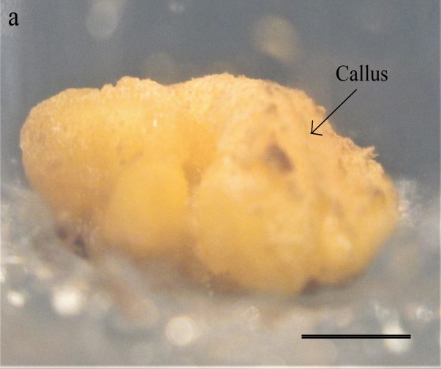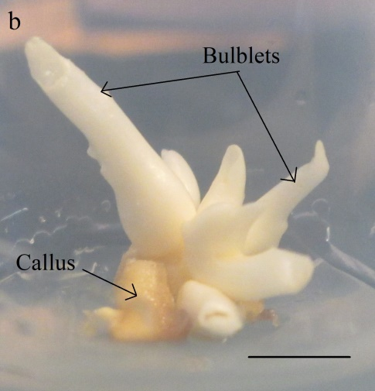

Fig. 1. (a) In vitro Narcissus pseudonarcissus L. cv. Carlton callus and (b) regenerated bulblets grown on T1 medium (Scale bar = 0.5 cm)

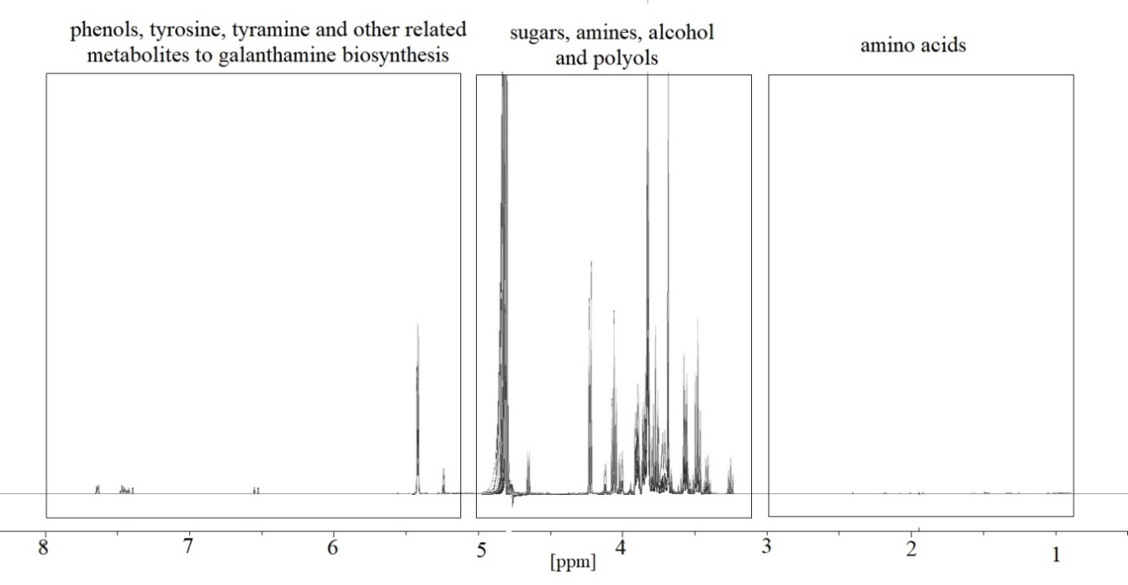
Fig. 2. Representative ¹H-NMR spectra from 0.8 ppm-8.0 ppm of Narcissus pseudonarcissus L. cv. Carlton callus representing the major groups of metabolites with raw peaks.

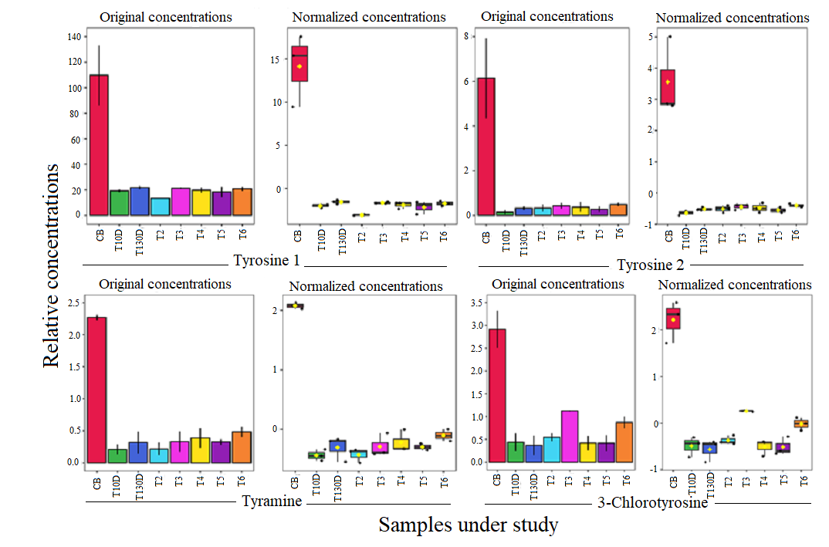
Fig. 3. ANOVA boxplot representing the relative concentrations of significantly different metabolites (peaks/ signals) involved in tyrosine and phenylalanine metabolism among Narcissus pseudonarcissus L. cv. Carlton samples under study (Carlton bulb = CB, T10D = callus obtained on the day of incubation on T1 medium, T130D = callus obtained after 30 d grown on T1 medium; T2 to T6 = callus obtained after 30 d grown on T2 to T6 media). Two sets of tyrosine (1 and 2) are due to the presence of two signals for tyrosine. Error bars = SE.

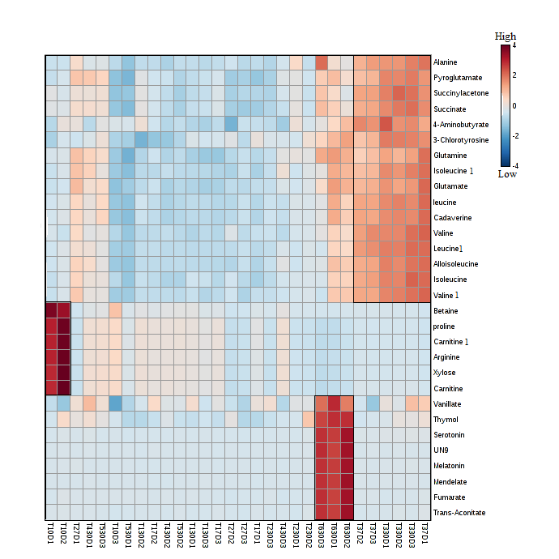
Fig. 4. Heatmap representing the top thirty metabolites identified by ANOVA, their distribution and relative amount (high to low colour gradient box on top right) in each Narcissus pseudonarcissus L. cv. Carlton sample under study; T10D = callus from medium T1 harvested before treatment, T1 to T3 (7D) = callus grown on media T1 to T3, harvested after 7 d and T1 to T6 (30D) = callus from media T1 to T6, harvested after 30 d of culture. Numbers 1, 2 and 3 represent three replications for each. The three boxes outlined with black line added to the heatmap represent the metabolites present in relatively high concentrations in callus incubated in T1 (two replicates), T6 and T3 media.

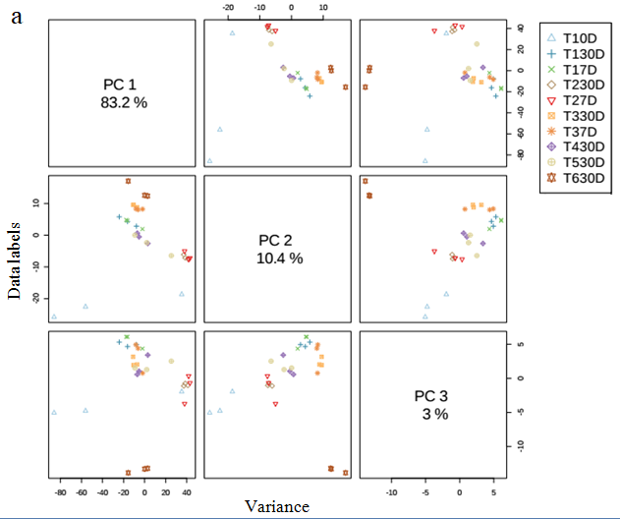
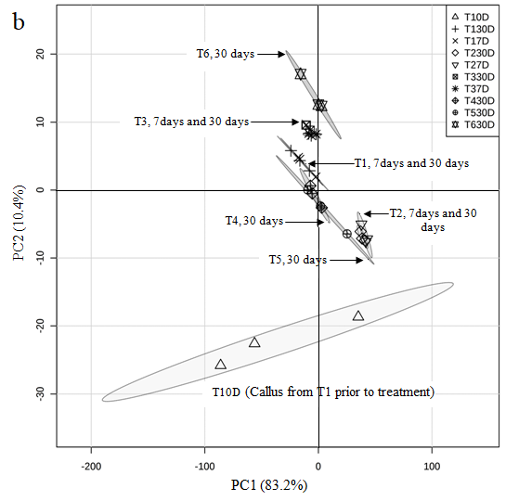
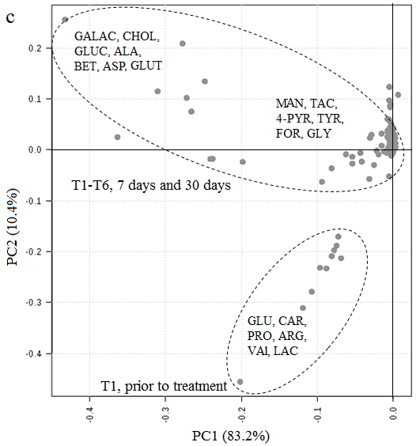

Fig. 5. (a) A three-component pair wise Principle Component Analysis plot between the selected Principle Components (PCs) for Narcissus pseudonarcissus L. cv. Carlton calluses, representing variances of each PC in the corresponding diagonal cell; (b) score scatter plot for principal component analysis (PC1 versus PC2) obtained from ¹H-NMR spectra of calluses grown in different media treatments (T1 to T6) harvested prior to treatment (0D), after 7 d (7D) and after 30 d (30D) of incubation and (c) corresponding loading plot. In the loading plot (•) represent ¹H-NMR signal buckets (metabolites). Signal buckets (metabolites) important for discrimination of the assigned classes are labelled; ALA: alanine, ASP: asparagine, ARG: arginine, BET: betaine, CHOL: choline, CAR: carnitine, FOR: formate, GALAC: galactitol, GLUC: glucitol, GLUT: glutamate, GLY: glycolate, GLU: glucuronate, LAC: lactate, MAN: mandelate, PRO: proline, TYR: tyrosine, TAC: trans-aconitate, VAL: valine, 4-PYR: 4-pyridoxate.

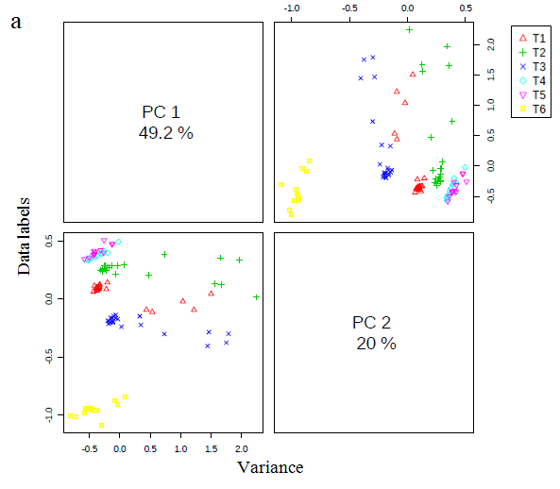

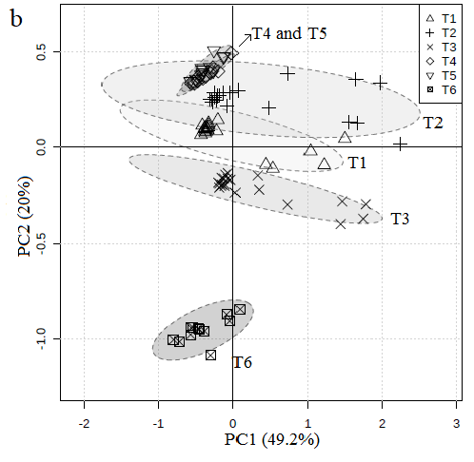
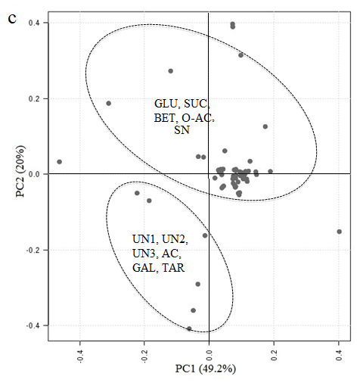
Fig. 6. (a) A two-component pair wise Principle Component Analysis score plot between the selected Principle Components (PCs) for media extracts, representing variance of each PC in the corresponding diagonal cell; (b) score scatter plot for principal component analysis (PC1 versus PC2) obtained from ¹H-NMR spectra of media extracts and (c) corresponding loading plot. In the loading plot (•) represent ¹H-NMR signals (metabolites). Signals (metabolites) important for discrimination of the assigned classes are labelled; UN: unknown compound, AC: acetylsalicylate, BET: betaine, GLU: glucose, GAL: galactose, O-AC: O-acetylcholine, SUC: sucrose, SN: sn- glycero-3-phosphocholine.

