Classification: Biological Sciences; Cell Biology
Drosophila Sex Peptide Controls the Assembly of Lipid Microcarriers in Seminal Fluid
S. Mark Wainwrightª, Ben R. Hopkins^{b,d}, Cláudia C. Mendesª, Aashika Sekarª, Benjamin Kroegerª, Josephine E.E.U. Hellbergª, Shih-Jung Fanª, Abigail Paveyª, Pauline Marieª, Aaron Leiblichª, Irem Sepil^{b}, Philip D. Charles^{c}, Marie L. Thezenas^{c}, Roman Fischer^{c}, Benedikt M. Kessler^{c}, Carina Gandyª, Laura Corriganª, Rachel Patelª, Stuart Wigby^{b,e,f}, John F. Morrisª, Deborah C.I. Goberdhanª, Clive Wilsonª
ª Department of Physiology, Anatomy and Genetics, University of Oxford, South Parks Road, Oxford, OX1 3QX, UK
^{b} Department of Zoology, University of Oxford, Oxford, OX1 3PS, UK
^{c} Target Discovery Institute (TDI) Mass Spectrometry Laboratory, Target Discovery Institute, Nuffield Department of Medicine, University of Oxford, Oxford, OX3 7BN, UK
^{d} Department of Evolution and Ecology, University of California, Davis, CA 95616, USA
^{e} Applied Zoology, Faculty Biology, Technische Universität Dresden, Dresden, Germany
^{f} Institute of Infection, Veterinary and Ecological Sciences, University of Liverpool, L69 7ZB Liverpool, United Kingdom

Corresponding Author: Clive Wilson
Tel: 44 1865 282662
e-mail: clive.wilson@dpag.ox.acuk

Keywords: Reproduction, secretion, seminal proteins, triacylglycerides, Sex Peptide, Drosophila
Abstract
Seminal fluid plays an essential role in promoting male reproductive success and modulating female physiology and behaviour. In the fruit fly, Drosophila melanogaster, Sex Peptide (SP) is the best-characterised protein mediator of these effects. It is secreted from the paired male accessory glands (AGs), which, like the mammalian prostate and seminal vesicles, generate most of the seminal fluid contents. After mating, SP binds to spermatozoa and is retained in the female sperm storage organs. It is gradually released by proteolytic cleavage and induces several long-term post-mating responses including increased ovulation, elevated feeding and reduced receptivity to remating, primarily signalling through the SP receptor (SPR). Here, we demonstrate a previously unsuspected SPR-independent function for SP. We show that, in the AG lumen, SP and secreted proteins with membrane-binding anchors are carried on abundant, large neutral lipid-containing microcarriers, also found in other SP-expressing Drosophila species. These microcarriers are transferred to females during mating, where they rapidly disassemble. Remarkably, SP is a key microcarrier assembly and disassembly factor. Its absence leads to major changes in the seminal proteome transferred to females upon mating. Males expressing non-functional SP mutant proteins that affect SP’s binding to and release from sperm in females also do not produce normal microcarriers, suggesting that this male-specific defect contributes to the resulting widespread abnormalities in ejaculate function. Our data therefore reveal a novel role for SP in formation of seminal macromolecular assemblies, which may explain the presence of SP in Drosophila species that lack the signalling functions seen in D. melanogaster.

Significance Statement
Seminal fluid plays a critical role in reprogramming female physiology and behaviour to promote male reproductive success. We show in the fruit fly that specific seminal proteins, including the archetypal ‘female-reprogramming’ molecule Sex Peptide, are stored in male seminal secretions in association with large neutral lipid-containing microcarriers, which rapidly disperse in females. Related structures are also observed in other Sex Peptide-expressing Drosophila species. Males lacking Sex Peptide have structurally defective microcarriers and exhibit abnormal transfer of many seminal proteins to females. Our data reveal that this key signalling molecule in Drosophila seminal fluid is also a microcarrier assembly factor that modulates transfer of other seminal factors, and that this may be a more evolutionarily ancient role of this protein.

Introduction
In addition to spermatozoa, semen contains a complex cocktail of macromolecules and nutrients secreted by the accessory glands of the male reproductive tract. In humans, seminal plasma nutrients include fructose from the seminal vesicles and triglycerides, both major energy sources for sperm in the female (1). In addition, enzymes, such as proteases and lipases, non-enzymatic binding proteins, like lectins and cysteine-rich secretory proteins (CRISPs), and a wide range of hormones and signalling molecules are major components, many of them generated in the prostate gland (2, 3). These molecules may be stored for days in the gland following cellular secretion, prior to being delivered to females during mating, when mixing of seminal plasma components can trigger enzyme and signal activation (4). However, the mechanisms that underpin these storage and activation events are generally not well understood.
The paired Drosophila melanogaster male accessory glands (AGs) share functional similarities with both the prostate and seminal vesicles in humans (5). The monolayer epithelium of these glands is formed from two secretory cell types, about 1000 main cells and 40 secondary cells at the distal tip (6) (Fig. 1A, A’). This glandular epithelial tube surrounds a large lumen. The AG secretome and its functions have been extensively characterised and multiple bioactive Accessory gland proteins (Acps) identified (7, 8). Several of these induce behavioural and physiological changes in mated females. The archetypal Acp is Sex Peptide (SP or Acp70Aa), a 36 amino acid protein, which is synthesised by main cells (9, 10). On transfer to females following mating, SP effects a comprehensive reprogramming of female physiology and behaviour. It promotes long-term increases in egg-laying, reduces female receptivity to remating (11, 12) and affects sperm release (13), diet (14), feeding behaviour (15), water balance (16), defaecation (17), sleep (18), immunity (19), aggression (20) and memory (21).
Maintaining this complex post-mating response (PMR) requires SP association with the sperm plasma membrane after mating (12). Sperm can then be stored for several weeks in two female organs, the paired spermathecae and the seminal receptacle, with SP gradually released by proteolytic cleavage to mediate its effects (22).
Studies in which SP or SP mutant peptides are either injected or expressed ectopically in females have demonstrated that SP can induce many of the characterised female PMRs, with distinct molecular domains in SP having different functions eg., (9, 23-25). In females, the SP receptor (SPR) is required to mediate most of these effects (26). SPR is expressed in specific neurons of the female reproductive tract that have a key role in the SP-dependent PMR (27, 28), and in other neurons in the CNS that are also able to respond to circulating SP (29, 21). In addition, SP appears to produce some SPR-independent post-mating responses in females (30, 20).
Here we report a novel SPR-independent function for SP in males, involving storage and delivery of seminal components. We show that the AG lumen is filled with many large, fusiform- and ellipsoid-shaped microcarriers containing a neutral lipid core and coated with specific proteins such as SP. Microcarriers rapidly dissipate on transfer to females after mating, providing a simple mechanism for timely release of stored seminal proteins. Surprisingly, we find that SP is essential for assembly of microcarriers in males, and that this function is required for the normal delivery of multiple seminal proteins and lipids to the female reproductive tract during mating. Furthermore, we identify related microcarrier structures in other Drosophila species that express a Sex Peptide and show that the size and shape of microcarriers has changed as the amino acid sequence of Sex Peptide evolved in these species.

Results
The lumen of the accessory gland is filled with large neutral lipid-containing microcarriers
While analysing the lipid content of epithelial cells within the male AG, using the lipophilic dye Nile Red, which stains membranes and lipid droplets, we observed that the large AG lumen is filled with fluorescent fusiform structures typically 3-8 µm in length (Fig. 1B, B’). These structures were of variable diameter ranging from less than 0.5 µm to a maximum of 4.0 µm (SI Appendix, Fig. S1F). Since these structures were found to bind specific main cell proteins (Fig. 2A), we call them ‘microcarriers’. The neutral lipid-specific dye LipidTox Red stained microcarriers highly selectively (Fig. 1C, C’), suggesting they contain large quantities of triglycerides and other non-polar lipids. Microcarriers were also detected using high concentrations of the acidophilic, but partially hydrophobic, LysoTracker dyes (Fig. 1D; (31)). By contrast, in fixed tissue, microcarriers exclude access to antibodies raised against soluble secreted AG proteins, such as angiotensin I-converting enzyme (ANCE; Fig. 1E). Microcarriers are not an artefact of fixation or staining, because they are readily discernible in living glands using Differential Interference Contrast (DIC) microscopy (Fig. 1F). In virgin males, they are not observed in other parts of the reproductive tract (eg. SI Appendix, Fig. S1A), suggesting they are exclusively made by the AG.
Previous studies have shown that some transmembrane proteins expressed in epithelial secondary cells of the AG are secreted via exosomes (32, 33). When transmembrane proteins were expressed in main cells, they did not associate with microcarriers (Fig. 1G, S1B, B’) and neither did dyes like PKH26 that bind to lipid bilayers (SI Appendix, Fig. S1C, C’). A secreted form of GFP, comprised of the SP signal sequence fused to GFP (25), also failed to preferentially bind to microcarriers (SI Appendix, Fig. S1D). By contrast, GFP-GPI, a GFP fusion protein carrying the lipid anchor glycosylphosphatidylinositol, strongly labelled microcarriers when expressed in main cells (Fig. 1H, H’), but not when made in secondary cells (SI Appendix, Fig. S1E, E’; (34), consistent with the idea that main cells produce these structures. Indeed, blocking secretion in adult secondary cells by expressing the BMP signalling inhibitor Dad from eclosion onwards (32, 34) had no obvious effect on microcarrier production (SI Appendix, Fig. S1G, H). However, microcarrier shape was frequently more bimodal than in control glands, with many thread-like microcarriers produced, suggesting that secondary cells may affect the final morphology of these structures. When GFP-GPI was overexpressed in main cells, a concentrated layer of GFP-GPI-positive staining was observed apically (Fig. 1H’), reflecting the shedding of lipophilic material from these cells. In the largest microcarriers, GFP-GPI, unlike LipidTox staining (Fig. 1C, C’), was surface-localised (Fig. 1H, H’), suggesting that these structures have a distinct outer layer, most likely a phospholipid monolayer into which the GPI anchor is inserted, surrounding the neutral lipid core. Although microcarrier ultrastructure was difficult to preserve for transmission electron microscopy, micrographs were consistent with these structures having a homogeneous internal structure (SI Appendix, Fig. S1I).

Sex Peptide is a microcarrier cargo
An SP-GFP C-terminal GFP fusion protein expressed in main cells under the control of SP gene regulatory elements (35) has previously been used to assess SP transfer to females. Surprisingly, we found that in the presence of wild-type SP, it strongly associates with microcarriers and concentrates at the surface of the largest structures, but is present at very low levels within main cells (Fig. 2A, B; SI Appendix, Movie 1). When these SP-GFP males were mated, fluorescently labelled microcarriers were transferred to females (Fig. 2C, D). We were unable to detect microcarriers using neutral lipid stains in the female reproductive tract, at least partly because of poor dye penetration. However, using SP-GFP as a marker, we found that 25 min after the start of mating (ASM), which is typically within five minutes of the end of mating, microcarriers had already started to change their morphology (Fig. 2E, E’). Although their basic fusiform shape was frequently still distinguishable, SP-GFP concentrated in microdomains on the microcarrier surface. Later, at 45 min ASM, smaller spherical SP-GFP-positive puncta were dispersed throughout the uterus and SP-GFP was observed on a subset of sperm tails (Fig. 2F, F’), while later still (60 min ASM), more of the SP-GFP (Fig. 2G, G’) was associated with sperm tails. However, at 90 min ASM, only very weak, if any, GFP expression was observed on sperm in the sperm storage organs (Fig. 2H-I’), either because the most strongly labelled sperm do not migrate to these organs or because the GFP tag or fluorescence is lost over time in females. Microcarriers that are ejected from the AG, but are trapped in the male ejaculatory duct at the end of mating, do not break down or form SP-GFP-labelled subdomains at their surface (Fig. 2J, J’), events exclusively seen in females. This suggests that microcarrier dissipation is only triggered by physical or chemical signals when these structures enter the uterus.
To confirm that C-terminal tagging of SP with GFP does not affect SP’s binding properties in the AG lumen and to begin to dissect out what domains in SP bind to microcarriers, we overexpressed three SP-GFP fusions in main cells under GAL4/UAS control: the N-terminal half of mature SP fused at its C-terminus to GFP (SPn-GFP), the C-terminal half of SP fused at its N-terminus to GFP (GFP-SPc), and a fusion with GFP located in the centre of the SP protein (SPn-GFP-SPc). The latter has been shown to have biological activity in females (25). Using the main cell-specific Acp26Aa-GAL4 driver (Fig. 1A) (11), which expresses at lower levels than GFP-tagged SP under its own promoter, all SP fusions partitioned with microcarriers (SI Appendix, Fig. S1J-L), albeit less selectively for the N-terminal SP construct, SPn-GFP. Microcarriers therefore appear to bind to both the N- and C-terminal domains of SP. We conclude that in addition to neutral lipids, they act as stores in males for SP and potentially other associated seminal proteins, such as those with a GPI anchor, and serve as vehicles for their transfer to females. Regulated microcarrier disassembly in females presumably assists in the timely release of lipids and seminal proteins, such as SP, after mating.

SP controls microcarrier morphology via an SPR-independent mechanism
To assess whether SP is involved in microcarrier assembly, we analysed AGs of males carrying the previously generated SP⁰ null allele (12), either as a homozygote or in transheterozygous combination with a small SP deficiency, Df(3L)Δ130 (36, 12). These transheterozygous SP null males have been used to characterise the full range of SP mutant PMR phenotypes (12-21). Unexpectedly, these mutant animals displayed dramatic defects in microcarrier morphology (Fig. 3A-D, I-J; S2A, B; S3A). Most microcarrier-like structures were highly enlarged, and either spherical or ellipsoid in shape. The enlarged microcarrier phenotype was never observed in wild type glands (Fig. 3A, C). In confocal images of the AG lumen, 10/10 SP⁰/Df(SP) null glands had microcarriers with a minimum width greater than 10 µm, whereas 0/10 wild type glands contained such structures (P<0.0001; Fisher’s exact test). The enlarged microcarriers from the SP⁰/Df(SP) null glands were uniformly stained by LipidTox. They appeared like large lipid droplets under DIC (Fig. 3D). The defects were absent in SP⁰ SP⁺/Df(3L)Δ130 males, which express an SP genomic rescue construct that rescues the PMR phenotypes in mated females (12) (Fig. 3E); 0/10 SP rescue glands had microcarriers with a minimum width greater than 10 µm (P<0.0001 versus SP⁰/Df(SP)). Automated measurement of minimum microcarrier diameter in individual images of male AGs with these different genotypes confirmed the change in size distribution in the SP null background (Fig. 3I). Mating SP⁰/Df(SP) null males multiple times with females over several days to mix and eject the AG’s contents, exacerbated the mutant phenotype, with some microcarriers spanning the entire diameter of the AG lumen (Fig. 3F, G), suggesting that microcarriers can enlarge by fusion. When seminal fluid remained in the ejaculatory duct of SP⁰/Df(SP) null males after mating, the duct lumen was also filled with enlarged microcarriers (Fig. 3H).
To confirm that SP expression in main cells is required for normal microcarrier assembly, we knocked down SP transcripts specifically in these cells, using the GAL4/UAS system (37), employing the Acp26Aa-GAL4 driver (11). Although limited effects were observed when these experiments were performed at 25ºC, expression of SP-RNAis from three different transgenic lines at 29ºC, a temperature that typically enhances GAL4-induced expression (38), produced consistent marked defects in microcarrier morphology (Fig. 4A-C, SI Appendix, Fig. S2C, D, SI Appendix, Fig. S3B). Microcarriers were enlarged in all three knockdowns, though to a lesser extent than in SP⁰/Df(SP) null males. As observed in mated SP⁰/Df(SP) null males (Fig. 3G), mating greatly exacerbated the size phenotype (Fig. 4E, F).
In females, many of SP’s activities in modulating the female PMR are mediated by the SPR (26). However, SPR mutant males displayed completely normal microcarriers (Fig. 4G), demonstrating that SP acts independently of the SPR in the male AG, presumably via direct interaction with microcarriers.
Binding of SP to the plasma membrane of sperm in females requires a short peptide sequence at the N-terminal end of the mature molecule (22). The C-terminal region of SP is proteolytically detached from sperm in the sperm storage organs over a two-week period, so that it can interact with SPR and other potential targets. Two mutants expressed under the control of the SP promoter, one that lacks the N-terminal membrane-association domain (SP^{∆2-7}) and the other mutated at the proteolytic cleavage site (SP^{QQ}), have both previously been shown to fail to induce the long-term PMR in females (22). These constructs also failed to rescue the microcarrier phenotype in SP⁰/Df(SP) null males (Fig. 4H-K; SI Appendix, Fig. S3C). For both mutants, 7/7 glands had microcarriers with a minimum width greater than 10 µm (SI Appendix, Fig. S3C), suggesting that the N-terminal region of SP, which appears to bind to microcarriers (SI Appendix, Fig. S1F), plays an important role in microcarrier assembly, as well as sperm binding.

Microcarriers from SP mutant males do not disassemble normally in females after mating
A key property of microcarriers is that they are stable in the male AG, yet change their morphology within minutes, when transferred to females. We tested how this process is affected in SP mutants. Since the C-terminally tagged SP-GFP construct, which has previously been reported to lack normal SP activity in females (23), failed to rescue the SP⁰/Df(SP) null microcarrier phenotype in males (Fig. 5B), we used this as an alternative to neutral lipid dyes to mark microcarriers. SP-GFP distributed evenly throughout the enlarged microcarriers in SP⁰/Df(SP) null males (Fig. 5A, B).
Unlike in controls (Fig. 5C), microcarriers from SP⁰/Df(SP) null males failed to rapidly dissipate in females and instead formed a homogeneously stained mass in the uterus (Fig. 5D), which did not break down during the period when SP-GFP is normally transferred to sperm tails (compare Fig. 5G, G’ with Fig. 5H, H’); indeed, unlike controls, the mass extended into the anterior uterus with some sperm tails embedded within it. We conclude that normal dissipation and distribution of microcarrier cargos is disrupted in females mated with SP⁰/Df(SP) null males (Fig. 5I), and this is likely to contribute to the aberrant post-mating phenotypes observed in mated females.

Loss of SP remodels the seminal proteome
To assess the effect of SP loss-of-function on the transferred seminal proteome, we compared the AG proteome of 4- to 5-day-old virgin and mated males, with either the null SP⁰/Df(3L)Δ130 or SP⁰ SP⁺/Df(3L)Δ130 rescue genotype. Focusing on the 116 detected known SFPs, which are generally reduced in relative levels following mating, a PCA biplot showed separation of samples according to both mating (PC1) and genotype (PC3), suggesting that loss of SP leads to compositional changes in the seminal proteome (SI Appendix, Fig. S4A). A hierarchical clustering analysis identified distinct profiles of SFP change across matings and genotypes that contribute to modulation of composition. By applying this analysis across glands, we could test for generalised behaviours of groups of SFPs in terms of production, post-mating retention, and the difference between these, which represents what is transferred to females (39).
Hierarchical clustering revealed the presence of five distinct, higher-order clusters (Fig. 6). We ran linear mixed effects models on each to test for associations with our measured variables. Clusters 3 and 5 showed significant associations with the interaction between genotype and mating (cluster 3: F_{1,42}=4.736, p=0.035; cluster 5: F_{1,75}=24.564, p<0.0001). The average response of SFPs in Cluster 3 was for reduced transfer to females in SP nulls. Cluster 3 includes Dup99B, a protein expressed in the anterior ejaculatory duct, which is consistently detected in AG preparations and shares considerable structural and functional similarity with SP, particularly in its C-terminal region (24). Furthermore, analysis of proteins not classed as SFPs with a genotype/mating interaction (SI Appendix, Fig. S4B) identified the GPI-anchored protein Contactin within a group of eight proteins that appear to be selectively retained in the glands of SP null males after mating (SI Appendix, Fig. S4B, cluster 1). Therefore, at least two proteins that might be expected to bind to microcarriers appear to be preferentially retained in SP null males, where these structures fail to form normally.
By contrast, SFPs in Cluster 5 were transferred to females in greater quantities in SP null males (Fig. 6). This elevated transfer is driven by two processes: greater production in virgins and lowered post-mating retention. Interestingly, despite accounting for just 26 of the 116 SFPs, Cluster 5 was significantly enriched for SP network proteins (p=0.014; Fisher’s exact test), containing five of the eight known: CG1652, CG1656, Antr, Intr, and Aqrs (53-56), suggesting an association between these proteins, SP and microcarriers.
Clusters 2 and 4 did not show a significant interaction term between genotype and mating (cluster 2: F_{1,18}=3.103, p=0.095; cluster 4: F_{1,192}=2.873, p=0.092), but did show significant associations with genotype (cluster 2: F_{1,19}=44.042, p<0.0001; cluster 4: F_{1,193}=40.401, p<0.0001). In both clusters the average response was for SFPs to be at higher abundance in SP null glands, consistent with elevated production in the absence of SP. Cluster 1, which contained only 3 SFPs, showed no significant associations with genotype (G x M: F_{1,6}=44.042, p=0.949; G: F_{1,7}=0.579).
In summary, the transfer of at least two subclasses of SFPs in the seminal proteome is significantly modulated in an SP null background, while many other proteins are transferred normally, despite some being produced in higher quantities. This is consistent with our hypothesis that SP influences the seminal proteome in males, presumably via its role in microcarrier assembly.

SP and microcarrier structure have rapidly co-evolved in Drosophila species
To test whether other species within the genus Drosophila might employ a similar neutral lipid-based strategy to package molecules in seminal fluid, we stained the AGs of multiple Drosophila species with LipidTox (Fig. 6). Species closely related to D. melanogaster, namely D. simulans and D. sechellia (Fig. 6A), had microcarriers with remarkably similar size and shape (Fig. 6B-D). AGs of the species D. erecta and D. yakuba, which are still members of the melanogaster group but have more divergent SP structure (25) (SI Appendix, Fig. S5), also contained microcarriers, but these were more spherical in shape (Fig. 6E, F).
Examining more distantly related Drosophila species with more diverged SP proteins (SI Appendix, Fig. S5) (25) revealed very different microcarrier organisation. D. pseudoobscura and D. persimilis, both members of the obscura group, have smaller spherical microcarriers that appear to be more widely separated (Fig. 6G, H).
Two further Drosophila species D. willistoni and D. virilis express forms of SP with major structural differences to the melanogaster and obscura groups (25). These proteins not only lack a central 10 amino acid portion of the molecule, including the sequence required for proteolytic cleavage, but have also diverged considerably in other regions with the exception of the last 15 C-terminal amino acids (SI Appendix, Fig. S5). Bright-field and DIC microscopy revealed D. willistoni glands have densely packed globular structures that can be stained with LipidTox, although this is most clearly observed in punctured glands (Fig. 6I-I’’). The D. virilis AG, whether intact or cut, showed little evidence of LipidTox-stained microcarriers (Fig. 6J) and bright-field and DIC imaging suggested a more uniform “flocculence” (Fig. 6J’, J’’). Finally, we examined the AGs of D. mojavensis, a species that lacks an SP homologue (SI Appendix, Fig. S5) (25). Although there were more dispersed large spherical structures in the gland lumen in DIC images, no LipidTox-positive staining was observed in these glands (Fig. 6K-K’). Staining accessory glands of these different Drosophila species with LysoTracker Deep Red revealed an identical pattern of microcarrier presence, shape and size (SI Appendix, Fig. S6), indicating that the lack of microcarrier staining with LipidTox in D. virilis and D. mojavensis is not a dye-specific phenomenon. Therefore, our analysis suggests that the evolutionary divergence of SP structure closely parallels changes in microcarrier shape, size and density.

Discussion
Seminal fluid plays an essential role in male reproductive success. In D. melanogaster, SP, produced from the male AG, has been highlighted as a central player in this process, acting via receptors in the female to stimulate changes that increase fecundity and prevent remating. Here we demonstrate that SP has an additional, unsuspected role in males in the assembly of neutral lipid-containing microcarriers in the AG lumen (summarised in Fig. 5I). These microcarriers store SP and can carry other proteins with lipid anchors. Furthermore, our proteomics analysis reveals that the normal delivery of subgroups of SFPs to females during mating requires SP, potentially because these subgroups interact differently with microcarriers. Microcarrier interactions are likely to also affect dispersal of these proteins in the female reproductive tract. Our analysis of microcarriers in other Drosophila species reveals that SP’s microcarrier assembly function may exist in species in which SP has more limited roles in modulating the PMR, suggesting that the former function might have been critical in the evolution of this molecule.

Lipid microcarriers provide a store, delivery vehicle and dispersal machinery for a subset of seminal proteins.
Seminal proteins are produced throughout adult life, but these proteins are only transferred to females sporadically. Some of these proteins are then rapidly activated via mechanisms that are thought to include proteolytic cleavage and pH changes in the female reproductive tract (discussed in (5)). Our data suggest that microcarriers could contribute to this activation process. They are repositories for main cell-derived seminal proteins, which presumably partition from the aqueous phase of the AG’s secretions, either because of their lipophilicity or because they have binding partners on the microcarrier surface. In the male, molecules like SP bind specifically to microcarriers and not to AG epithelial cells, strongly suggesting that these surfaces are structurally distinct. Subsequent microcarrier dissipation in the female reproductive tract provides a mechanism for dispersing proteins like SP, so they can associate with receptors and cell membranes following mating.
Although both staining of normal microcarriers with lipophilic dyes and the homogeneous internal structure of large defective SP⁰/Df(SP) null ‘microcarriers’ observed with DIC strongly suggest that neutral lipids are a major component of these structures, their precise composition remains unclear. In addition, their non-spherical shape in wild type males suggests that architectural proteins are highly likely to be involved in establishing their final structure, a proposal supported by the SP mutant phenotype. It will now be important to identify these other structural constituents and to establish whether any of these, unlike SP, play evolutionarily conserved roles in seminal fluid production outside the Drosophila genus.
Analysis of transcriptomics data from adult Drosophila organs reveals high level expression in the AG of multiple lipases that are predicted to be secreted (eg., CG5162, CG11598, CG11600, CG11608, CG13034, CG18258, CG18284, CG31872, CG34447; (40, 41), with all having been detected in proteomics analyses of seminal fluid (42, 8). These include proteins sharing homology with triacylglycerol lipases (eg., CG5162, CG13034, CG18258, CG34447). These lipases provide a potential mechanism to break down neutral lipid transferred in microcarriers to females, so the products can be used as fuel. Mammalian seminal fluid also contains lipases (43, 44, 45) and triacylglycerides (46, 47), suggesting that the latter may be required, perhaps as a male-derived nutrient source, in the reproductive system of all higher organisms.
Our identification of extracellular neutral lipid microcarriers as accessible stores of specific seminal proteins is reminiscent of the role of intracellular lipid droplets in storage of cytoplasmic and nuclear proteins (48, 49). Lipid droplets are able to dock with specific intracellular organelles to mediate their functions and deliver their cargos. It will be interesting to investigate whether the remnants of microcarriers, such as the microdomains observed with SP-GFP, are in any way targeted to specific cells or structures after transfer to females, as these storage vehicles break down.
It has previously been reported in Drosophila that males can adaptively modulate the relative balance of seminal proteins, including SP, in the ejaculate, depending on female mating status and the presence of rival males (50, 51). Loading of selected proteins on to microcarriers might provide a simple mechanism to control such rapid changes, if the transfer of these large structures can be differentially regulated compared to soluble proteins, for example by controlling the opening of the sphincters through which seminal fluid passes from the AGs to the ejaculatory duct.

Regulation of microcarrier morphology by SP and microcarrier/SP co-evolution in Drosophila.
Our study reveals a previously unsuspected male-specific, SPR-independent role for SP in regulating microcarrier shape and size. SP mutants in D. melanogaster still have neutral lipid-containing structures, but they appear to aggregate and fuse, particularly after mating, to generate large lipid droplet-like structures that no longer retain molecules like SP at their surface. To date, we have not been able to separate the different activities of SP in males and females through expression of different mutants or altered SP levels, making it difficult to fully gauge the importance of the male-specific microcarrier function. However, the observation that SP mutants, which were known to affect binding of SP to the surface of sperm or its subsequent release, also fail to rescue the microcarrier defect in SP null males, suggests that the interpretation of the phenotypes associated with these mutants requires some re-evaluation.
Our data suggest that both the C-terminal and N-terminal domains of SP can interact with microcarriers, even though they share no structural similarity. This may involve direct binding to the outer surface of the microcarrier, or because both domains contain charged residues, more indirect associations via other molecules attached to microcarriers. The multi-domain interaction contrasts with sperm binding and may underlie why SP can transfer to sperm in the female reproductive tract.
Tsuda et al. (25) have suggested that SP is likely to have roles in addition to its effects mediated via SPR signalling in the female reproductive tract, which include induction of a female sexual refractory period. This is because some SP-expressing species like D. pseudoobscura and D. persimilis do not appear to express SPR in this location and additionally show much less female post-mating refractoriness relative to other SP-producing species (52). Our data (Fig. 6) suggest that microcarrier assembly may be this additional function with the shape of microcarriers rapidly co-evolving with SP. An absence of microcarriers in species with a highly divergent (D. virilis) or no (D. mojavensis) SP homologue, as evidenced by two different staining methods, supports our hypothesis. Not unexpectedly, DIC microscopy suggested that the luminal content of these latter two species is not homogenous, but it is clearly different from the other Drosophila species we studied (Fig. 1F, Fig. 7I’’-K’’). Interestingly, D. virilis expresses SPR in the female reproductive tract, so unlike in other species, its SP protein may be specifically involved in activating the female PMR, rather than microcarrier formation.
In light of these findings, it will be now be important to investigate whether other proteins with fundamental roles in packaging and storing seminal fluid components have also evolved signalling roles in animals.
SP modulates the composition of the seminal proteome
An important conclusion from our study is that the normal transfer of different subgroups of SFPs is dependent on SP. One simple explanation is that this reflects differences in their interactions with microcarriers. Having shown that main cell-expressed GFP-GPI binds to microcarriers, it was interesting to identify the GPI-anchored junctional protein Contactin as one of the proteins, which appears to be retained more in the accessory glands of SP null males. Furthermore, preferential retention of Dup99B in SP null males is consistent with the idea that this SP-like protein might bind to microcarriers, even though it is primarily expressed in the adjacent ejaculatory duct epithelium.
Elegant studies by the Wolfner lab have identified several long-term response (LTR) network genes expressed in the AG that are inter-dependent and required either in the male or female for SP to be retained in the sperm storage organs (53-56). We noticed that several of these proteins appear to be expressed at higher levels in SP nulls and also that a greater proportion is transferred from mutant males to females upon mating. A previous study has suggested that two of these proteins, CG1652 and CG1656, are present at similar levels in the female reproductive tract one hour after the start of mating to SP null and SP rescue males (53). We cannot easily explain this difference, but it is important to emphasise that our study measures the relative quantity of these proteins that leaves the male AG, not what remains in the female reproductive tract some time later. Overall, our proteomics analysis clearly shows that SP modulates the transfer of specific subclasses of SFPs to females, and particularly in the case of proteins that are retained in SP nulls, this could result from the disruption of microcarriers.
It will now be important to investigate whether any of the network genes is involved in loading or unloading SP from microcarriers, or indeed, whether they play a role in microcarrier assembly, particularly since they appear to be present in species where SP does not seem to be involved in signalling (57). The role of secondary cells in microcarrier morphology also needs to be examined in more detail. Furthermore, confirming that other SFPs identified in the proteomics analysis or main cell-expressed GPI-anchored proteins are microcarrier cargos should allow the functions of these structures to be assessed more extensively and may suggest molecular tools that could be used to screen for similar processes in higher organisms.

Materials and Methods
Drosophila Stocks and Genetics
Fly stocks were obtained from the following sources: the Bloomington Drosophila Stock Center provided UAS-GFP.nls (58), UAS-mCD8-GFP (59), tub-GAL80^{ts} (60), UAS-SP-RNAi#2 TRiP.JF02022 (61), UAS-mCD8-ChRFP; the Vienna Drosophila Resource Center provided UAS-SP-RNAi#3 (v109175); the Kyoto DGRC Stock Center provided spi-GAL4 (62); S. Goodwin provided dsx-GAL4 (63), Acp26Aa-GAL4 (11), SP-GFP (35); T. Aigaki provided UAS-SPn-GFP-SPc, UAS-SPn-GFP, UAS-GFP-SPc, UAS-sGFP (25); M. Wolfner provided SP^{QQ}, SP^{∆2-7} (22), Df(SPR) (25); S. Eaton provided UAS-GFP-GPI (64); T. Chapman provided SP⁰, SP⁰ SP⁺ (12), Df(3L)Δ130 (36), UAS-SP-RNAi-IR2 (RNAi#1; (11)); B. Edgar provided esg^{ts}F/O (w; esg-GAL4, UAS-GFPnls; act>CD2>GAL4, UAS-FLP) and D. Bennett provided UAS-Dad (32); L. Partridge provided w¹¹¹⁸. A. McGregor provided D. simulans, D. sechellia, D. yakuba, D. pseudoobscura, D. virilis and the Gulbenkian Science Institute provided D. erecta, D. persimilis, D. mojavensis.
Fly husbandry
Flies were maintained on standard cornmeal agar food (12.5 g agar, 75 g cornmeal, 93 g glucose, 31.5 g inactivated yeast, 8.6 g potassium sodium tartrate, 0.7 g calcium, and 2.5 g Nipagen [dissolved in 12 ml ethanol] per litre) at 25°C on a 12:12-h light:dark cycle. Flies for the proteomics analysis were reared on Lewis medium (65). Males for SP knockdown or those with tub-GAL80^{ts} were shifted to 29°C on eclosion to activate UAS-transgenes.
Staining and immunostaining of fly reproductive tracts
Unless otherwise stated, 3-4-day-old virgin males were used for AG dissection and for mating experiments. 4-7-day-old w¹¹¹⁸ virgin females were used for mating experiments. For fixed tissues, reproductive tracts were dissected in 4% paraformaldehyde (Sigma-Aldrich) in PBS (Gibco). AGs with the ejaculatory duct attached were fixed for 20 min and rinsed at least four times in PBS prior to further treatments. For females the abdomen was carefully opened up and fixative allowed to permeate internally for 20 min prior to removal of the uterus with seminal receptacle, spermathecae and common oviduct attached. Reproductive tracts were washed four times with PBS.
Fixed accessory glands were stained at room temperature in the following solutions and then washed four times in PBS: 1:50 dilution in PBS of a 10 mg/ml solution of Nile red (Sigma-Aldrich) dissolved in acetone and incubated for 30 min; 1:100 dilution in PBS of LysoTracker Deep Red (Life Technologies) for 1 h; 1:50 dilution in PBS of LipidTox (Invitrogen) for 1 h; 1:40 dilution in diluent C of a 1mM stock of PKH26 red fluorescent cell marker (Sigma-Aldrich) for 30 min; 1:1000 dilution in PBS of a 10 mg/ml stock of Hoechst 33342 (Invitrogen) for 5 min.
For live imaging, accessory glands were dissected in ice-cold PBS. Live glands requiring staining were treated for 5 min in a 1:100 dilution of LysoTracker Red DND-99 (Life Technologies) in ice-cold PBS.
For ANCE antibody staining, fixed accessory glands were permeabilised for 6 x 10 min in PBST (1 X PBS, 0.3% Triton X-100 [Sigma-Aldrich]), blocked for 30 min in PBSTG (PBST, 10% goat serum [Sigma-Aldrich]) and incubated overnight at 4°C in rabbit anti-ANCE primary antibody (66) diluted 1:2000 in PBSTG. Glands were then washed for 6 x 10 min in PBST before incubation in a 1:400 dilution of Cy-5-conjugated donkey anti-rabbit secondary antibody (Jackson Laboratories) for 2 h at room temperature. Glands were further washed in PBST for 6 x 10 min prior to mounting.
Glands stained with Hoechst were mounted in PBS; all other fixed reproductive tracts were mounted in Vectashield with DAPI (Vector Laboratories). Glands for live imaging were mounted in a small drop of ice-cold PBS surrounded by 10S Voltalef (VWR) halocarbon oil (67).
Electron microscopy
3-day-old w¹¹¹⁸ male reproductive tracts were dissected and incubated overnight in 2.5% glutaraldehyde and 4% formaldehyde in PBS (pH 7.2). Glands were then washed with PBS, refixed in 1% osmium tetroxide (Agar Scientific) for 20 minutes, washed 3 times in distilled water and dehydrated through a graded alcohol series and incubated in ethanol and Spurr’s epoxy resin (1:1) (Agar Scientific). Glands were embedded in 100% Spurr’s epoxy resin between two sheets of polythene and polymerised overnight at 60°C. Ultrathin sections were prepared with a Reichert Ultracut R Ultramicrotome (Leica Biosystems) and mounted on formvar-coated slot grids (Agar Scientific). Sections were contrasted with 2% uranyl acetate and lead citrate (Agar Scientific), and imaged using a JEOL 1010 electron microscope (80kV).
Imaging
Images of fixed reproductive tracts were acquired either on a Zeiss LSM 510 Meta [Axioplan2] or a LSM 880 laser scanning confocal microscope equipped with Zeiss 10x NA 0.45, 20x NA 0.8, 40x NA 1.3 and 63x NA 1.4 objectives. Live scanning confocal imaging was performed on a Zeiss LSM 710 microscope using a 63x NA 1.4 objective. Live DIC images were acquired on a DeltaVision Elite wide-field fluorescence deconvolution microscope (GE Healthcare Life Sciences) equipped with a 100x, NA 1.4 UPlanSApo oil objective (Olympus).
Automated analysis of microcarrier size
Images were opened with Fiji software. Microcarrier image analysis was performed using the open‐access CellProfiler Software version 2.2.0. A workflow for segmenting all the microcarriers and measuring the minimum feret diameter of each microcarrier was developed by adding pre-programmed algorithmic modules in a pipeline. Histograms based on microcarrier minimum width and microcarrier area in different minimum width ranges were plotted using GraphPad Prism-8 software.
Changes in microcarrier size were further assessed by recording the presence or absence of microcarriers with a minimum width greater than 10 µm for 7-10 glands in a representative 100 µm² field of view of the lumen midway along the length of the gland. P-values were calculated using Fisher’s exact test.
Proteomics analysis
For the proteomics experiments, we followed the mating, sample preparation methods, LC-MS/MS analysis and MS data processing pipeline described by Sepil et al., 2018 (8). We detected 2246 proteins in total, but restricted our analysis to the 1502 detected on the basis of at least 2 unique peptides (as in 68, 8). This subset contained 118 SFPs known from previous work to be transferred to females (8, 42, 51, 55). One additional SFP was included that was not previously demonstrated to be transferred to females (intrepid, intr), due to its known role within the SP network pathway (55), and three proteins were excluded (see SI Appendix). All analyses were conducted using R statistical software (version 3.5.1) in RStudio (version 1.1.456). In each analysis, log2 transformed values were used to standardise variance across the dynamic range of protein abundances. Further details of methods and additional data analysis are given in SI Appendix.

All materials, tools and datasets generated in this study are presented in the paper or will be made available upon request.

Acknowledgements
We thank Suzanne Eaton, Mariana Wolfner, Toshiro Aigaki, Tracey Chapman, Stephen Goodwin, Elwyn Isaac, Bruce Edgar, Daimark Bennett, Nuno Soares and Alistair McGregor for stocks and reagents; we are grateful to the Bloomington Drosophila Stock Center, the Vienna Drosophila Resource Center and the Kyoto DGRC Stock Centre for flies. We thank the Micron Advanced Bioimaging Unit (supported by Wellcome Strategic Awards 091911/B/10/Z and 107457/Z/15/Z) for their support & assistance in this work. We acknowledge the support of the Biotechnology and Biological Sciences Research Council (BB/K017462/1, BB/L007096/1, BB/N016300/1, BB/R004862/1 and Fellowships to SW, BB/K014544/1, and IS, BB/T008881/1), Cancer Research UK (C19591/A19076, C602/A18974), the Cancer Research UK Oxford Centre Development Fund (C38302/A12278), the Wellcome Trust (Strategic Awards #091911, #107457 and 102347/Z/13/Z; 097813/11/Z to PDC, MLT, RF and BMK), and the John Fell Fund (133/075), as well as the MRC for studentship funding. BRH was funded by the EP Abraham Cephalosporin-Oxford Graduate Scholarship and NIH grant 5R35GM122592 to Artyom Kopp.

References
1. D. Montagnon, B. Valtat, F. Vignon, M. H. Koll-Back, Secretory proteins of human seminal vesicles and their relationship to lipids and sugars. Andrologia 22, Suppl. 1, 193-205 (1990).
2. T.L. Veveris-Lowe, S. J. Kruger, T. Walsh, R. A. Gardiner, J. A. Clements, Seminal fluid characterization for male fertility and prostate cancer: kallikrein-related serine proteases and whole proteome approaches. Semin. Thromb. Hemost. 33, 87-99 (2007).
3. J. Vitku, L. Kolatorova, R. Hampl, Occurrence and reproductive roles of hormones in seminal plasma. Basic Clin. Androl. 27, 19 (2017).
4. G. Pampalakis, G. Sotiropoulou, Tissue kallikrein proteolytic cascade pathways in normal physiology and cancer. Biochim. Biophys. Acta 1776, 22-31 (2007).
5. C. Wilson, A. Leiblich, D. C. Goberdhan, F. Hamdy, The Drosophila accessory gland as a model for prostate cancer and other pathologies. Curr. Topics Dev. Biol. 121, 339-375 (2017).
6. A. Bairati, Structure and ultrastructure of the male reproductive system in Drosophila melanogaster: the genital duct and accessory glands. Monitore Zool. Ital. 2, 105-182 (1968).
7. L. K. Sirot et al., Molecular social interactions: Drosophila melanogaster seminal fluid proteins as a case study. Adv. Genet. 68, 23-56 (2009).
8. I. Sepil et al., Quantitative proteomics identification of seminal fluid proteins in male Drosophila melanogaster. Mol. Cell Proteomics 18, S46-58 (2019).
9. P. S. Chen et al., A male accessory gland peptide that regulates reproductive behavior of female D. melanogaster. Cell 54, 291-298 (1988).
10. E. Kubli, Sex-peptides: seminal peptides of the Drosophila male. Cell. Mol. Life Sci. 60, 1689-1704 (2003).
11. T. Chapman et al., The sex peptide of Drosophila melanogaster: Female post-mating responses analyzed by using RNA interference. Proc. Natl. Acad. Sci. USA 100, 9923-9928 (2003).
12. H. Liu, E. Kubli, Sex-peptide is the molecular basis of the sperm effect in Drosophila melanogaster. Proc. Natl. Acad. Sci. USA 100, 9929-9933 (2003).
13. F. W. Avila, K. R. Ram, M. C. Bloch Qazi, M. F. Wolfner, Sex peptide is required for the efficient release of stored sperm in mated Drosophila females. Genetics 186, 595-600 (2010).
14. C. Ribeiro, B. J. Dickson, Sex peptide receptor and neuronal TOR/S6K signalling modulate nutrient balancing in Drosophila. Curr. Biol. 20, 1000-1005 (2010).
15. G. B. Carvalho, P. Kapahi, D. J. Anderson, S. Benzer, Allocrine modulation of feeding behavior by the sex peptide of Drosophila. Curr. Biol. 16, 692-696 (2006).
16. P. Cognigni, A. P. Bailey, I. Miguel-Aliaga, Enteric neurons and systemic signals couple nutritional and reproductive status with intestinal homeostasis. Cell Metab. 13, 92-104 (2011).
17. J. Apger-McGlaughon, M. F. Wolfner. Post-mating changes in excretion by mated Drosophila melanogaster females is a long-term response that depends on sex peptide and sperm. J. Insect Physiol. 59, 1024-1030 (2013).
18. R. E. Isaac, C. Li, A. E. Leedale, A. D. Shirras, Drosophila male sex peptide inhibits siesta sleep and promotes locomotor activity in the post-mated female. Proc. R. Soc. B 277, 65-70 (2010).
19. J. Peng, P. Zipperlen, E. Kubli. Drosophila sex-peptide stimulates female innate immune system after mating via the Toll and Imd pathways. Curr. Biol. 15, 1690-1694 (2005).
20. E. Bath et al., Sperm and sex peptide stimulate aggression in female Drosophila. Nat. Ecol. Evol. 1, 0154 (2017).
21. L. Scheunemann, A. Lampin-Saint-Amaux, J. Schor,T. Preat. A sperm peptide enhances long-term memory in female Drosophila. Sci. Adv. 5, eaax342 (2019).
22. J. Peng, S. Chen, S. Büsser, H. Liu, T. Honegger, E. Kubli, Gradual release of sperm bound sex-peptide controls female postmating behavior in Drosophila. Curr. Biol. 15, 207-213 (2005).
23. E. V. Domanitskaya, H. Liu, S. Chen, E. Kubli, The hydroxyproline motif of male sex peptide elicits the innate immune response in Drosophila females. FEBS J. 274, 5659-5668 (2007).
24. P. Saudan, et al. Ductus ejaculatorius peptide 99B (DUP99B), a novel Drosophila melanogaster sex-peptide pheromone. Eur J Biochem. 269, 989-997 (2002).
25. M. Tsuda, J. B. Peyre, T. Asano, T. Aigaki, Visualizing molecular functions and cross-species activity of sex-peptide in Drosophila. Genetics 200, 1161-1169 (2015).
26. N. Yapici, Y. J. Kim, C. Ribeiro, B. J. Dickson A receptor that mediates the post-mating switch in Drosophila reproductive behaviour. Nature 451, 33-37 (2008).
27. M. Häsemeyer, N. Yapici, U. Heberlein, B. J. Dickson, Sensory neurons in the Drosophila genital tract regulate female reproductive behavior. Neuron 61, 511-518 (2009).
28. C. H. Yang et al., Control of the postmating behavioral switch in Drosophila females by internal sensory neurons. Neuron 61, 519-526 (2009).
29. Z. Ding, I. Haussmann, M. Ottiger, E. Kubli, Sex-peptides bind to two molecularly different targets in Drosophila melanogaster females. J. Neurobiol. 55, 372-384 (2003).
30. I. U. Haussmann, Y. Hemani, T. Wijesekera, B. Dauwalder, M. Soller, Multiple pathways mediate the sex-peptide-regulated switch in female Drosophila reproductive behaviours. Proc. Biol. Sci. 280, 20131938 (2013).
31. B. Zhitomirsky, H. Farber, Y. G. Assaraf, LysoTracker and MitoTracker Red are transport substrates of P-glycoprotein: implications for anticancer drug design evading multidrug resistance. J. Cell Mol. Med. 22, 2131-2141 (2018).
32. L. Corrigan et al., BMP-regulated exosomes from Drosophila male reproductive glands reprogram female behavior. J. Cell Biol. 206, 671-688 (2014).
33. S.-J. Fan, S.-J., et al. Glutamine deprivation regulates the origin and function of cancer cell exosomes. EMBO J. https://www.embopress.org/doi/10.15252/embj.2019103009 (2020).
34. S. Redhai et al., Regulation of dense-core granule replenishment by autocrine BMP signalling in Drosophila secondary cells. PLoS Genet. 12, e1006366 (2016).
35. A. Villella, J. B. Peyre, T. Aigaki, J. C. Hall, Defective transfer of seminal-fluid materials during matings of semi-fertile fruitless mutants in Drosophila. J. Comp. Physiol. A 192, 1253–1269 (2006).
36. R. Nolo, L. A. Abbott, H. J. Bellen, Drosophila Lyra mutations are gain-of-function mutations of senseless. Genetics 157, 307-315 (2001).
37. A. H. Brand, N. Perrimon, Targeted gene expression as a means of altering cell fates and generating dominant phenotypes. Development 118, 401-415 (1993).
38. A. H. Brand, A. S. Manoukian, N. Perrimon, Ectopic expression in Drosophila. Methods Cell Biol. 44, 635-654 (1994).
39. B. R. Hopkins, et al. BMP-signalling inhibition in Drosophila secondary cells remodels the seminal proteome, and self and rival ejaculate functions. Proc. Natl. Acad. Sci. USA. 116, 24719-24728 (2019).
40. J. L. Mueller et al., Cross-species comparison of Drosophila male accessory gland protein genes. Genetics 171, 131-143 (2005).
41. V. R. Chintapalli, J. Wang, J. A. Dow, Using FlyAtlas to identify better Drosophila melanogaster models of human disease. Nat. Genet. 39, 715-720 (2007).
42. G. D. Findlay, X. Yi, M. J. Maccoss, W. J. Swanson, Proteomics reveals novel Drosophila seminal fluid proteins transferred at mating. PLoS Biol. 6, e178 (2008).
43. D. A. Carver, B. A. Ball, Lipase activity in stallion seminal plasma and the effect of lipase on stallion spermatozoa during storage at 5 degrees C. Theriogenology 58, 1587-1595 (2002).
44. B. Sias et al., Cloning and seasonal secretion of the pancreatic lipase-related protein 2 present in goat seminal plasma. Biochim Biophys Acta 1686, 169-180 (2005).
45. L. Anel-López et al., Analysis of seminal plasma from brown bear (Ursus arctos) during the breeding season: Its relationship with testosterone levels. PLoS One 12, e0181776 (2017).
46. F. Vignon, A. Clavert, M. H. Koll-Back, P. Reville, On the glandular origin of seminal plasma lipids in man. Andrologia 24, 341-343 (1992).
47. N. S. Juyena, J.Vencato, G. Pasini, I. Vazzana, C. Stelletta, Alpaca semen quality in relation to different diets. Reprod. Fertil. Dev. 25, 683-690 (2013).
48. Z. Li et al., Lipid droplets control the maternal histone supply of Drosophila embryos. Curr. Biol. 22, 2104-2213 (2012).
49. J. A. Olzmann, P. Carvalho, Dynamics and functions of lipid droplets. Nat. Rev. Mol. Cell. Biol. 20, 137-155 (2019).
50. L. K. Sirot, M. F. Wolfner, S. Wigby, Protein-specific manipulation of ejaculate composition in response to female mating status in Drosophila melanogaster. Proc. Natl. Acad. Sci. USA 108, 9922-992 (2011).
51. B. R. Hopkins et al., Divergent allocation of sperm and seminal proteome along a competition gradient in Drosophila melanogaster. Proc. Natl. Acad. Sci. USA 11, 17925-17933 (2019).
52. T. A. Markow, Evolution of Drosophila mating systems. Evol. Biol. 29, 73-106 (1996).
53. K. R. Ram, M. F. Wolfner, Sustained post-mating response in Drosophila melanogaster requires multiple seminal fluid proteins. PLoS Genet. 3, e238 (2007).
54. K. R. Ram, M. F. Wolfner, A network of interactions among seminal proteins underlies the long-term postmating response in Drosophila. Proc Natl Acad Sci U S A. 106, 15384-15389 (2009).
55. G. D. Findlay, et al., Evolutionary rate covariation identifies new members of a protein network required for Drosophila melanogaster female post-mating responses. PLoS Genet. 10, e1004108 (2014).
56. A. Singh, et al., Long-term interaction between Drosophila sperm and sex peptide is mediated by other seminal proteins that bind only transiently to sperm. Insect Biochem. Mol. Biol. 102, 43-51 (2018).
57. M. K. McGeary, G. D. Findlay, Molecular evolution of the sex peptide network in Drosophila. J Evol Biol. 33, 629-641 (2020).
58. Y. Shiga, M. Tanaka-Matakatsu, S. Hayashi, A nuclear GFP/B-galactosidase fusion protein as a marker for morphogenesis in living Drosophila. Develop. Growth Differ. 38, 99-106 (1996).
59. T. Lee, L. Luo, Mosaic analysis with a repressible cell marker for studies of gene function in neuronal morphogenesis. Neuron 22, 451-461 (1999).
60. L. A. Perkins et al., The transgenic RNAi project at Harvard Medical School: resources and validation. Genetics 201, 843-852 (2015).
61. S. E. McGuire, P. T. Le, A. J. Osborn, K. Matsumoto, R. L. Davis, Spatiotemporal rescue of memory dysfunction in Drosophila. Science 302, 1765-1768 (2003).
62. S. Hayashi et al., GETDB, a database compiling expression patterns and molecular locations of a collection of Gal4 enhancer traps. Genesis 34, 58-61 (2002).
63. E. J. Rideout, A. J. Dornan, M. C. Neville, S. Eadie, S. F. Goodwin, Control of sexual differentiation and behaviour by the doublesex gene in Drosophila melanogaster. Nat. Neurosci. 13, 458-466 (2009).
64. V. Greco, M. Hannus, S. Eaton, Argosomes: a potential vehicle for the spread of morphogens through epithelia. Cell 106, 633-645 (2001).
65. E. B. Lewis A new standard food medium. D. I. S. 34, 117—118 (1960).
66. C. M. Rylett, M. J. Walker, G. J. Howell, A. D. Shirras, R.E. Isaac, Male accessory glands of Drosophila melanogaster make a secreted angiotensin I-converting enzyme (ANCE), suggesting a role for the peptide-processing enzyme in seminal fluid. J. Exp. Biol. 210, 3601-3606 (2007).
67. R. M. Parton, A. M. Vallés, I. M. Dobbie, I. Davis, Live cell imaging in Drosophila melanogaster. Cold Spring Harb. Protoc. Doi:10.1101/pdb.top75 (2010).
68. K. Borziak, A. Álvarez-Fernández, T. L. Karr, T. Pizzari, S. Dorus. The seminal fluid proteome of the polyandrous red junglefowl offers insights into the molecular basis of fertility, reproductive ageing and domestication. Sci. Rep. 6, 35864 (2016).

Figure legends
Fig. 1. The accessory gland lumen contains abundant lipophilic microcarriers.
(A, A’) Fluorescence image with (A) and without (A’) bright-field illumination of paired Drosophila melanogaster male accessory glands (AGs) connecting to the ejaculatory duct (ed). Main cells express nuclear GFP under Acp26Aa-GAL4 main cell-specific control (green), but secondary cells in distal tip (two of which are marked by yellow arrows in A’) do not. (B-E) Confocal sections through AG lumen stained with Nile Red (B, B’; latter is high magnification view), LipidTox (C, C’), LysoTracker Deep Red (D; yellow) and anti-ANCE (red), a soluble secreted protein (E). White arrows mark representative large microcarriers and arrowheads mark small microcarriers. (F) DIC image of lumen from living AG also reveals microcarriers (black arrows). (G) Transmembrane CD8-GFP expressed in main cells marks the apical plasma membrane, but not luminal microcarriers. (H, H’) Main cell-expressed GFP-GPI labels microcarriers at their surface (H, H’; white arrowheads) together with the apical surface of the epithelial monolayer (H’; red arrows). Nuclei marked with Hoechst (A, A’; blue) or DAPI (B-E, G, H; blue). AG epithelium (ep) (dotted white line in G, H marks approximate basal surface). Scale bars, 10 µm.

Fig. 2. SP-GFP is loaded on microcarriers, which disassemble when transferred to females.
(A, B) SP-GFP (green) marks microcarriers in fixed (A) and non-fixed (B) AG lumen, coating the surface of the largest structures (arrows). (C, D) Combined fluorescence and bright-field images of reproductive tract of female mated to a control (C) or SP-GFP (D) male dissected 25 min after start of mating (ASM). Anterior (left) and posterior (right) limits of uterus are demarcated by white asterisks, and seminal receptacle (SR), paired spermathecae (Sp), common oviduct (ov) and mating plug (MP), which autofluoresces in the DAPI channel, are marked. (E, F) Higher magnification views of posterior uterus at this time reveal microcarrier structures have changed (E) with SP-GFP concentrated in microdomains (E’; arrow). (F, G) Later (45 min ASM), many microcarriers have disassembled and some SP-GFP has associated with sperm tails (ST; F, F’), while later still (60 min ASM), few recognisable microcarriers remain and many more strongly labelled sperm tails are observed in the anterior uterus (ST G, G’). Sperm heads (SH) are marked by DAPI. (H, I) Labelled sperm tails (ST) are not present in the seminal receptacles (60-90 min ASM), which contain sperm heads (SH), both in females mated with control (H, H’) and SP-GFP males (I, I’). (J, J’) Microcarriers remaining in the ejaculatory duct after mating maintain their structure. Outlines of seminal receptacles (H, I) and ejaculatory duct (J, J’) are marked by dotted lines. Nuclei marked with DAPI (blue). AG and ejaculatory duct epithelia (ep). Scale bars, 10 µm except C, D, 30 µm.

Fig. 3. SP is essential for proper assembly of microcarriers.
(A, B) Confocal images of LipidTox-labelled microcarriers in lumen of AG from control (A) and SP⁰/Df(SP) null (B) males. Mutant male has grossly enlarged microcarriers. (C, D) DIC images of living AGs dissected from control (C, black arrows) and SP⁰/Df(SP) (D) males. (E) Microcarrier structural defects in SP⁰/Df(SP) null males are rescued by a genomic SP construct SP⁰ SP⁺/Df(SP). (F, G) Microcarriers enlarge further after multiple matings in SP⁰/Df(SP) null (G), but not in wild type (F) males. (H) In SP⁰/Df(SP) null males, these enlarged microcarriers are observed when seminal fluid remains in the lumen of the ejaculatory duct after mating. (I, J) Microcarrier size and area profiles for glands shown in A, B, E. Microcarrier outlines were detected in images of the AG lumen using CellProfiler Software version 2.2.0 (see Methods) and then grouped according to minimum width range (I) or percentage of luminal area occupied by microcarriers in each width range (J). Numbers of microcarriers within each size range are shown above bars (I). SP⁰/Df(SP) null glands have considerably fewer small microcarriers (<10 µm) and more large microcarriers (>10 µm) than the other genotypes. The enlarged microcarriers in SP⁰/Df(SP) null glands contain most of the lipid in the AG lumen, as estimated by LipidTox staining area. Nuclei marked with DAPI (blue). AG (A-G) or ejaculatory duct (H) epithelium (ep). Scale bars, 10 µm.

Fig. 4. Knockdown of SP in main cells also produces highly enlarged microcarriers.
All specimens are stained with LipidTox. (A) Confocal image of microcarriers in lumen of AG from control male. (B-C) Knockdown of SP in main cells at 29ºC with two RNAis, UAS-SP-RNAi#1 (B; IR2 from (11)) and UAS-SP-RNAi#2 (C; TRiP.JF02022) produces enlarged microcarriers. (D-F) Multiple mating of SP knockdown males leads to further increases in microcarrier size (E, F), presumably via fusion, which is not observed in controls (D). (G) SPR mutant males (homozygous Df(1)Exel6234) have normal microcarriers. (H-K) The SP⁰/Df(SP) null phenotype (H) is rescued by a wild type SP genomic construct in SP⁰ SP⁺/Df(SP) males (I), but not by genomic constructs expressing mutant SP^{∆2-7} (J) or SP^{QQ} (K). Nuclei marked with DAPI (blue). AG epithelium (ep). Scale bar in (A), 10 µm applies to all panels.

Fig. 5. Microcarriers from SP null males do not dissipate normally when transferred to females during mating.
(A, B) A genomic SP-GFP fusion construct labels SP wild-type microcarriers (A), and enlarged defective microcarriers in the AG of SP⁰/Df(SP) null males, though it does not rescue the associated microcarrier phenotype (B). (C-F) Combined fluorescence and bright-field images at 25-30 min ASM of whole reproductive tracts (anterior on left; C, D) and posterior uterus at higher magnification (E, F) from females mated either with control males expressing SP-GFP (C, E) or with SP⁰/Df(SP) null males expressing SP-GFP (D, F). Microcarrier-like structures from the SP⁰/Df(SP) null male are fused together in a globular mass, whereas microcarriers from control males do not fuse, but carry localised SP-GFP puncta. (G, H) At 45-50 min ASM, SP-GFP-positive material remains in a globular mass in females mated with SP⁰/Df(SP) null males, which extends into the anterior uterus, unlike controls (H, H’). This mass contains a few intensely labelled sperm tails (arrows). By contrast, SP-GFP from wild type males has dispersed, although some intense fluorescent puncta remain (G, G’), and often many sperm tails in the anterior uterus are labelled (arrows in G’). (I) Schematic representing microcarrier structure in accessory glands of wild-type and SP⁰/Df(SP) null males, as visualised using the SP-GFP fusion protein, and the changes that take place 25-30 min ASM in the female reproductive tract. In (C, D), anterior (left) and posterior (right) boundaries of uterus are demarcated by asterisks and seminal receptacle (SR), one of the two spermathecae (Sp), oviduct (ov) and mating plug (MP) are labelled. Nuclei marked with DAPI (blue). AG epithelium (ep), uterine epithelium (Uep). Scale bars, 10 µm except for C, D, 30 µm.

Figure 6. SP loss differentially modifies the transfer of specific subclasses of seminal protein
(A) Heatmap shows mean log₂ abundance taken across three replicates for each SFP. Each protein is plotted for the rescue control virgin (far-left) and mated (middle-right column), and SP null virgin (middle-left) and mated (far-right) glands. Sex peptide network proteins (SPNPs) are marked (black on left), in addition to the five clusters. (B) Mean-centred abundance patterns for each protein in Clusters 1 to 5. N= SP null; R= rescue control; red = mated glands; blue = virgin glands. Black dashed lines give the average response for a mating treatment.

Fig. 7. Co-evolution of microcarrier morphology and SP in Drosophila species.
(A) Phylogenetic tree of Drosophila species used in this study. All species except D. mojavensis have a putative SP homologue. Adapted from http://flybase.org/blast/. (B-K) LipidTox staining of AGs from 6-day-old virgin males from selected Drosophila species, namely D. melanogaster (B), D. simulans (C), D. sechellia (D), D. erecta (E), D. yakuba (F), D. pseudoobscura (G), D. persimilis (H), D. willistoni (I), D. virilis (J) and D. mojavensis (K). For (I-K), where LipidTox microcarriers are not readily detectable, bright-field images of the same glands are shown (I’-K’), as well as DIC images (I’’-K’’) of different glands. Insets in (I, J, K) are images of AG with epithelial layer punctured to fully expose luminal contents to LipidTox stain, revealing stained structures only in D. willistoni. Note that different subgroups have noticeably different microcarrier size, shape and density. Nuclei marked with DAPI (blue). AG epithelium (ep). All scale bars, 10 µm; scale bar in (B) applies to (B-H); in (I), applies to (I-K) and (I’-K’); and in (I’’) applies to (I’’-K’’).

SI Appendix
Proteomics analysis
A single sample consisted of 17 pairs of accessory glands, which was dissected on ice under a light microscope in a drop of ice-cold PBS. Grouping of accessory glands enhanced ability to detect otherwise low abundance proteins (1). The accessory glands were severed from the distal end of the ejaculatory duct and the seminal vesicles and testes removed. Samples were transferred to 25 μl of PBS and stored at -80°C prior to processing. In total, 12 samples were generated: fully factorial permutations of mated status (virgin/mated) and genotype (SP null/control) across 3 replicates.
To prepare the samples for proteomics analysis, the Gel-Aided Sample Preparation (GASP) protocol (2) was used, which we have previously shown achieves highly-sensitive detection of SFPs (1). The glandular tissue was macerated using a pestle for one minute. 25μl of RIPA (radioimmunoprecipitation assay) buffer (Pierce) was added to lyse the cells, dripping it slowly over the pestle to wash residual tissue back into the sample. The lysate was then incubated on ice with 50 mM of dithiothreitol. An equal volume of 40% acrylamide/bisacrylamide solution (37.5:1; National Diagnostics), 5μl of 10% ammonium persulphate, and 5 μl of tetramethylethylenediamine were added in succession. This led to the formation of a solid gel, which was loaded on to a spin shredder (CLS9301, Sigma/Corning) and fragmented. The resulting pieces of gel were fixed in a solution of 5% acetic acid/40% ethanol before undertaking two rounds of alternating thiourea/urea and acetonitrile (ACN) washes, followed by a further two rounds of ammonium bicarbonate and ACN washes. Then 250μl of dilute trypsin was added and the solution incubated at 37°C overnight. The resulting peptides were extracted via two repeated ACN replacements before drying and desalting them in Sola SPE columns (Thermo Scientific). Prior to LC-MS/MS, the peptides were suspended in a 2% ACN/0.1% formic acid buffer.
For peptide analysis, we used a LC-MS/MS platform composed of a Dionex Ultimate 3000 and a Q-Exactive HF mass spectrometer (Thermo Scientific). Peptide loading took place in a solution of 0.1% TFA in 2% ACN on a trap column (PepMAP C18, 300μm x 5m, 5μm particle; Thermo Scientific). Peptides were separated using an easy spray column (PepMAP C18, 75 μm x 500 mm, 2 μm particle size; Thermo Scientific) with a gradient of 2% ACN to 35% ACN in 0.1% FA in 5% DMSO. For MS spectra collection, a resolution of 60,000 was used in profile mode on the Q-Exactive HF (ion target = 3x106). The top 12 most intense features were selected for subsequent MS/MS analysis (resolution of 30,000). The following parameters were set: dynamic exclusion = 27 seconds; AGC target = 1x105; isolation width = 1.2 m/z; and maximum acquisition time = 45ms.

MS data processing
The MS data processing pipeline employed has previously been described (1). RAW data were imported into Progenesis QIP (version 4.1.6675.48614), exporting spectra as MGF files using the 200 most intense peaks without deconvolution for searching. For peptide identification, the Drosophila melanogaster UniProt reference proteome was used as a search target, with database retrieval conducted on 30/03/2015 (21361 sequences) in Mascot 2.5.1. The search parameters incorporated the following: Oxidation (M), Propionamide (K), and Propionamide (N-term) as variable modifications; Propionamide (C) as a fixed modification; one missed cleavage sites; 0.05 Da fragment mass accuracy; 10 ppm precursor accuracy. Prior to importing the search results into Progenesis for quantification via the Top3 method, a peptide-level 1% FDR was applied alongside a further Mascot ion cut-off of 20. The resulting protein abundance data were subsequently normalised using the internal Progenesis algorithm to a set of housekeeping proteins.

Data analysis
As expected, significantly lower abundance of SP was detected in the SP null treatment compared to controls (LM: F1,12=30.726, p=0.0009). However, surprisingly SP peptides were detected in all null male samples at approximately 17% of control abundance, which we attribute to read-through of the stop codon in the null allele, a common event in Drosophila (3). Whether this protein is correctly processed and secreted remains unclear. To confirm that the presence of SP in our null samples was not a result of carry-over from previous control samples run on the MS, we independently re-ran two SP null samples: again, SP was detected, thus verifying our findings. SP was omitted from further analysis to avoid the confound of attributing changes to the SFP proteome to altered SP levels. We further omitted S-Lap7 and Spn28Db due to high between-replicate variability.
Hierarchical clustering analyses were performed on log₂ abundances using a Pearson correlation distance metric and graphically displayed using the pheatmap package. For each protein, a mean abundance was taken across replicates. The first five earliest-branching clusters were selected for further analysis. To visualise the general abundance profile across treatments that each cluster captured, the non-log₂ transformed abundance for each protein was divided by the mean calculated across all samples and averaged across replicates. Mean centring in this way gives a measure of abundance change that is comparable across the substantial variance range of proteins. We tested the significance of a relationship between the protein abundances within a cluster and our measured variables using linear mixed effects models that modelled protein identity as a random effect and mating and genotype as fixed effects. Protein abundances were averaged across the three replicates for each treatment combination to improve the model fit, which was inferred through visual inspection of diagnostic plots. The statistical significance of factors was assessed by analysis of deviance using the ‘drop1’ function. Where the interaction term was insignificant, the model was re-fitted without it.
To identify proteins that are not classified as SFPs, but which have a profile that suggests they might fail to be transferred or be transferred in excess quantities in SP null versus rescue males, we iterated a linear model over every non-SFP protein in our dataset. A hierarchical clustering analysis (as above) was then performed on all proteins that gave a significant (p<0.05) interaction between genotype and mating status.
PCAs were performed using the ‘prncomp’ function in the stats package and produced using ggbiplot.
References for SI appendix
1. I. Sepil et al., Quantitative proteomics identification of seminal fluid proteins in male Drosophila melanogaster. Mol. Cell Proteomics 18, S46-58 (2019).
2. R. Fischer, B. M. Kessler. Gel-aided sample preparation (GASP) - A simplified method for gel-assisted proteomic sample generation from protein extracts and intact cells. Proteomics 15, 1224–1229 (2015).
3. J. G. Dunn, C. K. Foo, N. G. Belletier, E. R. Gavis, J. S. Weissman (2013). Ribosome profiling reveals pervasive and regulated stop codon readthrough in Drosophila melanogaster. ELife, 2, e01179.

Supplementary Figures.
Fig. S1. Structure and cargos of accessory gland microcarriers.
(A) LipidTox staining of male reproductive tract, showing ejaculatory duct (ed) lumen in centre and the two lobes of the accessory gland at the top and bottom, which contain microcarriers (yellow arrows), unlike the ejaculatory duct lumen. (B, C) Both main cell-expressed transmembrane CD8-RFP (B) and the lipid bilayer dye PKH26 (C) mark the main cell apical membrane (B’, C’), but not the luminal microcarriers labelled by SP-GFP (merge in B, C). (D) Secreted GFP is not preferentially partitioned on to microcarriers. (E) In the AG lumen, secreted secondary cell-expressed GFP-GPI is primarily associated with puncta (arrowheads; cell boundaries seen in bright-field image; E’) and does not appear to be loaded on to microcarriers. (F) Size distribution of microcarriers in LipidTox-stained AG lumen from image in Fig. 1B’. (G, H) Microcarriers still form in accessory glands in which secretion of secondary cells has been suppressed by cell-type-specific expression of the BMP signalling antagonist Dad (H). However, microcarrier size generally appears more bimodal than controls (G), with more thin, thread-like structures present. (I) Transmission electron micrograph of AG lumen showing a range of sizes of microcarriers (arrowheads) (J-L). The N-terminus of mature SP with a C-terminal GFP tag (J; SPn-GFP), full length SP with a central GFP tag (K; SPn-GFP-SPc) and the C-terminus of SP with an N-terminal GFP tag (L; GFP-SPc) all concentrate on microcarriers when expressed in main cells albeit at lower levels for SPn-GFP. Nuclei marked with DAPI (blue). AG epithelium (ep). Scale bars, 10 µm.

Fig. S2. Loss or reduction of SP disrupts microcarrier morphology.
(A-D) LipidTox-stained microcarriers are highly enlarged in SP⁰/SP⁰ homozygous males (B) when compared to controls (A). Expressing a third RNAi targeting SP transcripts (UAS-SP-RNAi#3; v109175) induces the formation of enlarged microcarriers (D), unlike controls (C). Nuclei marked with DAPI (blue). AG epithelium (ep). Scale bars, 10 µm.

Fig. S3. SP mutant, SP RNAi and some SP rescue glands have enlarged microcarriers.
(A-C) Histograms showing percentage of microcarrier area within given microcarrier minimum width ranges. (A) More lipid is incorporated into microcarriers in larger size ranges in homozygous SP⁰/SP⁰ gland (from Fig. S2B) than in control glands (Fig. S2A). (B) SP-RNAi knockdown in main cells increases the incorporation of lipid into larger microcarriers (from glands shown in Fig. 4B, C) compared with control glands (Fig. 4A). (C) Expression of SP^{∆2-7} or SP^{QQ} (from glands shown in Fig. 4J, K) fails to rescue the SP⁰/Df(SP) null phenotype (Fig 4H) when compared with SP⁰ SP⁺/Df(SP) rescue (Fig. 4I). Main cell (MC).

Figure S4. Loss of SP is associated with compositional change in the seminal and ‘non-SFP’ proteome
(A) A biplot of PC1 against PC3 reporting the output of a PCA conducted on seminal fluid proteins (SFPs). PC2 did not show a clear association with genotype. NM = SP null, mated; NV = SP null, virgin; RM = Rescue, mated; RV = Rescue, virgin. Ellipses denote 80% probability. (B) Heatmap shows mean log₂ abundance taken across three replicates for each non-SFP protein that showed a significant interaction between mating and genotype. Each protein is plotted for the rescue control virgin (far-left) and mated (middle-right column), and SP null virgin (middle-left) and mated (far-right) glands. Mean-centred abundance patterns for each protein in the top 4 highest-order clusters are plotted to the right. N= SP null; R= rescue control; red = mated glands; blue = virgin glands. Black dashed lines give the average response for a mating treatment.

Fig. S5. Rapid evolution of SP sequences correlates with changes in microcarrier morphology, size and abundance in diverse Drosophila species.
SP protein sequence alignment for the different Drosophila species used in this study. Species are clustered according to subgroup. Conserved amino acids are highlighted or underlined; blue = conserved across all SP-expressing species; green = conserved in melanogaster and obscura groups; pink = conserved in melanogaster group; grey, brown or yellow = conserved within a single species cluster. The subdivision of these groups based on SP protein sequence, correlates with shape, size and abundance of microcarriers in each species. Adapted from (25).

Fig. S6. Co-evolution of microcarrier morphology and SP in Drosophila species.
(A) Phylogenetic tree of Drosophila species used in this study. All species except D. mojavensis have a putative SP homologue. Adapted from http://flybase.org/blast/. (B-K) LysoTracker Deep Red staining of AGs from 6-day-old virgin males from selected Drosophila species, namely D. melanogaster (B), D. simulans (C), D. sechellia (D), D. erecta (E), D. yakuba (F), D. pseudoobscura (G), D. persimilis (H), D. willistoni (I), D. virilis (J) and D. mojavensis (K). Note that different subgroups have noticeably different microcarrier size, shape and density, and staining correlates with LipidTox staining in Fig. 7. Nuclei marked with DAPI (blue). AG epithelium (ep). Scale bar, 10 µm, applies to all images.

SI Movie 1. Live imaging of SP-GFP-labelled microcarriers.
Z stack through distal tip of live SP-GFP AG. LysoTracker-Red (red; used at high concentrations) marks epithelial layer of gland. Confocal sections were captured at 1.5 µm intervals on Z axis.

Fig. 1
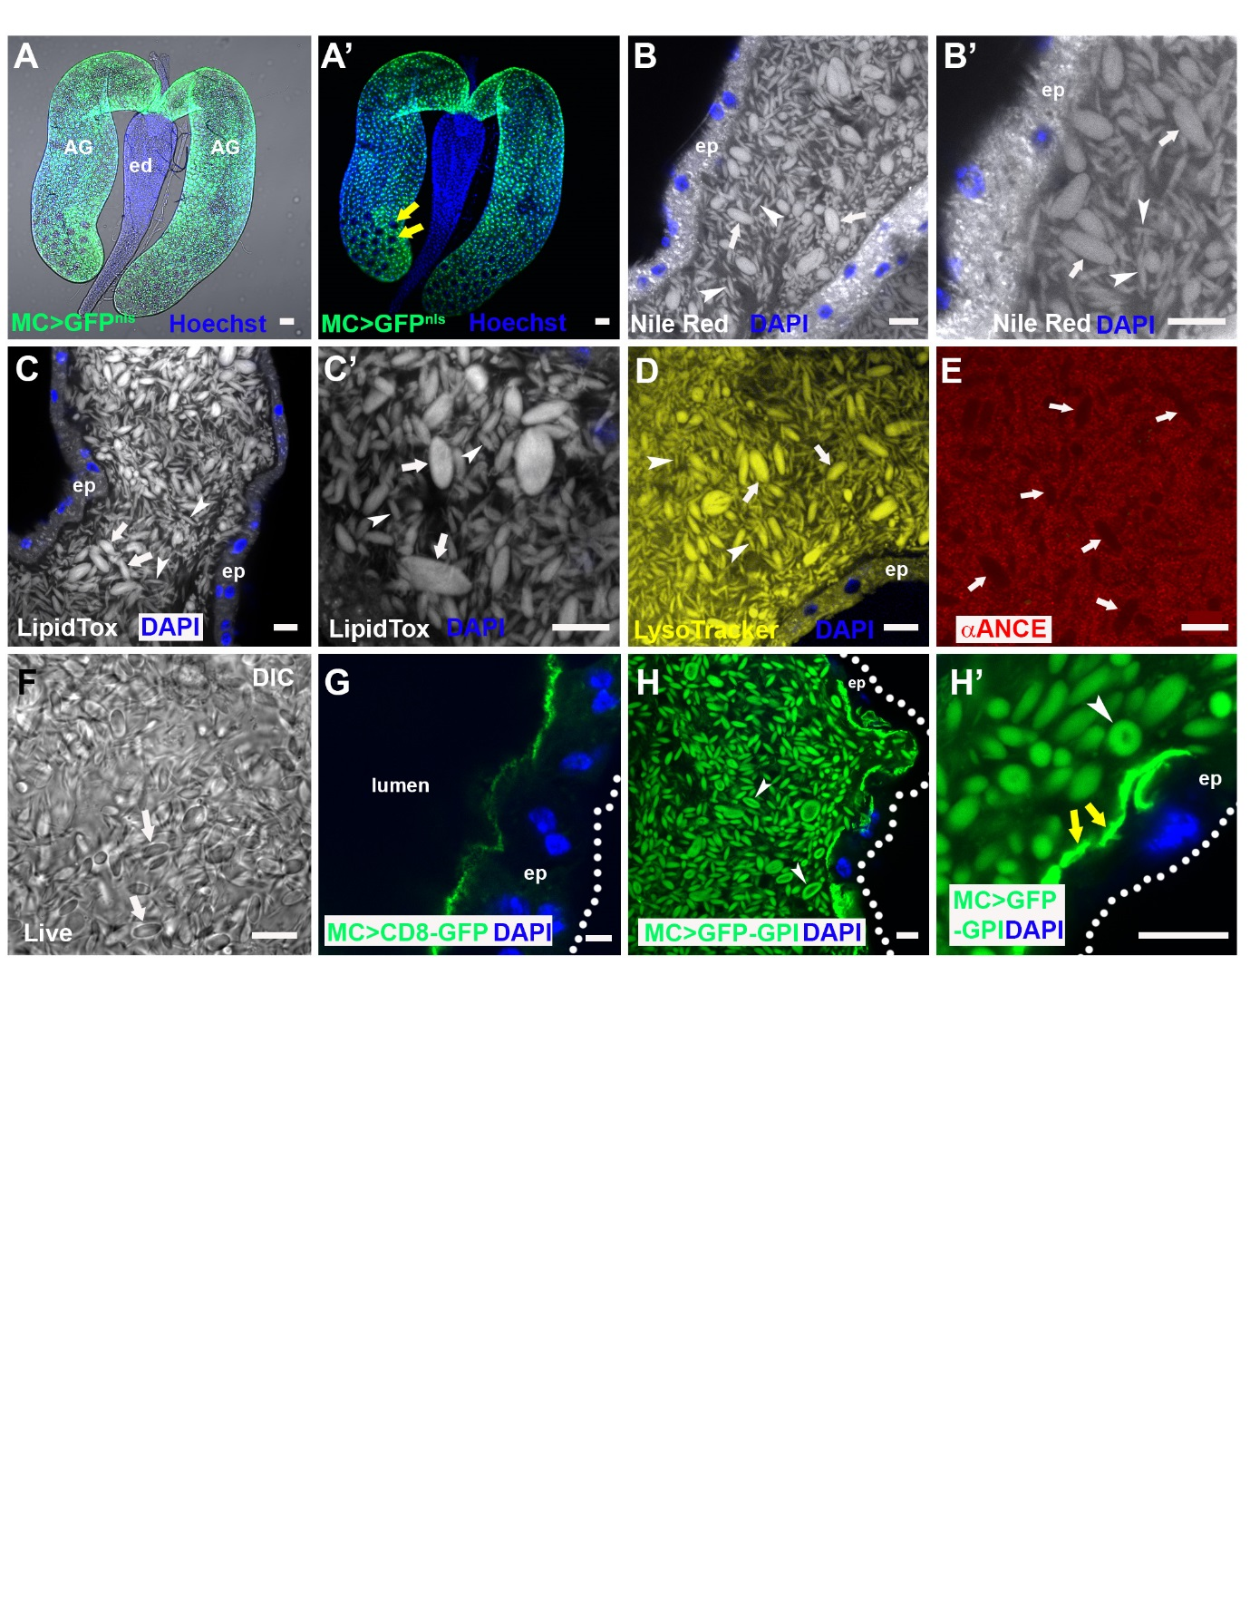

Fig. 2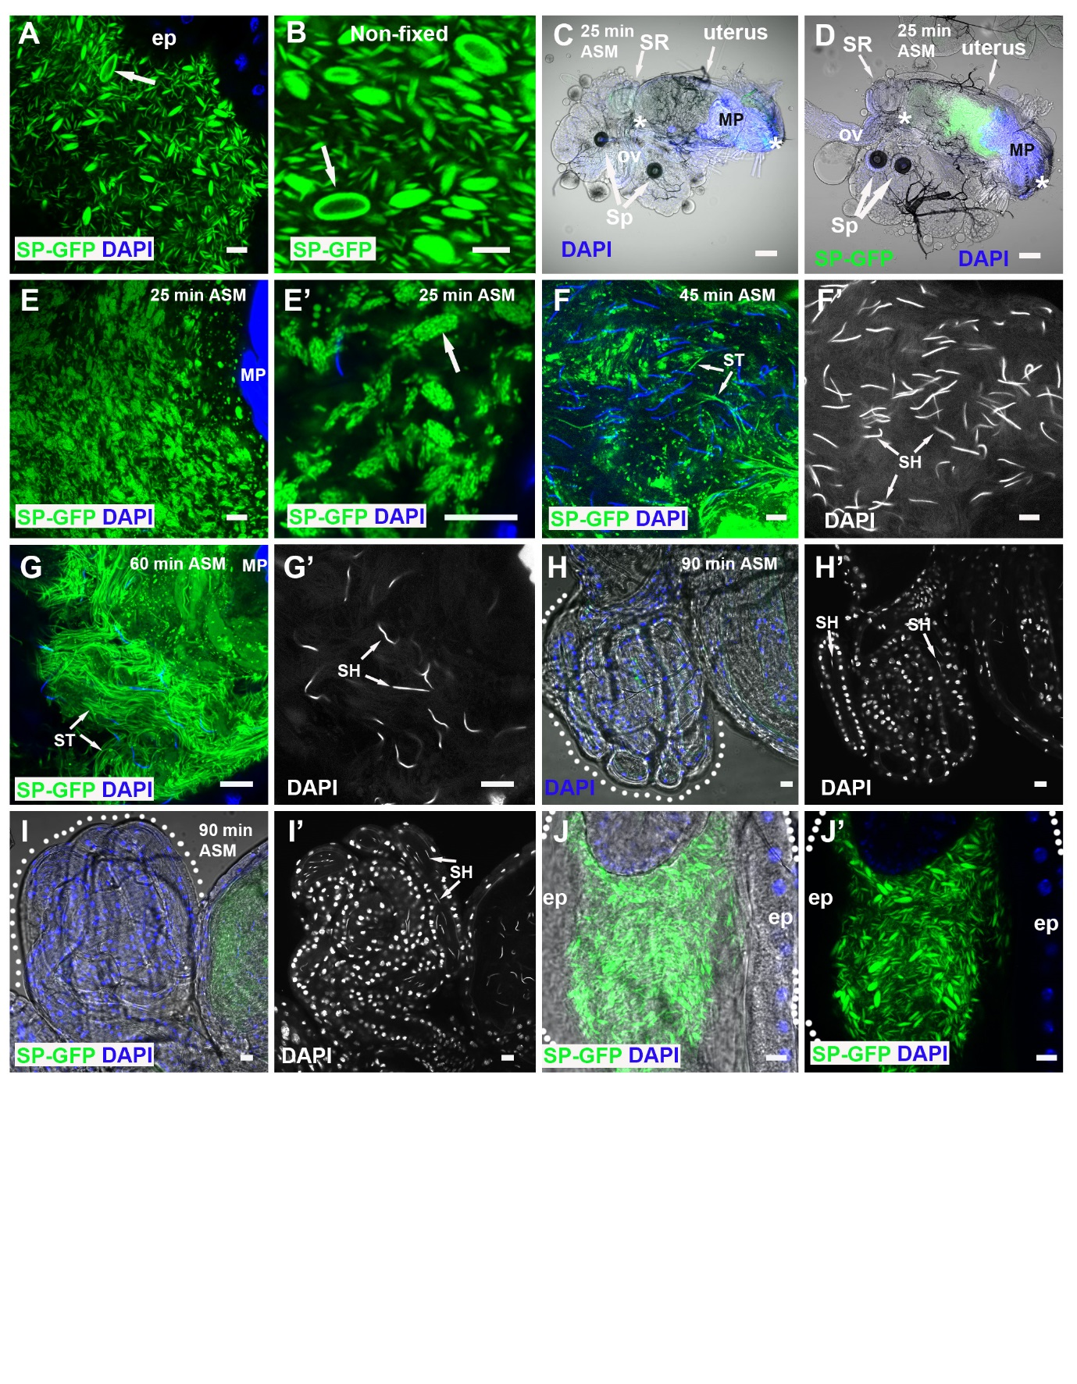

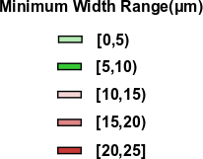
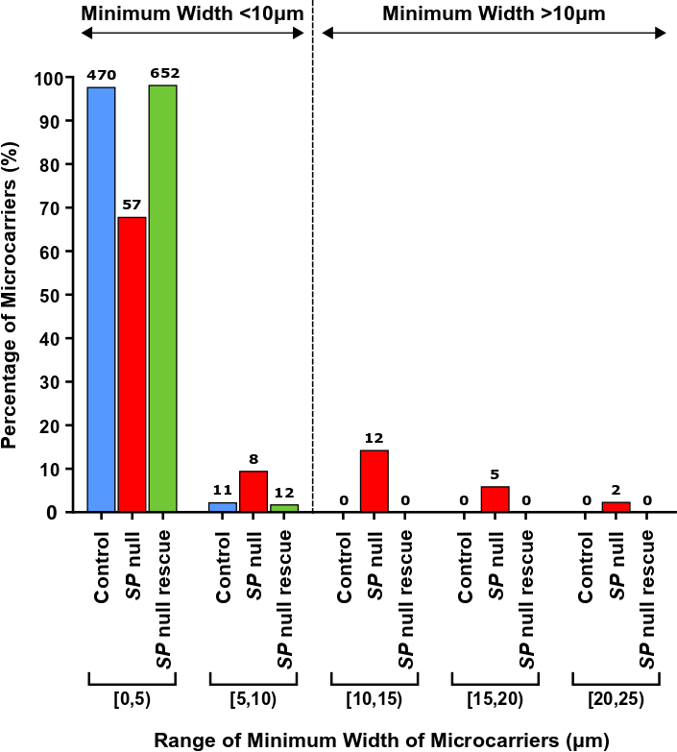
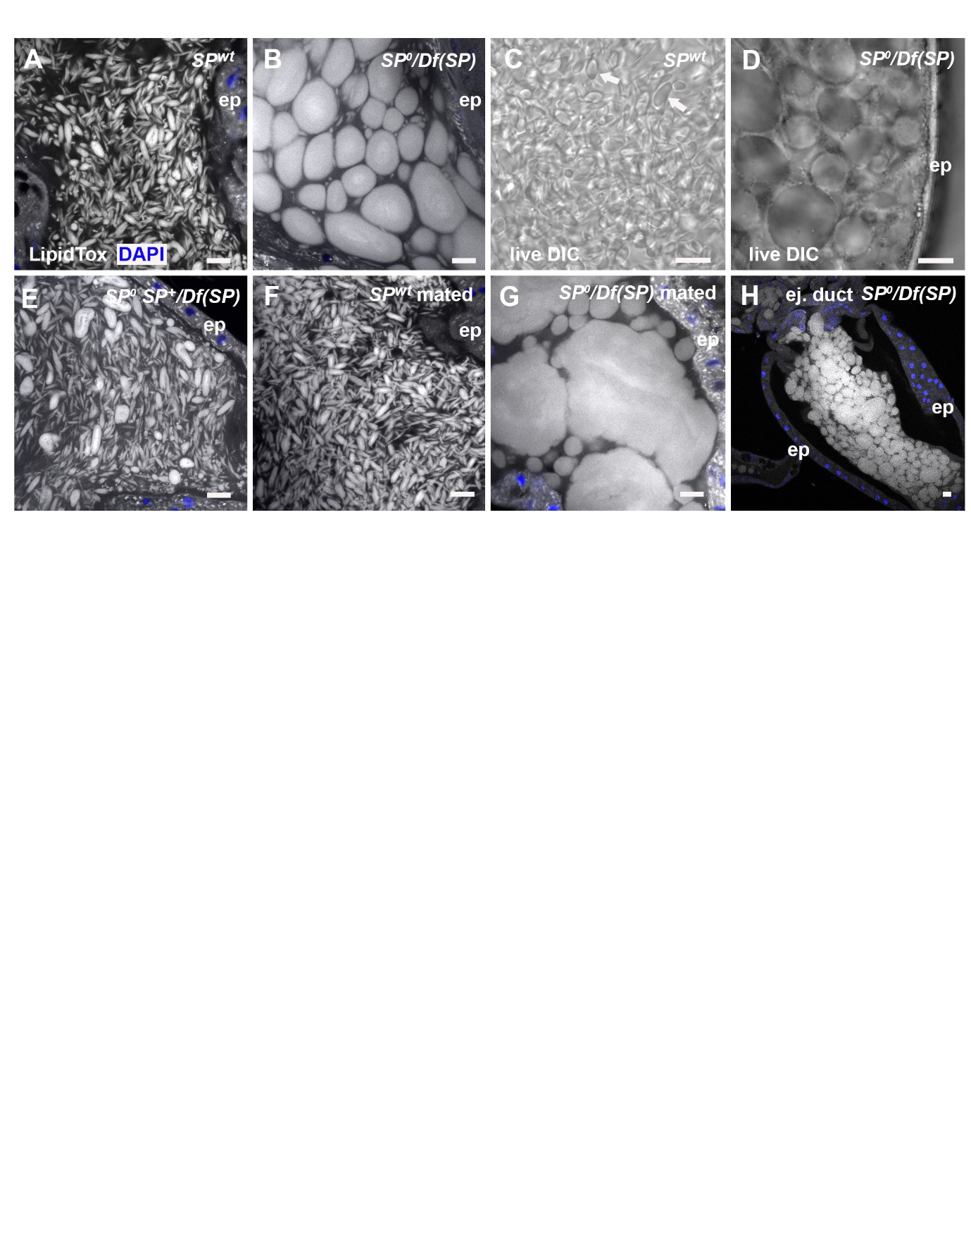
Fig. 3
J
I

Fig. 4
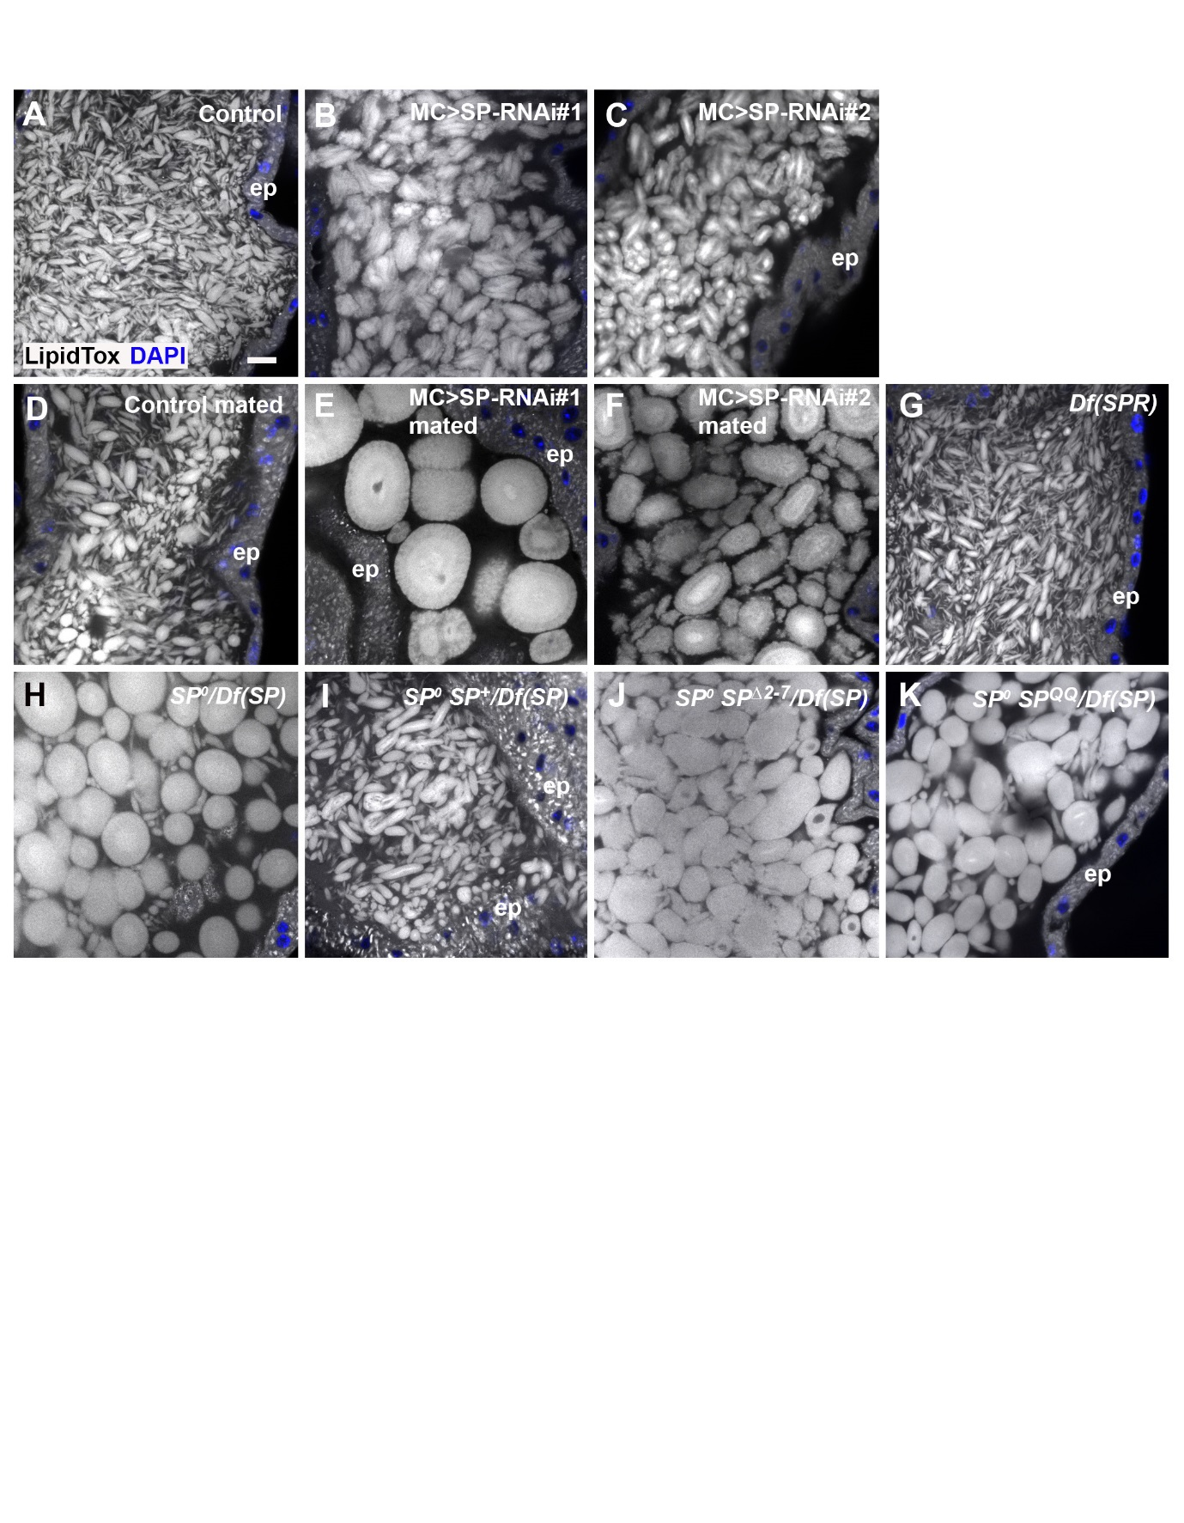

Fig. 5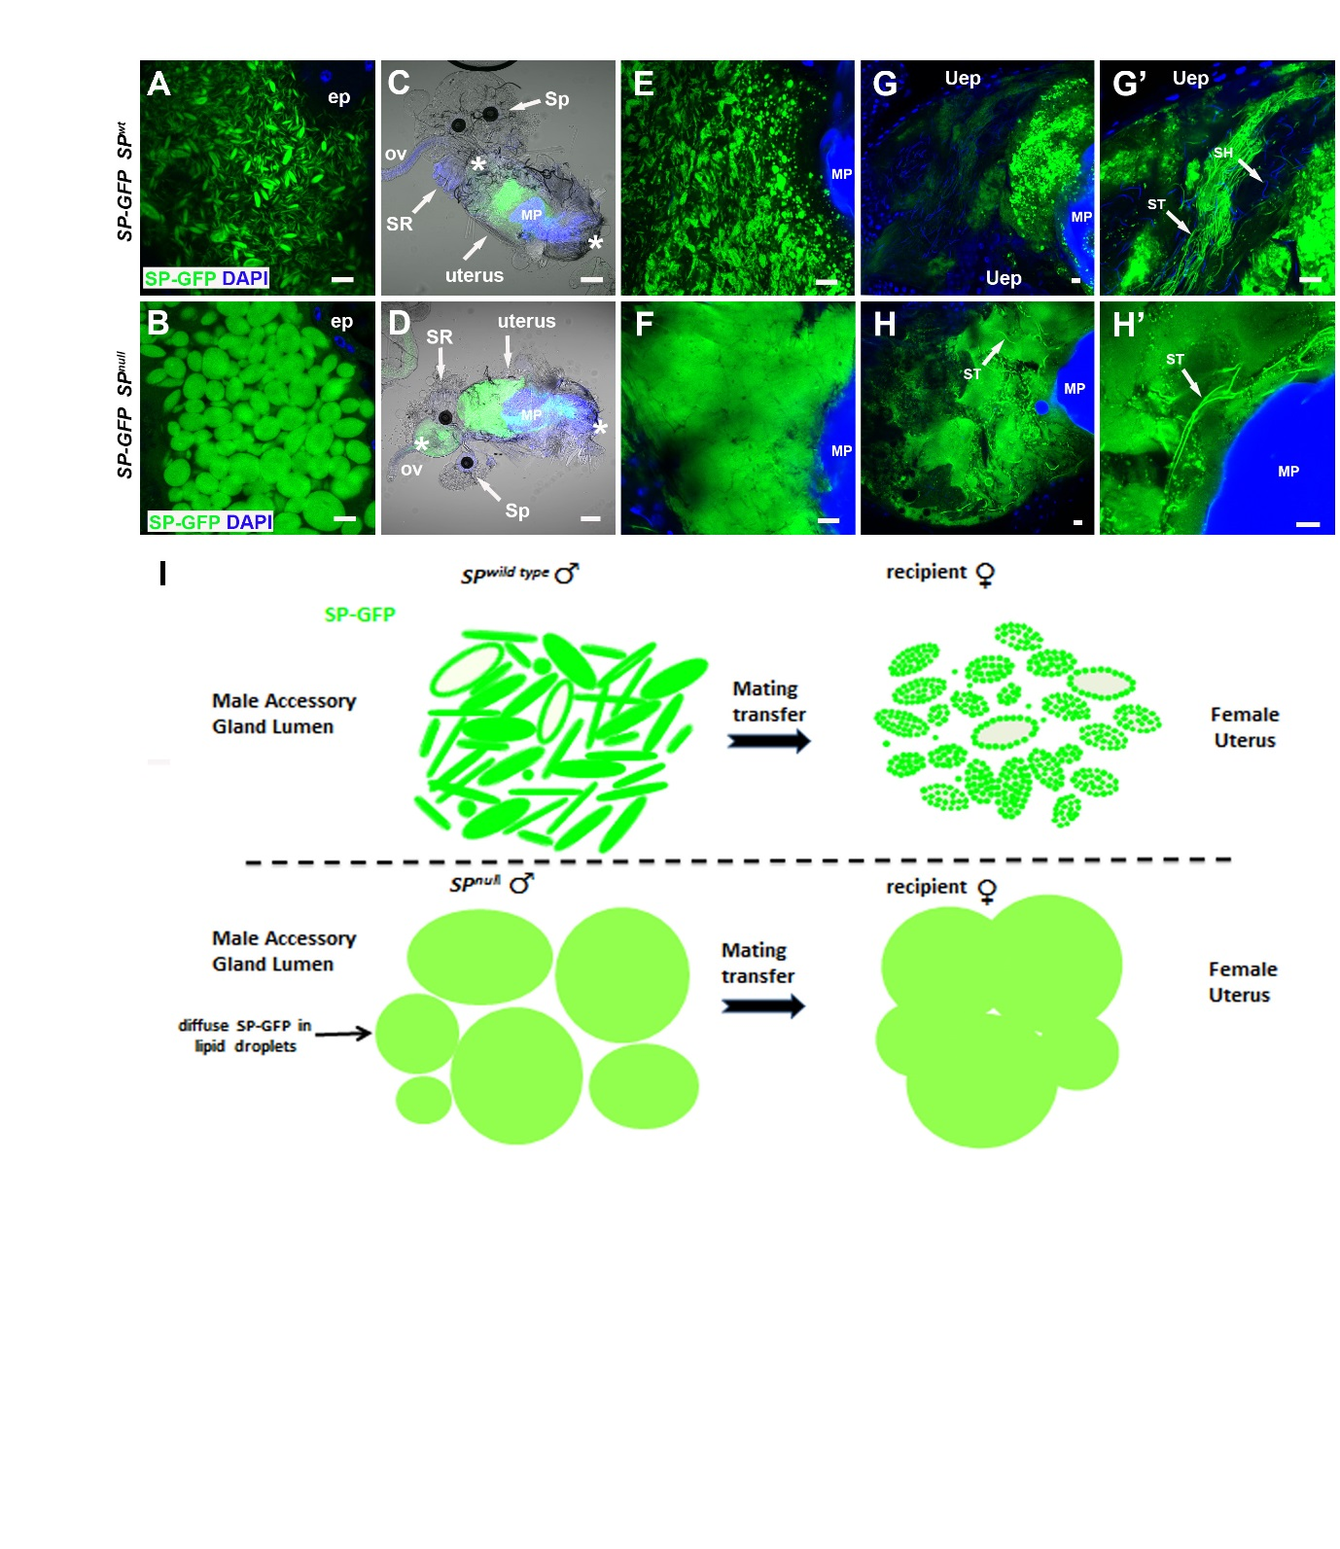

Fig. 6
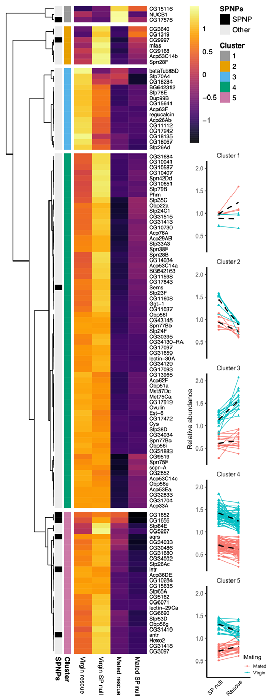
Fig. 7
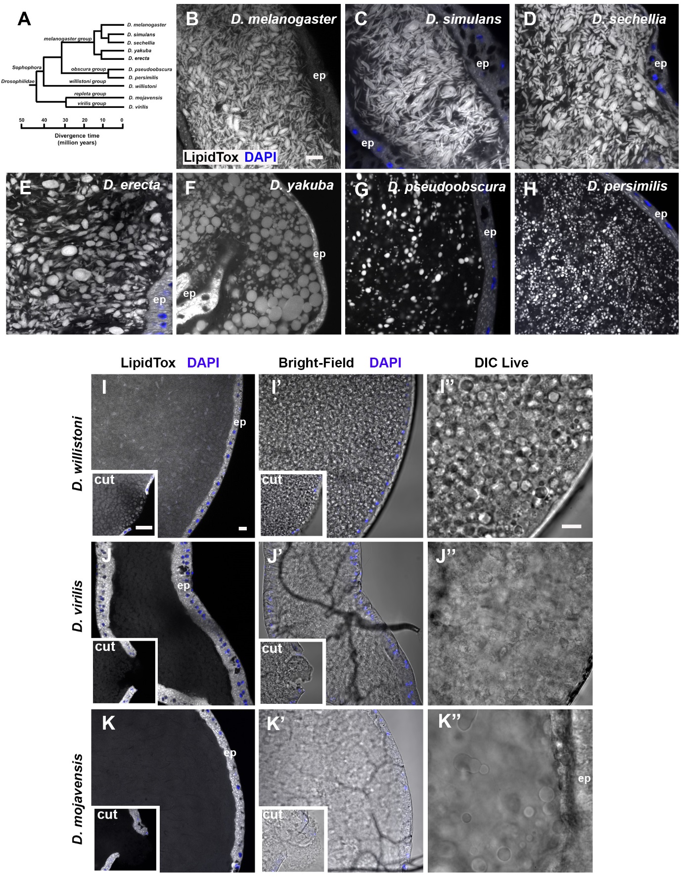

Fig. S1
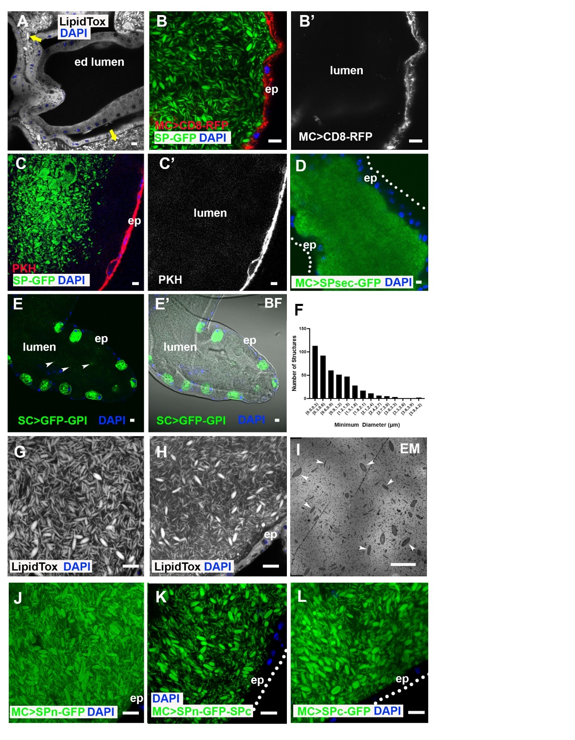

Fig. S2

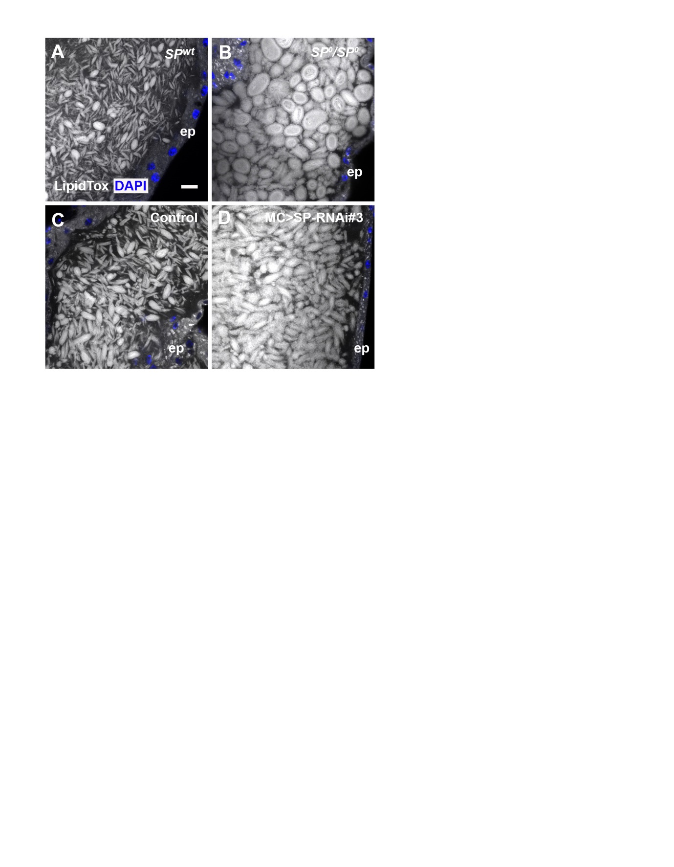
Fig. S3
C
B
A
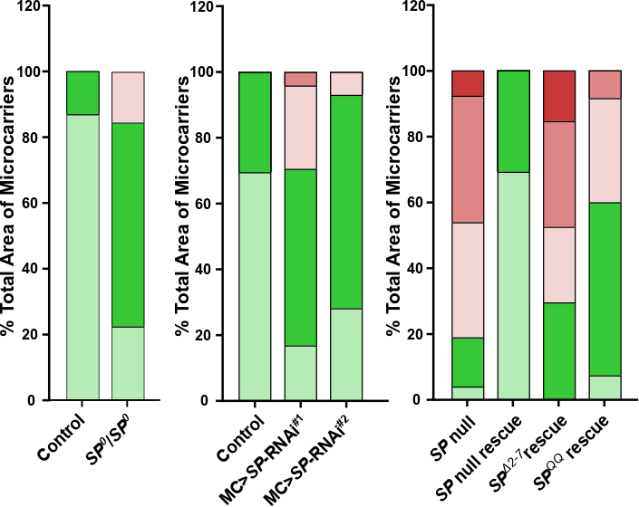

Fig. S4
A
B
Fig. S5
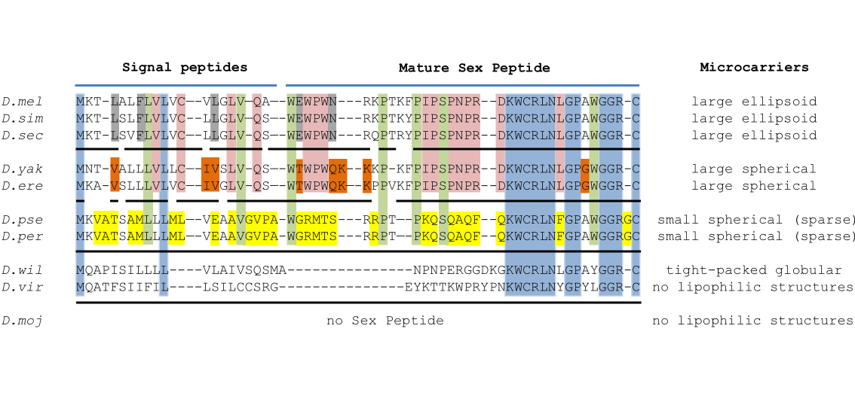

Fig. S6
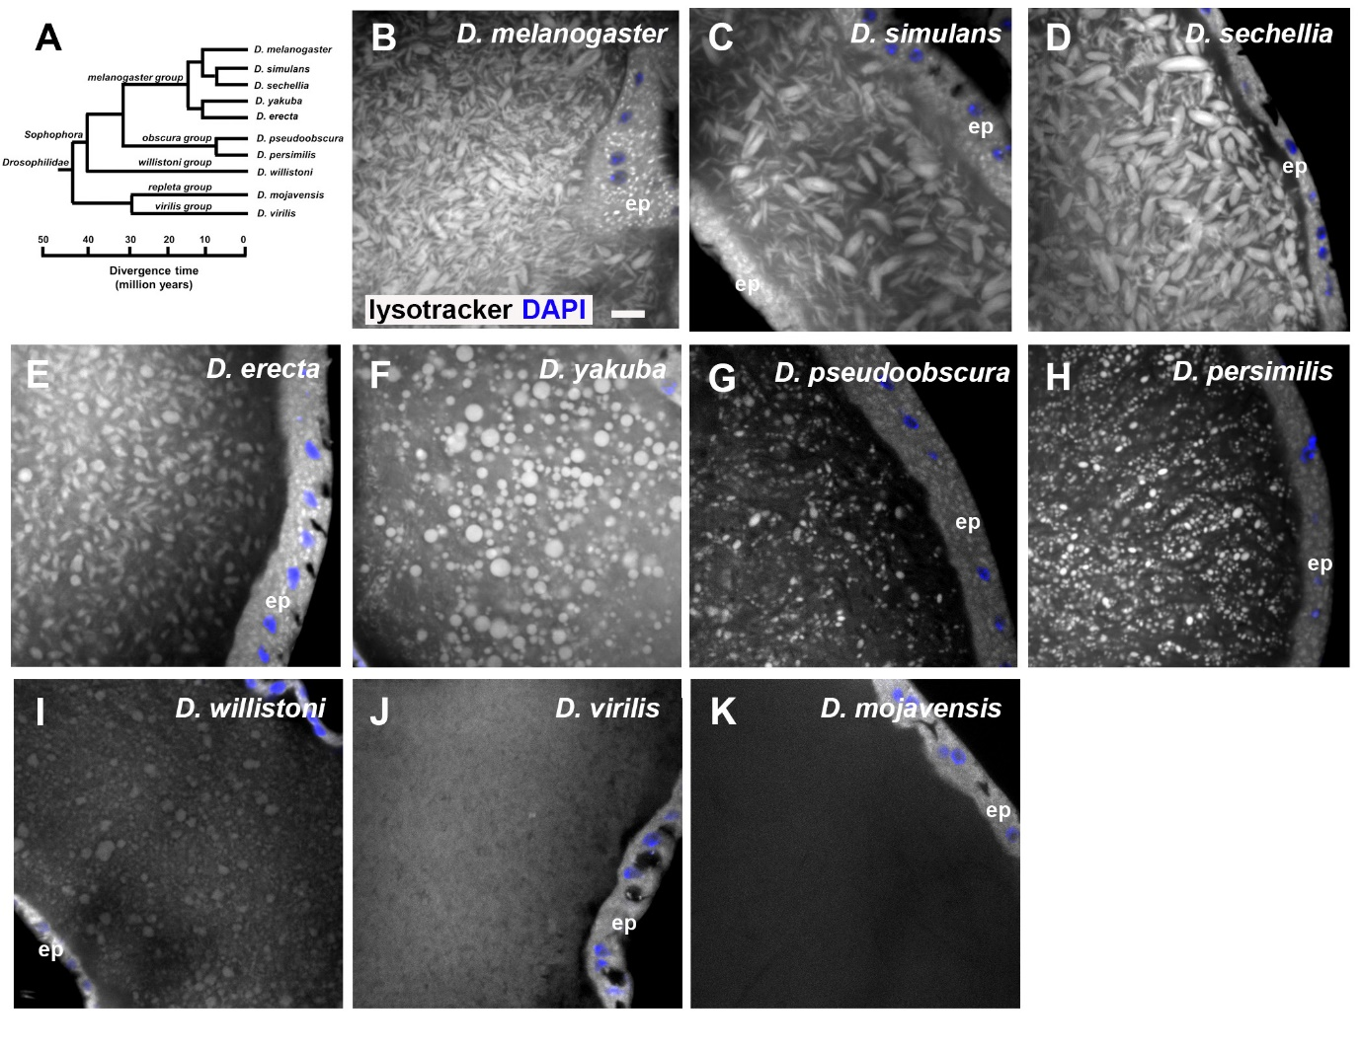

Supporting information Movie 1.
Live imaging: Z stack through distal tip of SP-GFP AG.

