Title: The effect of fire on ant assemblages does not depend on habitat openness but does select for large, gracile predators

Authors: Tom R. Bishop^{1, 2}, Andy Tomlinson¹, Travers McNeice³, Spyros Sfenthourakis⁴, Catherine L. Parr^{1, 2, 5}

Affiliations:
¹ Department of Earth, Ocean and Ecological Sciences, University of Liverpool, Liverpool, L69 3GP, UK
² Department of Zoology and Entomology, University of Pretoria, Pretoria 0002, South Africa
³ Environmental Change Institute, School of Geography, University of Oxford, Oxford, OX1 3QY, UK
⁴ Department of Biological Sciences, University of Cyprus, Nicosia, Cyprus
⁵ School of Animal, Plant and Environmental Sciences, University of the Witwatersrand, Wits, South Africa

Keywords: ants; assemblage; disturbance; fire; functional traits; habitat openness.

ABSTRACT
Ecosystems can respond in a variety of ways to the same agent of disturbance. In some contexts, fire causes large and long-lasting changes to ecological communities. In others, fire has a limited or short-lived impact on assemblages of animals and plants. Understanding why this occurs is critical if we are to manage these kinds of disturbances across the globe. A recent synthesis proposed that these seemingly idiosyncratic responses to fire can be understood in the context of habitat openness pre-disturbance. Assemblages in open habitats should respond less to a single fire event that those in closed habitats. We provide a test of this hypothesis by examining the response of ant (Hymenoptera: Formicidae) communities to large-scale fire events in three habitats of different natural canopy openness on the Peloponnese peninsula in Greece. We also test the hypothesis that assemblage responses to fire are trait dependent. Fire simplifies the physical structure of the environment, increases insolation and limits opportunities for ants to exploit herbivorous feeding strategies. Consequently, we predict that ants will face a strong environmental filter between unburnt and recently burnt plots, which will be reflected in their functional morphology. Our analysis shows that burnt plots have more individual ants, more species and an almost complete compositional change relative to unburnt plots. These changes do not depend on initial canopy openness. Rather, we suggest that openness must be interpreted relative to the study taxon; for ants, openness should be measured closer to the ground level. In our study ground level openness does not vary across the plots, which may explain the results. Furthermore, ants in burnt plots are significantly larger, have relatively longer legs, relatively longer mandibles and more elongate heads. This morphotype fits with our prediction of ants that can move and feed successfully in the burnt micro landscape. Ultimately, more work is needed to fully explore the relationship between habitat openness and the response to fire. Our results showing a filtered set of ant morphologies in burnt environments suggests that ant traits may offer a further way forward to understand the faunal response to fire and disturbance in general.
Introduction
Disturbance is a key determinant of diversity and temporal dynamics in natural ecosystems (Connell 1978). Acting across scales and varying in frequency and magnitude, disturbances simplify habitat structure through the removal of biomass (Grime 1979). Consequently, disturbances can alter microclimate conditions, resource availability, and interactions between species (Andersen 2019). Fire is a major agent of disturbance and is a dominant consumer across a large proportion of the Earth’s surface (Bond & Keeley 2005). Fire regimes control the origin and maintenance of several major biomes, notably savannas and C₄ grasslands (Bond, Woodward & Midgley 2005). By consuming biomass, fire strongly alters vegetation structure, carbon storage and the functioning of communities (Bond & Keeley 2005). Climate change is predicted to alter the timing, severity and frequency of fire events (Moritz et al. 2012; Fonseca et al. 2019) and, in this context, it is critical that we understand how and why communities of organisms respond to burning.
To date, a general understanding of how animal communities respond to single fire events has eluded us. This is due to two issues. The first is that animal communities appear to respond to the same kinds of fire event in idiosyncratic ways. Some animal communities exhibit high resilience and show little change in response to burning (Parr et al. 2004; Davies et al. 2012; Andersen et al. 2014), while others display strong responses and exhibit long-term legacy effects (Cochrane et al. 1999; Paolucci et al. 2017). Habitat type partly explains this idiosyncrasy: in ecosystems that have not evolved with fire, or where fires are infrequent, the response of animals to burning tends to be strong. For example, in the Amazon rainforest, which rarely burns naturally, animal communities typically experience large reductions in their biomass and diversity following recurrent fires (Barlow & Peres 2004b; Barlow & Peres 2004a; Paolucci et al. 2017). In African savannas, on the other hand, whose existence is maintained by frequent natural fires (Bond, Woodward & Midgley 2005), animal communities are often resilient to a variety of burning regimes (Parr et al. 2004; Davies et al. 2012). Despite this somewhat intuitive trend, however, there is still large variation in the response of animal communities to fire within similar habitat types (Nimmo et al. 2014; Vasconcelos, Maravalhas & Cornelissen 2017). For example, Australian ant faunas are highly resilient to fire (Andersen et al. 2014), whereas those in Brazilian savannas appear to be much more sensitive to fire events and also variation in fire regimes (Maravalhas & Vasconcelos 2014).
Recently, Andersen (2019) presented a new conceptual framework that attempts to reconcile the apparent idiosyncratic responses of animals to fire. Andersen (2019) proposes that the degree of habitat openness mediates the effect of disturbances, as the main impact of disturbance (including that of fire) is to “open up” a given habitat. It follows that the response of animals to fire events depends on the relative change in habitat openness. A fire in a forest can convert a closed habitat into a completely open one, whereas a fire in a grassland or a savanna does relatively little to affect the openness of the habitat. Conversely, the suppression of fire in savannas results in habitat encroachment, and parallel cascading effects on the associated fauna (Abreu et al. 2017). Consequently, Andersen’s (2019) framework may allow us to explain not only variation in the faunal response to fire between broad habitat types, but also within them.
The second issue that limits our general understanding of how animal communities respond to fire is that the animal literature is dominated by a taxonomic approach. Most research has focused on how animal species richness, abundance and taxonomic composition are affected by fire (e.g. Vasconcelos, Maravalhas & Cornelissen 2017). Relatively little attention has been paid to alternative measures of diversity, such as functional diversity. The argument for assessing functional diversity or trait change is that species respond to their environment depending on their traits, not their names (Violle et al. 2014). For example, if species’ responses to fire are dependent on the traits they possess, a focus on taxonomic metrics may, or may not, detect change. The answer will depend on the distribution and uniqueness of traits within the available species pool. Within the fire literature, available data, suggests that large taxonomic changes following fires can have variable effects on functional trait composition. Moretti et al. (2009) found that bee communities were reorganised in Israeli pine forest following fire events, but that the functional traits of these new communities remained the same as the unburnt ones. In contrast, Arnan et al. (2013) found that fires increased ant functional diversity across a range of Spanish forests and shrublands. Clearly, part of the reason why animal responses to fire appear so idiosyncratic is that different answers are arrived at when viewing fire-induced changes with a taxonomic perspective compared to a functional perspective. Species identities may diverge following a disturbance, but the functional composition of the communities may converge (Fukami et al. 2005; Moretti et al. 2009). Andersen’s (2019) framework touches on this issue but is restricted to discussion of a categorical functional classification on ants. Under this classification, for example, ant species are split into functional groups describing their broad habitat and diet preferences, and tendency for aggressive behaviour. Some of these groups are also strongly correlated with ant taxonomy (i.e. “dominant Dolichoderinae” or “subordinate Camponotini”). These groups are not necessarily generalisable across the globe or to other animal taxa (Lessard 2019).
In this paper, we explore both topics, habitat openness and functional traits, by examining the response of ant taxonomic and functional diversity to a single major fire event. Ants (Hymenoptera: Formicidae) are a popular taxon for the study of fire effects (Andersen 2019). As a group, they are dominant and widespread, occurring on all continents apart from Antarctica (Fisher 2010). Their high biomass and abundance is apparent in most systems within which they occur; for example, they constitute up to 60% of all ground-active invertebrates in the tropics (Tuma, Eggleton & Fayle 2020). They are diverse (an estimated 30,000 species, Ward 2010), act as predators, scavengers and herbivores, and are known to perform a number of ecosystem functions including seed dispersal (Lengyel et al. 2010), soil bioturbation (Del Toro, Ribbons & Ellison 2015), and scavenging (Griffiths et al. 2018). A recent meta-analysis by Vasconcelos, Maravalhas and Cornelissen (2017) of fire effects on ants illustrates that most studies have focused at the taxonomic level (but see Arnan et al. 2013), so there remains a need to better understand the extent to which fires might also modify ant functional diversity and composition – especially as a trait-based approach may well provide greater clarity on why faunal response to fire appear varied.
We present data opportunistically sampled following large fires in the Peloponnese region of Greece in 2007. We assessed whether ant diversity, taxonomic composition and functional composition were affected a year after the fires. Specifically, we aimed (1) to determine whether these responses depended on the degree of habitat openness before the fires, and (2) to identify candidate ant functional traits that respond to fire events. Following Andersen (2019), we predicted that ant assemblages in habitats which are more closed pre-fire will experience greater taxonomic and functional trait change following burning. Specifically, we predict that the two forest habitats we sampled here will change relatively more than the shrubland maquis habitat, which is naturally more open (Table 1). Immediately post-fire, the environment in Mediterranean forests and scrubland is open and light: the ground is hotter and drier, and less complex as the fire has consumed plant biomass. We therefore predict that ant species with traits well-adapted for an open and structurally simplified habitat, and for coping with a hotter microclimate will dominate in these post-fire landscapes (Sommer & Wehner 2012; Gibb & Parr 2013). Additionally, because vegetation regrowth is limited to seedlings, some forbs, and resprouting, and seed harvesting and liquid carbohydrate foraging options are limited (especially because almost no regrowth has taken place in our plots, Table 1), we predict that ants would have traits associated with predation and scavenging, rather than with liquid feeding (Gronenberg et al. 1997; Larabee & Suarez 2014).
Materials and Methods
Study site
The study sites were located in the northwestern Peloponnese, Greece, from 38°02’19’’ to 38°19’21’’ N and 21°50’43’’ to 22°09’00’’ E, Fig. 1). This area has a Mediterranean climate with cool, wet winters and hot, dry summers. Daily summer temperatures range from 26°C to 30°C and annual rainfall averages 778 mm (Hellenic National Meteorological Service: Tripolis Meteorological Station). Major fires spread through the Peloponnese region during the summer of 2007, burning approximately 667,000 acres of land (European Forest Fires Information System, 2007). We took advantage of these fires to sample burnt and adjacent unburnt habitats one-year post-fire; the sampled areas burnt between the 25th and 27th of July 2007.
We sampled in three habitats (Fig. 1): pine forest (Pinus halepensis with an understorey of scrubs, mostly Quercus coccifera, Pistacia lentiscus and Arbutus unedo, elevation from 170 to 180 m a.s.l.), maquis (Mediterranean scrubland, consisting mostly of Quercus coccifera and Pistacia lentiscus, and sparsely with Arbutus unedo, Calicotome villosa, Cistus spp., Thymus capitatus and Sarcopoterium spinosum, elevation from 730 to 830 m a.s.l.) and fir forest (Abies cephalonica with an understorey of ferns only, elevation from 870 to 1,180 m a.s.l.). All trees in the burnt plots had been killed by the fires and were dead when sampling took place. The landscape-scale nature of Mediterranean fires means that true replication of fire treatments within each habitat is rarely possible (Parr & Chown 2003); this was the case in this study where fire treatment replicates for the different habitat types were located within the bounds of the same fire. Nevertheless, because the fire was large in extent, it was possible to ensure that sampling grids were at least 100 m apart.

Ant sampling
We sampled epigaeic ants from the three different habitat types in both unburnt and burnt plots in June 2008 using pitfall traps. In each habitat we established three plots in burnt areas and three plots in unburnt areas. At each plot 12 pitfall traps were arranged in a 2 by 6 grid. Each trap was separated by 10 m. Each plot was placed at least 50 m away from major disturbances, such as roads, and at least 100 m away from neighbouring plots in the same habitat and burn category. While 100 m appears a relatively short distance, ample evidence suggests that the most ant species rarely forage beyond 40 m from their nest (Gordon 1995; Parr et al. 2007; Nyamukondiwa & Addison 2014; Hogg et al. 2018). Consequently, we do not expect that ant communities in separate plots will be interacting with each other, and we consider than independent replicates. Unburnt and burnt plots of the same habitat type were separated by 13.3-23.9 km. Overall, distances between sites ranged between 5.9-35.4 km. In total, 18 plots were sampled (3 per habitat X 3 habitats X 2 burn categories = 18). Pitfall traps were 70 mm in diameter and 95 mm in depth. We filled traps with 50 ml of propylene glycol which acted as a preservative. Traps were open for seven days and seven nights. All samples were taken to the laboratory for identification. Note that our pitfall trapping method likely under sampled the fauna that is strongly associated with the forest canopy (e.g. Temnothorax species). Our goal was to sample the ground fauna, but this bias is highly unlikely to alter the direction of our findings (see results) given that the forest canopy was completely destroyed by the fires and had not recovered.

Environmental data
We used 36 1 m² quadrats, randomly placed at least 10 m from each other, in each habitat and burn combination to estimate percentage bare ground cover. We also visually estimated canopy cover percentage from each of these quadrats. These environmental data were not taken from the exact plots as the pitfall traps but were from the same areas.

Functional traits
We measured four morphological traits which link to the diet and habitat use of ants (Bishop et al. 2015; Parr et al. 2017):
1) Weber’s length. This is a proxy of total body size in ants and covers the longest distance on the mesosoma, from the anterodorsal margin of the pronotum to the posteroventral margin of the propodeum (Brown 1953). Body size relates to many aspects of ant ecology including metabolism (Shik et al. 2012), prey size selection (Traniello 1987) and habitat use where larger ants have been found to select simpler microhabitats (Gibb & Parr 2013).
2) Relative leg length. We summed hind tibia and hind femur lengths and divided them by Weber’s length. Relatively longer legs correlate with a preference for simpler habitats (Gibb & Parr 2013), probably to allow rapid movement across planar surfaces, and are also linked to thermophilic behaviour whereby long legs raise ant bodies out of superheated boundary air layers (Sommer & Wehner 2012).
3) Relative mandible size. We measured this as mandible length, the distance from insertion to tip, divided by the head width across the eyes. Predatory specialists tend to have relatively long mandibles (Hölldobler & Wilson 1990; Larabee & Suarez 2014).
4) Head shape. This is measured as the ratio of head width to head length. Perfectly round heads have a value of one, whilst elongate heads have a value of less than one and wide heads have a value of greater than one. This measure relates directly to the biomechanics of mandible closure. Space for long, fast muscle fibres is maximised in an elongate head. Space for short, powerful muscle fibres is maximised in a wide or round head (Gronenberg et al. 1997). Consequently, head shape is linked to the use of the mandibles for fast (trap jaws, predatory behaviour) or powerful (leaf cutting, seed milling) ecological strategies.
We measured at least six minor worker individuals from each species; this sample size is capable of producing robust species trait means (Gaudard, Robertson & Bishop 2019). We measured all traits to 0.01 mm using an ocular micrometer fitted to a Leica microscope under the highest possible magnification that allowed the entire structure being measured to fit within the field of view.

Statistical methods
All data manipulation and analyses took place in the R statistical environment (R Core Team 2016).

Species richness, abundance and evenness
We counted the number of species and individuals occurring in each plot. We calculated Pielou’s index of evenness (J) which is the Shannon diversity index divided by the log number of species in a sample (Magurran & McGill 2011). We used two-way ANOVA to test for differences in species richness, log transformed abundance and z-transformed evenness (scaled and centred) between habitat types and burn category. For richness, we used Poisson errors with a log-link function. We also included an interaction between habitat type and burn category. For the ANOVA analyses, if significant, we used Tukey’s honest significant differences (HSD) to show which individual groups were different from each other.

Functional richness
We interpreted functional diversity as a multivariate space where each axis was a trait (Villéger, Mason & Mouillot 2008; Blonder et al. 2018). We log10 transformed, centred and scaled the ant functional traits. We then used the kernel density estimation method developed by Blonder et al. (2014) in the R package hypervolume (Blonder et al. 2018) to estimate the volume of multivariate space that each ant assemblage occupied. We used 6500 samples per point, a bandwidth of 0.459, a hypervolume boundary delineation of 3 standard deviations and used a 95% probability threshold (Blonder et al. 2018). These are all the default settings except for the number of samples per point, which we set at 1.5 times the default for a dataset of this size. We estimated hypervolumes for each plot twice: with and without a species relative abundance weighting.

Turnover dissimilarity
To quantify species and functional turnover between plots we used Simpson dissimilarity (Baselga 2010; Baselga 2013). This dissimilarity measure is independent of richness effects and is a measure of true turnover (Baselga 2010). This is an important property in the context of this study as there are strong richness and abundances gradients between the habitat types and burn categories. Simpson’s dissimilarity varies between 0 and 1 where 0 indicates that two plots are identical in their species or functional composition, with respect to turnover, and 1 indicates that they have completely different sets of species. Simpson’s dissimilarity is defined as:
$$β_{sim}=\frac{min⁡(b,c)}{a+min⁡(b,c)}$$
Where a is the number of species shared by two plots, b is the number of species unique to the first site and c is the number of species unique to the second plot (Baselga 2010). For species turnover we used this equation and a version that incorporates species abundance changes (Baselga 2013). For functional turnover, we calculated shared or unique volumes between pairs of plots in multivariate space and used these values as inputs to the Simpson’s equation (above). We calculated functional turnover separately, but using the same equation, for both the occurrence and abundance-weighted hypervolumes. We used the beta.pair and bray.pair functions in the betapart package in R (Baselga & Orme 2012) to calculate species turnover. We used the hypervolume_set function in the hypervolume package (Blonder et al. 2018) to calculate the amount of shared and unique volume between pairs of occurrence or abundance-weighted hypervolumes and then manually calculated the functional analogue of Simpson’s dissimilarity.

Analysing turnover
We used permutational MANOVA (hereafter, PERMANOVA, Anderson 2001) to test for differences in compositional turnover between habitat types and burn categories using the occurrence and abundance weighted dissimilarities for species and functional composition. We included an interaction between habitat type and burn category and used 9,999 permutations to generate p-values. We used the adonis function in the vegan package (Okansen et al. 2016) to run the PERMANOVAs. We also tested the homogeneity of multivariate group dispersions using the betadisper function of the vegan package; this procedure tests whether different groups have similar multivariate variance around their centroids, i.e. if one group of plots display more variability in composition than another group. We used principal coordinate analysis (PCoA) to visualise the turnover dissimilarities between plots.
We calculated the average Simpson’s turnover dissimilarity between burnt and unburnt plots of each habitat for both taxonomic and functional compositions, and for both occurrence and abundance weightings. This allows us to assess whether the composition of particular habitats changed more than others following burning – we do not run any formal post-hoc versions of the PERMANOVA analyses.
We calculated community weighted means (CWM, Lavorel et al. 2008) of each trait to test whether particular trait values were associated with particular burn categories and habitat types. We used two-way ANOVA to test for differences in the CWMs between habitat and burn categories. We calculated CWMs using both an occurrence and an abundance weighting. For the occurrence weighting, each species in a plot is weighted equally. For the abundance weighting, each species is weighted by its relative abundance. Again, we used Tukey HSD to determine which pairs of plots were different from each other if the original ANOVA was significant.
Finally, we calculated kernel density estimates of the trait distributions in unburnt and burnt plots separately so that we could visualise whether particular trait values were missing from either category, or whether they were simply at low frequency or abundance. We selected the trait values that were present in each burn category, weighted them by species relative abundance in each category, and then calculated kernel density estimates before plotting.

Results
Environmental characteristics
Pine forest and fir forest both had high canopy cover. Maquis had low canopy cover (Table 1). Canopy cover was always lower in burnt compared with unburnt plots (Table 1). The difference in canopy cover between burnt and unburnt plots, however, was much less in maquis than in the two forest habitats. This is because maquis is a relatively open environment to begin with. Burnt plots also had much more bare ground than unburnt plots, even a year post-fire (Table 1).

Species richness, abundance and evenness
We collected a total of 65 ant species and 9416 individual ants. The most abundant genera were Cataglyphis (overall abundance of 2999), Camponotus (1595), Myrmica (1432) and Crematogaster (890).
Species richness was higher in burnt than in unburnt plots (z = -2.61, p < 0.01, Fig. 2a), with an average of eight more species being present on burnt plots. There were fewer species in pine forest than in the other habitats (z = -3.52, p < 0.01, Fig. 2a). We did not find evidence for an interaction between burn category and habitat type (pine forest: z = -0.67, p = 0.5; pine meadow: z = -0.62, p = 0.53; fir forest was classed as the intercept for contrasts).
Abundance was also higher in burnt plots (F_{1, 12} = 281.19, p < 0.01, Fig. 2b) with an average of 841 more ant workers found at burnt plots compared with unburnt plots. Abundance differed across all three habitat types (F_{2, 12} = 61.65, p < 0.01, Fig. 2b), with pine forest having fewer individuals than the other two habitats. Furthermore, the effect of burn category on abundance was dependent on habitat type (F_{2, 12} = 15.43, p < 0.01, Fig. 2b) with the difference between unburnt and burnt plots being smaller in pine forest than maquis and fir forest (Tukey HSD, p < 0.01).
Burnt plots were to be less even in their abundance than unburnt plots (F_{1, 12} = 8.74, p = 0.01, Fig. 2c) but there was no effect of habitat (F_{2, 12} = 2.87, p = 0.09, Fig. 2c) or any interaction (F_{2, 12} = 0.18, p = 0.84, Fig. 2c). The difference in evenness between burnt and unburnt plots was relatively small, however, with the average difference between the categories being 0.08 on a scale that ranges from 0 (completely uneven) to 1 (completely even).

Species composition
There was a large difference in the occurrences and abundances of species between the burn categories with most species found only on either burnt or unburnt plots, but not both (Fig. 3). The PERMANOVA analyses showed that burn category explained the most variance in occurrence-weighted (46%) and abundance-weighted (46%) species turnover (Fig. 4a, b). Habitat type (18% and 14% for occurrence and abundance-weighted respectively), and the interaction between burn category and habitat type (13% and 12%) explained much less. All factors were significant in the PERMANOVA at p < 0.05.
For occurrence-weighted species turnover, burnt plots showed significantly less multivariate variance, and appeared homogenised, relative to unburnt plots (p < 0.01, average distance to medians: burnt = 0.19, unburnt = 0.38, Fig. 4a). This was not the case when considering abundance-weighted turnover where both burnt and unburnt plots displayed statistically similar multivariate variation (p = 0.059, average distance to medians: burnt = 0.27, unburnt = 0.39, Fig. 4b).

Functional composition
Like species turnover, PERMANOVA showed that burn category explained the most variation in functional turnover for occurrence (30%, Fig. 4c) and abundance-weighted (49%, Fig. 4d) analyses. Habitat type (22% and 23%) and the interaction between habitat type and burn category (16% and 0.6%) explained less. All factors were significant in the PERMANOVA at p < 0.05 except for the interaction term in the abundance-weighted analysis.
For occurrence-weighted functional turnover burnt plots showed significantly less variance and were homogenised relative to unburnt plots (p < 0.01, average distance to medians: burnt = 0.12, unburnt = 0.25). For abundance-weighted turnover, burnt and unburnt plots displayed similar levels of multivariate variance (p = 0.14, average distance to medians: burnt = 0.2, unburnt = 0.27).
We found mixed results when looking at occurrence-weighted trait means (Fig. 5). Weber’s length did not differ across habitat type or burn category (p > 0.05), but relative leg length was longer in burnt plots and in pine forest relative to fir forest. Relative mandible length was longer in burnt plots (p < 0.01) and this difference was even greater in pine forest than in the other habitats (interaction: p < 0.01). Head shape was more elongate in burnt plots than in unburnt plots (p < 0.01).
In contrast, for abundance-weighted trait means, Weber’s length, relative leg length and relative mandible length were all higher (p < 0.01) in burnt plots compared with unburnt plots (Fig. 5). Head shape was more elongate in burnt plots (p < 0.01).
Discussion
Our data show a clear response of Mediterranean ant communities to fire in all habitats. After burning, species richness was 63% higher, abundance was 695% higher, and assemblage composition almost completely turned over. Furthermore, post-fire communities were characterised by large, long legged species with traits associated with predatory feeding behaviours (Gronenberg et al. 1997; Larabee & Suarez 2014). The magnitude of these fire-driven changes, however, did not depend on habitat type. Consequently, we do not find support, in this context, for Andersen’s (2019) openness-faunal response framework. While fire opened up the habitats we studied, and changed the ant communities, this community-level change did not depend on the relative change in openness following fire. The trait changes we observe, however, clearly indicate the ecological strategies that either allow new ant species to colonise, or existing ones to rapidly increase in abundance, in the post-fire micro-landscape. Importantly, our results show clear directional effects and significance, despite the relatively small sample size imposed by logistical constraints.
Notably, we see large increases in species richness (Fig. 2a) and worker abundance (Fig. 2b), as well as almost a complete turnover in community composition (Fig. 3, Fig. 4a, b) following fires in the Peloponnese. These observations are at odds with findings from across the world (Vasconcelos, Maravalhas & Cornelissen 2017), which tend to find decreases in richness and abundance, and with results from fire-prone habitats such as savannas (Parr et al. 2004; Frizzo, Campos & Vasconcelos 2012; Andersen et al. 2014) and other Mediterranean ecosystems (Arnan, Rodrigo & Retana 2006) where ant communities appear to be highly resistant to single fire events and show little variation across different fire regimes.
One explanation for the increased ant abundance on burnt relative to unburnt plots could be the “trappability” effect (Melbourne 1999). Following fire, the environment is simpler and more planar, meaning that small invertebrates like ants can move around more easily and rapidly. This could lead to more individuals falling into pitfall traps purely as an artefact of the microhabitat around a pitfall trap, rather than because there genuinely are more individuals in an area. It is likely that this trappability effect has inflated our estimates of ant abundance in the burnt habitats, but unlikely to account for the full effect of increased abundance. It is unclear, however, why this effect has not been observed in other fire studies. These studies rarely detect significant ant abundance changes, either in relation to single fires or different fire regimes (Parr et al. 2004; Arnan, Rodrigo & Retana 2006), despite the environment undergoing the same simplification as we report in here and, consequently, with the same potential for the trappability effect to artificially inflate abundance estimates. Regardless, we urge caution in the interpretation of the abundance increases we report because of this effect, though it is less likely to bias the relative abundance estimates from which we analyse community composition (Melbourne 1999).
Why do these Peloponnese ant communities show such a dramatic change following fire events? We suggest that the duration and degree of habitat change is key in determining how long response to fires persist. In our study, the dramatic, and almost complete, loss of vegetation (at ground level and canopy) combined with the lack of vegetation recovery at the time of sampling is important. At one-year post-fire the burnt plots had considerable amounts of bare ground (50-68%, Table 1) and little canopy cover (0-12%, Table 1). This suggests slow and limited vegetation regeneration in each habitat. Previously, Arnan, Rodrigo and Retana (2006) presented data showing how Mediterranean ant community responses to fire depended on the ability of the vegetation to recover, with fast recovering vegetation types hosting highly resilient ant communities and vice-versa. This result is echoed by the correlated post-fire recovery of spider and plant communities in southern Brazil (Podgaiski et al. 2013), and habitat-contingent responses to fire in the arid savannas of Australia (Barrow, Parr & Kohen 2007). We suspect, therefore, that the strong response of the ant communities to fire across all the habitats we sampled is due to the lack of significant vegetation regeneration over the 11 months since the 2007 fires.
The reason why we find more ant species on the burnt plots is unclear. The increased species richness in these areas may in part, be due to the trappability effect (above), but we do not think that this can entirely explain the increases we see. We speculate that one explanation may be an increase in resources in the burnt areas. For example, the vegetation re-growth, potentially, with extra floral nectaries (at least four plant species in the region), can provide a resource input into the invertebrate food web. Herbivorous insects may be feeding on these saplings, and ants are likely to be predating and scavenging on these herbivores. Furthermore, the open environments of the burnt plots may make scavenging for food items easier than in the unburnt plots – increasing the chances that a greater number of species can collect enough food in these environments compared with the burnt plots. Regardless, these ideas are speculative, and more work will be needed to understand exactly why richness has increased in this case, and whether it is a more general feature of post-fire environments.
However, while the fire had a strong effect on the communities, the degree of response was not dependent on habitat type. Following Andersen’s (2019) framework we predicted that the most open habitats pre-fire would have the most resilient ant communities following burning – i.e. that there would be less change in these communities post-fire. Yet, while maquis was the most open habitat before the fires, the ant assemblages in these areas responded just as strongly as those in the more closed-canopy habitats. In terms of the alpha diversity metrics, for example, only abundance had a significant interaction term between burn and habitat type. This interaction term captured the fact that pine forest experienced a smaller abundance change between unburnt and burnt plots than the other habitats. For the models of compositional change, the interaction term explained the smallest fraction of compositional variation. In addition, there were consistent levels of dissimilarity between unburnt and burnt plots across all habitats, abundance weightings and composition types (Table 2). Consequently, we find no evidence that the more open habitats (i.e. maquis) were less affected by the fires of 2007 than the closed habitats.
There is a caveat to this conclusion, however. While openness measured as canopy cover differs between the habitats, bare ground cover pre and post-fire does not (Table 1). In the unburnt habitats, the amount of bare ground is ~5% and increasing to between ~50-70% in the burnt habitats (Table 1). Viewed from the perspective of change to ground cover, including herbaceous, short vegetation, the fire affected each habitat similarly. When considering how ground active fauna, such as the ants in our study, may respond, the complexity and cover and ground level can be as important as canopy cover. Consequently, we suggest that applications of Andersen’s (2019) framework need careful consideration of what “habitat openness” means from the perspective of the taxonomic group being studied.
As well as testing the openness-faunal response framework, we aimed to identify candidate ant functional traits that respond predictably to fire. Our data clearly show that ants with traits suited to foraging in open and hot microclimates, and those associated with a scavenging or predacious lifestyle were successful in burnt areas. This result holds whether considering occurrence or abundance data (Fig. 5). In ants, long legs are associated with efficiently moving around simple, planar landscapes (Gibb & Parr 2013), and with raising the body above the hot-boundary layer of the air to avoid over-heating (Sommer & Wehner 2012). Long mandibles (Larabee & Suarez 2014) and elongate heads (Gronenberg et al. 1997) are both associated with more predatory and scavenging lifestyles in ants. These are the traits which were most common in the burnt plots.
Furthermore, our kernel density estimates revealed that the burnt plots gained new trait values for Weber’s length, relative leg length and relative mandible length, but did not necessarily lose the trait values which characterised the unburnt plots (overlap in the ranges of unburnt and burnt in Fig. 5c, f, j). This pattern highlights that post-fire, many different trait values can exist, but that only a few will do disproportionately well. In this dataset, the genera Cataglyphis, Camponotus and Lasius tended to contain the new, or highly abundant, species at the burnt sites, while those in Crematogaster typified the unburnt specialists (Table S2). Cataglyphis is a well-known heat and desert specialist, and is a scavenger (Wehner, Marsh & Wehner 1992), while Crematogaster is often associated with arboreal environments and liquid feeding behaviours (Hölldobler & Wilson 1990). It is perhaps no surprise that these genera are associated with the burnt and unburnt environments, respectively. Otherwise, none of the ant species we sampled are recognised as dietary or habitat strata (i.e. subterranean vs canopy) specialists.
There are two important points of comparison between our trait-based results and those in other studies. The first, is that our finding of larger and longer-legged ants in more simple environments (the burnt plots) adds further support to the size-grain hypothesis in ants (Kaspari & Weiser 1999; Farji‐Brener, Barrantes & Ruggiero 2004; Schofield, Bishop & Parr 2016). This idea suggests that long appendages are a hindrance in complex habitats, but offer increased movement speed and efficiency in simple habitats (Kaspari & Weiser 1999). Thus, the size-grain hypothesis appears to be a common feature of ant species and community responses to environmental change at a range of scales and contexts. The second concerns the rapid post-disturbance colonisation of mobile (i.e. long legs of the workers, not in relation to reproductive dispersal), predatory and scavenging species. Similar results have been reported for beetle communities responding to fire in Tasmania (Fountain‐Jones et al. 2017), but the generality of this finding is difficult to assess as many studies on the post-disturbance reassembly of animal communities typically analyse taxa confined to a single trophic level (Ribera et al. 2001). Our initial prediction was that predacious and scavenging species would dominate post-fire because there would be limited resources for more herbivorous strategies to succeed. This appears to be the case, but we urge further research explicitly testing the link between floral and faunal regeneration in a functional trait context. As the vegetation recovers post-fire, we would expect a shift towards ant species using liquid carbohydrates in their diets.
Our data suggest that there is a predictable ant community response to fire which is mediated by their morphological traits. Alongside further explorations of Andersen’s framework, this trait-based effect may help us to reconcile the apparent idiosyncratic response of ant communities to fire. For example, the traits that appear to allow ants to colonize and succeed in post-fire environments (in this case, larger bodies, longer mandibles, elongate heads, longer legs) may be present at different frequencies in different regional species pools. If a large number of species have these post-fire traits, we may expect to see an increase in species richness after fire, whereas in an area where only a small number of species in the regional pool possess these traits, we may expect post-fire environments to experience a decrease in ant species richness. In this sense, functional traits may provide an explanation for the disparate alpha and beta diversity changes that ant communities go through following fire and other disturbances. We suggest that it would be worth revisiting previous ant-fire studies and collecting morphological trait information from specimens to explore whether these morphological patterns are consistent in disparate biogeographical contexts. Collecting these data is relatively cheap and may provide a promising path forward in invertebrate fire ecology.
A strong caveat of our study is that our experimental design was not perfect. Due to the practical constraints of sampling across different habitats in both unburnt and burnt areas, a problem often encountered in fire ecology (Parr & Chown 2003), ), we were unable to achieve a high level of replication or to implement a fully segregated sampling design with replicates of the same treatment combinations spread across different geographic sites. Consequently, the data presented here could be caused by pre-existing geographic differences in ant community composition, rather than by the effects of habitat and fire. We consider that this geographic explanation for our data, however, is unlikely. The nearest neighbour of each site is a site of a different habitat and fire treatment (except two, Fig 1) and there is limited evidence that geographic distance is a strong and consistent predictor of ant community changes in this dataset (Supplementary). Consequently, it is likely that the simplest explanation of our data are the habitat differences and wildfires that characterise this Mediterranean landscape. It may be the case, however, that further studies with more appropriate replication find smaller effect sizes or more nuance in the community patterns that they find.
In summary, we find large changes to ant communities following large fires in the Peloponnese region of Greece. The changes to the ant communities do not appear to depend on overall habitat openness, as predicted by Andersen (2019), and we suggest that the lack of a return to a pre-burn state is linked to the slow pace of vegetation regeneration. Furthermore, we identify a suite of ant functional traits that respond strongly to burning. Ants in burnt habitats are larger, longer legged, and possess morphological features adapted for predacious and scavenging strategies. This finding improves our understanding of the who and why of community change following disturbance events.
REFERENCES
Abreu, R.C., Hoffmann, W.A., Vasconcelos, H.L., Pilon, N.A., Rossatto, D.R. & Durigan, G. (2017) The biodiversity cost of carbon sequestration in tropical savanna. Science advances, 3, e1701284.
Andersen, A.N. (2019) Responses of ant communities to disturbance: Five principles for understanding the disturbance dynamics of a globally dominant faunal group. Journal of Animal Ecology, 88, 350-362.
Andersen, A.N., Ribbons, R.R., Pettit, M. & Parr, C.L. (2014) Burning for biodiversity: highly resilient ant communities respond only to strongly contrasting fire regimes in Australia's seasonal tropics. Journal of Applied Ecology, 51, 1406-1413.
Anderson, M.J. (2001) A new method for non‐parametric multivariate analysis of variance. Austral Ecology, 26, 32-46.
Arnan, X., Cerdá, X., Rodrigo, A. & Retana, J. (2013) Response of ant functional composition to fire. Ecography, 36, 1182-1192.
Arnan, X., Rodrigo, A. & Retana, J. (2006) Post‐fire recovery of Mediterranean ground ant communities follows vegetation and dryness gradients. Journal of Biogeography, 33, 1246-1258.
Barlow, J. & Peres, C.A. (2004a) Avifaunal responses to single and recurrent wildfires in Amazonian forests. Ecological Applications, 14, 1358-1373.
Barlow, J. & Peres, C.A. (2004b) Ecological responses to El Niño–induced surface fires in central Brazilian Amazonia: management implications for flammable tropical forests. Philosophical Transactions of the Royal Society of London. Series B: Biological Sciences, 359, 367-380.
Barrow, L., Parr, C.L. & Kohen, J.L. (2007) Habitat type influences fire resilience of ant assemblages in the semi-arid tropics of Northern Australia. Journal of Arid Environments, 69, 80-95.
Baselga, A. (2010) Partitioning the turnover and nestedness components of beta diversity. Global Ecology and Biogeography, 19, 134-143.
Baselga, A. (2013) Separating the two components of abundance‐based dissimilarity: balanced changes in abundance vs. abundance gradients. Methods in Ecology and Evolution, 4, 552-557.
Baselga, A. & Orme, C.D.L. (2012) betapart: an R package for the study of beta diversity. Methods in Ecology and Evolution, 3, 808-812.
Bishop, T.R., Robertson, M.P., van Rensburg, B.J. & Parr, C.L. (2015) Contrasting species and functional beta diversity in montane ant assemblages. Journal of Biogeography, 42, 1776-1786.
Blonder, B., Lamanna, C., Violle, C. & Enquist, B.J. (2014) The n‐dimensional hypervolume. Global Ecology and Biogeography, 23, 595-609.
Blonder, B., Morrow, C.B., Maitner, B., Harris, D.J., Lamanna, C., Violle, C., Enquist, B.J. & Kerkhoff, A.J. (2018) New approaches for delineating n-dimensional hypervolumes. Methods in Ecology and Evolution, 9, 305-319.
Bond, W.J. & Keeley, J.E. (2005) Fire as a global ‘herbivore’: the ecology and evolution of flammable ecosystems. Trends in Ecology & Evolution, 20, 387-394.
Bond, W.J., Woodward, F.I. & Midgley, G.F. (2005) The global distribution of ecosystems in a world without fire. New Phytologist, 165, 525-538.
Brown, W.L. (1953) Revisionary studies in the ant tribe Dacetini. American Midland Naturalist, 50, 1-137.
Cochrane, M.A., Alencar, A., Schulze, M.D., Souza, C.M., Nepstad, D.C., Lefebvre, P. & Davidson, E.A. (1999) Positive Feedbacks in the Fire Dynamic of Closed Canopy Tropical Forests. Science, 284, 1832-1835.
Connell, J.H. (1978) Diversity in tropical rain forests and coral reefs. Science, 199, 1302-1310.
Davies, A.B., Eggleton, P., van Rensburg, B.J. & Parr, C.L. (2012) The pyrodiversity–biodiversity hypothesis: a test with savanna termite assemblages. Journal of Applied Ecology, 49, 422-430.
Del Toro, I., Ribbons, R.R. & Ellison, A.M. (2015) Ant‐mediated ecosystem functions on a warmer planet: effects on soil movement, decomposition and nutrient cycling. Journal of Animal Ecology, 84, 1233-1241.
Farji‐Brener, A.G., Barrantes, G. & Ruggiero, A. (2004) Environmental rugosity, body size and access to food: a test of the size‐grain hypothesis in tropical litter ants. Oikos, 104, 165-171.
Fisher, B. (2010) Biogeography. Ant Ecology (eds L. Lach, C.L. Parr & K.L. Abbott). Oxford University Press, Oxford.
Fonseca, M.G., Alves, L.M., Aguiar, A.P.D., Arai, E., Anderson, L.O., Rosan, T.M. & Shimabukuro, Y.E. (2019) Effects of climate and land‐use change scenarios on fire probability during the 21st century in the Brazilian Amazon. Global Change Biology, 25, 2931-2946.
Fountain‐Jones, N.M., Jordan, G.J., Burridge, C.P., Wardlaw, T.J., Baker, T.P., Forster, L., Petersfield, M. & Baker, S.C. (2017) Trophic position determines functional and phylogenetic recovery after disturbance within a community. Functional Ecology, 31, 1441-1451.
Frizzo, T.L., Campos, R.I. & Vasconcelos, H.L. (2012) Contrasting effects of fire on arboreal and ground‐dwelling ant communities of a neotropical savanna. Biotropica, 44, 254-261.
Fukami, T., Bezemer, T.M., Mortimer, S.R. & van der Putten, W.H. (2005) Species divergence and trait convergence in experimental plant community assembly. Ecology Letters, 8, 1283-1290.
Gaudard, C.A., Robertson, M.P. & Bishop, T.R. (2019) Low levels of intraspecific trait variation in a keystone invertebrate group. Oecologia, 4, 725-735.
Gibb, H. & Parr, C.L. (2013) Does structural complexity determine the morphology of assemblages? An experimental test on three continents. PLOS ONE, 8, e64005.
Gordon, D.M. (1995) The development of an ant colony's foraging range. Animal Behaviour, 49, 649-659.
Griffiths, H.M., Ashton, L.A., Walker, A.E., Hasan, F., Evans, T.A., Eggleton, P. & Parr, C.L. (2018) Ants are the major agents of resource removal from tropical rainforests. Journal of Animal Ecology, 87, 293-300.
Grime, J.P. (1979) Plant strategies and vegetation processes. John Wiley & Sons.
Gronenberg, W., Paul, J., Just, S. & Holldobler, B. (1997) Mandible muscle fibers in ants: fast or powerful? Cell and Tissue Research, 289, 347-361.
Hogg, B.N., Nelson, E.H., Hagler, J.R. & Daane, K.M. (2018) Foraging distance of the Argentine ant in California vineyards. Journal of Economic Entomology, 111, 672-679.
Hölldobler, B. & Wilson, E.O. (1990) The Ants. Springer-Verlag, Berlin.
Kaspari, M. & Weiser, M.D. (1999) The size-grain hypothesis and interspecific scaling in ants. Functional Ecology, 13, 530-538.
Larabee, F.J. & Suarez, A.V. (2014) The evolution and functional morphology of trap-jaw ants (Hymenoptera: Formicidae). Myrmecol. News, 20, 25-36.
Lavorel, S., Grigulis, K., McIntyre, S., Williams, N.S.G., Garden, D., Dorrough, J., Berman, S., Quetier, F., Thebault, A. & Bonis, A. (2008) Assessing functional diversity in the field - methodology matters! Functional Ecology, 22, 134-147.
Lengyel, S., Gove, A.D., Latimer, A.M., Majer, J.D. & Dunn, R.R. (2010) Convergent evolution of seed dispersal by ants, and phylogeny and biogeography in flowering plants: a global survey. Perspectives in Plant Ecology, Evolution and Systematics, 12, 43-55.
Lessard, J.P. (2019) Ant community response to disturbance: A global synthesis. Journal of Animal Ecology, 88, 346-349.
Magurran, A.E. & McGill, B.J. (2011) Biological diversity: frontiers in measurement and assessment. Oxford University Press.
Maravalhas, J. & Vasconcelos, H.L. (2014) Revisiting the pyrodiversity–biodiversity hypothesis: long‐term fire regimes and the structure of ant communities in a Neotropical savanna hotspot. Journal of Applied Ecology, 51, 1661-1668.
Melbourne, B.A. (1999) Bias in the effect of habitat structure on pitfall traps: An experimental evaluation. Australian Journal of Ecology, 24, 228-239.
Moretti, M., De Bello, F., Roberts, S.P.M. & Potts, S.G. (2009) Taxonomical vs. functional responses of bee communities to fire in two contrasting climatic regions. Journal of Animal Ecology, 78, 98-108.
Moritz, M.A., Parisien, M.-A., Batllori, E., Krawchuk, M.A., Van Dorn, J., Ganz, D.J. & Hayhoe, K. (2012) Climate change and disruptions to global fire activity. Ecosphere, 3, art49.
Nimmo, D., Kelly, L., Farnsworth, L., Watson, S. & Bennett, A. (2014) Why do some species have geographically varying responses to fire history? Ecography, 37, 805-813.
Nyamukondiwa, C. & Addison, P. (2014) Food preference and foraging activity of ants: Recommendations for field applications of low-toxicity baits. Journal of Insect Science, 14.
Okansen, J., Blanchet, F.G., Friendly, M., Kindt, R., P., L., McGlinn, D., Minchin, P.R., O'Hara, R.B., Simpson, G.L., Solymos, P., Stevens, M.H.H., Szoecs, E. & Wagner, H. (2016) vegan: Community Ecology Package.
Paolucci, L.N., Schoereder, J.H., Brando, P.M. & Andersen, A.N. (2017) Fire-induced forest transition to derived savannas: Cascading effects on ant communities. Biological Conservation, 214, 295-302.
Parr, C.L., Andersen, A.N., Chastagnol, C. & Duffaud, C. (2007) Savanna fires increase rates and distances of seed dispersal by ants. Oecologia, 151, 33-41.
Parr, C.L. & Chown, S.L. (2003) Burning issues for conservation: a critique of faunal fire research in Southern Africa. Austral Ecology, 28, 384-395.
Parr, C.L., Dunn, R.R., Sanders, N.J., Weiser, M.D., Photakis, M., Bishop, T.R., Fitzpatrick, M.C., Arnan, X., Baccaro, F., Brandão, C.R.F., Chick, L., Donoso, D.A., Fayle, T.M., Gómez, C., Grossman, B., Munyai, T.C., Pacheco, R., Retana, J., Sagata, K., Silva, R.R., Tista, M., Vasconcelos, H., Yates, M. & Gibb, H. (2017) GlobalAnts: a new database on the geography of ant traits (Hymenoptera: Formicidae). Insect Conservation and Diversity, 10, 5-20.
Parr, C.L., Robertson, H.G., Biggs, H.C. & Chown, S.L. (2004) Response of African savanna ants to long-term fire regimes. Journal of Applied Ecology, 41, 630-642.
Podgaiski, L.R., Joner, F., Lavorel, S., Moretti, M., Ibanez, S., Mendonça Jr, M.d.S. & Pillar, V.D. (2013) Spider trait assembly patterns and resilience under fire-induced vegetation change in South Brazilian grasslands. PLOS ONE, 8, e60207.
R Core Team (2016) R: A language and environment for Statistical Computing. R Foundation for Statistical Computing, Vienna, Austria, http://www.R-project.org/.
Ribera, I., Dolédec, S., Downie, I.S. & Foster, G.N. (2001) Effect of land disturbance and stress on species traits of ground beetle assemblages. Ecology, 82, 1112-1129.
Schofield, S.F., Bishop, T.R. & Parr, C.L. (2016) Morphological characteristics of ant assemblages differ among contrasting biomes. Myrmecological News, 23, 129-137.
Shik, J.Z., Hou, C., Kay, A., Kaspari, M. & Gillooly James, F. (2012) Towards a general life-history model of the superorganism: predicting the survival, growth and reproduction of ant societies. Biology Letters, 8, 1059-1062.
Sommer, S. & Wehner, R. (2012) Leg allometry in ants: Extreme long-leggedness in thermophilic species. Arthropod Structure & Development, 41, 71-77.
Traniello, J.F.A. (1987) Comparative foraging ecology of north temperate ants - the role of worker size and cooperative foraging in prey selection. Insectes Sociaux, 34, 118-130.
Tuma, J., Eggleton, P. & Fayle, T.M. (2020) Ant‐termite interactions: an important but under‐explored ecological linkage. Biological Reviews, 95, 555-572.
Vasconcelos, H.L., Maravalhas, J.B. & Cornelissen, T. (2017) Effects of fire disturbance on ant abundance and diversity: a global meta-analysis. Biodiversity and Conservation, 26, 177-188.
Villéger, S., Mason, N.W.H. & Mouillot, D. (2008) New multidimensional functional diversity indices for a multifaceted framework in functional ecology. Ecology, 89, 2290-2301.
Violle, C., Reich, P.B., Pacala, S.W., Enquist, B.J. & Kattge, J. (2014) The emergence and promise of functional biogeography. Proceedings of the National Academy of Sciences, 111, 13690-13696.
Ward, P.S. (2010) Taxonomy, Phylogenetics and Evolution. Ant Ecology (eds L. Lach, C.L. Parr & K.L. Abbott). Oxford University Press, Oxford.
Wehner, R., Marsh, A. & Wehner, S. (1992) Desert ants on a thermal tightrope. Nature & Insects, 357, 586-587.

TABLES
Table 1. Canopy cover and bare ground percentage cover estimates for each habitat type and burn category. Data are means ± SE.
Habitat | Burn | Canopy cover (%) | Bare ground (%)
Pine forest | Unburnt | 58.63 ± 6.93 | 7.55 ± 3.11
 | Burnt | 12.5 ± 4.77 | 56.15 ± 8.98
Maquis | Unburnt | 17.5 ± 4.96 | 3.78 ± 1.55
 | Burnt | 0.17 ± 3.89 | 68.28 ± 3.1
Fir forest | Unburnt | 55.66 ± 7.91 | 5.5 ± 1.28
 | Burnt | 12.77 ± 5.03 | 50.12 ± 9.71

Table 2. Average Simpson’s dissimilarity between burnt and unburnt plots (± standard error) for each compositional view, abundance weighting and habitat type.
Composition | Weighting | Habitat | Average burnt-unburnt dissimilarity
Taxonomic | Abundance | Pine forest | 0.82 ± 0.03
 |  | Maquis | 0.79 ± 0.05
 |  | Fir forest | 0.83 ± 0.02
 | Occurrence | Pine forest | 0.75 ± 0.02
 |  | Maquis | 0.72 ± 0.04
 |  | Fir forest | 0.61 ± 0.03
Functional | Abundance | Pine forest | 0.62 ± 0.03
 |  | Maquis | 0.59 ± 0.03
 |  | Fir forest | 0.42 ± 0.01
 | Occurrence | Pine forest | 0.53 ± 0.01
 |  | Maquis | 0.36 ± 0.01
 |  | Fir forest | 0.22 ± 0.01

FIGURES
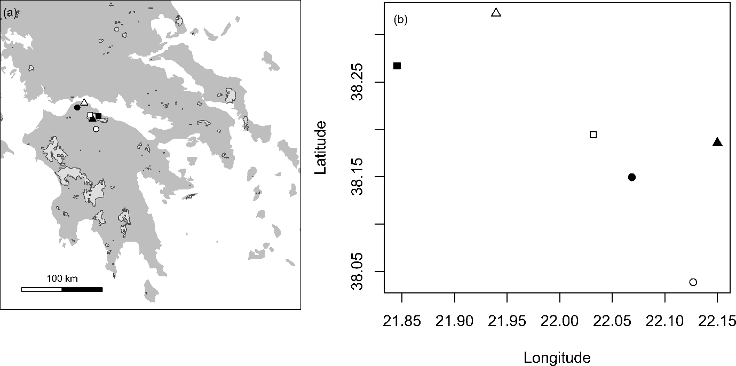
Figure 1. (a) Map of the Peloponnese peninsula, Greece (dark grey shading). Unburnt (white) and burnt (black) sites of pine forest (circles), maquis (squares) and fir forest (triangles) are shown. Within each site three plots of 12 pitfall traps are used as independent replicates. Light grey shading represents areas that burnt during 2007, data from European Forest Fire Information System. (b) Detail of the spatial distribution of the sites. Colours and symbols as in (a).
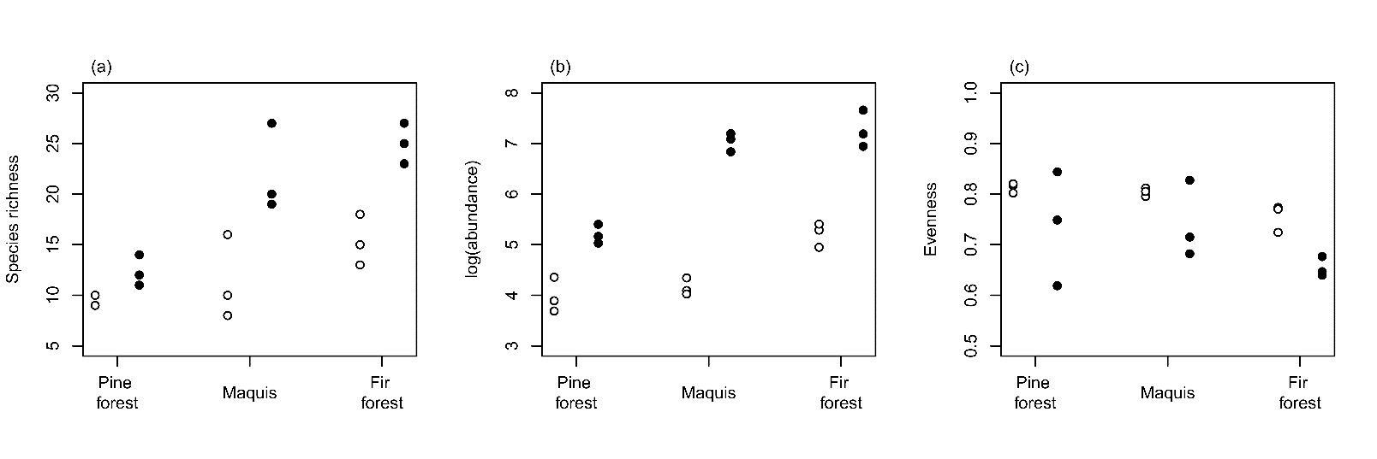
Figure 2. Plots showing (a) species richness, (b) log transformed abundance and (c) evenness of ants across unburnt (open circles) and burnt (closed circles) plots of pine forest, maquis and fir forest (n = 3 assemblages per habitat and burn combination).
Figure 3. Histogram of the difference in relative abundance of species between burnt and unburnt plots. -1 indicates that species are only found in burnt plots whilst 1 indicates that they are only found in unburnt plots. Dashed line indicates 0 where species would be found in equal relative abundances in both burn categories. (n = 65 species).

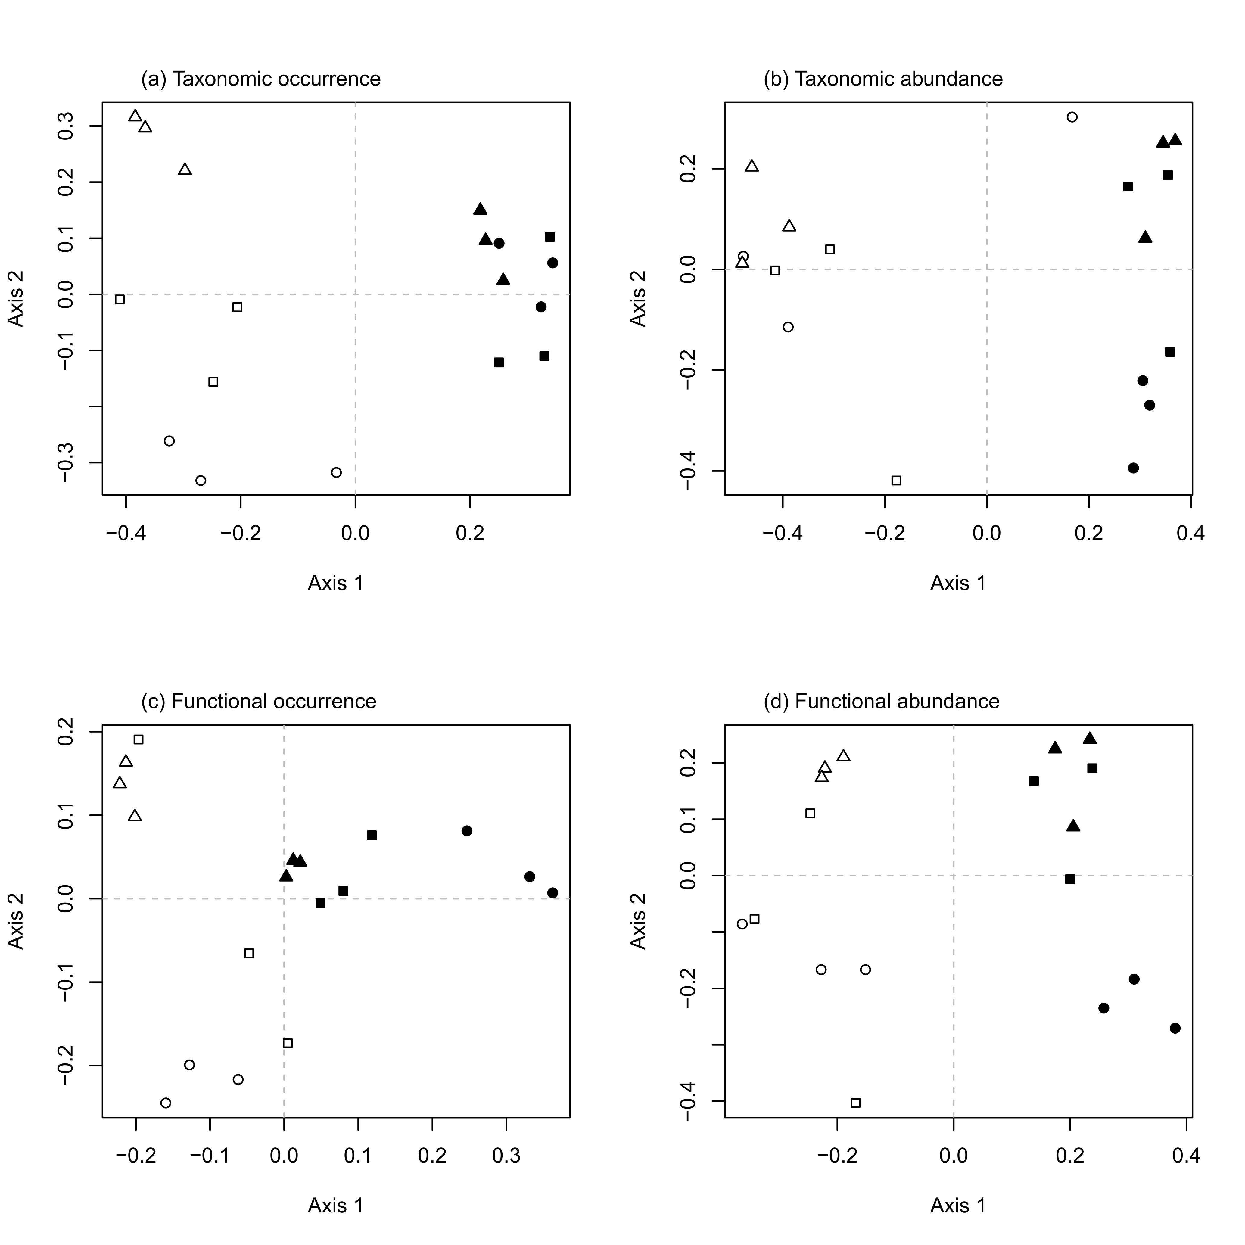
Figure 4. Principal coordinates plots of turnover dissimilarity as measured by (a) species occurrences, (b) species abundances, (c) functional occurrence and (d) functional abundance. Points are unburnt (white) and burnt (black) plots of pine forest (circles), maquis (squares) and fir forest (triangles). Plots that are closer together in ordination space are more similar in their composition.
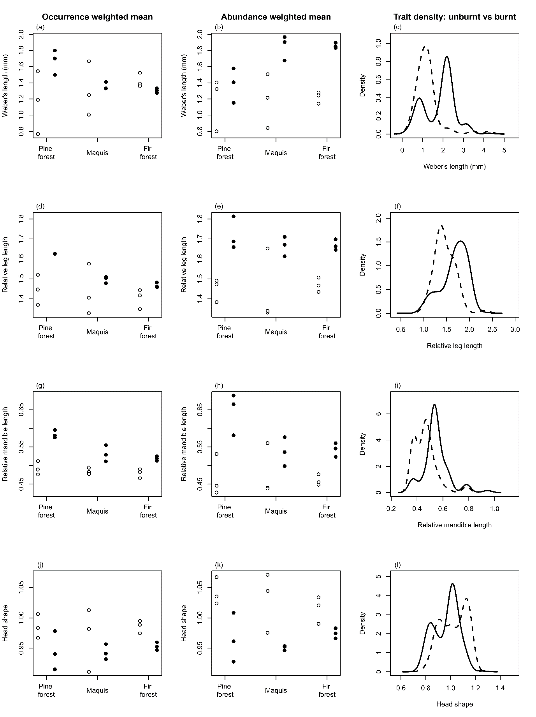
Figure 5. Graphs showing community weighted trait means weighted by species occurrence (left column) or species abundance (centre column), and abundance weighted trait density (right column). Points are unburnt (open circles) and burnt (closed circles) plots. Unburnt plots are denoted by the dashed line in the density graphs, and burnt plots have a solid line.

