Imaging isotopically labeled bacteria at the single cell level using high-resolution optical infrared photothermal spectroscopy
Cassio Lima¹, Howbeer Muhamadali¹, Yun Xu¹, Mustafa Kansiz², and Royston Goodacre^{1,} *
¹ Department of Biochemistry and Systems Biology, Institute of Systems, Molecular and Integrative Biology, University of Liverpool, L69 7ZB, United Kingdom
² Photothermal Spectroscopy Corporation, CA 93101, USA
KEYWORDS: stable isotope probing • O-PTIR spectroscopy • infrared imaging • microbial systems • E. coli
*corresponding author roy@goodacre@liverpool.ac.uk

ABSTRACT: We report that the cellular uptake of stable-isotope-labeled compounds by bacteria can be probed at the single cell level using infrared spectroscopy and this monitors the chemical vibrations affected by the incorporation of “heavy” atoms by cells, and thus can be used to understand microbial systems. This presents a significant advance as most studies have focused on evaluating communities of cells due to the poor spatial resolution achieved by classical infrared microspectrometers and, to date, there is no study evaluating the incorporation of labeled compounds by bacteria at single cell levels using infrared spectroscopy. The development of new technologies and instrumentations that provide information on the metabolic activity of a single bacterium is critical, as this will allow for a better understanding of the interactions between microorganisms as well as the function of individual members and their interactions in different microbial communities. Thus, the present study demonstrates the ability of a novel far-field infrared imaging technique, optical photothermal infrared (O-PTIR) spectroscopy, as a tool to monitor the uptake of ¹³C-glucose and ¹⁵N-ammonium chloride by Escherichia coli bacteria at single cell levels using spectral signatures recorded via single-point and imaging modes. An additional novelty is that imaging was achieved using six vibrational bands in the Amide I and II regions which were analysed with chemometrics employing partial least squares-discriminant analysis to predict ¹³C/¹²C and ¹⁵N/¹⁴N simultaneously.

INTRODUCTION
Fourier transform infrared (FTIR) spectroscopy has been widely used as a tool to interrogate the overall biochemistry of biological samples based on the vibrations of molecules that are infrared active such as proteins, nucleic acids, carbohydrates, and lipids¹. FTIR spectroscopy is by far the most used method to acquire infrared spectra of bacterial systems among the technologies currently available and has been well succeeded as a whole-organism fingerprinting tool to investigate the development of antibiotic resistance by bacteria^{2,3}, classification and identification of microbial species and strains⁴⁻⁸, as well as for studying the changing phenotype during growth of bacterial populations^{9,10}. Infrared chemical imaging enables simultaneous evaluation of the morphology and abundance of molecules in biological systems, but the long excitation wavelength of mid-infrared (mid-IR) radiation (3−30 μm) and the lack of high numerical aperture (NA) objectives provide spatial resolution of approximately 3-14 μm, with the information rich fingerprint region (1800-800 cm⁻¹) having an approximate spatial resolution of 7-14 μm, which makes the technique unsuitable for imaging subcellular structures or single microorganisms (with dimensions typically in the range 1-2 µm). Consequently, most bacterial studies using FTIR spectroscopy have mainly focused on the analysis of bulk samples instead of single bacterium. To overcome the spatial resolution challenge, the technology of infrared spectroscopy was combined with near-field optical imaging, resulting in the development of techniques capable of mapping infrared-active modes with nanoscale (< 100 nm) spatial resolution such as with atomic force microscopy-infrared spectroscopy (AFM-IR) and infrared scattering-scanning near-field microscopy (IR-SNOM)¹¹. Both methods operate by combining the sub-micron spatial resolution provided by an AFM tip with the high chemical specificity of infrared spectroscopy¹². These two techniques are fundamentally different regarding their basic principles of operation. Briefly, AFM-IR measures the light absorbed by the sample, whereas IR-SNOM is based on the scattered light¹³. The high spatial resolution achieved by nanoscale infrared spectroscopy allows the investigation of single cell bacterium, which is not possible with a state-of-the-art infrared microscope. So far, AFM-IR has been applied to investigate the cell wall of Gram-negative and Gram-positive bacteria¹⁴, detection of antibiotic resistance¹⁵, evaluation of bacteria infected by viruses¹⁶, as well as for monitoring the production of polyhydroxybutyrate¹⁷ and the distribution of biomolecules such as lipids¹⁸ and proteins¹⁹ in bacterial cells. Despite the high-resolution provided by scanning-probe techniques, these methods are complex in terms of instrumentation, laborious, have limited field of view, require contact and long time for acquiring data²⁰⁻²².
Recently, a novel far-field infrared imaging technique based on the photothermal effect of infrared radiation has been proposed to provide chemical images in a fast manner with sub-micron spatial resolution. This emerging method, so-called optical photothermal infrared (O-PTIR) spectroscopy, measures the photothermal response of a sample illuminated by a tunable mid-IR laser beam. The spatial resolution is determined by a visible probe beam that is used to detect the photothermal response, therefore the spatial resolution is limited now by the short visible wavelengths and is wavelength-independent in the infrared range²³. Previous studies have demonstrated the potential of infrared photothermal imaging to analyze single bacterial cells using the fingerprint²¹ and high wavenumber region²⁰ of mid-IR. Therefore, the present study aims to demonstrate, for the first time, the ability of O-PTIR spectroscopy to evaluate the incorporation of ¹³C and ¹⁵N labeled compounds by E. coli at single cell level using spectral signatures recorded via both single-point and imaging modes. Incorporating “heavy” atoms into bacterial cells has been widely used to understand their ecophysiology as well as their role in biogeochemical cycles²⁴, biotechnological processes²⁵, and human-disease interaction^{26,27}. The cellular uptake of stable-isotope-labeled atoms by bacterial cells can be probed by vibrational spectroscopic methods such as Raman and infrared spectroscopies due to their ability to monitor the chemical vibrations affected by the incorporation of isotopically labeled molecules by cells²⁸. Whilst the diffraction limit of Raman allows sufficient spatial resolution to probe single cells, despite the widespread use of infrared spectroscopy to investigate the incorporation of heavy atoms by bacteria, most of these stable isotope probing (SIP) studies have focused on evaluating bulk samples and, to date, there is no study analyzing isotopically labeled bacteria at single cell level. Development and application of novel methodologies such as O-PTIR spectroscopy is critical for better understanding of bacterial metabolism at the single cell level and bypassing the prolonged traditional culturing techniques, which may allow for understanding the interactions between microorganisms, as well as the functions of individual members and their interactions in their natural microbial communities.
EXPERIMENTAL SECTION
Growth conditions: Unless otherwise stated, all reagents used in the experiments were purchased from Fisher (Fischer Scientific, U.K.). Escherichia coli K-12 MG1655 cells were grown in minimal medium supplemented with ¹²C- or ¹³C-glucose (99 atom % homogeneously labelled; from Sigma-Aldrich, U.K.) as the sole carbon source (5 g/L), and ¹⁴N- or ¹⁵N-NH₄Cl (98 atom % homogeneously labelled; Sigma-Aldrich, U.K.) as the only nitrogen source (1 g/L), resulting in four growth conditions (¹²C¹⁴N, ¹³C¹⁴N, ¹²C¹⁵N, and ¹³C¹⁵N). Bacterial cells were transferred to sterile 24-well plates (Greiner Bio-one, U.K.) as 1.5 mL aliquot replicates (n = 3) and incubated in a Multitron standard shaker incubator (INFORS-HT, Bottmingen, Switzerland) for 15 h at 37°C with 170 rpm shaking. In order to reduce sample loss by potential evaporation, the plates were sealed with sterile Breathe-Easy membranes (Sigma-Aldrich, U.K.).
Sample preparation: After the incubation period, 1.3 mL aliquots from each of the samples were transferred to a 2 mL microcentrifuge tube and centrifuged for 10 min at 5000 xg using a benchtop Eppendorf Microcentrifuge 5424R (Eppendorf Ltd., Cambridge, U.K.). The supernatant was discarded and the biomass was resuspended in 2 mL of deionized water. A total of 5 µL of the cell suspension from each condition (¹²C¹⁴N, ¹³C¹⁴N, ¹²C¹⁵N, and ¹³C¹⁵N) was spotted onto four different CaF₂ substrates and left to dry in a desiccator at room temperature. Additional 2 µL of each sample was placed on another substrate and mixed in order to generate O-PTIR chemical maps and thus to evaluate the signatures from labeled and unlabeled cells.
O-PTIR spectroscopy: The working principle of O-PTIR spectroscopy is based on measuring the photothermal response of a sample illuminated by infrared radiation. The infrared beam causes specific IR vibrations and thus induces a temperature increase that locally changes the sample surface and refractive index; therefore, the photothermal effect can manifest itself both mechanically and optically²⁹. The magnitude of the photothermal effect is proportional to the infrared radiation that is being absorbed by the sample during vibration and is probed by measuring the intensity and propagation of a visible laser focused on the same spot illuminated by the infrared beam. Thus, O-PTIR spectroscopy can be described as a “pump–probe” technique. O-PTIR measurements were acquired on single-point and imaging mode using mIRage Infrared Microscope (Photothermal Spectroscopy Corp., Santa Barbara, USA), with the pump consisting of a tunable four-stage QCL device, while the probe beam is a continuous wave (CW) 532 nm laser. Spectral data were collected in reflection mode through a 40×, 0.78 NA, 8 mm working distance Schwarzschild objective. Single-point spectral data were acquired over the spectral region 800 to 1800 cm⁻¹, with 2 cm⁻¹ spectral resolution, and 50 scans per spectrum. Single frequency images were collected at 500 nm step size by tuning the QCL device to the frequencies corresponding to amide I and II vibrations (1660, 1614, 1544, 1534, 1530, and 1520 cm⁻¹) of labeled and unlabeled cells. Instrument control and data collection were performed using PTIR Studio software supplied by the manufacturers.
Data analysis: Spectral data collected on single-point mode were subjected to principal component analysis (PCA). Spectra were submitted to baseline correction, smoothed via Savitzky-Golay filter using a polynomial of second order in an eleven-point window (of approximately 22 cm⁻¹ size) and vector normalized and mean centered prior PCA. All collected data were processed using MATLAB software version 2011a (Mathworks Inc., Natwick, USA). Chemical maps showing isotope incorporation were reconstructed using multivariate analysis of partial least squares-discriminant analysis (PLS-DA). In this process PLS2 was used to predict ¹³C/¹²C and ¹⁵N/¹⁴N simultaneous. The input data (X-data) were 6 selected bands from the Amide I and II regions at 1520, 1530, 1535, 1544, 1614, and 1660 cm⁻¹ from data extracted from the full spectral data from single cells (data from Fig. 1). The output data (Y-data) comprised two Y columns (one for C and the other for N) that encoded the isotope patterns where -1 -1 (was from cells comprising ¹²C ¹⁴N), +1 -1 (¹³C ¹⁴N), -1 +1 (¹²C ¹⁵N), +1 +1 (¹³C ¹⁵N). The PLS algorithm was calibrate with these data and 4 latent variables (PLS factors) were used for modelling. This model was then challenged with the combination of the 6 single frequency images (individually shown in Fig. 4) and the two Y outputs plotted as a gray colour maps where black was negative and white was positive.

RESULTS AND DISCUSSION
Figure 1 illustrates typical O-PTIR spectra acquired from E. coli bacteria at single cell levels grown on combinations of labeled (¹³C, ¹⁵N) and unlabeled (¹²C, ¹⁴N) carbon and nitrogen sources. Several shifts are observed on the spectral range associated with the amide I and II regions (1400-1800 cm⁻¹), which have been previously reported as the main bands affected by the uptake of ¹³C-glucose and ¹⁵N-ammonium chloride³⁰.
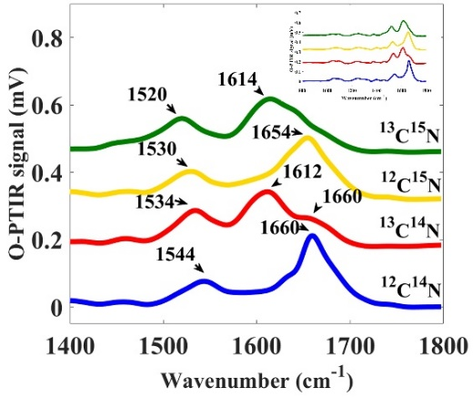
Figure 1. Amide I and II region (1400-1800 cm⁻¹) of O-PTIR spectra acquired from single E. coli cells incubated with ¹²C¹⁴N (blue line), ¹³C¹⁴N (red line), ¹²C¹⁵N (yellow line), and ¹³C¹⁵N (green line). The fingerprint region (800-1800 cm⁻¹) is illustrated on the top-right. The plots are offset for clarity.
The amide I vibration, peaking at 1660 cm⁻¹ in unlabeled cells, arises mainly from the C=O stretching vibration coupled with smaller contributions from the out-of-phase C−N stretching, the CCN deformation and the NH in-plane bend from the backbone of proteins³¹. Two peaks (1612 and 1660 cm⁻¹) are detected in the amide I region from spectra acquired from cells grown on ¹³C-glucose and unlabeled ammonium chloride. The vibration peaking at 1612 cm⁻¹ arises from proteins of cells that incorporated ¹³C atoms and presented higher intensity compared to the signal at 1660 cm⁻¹. Our findings indicate a shift of 6 cm⁻¹ toward lower wavenumber region (1654 cm⁻¹) from cells cultivated on ¹⁵N-ammonium chloride, which is probably due to the contribution of chemical bonds with nitrogen atoms that are coupled to the C=O stretching vibration from amide I. The shift induced by the incorporation of heavy atoms is more apparent in the ¹³C¹⁵N-labeled cells, which illustrated the highest shift (∆46 cm⁻¹). Amide II mode is assigned to the out-of-phase combination of the N−H in plane bend (~60% contribution) and the C−N stretching vibration (~40% contribution) with smaller contributions from the C−O in plane bend and the C−C and N−C stretching vibrations³¹. Amide II from cells grown with unlabeled ammonium chloride and glucose is identified at 1544 cm⁻¹. E. coli cells cultivated on ¹³C-glucose and ¹⁴N-ammonium chloride illustrated a shift of 10 cm⁻¹ (1534 cm⁻¹) towards lower wavenumbers, while the incorporation of ¹⁵N resulted in a shift to 1530 cm⁻¹. Cells grown with both compounds illustrated amide II band peaking around 1520 cm⁻¹. Regardless of the compound used to label isotopically the bacterial cells, all the altered peaks exhibited shifts toward the low wavenumber region (so called redshift), which is associated with an increase in the reduced mass (µ_{rm}) resulting from the incorporation of heavier isotopically labeled molecules by the cells³⁰. Table 1 compares the spectral signatures obtained for amide I and II in the present study to our previous work³⁰ using FTIR spectroscopy on bulk bacterial samples, to compare the alterations in the chemical vibrations of E. coli under similar growth conditions.
Table 1. Spectral signatures (peak maxima) obtained through FTIR and O-PTIR spectroscopies from labeled and unlabeled E. coli cells grown in similar conditions.
 | Amide I (cm⁻¹) |  | Amide II (cm⁻¹)
Grown | Bulk  FTIR | Single cell  O-PTIR | Bulk  FTIR | Single cell  O-PTIR
¹²C¹⁴N | 1655 | 1660 ± 0.9 | 1545 | 1544 ± 0.5
¹³C¹⁴N | 1616 | 1612 ± 0.5 / 1660 ± 1.72 | 1535 | 1534 ± 0.8
¹²C¹⁵N | 1655 | 1654 ± 1 | 1530 | 1530 ± 1.4
¹³C¹⁵N | 1616 | 1614 ± 1.28 | 1520 | 1520 ± 0.8

The effects of reduced mass on the detected vibrational frequencies were investigated in our previous work using FTIR spectroscopy, in which the percentage errors of the detected wavenumbers were less than 4% compared to their theoretically calculated reduced mass³⁰. According to Table 1, chemical shifts obtained in the present study are in agreement with our previous findings³⁰, therefore indicating that the magnitude of the chemical shifts are in-line with the values predicted by theory. Table 1 shows low standard deviations for peak positions obtained through O-PTIR, whereas data collected via FTIR spectroscopy presented zero standard deviation. These findings reflect the high reproducibility of chemical shifts from cells within same preparation as well as the superior ability of O-PTIR to probe biochemical changes at single cell level. Peak position of amide I obtained by O-PTIR and FTIR spectroscopies are slightly different. It is important to notice that data acquired by both technologies may vary due to the ability of each method in probing bacterial cells at community (bulk) and single cell levels. The signal obtained through FTIR is the combination of signatures from many individual cells in a community that interact with the relatively large area of the

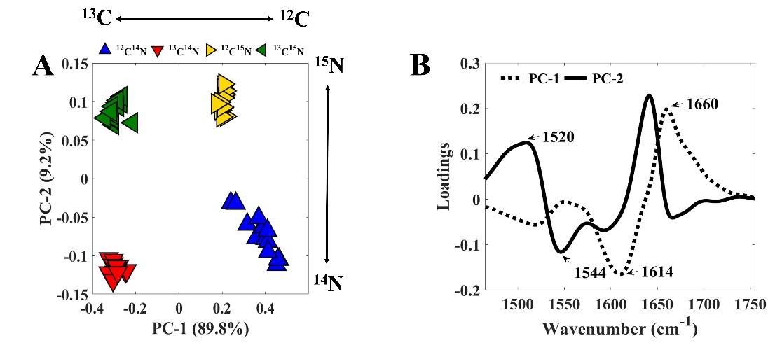
Figure 2. (a) PCA scores plot of preprocessed O-PTIR spectra of single E. coli cells grown with ¹²C/¹³C-glucose and/or ¹⁴N/¹⁵N-ammonium chloride where each point is the score related to the spectrum from a single bacterium; values in parentheses are the percentage total explained variance (TEV). (b) PCA loadings plot of the O-PTIR spectral data with PC1 (dashed line) and PC2 (full line) showing the major peaks affected by the labelling process and contributing to the separation.

polychromatic IR beam (for FTIR this was ~1 mm supplied by heated SiC³⁰). On the other hand, the higher spatial resolution achieved by O-PTIR provides accurate information from bacteria at single cell levels and reveals the variation in the metabolic activity of the cells in the community. Thus, O-PTIR allows one to monitor the uptake of heavy atoms by individual cells, whereas FTIR spectroscopy provide the average signal from a community of cells illuminated by the IR beam. Therefore, spectral differences may be expected when comparing results obtained by both techniques. To examine the ability of O-PTIR to differentiate bacteria cultivated on ¹²C/¹³C-glucose and/or ¹⁴N/¹⁵N-ammonium chloride, single-point spectra were recorded on CaF₂ substrates containing dispersed single bacteria grown in the four conditions and the resultant spectra were subjected to principal component analysis (PCA) in order to evaluate any specific separation resulting from the isotopic incorporation. The multivariate analysis investigation of the data was carried out using the amide I and II region (1450-1800 cm⁻¹) of spectra as input data.
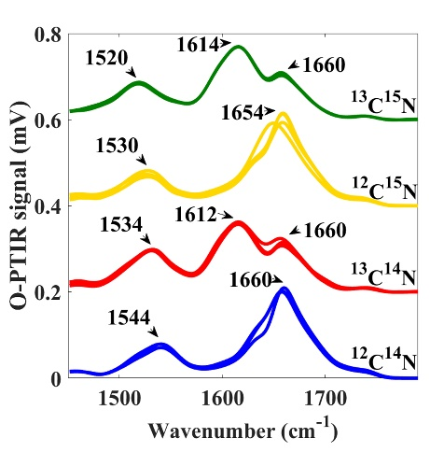
Figure 3. O-PTIR spectra acquired from a substrate containing a mixture of E. coli cells (n = 14) grown on ¹²C/¹³C-glucose and/or ¹⁴N/¹⁵N-ammonium chloride. The spectral signatures indicate three unlabeled cells (blue line); five ¹³C-labeled bacteria (red line); four ¹⁵N-labeled cells (yellow line), and two bacteria labeled with both compounds (green line). The plots are offset for clarity
The resultant PCA scores plot (Figure 2a) displayed a clear separation between spectra of cells grown with ¹³C/¹²C and ¹⁵N/¹⁴N. The first principal component (PC-1), which accounts for 89.8% of the total explained variance (TEV), retains information related to the effects of ¹³C/¹²C-glucose. ¹³C-labeled cells (¹³C¹⁴N and ¹³C¹⁵N) were grouped on the negative side of PC-1 axis, while bacteria grown on ¹²C-glucose (¹²C¹⁴N and ¹²C¹⁵N) were on the positive side. Consequently, PC-1 illustrated positive loadings on 1660 cm⁻¹ and negative loadings for 1614 cm⁻¹ (Figure 2b), which correspond to the vibrations of amide I from unlabeled and ¹³C-labeled cells. By contrast, the effects of ¹⁴N/¹⁵N-ammonium chloride on cells can be observed along PC-2 axis, which accounts for only 9.2% of TEV. ¹⁵N-labeled cells (¹²C¹⁵N and ¹³C¹⁵N) were grouped on the positive side of PC-2, whereas bacteria cultivated on ¹⁴N-ammonium chloride (¹²C¹⁴N and ¹³C¹⁴N) were clustered on the negative side. The loadings indicated that discrimination obtained along the second principal component is mainly related to amide II vibrations (1548 cm⁻¹ from unlabeled bacteria and 1520 cm⁻¹ from ¹⁵N-labeled cells). These findings indicate that amide I vibrations largely accounts in classifying cells cultivated on ¹³C/¹²C-glucose, while amide II retains information associated to the incorporation of ¹⁵N atoms into the cells. The lower contribution of amide II in the separation of bacteria grown in different conditions is perhaps not surprising considering that the amide I signature is mainly dominated by the C=O vibrations and the contribution of nitrogen atoms are minimal. Amide I band is also more intense than amide II peak due to the change in dipole moment with respect to the distance (∂µ/∂x) of C=O stretching vibrations is higher than the variation associated to the vibrations of amide II (mainly N−H in plane bend and the C−N stretching vibrations). Furthermore, the band peaking at 1614 cm⁻¹ (amide I) due to the incorporation of ¹³C atoms by bacteria arises in a spectral region with relatively less signal interference from other vibrations, compared to the shift associated to the amide II (1520 cm⁻¹) for the labeled cells, indicating the major contribution of ¹³C rather than ¹⁵N isotopes on the data discrimination achieved by PCA. These findings are in entire agreement with our previous results, where we analyzed bulk cells with FTIR, and both bulk and single cell

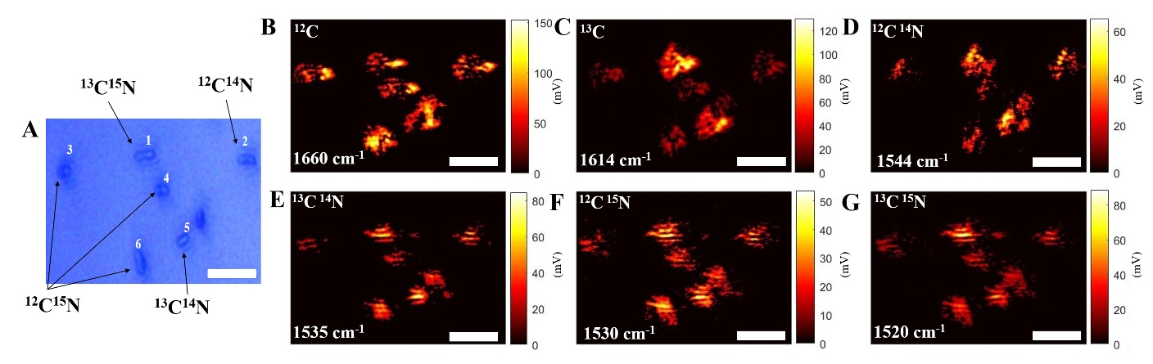
Figure 4. (A) Optical image showing one unlabeled bacterium (cell 2); one ¹³C-labeled bacterium (cell 5), three cells grown on ¹⁵N-ammonium chloride (cells 3, 4, 6), and one cell cultivated on both isotopically labelled compounds (cell 1). (B-G) Single wavenumber images collected through O-PTIR imaging by tuning the QCL device to the frequencies corresponding to amide I and II vibrations on unlabeled and labelled cells (1660, 1614, 1544, 1534, 1530, and 1520 cm⁻¹. Scale bar is 2 µm

infrared measurements showed a higher contribution ¹³C labelling in the PCA model which could be due to higher carbon content in comparison to nitrogen (C/N ratio 5.9±1.1)^{30,32}.
Spectral data were also recorded from a substrate containing a mixture of unlabeled and labeled cells (n = 14 cells) in order to evaluate the ability of O-PTIR in identifying the condition that the cells were grown within an artificial community. The signatures obtained for all 14 cells are shown in Figure 3, in which it is possible to identify three unlabeled cells; five ¹³C-labeled bacteria; four ¹⁵N-labeled cells, and two bacteria labeled with both elements. Spectral data of all 14 cells were subjected to PCA and the results were similar to those obtained from bacterial cells grown in different conditions and analyzed individually, which was shown in Figure 2: ¹²C/¹³C-labeled cells are discriminated along PC-1 (93.1%), whereas bacteria cultivated on ¹⁴N/¹⁵N-ammonium chloride are grouped along PC-2 (3.4%) (Figure S1a). The loadings related to PC-1 indicate major contributions of amide I, while PC-2 is mostly dominated by vibrations peaking at amide II region (Figure S1b).
The comparison of loadings related to PC-1 and PC-2 obtained from spectra recorded from labeled and unlabeled cells on the same substrate, as well as from different substrates, containing bacteria cultivated on each condition (Figure S1c) illustrated very similar findings, indicating the ability of O-PTIR in identifying the uptake of the different isotopically labelled substrates.
Although infrared spectroscopy has been extraordinarily successful as a tool for investigating biochemical features of bacterial cells, the low spatial resolution achieved by infrared microspectrometers where the IR light is supplied by a globar, or indeed Synchrotron source, have limited the study of bacterial organisms to the analysis of bulk samples and only a few studies using AFM-IR or IR-SNOM have evaluated a bacterium at the single cell level. To date, there is no reported study of imaging isotopically labeled bacteria using infrared spectroscopy. Besides the higher spatial resolution achieved by O-PTIR in comparison to FTIR spectroscopy, O-PTIR imaging enables the acquisition of discrete frequency images due to the tunable infrared laser (Quantum Cascade Laser, QCL) device used as infrared source, which provides information about the distribution of chemical species while improving the speed of data collection compared to the time-consuming hyperspectral images obtained by classical infrared microspectroscopy. Thus, single wavenumber images were collected by tuning the QCL device to the frequencies corresponding to amide I and II vibrations (1660, 1614, 1544, 1534, 1530, and 1520 cm⁻¹ (identified from Figure 1 and Table 1) on labeled and unlabeled cells from a region of interest containing cells grown in different conditions (n = 6 cells) in order to evaluate the ability of O-PTIR in identifying the incorporation of ¹³C/¹⁵N atoms by cells on imaging mode. The optical image shown in Figure 4a illustrates the region of interest containing seven unlabeled and labeled bacterial cells. Single-point O-PTIR spectral data acquired from cells numbered 1-6 are illustrated in Figure S2, in which we identified one unlabeled bacterium (cell 2); one ¹³C-labeled bacterium (cell 5), three cells grown on ¹⁵N-ammonium chloride (cells 3, 4, 6), and one cell cultivated on both isotopically labelled compounds (cell 1). Single frequency images obtained for wavenumbers associated to amide I and II are illustrated on Figure 4b-g. Bacterial cells grown on ¹³C-glucose can be easily identified in the single frequency image obtained for 1614 cm⁻¹ (Figure 5c) due to the high O-PTIR signal recorded for the cells that were numbered as 1 (¹³C¹⁵N) and 5 (¹³C¹⁴N) in Figure 5a. On the other hand, the localization of bacteria cultivated on ¹⁵N-ammonium chloride is not so clear. As previously described, ¹⁵N-labeled cells are mainly discriminated by information retained in the amide II vibrations. However, O-PTIR signal recorded from wavenumbers corresponding to the peak positions of amide II in labeled and unlabeled cells (1520, 1530, 1535, 1540 cm⁻¹) provided poor contrast for the identification of ¹⁴N/¹⁵N-labeled bacteria due to the relatively similar intensities registered in the surrounding wavenumbers. By contrast, the main effects of the incorporation of ¹³C atoms are observed in the vibrations associated to amide I, in which ¹³C-labeled bacteria present a peak arising at 1614 cm⁻¹, which has relatively less signal interference from other vibrations, therefore enhancing the contrast between the cells that were grown on ¹³C/¹²C-glucose on the images.
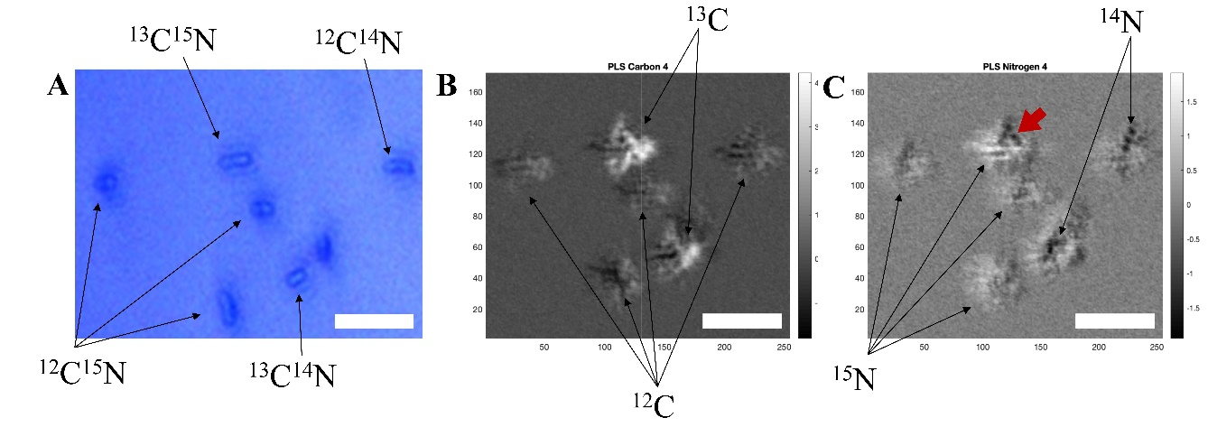
Figure 5. (A) Optical image displaying labelled and unlabeled bacterial cells. (B, C) Images reconstructed using the outputs obtained through PLS2 applied to the O-PTIR signal extracted from bands peaking at 1520, 1530, 1535, 1544, 1614, and 1660 cm⁻¹ from single cell data shown in Figure 1. (B) Predictions of ¹³C/¹²C where dark pixels indicate ¹²C-labelled cells and light pixels ¹³C incorporation into bacteria. (C) Predictions of ¹⁵N/¹⁴N where dark pixels show ¹⁴N-labelled cells and light pixels ¹⁵N incorporation. The cell highlighted by the red arrow presents both dark and light pixels, which may be associated to the incorporation of both ¹³C and ¹⁵N atoms. Scale bar is 2 µm.
Single-frequency images were subjected to PLS in order to enhance the contrast between labelled and unlabeled cells. Figure 5b shows the distribution of cells grown on ¹³C/¹²C-glucose, in which the highlighted cells represent ¹³C-labeled bacteria. These findings agree with the results shown on Figure 4c. Figure 5c depicts the image reconstructed by using the PLS component related to the incorporation of ¹⁵N atoms by the cells, in which the dark pixels indicate cells cultivated on ¹⁴N-ammonium chloride, and light pixels those that have incorporated ¹⁵N into their biomass. The cell highlighted by the red arrow presents both dark and light pixels, which may be associated to the incorporation of both ¹³C and ¹⁵N atoms. All chemical images provided information about the localization and number of cells that were probed by the laser. However, the morphological details obtained in the images such as shape and size were not clear representation of E. coli cells, as the rod-shaped morphology typically observed for E. coli was not clearly evident in these single wavenumber chemical images.
CONCLUSIONS
In this study, O-PTIR spectroscopy was used as a tool to monitor the incorporation of ¹³C-glucose and ¹⁵N-ammonium chloride by E. coli bacteria at single cell level using spectral signatures recorded via single-point and single wavelength imaging modes. This new method holds a number of key advantages over classical infrared spectroscopy such as higher spatial resolution, absence of spectral distortions due to scatter artifacts (e.g., Mie scattering), simple sample preparation, the measurement is contactless, as well as the acquisition of discrete frequency images in a fast manner, which enables to evaluate the distribution of chemical species on the sample. We have shown that O-PTIR spectra acquired on single-point mode can be used to identify the incorporation of stable-isotope-labeled compounds such as ¹³C-glucose and ¹⁵N-ammonium chloride by E. coli cells.
We have previously used Raman spectroscopy to measure metabolism in single bacteria by distinguishing isotopically labeled cells³⁰; however, this study did not include imaging (chemical mapping) due to the long collection times needed to collect Raman spectra of sufficient quality. The current study builds on this previous work and shows that O-PTIR can also be used to characterise single bacterial cells that have incorporated stable-isotope-labeled compounds. We found significant advantages of O-PTIR are both the speed of analysis and its non-destructive nature.
Regarding imaging with O-PTIR, we were able readily to identify cells grown on different carbon sources (¹²C or ¹³C) and despite the lack of accuracy in identifying the incorporation of ¹⁵N atoms by bacteria as well as the morphological details such as shape and size of the cells, all chemical images provided information about the localization and number of cells that were probed by the laser. Hence, this emerging new technique presents further opportunities as a whole-organism fingerprinting tool to investigate the metabolism of a single bacterium in a range of biological applications, shedding light on the interaction between microorganisms as well as the role of each individual in microbial communities
ASSOCIATED CONTENT
Supporting Information
This material is available free of charge at http://pubs.acs.org:
Figure S1, PCA scores and loadings from O-PTIR spectra; Figure S2, O-PTIR spectra from cells in Figure 4a (PDF).
AUTHOR INFORMATION
Corresponding Author
*Roy Goodacre
E-mail: roy.goodacre@liverpool.ac.uk
Author Contributions
The manuscript was written through contributions of all authors. All authors have given approval to the final version of the manuscript.
Notes
MK is employed by Photothermal Spectroscopy Corporation who manufacture the O-PTIR instrument used in this study. All other authors declare no competing financial interest.
ACKNOWLEDGMENT
RG, HM, CL thank the University of Liverpool for funding and support. YX and RG also thank the Wellcome Trust (202952/Z/16/Z) for funding.
REFERENCES
(1) Baker, M. J.; Trevisan, J.; Bassan, P.; Bhargava, R.; Butler, H. J.; Dorling, K. M.; Fielden, P. R.; Fogarty, S. W.; Fullwood, N. J.; Heys, K. A.; Hughes, C.; Lasch, P.; Martin-Hirsch, P. L.; Obinaju, B.; Sockalingum, G. D.; Sule-Suso, J.; Strong, R. J.; Walsh, M. J.; Wood, B. R.; Gardner, P.; Martin, F. L., Using Fourier transform IR spectroscopy to analyze biological materials. Nat Protoc 2014, 9, 1771-1791.
(2) Sharaha, U.; Rodriguez-Diaz, E.; Riesenberg, K.; Bigio, I. J.; Huleihel, M.; Salman, A., Using Infrared Spectroscopy and Multivariate Analysis to Detect Antibiotics' Resistant Escherichia coli Bacteria. Anal Chem 2017, 89, 8782-8790.
(3) Salman, A.; Sharaha, U.; Rodriguez-Diaz, E.; Shufan, E.; Riesenberg, K.; Bigio, I. J.; Huleihel, M., Detection of antibiotic resistant Escherichia coli bacteria using infrared microscopy and advanced multivariate analysis. Analyst 2017, 142, 2136-2144.
(4) Naumann, D.; Helm, D.; Labischinski, H., Microbiological characterizations by FT-IR spectroscopy. Nature 1991, 351, 81-82.
(5) Goodacre, R.; Timmins, E.; Rooney, P.; Rowland, J.; Kell, D., Rapid identification of Streptococcus and Enterococcus species using diffuse reflectance-absorbance Fourier transform infrared spectroscopy and artificial neural networks. FEMS Microbiol. Lett 1996, 140, 233-239.
(6) Martak, D.; Valot, B.; Sauget, M.; Cholley, P.; Thouverez, M.; Bertrand, X.; Hocquet, D., Fourier-Transform InfraRed Spectroscopy Can Quickly Type Gram-Negative Bacilli Responsible for Hospital Outbreaks. Front Microbiol 2019, 10, 1440.
(7) Muhamadali, H.; Subaihi, A.; Mohammadtaheri, M.; Xu, Y.; Ellis, D. I.; Ramanathan, R.; Bansal, V.; Goodacre, R., Rapid, accurate, and comparative differentiation of clinically and industrially relevant microorganisms via multiple vibrational spectroscopic fingerprinting. Analyst 2016, 141, 5127-5136.
(8) Muhamadali, H.; Weaver, D.; Subaihi, A.; AlMasoud, N.; Trivedi, D. K.; Ellis, D. I.; Linton, D.; Goodacre, R., Chicken, beams, and Campylobacter: rapid differentiation of foodborne bacteria via vibrational spectroscopy and MALDI-mass spectrometry. Analyst 2016, 141, 111-122.
(9) Nicolaou, N.; Xu, Y.; Goodacre, R., Fourier transform infrared and Raman spectroscopies for the rapid detection, enumeration, and growth interaction of the bacteria Staphylococcus aureus and Lactococcus lactis ssp. cremoris in milk. Anal Chem 2011, 83, 5681-5687.
(10) Wang, H.; Hollywood, K.; Jarvis, R. M.; Lloyd, J. R.; Goodacre, R., Phenotypic characterization of Shewanella oneidensis MR-1 under aerobic and anaerobic growth conditions by using Fourier transform infrared spectroscopy and high-performance liquid chromatography analyses. Appl Environ Microbiol 2010, 76, 6266-6276.
(11) Bechtel, H. A.; Muller, E. A.; Olmon, R. L.; Martin, M. C.; Raschke, M. B., Ultrabroadband infrared nanospectroscopic imaging. Proc Natl Acad Sci U S A 2014, 111, 7191-7196.
(12) Rao, V. J.; Matthiesen, M.; Goetz, K. P.; Huck, C.; Yim, C.; Siris, R.; Han, J.; Hahn, S.; Bunz, U. H. F.; Dreuw, A.; Duesberg, G. S.; Pucci, A.; Zaumseil, J., AFM-IR and IR-SNOM for the Characterization of Small Molecule Organic Semiconductors. J. Phys. Chem. C 2020, 124, 5331-5344.
(13) Dazzi, A.; Prater, C. B., AFM-IR: Technology and Applications in Nanoscale Infrared Spectroscopy and Chemical Imaging. Chem. Rev. 2016, 117, 5146-5173.
(14) Kochan, K.; Perez-Guaita, D.; Pissang, J.; Jiang, J. H.; Peleg, A. Y.; McNaughton, D.; Heraud, P.; Wood, B. R., In vivo atomic force microscopy-infrared spectroscopy of bacteria. J R Soc Interface 2018, 15, 20180115.
(15) Kochan, K.; Nethercott, C.; Perez Guaita, D.; Jiang, J. H.; Peleg, A. Y.; Wood, B. R.; Heraud, P., Detection of Antimicrobial Resistance-Related Changes in Biochemical Composition of Staphylococcus aureus by Means of Atomic Force Microscopy-Infrared Spectroscopy. Anal Chem 2019, 91, 15397-15403.
(16) Dazzi, A.; Prazeres, R.; Glotin, F.; Ortega, J. M.; Al-Sawaftah, M.; de Frutos, M., Chemical mapping of the distribution of viruses into infected bacteria with a photothermal method. Ultramicroscopy 2008, 108, 635-641.
(17) Mayet, C.; Deniset-Besseau, A.; Prazeres, R.; Ortega, J. M.; Dazzi, A., Analysis of bacterial polyhydroxybutyrate production by multimodal nanoimaging. Biotechnol Adv 2013, 31, 369-374.
(18) Deniset-Besseau, A.; Prater, C. B.; Virolle, M. J.; Dazzi, A., Monitoring TriAcylGlycerols Accumulation by Atomic Force Microscopy Based Infrared Spectroscopy in Streptomyces Species for Biodiesel Applications. J Phys Chem Lett 2014, 5, 654-658.
(19) Baldassarre, L.; Giliberti, V.; Rosa, A.; Ortolani, M.; Bonamore, A.; Baiocco, P.; Kjoller, K.; Calvani, P.; Nucara, A., Mapping the amide I absorption in single bacteria and mammalian cells with resonant infrared nanospectroscopy. Nanotechnology 2016, 27, 075101.
(20) Li, Z.; Aleshire, K.; Kuno, M.; Hartland, G. V., Super-Resolution Far-Field Infrared Imaging by Photothermal Heterodyne Imaging. J Phys Chem B 2017, 121, 8838-8846.
(21) Li, X.; Zhang, D.; Bai, Y.; Wang, W.; Liang, J.; Cheng, J. X., Fingerprinting a Living Cell by Raman Integrated Mid-Infrared Photothermal Microscopy. Anal Chem 2019, 91, 10750-10756.
(22) Perez-Guaita, D.; Kochan, K.; Batty, M.; Doerig, C.; Garcia-Bustos, J.; Espinoza, S.; McNaughton, D.; Heraud, P.; Wood, B. R., Multispectral Atomic Force Microscopy-Infrared Nano-Imaging of Malaria Infected Red Blood Cells. Anal Chem 2018, 90, 3140-3148.
(23) Klementieva, O.; Sandt, C.; Martinsson, I.; Kansiz, M.; Gouras, G. K.; Borondics, F., Super-Resolution Infrared Imaging of Polymorphic Amyloid Aggregates Directly in Neurons. Adv Sci (Weinh) 2020, 7, 1903004.
(24) Dawson, K. S.; Scheller, S.; Dillon, J. G.; Orphan, V. J., Stable Isotope Phenotyping via Cluster Analysis of NanoSIMS Data As a Method for Characterizing Distinct Microbial Ecophysiologies and Sulphur-Cycling in the Environment. Front Microbiol 2016, 7, 774.
(25) Madsen, E. L., The use of stable isotope probing techniques in bioreactor and field studies on bioremediation. Curr Opin Biotechnol 2006, 17, 92-97.
(26) Berry, D.; Loy, A., Stable-Isotope Probing of Human and Animal Microbiome Function. Trends Microbiol 2018, 26, 999-1007.
(27) Evert, C.; Loesekann, T.; Bhat, G.; Shajahan, A.; Sonon, R.; Azadi, P.; Hunter, R. C., Generation of (13)C-Labeled MUC5AC Mucin Oligosaccharides for Stable Isotope Probing of Host-Associated Microbial Communities. ACS Infect Dis 2019, 5, 385-393.
(28) Haris, P.; Robillard, G.; Dijk, A.; Chapman, D., Potential of ¹³C and ¹⁵N Labeling for Studying Protein-Protein Interactions Using Fourier Transform Infrared Spectroscopy. Biochemistry 1992, 31, 6279-6284.
(29) Klementieva, O.; Sandt, C.; Martinsson, I.; Kansiz, M.; Gouras, G. K.; Borondics, F., Super-Resolution Infrared Imaging of Polymorphic Amyloid Aggregates Directly in Neurons. Adv Sci (Weinh) 2020, 7, 1903004.
(30) Muhamadali, H.; Chisanga, M.; Subaihi, A.; Goodacre, R., Combining Raman and FT-IR spectroscopy with quantitative isotopic labeling for differentiation of E. coli cells at community and single cell levels. Anal Chem 2015, 87, 4578-4586.
(31) Barth, A., Infrared spectroscopy of proteins. Biochim Biophys Acta 2007, 1767, 1073-1101.
(32) Fukuda, R.; Ogawa, H.; Nagata, T.; Koike, I., Direct Determination of Carbon and Nitrogen Contents of Natural Bacterial Assemblages in Marine Environments. Appl. Environ. Microbiol. 1998, 64, 3352-3358.

TABLE OF CONTENTS GRAPHICS

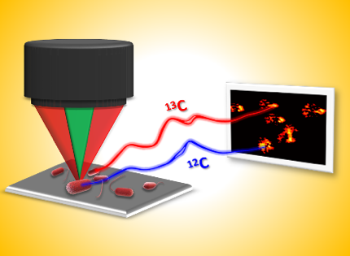
The artwork is from within the paper itself (Figure 4), so no copyright request is needed.

