Gene signatures reduce the stress of preclinical drug hepatotoxicity screening
Ian M Copple¹, B. Kevin Park¹, Christopher E. Goldring¹.
¹MRC Centre for Drug Safety Science, Department of Pharmacology & Therapeutics, Institute of Systems, Molecular and Integrative Biology, University of Liverpool, L69 3GE, UK.

Drug-induced liver injury (DILI) is a multi-factorial process, with a diverse clinical presentation, that remains a barrier to the development of safe and effective new medicines. Improvements in preclinical screening for DILI liabilities, together with a more conservative approach to handling relatively mild cases of liver injury during clinical trials, have resulted in no drug being licenced within the past 10 years and subsequently withdrawn due to hepatotoxicity. However, unexpected liver injury in clinical trials is still a cause of patient morbidity and drug attrition, whilst it is possible that some promising drug candidates are being screened out of stringent testing programmes when they could be developed into safe human therapies. Further advances in the preclinical detection of compounds carrying a DILI liability should therefore reduce patient harm and improve the efficiency of the drug development process.

In a recent series of linked publications (1-3), a team at Merck & Co described the development and use of a mechanism-based gene signature approach for identifying compounds that trigger the activation of cellular stress responses coordinated by the closely-related transcription factors Nrf2 and Nrf1, reflecting a DILI risk associated with the formation of chemically reactive metabolites (CRMs). Typically, the hepatic covalent binding burden of a drug is determined using in vitro or in vivo radiolabel and nucleophile trapping methods, but the Merck team found these approaches could not adequately distinguish compounds that are hepatotoxic from those that are safe in the clinic, even after taking into account the maximum human daily dose (1). As the Nrf2/1-driven stress responses are triggered as part of the cellular adaptation to chemical insult, they have for some time been considered more reflective of the consequence (risk), as opposed to the mere occurrence (hazard), of CRM formation. However, until now, this concept has not been examined in a comprehensive and systematic manner in the context of DILI.

Building on the computational modelling of a large in-house rat liver RNA-seq data set, the Merck team identified gene signatures representative of a host of xenobiotic nuclear receptors, the innate immune response and stress responsive transcription factors (2). In the latter case, a 46-gene signature (termed the bioactivation liver response assay, or BA-LRA) reflecting Nrf2/1 activity was developed and incorporated into a standard 4-day rat study design in which test compounds were administered orally at 300-750 mg/kg/day to maximise hepatic exposure to the associated reactive metabolite(s). The resulting BA-LRA scores were then multiplied by the recommended maximum daily dose across 116 DILI positive and negative compounds. A low sensitivity (32 %) for the identification of clinical DILI liability was observed, although this was not surprising given the diverse set of DILI mechanisms represented in the drug panel. However, very high specificity (92 %) and positive predictive values (83 %) were reported, suggesting false positive detection rates would be low, which is ideal in the early stages of drug discovery.

In an extension of the in vivo rat liver assay, the Merck team developed a 10-gene signature that could reflect Nrf2/1 activation in primary rat hepatocytes cultured in the HEPATOPAC platform, in which micro-patterned hepatocyte ‘islands’ are surrounded by stromal cells. Using a 9-day repeat-dose treatment protocol, the concentration-dependent response of the in vitro BA-LRA was interpreted in the context of projected human liver exposure, and this approach demonstrated 81 % sensitivity and 90 % specificity for detecting CRM-forming drugs known to carry a high risk of clinical DILI (3). The authors also highlighted their efforts to develop a version of the in vitro BA-LRA for use in primary human hepatocyte culture systems. Whilst this preliminary element of the work was performed with cells from only one or two individual donors, it provides a bridge to future studies using pooled donor lots or cells from individuals with relevant demographic and clinical features, as well as genotypes associated with certain forms of DILI. We previously reported that Nrf2-associated gene activation in primary human hepatocytes has high specificity and positive predictive values for identification of CRM formation and clinical DILI risk (4). Hence, this aspect of the work, aligned with recent advances in the use of complex human liver models for identifying clinical DILI liabilities that were missed by conventional toxicology approaches (5), holds promise for improving the translational relevance of preclinical DILI screening.

Given that a number of drugs terminated due to clinical liver toxicity triggered a BA-LRA response in the absence of overt liver injury in the rat (1), it appears that this species is highly adept at defending against CRM formation. Indeed, the Merck team observed that conserved in vitro BA-LRA gene expression responses were generally stronger in rat hepatocytes compared with human cells (3). Such quantitative differences in stress response capacity between species could contribute to the relatively poor ability of rats to identify drugs that are hepatotoxic in humans, in comparison with other preclinical species, when relying on traditional DILI indicators (6). The use of gene expression responses, which occur (in a temporal sense) closer to the molecular initiating event than traditional clinical chemistry or histopathological measures of hepatic insult, could help to overcome this limitation by indicating a biochemical risk that could translate to overt toxicity in less resistant species (Fig. 1).

A limitation of the in vivo BA-LRA is that, at least in the standard 4-day study format, it was unable to identify correctly the clinical DILI liabilities of some CRM-associated drugs, including amiodarone, nitrofurantoin and acetaminophen (1). Yet, in the latter case, for which clinical DILI is overwhelmingly associated with acute overdose, a positive BA-LRA score was noted after 1 day of dosing, suggesting that the false negative result after 4 days is related to adaptation within the rat liver. Hence, it may be necessary to alter the in vivo dosing timeframe for some drugs. This, together with the large investment of time and resource needed to implement the BA-LRA approach, may limit its widespread adoption as a standard screen across the industry. However, the BA-LRA was able to identify the clinical DILI risk associated with several drugs that were not flagged in the standard human hepatocyte covalent binding assay. As an example, the Merck team used the in vivo BA-LRA to guide the development of back-up molecules for two calcitonin gene-related peptide receptor antagonists that provoked unexpected hepatotoxicity in clinical trial participants (1). One of these back-up compounds, ubrogepant (Ubrelvy™), was recently licenced with an acceptable clinical safety profile. In addition, the in vitro BA-LRA was able to distinguish liver-safe and hepatotoxic structural analogues (e.g. clozapine and olanzapine) (3), suggesting that this higher throughput approach could be used as a second stage screen for probing a compound’s chemical space and determining whether the structural bases of efficacy and toxicity can be dissociated, particularly in the case of compounds flagged in standard, frontline CRM screens.

Taken together, the approach pioneered by Merck is likely to be seen as valuable by some companies in selected settings, which in itself would be regarded as a major achievement in an industry that has, to date, been largely reluctant to embrace gene expression technology within drug safety screening (7). Validation of the performance of the BA-LRA with other proprietary compound sets and specific case studies will be an important step towards this goal. Nevertheless, there is potential that these and other advances will provide greater mechanistic information and improved prediction of human DILI risk, thereby lowering the incidence of unexpected DILI in clinical trials and improving the ability to select liver safe compounds for further development as new medicines.

Notes
BKP and CEG are in receipt of research funding from Merck & Co. The company was not involved in the preparation of this article.

References
1. Monroe JJ, Tanis KQ, Podtelezhnikov AA, Nguyen T, Machotka SV, Lynch D, Evers R, et al. Application of a Rat Liver Drug Bioactivation Transcriptional Response Assay Early in Drug Development That Informs Chemically Reactive Metabolite Formation and Potential for Drug-induced Liver Injury. Toxicol Sci 2020;177:281-299.
2. Podtelezhnikov AA, Monroe JJ, Aslamkhan AG, Pearson K, Qin C, Tamburino AM, Loboda AP, et al. Quantitative Transcriptional Biomarkers of Xenobiotic Receptor Activation in Rat Liver for the Early Assessment of Drug Safety Liabilities. Toxicol Sci 2020;175:98-112.
3. Kang W, Podtelezhnikov AA, Tanis KQ, Pacchione S, Su M, Bleicher KB, Wang Z, et al. Development and Application of a Transcriptomic Signature of Bioactivation in an Advanced In Vitro Liver Model to Reduce Drug-induced Liver Injury Risk Early in the Pharmaceutical Pipeline. Toxicol Sci 2020;177:121-139.
4. Copple IM, den Hollander W, Callegaro G, Mutter FE, Maggs JL, Schofield AL, Rainbow L, et al. Characterisation of the NRF2 transcriptional network and its response to chemical insult in primary human hepatocytes: implications for prediction of drug-induced liver injury. Arch Toxicol 2019;93:385-399.
5. Jang KJ, Otieno MA, Ronxhi J, Lim HK, Ewart L, Kodella KR, Petropolis DB, et al. Reproducing human and cross-species drug toxicities using a Liver-Chip. Sci Transl Med 2019;11.
6. Olson H, Betton G, Robinson D, Thomas K, Monro A, Kolaja G, Lilly P, et al. Concordance of the toxicity of pharmaceuticals in humans and in animals. Regul Toxicol Pharmacol 2000;32:56-67.
7. Vahle JL, Anderson U, Blomme EAG, Hoflack JC, Stiehl DP. Use of toxicogenomics in drug safety evaluation: Current status and an industry perspective. Regul Toxicol Pharmacol 2018;96:18-29.

Figure
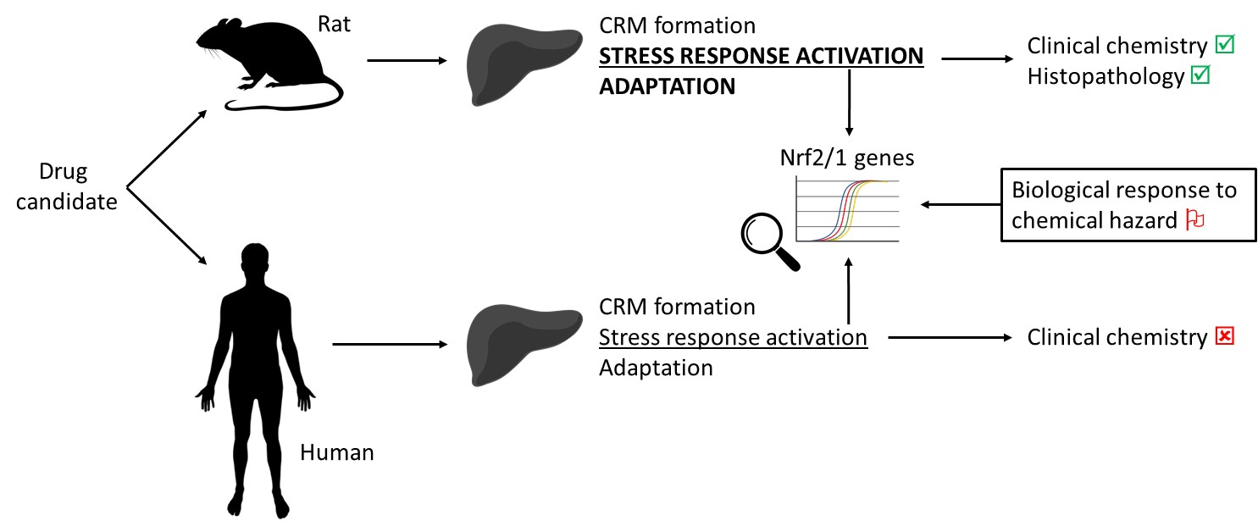
Fig. 1 – Measuring the response of Nrf2/1-associated genes activated by chemical, oxidative and proteotoxic stresses could flag CRM hazards during toxicology studies in the rat. The robust stress response and adaptive capacity of the rat liver may result in some CRM-forming compounds seeming liver safe when traditional markers of overt liver damage are used to predict human risk. Yet some patients may exhibit relatively low hepatic stress response and adaptive capacities, increasing their susceptibility to CRM insult and resulting liver toxicity.

