Impact of a Clinical Decision Rule on Antibiotic Prescription for Children with suspected Lower Respiratory Tract Infections presenting to European Emergency Departments - A simulation study based on routine data

Nienke N HAGEDOORN¹, Josephine H.L. WAGENAAR¹, Daan NIEBOER², David BATH³, Ulrich VON BOTH^{4,5}, Enitan D CARROL^{6,7,8}, Irini ELEFTHERIOU⁹, Marieke EMONTS^{10,11,12}, Michiel VAN DER FLIER^{13,14,15}, Ronald DE GROOT^{13,14}, Jethro HERBERG¹⁶, Benno KOHLMAIER¹⁷, Michael LEVIN¹⁶, Emma LIM^{10,11,12}, Ian MACONOCHIE¹⁸, Federico MARTINON-TORRES¹⁹, Ruud NIJMAN¹⁶, Marko POKORN²⁰, Irene RIVERO CALLE¹⁹, Maria TSOLIA⁹, Shunmay YEUNG^{3,21}, Dace ZAVADSKA²², Werner ZENZ¹⁷, Clementien L VERMONT²³, Rianne OOSTENBRINK¹, Henriëtte A MOLL^{1*}
On behalf of the PERFORM consortium (Personalised Risk assessment in Febrile children to Optimise Real-life Management across the European Union). †
Author affiliations:
- Department of General Paediatrics, Erasmus MC-Sophia Children’s Hospital, Rotterdam, the Netherlands.
- Department of Public Health, Erasmus University Medical Center, Rotterdam, the Netherlands.
- Faculty of Public Health and Policy, London School of Hygiene & Tropical Medicine, London, United Kingdom.
- Division of Paediatric Infectious Diseases, Dr. von Hauner Children's Hospital, University Hospital, Ludwig-Maximilians-University, Munich, Germany.
- Partner site Munich, German Center for Infection Research (DZIF), Germany
- Institute of Infection, Veterinary and Ecological Sciences Global Health Liverpool, University of Liverpool, , United Kingdom.
- Alder Hey Children’s NHS Foundation Trust, Liverpool, United Kingdom
- Liverpool Health Partners, Liverpool, United Kingdom
- Second Department of Paediatrics, National and Kapodistrian University of Athens, P. &A. Kyriakou Children’s Hospital, Athens, Greece.
- Paediatric Immunology, Infectious Diseases & Allergy, Great North Children’s Hospital, Newcastle upon Tyne Hospitals NHS Foundation Trust, Newcastle upon Tyne, United Kingdom.
- Translational and Clinical Research Institute, Newcastle University, Newcastle upon Tyne, United Kingdom
- NIHR Newcastle Biomedical Research Centre, Newcastle upon Tyne Hospitals NHS Trust and Newcastle University, Newcastle upon Tyne, United Kingdom
- Paediatric Infectious Diseases and Immunology, Amalia Children's Hospital, Radboud University Medical Center, Nijmegen, the Netherlands
- Section Paediatric Infectious Diseases, Laboratory of Medical Immunology, Radboud Institute for Molecular Life Sciences, Nijmegen, the Netherlands
- Paediatric Infectious Diseases and Immunology, Wilhelmina Children’s Hospital, University Medical Center Utrecht, Utrecht, The Netherlands
- Section of Paediatric Infectious Diseases, Imperial College, London, United Kingdom.
- Department of General Paediatrics, Medical University of Graz, Graz, Austria.
- Paediatric Emergency Medicine, Imperial College Healthcare NHS Trust, London, United Kingdom
- Genetics, Vaccines, Infections and Paediatrics Research Group (GENVIP), Hospital Clínico Universitario de Santiago de Compostela, Santiago de Compostela, Spain.
- Department of Infectious Diseases, University Medical Centre Ljubljana, University of Ljubljana, Ljubljana, Slovenia.
- Faculty of Infectious and Tropical Diseases, London School of Hygiene and Tropical Medicine, London, United Kingdom
- Department of Paediatrics, Children’s Clinical University Hospital , Rīgas Stradiņa universitāte, , Riga, Latvia
- Department of Paediatric Infectious diseases and Immunology, Erasmus MC-Sophia Children’s Hospital, Rotterdam, the Netherlands.

*Corresponding author:
Prof. Dr. Henriëtte A. Moll
Department of General Paediatrics, Erasmus MC – Sophia Children’s Hospital
P.O. Box 2060, 3000 CB, Rotterdam, the Netherlands
Telephone: +31 10 703 61 96
E-mail: h.a.moll@erasmusmc.nl
†Members of PERFORM consortium are listed in Text S1.
Short title: Simulating reduction of antibiotic prescriptions in young children
Journal: Journal of antimicrobial chemotherapy
Word count manuscript: 3455 (max 3500).
1 tables, 3 figures, 8 supplemental files

Reporting guideline: STROBE

Synopsis (Words: 250, max 250)
Background: Discriminating viral from bacterial lower respiratory tract infections (LRTIs) in children is challenging thus commonly resulting in antibiotic overuse. The Feverkidstool, a validated clinical decision rule including clinical symptoms and C-reactive protein, safely reduced antibiotic use in children at low/intermediate-risk for bacterial LRTIs in a multicentre trial at Emergency Departments (EDs) in the Netherlands.
Objectives: Using routine data from an observational study, we simulated the impact of the Feverkidstool on antibiotic prescriptions compared to observed antibiotic prescriptions in children with suspected LRTIs at 12 EDs in 8 European countries.
Methods: We selected febrile children aged 1 month-5 years with respiratory symptoms and excluded upper respiratory tract infections. Using the Feverkidstool, we calculated individual risks for bacterial LRTI retrospectively. We simulated antibiotic prescription rates under different scenarios: (1) applying effect estimates on antibiotic prescription from the trial and (2) varying both usage (50-100%) and compliance (70-100%) to the Feverkidstool’s advice to withhold antibiotics in children at low/intermediate-risk for bacterial LRTI (≤10%).
Results: Of 4938 children, 4209 (85.2%) were at low/intermediate-risk for bacterial LRTI. Applying effect estimates from the trial, the Feverkidstool reduced antibiotic prescription from 33.5% to 24.1% (pooled risk difference: 9.4%[95%CI: 5.7-13.1]). Simulating 50-100% usage with 90% compliance resulted in risk differences ranging from 8.3% to 15.8%. Our simulations suggest that antibiotic prescriptions would be reduced in EDs with high baseline antibiotic prescription rates or predominantly (>85%) low/intermediate risk children.
Conclusions: Implementation of the Feverkidstool could reduce antibiotic prescriptions in children with suspected LRTIs in European EDs.

Introduction
Discriminating viral from bacterial aetiology in lower respiratory tract infections (LRTIs) is challenging, due to similarities in clinical symptoms and the absence of a gold standard.¹ Despite the implementation of national guidelines,² antibiotic prescription rates for LRTIs are high and vary widely (27-84%) at European Emergency Departments (EDs), suggesting overtreatment.^{2, 3} Unnecessary antibiotic prescriptions can lead to adverse effects, additional costs and antimicrobial resistance.⁴⁻⁶ Therefore, unnecessary antibiotic prescriptions should be reduced in children at low-risk for bacterial LRTIs.
Clinical decision rules can be useful to reduce antibiotic prescribing.^{7, 8} Nijman et al.⁹ developed the Feverkidstool which predicts serious bacterial infections and specifies the individual probability of having a bacterial pneumonia for children, based on clinical parameters and C-reactive protein (CRP) level. To reduce antibiotic treatment, the Feverkidstool advises to withhold antibiotic prescription for patients at low/intermediate-risk for having bacterial LRTI. The Feverkidstool is extensively validated⁸⁻¹¹ and its effect on antibiotic prescriptions was evaluated in a stepped-wedge cluster randomized multicentre study in EDs in the Netherlands.¹² In this intervention trial, antibiotic prescription in usual care was compared with antibiotic prescription using the advice of the Feverkidstool: withholding antibiotics for patients at low/intermediate risk for bacterial pneumonia (≤10%) or for patients at high-risk (>10%) antibiotic prescription at the discretion of the physician. This did not result in overall reduction of antibiotic prescribing in all patients, but it did achieve a reduction of antibiotic prescription in low/intermediate-risk patients as well as less therapy failure amongst high-risk patients. Moreover, in low/intermediate-risk patients the withholding of antibiotics did not influence therapy failure and thus was shown to be safe. The proportion of low/intermediate-risk patients was lower in the intervention trial than was estimated in the power calculations. The authors discussed that the potential effect of the Feverkidstool is related to proportion of low/intermediate-risk patients and that its effect might be larger in settings with more low/intermediate-risk patients or higher baseline prescription rates.
Besides the differences in patient population, the potential impact of the Feverkidstool on antibiotic prescription is influenced by differences in uptake, including usage and compliance rates. In both clinical trials and observational studies at EDs, clinical decision rules were calculated in 50–93% (usage rate),¹²⁻¹⁷ whilst the treatment advice was followed in 80–96% (compliance rate).^{2, 10, 12-14, 16, 18} In addition, it is not evident that the effects from the intervention trial can be extrapolated to other European countries due to differences in proportion of low/intermediate-risk patients and baseline prescription rates in LRTIs at European EDs.⁸
A clinical study to assess the prospective impact of the Feverkidstool in European EDs is expensive and time-consuming and will expose children to additional investigations, whereas a simulation study is an efficient method to evaluate its effect under different scenarios for the uptake of the decision rule and on top of that, its effect in different patient populations.^{19, 20} Using routine data, this study aims to simulate the potential impact of the Feverkidstool on antibiotic prescription rates in children with suspected LRTIs at European EDs compared to observed antibiotic prescriptions.

Patients and Methods

Study design and population
This study is a secondary analysis of data collected as part of the MOFICHE study (Management and Outcome of Fever in Children in Europe), which is embedded in PERFORM (Personalized Risk assessment in Febrile illness to Optimize Real-life Management across the European Union, www.perform2020.org). MOFICHE is an observational study performed in 12 EDs in university or large teaching hospitals in 8 different European countries (Austria, Germany, Greece, Latvia, the Netherlands (n=3), Spain, Slovenia and the United Kingdom (n=3)). Study design and details regarding these EDs have previously been described.^{21, 22}
In short, MOFICHE included routine data of children <18 years with temperature ≥38.0° C measured at the ED or a history of fever in the 72 hours before ED visit. For this study, we focused the main analysis on children >1 month-5 years of age with suspected LRTIs. Following inclusion and exclusion criteria of the intervention trial, we selected children with respiratory symptoms, defined as coughing and/or increased work of breathing. We excluded children with a single clinical focus of upper respiratory tract infection, children with therapeutic antibiotic treatment up to 7 days prior to ED visit and children with relevant comorbidity (condition in ≥ 2 organ systems, or immunodeficiency, malignancy, cardiac condition, psychomotor delay or prematurity (born before gestational age of 32 weeks and <1 year of age at time of presentation).^{9, 12} For subanalysis, we also included children aged 5-12 years and 12-18 years with suspected LRTIs according to aforementioned inclusion and exclusion criteria.
Collected data included age, sex, comorbidity²³, referral (self-referral, general practitioner, private paediatrician, emergency medical services, or other), and triage urgency. In addition, we collected presence of ill appearance, vital signs (heart rate, respiratory rate, oxygen saturation, temperature, capillary refill time) and diagnostic data including laboratory results (CRP level), imaging, and microbiological results. We collected the presumed focus of infection by the physician after assessment at the ED, and hospital admission or intensive care unit admission following ED visit. We recorded antibiotic prescription (type, route of administration) at the ED or at the first 24 hours of hospital admission.²¹

Outcome
The primary outcome was the difference between observed antibiotic prescription rates and antibiotic prescription rate after simulating the implementation of the Feverkidstool in different scenarios.

Missing data
Vital signs marked as normal were given a normal value based on age-adjusted APLS ranges.²⁴ CRP values marked as normal were given a value ranging 0-8 mg/L.²⁵ Missing values of the predictor variables of the Feverkidstool, including missing CRP-level, were multiple imputed (MICE package). The imputation model included covariates of the Feverkidstool and auxiliary variables associated with urgency, disease severity, diagnostics, working diagnosis and antibiotic treatment. Patients with missing values on antibiotic prescription were excluded from analysis.

Simulation
We retrospectively calculated individual risk scores of having a bacterial LRTI based on the original Feverkidstool algorithm. The Feverkidstool included the following variables: age <1 year, age ≥ 1 year, sex, fever duration, temperature, tachypnea and tachycardia defined by Advanced Paediatric Life Support²⁴, oxygen saturation <94%, capillary refill time ≥3 seconds, increased work of breathing, ill appearance, and CRP level (details in Table S1).⁹ A risk threshold of 10%, based on earlier research,^{8, 9, 12} was used to classify patients at low/intermediate-risk (≤10%) or at high-risk (>10%) for bacterial LRTI. Characteristics of the low/intermediate-risk versus high-risk groups were compared using chi-squared-tests, independent T-tests, and Mann-Whitney U tests. Results were deemed significant with a p-value < 0.05.
The effect of the Feverkidstool on antibiotic prescriptions was simulated using five strategies: 1) applying the effect estimates on antibiotic prescription from the intervention trial; 2) sensitivity analysis showing the effect of different combinations of usage and compliance rates to the Feverkidstool’s advice; 3) subgroups of each separate ED; 4) the transferability of the Feverkidstool’s effect to older age groups (5-12 years, 12-18 years) and 5) sensitivity analysis on complete cases for CRP data. The differences between observed prescription rates with simulated prescription rates were quantified by risk differences (RD) and risk ratios (RR).²⁶ All simulations were calculated separately for each of the 12 EDs and were pooled using a random effects model (metafor package).
For the first simulated strategy, we simulated antibiotic prescription rates under the assumption that implementation of the Feverkidstool would have equal effect on antibiotic prescription as in the intervention trial.¹² In the trial, the pre-intervention prescription rate was 17% in the low/intermediate-risk group and 47% in the high-risk group. The adjusted odds ratios for antibiotic prescription after implementing the Feverkidstool were 0.31 [95%CI: 0.12-0.81] for the low/intermediate-risk group and 2.28 [95%CI: 0.84-6.17]) for the high-risk group. To estimate the overall prescription rate after simulating the implementation of the Feverkidstool, we sampled odds ratios (n=1000) based on the results from the intervention trial (estimated effect and standard error) and applied these to the routine data to obtain the simulated prescription rate and associated uncertainty after implementing the Feverkidstool. Separate odds ratios were sampled for the low/intermediate-risk and high-risk group.
For the sensitivity analysis, we simulated the effect of the Feverkidstool on antibiotic prescription for varying usage rates (50-100%) combined with varying compliance rates (70-100%). These rates were chosen according to published impact studies of clinical decision rules in the ED: usage rates (50-93%) ¹²⁻¹⁷ and compliance rates (80-96%) where the average compliance rates was ± 90%. ^{2, 10, 12-14, 16, 18} Usage and compliance rates were modelled using a uniform random distribution on patient-level meaning that every patient had the same probability of usage or compliance. The usage rate was modelled as the percentage of patients for whom the Feverkidstool risk-score was calculated. For these children, the compliance rate was modelled as the percentage of patients for whom physicians followed the advice of the Feverkidstool. Compliance resulted in withholding of antibiotics for low/intermediate-risk patients, whilst non-compliance resulted in antibiotic prescriptions to low/intermediate-risk patients despite the advice to withhold them. In high-risk patients, we assumed that antibiotic treatment was as observed in the data. For this analysis of varying compliance rates, we assumed that the simulated antibiotic rates could not exceed observed prescription rates.
Third, we simulated the effect estimates of the intervention trial in each ED separately to provide insight on the Feverkidstool’s effect in populations with different antibiotic prescription rates and different distribution of low/intermediate-risk patients. Fourth, we evaluated the transferability of the Feverkidstool’s effect to older age groups with suspected LRTIs including 5-12 years and 12-18 years. Last, since we imputed CRP-level for the main analyses, a sensitivity analysis was performed on complete cases: all analyses were repeated in children with CRP data available. Statistical analyses were performed in R version 3.6.
Ethics
The study was approved by all the participating hospitals. No informed consent was needed for this study. Austria (Ethikkommission Medizinische Universitat Graz, ID: 28-518 ex 15/16), Germany (Ethikkommission Bei Der LMU München, ID: 699-16), Greece (Ethics committee, ID: 9683/18.07.2016), Latvia (Centrala medicinas etikas komiteja, ID: 14.07.201 6. No. Il 16-07 -14), Slovenia (Republic of Slovenia National Medical Ethics Committee, ID: ID: 0120-483/2016-3), Spain (Comité Autonómico de Ética de la Investigación de Galicia, ID: 2016/331), The Netherlands (Commissie Mensgebonden onderzoek, ID: NL58103.091.16), United Kingdom (Ethics Committee, ID: 16/LO/1684, IRAS application no. 209035, Confidentiality advisory group reference: 16/CAG/0136). In United Kingdom an “opt-out” procedure was used for this study.

Results

Study population
Of 38,480 febrile children, 13,984 patients aged 1 month-5 years with respiratory symptoms were eligible for the main analysis. We excluded 7896 (56.5%) patients with solely upper respiratory infections, 429 (3.1%) with relevant comorbidity, 675 (4.8%) patients due to antibiotic treatment in the week prior to ED visit, and 46 (0.3%) with missing information on antibiotic prescription. This resulted in 4938 included patients (female: n=2122, 42.9%, median age: 1.8 years [IQR: 0.9-2.9]) (Table S2). Supplemental oxygen was provided to 459 patients (9.3%). Following ED visit, 2038 patients (41.3%) were admitted to a general ward and 29 (0.6%) to an intensive care unit. CRP-level was measured for 2409 patients (48.8%, median CRP-level: 19 [IQR: 5-52]). Characteristics of patients with and without CRP measurement are provided in Table S3.
Simulation of the Feverkidstool resulted in a median risk score of 2.9% [IQR: 1.5-6.3%] for bacterial LRTI. Characteristics of the low/intermediate-risk (n=4209, 85.2%) and high-risk group (n=729, 14.8%) for bacterial LRTI are presented in Table 1. Compared to high-risk patients, low/intermediate-risk patients were more often self-referred and more frequently triaged as low urgent (p<0.01). High-risk patients had a higher need for oxygen therapy, and higher admission rates to the ward or the ICU (p<0.01) than low/intermediate-risk patients.

Simulation of effect estimates from the intervention trial on antibiotic prescription
The overall observed antibiotic prescription rate was 33.5% (1656/4938), similar to the weighted prescription rate per ED (33.5%). In low/intermediate-risk patients, the observed antibiotic prescription rate was 29.6% (1247/4209), and 56.1% (409/729) in high-risk patients. Applying the effects estimates from the intervention trial (adjusted odds ratios for antibiotic prescription: low/intermediate risk group: 0.31 [95%CI: 0.12-0.81]; high-risk group: 2.28 [95%CI: 0.84-6.17]), reduced overall antibiotic prescriptions from 33.5% to 24.1% (pooled RD: 9.4% [95% CI 5.7-13.1]; pooled RR 0.72 [95%CI: 0.63-0.81]).
Varying usage and compliance rates
Simulating the Feverkidstool with 100% usage and compliance, reduced overall antibiotic prescriptions from 33.5% to 9.9% (pooled RD: 23.6% [95%CI: 19.2-28.0], pooled RR 0.28 [95% CI:0.22-0.36]). Both usage rates and compliance rates influenced the effect on antibiotic prescription rate. Simulating usage rates from 50-90% combined with 100% compliance to the Feverkidstool, resulted in a reduction of antibiotic prescription (50% usage: pooled RD 11.8% [95%CI: 9.6-14.0]; 90% usage: pooled RD 21.1% [95%CI: 17.0-25.1]) (Figure 1, Table S4). Assuming 100% usage, a minimum compliance rate of 78% was needed to achieve a significant reduction (pooled RD 4.9% [95%CI 0.2-9.7%]). Combining usage rates of 50-100% with 90% compliance resulted in overall antibiotic reductions ranging from 8.3% to 15.8%.

Subgroup analysis of each ED
Between EDs, observed overall antibiotic prescription rates varied between 20.0% and 44.4%. Simulation of the effect estimates of the intervention trial resulted in a reduction in all 12 EDs, and was significant in 9 EDs (range RD: 8.1% [95%CI 0.8 - 12.8] – 17.2% [95%CI 4.1-25.8]) (Figure 2). EDs with significant reductions had either large proportions of low/intermediate-risk patients (>85% in 7 EDs) or high observed antibiotic prescription rates (>35% in 5 EDs) (Table S5).
Transferability to older children
In the age range 1 month to 18 years, 6300 children were eligible with suspected LRTIs. Of those, the majority were aged 1 month-5 years (78.4% (4938/6300). Children aged 5-12 years comprised 16.7% (1056/6300) and children above 12 years 4.9% (306/6300) of this population. In children of 5-12 years and 12-18 years, the observed antibiotic prescription rate was 35.7% (377/1056) and 43.8% (134/306) respectively. In both these age groups, antibiotic prescriptions were reduced by applying effect estimates from the intervention trial (5-12 years: RD 13.4% (2.0-20.8); 12-18 years: RD 17.9% (4.0-27.6)) (Figure 3, Table S6 and Figure S1).
Complete cases for CRP
The sensitivity analysis involving the population of only children that had CRP performed (n=2409), showed similar results as found in all analyses (pooled RD intervention trial: 13.5% (10.0-17.1); pooled RD 100% usage/compliance: 34.6% (26.8-42.4) (Table S7).

Discussion
Based on the data of routine care of febrile children in EDs in Europe, we simulated the potential effect of implementing the Feverkidstool on antibiotic prescription rates in children with suspected LRTIs compared to observed prescriptions. Simulating the effect estimates of the intervention trial reduced antibiotic prescriptions in routine care from 33.5% to 24.1%,¹² whereas 100% usage and compliance of the Feverkidstool resulted in a reduction of antibiotic prescriptions to 9.9%. With usage rates varying from 50-100% and a compliance rate of 90%, antibiotic prescriptions reductions ranged from 8.3% to 15.8%. Subgroup analysis showed that largest reduction of antibiotic prescription was observed in EDs with high antibiotic prescription rates or high prevalence of low/intermediate-risk patients.
Our study has some limitations. First, our study is based on simulating assumptions and accordingly, results are estimates of the potential impact on antibiotics prescribing. Ideally, to reach maximum level of evidence, a multicentre intervention trial should be performed to assess the broad impact of a clinical decision rule.^{27, 28} However, it is expensive and time-consuming to conduct an intervention study in multiple European countries. Therefore, simulation using routine data can be used to estimate potential effects after safety of the intervention has previously been established in a previous clinical trial.
Second, we were not able to evaluate the safety of the implementation of the Feverkidstool in our simulation study as follow-up after ED visit was not available. The Feverkidstool proved to be safe in the intervention trial where safety was evaluated by secondary hospitalizations or antibiotic prescriptions, prolonged illness at day 7, or complications. In low/intermediate-risk patients, implementation of the Feverkidstool did not change safety outcomes in the trial, whilst in high-risk patients fewer secondary antibiotic prescriptions and prolonged duration of fever were observed. Safety is not likely to be different in EDs with lower or higher incidence of bacterial infections, since the clinical decision rule itself takes into account risk factors for bacterial pneumonia. Therefore, we assume that the Feverkidstool could be safely applied. Furthermore, Reilly et al.²⁸ suggest that the safety of a decision rule can be improved by a certain degree of non-compliance. In practice, physicians could overrule the recommendations of a decision rule due to clinical judgement. In our study, we simulated non-compliance by assuming that non-compliance would result in antibiotic prescriptions in low/intermediate-risk patients. This might overestimate antibiotic prescriptions for these patients.
Third, we simulated that all patients had equal probability on usage and compliance rates. We did not take into account that non-compliance might be related to higher predicted individual risks. Fourth, our inclusion criteria for fever (>=38.0 C) differed from the intervention trial (>=38.5). As temperature is a predictor in the Feverkidstool, this could have reflected a higher proportion of low/intermediate-risk patients in our cohort. It is unlikely that this has influenced calibration of the model as the population in which the Feverkidstool was developed, was selected on temperature of >= 38.0 C. Last, the Feverkidstool requires CRP-levels to calculate individual risk-scores and CRP-level measurement for febrile children varied widely (8-90%) at European EDs.²¹ To simulate the potential impact of the Feverkidstool, we imputed CRP-values for patients without CRP-measurement. We repeated analysis in complete cases of CRP-level and found similar results indicating that imputing CRP-level did not influence our results.
The main strength of our study is that we simulated the impact of the Feverkidstool in a large European wide cohort. Although EDs differed in case-mix and baseline antibiotic prescriptions, we observed a reduction of antibiotics at every ED and significant reduction in 9 EDs. This increases the generalisability of the potential effect of the Feverkidstool in young febrile children with respiratory symptoms. We believe our effect estimates to be representative for other EDs in Europe with comparable prescription rates and proportion of low/intermediate-risk patients. In the intervention trial, baseline antibiotic prescriptions were relatively low in the low/intermediate-risk group (17%) whereas in our study observed prescription rates were higher (overall 29.6%, range EDs: 20.0-44.4%). Our study showed that the potential antibiotic reduction is higher in EDs with higher baseline prescription rates. This agrees with a previous French study with a high baseline prescription rate (32%) where antibiotic prescription were significantly reduced by implementing antibiotic guidelines in paediatric respiratory tract infections.²
Simulation is an efficient method to collate evidence on impact of clinical decision rules; especially in situations when trials are not feasible. In addition, simulation introduces the possibility of changing assumptions in the models. We estimated the potential clinical impact on antibiotic prescription by applying the effect estimates on antibiotic prescription that were observed in the intervention trial, by varying usage and compliance rates to the Feverkidstool, and in different age groups. Furthermore, cost-effectiveness analyses could be added to simulation studies²⁹ and simulation provides the ability to determine target values of usage and compliance rates before implementing the decision model. Next, simulation could also be used to estimate the potential effect on antibiotic prescription to other settings including primary care settings or low/middle income countries with different baseline risks on bacterial infections.
As expected, our study showed that high usage and compliance were important to reach maximum effect of the Feverkidstool on antibiotic reduction.^{28, 30} Assuming a usage rate of 60% and a compliance rate of 90%, both frequently described in literature,¹³⁻¹⁷ the Feverkidstool led to a prescription reduction of 10.0% (95%CI 7.5-12.4). In practice, high level of acceptance of CRP measurement and incorporating the clinical decision rule in the electronic hospital system will contribute to higher usage rates.²²

The treatment decisions according to the Feverkidstool are targeted towards the low/intermediate-risk patients (withholding of antibiotics) whereas in high-risk patients, antibiotics were prescribed at the discretion of the physician. Since individual patients risks are only known after calculation of the Feverkidstool, all eligible patients were included in the intervention trial. As discussed by the authors ¹², the sample size was reached, but the proportion of low/intermediate risk patients was lower than as expected in the power calculations. Subsequently, implementation of the Feverkidstool did not reduce overall antibiotic prescriptions, but did result in antibiotic reductions in the subgroup of children at low/intermediate-risk. Instead of performing a new trial and exposing children to new risks, simulation is a good alternative to extrapolate trial data to populations with different risk profiles. In our simulation study, the proportion of low/intermediate-risk patients was higher (85%) based on the observed range across EDs 70-92%, than in the intervention study (58%). Consequently, our simulations in populations with predominance of low/intermediate-risk resulted in reductions of overall antibiotic prescriptions. Our results indicate that reductions in antibiotic prescriptions can be achieved by ensuring a broad use of this tool. In addition, EDs with either high antibiotic prescription rates or many low-risk patients are likely to benefit the most from the implementation of the Feverkidstool.³ Even in EDs with lower prescription rates, ensuring high usage and compliance to the Feverkidstool has substantial effect on antibiotic prescription.

The risk-threshold of 10% in the intervention trial was chosen according to previous literature.^{8, 9, 12} An appropriate threshold should balance the potential harm of under treating bacterial LRTIs and the benefit of reducing unnecessary antibiotic prescriptions. Physicians may consider to accept a higher risk threshold of 15% if adequate safety-netting is provided.
The Feverkidstool is broadly validated for all paediatric age groups.^{9, 11} Since viral infections have higher incidence in younger children, the intervention trial was performed in children <5 years. Although the safety of withholding antibiotic prescriptions has not yet been established in children >5 years at low/intermediate-risk for suspected LRTIs, our study shows that implementation of the Feverkidstool has the potential to reduce antibiotic prescriptions in this group. Future studies should be performed in older children to address safety and actual effect on antibiotic prescription.
Differences between European EDs including acceptance of CRP-measurement, should be taken into account when implementing a new strategy for antibiotic reduction in Europe.^{21, 22} Furthermore, a clinical decision rule could also aid in guiding decisions regarding appropriateness of antibiotic agents and prescription mode. Future research should focus on identifying local facilitators and barriers for the implementation of this clinical decision rule to achieve maximal uptake. In addition, the Feverkidstool should be validated in children with comorbidity.

Conclusion
Based on routine clinical data, we modelled the potential effect of implementation of the Feverkidstool, a clinical decision rule advising physicians whether or not to start antibiotic treatment in children with suspected LRTIs. Our simulation study showed that the Feverkidstool has the potential to reduce antibiotic prescription from 33.5 to 24.1% at European EDs. Both usage and compliance to the treatment advice influence the potential effect on antibiotic prescription. In addition, simulation predicted a significant reduction of antibiotics at 9 participating EDs. EDs with both higher antibiotic prescription rates and many low/intermediate-risk patients are likely to benefit more from this decision rule. Therefore, the Feverkidstool could contribute in reducing antibiotic prescriptions for LRTIs in Europe.

Acknowledgements:
Members of PERFORM consortium are listed in Text S1.

Funding:
This project has received funding from the European Union’s Horizon 2020 research and innovation programme under grant agreement No. 668303. The Research was supported by the National Institute for Health Research Biomedical Research Centres at Imperial College London, Newcastle Hospitals NHS Foundation Trust and Newcastle University. The views expressed are those of the author(s) and not necessarily those of the NHS, the NIHR or the Department of Health. RGN was funded by NIHR Academic Clinical Fellowship award (ACL-2018-21-007). For the remaining authors no sources of funding were declared. The funders had no role in study design, data collection and analysis, decision to publish, or preparation of the manuscript.

Transparency declaration: None to declare.
Declaration of interests: The authors have declared that no competing interests exist.
Details of contributors:
Conceptualization: NNH, JW, DN, DB, UvB, EDC, IE, ME, MvdF, RdG, JH, BK, ML, EL, IM, FM-T, RN, MP, IR, MT, SY, DZ, WZ, CV, RO, HAM
Data curation: NNH, DB, UvB, EDC, IE, ME, MvdF, RdG, JH, BK, ML, EL, IM, FM-T, RN, MP, IR, MT, DZ, WZ, HAM
Formal analysis: NNH, JW, DN, RO, HAM
Methodology: NNH, JW, DN, DB, UvB, EDC, ME, MvdF, RdG, JH, BK, ML, EL, FM-T, RN, MP, IR, MT, SY, DZ, WZ, CV, RO, HAM
Supervision: HAM
Visualisation: NNH, JW
Writing – original draft: NNH, JW
Writing – review & editing: DN, DB, UvB, EDC, IE, ME, MvdF, RdG, JH, BK, ML, EL, IM, FM-T, RN, MP, IR, MT, SY, DZ, WZ, CV, RO, HAM

Guarantors NNH, JW, HAM accept full responsibility for the work and/or the conduct of the study, verified the underlying data and controlled the decision to publish. All authors confirm that they had full access to all the data in the study and accept responsibility to submit for publication.
Data sharing statement: A data set containing individual participant data will be made available in a public data repository containing a specific DOI upon publication. The data will be anonymized and will not contain any identifiable data. The data manager of the PERFORM consortium can be contacted for inquiries (Tisham.de@imperial.ac.uk).

References
1. Harris M, Clark J, Coote N et al. British Thoracic Society guidelines for the management of community acquired pneumonia in children: update 2011. Thorax 2011; 66: ii1.
2. Angoulvant F, Skurnik D, Bellanger H et al. Impact of implementing French antibiotic guidelines for acute respiratory-tract infections in a paediatric emergency department, 2005-2009. Eur J Clin Microbiol Infect Dis 2012; 31: 1295-303.
3. van de Maat J, van de Voort E, Mintegi S et al. Antibiotic prescription for febrile children in European emergency departments: a cross-sectional, observational study. The Lancet Infectious Diseases 2019; 19: 382-91.
4. Tacconelli E, Sifakis F, Harbarth S et al. Surveillance for control of antimicrobial resistance. Lancet Infect Dis 2018; 18: e99-e106.
5. Cassini A, Hogberg LD, Plachouras D et al. Attributable deaths and disability-adjusted life-years caused by infections with antibiotic-resistant bacteria in the EU and the European Economic Area in 2015: a population-level modelling analysis. Lancet Infect Dis 2019; 19: 56-66.
6. Clavenna A, Bonati M. Adverse drug reactions in childhood: a review of prospective studies and safety alerts. Arch Dis Child 2009; 94: 724-8.
7. McGinn TG, Guyatt GH, Wyer PC et al. Users' guides to the medical literature: XXII: how to use articles about clinical decision rules. Evidence-Based Medicine Working Group. JAMA 2000; 284: 79-84.
8. van de Maat J, Nieboer D, Thompson M et al. Can clinical prediction models assess antibiotic need in childhood pneumonia? A validation study in paediatric emergency care. PLoS One 2019; 14: e0217570.
9. Nijman RG, Vergouwe Y, Thompson M et al. Clinical prediction model to aid emergency doctors managing febrile children at risk of serious bacterial infections: diagnostic study. BMJ 2013; 346: f1706.
10. de Vos-Kerkhof E, Nijman RG, Vergouwe Y et al. Impact of a clinical decision model for febrile children at risk for serious bacterial infections at the emergency department: a randomized controlled trial. PLoS One 2015; 10: e0127620.
11. Irwin AD, Grant A, Williams R et al. Predicting Risk of Serious Bacterial Infections in Febrile Children in the Emergency Department. Pediatrics 2017; 140.
12. van de Maat JS, Peeters D, Nieboer D et al. Evaluation of a clinical decision rule to guide antibiotic prescription in children with suspected lower respiratory tract infection in The Netherlands: A stepped-wedge cluster randomised trial. PLoS Med 2020; 17: e1003034.
13. Geurts DH, Vos W, Moll HA et al. Impact analysis of an evidence-based guideline on diagnosis of urinary tract infection in infants and young children with unexplained fever. Eur J Pediatr 2014; 173: 463-8.
14. Roukema J, Steyerberg EW, van der Lei J et al. Randomized trial of a clinical decision support system: impact on the management of children with fever without apparent source. J Am Med Inform Assoc 2008; 15: 107-13.
15. Demonchy E, Dufour JC, Gaudart J et al. Impact of a computerized decision support system on compliance with guidelines on antibiotics prescribed for urinary tract infections in emergency departments: a multicentre prospective before-and-after controlled interventional study. J Antimicrob Chemother 2014; 69: 2857-63.
16. McGinn TG, McCullagh L, Kannry J et al. Efficacy of an evidence-based clinical decision support in primary care practices: a randomized clinical trial. JAMA Intern Med 2013; 173: 1584-91.
17. Tra J, van der Wulp I, Appelman Y et al. Adherence to guidelines for the prescription of secondary prevention medication at hospital discharge after acute coronary syndrome: a multicentre study. Neth Heart J 2015; 23: 214-21.
18. Geurts D, de Vos-Kerkhof E, Polinder S et al. Implementation of clinical decision support in young children with acute gastroenteritis: a randomized controlled trial at the emergency department. Eur J Pediatr 2017; 176: 173-81.
19. Stiell IG, Wells GA. Methodologic Standards for the Development of Clinical Decision Rules in Emergency Medicine. Annals of Emergency Medicine 1999; 33: 437-47.
20. Sachs MC, Sjölander A, Gabriel EE. Aim for Clinical Utility, Not Just Predictive Accuracy. Epidemiology 2020; 31: 359-64.
21. Hagedoorn NN, Borensztajn DM, Nijman R et al. Variation in antibiotic prescription rates in febrile children presenting to emergency departments across Europe (MOFICHE): A multicentre observational study. PLOS Medicine 2020; 17: e1003208.
22. Borensztajn D, Yeung S, Hagedoorn NN et al. Diversity in the emergency care for febrile children in Europe: a questionnaire study. BMJ Paediatr Open 2019; 3: e000456.
23. Simon TD, Cawthon ML, Stanford S et al. Pediatric medical complexity algorithm: a new method to stratify children by medical complexity. Pediatrics 2014; 133: e1647-54.
24. Advanced Life Support Group. Advanced Paediatric Life Support: The Practical Approach: Wiley, 2011.
25. Jaye DL, Waites KB. Clinical applications of C-reactive protein in pediatrics. The Pediatric Infectious Disease Journal 1997; 16: 735-47.
26. Hirji KF, Fagerland MW. Calculating unreported confidence intervals for paired data. BMC Medical Research Methodology 2011; 11: 66.
27. Wallace E, Smith SM, Perera-Salazar R et al. Framework for the impact analysis and implementation of Clinical Prediction Rules (CPRs). BMC Medical Informatics and Decision Making 2011; 11: 62.
28. Reilly BM, Evans AT. Translating clinical research into clinical practice: impact of using prediction rules to make decisions. Ann Intern Med 2006; 144: 201-9.
29. Smits M, Dippel DWJ, Nederkoorn PJ et al. Minor Head Injury: CT-based Strategies for Management - A Cost-effectiveness Analysis. Radiology 2010; 254: 532-40.
30. Reilly BM, Evans AT, Schaider JJ et al. Impact of a clinical decision rule on hospital triage of patients with suspected acute cardiac ischemia in the emergency department. JAMA 2002; 288: 342-50.

Supplementary files
Table S1: Specification of the Feverkidstool
Table S2: Included patients per ED
Table S3: Descriptive characteristics of patients with complete cases for C-reactive protein level and for patients with missing C-reactive protein-level
Table S4: Main analysis: effect of simulating the implementation of the Feverkidstool based on pooled analysis of 12 EDs (n=6346)
Table S5: Subgroup analyses per ED
Figure S1: Correlation between proportion low/intermediate-risk patients and risk ratios for observed vs simulated antibiotic prescription presented per ED
Table S6: Transferability of Feverkidstool’s effect to older age groups
Table S7: Sensitivity analysis: study population with complete cases for CRP measurement (n=2409)
Text S1: Members of PERFORM consortium

Table 1. Descriptive characteristics of the study population stratified by risk groups based on the Feverkidstool risk score for bacterial lower respiratory tract infection
 | Low/intermediate-risk group ≤10%, N=4209 | Missing Values | High-risk group >10%, N=729 | Missing values
 | N (%) | N (%) | N (%) | N (%)
Female | 1785 (42.4) |  | 337 (46.2)
Age in years, median [IQR] | 1.7 [0.9-2.9] |  | 1.9 [1.3-2.8]
Simple comorbidity | 487 (11.6) | 61 (1.5) | 124 (17.0) | 9 (1.2)
Way of referral: |  | 82 (1.9) |  | 13 (1.8)
- Self-Referral | 2270 (53.9) |  | 240 (32.9)
- General practitioner or private paediatrician | 897 (21.3) |  | 307 (42.1)
- Emergency Medical Service | 579 (13.8) |  | 105 (14.4)
- Other healthcare professionals | 381 (9.1) |  | 64 (8.8)
High triage urgency ª | 1584 (37.6) | 122 (2.9) | 387 (53.1) | 46 (6.3)
Clinical symptoms
Ill appearance | 680 (16.2) | 218 (5.2) | 292 (40.1) | 53 (7.3)
Coughing | 4012 (95.3) | 100 (2.4) | 673 (92.3) | 31 (4.3)
Fever duration in days, median  [IQR] | 1.5 [0.5-3] | 341 (8.1) | 3 [1.5-5] | 54 (7.4)
Temperature in ºC, median [IQR] | 37.6 [36.9-38.3] | 250 (5.9) | 38.3 [37.5-39.0] | 53 (7.3)
Increased work of breathing | 1214 (28.8) | 327 (7.8) | 459 (63.0) | 67 (9.2)
Tachypnea | 1342 (31.9) | 785 (18.7) | 416 (57.1) | 176 (24.1)
Tachycardia | 1455 (34.6) | 288 (6.8) | 453 (62.1) | 39 (5.4)
Capillary refill time ≥ 3sec | 69 (1.6) | 480 (11.4) | 18 (2.5) | 134 (18.4)
Hypoxia <94% | 86 (2.0) | 485 (11.5) | 328 (45.0) | 55 (7.5)
Management
Chest X-ray performed | 1293 (30.7) | 1 (0.0) | 425 (58.3) | 2 (0.3)
C-reactive protein in mg/L, median (IQR) | 13 [4-35] | 2939 (54.0) | 64 [29-129] | 296 (32.6)
Oxygen therapy | 252 (5.9) | 14 (0.33) | 207 (28.4) | 8 (1.1)
Airway/breathing lifesaving interventions^{b} | 68 (1.6) |  | 45 (6.2)
Hemodynamic interventions^{c} | 27 (0.6) |  | 10 (1.4)
Admission to ward | 1519 (36.1) | 5 (0.1) | 519 (71.2) | 1 (0.1)
Admission to intensive care unit | 16 (0.4) |  | 13 (1.8)
Data is presented as N (%) or median (IQR (interquartile range).
ª High triage urgency included patients with urgency levels: “immediate”, “very urgent” and “urgent”
^{b} Airway/breathing lifesaving interventions are defined as the need for a non-rebreathing mask, non-invasive ventilation, intubation or ventilation.
^{c} Hemodynamic lifesaving interventions are defined as the need for intravenous or intra-ossal fluid resuscitation, intra-ossal access or blood administration.

Figure 1. Antibiotic prescription rate simulated by implementing the Feverkidstool with varying usage and compliance rates
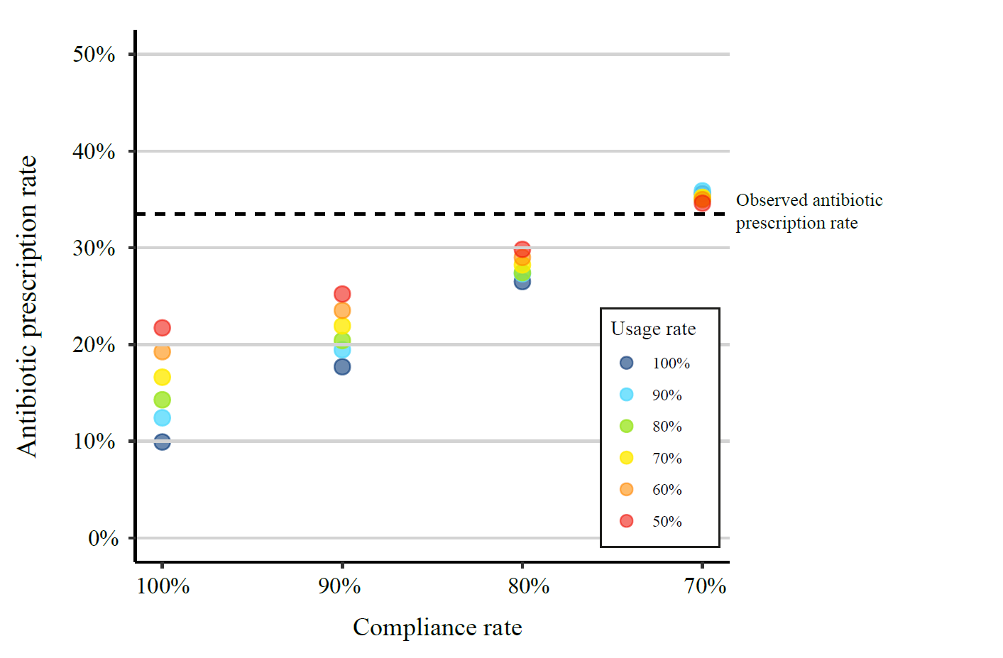
Presented data is based on pooled data from 12 Emergency Departments. Detailed information on simulation of the varying usage and compliance rates is presented in Table S4. This figure appears in colour in the online version of JAC.

Figure 2. Antibiotic prescription rates simulated by applying effect estimates from the intervention trial and for 100% usage and compliance for each ED
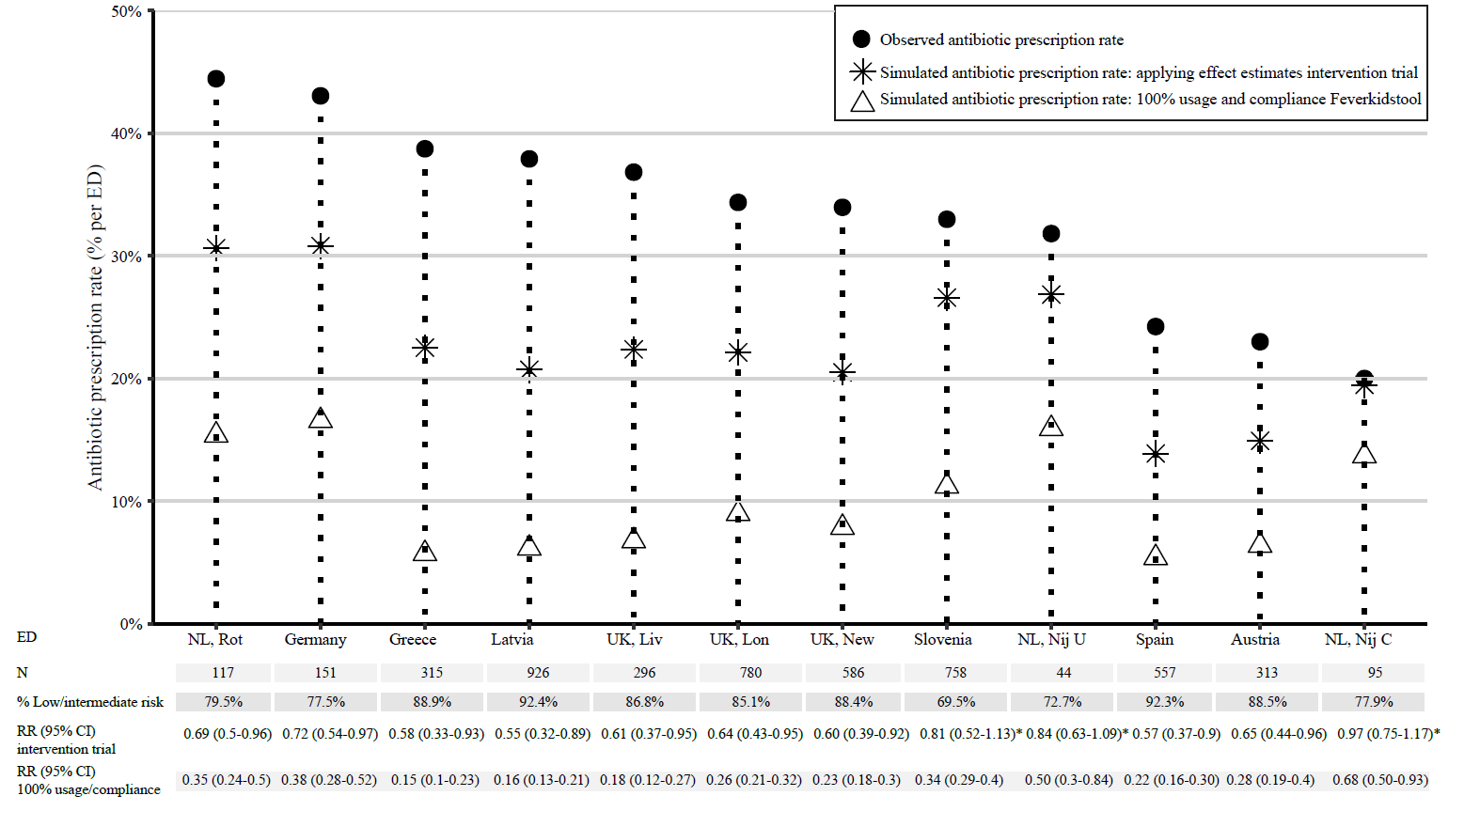
*Not significant. CI, confidence interval; ED, Emergency Department; Liv, Liverpool; Lon, London; New, Newcastle; Nij C, Nijmegen, Canisius; Nij U; Nijmegen, RadboudUMC; NL, Netherlands; Rot, Rotterdam; RR, risk ratio; UK, United Kingdom. EDs are sorted according to observed antibiotic prescription rates. Details of the analysis are presented in Table S5.
Figure 3. Antibiotic prescription rates simulated by applying effect estimates from the intervention trial and for 100% usage and compliance to the Feverkidstool for the age group 1 month-5 years and its transferability to children 5-12 years and 12-18 years
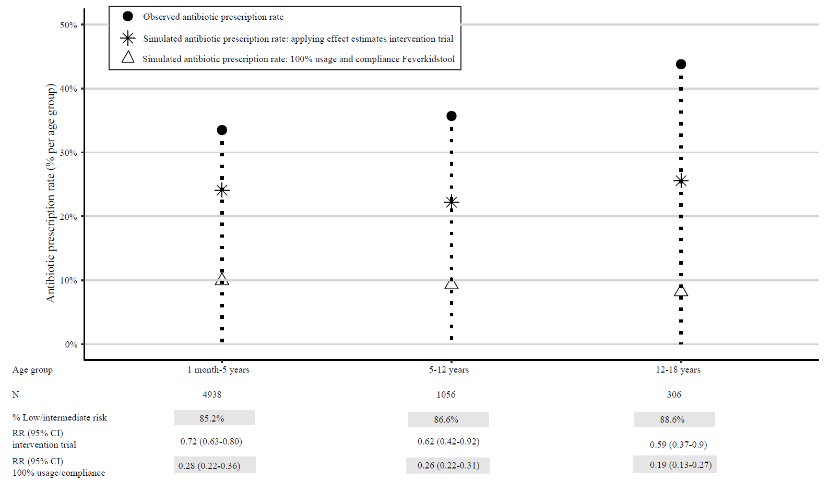
CI, confidence interval RR, risk ratio. Details of this analysis are presented in Table S6.

