Comparing two predictive risk models for nematodirosis in Great Britain

Aidan Hopkinson¹, Hannah Vineer¹, Dave Armstrong², Lesley Stubbings³, Mike Howe⁴, Eric R. Morgan⁵, John Graham-Brown¹
- Institute of Infection, Veterinary and Ecological Sciences, Leahurst Campus, University of Liverpool CH64 7TE.
- Zoetis UK Ltd, Birchwood Building, Springfield drive, Leatherhead KT22 7LP.
- LSSC Ltd, 6 North Street Oundle PE8 4AL.
- National Animal Disease Information Service, UK.
- School of Biological Sciences, Queen’s University Belfast, 19, Chlorine Gardens, Belfast, BT9 5DL.
Corresponding author: xp0u405d@liv.ac.uk

Abstract
Background: Nematodirus battus infection is a major health concern in lambs. Development and hatch of infective larvae on pastures is temperature dependent, making model-based risk forecasting a useful tool for disease control.
Methods: Air and 30cm soil temperature-based risk models were used to predict hatch dates using meteorological data from 2019 and compared to infection dates, estimated from the first appearance of N. battus eggs, on 18 sheep farms distributed across Great Britain.
Results: The air temperature model was more accurate in its predictions than the soil temperature model on 12 of the 18 farms, but tended to predict late hatch dates in the early part of the season.
Conclusion: Overall, the air temperature model appears the more appropriate choice for predicting N. battus peak hatch in the UK in terms of accuracy and practicality, but some adjustment might be needed to account for microclimatic variations at the soil-air interface.

Background
Parasitic Gastroenteritis (PGE) is an important disease of sheep in the UK and worldwide, with control dependent upon a limited number of anthelmintics. To slow selection for drug resistance, additional control measures including diagnostic testing, pasture management, targeted selective treatments of anthelmintic classes are advocated (1). In addition, predictive models can act as decision support tools for farmers, vets and other animal health advisors by providing an indication of disease risk over time, allowing targeted interventions to be implemented when the need is greatest (2).
Nematodirus battus is unique amongst the PGE-causing nematodes in the UK, since the majority of transmission occurs between one season’s lamb crop and the next. Larvated eggs which have survived on pastures over winter undergo synchronous hatch over a period of 1-2 weeks the following spring as ambient temperatures increase (3,4). If hatch coincides with the time lambs are beginning to graze, typically at 6-12 weeks of age (April to July in the UK), the resulting infections can lead to widespread and severe enteric disease (nematodirosis) (5).
Since temperature is the main trigger for hatching (4), meteorological data can be used to predict level of risk for a given location. Two risk models have been developed: The first is derived from the statistical relationship between soil temperature and pasture infectivity observed in the UK in the 1970s, and uses mean soil temperatures recorded at a depth of 30cm (6). The second uses daily minimum and maximum air temperatures (7), based on thresholds derived from laboratory observations of egg hatching at different constant temperatures (4). Here, we investigate the relative performance of these models by comparing predicted hatching dates to observed infection data taken from sheep farms across the UK.

Methods
Nematodirus battus faecal egg observations
Parasitological data for 2019 were obtained from 24 sheep farms in England, Wales and Scotland participating in the Parasite Watch initiative (https://www.zoetis.co.uk/). These included pooled faecal egg counts (FECs) in lambs at approximately monthly intervals over the course of the grazing season, analysed using the FECPAK^{G2} system (Techion UK) (8), with N. battus eggs specifically noted.
On each farm, infection date was estimated as 14 days prior to the first date N. battus eggs were detected, based on a pre-patent period of 14-16 days (5). It should be noted these estimates do not account for variations in sampling frequency or the limited information available on pasture management, i.e. whether lambs were grazing contaminated pastures at the time of peak hatch. It is likely hatch date was earlier than estimated on some farms. This uncertainty is considered in our conclusions.
Weather data
Daily 30cm soil temperatures and minimum and maximum air temperature data for 2019 were obtained from the Centre for Environmental Data Analysis archives (9,10). To ensure model-predicted hatch dates were comparable, only weather stations reporting both sets of data were included (Figure 1). Distance between farms and their designated weather stations was determined by GPS coordinates, and difference in elevation estimated by the Shuttle Radar Topography Mission (SRTM3) elevation model (11).
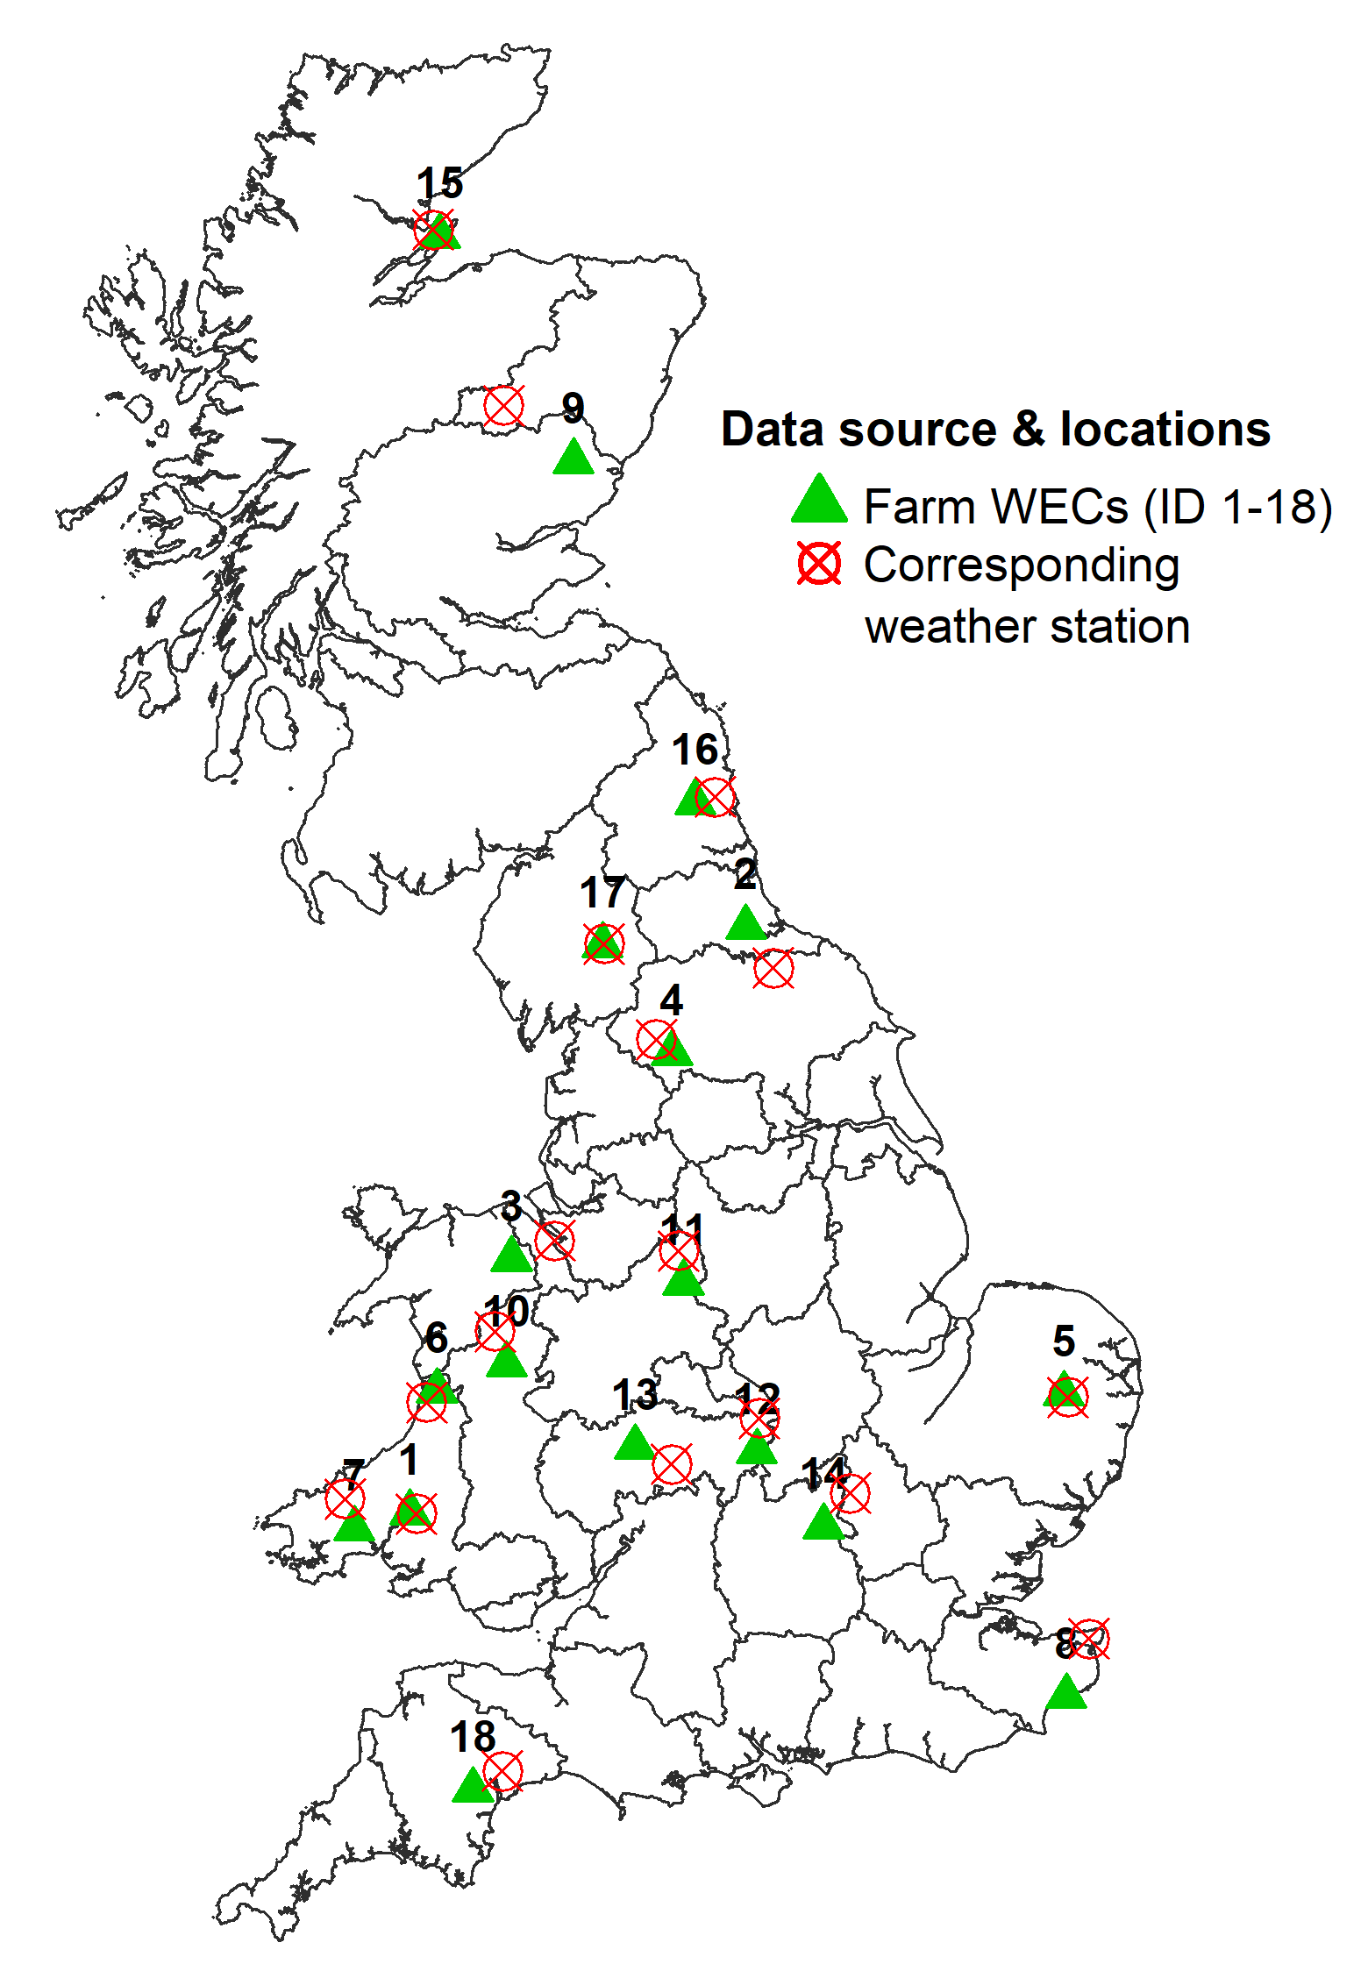
Figure 1: Geographic locations of Nematodirus battus positive farms (n=18) identified through faecal worm egg counts (FECs), and corresponding weather stations from which data were obtained for model-predicted hatch dates. Farms are numbered in chronological order of the first appearance of N. battus specific eggs.
Empirical soil temperature model
Predicted hatch dates were determined using daily mean soil temperatures for each location as described previously (6). Briefly, the mean daily 30cm soil temperature observed from 1st - 31st March was used to calculate the number of days after the 31st March that peak hatch was expected to occur. Where a negative value was obtained, the value was used to calculate an expected hatch date as the number of days before 31st March.
Mechanistic air temperature model
Predicted hatch dates were determined using daily air temperature data for each location as described previously (7). Briefly, daily minimum and maximum air temperatures from 1st January to 31st July 2019 were used to estimate the proportion of each day spent between the lower and upper temperature thresholds for N. battus egg hatch (11.5 – 17ºC) and summed cumulatively over consecutive days. Onset of hatching is predicted as the date when this cumulative development time reached ≥7 days in total.
Statistical analysis
Model-predicted hatch dates were compared to estimated infection dates by multivariable linear regression. For each farm, the difference in days between model-predicted hatch dates and estimated first infection was taken to be the dependent variable. The estimated first infection date for each farm, difference in elevation between farms and their designated weather stations (in metres), and model used for the predicted hatch date (“Air” or “Soil”) were entered as independent explanatory variables.

Results
From the 24 monitored farms, 18 were confirmed as N. battus positive through FECs and selected for analysis: 11 farms were in England, 2 in Scotland and 5 in Wales (Figure 1). Differences in distance and elevation between farms and designated weather stations are summarised in Table 1.
Estimated first infection dates for N. battus ranged between farms from 17th March – 6th June 2019 (Table 1). When compared to estimated first infection dates, the air temperature model yielded a more accurate prediction than the soil temperature model for 12 of the 18 farms (Table 1). Predicted hatch dates determined using the soil temperature model were on average 30.1 days (±19.8 SD) away from the estimated first infection date, yielding predicted hatch dates earlier than 31st March on 10 occasions. Predicted hatch dates determined using the air temperature model were on average 23.5 days (±17.7 SD) away from the estimated infection date.

Table 1: Summary of sheep farms and designated weather stations, estimated on-farm infection dates¹ and model-predicted hatch dates for N. battus.
Farm |  |  |  | Weather station |  |  |  | Soil model |  | Air model
ID | Latitude | Longitude | Estimated first infection date¹ | Latitude | Longitude | Distance from farm (Km) | Elevation difference² (m) | Predicted hatch date | Difference³ | Predicted hatch date | Difference³
1 | 51.93 | -4.15 | 17-Mar | 51.92 | -4.10 | 3.65 | -173 | 23-Mar | 6 | 29-Apr | 42
2 | 54.62 | -1.44 | 27-Mar | 54.43 | -1.22 | 25.35 | 43 | 07-Apr | 10 | 18-Apr | 21
3 | 53.09 | -3.33 | 31-Mar | 53.18 | -2.98 | 25.13 | -169 | 25-Mar | -5 | 22-Apr | 22
4 | 54.04 | -2.04 | 09-Apr | 54.10 | -2.16 | 10.92 | 181 | 16-Apr | 7 | 23-Jun | 74
5 | 52.47 | 1.13 | 12-Apr | 52.46 | 1.16 | 2.90 | 15 | 24-Mar | -18 | 25-May | 43
6 | 52.48 | -3.94 | 16-Apr | 52.43 | -4.02 | 8.12 | -204 | 22-Mar | -24 | 21-Apr | 5
7 | 51.85 | -4.60 | 16-Apr | 51.99 | -4.68 | 15.91 | 16 | 16-Mar | -30 | 12-May | 26
8 | 51.08 | 1.15 | 20-Apr | 51.35 | 1.34 | 32.13 | -3 | 28-Mar | -22 | 26-Apr | 6
9 | 56.76 | -2.83 | 01-May | 57.01 | -3.40 | 44.54 | 135 | 22-Apr | -9 | 26-May | 25
10 | 52.61 | -3.37 | 03-May | 52.76 | -3.47 | 17.91 | 129 | 05-Apr | -28 | 17-May | 14
11 | 52.98 | -1.94 | 04-May | 53.13 | -1.98 | 16.39 | 79 | 02-Apr | -32 | 01-May | -3
12 | 52.21 | -1.35 | 05-May | 52.36 | -1.33 | 17.02 | 4 | 28-Mar | -37 | 25-Apr | -10
13 | 52.23 | -2.33 | 10-May | 52.15 | -2.04 | 21.91 | -24 | 24-Mar | -46 | 24-Apr | -16
14 | 51.86 | -0.81 | 15-May | 52.01 | -0.59 | 22.49 | -3 | 27-Mar | -48 | 25-Apr | -20
15 | 57.79 | -3.91 | 18-May | 57.82 | -3.97 | 4.52 | -35 | 10-Apr | -38 | 28-Apr | -20
16 | 55.19 | -1.85 | 20-May | 55.21 | -1.69 | 10.66 | -46 | 07-Apr | -43 | 19-May | -1
17 | 54.53 | -2.60 | 02-Jun | 54.54 | -2.58 | 1.22 | -69 | 04-Apr | -58 | 29-Apr | -33
18 | 50.65 | -3.64 | 06-Jun | 50.74 | -3.41 | 19.35 | -39 | 15-Mar | -81 | 24-Apr | -42
- Estimated infection date is determined as the date 14 days prior to N. battus being detected for the first time on farm by presence of specific eggs in faecal worm egg counts.
- Calculated as difference in elevation in metres above sea level. Negative values indicate the weather station is lower in elevation relative to the farm.
- Difference in days between model-predicted and estimated infection date on farm. Negative values indicate an earlier model-predicted date than that determined by FEC.

The soil temperature model tended to predict earlier hatch dates compared to both the air temperature model and estimated first infection date. The air temperature model tended to predict a hatch date later than that estimated from egg appearance early in the season, and earlier than estimated later into the season. Multivariable linear regression analysis indicated:
- The soil temperature model predicted an earlier hatch date than the air temperature model by a coefficient of 34.9 days (±3.8 SE; p<0.001).
- Predicted hatch dates moved earlier relative to estimated first infection dates as the season progressed for both models (coefficient = -1.1 days, ±0.09 SE; p<0.001).
- Predicted dates moved later relative to estimated infection dates as the elevation of weather stations increased relative to their farms for both models (coefficient = 0.08 days, ±0.02 SE; p<0.001).

Conclusion
These results suggest that the air temperature model was more accurate in predicting N. battus peak hatch in Great Britain in spring 2019 than the soil temperature model. This study should not be considered a validation or reflection of either model’s true accuracy. Instead, it should be considered an assessment of the relative alignment of each model against real world observations. Peak hatch could have occurred sooner than estimated in some instances. Since the soil temperature model generally predicted an earlier hatch date than the air temperature model, the delay in observing first infection as a result of interval between FECs may have favoured the air temperature model in some instances. Further studies using on-farm data collected specifically for the purpose of risk model evaluation would be of use in verifying or refuting these findings.
Spring 2019 was unseasonably warm, with earlier hatch of N. battus than typically expected (5). A similar situation emerged again in 2020 and changing weather patterns for Europe indicate early hatch may become more commonplace in the future. Mechanistic models are expected to be more robust to such trends. Whilst the soil temperature model appears more accurate at the start of the grazing season (March-April), it is important to note it was developed to predict hatch dates after 31st March (6). Whilst it is technically possible to compute negative values and hatch dates before 31st March, extrapolation outside the range in which an empirical model has been developed to operate is not recommended (2). Conversely, whilst the air temperature model tended to predict a later hatch early in the season, it is based on live tracking of cumulative development time, such that risk status can be updated to indicate conditions favourable for development ahead of the predicted hatch date. Nevertheless, the tendency to predict a later-than-observed hatch early in the season could be a limitation. This might be explained by solar warming of the soil surface, in which case adjustments to improve model accuracy should be possible. One possible alternative could be to adopt a hybridised approach which uses both models to improve the overall accuracy of hatch date prediction. This could be achieved by weighting early season hatch predictions towards the empirical soil temperature-based model and later season predictions towards the air temperature-based mechanistic model. However, for the reasons already discussed, such an approach would first require further investigation and validation using current climate data, and future climate projections and observed hatch/infection data in a study designed specifically for this purpose.
Accuracy of model predictions were affected by the relative location of farms and their designated weather stations. Our analysis suggested a relationship between difference in observed infection and predicted hatch and the difference in elevation between farms and weather stations. This is to be expected, since altitude is known to affect ambient air temperature.
The soil temperature model has been used to forecast Nematodirus risk by the National Animal Disease Information Service (NADIS) (www.nadis.org.uk) since 1995, whilst the air temperature model has been the basis of the Sustainable Control of Parasites in Sheep (SCOPS) Nematodirus alerts since 2016 (www.scops.org.uk). In the light of findings presented here, combined with those practical considerations discussed, as of 2020 the air temperature model has also been incorporated into the NADIS Parasite Forecast in lieu of the soil temperature model, with signposting of users to SCOPS for additional guidelines on qualitative assessments of topographical and farm-specific factors for a more specific interpretation of risk.

Acknowledgements
This project was funded as an undergraduate student project through University of Liverpool’s School of Veterinary Science. Met Office RAMA datasets for daily soil and air temperatures were obtained with permission through the UK Centre for Environment Data Analysis (CEDA) archive (http://archive.ceda.ac.uk/). Farm locations and parasitological data used in this study were obtained from the Parasite Watch (https://www.zoetis.co.uk/livestock-farming/parasite-watch-map.aspx).

References:
1. SCOPS. Sustainable control of Parasites in Sheep [Internet]. 4th ed. Control of Worms Sustainably. SCOPS; 2012. Available from: http://www.scops.org.uk/index.php
2. Rose Vineer H. What Modeling Parasites, Transmission, and Resistance Can Teach Us. Vet Clin North Am Food Anim Pract. 2020 Mar;36(1):145–58.
3. Thomas RJ, Stevens AJ. Ecological studies on the development of the pasture stages of Nematodirus battus and N. filicollis, nematode parasites of sheep. Parasitology. 1960 May;50:31–49.
4. van Dijk J, Morgan ER. The influence of temperature on the development, hatching and survival of Nematodirus battus larvae. Parasitol -CAMBRIDGE- VO - 135. 2008;(2):269.
5. Taylor MA, Coop RL, Wall RL. Veterinary parasitology. Fourth edi. England: Chichester, West Sussex ; Ames, Iowa : John Wiley and Sons, Inc.; 2016.
6. Thomas RJ. Forecasting the onset of nematodiriasis in sheep. In: Gibson T, editor. Weather and Parasitic Animal Disease Technical Note No 159. Geneva: WMO No. 497; 1978.
7. Gethings OJ, Rose H, Mitchell S, Van Dijk J, Morgan ER. Asynchrony in host and parasite phenology may decrease disease risk in livestock under climate warming: Nematodirus battus in lambs as a case study. Parasitology. 2015 Sep;142(10):1306–17.
8. Vlaminck J, Cools P, Albonico M, Ame S, Ayana M, Bethony J, et al. Comprehensive evaluation of stool-based diagnostic methods and benzimidazole resistance markers to assess drug efficacy and detect the emergence of anthelmintic resistance: A Starworms study protocol. PLoS Negl Trop Dis. 2018 Nov 2;12(11).
9. Met Office. MIDAS: UK Soil Temperature Data. NCAS British Atmospheric Data Centre [Internet]. 2006 [cited 2019 Oct 1]. Available from: https://catalogue.ceda.ac.uk/uuid/8dc05f6ecc6065a5d10fc7b8829589ec
10. Met Office. MIDAS: UK Daily Temperature Data. NCAS British Atmospheric Data Centre [Internet]. 2006 [cited 2019 Oct 1]. Available from: https://catalogue.ceda.ac.uk/uuid/1bb479d3b1e38c339adb9c82c15579d8
11. Jarvis A, Reuter H, Nelson A, Guevara E. Hole-filled SRTM for the globe. CGIAR-CSI SRTM 90m Database; 2008.

