The risk of dementia after catheter ablation for atrial fibrillation: a nationwide cohort study

Daehoon Kim, MD*;¹ Pil-Sung Yang, MD*;² Jung-Hoon Sung, MD;² Eunsun Jang, MS;¹ Hee Tae Yu, MD;¹ Tae-Hoon Kim, MD;¹ Jae-Sun Uhm, MD;¹ Jong-Youn Kim, MD;¹ Hui-Nam Pak, MD;¹ Moon-Hyoung Lee, MD;¹ Gregory Y.H. Lip, MD†;³ Boyoung Joung, MD†¹

¹Division of Cardiology, Department of Internal Medicine, Severance Cardiovascular Hospital, Yonsei University College of Medicine, Seoul, Republic of Korea, ²Department of Cardiology, CHA Bundang Medical Center, CHA University, Seongnam, Republic of Korea, and ³Liverpool Centre for Cardiovascular Science, University of Liverpool and Liverpool Heart & Chest Hospital, Liverpool, United Kingdom.
[*The first two authors contributed equally to this work]
[†Joint senior authors]

Running Title: AF ablation and dementia
Word count: 3,242
Address for Correspondence:
Boyoung Joung, MD. Gregory Y.H. Lip, MD.
50-1 Yonseiro, Seodaemun-gu, Liverpool Centre for Cardiovascular Sciences,
Seoul, Republic of Korea 03722 University of Liverpool and Liverpool
Phone: +82-2-2228-8460 Heart & Chest Hospital,
Fax: +82-2-393-2041 Liverpool, United Kingdom
E-mail: cby6908@yuhs.ac E-mail: gregory.lip@liverpool.ac.uk
Abstract
Background: Accumulating evidence shows that atrial fibrillation (AF) is associated with increased risk of dementia. Catheter ablation for AF prolongs the duration of sinus rhythm, thereby improving the quality of life. We aimed to investigate the association of catheter ablation of AF with the occurrence of dementia.
Methods: From the Korean National Health Insurance Service database, 194,928 adult patients (≥18 years) with newly diagnosed AF were treated with ablation or medical therapy (antiarrhythmic or rate control drugs) between 1 January 2005 and 1 December 2015. Of patients without a history of dementia, we studied 9119 patients undergoing ablation and 17,978 patients managed with medical therapy. The time at risk was counted from the first medical therapy, and ablation was analyzed as time varying covariate. Propensity score matching was used to correct for differences between the groups.
Results: After propensity score matching, the ablation and medical therapy groups had similar background characteristics. During a median (25th, 75th percentiles) follow-up of 39 (16, 76) months, compared to medical therapy patients, ablated patients showed lower incidence and risk of overall dementia (5.1 and 8.0 per 1000 person-years, respectively; hazard ratio [HR] 0.66, 95% CI 0.54-0.79). Ablation was associated with a lower risk of overall dementia even after censoring for incident stroke (HR 2.8, 95% CI 1.7-4.0), regardless of age, heart failure, stroke history and risk of stroke. Ablation was also associated with lower risk of dementia subtypes including Alzheimer’s disease and vascular dementia, but this was non-significant after censoring for stroke.
Conclusion: In this nationwide cohort of AF patients treated with catheter ablation or medical therapy, ablation was associated with lower risks of overall dementia. This relationship was also evident after censoring for incident stroke, and adjusting for clinical confounders.

Keywords: atrial fibrillation, catheter ablation, dementia
Introduction
Atrial fibrillation (AF) is the most common type of sustained cardiac arrhythmia and is therefore a substantial economic and public health burden.¹⁻³ The age distribution of AF among populations of developed countries is predicted to shift in coming years, with an expected increase in prevalence among the elderly. The fact that AF prevalence has progressively risen 2.10 fold over the past 10 years in Korea, an increase to 8.15% in patients ≥80 years of age, supports this predicted progression.² Importantly, AF increases the risk of mortality and morbidity resulting from concurrently associated conditions including stroke, congestive heart failure, and hospitalization, and is associated with the occurrence of comorbid chronic diseases.⁴
There are approximately 40 million people living with dementia worldwide, and this number is expected to increase with a rising aged population.⁵ Although the pathophysiological mechanisms of dementia are largely unknown, evidence is accumulating that AF may contribute to the development of cognitive dysfunction and dementia.^{6, 7} The Rotterdam Study demonstrated that cognitive dysfunction was approximately twice as common in subjects with AF as in those without.⁶ Since then, several longitudinal studies have shown that AF is independently associated with an increased risk of cognitive decline or dementia.^{7, 8}
Compared to antiarrhythmic drug therapy, catheter ablation for AF reduces the number of acute episodes and prolongs the duration of sinus rhythm, thereby improving the quality of life.⁹⁻¹² The effect of ablation on the incidence of dementia has not been elucidated. Previous studies have reported that AF ablation was associated with declining cognitive function^{13, 14} and acute brain lesions.^{14, 15} Conversely, two recent studies demonstrated that cognitive function improved following ablation.^{16, 17}
Given the conflicting information available on the association of catheter ablation with cognitive function, we compared the development of dementia due to all-causes (including Alzheimer’s and vascular dementia) in patients with AF treated with or without ablation. Second, we assessed the relationship to stroke and long-term oral anticoagulation.

Methods
This study was a retrospective cohort analysis using the national health claims database (NHIS-2016-4-009) established by the NHIS of Korea. The NHIS is the single insurer managed by the Korean government. The majority (97.1%) of Korean citizens are mandatory subscribers to the NHIS, and the remaining 3% of the population are under the Medical Aid program. As the NHIS database contains the information of Medical Aid users, it is based on the entire Korean population.^{1-3, 6, 19, 20} This study was approved by the institutional review board of the Yonsei University Health System (4-2016-0179), and the requirement for informed consent was waived.
All data and materials have been made publicly available at the National Health Insurance Service (NHIS) of Korea. The data can be accessed on the National Health Insurance Data Sharing Service homepage of the NHIS (http://nhiss.nhis.or.kr). Applications to use the NHIS data will be reviewed by the inquiry committee of research support and, once approved, raw data will be provided to the authorized researcher with a fee at several permitted sites.
Study population
From the Korean NHIS database covering a population 51.5 million inhabitants, 834,735 adult patients (≥18 years) were newly diagnosed with AF from January 1, 2006, to December 31, 2015. Among these patients, the study population included those, who were treated with ablation or medical therapy [antiarrhythmic drugs or rate control drugs]. AF was diagnosed using the International Classification of Disease 10th revision code I48. To ensure diagnostic accuracy, AF was defined as present only when it was a discharge diagnosis or confirmed at least twice in the outpatient department. The AF diagnosis has previously been validated in the NHIS database with a positive predictive value of 94.1%.^{1-3, 6, 19, 20}
For both the ablated and the medical therapy patients, the time at risk was counted from index date of the first medical therapy. In patients who underwent AF ablation without medical therapy, the time at risk was counted from the index date of the first ablative procedure. Effect of ablation was analyzed as a time-varying exposure. The exclusion criteria for both groups were valvular AF, arrhythmia surgery (maze and similar procedures), implanted cardiac electric device, history of heart failure admission or dementia. Among medical therapy patients, patients who had oral anticoagulants less than 30 days or antiarrhythmic drugs less than 90 days during the same period were additionally excluded. After exclusions, 9119 patients with ablation and 17,978 patients with medical therapy remained for the analysis (Figure 1).
Covariates
Information regarding comorbidity conditions was obtained from inpatient and outpatient hospital diagnoses. Baseline comorbidities were defined using medical claims and prescription medications before the index date. The patients were considered to have comorbidities when the condition was a discharge diagnosis or was confirmed at least twice in an outpatient setting, similar to previous studies using NHIS data (Supplementary Table 1).^{1-3, 6, 19, 20} Baseline economic status was determined on the basis of the relative economic levels categorized into 10 levels according to their health insurance premiums in the index year. Prescription medication use was verified by identifying NHIS database claims within 90 days before the index date. The Hospital Frailty Risk Score was calculated retrospectively using 109 ICD-10 diagnostic codes, which were found to be associated with frailty (Supplementary Table 2). ²¹ Patients having the score of at least 5 were defined as frail.
Clinical outcome events and assessments
The primary clinical outcome was the initial occurrence of overall dementia. Secondary outcomes included development of dementia subtypes, including Alzheimer’s disease (AD) and vascular dementia (VaD). The Korean government covers medical expenditure for dementia patients. Diagnosis of dementia was defined using the following ICD-10 codes of dementia (F00 or G30 for AD, F01 for VaD, F02 for dementia with other diseases classified elsewhere, and F03 or G31 for unspecified dementia) and dementia drugs (rivastigmine, galantamine, memantine, or donepezil). To evaluate the accuracy of our definition of dementia, a validation study was conducted in two teaching hospitals with a total of 972 patients using patient medical records and results of cognitive function tests. The positive predictive value was 94.7%.⁸
Ischemic stroke was defined from any discharge diagnoses (ICD-10: I63, I64) with concomitant brain imaging studies. The accuracy of the diagnosis of an ischemic stroke in the NHIS claim data was previously validated.^{1-3, 6, 19, 20} The definitions of clinical outcomes are presented in Supplementary Table 1. It must be noted that the same patient could have more than one study outcome during the study duration, but only the first event of each outcome was considered in the study.
Statistical methods
Baseline characteristics of the participants with and without incident AF were compared using Student’s t-tests and Pearson’s chi-squared tests. One-to-two propensity score matching was used to account for the differences in baseline characteristics between patients who underwent ablation and those who were treated with medical therapy alone. A propensity score, the probability of undergoing ablation, was estimated using logistic regression based on socio-demographics, medical history, concurrent medication use, and AF duration (variables in Table 1).
Incidence rates of events were calculated by dividing the number of events by person-times at risk, with the 95% confidence intervals (CI) estimated by exact Poisson distributions. We compared the incidences of death using the weighted log-rank test and plotted weighted failure curves. Cox proportional hazards regressions were used to compare those patients treated with ablation and medical therapy. The Fine and Gray method was used to consider death as a competing risk when assessing dementia, Alzheimer’s disease and vascular dementia.²¹ The proportional hazards assumption was tested on the basis of Schoenfeld residuals.²²
Sensitivity analyses
First, we performed subgroup analyses for the primary outcome of dementia stratified by sex, age, heart failure, hypertension, diabetes, stroke/TIA, vascular disease, CHA₂DS₂-VASc, cardioversion or repeated ablation, and anticoagulation. Second, propensity score weighting was used to account for the differences in baseline characteristics between patients who underwent ablation and those who were treated with medical therapy alone. The weight was calculated as 1 - propensity score for the ablated patients, and the propensity score for the drug-treated patients. This weight is used to calculate the average treatment effect for the population. The balance between the treatment populations was evaluated by standardized differences of all baseline covariates using a threshold of 0.1 to indicate imbalance. Third, we conducted a stratified analysis based on whether the drug-treated patients were treated with antiarrhythmic or with rate control drugs only.
We performed a “falsification analysis” to determine whether ablation was associated with lower rates of urinary tract infections, influenza, Varicella-zoster, and fall accidents that should not be lower with ablation and would indicate that the population receiving ablation was different in ways that would result in reduced mortality or stroke that had nothing to do with ablation.²³
A two-sided P-values of < 0.05 were considered significant. Statistical analyses were conducted using SAS version 9.3 (SAS Institute, Cary, NC, USA) and R version 3.3.2 (The R Foundation, www.R-project.org).

Results

Compared with medical therapy patients, ablated patients were more often male, healthy, and with an income in the highest quartile (Table 1). Ablated patients were on average 10 years younger, and had less concomitant diseases. After propensity score matching, all baseline characteristics were similar between the two groups (Table 1). In multivariable analysis, the factors independently associated with the likelihood of undergoing catheter ablation were younger age, income in the highest quartile, and comorbidities including heart failure, hypertension and diabetes (Supplementary Table 2).
Ablated patients were younger, healthy and had less comorbidities than antiarrhythmic drug treated (Supplementary Table 3) and rate control patients (Supplementary Table 4). All baseline characteristics were similar between the two propensity score matched groups.
Risk of dementia
During a median (25th, 75th percentiles) follow-up of 39 (16, 76) months, 160 and 389 cases had dementia in the propensity score matched ablated and medical therapy group with annualized rates of 5.1 and 8.0 per 1000 person-years, respectively (P<0.001) (Table 2). The cumulative incidence of dementia was significantly lower in the ablated group compared with the medical group (P<0.001, Figure 2A). Compared with patients with medical therapy and after full adjustment of clinical variables and competing risk of mortality, the risk of primary outcome was reduced by 34% in patients with ablations (hazard ratio [HR] 0.66, 95% CI 0.54–0.79, P<0.001) (Table 2). The risk of dementia was reduced in the ablated group compared with antiarrhythmic drug treated (HR 0.71, 95% CI 0.59~0.586, P<0.001) and rate control groups (HR 0.59, 95% CI 0.48~0.72, P<0.001) (Table 2). Other factors associated with the increased risk of dementia included: older age (per 10 increase: HR 2.70, 95% CI 2.28–3.20, P<0.001), ischemic stroke (HR 1.55, 95% CI 1. 70–2.24, P=0.022), higher Charlson comorbidity indices (per 1 increase: HR 1.10, 95% CI 1.04–1.16, P<0.001), and higher Hospital Frailty Risk scores (per 1 increase: HR 1.05, 95% CI 1.03–1.07, P<0.001).
Subgroup analyses showed that the risk of primary outcome was reduced in subgroups regardless of age, heart failure, stroke history and risk of stroke. The association was more pronounced in those without cardioversion or repeated ablation (P for interaction<0.001) and those without optimal oral anticoagulation (< 80%) (P for interaction<0.001).
In the propensity score matched ablated and medical therapy group, annualized rates of ischemic stroke were 0.9 and 2.0 per 100 person-years, respectively (P<0.001). After additionally censoring for incident stroke, ablation was still associated with lower risk of overall dementia than medical therapy (HR 0.74, 95% CI 0.60-0.91, p=0.004), antiarrhythmic therapy (HR 0.78, 95% CI 0.63-0.97, p=0.025), and rate control only groups (HR 0.68, 95% CI 0.54-0.86, p=0.001).
Risks of Alzheimer’s disease and vascular dementia
Ablation was related with lower incidence and risk of Alzheimer’s disease (3.8 and 5.2 per 1000 person-years, HR 0.76, 95% CI 0.61–0.96, P=0.018) and vascular dementia (1.1 and 2.0 per 1000 person-years, HR 0.55, 95% CI 0.37–0.82, P=0.003) compared with the medical therapy (Table 2). The cumulative incidence of Alzheimer’s disease (P<0.001, Figure 4A) and vascular dementia (P<0.001, Figure 4B) was significantly lower in the ablated group compared with the medical therapy group. The risks of Alzheimer’s disease (HR 0.75, 95% CI 0.59~0.96, P=0.024) and vascular dementia (HR 0.46, 95% CI 0.30~0.71, P<0.001) were reduced in the ablated group compared with rate control group (Table 2).
After censoring for incident stroke, ablation was associated with consistent but non-significant trends for lower risks of Alzheimer disease and vascular dementia (Table 2, right panels of Figure 4A and Figure 4B).
Sensitivity analyses
The results using propensity score weighting (inverse probability of treatment weighting) were very similar to the primary results. For the primary outcome of overall dementia, the HR adjusted for clinical variables and competing risk of all-cause death was 0.52 (95% CI 0.44-0.61, p<0.001) for ablation vs. medical therapy, 0.58 (95% CI 0.49-0.69, p<0.001) for ablation vs. antiarrhythmic drug treated, and 0.47 (95% CI 0.40-0.57, p<0.001) for ablation vs. rate control. Ablation was also related to lower risks of Alzheimer’s disease and vascular dementia in the propensity score weighted ablated group compared to the medical therapy, antiarrhythmic drug treated and rate control groups. After additional censoring for ischemic stroke, these trends were consistently observed (Supplementary Table 5).
There were no significant relationships between ablation and any of the falsification endpoints (Supplementary Table 6).

Discussion
In this study, our principal finding was that patients with AF undergoing catheter ablation were at a lower risk of dementia compared to drug-treated patients, even after adjusting for variations in background characteristics and competing risk of death. This association was consistently evident after censoring for stroke. Second, the lower risks of dementia associated with AF ablation were consistent across different sex, heart failure, stroke, vascular disease history, and CHA₂DS₂-VASc score.
Bunch et al. reported that patients ablated for AF have a significantly lower risk of dementia in comparison to age/gender matched AF patients without ablation.⁷ The present study extends prior observations by enrolling a larger number of ablated patients than the previous study and using both propensity score- matching and - weighting approaches. A recent prospective study demonstrated an improvement in cognitive function in well-anticoagulated AF ablated patients.¹⁶ Mild cognitive dysfunction was found in 30.4% of the patients at baseline, but at the end of follow-up, Montreal-Cognitive Assessment score increased by a median of +1.0 (-1.0, 2.0) unit and 7.2% fewer patients had mild cognitive impairment than those at baseline. In the present study, the lower risks of dementia associated with ablation were observed mainly in subgroups without optimal anticoagulation, suggesting the association might be attributable to possibly different levels of OAC use between the ablation and control groups. On the contrary, ablation therapy for AF has been associated with declining cognitive function at 90 days after the procedure.^{13, 14} Furthermore, researchers have detected acute brain lesions without corresponding neurological symptoms in 25% of patients undergoing AF ablation using a high-resolution diffusion-weighted brain magnetic resonance imaging sequence that can identify acute cytotoxic brain edema.^{14, 15, 26, 27} However, a direct association of silent cerebral embolism with a decline in neurocognitive function is unproven.^{28, 29} The clinical significance of such asymptomatic cerebral embolic lesions is not known, and many will resolve to the point of being undetectable after weeks or months. These silent cerebral emboli are required to be distinguished from covert embolic strokes consequent to chronic AF. The latter have been linked with long-term cognitive decline and are much larger than the silent emboli observed peri-procedurally.^{30, 31} The impact on cognitive function, if any, is uncertain.
Our study shows that catheter ablation for AF was associated with the lower risk of both Alzheimer’s disease and vascular dementia. Given the relationship between AF and stroke, vascular dementia, encompassing both multi-infarct and small vessel disease dementia, might be considered as an obvious contributory factor for cognitive decline in AF population.^{6, 34} In general, the association of ablation with lower risk was more pronounced for vascular dementia than for Alzheimer’s disease. However, these results were not consistently observed after additionally censoring patients at the time of incident stroke suggesting that the reduction of overt stroke may account for the observed association of ablation with lower dementia risk.
Alzheimer’s disease is overall the most common type of dementia, and AF has been identified as a risk factor for Alzheimer’s disease.^{7, 8} In the majority of cases, the brains of patients with Alzheimer’s disease show vascular microinfarcts, white matter lesions, or vessel wall alterations.³² Experimentally induced cerebral micro-emboli in aged rats have induced beta-amyloid accumulation and increased hyperphosphorylated tau reactivity in both the infarcted and adjacent regions of the brain,³³ suggesting a possible association of the former with Alzheimer’s disease pathophysiology. Vascular risk factors have been correlated with a higher risk of Alzheimer’s dementia in many epidemiological studies.³² These vascular attributes might help explain the association between AF and the increased risk of Alzheimer’s disease, or between ablation and a decreased risk of Alzheimer’s disease.
Although we were able to observe an association between ablation and lower dementia risk across all subgroups, the association was accentuated especially in patients with prior cardioversion or repeated ablation, and those with optimal anticoagulation. This finding suggests the effect of reduction of dementia by ablation might be related with the maintenance of sinus rhythm, and the reduction of stroke in those with optimal anticoagulation.
Study limitations
The present study has several limitations. Although administrative databases are increasingly used for clinical research, such studies are potentially susceptible to inaccuracies arising from coding errors. To minimize this problem, we applied the definition that we had validated in previous studies using the Korean NHIS database [refs]. Second, our observational study findings cannot be used to establish causal relationships and residual confounding is likely to persist even after propensity score matching and weighting. Therefore, to check out the presence of confounding by indication, the falsification endpoints were assessed. No evidence of a hidden bias working in favor of ablation was found. Finally, level of education, baseline cognitive function, and quality of anticoagulation were not assessed and not included in our logistic regression models calculating propensity scores.

Conclusions
In this nationwide cohort of AF patients treated with catheter ablation or medical therapy, ablation was associated with lower risks of overall dementia. This relationship was also evident after censoring for incident stroke, and adjusting for clinical confounders.

Acknowledgements
National Health Information Database was provided by the NHIS of Korea. The authors would like to thank the National Health Insurance Service for cooperation.

Sources of Funding
This study was supported by a research grant from the Korean Healthcare Technology R&D project funded by the Ministry of Health & Welfare (HI15C1200, HC19C0130).

Disclosures
Gregory Y.H. Lip has served as a consultant for Bayer/Janssen, BMS/Pfizer, Biotronik, Medtronic, Boehringer Ingelheim, Novartis, Verseon and Daiichi-Sankyo and as a speaker for Bayer, BMS/Pfizer, Medtronic, Boehringer Ingelheim, and Daiichi-Sankyo. No fees have been received directly/personally. Boyoung Joung has served as a speaker for Bayer, BMS/Pfizer, Medtronic, and Daiichi-Sankyo, and received research funds from Medtronic and Abbott. No fees have been received directly/personally. The remaining authors have nothing to declare.
References
1. Lee H, Kim TH, Baek YS, Uhm JS, Pak HN, Lee MH, Joung B. The trends of atrial fibrillation-related hospital visit and cost, treatment pattern and mortality in korea: 10-year nationwide sample cohort data. Korean circulation journal. 2017;47:56-64
2. Kim D, Yang PS, Jang E, Yu HT, Kim TH, Uhm JS, Kim JY, Pak HN, Lee MH, Joung B, Lip GY. 10-year nationwide trends of the incidence, prevalence, and adverse outcomes of non-valvular atrial fibrillation nationwide health insurance data covering the entire korean population. American heart journal. 2018;202:20-26
3. Kim D, Yang PS, Jang E, Yu HT, Kim TH, Uhm JS, Kim JY, Pak HN, Lee MH, Joung B. Increasing trends in hospital care burden of atrial fibrillation in korea, 2006 through 2015. 2018;104:2010-2017
4. Stewart S, Hart CL, Hole DJ, McMurray JJ. A population-based study of the long-term risks associated with atrial fibrillation: 20-year follow-up of the renfrew/paisley study. The American journal of medicine. 2002;113:359-364
5. Wortmann M. Dementia: A global health priority - highlights from an adi and world health organization report. Alzheimer's research & therapy. 2012;4:40
6. Ott A, Breteler MM, de Bruyne MC, van Harskamp F, Grobbee DE, Hofman A. Atrial fibrillation and dementia in a population-based study. The rotterdam study. Stroke. 1997;28:316-321
7. Bunch TJ, Weiss JP, Crandall BG, May HT, Bair TL, Osborn JS, Anderson JL, Muhlestein JB, Horne BD, Lappe DL, Day JD. Atrial fibrillation is independently associated with senile, vascular, and alzheimer's dementia. Heart rhythm. 2010;7:433-437
8. Kim D, Yang PS, Yu HT, Kim TH, Jang E, Sung JH, Pak HN, Lee MY, Lee MH, Lip GYH, Joung B. Risk of dementia in stroke-free patients diagnosed with atrial fibrillation: Data from a population-based cohort. European heart journal. 2019;40:2313-2323
9. Wilber DJ, Pappone C, Neuzil P, De Paola A, Marchlinski F, Natale A, Macle L, Daoud EG, Calkins H, Hall B, Reddy V, Augello G, Reynolds MR, Vinekar C, Liu CY, Berry SM, Berry DA, ThermoCool AFTI. Comparison of antiarrhythmic drug therapy and radiofrequency catheter ablation in patients with paroxysmal atrial fibrillation: A randomized controlled trial. Jama. 2010;303:333-340
10. Aronsson M, Svennberg E, Rosenqvist M, Engdahl J, Al-Khalili F, Friberg L, Frykman-Kull V, Levin LA. Cost-effectiveness of mass screening for untreated atrial fibrillation using intermittent ecg recording. Europace : European pacing, arrhythmias, and cardiac electrophysiology : journal of the working groups on cardiac pacing, arrhythmias, and cardiac cellular electrophysiology of the European Society of Cardiology. 2015;17:1023-1029
11. Mark DB, Anstrom KJ, Sheng S, Piccini JP, Baloch KN, Monahan KH, Daniels MR, Bahnson TD, Poole JE, Rosenberg Y, Lee KL, Packer DL, Investigators C. Effect of catheter ablation vs medical therapy on quality of life among patients with atrial fibrillation: The cabana randomized clinical trial. Jama. 2019
12. Kirchhof P, Benussi S, Kotecha D, Ahlsson A, Atar D, Casadei B, Castella M, Diener HC, Heidbuchel H, Hendriks J, Hindricks G, Manolis AS, Oldgren J, Popescu BA, Schotten U, Van Putte B, Vardas P, Group ESCSD. 2016 esc guidelines for the management of atrial fibrillation developed in collaboration with eacts. European heart journal. 2016;37:2893-2962
13. Schwarz N, Kuniss M, Nedelmann M, Kaps M, Bachmann G, Neumann T, Pitschner HF, Gerriets T. Neuropsychological decline after catheter ablation of atrial fibrillation. Heart rhythm. 2010;7:1761-1767
14. Haeusler KG, Kirchhof P, Endres M. Left atrial catheter ablation and ischemic stroke. Stroke. 2012;43:265-270
15. Nakamura T, Okishige K, Kanazawa T, Yamashita M, Kawaguchi N, Kato N, Aoyagi H, Yamauchi Y, Sasano T, Hirao K. Incidence of silent cerebral infarctions after catheter ablation of atrial fibrillation utilizing the second-generation cryoballoon. Europace : European pacing, arrhythmias, and cardiac electrophysiology : journal of the working groups on cardiac pacing, arrhythmias, and cardiac cellular electrophysiology of the European Society of Cardiology. 2017;19:1681-1688
16. Kirchhof P, Haeusler KG, Blank B, De Bono J, Callans D, Elvan A, Fetsch T, Van Gelder IC, Gentlesk P, Grimaldi M, Hansen J, Hindricks G, Al-Khalidi HR, Massaro T, Mont L, Nielsen JC, Nolker G, Piccini JP, De Potter T, Scherr D, Schotten U, Themistoclakis S, Todd D, Vijgen J, Di Biase L. Apixaban in patients at risk of stroke undergoing atrial fibrillation ablation. European heart journal. 2018;39:2942-2955
17. Jin MN, Kim TH, Kang KW, Yu HT, Uhm JS, Joung B, Lee MH, Kim E, Pak HN. Atrial fibrillation catheter ablation improves 1-year follow-up cognitive function, especially in patients with impaired cognitive function. Circ Arrhythm Electrophysiol. 2019;12:e007197
18. Kim D, Yang PS, Jang E, Yu HT, Kim TH, Uhm JS, Kim JY, Pak HN, Lee MH, Joung B, Lip GYH. Increasing trends in hospital care burden of atrial fibrillation in korea, 2006 through 2015. Heart. 2018
19. Kim D, Yang PS, Kim TH, Uhm JS, Park J, Pak HN, Lee MH, Joung B. Effect of atrial fibrillation on the incidence and outcome of osteoporotic fracture- a nationwide population-based study. Circulation journal : official journal of the Japanese Circulation Society. 2018;82:1999-2006
20. Friberg L, Tabrizi F, Englund A. Catheter ablation for atrial fibrillation is associated with lower incidence of stroke and death: Data from swedish health registries. European heart journal. 2016;37:2478-2487
21. Gilbert T, Neuburger J, Kraindler J, Keeble E, Smith P, Ariti C, Arora S, Street A, Parker S, Roberts HC, Bardsley M, Conroy S. Development and validation of a hospital frailty risk score focusing on older people in acute care settings using electronic hospital records: An observational study. Lancet. 2018;391:1775-1782
22. Xu S, Ross C, Raebel MA, Shetterly S, Blanchette C, Smith D. Use of stabilized inverse propensity scores as weights to directly estimate relative risk and its confidence intervals. Value in health : the journal of the International Society for Pharmacoeconomics and Outcomes Research. 2010;13:273-277
23. Fine J, Gray R. A proportional hazards model for the subdistribution of a competing risk. J Am Stat Assoc. 1999;94:496-509
24. Grambsch P, Therneau T. Proportional hazards tests and diagnostics based on weighted residuals. Biometrika. 1994;81:515–526
25. Wimmer NJ, Resnic FS, Mauri L, Matheny ME, Yeh RW. Comparison of transradial versus transfemoral percutaneous coronary intervention in routine practice: Evidence for the importance of "falsification hypotheses" in observational studies of comparative effectiveness. Journal of the American College of Cardiology. 2013;62:2147-2148
26. Herm J, Fiebach JB, Koch L, Kopp UA, Kunze C, Wollboldt C, Brunecker P, Schultheiss HP, Schirdewan A, Endres M, Haeusler KG. Neuropsychological effects of mri-detected brain lesions after left atrial catheter ablation for atrial fibrillation: Long-term results of the macpaf study. Circ Arrhythm Electrophysiol. 2013;6:843-850
27. Benameur K, Bykowski JL, Luby M, Warach S, Latour LL. Higher prevalence of cortical lesions observed in patients with acute stroke using high-resolution diffusion-weighted imaging. AJNR Am J Neuroradiol. 2006;27:1987-1989
28. Deneke T, Jais P, Scaglione M, Schmitt R, L DIB, Christopoulos G, Schade A, Mugge A, Bansmann M, Nentwich K, Muller P, Krug J, Roos M, Halbfass P, Natale A, Gaita F, Haines D. Silent cerebral events/lesions related to atrial fibrillation ablation: A clinical review. Journal of cardiovascular electrophysiology. 2015;26:455-463
29. Bendszus M, Stoll G. Silent cerebral ischaemia: Hidden fingerprints of invasive medical procedures. The Lancet. Neurology. 2006;5:364-372
30. De Groot JC, De Leeuw FE, Oudkerk M, Van Gijn J, Hofman A, Jolles J, Breteler MM. Periventricular cerebral white matter lesions predict rate of cognitive decline. Annals of neurology. 2002;52:335-341
31. Wardlaw JM, Smith EE, Biessels GJ, Cordonnier C, Fazekas F, Frayne R, Lindley RI, O'Brien JT, Barkhof F, Benavente OR, Black SE, Brayne C, Breteler M, Chabriat H, Decarli C, de Leeuw FE, Doubal F, Duering M, Fox NC, Greenberg S, Hachinski V, Kilimann I, Mok V, Oostenbrugge R, Pantoni L, Speck O, Stephan BC, Teipel S, Viswanathan A, Werring D, Chen C, Smith C, van Buchem M, Norrving B, Gorelick PB, Dichgans M, nEuroimaging STfRVco. Neuroimaging standards for research into small vessel disease and its contribution to ageing and neurodegeneration. The Lancet. Neurology. 2013;12:822-838
32. de la Torre JC. Is alzheimer's disease a neurodegenerative or a vascular disorder? Data, dogma, and dialectics. The Lancet. Neurology. 2004;3:184-190
33. Han F, Ali Raie A, Shioda N, Qin ZH, Fukunaga K. Accumulation of beta-amyloid in the brain microvessels accompanies increased hyperphosphorylated tau proteins following microsphere embolism in aged rats. Neuroscience. 2008;153:414-427
34. Dagres N, Chao TF, Fenelon G, Aguinaga L, Benhayon D, Benjamin EJ, Bunch TJ, Chen LY, Chen SA, Darrieux F, de Paola A, Fauchier L, Goette A, Kalman J, Kalra L, Kim YH, Lane DA, Lip GYH, Lubitz SA, Marquez MF, Potpara T, Pozzer DL, Ruskin JN, Savelieva I, Teo WS, Tse HF, Verma A, Zhang S, Chung MK, Group ESCSD. European heart rhythm association (ehra)/heart rhythm society (hrs)/asia pacific heart rhythm society (aphrs)/latin american heart rhythm society (lahrs) expert consensus on arrhythmias and cognitive function: What is the best practice? Europace : European pacing, arrhythmias, and cardiac electrophysiology : journal of the working groups on cardiac pacing, arrhythmias, and cardiac cellular electrophysiology of the European Society of Cardiology. 2018;20:1399-1421

Table 1. Baseline characteristics before and after propensity score matching.
 | Ablation  (N=9,119) | Medical therapy (N=17,978) | SMD | Ablation  (N=6,562) | Medical therapy (N=6,562) | SMD
Demographic
Age, years | 57 (50, 65) | 67 (59, 73) | 80.9% | 60 (53, 67) | 60 (53, 67) | 1.5%
<65 years | 44.0% | 49.0% | 71.0% | 47.0% | 47.0% | 1.5%
65-74 year | 40.0% | 47.0% | 30.1% | 44.0% | 44.0% | 1.3%
≥75 years | 18.0% | 41.0% | 55.7% | 21.0% | 22.0% | 0.6%
Male | 42.0% | 47.0% | 20.1% | 44.0% | 43.0% | 1.6%
High income status | 50.0% | 50.0% | 19.5% | 50.0% | 50.0% | 2.1%
AF duration, months | 24.2 (7.1, 56.4) | 16.7 (2.5, 37.4) | 26.3% | 19.3 ( 5.9,48.0) | 19.6 (3.0, 44.7) | 1.1%
Risk scores
CHA₂DS₂-VASc score | 2.0 (1.0, 3.0) | 4.0 (2.0, 5.0) | 73.1% | 2.0 (1.0, 4.0) | 2.0 (1.0, 4.0) | 1.2%
mHAS-BLED score* | 2.0 (2.0, 3.0) | 3.0 (2.0, 4.0) | 38.2% | 2.0 (2.0, 3.0) | 3.0 (2.0, 3.0) | 2.8%
Charlson comorbidity index | 3.0 (2.0, 5.0) | 4.0 (2.0, 6.0) | 38.5% | 3.0 (2.0, 5.0) | 3.0 (2.0, 5.0) | 1.6%
Hospital frailty risk score | 1.1 (0.0, 3.4) | 1.6 (0.0, 5.6) | 32.6% | 1.1 (0.0, 3.7) | 0.8 (0.0, 3.6) | 1.5%
Comorbidities
Heart failure | 47.0% | 50.0% | 30.1% | 48.0% | 48.0% | 1.1%
Hypertension | 42.0% | 34.0% | 24.8% | 40.0% | 40.0% | 0.4%
Diabetes | 34.0% | 44.0% | 30.7% | 38.0% | 38.0% | 1.7%
Dyslipidemia | 39.0% | 42.0% | 10.5% | 40.0% | 40.0% | 1.7%
Ischemic stroke | 36.0% | 47.0% | 41.1% | 39.0% | 40.0% | 2.0%
TIA | 27.0% | 29.0% | 5.7% | 27.0% | 27.0% | 0.7%
Hemorrhagic stroke | 11.0% | 16.0% | 10.3% | 12.0% | 13.0% | 0.7%
Myocardial infarction | 30.0% | 35.0% | 12.3% | 31.0% | 31.0% | 1.1%
Peripheral arterial disease | 31.0% | 36.0% | 13.4% | 32.0% | 32.0% | 0.9%
Chronic kidney disease | 20.0% | 25.0% | 11.6% | 21.0% | 21.0% | 0.8%
End stage renal disease | 7.0% | 11.0% | 7.5% | 8.0% | 9.0% | 1.2%
Proteinuria | 22.0% | 24.0% | 4.7% | 23.0% | 23.0% | 0.5%
Hyperthyroidism | 39.0% | 35.0% | 11.3% | 37.0% | 37.0% | 0.2%
Hypothyroidism | 36.0% | 32.0% | 10.0% | 35.0% | 35.0% | 0.4%
Malignancy | 39.0% | 41.0% | 6.4% | 39.0% | 39.0% | 0.6%
COPD | 40.0% | 45.0% | 21.2% | 41.0% | 41.0% | 1.4%
Liver disease | 50.0% | 49.0% | 8.7% | 49.0% | 49.0% | 0.5%
Hypertrophic cardiomyopathy | 13.0% | 18.0% | 8.6% | 15.0% | 16.0% | 1.5%
History of bleeding | 45.0% | 46.0% | 2.6% | 45.0% | 46.0% | 2.2%
Osteoporosis | 36.0% | 43.0% | 21.9% | 38.0% | 38.0% | 1.2%
Sleep apnea | 14.0% | 8.0% | 11.3% | 12.0% | 11.0% | 1.4%
Medication (Treatment)
OAC | 49.0% | 45.0% | 26.0% | 48.0% | 48.0% | 1.9%
Antiplatelet agents | 44.0% | 48.0% | 20.7% | 46.0% | 46.0% | <0.1%
ACE-inhibitor/ARB | 50.0% | 49.0% | 26.8% | 50.0% | 50.0% | 0.5%
Diuretics | 47.0% | 50.0% | 46.2% | 49.0% | 49.0% | 0.4%
K sparing diuretics | 25.0% | 37.0% | 30.9% | 28.0% | 27.0% | 1.1%
Statin | 49.0% | 49.0% | 2.3% | 49.0% | 49.0% | 1.4%
Beta-blocker | 49.0% | 50.0% | 9.1% | 49.0% | 49.0% | 0.2%
CCB DHP | 45.0% | 49.0% | 28.7% | 47.0% | 47.0% | 0.7%
CCB Non-DHP | 42.0% | 39.0% | 13.3% | 41.0% | 41.0% | 0.5%
Digoxin | 32.0% | 44.0% | 37.8% | 35.0% | 35.0% | 0.8%
Values are presented as median (Q1, Q3, quartiles [25th and 75th percentiles]) or %. *Modified HAS-BLED=hypertension, 1 point: >65 years old, 1 point: stroke history, 1 point: bleeding history or predisposition, 1 point: liable international normalized ratio, not assessed: ethanol or drug abuse, 1 point: drug predisposing to bleeding, 1 point.
ACE, angiotensin converting enzyme; AF, atrial fibrillation; ARB, angiotensin II receptor blocker; COPD, chronic obstructive pulmonary disease; NOAC, non-vitamin K antagonist oral anticoagulant; OAC, oral anticoagulant; SMD, standardized mean difference; TIA, transient ischemic attack.

Table 2. Risk of clinical outcomes in propensity score matched ablated and non-ablated patients.
 | Number  of events | Person  years | Event rate (1000 person-years) | Number  of events | Person  years | Event rate (1000 person-years) | Absolute reduction  in event rate  (95% CI) | Adjusted hazard ratio  (95% CI) * | p-value
Ablation vs. Medical therapy
 | Medical Therapy (N= 6,562) |  |  | Ablation (N= 6,562)
Including stroke
Overall dementia | 389 | 48727 | 8.0 | 160 | 31153 | 5.1 | 2.8 (1.7-4.0) | 0.66 (0.54-0.79) | <0.001
Alzheimer’s disease | 253 | 49093 | 5.2 | 118 | 31275 | 3.8 | 1.4 (0.4-2.3) | 0.76 (0.61-0.96) | 0.018
Vascular dementia | 101 | 49516 | 2.0 | 35 | 31447 | 1.1 | 0.9 (0.3-1.5) | 0.55 (0.37-0.82) | 0.003
Censoring for stroke
Overall dementia | 288 | 46570 | 6.2 | 137 | 30370 | 4.5 | 1.7 (0.6-2.7) | 0.74 (0.60-0.91) | 0.004
Alzheimer’s disease | 200 | 46817 | 4.3 | 105 | 30466 | 3.4 | 0.8 (-0.1 to 1.7) | 0.83 (0.65-1.06) | 0.139
Vascular dementia | 61 | 47221 | 1.3 | 26 | 30630 | 0.8 | 0.4 (-0.04 to 0.9) | 0.65 (0.41-1.05) | 0.076
Ablation vs. Antiarrhythmic drug
 | Antiarrhythmic drug (N= 5,992) |  |  | Ablation (N= 5,992)
Including stroke
Overall dementia | 342 | 43907 | 7.8 | 159 | 28234 | 5.6 | 2.2 (0.9-3.4) | 0.71 (0.59-0.86) | <0.001
Alzheimer’s disease | 221 | 44219 | 5.0 | 115 | 28368 | 4.1 | 0.9 (-0.1 to 2.0) | 0.83 (0.66-1.04) | 0.106
Vascular dementia | 81 | 44534 | 1.8 | 37 | 28525 | 1.3 | 0.5 (-0.1 to 1.1) | 0.71 (0.48-1.06) | 0.093
Censoring for stroke
Overall dementia | 261 | 42105 | 6.2 | 137 | 27515 | 5.0 | 1.2 (0.1-2.4) | 0.78 (0.63-0.97) | 0.025
Alzheimer’s disease | 174 | 42325 | 4.1 | 104 | 27619 | 3.8 | 0.3 (-0.6 to 1.3) | 0.94 (0.73-1.20) | 0.601
Vascular dementia | 58 | 42580 | 1.4 | 28 | 27771 | 1.0 | 0.4 (-0.2 to 0.9) | 0.71 (0.45-1.13) | 0.145
Ablation vs. Rate control only
 | Rate control only (N= 3,829) |  |  | Ablation (N= 3,829)
Including stroke
Overall dementia | 358 | 29942 | 12.0 | 130 | 17933 | 7.2 | 4.7 (2.8-6.6) | 0.59 (0.48-0.72) | <0.001
Alzheimer’s disease | 222 | 30351 | 7.3 | 96 | 18040 | 5.3 | 2.0 (0.5-3.5) | 0.75 (0.59-0.96) | 0.024
Vascular dementia | 96 | 30685 | 3.1 | 28 | 18167 | 1.5 | 1.6 (0.7-2.5) | 0.46 (0.30-0.71) | <0.001
Censoring for stroke
Overall dementia | 251 | 28107 | 8.9 | 110 | 17419 | 6.3 | 2.6 (0.9-4.3) | 0.68 (0.54-0.86) | 0.001
Alzheimer’s disease | 167 | 28380 | 5.9 | 84 | 17503 | 4.8 | 1.1 (-0.3 to 2.5) | 0.84 (0.64-1.10) | 0.204
Vascular dementia | 53 | 28689 | 1.8 | 21 | 17619 | 1.2 | 0.7 (-0.1 to 1.4) | 0.59 (0.35-0.99) | 0.044
*Adjusted for clinical variables and competing risk of all-cause deaths. Clinical variables included age, sex, income, AF duration, CHA₂DS₂-VASc score, modified HAS-BLED score, hospital frailty risk score, Charlson comorbidity index, hypertension, diabetes, ischemic stroke/TIA, myocardial infarction, peripheral arterial disease, hypertrophic cardiomyopathy, chronic kidney disease, end stage renal disease, liver disease, malignancy, hyperthyroidism, hypothyroidism, venous thromboembolism, COPD, intracranial bleeding, cardioversion, history of bleeding, baseline use of warfarin, NOAC, aspirin, clopidogrel, beta-blocker, ACE-inhibitor/ARB, dihydropyridine/nondihydropyridine calcium channel blocker, Class Ic and III antiarrhythmic drug, statin, diuretics, and digoxin, and OAC coverage rate of time at risk.
ACE, angiotensin converting enzyme; ARB, angiotensin II receptor blocker; CI, confidence interval; COPD, chronic obstructive pulmonary disease; SE, systemic embolism NOAC, non-vitamin K antagonist oral anticoagulant; OAC, oral anticoagulant.

Figure Legends
Figure 1. Flowchart of the enrollment and analysis of the study population. AF, atrial fibrillation; ICD, implantable cardioverter defibrillator; OAC, oral anticoagulant.
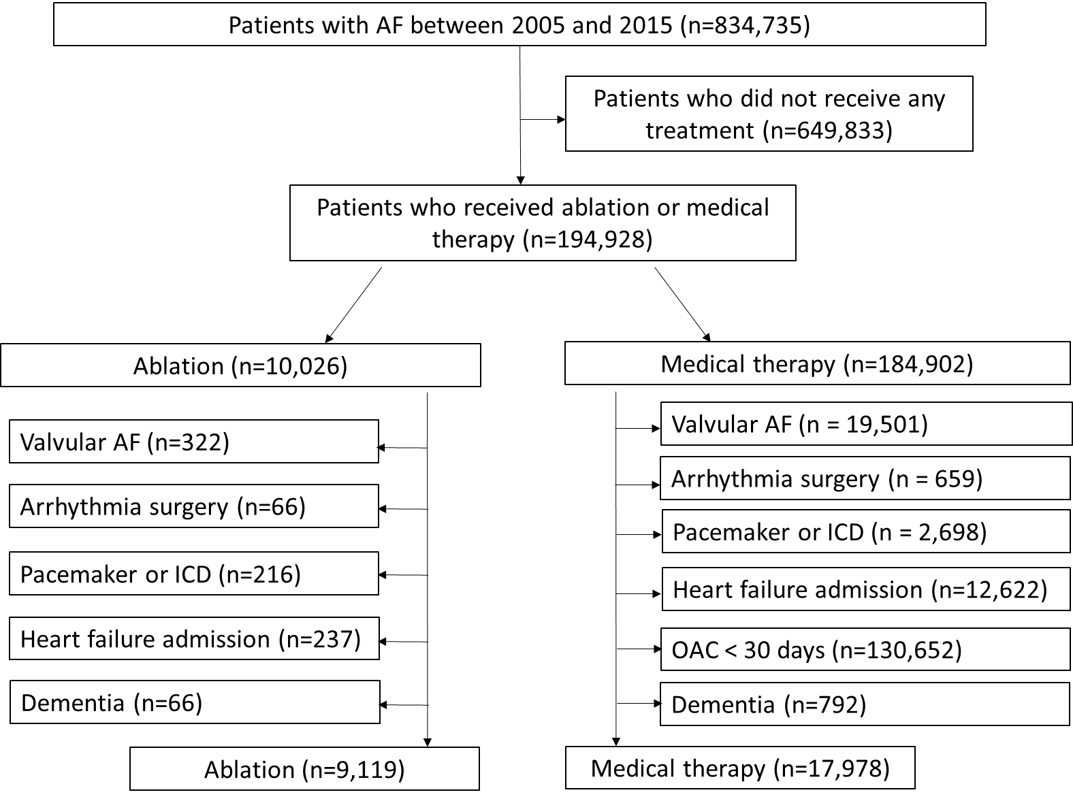
Figure 2. Cumulative incidence curves of overall dementia in propensity matched ablated or medical therapy patients. Left panel, Dementia including (not censoring) stroke. Right panel, Dementia after censoring for stroke.
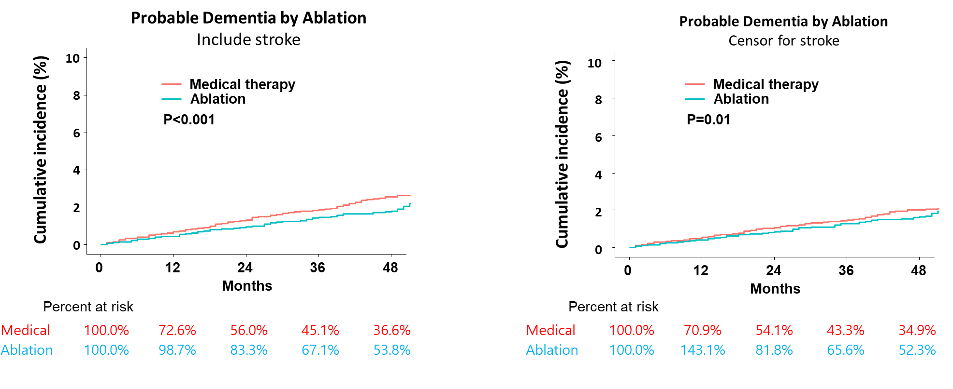

Figure 3. Subgroup analyses of the risk of primary composite outcome. CI: confidence interval, HR: hazard ratio, OAC: oral anticoagulant.
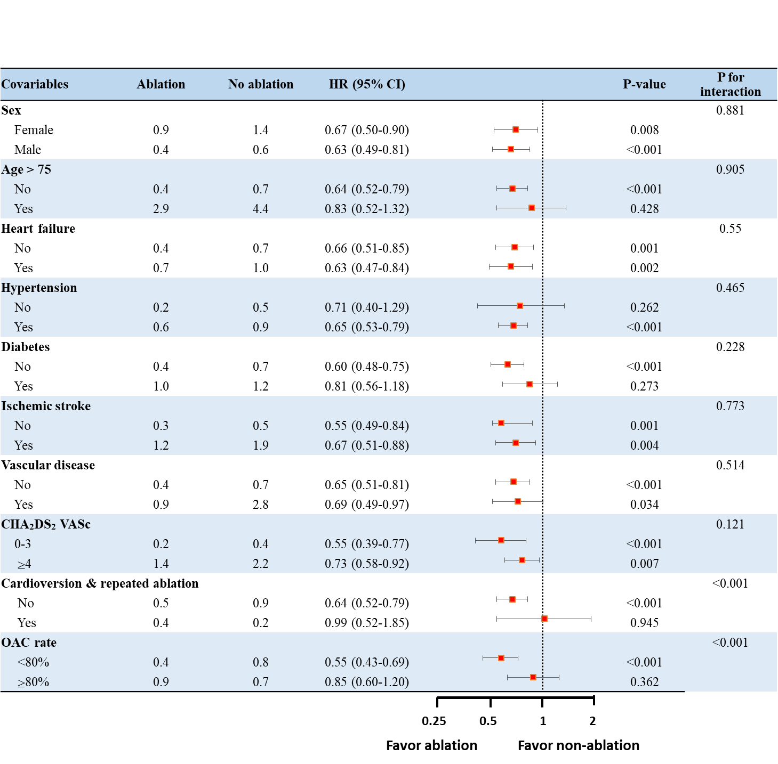
Figure 4. Cumulative incidence curves of Alzheimer’s disease (A) and vascular dementia (B) in ablated or medical therapy patients. Left panel, including (not censoring) stroke. Right panel, after censoring for stroke.
