A review of China’s municipal solid waste (MSW) and comparison with international regions: Management and technologies in treatment and resource utilization

Yin Ding,^{a #} Jun Zhao,^{b #} Jia-Wei Liu,ª Jizhi Zhou,^{c} Liang Cheng,^{d} Jia Zhao,^{e} Zhe Shao,^{f} Çağatay Iris,^{g *} Bingjun Pan,^{a, h} Xiaonian Li,^{e} Zhong-Ting Hu,^{a, h, i *}

ª College of Environment, Zhejiang University of Technology (ZJUT), Hangzhou 310014, China
^{b} Institute of Bioresource and Agriculture, Hong Kong Baptist University, Hong Kong SAR
^{c} School of Economics, Shanghai University, Shanghai 200444, China
^{d} Biofuel Institute of Jiangsu University, Zhenjiang 212013, Jiangsu, China
^{e} Industrial Catalysis Institute, ZJUT, Hangzhou 310014, China
^{f} Singapore Urban Dot Solution Pte Ltd, Singapore 369546, Singapore
^{g} Management School, University of Liverpool, L69 7ZH, United Kingdom
^{h} Key Laboratory of Microbial Technology for Industrial Pollution Control of Zhejiang Province, ZJUT, Hangzhou 310032, China
^{i} Zhejiang PUZE Environmental Protection Technology Pte Ltd, Ningbo 315301, China

*E-mail: zthu@zjut.edu.cn; c.iris@liverpool.ac.uk; #Co-first authors
Abstract
Although municipal solid waste (MSW) has a potential risk for human health and ecological environment, it is gradually considered as one of the most renewable resources. To maximize resource utilization of MSW and its elimination, numerous efforts have been devoted worldwide to develop a systematic MSW management coupled with technologies in treatment and resource utilization (TTRU). This paper mainly focuses on MSW in eight eastern coastal regions in China on the aspects of background information (MSW generation, population, gross domestic product (GDP)/gross regional product (GRP)), related laws (acts, regulations), MSW characteristics (composition, separation, collection, transport) and TTRU. Besides, emerging technologies in MSW resource utilization for waste-to-energy (WtE) and waste-to-material (WtM) are reviewed for the first time. Finally, a comparison based on above information is conducted between China and selected developed regions, namely Berlin, Tokyo, and Singapore. The findings for China are summarized as follows: (1) MSW generation keeps a strong increasing trend especially in Guangdong, Jiangsu, Shandong, Zhejiang, and Fujian provinces, while MSW generation shows spatiotemporal variation in eastern coastal cities, provinces, and special zones; (2) MSW composition characteristics is complicated with a > 50% moisture content and is dominated by 52.8-65.3% kitchen waste, 3.5-11.9% paper, and 9.9-19.1% rubber & plastics; (3) MSW management system needs to be optimized in China; (4) The MSW is treated by 52% landfill, 45% incineration and 3% composting technologies and utilization efficiency in China is much lower than that of developed countries; (5) Advanced and emerging technologies for MSW resource utilization are required and several potential WtE and WtM technologies are listed. Eventually, (6) Recommendations for developing an optimal system integrating MSW management with enhanced TTRU are presented, and technology transfer potentials from Berlin, Tokyo, and Singapore are noted.

Keywords: Municipal solid waste; Resource utilization; Waste management; Waste-to-materials

Introduction
Municipal solid waste (MSW) is becoming a key concern for the environment considering the population growth, development of economy and urbanization worldwide (Shareefdeen et al., 2015). World Bank predicted that the total MSW generation worldwide would reach up to 3.4*10⁹ tonnes in 2050 (Kaza et al., 2018). Amongst developing countries, China keeps a higher growth rate on urbanization and gross domestic product (GDP), and has been listed as one of the leading countries in generating MSW. Although MSW exposed to the atmosphere has a potential risk for human health and environment, it is gradually considered as one of the most renewable resources for its conversion into energy (Triyono et al., 2019), materials (Rodriguez-Narvaez et al., 2019), fuel (Białowiec et al., 2018) and higher-value byproducts (Liu et al., 2018). To be efficient in MSW utilization and reduce MSW harmfulness, a systematic waste management strategy and technologies in treatment and resource utilization (TTRU) are needed.
China produced more than 10% of the world’s MSW in 2016 (NBSC, 2016), and the amount of MSW generated keeps increasing (World Bank, 2019). Pursuant to the date from the National Bureau of Statistics of the People’s Republic of China (PRC), the quantity of MSW was about 157 million tonnes (Mt) in 2009. It has risen to ~228 Mt with water content in 2018, which is gradually reaching to that of USA (262 Mt in 2015) (EPA, 2015). As shown in Scheme 1, provinces in eastern coastal region generated over 47% of nationwide MSW in China in 2018. In eastern coastal region, MSW generation varied between provinces due to the difference in the level of urbanization. Moreover, the MSW in China is relatively complex in composition and characteristics because there are differences in individual regions on habits and material needs (Mian et al., 2016).
Facing the complex challenge of the increasing MSW generation, China has devoted considerable efforts on both MSW management and technology development in TTRU. In waste management, regulations and acts have been implemented such as “Prevention of Environmental Pollution Caused by Solid Waste” (MEE, 1996), “Cleaner Production Promotion Law” (MEE, 2002), “Administrative Measures for Urban Living Garbage” (MOHURD, 2007) and “Domestic Waste Classification Regulation” (MOHURD, 2017). The volume of wastes disposed effectively increased to 226 Mt/year in 2018 with treatment rate of consumption waste up to 99%. However, sanitary landfill is the main technology in MSW treatment in China as high as 52% share in 2018 (79% share in 2009). It reflects a weak awareness of resource utilization for MSW via recycling and conversion, which resulted in lots of resource loss in China.
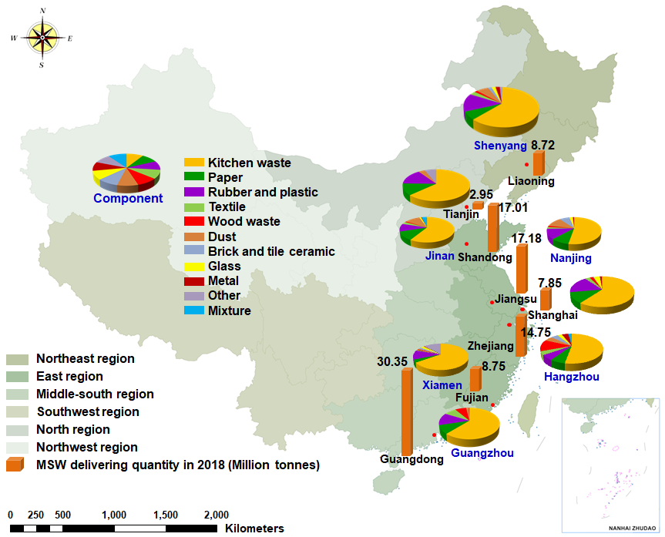
Scheme 1 Schematic diagram showing the MSW generation in China’s eastern coastal provinces and their provincial capital cities (or special zones) in 2018 associated with their spatial distribution, composition and characteristics.
Recently, the development on incineration technology for MSW treatment and its resource utilization is improved in China (Mian et al., 2016). Incineration capacity for nationwide MSW increased to 102 Mt/year in 2018. The corresponding percentage share is about 45% in 2018 (Table S1). As compared with that of developed countries (e.g., over 80% in Japan) (Yang et al., 2017), it is evident that incineration for MSW treatment in China needs to keep developing. In particular, since China’s MSW with non-classification has been dominated by kitchen waste (accounted for 50-70%) and has a high moisture content of over 50% (only 10-30% in America’s and Europe’s) (Chang and Davila, 2008), the MSW in China needs to be pretreated before disposed by incineration in order to improve the conversion rate of heat energy-to-electricity. Therefore, developing enhanced (emerging) technologies are sought to solve the root problem in MSW incineration with high energy consumption and low conversion of heat energy-to-electricity.
To be more effective and efficient in TTRU of MSW, there should be a combination of two strategies, (1) to optimize and develop MSW management systems, (2) to enhance and develop technologies in TTRU of MSW. A well-functioning MSW management system is urgently needed in China. In contrast, developed regions such as, Berlin, Tokyo and Singapore are well known as leaders on the development of MSW management and TTRU. To encourage the MSW source separation and collection, developed regions have successfully implemented “Closed Substance Cycle Waste Management Act” in Berlin (Menzler et al., 1999), “Basic Law for the Development of a Circle Society” in Japan (Hotta, 2013), and “Waste Management Hierarchy (WMH)” in Singapore (Ng et al., 2017). MSW in TTRU, such as waste-to-energy (WtE) (e.g., electricity) (Nanda and Berruti, 2021), waste-to-fuel (e.g., gaseous fuel, liquid biofuel, bio-oil, H₂-rich syngas) (He et al., 2010) and waste-to-materials (WtM) (e.g., road pavement (Luo et al., 2017), biochar (Yuan et al., 2019), cement (Fan et al., 2018), sorbent (Wang and Wang, 2019), ceramic (Hu et al., 2020) are fast developing examples worldwide.
With the population growth, sustainable development of economy and urbanization in China, MSW has attracted a great attention. This paper presents a review of MSW considering generation, management, and technologies in TTRU in China for the period between 2009 and 2018. By considering eastern coastal provinces, special zones and provincial capital cities as representative regions, results of MSW in generation and composition are collected, analyzed and discussed. By drawing lessons from cities in developed regions including Berlin, Tokyo and Singapore, this study compares and discusses results associated with influential factors (e.g., population, gross regional product (GRP)) and MSW distribution, characteristics and TTRU. Furthermore, some of emerging technologies for MSW resource utilization (e.g., WtE, WtM) are systematically reviewed for the first time. This review paper also identifies limitations in China, which could be used as a reference to establish an ideal system integrating MSW management, transport, and TTRU. International cases support that MSW utilization in China should mainly be incineration integrated with additional advanced (or emerging) technologies.
This review has several novel aspects compared to previous reviews and/or studies such as Chen et al., 2010, Gu et al., 2017, Li et al., 2015, Zheng et al., 2014. To the best of our knowledge, this review is the pioneering work that analyzes MSW’s management, characteristics, treatment and resource utilization in an integrated manner. Insights on feasible technologies for MSW treatment and resource utilization in aspects of WtE and WtM are presented for the first time considering the published paper of China’s MSW (Gu et al., 2017). Furthermore, a detailed comparison with international developed regions and related developed areas in China (i.e., eastern coastal regions) is conducted for the first time.

MSW situation in China on management and technologies in treatment and resource utilization (TTRU)

2.1 MSW situation
According to National Bureau of Statistics (NBS) of China reported in 2018, China owns the largest coastal population (approximately 0.8*10⁹ people) in the world, while people living in urban areas accounts for about 60% of population (Chen et al., 2019). Coastal cities are critical areas for the continued expansion of economy and urbanization in China (Li et al., 2017). In this paper, the eastern coastal cities in China are located in Liaoning, Tianjin, Shandong, Jiangsu, Shanghai, Zhejiang, Fujian and Guangdong provinces (or special zones) wherein the gross regional product (GRP) is reported to be up to 1000*10⁹ Chinese Yuan (RMB) in 2018 (Table S2).
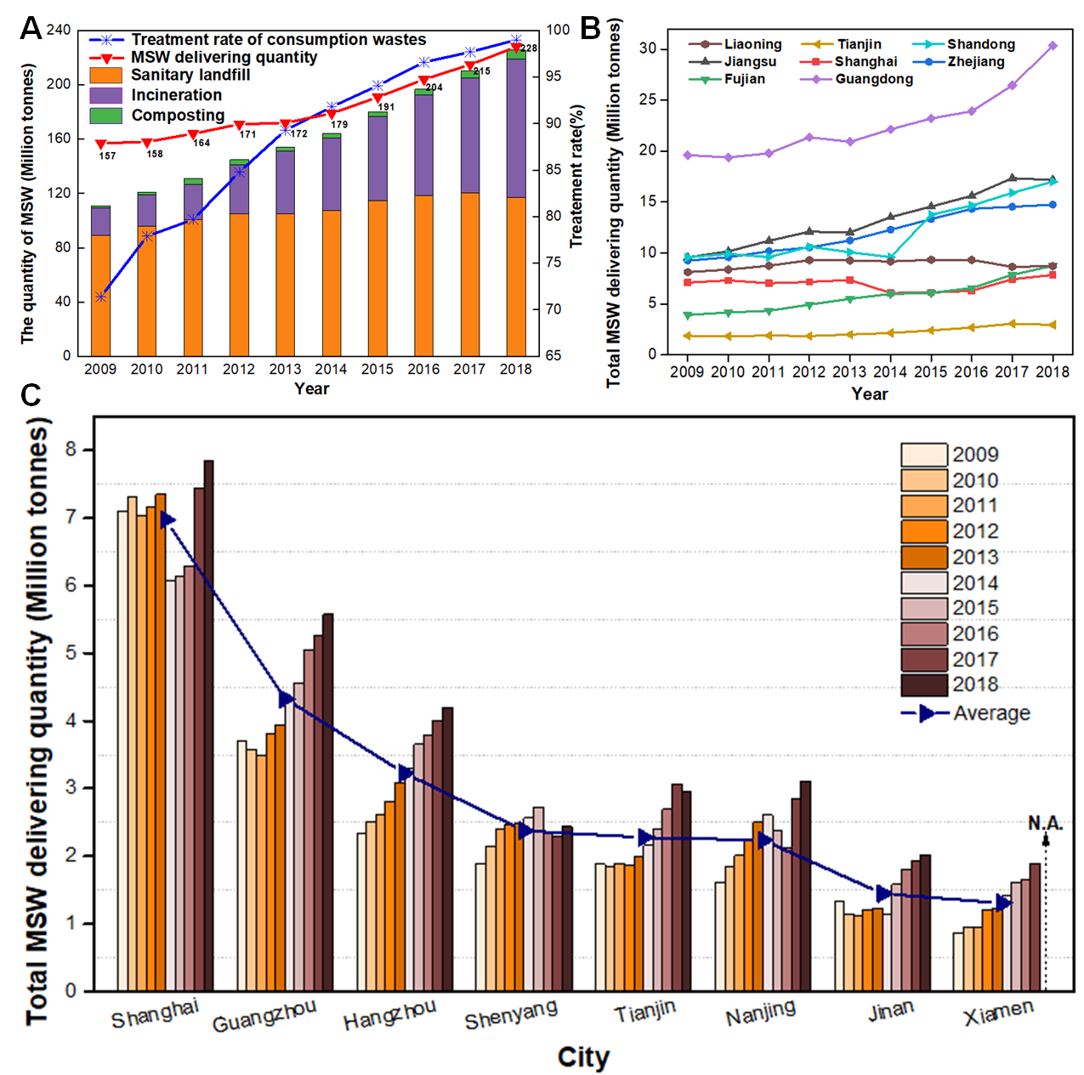
Figure 1 MSW generation in China between 2009 and 2018, and the corresponding treatment quantity using landfill, incineration and composting with the total treatment rate of consumption waste (A). MSW generation in eastern coastal provinces (B) and their provincial capital cities or special zones (C) during 2009-2018 (the data for Xiamen in 2018 is not applicable in Fujian Statistical Yearbook 2019).
As shown in Figure 1A, the quantity of MSW generated nationwide keeps a rising tendency during 2009-2018, especially growing faster since 2013 (red curve). It has risen to 228 Mt (the daily per capita is 0.45 kg) in 2018 (Table S3), in which the total of MSW generation in eight eastern coastal provinces and special zones is approximately half of the nationwide (107 Mt) (Figure 1B, Table S4) (NBSC, 2018). MSW generation in eastern coastal regions also displays an upward trend (Figure 1B). Among them, MSW generation in Guangdong reached 30.35 Mt in 2018 followed by Jiangsu (17.18 Mt), Shandong (17.01 Mt) and Zhejiang (14.75 Mt) (Table S4). As shown in Scheme 1, MSW generated at point sources in eastern coastal provinces (and special zones) shows a spatial distribution, which is related to the difference on the development of economy, population and urbanization (Gu et al., 2017). MSW generation remains steady in Liaoning during 2009-2018, while there is a decline trend from 2013 to 2016 in Shanghai. It could be thanks to promoting classification and reduction of MSW in Shanghai implemented in May 2014. Furthermore, there is a similar MSW generation upward trend during 2009-2018 in the corresponding provincial capital cities (and special zones), i.e., Guangzhou, Hangzhou, Shenyang, Tianjin, Nanjing, Jinan and Xiamen shown in Figure 1C. In recent years, MSW generation rate grows relatively fast in Guangzhou and Hangzhou. More discussion will be conducted in the following sections.

2.2 Polices and regulations for MSW management
Law of the People's Republic of China on the Prevention and Control of Environmental Pollution by Solid Waste was passed in 1995 (newly revised in 2020), which is the basic law of solid waste in China. In recent years, the importance of source separation has been increasing. The Chinese national polices and regulations including the “Classification Symbols for Municipal Solid Waste (GB/T19095-2008)” and “Classification and Evaluation Standard of Municipal Solid Waste (CJJ/T102-2004)” were established (Wei et al., 2017). The “Interim Measures for the Classification and Administration of Urban Waste in Guangzhou”, which is the first government regulation on the classification and management of MSW in China, was implemented on April 1, 2010.
In recent years, there is more attention to waste classification in China. The recycling rate of MSW in China increased from 12.1% in 2006 to 17% in 2011, and then decreased to 15.6% in 2015. Thus, on March 30, 2017, the “State Council on Forwarding the Notice of the Implementation Plan of the Waste Classification System of the Ministry of Housing and Urban-Rural Development (MOHURD)” set targets of a minimum 35% of recycling rate for domestic waste by 2021 and 46 important cities would apply classification of household waste and hazardous waste into one of the pre-defined categories (Xu, 2018). Lately, cities accelerated the implementation of waste classification. On January 31, 2019, Shanghai passed the “Regulations on the Management of Municipal Waste in Shanghai” and implemented formally after July 1, 2019, which represents that Shanghai has entered the “mandatory era” of waste classification. Since the regulation implemented in Shanghai, the cities such as Hangzhou, Xiamen, Guangzhou have developed their own measures for the classification and management of MSW according to the characteristics of the MSW. It is believed that more cities will form regulations on MSW management with the popular and constant attention on waste classification.

2.3 MSW characteristics, composition, separation and collection
Municipal solid waste (MSW) is mainly classified into four types and separated into collecting container (Table 1). Nevertheless, MSW classification systems and maturity of implementation are not uniform among different regions in China. This hinders an efficient nationwide MSW management system. For examples, Shanghai is the first mandatory waste sorting city, and MSW is mainly divided into recyclable waste, household food waste, residual waste and hazardous waste (Table S5). While in Hangzhou, MSW is lately classified into recyclable waste, perishable waste, harmful waste and other waste (Table S6).
MSW system establishment is significantly influenced by the difference of waste characteristics and composition in spatial attribute. As shown in Table 2, MSW characteristics are dominated by the components of kitchen waste, paper, rubber and plastics, textile, wood waste, dust, brick and tile ceramic, glass, metal, others, and mixture in Shanghai and Jinan. But, the mixture category (e.g., waste which is difficult to place in a category) is not used in Xiamen and Shenyang. MSW in Tianjin is only separated into kitchen waste, paper, rubber & plastics, dust, and others, while there are no waste components about dust and mixture in Guangzhou’s MSW composition. The MSW characteristic is varied with composition at different periods in Hangzhou.
Additionally, it is worth noting that waste composition percentage has variation in spatial and temporal attributes. The major components of kitchen waste/paper/rubber & plastics by percentage is 60.40/11.88/17.56 (Cheng and Dong, 2017), 56.80/9.31/19.09 (Data provided by Hangzhou Tianziling landfill), 63.22/11.74/14.63 (Wei, 2013), 65.28/3.50/11.38 (Lin, 2009), 52.83/9.32/12.26 (Data provided by Nanjing Urban Administration), 61.57/8.96/12.59 (Chen, 2011), 58.71/11.18/9.92 (Li and Zheng, 2014), and 59.77/7.58/12.85 (Ma, 2010) in Shanghai, Hangzhou, Tianjin, Xiamen, Nanjing, Guangzhou, Jinan, and Shenyang, individually. The fluctuation ranges in spatial are 52.83~65.28%, 3.50~11.88%, and 9.92~19.09% for kitchen waste, paper, and rubber & plastics. For Shanghai (during 2007-2016) and Guangzhou (during 2004-2014), it is changing dynamically between 60~68% and 31~61% for kitchen waste as shown in Table 2, while they are 15~18% and 12~22% for rubber & plastics. Thus, the classification processes should be adjusted based on local conditions to obtain preferred waste stream for MSW conversation into energy/fuels or materials (Mukherjee et al., 2020).

2.4 Technologies in treatment and resource utilization
Facing above mentioned complex challenge of increasing in MSW generation, China takes efforts on technology development in MSW TTRU. As shown in Figure 1A and Table S1, the volume of wastes disposed effectively increased by 226 Mt/year in 2018 (766 thousand tonnes/day) using landfill, incineration and composting technologies mainly, which is two times higher than 112 Mt/year in 2009 (356 thousand tonnes/day), with treatment rate of consumption waste up to 99%.
Landfill is the main technology in China’s MSW treatment in the past decades. During 2009-2018, its capacity of MSW disposal keeps gradually increasing from 89 to 117 Mt per year (Figure 1A, Table S1). By 2018, the number of landfills has over 660 plants in nationwide (NBSC, 2018). The top five provinces of the number of landfills are Guangdong (54), Shandong (34), Liaoning (32), Jiangsu (28) and Zhejiang (22) provinces in 2018 (SWB, 2018). The landfill gas-to-electricity plants are mostly distributed in much more developed southeast area which is densely populated and economically developed (Hui et al., 2010). Using landfill gas (LFG) generated, plants have been able to generate 200 million kWh in 2015 (Li et al., 2015). Whereas, LFG contains approximately 46-50% methane by volume in the later stages (see supporting Table S7 for GHG emissions of waste sector in China) and one tonne of MSW theoretically generate 65 Nm³ of biogas (Mian et al., 2016), LFG generated will be in peak around 2019 (3.49*10⁹ Nm³). In 2020, it will keep on generating 3.30*10⁹ Nm³ LFG, which can theoretically generate energy products, such as electricity (7.39*10⁹ kWh) and bio-derived nature gas (1.70*10⁹ Nm³) (Fei et al., 2019). Although the cost in landfill construction and operation is lower than most of other technologies (Robinson et al., 2003), this is not the best way for MSW in TTRU because the conversion efficiency is too low by landfill. The other reason is that landfill easily causes dissipated and contaminated land resources. The problem of inappropriate leachate exists in 47% landfill sites, which causes high concentration of pollutants with big challenges in their treatment (Mian et al., 2016). Moreover, MSW landfill is likely to produce offensive odors that influence some adjacent communities. In Hangzhou, there has been a record number of complaints at 2007 about the offensive odors (Ying et al., 2012).
Recently incineration technology for MSW treatment and its resource utilization is developing (Figure 1A, column in purple color). The total waste incineration capacity reaches 102 Mt per year in 2018 compared to 20 Mt per year in 2009 (Table S1). The percentage share of MSW incineration treatment in the volume of waste disposed (including landfill, incineration and composting technologies, etc.) is around 45% nationwide (Table S1). Some places could reach up to 68% in eastern part of China, such as Jiangsu and Zhejiang provinces, where there is a higher level of both modern industrialization and urbanization with booming economy and high-density of population (Song et al., 2017). By incineration processes, the volume of MSW can be effectively reduced into 10%. At the same time, the generated electricity, which reached 35*10⁹ kWh in 2017, can be used as renewable energy partially replacing coal consumption of ~5.5 Mt (Hong et al., 2017). The demand of MSW incineration power generation equipment is promising to create economic value of US$ 5*10⁹ over the next five years (China Value, 2013). However, it is observed that the conversion efficiency of waste-to-electricity is lower (of 2.43 kg MSW per 1 kWh) compared with that of Tokyo (0.49 kg MSW per 1 kWh) or thermo electric plants (in general 0.12 kg coal per 1 kWh). Currently, it suffers from uneven development of MSW incineration technology in China. Although MSW incineration is over 290 plants, about half of the plants were placed in relatively developed areas such as Guangdong, Jiangsu, and Zhejiang provinces in the east region of China (Song et al., 2017)
Over 10.6 Mt of ash generated in the process of MSW incineration is becoming a new challenge (Reck and Graedel, 2012). The incineration ashes are classified as bottom ashes (IBA) and fly ashes (IFA). IBA belongs to general industrial waste, which is mostly used for subgrade materials as well as baking-free brick. IFA is recognized as hazardous wastes for the full of heavy metals and dioxins and has to be disposed by landfill after stabilization (Sun et al., 2016). Another way for IFA disposal is a technology of co-processing of solid wastes in cement kiln (GB 30760-2014) (Liu et al., 2019). But there are existing disadvantages for IFA disposal such as high cost and low stabilization. According to the spot checks by the Ministry of Ecology and Environment (PRC), more than 70% of IFA disposal failed to meet the admission requirements. On the other hand, China is devoted developing conversion of incineration ashes to the partial raw material substitute for the production of cement/concrete as well as ceramics, higher value resource (such as hydrogen) (Wang et al., 2018) and others by different ways such as thermal treatment, solidification, chemical reaction. For examples, Fan et al. (2017) synthesized glass-ceramics with the MSW incineration fly ash as raw materials for the solidification of heavy metals and waste recycle. MSW incineration combined with cement kiln technology reported to have advantages of low risk in environment, simple process, and low cost with efficient utilization of heat and ash (Yuan et al., 2010). The others possessing higher energy recovery rate and less land requirement, such as pyrolysis (Kan et al., 2016) and gasification, are investigated as well. In the absence of air, pyrolysis technology can be used for MSW conversion into liquified bio-fuel and heats (Sipra et al., 2018). Gasification is viable option to form high caloric syngas without much tar content generation (Cao et al., 2019).
Composting process is a traditional technology widely applied in China (Li et al., 2016). It is a biological decomposition process of organic compounds by bacteria, fungi, worms and other organisms under controlled conditions (i.e., oxygen content, temperature, moisture, etc.) (Sánchez-García et al., 2015). As shown in Figure 1A (column in green color), the proportion of composting in MSW treatment is quite lower than landfill and incineration in China. Among the total MSW delivered quantity, landfill accounted for ~52%, incinerate for ~45%, and compost only for ~3% (NBSC, 2018). Over years, the major problem is that the product yield is low (28%) with heavy metal accumulation and a lack of quality in nutrients (Cheng and Hu, 2010). By 2015, the number of plants for wastes treatment has reached to 890, while the composting treatment plants is less than 3.3% (Cheng et al., 2017). In practice, in addition to composting, the anaerobic digestion for the biological treatment of MSW can also be used. Although the application of anaerobic digestion is mainly focused on the agricultural sector, such as livestock manure and straw, the research in recent years has turn to the commercial, industrial and municipal fields, such as kitchen waste, sewage sludge and the co-digestion of two or more organic wastes. Composting is the most effective method to convert kitchen waste into fertilizers. It can also be used as a pre-treatment to enhance transformation of MSW into high-value biogas (Wei et al., 2017). The compost product also could be used as soil conditioner or water conditioner of fish ponds. At present, the quality of compost attained from MSW is poor (e.g., low nutrient content, high rich in heavy metals, high impurity content). This is mainly attributed to the lack of proper separation/sorting of the waste or co-composting with sludge (Song and Chen, 2013). The attached odor results in some adverse effects such as environmental pollution and deteriorating human health (Wei et al., 2000). With the source separation of MSW implemented in many cities of China, the compost might influence waste treatment schemes (Wei et al., 2017).

MSW situation in international on management and TTRU

3.1 Berlin
3.1.1 Situation and MSW management
As the largest city in Germany, Berlin has a population of 3.61 million. It is one of the most dynamic economic regions in Europe (approximately 136.6*10⁹ EUR of GDP in 2017). The structure of economy is diverse and shaped by industries mainly including energy and clean technologies, transport industries, manufacturing industries, service industries and environmental technology businesses (Khankhasaeva et al., 2015). In Berlin, the disposal of waste has showed decline trend from 1992 (approximately 2.33 Mt) to 2012 (approximately 0.82 Mt). This largely accounted for the polices and acts for MSW management and various technologies, which will be reviewed in the following sections.
In Berlin, waste management is governed by the “Act for Promoting Closed Substance Cycle and Waste Management and Ensuring Environmentally Compatible Waste Disposal in Berlin”. The latest amendment occurred in 2011 and it was augmented by a series of ordinances regarding hazardous waste such as the “Hazardous Waste Ordinance and the Problematic Waste Ordinance”. Like the “Closed Loop Waste Management Act”, the aim of the “Closed Substance Cycle and Waste Management Act Berlin” is also to reduce the volumes of waste, promote second raw material utilization and ensure environmentally compatible waste disposal (BSD, 2013). Every year, the Berlin Senate Department for Urban Development and the Environment is required to carry out regular waste audits and publish waste reports. Besides, a ten-year waste management strategy is required to be prepared based on the reports. The waste management strategy aims at forecasting the next ten years’ waste recycling, recovery as well as disposal including details of the steps taken to plan, erect, or maintain the necessary waste handling technologies and treatment plants to develop a modern, closed-loop system.
3.1.2 MSW characteristics, composition, separation and collection
According to the source of waste generation, the municipal waste in Berlin is mainly divided into five types: domestic waste (73.80%), trade waste (10.06%), commercial waste (2.30%), bulky waste (6.95%) and road sweepings (3.78%) (Figure 2A) (BSD, 2013). Domestic waste reached 1.09 Mt (Table S8), which comes mainly from private households. It is collected and transported regularly by the public waste utility for further treatment. As having large volume, bulky waste is collected and separated from the other domestic waste (Zhang et al., 2010). Trade waste (mostly came from enterprises including service providers and larger retailers) is collected together with the household waste, while commercial waste (mainly produced by small businesses, retail shops, service companies, public institutions) is required to be disposed by the producer, and other types of wastes are summarized in Table S8.
The collection is separated into bins designated for waste type (Wang et al., 2011). As shown in Table S9 (BSD, 2013), the different types of waste such as papers, organic wastes and others are required to put in the corresponding colorful bins. It can be seen that around 0.17 Mt of paper, 0.12 Mt of organic waste, 0.08 Mt of light packaging, 0.07 Mt of glass as well as 0.003 Mt of similar non-packaging waste (stNVP) were collected from separated recycling bins and then recycled.
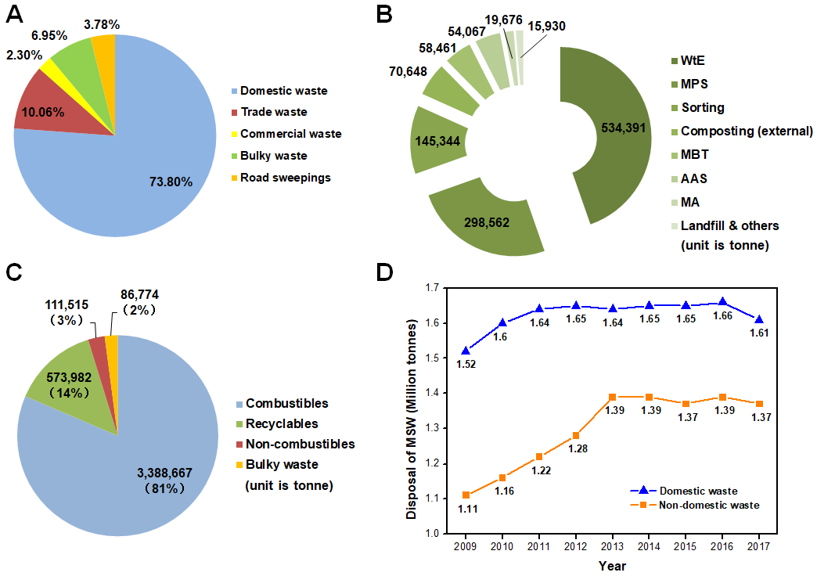
Figure 2 MSW composed of five types with proportion ratio (A) and the adopted technologies with the corresponding quantity in tonne (B) in Berlin (2013). MSW separated into four types with proportion ratio and generation quantity in Tokyo (Yang et al., 2017) (C). MSW mainly classified into domestic waste and non-domestic waste with the related disposal quantity (tonne) from 2009 to 2017 in Singapore (Ravindran et al., 2006) (D).
Berliner Stadtreinigungsbetriebe (BSR) is a statutory body in 100% ownership of Berlin municipality and it manages collection, treatment and disposal (BSD, 2013). The central tasks of BSR are to promote waste prevention, separate collection, environmentally compatible treatment and disposal. The recycling potential of the waste is maximized by the systematic source separation. For examples, white glass is typically collected in white recycling bins while colored glass is collected in green recycling bins (Table S9). Presently, around 90% of newly produced glass in Berlin is made from recycled glass (BSD, 2013). In the case of light packaging, manufacturers and distributors are obliged to take back.
The waste collection fee in Berlin is based on volume and frequency of collection. Different volume of waste bins of bio-waste in brown recycling bins and mixed waste in gray bins have different fees. It is worth mentioning that recyclables in Berlin are collected free of charge. Such waste charging system enormously encourages people to participate in source separation and recycling.
3.1.3 Technologies in treatment and resource utilization
In Berlin, there are a wide variety of treatment and disposal methods, including landfill, incineration, mechanical physical stabilization (MPS), mechanical biological treatment (MBT), mechanical treatment (MA) as well as a WtE power station.
The MPS processing starts with preparing the garbage mechanically, it then detects, classifies, and separates some of the garbage, and dries the remaining garbage to remove about 30% of the water. After drying, combustible wastes separated are converted into fuels. Such a waste treatment system achieves 95% of the material and energy recovery (energy recovery occurs in power plants and cement production) with only 5% requiring final disposal. The waste disposed by MPS reached 298,562 tonnes in 2013 (Figure 2B). The MPS plants operated in Berlin are the Pankow and Reinickendorf (treatment capacity 160,000 and 180,000 tonnes annually, respectively). The actual handling capacity of each plant is about 190,000 tonnes annually and each factory produces 90,000~95,000 tonnes of waste derived fuel (RDF) (BSD, 2013).
There is only one MBT plant in Berlin with capacity of 60,000 tonnes per year and it is called the Luheben biogas fermentation plant. In 2013, MBT plant had disposed about 58,461 tonnes MSW (Figure 2B). Biogas is mainly produced by dry fermentation of organic waste. This method is particularly applicable to organic waste from households with water content of 60-80%. Methane produced by the MBT process is fed into natural gas vehicles used by the BSR to collect waste.
Mechanical treatment factory is located in Köpenick, where MSW classification and processing take place. The factory is divided into two separate working lines. The first is the treatment of mixed building waste, large pieces of waste and the remaining low-grade building waste after sorting. The second is the disposal of mixed household waste with the treatment capacity of ~100,000 tonnes each year. MA can be used to derive recyclable or high calorific value products. Like MPS, a large amount of RDF is produced from the MA processes, which is then sent to RDF plants.
The WtE power station of BSR in Ruhleben is the centrepiece of Berlin’s waste disposal with an annual capacity of 520,000 tonnes. In 2013, 534,391 tonnes of waste were disposed which made up 45% of total MSW generated as shown in Figure 2B. In the processes, high pressure super-heated steam produced is used to generate electricity. Scrap metals are separated from the bottom ashes and slag by magnetic separators. Annually, about 12,000 tonnes of ferrous scrap can be collected from this procedure. Besides, slag and ashes from incineration are used in civil engineering projects such as road construction.
The need for the three available landfills has reduced dramatically thanks to the increasing amount of waste recycling. Furthermore, in order to avoid contamination problems, high standards for access to landfills have been set. Lately, landfills only accept the low calorific fraction from mechanical biological treatment (MBT) facilities, slag, ashes from incineration, and treated construction and demolition waste, which makes up only 2.2% of waste (BSD, 2013).

3.2 Tokyo
3.2.1 Situation and MSW management
Tokyo is Japan’s capital and the centre of politics, economy and culture. As the most populous city in Japan, the population of Tokyo is 13.74 million with a population density of around 6,264 persons per km². As Japan’s leading industrial centre, Tokyo is a major international finance center that puts much emphasis on financial services and banking. In addition, tourism in Tokyo plays an important role in its economy. In 2016, the total charged of MSW had reached 4.45 Mt with 22.7% recycle rate (SOT, 2017). Compared with 2009 (the total MSW discharged is approximately 4.76 Mt), the total charged of MSW is down by 6%.
Japan has a comprehensive legal system for waste management. As early as the 1970s, Japan passed the “Waste Disposal and Public Cleaning Law” (Tanaka, 1999). In 1982, the garbage classification system began to be implemented, advocating that garbage is a resource that is misplaced. Japan aims to prevent overconsumption of natural resources and reduce the negative impact to the environment with proper disposal (Ray et al., 2018). In June 2000, the Japanese government promulgated and implemented the “Basic Law for the Development of a Circular Society”. This law introduced the concept of 3R for the first time, clearly stipulating that the first step is to achieve the reduction of the source (reduce), followed by reuse (reuse), and finally recycling (recycle). These laws are conductive to operate, which specify waste treatment and resource recycling in different industries.
3.2.2 MSW characteristics, composition, separation and collection
In Tokyo, waste is classified into general and industrial waste. General waste mainly includes domestic waste from households and commercial waste from businesses. Industrial wastes, which could be solid, liquid, gaseous or residual materials, are usually hazardous and they are generated from industrial operations. Before 2000, the collection of general waste was handled by the Tokyo Metropolitan Government (TMG). With the update to the Local Autonomy Act, since April 1, 2000, 23 wards (i.e., individual municipal authorities) have carried out waste collection according to their own specific environmental conditions (Ray et al., 2018).
Tokyo has a highly organised curb side collection system which places much emphasis on source separation of household waste under the slogan “separation is resource and mixing is waste” (Matsumoto, 2011). Typically, there are four large categories: recyclable waste (573,982 tonnes), combustible waste (3,388,667 tonnes), non-combustible waste (111,515 tonnes), bulky waste (86,774 tonnes) (Figure 2C).
Depending on the types of waste, each municipality sets collection days and areas, which can be found on the website of the individual municipal authority. Households have to separate waste into categories and place them in the designated bags before taking them to the specified collection sites. Non-recyclable waste is collected once or twice a week, whereas recyclables are collected weekly. Waste collection is free for household-generated waste excluding the collection of large-sized waste as well as business-generated waste (Yan et al., 2018). All wards have separated collection for each recyclable category, like glass, bottles and cans, placed in different bags by households. The recyclable is divided into more than 10 categories. To increase the quantity of recyclables collected, organizations can register and cash reward are given as incentives. In 2016, about 0.57 Mt of recyclables were collected directly from households which constituted 14% of total MSW. Combustibles, non-combustibles and bulky waste collected made up 81%, 3% and 2% respectively as shown in Figure 2C (Yang et al., 2017).
3.2.3 Technologies in treatment and resource utilization
The intermediate treatment like incineration and pulverization of MSW in Tokyo’s 23 wards is managed by the Clean Authority of TOKYO 23 cities, a consortium formed by all wards based on the Local AuthCombustible waste collected and transported to incineration plants directly.
Combustible waste is transported to 19 incineration plants. By burning up, only 5% capacity of landfill disposal quantity by volume is required (CAT, 2017b). There are three types of incinerator to treat waste. In incineration plant, they use heat energy caused by waste incineration for electricity generation and heat supply. The electricity or hot water to run a facility can reduce the cost of additional electricity or fuel. At the same time, they sell remaining electricity to electricity supplier company. In 2016, the quantity of selling of power was up to 0.69*10⁹ kWh, which generated a revenue of 9.8*10⁹ Yen (¥) (CAT, 2017c). Also, an ash melting furnace is equipped by some of the plants with the aim of ash recycling. In the melting process, the incineration bottom ash (IBA) generated can be changed into molten slag (CAT, 2018). The process can decompose dioxins and restrains elution of heavy metals, which makes it safe to be used in place of sand in construction (CAT, 2018). Besides, as a chief ingredient, IBA can be used to produce eco-cement which is a civil construction material recognized by Japanese Industrial Standards. Traditionally, electricity and heat produced from the incineration process are utilized in the plant and/or sold to power plants, while fly ash is sent to be landfilled.
Incombustible waste and bulky waste are delivered to incombustible waste treatment plants and bulky waste treatment plants respectively. In Tokyo, the incombustible waste treatment process includes pulverization which fractures non-combustibles into less than 15 cm, and separation which removes ferrous metals and aluminum by magnet separators and aluminum sorters, respectively. The bulky waste treatment process starts with removing combustible bulky waste from incombustible one. After pulverization and separation processes, residues from non-combustibles are sent to landfills, whereas residues from combustibles are incinerated at processing plants or incineration plants (CAT, 2017a). Through such waste treatment processes, a large quantity of recyclables can be collected and recycled. At the same time, the volume of waste is reduced, which is beneficial to landfills.

3.3 Singapore
3.3.1 Situation and MSW management
Singapore consists of one main island and more than 60 smaller islands with a total land area of 719.9 km². The total population has reached 5.64 million in 2018 resulting in a high population density of 7,804 per km² (Qiao et al., 2018). It is a highly urbanized country with a foreign trade-driven economy dominated by electronics, oil, finance, services, transport and shipping (Iris et al., 2018). The manufacturing which is one of the largest sectors in the economy constitutes almost a quarter of the GDP over the years. Like Japan, Singapore has also made a big push into tourism. In 2017, the number of visitor arrivals (excluding Malaysian arrivals by land) has reached 17.42 million (Bialk-Bielinska et al., 2017). The amount of domestic and non-domestic waste disposed of from 2009 to 2017 is shown in Figure 2D (Wang et al., 2018). Although the rate of rising of domestic waste (up 5.9% from 2009 to 2017) is less than non-domestic waste (up 23.4% from 2009 to 2017), waste generation in Singapore shows decline trend.
The Ministry of Environment and Water Resources (MEWR) is the main body in charge of formulating waste policies in Singapore (Kolpin et al., 2002). Singapore’s MSW management is mainly legislated under the MEWR’s Environmental Public Health Act (EPHA), which came into effect on July 1, 1987 (Bai and Sutanto, 2002). Among the regulations, “General Waste Collection Regulations” specify the collection, transfer and disposal of general waste. The key strategy for waste management in Singapore is Waste Management Hierarchy including reducing and reusing waste at origin, recycling to reduce volume, incinerating to reduce volume to be landfilled, landfilling non-incinerable waste and incineration ash. The strategy emphasizes reducing, reusing, and recycling to prevent waste generation at origin, and recycling rates of 70%, non-domestic recycling rate of 81%, domestic recycling rates of 30% are targeted by 2030 (MEWR, 2015).
3.3.2 MSW characteristics, composition, separation and collection
In Singapore, the non-domestic waste mainly comes from commercial and industry premises, while the domestic waste refers to garbage collected from households, markets, food centres, hotels, restaurants, and shops (Tong et al., 2018). Domestic solid waste is collected daily and currently two primary methods are adopted by direct collection and indirect collection. The direct collection gathers waste directly from landed private housing as well as individual trade premises. A crew collects waste located outside of each premise (APO, 2007). This method is a labour intensive and time-consuming process. On contrary, the indirect collection gathers waste at specific clustered points like bin centers and refuse chute centers.
Solid waste management in Singapore can be divided into two major systems, public waste collection scheme (PWCs) and general waste collection system (GWCs). The PWCs mainly targets the waste generated by residents, such as general household waste, large waste (furniture, etc.), green waste and pet carcasses. The majority of households discharge their various waste through centralized refuse chute (CRC) system. This method improves collection efficiency. In addition, the pneumatic refuse collection (PRC) system has been implemented in a few new buildings and private housing estates. Underground pipe networks are used to transport waste by vacuum suction to a collection point. This is much more productive and hygienic compared with above two methods (Zhang et al., 2010). The application of this technology has been mature relatively in Singapore's housing community (NEA, 2019). General waste collection system (GWCs) serves commercial and industrial premises. Industrial and commercial solid waste, including inorganic waste, organic waste, sludge as well as grease, is still collected by the licensed GWCs (private waste collectors). The collected waste is transported to special disposal sites for recycling or treatment. Inorganic and organic waste can be transported to state-owned incinerators and transfer stations for treatment after signing treatment agreements (Han et al., 2018).
The collection and transport fee system are used in Singapore. The fees are two types, namely fixed fees and periodic approved fees. The fixed fees aim at ordinary residents for $6 per month, which is relatively low. The periodic approved fees aim at industrial and commercial premises, and the charges are determined every six months according to the amount of waste produced (Han et al., 2018). Authorities encourage waste reduction through tiered charging.
3.3.3 Technologies in treatment and resource utilization
Growth in Singapore’s population and economy has increased waste disposed from 1,260 tonnes a day in 1970 to 8,443 tonnes a day in 2017 (NEA, 2019). Singapore’s solid waste disposal methods include incineration and landfilling. There are four incinerators, handling combustible waste, namely Tuas Incineration Plant (TIP), Keppel Seghers Tuas Waste-to-Energy Plant (KSTWTEP), Tuas South Incineration Plant (TSIP) and Senoko Waste-to-Energy Plant (SWTEP) (Xue et al., 2015). Incineration reduces waste volume by 90% so it is most popular disposal method in such a land-scarce country. Incineration also reduces the need for a landfill space. The recovered heat is used for electricity generation which meets up to 3% of Singapore’s electricity needs (NEA, 2019). Patra et al. (2017) note that heavy metals in incineration bottom ash should be analyzed.
Landfilling is the last option for Singapore due to its limited land space. Only non-incinerable waste such as construction and demolition waste, and incineration ashes are allowed to be landfilled. The only landfill (i.e., Semakau landfill), which was opened in 1999, covers 350 hectares with a landfill capacity of 63 million m³ (NEA, 2015). Due to the land and resource scarcity, it is more economical and environmentally friendly to diverge incineration ash residues from landfill (Liu et al., 2018). Since 2010, the use of bottom ash in road pavements has been tested and approved by the Land Transport Authority (LTA) in Singapore (LTA, 2010). 0.82 Mt of plastic waste was generated in 2016, with only 7% is recycled. In order to reduce waste volumes and obtain energy in the form of electricity power, most plastic wastes are sent to WtE plants. A sorting machine using fluid mechanics can be adopted for sorting plastics in different types (DTU, 2020). At the WtE, a tonne of mixed plastic waste can produce about 634 kWh of electrical power and valuable fuels from plastics can be recovered via thermochemical methods (Khoo, 2019).

Emerging technologies in resource utilization of MSW

4.1 Conversion of MSW to energy/fuels
Waste-to-energy (WtE) has attracted a great attention worldwide because it is a win-win strategy with waste elimination and energy generation (Samoila et al., 2017), which is of great significance in terms of both environmental protection and energy risk reduction (Abd Kadir et al., 2013). Many WtE facilities have been set up and their economic and environmental impacts for China are studied in Zhao et. al. (2016a). WtE facilities are equipped with different technologies such as incineration (Li et al., 2015), gasification (Munir et al., 2019), pyrolysis (Zhao et al., 2016), biorefinery (Dehkordi et al., 2020), anaerobic digestion (Kumar and Samadder, 2017), wet torrefaction (Triyono et al., 2019), landfill gas (LFG) (Bolan et al., 2013), etc. More recently, new technologies such as hydrothermal incineration, thermochemical and hydrothermal liquefaction, and thermochemical and hydrothermal gasification are being developed (Nanda and Berruti, 2021). The generated energy (or fuels) could be kinds of heat (Zhao et al., 2016), electricity for seaports (Iris and Lam, 2019), syngas (He et al., 2010), biogas (e.g., CH₄) (Kumar and Samadder, 2017), liquid biofuel (e.g., CH₃OH, CH₃CH₂OH) (Shareefdeen et al., 2015), bio-crude oil (BCO) (Gandidi et al., 2018), solid fuel (Triyono et al., 2019), H₂-rich syngas, etc. As compared with traditional fossil fuel, these kinds of energies (or fuels) are better for lowering carbon footprint (Shareefdeen et al., 2015).
Incineration technology is gradually getting popular for converting MSW to electricity (Damgaard et al., 2010). As a developing country, incineration in China increased rapidly in the past 10 years (Figure 1A, Table S1). There were only 74 incineration plants in 2008 (Song et al., 2017), while there are over 290 plants in China by 2017 with the electricity generation of 35*10⁹ kWh (Hong et al., 2017). The use of incineration for WtE started much earlier in developed countries. For example, in 2013, there were 85 WtE plants, located in 22 states in the United States, and they generated ~14.2*10⁹ kWh of electricity and 14,840 Mlbs of steam annually (Berenyi and Associates, 2013). The electricity generated by incineration in Tokyo in 2016 was up to ~690 million kWh (CAT, 2017c).
Besides, MSW has the potential to be converted into gaseous fuels such as syngas. He et al. (2010) reported that syngas produced from MSW pyrolysis can be used as feedstock for Fischer-Tropsch synthesis on the production of transportation fuels as well as lower heating value MHV (mild hybrid vehicle) fuel (He et al., 2010). As biomass is pre-separated from MSW, it can be used to generate bio-energy by gasification (Munir et al., 2019), biorefinery (Bolan et al., 2013) or other technologie{Dehkordi, 2020 #243}s (Dehkordi et al., 2020). The generated bio-energy, such as biogas, liquid biofuel, bio-crude oil, and solid fuel, are the alternatives for replacing fossil fuels to reduce the emission of greenhouse gas (You et al., 2017). The produced biogas could be further transformed into bio-methanol in a small sized plant (Amaral et al., 2020).
In a catalytic reactor, it is reported that MSW has been successfully converted to liquid biofuels such as methanol or ethanol (Miezah et al., 2017). Gandidi et al. (2018) implemented thermal and catalytic pyrolysis on MSW (with 52% plastics content, e.g., bags, bottles) to obtain bio-crude oil (BCO). They found that the BCO yield could be improved when the natural activated zeolite is used as a catalyst. Bialowiec et al. (2018) obtained the carbonized refuse-derived fuel (CRDF) through MSW pelletization. Triyono et al. (2019) converted mixed organic-plastic MSW into renewable high energy density solid fuel and produced separate organic product under the process of wet torrefaction. To understand the fuel worth’s of waste, Bagheri et al. (2019) developed an algorithm to estimate higher heating value (HHV) which helps to model thermal WtE potential. It is worth noting that the modeling and simulation has a significant potential in understanding and optimizing conversion of MSW to energy/fuels in the reaction process. There are different ways to formulate modeling in gasification based on thermodynamics (Huang and Ramaswamy, 2009), or kinetics (Corbetta et al., 2015). The tool GASDS has strong potential as it’s able to model different biomasses gasification (Cabianca et al., 2016) and also plastics or MSW (Ranzi, 2016).

4.2 Conversion of MSW to materials
Some of MSW can be re-used materials such as the recyclables. This section presents a brief review on conversion of MSW into functional materials by resource utilization of incineration ashes, organic matters, or others (e.g., contaminated papers).
With the rapid development of incineration on conversion of MSW into energy, dealing with incineration bottom ash (IBA) and incineration fly ash (IFA) has become an important issue (Sun et al., 2016). Incineration ash might include heavy metals and hazardous compounds in significant amounts (Patra et al., 2017) so they must be treated properly before disposure to landfills. Otherwise, it will cause serious hazards both to eco-environment (Silva et al., 2019) and human health (Fan et al., 2018). Therefore, appropriate disposal methods and utilization technology are sought. There are reports on utilization of incineration ash as asphalt concrete layer, foam/lightweight material (Yang et al., 2014), cementitious binder (Silva et al., 2017), mesoporous sorbent, cement clinker (Kikuchi, 2001), glass ceramic composite (Wu et al., 2018), geopolymer (Lancellotti et al., 2015), H₂ evolution, etc. For example, IFA has been demonstrated to be used for secondary cementitious material in cement mortars (Tosti et al., 2020). Chuang et al. proposed that IBA and IFA are suitable for fabricating lightweight materials with a certain mixing ratio, while the product exhibited good chemical stabilities and high compressive strength (Chuang et al., 2018).
In Singapore, the utilization of MSW incineration ash for construction materials and environmental purification materials is studied. Both IBA and glass waste in IBA could be converted into cementitious binders by alkali activation (Zhu et al., 2019). IBA was transformed into mesoporous materials via hydrothermal method, which can be used as a sorbent for removal of organic pollutants (Luo et al., 2017). On the other hands, IBA could be used to produce glass ceramic composites by melt-quench process (Zhang et al., 2015). The product showed good properties with compressive strength of 67 ± 14 MPa and no leaching of heavy metals. More recently, IBA enriched aluminum is good for H₂ evolution and this provides new insights into the utilization of incineration ashes (Nithiya et al., 2018).
Conversion of MSW into biochar is another hot topic in solid waste resource utilization (Taherymoosavi et al., 2017). Biochar is a high-carbon, black-grained product synthesized by thermal decomposition of biomass in low (non)-oxygen atmosphere (Rizwan et al., 2016), which exhibits outstanding properties on physiochemical stability (Rodriguez-Narvaez et al., 2019), environmentally friendliness (Liu et al., 2012), good biocompatibility (Wang et al., 2018), high ion exchange capacity (Wang and Wang, 2019), etc. As a kind of carbon materials, biochar can act as sorbents, catalysts, activators, electrode materials, etc. Therefore, it could be applied in various fields of (1) soil remediation and amelioration (Hossain et al., 2010), (2) wastewater reclamation on heavy metal (Jin et al., 2014) and organic pollutants (Liu et al., 2012), (3) contaminated air treatment, (4) catalysis system (Zhao et al., 2020), (5) electrochemistry, (6) energy store (Pontiroli et al., 2019), etc.
Pyrolysis (Lee et al., 2017) and hydrothermal treatment (Lin et al., 2017) are the frequently-used carbonization processes for preparing biochar. The performance and characteristics of the produced biochar can vary due to the different species of organic matters in MSW (Taherymoosavi et al., 2017). For instances, fruit wastes (e.g., banana peel (Sari and Melati, 2019), coconut (Wu et al., 2017)), farm wastes (e.g., peanut hull (Han et al., 2016), cotton stalk (Ren et al., 2015)), plant wastes (e.g., eucalyptus leaf (Wang et al., 2015), palm kernel shell (Choi et al., 2015)), baverage wastes (e.g., coffee ground (Nguyen et al., 2019)), food/kitchen waste (e.g., fishmeal) (Shikhaliyev et al., 2018; Elkhalifa et al., 2019) have been used for biochar preparation. Biochar produced especially using banana can be further transformed into carbon nanofibers (Sari and Melati, 2019). Wu et al. produced microporous biochar derived from coconut fiber with enriched carboxyl and hydroxyl groups on the surface (Wu et al., 2017).
Furthermore, MSW papers as raw material for production of cellulose nanofibers (CNFs) was reported in which the waste papers could be fibrillated into nanoscale fibers undergoing pulping, flotation and washing processes (Hietala et al., 2018). The as-prepared CNFs show good properties including 70-100 MPa tensile strength and 7 GPa stiffness, which has potential application for packaging (Thiagamani et al., 2017), healthcare (Mishra et al., 2018), food sector (Onur et al., 2019), paint (Mishra et al., 2018), piezoelectric sensor (Rajala et al., 2016), etc. There are also some emerging investigation on MSW derived hydrochar (Wei et al., 2017a), pyrochar (Gai et al., 2016), aerogel (Yue et al., 2018), tar (Huang et al., 2015), B/N co-doped carbon nanosheet (Ling et al., 2016), carbon quantum dot (Kumari et al., 2018), etc.
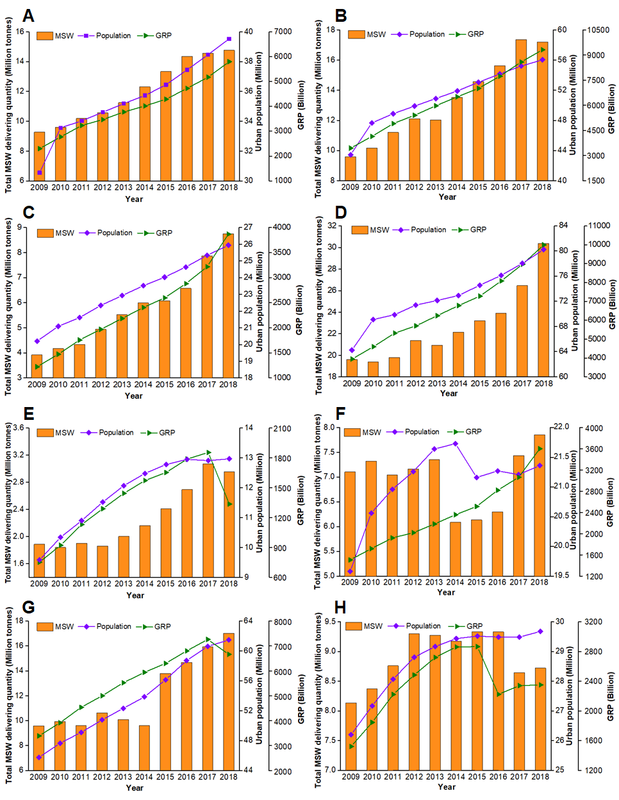
Figure 3 The relationship between MSW generation and influence factors such as urban population and gross regional product (GRP) in Zhejiang (A), Jiangsu (B), Fujian (C), Guangdong (D), Tianjin (E), Shanghai (F), Shandong (G) and Liaoning (H) province (or special zone), respectively.

China’s MSW situation analysis based on eastern coastal cities
In this section, according to the representative eight eastern coastal regions in China and international regions (e.g., Berlin, Tokyo and Singapore), a comparison is conducted on the relationship among MSW generation and composition, population, gross regional product (GRP), and TTRU. The purposes are (1) to point out the similarity and difference, and (2) to contribute into developing an ideal system (or strategy) containing MSW management and TTRU in an integrated manner. Data sources are China Statistical Yearbook in government website, petition letters, published papers, and online sources (NBSC, 2018).

Comparison in MSW generation based on population
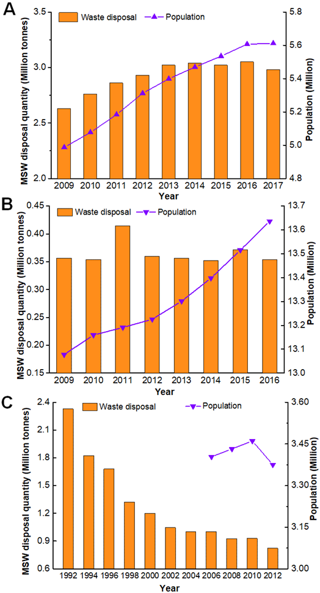
Figure 4 The relationship between MSW generation and influence factors such as urban population in Singapore (A), Tokyo (B), and Berlin (C), respectively.
Over the period 2009-2018 in China, Figure 3 illustrates the development of MSW generation in eastern coastal regions involving Zhejiang, Jiangsu, Fujian, Guangdong, Tianjin, Shanghai, Shandong, and Liaoning provinces (or special zones). The quantity of MSW produced in Zhejiang (Figure 3A, Table S4) has increased from 9.3 Mt in 2009 to 14.8 Mt in 2018 (59% increase), while the other regions, Jiangsu (Figure 3B), Fujian (Figure 3C), Guangdong (Figure 3D), Tianjin (Figure 3E), Shanghai (Figure 3F), Shandong (Figure 3G) and Liaoning (Figure 3H) have 81%, 101%, 35%, 63%, -11% (2016), 66%, 15% (2016) increase, respectively. The MSW generation in eastern coastal cities shows difference both in spatial and temporal attribute.
Due to the rapid urbanization and migration in eastern coastal regions, the population in Zhejiang, Jiangsu, Fujian, Guangdong, Tianjin, Shanghai, Shandong and Liaoning has reached 39.5, 56.0, 25.9, 80.2, 13.0, 21.4, 61.5 and 29.7 million by 2018 with 29%, 30%, 28%, 25%, 35%, 9%, 34%, and 13% increase in last nine years (Table S10). By comparison of the rate of increase, results suggest that MSW generation is less related to population growth. In Shanghai, there is overall 8% increase of population from 2009 to 2016, whereas the MSW generation showed a decline of 11%. The decline is possibly explained by the policy of promoting classification and reduction of MSW implemented in May 2014.
As shown in Figure 4, by comparison, the population is keeping on growing with the rapid urbanization of Singapore (Figure 4A) and Tokyo (Figure 4B). In Singapore, the quantity of MSW produced (Figure 4A) has increased from 2.6 Mt in 2009 to 3.0 Mt in 2013 (15% increase) followed by becoming steady during 2013-2017. The MSW generation basically showed a steady number (~0.35 Mt) from 2009 to 2017 in Tokyo (Figure 4B). Between 1992-2012 in Berlin, the MSW generation exhibited a rapid decline from 2.3 Mt to 0.8 Mt with 65% decrease (Figure 4C), indicating further that the MSW generation has been largely decoupled from population growth. Therefore, it also implies that there must be other factors, such as GRP/GDP (Khan et al., 2016), policies in MSW management, tourism development, birth control policy and so on influencing the MSW generation (Ng et al., 2017).

5.2 Comparison in MSW generation based on gross regional product

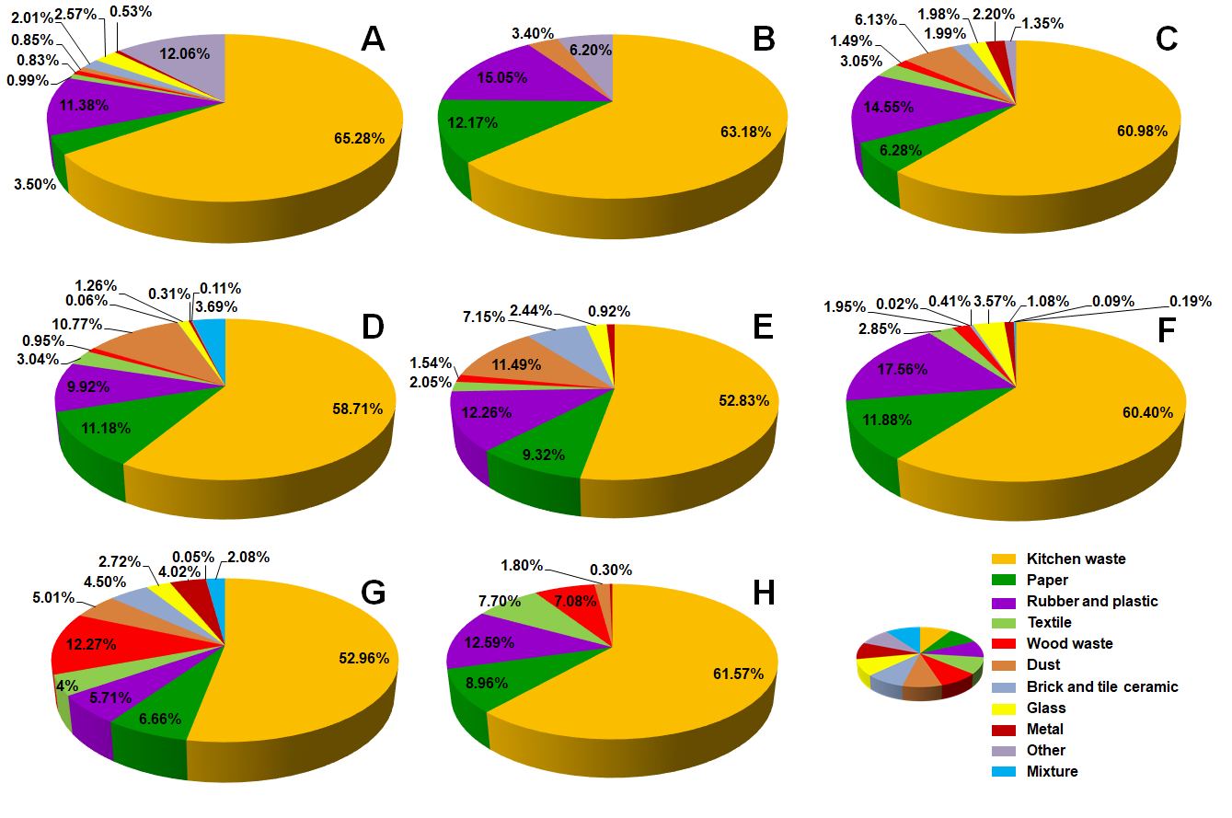
Figure 5 MSW composition and characteristics in provincial capital cities or special zones in the order of (A) Xiamen(Lin, 2009), (B) Tianjin(Wei, 2013), (C) Shenyang(Ren et al., 2011), (D) Jinan(Li and Zheng, 2014), (E) Nanjing (Apply to Nanjing Urban Administration), (F) Shanghai(Cheng and Dong, 2017), (G) Hangzhou(Zhou, 2010) and (H) Guangzhou(Chen, 2011).
Gross regional product (GRP) or gross domestic product (GDP) are important driving forces behind MSW generation (Gu et al., 2017). In Figure 3, GRP trends in eastern coastal regions for Zhejiang, Jiangsu, Fujian, Guangdong, Tianjin, Shanghai, Shandong, and Liaoning provinces (or special zones) are shown between 2009 and 2018. With the increase of GRP shown in Figure 3A, 3B, 3C, 3D and 3G, MSW generation exhibits an upward trend in the past decade. It seems that MSW generation is nearly proportional to GRP development in China. In Shanghai, 2015-2018 the economic growth is ~10% annually (Green curve in Figure 3F, Table S2) associated with MSW generation (Figure 3F, Table S4) rising quickly from 6.1 Mt in 2015 to 7.9 Mt in 2018 (23% increase). Meanwhile, it is obvious that MSW generation in Liaoning (Figure 3H, Table S4) was significantly reduced to 8.7 Mt by 2018, which has 7% decrease compared with 9.3 Mt in 2015. The corresponding economic growth once had averaged -9% annually from 2867*10⁹ Chinese Yuan in 2015 to 2351*10⁹ in 2018 (Green curve in Figure 3H, Table S2). It has been more or less indicated that GRP/GDP in China is one of the most important factors for MSW generation.

5.3 Comparison in MSW composition

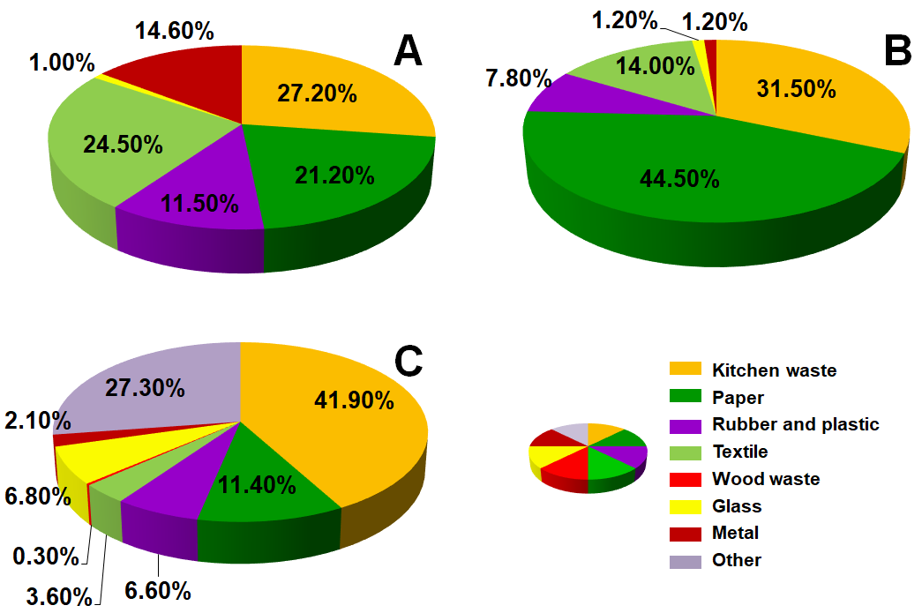
Figure 6 MSW composition and characteristics in (A) Singapore(Laohalidanond et al., 2015), (B) Tokyo(Laohalidanond et al., 2015), and (C) Berlin(Berlin, 2017).
With the rapid urbanization (Table S11) and increasing migration to cities, the habits and customs, such as food cultures, life style, travel, and other material needs, are in a continuous evolution (Wang et al., 2016). It has influenced MSW composition and characteristics in spatial and temporal attributes. It is worth noting that the proportion of kitchen waste to the entire MSW is more than 50% in China. The representative places have the order of 65.3% Xiamen (Figure 5A), 63.2% Tianjin (Figure 5B), 61.6% Guangzhou (Figure 5H), 61.0% Shenyang (Figure 5C), 60.4% Shanghai (Figure 5F), 58.7% Jinan (Figure 5D), 53.0% Hangzhou (Figure 5G), and 52.8% Nanjing (Figure 5E).
Xiamen island is a special economic zone in China where the tourism is well developed. Xiamen island is recognized at the advanced stages of urbanization with an urbanization rate reaching 100% (Xu et al., 2014). That is a possible reason for a high rate of kitchen waste in MSW produced annually. In contrast, the percentage of kitchen wastes in some developed regions, wherein the tourism is more developed (e.g., Singapore, Tokyo, and Berlin), are low (27.2%, 31.5% and 41.9%, respectively) (Figure 6). Therefore, the plausible reasons are ascribed to food cultures and life style in China, which is also corresponding to higher moisture content (> 50%) in MSW in China than that of other countries (10-30%) (Chang and Davila, 2008). These reasons amalgamate with secondary factors such as social/economic status (Aleluia and Ferrao, 2016), comprehensive quality (Mian et al., 2016), educational level (Khan et al., 2016), MSW management system (Aleluia and Ferrao, 2016), and so on.
As shown in Figure 6, although the MSW composition ratio is different in spatial among Singapore, Tokyo and Berlin, their composition is mostly composed of 6 categories, namely kitchen waste, paper, rubber & plastic, textile, glass, and metal. However, it shows more than 10 categories in China (Figure 5). It indicates that MSW in China is relatively more complicated than some developed countries, while it requires that MSW management system in China needs to be improved and well implemented. In addition, MSW composition within China differs. In particular, Hangzhou shows dynamic changes in temporal attributes (Table 2). In 1997, MSW composition characteristics of Hangzhou had 6 categories, whereas it changed to 11 categories in 2008 as shown in Figure 5G and Table 2. It is possibly attributed to the habits and customs and material needs changed with the urbanization development in individual places in China.

5.4 Comparison in TTRU for MSW
Currently, China is not at the high standards of developed countries in terms of MSW system management and TTRU (Xue et al., 2015). As mentioned before, landfill in China is still the main technology in MSW treatment (Figure 1A). There are over 650 plants nationwide with disposal capacity of 120 Mt (over 57% share) by 2017 (NBSC, 2018). However, as Tianziling landfill in Hangzhou is one of the representative plants for conversion of MSW into power with landfill gas (LFG) extraction system. But it performs with low efficiency of waste-to-biogas as 60.6 Nm³ per one tonne MSW, which only transforms into 135.7 kWh electricity (Fei et al., 2019). In contrast, one tonne MSW should generate around 300 Nm³ with conversion into 1200 kWh (Hui et al., 2010). Besides, the traditional landfills have hazardous risk in land resources associated with odors release. In some developed countries, advanced landfills are being developed to replace traditional landfills. The purpose is to develop a new landfill technology such as a biorefinery site with better environmental protection and higher efficiency (Bolan et al., 2013). For example, Semakau landfill in Singapore was set up beside several reefs covering 350 hectares. To prevent leaching of hazardous liquid into sea water, advanced construction design, technologies and materials (e.g., high density polyethylene (HDPE) membrane) were used simultaneously.
Incineration in Singapore has been adopted as the major technology for MSW TTRU. Four incineration plants can generate up to 3% of Singapore’s electricity requirement with conversion efficiency of one tonne MSW into electricity of ~630 kWh (Khoo, 2019). In Japan, incineration is used for 80% MSW treatment as the most common waste disposal technique (SOT, 2017). The conversion efficiency of waste-to-electricity can be as high as 2040 kWh per one tonne MSW. In contrast, the conversion efficiency in China for 40% shared incineration is only about 410 kWh per one tonne MSW. Since food cultures and life style in China are significantly different from other countries, there is no well-classified MSW and it contains 50-70% kitchen waste with high moisture content (Li et al., 2015). It results in the heat value of only 3,000-6,700 kJ/kg for MSW (Zhang et al., 2010), while it can be 8,400-17,000 kJ/kg in Japan (Lu et al., 2017). Therefore, although incineration technology developed fast in the past 10 years in China, it still needs to improve technology by combining it with optimization of MSW management.
China is in technology development phase on WtM like other countries. There are some reports that China is devoted to developing conversion of incineration ashes (i.e., IBA, IFA) to the partial raw material substitute for the production of cement (Yuan et al., 2010), ceramics (Fan et al., 2017), hydrogen by thermal treatment (Wang et al., 2018), solidification, etc. Liquidized bio-fuel, heats, and syngas were also derived from MSW via pyrolysis (He et al., 2010) or gasification (Cao et al., 2019). In contrast, numerous efforts in worldwide are additionally made on utilization of IBA or IFA (Tang et al., 2017) as asphalt concrete layer (Yang et al., 2014), lightweight material (Chuang et al., 2018), binder (Silva et al., 2017), mesoporous sorbent, geopolymer (Lancellotti et al., 2015), etc. Meanwhile, there are some emerging investigation worldwide on MSW derived biochar, cellulose nanofibers, hydrochar, pyrochar, aerogel, tar, B/N co-doped carbon nanosheet, carbon quantum dot and so on. In the future, China should work hard with other countries to enhance technology innovation in TTRU of MSW.

5.5 Trends and perspectives
An ideal system integrating MSW management and TTRU needs to be proposed by using technological development and advanced methods. In addition to technological concepts in MSW management, operational and behavioral analysis should be conducted in collection, segregation, transportation, treatment and disposal issues of MSW. All methods and techniques discussed in previous sections should be thoroughly investigated. Particularly, developing current technologies (landfill, incineration) in MSW TTRU will be the major trend in China in coming years. Advanced landfill as an enhanced biorefinery site could be considered for generating abundant biogas and producing bio-materials (e.g., biochar, bio-sorbent). Incineration plants might be further developed as the mainstream application. The main challenge is how to make efficient conversion of MSW into energy/fuel due to the diversity of MSW characteristics. Considering high moisture content in China’s MSW, Berlin’s technology can be a good reference for waste dewatering for China. Incineration technology for waste-to-electricity in Japan can be introduced to China because the conversion efficiency is 5 times higher than Chinese counterpart.
In controlling MSW generation, the government must make efforts on regulating implementation regarding MSW classification and collection in nationwide, as well as balance between urbanization and waste stream can be managed. For example, waste collection fee system can be built by learning from the developed countries. Moreover, an emerging strategy on MSW to materials is worth to carry out due to huge quantity of MSW in China. Further green initiatives should be discussed to promote WtE and WtM. There are also ongoing discussions noting that increased WtE capacity might jeopardize recycling. Therefore, a careful policy should be adopted to enhance prevention, reuse, and recycling and promote WtE for the produced waste at the same time.

Conclusion
Municipal solid waste (MSW) in China (especially in eastern coastal regions), Berlin, Tokyo and Singapore are presented in terms of background information (i.e., MSW generation, population, GDP/GRP), laws (acts, regulations, policies) for MSW management, MSW characteristics (composition, separation and collection), TTRU, and emerging technologies in MSW resource utilization. The findings are listed as follows:
(1) MSW generation in China kept a strong rising tendency in the past decade. Total annual generation has increased from 157 Mt in 2009 to 228 Mt in 2018. In particular, a new finding is that provinces in eastern coastal region, where urbanization is fast, generated more than half share in nationwide.
(2) MSW generation shows spatiotemporal variation. In spatial distribution, the point sources in eastern coastal regions are quite different. Guangdong, Shanghai and Tianjin produced MSW of 30.35, 7.85 and 2.95 Mt, respectively. In temporal distribution, during 2009-2018, Fujian province showed 123% increase in MSW generation while Liaoning province showed only 7% increase, whereas Shanghai special zone had a decline of -11% after 2013. Considering data from Singapore, Tokyo, and eastern coastal regions together, the major factor in MSW generation could be gross regional product (GRP) associated with policy implementation rather than population growth.
(3) MSW composition characteristics is complicated. The major components such as kitchen waste, paper and rubber & plastics in different eastern coastal cities have fluctuation in the range of 52.8~65.3%, 3.5~11.9%, and 9.9~19.1%, respectively. Meanwhile, MSW generated are usually put in more than 10 categories in separation and collection. Those are due to the rapid urbanization coupled with evolution of food cultures, lifestyle, travel, material demands and so on. Separation and collection will accelerate the WtE conversion.
(4) To reach 35% domestic waste recycling rate targets, MSW management system needs to be optimized. At present, it is not well adopted and implemented nationwide facing differences both in generation and composition characteristics in different places. Systematic waste separation would promote a successful built of integrated waste management system. At the same time, it’s significant to implement garbage classification to promote the coordinated development of source classification and terminal processing. Further analysis should be conducted on new technologies in segregation using smart bins with Internet of Things (IoT) and artificial intelligence technologies.
(5) Enhanced technologies in TTRU for MSW are sought in China. Treatment rate of consumption waste is up to 99% with a sum of 52% landfill, 45% incineration, and 3% composting technologies, indicating that landfill still dominates MSW treatment. The key point is that the efficiency of MSW resource utilization is much lower than that of developed countries and possible technology transfer options from the developed regions are noted.
(6) Emerging technologies for MSW resource utilization are being developed in world. WtE facilities have been set up worldwide with different technologies such as incineration, gasification, pyrolysis, anaerobic digestion, wet torrefaction, hydrothermal incineration, thermochemical and hydrothermal liquefaction, and thermochemical and hydrothermal gasification to transform MSW into heat, electricity, syngas, biogas, liquid biofuel, bio-crude oil, solid fuel, etc. Emerging investigation on WtM involves MSW derived biochar, cellulose nanofibers, hydrochar, pyrochar, aerogel, tar, carbon nanosheet etc. In China, exploring emerging technologies and maximizing the utilization of MSW will be the major challenges in the future.
Overall, this review paper gives a comprehensive update of MSW in management and the enhancement of TTRU in China and its comparison with international regions. The study points out the limitations in China on the aspects of MSW management system and technologies, and suggests possible solutions for future studies.

Acknowledgements
The authors are grateful to editor-in-chief and four anonymous reviewers who have helped to improve the manuscript significantly. The authors would like to acknowledge the Natural Science Foundation of Zhejiang Province (Y19B070005, LGG20B060004), the National Key Research and Development Project (2018YFC0214100), and the National Training Program of Innovation and Entrepreneurship for Undergraduates (201910337016) for financial support.
Supplementary material
Supplementary data associated with this article can be found, in the online version, at website.

References
Abd Kadir, S.A.S., Yin, C.-Y., Rosli Sulaiman, M., Chen, X., El-Harbawi, M., 2013. Incineration of municipal solid waste in Malaysia: Salient issues, policies and waste-to-energy initiatives. Renewable & Sustainable Energy Reviews 24(10), 181-186.
Aleluia, J., Ferrao, P., 2016. Characterization of urban waste management practices in developing Asian countries: A new analytical framework based on waste characteristics and urban dimension. Waste Management 58, 415-429.
Amaral, A.F., Previtali, D., Bassani, A., Italiano, C., Manenti, F., 2020. Biogas beyond CHP: The HPC (heat, power & chemicals) process. Energy, 117820.
APO, 2007. Solid waste management: issues and challenges in Asia. Asian Productivity Organization. http://www.doc88.com/p-7498317791112.html. (Accessed 20 August 2019).
Bagheri, M., Esfilar, R., Golchi, M.S., Kennedy, C.A., 2019. A comparative data mining approach for the prediction of energy recovery potential from various municipal solid waste. Renewable and Sustainable Energy Reviews 116, 109423.
Bai, R., Sutanto, M., 2002. The practice and challenges of solid waste management in Singapore. Waste Management 22(5), 557-567.
Berenyi, E.B., Associates, G.A., 2013. Nationwide economic benefits of the waste-to-energy sector http://energyrecoverycouncil.org/wp-content/uploads/2016/03/130820-Berenyi-Natl-WTE-Economic-Benefits.pdf. (Accessed 6 August 2019).
Berlin, 2017. Waste balance in Berlin. https://www.berlin.de/senuvk/umwelt/abfall/bilanzen/download/Abfallbilanz_2017.pdf. (Accessed 5 September 2019).
Bialk-Bielinska, A., Caban, M., Pieczynska, A., Stepnowski, P., Stolte, S., 2017. Mixture toxicity of six sulfonamides and their two transformation products to green algae Scenedesmus vacuolatus and duckweed Lemna minor. Chemosphere 173, 542-550.
Białowiec, A., Micuda, M., Koziel, J., 2018. Waste to carbon: densification of torrefied refuse-derived fuel. Energies 11(11), 3233.
Bolan, N.S., Thangarajan, R., Seshadri, B., Jena, U., Das, K.C., Wang, H., Naidu, R., 2013. Landfills as a biorefinery to produce biomass and capture biogas. Bioresource Technology 135(2), 578-587.
BSD, 2013. Municipal waste management in Berlin. Berlin Senate Department for Urban Development and the Environment Communication. https://www.berlin.de/senuvk/umwelt/abfallwirtschaft/downloads/siedlungsabfall/Abfall_Broschuere_engl.pdf. (Accessed 19 July 2019).
Cabianca, L., Bassani, A., Amaral, A.F., Rossi, F., Bozzano, G., Ranzi, E., Telenb, D., Logist, F., Impeb, J.V., Manenti, F., 2016. GASDS: a Kinetic-Based Package for Biomass and Coal Gasification. Chemical Engineering Transactions 50, 247-252.
Cao, Y., Fu, L., Mofrad, A., 2019. Combined-gasification of biomass and municipal solid waste in a fluidized bed gasifier. Journal of the Energy Institute 92(6), 1683-1688.
CAT, 2017a. Processing of incombustible waste. Clean Authority of Tokyo. http://www.union.tokyo23-seisou.lg.jp.e.de.hp.transer.com/shiro/shori/funen/index.html. (Accessed 13 August 2019).
CAT, 2017b. Role and structure of incineration plant. Clean Authority of Tokyo. http://www.union.tokyo23-seisou.lg.jp.e.de.hp.transer.com/shiro/shori/kanen/index.html. (Accessed 13 August 2019).
CAT, 2017c. Utilization of heat energy. Clean Authority of Tokyo. http://www.union.tokyo23-seisou.lg.jp.e.de.hp.transer.com/shiro/shori/kanen/joki.html. (Accessed 13 August 2019).
CAT, 2018. What is Slag. Clean Authority of Tokyo. http://www.union.tokyo23-seisou.lg.jp.e.de.hp.transer.com/shiro/shori/kanen/sullage.html. (Accessed 13 August 2019).
Chang, N.B., Davila, E., 2008. Municipal solid waste characterizations and management strategies for the Lower Rio Grande Valley, Texas. Waste Management 28(5), 776-794.
Chen, H., Wang, S., Guo, H., Lin, H., Zhang, Y., Long, Z., Huang, H., 2019. Study of marine debris around a tourist city in East China: Implication for waste management. Science of the Total Environment 676, 278-289.
Chen, X., 2011. Methane utilization in municipal solid waste landfill. Jinan University.
Chen, X., Geng, Y., Fujita, T., 2010. An overview of municipal solid waste management in China. Waste Management 30(4), 716-724.
Cheng, H., Hu, Y., 2010. Municipal solid waste (MSW) as a renewable source of energy: current and future practices in China. Bioresource Technology 101(11), 3816-3824.
Cheng, J., Dong, X., 2017. Physical and chemical characteristics of Municipal Solid Waste in Shanghai. Environmental Sanitation Engineering 25(4), 36-40.
Cheng, Y.-l., Gui-can, B., De-fang, W., Jun, X., 2017. Status quo of kitchen waste and its treatment measures at home and abroad. Advances in new and renewable energy 5(4), 266-271.
China Value, 2013. US$ 40 billion ready for MSW incineration power generation. http://www.chinavalue.net/Media/Article.aspx?ArticleId=102285. (Accessed 9 August 2019).
Choi, G.-G., Oh, S.-J., Lee, S.-J., Kim, J.-S., 2015. Production of bio-based phenolic resin and activated carbon from bio-oil and biochar derived from fast pyrolysis of palm kernel shells. Bioresource Technology 178, 99-107.
Chuang, K.-H., Lu, C.-H., Chen, J.-C., Wey, M.-Y., 2018. Reuse of bottom ash and fly ash from mechanical-bed and fluidized-bed municipal incinerators in manufacturing lightweight aggregates. Ceramics International 44(11), 12691-12696.
Corbetta, M., Bassani, A., Manenti, F., Pirola, C., Maggio, E., Pettinau, A., Deiana, P., Pierucci, S., Ranzi, E., 2015. Multi-scale Kinetic Modeling and Experimental Investigation of Syngas Production from Coal Gasification in Updraft Gasifiers. Energy & Fuels 29(6), 3972-3984.
Damgaard, A., Riber, C., Fruergaard, T., Hulgaard, T., Christensen, T.H., 2010. Life-cycle-assessment of the historical development of air pollution control and energy recovery in waste incineration. Waste Management 30(7), 1244-1250.
Dehkordi, S.M.M.N., Jahromi, A.R.T., Ferdowsi, A., Shumal, M., Dehnavi, A., 2020. Investigation of biogas production potential from mechanical separated municipal solid waste as an approach for developing countries (case study: Isfahan-Iran). Renewable and Sustainable Energy Reviews 119, 109586.
DTU, 2020. Start-up behind new plastic sorting technology. Technical University of Denmark. https://www.dtu.dk/english/news/nyhed?id=%7BCA7DED83-7906-4C95-8017-8540D5D303BD%7D. (Accessed 14 October 2020).
Elkhalifa, S., Al-Ansari, T., Mackey, H.R., McKay, G., 2019. Food waste to biochars through pyrolysis: A review. Resources, Conservation and Recycling 144, 310-320.
EPA, 2015. Advancing sustainable materials management: 2015 tables and figures. United States Envirnmental Protection Agency. https://www.epa.gov/sites/production/files/2018-07/documents/smm_2015_tables_and_figures_07252018_fnl_508_0.pdf. (Accessed 4 September 2019).
Fan, C., Wang, B., Zhang, T., 2018. Review on Cement Stabilization/Solidification of Municipal Solid Waste Incineration Fly Ash. Advances in Materials Science and Engineering 2018, 1-7.
Fan, W.-D., Liu, B., Luo, X., Yang, J., Guo, B., Zhang, S.-G., 2017. Production of glass–ceramics using Municipal solid waste incineration fly ash. Rare Metals 38(3), 245-251.
Fei, F., Wen, Z., De Clercq, D., 2019. Spatio-temporal estimation of landfill gas energy potential: A case study in China. Renewable and Sustainable Energy Reviews 103, 217-226.
Gai, C., Chen, M., Liu, T., Peng, N., Liu, Z., 2016. Gasification characteristics of hydrochar and pyrochar derived from sewage sludge. Energy 113, 957-965.
Gandidi, I.M., Susila, M.D., Mustofa, A., Pambudi, N.A., 2018. Thermal–Catalytic cracking of real MSW into bio-crude oil. Journal of the Energy Institute 91(2), 304-310.
Gu, B., Jiang, S., Wang, H., Wang, Z., Jia, R., Yang, J., He, S., Cheng, R., 2017. Characterization, quantification and management of China's municipal solid waste in spatiotemporal distributions: A review. Waste Management 61, 67-77.
Gu, C., Hu, L., Cook, I.G., 2017. China’s urbanization in 1949–2015: Processes and driving forces. Chinese geographical science 27(6), 847-859.
Han, H., Liu, Y., Yu, W., 2018. Solid waste collection and transportation system in Singapore. World Environment(5), 51-54.
Han, Y., Cao, X., Ouyang, X., Jin, S.C.,, Chen, J., 2016. Adsorption kinetics of magnetic biochar derived from peanut hull on removal of Cr (VI) from aqueous solution: Effects of production conditions and particle size. Chemosphere 145, 336-341.
He, M., Xiao, B., Liu, S., Hu, Z., Guo, X., Luo, S., Yang, F., 2010. Syngas production from pyrolysis of municipal solid waste (MSW) with dolomite as downstream catalysts. Journal of Analytical and Applied Pyrolysis 87(2), 181-187.
Hietala, M., Varrio, K., Berglund, L., Soini, J., Oksman, K., 2018. Potential of municipal solid waste paper as raw material for production of cellulose nanofibres. Waste Management 80, 319-326.
Hong, J., Chen, Y., Wang, M., Ye, L., Qi, C., Yuan, H., Zheng, T., Li, X., 2017. Intensification of municipal solid waste disposal in China. Renewable and Sustainable Energy Reviews 69, 168-176.
Hossain, M.K., Strezov, V., Chan, K.Y., Nelson, P.F., 2010. Agronomic properties of wastewater sludge biochar and bioavailability of metals in production of cherry tomato (Lycopersicon esculentum). Chemosphere 78(9), 1167-1171.
Hotta, Y., 2013. Recycling Policy: The Sound Material Cycle Society and 3R Concepts from Japan to Developing Asia. Issues in environmental science and technology 37, 162-186.
Hu, Z.T., Liu, J.W., Zhao, J., Ding, Y., Jin, Z., Chen, J., Dai, Q., Pan, B., Chen, Z., Chen, J., 2020. Enhanced BiFeO₃/Bi₂Fe₄O₉/H₂O₂ heterogeneous system for sulfamethoxazole decontamination: System optimization and degradation pathways. Journal of Colloid Interface Science 577, 54-65.
Huang, H.J., Ramaswamy, S., 2009. Modeling Biomass Gasification Using Thermodynamic Equilibrium Approach. Applied Biochemistry & Biotechnology 154(1-3), 14.
Huang, Q., Tang, Y., Lu, S., Wu, X., Chi, Y., Yan, J., 2015. Characterization of tar derived from principle components of municipal solid waste. Energy & Fuels 29(11), 7266-7274.
Hui, L.I., Yong, Y., Xiang, Z., 2010. Resource assessment and potential for power generation from landfill gas in China, International Conference on Waste Management & Technology.
Iris, Ç., Christensen, J., Pacino, D., Ropke, S., 2018. Flexible ship loading problem with transfer vehicle assignment and scheduling. Transportation Research Part B: Methodological 111, 113-134.
Iris, Ç., Lam, J.S.L., 2019. A review of energy efficiency in ports: Operational strategies, technologies and energy management systems. Renewable and Sustainable Energy Reviews 112, 170-182.
Jin, H., Capareda, S., Chang, Z., Gao, J., Xu, Y., Zhang, J., 2014. Biochar pyrolytically produced from municipal solid wastes for aqueous As(V) removal: adsorption property and its improvement with KOH activation. Bioresource Technology 169, 622-629.
Kan, T., Strezov, V., Evans, T.J., 2016. Lignocellulosic biomass pyrolysis: A review of product properties and effects of pyrolysis parameters. Renewable & Sustainable Energy Reviews 57(28), 1126-1140.
Kaza, S., Yao, L., Bhada-Tata, P., Van Woerden, F., 2018. What a waste 2.0: a global snapshot of solid waste management to 2050. World Bank Publications.
Khan, D., Kumar, A., Samadder, S.R., 2016. Impact of socioeconomic status on municipal solid waste generation rate. Waste Management 49, 15-25.
Khankhasaeva, S., Dambueva, D.V., Dashinamzhilova, E., Gil, A., Vicente, M.A., Timofeeva, M.N., 2015. Fenton degradation of sulfanilamide in the presence of Al,Fe-pillared clay: Catalytic behavior and identification of the intermediates. Journal of Hazardous Materials 293, 21-29.
Khoo, H.H., 2019. LCA of plastic waste recovery into recycled materials, energy and fuels in Singapore. Resources, Conservation and Recycling 145, 67-77.
Kikuchi, R., 2001. Recycling of municipal solid waste for cement production: pilot-scale test for transforming incineration ash of solid waste into cement clinker. Resources, Conservation and Recycling 31(2), 137-147.
Kolpin, D.W., Furlong, E.T., Meyer, M.T., Thurman, E.M., Zaugg, S.D., Barber, L.B., Buxton, H.T., 2002. Pharmaceuticals, hormones, and other organic wastewater contaminants in US streams, 1999−2000: A national reconnaissance. Environmental science & technology 36(6), 1202-1211.
Kumar, A., Samadder, S.R., 2017. A review on technological options of waste to energy for effective management of municipal solid waste. Waste Management 69, 407-422.
Kumari, A., Kumar, A., Sahu, S.K., Kumar, S., 2018. Synthesis of green fluorescent carbon quantum dots using waste polyolefins residue for Cu²⁺ ion sensing and live cell imaging. Sensors and Actuators B: Chemical 254, 197-205.
Lai, Z., 2013. Study on combustion characteristic of municipal solid waste (MSW) in O₂/CO₂ atmospheres and corrosion of water-wall tubes in AMSW incinerator. South China University of Technology.
Lancellotti, I., Cannio, M., Bollino, F., Catauro, M., Barbieri, L., Leonelli, C., 2015. Geopolymers: An option for the valorization of incinerator bottom ash derived “end of waste”. Ceramics International 41(2), 2116-2123.
Laohalidanond, K., Chaiyawong, P., Kerdsuwan, S., 2015. Municipal solid waste characteristics and green and clean energy recovery in Asian megacities. Energy Procedia 79, 391-396.
Lee, X.J., Lee, L.Y., Gan, S., Thangalazhy-Gopakumar, S., Ng, H.K., 2017. Biochar potential evaluation of palm oil wastes through slow pyrolysis: Thermochemical characterization and pyrolytic kinetic studies. Bioresource Technology 236, 155-163.
Li, J., Liu, K., Yan, S., Li, Y., Han, D., 2016. Application of thermal plasma technology for the treatment of solid wastes in China: An overview. Waste Management 58, 260-269.
Li, M., Hu, M., Du, B., Guo, Q., Tan, T., Zheng, J., Huang, X., He, L., Wu, Z., Guo, S., 2017. Temporal and spatial distribution of PM2.5 chemical composition in a coastal city of Southeast China. Science of the Total Environment 605-606, 337-346.
Li, M., Zheng, Z., 2014. Property change of domestic waste and diversified transition of treatment technologies in Jinan. Environmental Sanitation Engineering 22(4), 62-64.
Li, X.-D., Lu, S.-Y., Xu, X., Yan, J.-H., Chi, Y., 2001. Analysis on caloric value of Chinese cities's municipal solid waste. China Environmental Science 21(2), 156-260.
Li, Y., Zhao, X., Li, Y., Li, X., 2015. Waste incineration industry and development policies in China. Waste Management 46, 234-241.
Lin, L., 2009. Primary probe of MSW minimization management and the involvement of NGO: A case study based on Xiamen University. Xiamen University.
Lin, Y., Ma, X., Peng, X., Yu, Z., 2017. Hydrothermal carbonization of typical components of municipal solid waste for deriving hydrochars and their combustion behavior. Bioresource technology 243, 539-547.
Ling, Z., Wang, Z., Zhang, M., Yu, C., Wang, G., Dong, Y., Liu, S., Wang, Y., Qiu, J., 2016. Sustainable synthesis and assembly of biomass-derived B/N co-doped carbon nanosheets with ultrahigh aspect ratio for high-performance supercapacitors. Advanced Functional Materials 26(1), 111-119.
Liu, D.-s., Wang, C.-q., Mei, X.-d., Qian-Huang, Ding, S.-m., 2019. An effective treatment method for shale gas drilling cuttings solidified body. Environmental Science and Pollution Research 26(17), 17853-17857.
Liu, P., Liu, W.-J., Jiang, H., Chen, J.-J., Li, W.-W., Yu, H.-Q., 2012. Modification of bio-char derived from fast pyrolysis of biomass and its application in removal of tetracycline from aqueous solution. Bioresource Technology 121(121), 235-240.
Liu, Y., Sidhu, K.S., Chen, Z., Yang, E.-H., 2018. Alkali-treated incineration bottom ash as supplementary cementitious materials. Construction and Building Materials 179, 371-378.
LTA, 2010. Materials and workmanship specification for civil & structural works. Land Transport Autuority. https://www.lta.gov.sg/content/ltagov/en.html. (Accessed 20 August 2019).
Lu, J.-W., Zhang, S., Hai, J., Lei, M., 2017. Status and perspectives of municipal solid waste incineration in China: A comparison with developed regions. Waste Management 69, 170-186.
Luo, H., Wu, Y., Zhao, A., Kumar, A., Liu, Y., Cao, B., Yang, E.-H., 2017. Hydrothermally synthesized porous materials from municipal solid waste incineration bottom ash and their interfacial interactions with chloroaromatic compounds. Journal of Cleaner Production 162, 411-419.
Ma, Z., 2010. Domestic waste investigation and disposal method in Shenyang. Environmental Sanitation Engineering 18(2), 13-14.
Matsumoto, S., 2011. Waste separation at home: Are Japanese municipal curbside recycling policies efficient? Resources, Conservation and Recycling 55(3), 325-334.
MEE, 1996. Law on the Prevention and Control of Environmental Pollution Caused by Solid Waste. Ministry of Ecology and Environment of the People's Republic of China. http://zfs.mee.gov.cn/fl/200412/t20041229_65299.shtml. (Accessed 17 September 2019).
MEE, 2002. China Presses for Cleaner Production. Ministry of Ecology and Environment of the People's Republic of China. http://zfs.mee.gov.cn/fl/200206/t20020629_84834.shtml. (Accessed 17 September 2019).
Menzler, N.H., Mörtel, H., Weißmann, R., Balek, V., 1999. Examination of two glass compositions for the vitrification of toxic products from waste incineration. Applied & Environmental Microbiology 40(2), 65-70.
MEWR, 2015. Good progress made in a year, on implementation of the Sustainable Singapore Blueprint. Ministry of Environment and Water Resources. https://www.mewr.gov.sg/news/good-progress-made-in-a-year--on-implementation-of-the-sustainable-singapore-blueprint-2015. (Accessed 21 July 2019).
Mian, M.M., Zeng, X., Nasry, A.a.N.B., Al-Hamadani, S.M.Z.F., 2016. Municipal solid waste management in China: a comparative analysis. Journal of Material Cycles and Waste Management 19(3), 1127-1135.
Miezah, K., Obiri-Danso, K., Kádár, Z., Heiske, S., Fei-Baffoe, B., Mensah, M., Meyer, A.S., 2017. Municipal solid waste management in a low income economy through biogas and bioethanol production. Waste and biomass valorization 8(1), 115-127.
Mishra, R.K., Sabu, A., Tiwari, S.K., 2018. Materials chemistry and the futurist eco-friendly applications of nanocellulose: status and prospect. Journal of Saudi Chemical Society 22(8), 949 - 978.
MOHURD, 2007. Administrative Measures for Urban Living Garbage. Ministry of Housing and Urban-Rural Development of the People's Republic of China. http://www.mohurd.gov.cn/fgjs/jsbgz/200706/t20070604_159100.html. (Accessed 17 September 2019).
MOHURD, 2017. Domestic Waste Classification Regulation. Ministry of Housing and Urban-Rural Development of the People's Republic of China http://www.mohurd.gov.cn/wjfb/201906/t20190606_240787.html. (Accessed 4 September 2019).
Mukherjee, C., Denney, J., Mbonimpa, E.G., Slagley, J., Bhowmik, R., 2020. A review on municipal solid waste-to-energy trends in the USA. Renewable and Sustainable Energy Reviews 119, 109512.
Munir, M.T., Mardon, I., Al-Zuhair, S., Shawabkeh, A., Saqib, N.U., 2019. Plasma gasification of municipal solid waste for waste-to-value processing. Renewable and Sustainable Energy Reviews 116, 109461.
Nanda, S., Berruti, F., 2021. A technical review of bioenergy and resource recovery from municipal solid waste. Journal of Hazardous Material 403, 123970.
NBSC, 2016. China Statistical Yearbook. National Bureau of Statistics of China. https://data.stats.gov.cn/easyquery.htm?cn=C01. (Accessed 14 October 2020).
NBSC, 2018. China Statistical Yearbook. National Bureau of Statistics of China. http://data.stats.gov.cn/easyquery.htm?cn=C01. (Accessed 11 July 2020).
NEA, 2015. Phase II Semakau Landfill ready to meet Singapore’s waste disposal needs to 2035 and beyond. National Environment Agency. https://www.nea.gov.sg/media/news/news/index/phase-ii-semakau-landfill-ready-to-meet-singapore-s-waste-disposal-needs-to-2035-and-beyond. (Accessed 20 August 2019).
NEA, 2019. Waste management. National Environment Agency. https://www.nea.gov.sg/our-services/waste-management/overview/. (Accessed 13 August 2019).
Ng, B.J.H., Mao, Y., Chen, C.-L., Rajagopal, R., Wang, J.-Y., 2017. Municipal food waste management in Singapore: practices, challenges and recommendations. Journal of material cycles and waste management 19(1), 560-569.
Nguyen, V.-T., Nguyen, T.-B., Chen, C.-W., Hung, C.-M., Vo, T.-D.-H., Chang, J.-H., Dong, C.-D., 2019. Influence of pyrolysis temperature on polycyclic aromatic hydrocarbons production and tetracycline adsorption behavior of biochar derived from spent coffee ground. Bioresource technology 284, 197-203.
Nithiya, A., Saffarzadeh, A., Shimaoka, T., 2018. Hydrogen gas generation from metal aluminum-water interaction in municipal solid waste incineration (MSWI) bottom ash. Waste Management 73, 342-350.
Njdaily, 2018. Learn about the guide to classify MSW. http://www.njdaily.cn/2018/0708/1710450.shtml. (Accessed 5 September 2019).
Onur, A., Ng, A., Garnier, G., Batchelor, W., 2019. The use of cellulose nanofibres to reduce the wet strength polymer quantity for development of cleaner filters. Journal of Cleaner Production 215, 226-231.
Patra, S., Whaung, S.T., Kwan, W.L., 2017. Analysis of heavy metals in Incineration Bottom Ash in Singapore and potential impact of pre-sorting on ash quality. Energy Procedia 143, 454-459.
Pontiroli, D., Scaravonati, S., Magnani, G., Fornasini, L., Bersani, D., Bertoni, G., Milanese, C., Girella, A., Ridi, F., Verucchi, R., Mantovani, L., Malcevschi, A., Riccò, M., 2019. Super-activated biochar from poultry litter for high-performance supercapacitors. Microporous and Mesoporous Materials 285, 161-169.
Qiao, M., Ying, G.G., Singer, A.C., Zhu, Y.G., 2018. Review of antibiotic resistance in China and its environment. Environment International 110, 160-172.
Rajala, S., Siponkoski, T., Sarlin, E., Mettänen, M., Vuoriluoto, M., Pammo, A., Juuti, J., Rojas, O.J., Franssila, S., Tuukkanen, S., 2016. Cellulose nanofibril film as a piezoelectric sensor material. ACS applied materials & interfaces 8(24), 15607-15614.
Ranzi, E., 2016. Thermochemical Process Engineering Volume 49 || Pyrolysis, Gasification, and Combustion of Solid Fuels. Advances in Chemical Engineering, 1-94.
Ravindran, P., Vidya, R., Kjekshus, A., Fjellvåg, H., Eriksson, O., 2006. Theoretical investigation of magnetoelectric behavior in BiFeO₃. Physical Review B 74(22).
Ray, S.K., Dhakal, D., Lee, S.W., 2018. Insight into sulfamethoxazole degradation, mechanism, and pathways by AgBr-BaMoO₄ composite photocatalyst. Journal of Photochemistry and Photobiology A: Chemistry 364, 686-695.
Reck, B.K., Graedel, T.E., 2012. Challenges in metal recycling. Science 337(6095), 690-695.
Ren, J., Li, N., Li, L., An, J.-K., Zhao, L., Ren, N.-Q., 2015. Granulation and ferric oxides loading enable biochar derived from cotton stalk to remove phosphate from water. Bioresource Technology 178, 119-125.
Ren, W.-X., Geng, Y., Xue, B., 2011. Emission and generation forecasting of municipal solid waste in Shenyang. Environmental science & technology 34(9), 105-110.
Rizwan, M., Ali, S., Qayyum, M.F., Ibrahim, M., Zia-Ur-Rehman, M., Abbas, T., Yong, S.O., 2016. Mechanisms of biochar-mediated alleviation of toxicity of trace elements in plants: a critical review. Environmental Science & Pollution Research 23(3), 2230-2248.
Robinson, A., Sewell, G.C., Wu, S., Damodaran, N., Kalas-Adams, N., 2003. Landfill date from China: addressing information needs for methane recovery, 3rd International Methane NitrousOxide Mitigation Conference.
Rodriguez-Narvaez, O.M., Peralta-Hernandez, J.M., Goonetilleke, A., Bandala, E.R., 2019. Biochar-supported nanomaterials for environmental applications. Journal of Industrial and Engineering Chemistry 78, 21-33.
Sánchez-García, M., Alburquerque, J.A., Sánchez-Monedero, M.A., Roig, A., Cayuela, M.L., 2015. Biochar accelerates organic matter degradation and enhances N mineralisation during composting of poultry manure without a relevant impact on gas emissions. Bioresource Technology 192, 272-279.
Samoila, P., Cojocaru, C., Sacarescu, L., Dorneanu, P.P., Domocos, A.-A., Rotaru, A., 2017. Remarkable catalytic properties of rare-earth doped nickel ferrites synthesized by sol-gel auto-combustion with maleic acid as fuel for CWPO of dyes. Applied Catalysis B: Environmental 202, 21-32.
Sari, S.N., Melati, A., 2019. Facile Preparation of Carbon Nanofiber from Banana Peel Waste. Materials Today: Proceedings 13, 165-168.
Shareefdeen, Z., Elkamel, A., Tse, S., 2015. Review of current technologies used in municipal solid waste-to-energy facilities in Canada. Clean Technologies and Environmental Policy 17(7), 1837-1846.
Shikhaliyev, K., Okoye, P.U., Hameed, B.H., 2018. Transesterification of biodiesel byproduct glycerol and dimethyl carbonate over porous biochar derived from pyrolysis of fishery waste. Energy Conversion and Management 165, 794-800.
Silva, R.V., de Brito, J., Lynn, C., Dhir, R., 2019. Environmental impacts of the use of bottom ashes from municipal solid waste incineration: A review. Resources, Conservation and Recycling 140, 23-35.
Silva, R.V., de Brito, J., Lynn, C.J., Dhir, R.K., 2017. Use of municipal solid waste incineration bottom ashes in alkali-activated materials, ceramics and granular applications: A review. Waste Management 68, 207-220.
Sipra, A.T., Gao, N., Sarwar, H., 2018. Municipal solid waste (MSW) pyrolysis for bio-fuel production: A review of effects of MSW components and catalysts. Fuel Processing Technology 175, 131-147.
Song, J., Sun, Y., Jin, L., 2017. Pestel analysis of the development of the waste-to-energy incineration industry in China. Renewable and Sustainable Energy Reviews 80, 276-289.
Song, L., Chen, S., 2013. Status and Development Trend of Waste Composting Biological Treatment in China. Environmental Sanitation Engineering 21(01), 5-7+12.
SOT, 2017. Tokyo statistical yearbook. Statistics of Tokyo. http://www.toukei.metro.tokyo.jp/tnenkan/2017/tn17q3e001.htm. (Accessed 22 October 2019).
Sun, X., Li, J., Zhao, X., Zhu, B., Zhang, G., 2016. A Review on the management of municipal solid waste fly ash in American. Procedia Environmental Sciences 31, 535-540.
SWB, 2018. Annual development report on the industry of MSW treatment. Solid waste observation. http://huanbao.bjx.com.cn/news/20190211/961689-2.shtml. (Accessed 21 September 2019).
Taherymoosavi, S., Verheyen, V., Munroe, P., Joseph, S., Reynolds, A., 2017. Characterization of organic compounds in biochars derived from municipal solid waste. Waste Management 67, 131-142.
Tanaka, M., 1999. Recent trends in recycling activities and waste management in Japan. Journal of Material Cycles & Waste Management 1(1), 10-16.
Tang, Q., Zhang, Y., Gao, Y., Gu, F., 2017. Use of cement-chelated, solidified, municipal solid waste incinerator (MSWI) fly ash for pavement material: mechanical and environmental evaluations. Canadian Geotechnical Journal 54(11), 1553-1566.
Thiagamani, S.M.K., Nagarajan, R., Jawaid, M., Anumakonda, V., Siengchin, S., 2017. Utilization of chemically treated municipal solid waste (spent coffee bean powder) as reinforcement in cellulose matrix for packaging applications. Waste management 69, 445-454.
Tong, H., Yao, Z., Lim, J.W., Mao, L., Zhang, J., Ge, T.S., Peng, Y.H., Wang, C.-H., Tong, Y.W., 2018. Harvest green energy through energy recovery from waste: A technology review and an assessment of Singapore. Renewable and Sustainable Energy Reviews 98, 163-178.
Tosti, L., van Zomeren, A., Pels, J.R., Damgaard, A., Comans, R.N.J., 2020. Life cycle assessment of the reuse of fly ash from biomass combustion as secondary cementitious material in cement products. Journal of Cleaner Production 245, 118937.
Triyono, B., Prawisudha, P., Aziz, M., Mardiyati, Pasek, A.D., Yoshikawa, K., 2019. Utilization of mixed organic-plastic municipal solid waste as renewable solid fuel employing wet torrefaction. Waste Management 95, 1-9.
Wang, A., Li, Y.-Y., Estrada, A.L., 2011. Mineralization of antibiotic sulfamethoxazole by photoelectro-Fenton treatment using activated carbon fiber cathode and under UVA irradiation. Applied Catalysis B: Environmental 102(3-4), 378-386.
Wang, B., Gao, B., Fang, J., 2018. Recent advances in engineered biochar productions and applications. Critical Reviews in Environmental Science & Technology 47(22), 1-50.
Wang, J., Wang, S., 2019. Preparation, modification and environmental application of biochar: A review. Journal of Cleaner Production 227, 1002-1022.
Wang, J., Xie, Y., Lu, J., Chen, J., Xu, N., Yue, L., 2018. Treatment technology and utilization of municipal solid waste incineration (MSWI) bottom ash. Guangdong Chemical Industry 45(15), 143-144+150.
Wang, M., Yang, Y., Jin, S., Gu, L., Zhang, H., 2016. Social and cultural factors that influence residential location choice of urban senior citizens in China–The case of Chengdu city. Habitat International 53, 55-65.
Wang, S.-y., Tang, Y.-k., Chen, C., Wu, J.-t., Huang, Z., Mo, Y.-y., Zhang, K.-x., Chen, J.-b., 2015. Regeneration of magnetic biochar derived from eucalyptus leaf residue for lead(II) removal. Bioresource Technology 186, 360-364.
Wang, X., Yang, C., Zhou, D., Wang, Z., Jin, M., 2018. Chemical co-precipitation synthesis and properties of pure-phase BiFeO₃. Chemical Physics Letters 713, 185-188.
Wei, J., Guo, Q., Ding, L., Yoshikawa, K., Yu, G., 2017a. Synergy mechanism analysis of petroleum coke and municipal solid waste (MSW)-derived hydrochar co-gasification. Applied Energy 206, 1354-1363.
Wei, W., 2013. Utilization of municipal solid waste in Tianjin central city. Tianjin University.
Wei, Y., Li, J., Shi, D., Liu, G., Zhao, Y., Shimaoka, T., 2017. Environmental challenges impeding the composting of biodegradable municipal solid waste: A critical review. Resources, Conservation and Recycling 122, 51-65.
Wei, Y.S., Fan, Y.B., Wang, M.J., Wang, J.S., 2000. Composting and compost application in China. Resources Conservation & Recycling 30(4), 277-300.
World Bank, 2019. Solid Waste Management. https://www.worldbank.org/en/topic/urbandevelopment/brief/solid-waste-management. (Accessed 14 October 2020).
Wu, W., Li, J., Lan, T., Müller, K., Niazi, N.K., Chen, X., Xu, S., Zheng, L., Chu, Y., Li, J., Yuan, G., Wang, H., 2017. Unraveling sorption of lead in aqueous solutions by chemically modified biochar derived from coconut fiber: A microscopic and spectroscopic investigation. Science of the Total Environment 576, 766-774.
Wu, X., Silberschmidt, V.V., Hu, Z.T., Chen, Z., 2018. When superhydrophobic coatings are icephobic: Role of surface topology. Surface and Coatings Technology 358, 207-214.
Xu, H., 2018. Development report on treatment industry of urban domestic refuse in 2017. China Environmental Protection Industry (07),5-9.
Xu, L., Lin, T., Xu, Y., Xiao, L., Ye, Z., Cui, S., 2014. Path analysis of factors influencing household solid waste generation: a case study of Xiamen Island, China. Journal of Material Cycles and Waste Management 18(2), 377-384.
Xue, W., Kai, C., Li, W., 2015. Municipal solid waste collection optimization in Singapore. Applied Geography 62, 182-190.
Yan, J., Peng, J., Lai, L., Ji, F., Zhang, Y., Lai, B., Chen, Q., Yao, G., Chen, X., Song, L., 2018. Activation CuFe₂O₄ by Hydroxylamine for Oxidation of Antibiotic Sulfamethoxazole. Environmental Science Technology 52(24), 14302-14310.
Yang, S.F., Chiu, W.-T., Wang, T.-M., Chen, C.-T., Tzeng, C.-C., 2014. Porous materials produced from incineration ash using thermal plasma technology. Waste Management 34(6), 1079-1084.
Yang, Y., Lu, X., Jiang, J., Ma, J., Liu, G., Cao, Y., Liu, W., Li, J., Pang, S., Kong, X., Luo, C., 2017. Degradation of sulfamethoxazole by UV, UV/H₂O₂ and UV/persulfate (PDS): Formation of oxidation products and effect of bicarbonate. Water Research 118, 196-207.
Ying, D., Chuanyu, C., Bin, H., Yueen, X., Xuejuan, Z., Yingxu, C. and Weixiang, W., 2012. Characterization and control of odorous gases at a landfill site: A case study in Hangzhou, China. Waste management, 32(2), pp.317-326.
Zhuang, Y., Wu, S.-W., Wang, Y.-l., Wu, W.-X., Chen, Y.-X., 2008. Source separation of household waste: a case study in China. Waste Management 28(10), 2022-2030.
You, S.M., Tong, H.H., Armin-Hoiland, J., Tong, Y.W., Wang, C.H., 2017. Techno-economic and greenhouse gas savings assessment of decentralized biomass gasification for electrifying the rural areas of Indonesia. Applied Energy 208, 495-510.
Yuan, W., He, H., Yu, Q., 2010. Investment and benefit of combined treatment of municipal solid waste by cement kilns and incinerators. China Cement (09), 50-51.
Yuan, P., Wang, J., Pan, Y., Shen, B., Wu, C., 2019. Review of biochar for the management of contaminated soil: Preparation, application and prospect. Sci. Total Environ. 659, 473-490.
Yue, X., Zhang, T., Yang, D., Qiu, F., Li, Z., 2018. Hybrid aerogels derived from banana peel and waste paper for efficient oil absorption and emulsion separation. Journal of cleaner production 199, 411-419.
Zhang, D., Keat, T.S., Gersberg, R.M., 2010. A comparison of municipal solid waste management in Berlin and Singapore. Waste Management 30(5), 921-933.
Zhang, D.Q., Tan, S.K., Gersberg, R.M., 2010. Municipal solid waste management in China: status, problems and challenges. Journal of Environmental Management 91(8), 1623-1633.
Zhang, Z., Zhang, L., Li, A., 2015. Development of a sintering process for recycling oil shale fly ash and municipal solid waste incineration bottom ash into glass ceramic composite. Waste Management 38, 185-193.
Zhao, B., Xu, R., Ma, F., Li, Y., Wang, L., 2016. Effects of biochars derived from chicken manure and rape straw on speciation and phytoavailability of Cd to maize in artificially contaminated loess soil. Journal of Environmental Management 184, 569-574.
Zhao, J., Yan, Y., Chen, X.,, Jose, V., Chen, X., Lee, J.-M., 2020. Bifunctional carbon nanoplatelets as metal-free catalysts for direct conversion of fructose to 2,5-diformylfuran. Catalysis Science & Technology 10(13), 4179-4183.
Zhao, X.., Jiang, G., Li, A., Wang, L., 2016a. Economic analysis of waste-to-energy industry in China. Waste Management 48, 604-618.
Zheng, L., Song, J., Li, C., Gao, Y., Geng, P., Qu, B., Lin, L., 2014. Preferential policies promote municipal solid waste (MSW) to energy in China: Current status and prospects. Renewable and Sustainable Energy Reviews 36, 135-148.
Zhou, F., 2010. Research on the comprehensive evaluation method of MSW treatment system in Hangzhou. Central South University.
Zhu, W., Chen, X., Zhao, A., Struble, L.J., Yang, E.-H., 2019. Synthesis of high strength binders from alkali activation of glass materials from municipal solid waste incineration bottom ash. Journal of Cleaner Production 212, 261-269.
Zhuang, Y., 2007. Study on integrated MSW treatment in Hangzhou city. Zhejiang University.

List of Figures

Scheme 1 Schematic diagram showing the MSW generation in China’s eastern coastal provinces and their provincial capital cities (or special zones) in 2018 associated with their spatial distribution, composition and characteristics.

Figure 1 MSW generation in China between 2009 and 2018, and the corresponding treatment quantity using landfill, incineration and composting with the total treatment rate of consumption wastes (A). MSW generation in eastern coastal provinces (B) and their provincial capital cities or special zones (C) during 2009-2018 (the data for Xiamen in 2018 is not applicable in Fujian Statistical Yearbook 2019).

Figure 2 MSW composed of five types with proportion ratio (A) and the adopted technologies with the corresponding quantity in tonne (B) in Berlin(2013). MSW separated into four types with proportion ratio and generation quantity in Tokyo(Yang et al., 2017) (C). MSW mainly classified into domestic waste and non-domestic waste with the related disposal quantity (tonne) from 2009 to 2017 in Singapore(Ravindran et al., 2006) (D).

Figure 3 The relationship between MSW generation and influence factors such as urban population and gross regional product (GRP) in Zhejiang (A), Jiangsu (B), Fujian (C), Guangdong (D), Tianjin (E), Shanghai (F), Shandong (G) and Liaoning (H) province (or special zone), respectively.

Figure 4 The relationship between MSW generation and influence factors such as urban population in Singapore (A), Tokyo (B), and Berlin (C), respectively.

Figure 5 MSW composition and characteristics in provincial capital cities or special zones in the order of (A) Xiamen(Lin, 2009), (B) Tianjin(Wei, 2013), (C) Shenyang(Ren et al., 2011), (D) Jinan(Li and Zheng, 2014), (E) Nanjing (Apply to Nanjing Urban Administration), (F) Shanghai(Cheng and Dong, 2017), (G) Hangzhou(Zhou, 2010) and (H) Guangzhou(Chen, 2011).

Figure 6 MSW composition and characteristics in (A) Singapore(Laohalidanond et al., 2015), (B) Tokyo(Laohalidanond et al., 2015), and (C) Berlin(Berlin, 2017).

List of Tables

Table 1 MSW types classified generally in China (Njdaily, 2018)
Table 2 Characteristic variation of MSW at different period in a provincial capital city (or special zone) in China’s eastern coastal regions, and their similarities and differences each other

Table 1 MSW types classified generally in China (Njdaily, 2018)
Types | MSW components | Collecting container
Recyclable | Paper: newspapers and magazines, used books, tissue box, cardboard boxes, cartons, office paper, etc.  Glass: cullet, various glass bottles, mirror, etc.  Metal: pop-top cans, tin cans, toothpaste, etc.  Plastics: plastic bottles, plastic foam, disposable plastic tableware, plastic packaging, plastic cup, etc.  Textile: discarded clothes, towels, school bags, etc. | Blue
Kitchen waste | Leftovers, vegetable stems, tea stalks, plant leaves, waste food oil, fruit residual, animal skeleton viscera, etc. | Green
Harmful waste | Battery, used electronic products, overdue drugs, hair dye, expired cosmetics, waste tube bulb, waste the paint can, scrap printer cartridges, pesticide container, etc. | Red
Other waste | Contaminated paper, shell, non-recyclable glass, worn out ceramics, cigarette, contaminated plastic bags, contaminated diapers, dust, etc. | Gray or Black

Table 2 Characteristic variation of MSW at different period in a provincial capital city (or special zone) in China’s eastern coastal regions, and their similarities and differences each other
City (Special zone) | Year | Composition percentage (%)
 |  | Kitchen waste | Paper | Rubber and plastics | Textile | Wood waste | Dust | Brick and tile ceramic | Glass | Metal | Others | Mixture
Shanghai | 2016 (Cheng and Dong, 2017) | 60.40 | 11.88 | 17.56 | 2.85 | 1.95 | 0.02 | 0.41 | 3.57 | 1.08 | 0.09 | 0.19
 | 2015 (Cheng and Dong, 2017) | 61.10 | 12.07 | 16.57 | 2.57 | 4.52 | 0.02 | 0.44 | 2.10 | 0.51 | 0.07 | 0.03
 | 2014 (Cheng and Dong, 2017) | 65.07 | 10.58 | 15.99 | 2.03 | 2.70 | 0.08 | 0.45 | 2.31 | 0.54 | 0.14 | 0.11
 | 2013 (Cheng and Dong, 2017) | 62.21 | 12.66 | 16.56 | 2.14 | 1.49 | 0.05 | 0.14 | 2.29 | 0.35 | 0.02 | 2.09
 | 2012 (Cheng and Dong, 2017) | 64.97 | 9.57 | 15.71 | 2.31 | 2.69 | 0.00 | 0.53 | 2.53 | 0.33 | 0.05 | 1.31
 | 2011 (Cheng and Dong, 2017) | 61.66 | 13.31 | 17.11 | 2.12 | 1.60 | 0.12 | 0.45 | 2.98 | 0.32 | 0.21 | 0.12
 | 2010 (Cheng and Dong, 2017) | 63.51 | 11.90 | 16.75 | 2.29 | 1.48 | 0.01 | 0.35 | 3.03 | 0.48 | 0.07 | 0.13
 | 2009 (Cheng and Dong, 2017) | 63.69 | 11.71 | 16.66 | 2.38 | 1.24 | 0.06 | 0.51 | 2.84 | 0.52 | 0.06 | 0.33
 | 2008 (Cheng and Dong, 2017) | 63.47 | 10.19 | 18.26 | 2.57 | 1.09 | 0.10 | 0.46 | 2.50 | 0.34 | 0.05 | 0.97
 | 2007 (Cheng and Dong, 2017) | 67.37 | 9.01 | 15.67 | 2.58 | 1.10 | 0.19 | 0.44 | 2.35 | 0.50 | 0.05 | 0.74
Hangzhou | 2010 ª | 56.80 | 9.31 | 19.09 | 3.05 | 1.92 | - | - | 1.40 | 0.46 | 3.85 | -
 | 2008 (Zhou, 2010) | 52.96 | 6.66 | 5.71 | 4.00 | 12.27 | 5.01 | 4.50 | 2.72 | 4.02 | 0.05 | 2.08
 | 2004 (Zhuang, 2007) | 64.24 | 6.95 | 15.29 | 2.13 | 1.21 | 5.58 | 1.53 | 2.16 | 0.91 | - | -
 | 1997 (Li et al., 2001) | 58.19 | 3.68 | 7.63 | 2.23 | 1.20 | - | - | 2.09 | 0.98 | - | -
Tianjin  (city center) | 2012 (Wei, 2013) | 63.22 | 11.74 | 14.63 | - | - | 3.89 | - | - | - | 6.52 | -
 | 2011 (Wei, 2013) | 63.18 | 12.16 | 15.05 | - | - | 3.41 | - | - | - | 6.20 | -
 | 2010 (Wei, 2013) | 65.45 | 11. 07 | 13.95 | - | - | 3.81 | - | - | - | 5.72 | -
 | 2009 (Wei, 2013) | 63.42 | 11.24 | 13.30 | - | - | 5.76 | - | - | - | 6.28 | -
 | 2008 (Wei, 2013) | 58.46 | 10.44 | 14.05 | - | - | 9.15 | - | - | - | 7.90 | -
Xiamen | 2006 (Lin, 2009) | 65.28 | 3.50 | 11.38 | 0.99 | 0.83 | 0.85 | 1.01 | 2.57 | 0.53 | 11.78 | -
 | 2005 (Lin, 2009) | 62.57 | 3.95 | 11.49 | 1.54 | 0.96 | 1.99 | 0.84 | 3.12 | 0.80 | 11.26 | -
 | 2004 (Lin, 2009) | 65.62 | 3.09 | 10.36 | 1.51 | 0.57 | 4.79 | 2.14 | 2.18 | 0.65 | 4.35 | -

Table 2 Continued
City (Special zone) | Year | Composition percentage (%)
 |  | Kitchen waste | Paper | Rubber and plastics | Textile | Wood waste | Dust | Brick and tile ceramic | Glass | Metal | Others | Mixture
Nanjing | 2008 ^{b} | 52.83 | 9.32 | 12.26 | 2.05 | 1.54 | 11.49 | 7.15 | 2.44 | 0.92 | - | -
Guangzhou | 2014 (Chen, 2011) | 61.57 | 8.96 | 12.59 | 7.70 | 7.08 | 1.80 | - | - | 0.30 | - | -
 | 2011 (Lai, 2013) | 31.35 | 8.36 | 21.86 | 13.44 | 10.32 | - | - | 3.10 | 0.37 | 11.20 | -
 | 2009 (Chen, 2011) | 54.66 | 8.39 | 19.96 | 10.28 | 1.12 | - | 1.69 | 1.34 | 0.33 | 2.20 | -
 | 2008 (Chen, 2011) | 52.49 | 9.22 | 22.10 | 8.72 | 1.15 | - | 2.11 | 1.38 | 0.25 | 2.55 | -
 | 2007 (Chen, 2011) | 52.33 | 8.00 | 19.46 | 10.35 | 1.68 | - | 2.04 | 1.67 | 0.38 | 3.43 | -
 | 2006 (Chen, 2011) | 58.11 | 8.62 | 16.92 | 6.67 | 1.22 | - | 1.62 | 1.17 | 0.27 | 5.32 | -
 | 2005 (Chen, 2011) | 52.43 | 7.92 | 18.96 | 8.81 | 2.57 | - | 3.15 | 1.58 | 0.32 | 4.17 | -
 | 2004 (Chen, 2011) | 56.33 | 6.88 | 17.23 | 5.88 | 2.49 | - | 2.96 | 1.59 | 0.32 | 5.97 | -
Jinan | 2012 (Li and Zheng, 2014) | 58.71 | 11.18 | 9.92 | 3.04 | 0.95 | 10.77 | 0.06 | 1.26 | 0.31 | 0.11 | 3.69
 | 2011 (Li and Zheng, 2014) | 60.05 | 8.40 | 10.14 | 1.27 | 0.30 | 15.27 | 0.15 | 1.03 | 0.65 | 0.53 | 2.21
 | 2010 (Li and Zheng, 2014) | 54.71 | 12.78 | 9.63 | 2.11 | 2.03 | 11.37 | 0.63 | 0.86 | 0.24 | 0.98 | 4.66
 | 2009 (Li and Zheng, 2014) | 55.44 | 10.66 | 9.76 | 1.89 | 1.42 | 12.18 | 0.95 | 1.03 | 0.35 | 0.56 | 5.76
 | 2008 (Li and Zheng, 2014) | 56.93 | 10.18 | 7.13 | 1.29 | 0.74 | 17.50 | 1.66 | 0.77 | 0.25 | 0.38 | 3.17
Shenyang | 2008 (Ma, 2010) | 59.77 | 7.58 | 12.85 | 3.61 | 2.52 | 2.23 | 3.11 | 5.40 | 2.01 | - | -
 | 2007 (Ren et al., 2011) | 60.98 | 6.28 | 14.55 | 3.05 | 1.49 | 6.13 | 1.99 | 1.98 | 2.20 | 1.35 | -
 | 2006(Ren et al., 2011) | 73.95 | 6.06 | 10.29 | 2.87 | 0.60 | 1.88 | 1.51 | 2.25 | 0.50 | 0.09 | -
ª Data provided by Hangzhou Tianziling landfill.
^{b} Data provided by Nanjing Urban Administration.

