GaSbBi metal-semiconductor-metal photodetectors for mid-infrared sensing

Zhongming Cao
Department of Electrical Engineering and Electronics
University of Liverpool
Liverpool, United Kingdom
zmc506@liverpool.ac.uk
Tim Veal
Department of Physics
University of Liverpool
Liverpool, United Kingdom
T.Veal@liverpool.ac.uk
Mark Ashwin
Department of Physics
University of Warwick
Coventry, United Kingdom
m.j.ashwin@warwick.ac.uk
Ian Sandall
Department of Electrical Engineering and Electronics
University of Liverpool
Liverpool, United Kingdom
Ian.Sandall@Liverpool.ac.uk

Abstract— We demonstrate the operation of GaSbBi metal-semiconductor-metal photodetectors with different Bi concentration and compare performance with a reference GaSb device. A GaSbBi MSM-PDs is shown to have a 220 nm wavelength extension in cut-off wavelength, with 2.9% bismuth concentration, compared to the reference device. We also investigate the influences of electrode geometry and size on the final device performance.
Keywords— GaSbBi, MSM-PDs, bismuth.

Introduction
There are many technologically essential applications, including optical sensing, environmental monitoring, spectroscopy, free-space telecommunications, and thermal imaging, which make the development of photonic devices for the near and mid-infrared spectral ranges of increasing research interest.
Bismuth containing semiconductors have attracted increasing interest in recent years due to the considerable bandgap reduction possible with a small concentration of Bi [1]. While significant work has been undertaken on developing GaAsBi based alloys for operation at telecommunication wavelengths [2], comparatively little work has been conducted on other dilute Bi alloys for operation at longer wavelengths. GaSbBi offers the possibility to extend the operational wavelength of GaSb emitters and detectors to around 3µm, and as such is of interest for a range of applications including gas and chemical sensing. Metal-semiconductor-metal (MSM) photodetectors (PDs) are a promising candidate for optoelectronic application due to their ease of fabrication and high spectral bandwidth compared to conventional photodetectors. The relatively simple fabrication steps required to realise these devices, also make them attractive to rapidly characterise the potential of relatively immature material layers for future device applications.

Experimental work
In this study, nominally undoped GaSbBi layers with a thickness of approximately 500 nm and Bi compositions in the range of 0.5 – 5% have been grown using molecular beam epitaxy on GaSb substrates. Interdigit MSM-PDs have been fabricated via standard photolithography and thermal evaporation techniques. The spectral response of the devices has been measured by using a monochromator system, comprising of dual excitation sources (a 200W quartz tungsten lamp and a globar), coupled to a Horbia Yvon iHR320 spectrometer. The photocurrent was measured using phase sensitive detection techniques, utilising an optical chopper and a lock-in amplifier with a transimpedance pre-amplification stage.

result and discussion
After fabrication the devices were initially tested by measuring their current-voltage performance in the dark and under broadband blackbody illumination (with a blackbody temperature of 1900K) under DC conditions. The resultant current-voltage curves for a GaSbBi MSM-PD device with a Bi content of 2.9% is in Fig. 1(a), while the voltage range for this sweep was intentionally limited to restrict the power being dissipated a clear photo response upon illumination. To further investigate the generated photocurrent the spectral response was measured with the resultant traces for this device and a reference GaSb detector shown in Fig.1(b), demonstrating a clear extension in the cut-off wavelength (defined as 10% of the maximum intensity) from around 1720 nm, to 1940 nm. From previous photoreflectance and photoluminescence studies [3-5] on GaSbBi layers a wavelength shift of 29 to 36 meV/ Bi% was estimated. In our layer the 2.9% bismuth content has been confirmed by Rutherford backscattering experiments, as such, the 220 nm wavelength extension observed here corresponds to a shift of 28 meV/Bi%, giving good agreement with these previous studies. However, to our knowledge this is the first observation of an extended wavelength response in an actual photodetector device. While this indicates that Bi can indeed be used to extend the operation wavelength of GaSb photodetectors, it does not provide any information regarding any change in efficiency upon Bi incorporation. To investigate this the spectral response has been re-plotted as photocurrent in Fig. 2(a), where the photocurrent has been determined from the settings of the lock-in amplifier and preamplifier. The photocurrent response from the GaSbBi samples is seen to be four times greater than the GaSb samples at 1000 nm, with an enhanced response seen over the entire spectral range. Demonstrating the GaSbBi devices provide both extended wavelength response and enhanced responsivity. The effect of different geometries of the electrode has also been investigated to help maximise the generated photocurrent, examples of the generated photocurrent from the same GaSbBi wafer with differing electrode configurations is shown in in Fig. 2(b). The zigzag electrode structure, demonstrated a three times larger photocurrent than the bar electrode structure (the ratio of metal to semiconductor area for different type electrode is identical). We propose that this increased response is due to a reduced distance that the photogenerated carriers have to travel to the electrodes with this configuration.

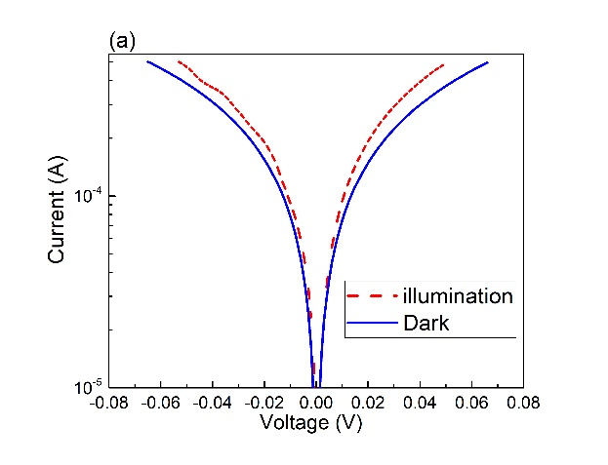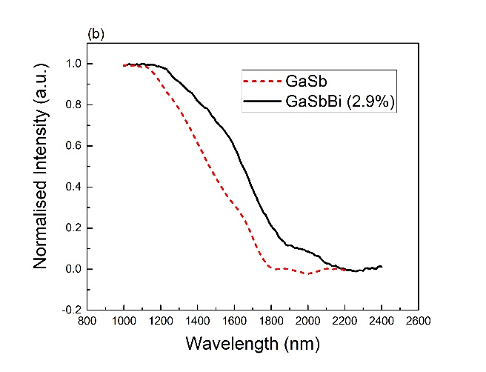
Figure 1: (a) Current-voltage characteristics of GaSbBi MSM-PDs under illumination, (b) the spectral response of GaSbBi and GaSb MSM-PDs.
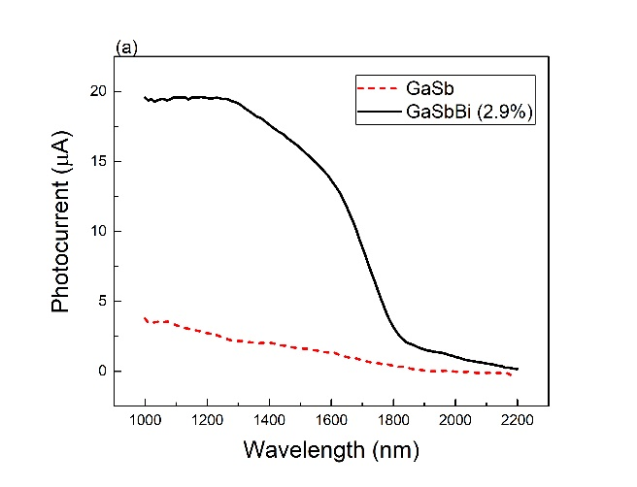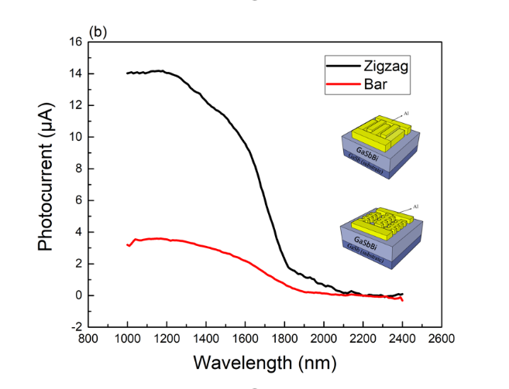
Figure 2: The photoresponse of (a) GaSbBi and GaSb MSM-PDs, (b) GaSbBi MSM-PD with different types of the electrode, the inset shows the schematic of different types of electrode.

In summary, we demonstrate a group of GaSbBi MSM-PDs with an increased cut-off wavelength and efficiency compared with GaSb MSM-PDs, demonstrating the suitably of this material system for use in infrared optoelectronic applications. The influence of both the Bi concentration and the electrode geometry on the resultant device performance has also been discussed.

References
[1] M. Rajpalke, W. Linhart, K. Yu, T. S. Jones, M. Ashwin, and T. D. Veal, "Bi flux-dependent MBE growth of GaSbBi alloys," Journal of Crystal Growth, vol. 425, pp. 241-244, 2015.
[2] R. D. Richards, C. J. Hunter, F. Bastiman, A. R. Mohmad, and J. P. R. David, "Telecommunication wavelength GaAsBi light emitting diodes," IET Optoelectronics, vol. 10, no. 2, pp. 34-38, 2016.
[3] J. Kopaczek et al., "Temperature dependence of the band gap of GaSb1− xBix alloys with 0< x≤ 0.042 determined by photoreflectance," Applied Physics Letters, vol. 103, no. 26, p. 261907, 2013.
[4] J. Kopaczek et al., "Low-and high-energy photoluminescence from GaSb1− xBix with 0< x≤ 0.042," Applied Physics Express, vol. 7, no. 11, p. 111202, 2014.
[5] M. K. Rajpalke et al., "High Bi content GaSbBi alloys," Journal of applied physics, vol. 116, no. 4, p. 043511, 2014.

