Title: Populism in musical mash ups: Recontextualising Brexit
Author: Lyndon C.S. Way
Abstract
For many of us, social media is our preferred option over traditional media when we want to be informed and entertained. Though memes, mash ups, parodies, animations and other forms of popular culture on social media are dismissed by some as ‘just a bit of fun’, scholars have shown how these can also be political (Denisova 2019; Wiggins 2019; Way 2021). It is precisely through popular culture where we most experience politics ‘as fun, as style, and simply as part of the taken for granted everyday world…. [though these] are infused by and shaped by, power relations and ideologies’ (Machin 2013, 347). This has never been more evident than now as we navigate a constant flow of entertaining offerings at the swipe of a finger. Leaning on Multimodal Critical Discourse Studies, this paper analyses written and spoken lexica, images and musical sounds to reveal how a musical mash up widely distributed on social media recontextualises the UK government’s handling of Britain’s withdrawal from the European Union (Brexit). Here, logically structured political arguments are side-lined in favour of entertaining, affective and populist discourses. It is through such a close reading that we consider the role(s) such digital popular culture plays in our understanding of politics during users’ search to be entertained online.
Key words: Brexit, Multimodal Critical Discourse studies, music, mash up, populism, digital popular culture
Introduction
A good part of our social media use is not searching, watching and considering politicians’ speeches and hard-news reports, but looking to be entertained. We engage in what I call ‘scroll culture’, that is, where we are guided by our thumbs, skimming, reading, liking and commenting on a constant flow of artefacts that entertain and inform. As this special issue illustrates, though much of this is considered ‘mundane’, on closer examination it is highly ideological. Between videos of unpacking trainers and photographs of friends’ meals, we engage with digital popular culture (such as memes, musical mash ups, animations and parodies) which represent politicians and their ideas. This paper considers what politics these short, fun distractions offer us and how these communicate to us before we scroll down our feeds for more.
Brexit is one of a plethora of topics represented in digital popular culture. On 23 June 2016, 51.9 % of the people who voted in the UK’s ‘Brexit’ referendum (17,410,742 out of a population of over 65 million) chose to leave the European Union. Though not binding, the UK government promised to act upon the result. Since this time and up to the time of writing, the UK has had two national parliamentary elections and two new prime ministers. Though Boris Johnson (the UK’s prime minster at the time of writing) delivered on his promise to ‘Get Brexit Done’ on 31 January 2020, there is much uncertainty as to what that means and what relations will emerge between the UK and the EU at the end of the ‘transition period’ and beyond. These events and associated actors have been prime targets for producers of digital popular culture.
One such public figure is Jacob Rees-Mogg. He is a high-profile British Conservative MP (since 2010) who has served as Leader of the House of Commons and Lord President of the Council since 2019. Mogg is a symbol of privilege, being born into the elite and educated at Eton College and the University of Oxford. He is one of the highest-earning politicians in the country, amassing a substantial fortune working in the financial sector in London and co-founding investment management firm Somerset Capital Management (Bennet 2018; Wilford 2017). He is also a divisive figure, nicknamed ‘the Honourable Member for the 18th Century’ due to his penchant for Latin and three-piece suits. On the one hand, he is idolised by right-wing, pro-Brexit voters who claim he can ‘lead the Conservative fightback’ (Wilford 2017). On the other hand, he is reviled by the left for his support for policies that challenge workers’ rights and oppose raising benefit payments for those in need of social assistance (Wilford 2017). Since January 2018, Mogg has been a regular feature in mainstream news due to his Chairmanship of the European Research Group (ERG). This group, made up of pro-Brexit Conservative MPs, was established in July 1993 in response to Britain's integration into the European community through the Maastricht Treaty. ERG members contributed to the Brexit ‘Vote Leave’ campaign, and have been influential in shaping Brexit negotiations. They continue to influence withdrawal negotiations, seen in actions such as ERG members’ ‘wholehearted backing behind the prime minister’s new [Brexit] deal’ in 2019 (Burton-Cartledge 2019).
It is no surprise that our digital feeds represent aspects, events and people involved in Brexit, including Mogg, considering its (and his) divisive nature. In this paper, I analyse a musical mash up, where Mogg visuals and his voice are ‘mashed’ into a popular music video. A close textual analysis of ‘Jacob Rees-Mogg’s message for the Common People’ (hereafter ‘Mogg’s Message’) not only reveals what discourses this mash up articulates about Brexit, those who support it and those who do not, but also how this is done. Analysis demonstrates how the mash up leans heavily on populism, where ‘the people’ are represented as pitted against ‘an elite’ other (Laclau 2005; De Cleen and Carpentier 2010). Previous studies into populism demonstrate how ‘the people’ is not a prefixed natural category, but a signifier that acquires meaning through a diversity of discourses with its meaning changing and fought for by different groups (Laclau 2005, 74; De Cleen and Carpentier 2010). Regardless of circumstances, we find a universal ‘appeal to the people and anti-elitism’ (Laclau 2005, 7) alongside ‘the formation of an internal antagonistic frontier separating the “people” from power’ (Laclau 2005, 224). Our present study reveals in detail how the mash up articulates such discourses not through fact-based arguments, but affectively. As such, we consider the implications such digital popular culture plays in our understanding of politics during our constant search to be entertained.
Social Media and politics
The term ‘mash up’ has its roots in musicology, referring to ‘sample-based music where “new” songs are created entirely from “old” recordings’ (Maloy 2010, 2). In audio-visual mash ups (hereafter ‘mash ups’), producers sample extracts of video, sound and music to produce a ‘new’ video, a hybrid of both meme and music. Some of these represent politics and/ or politicians. These are politically important, being viewed by a large number of young people who are ‘unlikely to watch a conventional political broadcast’ (D’Ursa 2018).
Though digital popular culture is well-liked, not all academics are optimistic about its political potential. Similar to life offline, we use social media as a place to (digitally) meet with friends, where ‘gossiping is far more common and interesting to people than voting…. [and] embarrassing videos and body fluid jokes fare much better than serious critiques of power’ (Boyd 2008, 243-4). However, we argue here (and throughout this Special Issue), that some of this is highly ideological. Scholars demonstrate how internet memes are political, being a ‘public commentary’ or a way ‘a society expresses and thinks of itself’ (Milner 2018, 2357; Denisova 2019, 2). These political articulations are expressed through comedy, affect and fun. Memes use satire, parody and critique ‘to posit an argument, visually, in order to commence, extend, counter, or influence a discourse’ (Wiggins 2019). They are not only popular, but an integral part of ‘trolling culture’ that ridicules those in power. Though this may be dismissed as unimportant in terms of mainstream political processes, trolling is ‘central to our political processes, spreading through the mainstream to become one of the most important forms of political participation and activism today’ (Merrin 2019, 201). Memes target both local and international politics, including criticising water problems in Egypt, avoiding Chinese censorship, and the Kony2012 online campaign that aimed to arrest a Ugandan guerrilla group leader (Wallis 2011; Kligler-Vilenchik & Thorsaon 2015; El Khachab 2016). Governments also use memes for their political purposes. For example, an important part of Trump’s 2016 US presidential election campaign involved memes that persuaded voters to support Trump and not vote for the Democrats (Glasser 2017).
Memes, and digital popular culture more generally, do not communicate to us in logical well-structured arguments, but affectively (Denisova 2019; Merrin 2019; Wiggins 2019). Affect is not emotion, but ‘provides and amplifies intensity [of emotion] by increasing our awareness of a certain mind or body state that we, as adults, learn to label as a particular feeling and express as a given emotion’ (Papacharissi 2015, 309). So, affect, in short, is the intensity with which we experience emotion. In digital popular culture we connect otherwise disconnected crowds that enable the formation of ‘affective publics’ to produce a feeling of community (Dean 2010; Howard & Hussain 2013; Papacharissi 2015). Music also communicates to us affectively (Way 2019), in advertisements (Cooke 1959; Wingsted 2017), political campaigns (Way 2019a) and in music videos (Way 2015, 2016 & 2017). It has more semantic ambiguity than other modes like still images or written text (Moore 2013, 14), so it has to rely on visuals as part of its meaning-making package (Machin 2010). In the digital realm, this is even more so with digital technology changing music’s production, distribution, consumption and how fans make sense of its meanings (Arnold et al. 2017, 2; Way 2017). Official promotional music videos, fan-made videos and mash ups all vie for our attention on social media, providing a means for us ‘to communicate and experiment with the forming of identities and social connections’ (Arnold et al. 2017, 40). Distributed on social media, music platforms such as YouTube allow fans to view, like and comment on videos. These actions add yet more affective layers of meaning onto how fans experience music (Way 2015 & 2017). In our study, we examine one such artefact.
Data sample
The mash up analysed here is Joe.co.uk’s ‘Mogg’s message’. Joe.co.uk, launched in March 2015 and attracting four million unique users to its channel, is part of Maximum Media digital publishing company. It distinguishes itself from the now failed ‘lad’ publications of the 1990s, being ‘for men, not lads’ who are interested in fashion, news, comedy and sport (Southern 2016). Though there is nowhere in their publicity that claims any political affiliation, their content suggests an anti-Brexit stance alongside many mash ups critical of UK Conservative politicians and positive representations of UK Labour politicians.
Joe.co.uk produces and distributes a large number of mash ups on its social media platforms (including its website, Facebook, Twitter, Reddit and Linked In accounts) that reflect current political events and actors. UK and US politicians and politics are prime targets, including criticism of Donald Trump’s handling of COVID-19 in ‘Donald Trump x REM Losing My Civilians’ and praise for UK opposition politician Jeremy Corbyn in ‘No one spits bars like Jeremy Corbzy’. ‘Mogg’s Message’ is one such mash up with over 1,088,130 YouTube views at the time of writing. I chose this mash up due to its popularity and topic, Brexit being highly emotive, divisive and newsworthy. The mash up includes visuals from Pulp’s ‘Common people’ edited with images of Mogg, both in a variety of speaking engagements and with his head superimposed on to the body of Pulp’s frontman Jarvis Cocker. Musically, it is a simplified version of Pulp’s original, released in May 1995 and reaching number two in the UK. Cocker wrote the original song about ‘a rich girl who wanted to slum it with the “common people”’ (‘The making of…’ 2014). It is a critical examination of class in the UK, exposing ‘a bleak assessment of working-class life, wasting away at jobs and pool halls, “with no meaning or control”, their desolation unfathomable from the outside’ (Keppler 2018). Choosing to mash up Mogg with ‘Common people’ is ironic, considering Mogg’s privileged position and his support for policies that do not benefit those most in need in society.
Method
This paper uses a musicology-inspired Multimodal Critical Discourse Studies approach (McKerrell and Way 2017; Way 2019). The analysis of lexica, images and musical sounds reveals how the mash up recontextualises the social practices of those involved in and affected by Brexit. A social practice always includes activities, participants, performance indicators, times, places, tools and materials, dress and grooming, and conditions of eligibility for those engaged in such practices (van Leeuwen 1993a & 1993b). How social practices are represented in other texts can be considered a recontextualisation, that is, a construction that involves transformations. These transformations are ideological. Choices are made that ‘selectively appropriate, relocate, refocus and relate other discourses to constitute its own order’ thereby detaching or ‘abstracting’ a discourse from its original ‘social base, position and power relations’ (Bernstein 1996, 47 & 53). As such, recontextualisations involve a complex process of transformations that result in discourses different from the original texts. In our case, the social practices of Jacob Rees-Mogg, other pro-Brexit Conservative politicians and the British ‘people’ are transformed and recontextualised into a musical mash up.
The analysis of ‘Mogg’s Message’ is framed around van Leeuwen and Wodak’s (1999) four types of transformations that recontextualise social practices: Deletions, rearrangements, substitutions, and additions. In the mash up’s lexica, visuals and sounds, we consider what has been included and excluded; how facts, events and issues are rearranged; what semiotic resources are substituted for social actors, their actions and events; and what reactions, purposes, and legitimations are added to the representation of social practices. The analysis also includes an examination of how Mogg’s voice and musical aspects of Pulp’s original pop song are recontextualised into this mash up. Studies from a number of disciplines that examine the semiotics of sound inform this analysis of musical sounds to reveal the roles music makes in articulating political discourses (Cooke 1959; Tagg 1984 & 1990; Walser 1995; van Leeuwen 1999; Machin 2010; Zbikowski 2015; Way 2017). In this case, discourses in Mogg’s Message.
Analysis: ‘Mogg’s message’
‘Mogg’s message’ leans heavily on populism, that is, the mash up ‘pretends to speak for the underdog whose political identity is constructed by opposing it to an elite’ (De Cleen and Carpentier 2010, 180). The elite are personified in Mogg, represented as callous and lacking emotion while they (including Mogg) victimise ‘us the people’. Through the prism of the four transformation types, our analysis reveals how each mode both individually and together articulate such populist discourses affectively based on simplified representations of Brexit, Brexiteers and the wider UK population.
Deletions (and inclusions)
What is included, emphasised and deleted in the recontextualisation of social practices greatly impact discourses. One obvious inclusion is Mogg, represented in all visuals and almost all lexical lines, connoting his importance. Mogg narrates the mash up, constructing two distinct groups: Brexit-supporting elites and ‘the people’. The elite are named with the pronouns ‘I’, ‘we’ and ‘us’. The people are personified as a woman from Greece represented as ‘she’ and ‘her’ (‘you’ is used once), while the wider people are represented as ‘the people’ and the pronouns ‘their’ and ‘them’. In Critical Discourse Analysis, it has been shown how pronouns are commonly used in expressing and manipulating social relations (van Dijk 1993), in this case constructing a polemic of ‘us’ the people struggling against ‘them’ Brexiteer elites.
Naming Brexit-supporting elites distinct from the people is key to recontextualising politicians’ social practices as powerful and callous, such as in the lines ‘We let the people have their say’ and ‘Then we convinced them not to stay’. Here, the social practice of holding a national referendum is recontextualised as letting ‘the people have their say’, whilst convincing them to leave. To be in a position to ‘let’ a referendum happen and then ‘convince’ people, presupposes that the governing elite are both powerful and manipulative, respectively. This is an oversimplification of the governing elite, some of whom campaigned to stay in the EU, including the UK’s Prime Minister at the time, David Cameron. Deleted from this recontextualisation is any agency by the people. This is manifested in no lexical representations of the people active with agency, and no mentions of the ground-swell of support by a large part of the UK population for Brexit and support for Brexit-friendly parties, including the far-right ‘UKIP’ party. Also deleted from this recontextualisation are factors that led to a slim majority of voters choosing to ‘leave’ the EU, including fear of foreigners, national pride and a distrust in the EU. What we find in this recontextualisation is a severe simplification of social practices that emphasise politicians’ despotic use of power, while the people are disempowered and victims of the elite: Typical elements of populism (Laclau 2005).
Most of the power ascribed to politicians and their social practices are negative. This is made clear with lines such as ‘[We] Sold them falsehoods on a bus, deflect all the blame from us’. As part of the Vote Leave drive, campaigners painted the slogan ‘We send the EU £350 million a week, let’s fund our NHS instead’ on the side of a campaign bus. Since the referendum, politicians have distanced themselves from this idea. However, this campaign stunt is recontextualised here as selling ‘falsehoods’ and deflecting blame. The ‘Leave’ campaign was a wide and complex campaign constructed to tap into the public’s fears and concerns. Some of this included Brexit-supporting politicians making claims, statements and arguments with what they perceived as good intentions. However, these practices are not included in our recontextualisation, drawing upon a discourse of powerful, deceitful elites.
Though Mogg dominates the visuals, a noticeable (almost) deletion is the people. However, there are two scenes (a speaking engagement and Mogg on the dancefloor) where people other than Mogg are included. These act as visual metaphors or metonyms for the people. Figure 1 is a screen grab of the former. Here, Mogg’s clothing and actions suggest he is an elite, distinct from the people. He is in formal attire including a bow tie, active with agency, ‘speaking to an audience’. But his audience is different. The spectator to the left of Mogg is more salient than the others through lighting, focus and proximity to the centre of the image. He wears ‘normal’ clothes, including a dark T-shirt as he frowns at Mogg. This act is an emotive reaction, representing his private feelings and suggesting weakness (van Leeuwen 1995, 86). Deleted from this is the praise, applause and common thinking between Mogg and his audience. However, recontextualised as such, the boy is a metonym for the people, undermining Mogg, showing difference and disapproval towards him.
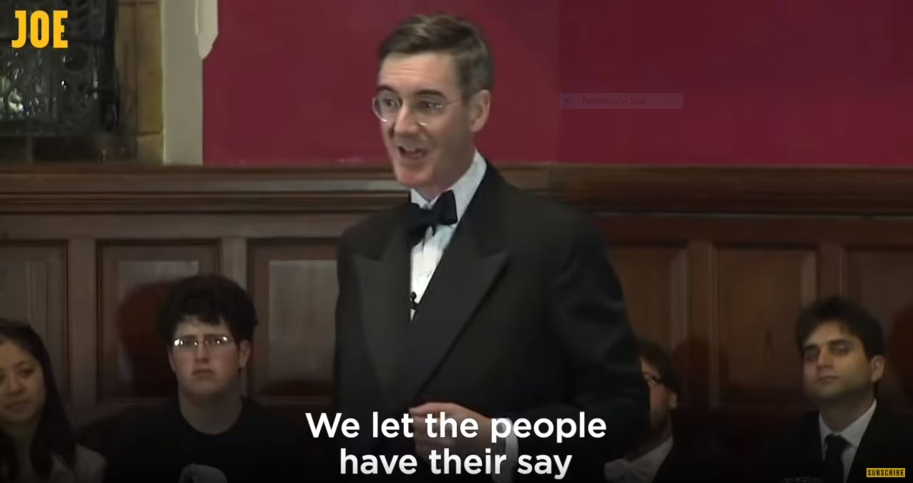
Figure 1: Difference and disapproval
Another scene where we see the people is in the dance floor scenes (Figure 2). In the original Pulp video, these scenes represent dancing at a disco as one aspect of ‘bleak’ working-class life (Keppler 2018). In the mash up, Mogg is salient being centre stage and in the foreground connoting his importance (Kress & van Leeuwen 1996; Machin 2007). All the while, dancers are represented in the background connoting less importance. They are powerless, reacting to Mogg by copying his dance moves (van Leeuwen 1995, 86). Furthermore, they dance with a lack of energy and conviction, robotically, and mindlessly doing as they are told. Here, the people are represented as victims of the elite, powerless by metaphorically being manipulated and reacting to the elite’s (Mogg) actions. As such, this recontextualisation again deletes any people-power, connoting victimhood.
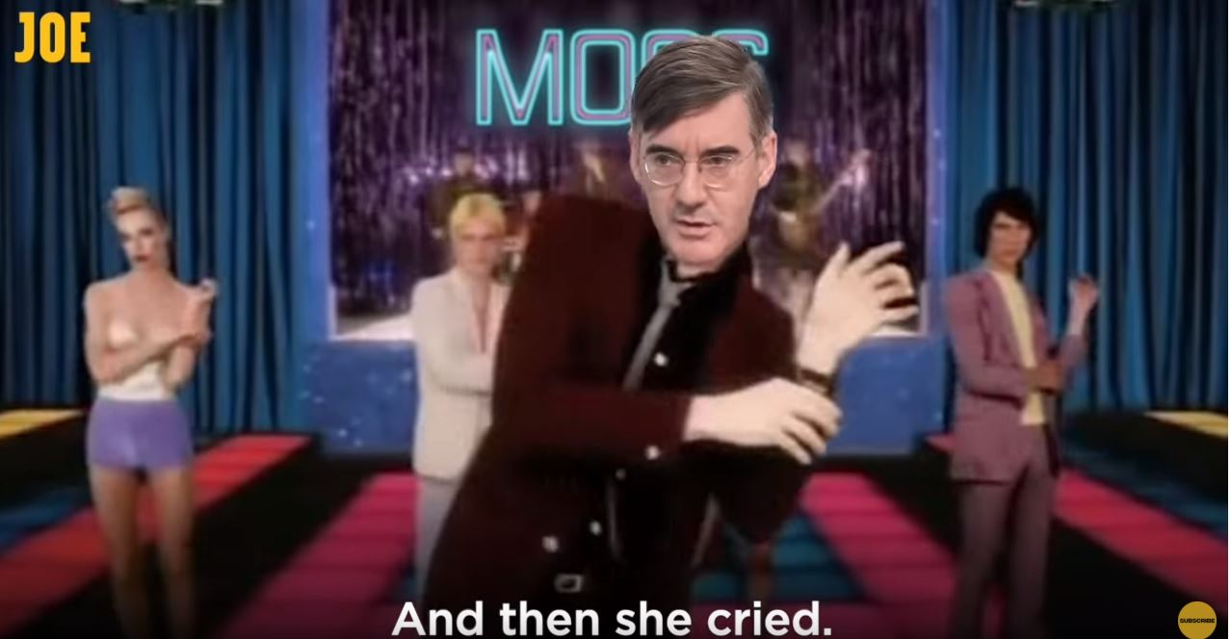
Figure 2: The people
Mogg’s salience and power are also noticeable in the sounds, while all other voices, such as opposing politicians and the people, are deleted. In fact, Mogg is acoustically positioned as the ‘figure’, that is, upfront in the mix where he is treated ‘as more important than others’ (Schafer 1977, 157). This hierarchy of sound (a vocalist ‘on top’ of musical accompaniment) is common in popular music (Tagg 1990, 111). However, it is also ideological, with the ‘figure’ being the sounds listeners ‘must attend to and/ or react to and/ or act upon’ (van Leeuwen 1999, 16). Here, Mogg’s voice tells us the elite are callous and the people are powerless while music plays ‘second fiddle’ and other voices are excluded. This is far from how politicians and the people debated, persuaded, campaigned and spoke around Brexit and the referendum.
Sounds from Pulp’s original song incur a number of deletions when recontextualised into this mash up. Instrumentation in the mash up is simple, not like the original that has a large list of instruments, both electronic and acoustic that ‘filled a 48-track tape and created a multi-layered sound’ (‘Classic Tracks: Pulp’ 2013). Though many of the tonal characteristics such as keyboard sounds remain, deleted are the flourishes, instrumentation, and nuances. This simplicity (deletion) of sounds helps us focus on Mogg’s voice, with little else to compete for our attention. Furthermore, this simplicity connotes a high level of certainty or modality about elites being callous, out of touch, and against the people’s interests (van Leeuwen 1999). We find these same discourses made obvious in the lyrics and images.
Rearrangements
Rearrangements are another important aspect of recontextualisations, where aspects of a social practice are put in an order different from the original practice. Rearranging happens in most texts and ‘in various ways which relate to the interests, goals and values of the context into which the practice is recontextualized’ (van Leeuwen 1999, 97). Throughout the song, lexica are rearranged in ways that emphasise populist discourses. Consider the first verse:
She came from Greece
She had a thirst for knowledge
I explained ‘I went to Eton college’,
That’s when she…
….laughed at me.
I told her that my dad was loaded
And how I’ll profit if the pound imploded
And then she cried.
Because her visa had expired.
In this verse, Mogg’s education and his views on immigration have been rearranged in ways that emphasise his callousness and the victimisation of the people. In the first two lines, ‘a woman from Greece’ is used as a metonym for people from countries other than the UK. She is represented positively. In the line ‘She had a thirst for knowledge’, she is empowered through a mental process, which is also the only time the people are represented acting and not reacting. This positive representation is a far cry from some Brexit arguments that represent ‘foreigners’ as being out to steal UK jobs and burden the welfare state. These two lines are arranged directly before we learn of Mogg’s elite status in: ‘I explained “I went to Eton College”’. Here, as is the case in most lines, Mogg is active (‘I explained’ and ‘I went’), connoting a degree of power, though neither are material processes with agency. His elite status is suggested by being educated at Eton, a school to the UK’s most privileged since King Henry VI.
We also learn of his economic status in ‘I told her that my dad was loaded’. Here, Mogg is delegitimised. He is privileged not as a result of his own hard work, but due to his father’s wealth. Indeed, Mogg’s father was a Baron and Lord, editor of The Times, and filled a number of other high profile positions. All the same, deleted from this is Mogg as an active and wealthy businessman. This omission discredits Mogg, suggesting he is someone who enjoys undeserved privilege, a discourse used against other elites such as Donald Trump. Rearranged directly after a positive representation of the woman from Greece, this verse emphasises positivity about the people and how the elite are out of touch.
In this verse, we also see the Greek woman disempowered further, though active and rearranged in ways that create sympathy for her and the people. Both she ‘laughed’ and ‘cried’ are semiotic processes suggesting some power. However, these are both reactions to Mogg, a disempowered representation. Furthermore, crying is a semiotic process associated with weakness and more with women than men (Caldas-Coulthard 1994, 306). Here, we learn of her emotional state, inviting us to sympathise with her and align ourselves with her point of view while actual people and the process of immigration have been deleted. This is in stark contrast to representations of Mogg’s emotions (see below) that are largely deleted to connote an out of touch callous elite.
Also in this verse, we find the lines ‘Then she cried … because her visa had expired’ are arranged in an order that directly links her reacting to her immigration status, it being the cause of her grief. Though Mogg is not represented as directly acting upon her visa decision as in ‘I refused to renew your visa’, the action of ‘her visa had expired’ is an ‘eventuation de-agentialization’, where an action is represented as an event, as something that just happens (van Leeuwen 1995, 96). Directly after this verse however, Mogg is represented as being at least partly responsible for her situation when he declares ‘[I] Want to keep out…Foreign people like you’. Taking (back) control of immigration was one of the discourses of the Leave campaign and one of many reasons why people voted to leave. Some of this discourse was fuelled by racism (Shaw 2019). Here, the motive behind Mogg wanting Brexit is represented as racist. As such, in this first verse and chorus, rearrangements of unsubstantiated motives and fictitious persons represent the people sympathetically, while Mogg is represented as a racist, articulating a populist discourse of an unsympathetic elite victimising the people.
In fact, how sounds are rearranged directly following this ‘racist’ line, and throughout the mash up, further connote negativity. Throughout, sounds connote unnatural, non-human qualities in Mogg. His original spoken words are taken from various sources. These are rearranged in a fast-paced speech delivery, with unnatural pauses and rhythms. Mogg sounds like a mechanical recording heard in airports, announcing flight numbers and arrivals. Missing are the pauses and changes in speed that are natural when we want to emphasise, express excitement, and give listeners time for contemplation. The only exception to this is the natural sounding pause that follows ‘Foreign people like you’. Here, a pause emphasises a line that suggests Mogg chose Brexit for racist reasons. Rearrangements as such lean on an anti-elitist populist discourse.
Imagery includes scenes with Mogg’s head edited onto Cocker’s body in visual rearrangements that articulate not only discourses of power (see above), but also absurdity (Figure 3). As is the case throughout the mash up, Mogg is salient, here through focus, lighting and being centre stage. He is active dancing and singing. In the original Pulp video, Cocker created the dance to represent the ‘stupid things you do’ as part of his critique on class tourism (‘The making of…’ 2014). Here, these actions are recontextualised to ridicule Mogg. In this scene, Mogg dances energetically, kicking like a chorus line dancer in a Las Vegas show. This scene also ridicules Mogg’s conservative public persona through not only his actions, but his clothing. He wears Cocker’s reddish-brown coloured jacket, black shirt open at the collar and a tan-coloured tie. This dress sense is very different from his normal conservative style seen in all his ‘in situation’ shots where we see him wear dark jackets, white shirts and dark ties or bowties.
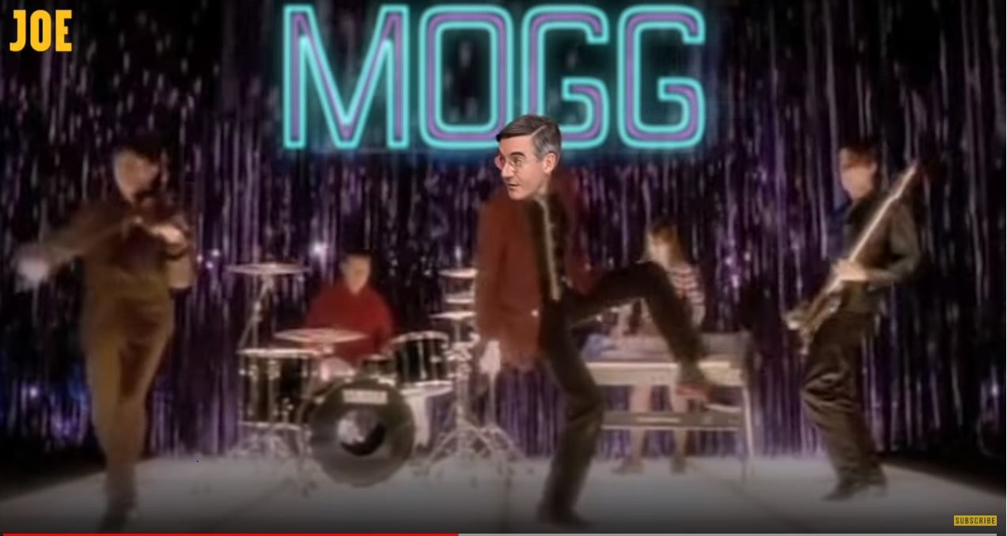
Figure 3: Ridiculous
Substitutions
Communication of any sort involves substituting social practices for signs. The modes of representation used (musical sounds, lexica and visuals) offer a range of possible ways of representing social practices. In this section, we examine how representations in the three mentioned modes substitute activities associated with social practices.
Mogg is emphasised and represented negatively throughout this mash up, though not shown as powerful as he could be. In most lines he is active (he ‘explained’, ‘told’, ‘went’, ‘profit’, ‘said’ and ‘want’) and at the beginning of each line, a prominent position is used for emphasis (van Dijk 1993). Most of these do not represent Mogg with transivity, that is, acting upon something or someone. As such, this suggests a lack of power, though they all connote negativity. For example, the line ‘And how I’ll profit if the pound imploded’ is a conditional sentence suggesting uncertainty. Unlike the people who it is presupposed will suffer if Brexit will ‘leave the whole economy screwed’, Mogg is immune to this by profiting from Brexit. This line recontextualises a number of social practices involving Mogg financially securing himself against the negative impact of Brexit, such as setting up a second investment fund in Ireland for Somerset Capital Management company after it warned its clients about the financial dangers of a hard Brexit (Quinn 2018). Not surprisingly, this information has been used by political opponents who note the discrepancy between his company’s statements about Brexit, his company’s interests in Ireland, and his actions as an MP when he ‘repeatedly dismissed the concerns of those worried about the financial risks of Brexit’ (Quinn 2018). Though it is likely Mogg will not suffer significantly from the negative effects of Brexit due to his financial circumstances, it is unlikely he will benefit either. In any case, Mogg’s actions have been substituted here to connote callousness on behalf of the elite at the expense of the people.
Visual substitutions for Mogg see him lacking engagement with viewers and the people, connoting the elite are not to be trusted. Figure 4 and 5 exemplify this. In both images, Mogg is active, connoting a degree of power and importance. However, he does not engage with the viewer, his gaze looking off camera. These are ‘offer images’, offered to us for our scrutiny. They connote a lack of power, symbolic interaction and empathy with viewers (Kress & van Leeuwen 1996, 124). In fact, in the whole video there is not a single shot where Mogg’s gaze directly addresses viewers. Eyes are always off to one side. In Western culture, this also signifies a lack of trust, where we are suspicious of people who do not look us in the eye.
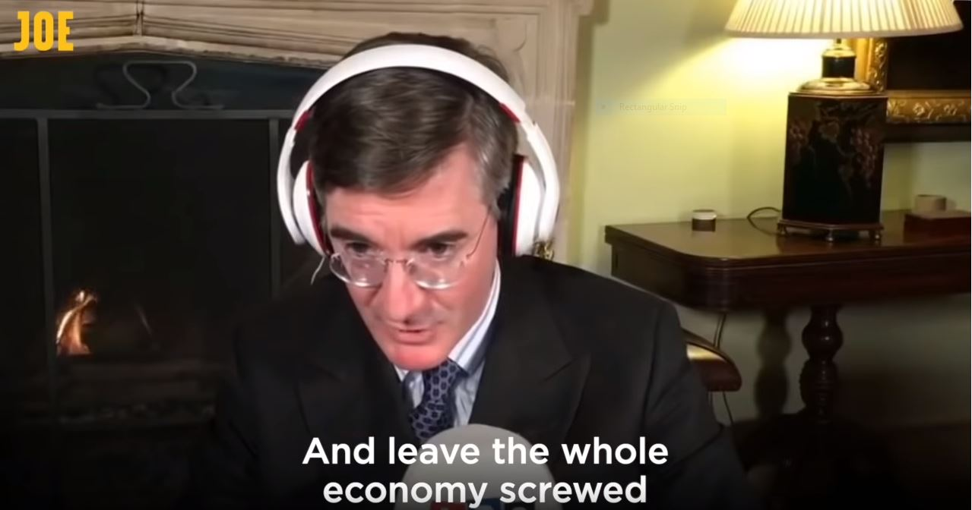
Figure 4: Offer image
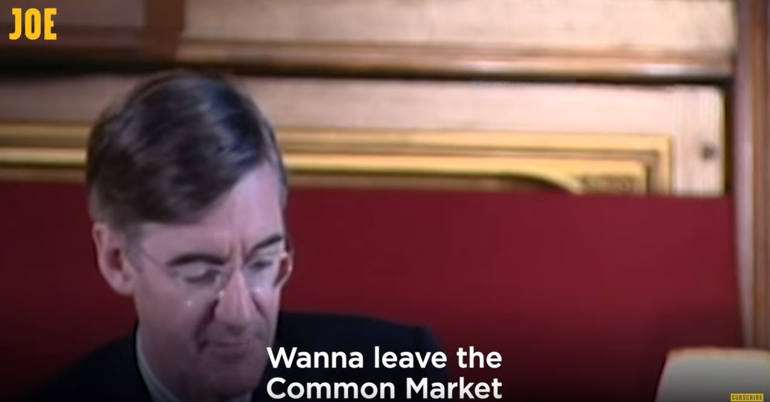
Figure 5: Lack of trust
A lack of power is also connoted through choices in camera positions. Most shots are close ups, which grant viewers a point of identification. However, many of these are taken from a high angle (notable in Figures 4 and 5), belittling Mogg’s power, as metaphorically not being one to look up to (Kress & van Leeuwen 2001).
A number of melodic choices further connote negativity surrounding Mogg and the elite. Like the original Pulp song, the mash up’s melody is based on a three chord progression of the first, fourth and fifth notes (C, G7 and F) in the key of C. Scholars have illustrated how note choices carry with them specific connotations, though these are heavily dependent on context (Cooke 1959; Machin 2010). Choices of notes here suggest Mogg is boring. The first and fifth (C and G7) anchor the melody and connote stability, but also the pedestrian, the everyday, boring stuff (Cooke 1959). The fourth (F) is associated with building or moving forward. In the context of the mash up, relying on these notes suggests Mogg is not only boring and uncool. They also suggest there are changes afoot. Images and lyrics point to negative changes associated with the social practices of Brexit-supporting elites.
As pointed out above, the song’s instrumental and vocal melodies may be characterised as static, based around three notes . Figure 6 is a visual representation of a typical vocal line in the chorus. This is fairly static with most of the line sung on one note (F) and then moving up one note on the scale twice to the G. A melody like this connotes ‘very little outward giving of emotion or positive energy’ (Machin 2010). Here, Pulp’s song is good to use as a comparison to see how musical sounds from the original have been deleted and manipulated, whilst new sounds have been substituted to articulate very different discourses. For the first minute and 40 seconds, Cocker sings the same few notes, like ‘Mogg’s Message’. Here constrained emotional ‘coolness’ is connoted. In the case of ‘Mogg’s Message’, there is also a coolness in emotions, though without Cocker’s positive connotations. Both Cocker and Mogg sing in a low pitch suggesting ‘feeling down’, and gravity (Cooke 1959; Machin 2010). However, in the second half of the original, Cocker raises his voice a whole octave as the tempo increases. Together, these connote excitement, agitation and possibly anger. To the contrary, Mogg sings the whole mash up without a change in pitch, suggesting a lack of emotion, despite lyrics that many viewers would find emotionally charged, further connoting callousness.

Figure 6: Static melody
The manipulation of time in music also carries meanings, and here two aspects of time are relevant: tempo and consistency. Like our heart beats, a slower tempo in a song suggests less excitement than a faster one. A consistent tempo also suggests an ‘unnatural’ mechanical obedience to ‘the system’ (Tagg 1984). In the original Pulp song, tempo fluctuates between 90 and 160 beats per minute. Producer Chris Thomas claimed this fluctuating ‘is absolutely intrinsic to the [song’s] excitement’. In ‘Mogg’s message’, timing remains perfectly consistent at a slower 72 beats per minute. This choice has two connotations: Its consistency emphasises the idea that Mogg is unhuman, robotic, uncaring and inauthentic by being part of the system. Its relative slowness excludes the excitement of the original, suggesting Mogg is a bit of a bore. Both these connotations are represented in the visual and lexical choices throughout the mash up.
Additions
Reactions, purposes, and legitimations can be added to representations of social practices. Though there is a vast array of possible additions in any recontextualisation, all of which can be ideological, in this mash up we see representations of purposes for a practice, reasons for why practices are as they are, and the representation of participants’ private feelings, such as their worries, fear, hopes, desires, joys and griefs. Consider the chorus, sung twice:
I want to leave the Common Market
I want to leave the Customs Union, too
Want to leave the Common Market
Want to keep out…
(first chorus):
Foreign people like you.
But I didn’t understand
Why she refused to shake my hand
(second chorus):
Wanna watch it all slide out of view
And leave the whole economy screwed
‘Cos I’ve got nothing else to do-o-o-.
Both choruses consist of Mogg reciting a list of what he wants. These, of course, are added for comic effect, but are also ideological. Like most additions, they are unsubstantiated, yet articulate negative discourses about Mogg. In chorus one, Mogg’s ‘wants’ suggest racism (see above). In the second chorus, Mogg is represented as wanting the economy to collapse. The lexical choice of ‘slide out of view’ and ‘screwed’ are emotional, informal lexica, there to add emotion and mock Mogg’s formality. The further addition of his reasons for collapsing the economy again suggests callousness in ‘‘Cos I’ve got nothing else to do-o-o-’. However, many of these additions are anchored in presuppositions, that is, ‘a taken-for-granted, implicit claim embedded within the explicit meaning of a text or utterance’ (Richardson 2007, 63). Here, three things are presupposed: Brexit will ruin the economy, Mogg ‘wants’ to ruin the economy, and he is in a position to affect the economy. Though there is almost unanimity concerning Brexit and its negative impact on the economy, there is considerable debate about what will be the effect. To represent it as ‘screwed’ is simplistic. The presupposition that Mogg is powerful enough to impact the economy again should be questioned. Although he is influential in the Conservative government, he is only one of a large number of voices, many of whom do not want a hard Brexit. And finally, the presupposition that Mogg indeed wants to ruin the economy ought to be questioned. Though indeed he wants a hard Brexit, which will be bad for the economy, it is unlikely Mogg wants to ruin the economy. As a businessman, it is in his interest to work within a strong UK economy. However, these additions affectively emphasise Mogg as being callous by not caring about the people and their financial circumstances.
As mentioned above, the notes sung in ‘Mogg’s Message’ may be characterised as static, with very little pitch movement. However, there is limited pitch movement in the chorus, which suggests negativity. Alongside lyrics and visuals that depict Mogg negatively, the pitch descends, connoting a lack of energy and negativity (Cooke 1959). In fact, throughout the song, near the end of every two or three lines, the singing melody descends. This makes sense. In the original song, Cocker represents the hardships of working-class life negatively, not as something students should glamourise. In the mash up, we see a similar pitch movement. Figure 7 is a visual representation of the chorus’s pitch movement, where the number one and eight are the key note of C. As this image illustrates, the pitch movement descends, the chorus starting on the F, rising to the G, before slowly descending down to the C, all connoting negativity towards Mogg. In the choruses’ lyrics, Mogg is represented as a racist and being callous. Pitch movement connotes that these are negative qualities.

Figure 7: Vocal pitch movement
During the last verse, Mogg sings ‘If the backstop fails we can build a wall (laughs)’. Here the addition of a laugh works alongside in-group construction to de-legitimise Mogg further. The Irish backstop is ‘a position of last resort, to maintain an open border on the island of Ireland in the event that the UK leaves the EU without securing an all-encompassing deal’ (Campbell 2018). This was a sticking point in Brexit negotiations. At the same time, Trump tried to secure funding for a wall across the US-Mexican border to control immigration. The conditional representation of building a wall links the Irish border to Trump’s Mexican border wall. It also creates a ‘we’ group of right-wing populists, ‘we’ performing the same (desired) actions of building a wall. Though indeed, some Brexiteers share some views with right-wing populists such as Trump, there are many Brexiteers with very different views. Grouped and acting as such, a very negative discourse of Mogg and Brexiteers is formulated. This is emphasised with the laugh, it being the only time we ‘hear’ Mogg expressing any real emotions. Following a line that groups Mogg with Trump’s anti-immigration wall, this addition draws upon very negative discourses about Mogg and the elite.
How voices are recorded contributes to meanings we experience in music (Ord 2019). Differences in the transformation between ‘Common People’ and ‘Mogg’s Message’ reveal a number of additions, deletions and substitutions that work ideologically. In the original, during the first minute and 40 seconds, Cocker’s voice is very breathy, at times a whisper, connoting intimacy (van Leeuwen 1999). Later, when he sings an octave higher, his throat tenses, suggesting agitation and excitement. Between lines, we can hear his breathing, suggesting that he is close to us, even when he is excited. In ‘Mogg’s Message’, omitted is the intimacy connoted in breathiness and whispers. Instead, throat muscles sound tense throughout the entire mash up. Many of the bass tones are deleted, making him sound higher, sharper and ‘more tense’. Auto-tune has also been added to ‘Mogg’s Message’ so it appears he is singing in tune with the instrumentation. However, it has been left rough, unlike the far subtler auto-tune we hear in many of the pop songs we enjoy. As such, he sounds robotic, reducing how ‘human’, real and authentic he sounds. These recording choices do not connote a warm and compassionate politician, but one who is cold and calculating.
Conclusion
Mash ups, memes, parodies and animations are all important parts of our daily consumption of digital popular culture on social media. Though many of these may represent jokes about body fluids and the likes, some of these more directly consider politicians and politics of the day. The idea that we cannot interact with crude jokey digital popular culture affectively and be politically engaged is absurd. Fun can be political. Our analysis of this mash up uncovers how such a fun artefact is indeed highly political. It brings to light actors, issues and views involved with Brexit. However, it also reveals that the politics articulated in ‘Mogg’s Message’ do not necessarily address issues surrounding Brexit in a way conducive to debate and discussion.
In our mash up, we find discourses are recontextualised based on the simplification of facts. Brexit is reduced to a polemic of ‘us’ the people struggling against ‘them’ Brexiteer elites. Discourses lean on populism, where the Brexit-supporting elite are represented as callous and working against the interests of the people who are victims. Furthermore, very complex issues are simplified relying on stereotypes of elites, groups of voters and a unified people. These representations are far from reality. One of the limitations of digital popular culture is that it allows ‘little analysis and no doubt about …. guilt’ (Denisova 2019, 190). That is, mash ups and digital popular culture act as indictments of guilt before trial. As such, these do little to inform debate about the merits and dangers of Brexit. In fact, they do the opposite by polarising positions into simple binary opposites. This results in a hardening of positions and does nothing to encourage discussions amongst those who hold a variety of views.
All the same, this is highly ideological. Mash ups and other popular culture on social media are part of our customised feeds that shelter us (to some extent) from other points of view and leave us (somewhat) content in our ‘filter bubbles’ (Pariser 2011). Mash ups and digital popular culture are an entertaining part of our ‘scroll culture’, but with a political bite. Though digital popular culture like this mash up may not change the world, it engages us for a brief moment in affective populist political framings of current events, before we scroll through our feeds in our never-ending search for our next morsel of entertainment.

References
Arnold, G., D. Cookney, K. Fairclough and M. Goddard. 2017. Introduction, The persistence of the Music Video Form from MTV to Twenty-First-Century Social Media. In Music/Video: Histories, aesthetics, media, eds. Arnold, Cookney, Fairclough and Goddard, 1-19. NY and London: Bloomsbury.
Bennet, C. 2018. Inside Jacob Rees-Mogg. Tatler. (accessed September 26, 2019). https://www.tatler.com/article/jacob-rees-mogg-trivia-facts
Bernstein, B. 1996. Pedagogy, symbolic control and identity. British Journal of Sociology of Education 18(1): 119-24.
Boyd, D. 2008. Can social media sites enable political action? International Journal of Media and Cultural Politics 4(2): 241-4.
Burton-Cartledge, P. 2019. How did the ERG go from hating any Brexit deal to loving Boris Johnson’s? The Guardian. https://www.theguardian.com/commentisfree/2019/oct/23/erg-brexit-deal-boris-johnson-financial-interests (accessed September 25, 2019).
Caldas-Coulthard, C.R. 1994. On reporting reporting: the representation of speech in factual and factional narratives. In Advances in Written Text Analysis, ed. M. Coulthard, 295-308. London: Routledge Press.
Campbell, J. 2018. Q & A: The Irish border Brexit backstop. BBC. https://www.bbc.co.uk/news/uk-northern-ireland-politics-44615404 (accessed December 19, 2019).
‘Classic Tracks: Pulp “Common People”’. 2013. Sound on Sound. https://www.soundonsound.com/people/classic-tracks-pulp-common-people (accessed August 21, 2019)
Cooke, D. 1959. The language of music. Oxford: Clarendon.
Dean, J. 2010. Blog theory. Cambridge: Polity Press.
De Cleen, B. and N. Carpentier. 2010. Contesting the populist claim on ‘the People’ through popular culture: The 0110 concerts versus the Vlaams Belang. Social Semiotics 20(2): 175–96.
Denisova, A. 2019. Internet Memes and Society: Social, Cultural, and Political Contexts. New York & London: Routledge.
D’Ursa, J. 2018. Who spent what on Facebook during 2017 election campaign? BBC. https://www.bbc.co.uk/news/uk-politics-43487301 (accessed September 28, 2019)
El Khachab, C. 2016. Living in darkness: Internet humour and the politics of Egypt’s electricity infrastructure. Anthropology Today 32(4): 21-4.
Glasser, A. 2017. Politicians are addicted to data like it's campaign cash. Slate. https://slate.com/technology/2017/10/politicians-are-addicted-to-big-data-like-its-campaign-cash.html (accessed September 21, 2019)
Howard, P. N., & M. Hussain. 2013. Democracy’s fourth wave? Digital media and the Arab Spring. New York: Oxford University Press.
Keppler, N. 2018. Pulp’s Common People — railing against class tourism. Financial Times. https://ig.ft.com/life-of-a-song/common-people.html (accessed April 21, 2019)
Kligler-Vilenchik, N. & K. Thorson. 2015. Good citizen as a frame contest: Kony2012, memes and critiques of the networked citizen. New media and society 8(9): 1-19.
Kress, G. & T. van Leeuwen. 1996. Reading Images: The grammar of visual design. Oxon: Routledge.
Kress, G. and T. van Leeuwen. 2001. Multimodal discourse: the modes and media of contemporary communication. London: Hodder Education.
Laclau, E. 2005. On Populist Reason. London: Verso.
Machin, D. 2013. What is multimodal critical discourse studies? Critical Discourse Studies 10(4): 347–55.
Machin, D. 2010. Analyzing Popular Music. London: Sage.
Machin, D. 2007. Introduction To Multimodal Analysis. London: Hodder Education.
Maloy, L. 2010. ‘Stayin’ alive in da club’: The Illegality and Hyperreality of mash ups. Journal of the International association for the study of popular music 1(2): 1-20.
McKerrell, S. & L. Way. 2017. Understanding music as Multimodal Discourse. In Music as Multimodal Discourse: Media, power and Protest, eds. L. Way & S. McKerrell, 1-20. London & New York: Bloomsbury.
Merrin, W. 2019. President Troll: Trump, 4Chan and Memetic Warfare. In Trump’s Media War, eds. C. Happer, A. Hoskins and W. Merrin, 201-26. London: Palgrave Macmillan.
Milner, R. M. 2018. Media Lingua Franca: Fixity, Novelty, and Vernacular Creativity in Internet Memes. AoIR Selected Papers of Internet Research, 3. https://journals.uic.edu/ojs/index.php/spir/article/view/8725 (accessed February 1, 2020)
Moore, A. 2013. Song Means: Analysing and Interpreting Recorded Popular Song. Oxon: Ashgate Publishing.
Ord M. 2019. From Here: The Multimodal Construction of Place in English Folk Field Recordings. Journal of Language and Politics 18(4), 598-616.
Papacharissi, Z. 2015. Affective publics and structures of storytelling: sentiment, events and mediality. Information, Communication and Society 19(3): 307-24.
Pariser, E. (2011). The Filter Bubble: How the New Personalized Web is Changing What We Read and How We Think. New York, NY: Penguin Press.
Quinn, B. 2018. Jacob Rees-Mogg's investment firm launches second Irish fund. The Guardian. https://www.theguardian.com/politics/2018/jul/22/jacob-rees-mogg-second-irish-fund-scm (accessed February 5, 2020)
Richardson, J.E. 2007. Analyzing Newspapers: An approach from Critical Discourse Analysis. London: Palgrave Macmillan.
Schafer, R. M. 1977. The Tuning of the World. Michigan: Knopf.
Shaw, M. 2019. Vote Leave relied on racism. Brexit: The Uncivil War disguised that ugly truth. The Guardian. https://www.theguardian.com/commentisfree/2019/jan/08/vote-leave-racism-brexit-uncivil-war-channel-4 (accessed February 5, 2020)
Southern, L. 2016. Lad-lite publisher JOE Media rings in 2016 by doubling its UK team. DigidayUK. https://digiday.com/uk/joe-media-kicks-off-2016-doubling-uk-team/ (accessed February 7, 2020)
Tagg, P. 1984. Understanding musical time sense: concepts, sketches and consequences. http://www.tagg.org/articles/xpdfs/timesens.pdf (accessed April 3, 2016)
Tagg, P. 1990. Music in mass media studies. Reading sounds for example. In Popular Music Research, ed. K. Roe & U. Carlsson. Sweden: Nordicom.
‘The Making of ….Pulp’s Common People’. 2014. Uncut. https://www.uncut.co.uk/features/the-making-of-pulp-s-common-people-8632 (accessed August 21, 2019)
van Dijk, T. 1993. Racism and the press. London: Routledge.
van Leeuwen, T. 1993a. Genre and field in critical discourse analysis: a synopsis. Discourse and Society 4(2): 193-223.
van Leeuwen, T. 1993b. Language and representation – The recontextualization of participants, activities and reactions. Unpublished PhD thesis. University of Sidney.
van Leeuwen, T. 1995. Representing social action. Discourse and society 6(1): 81-106.
van Leeuwen, T. 1999. Speech, Music, Sound. London: Macmillan Press.
van Leeuwen, T. and R. Wodak. 1999. Legitimising immigration: A discourse historical approach. Discourse Studies 1(1): 83–118.
Wallis, C. 2011. New media practices in China: Youth patterns, processes, and politics. International journal of communication 5: 406-36. https://ijoc.org/index.php/ijoc/article/viewFile/698/530 (accessed August 21, 2019)
Walser, R. 1995. Rhythm, Rhyme, and Rhetoric in the Music of Public Enemy. Ethnomusicology 39(2): 193-217.
Way, L. 2015. Youtube as a site of debate through populist politics: The case of a Turkish protest pop video. Journal of Multicultural discourse 10(2): 180-96.
Way, L. 2016. Protest music, populism, politics and authenticity: the limits and potential of popular music's articulation of subversive politics. Journal of Language and Politics 15(4): 422-46.
Way, L. 2017. Authenticity and subversion: protest music videos’ struggle with countercultural politics and authenticity. In Way, L, McKerrell, S, (eds.) Music as Multimodal Discourse: Media, power and Protest, 95-118. London & New York: Bloomsbury.
Way, L. 2018. Turkish newspapers and how they use Brexit for Domestic Political Gain. In EU Referendum and the media: National and international perspectives, ed. A. Ridge-Newman, 281-94. London & New York: Palgrave McMillan.
Way, L. 2019. Discourse, music and political communication: Towards a critical approach. Journal of Language and Politics 18(3): 1-16.
Way, L. 2019a. Music video as party political communication: Opportunities and limits. Journal of Language and Politics 18(4): 579-98.
Way, L. 2021. Analysing Politics and Protest in Digital Popular Culture: A Multimodal Approach. London: Sage.
Wiggins, B. 2019. The Discursive Power of Memes in Digital Culture: Ideology, semiotics and intertexuality. New York & London: Routledge.
Wilford, G. 2017. Jacob Rees-Mogg is earning millions from his investment company, accounts reveal. The Independent. https://www.independent.co.uk/news/uk/politics/jacob-rees-mogg-conservative-mp-north-east-somerset-capital-management-investment-firm-belgravia-a7902951.html (accessed February 5, 2020)
Wingsted, J. 2017. ‘If You Have Nothing To Say – Sing It!': On the Interplay of Music, Voice and Lyrics in the Advertising Jingle. In Music as Multimodal Discourse: Media, power and Protest, eds. L. Way & S. McKerrell, 135-58. London & New York: Bloomsbury.
Zbikowski, L. 2015. Words, Music, and Meaning. In Semiotic de la musique, eds. P. A. Brandt and J. R. do Carmo Jr., 143–64. Liège: Presses universitaires de Liège–Sciences humaines.

