Cardiovascular, renal and metabolic outcomes of dapagliflozin vs. placebo in a primary cardiovascular prevention cohort. Analyses from the DECLARE-TIMI 58 study
Avivit Cahn¹, Itamar Raz¹ Lawrence A. Leiter², Ofri Mosenzon¹, Sabina A. Murphy³, Erica L. Goodrich³, Ilan Yanuv¹, Aliza Rozenberg¹, Deepak L. Bhatt³, Darren K. McGuire⁴, John P.H. Wilding⁵, Ingrid A. M. Gause-Nilsson⁶, Anna Maria Langkilde⁶, Marc S. Sabatine³, Stephen D. Wiviott³

¹ Diabetes Unit, Department of Endocrinology and Metabolism, Hadassah Medical Center, Hebrew University of Jerusalem, The Faculty of Medicine, Jerusalem, Israel
² Li Ka Shing Knowledge Institute, Department of Medicine, St. Michael’s Hospital, University of Toronto, Toronto, Canada
³ TIMI Study Group, Division of Cardiovascular Medicine, Brigham and Women's Hospital and Harvard Medical School, Boston, MA USA
⁴ Division of Cardiology, Department of Internal Medicine, University of Texas Southwestern Medical Center, and Parkland Health and Hospital System, Dallas, Texas, USA
⁵ Department of Cardiovascular and Metabolic Medicine, Institute of Life Course and Medical Sciences, University of Liverpool, Liverpool, UK
⁶ BioPharmaceuticals R&D, AstraZeneca, Gothenburg, Sweden

Running head: DECLARE TIMI-58 outcomes in the MRF cohort

Corresponding author:
Dr. Avivit Cahn
Diabetes Unit, Department of Endocrinology and Metabolism
Hadassah Hebrew University Hospital, PO Box 12000
Jerusalem, Israel 91120
Tel: 972-2-6776498; Fax: 972-2-6437940; Email: avivit@hadassah.org.il

Clinical trial registration: URL: https://clinicaltrials.gov Unique Identifier: NCT01730534

Abstract word count: 249
Main text word count: 2541
References: 34
Tables: 1
Figures: 3

Abstract

Aims: International guidelines propose prescribing SGLT-2 inhibitors to patients with type-2 diabetes (T2D) as secondary prevention in patients with established atherosclerotic cardiovascular disease (ASCVD) or for primary prevention of cardiovascular events in high-risk patients. The current analyses expand on the cardiovascular and renal effects of SGLT-2 inhibitors in high-risk populations with multiple risk factors (MRF) for ASCVD.
Methods: The DECLARE-TIMI 58 trial randomized 17,160 patients with T2D and MRF (59.4%) or established ASCVD (40.6%) to dapagliflozin vs. placebo, followed for a median of 4.2 years. The cardiovascular and renal outcomes in the MRF cohort were studied across clinically relevant subgroups for treatment effect and subgroup-based treatment interaction.
Results: Among patients with MRF, the reduction with dapagliflozin in risk of CVD/HHF (HR 0.84, 95% CI 0.67-1.04) and the renal-specific outcome (HR 0.51, 95% CI 0.37-0.69) did not differ from patients with ASCVD (P_{interaction} 0.99 and 0.72 respectively). The effect on CVD/HHF was entirely driven by a reduction in HHF (HR 0.64, 95% CI 0.46-0.88). The benefits of dapagliflozin on HHF and on the renal-specific outcome, among the subset with MRF, were consistent across all subgroups assessed (P_{interaction} >0.05 for all). At 48 months, HbA1c, weight, systolic blood pressure and urinary albumin:creatinine ratio were lower with dapagliflozin vs. placebo and eGFR was higher (p<0.05).
Conclusion: In patients with T2D and MRF, dapagliflozin reduced the risk of HHF and adverse renal outcomes regardless of baseline characteristics. These analyses support the benefit of dapagliflozin on important outcomes in a broad primary prevention population.

introduction
Sodium glucose cotransporter 2 (SGLT2) inhibitors have been approved for the treatment of T2DM since 2012. Early clinical trials with these agents demonstrated their capacity not only for lowering glucose but also for reducing weight and blood pressure, thus addressing several important components of the metabolic syndrome (1). The EMPA-REG OUTCOME trial, the first published cardiovascular outcome trial (CVOT) of a drug in the class, revolutionized our view of management of T2D by demonstrating significant reduction in risk for major adverse cardiovascular events (MACE), cardiovascular death, hospitalization for heart failure (HHF), as well as significant reduction in the occurrence of adverse renal outcomes (2, 3). Subsequently, published CVOTs demonstrated some heterogeneity with respect to SGLT2 inhibitor effects on MACE and cardiovascular death, yet the effects on HHF and renal outcomes were largely consistent (4-7). Still, all patients included in the studies of empagliflozin, ertugliflozin and most of the patients included in the canagliflozin program had established atherosclerotic cardiovascular disease (ASCVD), thus limiting our ability to extrapolate the effects of these drugs on populations without established ASCVD, which include the majority of patients with T2D (8-9).
In the DECLARE-TIMI 58 CVOT of dapagliflozin vs. placebo, 59.4% of the patients had multiple risk factors (MRF) but not established ASCVD. This large primary prevention cohort (N=10,146) represents a broad T2D population with respect to the number of cardiovascular risk factors, age, disease duration and renal function. Thus, this trial affords a unique opportunity to assess the effects of an SGLT2 inhibitor in a population with T2D without prevalent ASCVD. (6, 10).
In the overall trial, dapagliflozin demonstrated a reduction in one of the dual primary composite outcomes of hospitalization for heart failure / cardiovascular death (HHF/CVD; HR 0.83, 95% CI 0.73-0.95), driven by a reduction in HHF, and also met the prespecified criterion for noninferiority but did not achieve statistically significant superiority with respect to the second dual primary outcome of MACE (HR 0.93, 95% CI 0.84-1.03) (6). The renal-specific outcome was significantly reduced with dapagliflozin (HR 0.53, 95% CI 0.43-0.66) (11). All outcomes were directionally consistent in the established ASCVD and the MRF groups (P_{interaction} >0.05) (6). In the current analysis, we focus on the MRF cohort aiming to better characterize the cardiovascular, renal and metabolic benefits of dapagliflozin on a broad population with varying demographic, clinical and metabolic features.

Materials and Methods
Study overview
In the DECLARE - TIMI 58 trial, a total of 17,160 patients were randomly assigned to receive dapagliflozin 10 mg daily or placebo and followed for a median of 4.2 years. The trial included 6,974 patients with established ASCVD and 10,186 with MRF but without ASCVD. MRF participants were men aged ≥55 and women aged ≥60 years with at least one additional cardiovascular risk factor including dyslipidemia, hypertension, or current tobacco use. Patients with a HbA1c of 6.5 - <12.0% and a creatinine clearance of ≥60 ml/min/1.73 m² were eligible for inclusion. All patients were treated according to guidelines and regional standards of care for cardiovascular risk factors - blood pressure, lipids, antithrombotic treatment and HbA1c. The trial protocol was approved by the institutional review board at each participating site, and all participants provided written informed consent. The design, baseline characteristics and principal results of this study have been previously published (6, 10, 12).

Assessment of outcomes
The dual primary composite efficacy outcomes were cardiovascular death or hospitalization for heart failure (CVD/HHF) and major adverse cardiovascular events (MACE; the composite of cardiovascular death, myocardial infarction or ischemic stroke). A renal-specific composite outcome included a sustained decrease of 40% or more in eGFR to <60 ml/min/1.73 m², end stage renal disease (ESRD) or death from renal cause. Additional outcomes included the components of the primary outcomes and all-cause mortality.

Statistical analysis
Baseline characteristics are reported as frequencies and percentages for categorical variables and as mean and standard deviation (SD) or median (IQR) for continuous variables. Baseline and efficacy analyses were performed on an intention-to-treat basis. Safety analyses were performed using the on-treatment analysis set, as previously described, except for amputation, fracture and malignancy outcomes which included all events after first dose in all patients who were randomized and received at least one dose of study drug.
We calculated the effect of dapagliflozin on the incidence of the efficacy outcome within each subgroup using Cox regression models that included the randomization stratification factor of baseline hematuria, and we report the hazard ratios (HRs) and 95% confidence intervals (CI). To test for heterogeneity of effect, an interaction term was included in the Cox regression model.
The mean ± SD values of HbA1c, weight, systolic blood pressure (SBP), eGFR and urinary albumin creatinine ratio (UACR) with dapagliflozin vs. placebo during the trial in the MRF group are shown. Mixed models for repeated measures were analyzed to compare change from baseline by treatment group at month 48. Undetectable UACR values were imputed to be 7.0 mg/g which was the lowest detectable level of the assay used in the latter part of the trial.
There was no statistical adjustment for multiple comparisons. A p-value <0.05 was considered statistically significant.
All analyses were performed using SAS software, version 9.4 (SAS Institute Inc., Cary, NC, USA) and Stata version 16.1 (College Station, TX, USA).

Results
Baseline characteristics
10,186 MRF patients were included in these analyses. Their baseline characteristics are shown in table 1. There were 5713 (56.1%) males, the mean ± SD age was 64.8±5.6 years, BMI 32.0±6.0 kg/m² and baseline HbA1c was 8.3±1.2%. Heart failure at baseline was noted in 568 (5.6%) patients and 622 (6.1%) had an eGFR <60 mL/min/1.73 m².

Cardiovascular and renal outcomes
Among patients with MRF, the reduction with dapagliflozin in risk of CVD/HHF (HR 0.84, 95% CI 0.67-1.04) did not differ from that seen in patients with ASCVD (P_{interaction} 0.99). The effect on CVD/HHF was entirely driven by a reduction in HHF (HR 0.64, 95% CI 0.46-0.88, figure 1A). HHF was reduced with dapagliflozin vs. placebo in MRF patients with no heterogeneity across subgroups assessed (P_{interaction} >0.05, figure 2A). MACE was balanced with dapagliflozin vs. placebo in the MRF patients (HR 1.01, 95% CI 0.86-1.20), in line with that observed in the established ASCVD cohort (P_{interaction} 0.25).
The renal-specific outcome was reduced with dapagliflozin vs. placebo in the MRF group (HR 0.51, 95% CI 0.37-0.69, figure 1B) and did not differ from those with ASCVD (Pi_{nteraction} 0.72). This observed reduction was consistent across all subgroups assessed (P_{interaction} >0.05, figure 2B).

Metabolic outcomes
At 48 months, patients randomized to dapagliflozin vs. placebo had lower HbA1c (7.8±1.2 vs. 8.0±1.4%), weight (86.8±19.7 vs. 88.4±20.4 kg), systolic blood pressure (132.8±14.6 vs. 135.1±15.0 mmHg), and urinary albumin creatinine ratio (93.0±437.4 vs. 130.2±483.6 mg/g), and had higher eGFR (77.7±16.8 vs. 76.8±17.3 mL/min/1.73m²; p<0.05 for difference in change from baseline for dapagliflozin vs. placebo for all parameters; Figure 3).

Safety outcomes
In the MRF group, there were fewer patients with a serious adverse event or with major hypoglycemia with dapagliflozin vs. placebo. Genital infections and diabetic ketoacidosis were increased consistent with the known safety profile of the class. Additional safety outcomes including amputations, fractures, volume depletion, acute kidney injury, urinary tract infection and cancer were balanced with dapagliflozin vs. placebo (supplementary table 1).

Discussion
This post-hoc analysis of the large primary prevention cohort (MRF) in the DECLARE-TIMI 58 trial delineates the benefits of dapagliflozin in patients without established ASCVD. The reduction in HHF and in adverse renal outcomes that was observed in the overall study population was consistently observed in the MRF group irrespective of age, sex, diabetes duration, HbA1c, eGFR, history of heart failure or number of additional cardiovascular risk factors. Moreover, in line with the overall study data, no new safety signals emerged in this cohort, and the metabolic benefits known for the class were observed as well.
In recent years, with accumulating data from cardiovascular and renal outcome trials of SGLT-2 inhibitors, the position of these agents in the treatment algorithm of patients with T2D has been under extensive discussion (13-15). Trials of SGLT2 inhibitors have demonstrated consistent metabolic benefits in patients with T2D with clinically significant reductions in HbA1c, blood pressure and weight, irrespective of baseline cardiovascular risk. The cardiovascular and renal benefits of the class were initially assessed in a mostly secondary prevention population, however, the large primary prevention population in the DECLARE-TIMI 58 trial has enabled closer scrutiny of the benefits of dapagliflozin in this patient cohort.
When determining the treatment regimen for patients with T2D, particularly in the case of lower risk patients without established ASCVD, several factors should be considered. Type 2 diabetes usually occurs in the constellation of the metabolic syndrome with obesity, hypertension and dyslipidemia being important comorbidities. Multifactorial intervention targeting several cardiovascular risk factors, particularly when implemented in the early stages of T2D, is thus of paramount importance (16). The unique mode of action of SGLT2 inhibitors, which is insulin independent, yields metabolic advantages in early as well as progressive T2D when endogenous insulin reserves may have diminished. Long-term benefits can be expected in slowing diabetes progression by maintaining HbA1c reduction, reducing microvascular complications as well as decreasing cardiovascular complications (17-20).
Besides control of the “standard” cardiovascular risk factors (obesity, hypertension, dyslipidemia, dysglycemia), the clinical relevance of the cardio-renal axis is becoming increasing apparent (21). Reduced eGFR as well as increased albuminuria lead to a synergistic increase in the risk of cardiovascular events (22, 23). SGLT2 inhibitors have consistently demonstrated improvements in renal outcomes. These include both reversal of pre-existing albuminuria, as well as reduced conversion from normo- to micro- or macro-albuminuria. Moreover, SGLT2 inhibitors have been shown to slow the decline in eGFR and lead to a significant reduction in end stage renal disease (3, 9, 11, 24, 25). These benefits have been observed in those with and without baseline chronic kidney disease (CKD), and regardless of established ASCVD (5).
Adverse renal outcomes have been markedly reduced with dapagliflozin. A reduction in adverse renal outcomes, as well as a marked decline in albuminuria, were observed irrespective of baseline cardiovascular or renal risk, and consistently across all risk categories in the MRF population. These data further support the role of dapagliflozin in early, primary prevention, of adverse renal outcomes (11).
HHF was also significantly reduced with dapagliflozin, and in the present analyses – also in lower risk patients with no heterogeneity based on age, sex, BMI, diabetes duration, HbA1c, eGFR, history of heart failure or number of additional risk factors. The pivotal role of heart failure in the prognosis of patients with diabetes is becoming increasingly apparent, and the role of dapagliflozin in the primary prevention of HHF in patients with T2DM is of utmost importance (26, 27).
The ADA 2020 Standards of Medical Care propose prescribing SGLT2 inhibitors with evidence of reducing heart failure and / or CKD progression, independently of HbA1c levels, to patients in whom heart failure or CKD predominate (14). Yet, these benefits were observed in our study irrespective of pre-existing heart failure or CKD, and consistently across risk categories – suggesting these recommendations may be expanded to a broader population of T2D.
The ESC 2019 guidelines propose prescribing SGLT2 inhibitors to patients with T2D and cardiovascular disease, or at high or very high cardiovascular risk (13). Additionally, the 2019 American College of Cardiology/American Heart Association Guideline on the primary prevention of cardiovascular disease propose initiating SGLT2 inhibitors or glucagon like peptide-1 receptor agonists (GLP-1 RA) in patients with T2D and additional cardiovascular risk factors (15). This definition is reflective of the broad inclusion criteria of the DECLARE-TIMI 58 study.
A meta-analysis of SGLT2 inhibitors CVOTs – showed no evidence of heterogeneity on the effects on MACE in patients with and without ASCVD, supporting the use of SGLT-2 inhibitors in primary prevention populations as well (8). Notably, MACE reduction was noted for GLP-1 RA as well, with no heterogeneity in primary vs. secondary prevention populations (28, 29). These results were mainly driven by data from the REWIND CVOT of dulaglutide, which included a large primary prevention population (30). However, though relative risk reduction was consistent in both classes in primary and secondary prevention populations, absolute risk reduction was smaller in the lower risk populations, and individualized decision making is recommended.
Safety is an important consideration for a drug intended for use early in the disease, as long-term exposure is expected. In that respect, the safety profile of dapagliflozin, which had been extensively reviewed in our previous analysis, was consistently observed in the MRF population, providing further reassurance to the early use of this agent (31).
Recent data have expanded the role of dapagliflozin from the prevention of HHF and adverse renal outcomes to the treatment of these conditions once established. The DAPA-HF trial demonstrated a reduction in HHF in patients with heart failure and reduced ejection fracture with or without diabetes (32). Notably, a reduction in HHF in patients with heart failure and reduced ejection fracture was also observed with empagliflozin, and was likewise unrelated to baseline diabetes status (33). Moreover, a reduction in adverse renal outcomes with dapagliflozin in patients with established chronic kidney disease has been shown in the DAPA-CKD study, and the benefit was observed irrespective of pre-existing diabetes (34).
In conclusion, extensive early clinical data show the beneficial glucose, weight and blood pressure lowering effects of dapagliflozin in patients at all stages of T2D. The current analyses highlight the benefits of dapagliflozin in the prevention of HHF and adverse renal outcomes across a broad risk continuum of a primary prevention population with T2D. Expected outcomes of dapagliflozin treatment include – long term metabolic benefits (glucose, weight, blood pressure and albuminuria) as well as primary prevention of HHF and adverse renal outcomes. Moreover, dapagliflozin’s overall favorable safety profile places it as an appropriate option early in the disease for patients with T2D.

Funding
The sponsor of the DECLARE - TIMI 58 study was initially AstraZeneca and Bristol-Myers Squibb and AstraZeneca later became the sole sponsor of the study. The DECLARE–TIMI 58 trial was a collaboration between the funder and two academic research organizations (TIMI Study Group and Hadassah Medical Organization). The funder was involved in the study design, data collection, data analysis, interpretation, and writing of this report. IAMG-N and AML are employed by the study funder. Data analyses were done by the academic TIMI Study Group, which has access to the complete study database, allowing independent analyses of the results; any discrepancies were resolved by discussion. The DECLARE–TIMI 58 publication committee made the decision to submit for publication.

conflict of interest
AC reports grants and personal fees from AstraZeneca and Novo Nordisk and personal fees from Abbott, Eli Lilly, Sanofi, Boehringer Ingelheim, Merck Sharp & Dohme, Medial Early-Sign and GlucoMe. IR reports personal fees from AstraZeneca, Bristol-Myers Squibb, Boehringer Ingelheim, Concenter BioPharma and Silkim, Eli Lilly, Merck Sharp & Dohme, Novo Nordisk, Orgenesis, Pfizer, Sanofi, SmartZyme Innovation, Panaxia, FuturRx, Insuline Medical, Medial EarlySign, CameraEyes, Exscopia, Dermal Biomics, Johnson & Johnson, Novartis, Teva, GlucoMe, and DarioHealth. LAL reports grants and personal fees from AstraZeneca, Boehringer Ingelheim, Eli Lilly, Janssen, Novo Nordisk, and Sanofi; personal fees from Merck and Servier; and grants from GlaxoSmithKline and Lexicon. OM reports grants and personal fees from AstraZeneca, Bristol-Myers Squibb, and Novo Nordisk and personal fees from Eli Lilly, Sanofi, Merck Sharp & Dohme, Boehringer Ingelheim, Johnson & Johnson, and Novartis. SAM and ELG report research grant support through Brigham and Women’s Hospital from Abbott, Amgen, Aralez, AstraZeneca, Bayer HealthCare Pharmaceuticals, Inc., Daiichi-Sankyo, Eisai, GlaxoSmithKline, Intarcia, Janssen, MedImmune, Merck, Novartis, Pfizer, Poxel, Quark Pharmaceuticals, Roche, Takeda, The Medicines Company, Zora Biosciences. IY and AR declare no competing interests. DLB discloses the following relationships - Advisory Board: Cardax, CellProthera, Cereno Scientific, Elsevier Practice Update Cardiology, Level Ex, Medscape Cardiology, PhaseBio, PLx Pharma, Regado Biosciences; Board of Directors: Boston VA Research Institute, Society of Cardiovascular Patient Care, TobeSoft; Chair: American Heart Association Quality Oversight Committee; Data Monitoring Committees: Baim Institute for Clinical Research (formerly Harvard Clinical Research Institute, for the PORTICO trial, funded by St. Jude Medical, now Abbott), Cleveland Clinic (including for the ExCEED trial, funded by Edwards), Contego Medical (Chair, PERFORMANCE 2), Duke Clinical Research Institute, Mayo Clinic, Mount Sinai School of Medicine (for the ENVISAGE trial, funded by Daiichi Sankyo), Population Health Research Institute; Honoraria: American College of Cardiology (Senior Associate Editor, Clinical Trials and News, ACC.org; Vice-Chair, ACC Accreditation Committee), Baim Institute for Clinical Research (formerly Harvard Clinical Research Institute; RE-DUAL PCI clinical trial steering committee funded by Boehringer Ingelheim; AEGIS-II executive committee funded by CSL Behring), Belvoir Publications (Editor in Chief, Harvard Heart Letter), Duke Clinical Research Institute (clinical trial steering committees, including for the PRONOUNCE trial, funded by Ferring Pharmaceuticals), HMP Global (Editor in Chief, Journal of Invasive Cardiology), Journal of the American College of Cardiology (Guest Editor; Associate Editor), K2P (Co-Chair, interdisciplinary curriculum), Level Ex, Medtelligence/ReachMD (CME steering committees), MJH Life Sciences, Population Health Research Institute (for the COMPASS operations committee, publications committee, steering committee, and USA national co-leader, funded by Bayer), Slack Publications (Chief Medical Editor, Cardiology Today’s Intervention), Society of Cardiovascular Patient Care (Secretary/Treasurer), WebMD (CME steering committees); Other: Clinical Cardiology (Deputy Editor), NCDR-ACTION Registry Steering Committee (Chair), VA CART Research and Publications Committee (Chair); Research Funding: Abbott, Afimmune, Amarin, Amgen, AstraZeneca, Bayer, Boehringer Ingelheim, Bristol-Myers Squibb, Cardax, Chiesi, CSL Behring, Eisai, Ethicon, Ferring Pharmaceuticals, Forest Laboratories, Fractyl, Idorsia, Ironwood, Ischemix, Lexicon, Lilly, Medtronic, Pfizer, PhaseBio, PLx Pharma, Regeneron, Roche, Sanofi Aventis, Synaptic, The Medicines Company; Royalties: Elsevier (Editor, Cardiovascular Intervention: A Companion to Braunwald’s Heart Disease); Site Co-Investigator: Biotronik, Boston Scientific, CSI, St. Jude Medical (now Abbott), Svelte; Trustee: American College of Cardiology; Unfunded Research: FlowCo, Merck, Novo Nordisk, Takeda. DKM discloses the following relationships: personal fees for clinical trial leadership from GlaxoSmithKline, Janssen, Lexicon, AstraZeneca, Sanofi, Boehringer Ingelheim, Merck & Co, Pfizer, Novo Nordisk, Eisai Inc., Esperion, Lilly USA; and personal fees for consultancy from AstraZeneca, Lilly USA, Boehringer Ingelheim, Merck & Co, Novo Nordisk, Metavant, Applied Therapeutics, Sanofi, Afimmune.
JPHW, outside the submitted work, has grants, personal fees for lectures and consultancy fees (paid to his institution) from AstraZeneca and Novo Nordisk; personal fees for lectures and consultancy fees (paid to his institution) from Boehringer Ingelheim, Janssen, Lilly, Mundipharma, Napp, Sanofi and Takeda; and consultancy fees (paid to his institution) from Rhythm Pharmaceuticals and Wilmington Healthcare. IAMG-N, and AML are employees of AstraZeneca. MSS reports grants and consulting fees from Amgen, consulting fees from Anthos Therapeutics, grants and consulting fees from AstraZeneca, grants from Bayer, consulting fees from Bristol-Myers Squibb, consulting fees from CVS Caremark, grants from Daiichi-Sankyo, consulting fees from DalCor, consulting fees from Dyrnamix, grants from Eisai, consulting fees from Esperion, grants from GlaxoSmithKline, consulting fees from IFM Therapeutics, grants and consulting fees from Intarcia, consulting fees from Ionis, grants and consulting fees from Janssen Research and Development, grants and consulting fees from Medicines Company, grants and consulting fees from MedImmune, grants and consulting fees from Merck, grants and consulting fees from Novartis, grants from Pfizer, grants from Poxel, grants from Quark Pharmaceuticals, grants from Takeda, and is a member of the TIMI Study Group, which has also received institutional research grant support through Brigham and Women’s Hospital from: Abbott, Aralez, Roche, and Zora Biosciences. SDW discloses grants from AstraZeneca, Bristol-Myers Squibb, Sanofi Aventis, and Amgen; grants and personal fees from Arena, Daiichi Sankyo, Eisai, Eli Lilly, and Janssen; grants and consulting fees from Merck (additionally his spouse is employed by Merck); and personal fees from Aegerion, Allergan, AngelMed, Boehringer Ingelheim, Boston Clinical Research Institute, Icon Clinical, Lexicon, St Jude Medical, Xoma, Servier, AstraZeneca, and Bristol-Myers Squibb.

References
- Scheen AJ. Pharmacodynamics, efficacy and safety of sodium-glucose co-transporter type 2 (SGLT2) inhibitors for the treatment of type 2 diabetes mellitus. Drugs 2015;75:33-59.
- Zinman B, Wanner C, Lachin JM, Fitchett D, Bluhmki E, Hantel S, Mattheus M, Devins T, Johansen OE, Woerle HJ, Broedl UC, Inzucchi SE; EMPA-REG OUTCOME Investigators. Empagliflozin, Cardiovascular Outcomes, and Mortality in Type 2 Diabetes. N Engl J Med. 2015;373(22):2117-28
- Wanner C, Inzucchi SE, Lachin JM, et al. EMPA-REG OUTCOME Investigators. Empagliflozin and Progression of Kidney Disease in Type 2 Diabetes. N Engl J Med. 2016;375(4):323-34
- Neal B, Perkovic V, Mahaffey KW, de Zeeuw D, Fulcher G, Erondu N, Shaw W, Law G, Desai M, Matthews DR; CANVAS Program Collaborative Group. Canagliflozin and Cardiovascular and Renal Events in Type 2 Diabetes. N Engl J Med. 2017;377(7):644-657
- Zelniker TA, Wiviott SD, Raz I, Im K, Goodrich EL, Bonaca MP, Mosenzon O, Kato ET, Cahn A, Furtado RHM, Bhatt DL, Leiter LA, McGuire DK, Wilding JPH, Sabatine MS. SGLT2 inhibitors for primary and secondary prevention of cardiovascular and renal outcomes in type 2 diabetes: a systematic review and meta-analysis of cardiovascular outcome trials. Lancet. 2019;393(10166):31-39.
- Wiviott SD, Raz I, Bonaca MP, Mosenzon O, Kato ET, Cahn A, Silverman MG, Zelniker TA, Kuder JF, Murphy SA, Bhatt DL, Leiter LA, McGuire DK, Wilding JPH, Ruff CT, Gause-Nilsson IAM, Fredriksson M, Johansson PA, Langkilde AM, Sabatine MS; DECLARE–TIMI 58 Investigators. Dapagliflozin and Cardiovascular Outcomes in Type 2 Diabetes. N Engl J Med. 2019;380(4):347-357.
- Cannon CP, Pratley R, Dagogo-Jack S, Mancuso J, Huyck S, Masiukiewicz U, Charbonnel B, Frederich R, Gallo S, Cosentino F, Shih WJ, Gantz I, Terra SG, Cherney DZI, McGuire DK; VERTIS CV Investigators. Cardiovascular Outcomes with Ertugliflozin in Type 2 Diabetes. N Engl J Med. 2020 Sep 23.
- McGuire DK, Shih WJ, Cosentino F, Charbonnel B, Cherney DZI, Dagogo-Jack S, Greenberg M, Wang S, Huyck S, Gantz I, Terra SG, Masiukiewicz U, Cannon CP. Sodium-Glucose Cotransporter 2 Inhibitors, Cardiovascular and Kidney Outcomes in Patients with Type 2 Diabetes: A Systematic Review and Meta-Analysis of Outcomes Trials. JAMA Cardiol 2020; In press.
- Perkovic V, Jardine MJ, Neal B, Bompoint S, Heerspink HJL, Charytan DM, Edwards R, Agarwal R, Bakris G, Bull S, Cannon CP, Capuano G, Chu PL, de Zeeuw D, Greene T, Levin A, Pollock C, Wheeler DC, Yavin Y, Zhang H, Zinman B, Meininger G, Brenner BM, Mahaffey KW; CREDENCE Trial Investigators. Canagliflozin and Renal Outcomes in Type 2 Diabetes and Nephropathy. N Engl J Med. 2019;380(24):2295-2306
- Raz I, Mosenzon O, Bonaca MP, Cahn A, Kato ET, Silverman MG, Bhatt DL, Leiter LA, McGuire DK, Wilding JPH, Gause-Nilsson IAM, Langkilde AM, Johansson PA, Sabatine MS, Wiviott SD. DECLARE-TIMI 58: Participants' baseline characteristics. Diabetes Obes Metab. 2018;20(5):1102-1110.
- Mosenzon O, Wiviott SD, Cahn A, Rozenberg A, Yanuv I, Goodrich EL, Murphy SA, Heerspink HJL, ZelniSker TA, Dwyer JP, Bhatt DL, Leiter LA, McGuire DK, Wilding JPH, Kato ET, Gause-Nilsson IAM, Fredriksson M, Johansson PA, Langkilde AM, Sabatine MS, Raz I. Effects of dapagliflozin on development and progression of kidney disease in patients with type 2 diabetes: an analysis from the DECLARE-TIMI 58 randomised trial. Lancet Diabetes Endocrinol. 2019 Jun 10. pii: S2213-8587(19)30180-9.
- Wiviott SD, Raz I, Bonaca MP, Mosenzon O, Kato ET, Cahn A, Silverman MG, Bansilal S, Bhatt DL, Leiter LA, McGuire DK, Wilding JP, Gause-Nilsson IA, Langkilde AM, Johansson PA, Sabatine MS. The design and rationale for the Dapagliflozin Effect on Cardiovascular Events (DECLARE)-TIMI 58 Trial. Am Heart J. 2018;200:83-89
- Cosentino F, Grant PJ, Aboyans V, Bailey CJ, Ceriello A, Delgado V, Federici M, Filippatos G, Grobbee DE, Hansen TB, Huikuri HV, Johansson I, Jüni P, Lettino M, Marx N, Mellbin LG, Östgren CJ, Rocca B, Roffi M, Sattar N, Seferović PM, Sousa-Uva M, Valensi P, Wheeler DC; ESC Scientific Document Group . 2019 ESC Guidelines on diabetes, pre-diabetes, and cardiovascular diseases developed in collaboration with the EASD. Eur Heart J. 2019 Aug 31
- American Diabetes Association. 9. Pharmacologic Approaches to Glycemic Treatment: Standards of Medical Care in Diabetes-2020. Diabetes Care. 2020;43(Suppl 1):S98-S110
- Arnett DK, Blumenthal RS, Albert MA, Buroker AB, Goldberger ZD, Hahn EJ, Himmelfarb CD, Khera A, Lloyd-Jones D, McEvoy JW, Michos ED, Miedema MD, Muñoz D, Smith SC Jr, Virani SS, Williams KA Sr, Yeboah J, Ziaeian B. 2019 ACC/AHA Guideline on the Primary Prevention of Cardiovascular Disease: A Report of the American College of Cardiology/American Heart Association Task Force on Clinical Practice Guidelines. J Am Coll Cardiol. 2019;74(10):e177-e232.
- Gaede P, Lund-Andersen H, Parving HH, Pedersen O. Effect of a multifactorial intervention on mortality in type 2 diabetes. N Engl J Med. 2008;358(6):580-91
- Zoungas S, Arima H, Gerstein HC, Holman RR, Woodward M, Reaven P, Hayward RA, Craven T, Coleman RL, Chalmers J; Collaborators on Trials of Lowering Glucose (CONTROL) group. Effects of intensive glucose control on microvascular outcomes in patients with type 2 diabetes: a meta-analysis of individual participant data from randomised controlled trials. Lancet Diabetes Endocrinol. 2017 Jun;5(6):431-437
- Rawshani A, Rawshani A, Franzén S, Sattar N, Eliasson B, Svensson AM, Zethelius B, Miftaraj M, McGuire DK, Rosengren A, Gudbjörnsdottir S. Risk Factors, Mortality, and Cardiovascular Outcomes in Patients with Type 2 Diabetes. N Engl J Med. 2018;379(7):633-644
- Holman RR, Paul SK, Bethel MA, Matthews DR, Neil HA. 10-year follow-up of intensive glucose control in type 2 diabetes. N Engl J Med. 2008;359(15):1577-89
- Ray KK, Seshasai SR, Wijesuriya S, Sivakumaran R, Nethercott S, Preiss D, Erqou S, Sattar N. Effect of intensive control of glucose on cardiovascular outcomes and death in patients with diabetes mellitus: a meta-analysis of randomised controlled trials. Lancet. 2009 23;373(9677):1765-72
- Sattar N, McGuire DK. Pathways to Cardiorenal Complications in Type 2 Diabetes Mellitus: A Need to Rethink. Circulation. 2018;138(1):7-9
- Afkarian M, Sachs MC, Kestenbaum B, Hirsch IB, Tuttle KR, Himmelfarb J, de Boer IH. Kidney disease and increased mortality risk in type 2 diabetes. J Am Soc Nephrol. 2013;24(2):302-8
- Scirica BM, Mosenzon O, Bhatt DL, Udell JA, Steg PG, McGuire DK, Im K, Kanevsky E, Stahre C, Sjöstrand M, Raz I, Braunwald E. Cardiovascular Outcomes According to Urinary Albumin and Kidney Disease in Patients With Type 2 Diabetes at High Cardiovascular Risk: Observations From the SAVOR-TIMI 53 Trial. JAMA Cardiol. 2018;3(2):155-163
- Perkovic V, de Zeeuw D, Mahaffey KW, et al. Canagliflozin and renal outcomes in type 2 diabetes: results from the CANVAS Program randomised clinical trials. Lancet Diabetes Endocrinol. 2018 Sep;6(9):691-704.
- Giugliano D, De Nicola L, Maiorino MI, et al. Type 2 diabetes and the kidney: Insights from cardiovascular outcome trials. Diabetes Obes Metab. 2019 Aug;21(8):1790-1800
- Lytvyn Y, Bjornstad P, Udell JA, Lovshin JA, Cherney DZI. Sodium Glucose Cotransporter-2 Inhibition in Heart Failure: Potential Mechanisms, Clinical Applications, and Summary of Clinical Trials. Circulation. 2017;136(17):1643-1658.
- Standl E, Schnell O, McGuire DK. Heart Failure Considerations of Antihyperglycemic Medications for Type 2 Diabetes. Circ Res. 2016 May 27;118(11):1830-43
- Giugliano D, Maiorino MI, Bellastella G, Longo M, Chiodini P, Esposito K. GLP-1 receptor agonists for prevention of cardiorenal outcomes in type 2 diabetes: An updated meta-analysis including the REWIND and PIONEER 6 trials. Diabetes Obes Metab. 2019 Nov;21(11):2576-2580.
- Zelniker TA, Wiviott SD, Raz I, Im K, Goodrich EL, Furtado RHM, Bonaca MP, Mosenzon O, Kato ET, Cahn A, Bhatt DL, Leiter LA, McGuire DK, Wilding JPH, Sabatine MS. Comparison of the Effects of Glucagon-Like Peptide Receptor Agonists and Sodium-Glucose Cotransporter 2 Inhibitors for Prevention of Major Adverse Cardiovascular and Renal Outcomes in Type 2 Diabetes Mellitus. Circulation. 2019;139(17):2022-2031
- Gerstein HC, Colhoun HM, Dagenais GR, Diaz R, Lakshmanan M, Pais P, Probstfield J, Riesmeyer JS, Riddle MC, Rydén L, Xavier D, Atisso CM, Dyal L, Hall S, Rao-Melacini P, Wong G, Avezum A, Basile J, Chung N, Conget I, Cushman WC, Franek E, Hancu N, Hanefeld M, Holt S, Jansky P, Keltai M, Lanas F, Leiter LA, Lopez-Jaramillo P, Cardona Munoz EG, Pirags V, Pogosova N, Raubenheimer PJ, Shaw JE, Sheu WH, Temelkova-Kurktschiev T; REWIND Investigators. Dulaglutide and cardiovascular outcomes in type 2 diabetes (REWIND): a double-blind, randomised placebo-controlled trial. Lancet. 2019 Jul 13;394(10193):121-130.
- Cahn A, Raz I, Bonaca M, Mosenzon O, Murphy SA, Yanuv I, Rozenberg A, Wilding JPH, Bhatt DL, McGuire DK, Gause-Nilsson IAM, Fredriksson M, Johansson PA, Jermendy G, Hadjadj S, Langkilde AM, Sabatine MS, Wiviott SD, Leiter LA. Safety of dapagliflozin in a broad population of patients with type 2 diabetes: Analyses from the DECLARE-TIMI 58 study. Diabetes Obes Metab. 2020 Apr 2. doi: 10.1111/dom.14041
- McMurray JJV, Solomon SD, Inzucchi SE, Køber L, Kosiborod MN, Martinez FA, Ponikowski P, Sabatine MS, Anand IS, Bělohlávek J, Böhm M, Chiang CE, Chopra VK, de Boer RA, Desai AS, Diez M, Drozdz J, Dukát A, Ge J, Howlett JG, Katova T, Kitakaze M, Ljungman CEA, Merkely B, Nicolau JC, O'Meara E, Petrie MC, Vinh PN, Schou M, Tereshchenko S, Verma S, Held C, DeMets DL, Docherty KF, Jhund PS, Bengtsson O, Sjöstrand M, Langkilde AM; DAPA-HF Trial Committees and Investigators. Dapagliflozin in Patients with Heart Failure and Reduced Ejection Fraction. N Engl J Med. 2019;381(21):1995-2000.
- Packer M, Anker SD, Butler J, Filippatos G, Pocock SJ, Carson P, Januzzi J, Verma S, Tsutsui H, Brueckmann M, Jamal W, Kimura K, Schnee J, Zeller C, Cotton D, Bocchi E, Böhm M, Choi DJ, Chopra V, Chuquiure E, Giannetti N, Janssens S, Zhang J, Gonzalez Juanatey JR, Kaul S, Brunner-La Rocca HP, Merkely B, Nicholls SJ, Perrone S, Pina I, Ponikowski P, Sattar N, Senni M, Seronde MF, Spinar J, Squire I, Taddei S, Wanner C, Zannad F; EMPEROR-Reduced Trial Investigators. Cardiovascular and Renal Outcomes with Empagliflozin in Heart Failure. N Engl J Med. 2020 Aug 29. doi: 10.1056/NEJMoa2022190
- Heerspink HJL, Stefánsson BV, Correa-Rotter R, Chertow GM, Greene T, Hou FF, Mann JFE, McMurray JJV, Lindberg M, Rossing P, Sjöström CD, Toto RD, Langkilde AM, Wheeler DC; DAPA-CKD Trial Committees and Investigators. Dapagliflozin in Patients with Chronic Kidney Disease. N Engl J Med. 2020 Sep 24. doi: 10.1056/NEJMoa2024816

Legends to figures
Figure 1A – Hospitalization for heart failure in the MRF cohort with dapagliflozin vs. placebo
Figure 1B – The renal specific outcome in the MRF cohort with dapagliflozin vs. placebo
Figure 2A – Hospitalization for heart failure in the MRF cohort by subgroups
Figure 2B – Renal-specific outcome in the MRF cohort by subgroups
Figure 3 - Metabolic outcomes in the MRF cohort
Legend: Data shown are mean ±SE. SBP – systolic blood pressure, UACR – urinary albumin creatinine ratio, eGFR – estimated glomerular filtration rate

Table 1 – Baseline characteristics of the Multiple Risk Factor population
 | Dapagliflozin  N=5108 | Placebo  N=5078 | p-value
Age, Mean (SD) | 64.8 (5.7) | 64.8 (5.6) | 0.697
Male Sex, N (%) | 2874 (56.3%) | 2839 (55.9%) | 0.717
BMI (kg/m²), Mean (SD), N | 32.0 (5.9) | 32.0 (6.1) | 0.958
White N (%) | 4056 (79.4%) | 4013 (79.0%) | 0.639
Diabetes duration, Mean (SD) | 11.8 (7.4) | 11.7 (7.7) | 0.316
HbA1c (%) | 8.3 (1.2) | 8.3 (1.2) | 0.818
Systolic BP (mmHg), Mean (SD) | 135.7 (15.0) | 135.5 (15.2) | 0.704
eGFR (CKD-EPI), Mean (SD) | 85.4 (15.2) | 85.8 (14.8) | 0.522
<60 mL/min/1.73m² | 325 (6.4%) | 297 (5.8%) | 0.445
60 to <90 mL/min/1.73m² | 2281 (44.7%) | 2313 (45.5%)
≥90 mL/min/1.73m² | 2501 (49.0%) | 2468 (48.6%)
UACR mg/g, Median (IQR), N | 12.2 (5.9, 35.9) | 12.1 (5.8, 36.7) | 0.835
<30 mg/g | 3602 (71.6%) | 3590 (71.8%) | 0.769
30 - 300 mg/g | 1123 (22.3%) | 1121 (22.4%)
> 300 mg/g | 305 (6.1%) | 286 (5.7%)
LDL-C (mg/dL), Mean (SD), N | 91.4 (34.9) | 91.5 (35.4) | 0.832
Number of Additional Risk Factors
One | 1440 (28.2%) | 1422 (28.0%) | 0.770
Two | 3257 (63.8%) | 3263 (64.3%)
Three | 406 (8.0%) | 386 (7.6%)
History of HF, N (%) | 268 (5.2%) | 300 (5.9%) | 0.146
Dyslipidemia, N (%) | 3745 (73.3%) | 3782 (74.5%) | 0.182
Hypertension, N (%) | 4692 (91.9%) | 4595 (90.5%) | 0.015
Current tobacco use, N (%) | 735 (14.4%) | 729 (14.4%) | 0.962
Baseline medications
Insulin, N (%) | 1948 (38.1%) | 1873 (36.9%) | 0.192
Antiplatelet, N (%) | 2221 (43.5%) | 2231 (43.9%) | 0.644
ACE/ARB, N (%) | 4123 (80.7%) | 4092 (80.6%) | 0.864
Beta-blocker, N (%) | 1969 (38.5%) | 1992 (39.2%) | 0.481
Statin or Ezetimibe, N (%) | 3395 (66.5%) | 3414 (67.2%) | 0.411

Figure 1A – Hospitalization for heart failure in the MRF cohort with dapagliflozin vs. placebo
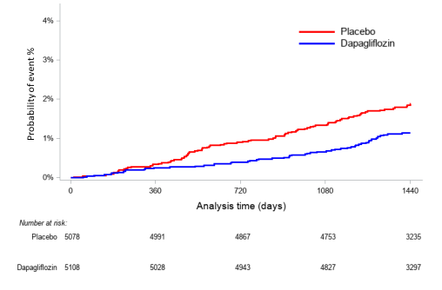

Figure 1B – The renal specific outcome in the MRF cohort with dapagliflozin vs. placebo
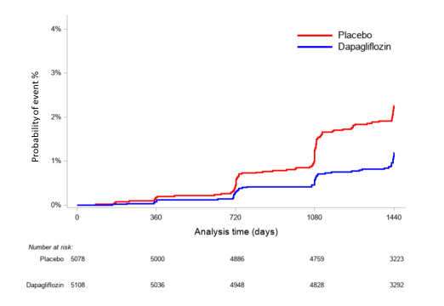

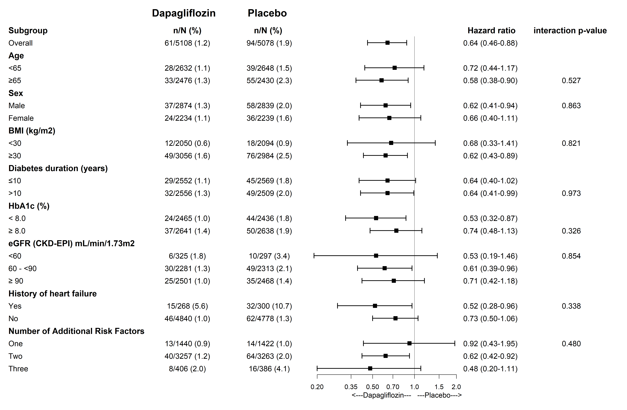
Figure 2A – Hospitalization for heart failure in the MRF cohort by subgroups

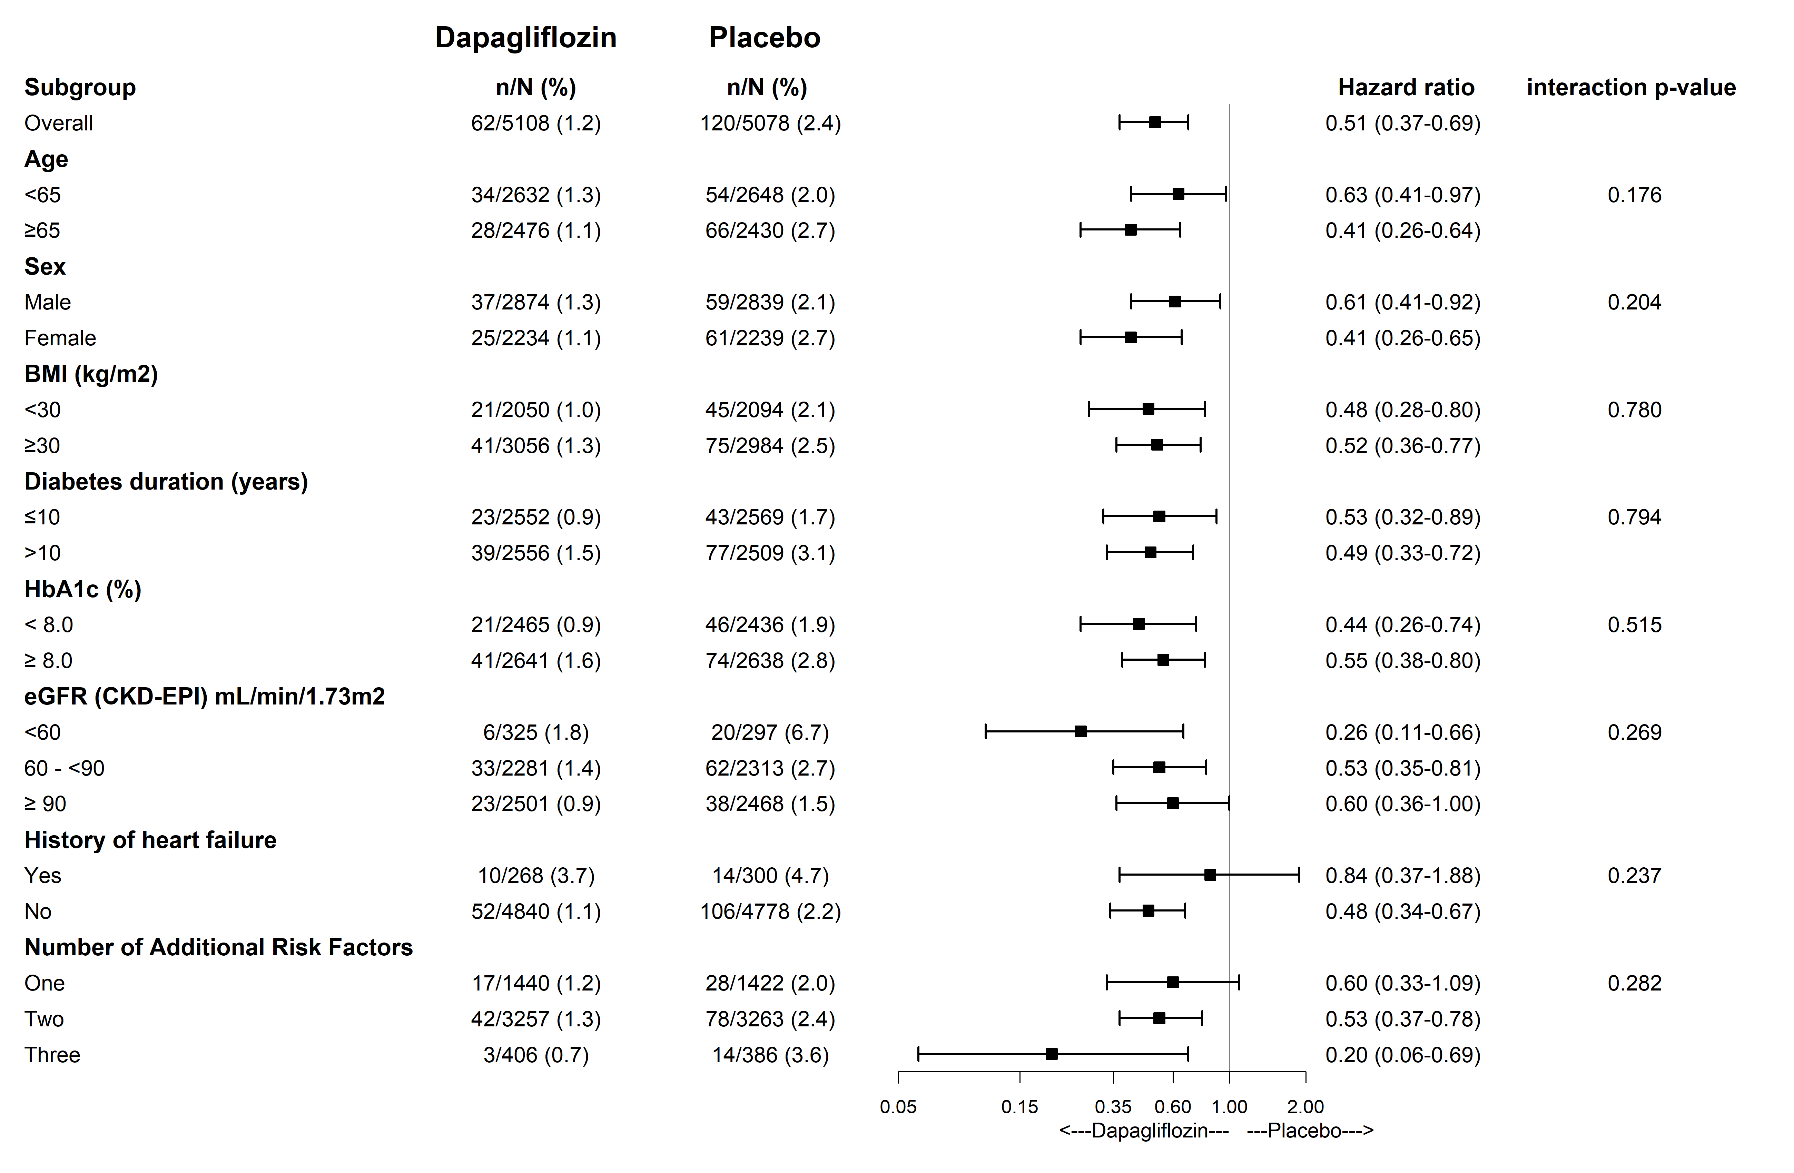
Figure 2B – Renal-specific outcome in the MRF cohort by subgroups
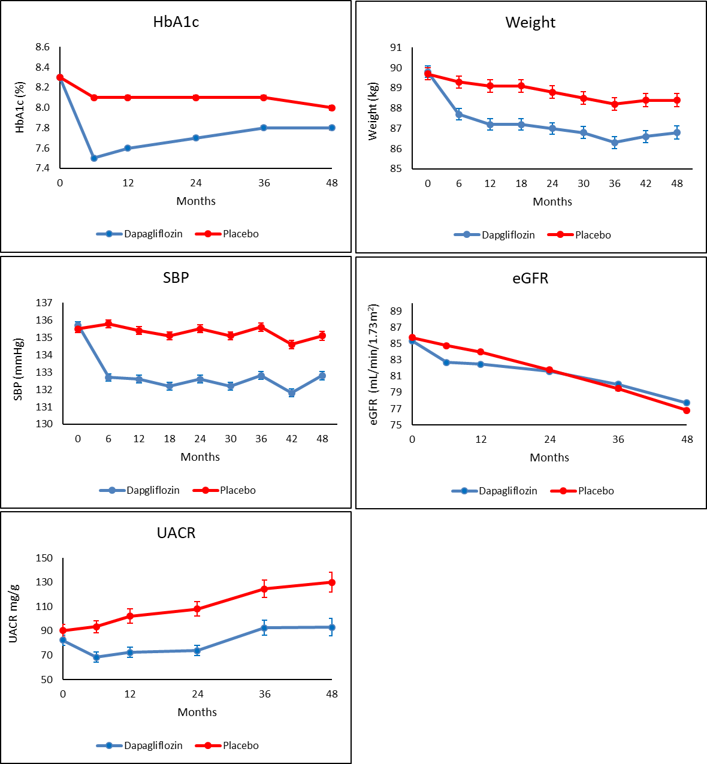
Figure 3 - Metabolic outcomes in the MRF cohort

Legend: Data shown are mean ±SE. SBP – systolic blood pressure, UACR – urinary albumin creatinine ratio, eGFR – estimated glomerular filtration rate
Supplementary table 1 – Safety outcomes in the MRF cohort

 | Dapagliflozin  N=5104 |  | Placebo  N=5073
Outcome | n | % | n | % | HR (95% CI) | Cox p-value
Major hypoglycemic event | 24 | 0.5% | 44 | 0.9% | 0.53 (0.32-0.87) | 0.011
Diabetic Ketoacidosis Definite or Probable | 16 | 0.3% | 6 | 0.1% | 2.56 (1.00-6.54) | 0.050
Amputation | 42 | 0.8% | 54 | 1.1% | 0.77 (0.51-1.15) | 0.200
Fracture | 262 | 5.1% | 227 | 4.5% | 1.15 (0.96-1.37) | 0.128
Symptoms of volume depletion | 82 | 1.6% | 78 | 1.5% | 1.02 (0.75-1.39) | 0.921
Genital infections | 51 | 1.0% | 3 | 0.1% | 16.72 (5.22-53.56) | <0.001
Urinary tract infection | 70 | 1.4% | 80 | 1.6% | 0.84 (0.61-1.16) | 0.301
Cancer | 294 | 5.8% | 281 | 5.5% | 1.04 (0.88-1.22) | 0.668
Acute kidney injury | 59 | 1.2% | 64 | 1.3% | 0.89 (0.62-1.26) | 0.505

Legend: Genital and urinary infections considered were either serious (2 in each arm) or led to discontinuation of study drug.

