Original Article
COVID-LEGAL Study: Neurosurgeon experience in Britain during the First Phase of the COVID-19 pandemic – medico-legal considerations

Roisin Finn^{1*}, Mario Ganau^{1*}, Michael D Jenkinson^{3, 5}, Puneet Plaha^{1, 4}.
¹Department of Neurosurgery, John Radcliffe Hospital, Oxford University Hospitals NHS Foundation Trust, Oxford, UK
²Department of Clinical Neurosciences, University of Cambridge, UK
³Department of Neurosurgery, Walton Centre NHS Foundation Trust, Liverpool, UK
⁴Nuffield Department of Surgical Sciences, University of Oxford, UK
⁵Institute of Systems, Molecular and Integrative Biology, University of Liverpool, Liverpool, UK

Title character count: 115
Abstract words count: 229
Manuscript words count: 2,177
Figures and/or tables: 1
References: 15

Authors contribution: *Equally share first authorship; RF and PP conceived the study; RF, PP, and MDJ designed the survey: RF edited the survey; RF, MG, PP analyzed the results and wrote the manuscript; all authors reviewed and approved the final manuscript.

Corresponding Author:
Ms Roisin Finn
Department of Neurosurgery
John Radcliffe Hospital, Nuffield Department of Surgery
Oxford University Hospitals NHS Foundation Trust
Headley Way, Oxford - United Kingdom, OX3 9DU
Email: Roisin.Finn@ouh.nhs.uk
Telephone: +44 1865 234838

COVID-LEGAL study: Neurosurgeons experience in Britain during the COVID-19 pandemic – medico-legal considerations

Abstract
The COVID-19 pandemic has resulted in a significant number of changes to elective and emergency neurosurgical practice. This paper reports the results of an online survey of Society of British Neurological Surgeons (SBNS) members undertaken between 10th to 24th of June 2020 regarding changes in consent practice in response to COVID-19, as well as the physical challenges experienced while operating under higher levels of personal protective equipment (PPE).

Despite the real and substantial risks associated with COVID-19, 23% of surgeons reported they not made any changes to their usual consent process, and 54% of surgeons indicated that they made reference to COVID-19-associated risks in their written consent documentation. 93% of neurosurgeons reported physical difficulties operating using PPE; 62% reported visors/goggles fogging up, 55% experienced ‘overheating’, 62% reported fatigue, and 82% of surgeons reported difficulty communicating with the theatre staff.

This survey highlights discrepancies in the consent practice between neurosurgeons which needs to be addressed at both local and national levels. The PPE being used in neurosurgical operations is not designed for use with specialist equipment (82% of respondents reported having to remove PPE to use the microscope) and the reported physical difficulties using PPE intraoperatively could significantly impact on both neurosurgeon performance and patient outcomes. This requires urgent attention by NHS procurement and management, and should be urgently escalated to trust occupational health authorities as a workplace safety concern.

Keywords: Medico-Legal Practice; Neurosurgery; Covid-19; Surgical Consent, Patient Safety.

Introduction
There have been a number of changes to UK neurosurgical practice in response to the COVID-19 pandemic, including the adoption of virtual clinics, postponement of elective operations and modifications to the equipment worn by surgeons whilst operating. These changes were introduced rapidly, giving healthcare organizations little time to measure or study the impact they may have on surgical performance or patient safety.¹⁻⁶

Early reports on the risks of clinical personnel contamination with aerosol-generating procedures, including surgical-related ones, fostered a public debate on the preparedness of healthcare systems all over the world. In the UK, the Royal College of Surgeons and the Society of British Neurological Surgeons (SBNS) had promptly issued, and shared with all units in the country, detailed guidelines on the level of Personal Protective Equipment (PPE) required to safely undertake surgery^{6,7} Besides the processes of intubation and extubation, which are obviously considered high risk, the neurosurgical community had been promptly informed about the risks of other aerosol-generating procedures, such as those related to bipolar/monopolar cautery, bone drilling, and use of ultrasonic aspirators.⁶

The additional PPE required to care for COVID patients has been widely reported as being uncomfortable for the wearer in non-surgical settings such as Intensive Care Units (ICU), and increases fatigue and body temperature, with reports of heat exhaustion and dehydration.^{5, 7} Additionally, the masks/respirators can cause muffling of the voice and difficulty communicating between staff members, which is particularly concerning in the operative setting where communication is vital.

Since the landmark Montgomery case, ^{8, 9} there has been increased emphasis on ensuring patients are fully informed of the risks of surgery. The information provided needs to be as comprehensive as possible, and be personalized for each patient, taking into consideration what patients feel are important risks. The COVIDSurg Collaborative study¹⁰ demonstrated a high risk of death and respiratory morbidity for patients with SARS-Cov-2 undergoing procedures under general anesthetic, which is an important risk to discuss with patients, particularly those undergoing procedures requiring a prolonged general anesthetic. The aim of this survey was to gather data on the new challenges experienced by neurosurgeons operating using higher levels of PPE and to better understand what patients are being informed before surgery in relation to the new potential risks of COVID-19 and associated changes in neurosurgical practice.

Materials and methods
A short online survey was designed by our taskforce and discussed with the SBNS academic committee. A Team Advantage SurveyMonkey® account was set up and used to edit the survey and collect responses. A beta test was run after discussion with the SBNS academic committee. The finalized version of the survey was emailed to all full SBNS consultant members as an online weblink. The weblink remained open for a period of 2 weeks, between 10th and 24th of June 2020.

Respondent were first asked if they had been operating during the pandemic, and if they replied they had not, then these neurosurgeons were automatically excluded from the survey. The subsequent questions (figure 1) related to pre-operative COVID-19 testing, changes in consent practice and the level of PPE worn during surgery. Level 1 PPE involves wearing one pair of gloves, a surgical mask and a gown (or pinafore). Level 2 PPE, which is to be used during aerosol-generating procedures, requires an additional gown, a second pair of gloves, eye protection (in the form of googles or a visor), as well as a specialized Filtering Face Pieces (FFP) mask or respirator.⁷ Respondents were asked to report any difficulties encountered obtaining appropriate levels of PPE and also if they encountered any physical challenges while operating while wearing level 2 PPE. Descriptive statistics provided by the SurveyMonkey® software was used collate and analyze the results.

Results
106 UK consultant neurosurgeons undertook the survey. As of 2020, there are 357 consultant neurosurgeons employed within the NHS, however not all of these are practicing.¹¹ The SurveyMonkey® software calculated the completion time to be 2 minutes and estimated a completion rate of 92%. The system revealed that 4 responders (3.81%) were excluded from the study after the first question as they had not performed surgery during the COVID-19 pandemic.

The UK national government COVID19 pandemic restrictions (‘lockdown’) came into force on 23th of March 2020.¹² By the time of the survey period 10th to 24th of June 2020, there had been 306, 210 confirmed COVID-19 cases in the UK, and both the daily death rate and numbers of daily hospital admissions with COVID-19 rate had fallen significantly. The 7 day rolling average death rate from COVID-19 on 14th of April was 943; by 23rd of June this had fallen to 121.¹² At the peak of the pandemic, on 1 April 2020, there were 3,301 admissions per day with COVID-19, by the end of the survey period, there were 283 admissions per day to UK hospitals with confirmed COVID-19.

Most neurosurgeons (93%) reported in our survey that by that stage of the pandemic (from 10th to 24th of June 2020), patients were being routinely pre-tested for SARS-CoV-2 prior to surgery. The majority of those tests were conducted with oropharyngeal/nasopharyngeal swab, with 85% of surgeons reporting that patients were routinely undergoing reverse transcription polymerase chain reaction (RT-PCR) swab testing before surgery. Only 0.95% of surgeons reported that patients were undergoing CT chest as the single pre-operative testing methodology, and 6.67% reported that both CT chest and RT-PCR testing were being used to screen for COVID-19 prior to surgery.

More than three quarters of responders (77%) stated that they had amended their consent practice in light of the COVID-19 pandemic. 70% of surgeons stated they verbally informed the patients regarding the risk of contracting SARS-Cov-2 by coming into hospital for surgery. Only 54% of surgeons made any reference to risks associated with COVID-19 in the written consent documentation. 50% of the surgeons reported informing patients that testing for COVID-19 can be falsely negative and only 46% of surgeons told patients that if they had asymptomatic or undetected COVID-19 and were put on a ventilator for surgery, they were at risk of developing a symptomatic COVID-19 respiratory illness. 61% of the neurosurgeons reported that they told patients with symptomatic COVID-19 that they were at risk of experiencing respiratory deterioration following general anaesthesia (GA), including requiring admission to ICU, or risk of death in the postoperative period.

10% of surgeons reported they still used standard Level 1 PPE during all operations, while 79% reported that they were using Level 2 PPE for all cases. 11% of surgeons reported a variety of different practice (i.e.: the level of PPE worn varied depending on whether the patients were pre-tested or not, as well as depending on the type of operation and a preoperative assessment of the risk of aerosol-generation). The survey demonstrated that 26% of neurosurgeons had experienced difficulties obtaining the correct level of PPE to wear during operations.

Neurosurgeons reported a number of challenges faced while operating using Level 2 PPE. 62% of respondent reported visor/googles fogging up and 68% of surgeons reported difficulties using the operating microscope while wearing the visor/googles. 82% of surgeons reported having to remove eye protection in order to use the microscope, in order to make the surgery safer for the patient and to be able to use this equipment.

Surgeons also reported other physical challenges: 55% of responders experienced ‘overheating’ during the surgery, 34% reported headaches, and 62% complained of fatigue in excess to usual. 23% of surgeons reported other physical discomfort while wearing Level 2 PPE, which included reports of nasal pressure sores from the visors and tight-fitting masks, ear and facial pain, dehydration and difficulty breathing. Only 7% of respondents reported no issues experienced while operating using additional levels of PPE. Difficulties in communicating with other members of staff during the surgery while wearing those PPE were reported by the majority of responders (82%).

Discussion

Summary of results

This survey highlighted variations in the perioperative consent process across neurosurgical units in the UK as well as highlighting the physical challenges experienced by neurosurgeons operating while wearing Level 2 PPE. There were differences in what neurosurgeons were informing patients about the additional risks posed to them by coming into hospital during the COVID-19 pandemic. However, since less than a 1/3 of UK neurosurgeons took part in this study, the results should be interpreted with caution.

Pre-operative Covid-19 Consent Process

Despite widespread difficulties in accessing testing for asymptomatic patients in the early stages of the pandemic,¹⁴ by the time this survey was conducted (10th to 24th of June 2020) most neurosurgeons reported that patients were routinely pre-tested for COVID-19 prior to their admission for surgery. The results were in keeping with the advice given by NHS England guidelines for COVID-19 testing and reflected increased uptake of testing prior to elective surgery.

This study found that following the outbreak of this new virus, unsurprisingly, there were differences in how neurosurgeons responded in terms of amending their consent practice. Subsequent large studies such as COVIDSurg Collaborative study¹⁰ reported increased rates of respiratory morbidity for patients with COVID-19 undergoing surgery under general anesthesia (GA). While this study did not include a considerable number of neurosurgical patients, it did include a large number of patients undergoing long procedures under GA and demonstrated risk of exacerbating COVID-19 respiratory symptoms with the use of the ventilator during GA for any type of procedure. Even prior to the wide dissemination of the COVIDSurg study¹⁰, most neurosurgeons were verbally informing patients of some of the possible risks relating to COVID-19 by choosing to come into hospital for surgery during the pandemic, and 54% of surgeons reported documenting COVID-associated risks in the consent documentation.

In the landmark 2015 Montgomery ruling¹⁵, the Supreme Court places a legal obligation upon clinicians to ensure that their patient is aware of any material risks involved in any recommended intervention. Given the emerging information on COVID-19 and the findings of this study, surgeons should disclose the risk of SARS-CoV-2 infection that would be relevant for that patient during the consent process.

Intraoperative PPE and Challenges
Level 2 PPE has brought its challenges with new equipment (masks, visors etc.), “donning”, “doffing” and new theatre protocols.⁷ Almost a quarter (23%) of neurosurgeons reported struggling to access appropriate PPE for suspected or confirmed COVID-19 cases. A big challenge for surgeons was the physical aspect of wearing higher levels of PPE during the surgery. As expected, most surgeons reported difficulties with eye protection (visor/googles) and FFP3 face masks or respirators. This protective gear was particularly challenging when surgeons were using the operating microscope/surgical loupes as the eye protection and some of the face masks are not designed for microscope/loupes use. Donning an additional gown/apron and another pair of gloves, as well as the FFP3 masks, made surgeons more likely to suffer from headaches, experience more fatigue than normal and “overheat”. The guidance for Level 2 PPE for neurosurgery has since been revised and apart from nasal passage related procedure (e.g. trans-sphenoidal pituitary surgery) other neurosurgical procedures are now considered safe including bone drilling.⁶Therefore, in majority of neurosurgical units in the UK surgeons now do not wear full level 2 PPE for SARS-CoV-2 negative patients planned for elective surgery. However, the difficulties faced by surgeons using level 2 PPE at surgery needs to be made known to NHS hospital trusts and suppliers of PPE equipment so that existing designs can be modified to suit the needs of neurosurgeons when they are dealing with suspected or confirmed COVID-19 cases.

In the first phase of this pandemic, British neurosurgeons are operating wearing PPE which is not specifically designed for use in this highly specialized environment. Our results highlight a number of potential patient safety concerns. Most surgeons (82%) reported difficult communication with other staff members in theatre and this survey found high levels of surgeon fatigue and discomfort, all of which may impact on patient outcomes and surgeon performance. The findings of this study raise the question about whether or not patients undergoing elective procedures should be informed about the potential impact the surgeon’s working conditions while wearing Level 2 PPE may have on their outcomes, as the patient may wish to defer surgery or elect to have it done in a unit where Level 2 PPE is not worn routinely for all cases.

Conclusions
The results of this SBNS survey highlight the differences in consent practice between neurosurgeons in light of the pandemic and the impact on surgical practice. There are differences between what neurosurgeons are telling their patients about the risks of surgery during the COVID-19 pandemic, the risks COVID-19 poses to them and their outcomes from surgery. We propose that all patients should be informed of the material risk posed by SARS-Cov-2 infection. Additionally, this survey reports concerning difficulties experienced by neurosurgeons while operating using level 2 PPE which is not designed for this specialist use. A well designed clinical trial comparing different PPE and the risk of surgeons developing SARS-Cov-2 infection would provide class I evidence. Furthermore, PPE that is designed for use with specialized equipment e.g. operating microscope, loupes is required for the ongoing and future pandemics.

Acknowledgments: The authors wish to thank the Society of British Neurological Surgeons for their assistance in disseminating this questionnaire

Funding source: This work did not receive any specific grant from funding agencies in the public, commercial or not-for-profit sectors.

Declarations of interest: None declared

Tables and Figures:

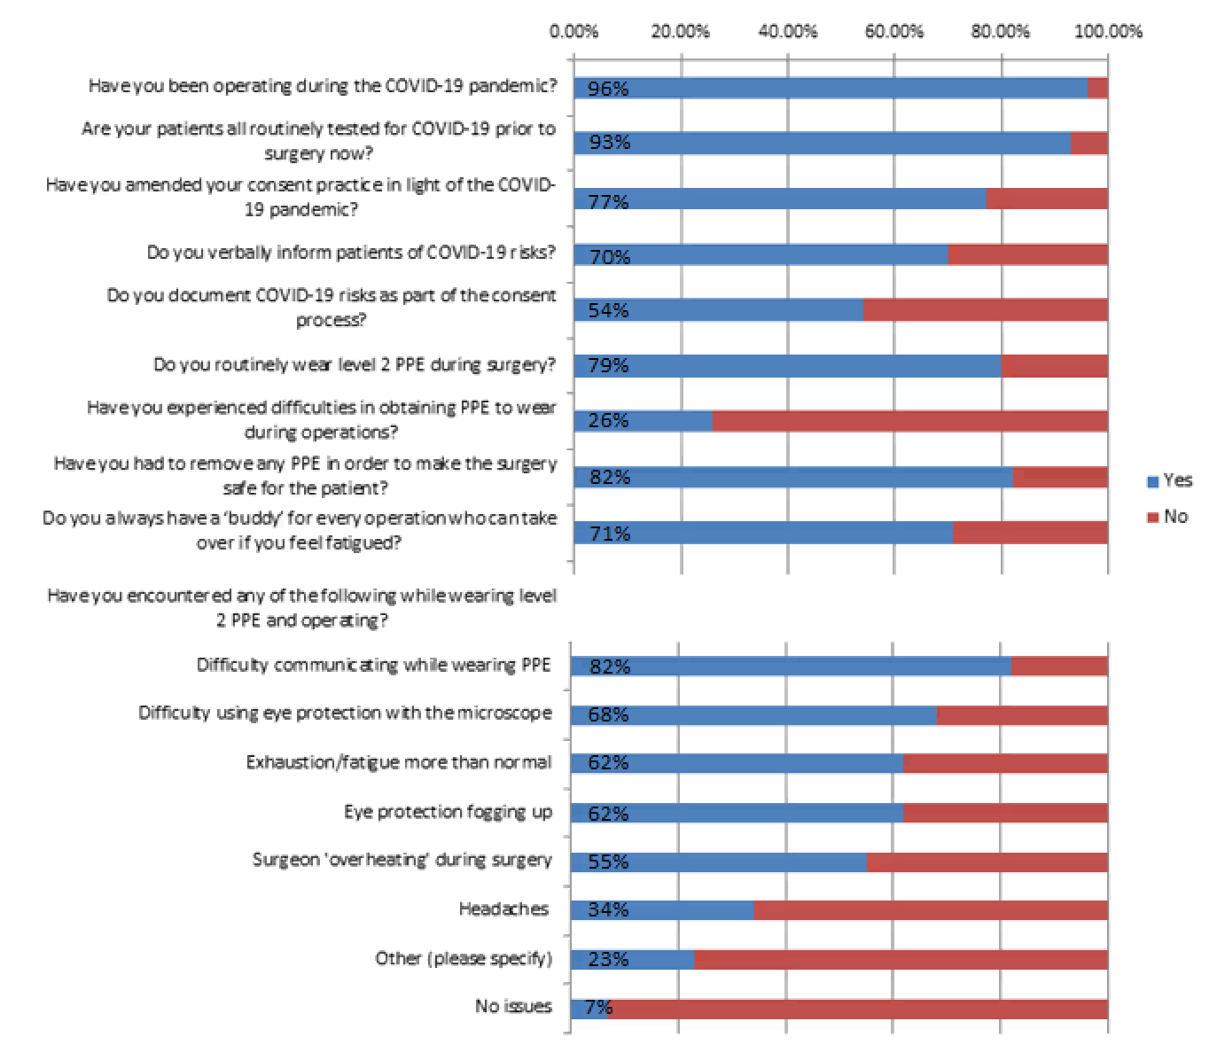
Figure 1: Survey questions and responses from 106 UK consultant neurosurgeons

References

- Jenkinson M, Grundy P, Brodbelt A, Al-Salihi O, Watts C. Adult Neuro-Oncology Service Provision during COVID-19 outbreak [Internet]. British Neuro-Oncology Society; 2020 [cited 2020 Apr 30]. Available from: https://www.bnos.org.uk/wp-content/uploads/2020/03/Adult-neuro-oncology-service-provision-during-COVID-outbreak_SBNS-BNOS.pdf
- Chibbaro S, Ganau M, Todeschi J, Proust F, Cebula H. How SARS-CoV-2 is forcing us to reconsider and reorganize our daily neurosurgical practice [published online ahead of print, 2020 May 13]. Neurochirurgie. 2020;S0028-3770(20)30065-5. doi:10.1016/j.neuchi.2020.05.001
- Minhas Z, Ganau M, Thakar C, Reynolds J, Rothenfluh D, Bojanic S, Grannum S, Chaudhary BR, Pyrovolou N, Sikander M, Bowden G, Patel UJ, Nnadi C. COVID-19: new challenges, risks, and the future provision of care in spinal services. Bone Joint J. 2020 Jun;102-B(6):655-657. doi: 10.1302/0301-620X.102B6.BJJ-2020-0686.
- Ganau M, Netuka D, Broekman M, Zoia C, Tsianaka E, Schwake M, Balak N, Sekhar A, Ridwan S, Clusmann H; EANS IM Committee. Neurosurgeons and the fight with COVID-19: a position statement from the EANS Individual Membership Committee. Acta Neurochir (Wien). 2020 Aug;162(8):1777-1782. doi: 10.1007/s00701-020-04360-3. Epub 2020 May 29.
- Royal College of Surgeons of England. COVID-19: Good Practice for Surgeons and Surgical Teams; 2020. [cited 2020 June 15]. Available from https://www.rcseng.ac.uk/standards-and-research/standards-and-guidance/good-practice-guides/coronavirus/covid-19-good-practice-for-surgeons-and-surgical-teams/
- Society of British Neurological Surgeons. Guidance on Neurosurgical Procedures and COVID-19. [cited 2020 July 15] Available from https://www.sbns.org.uk/index.php/policies-and-publications/covid/
- Royal College of Nursing. Personal protective equipment (PPE) and COVID-19. [cited 2020 June 17]. Available from https://www.rcn.org.uk/get-help/rcn-advice/personal-protective-equipment-ppe-and-covid-19
- McKinnon C, Loughran D, Finn R, Coxwell-Matthewman M, Jeyaretna DS, Williams AP. Surgical consent practice in the UK following the Montgomery ruling: A national cross-sectional questionnaire study. Int J Surg. 2018 Jul;55:66-72. doi: 10.1016/j.ijsu.2018.05.016. Epub 2018 May 26.
- Montgomery v Lanarkshire Health Board [2015] SC 11 [2015] 1 AC 1430.
- COVIDSurg Collaborative. Mortality and pulmonary complications in patients undergoing surgery with perioperative SARS-CoV-2 infection: an international cohort study. The Lancet. Vol 396, issue 10243, p27-28, Jul 2020
- The Society of British Neurological Surgeons. Available at https://www.sbns.org.uk/index.php/about-us/membership/ [accessed 29 Oct 2020]
- Prime Minister's statement on coronavirus (COVID-19): 23 March 2020. Available at https://www.gov.uk/government/speeches/pm-address-to-the-nation-on-coronavirus-23-march-2020 [accessed 29 Oct 2020]
- Cabinet Office Briefing Rooms. Available at https://www.gov.uk/government/collections/slides-and-datasets-toaccompany-coronavirus-press-conferences [accessed 29 Oct 2020]
- Carding N, Thomas R. Trusts concerned over long waits for covid-19 test results. Health Services Journal. 25 March 2020. Available at https://www.hsj.co.uk/quality-and-performance/trusts-concerned-over-long-waits-for-covid-19-test-results/7027221.article
- Montgomery v Lanarkshire Health Board [2015] UKSC 11.

