The Origin of High Mobility in Molybdenum Doped Indium Oxide
Supplementary Information

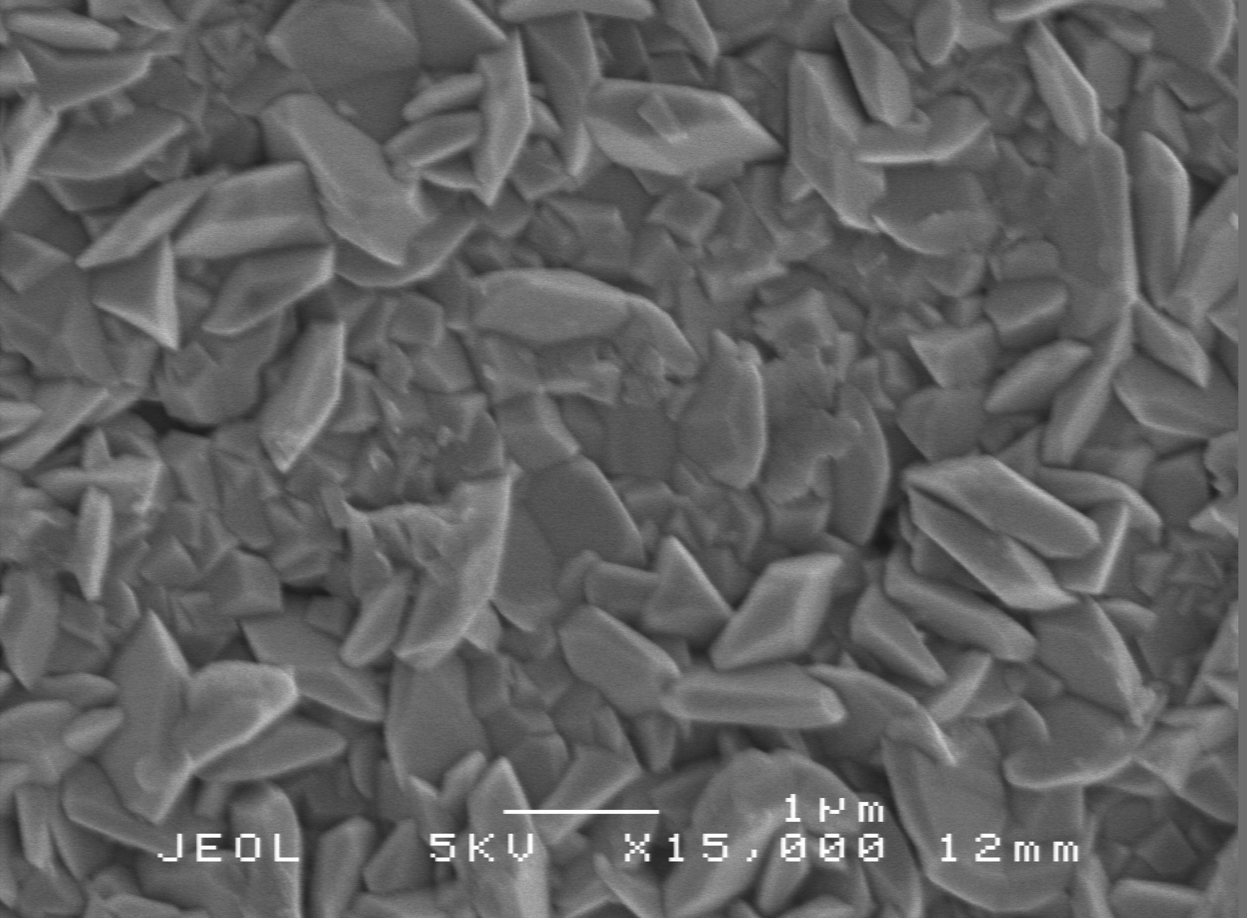
Figure 1. Top down SEM image of Sn:In₂O₃ (2 mol.% Sn/In in precursor solution) thin film prepared by AACVD.

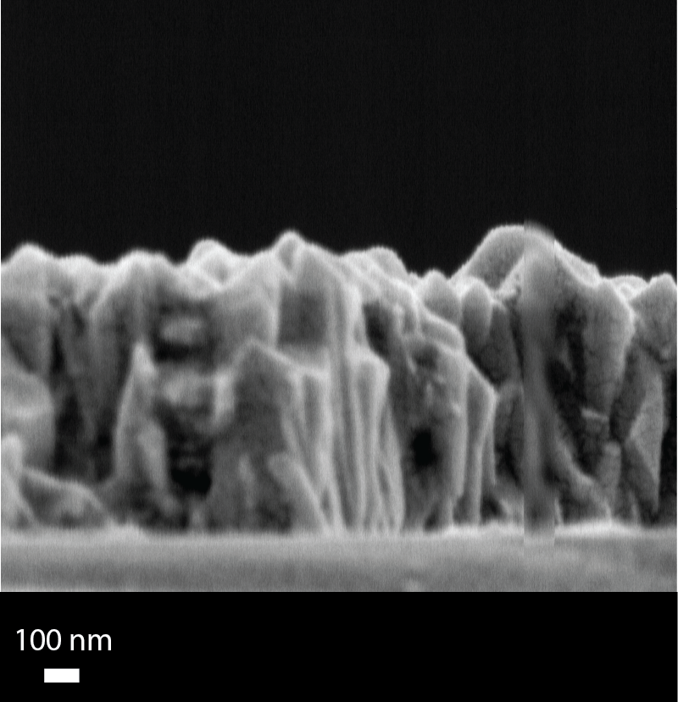
Figure 2. Side-on SEM image of Mo:In₂O₃ (2 mol.% Mo/In in precursor solution) thin film prepared by AACVD.

