Different conspiracy theories have different psychological and social determinants:
Comparison of three theories about the origins of the COVID-19 virus in a representative sample of the UK population

Running Head

DIFFERENT CONSPIRACY THEORIES HAVE DIFFERENT
PSYCHOLOGICAL AND SOCIAL DETERMINANTS

Todd K. Hartman1*, Michael Marshall1, Thomas VA Stocks1, Ryan McKay2, Kate Bennett3, Sarah Butter1, Jilly Gibson Miller1, Philip Hyland4, Liat Levita1, Anton P. Martinez1, Liam Mason5, Orla McBride6, Jamie Murphy6, Mark Shevlin6, Frédérique Vallières7, & Richard P. Bentall1

1 University of Sheffield
2 Royal Holloway, University of London
3 Liverpool University
4 Maynooth University
5 University College London
6 Ulster University
7 Trinity College Dublin

* Corresponding Author: t.k.hartman@sheffield.ac.uk

Abstract
COVID-19 conspiracy theories have proliferated during the global pandemic, and their rapid spread among certain groups may jeopardise the public health response (e.g., undermining motivation to engage in social distancing and willingness to vaccinate against the virus). Using survey data from two waves of a nationally representative, longitudinal study of life in lockdown in the UK (N = 1,406), we analyze the factors associated with belief in three origin theories related to COVID-19, namely that it 1) originated in a meat market in Wuhan, China; 2) was developed in a lab in Wuhan, China; and 3) is caused by 5G mobile networks. Our findings suggest that political-psychological predispositions are strongly associated with belief in conspiracy theories about the virus, though the direction and effect sizes of these predictors vary depending on the specific content of each origin theory. For instance, belief in the Chinese lab conspiracy theory is strongly associated with right-wing authoritarianism (RWA), social dominance orientation (SDO), and general conspiracy ideation, as well as less reliable news sources, distrust in scientists, and anxiety about the pandemic. Belief in the 5G network conspiracy theory is strongly associated with SDO, distrust in scientists, while less strongly with conspiracy ideation and information from social networks/media; RWA is strongly negatively associated with belief in the 5G conspiracy theory, with older and more wealthy individuals somewhat less likely to endorse it. The meat market origin theory is predicted by intolerance of uncertainty, ethnocentrism, COVID-19 anxiety, and less so by higher income, while distrust in scientists is negatively associated with this origin story. Finally, belief in COVID-19 conspiracy theories is associated with negative public health behaviours such as unwillingness to social distance and vaccinate against the virus. Crucially, our findings suggest that the specific content of COVID-19 conspiracy theories likely determines which individuals may be most likely to endorse them.

It is virtually not assimilable to our reason that a small lonely man felled a giant in the midst of his limousines, his legions, his throng, and his security. If such a nonentity destroyed the leader of the most powerful nation on earth, then a world of disproportion engulfs us, and we live in a universe that is absurd.

- From Oswald's Tale: An American Mystery by Norman Mailer, on the public’s obsession with conspiracy theories about the assasssination of John F. Kennedy

Christmas cancelled. Thank you, China.

- Nigel Farage, Twitter, December 2020

1. Introduction
Major world events are known to spawn conspiracy theories. This may be due, at least in part, to proportionality intuitions that render mundane explanations for important events inadequate and unsatisfying (Douglas, Sutton & Cichocka, 2019; Leman & Cinnirella, 2007). Thus, the notion that Princess Diana died because her driver was drunk, or that John F. Kennedy was felled by a lone gunman, threatens to engulf us in Norman Mailer’s “world of disproportion.”
Likewise, the COVID-19 pandemic is an event of immense global significance. The pandemic has occasioned massive social and economic upheaval, including nationwide lockdowns, school closures, the postponement or cancellation of major public events, and the largest global recession since the Great Depression of the 1930s. At the time of writing, the pandemic is already responsible for nearly three million deaths worldwide.
As with Kennedy’s assassination, the COVID-19 pandemic has proven to be fertile ground for conspiracy theories. Some theories, for example, deny the existence of the virus or downplay its severity altogether. Such theories may attribute COVID-19 “propaganda” to assumed nefarious actors such as the US government (and its plans to link passports with vaccination records as a means of totalitarian control; Ritschel, 2020, March 24) or to the purported vested interests of Bill Gates and the World Health Organization (McGreal, 2020, May 14). Yet, as Nigel Farage’s blithe tweet illustrates, a number of COVID-19 origin theories are intended to stoke hostility toward foreigners and foreign interests, which comports with the first reported cases in Wuhan, China. Examples include origin theories that posit the virus was engineered by the Chinese government, either in a laboratory as a biological weapon or with the introduction of 5G mobile technology (i.e., ostensibly causing the virus through radiation for which COVID-19 is merely a cover-up; Henley & McIntyre, 2020, October 26; Ahmed et al., 2020; Bruns et al., 2020). While such theories may satiate the need for narrative order among those individuals prone to conspiratorial thinking, they are also animated by intergroup dynamics of conflict and threat. In fact, recent studies on COVID-19 conspiracy theories have demonstrated that predispositions like party identification and ideology are associated with belief in such theories above and beyond a general conspiratorial mentality, though admittedly these reported effects may be context dependent (e.g., Uscinski et al., 2020).
Here we analyze the factors associated with belief in three theories regarding the origin of the COVID-19 pandemic, which at the time of data collection (April 2020) were most prominent: (1) that it originated in a meat market in China (a theory widely held in the early days of the pandemic but now contested); (2) that it originated in a laboratory in Wuhan, China; and (3) that it was caused by the rollout of the 5G mobile network. In the study, we consider the Wuhan laboratory and 5G theories as classic conspiracy theories, which we will explain in subsequent sections, while the meat market origin story serves as a baseline because it falls short of the core definition of a conspiracy theory.
Using data from two waves of a nationally representative, longitudinal dataset collected during the UK lockdown in 2020 (N = 1,406), we analyze several potential factors that may explain belief in COVID-19 origin theories. In particular, we focus on interplay between the specific content of each theory and the political-psychological predispositions that motivate its belief. We also control for several other socio-demographic factors, as well as political orientation, information sources about the pandemic, distrust in scientists, and COVID-19 anxiety, all of which may impact support for conspiracy theories. Our results suggest that political-psychological predispositions such as right-wing authoritarianism (RWA) and social dominance orientation (SDO) are statistically significant and substantively interesting predictors of belief in various COVID-19 origin stories. Moreover, and in contrast to previous research, the effects of these latent predispositions are distinct from and sometimes larger than that of an underlying conspiracy mentality, depending on the content of the specific conspiracy theory in question. Finally, we show that belief in conspiracy theories is associated with certain negative public health attitudes, for example, predicting motivations to violate social distancing guidelines and the unwillingness to vaccinate against COVID-19.
In the sections that follow, we address two research questions: What political-psychological predispositions predict belief in unsubstantiated COVID-19 origin theories? And what implications do these conspiracy beliefs have for health-related behaviours? We contribute to the literature by positing a motivational model of belief in COVID-19 origin theories, in which we argue the importance of political-psychological predispositions as motivational factors in explaining susceptibility to belief in conspiracy theories, as well as their behavioral consequences.

2. Theory

2.1 Belief in (COVID-19) Conspiracy Theories

Conspiracy theories are unsubstantiated explanations of major events with a twist -- that powerful and malevolent actors are involved in secret plots for their own benefit to the detriment of the common good (Goertzel, 1994; Uscinski & Parent, 2014). They generally consist of complex storylines that are hidden from public scrutiny, thus making them especially resistant to falsification (Lewandowsky et al., 2015). Most importantly, conspiracy theories function to protect entrenched beliefs by discounting contrary evidence as the product of a conspiracy (Lewandowsky, Oberauer, & Gignac, 2013). Indeed, some conspiracy theories predict such contrary evidence, evincing what Boudry (2020) calls a “warped epistemology.” Hence, conspiracy theories may even serve a valuable purpose for individuals by allowing them to maintain certain beliefs in the presence of contradictory evidence (Douglas et al. 2017).

A striking finding in the literature on conspiracy theories, however, is that belief in one conspiracy theory tends to predict belief in others (Goertzel, 1994). This is not epistemically problematic when conspiracy theories are mutually consistent or reinforcing. Yet, studies have found that even flagrantly contradictory conspiracy theories are positively correlated in endorsement. For example, Wood, Douglas, and Sutton (2012) reported that participants who believed Princess Diana faked her own death were also more likely to believe she was murdered. Such findings imply that conspiracist ideation is driven by a conspiratorial worldview, perhaps characterised by higher-level rejection of official explanations (Franks et al., 2017). Indeed, the tendency to believe in conspiracy theories is associated with narcissism (Chichocka et al. 2016), and those highly disposed to believe in conspiracy theories are especially likely to endorse theories which they think are only believed by a minority (Imhoff & Lamberty, 2017).

Yet, conspiracy thinking may also confer a sense of control during periods of perceived uncertainty or threat (Sullivan, Landau & Rothschild, 2010; Uscinski et al., 2017). Miller (2020), for example, has recently amassed evidence for the “monological belief system” conception of conspiracy theories (e.g., see Goertzel, 1994) in the context of COVID-19, finding that contradictory COVID-19 conspiracy beliefs are positively related in endorsement, though this finding was partially explained by personal uncertainty (i.e., the more uncertain people were about themselves, the world, and the future, the more intercorrelated their evaluations of conspiracy theories). This adds to previous work demonstrating that people are more likely to endorse conspiracy theories when conditions of uncertainty and stress are salient (van Prooijen and Jostmann, 2013; Swami et al., 2016), and that intolerance of this uncertainty is related to a tendency to seek simplifying explanations often involving external and threatening agents (Darwin, Neave & Holmes, 2011). Given the uncertainty caused by the global pandemic, it is perhaps unsurprising that people may grasp onto conspiracy theories as a security blanket.

In line with the theory of monological belief systems--that there is a general conspiracist mentality underpinning belief in specific conspiracy theories--we hypothesize that endorsement of one specific theory will be positively associated with belief in others (Hypothesis 1a); and that conspiracist ideation will be associated with belief in specific COVID-19 origin theories (Hypothesis 1b). However, these associations may be limited in helping us understand the diversity in conspiracy belief during the pandemic. Thus, in the sections that follow, we propose a motivational model of belief in various COVID-19 origin theories.

2.2 A Motivational Model of Belief in Conspiracy Theories
Research on motivated reasoning suggests that individuals are biased information processors, who seek out and accept information that conforms to their existing predispositions, while expending considerable effort to discount that which challenges strongly held priors (Kahan, 2013; Taber & Lodge, 2005). For example, Tappin, van der Leer, and McKay (2017) reported evidence of desirability bias in the context of the 2016 US election campaign: Individuals presented with polling evidence about the anticipated election outcome updated their beliefs more if the evidence was consistent (vs. inconsistent) with their preferred result. Similarly, Hartman & Newmark (2012) found that Republicans and ideological conservatives were especially predisposed to believe negative rumors about former President Barack Obama because of their different party identification and strong dislike of him.

We argue that two important political-psychological predispositions that may be associated with belief in COVID-19 origin theories are right-wing authoritarianism (RWA) and social dominance orientation (SDO). Both RWA and SDO emerged from research investigating different individual-level factors that explain prejudice and are thought to represent two types of right-wing personalities (Altemeyer, 1981; Diaz-Veizades et al., 1995; Duckitt, 2001; Sibley et al., 2006; Wilson and Sibley, 2013). In the Dual Process Motivational Model, for example, Duckitt (2001) theorised that two sets of motivational schemas, threat-control and competition-dominance, are the foundations of RWA and SDO, respectively, and that these dimensions were responsible for distinct forms of prejudice. For instance, while RWA and SDO both predict prejudice towards lower status groups, RWA-based prejudice typically categorises outgroups as dangerous – as threatening to the security and safety of the ingroup – or dissident – as representing a symbolic threat to social norms and cohesion (Shaffer and Duckitt, 2013; Kauff et al. 2015; Crowson and Brandes, 2017; Faragó et al. 2019). Conversely, SDO-based prejudice typically categorises outgroups as inferior, weak, or undeserving (Duckitt, 2001; Ho et al. 2015).

However, the exact relationships that RWA and SDO have with conspiracy belief remains unclear. In the development of the Conspiracy Mentality Scale, for example, Imhoff and Bruder (2014) note the importance of recognising the distinction between prejudice toward lower status groups (e.g., minority ethnic or religious groups), which is associated with RWA and SDO, and prejudice toward higher status groups (e.g., the wealthy), which is not associated with RWA and SDO. Yet, conspiracy mentality is generally related to prejudice against high-status and powerful groups or members of society, which are perceived as less likeable and more threatening compared to low-status and weaker groups (Imhoff and Bruder, 2014). A consistent finding in the literature, then, is that conspiracy mentality predicts belief in conspiracy theories more strongly than RWA and SDO (Dyrendal et al., 2021).

In contrast, Richey (2017) presented an alternative theory in which those with authoritarian personalities are more likely to support conspiracy beliefs due to higher levels of anxiety and difficulty with higher order thinking, which has recently been supported by work that presents a positive association between conspiracy mentality and RWA, SDO and political conservatism (van der Linden et al., 2020; Dyrendal et al., 2021). Yet, Richey’s work focused exclusively on birtherism (i.e., that former US President Obama is not an American citizen) and trutherism (i.e., that former US President Bush and the Republican Party knew of 9/11 prior to the attack). Nor did it control for SDO, which has been found elsewhere to predict scores on the General Conspiracist Belief scale, along with anxious attachment, interpersonal trust, and a Manichean world view (Green and Douglas, 2018).

Noting the divergent findings on the ability of predispositions to predict conspiracy belief, Wood and Gray (2019) highlight that psychologists tend to treat conspiracies as a unitary construct rather than engaging with the specific content of different conspiracy theories. They note that some conspiracy theories reinforce the RWA-associated view that the world is a threatening place, but that others present a view of the world that is incompatible with RWA, in which authority figures are corrupt, and leaders and traditions are social control mechanisms that must be resisted. In their findings, for example, RWA was positively associated with pro-establishment conspiracy beliefs but was uncorrelated with anti-establishment conspiracy beliefs (i.e., those suggesting that powerful groups are conspiring to restrict individual freedoms). Anti-establishment beliefs were moderately positively correlated with SDO. Wood and Gray (2019) speculate that a dislike of the deviant groups behind anti-establishment conspiracies, which present a material threat to social order, could partly explain the lack of association for RWA. Thus, the model proposes that RWA predicts a susceptibility to a belief in certain conspiracies that are compatible with the individual’s existing worldview.

As discussed above, both RWA and SDO are associated with heightened sensitivity to certain types of threat (Duckitt, 2001, 2006, 2009; Duckitt et al., 2010; Duckitt & Fisher, 2003; Duckitt & Sibley, 2009, 2010; Stenner, 2005). Those high in RWA, which is motivated by a belief that the world is an inherently threatening place, are particularly sensitive to threats posed by dangerous or dissident outgroups, while those high in SDO are particularly sensitive to the threat of competition from outgroups that challenge societal hierarchies or the dominance of the ingroup. Of the three explanations for the origin of the coronavirus examined in the present paper, it seems likely that people high in RWA would find the theory that the coronavirus was a bioweapon developed by China’s military as inherently threatening. In this theory, China’s proliferation of bioweapons presents an external danger in the form of a security threat from a potentially hostile political rival, and a social threat in the form of a deviant or dissident political ideology, communism, to which people high in RWA are sensitive (Kauff et al. 2015; Crowson and Brandes, 2017; Faragó et al. 2019). It is also feasible that those high in SDO would be sensitive to the competitive threat this theory poses. In the bioweapon origin theory, an international competitor is trying to gain a military advantage that might threaten international hierarchies and challenge Britain’s ability to leverage military power in the international arena, which is compatible with the underlying ‘competitive jungle’ worldview of SDO. Moreover, the bioweapon theory presents a situation that could be used to justify more aggressive foreign policy positions or increased militarisation in the UK. RWA and SDO are both associated with nationalism, support for aggressive foreign policy, and military action (Pratto et al. 1994; Doty et al. 1997; Terrizzi and Drews, 2005; McFarland and Mathews, 2005; Crowson et al. 2006; Jackson and Gaaertner, 2010; McFarland, 2015; Lindén et al. 2018). Therefore, we expect that RWA and SDO will be positively associated with belief in the Chinese lab origin story (Hypothesis 2).

Conversely, the links between predispositions and the 5G origin theory appear less clear cut. While the 5G origin theory taps into a potential security threat, the development of 5G technology in the UK had the support of the government, and therefore is less compatible with an RWA worldview that would be largely pro-establishment. Rather, the various forms of 5G origin theories are often linked to the virus via somewhat convoluted and contradictory mechanisms, some of which claim the virus is real but caused by 5G, and some of which claim it is a hoax altogether (Sturm and Albrecht, 2020). One such conspiracy claims that COVID-19 is a pretense to cover-up to the negative health effects of 5G radiation established by those profiteering from the technology (Bruns et al., 2020). Such a claim is consistent with theory that predicts people high in SDO may be more likely to perceive dishonesty as an accepted norm in a highly competitive world, in which people do whatever is necessary to succeed (De keersmaeker and Roets, 2019), and is supported by evidence from a UK sample showing a positive association between SDO and belief COVID-19 is a hoax (Imhoff and Lamberty, 2020). A consistent theme running through the proliferation of 5G conspiracy theories has been their mobilisation by partisan groups, in particular their assimilation into and conjoining with pre-existing conspiracies frequently espoused in far-right networks (Bruns et al., 2020). SDO has been found to positively predict identification with far right groups, and subsequent intent to engage in extreme and violent actions towards outgroups, providing a justification for beliefs and actions that benefit the ingroup (Bai, 2020). Relatedly, Kreko (2015) has argued that motivation to believe in conspiracy theories is greater when they are related to a salient group identity such as the far right. Therefore, given the proliferation of 5G conspiracies through far-right networks, the extremity of the intent and actions associated with it (e.g., the burning of 5G towers; Jolley and Paterson, 2020), and the consistency of its content that sees the world as competitive and actors as self-interested, we predict SDO will be positively associated with the 5G origin theory (Hypothesis 3).

Yet, we have no strong expectations regarding the association between RWA and 5G belief, and similarly no strong expectations regarding RWA and SDO and belief in the Chinese meat market theory. Our reasoning is that the former does not tap into threats to the social order or status of the ingroup, while the latter is not really a conspiracy theory (i.e., it does not involve intentional actions by a powerful and malevolent group).

2.3 Public Health Implications
Finally, endorsement of COVID-19 conspiracy theories may affect critical public health issues such as adherence to social distancing rules and attitudes toward vaccination. Experimental evidence suggests exposure to conspiracy theories reduces the intent to engage in health-promoting behaviours, such as visiting a doctor, and that the relationship is mediated by decreased trust in health professionals (Natoli and Marques, 2020). More recently, conspiracy mentality has been shown to reduce willingness to comply with preventative COVID-19 measures, such as national lockdowns, where they are mandated by governments or authority figures (Marinthe et al., 2020).

Again there is evidence that the content of a conspiracy theory matters for subsequent behavior. For instance, Imhoff and Lamberty (2020) report that claiming the virus was a hoax reduced compliance with social distancing but claiming the virus was man-made had no effect. In this vein, social distancing motivations may be undermined if the severity of the virus is understated or if the scientific consensus on human-to-human transmission is questioned, as insinuated by claims it is caused by 5G radiation or that the pandemic lockdowns were only a pretense for the cover-up and/or rollout of 5G networks (Bruns et al., 2020). Similarly, a number of conspiracy theories make unfounded claims regarding the supposed dangers of vaccines (Sturm and Albrecht, 2020). Indeed, social network analysis of the spread of COVID-19 conspiracies details the prominence of a conspiracy theory which overlaps across those origin theories tested in this study, suggesting the virus was engineered in China, but that its full effects will be realised via a vaccine that is activated by 5G (Bruns et al., 2020: 19).

Thus, given the negative effect of conspiracy belief on health promoting behaviours, and their potentially corrosive effect on trust in medical interventions and the consensus on human transmission, we expect belief in our set of conspiracies to be negatively associated with social distancing motivations (Hypothesis 4a) and positively associated with vaccine rejection (Hypothesis 4b).

3. Materials and Methods
3.1 Data
The data for this study come from a nationally representative longitudinal survey of adults living in the United Kingdom during the early phases of the COVID-19 global pandemic. Participants were recruited by Qualtrics from March 23rd to 28th, 2020 (Wave 1: N = 2,025), and were recontacted from April 22nd to May 1st, 2020 (Wave 2: n = 1,406, recontact rate = 69%). Data for Wave 1 of the survey occurred during the first week of the strict national lockdown in the UK, while follow-up data for Wave 2 was collected approximately 1 month later during the lockdown and 3 months after the first confirmed COVID-19 case there, which saw rapidly increasing infections. These data comprise part of a longitudinal, multi-country study that aims to assess the psychological, social, economic, and political impact of the COVID-19 virus in the general population (McBride et al., 2020).
Although the sample was drawn from non-probability methods, research suggests that Qualtrics approximates probability-based samples reasonably well when quotas are used (Zack, Kennedy & Long, 2019). Thus, we employed stratified quota sampling matched against known demographics in terms of age, gender, and household income within the UK. We also present a summary table of demographics benchmarked against Wave 19 of the British Election Study, which was collected using similar survey methods. McBride et al. (2020) provide a more detailed description of the panel recruitment, sampling methodology (including post-stratification weights and analysis of panel attrition), and explanation of all measures administered in the study. The full panel dataset will be deposited to the UK Data Archive and Open Science Framework approximately six months after data collection for the project has been completed.

Table 1: Sample demographics (n = 1,406) benchmarked against British Election Study (BES) Wave 19 (n = 32,177)
Variable | Category |  | Proportion | BES W19 Proportion
Age | 18-24 |  | 0.055 | 0.042
 | 25-34 |  | 0.151 | 0.089
 | 35-44 |  | 0.174 | 0.130
 | 45-54 |  | 0.218 | 0.170
 | 55-64 |  | 0.221 | 0.231
 | 65-74 |  | 0.153 | 0.261
 | 75+ |  | 0.027 | 0.078
Gender | Male |  | 0.517 | 0.468
 | Female |  | 0.481 | 0.532
 | Other/Prefer not to say |  | 0.002
Ethnicity | White |  | 0.930 | 0.942
 | Ethnic minorities (excluding White minorities) |  | 0.070 | 0.044
 | Prefer not to say |  |  | 0.010
 | NA |  |  | 0.005
Education | Other qualification or no qualifications |  | 0.556 | 0.684
 | Degree education |  | 0.444 | 0.316
Gross household income | Study categories | BES W19 categories
 | £0 - 15,490 | £0 - £14,999 | 0.198 | 0.184
 | £15,491 - £25,340 | £15,000 - £24,999 | 0.179 | 0.206
 | £25,341 - £38,740 | £25,000 - £39,999 | 0.184 | 0.264
 | £38,741 - £57,930 | £40,000 - £59,999 | 0.221 | 0.186
 | £57,931 or more | £60,000 or more | 0.217 | 0.159

3.2 Dependent Variables
To assist interpretation and comparison of effect sizes, we rescaled all of the continuous variables described below to range from zero to one. Descriptive statistics for all measures included in our analyses are available in Table 2, which also details the study wave in which they were collected.

Table 2: Descriptive statistics of key measures

Variable | Mean | SD | Wave | Description
Dependent Variables
Meat market belief | 0.64 | 0.29 | 2 | Slider scale from 0-100, scaled 0-1
Wuhan lab belief | 0.38 | 0.33 | 2 | Slider scale from 0-100, scaled 0-1
5G belief | 0.11 | 0.22 | 2 | Slider scale from 0-100, scaled 0-1
Motivation to engage in social distancing | 0.82 | 0.19 | 2 | 4-item subscale of reflective motivation from the COM-B model, alpha = 0.87, scaled 0-1
Willingness to accept a vaccine | -- | -- | 2 | Willingness to accept a hypothetical COVID-19 vaccine for themselves? Willing: 67.6% (‘Yes’); reluctant: 32.4% (‘Maybe’ = 23.4%, ‘No’ = 9.1%)
Independent variables
Conspiracy ideation | 0.57 | 0.2 | 1 | 5-item conspiracy mentality scale, alpha = 0.85, scaled 0-1
RWA | 0.51 | 0.17 | 1 | 6-item Very Short Authoritarianism Scale, alpha = 0.68, scaled 0-1
SDO | 0.36 | 0.18 | 1 | 8-item SDO₇ Scale, alpha = 0.84, scaled 0-1
Left-right scale | 0.49 | 0.2 | 1 | Self-reported placement on a political scale, ranging from 1 (left) - 10 (right), scaled 0-1
Ethnocentrism | 0.57 | 0.25 | 2 | 2-item scale, alpha = 0.82, scaled 0-1
Distrust of scientists | 0.34 | 0.25 | 2 | Ordinal degree of distrust in scientists, scaled 0-1
COVID-19 anxiety | 0.61 | 0.26 | 2 | Slider scale from 0 (not at all) to 100 (extremely anxious), scaled 0-1
Intolerance of uncertainty | 0.49 | 0.2 | 2 | 12-item scale,  alpha = 0.91, scaled 0-1
News consumption: Elite | 0.38 | 0.48 | 2 | Dummy for those who read “elite-level” newspapers (yes = 1; none = 0)
News consumption: Mid-level | 0.32 | 0.47 | 2 | Dummy for those who read “mid-level” newspapers (yes = 1; none = 0)
News consumption: Tabloid | 0.27 | 0.44 | 2 | Dummy for those who read tabloid newspapers (yes = 1; none = 0)
Information from family and friends | 0.38 | 0.28 | 2 | Ordinal measure of extent of COVID-19 information received from family and friends, scaled 0-1
Information from social media | 0.3 | 0.32 | 2 | Ordinal measure of extent of COVID-19 information received from social media, scaled 0-1
Age | 0.45 | 0.21 | 2 | Continuous variable, scaled 0-1
Gender | 0.48 | 0.5 | 2 | Dummy variable (female = 1)
Income | 0.52 | 0.36 | 1 | Ordinal gross income bands (2019), scaled 0-1
Education | 0.44 | 0.5 | 1 | Dummy for university education (Bachelor’s degree or higher = 1)

3.2.1. Theories about the Origin of COVID-19
Respondents indicated the degree to which they believed various COVID-19 origin stories using a slider scale ranging from 0-100. This yielded three outcomes concerning belief in the following:
- “COVID-19 originated in a meat market in Wuhan, China” (M = 0.64, SD = 0.29);
- “COVID-19 was developed in a lab in Wuhan, China” (M = 0.38, SD = 0.33);
- “5G mobile networks are responsible for the current global pandemic” (M = 0.11, SD = 0.22)
The distributions for these three origin stories are displayed in Figure 1. Prior to data collection, we reviewed a number of potential conspiracy theories regarding COVID-19 (e.g., see Lynas, 2020, April 20). We selected these three origin theories because they varied along two theoretically interesting dimensions: 1) the degree to which they might be defined as conspiracy theories (low to high), and 2) the nature of the threat that they imply. For instance, the Wuhan lab origin theory is arguably the most conventional conspiracy theory according to the definition we have outlined above, implicating powerful actors in a malevolent plot. In contrast, the meat market origin story is hardly a full-blown conspiracy theory because it was not created by a cabal of powerful people with selfish intentions. And finally, the 5G theory is a conspiracy theory, but differs from the Wuhan laboratory theory in terms of the nature of the implied threat: Where the laboratory theory implicates a foreign military power and is framed as a potential matter of national security, the 5G theory is an anti-establishment conspiracy concerned with a coalition of powerful corporate, technological and government actors. This variation allows us to analyse the common drivers of belief in COVID-19 conspiracies, and to compare these to the factors related to more mainstream beliefs, but also how a differential sense of threat from a conspiracy theory produces diversity in subsequent propagation and behaviours.
Figure 1. Distributions of Belief in COVID-19 Origin Stories
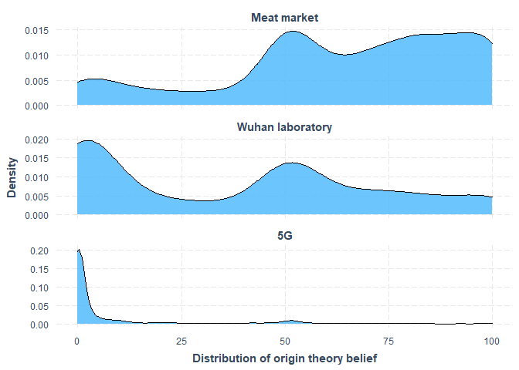

3.2.2. Motivation to Engage in Social Distancing

Four items from the Capability, Opportunity, Motivation-Behaviour (COM-B) model of behaviour change (Michie, Van Stralen, & West, 2011) were used to assess respondents’ motivation to engage in social distancing behaviours (M = 0.82, SD = 0.19, alpha = 0.87).

3.2.3. Willingness to Take a COVID-19 Vaccine

Respondents were asked “If a new vaccine were to be developed that could prevent COVID-19, would you accept it?” Three response options were available: Yes (n = 939, 67.6%), No (n = 126, 9.1%), and Maybe (n = 325, 23.4%).
3.3 Independent Variables
As with the outcomes above, we rescaled all continuous predictors to range from 0 to 1 to aid interpretation and comparison of effect sizes.

3.3.1. Conspiracy Ideation
Conspiracy mentality (Imhoff & Bruder, 2014) was measured using five items (scored on an 11-point scale from 1 ‘Certainly not 0%’ to 11 ‘Certainly 100%’), including: ‘I think that many very important things happen in the world, which the public is never informed about’; and ‘I think that events which superficially seem to lack a connection are often the result of secret activities’ (M = 0.57, SD = 0.20, alpha = 0.85).

3.3.2. Right-wing Authoritarianism

The 6-item Very Short Authoritarianism scale (Bizumic & Duckitt, 2018) was used to assess respondents’ levels of authoritarianism. Participants indicated the extent to which they agreed with statements (on a 5-point Likert scale ranging from 1 ‘strongly disagree’ to 5 ‘strongly agree’) such as follows: ‘It’s great that many young people today are prepared to defy authority’; ‘What our country needs most is discipline, with everyone following our leaders in unity’; and ‘Our society does NOT need tougher government and stricter laws’ (M = 0.51, SD = 0.17, alpha = 0.68).

3.3.3. Social Dominance Orientation

Respondents’ levels of social dominance orientation were assessed using the 8-item social dominance orientation scale (SDO-7; Ho et al. (2015). Respondents were asked the extent to which they favoured statements (on a 5-point Likert scale ranging from 1 ‘Strongly oppose’ to 5 ‘Strongly favour’) such as the following: ‘An ideal society requires some groups to be on top and others to be on the bottom’; ‘Some groups of people are simply inferior to other groups’; and ‘We should do what we can to equalize conditions for different groups’ (M = 0.36, SD = 0.18, alpha = 0.84).

3.3.4. Political Orientation

One question (adapted from the British Election Study 2017) asked respondents how they would describe their political affiliation on a 10-point scale ranging from 1 ‘left-wing’ to 10 ‘right-wing’ (M = 0.49, SD = 0.20).

3.3.5. Ethnocentrism

Two items to measure ethnocentrism were adapted from Davidov (2011): ‘The world would be a better place if people from other countries were more like the British’ and ‘Generally speaking, Britain is a better country than most other countries’. Responses were scored on 5-point Likert scales from 1 ’strongly disagree’ to 5 ’strongly agree’ (M = 0.57, SD = 0.25, alpha = 0.82).

3.3.6. Distrust in Scientists

Respondents were asked the extent to which they trusted scientists. Responses were scored on a 5-point Likert scale ranging from 1 ‘completely trust’ to 5 ‘do not trust at all’ (M = 0.34, SD = 0.25).

3.3.7. COVID-19 Related Anxiety

Respondents’ degree of specific anxiety about the COVID-19 pandemic was assessed using a single visual slider scale, ranging from 0 ‘not at all anxious’ on the left-hand side to 100 ‘extremely anxious’ on the right-hand side (M = 0.61, SD = 0.26).

3.3.8. Intolerance of Uncertainty

Respondents’ intolerance of uncertainty, which is thought to play a key role in the aetiology and maintenance of worry, was assessed using the 12-item Intolerance of Uncertainty Scale (IUS) (Buhr & Dugas, 2002). The IUS has a good construct validity (Birrell, Meares, Wilkinson, & Freeston, 2011), and recent psychometric research has shown that it is best scored as a single dimension (Shajata et al. 2018). All 12 items are scored on a 5-point Likert scale ranging from 1 ‘not at all characteristics of me’ to 5 ‘entirely characteristic of me’. The IUS has excellent internal consistency, good test–retest reliability over a five-week period, and convergent and divergent validity when assessed with symptom measures of worry, depression, and anxiety (Buhr & Dugas, 2002). (M = 0.49, SD = 0.20, alpha = 0.91)

3.3.9. Sources of Information about COVID-19

Respondents were asked to indicate, from a list of the mainstream newspapers, their preferred news source (either in print or online), as a proxy measure for quality of news source and partisan news consumption. Responses to these items were dummy coded by elite news (M = 0.38, SD = 0.48), mid-level news (M = 0.32, SD = 0.47), and tabloid news (M = 0.27, SD = 0.44). In addition, respondents were asked the extent to which they received information about COVID-19 from a) family and friends (M = 0.38, SD = 0.32) and b) social media (M = 0.30, SD = 0.32).

3.3.10. Socio-Demographic Indicators

Respondents also provided their gender, age, and gross annual household income, each of which were used for quota sampling, as well as their highest level of education (no qualifications; O-level/GCSE or similar; A-level or similar; diploma; undergraduate degree; postgraduate degree; technical qualification; or other).
4. Results
4.1. COVID-19 Origin Theories
To begin, we examine the correlations among beliefs in the respective COVID-19 origin theories. Recall, that we hypothesized that endorsement of one origin theory will be positively associated with belief in others (Hypothesis 1a). Table 3 displays the Pearson’s correlations (r) between each belief, with all estimated correlations that are statistically significant at the .05 level (two-tailed) listed in bold. Consistent with prior research, we find that the two COVID-19 conspiracy theories -- that the virus originated from a Wuhan laboratory or 5G mobile networks -- are moderately positively associated (r = 0.330). However, the meat market origin theory appears weakly negatively associated with both major conspiracy theories (Wuhan lab, r = -0.097; r = -0.041), which is contrary to previous findings on COVID-19 origin beliefs (e.g. Miller, 2020). In sum, these descriptive results suggest that there is a moderately positive association between some but not all of the COVID-19 origin theories; their content seems to matter.
Table 3: Correlations among COVID-19 origin theories
Origin Belief | Meat Market | Wuhan Lab | 5G Network
Meat Market | --
Wuhan Lab | -0.097 | --
5G Network | -0.041 | 0.330 | --
Note: N = 1,406. Cell entries are Pearson’s correlations (r). Statistically significant correlations printed in bold (two-tailed test, p < 0.05).
Next, we turn to our test of the factors that predict belief in various COVID-19 origin theories. If we are correct -- that political-psychological predispositions like RWA and SDO are important yet differential predictors of conspiracy theory endorsement depending upon their specific content -- then we should see different patterns for different conspiracy theories. To this end, we regressed each COVID-19 origin theory on political-psychological predispositions -- for example, conspiracy ideation, RWA, and SDO -- as well as several control variables outlined in the previous section, using ordinary least squares (OLS). Missing values were removed using listwise deletion. As such, we present the results of three models: Model 1 (Wuhan laboratory), Model 2 (5G network), and Model 3 (meat market).
To aid in interpretation, we present the estimated coefficients for our main political-psychological predictors(with 95% confidence intervals) across each conspiracy theory in Figure 2; the full regression results are available in Table 4 (for additional model specifications relating to the 5G origin theory, please see the Table A2 in the Supplemental Appendix). The dashed vertical line represents the null hypothesis (i.e., b = 0); plot points to the right of this vertical line indicate a positive association with belief in the listed conspiracy theory; plot points to the left, suggest a negative association. Statistically significant results correspond to estimates for which the 95% confidence intervals do not include zero (i.e., those that do not cross the dashed vertical reference line). Finally, recall that all variables have been scaled to range from 0 to 1, which means that while they are not measured in the same units, they do display the associated change in each outcome for a minimum to maximum change in the predictors. For example, a 1-unit change in RWA is equivalent to increasing from those who scored lowest to highest on the 6-item Very Short Authoritarianism scale.
Figure 2: Estimated Coefficients for Predictors on Belief in Different COVID-19 Origin Theories
- Origin Theory: Wuhan Lab
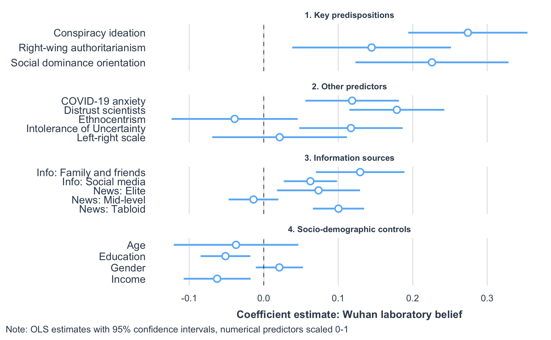
- Origin Theory: 5G Network
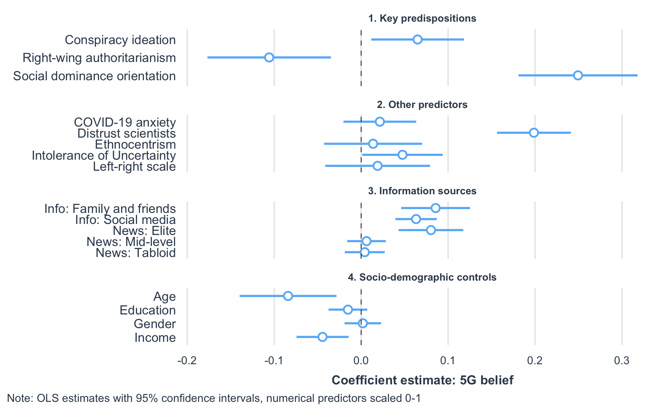
- Origin Theory: Meat Market
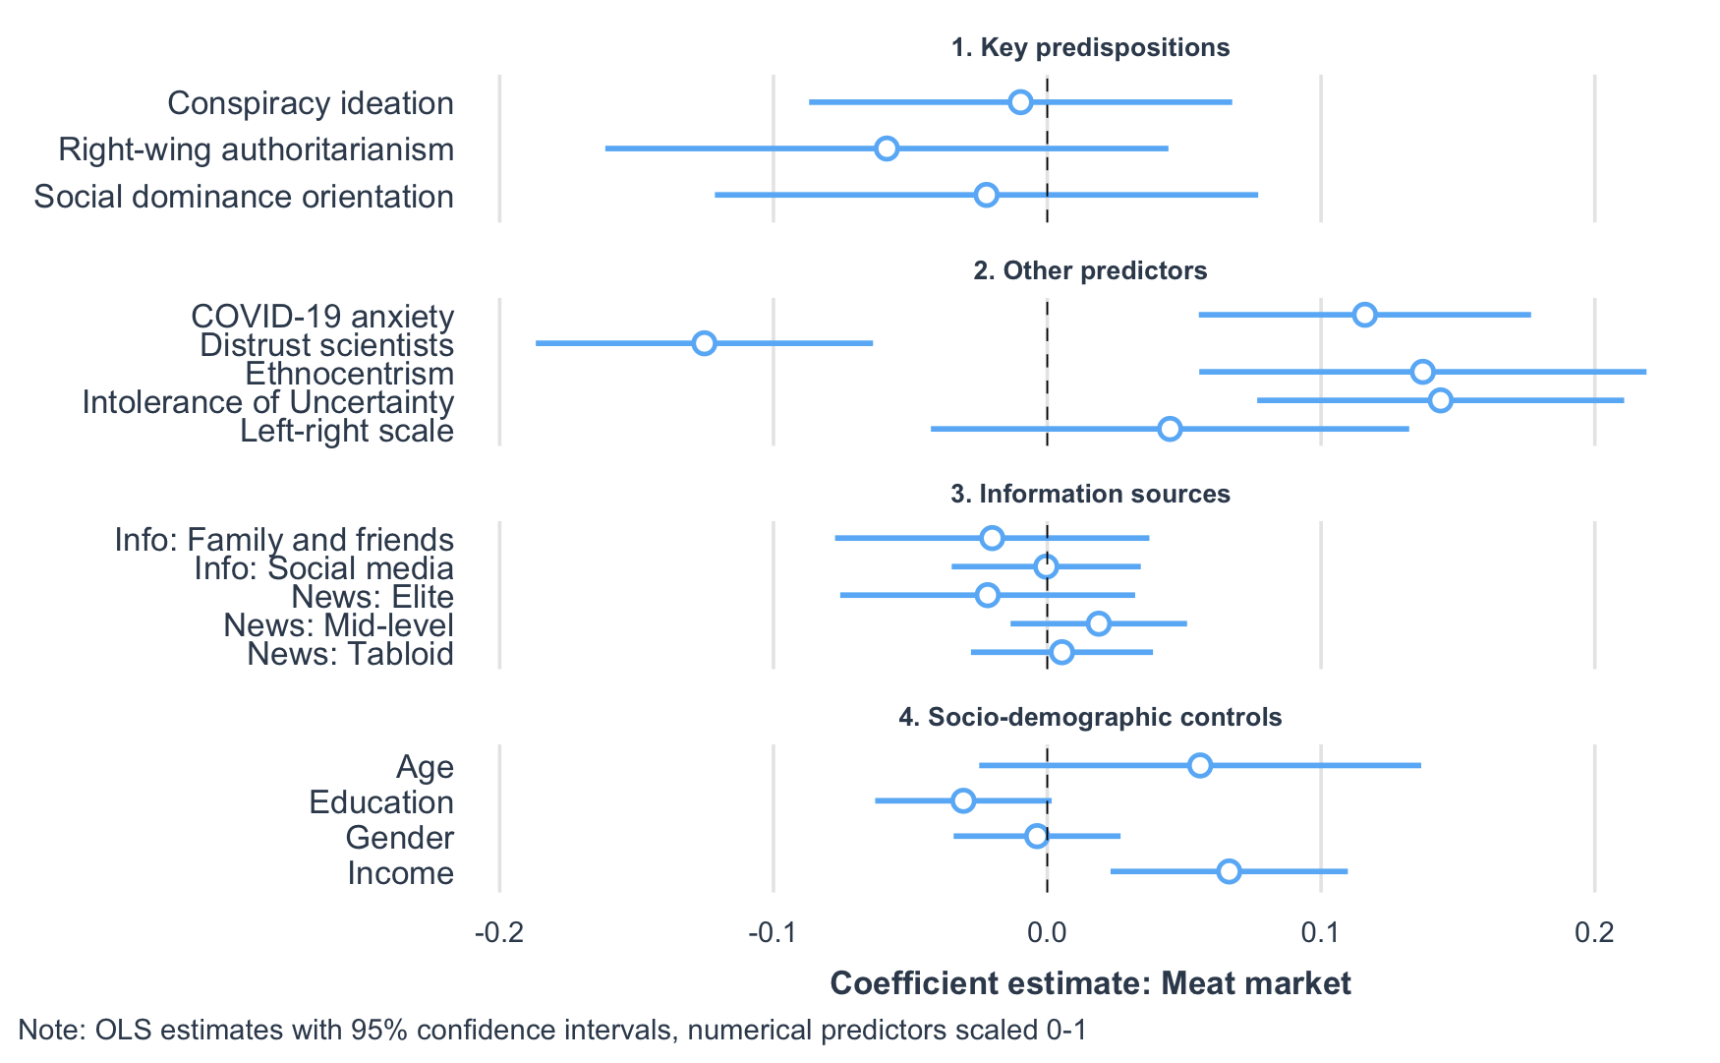
Looking at the results in Figure 2 (and Table 4), we can clearly see that different conspiracy theories have different psychological and social determinants. In other words, the pattern of coefficient plots is not consistent across panels A, B, and C. For example, conspiracy ideation has a relatively large and statistically significant effect on belief in the Wuhan laboratory origin (b = .27, se = .04, p < .001), a relatively small though still statistically significant effect on 5G belief (b = .07, se = .03, p < .05), and a near-zero, non-significant effect on meat market belief (b = -.01, se = .04, p = .81). Thus, we find some support for Hypothesis 1b, but our findings suggest the content of each origin theory conditions these effects.

Table 4: OLS Regression Results for Belief in Each COVID-19 Origin Theory
 | Dependent variable
 | Wuhan lab | 5G Network | Meat market
Conspiracy ideation | 0.274***  (0.041) | 0.065*  (0.027) | -0.010  (0.039)
RWA | 0.145**  (0.054) | -0.106**  (0.036) | -0.059  (0.052)
SDO | 0.226***  (0.052) | 0.249***  (0.035) | -0.022  (0.051)
Left-right scale | 0.021  (0.046) | 0.019  (0.031) | 0.045  (0.045)
Ethnocentrism | 0.117***  (0.035) | 0.048*  (0.024) | 0.144***  (0.034)
Distrust in scientists | 0.179***  (0.033) | 0.199***  (0.022) | -0.125***  (0.031)
COVID-19 anxiety | 0.119***  (0.032) | 0.022  (0.021) | 0.116***  (0.031)
Intolerance of uncertainty | -0.039  (0.043) | 0.014  (0.029) | 0.137**  (0.042)
Elite news | -0.014  (0.017) | 0.006  (0.011) | 0.019  (0.016)
Mid-level news | 0.100***  (0.018) | 0.004  (0.012) | 0.005  (0.017)
Tabloid news | 0.063***  (0.018) | 0.063***  (0.012) | -0.0004 (0.018)
Info: Family and friends | 0.129***  (0.030) | 0.086***  (0.020) | -0.020  (0.029)
Info: Social media | 0.074**  (0.028) | 0.080***  (0.019) | -0.022  (0.027)
Gender | 0.021  (0.016) | 0.002  (0.011) | -0.004  (0.016)
Age | -0.037  (0.043) | -0.084**  (0.028) | 0.056  (0.041)
Income | -0.063**  (0.023) | -0.044**  (0.015) | 0.066**  (0.022)
Education | -0.051**  (0.017) | -0.015  (0.011) | -0.031  (0.016)
Constant | -0.175***  (0.052) | -0.097**  (0.034) | 0.444***  (0.050)
Observations | 1,399 | 1,399 | 1,399
R2 | 0.254 | 0.235 | 0.068
Note: | *p<0.05; **p<0.01; ***p<0.001

Our regression results also provide support for Hypothesis 2, as we find statistically significant effects of both RWA and SDO on belief in the Wuhan laboratory theory (RWA: b = .15, se = .05, p < .01; SDO: b = .23, se = .05, p < .001), the latter of which has the second largest effect size in the model. As expected, the effect of SDO on 5G belief is positive and relatively large (b = .25, se = .04, p < .001), which is also substantially larger than the effect size of conspiracy ideation as previously noted. However, in line with our expectations, we find a negative effect of RWA on 5G belief (b = -.11, se = .04, p < .01), again reinforcing the notion that the content of each COVID-19 conspiracy theory motivates belief differently depending on an individuals’ underlying predispositions. Once again, RWA and SDO are not statistically significant predictors of belief in the meat market origin theory (RWA: b = -.06, se = .05, p = .26; SDO: b = -.02, se = .05, p = .66). Overall, however, our results provide support for Hypothesis 3.
It is worth noting that a number of other psychological factors also differentially predict belief in various COVID-19 conspiracy theories. For instance, ethnocentrism is a statistically significant and reasonably strong predictor of belief in all three origin theories, which we might expect given the linkages of all origin theories to China in some way or another. Likewise, distrust in scientists is a statistically significant and reasonably large predictor of Wuhan lab and 5G beliefs, but it negatively predicts endorsement of the meat market origin theory. COVID-19 anxiety predicts support for Wuhan lab and meat market beliefs, but not 5G networks, while intolerance of uncertainty only predicts support for the meat market origin theory. Again, the effect sizes vary considerably across conspiracy theories. News consumption has predictable associated effects: obtaining news from family and friends increases support for classic conspiracy theories, as does reading tabloids or other non-elite news sources. Finally, those individuals who earn less and are less educated are somewhat more likely to believe COVID-19 conspiracy theories, but again the size of the effect and its statistical significance appears to be content dependent.
Before moving on to public health attitudes, we visualize the estimated effects of our main political-psychological predispositions across all three of the COVID-19 origin theories in Figure 3. What is immediately apparent is that the predicted effects on beliefs vary considerably by predisposition and, of course, by the conspiracy theory in question.
Figure 3: Estimated Coefficients for Political-Psychological Predispositions on Belief in Different COVID-19 Origin Theories
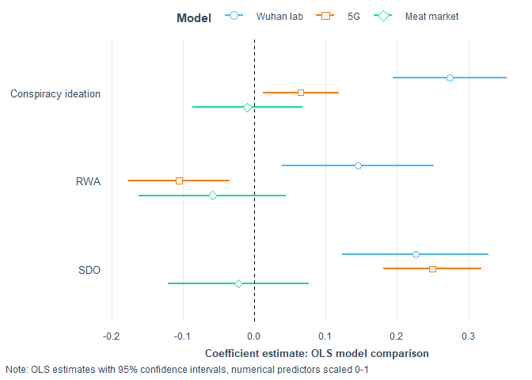

4.2. Attitudes toward Public Health
We conducted additional analyses seeking to understand the potential effect of conspiracy beliefs on attitudes towards public health policies, namely motivation to engage in social distancing and willingness to accept a COVID-19 vaccine. To this end, we regressed social distancing motivation on the predictor variables from from the previous models, plus the three COVID-19 origin theory belief scales, using OLS. The results are presented in full in Table A3 in the Supplemental Appendix. Using the same predictor variables, we conducted a multinomial logit regression on willingness to accept a vaccine, with the baseline set to ‘yes’, also presented in full in Table A3. Here, we present the unstandardized coefficients of motivation to social distance (with 95% confidence intervals) for visual inspection in Figure 4, and in Figure 5 we present the marginal effects of selected predictor variables (i.e., those that are statistically significant or theoretically interesting) in relation to respondents’ willingness to vaccinate, again with 95% confidence intervals.
Figure 4: Estimated Coefficients for Motivation to Engage in Social Distancing
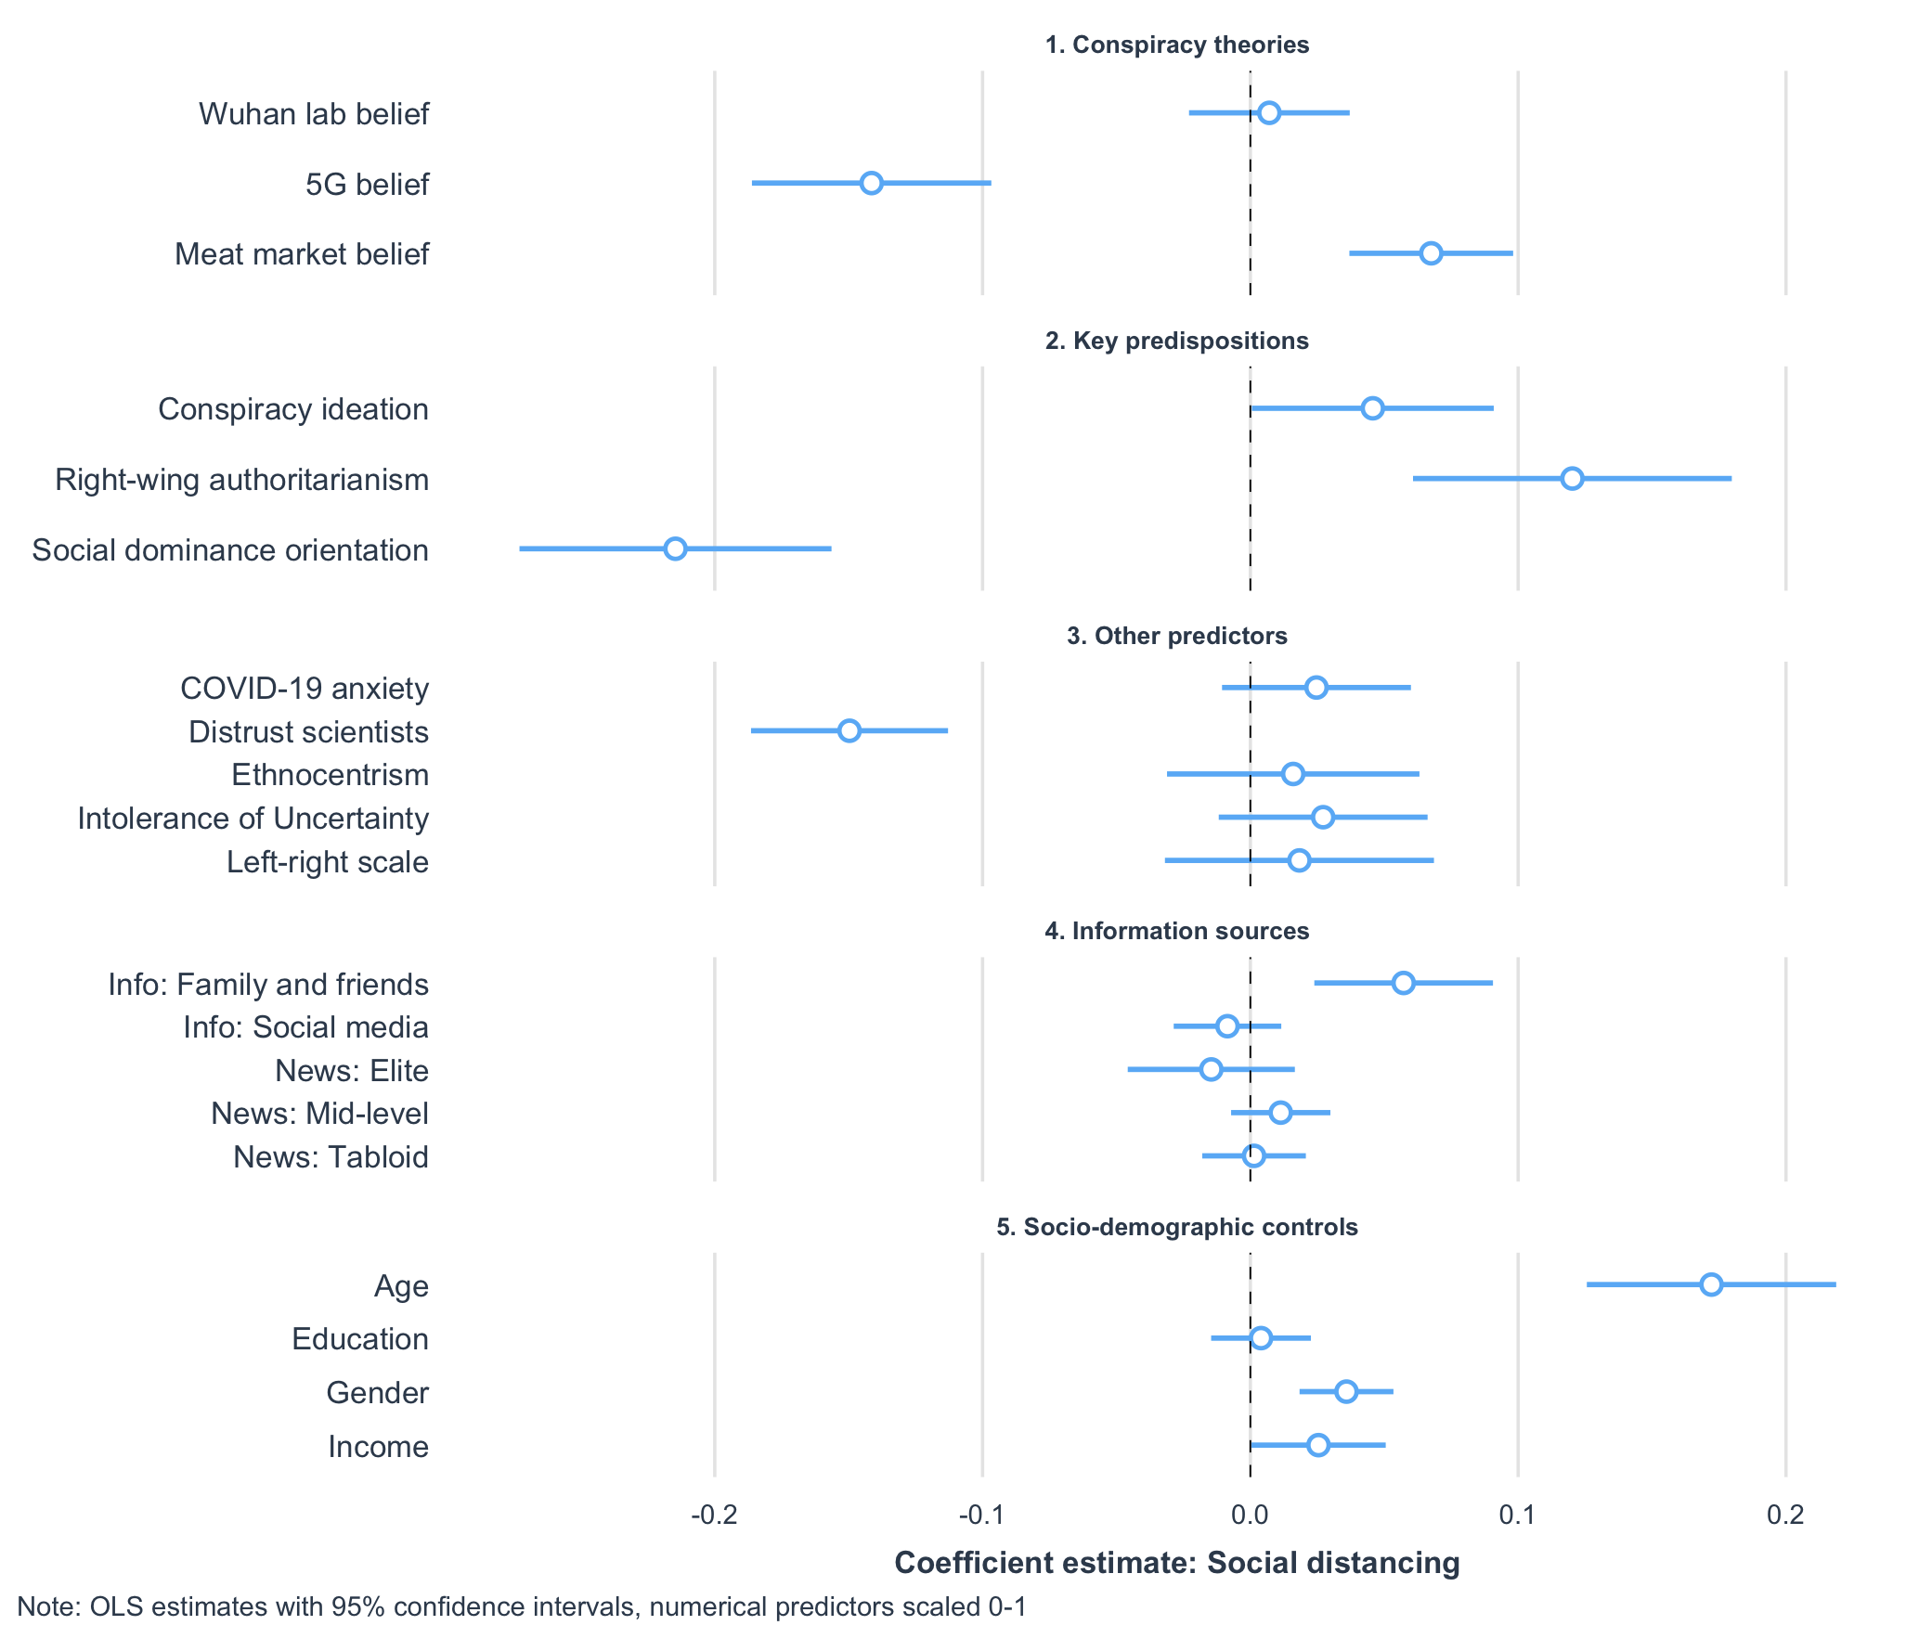

Closer inspection of Figure 4 reveals that COVID-19 conspiracy theories do affect attitudes toward public health, albeit in different directions. For instance, belief in the 5G origin theory is statistically significant and negatively associated with social distancing, accounting for a 14-point reduction in motivation. This finding is perhaps unsurprising, given that a vaccine would do little to prevent the perceived damage caused by 5G networks. By contrast, the effect of Wuhan laboratory origin belief is positively signed, near zero, very small, and not statistically significant. Thus, these results provide partial support for Hypothesis 4a, in particular where belief in the 5G theory is concerned. Belief in the meat market origin theory is positively associated with social distancing motivations, though the estimate is relatively small at 7 percentage points. While the effect of general conspiracy ideation is also positive, equivalent to a 5 percentage point increase, this predictor just falls below a threshold for statistical significance.
Interestingly, the largest relative effects on motivations to social distance are observed from the key political-psychological predispositions. For example, SDO is associated with a large and statistically significant reduction in motivation, accounting for a 21-point decrease in social distancing. In contrast, RWA is associated with a relatively large and statistically significant increase in motivation, representing a 12-point increase in this outcome. Finally, distrust in scientists decreases motivation (by 15 points), while age increases it (by 17 points).These results suggest that certain factors may have a direct effect on social distancing, for instance by reducing empathy or stimulating scepticism towards scientific advice (Bentley and Cowan, 2021; Eiser et al., 2009).
Figure 5: Marginal effects of selected predictors on willingness to take a vaccine
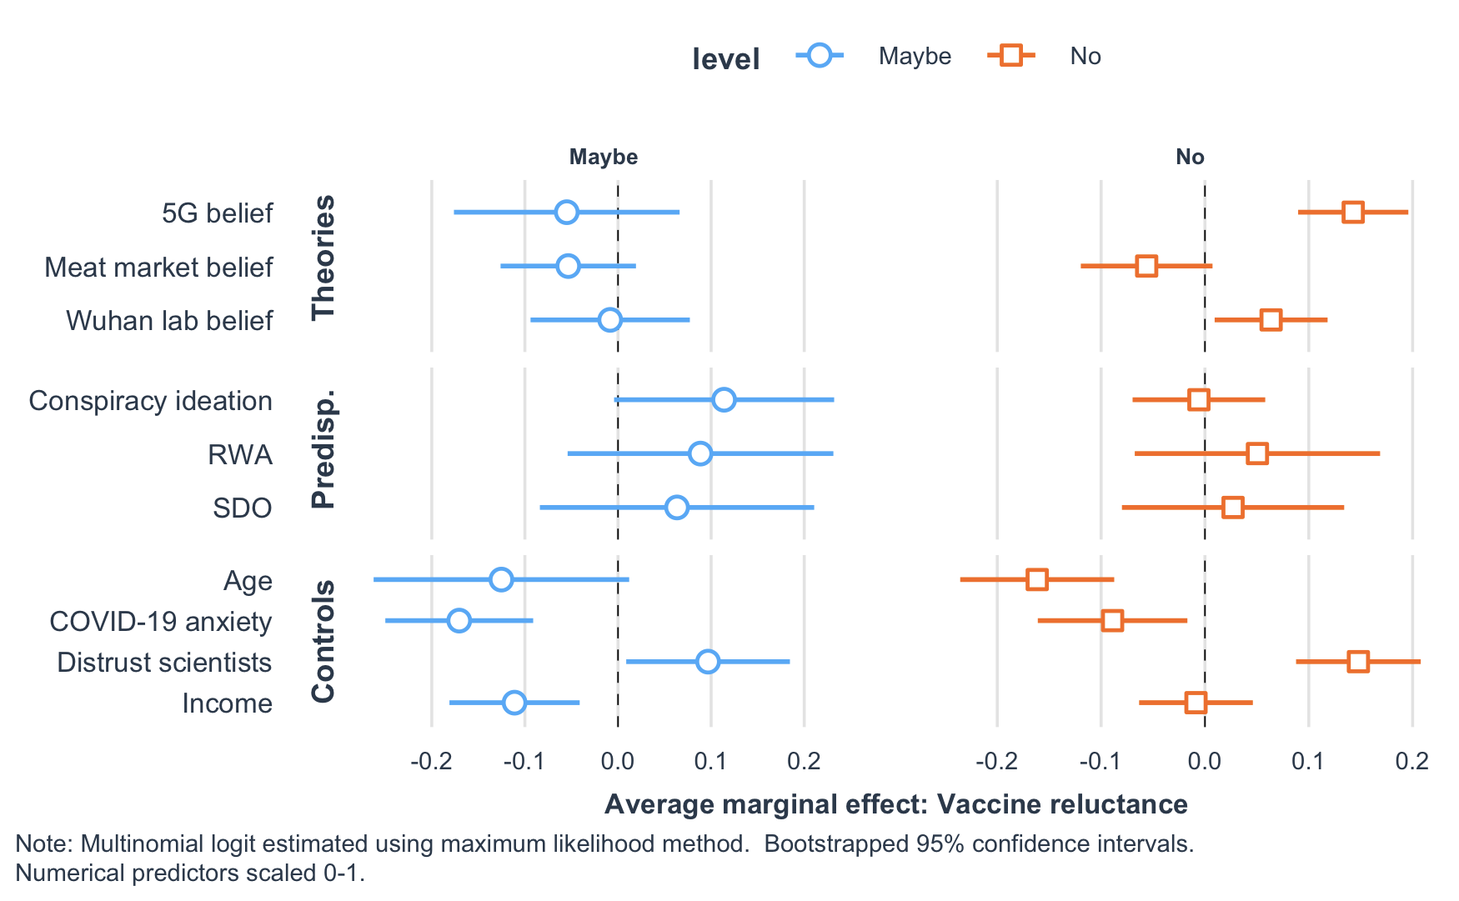

Looking at the plotted marginal effects from the willingness to vaccinate models (in Figure 5), we see that belief in both the 5G and Wuhan lab conspiracy theories is associated with a statistically significant increase in vaccine reluctance (i.e., responding ‘no’). We also present the full set of relative risk ratios and average marginal effects from these models in the Appendix (see Table A4). Political-psychological predispositions like conspiracy ideation, RWA, and SDO, however, do not appear to be associated with a statistically significant direct effect on willingness to vaccinate. Belief in the meat market theory is negatively signed but not statistically significant for both vaccine rejection and vaccine hesitancy. Overall, we consider the results as providing support for Hypothesis 4b. We should also note that other factors like age, income, and COVID-19 anxiety decrease vaccine reluctance, while distrust in scientists appears to increase it.

Table 5: Summary findings from our hypothesis tests
Hypothesis | Results
Endorsement of one COVID-19 conspiracy theory will correlate with endorsement of another (Hypothesis 1a) | Supported
Conspiracist ideation will be positively associated with belief in COVID-19 origin theories (Hypothesis 1b) | Supported
RWA and SDO will be positively associated with belief in the Chinese lab origin theory (Hypothesis 2) | Supported
SDO will be positively associated with the 5G origin theory (Hypothesis 3) | Supported
Belief in COVID-19 conspiracy theories will be negatively associated with social distancing motivation (Hypothesis 4a) | Partially supported - belief in 5G origin theory negatively associated with social distancing motivation, but no effect of Wuhan laboratory belief
Belief in COVID-19 conspiracy theories will be positively associated with vaccine rejection (Hypothesis 4b) | Supported

5. Discussion

In this study we have tested hypotheses regarding the factors that predict COVID-19 origin theories, including two that we think fit the definition of a conspiracy theory (i.e., the virus originated in a Chinese laboratory and the current pandemic has been caused by 5G wireless technology), as well as one plausible, yet contested origin theory (i.e, the virus originated in a Wuhan meat market). We also studied the implications of these conspiracy theories for attitudes toward public health: 1) Motivation to engage in social distancing, and 2) willingness to accept a COVID-19 vaccine. The results of these hypothesis tests are summarised in Table 5. Overall, our results provide support for the notion that belief in COVID-19 conspiracy theories is associated with political-psychological predispositions that align with the specific content of each origin theory. Our results also highlight the negative consequences of conspiracy theories for effective public health interventions.

Previous research has found that there is a general disposition to believe in conspiracy theories, which has sometimes been referred to as a “conspiracy mentality” (Goertzel, 1994; Bruder et al. 2013). Our findings are consistent with this literature, as we report that a general measure of conspiracy ideation is associated with the Wuhan lab theory albeit less so with the 5G theory. Yet, our findings also raise some questions about the monological belief system model of conspiracy theories, at least in the case of COVID-19, as well as the explanatory power of conspiracy mentality to predict subsequent behaviours (Miller, 2020; Imhoff and Lamberty, 2020). In both of our conspiracy theory models, the effect size of conspiracy ideation is smaller than the findings of recent studies that also control for political predispositions like partisanship (e.g. see Uscinski et al., 2020). Of course, differences in effect sizes across studies could be partly due to differences in research design, measures, and analyses’ for example Uscinski et al. (2020) used belief that the virus was purposefully made and spread as their outcome variable, whereas we look at COVID-19 origin theories that may be intentional but differ in terms of their potential plausibility and the nature of the implied threat.

We argue, however, that it is this latter source of variation--and the specific content of the theories themselves--that underlies our primary contribution: Different conspiracy theories have different psychological and social determinants. Both RWA and SDO are strong predictors of belief in the Wuhan laboratory conspiracy theory, while belief in the 5G conspiracy theory is only positively associated with SDO; RWA, in fact, decreases endorsement in 5G belief. Our findings suggest these underlying predispositions may motivate differential beliefs depending upon, for example, the specific threats triggered by the content of a conspiracy theory, though we acknowledge we do not measure this directly.

Our differential findings between RWA and COVID-19 conspiracy theories is inconsistent with previous research suggesting a positive association between authoritarianism and conspiracy theories, in general (Bruder et al. 2013; Richey, 2017); however, our results are in line with more recent work that indicates a susceptibility of those high in RWA to conspiracy theories conforming to their worldview (Wood and Gray, 2019). For instance, RWA has shown to be associated with pro-military positions, and those high in RWA are particularly sensitive to threats to both security and the social order (Pratto et al. 1994; Doty et al. 1997; Terrizzi and Drews, 2005; McFarland and Mathews, 2005; Crowson et al. 2006; Jackson and Gaaertner, 2010; McFarland, 2015; Lindén et al. 2018). In this respect, a susceptibility of those high in RWA to a specific belief in the Wuhan lab (i.e., bioweapons) theory seems logical.

A similar case was put forward for why those high in SDO would be specifically susceptible to the Wuhan lab theory; however, SDO also predicted belief in the 5G conspiracy theory. While it might seem unexpected that this preference should be associated with conspiracy belief, previous research has reported a similar magnitude of association to that reported here (e.g., see Bruder et al. 2013), and recent research has reported a moderate positive association between SDO and belief COVID-19 that was man-made (Imhoff and Lamberty, 2020). As suggested in our theoretical discussion above, this association may be indicative of a relationship between SDO and anti-establishment conspiracy belief, in which conspiracy accounts are more plausible for those that see the world as naturally hierarchical, ruthless, and a “dog-eat-dog” competition (De keersmaeker and Roets, 2019). Perhaps, then, a theory in which the UK government has risked or deliberately compromised the health of the population to get ahead technologically, or in which the negative health effects of 5G are hidden as part of a corporate cover-up, might seem more plausible to those high in SDO. Moreover, although this is speculative, the present study cannot rule out the possibility that the responses given by those high in SDO are expressive rather than truthful responses (e.g., see Hartman & Newmark, 2012; Richey, 2017). In other words, perhaps those high in SDO are reporting a belief in the 5G theory due to a desire to express a related opinion that they hold, rather than because they truly believe 5G causes COVID-19. Those high in SDO are particularly sensitive to the economic threat of outgroups and are motivated towards socio-economic dominance (Craig and Richeson, 2014; Ho et al. 2015); it is therefore conceivable that those high in SDO are expressing an attitude about the reliance on Chinese technology during the development of the 5G network, or a more indirect sense of threat from the economic consequences inherent to national lockdowns. It is also possible that the link between 5G and China is more salient to those high in SDO, and their response here is motivated by prejudice (Duckitt, 2001; Ho et al. 2015). Alternatively, perhaps indicating belief in conspiracies in this context is related to a deeper desire to spread conspiracy beliefs, which fits with Lobato et al.’s (2020) findings.

Amongst our other predictors, distrust in scientists was a strong predictor of both Wuhan laboratory and 5G belief, consistent with previous research suggesting trust in sources is a key motivator of subsequent behaviour, but that trust in knowledgeable experts may be undermined where they are perceived as withholding information or possessing ulterior motives (Eiser et al., 2009). Similarly, the influence of political and informational factors on the perceived plausibility of COVID-19 origin theories draws attention to the fact that conspiracy theories are to some extent social phenomena (Kreko, 2015). Both conspiracy theories were associated with obtaining information about the pandemic from family and friends and tabloid newspapers, and 5G belief was uniquely predicted by receiving information from social media.

The more plausible meat market origin theory differed from both of the conspiracy theories by being positively associated with intolerance of uncertainty, which we would expect, whereas this construct had no effect on the conspiracy theories. This is perhaps a counterintuitive finding given evidence of the role uncertainty plays in conspiracy belief (e.g. van Prooijen and Jostmann, 2013). However, it is notable that one mechanism through which uncertainty affects conspiracy belief is through over-attentiveness to prior judgements of the morality of conspiracy protagonists (ibid.), which may not be a salient factor for people’s judgements of the protagonists in our conspiracy theories, such as the 5G network. Moreover, the effect of uncertainty in these studies was demonstrated on conspiracies involving political and military espionage that posed no direct threat to the participants (ibid.), whereas we have argued the Wuhan laboratory and 5G origin theories may motivate belief via predispositions due to an increased sense of normative threat.

In addition to revealing general and specific influences on theories about the origins of the COVID-19 virus, our findings also reveal the effects of these theories on willingness to take part in public health interventions. Our findings provide an interesting comparison to those of recent studies that found that belief the virus was a hoax, but not belief the virus was man-made, reduced social distancing compliance, and that conspiracy mentality negatively predicted compliance with self-isolation to prevent transmission (Imhoff and Lamberty, 2020; Marinthe et al., 2020). Willingness to comply with social distancing was positively associated with the meat market theory but negatively with the 5G theory, despite the content of a number of 5G conspiracy theories which implied the virus is man-made. In addition, we find a small positive effect of conspiracy ideation on social distancing. Rather, our findings may suggest the more salient factor for social distancing is whether the conspiracy implies human transmission. The lack of effect for the Wuhan laboratory theory is congruent with this assertion, given it still implies human transmission. Nevertheless, these reflections on our results are largely exploratory and a matter for further research as they provide nuance on our initial hypothesis that conspiracy belief would be negatively associated with social distancing. Both conspiracy theories were also associated with skepticism about vaccines, perhaps reflecting the fact that these theories are both strongly associated with distrust in scientists or the established relationship between conspiracy belief and rejection of the biomedical model (Lamberty and Imhoff, 2018). These observations highlight the fact that conspiracy theories are a potentially severe threat to public health.

Our study has a number of strengths and limitations that must be acknowledged. The main strengths were a large, representative sample of the UK population, who had provided a rich dataset encompassing social, demographic, psychological, and political variables. The major limitations were that we had measurements of only three origin theories, which means that we differ from recent research that explicitly models belief that the virus is a hoax (Imhoff and Lamberty, 2020; Uscinski et al., 2020), although as noted above, for some believers in the 5G theory this may be implied. Also, our COVID-19 origin theory measures were observational and cross-sectional, limiting our ability to make stronger causal inferences.

Finally, the findings we outline may be relatively bounded by context, which potentially limits their generalizability. In the first instance, the relationship between predispositions and conspiracy belief, we have argued, will be partly dependent upon the sense of threat implied by conspiracy content. But further than this, Marinthe et al. (2020) find conspiracy mentality reduces compliance with preventative public health behaviours primarily when they are mandated by authorities, rather than aversion to the behaviour itself. In a similar sense, the aversion to social distancing and vaccination we find among conspiracy theory believers may be partly mediated by a rejection of government mandates, as opposed to the specific behaviours per se. It is plausible that in a context where social distancing and vaccination are not normatively encouraged by government that the relationship with conspiracy belief would be suppressed, though it is unlikely to completely disappear, given the anti-scientific themes running through many conspiracy theories.

Yet, we would argue an important implication of our work is the need for public health agencies to consider conspiracy theories in their planning and interventions that might mitigate these effects. Despite evidence of relative stability, neither SDO nor RWA are immutable; rather, we have argued that they are predispositions that are sensitive to the current context, including the salience of perceived threats to the social order and security of the ingroup (Duckitt and Sibley, 2016:192,199; Stenner, 2005: 14-19). Interventions will therefore need to be part of multifaceted strategies that reflect the complexity of conspiracy theory proliferation, as well as how they might interact with predispositions, with interventions targeted at both the purposeful propagators of conspiracy theories and the susceptible receivers of misinformation. For example, Uscinksi et al. (2020) have recently argued that if partisan cues exacerbate the propagation of conspiracy beliefs (at least in the US), then partisanship may also be mobilised to provide corrective information. While we find no effect of political orientation in our work, there are parallels in that perhaps the group identities salient to people high in RWA and SDO can be mobilised, for instance by having trusted sources within sceptical communities help seed reliable information. The feasibility and efficacy of strategies, given the strongly held prior beliefs of such groups, remains an open question for both practitioners and researchers.

Concerning susceptible receivers, research has demonstrated some success in ‘inoculating’ people against conspiracy theories, either by being pre-warned about them or by taking part in exercises, for example presented as computer games, in which they are asked to generate ‘fake news’ themselves (see van der Linden et al. 2020). Strategies such as these may be amenable to mass dissemination but this would require public health agencies to include the tracking of conspiracy theories in their pandemic planning and be ready to intervene as widely as possible at the earliest opportunity.

6. References
Ahmed, W., Vidal-Alaball, J., Downing and J., López Segui, F. (2020). “COVID-19 and the 5G Conspiracy Theory: Social Network Analysis of Twitter Data.” Journal of Medical Internet Research. 22(5), e19458. doi: 10.2196/19458
Altemeyer, B. (1981) Right-wing Authoritarianism, University of Manitoba Press, Manitoba, Canada
Bai, H., (2020). “Whites’ racial identity centrality and social dominance orientation are interactively associated with far-right extremism.” British Journal of Social Psychology. 59, 387-404. DOI:10.1111/bjso.12350
BBC (2020). Coronavirus: Trump stands by China lab origin theory for virus [online]. BBC. [Viewed 13 December 2020]. Available from: https://www.bbc.com/news/world-us-canada-52496098
Bellemare, M. F. & Wichman, C. J., (2020). Elasticities and the Inverse Hyperbolic Sine Transformation. Oxford Bulletin of Economics and Statistics. 82:1, 50-61. doi: 10.1111/obes.12325
Bentley, L. A. & Cowan, D. G., (2021). “The socially dominant troll: Acceptance attitudes towards trolling”. Personality and Individual Differences. 173. DOI:10.1016/j.paid.2021.110628
Boudry, M. (2020, September 8). The warped epistemology of conspiracy theories. Blog of the American Philosophical Association. Retrieved from: https://blog.apaonline.org/2020/09/08/the-warped-epistemology-of-conspiracy-theories/
Brown, S. (2009). The new deficit model. Nature Nanotechnology, 4, 609-611.
Bruns, A., Harrington, S. and Hurcombe, A. (2020). “‘Corona? 5G? or both?’: the dynamics of COVID-19/5G conspiracy theories on Facebook”. Media International Australia. 177(1), 12-29. DOI: 10.1177/1329878X20946113
Burbidge, J. B., Magee, L. and Robb, A. L. (1988). Alternative transformations to handle extreme values of the dependent variable. Journal of the American Statistical Association, 83(401), 123-127.
Caudill, S. B. (1988). Type I errors after preliminary tests for heteroscedasticity. Journal of the Royal Statistical Society. 37(1), 65-68. doi:10.2307/2348380
Chaiken, S., & Trope, Y. (Eds.). (1999). Dual-process theories in social psychology. Guilford Press.
Crowson, H., and Brandes, J. (2017) “Differentiating Between Donald Trump and Hillary Clinton Voters Using Facets of Right-Wing Authoritarianism and Social-Dominance Orientation: A Brief Report” Psychological Reports, 120:3, 364-373
Crowson, M., Debacker, T., and Thoma, S. (2006) “The Role of Authoritarianism, Perceived Threat, and Need for Closure or Structure in Predicting Post-9/11 Attitudes and Beliefs” The Journal of Social Psychology, 146:6, 733-750
Darwin, H., Neave, N. and Holmes, J. (2011). “Belief in conspiracy theories. The role of paranormal belief, paranoid ideation and schizotypy”. Personality and Individual Differences. 50, 1289-1293. doi:10.1016/j.paid.2011.02.027
De keersmaecker, J. & Roets, A. (2019) “Is there an ideological asymmetry in the moral approval of spreading misinformation by politicians?” Personality and Individual Differences, 143, 165-169
Dhanani, L.Y. and Franz, B. (2020). “The Role of News Consumption and Trust in Public Health Leadership in Shaping COVID-19 Knowledge and Prejudice”. Frontiers in Psychology. 11:560828. doi: 10.3389/fpsyg.2020.560828
Diaz-Veizades, J., Widaman, K., Little, T., and Gibbs, K. (1995) “The Measurement and Structure of Human Rights Attitudes” The Journal of Social Psychology, 135:3, 313-328
Ditto, P. H and Lopez, D. H. (1992). “Motivated Skepticism: Use of Differential Decision Criteria for Preferred and Nonpreferred Conclusions”. Journal of Personality and Social Psychology. 63(4), 568-584.
Doty, R., Peterson, M., and Kemmelmeier, M. (1997) “Authoritarianism and American Students’ Attitudes About the Gulf War, 1990-1996” PSPB, 23:11, 1133-1143
Douglas, K., Sutton, R. M. & Cichocka, A. (2019). Belief in conspiracy theories: Looking beyond gullibility. In J. Forgas & R. Baumeister (Eds.) The Social Psychology of Gullibility: Conspiracy Theories, Fake News and Irrational Beliefs. Routledge.
Drummond, C. & Fischhoff, B. (2017). Individuals with greater science literacy and education have more polarized beliefs on controversial science topics. Proceedings of the National Academy of Sciences, 114(36), 9587-9592. doi:10.1073/pnas.1704882114
Duckitt, J. (2001) “A dual-process cognitive-motivational theory of ideology and prejudice” Advances in Experimental Social Psychology, 33, 41-133
Duckitt, J., & Sibley, C. (2016). The Dual Process Motivational Model of Ideology and Prejudice. In C. Sibley & F. Barlow (Eds.), The Cambridge Handbook of the Psychology of Prejudice (Cambridge Handbooks in Psychology, 188-221). Cambridge: Cambridge University Press. doi:10.1017/9781316161579.009
Dyrendal, A., Kennair, L. E. O. & Bendixen, M., (2021). “Predictors of belief in conspiracy theory: The role of individual differences in schizotypal traits, paranormal beliefs, social dominance orientation, right wing authoritarianism and conspiracy mentality.” Personality and Individual Differences. 173. doi:10.1016/j.paid.2021.110645
Eiser, J. R., Stafford, T., Henneberry, J., and Catney, P. (2009). ““Trust me, I’m a Scientist Not a Developer)”: Perceived Expertise and Motives as Predictors of Trust in Assessment of Risk from Contaminated Land”. Risk Analysis. 29(2), 288-297. doi:10.1111/j.1539-6924.2008.01131.x
Faragó, L., Kende, A., and Krekó, P. (2019) “Justification of intergroup violence – the role of right-wing authoritarianism and propensity for radical action” Dynamics of Asymmetric Conflict, 12:2, 113-128
Franks, B., Bangerter, A., Bauer, M. W., Hall, M. & Noort, M. C. (2017). Beyond “monologicality”? Exploring conspiracist worldviews. Frontiers in Psychology, 8, 861. doi:10.3389/fpsyg.2017.00861
Green, R. & Douglas, K. M. (2018) “Anxious attachment and belief in conspiracy theories” Personality and Individual Differences, 125, 30-37
Goertzel, T. (1994). Belief in conspiracy theories. Political Psychology, 15, 731–742.
Hatcher, W. (2020). A Failure of Political Communication Not a Failure of Bureaucracy: The Danger of Presidential Misinformation During the COVID-19 Pandemic. American Review of Public Administration. 50(6-7), 614–620. doi: 10.1177/0275074020941734
Henley, J., & McIntyre, N. (2020, October 26). Survey uncovers widespread belief in 'dangerous' Covid conspiracy theories. The Guardian. Retrieved from: https://www.theguardian.com/world/2020/oct/26/survey-uncovers-widespread-belief-dangerous-covid-conspiracy-theories
Ho, A. K., Sidanuis, J., Kteily, N., Sheehy-Skeffington, J., Pratto, F., Henkel, K. E., Foels, R., & Stewart, A. L. (2015) “The nature of social dominance orientation: Theorizing and measuring preferences for intergroup inequality using the new SDO₇ scale” Journal of Personality and Social Psychology, 109:6, 1003-28
Ibbetson, R., (2020). “Did coronavirus originate in Chinese government laboratory? Scientists believe killer disease may have begun in research facility 300 yards from Wuhan wet fish market”. Daily Mail Online [online]. [Viewed 09 March 2021]. Available from: https://www.dailymail.co.uk/news/article-8009669/Did-coronavirus-originate-Chinese-government-laboratory.html
Imhoff, R., & Bruder, M. (2014) “Speaking (Un‐)Truth to Power: Conspiracy Mentality as a Generalised Political Attitude” European Journal of Personality, 28:1, 25-43
Imhoff, R., & Lamberty, P. K. (2017). “Too special to be duped: Need for uniqueness motivates conspiracy beliefs.” European journal of social psychology, 47:6, 724-734.
Imhoff, R., & Lamberty, P., (2020). “A Bioweapon or a Hoax? The Link Between Distinct Conspiracy Beliefs About the Coronavirus Disease (COVID-19) Outbreak and Pandemic Behavior.” Social Psychological and Personality Science. 11:8, 1110-1118. DOI: 10.1177/1948550620934692
Jackson, L., Gaaertner, L. (2010) “Mechanisms of Moral Disengagement and Their Differential Use by Right-Wing Authoritarianism and Social Dominance Orientation in Support of War” Aggressive Behaviour, 36, 238-250
Jolley, D. and Paterson, J. L. (2020) “Pylons ablaze: Examining the role of 5G COVID-19 conspiracy beliefs and support for violence”. British Journal of Social Psychology. 59, 628-640. doi:10.1111/bjso.12394
Kahan, D. M. (2012). Ideology, motivated reasoning, and cognitive reflection: An experimental study. Judgment and Decision making, 8, 407-24.
Kauff, M., Asbrok, F., Issmer, C., Thörner, S., and Wagner, U. (2015) “When immigrant groups “misbehave”: The influence of perceived deviant behaviour on increased threat and discriminatory intentions and the moderating role of right-wing authoritarianism” European Journal of Social Psychology, 45, 641-652
Kreko, P., (2015). “Conspiracy theory as collective motivated cognition.” In M. Bilewicz, A. Cichocka, & W. Soral (Eds.). The psychology of conspiracy. Routledge, 62-75.
Kunda, Z. (1990). The case for motivated reasoning. Psychological Bulletin, 108(3), 480.
Lamberty, P., & Imhoff, R. (2018). “Powerful pharma and its marginalized alternatives? Effects of individual differences in conspiracy mentality on attitudes toward medical approaches.” Social Psychology. 48:5, 255–270. doi: 10.1027/1864-9335/a000347
Leman, P. J. & Cinnirella, M. (2007). A major event has a major cause: Evidence for the role of heuristics in reasoning about conspiracy theories. Social Psychological Review, 9, 18-28.
Lindén, M., Björklind, F., and Bäckström, M. (2018) “How a terror attack affects right-wing authoritarianism, social dominance orientation, and their relationship to torture attitudes” Scandinavian Journal of Psychology, 59, 547-552
Lobato, E. J. C., Powell, M., Padilla, L. M. K., & Holbrook, C. (2020) “Factors Predicting Willingness to Share COVID-19 Misinformation” Frontiers in Psychology [Available via: https://doi.org/10.3389/fpsyg.2020.566108]
Lynas, M. (2020, April 20). COVID: Top 10 current conspiracy theories. Cornell Alliance for Science [Blog post]. Retrieved from: https://allianceforscience.cornell.edu/blog/2020/04/covid-top-10-current-conspiracy-theorie
MacKinnon, J. G. & Magee, L., (199). “Transforming the Dependent Variable in Regression Models”. International Economic Review. 31:2, 315- 339.
Marinthe, G., Brown, G., Delouvee, S. and Jolley, D., (2020). “Looking out for myself: Exploring the relationship between conspiracy mentality, perceived personal risk, and COVID-19 prevention measures.” British Journal of Health Psychology. 25, 957-980. DOI:10.1111/bjhp.12449
McFarland, S. (2015) “Culture, Individual Differences, and Support for Human Rights: A General Review” Peace and Conflict: Journal of Peace Psychology, 21:1, 10-27
McFarland, S., and Mathews, M. (2005) “Who Cares about Human Rights?” Political Psychology, 26:3, 365-285
McGreal, C. (2020, May 14). A disgraced scientist and a viral video: How a Covid conspiracy theory started. The Guardian, Retrieved from: https://www.theguardian.com/world/2020/may/14/coronavirus-viral-video-plandemic-judy-mikovits-conspiracy-theories
Miller, J. M. (2020). Do COVID-19 conspiracy theory beliefs form a monological belief system? Canadian Journal of Political Science, 53, 319–326. doi:10.1017/S0008423920000517
Miller, J. M., Saunders, K. L., & Farhart, C. E. (2016). Conspiracy endorsement as motivated reasoning: The moderating roles of political knowledge and trust. American Journal of Political Science, 60(4), 824-844.
Natoli, E. E. and Marques, M. D. (2020). “The antidepressant hoax: Conspiracy theories decrease health-seeking intentions”. British Journal of Social Psychology. DOI:10.1111/bjso.12426
Nyhan, B., Reifler, J., Richey, S., and Freed, G. L. (2014). “Effective Messages in Vaccine Promotion: A Randomized Trial”. Pediatrics. 133(4), e835. DOI: 10.1542/peds.2013-2365
Pratto, F., Sidanius, J., Stallworth, L., and Bertram., F. (1994) “Social dominance orientation: A personality variable prediction social and political attitudes” Journal of Personality and Social Psychology, 67:4, 741-763
Richey, S. (2017) “A Birther and a Truther: The Influence of the Authoritarian Personality on Conspiracy Beliefs” Politics & Policy, 45:3, 465-485
Rischel, C. (2020, March 24). Goop expert says coronavirus doesn’t exist: ‘There is potentially no such thing.’ The Independent. Retrieved from: https://www.independent.co.uk/life-style/goop-coronavirus-kelly-brogan-expert-contributor-md-deaths-covid-19-a9421476.html
Roozenbeek, J. & van der Linden, S. (2018). The fake news game: actively inoculating against the risk of misinformation. Journal of Risk Research, 22(5), 570-580.
Roozenbeek, J. & van der Linden, S. (2019). Fake news game confers psychological resistance against online misinformation. Palgrave Communications, 5(65), 1-10.
Shaffer, B., and Duckitt, J. (2013) “The dimensional structure of people’s fears, threats, and concerns and their relationship with right-wing authoritarianism and social dominance orientation” International Journal of Psychology, 48:1, 6-17.
Sibley, C., Robertson, A., and Wilson, M. (2006) “Social Dominance Orientation and Right-Wing Authoritarianism” Political Psychology, 27:5, 755-768.
Sniderman, P. M., Hagendoorn, L. & Prior, M., (2004). “Predisposing Factors and Situational Triggers: Exclusionary Reactions to Immigrant Minorities”. American Political Science Review. 98:1, 35-49.
Stenner, K., (2005). The Authoritarian Dynamic. Cambridge University Press: New York.
Sturm, T. and Albrecht, T. (2020): “Constituent Covid-19 apocalypses: contagious conspiracism, 5G, and viral vaccinations”. Anthropology & Medicine. doi: 10.1080/13648470.2020.1833684
Sullivan, D., Landau, M. J. and Rothschild, Z. K. (2010). “An Existential Function of Enemyship: Evidence That People Attribute Influence to Personal and Political Enemies to Compensate for Threats to Control”. American Psychological Association. 98(3), 434-449. doi: 10.1037/a0017457
Swami, V., Furnham, A., Smyth, N., Weis, L., Laye, A. and Clow, A. (2016). “Putting the stress on conspiracy theories: Examining associations between psychological stress, anxiety, and belief in conspiracy theories.” Personality and Individual Differences. 99, 72-76. doi: 10.1016/j.paid.2016.04.084
Swami, V., Voracek, M., Stieger, S., Tran, U. S., and Furnham, A. (2014). “Analytic thinking reduces belief in conspiracy theories”. Cognition. 133(3), 572-585. doi:10.1016/j.cognition.2014.08.006
Taber, C. S., & Lodge, M. (2006). Motivated skepticism in the evaluation of political beliefs. American Journal of Political Science, 50(3), 755-769.
Tappin, B. M., van der Leer, L. & McKay, R. T. (2017). The heart trumps the head: Desirability bias in political belief revision. JEP: General, 146(8), 1143-1149. doi: 10.1037/xge0000298.
Terrizzi, J., and Drews, D. (2005) “Predicting Attitudes Toward Operation Iraqi Freedom” Psychological Reports, 96, 183-189.
Uscinski, J. E., Douglas, K. and Lewandowsky, S. (2017). “Climate Change Conspiracy Theories.” Oxford Research Encyclopedias, Climate Science. https://doi.org/10.1093/acrefore/9780190228620.013.328
Uscinski, J. E., Enders, A. M., Klofstad, C. A., Seelig, M. I., Funchion, J. R., Everett, C., Wuchty, S., Premaratne, K., & Murthi, M. N., (2020). “Why do people believe COVID-19 conspiracy theories?”. Harvard Kennedy School (HKS) Misinformation Review. https://doi.org/10.37016/mr-2020-015
Uscinski, J. E., & Parent, J. M. (2014). American conspiracy theories. New York: Oxford University Press.
van der Linden, S., Panagopoulos, C., Azevedo, F., and Jost, J. T. (2020). The paranoid style in American politics revisited: an ideological asymmetry in conspiratorial thinking. Polit. Psychol. [Preprint]. doi: 10.1111/pops.12681
van Prooijen, J.‐W. (2017). Why education predicts decreased belief in conspiracy theories. Applied Cognitive Psychology, 31(1), 50–58. https://doi.org/10.1002/acp.3301
van Prooijen, J.-W. and Jostmann, N. B. (2013). Belief in conspiracy theories: The influence of uncertainty and perceived morality. European Journal of Social Psychology. 43, 109-115. DOI: 10.1002/ejsp.1922
Williams, R. B. (2017). Wealth Privilege and the Racial Wealth Gap: A Case Study in Economic Stratification. Rev Black Political Economy. 44, 303-325. doi:10.1007/s12114-017-9259-8
Wilson, M., and Sibley, C. (2013) “Social Dominance Orientation and Right-Wing Authoritarianism: Additive and Interactive Effects on Political Conservatism” Political Psychology, 34:2, 277-284
Wood, M. J., Douglas, K. & Sutton, R. M. (2012). Dead and alive: Belief in contradictory conspiracy theories. Soc. Psychol. Pers. Sci., 3, 767–773. doi:10.1177/1948550611434786
Wood, M. J. & Gray, D. (2019) “Right-wing authoritarianism as a predictor of pro-establishment versus anti-establishment conspiracy theories” Personality and Individual Differences, 138, 163-166
Uscinski, J. E., et al. (2020). Why do people believe COVID-19 conspiracy theories? The Harvard Kennedy School (HKS) Misinformation Review, 1. doi:10.37016/mr-2020-015
Zhang, M., Fortney, J. C., Tilford, J. M., Rost, K. M. (2000). An Application of the Inverse Hyperbolic Sine Transformation - A Note. Health Services & Outcomes Research Methodology. 1(2), 165-171.

Supplemental Appendix

Table A1. Zero-Order Correlation Matrix [INSERT HERE]

Table A2: Models for Belief in 5G Network COVID-19 Origin Theory
 | Model
 | OLS | OLS (IHS) | Poisson
Conspiracy ideation | 0.065*  (0.027) | 0.463*  (0.210) | 0.682**  (0.236)
RWA | -0.106**  (0.036) | -0.173  (0.280) | -0.480  (0.337)
SDO | 0.249***  (0.035) | 2.027***  (0.270) | 2.359***  (0.309)
Left-right scale | 0.019  (0.031) | 0.045  (0.237) | 0.007  (0.232)
Ethnocentrism | 0.048*  (0.024) | 0.362*  (0.182) | 0.371  (0.213)
Distrust in scientists | 0.199***  (0.022) | 1.805***  (0.167) | 1.403***  (0.169)
COVID-19 anxiety | 0.022  (0.021) | 0.222  (0.165) | 0.290  (0.195)
Intolerance of uncertainty | 0.014  (0.029) | 0.117  (0.222) | 0.017  (0.239)
Elite news | 0.006  (0.011) | -0.062  (0.088) | 0.003  (0.100)
Mid-level news | 0.004  (0.012) | 0.067  (0.090) | 0.011  (0.099)
Tabloid news | 0.063***  (0.012) | 0.456***  (0.094) | 0.478***  (0.097)
Info: Family and friends | 0.086***  (0.020) | 0.579***  (0.156) | 0.597**  (0.182)
Info: Social media | 0.080***  (0.019) | 0.778***  (0.146) | 0.523**  (0.165)
Gender | 0.002  (0.011) | 0.178*  (0.083) | 0.086  (0.094)
Age | -0.084**  (0.028) | -0.387  (0.219) | -0.945***  (0.248)
Income | -0.044**  (0.015) | -0.397***  (0.118) | -0.397**  (0.143)
Education | -0.015  (0.011) | -0.143  (0.088) | -0.154  (0.102)
Constant | -0.097**  (0.034) | -0.675*  (0.266) | 0.273  (0.315)
Observations | 1,399 | 1,399 | 1,399
R2 | 0.235 | 0.27
Adjusted R2 | 0.226 | 0.261
Note: | *p<0.05; **p<0.01; ***p<0.001

Table A3: Public Health Measures Model Results
 | Dependent variable:
 | Social distancing | Vaccine acceptance
 | (OLS) | (Multinomial logit)
 |  | No | Maybe
Wuhan lab belief | 0.007  (0.015) | 0.996*  (0.400) | 0.096  (0.240)
5G belief | -0.141***  (0.023) | 2.147***  (0.435) | -0.013  (0.375)
Meat market belief | 0.068***  (0.016) | -1.019**  (0.391) | -0.468*  (0.238)
Conspiracy ideation | 0.046*  (0.023) | 0.173  (0.595) | 0.704  (0.370)
RWA | 0.120***  (0.030) | 1.012  (0.769) | 0.676  (0.479)
SDO | -0.215***  (0.030) | 0.579  (0.774) | 0.463  (0.467)
Left-right scale | 0.018  (0.026) | -0.156  (0.603) | -0.640  (0.405)
Ethnocentrism | 0.027  (0.020) | -0.801  (0.487) | -0.557  (0.310)
Distrust in scientists | -0.150***  (0.019) | 2.581***  (0.440) | 0.954**  (0.295)
COVID-19 anxiety | 0.025  (0.018) | -1.816***  (0.450) | -1.282***  (0.276)
Intolerance of uncertainty | 0.016  (0.024) | -0.426  (0.594) | 0.401  (0.376)
Elite news | 0.011  (0.009) | 0.066  (0.234) | -0.207  (0.152)
Mid-level news | 0.001  (0.010) | 0.183  (0.238) | 0.090  (0.156)
Tabloid news | -0.009  (0.010) | -0.229  (0.245) | -0.131  (0.162)
Info: Family and friends | 0.057***  (0.017) | -0.310  (0.443) | -0.039  (0.269)
Info: Social media | -0.015  (0.016) | 0.379  (0.405) | 0.197  (0.247)
Gender | 0.036***  (0.009) | 0.214  (0.225) | 0.253  (0.141)
Age | 0.172***  (0.024) | -2.867***  (0.617) | -1.166**  (0.372)
Income | 0.025*  (0.013) | -0.397  (0.329) | -0.720***  (0.200)
Education | 0.004  (0.009) | 0.149  (0.236) | 0.093  (0.150)
Constant | 0.657***  (0.030) | -1.210  (0.766) | -0.098  (0.463)
Observations | 1,399 | 1,390 | 1,390
R² | 0.266
Adjusted R² | 0.255
Akaike Inf. Crit. |  | 2,054.66 | 2,054.66
Note: | *p<0.05; **p<0.01; ***p<0.001

Table A4: Multinomial logit relative risk ratios and average marginal effects (with bootstrapped standard errors) on vaccine acceptance
 | Vaccine acceptance:
 | No |  | Maybe
 | Relative risk ratio | AME | Relative risk ratio | AME
Wuhan lab belief | 2.71 | 0.064*  (0.028) | 1.10 | -0.008  (0.044)
5G belief | 8.56 | 0.143***  (0.027) | 0.99 | -0.055  (0.062)
Meat market belief | 0.36 | -0.056  (0.032) | 0.63 | -0.053  (0.037)
Conspiracy ideation | 1.19 | -0.006  (0.033) | 2.02 | 0.114  (0.06)
RWA | 2.75 | 0.051  (0.06) | 1.97 | 0.089  (0.073)
SDO | 1.79 | 0.027  (0.055) | 1.59 | 0.063  (0.075)
Left-right scale | 0.86 | 0.005  (0.049) | 0.53 | -0.104  (0.057)
Ethnocentrism | 0.45 | -0.039  (0.033) | 0.57 | -0.074  (0.051)
Distrust in scientists | 13.21 | 0.148***  (0.031) | 2.60 | 0.097*  (0.045)
COVID-19 anxiety | 0.16 | -0.089*  (0.037) | 0.28 | -0.171***  (0.041)
Intolerance of uncertainty | 0.65 | -0.038  (0.044) | 1.49 | 0.078  (0.063)
Elite news | 1.07 | 0.009  (0.016) | 0.81 | -0.036  (0.021)
Mid-level news | 1.20 | 0.01  (0.016) | 1.09 | 0.011  (0.026)
Tabloid news | 0.80 | -0.012  (0.015) | 0.88 | -0.016  (0.026)
Info: Family and friends | 0.73 | -0.02  (0.033) | 0.96 | 0.001  (0.046)
Info: Social media | 1.46 | 0.02  (0.028) | 1.22 | 0.024  (0.046)
Gender | 1.24 | 0.008  (0.015) | 1.29 | 0.037  (0.024)
Age | 0.06 | -0.162***  (0.038) | 0.31 | -0.125  (0.07)
Income | 0.67 | -0.009  (0.028) | 0.49 | -0.111**  (0.036)
Education | 1.16 | 0.008  (0.017) | 1.10 | 0.012  (0.022)
Note: | *p<0.05; **p<0.01; ***p<0.001

Due to the non-normality of the 5G origin belief dependent variable, and issues of heteroscedasticity in the residuals, we ran two supplementary tests on this belief scale. The first involved transforming the dependent variable using the inverse hyperbolic sine (IHS) transformation and subsequently fitting an OLS regression. The IHS transformation approximates the natural logarithm for large values of the dependent variable, but unlike the log transformation, it can accommodate zero values (Burbridge et al., 1988:123,126; Zhang et al., 2000:169). The IHS transformation involves estimating a parameter (𝛳) using the concentrated log likelihood (Burbridge et al.,1988), but in our application the parameter increased in value indefinitely. Therefore, we use sinh⁻¹(𝑥) as a case of the IHS transformation that retains the aforementioned benefits with regards to zero and large values, and one which is frequently applied to long-tailed distributions (MacKinnon and Magee, 1990:324; Williams, 2017; Bellemare and Wichman, 2020). The second supplementary test was a poisson regression, with a parameter added to adjust for overdispersion (31.86), without which the standard errors may be biased. We estimated the poisson regression model using maximum likelihood. For both supplementary models, the results broadly confirm those of the initial OLS model in terms of statistical significance and effect size, with the exception of the effect of RWA. Therefore, to allow easier comparisons across origin stories, we present the OLS model results for 5G in the sections that follow, with any differences between these results and the supplementary models highlighted where necessary. We present the full results of the supplementary models in the Appendix.
All Variance Inflation Factors (VIFs) were below 2, suggesting that multicollinearity was not an issue among the various predictors in the models.
Missing values were as follows: Three missing for gender, 4 from distrust of scientists, and 9 from the vaccination acceptance outcome. Therefore, for Models 1 to 4, N = 1,399, and for Model 5, N = 1,390. In short, the number of missing data is relatively small across all models presented.
Indeed it is worth noting that due to the ongoing investigations into the origin of the virus, what is considered a conspiracy with regards to its origins is to a degree dependent upon time and context. At the time of writing the World Health Organisation have explored both the weapons laboratory and meat market hypotheses; however, it is thought that neither origin theory is likely.
It is worth noting that in supplementary models 3a and 3b, this finding was statistically non-significant, and the effect size reduced (see Table A2). Therefore, this finding should be treated with more caution than others which were replicated in the supplementary models.

