Social Sharing of Consumption Emotion in Electronic Word of Mouth (eWOM):
A Cross-Media Perspective

Abstract
Despite increased research into electronic word of mouth (eWOM) in the hospitality sector, the role of emotion in consumers’ eWOM behavior remains underexplored. Highlighting media differences in eWOM, we apply online disinhibition effect and social sharing of emotion theory to investigate the consequences of consumption emotion for consumers’ eWOM behavior and emotion-specific media preferences (social networking sites [SNSs] vs. review sites). Experimental results identify emotional intensity as the key driver of consumers’ eWOM-giving intention on both media, whereas emotional valence shows media-specific effects on eWOM-giving. Satisfaction demonstrates a ‘positivity bias’ in consumers’ eWOM-giving, but only on SNSs. Expressive suppression also regulates the impact of emotional intensity on eWOM-giving intention. We push the boundaries of valence-centered assertions in eWOM research and advance theoretical understanding of consumers’ eWOM behavior through the lenses of emotion and media differences. Our findings have important implications for practitioners in the hospitality sector and for eWOM media providers.

Keywords: Electronic word of mouth (eWOM); Consumption emotion; Social sharing of emotion; Online disinhibition effects; Media differences

1. Introduction
Electronic word of mouth (eWOM) has changed consumers’ information consumption patterns completely in the digital age and is attracting increasing attention from both academics and practitioners. Originating from the concept ‘word of mouth’ (WOM), eWOM refers to any Internet-mediated informal communication about products, services or brands, regardless of the information valence (Hennig-Thurau, Gwinner, Walsh & Gremler, 2004). In the hospitality sector, customers increasingly rely on eWOM to seek information about service providers and to share their personal experiences of service encounters (Golmohammadi, Mattila & Gauri, 2020; Manes & Tchetchik, 2018). For example, according to industry reports, 94% of travelers state that reviews are an important decision factor in choosing their accommodation, and 80% of customers will leave an online review if they are asked to do so (Condor Ferries, 2020; TripAdvisor, 2020). The existing research on eWOM appears to focus more on how eWOM information influences consumers’ purchase decisions in the pre-purchase stage (eWOM-seeking behaviors) and significantly less on eWOM-giving (Chan & Ngai, 2011; Kanje, Charles, Tumsifu, Mossberg & Andersson, 2020). eWOM-giving refers to consumers’ online sharing activities about a product/service/brand (Yen & Tang, 2015). It is often drawn from personal consumption experience and occurs in the post-purchase phase (Liu, Jayawardhena, Osburg & Babu, 2019). Although we know the general motives behind consumers’ eWOM-giving behaviors (e.g., altruism, economic incentives and enjoyment), a fundamental question – why, of all the consumption experiences they have, consumers share eWOM about some but not others – needs further exploration (Hu & Kim, 2018).
The literature on eWOM-giving behaviors highlights the importance of two elements: motivation and media. Although early eWOM research recognized that eWOM-giving is elicited by both cognitive and emotional antecedents (e.g., Hennig-Thurau et al., 2004), the role of emotion in eWOM has largely failed to undergo empirical scrutiny (Ahn & Back, 2018; Borges-Tiago, Tiago & Cosme, 2019). This is surprising, given that consumption emotion plays a central role in explaining consumer behaviors in the post-purchase phase and eWOM-giving plays an irreplaceable role in consumers’ post-purchase behavioral response in the digital age (Yan, Zhou & Wu, 2018). Similarly, although consumers’ eWOM activities have penetrated various online media, their eWOM media preferences and cross-media eWOM engagement remain underexplored (Naumann, Bowden & Gabbott, 2020; Xu & Lee, 2020). The medium is an essential dimension of eWOM behaviors (Yen & Tang, 2019; Zhou, Yan, Yan & Shen, 2020). However, from the perspective of eWOM-giving, the dynamics of selecting different media for eWOM have not been fully understood. Nonetheless, the literature does recognize the potential impact of emotional state on individuals’ media choices and selective disclosure of information (Choi, Thoeni & Kroff, 2018; Wang, 2013). Such observations constitute an urgent call for understanding consumers’ cross-media eWOM behaviors from an emotional angle.
Against this background, we examine the impact of consumption emotion drawn from hospitality service encounters on consumers’ eWOM-giving intention across different eWOM media (social networking sites [SNSs] vs. review sites). We focus on the hospitality sector as customers increasingly rely on eWOM when selecting a destination, hotel or restaurant and sharing their service encounters (Jia, 2020; Uchinaka, Yoganathan & Osburg, 2019). Our inquiry is timely and important in advancing the theoretical ground of eWOM research and offering fresh managerial insights for practitioners in the hospitality sector. Specifically, we examine two primary dimensions of emotion in eWOM: emotional valence and emotional intensity. These dimensions are primary constructs that arise from an emotion-eliciting event and influence an individual’s social sharing behaviors (López-López, Ruiz-de-Maya & Warlop, 2014; Rimé, 2009). In the context of eWOM, we argue that eWOM-giving could be an outcome of the emotional intensity and emotional valence drawn from a consumption emotion. Given our objectives, we employ two scenario-based online experiments to examine the impact of consumption emotion on consumers’ cross-media eWOM behavior. Our use of social sharing of emotion (SSE) theory offers a unique perspective in understanding consumption emotion concerning consumers’ eWOM behavior and explains why consumers choose to share some experiences rather than others. Our approach of separating emotional intensity from emotional valence pushes the boundaries of valence-centered assertions in eWOM research and indicates the determining role of the emotional intensity of consumers’ eWOM behavior. At the same time, by taking the innovative step of examining online disinhibition effect (ODE), i.e., people’s media-specific self-disclosure tendency, in the context of eWOM, we advance our theoretical understanding of often-neglected media differences in eWOM and shed new light on the valence biases in consumers’ eWOM media choices. From a managerial perspective, understanding emotion-elicited eWOM across different media can inform service providers of the utility of managing customer experiences and, most importantly, the conditions in which people give eWOM and which eWOM media they are likely to engage.
In the next section, we present the theoretical background that underpins the relationships examined in this study and develop the research hypotheses. We then discuss the research methodology, followed by our analysis and results. We then present a discussion of the results and their implications for academics and practitioners. The paper concludes with the study’s limitations and suggested future research directions.

2. Theoretical Background and Hypotheses Development
In adhering to the specific focus of consumption emotion in considering consumers’ eWOM behavior across different media, we adopt SSE theory (Rimé, 2009) and ODE (Suler, 2004) as theoretical lenses. In what follows, the theoretical foundations and constructs under consideration in this study, and the rationale behind the linkages between the individual concepts, are outlined.
Emotion in consumer research is often specified as consumption emotion, referring to the set of emotional responses elicited during product usage or a consumption experience (i.e., pleasure perceived in the consumption experience) (Hunt, 1977; Westbrook & Oliver, 1991). Previous studies claim that consumption emotion has a strong impact on consumers’ post-purchase evaluation and prospective behaviors, such as satisfaction, repurchase planning, word of mouth, complaint behaviors and switching behavior (Hume & Sullivan Mort, 2010; Sumino & Harada, 2004; Westbrook & Oliver, 1991). Emotion is seen as playing an irreplaceable role in individuals’ sharing behaviors. Lemerise and Arsenio (2000) suggest that this is driven by the emotion drawn from an event after it has been compared with the individual’s existing knowledge. Following a consumption experience, a consumer might decide whether or not to share that experience through eWOM (Lemerise & Arsenio, 2000; Zadeh, Zolbanin, Sharda & Delen, 2019). This notion forms the basis for adopting Rimé’s (2009) SSE theory to explain of consumers’ eWOM-giving behavior that is driven by the emotions drawn from a consumption experience.

2.1 Social Sharing of Emotion and Emotional Intensity
The idea of social sharing originates from Festinger’s (1954) theory of social comparison, which assumes that individuals constantly confirm their understanding and perceptions with other people, particularly when their emotions have led to confusion or ambiguity. Individuals share their emotions socially, seeking to be following others or to achieve superiority, thereby constructing their social reality (Rimé, 2009; Rimé, Philippot, Boca & Mesquita, 1992). SSE is present in conversations in which people openly communicate their emotional circumstances, feelings and reactions (Rimé, Finkenauer, Luminet, Zech & Philippot, 1998). The proposition of SSE is useful in exploring two primary dimensions of emotion: emotional valence and emotional intensity. Emotional valence refers to the “emotional evaluation (‘positive’ or ‘negative’) of particular events, objects, or situations”, and emotional intensity to “the strength with which an emotion manifests itself, and it ranges from ‘low’ to ‘high’” (Catino & Patriotta, 2013, p. 441). Emotional valence and intensity are consistent with an individual’s subjective evaluation of the valence and intensity of the original event, object or situation. For instance, a dramatic negative life experience usually leads to profoundly negative emotions (Rimé, 2009). We, therefore, posit that eWOM-giving behavior is a manifestation of how consumers share their thoughts and feelings following a product/service usage and is a form of SSE.
Rimé et al. (1998) suggest that more intense emotion could lead to more frequent sharing of an event and the eliciting of emotion. Previous studies suggest WOM could be seen as a type of SSE and can be explained by SSE in the offline environment (López-López et al., 2014; Wetzer, Zeelenberg & Pieters, 2007). Similarly, eWOM-giving is an act involving the disclosure of emotions and thoughts drawn from consumption experiences and could also be considered a form of SSE (Liu et al., 2019; Previte, Russell-Bennett, Mulcahy & Hartel, 2019; Wakefield & Wakefield, 2018). However, unlike sharing in the offline environment, where WOM is measured by frequency and volume, consumers are not usually expected to share eWOM repeatedly based on a given experience on eWOM media. This is because eWOM media creates pools of eWOM recipients with whom eWOM-givers want to share their emotions and experiences. Therefore, eWOM-giving is more likely to be a one-off behavior regarding a particular event and is usually measured by intention and/or an actual behavior on a particular medium. In such one-off sharing situations, emotional intensity drawn from a consumption experience is expected to be highly predictive of the likelihood of consumers’ eWOM-giving behavior. We illustrate the differences between SSE in WOM and eWOM in Fig. 1.
<Insert Fig. 1 here>
The literature also suggests that individuals’ SSE is not restricted by the social relationships between the sharer and the listeners and that emotional intensity motivates individuals to share their experiences and emotions with both intimates and strangers (López-López et al., 2014; Rimé, 2009). The diversity of eWOM media allows consumers to reach different target audiences in terms of numbers and the degree of intimacy required (Mohammadiani, Mohammadi & Malik, 2017). However, since the impact of emotional intensity on social sharing does not differ with the recipients’ intimacy level, the driving power of emotional intensity in eWOM-giving is present in both media. Thus,
H1. Emotional intensity leads to higher eWOM intention on (a) SNSs and (b) review sites.

2.2 Emotional Valence and eWOM Media Preference
SSE theory does not carry an inductive assertion of emotional valence in social sharing (Rimé et al., 1998). However, the eWOM literature suggests that emotional valence has an impact on consumers’ media choice when giving eWOM (Coviello et al., 2014). The psychological mechanism behind the media preference can be reasoned as consumers’ eWOM-giving on SNSs tending to be self-driven, whereas eWOM-giving on review sites is more likely to be fact-driven (Roma & Aloini, 2019). In other words, consumers’ eWOM-sharing on SNSs contributes to self-image development, whereas consumers use review sites to reflect their experiences (Choi & Kim, 2014; Kim & Gupta, 2012). These initial incentives shape the content, including its valence, being shared on different sites. Thus, differently valenced consumption emotion could, in turn, influence consumers’ behavioral patterns on SNSs and review sites. More importantly, Suler’s (2004) view of ODE demonstrates that the sharing of dark emotions and ideas in the online environment is subject to the media used.
2.2.1 Online Disinhibition Effect
The ODE refers to “the dark underworld of the Internet”, in which people share very personal things about themselves/reveal secret emotions, fears or wishes (Suler, 2004, p. 321). These effects differ according to the media, depending on differences in dissociative anonymity, invisibility, asynchronicity, minimization of status and authority, solipsistic introjection and dissociative imagination (Suler, 2004). The cyberspheres of SNSs and review sites are very different, influencing, to varying degrees, consumers’ choice of whether or not to share a specific consumption experience and emotion on a particular site. Table 1 summarizes the media differences between SNSs and review sites as outlets of eWOM-sharing through the lens of the ODE.
<Insert Table 1 here>
Following Suler (2004), and based on the above comparison, ODEs are present to very different degrees on SNSs and review sites. In terms of dissociative anonymity, invisibility, asynchronicity and minimization of status and authority, the audience on SNSs tends to comprise people with whom the consumer has interpersonal relationships, and interactivity is relatively high and synchronic. Consumers are unlikely to hide their identity completely, given the nature of social networking, and, due to the personal relationship between two parties and the information revealed by SNS profiles, people have more knowledge about each other when interacting on SNSs. Therefore, in terms of solipsistic introjection and dissociative imagination, consumers can imagine how significant others (e.g., friends and family members) would interpret their message and are unable to distinguish their online self from their real-world self to any significant degree. In contrast, revealing one’s identity and interpersonal interactions on review sites is relatively rare, as the nature of the medium does not require/support such activities. Communication tends to be one way and asynchronic. The potential audiences for consumers’ eWOM-giving on review sites are peer consumers with no personal relationships or knowledge about each other, which restricts solipsistic introjection and dissociative imagination. Therefore, the ODE is expected to be stronger on review sites than on SNSs. The main outcome of ODEs is that users are less inhibited about the dark side of their emotions and desires and are more likely to make negative comments.

2.2.2 Self-Driven eWOM-Giving on SNSs
The existing research suggests that individuals’ desire to share positive information and emotions on SNSs has been constructed as positive ‘self-presentation’ (Lee-Won, Shim, Joo & Park, 2014) through positive ‘self-disclosure’ (Utz, 2015), thus establishing a positive ‘self-image’ (Gentile, Twenge, Freeman & Campbell, 2012) and achieving ‘self-enhancement’ (Kim & Lee, 2011) among significant others (‘friends’ or ‘followers’) (Chu & Kim, 2011; Zhang, Liang & Qi , 2020). In short, individuals’ social sharing on SNSs is based on the premise that such content is being perceived as a positive characteristic by others and concentrates on the concept of ‘self’. On the other hand, negative emotions inhibit consumers’ sharing on SNSs due to the tendency to disclose oneself positively among other SNS members (Coviello et al., 2014).

2.2.3 Fact-Driven eWOM-Giving on Review Sites
As already explained, in terms of sharing eWOM, users on review sites experience stronger ODEs than on SNSs (Suler, 2004). On review sites, what gathers people together is being a ‘former’, ‘actual’ or ‘potential’ customer of a particular product, service or brand (Hennig-Thurau et al., 2004). Since eWOM-giving on review sites is more likely to be reflecting on a consumption experience, consumers’ eWOM-sharing relies on the ‘facts’ of the service encounter, rather than an emphasis on the ‘self’. With fewer social constraints, consumers are under little or no pressure to avoid sharing negative emotions and/or content on review sites (Scott & Orlikowski, 2014). Consumers’ negative eWOM-sharing on review sites is often driven by appeals to restore justice, warn peer customers and take revenge on firms that have failed to provide a good service experience (Liu, Jayawardhena, Dibb & Ranaweera, 2019). In contrast, consumers are also strongly engaged in giving positive eWOM to express positive feelings, share enjoyment, make recommendations to peer consumers and support companies, all based on positive emotions drawn from the consumption experience (Bronner & De Hoog, 2011). Consequently, consumers’ eWOM-giving on review sites tends to be factual and comparatively unbiased in valence.
Based on the above, when considering the nature of SNSs and review sites, eWOM-sharing tends to be self-driven on SNSs (e.g., I enjoyed/hated my stay at Hotel A) and fact-driven on review sites (e.g., My stay at Hotel A was great/horrible). Such self-driven sharing is positively biased, since with weaker ODEs, SNSs function as pools of acquaintances, among which consumers tend to inhibit their negative disclosure (e.g., negative eWOM-giving) and consistently present themselves in a positive light (Kim, Park, Lee & Park, 2018; Walther, 2007). Consumers’ eWOM on review sites, however, is driven by facts (e.g., consumption experiences) and unbiased in valence. This is because these sites show stronger ODEs (e.g., high anonymity and asynchronicity), which minimize consumers’ concerns about the content shared and allow them to reveal a dark side of their online persona in their online sharing (Gottschalk & Mafael, 2017; Suler, 2004). Such media has, therefore, less inhibiting effects on consumers’ sharing and results in unbiased eWOM-giving. Drawing upon the propositions of the ODE, we hypothesize,
H2a. Positive emotion (vs. negative emotion) leads to higher eWOM intention on SNSs.
H2b. eWOM intention on review sites is unaffected by emotional valence.

2.3 Satisfaction and Positivity Bias on Different Media
Consumer satisfaction refers to a “summary psychological state resulting when the emotion surrounding disconfirmed expectations is coupled with the consumer’s prior feeling about the consumption experience” (Oliver, 1981, p. 27). Therefore, consumption emotion is closely correlated with satisfaction (Mano & Oliver, 1993). Based on SSE, we define consumption emotion as a concept composed of emotional valence and emotional intensity. The literature suggests that satisfaction is formed by interactive effects between emotional valence and emotional intensity (Dube-Rioux, 1990). Specifically, emotional valence (positive vs. negative) sets the tone for consumers’ satisfaction judgment (satisfaction vs. dissatisfaction), and emotional intensity modifies the strength of the judgment (Cadotte, Woodruff & Jenkins, 1987; Forgas, 1995; Woodruff, Cadotte & Jenkins, 1983).
Satisfaction and its effects on WOM/eWOM behavior have been subjected to frequent inquiry. The existing research recognizes the positivity bias in this context and there is a belief in a positive association between satisfaction and eWOM-giving (Jones, Aiken & Boush, 2009; Söderlund, 1998). The proposition of positivity bias is rationalized as pleasantness predominating in the communication (Söderlund, 1998). Satisfaction reflects consumers’ pleasantness drawn from a consumption experience and is, therefore, believed to have a positive influence on consumers’ eWOM-giving in general. However, as noted earlier, consumers selectively utilize eWOM media to share eWOM information and, in turn, media preference shapes consumers’ eWOM behavior on a specific site. On SNSs, consumers tend to inhibit negative disclosure of themselves and share more positive experiences (Coviello et al., 2014; Suler, 2004), whereas the ODE of review sites allows consumers to share positive and negative eWOM more equally (Suler, 2004). Although the positivity bias in the satisfaction-eWOM relationship is media-specific, consumption emotion is an important component of satisfaction, whereas the influence of consumption emotion on eWOM behavior could be generalized to the level of satisfaction (Hosany, Prayag, Van Der Veen, Huang & Deesilatham, 2017; Prayag, Hosany, Muskat & Del Chiappa, 2017). Therefore, with negative sharing being inhibited on SNSs and review sites being unbiased media, we postulate that,
H3a. Satisfaction positively influences eWOM intention on SNSs.
H3b. eWOM intention on review sites is unaffected by satisfaction.

2.4 Emotion Regulation and eWOM Behavior
SSE theory highlights the driving power of emotion in individuals’ sharing behavior (Rimé, 2009). However, during the process of transforming the emotion elicited from a specific experience into actual expressive behavior (e.g., eWOM-sharing), consumers may self-regulate their consumption emotions and adjust their sharing behavior. Emotion regulation refers to the shaping of which emotions people have, when they have them, and how they experience or express these emotions (Gross, 1998). Gross and Thompson (2017) claim that between a situation that triggers certain emotions and the response to the situation, a person must go through a procedure of attention raising and appraisal conducting. Therefore, as the emotional response is shaped in the process, the final behavioral outcome of emotion might differ from the original immediate physiological response to the situation based on the cognitive evaluation, the diagnosis of the social context and a prediction of the social consequences (Gross, 2014). More specifically, John and Gross (2004) argue that there are two attributes that might potentially influence individuals’ emotion-elicited behavioral responses: cognitive reappraisal and expressive suppression. More precisely, cognitive reappraisal refers to changing the way one thinks about a potentially emotion-eliciting event, and expressive suppression implies changing the way one responds behaviorally to an emotion-eliciting event (Gross, 1998). Both regulating mechanisms function under both valences (i.e., positive and negative) and reduce the impact of emotions on individuals’ responses to emotions.
Prior research on emotion regulation asserts that individuals have different tendencies in employing cognitive reappraisal and expressive suppression in regulating their emotions, which highlights the individual differences in emotion regulation. Such individual differences may not overturn the emotions that have arisen (e.g., changing positive emotions into negative), but could shape the impact of those emotions on individuals’ behavioral responses (Gross, 1998). By following SSE theory, emotional intensity is seen as the key driver of consumers’ eWOM-sharing. However, considering emotion regulation, consumers who are more likely to change the way they think or behave to regulate their emotions are less driven by the emotion drawn from the service encounters in their eWOM-sharing behavior. This is because they are capable of digesting their emotions before sharing them. We, therefore, expect cognitive reappraisal and expressive suppression to weaken the impact of emotional intensity on consumers’ eWOM behavior.
However, research also notes that, in daily life, individuals who regulate the dynamics of positive and negative emotions in developing behavioral responses, especially social sharing behaviors, often consider the social context (Brans, Koval, Verduyn, Lim & Kuppens, 2013). SNSs and review sites represent different online social contexts when considering the ODE. Compared to review sites, consumers’ social sharing on SNSs is inhibited and self-oriented (Farias, 2017; Pasternak, Veloutsou & Morgan-Thomas, 2017). Emotion researchers argue that mental effort is required in the process of emotion regulation to develop the behavioral responses elicited by the emotions, and self-conscious thoughts facilitate the emotion-regulating process and alleviate the impact of emotional intensity (Heppner, Spears, Vidrine & Wetter, 2015; Pennebaker, 1985, 1989). Although review sites offer an anonymous online environment, which minimizes the effects of self on consumers’ emotion regulation and sharing behaviors (Suler, 2004), it can be inferred that emotion regulation (i.e., cognitive reappraisal and expressive suppression) has a stronger impact on shaping the association between emotional intensity and eWOM behavior on SNSs, compared to review sites. Therefore, we hypothesize that,
H4. Consumers’ emotion regulation (a: suppression; b: reappraisal) inhibits the impact of emotional intensity on eWOM behavior (i.e., emotion regulation negatively moderates the relationship between emotional intensity and eWOM behavior), and that such inhibiting effects are stronger on SNSs compared to review sites.

3. Method and Results

3.1 Experimental Design
We devised scenario-based experiments in order to explore our research objectives. A scenario-based approach was deemed to be appropriate as it overcomes the issues of recall bias related to self-report techniques and provides an improved level of control in manipulations (Smith, Bolton & Wagner, 1999).
We chose a hotel service encounter as the background of an experimental scenario because this type of customer-facing service often triggers consumption emotions (Cantallops & Salvi, 2014; Hosany, Martin & Woodside, 2020). We developed four similar-length scenarios that differ in valence and intensity in order to elicit either a positive or negative emotion of different intensity. A series of vignettes described a service encounter at a 3-star hotel (i.e., a fictitious name, the Diamond Hotel, was given to avoid bias), covering three key aspects of hotel service: the building/room, furniture/equipment, and services. Participants were also given 3-star hotel criteria based on the standards of Expedia and the Hotelstars Union, which we used for reference and expectation-setting purposes in our study (Expedia, n.d.; Hotelstars.EU, 2015). We chose Orlando as the hotel location in the scenario since it is one of the most popular domestic holiday destinations (Gollan, 2015). Most participants would be familiar with Orlando and find it a desirable holiday destination, thereby better engaging with the scenarios. To enhance the realism of the scenarios, we recruited 52 participants from an online panel and asked them about their domestic holiday hotel booking habits regarding booking time (Mode = 6 weeks in advance, n = 18) and willingness-to-pay amount (Mode = $100, n = 24). The sample scenarios are presented in Appendix A.
The experiment follows a 2 × 2 between-subjects design, with emotional valence (positive vs. negative) and emotional intensity (low vs. high). A pre-test was initially conducted for manipulation and realism checks. Following successful manipulation and realism checks, we used two separate studies that adopted the same experimental design to test the hypotheses. Fig. 2 demonstrates the purpose and sample size of each study. Fig. 3 illustrates the experimental procedure and rationale behind each step that was adopted in all the studies.
<Insert Fig. 2 here>
<Insert Fig. 3 here>

3.2 Pre-test: Realism and Manipulation Checks
A pre-test was conducted to perform realism and manipulation checks. We recruited an online panel of 102 participants from the USA excluded those from Florida to avoid any local residents of Orlando. To best serve the research purpose and recruit appropriate participants who could relate to the scenarios, we also set up a series of screening questions at the beginning of the experiments, including eWOM-giving experience on SNSs and review sites and recent hotel stay and holiday experiences. Participants with limited eWOM and hotel stay and holiday experiences were excluded. The participants who qualified for inclusion were asked to read the scenarios and to rate their feelings on the experimental realism (how realistic the scenario was) and mundane realism (how likely was it that the described situation could happen in real life) of the situations depicted (Liao, 2007; Roschk and Kaiser, 2013). The results (see Table 2) suggested that the situations in the scenarios were realistic. Emotional valence measures were adapted from Duprez, Christophe, Rimé, Congard and Antoine (2015). A single-item 10-point Likert scale supported the effectiveness of the manipulation checks: M_{positive} = 8.40, M_{negative} = 3.67, t(100) = 13.25, and p < .001. One-sample t-tests supported the negative scenarios (test value = 5), t(85) = -6.318 and p < .001 and positive scenarios (test value = 6), t(85) = 12.11 and p < .001 being perceived by the participants as negative and positive, respectively. Emotional intensity is usually specific to a particular type of emotion. Therefore, in measuring emotional intensity in a positive case, participants were asked to rate the intensity with which they felt positive emotions, including enjoyment, pleasure, euphoria, fun, entertainment, enthusiasm, fascination and happiness (α = .94), in response to the described scenario on a 7-point Likert scale (where 1 = not at all and 7 = extremely). Similarly, negative emotional intensity was captured by the sum of anger, sadness, irritation, disappointment, frustration, indignation, disgust and resentment (α = .95). The measurement of emotional intensity was adapted from the experimental study of consumption emotion by López-López et al. (2014): M_{high intensity} = 4.72, M_{low intensity} = 3.21, t(100) = 13.25 and p < .001. Emotional intensity was successfully manipulated.
<Insert Table 2 here>

3.3 Study 1

Participants, Procedure and Measures
Following successful manipulation and realism checks, we recruited another 335 participants (from the same online panel, using the same selection criteria as in the pre-test) (aged 18-80 and 60.2% female). Each participant was randomly assigned to read one of the four scenarios and answer questions regarding the following dependent variables: satisfaction (α = .93; Patterson and Smith, 2003) and eWOM-giving intention (Leung, Bai & Stahura, 2015) on SNSs (α = .96) and review sites (α = .95). All measurements can be found in Appendix B. In addition, notably, eWOM intentions on SNSs and review sites were randomly displayed on two pages of the questionnaire to avoid the carry-over effects of employing the same measurement for different media. During their participation, all respondents were required to answer a series of comprehension and attention-checking questions. The responses were only classified as valid if the respondents correctly answered all the questions.

Results
We employed ANOVA analysis to examine the influence of emotional intensity on eWOM intention. We observed that emotional intensity is positively related to eWOM intention on SNSs (H1a) (F (1,334) = 6.58; p < .05) and review sites (H1b) (F (1,334) = 6.59; p < .05). Both H1a and H1b are supported. Second, the impact of emotional valence on eWOM-giving intention on SNSs (H2a) is supported through the ANOVA analysis (F (1,334) = 5.39; p < .05), suggesting positive emotion leads to higher eWOM-giving intention on SNSs. We performed the same analysis in examining eWOM intention on review sites. The results suggest eWOM-giving on review sites is unaffected by emotional valence (F (1,334) = 2.58; p > .05), supporting H2b. Furthermore, we conducted linear regression analyses to identify the effects of satisfaction on eWOM intention on SNSs and review sites. The results suggest satisfaction positively influences eWOM intention on SNSs (F (1,334) = 10.43; p < .005) but has no impact on review sites (F (1,334) = 2.96; p > .05). H3a and H3b are supported.

3.4 Study 2

Participants, Procedure and Measures
To examine the influence of emotion regulation in shaping the relationship between emotional intensity and consumers’ eWOM-sharing, we adopted the same experimental design and data collection procedure used in Study 1 and measured cognitive reappraisal (α = .89) and expressive suppression (α = .92) from Gross and John (2003). We recruited another 351 participants (aged 18-80 and 51.3% female) from the same online panel, using the same selection criteria as in the pre-test and Study 1.

Results
As H4 involves examining the moderating effects of expressive suppression and cognitive reappraisal in the association between emotional intensity and eWOM-giving on SNSs and review sites, we employed the PROCESS macro model 1 with 5,000 bootstrap samples (Hayes, 2013). We controlled emotional valence and eWOM frequency on both types of media. As shown in Table 3, H4a is not supported, as the moderating effects of cognitive reappraisal are insignificant in the relationships between emotional intensity and eWOM-giving on SNSs (95% confidence interval [CI] = [-.093, .264], p > .05) and review sites (CI = [-.045, .436], p > .05). The same analysis was performed to examine the moderating effects of expressive suppression. As can be seen in Table 3, the results suggest that expressive suppression has stronger inhibiting effects (i.e., negative moderation) in translating emotional intensity into eWOM-sharing on SNSs (CI = [-.354, -.036], p < .05), compared to eWOM on review sites (CI = [-.277, .014], p > .05). H4b is, therefore, partially supported.
<Insert Table 3 here>

4. Discussion and Conclusion

4.1 Theoretical Contributions
We had the aim of exploring how consumption emotion influences how consumers’ eWOM-giving intention varies between SNSs and review sites. In so doing, we make three important contributions, in terms of the salience of emotion, the valence of consumption emotion and in identifying conditions in which consumers select their eWOM media. First, we illustrate the salience of emotional intensity, a hitherto unexplored construct in the field of eWOM, in explaining consumers’ consumption-related evaluation and behavior in the post-purchase phase. Consumption emotion elicited during and after a service encounter persists in influencing consumers’ eWOM-giving intention on both SNSs and review sites. Thus, we confirm the positive cause-effect association between consumption emotion and eWOM and give credence to the notion that there is a baseline of emotional intensity for sharing (Rimé, 2009). Consumers will only share eWOM for a ‘bad’ or ‘good’ consumption experience based on a particular ‘negative’ or ‘positive’ threshold of consumption emotion. This explains why a consumer may go through numerous consumption episodes in a given period but only choose to share one (or a few) episode(s) through eWOM rather than all of them. In other words, the level of emotional intensity that a consumption experience elicits indicates whether consumption is worthy of sharing. Following Rimé et al. (1992), we confirm that in a one-time sharing situation, emotional intensity appears to be more predictive of sharing behavior than in a frequency-measured sharing situation.
Second, we examine the impact of consumption emotion on eWOM media preference through the novel theoretical lens of the ODE (Suler, 2004, 2005). The results identify that emotional valence influences consumers’ eWOM behavior differently on SNSs and review sites. Extending previous research that recognizes the media difference in eWOM (e.g., Marchand, Hennig-Thurau & Wiertz, 2017; Yen & Tang, 2015), our findings suggest that consumers’ eWOM-giving is positively biased on SNSs (i.e., positive emotions lead to higher eWOM-giving) and unbiased on review sites (i.e., eWOM-giving is unaffected by emotional valence). This is because review sites, with higher ODEs, allow consumers to share negative thoughts and emotions more freely, whereas consumers’ sharing on SNSs is inhibited as these online environments are often connected with their offline world. From the perspective of motivation, our findings also indicate that, when compared, eWOM-giving is more self-driven on SNSs (i.e., eWOM-giving as an outcome of how consumers like to present themselves to others) and fact-driven on review sites (i.e., eWOM-giving as a reflection of what the consumption experience was like). Consumers focus on the ‘self’ when they share eWOM on SNSs, and sharing such experiences dovetails with building a positive self-image with other members on SNSs who are ‘significant’ to them (Kim and Lee, 2011; Lee-Won et al., 2014; Utz, 2015). On review sites, however, consumers rarely know each other and eWOM-giving focuses on the product/service/brand instead of the consumers themselves, resulting in fact-driven (objective) eWOM-giving (Bronner & De Hoog, 2011; Hennig-Thurau et al., 2004). This explains why there is a positivity bias in eWOM-sharing on SNSs, but not on review sites. Based on our findings and previous empirical evidence, we can illustrate that eWOM-sharing on SNSs and review sites varies in terms of motivation, the nature of the sharing, the valence of the sharing, and the eWOM recipients (see Fig. 4).
<Insert Fig. 4 here>
Third, again, a positivity bias of satisfaction is reflected in the eWOM-giving intention on SNSs, but not on review sites. Aligned with previous research, emotional valence explains the tone of the satisfaction (vs. dissatisfaction); satisfaction is a function of the interaction between emotional valence and emotional intensity (Cadotte et al., 1987; Forgas, 1995). However, the effects of positivity bias vary across media. Plotting the relationship between satisfaction and eWOM-giving intention on SNSs shows a positive association in a check-like ‘U’ shape (see Fig. 5). In contrast, consumers’ eWOM-giving on review sites adheres to the nature of consumption experience and emotion: the impact of satisfaction on eWOM-giving is insignificant, resulting in a more definite ‘U’ relationship. By observing the plot chart, on the satisfactory side (> 4), eWOM intention on SNSs and review sites are not significantly different. However, on the unsatisfactory side (< 4), eWOM-giving intention on SNSs is observably lower than that on review sites. The positivity bias on SNSs is cemented by ‘avoiding the negative’, which results in a stronger tendency between satisfaction and eWOM-giving intention. On review sites, satisfaction does not influence consumers’ eWOM-giving because, as mentioned earlier, eWOM-giving is relatively fact-driven and bias-free on those media.
<Insert Fig. 5 here>
Finally, we illustrate the emotion-regulating mechanism in highlighting cognitive reappraisal and expressive suppression. Our findings suggest that expressive suppression alleviates the power of emotional intensity in driving consumers’ eWOM behavior and that such alleviating effects are stronger on SNSs compared to review sites. In contrast, the impact of emotional intensity on consumers’ eWOM behavior is unaffected by consumers’ cognitive reappraisal. This implies that although consumers might change the way they think about an emotion-eliciting event (e.g., a service encounter), this type of reappraisal tendency does not influence consumers’ eWOM behavior as a response to the emotions drawn from the event. John and Gross (2004) argue that although both cognitive reappraisal and expressive suppression are practiced by individuals as regulation strategies to cope with emotions, the functioning mechanisms could be different. Cognitive reappraisal is antecedent-focused emotion regulation, whereas expressive suppression is response-focused emotion regulation. Here, it is reasonable to infer that eWOM-giving as an expressive behavioral response to the emotional intensity derived from a service encounter is influenced more by expressive suppression than by cognitive reappraisal. Since cognitive reappraisal is immediately triggered when the emotion-eliciting event happens, the emotional intensity developed from the service encounter may already have captured the effects of reappraisal. Our findings also reveal the media-specific nature of emotion regulation. Prior research (e.g., John & Gross; 2007; Troy, Shallcross & Mauss, 2013) argues that individuals consider the contextual and situational factors when regulating their emotions and developing a behavioral response to those emotions. SNSs represent a more inhibited online environment, in which expressive suppression has a stronger impact on consumers’ eWOM behavior driven by the emotions drawn from a service encounter.

4.2 Managerial Implications
From a managerial perspective, we demonstrate the utility of service providers’ paying attention to consumers’ emotions, both when serving them and during follow-up customer interactions. There is merit in the argument that organizations should allocate resources to influencing the emotions that consumers come to associate with service encounters. Concerning positive emotion, the objective should not only be to elicit positive emotions, but also to exceed the ‘sharing threshold’ through appropriate incentives. In line with previous studies, we find that customer delight as a high-intensity emotional response derived from a consumption experience usually involves a ‘pleasant surprise’ and has a significant influence on consumers’ post-purchase evaluation and intentions (Oliver, Rust & Varki, 1997; Rust & Oliver, 2000). Service providers should explore means by which they can delight their customers, to elevate positive emotions above the sharing threshold and maximize the chance of consumers’ positive eWOM-giving (Taheri, Hosany & Altinay, 2019). In the long run, concerns over consumers’ emotional status and pleasant surprises could be absorbed into the organizational culture and brand identity, to develop sustainable customer relationships (Barnes, Collier, Howe & Hoffman, 2016; Kao, Tsaur & Wu, 2016; Nowak, Thach & Olsen, 2006). For example, warm welcome cookies have become a worldwide signature service of DoubleTree by Hilton and have earned a good reputation among customers (Vivion, 2014). Emotion-oriented creative services not only increase the chance of consumers’ positive eWOM on different media but also long-term brand building and maintenance of customer relationships. Service providers need to have a long-term plan for implementing creative and surprising services to trigger positive emotions. Sudden withdrawal or curtailment of such ‘delights’ might, however, lead customers to distrust the brand, although over time these might become the expected service, requiring yet further effort to delight customers (Rust & Oliver, 2000).
Conversely, where the likelihood of negative emotions has been observed, energies should be directed to diluting negative emotional intensity so that it falls below the ‘sharing threshold’. Organizations could offer commensurate service, ranging from reaching out to customers to apologize to financial compensation. It is important to appreciate that such restorative steps should be implemented promptly to minimize the likelihood of negative eWOM being shared on both SNSs and review sites (Wu, Shen, Li & Deng, 2017). After all, from a managerial perspective, negative WOM is likely to yield greater losses than the gains generated by positive WOM, in terms of both acquiring and retaining customers (East, Romaniuk, Chawdhary & Uncles, 2017). More importantly, frontline employees need to be empowered and given the autonomy to make service decisions so that they can offer appropriate compensation if they detect negative emotions in customers during the consumption episode, to avoid unrecoverable losses such as negative eWOM. Therefore, in hospitality management, the management team should consider selecting frontline employees with both high emotional intelligence and the ability to think on their feet for end-of-service occasions, such as presenting bills and checking out, to make a last-minute recovery effort (Hennig-Thurau, Groth, Paul & Gremler, 2006; Wu, Tsai, Hsiung & Chen, 2015). Such value-adding strategies do not have to be major and could be implemented through giving small physical incentives (e.g., free bottled water at check-out time) and providing special services based on customer needs (e.g., a packed breakfast for an early check-out). Furthermore, as this study suggests, eWOM on review sites is a better reflection of consumers’ true feelings, which might, in turn, lead to the higher perceived credibility of review sites when eWOM-givers are seekers of another product/service. Thus, the media owners of review sites should maintain the advantage brought by ODEs and encourage consumers to stay true to themselves and express their real opinion and feelings when giving eWOM. Media owners and consumers can then co-create a reliable and persuasive online environment. After all, customers’ trust is the foundation of review sites’ development and extension (Kim & Park, 2013).

5. Limitations and Future Research
As with any research, our study suffers from certain limitations. First, we only measured consumers’ eWOM-giving intention through a scenario-based experiment, which opens the possibility for future research to replicate the findings using other methods (e.g., secondary data, memory recall and large-scale survey) and bridge the intention-behavior gap by taking a longitudinal approach (Mariani, Borghi & Gretzel, 2019; Sloan & Quan-Haase, 2017). Second, as media differences not only influence behavioral tendency but also linguistic expression (Bronner & De Hoog, 2011), future research could examine the impact of media differences on eWOM expression and further explore ‘self-driven’ and ‘fact-driven’ eWOM across different media. Third, although review sites embody a comparatively high level of disinhibition effect, allowing consumers to give eWOM with fewer social constraints, extreme disinhibition effects might result in consumers going over to ‘the dark side’ of the Internet. In highly anonymous and invisible cyberspace, individuals cannot be identified through their online activities, which could lead to cyber-violence, cyber-bullying and other anti-social behaviors (Suler, 2004, 2005). eWOM on highly disinhibited media might lead to potential problems for organizations, such as intentional denigration from competitors and deliberate revenge-taking from customers (Liu et al., 2019). Future research could look into the dark side of eWOM and explore effective strategies in coping with the challenging behaviors elicited by eWOM communication. Fourth, as consumption emotion can change during social interaction (López-López et al., 2014), future inquiries could examine the impact of online interaction with friends on SNSs and with service providers on review sites on consumers’ emotional intensity and overall evaluation in the post-eWOM phase. Finally, a single-service setting on only two types of media (i.e., SNSs vs. review sites) has implications for generalizability, particularly as any consumption emotion could be highly context-specific (Baker & Kennedy, 1994). Future studies could explore the nuances in different service settings within the hospitality sector (restaurants, leisure centers and theme parks, for example) over a wider range of media outlets (e.g., travelers’ communities) to enhance the generalizability of our findings (Babić Rosario, Sotgiu, De Valck & Bijmolt, 2016).

Appendix A: Sample scenarios
Imagine that you are going to Orlando for a 5-day (4 nights) holiday with your partner (or best friend) during the summer time and staying at the Diamond Hotel which you booked about 6 weeks in advance. The Diamond Hotel is recognized as a 3-star hotel on major hotel booking sites (e.g., Expedia, Hotels.com and Booking.com). You booked the hotel at the average rate of $100/per night for a standard room.

A brief of key standards for a 3-star hotel*

Building/rooms
- Clean, hygienic, and all mechanisms and equipment are functional and in faultless condition.

Furniture/equipment
- Toothbrush tumbler, soap or body wash, bath essence or shower gel, shampoo, cleansing tissue, and towels are available in the private bathroom.
- Double beds are a minimum of 1.80 m x 1.90 m.
- Color TV with a remote control and telephone.
- Internet access in the public area or in the rooms.

Services
- Daily room cleaning.
- Breakfast buffet or equivalent breakfast menu card that includes at least one hot beverage, a fruit juice, fruit or fruit salad, a choice of bread and rolls with butter, jam, cold cuts, and cheese.
- Most offer 24-hour reception service.

* Adopted from the criteria for Hotelstars Union and Expedia Star Ratings (hotel class).

During your stay at the Diamond Hotel, you found that……

Highly positive

During your stay at the Diamond Hotel, you found that……

Building/room
The hotel looked magnificent from the outside. The whole building was neat and smelled fresh all the time. The hotel room was very bright, clean, and spacious.

Furniture/equipment
The wardrobe had a large built-in full-length mirror with separate luggage space in the closet. The bed was fairly big and comfortable. Different types of pillow were available for you to choose based on your preference. The sheet and duvet cover felt supple with attractively textured fabric. There were over 100 TV channels available on the flat-screen TV in the room. The free Wi-Fi worked well. The bathroom was very clean, spacious, and was provided with branded toiletries.

Services
The room was cleaned daily. A wide range of tea and coffee with a selection of biscuits were supplemented daily. The breakfast buffet was served from 6:00 am to 11:00 am, offering a number of choices. Reception service was accessible 24/7 by phone. The hotel staff were polite, friendly, and very helpful, and always had a smile on their face. The reception staff worked professionally and you were served almost immediately at check-in and check-out.

Highly negative

During your stay at the Diamond Hotel, you found that……

Building/room
The hotel looked dirty and poorly maintained from the outside. The whole building was damp and smelled musty. The hotel room was very dark, dusty and small.

Furniture/equipment
The wardrobe had a small built-in dressing mirror that was cracked. There was no space for language in the closet. The bed was fairly small and too hard. The pillows that the hotel provided were too soft and the hotel claimed that they did not have alternative pillows after you asked about this. The texture of the sheet and duvet cover was quite rough. A small TV was installed in the room but did not function at all. The Wi-Fi was available in public areas, but not in the room. The bathroom was very small with hairs on the floor, and was provided with no toiletries.

Service
The room was cleaned on the first two days. On the second two days, the room was only cleaned if required. Only a couple of tea bags and instant coffee sachets were available in the room and these were not supplemented after being consumed. The breakfast buffet was served from 7:00 am to 10:00 am with very limited choices. The call to reception was not answered during the night. The hotel staff were polite, friendly, and very helpful, and always had a smile on their face. The reception staff worked rather unprofessionally and you were served after waiting for 15 minutes at check-in and check-out.

Appendix B: Measurements
Emotional Valence (Strongly negative to strongly positive, 10-point Likert scale) (Duprez et al., 2015)
Using the rating scale below, please rate how positive/negative the scenario was for you

Emotional Intensity (Not at all to extremely, 7-point Likert scale) (López-López et al., 2014)
After experiencing the scenario, I feel a sense of…
Anger (negative)/enjoyment (positive)
Sadness (negative)/pleasantness (positive)
Irritation (negative)/euphoria (positive)
Disappointment (negative)/fun (positive)
Frustration (negative)/entertainment (positive)
Resentment (negative)/happiness (positive)
Indignation (negative)/enthusiasm (positive)
Disgust (negative)/fascination (positive)

eWOM-giving Intention (Strongly disagree to strongly agree, 7-point Likert scale) (Leung et al., 2015)
My willingness to share this experience on SNSs/review sites is very high.
The probability that I would consider sharing this hotel experience on SNSs/review sites is very high.
The likelihood of sharing this hotel experience with others on SNSs/review sites is very high.

Satisfaction (Strongly disagree to strongly agree, 7-point Likert scale) (Patterson and Smith, 2003)
I am happy with my decision to stay in this hotel.
My choice of the Diamond Hotel was a wise one.
I feel good about my decision to stay in this hotel.
Taking everything into consideration, how do you feel about the service you received from the Diamond Hotel? (Extremely unsatisfied to extremely satisfied, 7-point Likert scale)

Emotion Regulation (Strongly disagree to strongly agree, 7-point Likert scale) (Gross and John, 2003)
Cognitive Reappraisal
I control my emotions by changing the way I think about the situation I’m in.
When I want to feel less negative emotion, I change the way I’m thinking about the situation.
When I want to feel more positive emotion, I change the way I’m thinking about the situation.
When I want to feel more positive emotion (such as joy or amusement), I change what I’m thinking about.
When I want to feel less negative emotion (such as sadness or anger), I change what I’m thinking about.
When I’m faced with a stressful situation, I make myself think about it in a way that helps me stay calm.
Expressive Suppression
I control my emotions by not expressing them.
When I am feeling negative emotions, I make sure not to express them.
I keep my emotions to myself.
When I am feeling positive emotions, I am careful not to express them.

References
Ahn, J., & Back, K. J. (2018). Antecedents and consequences of customer brand engagement in integrated resorts. International Journal of Hospitality Management, 75, 144-152.
Babić Rosario, A., Sotgiu, F., De Valck, K., & Bijmolt, T. H. (2016). The effect of electronic word of mouth on sales: A meta-analytic review of platform, product, and metric factors. Journal of Marketing Research, 53(3), 297-318.
Baker, S. M., & Kennedy, P. F. (1994). Death by nostalgia: A diagnosis of context-specific cases. ACR North American Advances, 21, 169-174.
Barnes, D. C., Collier, J. E., Howe, V., & Hoffman, K. D. (2016). Multiple paths to customer delight: The impact of effort, expertise and tangibles on joy and surprise. Journal of Services Marketing, 30(3), 277-289.
Borges-Tiago, M. T., Tiago, F., & Cosme, C. (2019). Exploring users' motivations to participate in viral communication on social media. Journal of Business Research, 101, 574-582.
Brans, K., Koval, P., Verduyn, P., Lim, Y. L., & Kuppens, P. (2013). The regulation of negative and positive affect in daily life. Emotion, 13(5), 926-939. https://doi.org/10.1037/a0032400
Bronner, F., & De Hoog, R. (2011). Vacationers and eWOM: Who posts, and why, where, and what? Journal of Travel Research, 50(1), 15-26.
Cadotte, E. R., Woodruff, R. B., & Jenkins, R. L. (1987). Expectations and norms in models of consumer satisfaction. Journal of Marketing Research, 305-314.
Cantallops, A. S., & Salvi, F. (2014). New consumer behavior: A review of research on eWOM and hotels. International Journal of Hospitality Management, 36, 41-51.
Catino, M., & Patriotta, G. (2013). Learning from errors: Cognition, emotions and safety culture in the Italian air force. Organization Studies, 34(4), 437-467.
Chan, Y. Y., & Ngai, E. W. (2011). Conceptualising electronic word of mouth activity: An input-process-output perspective. Marketing Intelligence & Planning, 29(5), 488-516.
Choi, J., & Kim, Y. (2014). The moderating effects of gender and number of friends on the relationship between self-presentation and brand-related word-of-mouth on Facebook. Personality and Individual Differences, 68, 1-5.
Choi, Y., Thoeni, A., & Kroff, M. W. (2018). Brand actions on social media: Direct effects on electronic word of mouth (eWOM) and moderating effects of brand loyalty and social media usage intensity. Journal of Relationship Marketing, 17(1), 52-70.
Chu, S. C., & Kim, Y. (2011). Determinants of consumer engagement in electronic word-of-mouth (eWOM) in social networking sites. International Journal of Advertising, 30(1), 47-75.
Condor Ferries (2020) Online Travel Booking Statistics 2020. Retrieved January 12, 2021 from https://www.condorferries.co.uk/online-travel-booking-statistics
Coviello, L., Sohn, Y., Kramer, A. D., Marlow, C., Franceschetti, M., Christakis, N. A., & Fowler, J. H. (2014). Detecting emotional contagion in massive social networks. PloS one, 9(3), e90315.
DeMarco, J., Sharrock, S., Crowther, T., & Barnard, M. (2018). Behaviour and characteristics of perpetrators of online-facilitated child sexual abuse and exploitation: NatCen Social Research Final Report. Retrieved April 11, 2020, from IICSA Website: https://www.iicsa.org.uk/key-documents/3720/view/rapid-evidence-assessment-behaviour-characteristics-perpetrators-online-facilitated-child-sexual-abuse-exploitation.pdf
Dube-Rioux, L. (1990). The power of affective reports in predicting satisfaction judgments. ACR North American Advances, 17, 571-576.
Duprez, C., Christophe, V., Rimé, B., Congard, A., & Antoine, P. (2015). Motives for the social sharing of an emotional experience. Journal of Social and Personal Relationships, 32(6), 757-787.
East, R., Romaniuk, J., Chawdhary, R., & Uncles, M. (2017). The impact of word of mouth on intention to purchase currently used and other brands. International Journal of Market Research, 59(3), 321-334.
Expedia (n.d.). Star ratings (hotel class). Retrieved September 14, 2020, from https://www.expedia.co.uk/Hotel-Star-Rating-Information
Farías, P. (2017). Identifying the factors that influence eWOM in SNSs: the case of Chile. International Journal of Advertising, 36(6), 852-869.
Festinger, L. (1954). A theory of social comparison processes. Human Relations, 7(2), 117-140.
Field, A. (2009). Discovering statistics using SPSS (3rd ed.). London: Sage.
Forgas, J. P. (1995). Mood and judgment: the affect infusion model (AIM). Psychological Bulletin, 117(1), 39-66.
Gentile, B., Twenge, J. M., Freeman, E. C., & Campbell, W. K. (2012). The effect of social networking websites on positive self-views: An experimental investigation. Computers in Human Behavior, 28(5), 1929-1933.
Gollan, D. (2015). Luxury lifts Orlando to record 62 million visitors. Retrieved April 11, 2020, from Forbes Website from http://www.forbes.com/sites/douggollan/2015/04/10/orlando-tops-in-visitors-with-62-million-mayoral-bliss/#69bd604c25a7
Golmohammadi, A., Mattila, A. S., & Gauri, D. K. (2020). Negative online reviews and consumers’ service consumption. Journal of Business Research, 116, 27-36.
Gottschalk, S. A., & Mafael, A. (2017). Cutting through the online review jungle: Investigating selective eWOM processing. Journal of Interactive Marketing, 37, 89-104.
Gross, J. J. (1998). Antecedent- and response-focused emotion regulation: divergent consequences for experience, expression, and physiology. Journal of personality and social psychology, 74(1), 224.
Gross, J. J., & John, O. P. (2003). Individual differences in two emotion regulation processes: implications for affect, relationships, and well-being. Journal of personality and social psychology, 85(2), 348.
Gross, J. J., & Thompson, R. (2007). Emotion regulation: Conceptual foundations. In J. J. Gross (Ed.), Handbook of emotion regulation (pp. 3-24). New York: Guilford.
Güler, K. (2015). Social media-based learning in the design studio: A comparative study. Computers & Education, 87, 192-203.
Häkkinen, A. (2013). The role of emotional state, sexual arousal, and alcohol intoxication as situational factors associated with adults’ online sexual contact with children and adolescents (Master’s thesis). Åbo Akademi University, Finland.
Hayes, A. (2013). Introduction to mediation, moderation, and conditional process analysis: A regression-based approach. Methodology in the social sciences. New York: The Guildford Press.
Hennig-Thurau, T., Groth, M., Paul, M., & Gremler, D. D. (2006). Are all smiles created equal? How emotional contagion and emotional labor affect service relationships. Journal of Marketing, 70(3), 58-73.
Hennig-Thurau, T., Gwinner, K. P., Walsh, G., & Gremler, D. D. (2004). Electronic word-of-mouth via consumer-opinion platforms: What motivates consumers to articulate themselves on the internet? Journal of Interactive Marketing, 18(1), 38-52.
Heppner, W. L., Spears, C. A., Vidrine, J. I., & Wetter, D. W. (2015). Mindfulness and emotion regulation. In Handbook of mindfulness and self-regulation (pp. 107-120). Springer, New York, NY.
Hosany, S., Martin, D., & Woodside, A. G. (2020). Emotions in Tourism: Theoretical Designs, Measurements, Analytics, and Interpretations. Journal of Travel Research,
Hosany, S., Prayag, G., Van Der Veen, R., Huang, S., & Deesilatham, S. (2017). Mediating effects of place attachment and satisfaction on the relationship between tourists’ emotions and intention to recommend. Journal of Travel Research, 56(8), 1079-1093.
Hotelstars.EU (2015). Criteria 2015-2020. Retrieved April 11, 2020, from Hotelstars Website: https://www.hotelstars.eu/fileadmin/Dateien/PORTAL_HSU/Kriterienkataloge/EN_Hotelstars_Union-Criteria_2015-2020.pdf
Hu, Y., & Kim, H. J. (2018). Positive and negative eWOM motivations and hotel customers’ eWOM behavior: Does personality matter? International Journal of Hospitality Management, 75, 27-37.
Hume, M., & Sullivan Mort, G. (2010). The consequence of appraisal emotion, service quality, perceived value and customer satisfaction on repurchase intent in the performing arts. Journal of Services Marketing, 24(2), 170-182.
Hunt, H. K. (1977). CS/D-overview and future research directions. In Hunt H. K (Ed.), Conceptualization and measurement of consumer satisfaction and dissatisfaction, (pp. 455-488). Cambridge, MA: Marketing Science Institute.
Jia, S. S. (2020). Motivation and satisfaction of Chinese and US tourists in restaurants: A cross-cultural text mining of online reviews. Tourism Management, 78, 104071.
John, O. P., & Gross, J. J. (2004). Healthy and unhealthy emotion regulation: Personality processes, individual differences, and life span development. Journal of Personality, 72(6), 1301-1334.
John, O. P., & Gross, J. J. (2007). Individual differences in emotion regulation. In J. J. Gross (Ed.), Handbook of emotion regulation (pp. 3–24). New York: Guilford.
Jones, S. A., Aiken, K. D., & Boush, D. M. (2009). Integrating experience, advertising, and electronic word of mouth. Journal of Internet Commerce, 8(3-4), 246-267.
Kanje, P., Charles, G., Tumsifu, E., Mossberg, L., & Andersson, T. (2020). Customer engagement and eWOM in tourism. Journal of Hospitality and Tourism Insights, 3 (3), pp. 273-289.
Kao, C. Y., Tsaur, S. H., & Wu, T. C. E. (2016). Organizational culture on customer delight in the hospitality industry. International Journal of Hospitality Management, 56, 98-108.
Kim, J., & Gupta, P. (2012). Emotional expressions in online user reviews: How they influence consumers' product evaluations. Journal of Business Research, 65(7), 985-992.
Kim, J., & Lee, J. E. R. (2011). The Facebook paths to happiness: Effects of the number of Facebook friends and self-presentation on subjective well-being. CyberPsychology, Behavior, and Social Networking, 14(6), 359-364.
Kim, S., & Park, H. (2013). Effects of various characteristics of social commerce (s-commerce) on consumers’ trust and trust performance. International Journal of Information Management, 33(2), 318-332. https://doi.org/10.1016/j.ijinfomgt.2012.11.006
Kim, Y., Park, Y., Lee, Y., & Park, K. (2018). Do we always adopt Facebook friends’ eWOM postings? The role of social identity and threat. International Journal of Advertising, 37(1), 86-104.
Lee-Won, R. J., Shim, M., Joo, Y. K., & Park, S. G. (2014). Who puts the best “face” forward on Facebook? Positive self-presentation in online social networking and the role of self-consciousness, actual-to-total friends ratio, and culture. Computers in Human Behavior, 39, 413-423.
Lemerise, E. A., & Arsenio, W. F. (2000). An integrated model of emotion processes and cognition in social information processing. Child Development, 71(1), 107-118.
Leung, X. Y., Bai, B., & Stahura, K. A. (2015). The marketing effectiveness of social media in the hotel industry: A comparison of Facebook and Twitter. Journal of Hospitality & Tourism Research, 39(2), 147-169.
Liao, H. (2007). Do it right this time: The role of employee service recovery performance in customer-perceived justice and customer loyalty after service failures. Journal of Applied Psychology, 92(2), 475-489.
Litvin, S. W., Goldsmith, R. E., & Pan, B. (2008). Electronic word-of-mouth in hospitality and tourism management. Tourism Management, 29(3), 458-468.
Liu, H., Jayawardhena, C., Dibb, S., & Ranaweera, C. (2019). Examining the trade-off between compensation and promptness in eWOM-triggered service recovery: A restorative justice perspective. Tourism Management, 75, 381-392.
Liu, H., Jayawardhena, C., Osburg, V. S., & Babu, M. M. (2019). Do online reviews still matter post-purchase? Internet Research, 30 (1), 109-139.
López-López, I., Ruiz-de-Maya, S., & Warlop, L. (2014). When sharing consumption emotions with strangers is more satisfying than sharing them with friends. Journal of Service Research, 17(4), 475-488.
Manes, E., & Tchetchik, A. (2018). The role of electronic word of mouth in reducing information asymmetry: An empirical investigation of online hotel booking. Journal of Business Research, 85, 185-196.
Mano, H., & Oliver, R. L. (1993). Assessing the dimensionality and structure of the consumption experience: Evaluation, feeling, and satisfaction. Journal of Consumer Research, 20(3), 451-466.
Marchand, A., Hennig-Thurau, T., & Wiertz, C. (2017). Not all digital word of mouth is created equal: Understanding the respective impact of consumer reviews and microblogs on new product success. International Journal of Research in Marketing, 34(2), 336-354.
Mariani, M. M., Borghi, M., & Gretzel, U. (2019). Online reviews: differences by submission device. Tourism Management, 70, 295-298.
Miller, B. (2015). “Dude, where’s your face?” Self-presentation, self-description, and partner preferences on a social networking application for men who have sex with men: A content analysis. Sexuality & Culture, 19(4), 637-658.
Mohammadiani, R. P., Mohammadi, S., & Malik, Z. (2017). Understanding the relationship strengths in users’ activities, review helpfulness and influence. Computers in Human Behavior, 75, 117-129.
Naumann, K., Bowden, J., & Gabbott, M. (2020). Expanding customer engagement: the role of negative engagement, dual valences and contexts. European Journal of Marketing, 54(7), 1469-1499.
Nowak, L., Thach, L., & Olsen, J. E. (2006). Wowing the millennials: Creating brand equity in the wine industry. Journal of Product & Brand Management, 15(5), 316-323.
Oliver, R. L. (1981). Measurement and evaluation of satisfaction processes in retail settings. Journal of Retailing.57 (3), 25-48.
Oliver, R. L., Rust, R. T., & Varki, S. (1997). Customer delight: Foundations, findings, and managerial insight. Journal of Retailing, 73(3), 311-336.
Pasternak, O., Veloutsou, C., & Morgan-Thomas, A. (2017). Self-presentation, privacy and electronic word-of-mouth in social media. Journal of Product & Brand Management, 26(4), 415-428.
Patterson, P. G., & Smith, T. (2003). A cross-cultural study of switching barriers and propensity to stay with service providers. Journal of Retailing, 79(2), 107-120.
Pennebaker, J. W. (1985). Traumatic experience and psychosomatic disease: Exploring the roles of behavioural inhibition, obsession, and confiding. Canadian Psychology/Psychologie canadienne, 26(2), 82-95.
Pennebaker, J. W. (1989). Confession, inhibition, and disease. In L. Berkowitz (Ed.), Advances in Experimental Social Psychology. 22. 211-244. New York: Academic Press.
Prayag, G., Hosany, S., Muskat, B., & Del Chiappa, G. (2017). Understanding the relationships between tourists’ emotional experiences, perceived overall image, satisfaction, and intention to recommend. Journal of Travel Research, 56(1), 41-54.
Previte, J., Russell-Bennett, R., Mulcahy, R., & Hartel, C. (2019). The role of emotional value for reading and giving eWOM in altruistic services. Journal of Business Research, 99, 157-166.
Rimé, B. (2009). Emotion elicits the social sharing of emotion: Theory and empirical review. Emotion Review, 1(1), 60-85.
Rimé, B., Finkenauer, C., Luminet, O., Zech, E., & Philippot, P. (1998). Social sharing of emotion: New evidence and new questions. European Review of Social Psychology, 9(1), 145-189.
Rimé, B., Philippot, P., Boca, S., & Mesquita, B. (1992). Long-lasting cognitive and social consequences of emotion: Social sharing and rumination. European Review of Social Psychology, 3(1), 225-258.
Roma, P., & Aloini, D. (2019). How does brand-related user-generated content differ across social media? Evidence reloaded. Journal of Business Research, 96, 322-339.
Roschk, H., & Kaiser, S. (2013). The nature of an apology: An experimental study on how to apologize after a service failure. Marketing Letters, 24(3), 293-309.
Rust, R. T., & Oliver, R. L. (2000). Should we delight the customer? Journal of the Academy of Marketing Science, 28(1), 86-94.
Scott, M. R. (2013). Psychosocial variables as predictors of gaming behaviors and gaming addiction in the massively multiplayer online game World of Warcraft (Master’s thesis). California State University, Fullerton.
Scott, S. V., & Orlikowski, W. J. (2014). Entanglements in practice: Performing anonymity through social media. MIS Quarterly, 38(3), 873-893.
Sloan, L., & Quan-Haase, A. (Eds.). (2017). The Sage handbook of social media research methods. London: Sage.
Smith, A. K., Bolton, R. N., & Wagner, J. (1999). A model of customer satisfaction with service encounters involving failure and recovery. Journal of Marketing Research, 36(3), 356-372.
Söderlund, M. (1998). Customer satisfaction and its consequences on customer behaviour revisited: The impact of different levels of satisfaction on word-of-mouth, feedback to the supplier and loyalty. International Journal of Service Industry Management, 9(2), 169-188.
Suler, J. (2004). The online disinhibition effect. Cyberpsychology & Behavior, 7(3), 321-326.
Suler, J. (2005). The online disinhibition effect. International Journal of Applied Psychoanalytic Studies, 2(2), 184-188.
Sumino, M., & Harada, M. (2004). Affective experience of J. League fans: The relationship between affective experience, team loyalty and intention to attend. Managing Leisure, 9(4), 181-192.
Taheri, B., Hosany, S., & Altinay, L. (2019). Consumer engagement in the tourism industry: new trends and implications for research. The Service Industries Journal, 39 (7-8), 463-468.
Thomas, S. E., Weinstein, E., & Selman, R. L. (2017). Did I cross the line? Gender differences in adolescents’ anonymous digital self-reports of wrongdoing in an online anonymous context. Sex Roles, 77(1-2), 59-71.
TripAdvisor (2020) Tripadvisor Reputation Pro: The Complete Guide. Retrieved January 12, 2021 from https://www.tripadvisor.com/TripAdvisorInsights/w7026
Troy, A. S., Shallcross, A. J., & Mauss, I. B. (2013). A person-by-situation approach to emotion regulation: Cognitive reappraisal can either help or hurt, depending on the context. Psychological Science, 24(12), 2505-2514.
Uchinaka, S., Yoganathan, V., & Osburg, V. S. (2019). Classifying residents' roles as online place-ambassadors. Tourism Management, 71, 137-150.
Utz, S. (2015). The function of self-disclosure on social network sites: Not only intimate, but also positive and entertaining self-disclosures increase the feeling of connection. Computers in Human Behavior, 45, 1-10.
Vivion, K. (2014) Doubletree Global Head talks tech expansion, Cookie Care and Airbnb. Retrieved September 01, 2020 from https://www.tnooz.com/article/doubletree-global-head-talks-tech-expansion-cookie-care-airbnb-video/
Wakefield, L. T., & Wakefield, R. L. (2018). Anxiety and ephemeral social media use in negative eWOM creation. Journal of Interactive Marketing, 41, 44-59.
Walther, J. B. (2007). Selective self-presentation in computer-mediated communication: Hyperpersonal dimensions of technology, language, and cognition. Computers in Human Behavior, 23(5), 2538-2557.
Wang, S. S. (2013). “I share, therefore I am”: Personality traits, life satisfaction, and Facebook check-ins. Cyberpsychology, Behavior, and Social Networking, 16(12), 870-877.
Westbrook, R. A., & Oliver, R. L. (1991). The dimensionality of consumption emotion patterns and consumer satisfaction. Journal of Consumer Research, 18(1), 84-91.
Wetzer, I. M., Zeelenberg, M., & Pieters, R. (2007). “Never eat in that restaurant, I did!”: Exploring why people engage in negative word-of-mouth communication. Psychology & Marketing, 24(8), 661-680.
Woodruff, R. B., Cadotte, E. R., & Jenkins, R. L. (1983). Modeling consumer satisfaction processes using experience-based norms. Journal of Marketing Research, 20(3) 296-304.
Wu, L., Shen, H., Li, M., & Deng, Q. (2017). Sharing information now vs later: The effect of temporal contiguity cue and power on consumer response toward online reviews. International Journal of Contemporary Hospitality Management, 29(2), 648-668.
Wu, Y. C., Tsai, C. S., Hsiung, H. W., & Chen, K. Y. (2015). Linkage between frontline employee service competence scale and customer perceptions of service quality. Journal of Services Marketing, 29(3), 224-234.
Xu, X., & Lee, C. (2020). Utilizing the platform economy effect through EWOM: Does the platform matter? International Journal of Production Economics, 227, 107663.
Yan, Q., Zhou, S., & Wu, S. (2018). The influences of tourists’ emotions on the selection of electronic word of mouth platforms. Tourism Management, 66, 348-363.
Yen, C. L. A., & Tang, C. H. H. (2015). Hotel attribute performance, eWOM motivations, and media choice. International Journal of Hospitality Management, 46, 79-88.
Yen, C. L. A., & Tang, C. H. H. (2019). The effects of hotel attribute performance on electronic word-of-mouth (eWOM) behaviors. International Journal of Hospitality Management, 76, 9-18.
Zadeh, A. H., Zolbanin, H. M., Sharda, R., & Delen, D. (2019). Social media for nowcasting flu activity: Spatio-temporal big data analysis. Information Systems Frontiers, 21(4), 743-760.
Zhang, H., Liang, X., & Qi, C. (2020). Investigating the impact of interpersonal closeness and social status on electronic word-of-mouth effectiveness. Journal of Business Research,
Zhou, S., Yan, Q., Yan, M., & Shen, C. (2020). Tourists' emotional changes and eWOM behavior on social media and integrated tourism websites. International Journal of Tourism Research, 22(3), 336-350.

Figures and Tables

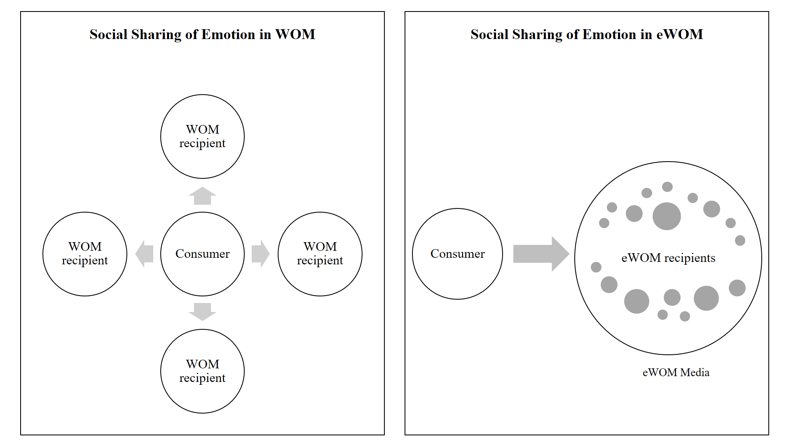

Fig. 1. Social sharing of emotion in WOM and eWOM

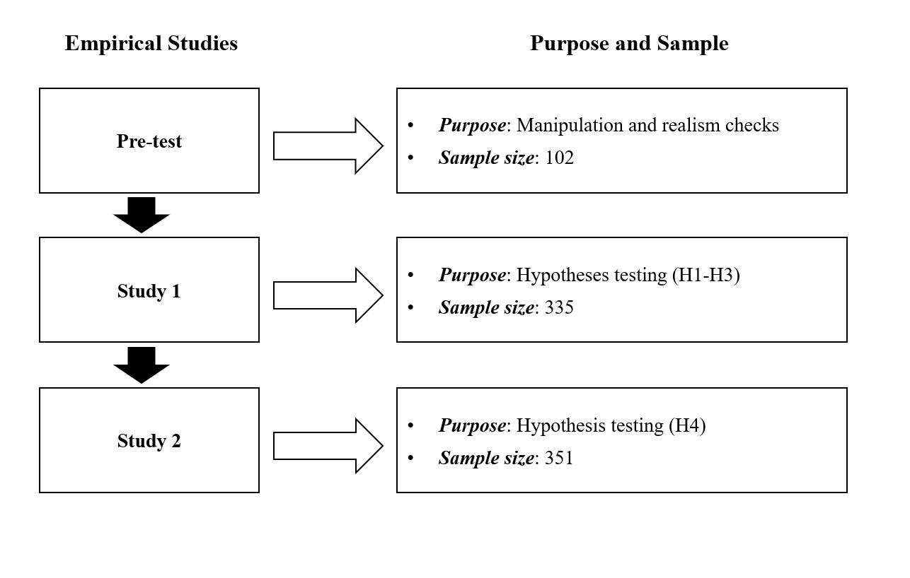
Fig. 2. Purposes and samples of empirical studies

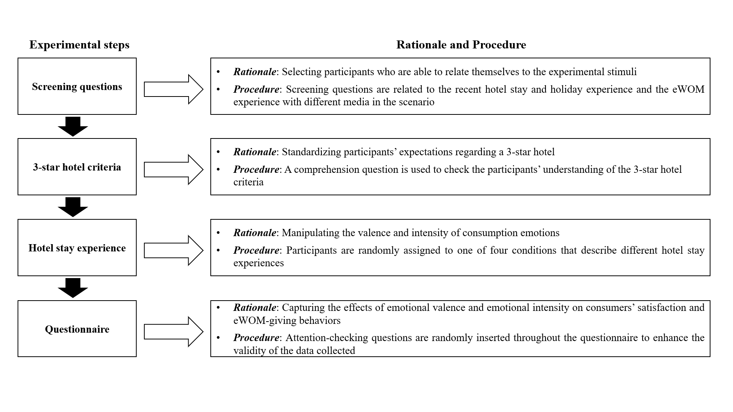
Fig. 3. Experimental design and procedure

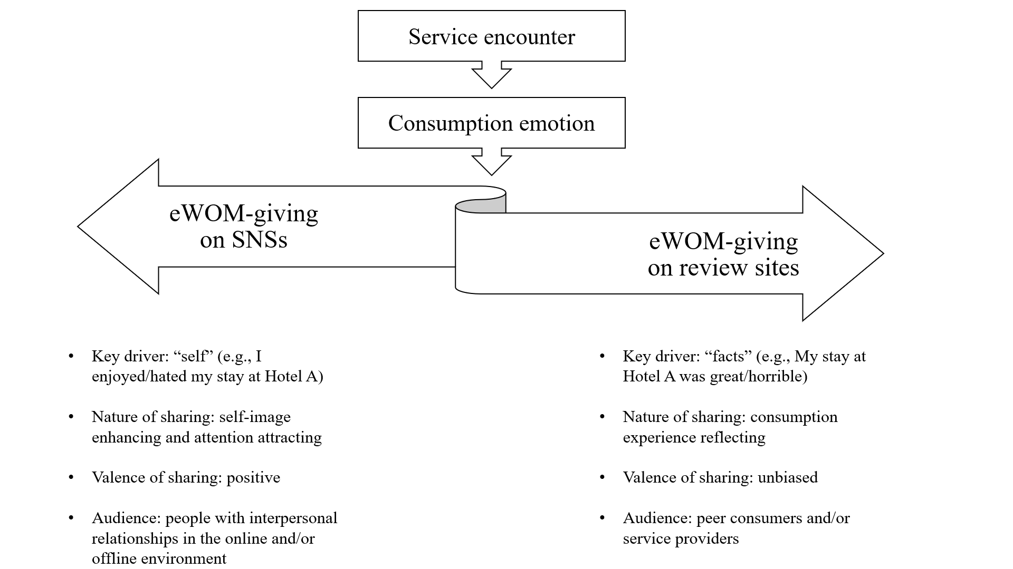

Fig. 4. eWOM-giving and media comparison

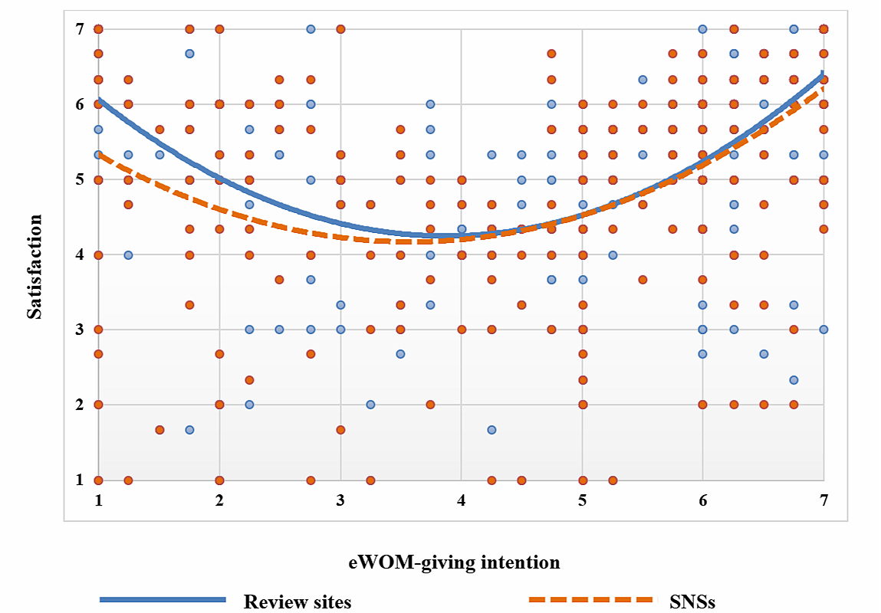

Fig. 5. Relationship between satisfaction and eWOM-giving intention

Table 1 Online disinhibition effects on eWOM media (SNSs vs. review sites)
Media  ODEs | Conceptualization* | Media comparison | SNSs | Review sites
Dissociative anonymity | The capability of cyberspace users to hide, or even modify, some or all of their non-virtual identities. | It is easier for users to hide their identities on review sites compared to SNSs. | Low | High
Invisibility | Information recipients can peruse others’ activities without revealing themselves to the original poster. | Users can observe social interactions triggered by their post without revealing themselves on review sites, whereas SNSs sometimes require users to ‘friend’ or ‘follow’ in order to consume posts and content. | Low | High
Asynchronicity | An action and its reaction in communication can take place at different times/places. | SNSs are often associated with messaging functions and being used more often than review sites in daily life, thereby presenting a higher level of synchronicity. | Low | High
Minimization of status and authority | The fact that typical socioeconomic hierarchies, such as social status, wealth, race, gender or age, are less visible online than offline. | SNSs as a means of networking reveal more socioeconomic information, but such information is less likely to be required on review sites. | Low | High
Solipsistic introjection | Self-tailored interpretation and imagination of the received messages (e.g., imaginary tones and facial expression) in the absence of face-to-face cues. | Users are more likely to interpret information on review sites using their own interpretation and imagination as the sharers are usually strangers (vs. friends on SNSs). | Low | High
Dissociative imagination | The conscious or unconscious process that splits or dissociates the online self from the self in the real world. | It takes less effort for users to act differently from the offline self on reviews sites, compared to SNSs, as there is less pressure for self-presentation on review sites. | Low | High
* Definitions adapted and modified from DeMarco, Sharrock, Crowther & Barnard (2018), Güler (2015), Häkkinen (2013), Miller (2015), Scott (2013), Suler (2004), and Thomas et al. (2017). ODE = online disinhibition effect; SNS = social networking site.
Table 2 Results of realism checks

Scenario | Experimental realism (mean) | t-value | Mundane realism (mean) | t-value
Positive
High intensity (n = 24) | 5.46 | 4.85* | 5.58 | 6.40*
Low intensity (n = 23) | 5.09 | 2.93* | 5.83 | 10.50*
Negative
High intensity (n = 29) | 5.62 | 7.06* | 6.00 | 8.06*
Low intensity (n = 26) | 4.54 | 2.16* | 4.96 | 3.83*
* = t-values > 1.96; p < .05 (Field, 2009)

Table 3 Results of moderating effects (H4)

Hypothesis | Relationship | Coefficient (standard error) | p-value | 95% CI
H4a | Emotional intensity × Cognitive reappraisal → eWOM on SNSs | .086 (.091) | > .05 | [-.093, .264]
 | Emotional intensity × Cognitive reappraisal → eWOM on review sites | .195 (.122) | > .05 | [-.045, .436]
H4b | Emotional intensity × Expressive suppression → eWOM on SNSs | -.195 (.081) | < .05 | [-.354, -.036]
 | Emotional intensity × Expressive suppression → eWOM on review sites | -.132 (.074) | > .05 | [-.277, .014]
CI = confidence interval; eWOM = electronic word of mouth; SNS = social networking site

