Cells in slow motion: Apparent undercooling increases glassy behavior at physiological temperatures

Jörg Schnauß^{1,2,3,}*, Tom Kunschmann^{1,+}, Steffen Grosser^{1,+}, Paul Mollenkopf^{1,2}, Tobias Zech⁴, Jessica S. Freitag², Dusan Prascevic¹, Roland Stange¹, Luisa S. Röttger⁵, Susanne Rönicke¹, David M. Smith^{1,2,6,7}, Thomas M. Bayerl⁵, and Josef A. Käs¹

¹ Peter Debye Institute for Soft Matter Physics, University Leipzig, Linnéstraße 5, 04103 Leipzig, Germany
² Fraunhofer Institute for Cell Therapy and Immunology, Perlickstraße 1, 04103 Leipzig, Germany
³ Unconventional Computing Lab, Department of Computer Science and Creative Technologies, UWE, Bristol BS16 1QY, U.K.
⁴ Institute of Systems, Molecular and Integrative Biology, University of Liverpool, Liverpool, U.K.
⁵ D2 Bioscience Group Ltd., Trinity Hall, 43 Cedar Ave. Hamilton, HM LX
⁶ Institute of Clinical Immunology, University of Leipzig Medical Faculty, 04103 Leipzig, Germany
⁷ Dhirubhai Ambani Institute of Information and Communication Technology, Gandhinagar 382 007, India
⁺ Steffen Grosser and Tom Kunschmann contributed equally to this work

* E-mail: joerg.schnauss@uni-leipzig.de

((Optional Dedication))

Dr. J. Schnauß^{1,2,3,}*
¹ Peter Debye Institute for Soft Matter Physics, University Leipzig, Linnéstraße 5, 04103 Leipzig, Germany
² Fraunhofer Institute for Cell Therapy and Immunology, Perlickstraße 1, 04103 Leipzig, Germany
³ Unconventional Computing Lab, Department of Computer Science and Creative Technologies, UWE, Bristol BS16 1QY UK
*E-mail: joerg.schnauss@uni-leipzig.de

T. Kunschmann¹
¹ Peter Debye Institute for Soft Matter Physics, University Leipzig, Linnéstraße 5, 04103 Leipzig, Germany

Dr. S. Grosser¹
¹ Peter Debye Institute for Soft Matter Physics, University Leipzig, Linnéstraße 5, 04103 Leipzig, Germany

P. Mollenkopf^{1,2}
¹ Peter Debye Institute for Soft Matter Physics, University Leipzig, Linnéstraße 5, 04103 Leipzig, Germany
² Fraunhofer Institute for Cell Therapy and Immunology, Perlickstraße 1, 04103 Leipzig, Germany

Dr. Tobias Zech⁴
⁴ Institute of Systems, Molecular and Integrative Biology, University of Liverpool, Liverpool, U.K.

Dr. J. S. Freitag²
² Fraunhofer Institute for Cell Therapy and Immunology, Perlickstraße 1, 04103 Leipzig, Germany

D. Prascevic¹
¹ Peter Debye Institute for Soft Matter Physics, University Leipzig, Linnéstraße 5, 04103 Leipzig, Germany

R. Stange¹
¹ Peter Debye Institute for Soft Matter Physics, University Leipzig, Linnéstraße 5, 04103 Leipzig, Germany

L. S. Röttger⁴
⁴ D2 Bioscience Group Ltd., Trinity Hall, 43 Cedar Ave. Hamilton, HM LX

S. Rönicke¹
¹ Peter Debye Institute for Soft Matter Physics, University Leipzig, Linnéstraße 5, 04103 Leipzig, Germany

Dr. D. M. Smith^{1,2,6,7}
¹ Peter Debye Institute for Soft Matter Physics, University Leipzig, Linnéstraße 5, 04103 Leipzig, Germany
² Fraunhofer Institute for Cell Therapy and Immunology, Perlickstraße 1, 04103 Leipzig, Germany
⁶ Institute of Clinical Immunology, University of Leipzig Medical Faculty, 04103 Leipzig, Germany
⁷ Dhirubhai Ambani Institute of Information and Communication Technology, Gandhinagar 382 007, India

Prof. Dr. T. M. Bayerl⁴
⁴ D2 Bioscience Group Ltd., Trinity Hall, 43 Cedar Ave. Hamilton, HM LX

Prof. Dr. J. A. Käs¹
¹ Peter Debye Institute for Soft Matter Physics, University Leipzig, Linnéstraße 5, 04103 Leipzig, Germany

Keywords: Cell mechanics, cell motility, glassy dynamics, actin, time-temperature-superposition, heavy water

Abstract

Solvent conditions are unexpectedly sufficient to drastically and reversibly slow down cells. In vitro on the molecular level protein-solvent interactions drastically change in the presence of heavy water (D₂O) and its stronger hydrogen bonds. Adding D₂O to the cell medium of living cells increases the molecular intracellular viscosity. While cell morphology and phenotype remain unchanged, cellular dynamics transform into slow motion in a changeable manner. This is exemplified in the slowdown of cell proliferation and migration, which is caused by a reversible gelation of the cytoplasm. In analogy to the time-temperature superposition principle, where temperature is replaced by D₂O, an increase in viscosity slows down the effective time. Actin networks, crucial structures in the cytoplasm, switch from a power law-like viscoelastic to a more rubber-like elastic behavior. The resulting intracellular resistance and dissipation impair cell movement. Since cells are highly adaptive non-equilibrium systems, they usually respond irreversibly from a thermodynamic perspective. D₂O induced changes, however, are fully reversible and their effects are independent of signaling as well as expression. The stronger hydrogen bonds lead to glass-like, drawn-out intramolecular dynamics, which may facilitate longer storage times of biological matter, for instance, during transport of organ transplants.

1. Introduction
Although H₂O can be easily exchanged with D₂O in biological systems, it is rarely used in life sciences to change cellular properties. However, it is known for decades that D₂O directly interferes with the cell cycle, markedly slows down the overall gene expression and reduces the proliferation of various cell types, which has proven a possibility to impair human tumor growth in animal models^{[1–7]}. Heavy water is the only known chemical substance that affects the period of circadian oscillations, consistently increasing the length of each cycle^{[8]}.
Generally, heavy water or deuterium oxide (D₂O) is a form of water, where both protium atoms (¹H – only one proton) of normal H₂O are replaced by the hydrogen isotope deuterium (²H – one proton + one neutron)^{[9]}. Due to the additional neutron, deuterium atoms are roughly twice as heavy as normal hydrogen atoms. Consequently, D₂O is heavier than H₂O leading to slightly different chemical and physical properties such as an 11% higher density or 23% higher viscosity^{[10,11]}.
To perform their tasks, proteins rely on their finely tuned networks of hydrogen bonds to stabilize their tertiary structures. As a hydrogen bond with deuterium is slightly stronger than one involving ordinary hydrogen, biomolecules undergo conformational changes in D₂O-rich environments^{[12]}, which must have an impact on cell functions. So far, however, the impact of D₂O has been only reported occasionally for single biological components such as proteins^{[13]} or on functions such as the formation of the mitotic spindle^{[7]}. A clear picture on cellular alterations is still missing. Here, we comprehensively tested the impact of D₂O on cells with multiple metrics (proliferation, single cell migration and invasion, invasion assays, single cell mechanics and rheology) to show that internal cellular dynamics are inherently and consistently slowed down.
Interestingly, we found a clear reduction of proliferation upon treatment of living cells with D₂O (Figure 1a), but found no apparent morphological changes (Figure 1b; see supplemental videos). Independent of H₂O/D₂O ratios, the cells also remained in their epithelial phenotype showing no apparent alterations (see supplemental videos S1 – S5). Especially the actin cytoskeleton is central for the mechanisms tested in this study and is considered the crucial cellular functional module in the cytoplasm. It is involved in a variety of very dynamic cellular processes such as proliferation, migration and invasion, but also in rather static tasks such as lending cells’ their mechanical integrity^{[14,15]}.
In order to test the global cell properties, we have chosen the epithelial breast cell line MCF 10A as a prototype for healthy epithelial tissue. Cells were cultured in normal H₂O-based medium as well as in media containing different ratios of H₂O and D₂O. The uptake of D₂O was directly verified by the reduction of proliferation, which also clearly illustrates that cells were still viable (Figure 1a). To investigate the basic properties of individual cells in their “ground” state, we probed the intrinsic mechanics of single, suspended cells in the optical cell stretcher without external obstacles such as other cells or microenvironments that can act as stimuli^{[16]}. Since mechanical properties of cells are largely determined by the actin cytoskeleton, which also drives cell migration^{[14]}, we subsequently investigated the motility of single cells in the different H₂O/D₂O environments. Knowing the ground states of whole cell mechanics and dynamics, we then extended our studies to invasion and wound healing assays to also research D₂O-induced differences of cells in a dense microenvironment.
For the optical stretcher measurements, MCF 10A cells were cultured under different D₂O concentrations. However, cells are heated up by the laser light during the stretching process and since D₂O has a lower light absorption than H₂O, the difference had to be compensated. Therefore, we precisely tuned the surrounding temperature by two additional heating lasers (Figure 1c,d) to achieve the same heating profile for the different measurement conditions (Figure 1e)^{[17,18]}. By recording the intensity profile of the temperature-dependent dye rhodamine B^{[19]} in H₂O, the heating patterns for the D₂O measurement could be precisely adjusted by the additional heating lasers. With this approach, we were able to attribute all observed mechanical changes to exclusively D₂O-induced transformations. Subsequently, we have connected the D₂O-indced mechanical alterations, which are dominated by the cytoskeleton, to cell migration and invasion.

Figure 1. Cells and experimental setup with heat compensation. (a) The proliferation of the cells was drastically slowed down upon D₂O treatment. The duration of the cell cycle was roughly 17 h under normal H₂O conditions and 44 h under 45% D₂O conditions. (b) Independent of the culturing conditions, the actin cytoskeleton (orange) as well as the nucleus (blue) remained intact. Shown are typical pictures, which suggest that structures are comparable for the different H₂O and D₂O concentrations. The characteristics of the epithelial phenotype show no alterations (see supplemental videos S1 – S5). (c) The optical stretcher setup is composed of a flow channel delivering cells to the measurement region and two central, axially aligned optical fibers enabling to trap and stretch them by optical forces. This setup is complemented by two additional optical fibers facilitating heating lasers (controllable on a ms timescale) for the cell’s environment during the experiment without directly interacting with the cell. (d) The phase contrast image shows the laser light as bright stripes in the flow channel and the dashed circle illustrates the position of trapped cells during a measurement. (e) H₂O and D₂O absorb light differently yielding a different heating of cells (for the same stretch laser powers) during the measurements. The intensity profiles were recorded with the temperature sensitive rhodamine B dye^{[19]}. The graph shows the influence of the laser pattern used for the cell experiments on the dye for a H₂O solution (blue), a D₂O solution (red), and the temperature corrected D₂O solution (green) employing the heating lasers. The used heat-laser pattern was determined iteratively to compensate the difference with a time resolution of 33ms per data point.

2. Results
To study the effect of D₂O on the ensemble average velocity of single cell migration, we seeded the cells in six well plates. They needed an initial time before reaching a steady state-like velocity value (Figure 2a; 15 h for H₂O to 25 h for the D₂O conditions) signifying the slowdown of cellular changes. The average single cell velocity was reduced with increasing D₂O content (Figure 2a). This becomes directly apparent when comparing the velocity distributions, which are exemplary shown after 60 h in Figure 2b. Cells cultured under normal H₂O conditions show a rather broad velocity distribution with a median velocity of 0.95 µm/min. With increasing D₂O content, the velocity distribution becomes increasingly narrower with a median velocity of 0.6 µm/min for 45% D₂O and 0.4 µm/min for 70% D₂O. The effect also becomes apparent in wound healing assays revealing a comparable reduction of velocity with increasing D₂O concentration (see supplemental videos S4 & S5).
Since single cell migration was slowed down, we also tested the influence of D₂O on the invasive potential through the extracellular matrix (ECM). Cells were plated on a collagen substrate mimicking the physiological 3D microenvironment of the ECM. After three days, the sample was fixed and the nuclei were stained allowing to monitor their 3D position within the matrix by LSM. These measurements revealed that the invasion potential, i.e. the relative amount of cells that invaded the ECM, was significantly reduced with increasing D₂O content (Figure 2c, d). The invasion potential was highest under normal H₂O conditions and significantly decreased with increasing D₂O concentrations (Figure 2c). We further determined the invasion depth into the collagen matrix (depth to which 95% of the invading cells were counted) revealing that with increasing D₂O contents the invasion speed/depth were significantly reduced (Figure 2d). The fact that cells were still able to invade and move in the collagen matrix shows that the cellular motility machinery was still intact, but D₂O slows down their dynamics.
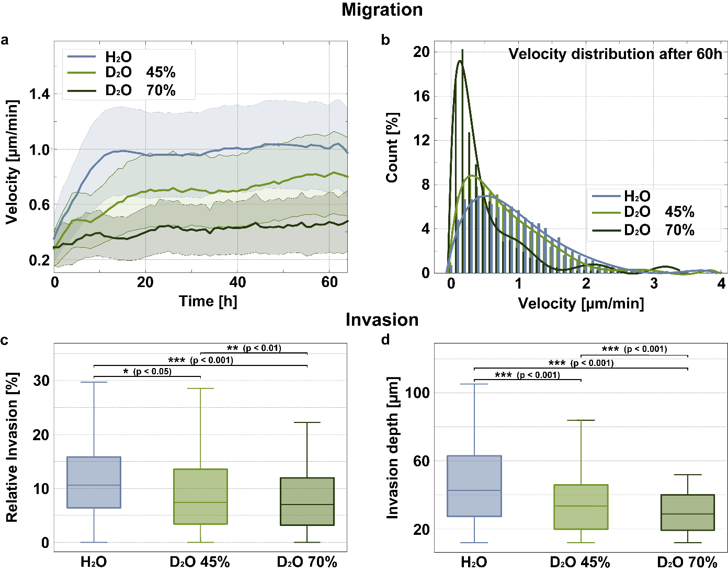
Figure 2. Migration and invasion for different heavy water concentrations. (a) Measuring the ensemble average of single cell velocity without external obstacles revealed that cells drastically slow down with increasing D₂O concentrations. The initial time before reaching a roughly stable value was also prolonged due to the D₂O treatment. Under H₂O conditions, cells settle approximately at an average velocity of 1(±0.31) µm/min, for 45% D₂O at 0.7(±0.25) µm/min and for 70% at 0.44(±0.18) µm/min. The shaded areas represent the standard deviation of average velocities, which were measured for several thousand cells per hour (number of cells measured per hour: H₂O: 20308; 45% D₂O: 13774; 70% D₂O: 4164). (b) The single cell velocity distributions after 60 h clearly display that D₂O treated cells have an increasingly large fraction of slowly moving cells. (c) We tested the invasiveness of the cells under different H₂O/D₂O ratios by platting them on a collagen matrix and determined their invasion into the matrix after three days of incubation. With respect to the overall cell number, less cells invaded the collagen matrix with increasing D₂O content. (d) Confocal LSM enabled us to evaluate how deep the cells invaded the matrix revealing higher D₂O contents decrease the amount of invasive cells (i.e. invasive potential) and the invasion depth. The significance was determined with a Mann–Whitney U test. The horizontal line within the box denotes the median and whiskers denote the farthest data point still within 1.5 times the interquartile range.
To evaluate and quantify the origin of these retarded dynamics, we studied the dynamics of the actin motility machinery in vitro as well as in cells (Figure 3). Actin filaments constantly assemble and disassemble monomers to drive a cell forward^{[14]}. In this steady state, monomers are predominantly polymerized at the filaments’ plus ends and disassembled at the minus end, which in turn supplies free monomers for the polymerization at the plus end again. These two special phases of the polymerization/depolymerization cycle form the basis for the treadmilling process (also known as actin turnover) enabling cells to move^{[14]}.
We used in vitro pyrene assays to effectively decouple D₂O-induced effects during the polymerization and depolymerization phase. As shown in Figure 3a, the polymerization is not affected by exchange of H₂O towards increasing amounts of D₂O. Interestingly, we found a significant impact on the depolymerization revealing a drastic slowdown of the disassembly kinetics with increasing amounts of D₂O (Figure 3b). These alterations are reminiscent of effects induced by crosslinking complexes, which significantly slow down depolymerization dynamics since the crosslinkers enhance interactions of disassociating monomers of neighboring filaments^{[20]}.
Since a crucial part of the treadmilling process is significantly influenced by the presence of D₂O, we also tested the impact on the treadmilling dynamics within cells expressing Actin-GFP. A direct visualization and subsequent quantification was achieved via fluorescence recovery after photobleaching (FRAP) experiments (see also supplemental videos S6 – S8). In these experiments, the fluorescent actin-GFP is photobleached in a region of interest (ROI) yielding a dark region within the fluorescing system. Due to actin treadmilling, the bleached monomers are gradually disassembled and dispersed while still fluorescent monomers succeed in their position. Thus, the fluorescent signal in the bleached ROI recovers over time allowing to determine differences in the treadmilling dynamics.
Our FRAP experiments in cells have revealed that also the treadmilling dynamics are slowed down with increasing amounts of D₂O (Figure 3c). This finding is in direct agreement with the retarded depolymerization dynamics since fewer monomers are disassembled. We would like to note that the pyrene assays cannot be applied to study the polymerization during the treadmilling process. The pyrene assays inherently start with monomers and filaments are only formed when appropriate salt concentrations are added at the beginning of the experiment. In cells, actin filaments are already polymerized and the D₂O-induced effects via the alterations of the depolymerization can only be inferred.
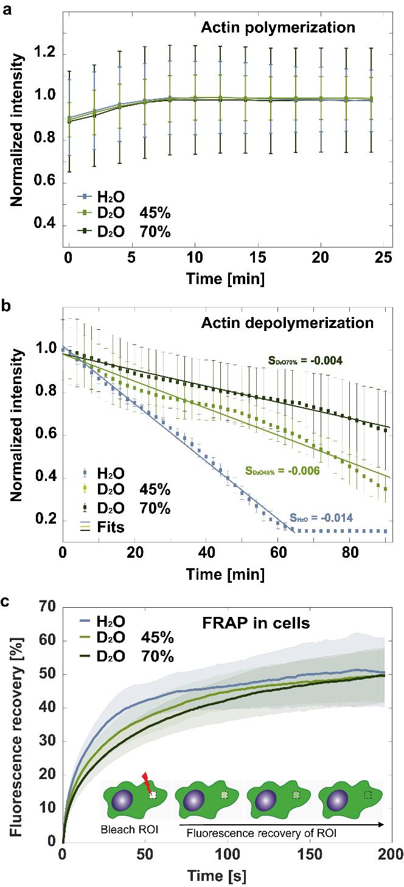
Figure 3. (De)polymerization kinetics in vitro and in vivo. (a, b) We used standardized in vitro pyrene assays to monitor D₂O induced effects in assembly and disassembly dynamics. Pyrene labelled actin monomers have a higher fluorescence intensity when bound within filaments. Thus, the higher the measured fluorescence intensity the more monomers are polymerized into filaments. Displayed are the mean curves for the respective D₂O concentration and error bars indicate the according standard deviations. (a) The polymerization into filaments appears to be independent of the heavy water content. (b) However, when inducing filament depolymerization by adding latrunculin A, our measurements revealed that heavy water significantly retards the disassembly in a concentration-dependent manner. Combining these findings of the (de)polymerization kinetics suggests that actin treadmilling dynamics, which drive the cellular motility machinery, are slowed down. (c) Further support for this conclusion is provided by direct measurements of the treadmilling dynamics inside cells induced by D₂O. To quantify differences, we used fluorescence recovery after photobleaching (FRAP) with labelled actin filaments (see also supplemental videos S6 – S8). Following a photobleached spot within the cell, the signal can recover due to actin turnover, which is significantly reduced with increasing D₂O content (p<0.001 for H₂O-D₂O45% & H₂O-D₂O70%, p<0.05 for D₂O45%/D₂O70%; Mann–Whitney U test). Accordingly, the half-life (T_{1/2}; the time it takes for the intensity to reach half of its incomplete recovery, i.e. half of the mobile fraction) increases from 13.7s for H₂O to 19.7s for 45% D₂O and to 25.3s for 70% D₂O, which clearly quantifies the retarded treadmilling dynamics within the cells. T_{1/2} was determined via a one-phase exponential association curve fit. Shown are mean curves (each containing 15 measurements from 3 independent samples (n=5 in N=3)) and shaded areas represent the standard deviation.
The cell’s motility machinery is based on key components of the cellular cytoskeleton and most prominently actin and according accessory proteins^{[14]}. These key constituents also largely determine the viscoelastic properties of cells, which should be correspondingly altered by D₂O treatment. To measure alterations of cell mechanics, we tested the D₂O-induced impact on cell resistance using an optical stretcher setup (Figure 1). This technique explicitly enabled us to measure mechanics of single cells independent of effects caused by interactions with any microenvironment, which could superimpose D₂O-induced effects. For the control experiments, cells were cultured and measured under normal H₂O medium conditions resulting in a maximal median relative deformation at the end of the stretching process of 3.65(±0.04)% (Figure 4a, b). Subsequently, cells were cultured with increasing amounts of D₂O revealing a drastic, concentration-dependent impact on the mechanical resistance. Cells treated with 45% D₂O were significantly more resistant and displayed a reduced median relative deformation to 3.20(±0.07) % at the end of the stretch. Treatment with 70% D₂O revealed an even more drastic reduction with a deformation of 1.95(±0.6)%, a difference which is comparable to alterations in cell resistance from cancerous to benign cells^{[21]}.
Based on these findings, the question arises whether the D₂O treated cells are harder, more solid-like or if they just viscously deform more slowly. Despite the significant difference in resistance, the deformation curves can be readily superimposed by rescaling the time axis in analogy to the time–temperature superposition principle (TTS) (Figure 4a, c). This shows that D₂O cells indeed deform more slowly. The TTS is well-known from polymer physics and is used to overlay measurements of rheological deformation curves at different temperatures resulting in a single master curve^{[22]}. In biologically relevant systems, the TTS has proven applicable for single microtubules^{[23]}, in actin filament solutions^{[24]}, in cross-linked actin/α-actinin gels^{[25]}, and even some whole cells^{[18]}. TTS hinges on the idea that lower temperature causes less Brownian motion resulting in an increased viscous resistance. Here, however, all measurements were carried out at the same temperature and mechanical alterations were solely caused by D₂O. For higher D₂O contents, the time shift factor increases. Thus, the presence of D₂O induces effects, which are comparable to a temperature decrease, and all processes are retarded due to a higher resistance. This already highlights the possibility to reversibly switch the mechanical properties (see below) and that biological systems can be transferred to ‘undercooled’ states without changing the temperature.
The drastic changes in whole cells’ resistance have to be reflected in significant alterations of the cells’ internal rheological behavior. Especially since cell motility, invasiveness and mechanics are affected by D₂O treatment (Figure 2), the actin cytoskeleton is the prime suspect as source of these alterations. Probing the mechanical properties of actin networks by in vitro rheology experiments directly explains the increase in resistance for D₂O treated cells. Upon treatment with D₂O, these pure reconstituted actin networks exhibit higher plateau moduli for the storage modulus G’, which directly correlates with an increasing mechanical resistance of the network (Figure 4d).
More importantly, in H₂O the solution of actin filaments assumes a power law-like, more viscous fluid state, with a power law exponent of 0.38. In D₂O, the actin filament solution behaves more like a rubber-like, elastic gel, i.e. with a character closer to a crosslinked polymer gel. This tendency is more pronounced with increasing D₂O content and the power law exponent decreases to 0.26 for 45% D₂O and to 0.14 for 70% D₂O. In this respect, it is known that deuterium bonds of D₂O are slightly stronger than the hydrogen bonds of H₂O^{[10]} and that D₂O may enhance hydrophobic interactions^{[26]}. Within the glassy worm-like chain model^{[27–30]}, these interactions are modelled as a stickiness parameter (ε), and a higher ε reflects stronger inter-filament interactions. We found that the stickiness parameter increases under D₂O conditions non-monotonically from ε = 1.8 for normal H₂O conditions to 4.6 and 2.7 for the respective D₂O concentrations (see supplemental material; since multiple factors can impact the viscoelastic behavior of actin networks, we speculate that the non-monotonic behavior of ε could be caused by a D₂O induced shortening of filaments). Thus, D₂O leads to a stickier behavior of the actin filaments, which therefore interact more strongly. Consequently, the network changes from an entangled to a more crosslinked state, which explains the increased mechanical resistance of cells upon D₂O treatment. We found that the mechanical properties of the filaments do not change upon D₂O treatment and can thus be ruled out as origin of the higher resistance of the networks^{[31]} (see supplemental material).
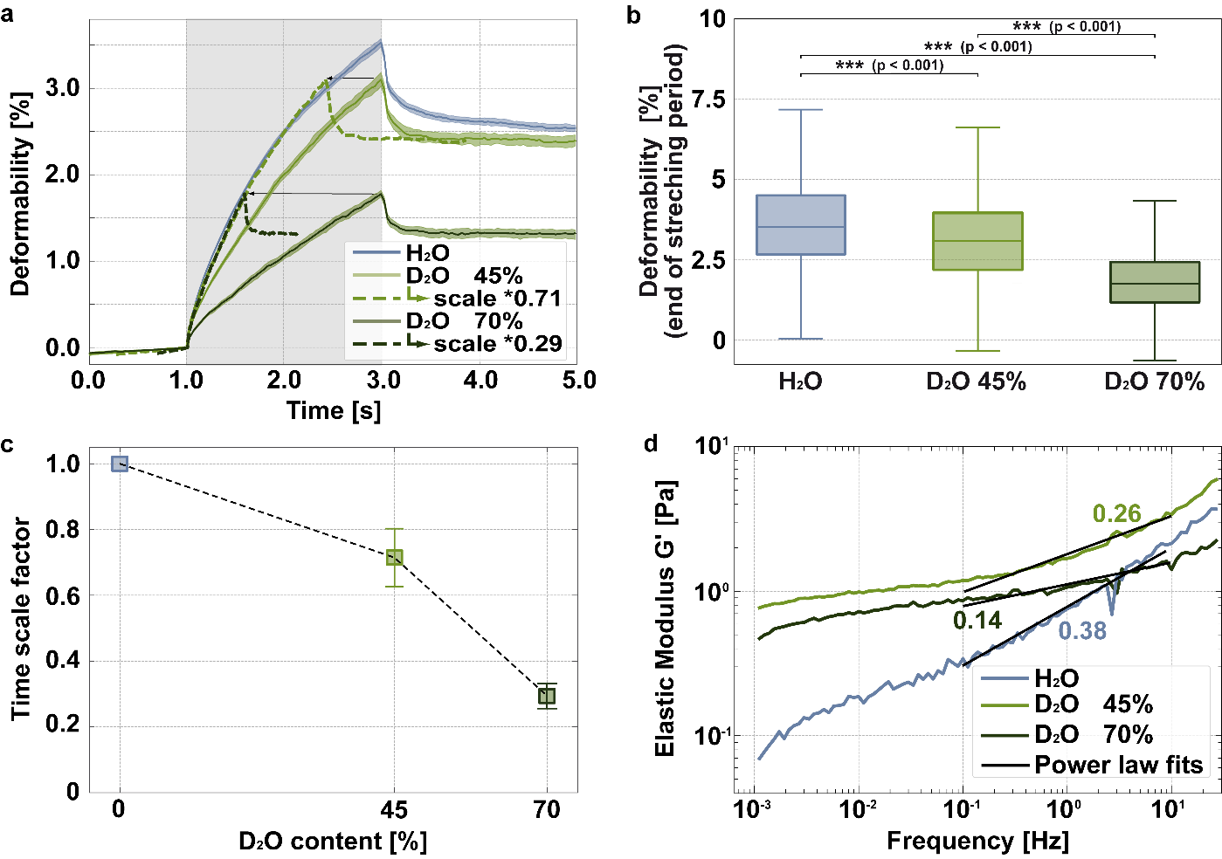
Figure 4. Rheological characterization of the actin cortex in vivo and in vitro. (a) Creep deformation curves of living MCF 10A cells probed with an optical stretcher (deformation period indicated by grey area) reveal a concentration-dependent increase in the resistance of the cells after treatment with D₂O. All creep deformation curves (solid lines) are represented by their median (nH₂O=3401 cells, n45%D₂O=1706 cells, n70%D₂O =1307 cells) and bootstrapping was used to depict a 95% confidence interval as error (shaded areas around the respective medians). The D₂O-dependent measurements of increasing resistance can be overlaid onto a master curve by solely rescaling the time axis for the specific condition with a time shift factor reminiscent of the time-temperature superposition^{[17,18]}. Here, the time shift of median curves is illustrated by the dashed lines revealing that all conditions can be collapsed onto a master curve by only one parameter. (b) Shown is the boxplot of the deformability at the end of the deformation process (i.e. the values at 3s in (a)) illustrating the statistically significant differences of the deformation process. The line in the middle indicates the median, and the bottom and top edges of the box indicate the 25th and 75th percentiles, respectively. The whiskers extend to the most extreme data points and outliers are not considered. (c) The determined time shift factors and according error ranges are displayed in dependency of the D₂O content. This rescaling shows that D₂O slows down intra-cellular dynamics similar to low temperatures in a passive, viscoelastic system. (d) Bulk shear rheology of pure in vitro actin networks confirms our findings in cells. Networks become significantly more resistant upon D₂O treatment. The transition from an entangled to an increasingly sticky (almost crosslinked) network is emphasized by a decrease of the power law exponents.
The question arises if cells have changed permanently in response to D₂O or if the response is reversible, which would be unusual for an active non-equilibrium system. Most external stimuli lead to an active response such as signaling and expression changes. Those changes are usually reflected in alterations in the intracellular molecular and proteomic composition. Consequently, cells would change their phenotype, a feature we did not find in our experiments. The answer to the reversibility question directly points towards whether D₂O permanently changes/damages cells.
To probe reversibility, we rapidly changed the medium during migration experiments within the very same sample. For the mechanical characterization, we changed the medium during cell culturing just before the sample was measured in the optical stretcher. As a control, we measured the mechanical resistance of cells, which were also subjected to a medium exchange with the same medium (H₂O → H₂O, D₂O → D₂O) to mimic the conditions for the switching experiments (H₂O → D₂O, D₂O → H₂O; Figure 5a, b). We would like to note that the media compositions were the same except for the H₂O/D₂O ratio. A medium exchange from H₂O to D₂O lead to the already expected increase in intracellular resistance. The reverse switch (D₂O → H₂O) during culturing revealed a remarkable fast restoring of the D₂O-free cell mechanics within less than a few hours, which makes a reversal by adaption through expression changes highly unlikely. The deformation curves almost completely overlap with the unaltered H₂O → H₂O control cells (Figure 5a, b) even for the very high concentration of D₂O. The control experiments verify that the increase in cell resistance can be solely attributed to D₂O.
The reversibility is even more obvious in the migration experiments. The dependence of the speed, i.e. dynamics, of the motility on the H₂O/D₂O ratio was tested by recording the single cell motion and underlying velocities of cells as described above. However, during the measurements, cells were subjected to a sudden medium exchange after 31 h. After this time, the cells had reached their rather stable motility and we tested whether D₂O treated cells recover from their retarded motion and slowed down dynamics (Figure 5c, d). Changing the medium during the experiment has the inherent advantage that the same cells can be compared before and after the medium exchange, but also renders the experiments challenging. As illustrated in Figure 5, H₂O cultured cells moved faster than D₂O treated cells. After the media exchange from D₂O to H₂O, cells sped up remarkably. In the case of 45% D₂O → H₂O, cells reached comparable velocities as cells treated only with H₂O within less than a day. After the switch 70% D₂O → H₂O, the effect was more drastic and cells apparently needed a certain time to adapt to the new conditions and started to move faster after several hours. The medium exchange from H₂O to 70% D₂O led to an immediate and persistent velocity reduction. When changing from H₂O to the lower D₂O content of 45%, the effect was less pronounced than for 70%. As shown in Figure 5c, sometimes even no consistent trend was visible. These experiments require a medium exchange while observing the cells, which renders these experiments rather difficult to conduct and multiple curves cannot be readily averaged. Nevertheless, our experiments show a clear trend that D₂O induced effects are reversible and especially that the switch from D₂O to H₂O works consistently. Although D₂O has a severe effect on the cellular motility machinery, our findings emphasize that the induced changes are reversible in agreement with the observed time-D₂O-concentration superposition and that they supposedly originate from the inherently stronger hydrogen bonds of D₂O. Upon removal of D₂O, this effect is no longer a factor and cells display their normal mechanical and dynamical characteristics. The observed collapse of the deformation curves by solely rescaling the time axis requires that the cells slow down reversible. Those thermodynamic reversible changes do practically not exist in an active non-equilibrium system, but since we found no morphological changes it seems that cells do not to actively respond to these solvent change. The actin cytoskeleton is directly influenced through altered protein solvent interactions, which are - in contrast to our findings - usually lethal. Processes are solely slowed down similarly to the effect of an increased viscosity in TTS induced by a decreased temperature. Similar to a lower temperature, D₂O puts cells reversibly into slow motion.
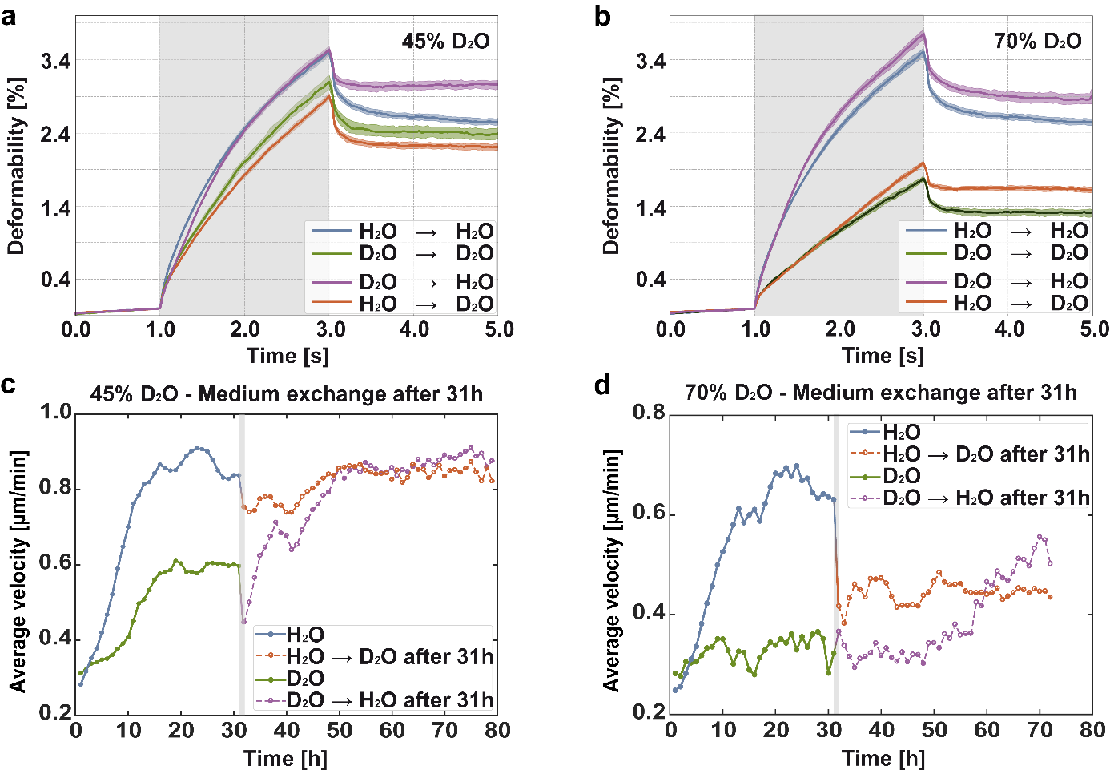
Figure 5. Reversibility of D₂O effects. (a, b) To test the reversibility, the medium was exchanged during cell culturing prior to optical stretcher measurements. To test effects consistently, cells were also subjected to a medium exchange when the medium conditions were not changed (H₂O → H₂O, D₂O → D₂O). Changing the medium from H₂O to D₂O conditions lead to a comparable increase in cell resistance as for pure D₂O culture conditions. Switching from D₂O to H₂O restored the original mechanical fingerprint of the cells for both tested D₂O concentrations illustrating the reversibility of the D₂O effect. All creep deformation curves (solid lines) are represented by their median and bootstrapping was used to depict a 95% confidence interval as error (shaded areas around the respective medians). (c, d) The reversibility of the motility alterations was tested by changing the media during single cell migration experiments. The average velocity in the original medium (H₂O or D₂O) was recorded over 31 h to allow reaching a stable state of cell motility. After this time (illustrated by the grey bar), the medium was changed to the other condition. These measurements revealed that formerly D₂O treated cells increasingly moved faster after the change to H₂O conditions (number of cells measured per hour: c) H₂O (7263 cells) → 45% D₂O (7963 cells) & 45% D₂O (7456 cells) → H₂O (4214 cells); d) H₂O (4214 cells) → 70% D₂O (1111 cells) & 70% D₂O (2350 cells) → H₂O (4637 cells). In the observation period, cells treated with 45% D₂O even reached the values of cells in H₂O medium after the switch illustrating that the migratory behavior was switched back fully reversibly within less than a day.

3. Discussion
D₂O-induced effects become apparent on the cellular as well subcellular scale. For instance, D₂O already significantly increases the resistance of actin networks, which can only have two reasons: 1) a stiffening of the single actin filaments, which we were able rule out or 2) an increase in filament interaction/crosslinking, which we can confirm in rheology. Although D₂O may have many effects on the protein structure, we speculate that D₂O probably leads to a tighter helical structure of actin filaments since the intercalating dye rhodamine-phalloidin is less effective in its stiffening influence compared to H₂O conditions (see supplemental material). This may also explain the D₂O-induced reduction of actin-myosin velocities reported in a previous study^{[32]}. Despite this potential tighter helical structure, the stiffness, i.e. the persistence length, of the filaments remains rather unaffected. However, what is changing is the affinity between entangled filaments. As reported previously, D₂O may enhance hydrophobic interactions^{[26]}, which yields stronger attractive inter-filament interactions. These increased interactions lead to a transition from a power law behavior of an entangled filament solution to a more rubber plateau-like behavior of an at least transiently crosslinked network. This agrees with the observed increase in stickiness since the rubber behavior is caused by the transition from an entangled to a crosslinked network^{[28–30]}. Our findings also illustrate that the increased resistance is not simply caused by the inherently higher solvent viscosity of D₂O compared to H₂O^{[10,11]} since this would not results in a more pronounced rubber-like behavior. In fact, viscous contributions of the in vitro systems are hardly affected by different H₂O/D₂O ratios (see supplemental figure S3). These stronger inter-filament interactions also increase internal cell resistance (Figure 4) and explain the slowdown in cell motility (Figure 2) especially due to the retarded depolymerization and thus treadmilling dynamics (Figure 3). In addition to the alterations of the single cell properties, also the multicellular dynamics in wound healing assays are significantly slowed down with increasing D₂O concentration with comparable time shift factors to the single cell properties (see Figure 6 and supplemental videos S4 & S5). The facts that D₂O effects are reversible and can be rescaled to one master curve by changing solely the time axis support our conjecture that the D₂O-induced changes of hydrophobic proteomic interactions are the cause of the increased cell resistance as well as slowed down dynamics and not changes in cell expression or signaling.
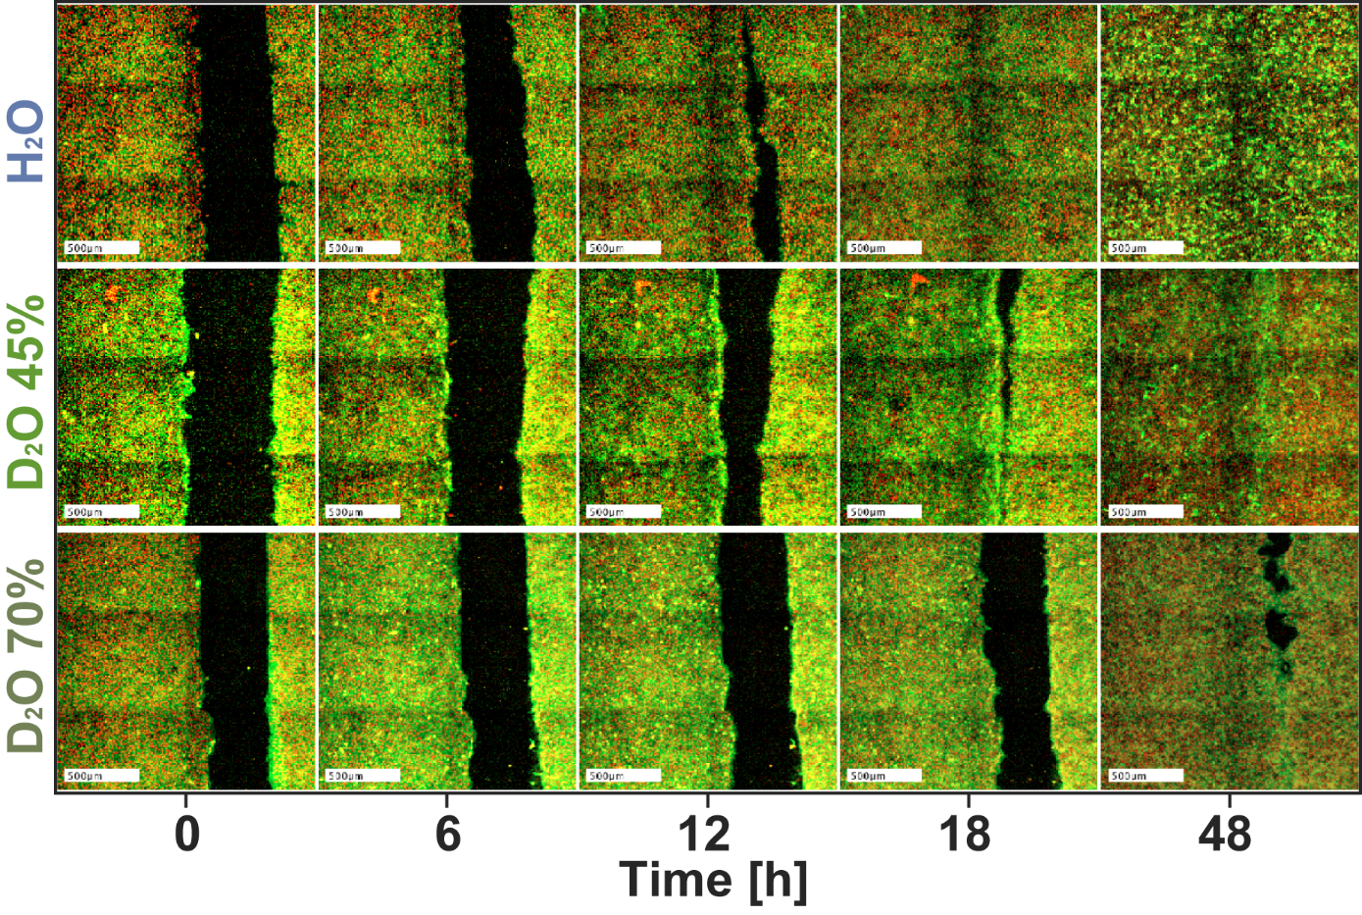
Figure 6. Time series of wound healing experiments showing delayed collective migration in D₂O in a concentration dependent manner (also see supplemental videos S4 & S5). Fluorescent confocal images, red shows DNA and green actin. Note that the time axis is not linearly scaled, but rather highlights approximate times when the respective wounds close. The scale bars each display a length of 500µm.
In contrast to our findings, cellular responses to external stimuli are usually irreversible. Moreover, drastic changes to the cytoplasm are often lethal to cells or at least inhibit molecular processes required for cell motility. The effect is based on a collective molecular, dissipative resistance through alteration of all proteins in the cytoplasm similar to slowed down relaxation processes when a temperature decrease slows down Brownian motion.
Amazingly, cells remain viable and motile. With regard to their passive material properties, we observe a maximal time shift factor of 0.31 as a measure of the observed slow down under D₂O conditions. To observe the same time shift factor within the TTS, it requires a decrease in temperature by 8(±1)K^{[17]}.

4. Conclusion
Cell motility as well as other cell functions are usually modulated by specific molecular agents, which are often toxic to a whole organ or organism. Our results can open new perspectives for cell biology as well as biomedicine since reversibly reducing cellular dynamics was usually only achievable by reducing the overall temperature. As our findings show, D₂O can be also used to retard dynamics, which could be beneficial, for instance, to prolong degeneration times of organs or tissues during transport and storage for transplantations. At the moment this can be only achieved by cooling the transplant, which however quickly becomes critical since organs can be only kept viable for few hours before deterioration begins. This time period could be potentially prolonged by keeping the transplants in a cooled, D₂O-rich environment. Additionally, D₂O could be used in anti-cancer treatments to suppress metastasis.

5. Experimental Section/Methods

Cell culture: The MCF10A cell line was purchased from ATCC (Cat.No.: CRL-10317™). Cells were cultured in 95% 1:1 mixture of DMEM and Ham's F12 medium (PAA E15-813 with L-Glutamine), 5% Horse Serum HS (PAA A15-151), 20 ng/ml Epidermal Growth Factor (EGF), 10 µg/ml Insulin (Sigma-Aldrich, I6634), 100 ng/ml Cholera Toxin (Sigma-Aldrich, C8052), 500 ng/ml Hydrocortisone (Sigma-Aldrich H0888) and 1% 10000 U/ml Penicillin/Streptomycin PS (Sigma P0781).

Optical stretcher measurements: Cells were incubated for one day until the cell confluence reached approximately 70%. Before each measurement cells were rinsed with 2 ml PBS and incubated with the respective medium for 2 h again. After the incubation, cells were rinsed once again with 2 ml PBS. For detaching the cells from the substrate 1 ml trypsin was added and the sample incubated for 13 min at 37°C and 5% CO₂. Subsequently, the cells were diluted in 5 ml of their respective medium and centrifuged. The cell pellet was resuspended in 600 – 1000 µl medium for the measurement.
For the 70% D₂O experiments deuterium oxide based trypsin and PBS was used for the preparation. The incubation time for the 70% D₂O trypsin was prolonged to 47 min. However, it was not possible to use a trypsin concentration of 0.025%vol for detaching of the cells due to an initial H₂O-Trypsin stock solution concentration of 0.05%vol. Thus, the trypsin was diluted to 0.014 %vol to reach a 70% deuterium oxide concentration, which corresponds to 57% of the standard trypsin concentration. The same trypsin concentration was used for the 45% D₂O preparation, which prolonged the trypsin exposure to 23 min.

Deformation Data Analysis: A self-written Matlab algorithm (The MathWorks Inc.) was employed to extract the contours for each frame, which were subsequently used to derive the deformation data. A creep deformation J(t)=ε(t)/σ_0 was used to evaluate the cells, with σ_0 being the optically induced stress depending linearly on the applied laser power and ε(t)=(d(t)-d(0))/d(0) the relative deformation along the long axis d of the cell. All creep deformation curves are represented by their median using bootstrapping to estimate a 95% confidence interval as error.

Temperature calibration: D₂O absorbs less light at a wavelength of 1064 nm than H₂0 leading to different heating profiles of the cells’ direct environment during the measurement (at 1064nm: H₂O: 0,65; D₂O: 0,069). Thus, it was necessary to compensate this temperature difference during the stretching process in order to gain comparable results. To achieve this compensation, additional heating laser fibers were added to the setup (Figure 1a, b) located directly next to the stretch laser fibers. The additional heating process and the underlying power of the heating lasers were calibrated via the temperature sensitive fluorescent dye rhodamine B. To prevent unwanted bleaching effects, an anti-bleaching agent containing glucose and glucose oxidase was used^{[33]}. A solution with 0.25mM rhodamine B (Sigma-Aldrich) was flushed in the microfluidic capillary. Before each measurement the capillary was purged for 3 s to ensure that already bleached rhodamine did not influence the measurement. In a first step the fluorescence signal of the solution in the specific region of interest was recorded to calculate the mean intensity over time. This allowed to correct for effects solely caused by bleaching of the dye. Subsequently, the normal protocol for the stretching process was carried out (without cell in the microfluidic capillary) consisting of a 1 s trapping phase with 100 mW, 2 s stretching phase with 800 mW, and 2 s relaxation phase with 100 mW laser power.
After switching on the laser, the solution is heated up and the intensity of the rhodamine B dye decreased by 2.5% per Kelvin. The fluorescence signal was recorded and corrected for bleaching effects to determine the intensity progression, which in this form solely depended on the temperature. Using a temperature controlled micro-stage, we were able to determine the calibration curve in steps of 1 K allowing to convert the intensity values at different laser powers into a temperature scale.
The corrected intensity curve of the H₂O-rhodamin B solution was used as standard allowing to correct for the lower absorption in heavy water and the corresponding different heating pattern caused by the stretch laser. For D₂O measurements, the heat lasers corrected the heating profile to precisely match the experiments with H₂O (Figure 1c). The used heat-laser pattern was determined iteratively to compensate the difference with a time resolution of 33 ms.

Migration experiments: The MCF10A cells were cultivated in their normal medium to a confluence of 80 to 90%. Subsequently, the medium was sucked off and the cells where rinsed with PBS. Afterwards, 1 ml trypsin was added to the culture flask for 15 minutes at 37°C. To inactivate trypsin, 5 ml medium were added and the cell suspension was transferred to a 10 ml centrifuge tube to centrifuge the suspension at 125 g for 4 minutes. The cells formed a pellet, which was mixed carefully with 1 ml medium to gain a homogenous cell suspension. In an additional 10 ml tube, 6 ml medium and 6-10 µl cell suspension (depending on the initial confluence) were added and gently mixed again. This diluted suspension was inserted into 2 wells of a 6-well plate in equal amounts and incubated for 6 h at 37°C. Cells attached to the bottom allowing to easily change the medium. In both wells 3 ml pre-warmed D₂O or H₂O medium, respectively, were added and subsequently transported to a pre-warmed thermos-box for measuring. The reversibility of the D₂O influence on the cells after several hours was measured by changing the D₂O medium to H₂O medium. For this purpose, the old medium was removed and the adherent cells were rinsed with H₂O- or D₂O-PBS and 3 ml H₂O medium per well was added.

Migration Experiments – Data Analysis: The recording area was a 10x10 grid of images (each with the dimension of 1171 x 877 µm, i.e. the overall observed area had the dimension 11.7 x 8.8 mm) centered around the middle of each well. The time resolution between frames at the very same position was 4 minutes, which was sufficient to connect the migrating cells from frame to frame. Due to small temperature fluctuations, a subpixel drift correction via cross-correlation was applied to the images. The phase contrast images were binarized by a background adjusted threshold algorithm, which was suitable in a wide illumination range due to the small cell concentration. Subsequently, dilation, erosion, and filling hole operations were performed to reduce small cell shape artefacts. Finally, objects too small (everything smaller than a dividing cell such as dirt, remaining parts of dead cells, etc.) and too large (e.g. cell clusters) were omitted from further evaluation by setting size thresholds ensuring that only single cells were analyzed. The cells in consecutive images were connected via a closest distance method. To avoid wrong assignments of cells between frames, empirically evaluated parameters (cell size and size changes, velocity and velocity changes, change of overlapping region with the neighboring frame) were introduced ensuring a precise recognition of the specific cells.
Subsequently, the objects in the binarized images were detected with a self-written MATLAB (MathWorks, USA) code. The detected objects were connected via a self-written LabVIEW (National Instruments, Munich, Germany) software yielding the trajectory of each single cell in the observed area.

Fluorescent live migration experiments: There are two types of live migration experiments with confocal fluorescent microscopy in this study:
1) cell migration in a non-confluent situation
2) wound healing experiments (starting from a confluent situation)
For both types of experiments, MCF-10A cells were stained using the respective medium (0%, 45%, 70% D₂O) supplied with 0.2mM SPY-650-DNA and 0.2mM SPY-555-Actin live stains (Spirochrome). The stain concentrations are below the maximum concentrations the vendor recommends for continuous long-term exposure. The medium with stains was used throughout the observation time to ensure stable fluorescent signal.
Cells were always kept at 37°C and 5%CO₂ cell culture conditions during observation. We used an automated spinning disk confocal microscopy setup (ZEISS Axio Observer.Z1, ZEISS, Germany) to observe multiple positions in parallel in multi-well plates.

Cell migration in a non-confluent situation: Cells were grown in MCF-10A medium (100% H₂O), passaged, resuspended in the respective staining medium (0%, 45%, 70% D₂O), and diluted to the desired concentrations. Cells were subsequently seeded into 96-well-plates (µ-Plate 96 Well Black, Ibidi, Germany), and imaging was started about 1h later as described above.
Imaging was done using a 20X air objective with NA=0.5 (ZEISS EC Plan-Neofluar) to ensure high image quality. At the same time, any problems that immersion could cause during long-term observation with automated stage movement are avoided. One image every 10 min was taken. Representative videos of these cell migration experiments are given as supplemental materials:
Video S1 - CellMigration_ActinDNA_H2O.mov, Video S2 - CellMigration_ActinDNA_D2O45%.mov, Video S3 - CellMigration_ActinDNA_D2O70%.mov.

Wound healing experiments: We used silicone culture inserts (Cat.No. 80209, Ibidi GmbH, Germany) consisting of two chambers separated by a 500μm thin wall. These inserts can be used to culture two monolayers of cells with a well-defined gap in between. Once the culture insert is removed, both monolayers are free to close the gap. We carefully pushed the inserts against the substrate to ensure firm attachment of all chamber walls. We used 24-well-plates (Ibidi µ-Plate 24 Well Black, Cat. No 82406, Ibidi, Germany). In each well of the 2-well-inserts, 15000 MCF-10A cells were seeded in 70µl MCF-10A medium (100% H₂O) for 48 hours, reaching confluency. Four hours before the start of the measurement, the medium was changed to the respective D₂O concentration (0%, 45%, 70%) supplied with live stain (as mentioned above). Right before starting the automated imaging, the inserts were removed using sterilized tweezers. The wells were filled again with the respective medium (same stain concentrations as before), and the positions were entered in the ZEISS ZEN software.
Imaging was done every 6 min using a 10X air objective with NA=0.3 (ZEISS EC Plan-Neofluar). Compared to the cell migration experiments above (which used a 20X/0.5), the wound healing setup requires as first objective to record a larger field of view, and depends less on quality. To achieve an overview over a large field, the 10X objective was chosen and 2*3 tiles were recorded, which were subsequently stitched together. To create the videos given as supplemental material, the signal of both channels were individually time-stabilized using a self-written MATLAB algorithm. Representative videos of wound healing experiments are given as supplemental materials:
Video S4 - WoundHealings-All.mov and
Video S5 - WoundHealings-All-TimeShifted.mov.

Invasion assay: Two different types of collagen, collagen R (4 mg/ml rat collagen type I, Serva, Heidelberg, Germany) and collagen G (4 mg/ml bovine collagen type I, Biochrom, Berlin, Germany) were mixed at a ratio of 1 to 2, diluted in H₂O and buffered in a 1 M phosphate buffered saline with a pH of 7.4 and a ionic strength of 0.7 (with a final concentration of 320 mM)^{[34]}. Everything was cooled on ice to reduce premature fibrillation. 1.2 ml of the collagen mixture was added to each well of 6-well plate and subsequently incubated for 2 h at 37°C. Afterwards the wells were washed three times with PBS to remove the remaining phosphate buffer and sterilized with UV light for 10 min at room temperature. The PBS was pipetted out and replaced by 2 ml of the medium used for the measurement (according H₂O/D₂O ratios) followed by an overnight incubation.
On the next day, the prepared cells (see above) were detached, counted and put in fresh medium. 45000 cells in 2 ml medium were pipetted in each well and incubated for three days at room temperature. Following this incubation, the medium was removed and the system was fixed by adding 2 ml of 2.5% glutaraldehyde solution (Serva, Heidelberg, Germany) in each well. After an incubation time of 20 min at 37°C, the remaining solution was pipetted out and 2 ml of 4µg/ml Hoechst 33342 staining solution was added. After an overnight incubation in the fridge, the Hoechst solution was replaced by PBS followed after 12 h by the actual observation.
Image and data acquisition were conducted as described previously^{[34]}. The percentage of invasive cells and their invasion depths were ascertained in at least 100 randomly selected fields of view located in the center of each six well. Z-stacks harboring at least 100 images were recorded at 4 μm steps using a 20x objective and a CCD Orca camera (Hamamatsu Photonics, Hersching am Ammersee, Germany), mounted on a 0.55x c-mount. Cell nuclei were detected using a customized 3D cell nucleus detection algorithm written in Python. A cell is identified as invasive when the nucleus was found to be located below the topmost cell-layer of non-invasive cells. Due to the depth of field for the 20 × 0.4 NA objective, the uncertainty of this method is approximately 5 µm. To determine the proportion of invasive cells, non-motile cells adhering to the surface of the collagen gel were enumerated. For the cell cluster analysis, we used the DBSCAN algorithm. The DBSCAN clustering algorithm can detect individual cells and cells in a cluster separately. Cells are considered to belong to a cluster if such a cluster contains at least 5 cells and their nuclei lie within a distance of 10 µm.

LSM: The procedure was carried out as described previously^{[34]}. Glass cover slides with a diameter of 13mm were cleaned and coated with 10 µg/ml laminin for 24h at 37°C and 5% CO₂. After the coating, the glasses were rinsed two times with PBS. Finally 1 ml 4.5 g/l DMEM medium with about 8000 cells per cover slides were added and cultivated for 16h. The adhered cells were exposed for 2 h to 45%, 70% D₂O or H₂O based DMEM medium. For preservation of the cytoskeleton, a 4% paraformaldehyde fixation solution was used for 10 minutes at room temperature. To reduce the background signal, the cover slides were incubated in a 1% bovine serum albumin (BSA) solution for 20 min at 37°C. The actin cytoskeleton was stained with a 1% BSA solution containing 2 unit/ml AlexarFluor546 for 4 h. The staining solution was aspirated off and glass cover slips were conserved in a pro long diamond antifade solution. After 24 h the cover slides with the gel-like antifade were sealed with nail polish and recorded with a laser scanning microscope (TCS SP8, Leica, Wetzlar, Germany; 64x glycerol objective; pinhole 0.5x airy disc; laser diode with λ = 561 nm; images were deconvoluted with the LSM software).

Actin Preparation: Monomeric actin (G-actin) was obtained with an acetone powder prep from rabbit muscle, purified, and stored at −80 °C in G-Buffer (2 mM sodium phosphate buffer pH 7.5, 0.2 mM ATP, 0.1 mM CaCl2, 1 mM DTT, 0.01% NaN3) as described previously^{[35]}. Small sample volumes were thawed and kept on ice no longer than one day before experiments. The polymerization to F-actin was always induced by adding 1/10 volume fraction of 10 times concentrated F-buffer (20 mM sodium phosphate buffer pH 7.5, 1 M KCl, 10 mM MgCl2, 2 mM ATP, 10 mM DTT) to the final sample solution. Actin was polymerized in the respective deuterium oxide concentrations (0%, 45%, 70%).

Rheology: 175 µl of the sample was loaded to the dynamic shear rheometer (ARES, TA Instruments, USA or MCR 502, Anton Paar, Germany) equipped with a cone (diameter 25 mm, 0.04 rad, 0.05 mm gap size). The network between cone and plate was surrounded with a 1 ml 1x F‐buffer bath similarly as described previously^{[36]} to avoid direct contact of the sample with air. The sample chamber was sealed with a cap equipped with wet sponges to suppress evaporation. Measurements were performed at 20°C and followed the sequence: (i) The time evolution of the polymerization was monitored for 4 h (one data point per every 2 min; γ = 5%; f = 1 Hz), which was subsequently followed by a (ii) short f sweep (γ = 5%; f = 0.01–10 Hz; five data points per decade), (iii) long f sweep (γ = 5%; f = 0.001–78 Hz; 21 data points per decade), (iv) short f sweep, and (v) a step rate test at a shear rate of 0.1. Fitting was performed with a self-written script in Python (Python Software Foundation , USA) and the analysis of the stickiness parameter was performed as described previously by Golde et al. ^{[28,29]}.

Persistence length measurements and length distributions: Contour lengths as well as persistence lengths were determined by analyzing individual labeled filaments with an epifluorescence microscope (Leica DM-IRB, 100x oil objective, NA 1.35 - Leica Camera AG, Germany) equipped with a CCD camera (Andor iXon DV887 - Andor Technology Ltd, UK). The analysis was performed with the freely available ImageJ plugin JFilament (http://imagej.nih.gov/ij/).
F-actin was fluorescently labelled by polymerizing G-actin at 1 μM in a 1 : 1 ratio with phalloidin–tetramethylrhodamine B isothiocyanate (Phalloidin-TRITC – Sigma-Aldrich Co., USA) or rhodamine labeled without the use of phalloidin according to^{[37,38]}. Actin was polymerized by adding KCl to 0.1 M. Rhodamine was added to actin filaments to prevent the occupation of polymerization-relevant binding sites. Rhodamine-actin was separated from polymerization incompetent actin and unbound rhodamine by centrifugation and a subsequent gel filtration.

Pyrene Assay: In order to investigate the effect of different D2O concentrations on in vitro actin polymerization and depolymerization, a standard pyrene assay using pyrene muscle actin (Cytoskeleton Inc.) was conducted. Those actin monomers had been modified to contain covalently linked pyrene molecules at the cysteine 374 residue via N-(1-pyrene) iodoactetamide. The fluorescent signal of monomer pyrene-actin is enhanced during its polymerization into filaments making it an ideal tool for monitoring both actin polymerization as well as depolymerization^{[39]}.
Lyophilized pyrene-actin was reconstituted according to manufacturers’ instructions and further diluted to 4 mg/ml with 1X G-buffer (5 mM Tris-HCl pH 8, 0.2 mM CaCl2, 0.2 mM ATP, 0.5 mM DTT). To depolymerize actin oligomers, the solution was placed on ice. After 1 h, pyrene-actin was spun for 30 min at 14,000 rpm and 4 °C to remove residual nucleating centers. According to the manufacturers’ instructions, this step is supposed to be performed at a pyrene-actin concentration of 0.45 mg/ml. However, we used a slightly higher concentration since samples with 70 % D2O did not allow to use these low concentrations. Due to this alteration, possibly not all residual nucleating centers were removed, which can explain the fast polymerization behavior. However, we prepared all experiments from the same stock solution for consistency. Pyrene-actin was diluted to 0.4 mg/ml in a total volume of 100 µl each well containing various percentages of D2O (0 %, 45 %, 70 %), 1X G-buffer (5 mM Tris-HCl pH 8, 0.2 mM CaCl2, 0.2 mM ATP, 0.5 mM DTT) and 1X anti-bleaching buffer (1 mM Tris-HCl pH 8, 5 mM NaCl, 0.4 % (w/v) glucose, 0.2 % (w/v) glucose oxidase). The process of pyrene-actin filament formation was induced by the addition of 5 µl 20X KME-buffer (20 mM MgCl2, 2 M KCl, 4 mM EGTA) containing 0 %, 45 % or 70 % D2O, respectively. The reaction was performed in triplicates in a black 96-well plate (Microplate 96-well (black), fluorotrac, Greiner Bio-One) at room temperature. The fluorescence signal at 407 nm was scanned every 2 min. After 90 min, depolymerization was induced by the addition of Latrunculin B (Sigma-Aldrich) to a final concentration of 1 mM and fluorescence measured for another 90 min every 2 min.

Fluorescence Recovery After Photobleaching (FRAP): All images were recorded with a Marianas spinning disk confocal microscope (3i) using a 63× 1.4 NA Zeiss Plan Apochromat lens and an Orca-Fusion C14440 CMOS (Hamamatsu) camera. Images were acquired at 1s intervals. Photobleaching in a set custom ROI was achieved with a short (1ms) pulse of 488nm laser using the VectorTM photomanipulation system (3i). Slidebook software (3i) was used to record and analyze fluorescence recovery after photobleaching (FRAP) experiments. The fluorescence recovery inside the photobleached region of interest (ROI) was corrected for global loss of fluorescence in a control ROI. Corrected recovery traces were extracted and a one-phase exponential association curve was fitted to the data in PRISM (Graphpad)

Conﬂict of Interest
The authors declare no conﬂict of interest.

Contributions
JS and PM conducted and analyzed rheology measurements. TK, SG, RS and SR conducted cell experiments with the optical stretcher, which were analyzed by JS, SG, TK and RS. TK conducted and analyzed the single migration and invasion experiments with input from JS and RS. SG and TK conducted the fluorescence microscopy guided by JS. SG conducted wound healing assays. TZ conducted and analyzed FRAP experiments, JSF and DMS conducted the pyrene assay experiments and analyzed them in collaboration with JS. DP carried out the single filament measurements and analyzed them in collaboration with JS. RS established the absorbance correction for D₂O. JS, RS, TB and JK conceived the project. JS, TK, PM, RS, SR, TB and JK designed the experiments. JS wrote the manuscript, which was reviewed and approved by all authors.

Data Availability Statement
The data that support the findings of this study are available from the corresponding author upon reasonable request.

Supporting Information
Supporting Information is available from the Wiley Online Library or from the author.

Acknowledgements
JS, and JK acknowledge funding by the European Research Council (ERC-741350) and the German Research Foundation (DFG Grant INST 268/296-1 FUGG). P.M. acknowledges funding from the European Social Fund (ESF—100316844). TZ acknowledges the Biomedical Imaging facility (ISMIB) for provision of imaging equipment and technical assistance. TZ lab is support by MRC Research Grant (MR/S008632/1). JSF acknowledges funding from the Fraunhofer Gesellschaft (Talenta and ZyKaFa-840207) and Zentrales Innovationsprogramm Mittelstand (PEPTIM-ZF4086509AJ8). DMS acknowledges funding from the Fraunhofer Gesellschaft (Glyco3Display).

Received: ((will be filled in by the editorial staff))
Revised: ((will be filled in by the editorial staff))
Published online: ((will be filled in by the editorial staff))

Jörg Schnauß^{1,2,3,}*, Tom Kunschmann^{1,+}, Steffen Grosser^{1,+}, Paul Mollenkopf^{1,2}, Tobias Zech⁴, Jessica S. Freitag², Dusan Prascevic¹, Roland Stange¹, Luisa S. Röttger⁵, Susanne Rönicke¹, David M. Smith^{1,2,6,7}, Thomas M. Bayerl⁵, and Josef A. Käs¹

Cells in slow motion: Apparent undercooling increases glassy behavior at physiological temperatures

Heavy water (D₂O) reversibly slows down cells, retards cell invasion and drastically impacts cell mechanics possibly prolonging storage times for biological materials. Cellular dynamics transform into slow motion, which can be captured via the time-temperature superposition principle, where temperature is replaced by D₂O. Induced changes are fully reversible and effects are independent of signaling/expression.

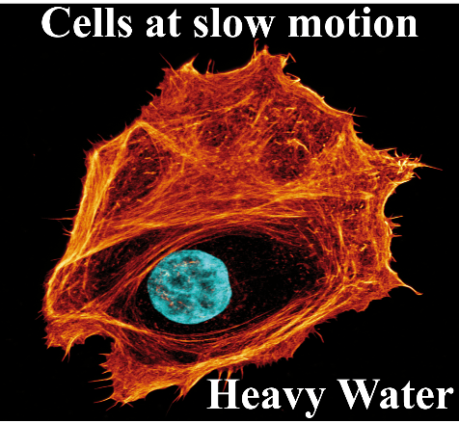

Copyright WILEY-VCH Verlag GmbH & Co. KGaA, 69469 Weinheim, Germany, 2018.
Supporting Information

Supplemental material: Cells in slow motion: Apparent undercooling increases glassy behavior at physiological temperatures

Jörg Schnauß^{1,2,3,}*, Tom Kunschmann^{1,+}, Steffen Grosser^{1,+}, Paul Mollenkopf^{1,2}, Tobias Zech⁴, Jessica S. Freitag², Dusan Prascevic¹, Roland Stange¹, Luisa S. Röttger⁵, Susanne Rönicke¹, David M. Smith^{1,2,6,7}, Thomas M. Bayerl⁵, and Josef A. Käs¹

¹ Peter Debye Institute for Soft Matter Physics, University Leipzig, Linnéstraße 5, 04103 Leipzig, Germany
² Fraunhofer Institute for Cell Therapy and Immunology, Perlickstraße 1, 04103 Leipzig, Germany
³ Unconventional Computing Lab, Department of Computer Science and Creative Technologies, UWE, Bristol BS16 1QY UK
⁴ Institute of Systems, Molecular and Integrative Biology, University of Liverpool, Liverpool, U.K.
⁵ D2 Bioscience Group Ltd., Trinity Hall, 43 Cedar Ave. Hamilton, HM LX
⁶ Institute of Clinical Immunology, University of Leipzig Medical Faculty, 04103 Leipzig, Germany
⁷ Dhirubhai Ambani Institute of Information and Communication Technology, Gandhinagar 382 007, India
⁺ Steffen Grosser and Tom Kunschmann contributed equally to this work

* E-mail: joerg.schnauss@uni-leipzig.de

The origin of this stiffening behavior of in vitro actin networks is not directly reflected in apparent properties of the filaments building up the actin structures. We investigated these single filament properties under different D₂O conditions via fluorescence microscopy. Our measurements revealed that D₂O interferes with the (de)polymerization dynamics (Figure 3). We further analyzed the impact of D₂O on properties of the single filaments such as the contour length and persistence length (l_{p}). The assays started from a monomeric basis and the average filament length decreased with increasing D₂O content (Figure S 1). This can explain why the in vitro networks become softer from 45% to 70% since shorter filaments result in a softer network. This finding is not consistent with our cell experiments, where cells treated with 70% D₂O were stiffer than under 45% D₂O conditions. However, in cells the actin cytoskeleton was already pre-polymerized when the treatment with D₂O started and is also controlled by accessory proteins. We would also like to mention the interesting fact that although polymerization dynamics of in vitro actin networks are independent of the D₂O content while depolymerization is slowed in a dose dependent fashion (Figure 3), filaments become shorter in average with increasing D₂O content. One might intuitively think that a slowdown in depolymerization should yield longer filaments, which is in contrast to our observations. However, pyrene assays only give information on the overall bulk behavior and give no direct information about the behavior of single filaments. A possible explanation could be that D₂O induces more nucleation seeds and thus filaments are shorter in average while still showing comparable polymerization dynamics.
Additionally, we studied whether the mechanical properties of the single filament change upon D₂O treatment, which could explain the stiffening of the networks^{[31]}. However, actin filaments did not significantly change their mechanical properties when stained with a non-intercalating dye (Figure S 1). The filament stiffness only changed when using the intercalating dye rhodamine-phalloidin (Figure S 2), which is known to double the filaments’ persistence length - a measure for the filament stiffness^{[14,31]}. Interestingly, the stabilization effect of the rhodamine-phalloidin dye decreased with increasing D₂O content and higher amounts of the dye were needed to achieve a sufficient staining of the filaments. We speculate that D₂O slightly changes the helical conformation of the actin filaments and that the dye cannot sufficiently bind and intercalate anymore. This would result in softer, less stabilized filaments.
Non-intercalating dye (rhodamine B)
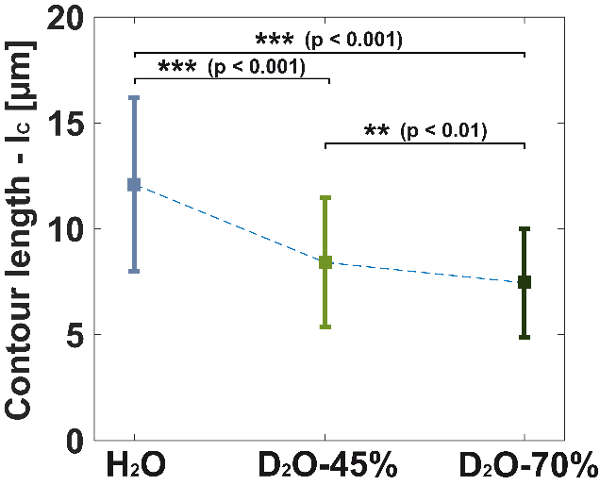 | 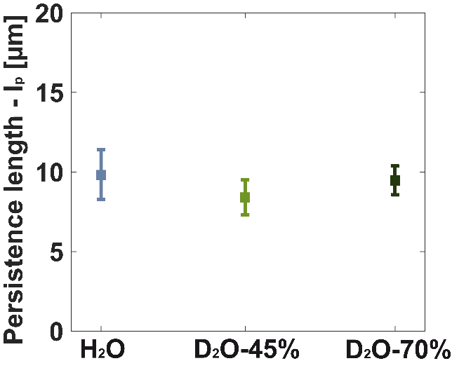
Figure S 1. Non-intercalating dye. Staining actin filaments with the non-intercalating dye Rhodamine B revealed that the average contour length (l_{c}) decreases with increasing D₂O content in the medium. The polymerization was initiated by adding the appropriate salt concentrations in a system only containing actin monomers in the respective D₂O environment. (Number of analyzed filaments (n): nH₂O=160 filaments, n45%D₂O=161 filaments, n70%D₂O =159 filaments). The significance was determined with a two-sample Kolmogorov-Smirnov test and error bars represent the standard deviation from the mean value.

Intercalating dye (Phalloidin-TRITC)
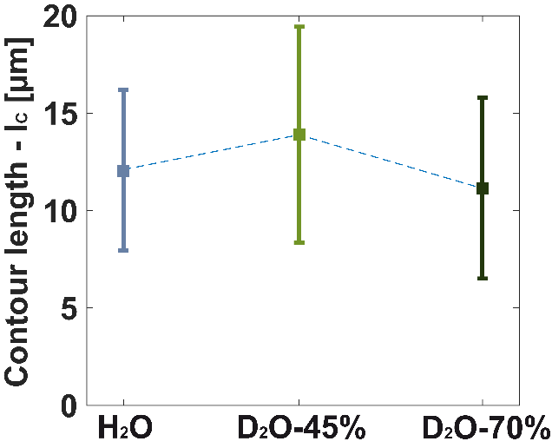 | 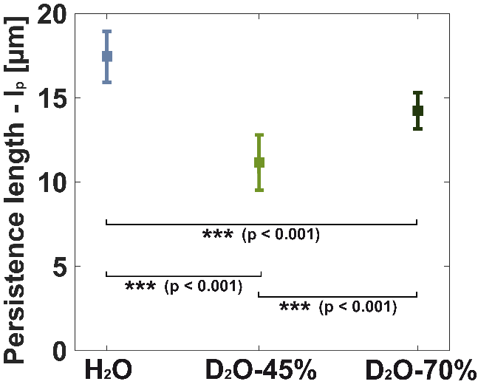
Figure S 2. Intercalating dye. Staining actin filaments with the intercalating dye Phalloidin-TRITC stabilized actin filaments and revealed no significant differences of the average contour length (l_{C}). However, the stabilization is apparent when measuring the filament stiffness, i.e. the persistence length (l_{p}). Under H₂O conditions, the stabilized filaments revealed an l_{p} = 18µm. Adding D₂O to the system reduced this stabilization effects and the filaments became softer. We speculate that the dye could not sufficiently intercalate anymore potentially due to a tighter twist of the actin filament structure. (Number of analyzed filaments (n): nH₂O=181 filaments, n45%D₂O=184 filaments, n70%D₂O =160 filaments). The significance was determined with a two-sample Kolmogorov-Smirnov test and error bars represent the standard deviation from the mean value.

The shortening of the filaments is also reflected in the bulk rheology. Shorter filaments allow an easier dissipation or relaxation of the external force within the network, i.e. the viscosity becomes quickly a dominating factor in these systems. This becomes directly apparent when comparing the crossover of G’ and G’’ under the different conditions (Figure S 3). Especially for 70% D₂O, this crossover appears for rather low frequencies and the loss modulus G’’ becomes the dominant part.
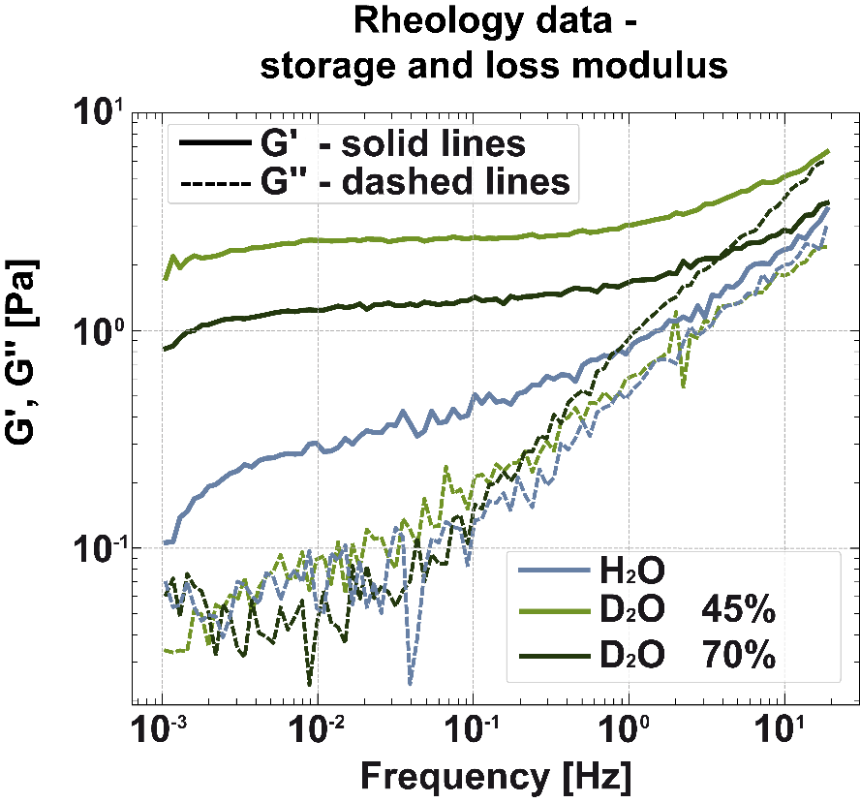
Figure S 3. Elastic and loss moduli of in vitro actin networks for different H₂O/D₂O ratios.

Since the underlying architecture of the actin cytoskeleton in the cells remained largely structurally unchanged and the mechanics of the constituting filaments remained mostly unaffected, the stiffening has to have a different origin. In this respect, it is known the deuterium bonds of D₂O are slightly stronger than the hydrogen bonds of H₂O^{[10]} and that D₂O may enhance hydrophobic interactions^{[26]}. This naturally has to affect actin monomers, which can in turn interact more strongly with other monomers from other filaments. An enhanced interaction between the monomers would thus directly result in stronger filament-filament interactions. Within the glassy worm-like chain model^{[27]} these interactions are modelled as a stickiness parameter (ε), which has proven to be a powerful tool to differentiate and quantify mechanical properties of different biopolymers^{[28,29]}. Within this model, a higher stickiness parameter reflects stronger inter-filament interactions. Evaluating our in vitro rheology data with this model, we found that the stickiness parameters increases under D₂O conditions. While fitting lead to an ε=1.8 for normal H₂O conditions, we found the stickiness parameter to be 2.7 and 4.6 for the respective D₂O concentrations (Figure S 4). This quantifies the stronger inter-filament interactions and can explain the stiffening effects upon D₂O treatment. The decrease in stickiness for a higher D₂O content can be considered a geometrical artefact due to the shorter filament length^{[40]}, which only occurs in vitro and not in cells since actin filaments are already prepolymerized. In addition to a decrease in elasticity, shorter filaments steepen the slope in the log-log- plot of the frequency sweep^{[40]}, i.e. increase the power law exponent. Both changes directly impact and lower the stickiness parameter calculated via the glassy worm-like chain model^{[27–29]}.
A different stickiness parameter infers different inter-filament interactions, which originate from different molecular details. These interactions are crucial key factors for the rheological profiles of different semiflexible polymers and can easily overwrite effects from e.g. persistence length variations ^{[28–31]}. Higher inter-filament interactions induce a more pronounced glassy behavior in the network reducing the power-law characteristic within the frequency sweep up to a point where a plateau is reached^{[28]}. As a consequence, the stickiness parameter ε decreases if filaments interact less, which in turn results in an increasing slope, i.e. increasing power law exponent, in the frequency sweeps. Additionally, the value of ε derived from fitting the frequency sweep curves also depends on the magnitude of G’. If measurements show a lower G’, the fit would also return a reduced ε. However, an increase of the power law exponent and decrease of G’ is also caused when shortening the filaments (see above). Thus, we presume that the shortening of filaments is causing the decrease of ε from 45% to 70% D₂O.

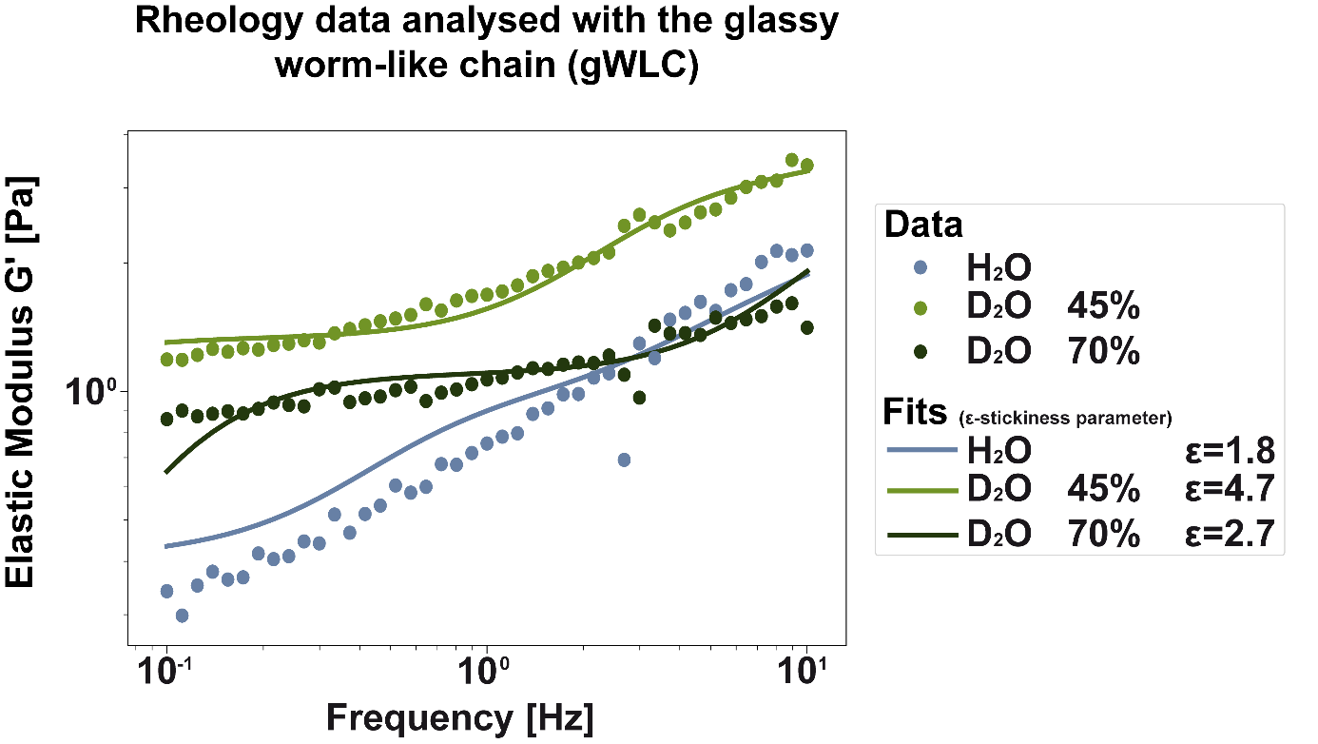
Figure S 4. Fitting the GWLC to the rheological data reveals an increased interaction between neighboring filaments quantified as the stickiness parameter ε.

Descriptions to the supplemental videos:
The supplemental videos S1 – S3 (Video S1 - CellMigration_ActinDNA_H2O.mov, Video S2 - CellMigration_ActinDNA_D2O45%.mov and Video S3 - CellMigration_ActinDNA_
D2O70%.mov) show cell migration on a 2D cell culture substrate, for the different D₂O concentrations used in this study. Stains: DNA (red) and actin (green). Total duration of the videos corresponds to 14h; one frame every for 10mins.

Video S4 - WoundHealings-All.mov and Video S5 - WoundHealings-All-TimeShifted. Mov show collective cell migration into an open wound. As indicated, the upper part shows cells in H₂O medium, the middle part in D₂O-45% and the lower in D₂O-70% medium. Stains: DNA (red) and actin (green). FOV is about (1.7mm)² large. Duration of the first video (Video S4 - WoundHealings-All.mov) is 48h. In the second video (Video S5 - WoundHealings-All-TimeShifted.mov), the two lower parts are time-scaled (accelerated) by the factors indicated, which were obtained from the time shift of the mechanical characterizations in the optical stretcher.

The supplemental videos S6 – S8 (Video S6 - FRAP in H2O.avi, Video S7 - FRAP in 45% D2O.avi and Video S8 - FRAP in 70%D2O.avi) show one example of each condition tested with FRAP experiments. The ROI, which is photo-bleached and the subsequent recovery of the fluorescent signal is observed, is indicated by the white frame.

References
[1] A. P. Amarose, D. M. Czajka, Experimental Cell Research 1962, 26, 43.
[2] D. J. Kushner, A. Baker, T. G. Dunstall, Can. J. Physiol. Pharmacol. 1999, 77, 79.
[3] O. Dybing, G. Guldberg, K. Hansen, Klin Wochenschr 1938, 17, 1585.
[4] P. BACHNER, D. G. MCKAY, D. RITTENBERG, Proceedings of the National Academy of Sciences of the United States of America 1964, 51, 464.
[5] J. Hartmann, Y. Bader, Z. Horvath, P. Saiko, M. Grusch, C. Illmer, S. Madlener, M. Fritzer-Szekeres, N. Heller, R.-G. Alken, T. Szekeres, Anticancer research 2005, 25, 3407.
[6] D. Schroeter, J. Lamprecht, R. Eckhardt, G. Futterman, N. Paweletz, European journal of cell biology 1992, 58, 365.
[7] O. Mosin, I. Ignatov, European Reviews of Chemical Research 2015, 3, 25.
[8] C. S. Pittendrigh, P. C. Caldarola, E. S. Cosbey, Proceedings of the National Academy of Sciences of the United States of America 1973, 70, 2037.
[9] M. Nič, J. Jirát, B. Košata, A. Jenkins, A. McNaught (Eds.), IUPAC Compendium of Chemical Terminology, IUPAC, Research Triagle Park, NC 2009.
[10] J. J. KATZ, American Scientist 1960, 48, 544.
[11] L. S. Hohlefelder, T. Stögbauer, M. Opitz, T. M. Bayerl, J. O. Rädler, BioMed research international 2013, 2013, 592745.
[12] J. Basu, N. Padhy, A. Mookerjee, Indian journal of biochemistry & biophysics 1990, 27, 202.
[13] P. Cioni, G. B. Strambini, Biophysical Journal 2002, 82, 3246.
[14] F. Huber, J. Schnauß, S. Rönicke, P. Rauch, K. Müller, C. Fütterer, J. Käs, Advances in physics 2013, 62, 1.
[15] A. Fritsch, M. Höckel, T. Kiessling, K. D. Nnetu, F. Wetzel, M. Zink, J. A. Käs, Nature Phys 2010, 6, 730.
[16] J. Schnauß, J. A. Käs, D. M. Smith, in Springer Handbook of Nanotechnology (Ed.: B. Bhushan), Springer Berlin Heidelberg. Berlin, Heidelberg 2017, p. 617.
[17] B. U. S. Schmidt, T. R. Kießling, E. Warmt, A. W. Fritsch, R. Stange, J. A. Käs, New J. Phys. 2015, 17, 73010.
[18] T. R. Kießling, R. Stange, J. A. Käs, A. W. Fritsch, New J. Phys. 2013, 15, 45026.
[19] D. Moreau, C. Lefort, R. Burke, P. Leveque, R. P. O'Connor, Biomedical optics express 2015, 6, 4105.
[20] K. M. Schmoller, C. Semmrich, A. R. Bausch, Journal of structural biology 2011, 173, 350.
[21] F. Meinhövel, R. Stange, J. Schnauß, M. Sauer, J. A. Käs, T. W. Remmerbach, Converg. Sci. Phys. Oncol. 2018, 4, 34001.
[22] M. L. Williams, R. F. Landel, J. D. Ferry, J. Am. Chem. Soc. 1955, 77, 3701.
[23] A. Kis, S. Kasas, B. Babić, A. J. Kulik, W. Benoît, G. A. D. Briggs, C. Schönenberger, S. Catsicas, L. Forró, Physical review letters 2002, 89, 248101.
[24] C. Semmrich, T. Storz, J. Glaser, R. Merkel, A. R. Bausch, K. Kroy, Proceedings of the National Academy of Sciences of the United States of America 2007, 104, 20199.
[25] J. Xu, D. Wirtz, T. D. Pollard, The Journal of biological chemistry 1998, 273, 9570.
[26] D. Panda, G. Chakrabarti, J. Hudson, K. Pigg, H. P. Miller, L. Wilson, R. H. Himes, Biochemistry 2000, 39, 5075.
[27] K. Kroy, J. Glaser, New J. Phys. 2007, 9, 416.
[28] T. Golde, M. Glaser, C. Tutmarc, I. Elbalasy, C. Huster, G. Busteros, D. M. Smith, H. Herrmann, J. A. Käs, J. Schnauß, Soft matter 2019, 15, 4865.
[29] T. Golde, C. Huster, M. Glaser, T. Händler, H. Herrmann, J. A. Käs, J. Schnauß, Soft matter 2018, 14, 7970.
[30] I. Elbalasy, P. Mollenkopf, C. Tutmarc, H. Herrmann, J. Schnauß, Soft matter 2021, 17, 3954.
[31] C. Schuldt, J. Schnauß, T. Händler, M. Glaser, J. Lorenz, T. Golde, J. A. Käs, D. M. Smith, Physical review letters 2016, 117, 197801.
[32] S. Chaen, N. Yamamoto, I. Shirakawa, H. Sugi, Biochimica et Biophysica Acta (BBA) - Bioenergetics 2001, 1506, 218.
[33] J. Schnauß, T. Golde, C. Schuldt, B. U. S. Schmidt, M. Glaser, D. Strehle, T. Händler, C. Heussinger, J. A. Käs, Physical review letters 2016, 116, 108102.
[34] T. Kunschmann, S. Puder, T. Fischer, A. Steffen, K. Rottner, C. T. Mierke, Scientific reports 2019, 9, 7675.
[35] B. Gentry, D. Smith, J. Käs, Physical review. E, Statistical, nonlinear, and soft matter physics 2009, 79, 31916.
[36] J. S. Lorenz, J. Schnauß, M. Glaser, M. Sajfutdinow, C. Schuldt, J. A. Käs, D. M. Smith, Advanced materials (Deerfield Beach, Fla.) 2018, 30, e1706092.
[37] H. Isambert, P. Venier, A. C. Maggs, A. Fattoum, R. Kassab, D. Pantaloni, M. F. Carlier, The Journal of biological chemistry 1995, 270, 11437.
[38] F. Huber, D. Strehle, J. Schnauß, J. Käs, New J. Phys. 2015, 17, 43029.
[39] J. A. Cooper, S. B. Walker, T. D. Pollard, Journal of muscle research and cell motility 1983, 4, 253.
[40] K. S. Zaner, J. H. Hartwig, The Journal of biological chemistry 1988, 263, 4532.

